|  |
| --- |
|  |

|  |  |
| --- | --- |
| CHANGE REQUEST | |
| Meeting ID:* | SDS 43 |
| Source:* | Bob Flynn, Convida Wireless , Bob.Flynn@convidawireless.com |
| Date:* | 2020-02-18 |
| Reason for Change/s:* |  |
| CR against: Release* | Rel-4 |
| CR against: WI* | Active <WI-0096>  MNT maintenance / < Work Item number(optional)>  Is this a mirror CR? Yes  No  mirror CR number: (Note to Rapporteur - use latest agreed revision)  STE Small Technical Enhancements / < Work Item number (optional)>  Only ONE of the above shall be ticked |
| CR against: TS/TR* | TR-0063 v0.0.1 |
| Clauses * | multiple |
| Type of change: * | Editorial change  Bug Fix or Correction  Change to existing feature or functionality  New feature or functionality  Only ONE of the above shall be ticked |
| Other TS/TR(s) impacted | None |
| Post Freeze checking:* | This CR contains only essential changes and corrections? YES  NO  This CR may break backwards compatibility with the last approved version of the TS? YES  NO |
| Template Version: January 2019 (do not modify) | |

**oneM2M Notice**

The document to which this cover statement is attached is submitted to oneM2M. Participation in, or attendance at, any activity of oneM2M, constitutes acceptance of and agreement to be bound by terms of the Working Procedures and the Partnership Agreement, including the Intellectual Property Rights (IPR) Principles Governing oneM2M Work found in Annex 1 of the Partnership Agreement.

GUIDELINES for Change Requests:

Provide an informative introduction containing the problem(s) being solved, and a summary list of proposals.

Each CR should contain changes related to only one particular issue/problem.

In case of a correction, and the change apply to previous releases, a separate “mirror CR” should be posted at the same time of this CR

Mirror CR: applies only when the text, including clause numbering are exactly the same.

Companion CR: applies when the change means the same but the baselines differ in some way (e.g. clause number).

Follow the principle of completeness, where all changes related to the issue or problem within a deliverable are simultaneously proposed to be made E.g. A change impacting 5 tables should not only include a proposal to change only 3 tables. Includes any changes to references, definitions, and acronyms in the same deliverable.

Follow the drafting rules.

All pictures must be editable.

Check spelling and grammar to the extent practicable.

Use Change bars for modifications.

The change should include the current and surrounding clauses to clearly show where a change is located and to provide technical context of the proposed change. Additions of complete clauses need not show surrounding clauses as long as the proposed clause number clearly shows where the new clause is proposed to be located.

Multiple changes in a single CR shall be clearly separated by horizontal lines with embedded text such as, start of change 1, end of change 1, start of new clause, end of new clause.

When subsequent changes are made to content of a CR, then the accepted version should not show changes over changes. The accepted version of the CR should only show changes relative to the baseline approved text.

## Introduction

-------------------------------------------------- Start of Change 1---------------------------------------------------

# 1 Scope

As described in [xx cross reference to GSMA TS.34] the expected massive deployment of IoT devices using mobile networks is anticipated to create problems similar to those encountered when smartphone application developers created inefficient applications. In the case of IoT devices the challenge is much more complex because there many more devices and in the general case these devices with not have human interaction to address problems. This document captures the requirements defined by GSMA to provide a good design structure so that devices can connect to the network and operate in a safe manner and then presents the oneM2M solution and sample scenarios for 3GPP based cellular deployments.

The [xx cross reference to GSMA TS.34] recommends an evolved architecture that aligns well with the oneM2M architecture shown in [FIGXX].

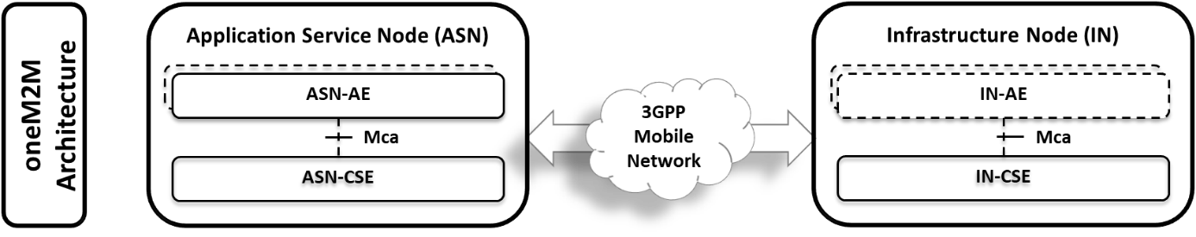

This document will serve as an analysis of the [xx cross reference to GSMA TS.34] requirements and a description of how the requirements can be met using a oneM2M solution. If there are gaps in the oneM2M common services, solutions will be explored to address those gaps. Clause 5 captures the [xx cross reference to GSMA TS.34] requirements and where necessary a description of the requirement using oneM2M capabilities and terminology. Clause 6 captures call flows using oneM2M CSEs and AEs to implement the requirements described. Where the oneM2M requires additional definition to implement the call flow, it will be highlighted. Clause 7 describes example scenarios for the deployment of oneM2M using a 3GPP Mobile network for communications. Clause 8 captures specific change requests to existing oneM2M specifications if any are identified in this analysis.

*The Scope* ***shall not*** *contain requirements.*

-------------------------------------------------- End of Change 1---------------------------------------------------

-------------------------------------------------- Start of Change 2--------------------------------------------------

# 5 Efficient Communications over 3GPP networks

## 5.1 Introduction

The following sub-clauses capture the requirements from GSMA TS.34 [1] and indicate their applicability to a oneM2M solution using this architecture.

Terminology to be added.

## 5.2 IOT Device Requirements

Define what the IOT Device is

|  |  |  |
| --- | --- | --- |
| TS.34_3.0_REQ_001 | The IoT Device should conform to all IoT Device Application requirements defined in TS.34, section 4 | See below [UPDATE THIS] |
| TS.34_3.0_REQ_002 | The IoT Device shall conform to all Communication Module requirements defined in TS.34,section 5. | See below [UPDATE THIS] |
| TS.34_3.0_REQ_003 | The IoT Device should conform to GSMA TS.24 “Operator Minimum Acceptance Values for Device Antenna Performance” [x]. | Not within the scope of oneM2M. |
| TS.34_3.0_REQ_004 | When required by the Mobile Network Operator, the IoT Device shall be certified by the GCF and/or the PTCRB. | Recommended by oneM2M. Conformance test cases are defined in TS-0018. Profiles are defined in TS-0025. |

## 5.3 IOT Device Application Requirements

This clause is derived from GSMA TS.34, clause 4. Two architectures are described in [XX], where the IoT Device application can be a monolithic application that meets all the requirements or an evolved architecture that separates the business logic from embedded service layer logic. This technical report addresses the evolved architecture.

The remainder of this section is organized by the components shown in figure XX.

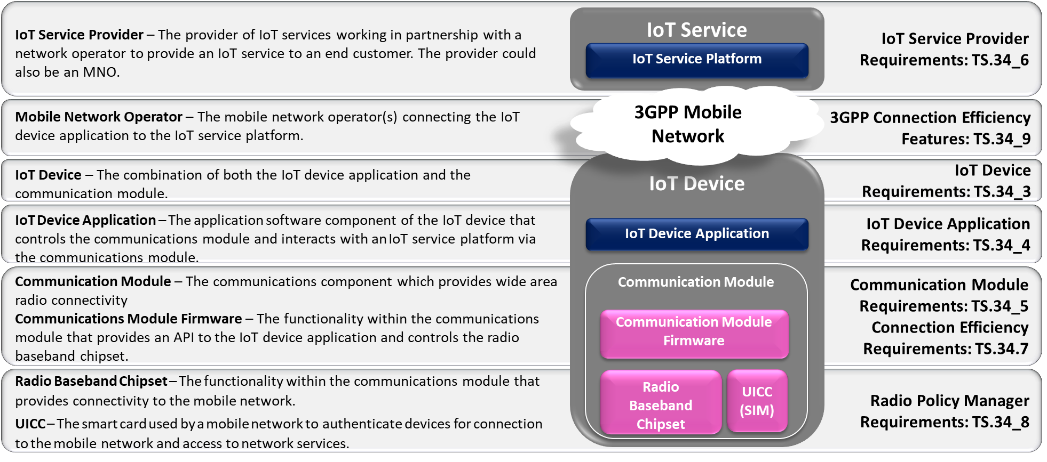

Figure 0‑1

### 5.2.3 **Tiered IoT Device Application Requirements**

In the evolved architecture the Tiered IoT Device Application performs the business logic of the IoT solution. The GSMA requirements for such an application are captured in TABLE XX.

|  |  |  |
| --- | --- | --- |
| TS.34_4.1_REQ_001 | If data speed and latency is critical to the IoT Service the IoT Device Application should be able to retrieve mobile network speed and connection quality information from the IoT Embedded Service Layer in order to request the appropriate quality of content from the IoT Service Platform. | See clause 6.1 [make cross reference] |
| TS.34_4.1_REQ_002 | The IoT Device Application should always be prepared to handle situations when communication requests fail, when such failure is reported by the IoT Embedded Service Layer. | See clause 6.2 [make cross reference] |
| TS.34_4.1_REQ_003 | Each time there is a need to send data over the mobile network the IoT Device Application should classify the priority of each communication. For example, the IoT Device Application should distinguish between data that requires instantaneous transmission and delay tolerant data that could be aggregated and/or sent during non-peak hours. Such information about the priority of the communication should be communicated to the IoT Embedded Service Layer. |  |
| TS.34_4.1_REQ_004 | When an IoT Device Application does not need to perform regular data transmissions and it can tolerate some latency for its IoT Service, it should communicate this information to the IoT Embedded Service Layer so that it can use this information in its interactions with the network.. |  |

-------------------------------------------------- End of Change 2---------------------------------------------------

-------------------------------------------------- Start of Change 3--------------------------------------------------

## 6.1 TS.34_4.1_REQ_001

This requirement indicates the need to expose an API that the IoT device application can use to retrieve current network speed and connection quality. In TS-0026 oneM2M describes that this information can be provided through the SCEF interface.



Figure 0‑1 - Network Condition Monitoring

AE1 – IoT Device Application

CSE1 – (NHTN) ASN-CSE

CSE2 – IN-CSE managed by MNO

AE2 – MNO Service AE

CSE3 – MN-CSE managed by IoT Service Provider

AE3 – IoT Services and applications managed by IoT SP

SCEF – MNO managed interface to 3GPP IoT services

1. AE1 requests network condition/speed. TBD the targetURI is dependent on the resource this is stored in.
2. CSE1 responds to request. The resource type is described in Clause 7.2.[add cross reference] This is dependent on the resource this is stored in.
3. SCEF notifies CSE2 of changes in a particular eNodeB (affecting all CIoT devices in that area). This notification comes via the SCEF T8 API – Network Status Monitoring described in TS-0026 clause 7.8.1. This *NetworkStatusReportingNotification* contains a *subscription* URI that indicates the *targetNetwork* that this message applies to.
4. Update resource that stores the network speed/condition value for eNodeB-ID [Describe procedure when this notification occurs] Step 8 of clause 7.8.1 Throttling requests based on Network Status Reports indicates that [cmdhNwAccessRule] resource may be modified. The *targetNetwork* may contain an identifier that matches the identifier from step 3.
5. Update each CIoT device within the eNodeB-ID area.
   1. Using announcement will cause CSE2 to do this automatically

Pre-requisites are shown in [XX-below]

NOTE: in a TS, this will likely appear prior to the call flow showing the solution to the requirement. However for this TR, this flow seems more appropriate to assist with mapping of requirements to solutions.



1. CSE1 registers to CSE2, specifying 3GPP M2M-Ext-ID
2. CSE2 sends to SCEF the *NetworkStatusReportingSubscription* message with *thresholdValues* set according to Policy (policy will be settable by the MNO via a CMDH resource). Location area will be one or more cellIds from ??? [network Condition Monitoring] Type: LocationInfo will contain the cell ID in the notification
   1. POST *{apiRoot}/3gpp-net-stat-report/v1/{scsAsId}/subscriptions/*
   2. Payload = {
      1. notificationdestination = This is a URI that the IN-CSE can be use as an identifier of the specific eNodeBID because the notification payload from the SCEF does not include identifier information. {cseRoot}/{locationReport}/{eNodeBID}
      2. One of *thresholdValues* or *thresholdTypes* [This implies a cmdh policy for each value or type or a rule, for example ThreshVal applies to policy with val <= ThreshVal].
      3. *timeDuration* – non-standard approach to specifying this value, meaning that it does not come from a Mca [Since there is an implied policy, this can be set to the policy expiration time (implementation detail). But we need a way to close the loop.
      4. *locationArea* – TBD need relevant information from the CN.
3. CSE2 updates CSE1 (resource/attribute) to indicate which eNodeB-ID (is that needed?)
4. CSE2 updates eNodeB (resource/attribute) causing the announceTo CSE1 process or subscription with notificationURI (good for monolithic AE on CIoT device) [Change of TS-0026 when initial sub/monitoring occurs – add update to announceTo]

Resource Type storing the network speed or condition could be a <mgmtObj> specialization or <flexContainer> specialization.

Consider that <mgmtObj> resources are children of <node> and represent oneM2M entities or devices, use of these resources for the 3GPP network is not consistent. Therefore a <flexContainer> specialization is recommended. See Clause 7.2

## 6.2 TS.34_4.1_REQ_002

This requirement is an Application responsibility, however oneM2M should identify the types of errors that can occur and define when the CSE should report the errors such that the application can implement appropriate error handling procedures. Also since these devices may be in remote locations, there should also be a mechanism to report these errors to the MNO and/or SP such that the need for remote management or maintenance of the device can be indicated.

Application logic errors: these types of errors occur as a result of operations initiated by the application, such as sending messages that exceed policy limits. NOTE: all normal payload validation errors also apply, but this solution will address errors related to communication on the 3GPP Core Network.

ASN-CSE logic errors occur when the ASN-CSE performs operations that fall within the parameters of specified policies, but have a failure result, e.g. based on a CMDH policy to buffer messages until a specified buffer size occurs, when the ASN-CSE sends the payload yet the transmission fails. This is an example of an error not caused by the application, rather something in the communication channel (ASN-CSE-comm module-core network-IN-CSE…).

Remote CSE errors occur when the ASN-CSE is able to successful send a primitive to an oneM2M entity, yet the response to that message is a failure response (or timeout).

ASN-CSE errors: To be prepared to meet this requirement, the ASN-CSE should report this type of error to the application(s) on the device (store in an errorlog resource container such that a subscription/notification can be created), but they may not know how to handle it. Given that this is reported to the applications, we must assume that some applications could modify their behaviour based on this error report, therefore there should be an indication when the error condition is resolved (if possible). As these devices may be in remote locations, there should also be a mechanism to report these errors to the MNO and/or SP such that the need for remote management or maintence of the device can be indicated.

To ensure error reporting does not create a large signalling /communication load on the CN, error reporting should be managed by a CMDH policy and adhere to applicable message transmission policies.

Solution should include the following:

- listing of the different types of errors that the application can cause

- Listing of error types that are caused by CN conditions, i.e. failure to connect.

- location to store error conditions (not

- procedure to report errors to MNO/SP when they occur or later based on communication schedule and policies

-------------------------------------------------- End of Change 3---------------------------------------------------

-------------------------------------------------- Start of Change 4--------------------------------------------------

## 7.2 TS-0026 – <flexContainer> specialization describing 3GPP network

This specialization of <*flexContainer*> is used to represent a single instance of a 3GPP eNodeB area network. Other types of networks may also be represented using this representation, if appropriate.

Table 7.2‑1: Resource Specific Attributes of [3GPPeNodeB] resource

|  |  |  |  |
| --- | --- | --- | --- |
| *areaNwkType* | 1 | RW | The areaNwkType is an implementation-chosen string that indicates the type of M2M Area Network. For 3GPP Rel15 this could be SCEF. |
| *networkID* | 1 | WO | Configured with the identity of the underlying network which the M2M Node is currently attached to. |
| *networkCondition* | 1 | RW | Contains a qualitative description of the network condition. |

Table 7.2‑2: Resource Specific Attributes of [3GPPeNodeB] resource

|  |  |  |  |  |
| --- | --- | --- | --- | --- |
| Attribute Name | Request Optionality | | Data Type | Default Value and Constraints |
| Create | Update |
| *containerDefinition* | M | NP | xs:anyURI | No default |
| *areaNwkType* | O | O | xs:anyURI | No default |
| *networkID* | M | O | xs:string | No default |
| *networkCondition* | O | O | xs:string | No default |

Table 7.2‑3: Child Resources of [3GPPeNodeB] resource

|  |  |  |
| --- | --- | --- |
| Child Resource Type | Child Resource Name | Multiplicity |
| *<subscription>* | [variable] | 0..n |
| *<semanticDescriptor>* | [variable] | 0..n |

-------------------------------------------------- End of Change 4---------------------------------------------------

-------------------------------------------------- Start of Change 5--------------------------------------------------

|  |  |
| --- | --- |
| **oneM2M**  **Technical Report** | |
| Document Number | TR-00xx-V-0.0.1 |
| Document Name: | Effective IoT Communication to Protect 3GPP Networks |
| Date: | 2019-11-24 |
| Abstract: | This work item describes how a oneM2M service layer hosted on a 3GPP Cellular IoT device can implement the requirements defined in GSMA TS.34 to ensure that a device does not operate in a manner that can impair the 3GPP Cellular network. |
| 'Template Version: January 2019 (do not modify) | |

-------------------------------------------------- End of Change 5---------------------------------------------------