

oneM2M
Technical Report
Document Number | SDS-2020-0141-oneM2M-SensorThingsAPI_Interworking
Document Name: | oneM2M-SensorThings API interworking
Date: | 2020-04-17
Abstract: | This document investigates in oneM2M-to-SensorThings API interworking
'Template Version: January 2019 (do not modify)

The present document is provided for future development work within oneM2M only. The Partners accept no liability for any use of this report.
The present document has not been subject to any approval process by the oneM2M Partners Type 1. Published oneM2M specifications and reports for implementation should be obtained via the oneM2M Partners' Publications Offices.

About oneM2M
The purpose and goal of oneM2M is to develop technical specifications which address the need for a common M2M Service Layer that can be readily embedded within various hardware and software, and relied upon to connect the myriad of devices in the field with M2M application servers worldwide.
More information about oneM2M may be found at: http//www.oneM2M.org
Copyright Notification
© 2019, oneM2M Partners Type 1 (ARIB, ATIS, CCSA, ETSI, TIA, TSDSI, TTA, TTC).
All rights reserved.
The copyright and the foregoing restriction extend to reproduction in all media.

Notice of Disclaimer & Limitation of Liability
The information provided in this document is directed solely to professionals who have the appropriate degree of experience to understand and interpret its contents in accordance with generally accepted engineering or other professional standards and applicable regulations. No recommendation as to products or vendors is made or should be implied.
NO REPRESENTATION OR WARRANTY IS MADE THAT THE INFORMATION IS TECHNICALLY ACCURATE OR SUFFICIENT OR CONFORMS TO ANY STATUTE, GOVERNMENTAL RULE OR REGULATION, AND FURTHER, NO REPRESENTATION OR WARRANTY IS MADE OF MERCHANTABILITY OR FITNESS FOR ANY PARTICULAR PURPOSE OR AGAINST INFRINGEMENT OF INTELLECTUAL PROPERTY RIGHTS. NO oneM2M PARTNER TYPE 1 SHALL BE LIABLE, BEYOND THE AMOUNT OF ANY SUM RECEIVED IN PAYMENT BY THAT PARTNER FOR THIS DOCUMENT, WITH RESPECT TO ANY CLAIM, AND IN NO EVENT SHALL oneM2M BE LIABLE FOR LOST PROFITS OR OTHER INCIDENTAL OR CONSEQUENTIAL DAMAGES. oneM2M EXPRESSLY ADVISES ANY AND ALL USE OF OR RELIANCE UPON THIS INFORMATION PROVIDED IN THIS DOCUMENT IS AT THE RISK OF THE USER.

Contents
Contents 3
1 Scope 4
2 References 4
2.1 Normative references 4
2.2 Informative references 4
3 Definition of terms, symbols and abbreviations 4
3.1 Terms 4
3.2 Symbols 5
3.3 Abbreviations 5
4 Conventions, 5
5 User defined clause(s) from here onwards 5
5.1 User defined subdivisions of clause(s) from here onwards 5
Proforma copyright release text block 5
Annexes 6
Annex <y>: Bibliography 6
History 7

1 Scope
The present document defines an interworking of both standards oneM2M and OGC SensorThings API.
The document is structured as followed:
- Introduction and background to OGC-SensorThings API
- Describing interworking scenarios that are relvant but not exclusive for Smart City (there are also examples from other areas and verticals as well)
- Technical comparison of oneM2M and OGC / STA
- Describing a technical solution for interworking of both standards; there might be interworking on different level:
o opaque data routing
o data model mapping between oneM2M-SDT and OGC ISO 19156
- Developing test cases for interworking between oneM2M and OGC SensorThings API
The Scope shall not contain requirements.

2 References
The following text block applies.
References are either specific (identified by date of publication and/or edition number or version number) or non-specific. For specific references,only the cited version applies. For non-specific references, the latest version of the referenced document (including any amendments) applies.

2.1 Normative references
As a Technical Report (TR) is entirely informative it shall not list normative references.
The following referenced documents are necessary for the application of the present document.
Not applicable.

2.2 Informative references
Clause 2.2 shall only contain informative references which are cited in the document itself.
The following referenced documents are not necessary for the application of the present document but they assist the user with regard to a particular subject area.
[i.1] oneM2M Drafting Rules (http://member.onem2m.org/Static_pages/Others/Rules_Pages/oneM2M-Drafting-Rules-V1_0.doc)
[i.2] SensorThings API website, https://www.ogc.org/standards/sensorthings
[i.3] ISO 19156 website, https://www.iso.org/standard/32574.html

3 Definition of terms, symbols and abbreviations
Delete from the above heading the word(s) which is/are not applicable.

3.1 Terms
Clause numbering depends on applicability.
- A definition shall not take the form of, or contain, a requirement.
- The form of a definition shall be such that it can replace the term in context. Additional information shall be given only in the form of examples or notes (see below).
- The terms and definitions shall be presented in alphabetical order.
For the purposes of the present document, the [following] terms and definitions [given in ... and the following] apply:
Definition format
<defined term>: <definition>
If a definition is taken from an external source, use the format below where [N] identifies the external document which must be listed in Section 2 References.
<defined term>[N]: <definition>
example 1: text used to clarify abstract rules by applying them literally
NOTE: This may contain additional information.

3.2 Symbols
Clause numbering depends on applicability.
For the purposes of the present document, the [following] symbols [given in ... and the following] apply:
Symbol format
<symbol> <Explanation>
<2nd symbol> <2nd Explanation>
<3rd symbol> <3rd Explanation>

3.3 Abbreviations
Abbreviations should be ordered alphabetically.
Clause numbering depends on applicability.
For the purposes of the present document, the [following] abbreviations [given in ... and the following] apply:
Abbreviation format
OGC Open Geospacial Consortium
STA SensorThing API

4 Conventions,
The key words “Shall”, ”Shall not”, “May”, ”Need not”, “Should”, ”Should not” in this document are to be interpreted as described in the oneM2M Drafting Rules [i.1]

5 Background
The following text explains what is SensorThings API and how does it work
SensorThings API (STA) is a standard of the Open Geospacial Consortium (OGC). It provides a framework for communication and exchanging data between sensors and applications. The standard is devided in two parts. SensorThings API Part 1 is dedicatd to sensing and was published in 2016. Part 2 deals with tasking and was published in 2019. There is a OGC certified Open-Source SensorThings API Server available (FROST Server). It supports the OGC SensorThings API Part 1: Sensing. It also includes preliminary actuation/tasking support.
For the description of entites SensorThings API uses ISO 19156:2011 data model and JSON as data format. The communication is REST-based and uses HTTP and also CoAP, MQTT, 6LowPAN.

5.1 SensorThings API Architecture
A typical STA-based architecture works in Client/Server mode. The sensor device pushes its data to the SensorThings Server via HTTP POST request. The SensorThings Server has also a MQTT broker. An interested application can subscribe to the MQTT-Broker in order to get notified about new sensor events.
The data in the SensorThings server are organized according to ISO 19156 (see Figure 1: ISO 19156 data model).
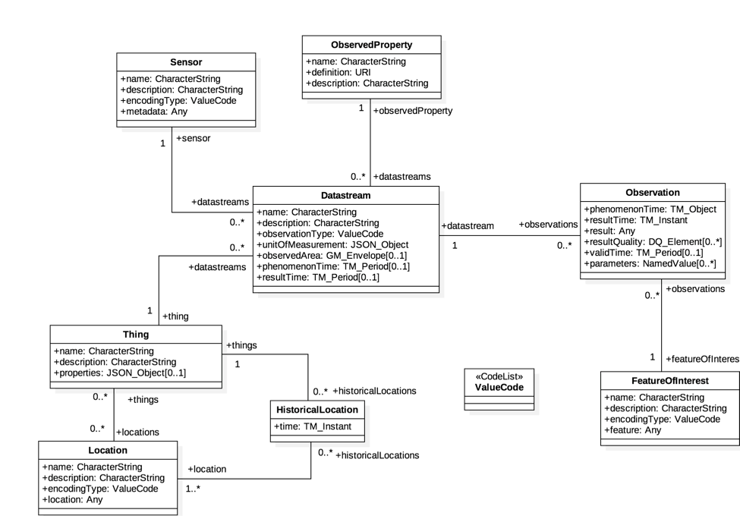
Figure 1: ISO 19156 data model
In the SensorThings data model an events or sensor data is an ‘observations’. Before a sensor is able to push an observation to the server it needs at least a ‘thing’- and a ‘data stream’ entity. This has to be created beforehand. One ‘thing’ might have different ‘sensors’, one ‘location’ or many ‘historical locations’.
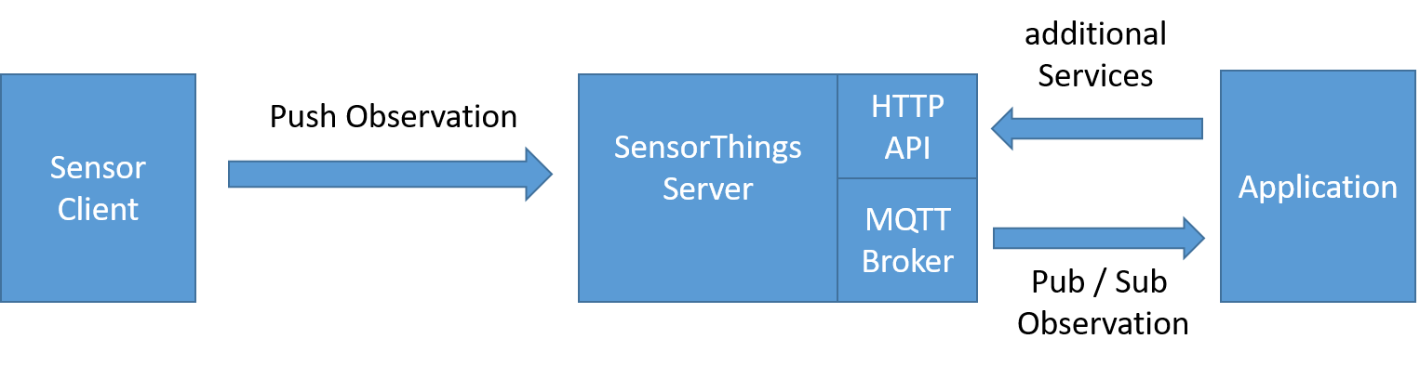
Figure 2: Exemplary STA message flow

5.2 SensorThings API example use-case
The message flow in Figure 2 can be explained by using an example of an application that wants to use data of ev-charging stations in a city.
- In order to get all relevant observations belonging to the cities ev-charging stations the application needs to know all regarded data streams. Therefore the application sends a request with filter parameter to the HTTP-API of the server e.g.:
https://sta-example-server-address.com/v1.0/Things?$filter=substringof(“Charging”,name)&$count=true&$expand=Datastreams
As a response the server provides a list of all data streams belonging to a charging staation.
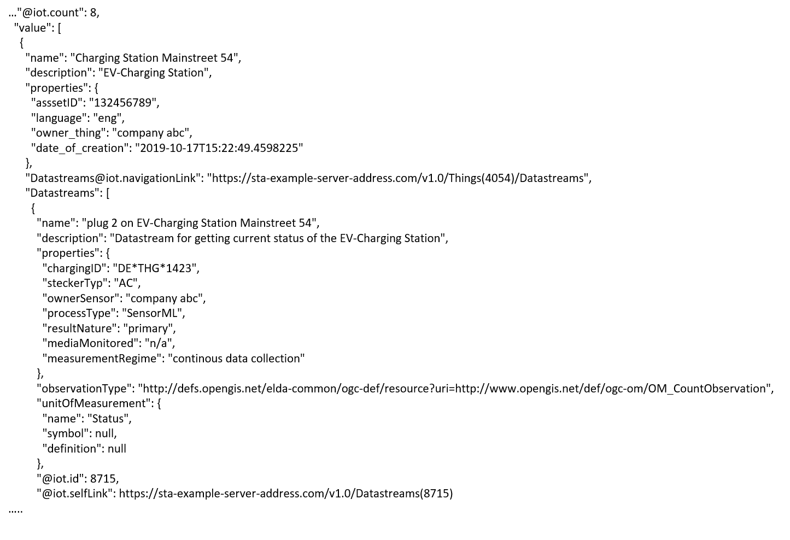
Figure 3: One exemplary entry of the result list of an filter request
- The application can now subscribe to the these data streams. Figure 3 shows one entry of the result list. It represents an EV-Charging Station as a thing including the regraded datastream in the last line of the entry.
- As soon as the sensor (ev-charging station) changes its status e.g. from “available” to “charging” it pushes an oberservation to the server.
- The application gets the observation through a notification that is send by the MQTT-Broker. An example of an observation is shown in figure 4. In the result field is shown the current status of the EV-Charging Station “charging”.
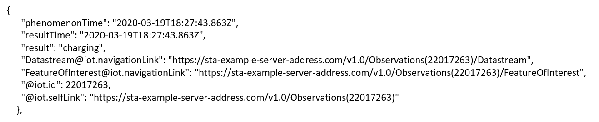
Figure 4: Exemplary STA observation
The following text is to be used when appropriate:

Proforma copyright release text block
This text box shall immediately follow after the heading of an element (i.e. clause or annex) containing a proforma or template which is intended to be copied by the user. Such an element shall always start on a new page.
Notwithstanding the provisions of the copyright clause related to the text of the present document, oneM2M grants that users of the present document may freely reproduce the <proformatype> proforma in this {clause|annex} so that it can be used for its intended purposes and may further publish the completed <proformatype>.
<PAGE BREAK>

Annexes
Each annex shall start on a new page (insert a page break between annexes A and B, annexes B and C, etc.).
Use the Heading 9 style for the title and the Normal style for the text.
Annex <A>:
Title of annex (style H9)
<Text>
<PAGE BREAK>
Annex <B>:
Title of annex (style H9)
<Text>
B.1 First clause of the annex (style H1)
<Text>
B.1.1 First subdivided clause of the annex (style H2)
<Text>
<PAGE BREAK>

Annex <y>:
Bibliography
The annex entitled "Bibliography" is optional.
It shall contain a list of standards, books, articles, or other sources on a particular subject which are not mentioned in the document itself.
It shall not include references mentioned in the document.
Use the Heading 9 style for the title and B1+ or Normal for the text.
- <Publication>: "<Title>".
OR
<Publication>: "<Title>".
<PAGE BREAK>

History
This clause shall be the last one in the document and list the main phases (all additional information will be removed at the publication stage).
Publication history
V1.1.1 | <yyyy-mm-dd> | <Milestone>

Draft history (to be removed on publication)
V0.0.1 | 2020-04-17 | Initial draft

