CHANGE REQUEST
Meeting ID:* | SDS 45
Source:* | Preeti Rani (preetir@cdot.in), Poornima Shandilya (poornima@cdot.in), Anupama Chopra (anupama@cdot.in)
Date:* | 2020-04-22
Reason for Change/s:* | Node-ID certificate details missing in TS-0003
CR against: Release* | Release 3
CR against: WI* | Active <Work Item number>  MNT maintenance / < Work Item number(optional)>  Is this a mirror CR? Yes No  mirror CR number: (Note to Rapporteur - use latest agreed revision)  STE Small Technical Enhancements / < Work Item number (optional)>  Only ONE of the above shall be ticked
R against: TS/TR* | TS-0003-V3.12.0
Clauses * | 3.1, 3.3, 8.1.2, 8.2.1, 8.2.2.2, 8.3.1.2, 8.3.7.1, 8.5.2.2.4.1, 8.5.2.3.2.1, 8.8.3.1, 9.1.1.1, 9.1.2, 9.2.1.1, 9.2.2.3, 10.1.3, 12.3.2.1
Type of change: * | Editorial change  Bug Fix or Correction  Change to existing feature or functionality  New feature or functionality  Only ONE of the above shall be ticked
Other TS/TR(s) impacted | <TS/TR number>, <Version Number>, and <Description on which aspect should be reflected in this TS/TR>
Post Freeze checking:* | This CR contains only essential changes and corrections? YES NO  This CR may break backwards compatibility with the last approved version of the TS? YES NO
Template Version: January 2019 (do not modify)

oneM2M Notice
The document to which this cover statement is attached is submitted to oneM2M. Participation in, or attendance at, any activity of oneM2M, constitutes acceptance of and agreement to be bound by terms of the Working Procedures and the Partnership Agreement, including the Intellectual Property Rights (IPR) Principles Governing oneM2M Work found in Annex 1 of the Partnership Agreement.
GUIDELINES for Change Requests:
Provide an informative introduction containing the problem(s) being solved, and a summary list of proposals.
Each CR should contain changes related to only one particular issue/problem.
If this is a correction, and the change applies to previous releases, a separate “mirror CR” should be posted at the same time as this CR
Mirror CR: applies only when the text, including clause numbering are exactly the same.
Companion CR: applies when the change means the same but the baselines differ in some way (e.g. clause number).
Follow the principle of completeness, where all changes related to the issue or problem within a deliverable are simultaneously proposed to be made e.g. a change impacting 5 tables should not only include a proposal to change only 3 tables. Include any changes to references, definitions, and abbreviations in the same deliverable.
Follow the drafting rules.
All pictures must be editable.
Check spelling and grammar.
Use change bars for modifications.
The change should include the current and surrounding clauses to clearly show where a change is located and to provide technical context of the proposed change. Additions of complete clauses need not show surrounding clauses as long as the proposed clause number clearly shows where the proposed new clause is located.
Multiple changes in a single CR shall be clearly separated by horizontal lines with embedded text such as, start of change 1, end of change 1, start of new clause, end of new clause.
When subsequent changes are made to the content of a CR, then the accepted version should not show changes over changes. The accepted version of the CR should only show changes relative to the baseline approved text.

Introduction
OneM2M specification document TS-0003 introduces Node-ID Certificate flavor in section 8.1.2.1 Public Key Certificate Flavours and 10.1.1.8 Profile for Node-ID Certificates and their Certificate Chains to authenticate nodes.
But the usage of Node-ID certificate is missing in the document and 12.3.2.1 sec:credIDTypeID enum. Thus it is proposed to add missing usage details and entry in the enum.

-----------------------Start of change 1-------------------------------------------

3.1 Definitions
Node-ID Certificate: certificate with a certificate chain to a root of trust and containing a M2M-Node-ID of a Node in the subjectAltName extension
NOTE: A Node-ID certificate can be used to verify the identity of a Node.

-----------------------End of change 1---------------------------------------------

-----------------------Start of change 2-------------------------------------------

3.3 Abbreviations
For the purposes of the present document, the abbreviations given in oneM2M TS-0011 [Error: Reference source not found] and the following abbreviations apply:
Node-ID Node Identifier

-----------------------End of change 2---------------------------------------------

-----------------------Start of change 3-------------------------------------------

8.1.2 General Introduction to the Certificate-Based Security Frameworks

8.1.2.0 Introduction
This clause describes the Credential Configuration and Certificate Verification used in the Certificate-Based Security Association Establishment Framework and Certificate-Based Remote Security Provisioning Framework.

8.1.2.1 Public Key Certificate Flavours
The present document defines procedures using the following Public Key Certificate flavours:
- Raw Public Key Certificates:
- Description: A raw public key certificate (IETF RFC 7250 [Error: Reference source not found]) contains only the raw public key, without other information normally provided in a certificate. The raw public key certificate is exchanged in the TLS handshake in the place of a traditional certificate (see IETF RFC 7250 [Error: Reference source not found]).
- Use: A raw public key certificate can be used for authenticating a CSE or AE either during the Association Security Handshake phase of the Certificate-Based Security Association Establishment or during the Bootstrap Enrolment Handshake phase of the Certificate-Based Remote Security Provisioning Framework.
- Device certificates:
- Description: These certificates have a certificate chain to a trust anchor and include one or more globally unique hardware instance identifier (such as the Object Identifier Based M2M Device identifiers discussed in annex H "Object Identifier Based M2M Device Identifier" oneM2M TS-0001 [Error: Reference source not found]) in the subjectAltName extension of the certificate. A device certificate can be used to verify the identity of the hardware instance on which the entity is being executed.
- Use: Device certificates can be used to authenticate a CSE or AE executing on a specific M2M Device. If the M2M device is an ASN or MN (which supports a CSE), then the device certificate is implicitly associated with the CSE that executes on the device. If the device is an ADN (which does not support a CSE) then the device certificate is not implicitly associated with a specific AE executing on the hardware. A device certificate can be used for authenticating a Field Domain CSE either during the Association Security Handshake phase in the Certificate-Based Security Association Establishment Framework or during the Bootstrap phase of the Certificate-Based Remote Security Provisioning Framework.
- Node-ID certificates:
- Description: These certificates have a certificate chain to a trust anchor and include the Node-ID of a Node (see oneM2M TS-0001 [Error: Reference source not found]) in the subjectAltName extension of the certificate. A Node-ID certificate can be used to verify the identity of a Node.
- Use: A Node-ID certificate can be used to authenticate a Security Principal on a Node acting on behalf of the CSE and/or AE(s) executing on a specific Node. If the Node supports a CSE i.e. an ASN or MN, then the Node-ID certificate is implicitly associated with the CSE that executes on the Node. If the Node does not support a CSE i.e. an ADN, then the Node-ID certificate is associated with one or more AEsnot implicitly associated with a specific AE executing on the Node.
- CSE-ID certificates:
- Description: These certificates have a certificate chain to a trust anchor and include the public domain name representation of a CSE-ID (see oneM2M TS-0001 [Error: Reference source not found]) in the subjectAltName extension of the certificate. A CSE-ID certificate verifies that the entity presenting the certificate has been assigned a particular CSE-ID.
- Use: A CSE-ID certificate can be used to authenticate a CSE only.
- AE-ID certificates:
- Description: These certificates have a certificate chain to a trust anchor and include the full URI representation of an AE-ID in the subjectAltName extension of the certificate. An AE-ID certificate verifies that the entity presenting the certificate has been assigned a particular AE-ID.
- Use: An AE-ID certificate can be used to authenticate an AE only.
- FQDN certificates:
- Description: These certificates have a certificate chain to a trust anchor and include the FQDN of an M2M Enrolment Function in the subjectAltName extension of the certificate. An FQDN certificate verifies that the entity presenting the certificate has been assigned a particular FQDN.
- Use: A FQDN certificate is used to authenticate an M2M Enrolment Function to an Enrolee during a Bootstrap Enrolment Handshake phase in a Certificate-Based Remote Security Provisioning Framework.
NOTE: The flavours, and the details specific for these flavours, are specified to support a range of deployment models while ensuring that oneM2M entities have clear procedures for authenticating other oneM2M entities using certificates.
The profiles for these certificates are found in clause 10.1.1 "Certificate Profiles".

8.1.2.2 Certification Path Validation and Certificate Status Verification
If an entity is to authenticate another entity using a device certificate, CSE-ID certificate, AE-ID certificate, Node-ID certificate or FQDN certificate, then the entity shall perform basic certification path validation (section 6.1of IETF RFC 5280 [Error: Reference source not found]) as part of verifying the other entity's certificate (see clause 8.1.2.4 "Certificate Verification").
CA certificates shall include the name constraint extensions (clause 4.2.1.10 "Name Constraints" of IETF RFC 5280 [Error: Reference source not found]) and shall constrain the names (object identifier M2M Device IDs from Annex H "Object Identifier Based M2M Device Identifier" oneM2M TS-0001 [Error: Reference source not found], public domain name representation of the CSE-ID, Absolute AE-ID, Node-ID or FQDNs) which may be in the subsequent certificate used to authenticate the entity (device certificate, CSE-ID certificate, AE-ID certificate, Node-ID certificate or FQDN certificate respectively).
- Clause 4.2.1.10 "Name Constraints" in IETF RFC 5280 [Error: Reference source not found] describes how the name constraint extension is used for constraining URIs and FQDNs.
- Clause 10.4.1.4.2 "Profile for Certificate Authority Certificates for Device Certificates" describes how the name constraint extension is used for constraining object identifier M2M Device IDs.
The trust anchor information (section 6.1.1 of IETF RFC 5280 [Error: Reference source not found]) is provided to the entity during Credential Configuration, Association Configuration, Bootstrap Credential Configuration or Bootstrap Instruction Configuration.
NOTE 1: Section 6.1.1 of IETF RFC 5280 [Error: Reference source not found] states "The trust anchor information is trusted because it was delivered to the path processing procedure by some trustworthy out-of-band procedure". Credential Configuration, Association Configuration, Bootstrap Credential Configuration and Bootstrap Instruction Configuration satisfy the requirements of being trustworthy out-of-band procedures.
Certificate status verification: In the case of an Infrastructure Domain entity receiving an MEF certificate, the entity shall verify the status of the certificate using a Certificate Revocation List as described in IETF RFC 5280 [Error: Reference source not found]. A mapping of the Online Certificate Status Protocol (OCSP) onto HTTP may be used, as described in Appendix A of IETF RFC 6960 [Error: Reference source not found], however a mapping of OCSP onto CoAP is not currently defined. Furthermore, OCSP may also not be easily applicable in all environments. An alternative approach may be using the TLS Certificate Status Request extension (section 8 of IETF RFC 6066 [Error: Reference source not found]; also known as "OCSP stapling") or preferably the Multiple Certificate Status Extension (IETF RFC 6961 [Error: Reference source not found]), if available.
NOTE 2: Most of the above paragraph is based on almost identical text in the CoAP specification IETF RFC 7252 [Error: Reference source not found], a protocol with similar (if not identical) considerations to oneM2M deployments.

8.1.2.3 Credential Configuration for Certificate-Based Security Framework
If an entity is to authenticate itself using a Certificate-Based Security Framework, then the entity shall be pre-provisioned with the following information:
- The entity's Private Signing Key, which should remain protected in a secure environment, e.g. using the framework described in annex L.
NOTE: An entity authenticates itself to other entities by proving that it knows the Private Signing Key corresponding to a particular Public Verification Key.
- The entity's Certificate (and if applicable, Certificate Chain) as described in clause 10.1.1 "Certificate Profiles".
- In the case of a CSE-ID certificate the entity shall be configured with the entity's CSE-ID.
- In the case of an AE-ID certificate the entity shall be configured with the entity's AE-ID.

8.1.2.4 Information Needed for Certificate Authentication of another Entity
Entity A shall be configured to trust the following information in order to authenticate Entity B using the certificate-Based SAEF:
- An indication of the public key certificate flavour of other Entity B's Certificate (that is, raw public key certificate, device certificate, CSE-ID certificate, Node-ID certificate or FQDN certificate).
- In the case where Entity B's certificate is a raw public key certificate:
- A public key identifier for the raw public key in the certificate (see clause 10.1.2 "Public Key Identifiers").
- In the case where other Entity B's certificate is a device certificate, CSE-ID certificate, Node-ID certificate or FQDN certificate:
- A Globally unique identifier: The globally unique identifier for the entity which is also present in the subjectAltName extension of the other entity's certificate:
- Device Certificate: A globally unique hardware instance identifier (such as the object identifier M2M Device ID in Annex H "Object Identifier Based M2M Device Identifier" oneM2M TS-0001 [Error: Reference source not found]) that is present in the device certificate.
- CSE-ID Certificate: The public domain name representation of the CSE-ID as defined in oneM2M TS-0001 [Error: Reference source not found].
- Node-ID Certificate: The Node-ID of a Node as defined in oneM2M TS-0001 [Error: Reference source not found].
- Trust Anchor Information: For the trust anchor certificates of Entity B's certificate chain (see clause 8.1.2.2 "Path Validation and Certificate Status Verification").
Entity B shall be configured to trust the following information in order to authenticate Entity A using the Certificate-Based SAEF:
- An indication of the public key certificate flavour of Entity A's Certificate (that is, raw public key certificate, device certificate, CSE-ID certificate, Node-ID certificate or AE-ID Certificate).
- In the case where Entity A's certificate is a raw public key certificate:
- A public key identifier for the raw public key in the certificate (see clause 10.1.2 "Public Key Identifiers").
- In the case where Entity A's certificate is an device certificate, CSE-ID certificate, Node-ID certificate or AE-ID certificate:
- Trust Anchor Information: for the trust anchor certificate for Entity A's certificate chain (see clause 8.1.2.2 "Path Validation and Certificate Status Verification").
In order to authenticate the M2M Enrolment Function using the certificate-based RSPF, an Enrolee shall be configured to trust the trust anchor information of the M2M Enrolment Function's certificate chain.
An M2M Enrolment Function shall be configured to trust the following information in order to authenticate an Enrolee using the certificate-based RSPF:
- An indication of the public key certificate flavour of Entity B's Certificate (that is, raw public key certificate or device certificate).
- In the case where the Enrolee's certificate is a raw public key certificate:
- A public key identifier for the raw public key in the certificate (see clause 10.1.2 "Public Key Identifiers").
- In the case where the Enrolee's certificate is an device certificate, CSE-ID certificate, Node-ID certificate or AE-ID certificate:
- A Globally unique identifier: The globally unique identifier which is also present in the subjectAltName extension of the Enrolee's certificate:
- Device Certificate: A globally unique hardware instance identifier (such as the object identifier M2M Device ID in Annex H "Object Identifier Based M2M Device Identifier" oneM2M TS-0001 [Error: Reference source not found]) that is present in the device certificate.
- CSE-ID Certificate: The public domain name representation of the CSE-ID as defined in oneM2M TS-0001 [Error: Reference source not found].
- Node-ID Certificate: The Node-ID of a Node as defined in oneM2M TS-0001 [Error: Reference source not found].
- AE-ID Certificate: The Absolute AE-ID assigned to the AE.
- Trust Anchor Information: for the trust anchor certification for the Enrolee's certificate chain (see clause 8.1.2.2 "Path Validation and Certificate Status Verification").

8.1.2.5 Certificate Verification
This clause describes how an entity authenticates the other entity in the Security Handshake of a Certificate-Based Security Framework.
The other entity's Certificate is received during the Security Handshake.
The other entity's Certificate is verified as follows:
- If the certificate information configured during the Association Configuration or Bootstrap Instruction Configuration indicates that the other entity's Certificate is a raw public key certificate, then the entity verifies that the public key identifier (received during Association Configuration or Bootstrap Instruction Configuration) corresponds to the raw public key certificate (received during the Security Handshake) using the process described in clause 10.1.2 "Public Key Identifiers".
- If the certificate information configured during the Association Configuration or Bootstrap Instruction Configuration indicates that the other entity's Certificate is a device certificate, CSE-ID certificate, AE-ID certificate, Node-ID certificate or FQDN certificate, then the entity shall perform the following verifications:
- The entity shall look for a match between the globally unique identifier described in clause 8.1.2.4 "Information Needed for Certificate Authentication of another Entity" (received during Association Configuration or Bootstrap Instruction Configuration) and the values in the subjectAltName extension of the other entity's Certificate (received during the Security Handshake). If there is not an exact match, then the entity shall abort the (D)TLS handshake:
- In the case of device certificate, the globally unique identifier is a globally unique hardware instance identifier (such as the object identifier M2M Device ID in Annex H "Object Identifier Based M2M Device Identifier" oneM2M TS-0001 [Error: Reference source not found]). In this case, the notion of a "match" depends on how the globally unique hardware instance identifier may be represented in the subjectAltName extension.
- In the case of a CSE-ID certificate, the globally unique identifier is the public domain name representation of the CSE-ID as defined in oneM2M TS-0001 [Error: Reference source not found], and a match is a FQDN in the subjectAltName extension in the other entity's certificate that is an exact match for the public domain name representation of the CSE-ID.
- In the case of an AE-ID certificate, the globally unique identifier is the AE-ID, and a match is a URI in the subjectAltName extension in the other entity's certificate that is an exact match for the Absolute AE-ID.
- In the case of a Node-ID certificate, the globally unique identifier is the M2M-Node-ID as defined in oneM2M TS-0001 [Error: Reference source not found], and a match is a Node-ID in the subjectAltName extension in the other entity's certificate that is an exact match for the Node-ID.
- In the case of an FQDN certificate, the globally unique identifier is the FDQN of the M2M Authentication Function or M2M Enrolment Function, and a match is a URI, FQDN or dNSName in the subjectAltName extension in the other entity's certificate that is an exact match for the FDQN of the M2M Authentication Function or M2M Enrolment Function.
- The entity shall perform path validation and certificate status verification using the trust anchor certificate as described in clause 8.1.2.2 "Path Validation and Certificate Status Verification"). If this verification fails, then the entity shall abort the (D)TLS handshake.
NOTE: After a successful Security Handshake in which the other entity provides a Certificate Chain, the other entity's identity (received during Association Configuration or Bootstrap Instruction Configuration) can be associated with additional information extracted from the other entity's Certificate Chain (e.g. the other entity manufacturer, other entity owner, or conformance criteria). These details are not described in the present document.

-----------------------End of change 3---------------------------------------------

-----------------------Start of change 4-------------------------------------------

8.2.1 Overview on Security Association Establishment Frameworks
The Security Association Establishment Frameworks (SAEF) described in the present document, apply to direct connections on the Mcc, Mcc' or Mca reference points.
The Security Association Establishment Framework end-points are denoted:
- Entity A, which may be an AE or CSE. This entity always acts as the client of the security association (TLS/DTLS session).
- Entity B, which shall be a CSE. This entity always acts as the server of the security association (TLS/DTLS session).
If entity A is request reachable, i.e. capable to receive request primitives from entity B on a separate point of access (see clauses 9.3.2 and 9.6.5 of oneM2M TS-0001 [Error: Reference source not found]), it also acts as the server of a second security association (TLS/DTLS session denoted SA2) and entity B acts as a client of this second security association. The relationship between the first and second security association, SA1 and SA2, is specified below and illustrated in figure 8.2.1-2.
The oneM2M system supports the following Security Association Establishment Frameworks:
- Security Association Establishment Frameworks:
- Provisioned Symmetric Key Security Association Establishment. A symmetric key is provisioned to the entities: this is called the Provisioned M2M Symmetric Key, and denoted Kpsa. The entities authenticate each other by verifying Message Integrity Codes (MIC) in the Security Handshake which were generated using the symmetric key. For more details see clause 8.2.2.1.
- Certificate-Based Security Association Establishment: The entities are each issued with:
- a Private Signing Key that is known only to that entity;
- a Certificate containing the corresponding Public Verification Key; and
- (Optionally) a Certificate Chain from the entity's Certificate to a Root Certificate.
The entities validate each other's Certificate before trusting the Public Verification Keys in the Certificate. Within the Security Handshake, entity A creates a digital signature of the session parameters using its private signing key and entity B verifies the digital signature using entity A's public verification key. Then the roles are reversed: entity B creates a digital signature and entity A verifies it. For more details see clause 8.2.2.2.
- M2M Authentication Function (MAF)-based Security Association Establishment. This Security Association Establishment Framework uses mutual authentication of the entity A and the M2M Authentication Function (MAF) and derive a M2M Secure Connection key (Kc) that the MAF delivers to entity B (via separate mutually-authenticated communication). The entities then authenticate each other using the M2M Secure Connection key (Kc). Each of Entity A and Entity B can use either symmetric key credentials or certificates for mutual authentication with the MAF. For more details see clause 8.2.3.1.
For a more detailed description of the above Security Association Establishment Frameworks, it is useful to compare the following aspects of the Security Association Establishment Frameworks:
- Credential Configuration:
- For the Provisioned Symmetric Key Security Association Establishment Framework, Entity A and Entity B are provisioned with the Provisioned M2M Symmetric Key that entities subsequently use to authenticate each other using pre-provisioning or remote provisioning.
- For the Certificate-Based Security Association Establishment Frameworks, Entity A and Entity B are pre-provisioned with the Credential that the entity subsequently use to authenticate itself to the other entity using pre-provisioning or remote provisioning.
- For the MAF-based Security Association Establishment Framework, the MAF Credential Configuration procedure (clause 8.8.3.1) is performed twice: once to provision credentials for mutual authentication of Entity A with MAF, and once to provision credentials for mutual authentication of Entity B with MAF.
The method for pre-provisioning of credentials for mutual authentication can be deployment dependent. Interoperable frameworks enabling pre-provisioning are described in annex D for UICC and in Annex L for independent hardware based secure environments supporting asymmetric cryptography. Mechanisms for remote provisioning are specified in clause 8.3. This includes remote provisioning of credentials using the device configuration mechanisms specified in oneM2M TS-0022 [Error: Reference source not found].
- Identity Configuration: Identity configuration can occur as part of Credential Configuration, or can occur at a later time.
- For the MAF-based Security Association Establishment Framework, the MAF is configured with information about the identities of Entity B and, optionally, Entity A. Clause 8.2.2.3 provides additional details.
NOTE 1: The current oneM2M specifications do not describe how this information is configured to the MAF.
- Entity A's knowledge of its identity (IdA) has no impact on the security association establishment.
- Entity B shall be configured with its CSE-ID (IdB) prior to Association Configuration.
- Association Configuration:
- Entity A shall be provided with IdB, the CSE-ID for Entity B.
NOTE 2: The present document does not describe how Entity A is provided with IdB. Example mechanisms could include configuration via remote management, and discovery mechanisms supported by the Underlying Network(s).
- In the case of Certificate-Based Authentication Framework: each entity (Entity A and Entity B) is additionally configured with the certificate information that the entity subsequently uses to verify the other entity. The necessary certificate information is dependent on the flavour of the certificates, with details provided in clause 8.1.2.4 "Information Needed for Certificate Authentication of another Entity".
- In the case of the MAF-Based Security Association Establishment Framework:
  - The MAF is provided with the identity of Entity B for which the MAF is authorized to facilitate establishing a security association with Entity A.
  - Entity A and the MAF interact, using the MAF Key Registration procedure (clause 8.8.2.7) to establish M2M Secure Connection Key (Kc) and M2M Secure Connection Key Identifier (KcID) and authorize Entity A to establish a security association with Entity B. This step includes mutual authentication using the MAF Handshake Procedure (clause 8.8.2.2). This step includes Entity A providing the MAF with IdB. See note 2 above,
- Association Security Handshake: Identification, authentication and security context establishment between the entities:
- In the case of the MAF-based Security Association Establishment Framework:
  - Entity A provides the M2M Secure Connection Key Identifier (KcID) to Entity B.
  - Entity B and the MAF interact using the MAF Key Retrieval procedure (clause 8.8.2.8). This step includes mutual authentication using the MAF Handshake Procedure (clause 8.8.2.2). Entity B forwards KcID to the MAF and, if Entity B is authorized, the MAF returns the M2M Secure Connection Key (Kc) and either IdA or a globally unique identifier for the credential used by the MAF to authenticate Entity A during Association Configuration.
  - The M2M Secure Connection Key (Kc) is then used in the Security Handshake for mutual authentication between Entity A and Entity B.
Entity A associates the resulting security context with IdB: the AE-ID or CSE-ID for Entity B established during Association Configuration.
Entity B associates the security context with one of the following:
- A single Absolute CSE-ID, and indication that Entity A is a CSE;
- A single Absolute AE-ID, and indication that Entity A is a AE; or
- A list of allowed Absolute AE-ID values, and indication that Entity A is an AE. This case applies only when Entity A presents a Device Certificate or a Node-ID Certificate.

- The present document provides the following approaches for Entity B to determine the applicable CSE-ID or AE-ID(s) prior to registration:
- If Entity A is authenticated using a CSE-ID certificate (or AE-ID certificate), then Entity B extracts the CSE-ID (or AE-ID respectively) from the certificate and associates the security context with this CSE-ID (or AE-ID respectively), as described in the certificate profile in clause 10.1.1 "Certificate Profiles".
- In all other cases, Entity B forms a globally unique Credential-ID (see clause 10.4 "Credential-ID Details") identifying the credential used by Entity A in the security association establishment mechanism. The Credential-ID identifies one of a Kpsa (in the case of a PSK SAEF), certificate (in the case of a Certificate-Based SAEF) or the Km (in the case of an MAF-Based SAEF). Entity B subsequently determines the CSE-ID or AE-ID(s) which are applicable for this Credential-ID.
- If Entity B assigned the AE-ID(s) corresponding to this Credential-ID, then Entity B is responsible for determining the AE-ID(s) corresponding to this Credential-ID.
- Otherwise, the CSE-ID or AE-ID(s) can be made available to Entity B via one of the following approaches. The M2M SP is expected to ensure one of these approaches will successfully provide the CSE-ID or AE-ID(s) of Entity A.
- If the Security Association Establishment procedure is facilitated by an M2M Authentication Function, then the M2M Authentication Function may be provided with the CSE-ID or AE-ID and the M2M Authentication Function may provide this to Entity B at the same time as Kc is provided to Entity B. The M2M Authentication Function could have been provided with the CSE-ID or AE-ID during provisioning, including the case where the M2M Authentication Function is provided with the CSE-ID or AE-ID during remote provisioning by an M2M Enrolment Function (which is similar to the case described in the following bullet).
- If the Security Association Establishment procedure uses a Provisioned Symmetric Key which was remotely provisioned to Entity A and Entity B, then the M2M Enrolment Function may provide Entity B with CSE-ID or AE-ID during the Remote Security Provisioning procedure.
- If the M2M Service Provider assigns Entity A's entity identifier(s), then the CSE-ID or AE-ID(s) may be securely configured by the M2M Service Provider to Entity B prior to the Association Security Handshake. For example, the CSE-ID or AE-ID(s) may be configured as part of Credential Configuration or Association Configuration. The present document permits using other mechanisms, with the assumption that the mechanism provides authentication, integrity protection and optionally confidentiality.
EXAMPLE 1: If the M2M Service Provider has the opportunity to configure Entity B prior to deployment, then the M2M Service Provider could configure the CSE-ID or AE-ID(s) to Entity B at this time.
EXAMPLE 2: A secure remote management protocol could be used to configure Entity B with the CSE-ID or AE-ID(s). However, this is not currently an interoperable feature as there is no standardized management object facilitating this management.
- In the case that Entity A is an AE and Entity B is a CSE, the applicable AE-ID(s) may be obtained by retrieving the applicable <serviceSubscribedAppRule> resources which are linked to by the ruleLinks attribute of the Entity B's <serviceSubscribedNode> on the IN-CSE as described in clause 10.1.1.2.2 "Application Entity Registration procedure" in oneM2M TS-0001 [Error: Reference source not found].
Figure 8.2.1-1 provides a summary of the above defined three Security Association Establishment Frameworks.
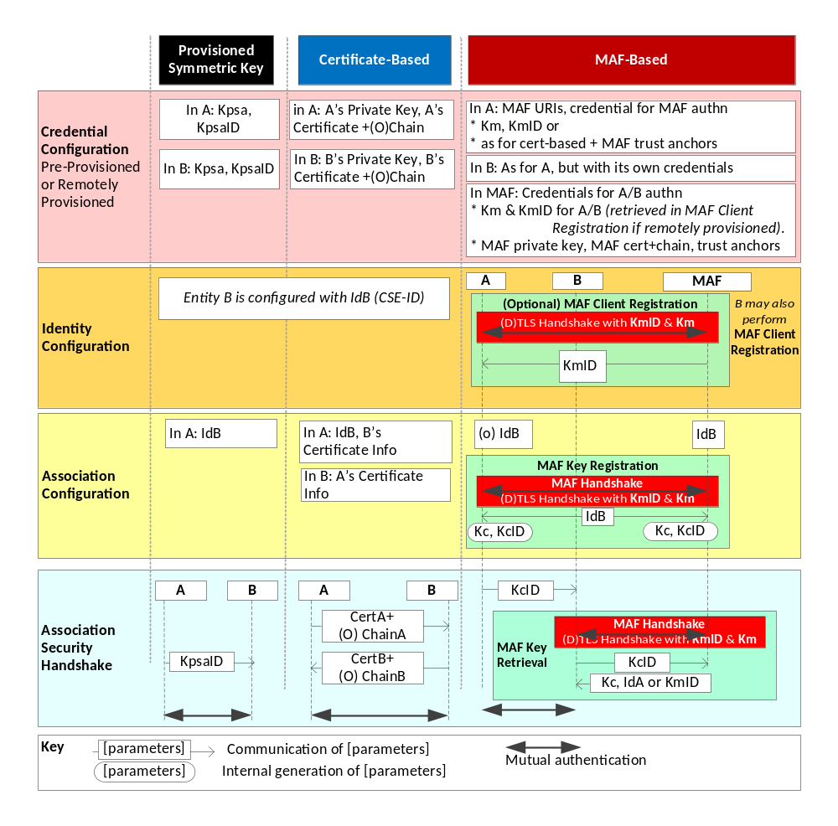
Figure 8.2.1-1: Overview of the Security Association Establishment Frameworks
supported by oneM2M
If entity A is request reachable, i.e. capable to receive request primitives from entity B on a separate point of access (see clauses 9.3.2 and 9.6.5 of oneM2M TS-0001 [Error: Reference source not found]), then a second security association needs to be established between entity A and entity B to serve secure communications in the reverse direction.
In order to allow differentiation between the two security associations between a pair of entities, we denote these as SA1 and SA2 in the following. SA1 refers to the security association established when entity A acts as the registree which sends requests to its registrar CSE. SA2 refers to the security association established when the registrar entity B sends requests to its request reachable registree entity A.
Figure 8.2.1-2 depicts the sequence of steps when establishing SA1 and SA2. Since the request reachable entity A can receive requests only after it has registered to entity B, security association SA1 has to be established always prior to first-time establishment of SA2. Establishment of security association SA1 is performed as outlined in Figure 8.2.1-1, using one of the applicable Security Association Establishment Frameworks, i.e. provisioned symmetric key (PSK) based, certificate based or MAF based SAEF. The four phases described above and illustrated in figure 8.2.1-2 are executed: credential configuration, identity configuration, association configuration and association security handshake. The details of these procedures are specified in clause 8.2.2.
When security association SA2 is established subsequently, the procedure can take advantage of already available credential configuration, identity configuration and association configuration and does not need to execute these steps again. SA2 establishment reduces to the association security handshake step, i.e. to performing a (D)TLS handshake using the credentials established with security association SA1. When MAF-based SAEF is applied, there is no need to execute the MAF Key retrieval procedure unless the credentials are expired. The symmetric key credentials Kc and KcID established with SA1 can be used directly to perform the (D)TLS PSK handshake.
Note that for establishment of security association SA2 the roles of entities A and B are reversed compared to SA1 establishment. In SA2, entity B acts as (D)TLS client and entity A acts as (D)TLS server. There is otherwise no difference.
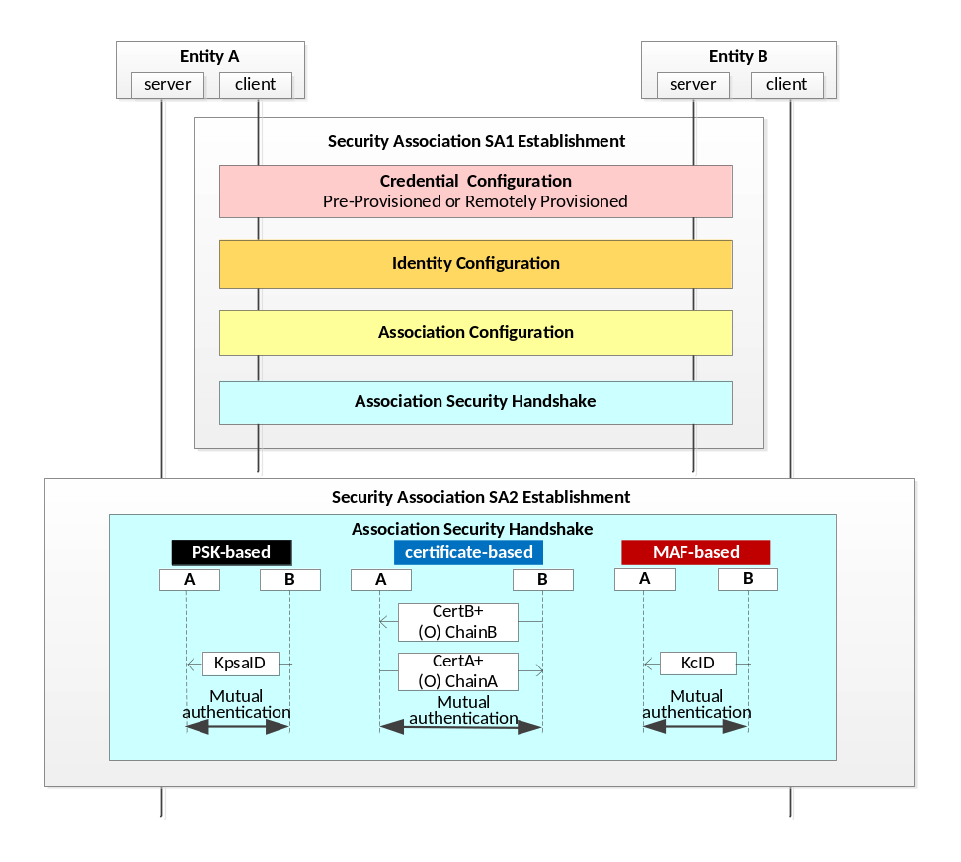
Figure 8.2.1-2: Security Associations for request reachable entities

-----------------------End of change 4---------------------------------------------

-----------------------Start of change 5-------------------------------------------

8.2.2.2 Certificate-Based Security Association Establishment Frameworks
This clause describes the Certificate-Based Security Association Establishment Framework.
Figure 8.2.2.2-1 illustrates the sequence of events when using the Certificate-Based Security Association Establishment Framework. In this description, "Entity A" and "Entity B" correspond to either two CSEs or a CSE and an AE.
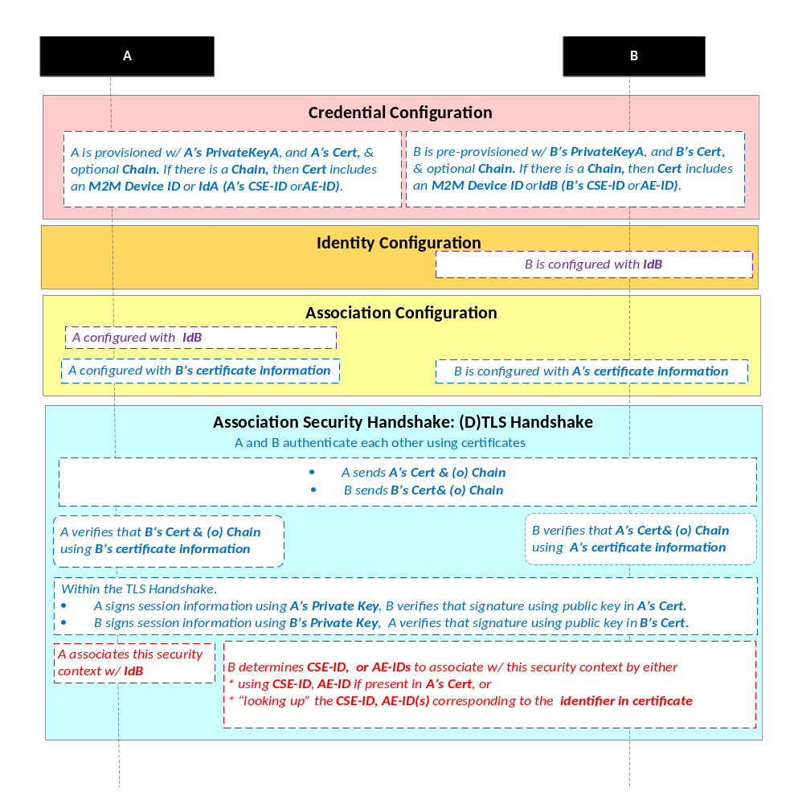
NOTE: The following font colours differentiate the general topic that the text relates to:
Blue italic text highlights details specific to this particular Security Association Establishment Framework.
Purple italic text highlights technical actions that may include steps not specified by oneM2M.
Red italic text highlights security-related properties.

Figure 8.2.2.2-1: The sequence of events when using the Certificate-Based Security
Association Establishment Framework
Credential Configuration: The private keys and certificates for each entity shall be pre-provisioned as described in clause 8.1.2.3 "Credential Configuration for Certificate-Based Security Frameworks". If Entity A is a CSE, then Entity A shall also be configured with its CSE-ID (not shown in the figure 8.2.2.2-1).
Identity Configuration: See clause 8.2.1.
Association Configuration: Entity A and Entity B shall be configured with the information needed for the authentication and identification (during Association Security Handshake) of Entity B and Entity A respectively:
- The information configured to Entity A shall include the following arguments:
- Entity B's certificate information: as described in clause 8.1.2.4 "Information Needed for Certificate Authentication of another Entity".
- Entity B's identity (IdB). Entity A shall use this identity for Entity B authenticating using the above arguments. This is used to route the (D)TLS exchange.
NOTE: The Entity A will associate Entity B's identity with messages secured within Security Contexts established in accordance with the configured Entity B's certificate information.
- The information configured to Entity B shall include the following argument:
- Entity A's certificate information: as described in clause 8.1.2.4 "Information Needed for Certificate Authentication of another Entity".
Association Security Handshake:
- Each entity shall verify the other entity's certificate as described in clause 8.1.2.2 "Certificate Verification".
- The entities shall authenticate each other using the validated certificates as specified in TLS 1.2 IETF RFC 5246 [Error: Reference source not found] and DTLS 1.2 IETF RFC 6347 [Error: Reference source not found] specifications.
- The (D)TLS cipher suite profile for the Certificate-Based Security Association Establishment Framework shall conform to clause 10.2.3.
- Following successful authentication of Entity B, Entity A shall associate the security context with IdB (Entity B's entity identifier) configured to Entity A during Association Configuration.
- Following successful authentication of Entity A, Entity B shall associate the security context with a CSE-ID, AE-ID or list of allowed AE-IDs:
- If Entity A establishes a security context by presenting a CSE-ID certificate, then Entity B shall associate the security context with the CSE-ID in the certificate.
- If Entity A establishes a security context by presenting an AE-ID certificate, then Entity B shall associate the security context with the Absolute AE-ID in the certificate.
- If Entity A establishes a security context by presenting a Node-ID certificate, then Entity B shall associate the security context with the Credential-ID formed from the globally unique Node identifier in the certificate.
- If Entity A establishes a security context by presenting a device certificate, then Entity B shall associate the security context with the Credential-ID formed from the globally unique hardware instance identifier in the certificate as described in clause 10.4 "Credential Details". Entity B shall then use Credential-ID to determine the CSE-ID, AE-ID or list of allowed AE-IDs as described in clause 8.2.1 "Overview on Security Association Establishment Frameworks".
- If Entity A establishes a security context by presenting a raw public key certificate, then Entity B shall associate the security context with the Credential-ID formed from the corresponding public key identifier described in clause 10.1.2 "Public Key Identifiers". Entity B shall then use Credential-ID to determine the CSE-ID or AE-ID as described in clause 8.2.1 "Overview on Security Association Establishment Frameworks".

-----------------------End of change 5---------------------------------------------

-----------------------Start of change 6-------------------------------------------

8.3.1.2 High Level Flow
A security principal in a Node or AE or CSE that requires remote provisioning is called an Enrolee or Source MEF Client. When a key is being provisioned, then the Nodes or AEs or CSEs or M2M Authentication Function with whom the Enrolee is to establish the symmetric key is called an Enrolment Target or Target MEF Client.
The oneM2M system supports the following authentication methods for Remote Security Provisioning Frameworks:
- Pre-Provisioned Symmetric Enrolee Key Remote Security Provisioning Framework: A symmetric key is pre-provisioned to the Enrolee and M2M Enrolment Function for the mutual authentication of those entities. For more details, see clause 8.3.2.1.
NOTE 1: The present document supports only pre-provisioned symmetric keys. Future versions intend to add support for authentication using symmetric keys provisioned by other MEF using an RSPF, or other mechanisms.
- Certificate-Based Remote Security Provisioning Framework: The Enrolee and M2M Enrolment Function are each issued with:
- a Private Signing Key that is known only to that entity;
- a Certificate containing the corresponding Public Verification Key; and
- (In the case of a device certificate, Node-ID certificate, CSE-ID certificate or AE-ID certificate) a Certificate Chain from the entity's Certificate to a Trust Anchor Certificate.
The Certificate may be pre-provisioned or provisioned within an RSPF using the Certificate Provisioning procedures specified in clause 8.3.6. If an MEF provisions an MEF Client then the MEF Client shall authenticate itself to the MEF using the latest provisioned certificate from the MEF.
The Enrolee and M2M Enrolment Function shall validate each other's Certificate before trusting the Public Verification Keys in the Certificate. Within the Security Handshake, the M2M Enrolment Function creates a digital signature of the session parameters using its private signing key and the Enrolee verifies the digital signature using the M2M Enrolment Function's public verification key. Then the roles are reversed: the Enrolee creates a digital signature and the M2M Enrolment Function verifies it.
For more details see clause 8.3.2.2.
- GBA-based Remote Security Provisioning Framework. In this case, the role of the M2M Enrolment Function is performed by a GBA Bootstrap Server Function. This framework uses 3GPP or 3GPP2 symmetric keys to authenticate the Enrolee and the M2M Enrolment Function (which is also a GBA BSF). The details are specified by 3GPP TS 33.220 [Error: Reference source not found] and 3GPP2 S.S0109-A [Error: Reference source not found]. For more details see clause 8.3.2.3.
The Remote Security Provisioning Frameworks are comprised of the following phases:
- MEF Client Credential Configuration: The MEF Client and M2M Enrolment Function are provisioned with the Bootstrap Credential that the entity will use to authenticate itself to the other entity. This phase is also denoted as Bootstrap Credential Configuration.
- Frequency: If the credential is a symmetric key, then this occurs once per association between the MEF Client and MEF. If the credential is a certificate, then this occurs once per MEF Client.
- MEF Client Service Configuration:
- The MEF Client is configured with the M2M Enrolment Function URI (for the purpose of routing the (D)TLS messages to the M2M Enrolment Function).
Additionally, in the case of Certificate-Based Remote Security Provisioning Framework:
- The MEF Client is configured with the M2M Enrolment Function Trust Anchor CA Certificates that the MEF Client will use to verify the M2M Enrolment Function.
- The M2M Enrolment Function is configured with the MEF Client's certificate information that the M2M Enrolment Function will use to verify the MEF Client's certificate. The necessary certificate information is dependent on the MEF Client's certificate's flavour, with details provided in clause 8.1.2.4 "Information Needed for Certificate Authentication of another Entity".
- Frequency: This occurs once per association between the MEF Client and MEF.
NOTE 2: In the case of the PPSK RSPF and GBA-Based RSPF, the MEF Client Credential Configuration and MEF Client Assignment would typically occur simultaneously. In the case of the Certificate-based RSPF, the MEF Client Assignment can be separate from MEF Client Credential Configuration.
- Administrating Stakeholder coordination with MEF (details are not described in the present document). An Administrating Stakeholder authorizes the MEF to provide services to MEF clients, oversees authorizing the distribution of symmetric keys, and oversees management of security-related MOs on the MEF Client. This typically occurs prior to the MEF Handshake.
- Frequency: This occurs as requested by the Administrating Stakeholder.
- Provisioning Procedure Instructions: The MEF Client either implicitly determines that it is to perform specific provisioning procedures, or is provided with explicit instructions. This triggers the MEF Client to perform the MEF Handshake and initiate provisioning procedures in the Enrolment Exchange.
- Frequency: This occurs whenever the MEF Client is to initiate a set of provisioning procedures.
MEF Client Service Configuration, Administrating Stakeholder coordination with MEF, and Provisioning Procedure Instructions phases together are also denoted as Bootstrap Instruction Configuration.
- MEF Handshake: Identification, authentication and security context establishment between the MEF Client and M2M Enrolment Function.
- Frequency: MEF Handshake occurs whenever the MEF client is triggered by Provisioning Procedure Instructions.
This phase is also denoted as Bootstrap Enrolment Handshake.
- Enrolment Exchange:
- After a successful MEF Handshake in the GBA-Based RSPF, the MEF Client and MEF have established a symmetric key from which keys can be derived for use with other AEs, CSEs or MAF. There is no further interaction between the MEF Client and MEF until the established symmetric key expires, at which point a new handshake is performed.
- After a MEF Handshake in a PPSK-based and Certificate-based RSPFs, the MEF Client and MEF have established a secure channel which is used to protect the Enrolment Exchange used to provision credentials. The Enrolment Exchange is described in more detail in clause 8.3.4. The Enrolment Exchange can include following types of procedures: MEF Client Registration, Symmetric Key Provisioning, Certificate Provisioning, and Device Configuration. The sequence of Enrolment Exchange procedures can be controlled by the MEF Client Command procedure which is outlined in clause 8.3.4 and specified in detail in clause 8.3.9.
- Frequency: This occurs whenever triggered by Provisioning Procedure Instructions.
- Usage of Provisioned Credentials The provisioned credentials can then be used in the following types of security frameworks:
- Certificate-Based SAEF, ESPrim and ESData: Certificates and configured trust anchors, are used directly in certificate-based security frameworks with the other Nodes, AEs or CSEs. Trust Anchors can also be configured separately, for example, using oneM2M TS-0022 [Error: Reference source not found].
- PSK-Based SAEF, ESPrim and ESData: The Source MEF Client and MEF have established a usage-constrained symmetric key, corresponding key identifier and a list of authorized Target MEF Client(s). The Source MEF Client provides the key identifier to Target MEF Client(s) in the security protocol. The Target MEF Client(s) establishes a secure connection to the MEF, and performs the MEF Key Retrieval Procedure (clause 8.3.5.2.8) to retrieve the symmetric key subject to authorization at the MEF.
- MAF-Based SAEF, ESPrim and ESData: If certificates are to be used for authentication to the MAF, then the certificate and trust anchors provisioned during Certificate Enrolment are used for mutual authentication of the MEF Client and MAF. If a symmetric key is used for mutual authentication, then the MEF Client and MEF have established a symmetric key and corresponding key identifier, with constraint for use with a specific MAF. The MEF Client (now acting as a MAF Client) performs the MAF Client Registration procedure, during which the MEF Client/MAF Client provides the key identifier to the MAF. The MAF establishes a secure connection to the MEF, and performs the MEF Key Retrieval Procedure (clause 8.3.5.2.8) to retrieve the symmetric key subject to authorization at the MAF. The MAF provides a KmID for the MEF Client/MAF Client to use in subsequent MAF Handshake procedures.
NOTE 3: If the Enrolment Target hosts a <ServiceSubscribedAppRule> resource, then the fetched credentials from the M2M Enrolment Function or the M2M Authentication Function needs to be stored after the Enrolment Target establishes a secured connection with the Enrolee. A Credential ID value in the format as mentioned in clause 10.4 is generated using the credential used for the secured connection establishment and is added into the applicableCredIDs attribute of the <ServiceSubscribedAppRule> resource.
NOTE 4: If the Enrolee-ID of the Enrolee is retrieved from the M2M Enrolment Function or the M2M Authentication Function, then the same is saved in the allowedAEs attribute of the <ServiceSubscribedAppRule> resource.
Figure 8.3.1.2-1 illustrates the phases of the Remote Security Provisioning Frameworks.
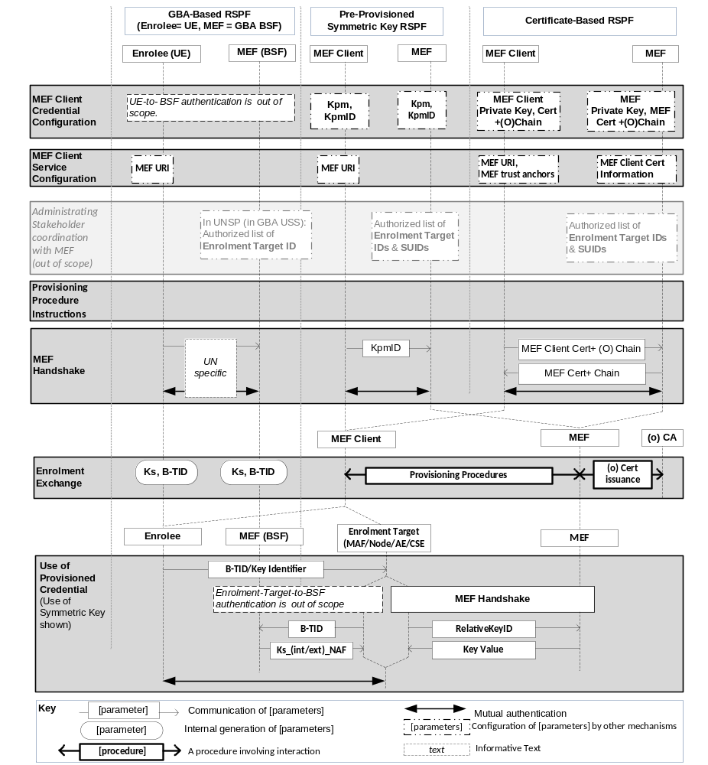
Figure 8.3.1.2-1: Overview of the Remote Security Provisioning Frameworks supported by oneM2M

-----------------------End of change 6---------------------------------------------

-----------------------Start of change 7-------------------------------------------

8.3.7.1 MEF Client Credential Configuration Details
The MEF Client and MEF shall be configured with credentials for mutual authentication of the MEF Client and MEF.
The credentials for mutual authentication shall be either pre-provisioned or remotely provisioned by another MEF using Remote Security Provisioning Frameworks, or by Device Configuration as specified in oneM2M TS-0022 [Error: Reference source not found]. Either symmetric key credentials or certificate credentials maybe provisioned. Symmetric key credentials may be used for authenticating some MEF Clients and certificate credentials may be used for authenticating other MEF Clients. The selection may be based on the capabilities of the MEF Client.
The details depend on the type of credential (symmetric key or certificates) and, in the case of symmetric keys, the type of provisioning (pre-provisioning or remote provisioning).
- Details specific to Pre-Provisioned Symmetric Keys (PPSKs): the Pre-Provisioned Symmetric Enrolee Key (Kpm) and corresponding key Identifier (KpmID) shall be provisioned to the MEF Client (assuming the role of Enrolee) and the MEF.
- Details specific to Remotely-Provisioned Symmetric Keys (RPSKs): The MEF Client and an M2M Enrolment Function (MEF) shall be provisioned with credentials for performing a Remote Security Provisioning (RSPF) Framework. The MEF Client shall be authorized to use the services of the MEF. For more details, see clause 8.3.2.
NOTE 1: In this case, the Pre-Provisioned Symmetric Enrolee Key (Kpm) and key Identifier (KpmID) are established during the MEF Client Registration procedure.
- Details specific to Certificates (whether pre-provisioned or remotely provisioned): The MEF Client shall be provisioned with an MEF Client certificate with optional certificate chain. The MEF Client certificate shall be a device certificate, Node-ID certificate, AE-ID certificate or CSE-ID certificate.
NOTE 2: The configuration of MEF trust anchor CA certificates is addressed in MEF Client Registration Configuration, and can occur separately from MEF Client Credential Configuration.
The oneM2M Device Configuration specification oneM2M TS-0022 [Error: Reference source not found] provides a set of <mgmtObj> specializations that shall be used for MEF Client Credential Configuration when the MEF Client supports device management (either remotely or via manual input). The present document does not specify how the MEF Client Credential Configuration is represented when the MEF Client does not support device management.

-----------------------End of change 7---------------------------------------------

-----------------------Start of change 8-------------------------------------------
8.5.2.2.4.1 Associating Public Key Certificate with Target End-Points
For this Protection Option, each Target End-Point shall be provisioned with a public key certificate which the Source End-Point trusts to be associated with the intended Target End-Point. The following options are supported:
- The Target End-Point Certificates may use the following Public Key Certificate flavours identified in clause 8.1.2.1 "Public Key Certificate Frameworks":
- In the case of a Raw Public Key Certificate, the Source End-Point shall be securely configured (either directly or remotely) to associate the Target End-Point with the raw public key or its hash. The details of this configuration are not provided in the present document.
- In the case of a Device Certificate:
- The Source End-Point shall be securely configured with the trust anchor in the certificate chain of the Device Certificate; typically during initial provisioning.
- The Source End-Point shall be securely configured to associate the Target End-Point with the globally unique hardware instance identifier. The details of this configuration are not provided in the present document.
- In the case of an AE-ID certificate or CSE-ID certificate, the Source-End-Point shall be securely configured with the trust anchor in the certificate chain of the AE-ID certificate or CSE-ID certificate; typically during initial provisioning. The Source End-Point then trusts that the Target End-Point with a particular AE-ID or CSE-ID is associated with the certificate that contains that AE-ID or CSE-ID.
- In the case of a Node-ID certificate, the Source-End-Point shall be securely configured with the trust anchor in the certificate chain of the Node-ID certificate; typically during initial provisioning. The Source End-Point then trusts that the Target End-Point with a particular Node-ID is associated with the certificate that contains that Node-ID.
- The Target End-Point Certificates may use other Public Key Infrastructures, particularly when the Target End-Point is in a non-oneM2M system interworking with the oneM2M system. The present document provides no interoperability guarantees when such certificates are used.
Public keys for verifying signature cannot be used for this Protection Option.

-----------------------End of change 8---------------------------------------------

-----------------------Start of change 9-------------------------------------------
8.5.2.3.2.1 Associating Public Key Certificate with Source End-Point:
For this Protection Option, each Source End-Point shall be provisioned with a public key certificate which the Target End-Point trusts to be associated with the intended Source End-Point. The following options are supported:
- The Source End-Point Certificates may use the following Public Key Certificate flavours identified in clause 8.1.2.1 "Public Key Certificate Frameworks":
- In the case of a Raw Public Key Certificate, the Target End-Point shall be securely configured (either directly or remotely) to associate the Source End-Point with the raw public key or its hash. The details of this configuration are not provided in the present document.
- In the case of a Device Certificate:
- The Target End-Point shall be securely configured with the trust anchor in the certificate chain of the Device Certificate; typically during initial provisioning.
- The Target End-Point shall be securely configured to associate the Source End-Point with the globally unique hardware instance identifier. The details of this configuration are not provided in the present document.
- In the case of an AE-ID certificate or CSE-ID certificate, the Target-End-Point shall be securely configured with the trust anchor in the certificate chain of the AE-ID certificate or CSE-ID certificate; typically during initial provisioning. The Target End-Point then trusts that the Source End-Point with a particular AE-ID or CSE-ID is associated with the certificate that contains that AE-ID or CSE-ID.
- In the case of a Node-ID certificate, the Target-End-Point shall be securely configured with the trust anchor in the certificate chain of the Node-ID certificate; typically during initial provisioning. The Target End-Point then trusts that the Source End-Point with a particular Node-ID is associated with the certificate that contains that Node-ID.
- The Source End-Point Certificates may use other Public Key Infrastructures, particularly when the Source End-Point is in a non-oneM2M system interworking with the oneM2M system. The present document provides no interoperability guarantees when such certificates are used.
Public keys for verifying signatures shall be used for this Protection Option.

-----------------------End of change 9---------------------------------------------

-----------------------Start of change 10-------------------------------------------

8.8.3.1 MAF Client Credential Configuration Details
The MAF Client and MAF shall be configured with credentials for mutual authentication of the MAF Client and MAF.
The credentials for mutual authentication shall be either pre-provisioned or remotely provisioned thanks to Remote Security Provisioning Frameworks. Either symmetric key credentials or certificate credentials maybe provisioned. Symmetric key credentials may be used for authenticating some MAF Clients and certificate credentials may be used for authenticating other MAF Clients. The selection may be based on the capabilities of the MAF Client.
The details depend on the type of credential (symmetric key or certificates) and, in the case of symmetric keys, the type of provisioning (pre-provisioning or remote provisioning).
- Details specific to Pre-Provisioned Symmetric Keys (PPSKs): the Master Credential (Km) and corresponding Master Credential Identifier (KmID) shall be provisioned to the MAF Client (assuming the role of Enrolee) and the MAF. The format of KmID is defined in clause 10.6 "KmID Format".
- Details specific to Remotely-Provisioned Symmetric Keys (RPSKs): The MAF Client and an M2M Enrolment Function (MEF) shall be provisioned with credentials for performing a Remote Security Provisioning (RSPF) Framework. The MAF Client shall be authorized to use the services of the MEF. For more details, see clause 8.3.
NOTE 1: In this case, the Master Credential (Km) and Master Credential Identifier (KmID) are established during the MAF Client Registration procedure.
- Details specific to Certificates (whether pre-provisioned or remotely provisioned): The MAF Client shall be provisioned with an MAF Client certificate with optional certificate chain. The MAF Client certificate shall be a device certificate, Node-ID certificate, AE-ID certificate or CSE-ID certificate.
NOTE 2: The configuration of MAF trust anchor CA certificates is addressed in MAF Client Registration Configuration, and can occur separately from MAF Client Credential Configuration.
The oneM2M Device Configuration specification oneM2M TS-0022 [Error: Reference source not found] provides a set of <mgmtObj> specializations that shall be used for MAF Client Credential Configuration when the MAF Client supports device management (either remotely or via manual input). The present document does not specify how the MAF Client Credential Configuration is represented when the MAF Client does not support device management.

-----------------------End of change 10---------------------------------------------

-----------------------Start of change 11-------------------------------------------

9.1.1.1 Credential Configuration of Entity A and Entity B
Table 9.1.1.1-1 lists the parameters that may be configured to Entity A during the Credential Configuration phase and which are common to all Security Association Establishment Frameworks.
Table 9.1.1.1-1: Parameters that may be configured to Entity A during the Credential Configuration phase and which are common to all Security Association Establishment Frameworks
Parameter common to all Security Association Establishment Frameworks
(If Entity A is a CSE) Entity A's CSE-ID

Table 9.1.1.1-2 lists the parameters configured to a Field-Domain Security Association End-Points in the Credential Configuration phase and which are specific to the Security Association Establishment Framework.
Table 9.1.1.1-2: Parameters configured to a Field Domain Security Association end-point
during the Credential Configuration phase and which are specific to
a Security Association Establishment Framework
Security Association Establishment Framework |  | Parameter
Provisioned Symmetric Key |  | Kpsa
 |  | KpsaID
Certificate Based | Entity authenticates itself using a Raw Public Key Certificate | Entity's Private Key
Certificate Based |  | Entity's Raw Public Key Certificate
Certificate Based | Entity authenticates itself using a Device Certificate | Entity's Private Key
Certificate Based | Entity authenticates itself using a Device Certificate | Entity's Certificate and Chain
Certificate Based | Entity authenticates itself using a CSE-ID Certificate | Entity's CSE-ID
Certificate Based | Entity authenticates itself using a CSE-ID Certificate | Entity's Private Key
Certificate Based | Entity authenticates itself using a CSE-ID Certificate | Entity's Certificate and Chain
Certificate Based | Entity authenticates itself using an AE-ID Certificate | Entity's AE-ID
Certificate Based | Entity authenticates itself using an AE-ID Certificate | Entity's Private Key
Certificate Based | Entity authenticates itself using an AE-ID Certificate | Entity's Certificate and Chain
Certificate Based | Entity authenticates itself using a Node-ID Certificate | Entity's Node-ID
Certificate Based | Entity authenticates itself using a Node-ID Certificate | Entity's Private Key
Certificate Based | Entity authenticates itself using a Node-ID Certificate | Entity's Certificate and Chain
MAF-Based | Entity A | MAF Identifier (MAF-ID)
MAF-Based | Entity A | Master Credential (KmID)
MAF-Based | Entity A | Master Credential Identifier (KmID)
MAF-Based | Entity B | Entity B and MAF shall be able to establish mutually-authenticated secure communication. The details are not specified in the present document.
The Credential Configuration of Entity A and Entity B for the Provisioned Symmetric Key Security Association Establishment Framework, or the MAF-Based Security Association Establishment Framework is achieved through either:
- Pre-provisioning via mechanisms which are not specified in the present document.
- Remote provisioning via one of the Remote Security Provisioning Frameworks in clause 8.3.
The Credential Configuration of Entity A and Entity B for the Certificate Security Association Establishment Frameworks is performed by pre-provisioning via mechanisms which are not specified in the present document.

-----------------------End of change 11---------------------------------------------

-----------------------Start of change 12-------------------------------------------

9.1.2 Association Configuration Procedures and Parameters

9.1.2.0 Introduction
The following Association Configuration procedures are described in this clause:
- Association Configuration of Entity A, see clause 9.1.2.1.1.
- Association Configuration of Entity B, see clause 9.1.2.1.2.
- Association Configuration of M2M Authentication Functions, see clause 9.1.2.2.

9.1.2.1 Association Configuration of Entity A and Entity B

9.1.2.1.1 Association Configuration of Entity A
Table 9.1.2.1.1-1 lists the parameters configured to Entity A in the Association Configuration phase and which are common to all Security Association Establishment Frameworks.
Table 9.1.2.1.1-1: Parameters configured to Entity A during the Association Configuration phase and which are common to all Security Association Establishment Frameworks
Parameter common to all Security Association Establishment Frameworks
Entity B's CSE-ID
Table 9.1.2.1.1-2 lists the parameters configured to Entity A in the Association Configuration phase which are specific to the Security Association Establishment Framework.
Table 9.1.2.1.1-2: Parameters configured to Entity A
during the Association Configuration phase which are specific to
a Security Association Establishment Framework
Security Association Establishment Framework |  | Parameters specific to the Security Association Establishment Frameworks
Provisioned Symmetric Key |  | None
Certificate Based | Entity B is authenticated using Raw Public Key Certificate | Entity B's Public key identifier
Certificate Based | Entity B is authenticated using Device Certificate | Entity B's globally unique hardware instance identifier
Certificate Based | Entity B is authenticated using Device Certificate | Entity B's trust anchor information
Certificate Based | Entity B is authenticated using CSE-ID Certificate | Entity B's trust anchor information
Certificate Based | Entity B is authenticated using AE-ID Certificate | Entity B's trust anchor information
Certificate Based | Entity B is authenticated using Node-ID Certificate | Entity B's trust anchor information
MAF-Based |  | None

Mechanisms for Association Configuration of Entity A shall authenticate the configuration source and provide integrity protection for the configured information communicated from the configuration source to the entity.

9.1.2.1.2 Association Configuration of Entity B
Table 9.1.2.1.2-1 lists the parameters configured to the Registrar (Entity B) in the Association Configuration phase.
Table 9.1.2.1.2-1: Parameters configured to Entity B during the Association Configuration phase
Security Association Establishment Framework |  | Parameters specific to the Security Association Establishment Frameworks
Provisioned Symmetric Key |  | None
Certificate Based | Entity A is authenticated using Raw Public Key Certificate | None
Certificate Based | Entity A is authenticated using Device Certificate, CSE-ID Certificate, Node-ID Certificate or AE-ID Certificate | Entity A's trust anchor information
MAF-Based |  | None

Mechanisms for Association Configuration of Entity B shall authenticate the configuration source and provide integrity protection for the configured information communicated from the configuration source to the entity.

9.1.2.2 Association Configuration of M2M Authentication Functions
Table 9.1.2.2-1 lists the parameters configured to M2M Authentication Functions in the Association Configuration phase.
Table 9.1.2.2-1: Parameters configured to a M2M Authentication Functions
during the Association Configuration phase
Security Association Establishment Framework |  | Parameter
MAF-Based | A-to-MAF Authentication | Entity B's CSE-ID or AE-ID (IdB)

The present document assumes that Association Configuration of the M2M Authentication Functions will utilize business logic of the Stakeholder that operates the M2M Authentication Function, and the details are not described in the present document.

-----------------------End of change 12---------------------------------------------

-----------------------Start of change 13-------------------------------------------

9.2.1.1 Bootstrap Credential Configuration of Enrolee
Table 9.2.1.1-1 lists the parameters configured to Enrolees in the Bootstrap Credential Configuration phase for authentication with the M2M Enrolment Function in the Pre-Provisioned Symmetric Enrolee Key Remote Security Provisioning Framework and Certificate-Based Remote Security Provisioning Framework.
Table 9.2.1.1-1: Parameters configured to Enrolees
during the Bootstrap Credential Configuration phase
Remote Security Provisioning Framework |  | Parameter
Pre-Provisioned M2M Secure Connection Key authentication. Not applicable to MAF. |  | Kpm
 |  | KpmID
 |  | MEF URI
Certificate-Based authentication | Enrolee authenticates itself using a raw public key | Enrolee's Private Key
Certificate-Based authentication | Enrolee authenticates itself using a raw public key | Enrolee's Raw Public Key Certificate
Certificate-Based authentication | Enrolee authenticates itself using a device certificate | Enrolee's Private Key
Certificate-Based authentication | Enrolee authenticates itself using a device certificate | Enrolee's Certificate and Chain
Certificate-Based authentication | Enrolee authenticates itself using a CSE-ID, Node-ID or AE-ID certificate | Enrolee's Private Key
Certificate-Based authentication |  | Enrolee's Certificate and Chain

The Bootstrap Credential Configuration of an Enrolee for the Pre-Provisioned Symmetric Enrolee Key Remote Security Provisioning Framework and Certificate-Based Remote Security Provisioning Framework shall authenticate the configuration source and shall provide confidentiality and integrity protection of the configured information communicated from the configuration source to the secured environment of the Enrolee. The present document does not specify any such mechanisms.
The Bootstrap Credential Configuration of an Infrastructure Domain Enrolment Target (including an M2M Authentication Functions) expected to use business logic of the Stakeholder operating the Infrastructure Domain Enrolment, and the details are not described in the present document.

-----------------------End of change 13---------------------------------------------

-----------------------Start of change 14-------------------------------------------

9.2.2.3 Bootstrap Instruction Configuration of M2M Enrolment Functions
Table 9.2.2.3-1 lists the parameters configured to an M2M Enrolment Function during the Bootstrap Instruction Configuration phase which are common to the Pre-Provisioned Symmetric Enrolee Key Remote Security Provisioning Framework and Certificate-Based Remote Security Provisioning Framework.
Table 9.2.2.3-1: Parameters configured to M2M Enrolment Functions
during the Bootstrap Instruction Configuration phase which are common to
the Pre-Provisioned Symmetric Enrolee Key Remote Security Provisioning Framework
and Certificate-Based Remote Security Provisioning Framework
Parameter common to all Remote Security Provisioning Frameworks
Enrolment Target Identity
(Enrolee B's CSE-ID or AE-ID, or MAF-ID)

Table 9.2.2.3-2 lists the Remote Security Provisioning Framework-specific parameters configured to an M2M Enrolment Functions in the Bootstrap Instruction Configuration phase of the Pre-Provisioned Symmetric Enrolee Key Remote Security Provisioning Framework and Certificate-Based Remote Security Provisioning Framework.
Table 9.2.2.3-2: Remote Security Provisioning Framework-specific parameters configured
to an M2M Enrolment Function during the Instruction Configuration phase
of the Pre-Provisioned Symmetric Enrolee Key Remote Security Provisioning Framework
and Certificate-Based Remote Security Provisioning Framework
Remote Security Provisioning Framework |  | Remote Security Provisioning Framework-specific Parameters
Pre-Provisioned Symmetric Enrolment Key |  | Enrolment Expiry
Certificate Based | Enrolee is authenticated using a raw public key certificate | Enrolee's Public key identifier
Certificate Based | Enrolee is authenticated using a device certificate | Enrolee's M2M Device ID
Certificate Based | Enrolee is authenticated using a device certificate | Enrolee's Trust Anchor Information
Certificate Based | Enrolee is authenticated using a CSE-ID, Node-ID or AE-ID certificate | Enrolee's Trust Anchor Information

The present document assumes that Bootstrap Instruction Configuration of the M2M Enrolment Functions utilizes business logic of the Stakeholder that operates the M2M Enrolment Function, and the details are not described in the present document.

-----------------------End of change 14-------------------------------------------

-----------------------Start of change 15-------------------------------------------

10.1.3 Support Requirements for each Public Key Certificate Flavour
Table 10.1.3-1 lists, for each of the various types of entity (Field Domain CSE, Field Domain AE, IN-CSE, IN-AE, M2M Authentication Function and M2M Enrolment Function), the flavour of certificate that may be issued to the entity and the flavour of other entity's certificates that the entity is required to be able to process. In this table "O" indicates optional, "M" indicates Mandatory, "CA" indicates that the option is required if the entity supports the certificate-based security association establishment framework, "CB" indicates conditional on the entity supporting certificate-based Remote Security Provisioning framework.
Table 10.1.3-1: Applicability of certificate flavours issued to an entity and flavours
of other entity's certificates that the entity is required to be able to process
Entity | Flavour of certificate may be issued to entity |  |  |  |  |  | Flavour of other entity's certificates that the entity is recommended to be able to process.
Entity | Raw | Device | CSE-ID | AE-ID | Node-ID | FQDN | Raw | Device | CSE-ID | AE-ID | Node-ID | FQDN
Field Domain CSE | O | O | O | - | O | - | CA | CA | CA | CA | CA | CB
Field Domain AE | O | O | - | O | O | - | CA | CA | CA | - | CA | CB
IN-CSE | O | - | O | - | - | - | CA | CA | CA | CA | CA | -
IN-AE | O | - | - | O | - | - | CA | - | CA | - | - | -
MAF | - | - | - | - | - | M | - | - | - | - | - | M
MEF | - | - | - | - | - | M | CB | CB | - | - | CB | M

Mutual authentication between remote management servers and remote management clients is not considered in the present document. Where supported, Remote Security Administration may be used to provision the certificates.

-----------------------End of change 15---------------------------------------------

-----------------------Start of change 16-------------------------------------------

12.3.2.1 sec:credIDTypeID
The sec:credIDTypeID enumeration type is used in sec:credentialID to identify the type of the identified credential. ;;
Table 12.3.2.1-1: Interpretation of the sec:credIDTypeID enumeration type
Value | Interpretation | Note
10 | Symmetric key used to authenticate to a MEF (KpmID) | See clause 8.3.2.1
11 | Symmetric key used to authenticate to a MAF (KmID) | See clause 8.8.3.1
12 | Symmetric key used to authenticate in an SAEF (KpsaID or KcID) | See clauses 8.2.2.1, 8.2.2.3
13 | Symmetric key used to authenticate in ESPrim (pairwiseESPrimKeyID) | See clauses 8.4.2
14 | Symmetric key used for direct encryption in the ESData Encryption-only or Nested-Sign-then-encrypt security classes (generic symmetric key identifier format) | See clause 8.5.2
15 | Symmetric key used for symmetric key wrap in the ESData Encryption-only or Nested-Sign-then-encrypt security classes (generic symmetric key identifier format) | See clause 8.5.2
16 | Symmetric key used for HMAC in the ESData Signature-only security class (generic symmetric key identifier format) | See clause 8.5.2
30 | Raw Public Key Certificate used in TLS: (Public Key Identifier) | 10.1.2
31 | Device Certificate used in TLS (globally unique hardware instance identifier) | 10.1.1.4
32 | CSE-ID Certificate used in TLS (CSE-ID) | oneM2M TS-0001 [Error: Reference source not found]
33 | AE-ID Certificate used in TLS (AE-ID) | oneM2M TS-0001 [Error: Reference source not found]
34 | Node-ID Certificate used in TLS (Node-ID) | 10.1.1.8
41 | Raw Public Key Certificate used for RSA or ECDH Key management in the ESData Encryption-only or Nested-Sign-then-encrypt security classes: (Public Key Identifier) | 10.1.2
42 | Device Certificate used for RSA or ECDH Key management in the ESData Encryption-only or Nested-Sign-then-encrypt security classes (globally unique hardware instance identifier) | 10.1.1.4
43 | CSE-ID Certificate used for RSA or ECDH Key management in the ESData Encryption-only or Nested-Sign-then-encrypt security classes (CSE-ID) | oneM2M TS-0001 [Error: Reference source not found]
44 | AE-ID Certificate used for RSA or ECDH Key management in the ESData Encryption-only or Nested-Sign-then-encrypt security classes (AE-ID) | oneM2M TS-0001 [Error: Reference source not found]
45 | Node-ID Certificate used for RSA or ECDH Key management in the ESData Encryption-only or Nested-Sign-then-encrypt security classes (Node-ID) | 10.1.1.8
51 | Raw Public Key Certificate used for RSA or ECDH Key management in the ESData Signature-only security class: (Public Key Identifier) | 10.1.2
52 | Device Certificate used for RSA or ECDSA signatures in the ESData Signature-only security class (globally unique hardware instance identifier) | 10.1.1.4
53 | CSE-ID Certificate used for RSA or ECDH Key management in the ESData Signature-only security class (CSE-ID) | oneM2M TS-0001 [Error: Reference source not found]
54 | AE-ID Certificate used for RSA or ECDH Key management in the ESData Signature-only security class (AE-ID) | oneM2M TS-0001 [Error: Reference source not found]
55 | Node-ID Certificate used for RSA or ECDH Key management in the ESData Signature-only security class (Node-ID) | 10.1.1.8
NOTE: The form of the identifier for the credential type is described in brackets.

-----------------------End of change 16---------------------------------------------

CHECK LIST
- Does this Change Request include an informative introduction containing the problem(s) being solved, and a summary list of proposals.?
- Does this CR contain changes related to only one particular issue/problem?
- Have any mirror CRs been posted?
- Does this Change Request make all the changes necessary to address the issue or problem? E.g. A change impacting 5 tables should not include a proposal to change only 3 tables?Does this Change Request follow the drafting rules?
- Are all pictures editable?
- Have you checked the spelling and grammar?
- Have you used change bars for all modifications?
- Does the change include the current and surrounding clauses to clearly show where a change is located and to provide technical context of the proposed change? (Additions of complete clauses need not show surrounding clauses as long as the proposed clause number clearly shows where the new clause is proposed to be located.)
- Are multiple changes in this CR clearly separated by horizontal lines with embedded text such as, start of change 1, end of change 1, start of new clause, end of new clause.?

