

oneM2M
Technical Report
Document Number | SDS-2020-0212-Interworking_SensorThingsAPI_update
Document Name: | oneM2M-SensorThings API interworking UPDATE
Date: | 2020-07-23
Abstract: | This document investigates in oneM2M-to-SensorThings API interworking UPDATE
'Template Version: January 2019 (do not modify)

The present document is provided for future development work within oneM2M only. The Partners accept no liability for any use of this report.
The present document has not been subject to any approval process by the oneM2M Partners Type 1. Published oneM2M specifications and reports for implementation should be obtained via the oneM2M Partners' Publications Offices.

About oneM2M
The purpose and goal of oneM2M is to develop technical specifications which address the need for a common M2M Service Layer that can be readily embedded within various hardware and software, and relied upon to connect the myriad of devices in the field with M2M application servers worldwide.
More information about oneM2M may be found at: http//www.oneM2M.org
Copyright Notification
© 2019, oneM2M Partners Type 1 (ARIB, ATIS, CCSA, ETSI, TIA, TSDSI, TTA, TTC).
All rights reserved.
The copyright and the foregoing restriction extend to reproduction in all media.

Notice of Disclaimer & Limitation of Liability
The information provided in this document is directed solely to professionals who have the appropriate degree of experience to understand and interpret its contents in accordance with generally accepted engineering or other professional standards and applicable regulations. No recommendation as to products or vendors is made or should be implied.
NO REPRESENTATION OR WARRANTY IS MADE THAT THE INFORMATION IS TECHNICALLY ACCURATE OR SUFFICIENT OR CONFORMS TO ANY STATUTE, GOVERNMENTAL RULE OR REGULATION, AND FURTHER, NO REPRESENTATION OR WARRANTY IS MADE OF MERCHANTABILITY OR FITNESS FOR ANY PARTICULAR PURPOSE OR AGAINST INFRINGEMENT OF INTELLECTUAL PROPERTY RIGHTS. NO oneM2M PARTNER TYPE 1 SHALL BE LIABLE, BEYOND THE AMOUNT OF ANY SUM RECEIVED IN PAYMENT BY THAT PARTNER FOR THIS DOCUMENT, WITH RESPECT TO ANY CLAIM, AND IN NO EVENT SHALL oneM2M BE LIABLE FOR LOST PROFITS OR OTHER INCIDENTAL OR CONSEQUENTIAL DAMAGES. oneM2M EXPRESSLY ADVISES ANY AND ALL USE OF OR RELIANCE UPON THIS INFORMATION PROVIDED IN THIS DOCUMENT IS AT THE RISK OF THE USER.

Contents
Contents 3
1 Scope 4
2 References 4
2.1 Normative references 4
2.2 Informative references 4
3 Definition of terms, symbols and abbreviations 5
3.1 Terms 5
3.2 Symbols 5
3.3 Abbreviations 5
4 Conventions, 5
5 Background 6
5.1 SensorThings API Architecture 6
5.2 SensorThings API example use-case 7
6 Architecture Model 8
6.1 Interworking via Mcc Interface 8
6.1.1 Composition of the Protocol Gateway 9
7 Architecture Aspects 9
7.1 Gateway startup 9
7.1.1 RemoteCSE registration 9
7.1.2 Subscription to MQTT Broker 10
7.1.3 Preconfiguration of the OGC / STA Server 10
7.2 Data Exchange 10
7.2.1 Data Mapping 10
Proforma copyright release text block 11
Annexes 11
Annex <y>: Bibliography 12
History 12

1 Scope
The present document defines an interworking of both standards oneM2M and OGC SensorThings API.
The document is structured as followed:
- Introduction and background to OGC-SensorThings API
- Describing interworking scenarios that are relvant but not exclusive for Smart City (there are also examples from other areas and verticals as well)
- Technical comparison of oneM2M and OGC / STA
- Describing a technical solution for interworking of both standards; there might be interworking on different level:
o opaque data routing
o data model mapping between oneM2M-SDT and OGC ISO 19156
- Developing test cases for interworking between oneM2M and OGC SensorThings API
The Scope shall not contain requirements.

2 References
The following text block applies.
References are either specific (identified by date of publication and/or edition number or version number) or non-specific. For specific references,only the cited version applies. For non-specific references, the latest version of the referenced document (including any amendments) applies.

2.1 Normative references
As a Technical Report (TR) is entirely informative it shall not list normative references.
The following referenced documents are necessary for the application of the present document.
Not applicable.

2.2 Informative references
Clause 2.2 shall only contain informative references which are cited in the document itself.
The following referenced documents are not necessary for the application of the present document but they assist the user with regard to a particular subject area.
[i.1] oneM2M Drafting Rules (http://member.onem2m.org/Static_pages/Others/Rules_Pages/oneM2M-Drafting-Rules-V1_0.doc)
[i.2] SensorThings API website, https://www.ogc.org/standards/sensorthings
[i.3] ISO 19156 website, https://www.iso.org/standard/32574.html

3 Definition of terms, symbols and abbreviations
Delete from the above heading the word(s) which is/are not applicable.

3.1 Terms
Clause numbering depends on applicability.
A definition shall not take the form of, or contain, a requirement.
The form of a definition shall be such that it can replace the term in context. Additional information shall be given only in the form of examples or notes (see below).
The terms and definitions shall be presented in alphabetical order.
For the purposes of the present document, the [following] terms and definitions [given in ... and the following] apply:
Definition format
<defined term>: <definition>
If a definition is taken from an external source, use the format below where [N] identifies the external document which must be listed in Section 2 References.
<defined term>[N]: <definition>
example 1: text used to clarify abstract rules by applying them literally
NOTE: This may contain additional information.

3.2 Symbols
Clause numbering depends on applicability.
For the purposes of the present document, the [following] symbols [given in ... and the following] apply:
Symbol format
<symbol> <Explanation>
<2nd symbol> <2nd Explanation>
<3rd symbol> <3rd Explanation>

3.3 Abbreviations
Abbreviations should be ordered alphabetically.
Clause numbering depends on applicability.
For the purposes of the present document, the [following] abbreviations [given in ... and the following] apply:
Abbreviation format
OGC Open Geospacial Consortium
STA SensorThing API

4 Conventions,
The key words “Shall”, ”Shall not”, “May”, ”Need not”, “Should”, ”Should not” in this document are to be interpreted as described in the oneM2M Drafting Rules [i.1]

5 Background
The following text explains what is SensorThings API and how does it work
SensorThings API (STA) is a standard of the Open Geospacial Consortium (OGC). It provides a framework for communication and exchanging data between sensors and applications. The standard is devided in two parts. SensorThings API Part 1 is dedicatd to sensing and was published in 2016. Part 2 deals with tasking and was published in 2019. There is a OGC certified Open-Source SensorThings API Server available (FROST Server). It supports the OGC SensorThings API Part 1: Sensing. It also includes preliminary actuation/tasking support.
For the description of entites SensorThings API uses ISO 19156:2011 data model and JSON as data format. The communication is REST-based and uses HTTP and also CoAP, MQTT, 6LowPAN.

5.1 SensorThings API Architecture
A typical STA-based architecture works in Client/Server mode. The sensor device pushes its data to the SensorThings Server via HTTP POST request. The SensorThings Server has also a MQTT broker. An interested application can subscribe to the MQTT-Broker in order to get notified about new sensor events.
The data in the SensorThings server are organized according to ISO 19156 (see Figure 1: ISO 19156 data model).
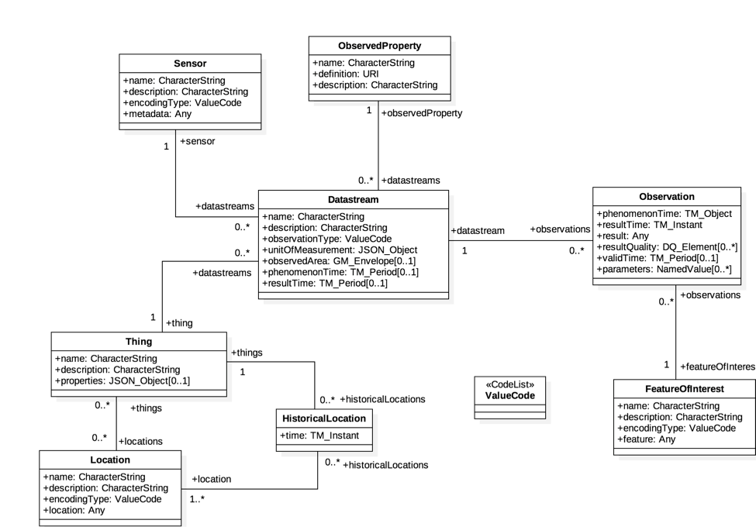
Figure 1: ISO 19156 data model
In the SensorThings data model an events or sensor data is an ‘observations’. Before a sensor is able to push an observation to the server it needs at least a ‘thing’- and a ‘data stream’ entity. This has to be created beforehand. One ‘thing’ might have different ‘sensors’, one ‘location’ or many ‘historical locations’.
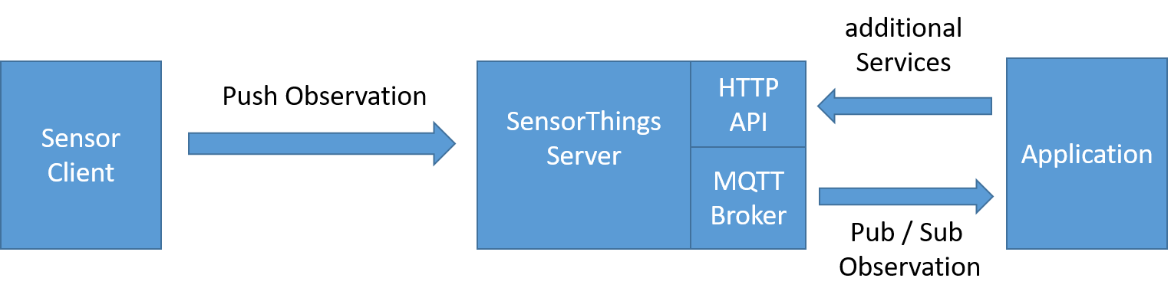
Figure 2: Exemplary STA message flow

5.2 SensorThings API example use-case
The message flow in Figure 2 can be explained by using an example of an application that wants to use data of ev-charging stations in a city.
- In order to get all relevant observations belonging to the cities ev-charging stations the application needs to know all regarded data streams. Therefore the application sends a request with filter parameter to the HTTP-API of the server e.g.:
https://sta-example-server-address.com/v1.0/Things?$filter=substringof(“Charging”,name)&$count=true&$expand=Datastreams
As a response the server provides a list of all data streams belonging to a charging staation.
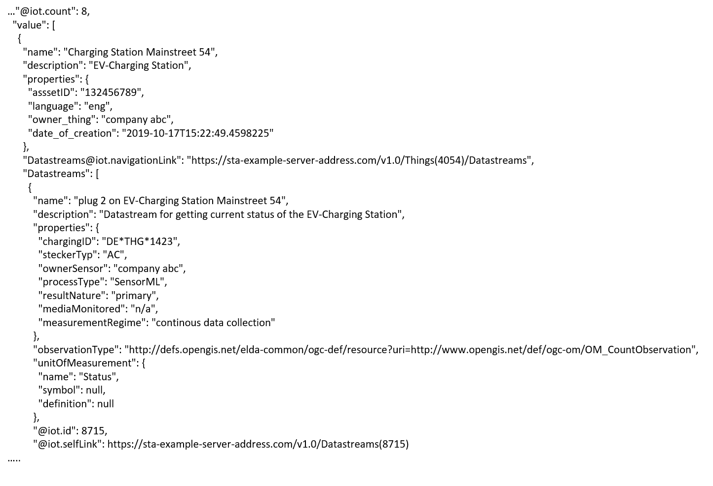
Figure 3: One exemplary entry of the result list of an filter request
- The application can now subscribe to the these data streams. Figure 3 shows one entry of the result list. It represents an EV-Charging Station as a thing including the regraded datastream in the last line of the entry.
- As soon as the sensor (ev-charging station) changes its status e.g. from “available” to “charging” it pushes an oberservation to the server.
- The application gets the observation through a notification that is send by the MQTT-Broker. An example of an observation is shown in figure 4. In the result field is shown the current status of the EV-Charging Station “charging”.
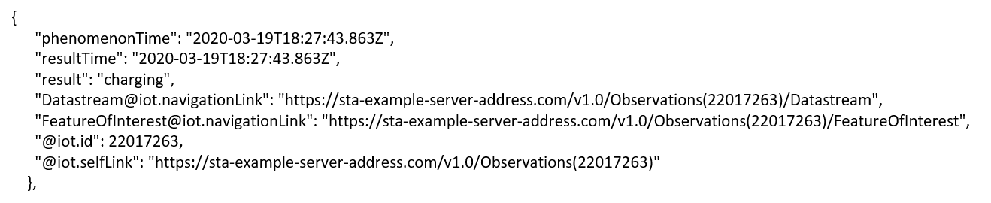
Figure 4: Exemplary STA observation

6 Architecture Model
The basic interworking enables applications that are connected to an oneM2M-based system to get data from sensors that are connected to a OGC / SensorThingsAPI server. Furthermore an application that is connected to an OGC / SensorThingsAPI server should be able to get data from sensors that are connected to a oneM2M-based system.

6.1 Interworking via Mcc Interface
In this option the interworking is defined as a protocol gateway between SensorThingsAPI and oneM2M. The protocol gatewy resides as a separate service between an OGC / SensorThingsAPI server and a oneM2M CSE. The CSE handles the Gateway as a Remote CSE and the Mcc interface is used for the communication between a CSE and the protocol gateway.
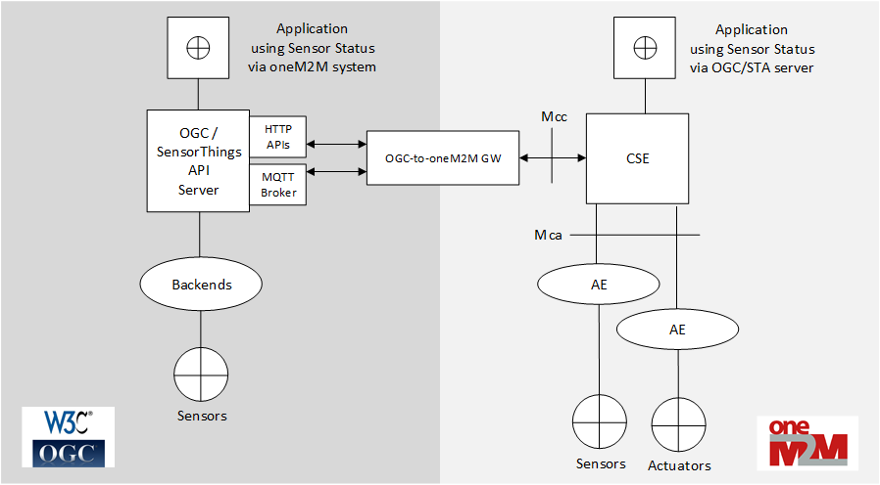
Figure 5: Architecture model - protocol gateway

6.1.1 Composition of the Protocol Gateway
The protocol gateway consists of three modules. Towards the oneM2M-side the gateway implements basic CSE Mcc interface functionalities. So any other CSE can receive data from the gateway and forward data to the gateway using RemoteCSE functionalies.
Towards the OGC/SensorThingsAPI side the gate way implements a sensor interface pushing data via HTTP to the OGC / SensorThingsAPI server.
Since OGC / SensorThingsAPI does not have a publish / subscribe mechanism on HTTP level an MQTT-Borker is used to publish events that are pushed to the OGC / SensorThingsAPI server. The gateway subscribes to the MQTT_broker in order to get data from the OGC / SensorThingsAPI server.
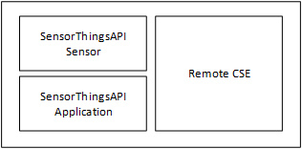
Figure 6: Composition of protocol gateway

7 Architecture Aspects

7.1 Gateway startup
The operation of the protocol gateway requires registration and mapping beforehand at both, CSE and OGC / SensorThingsAPI server:
- Register the gateway as remoteCSE at Hosting CSE
- Subscribe to selected <Thing> at MQTT-broker at OGC / SensorThingsAPI server
- Create <Thing> and <Datastream> at OGC / SensorThingsAPI server

7.1.1 RemoteCSE registration
The RemoteCSE representing the gateway needs to be created at the Hosting CSE. Applications can use this entity to get data from the gateway or to send additional requests. Figure 7 shows the remoteCSE registration call flow.
- The gateway requests to create an <remoteCSE> resource on the Hosting CSE
- The Hosting CSE evaluates the request, performs the appropriate checks, and creates the <remoteCSE> resource. Hosting CSE responds with the successful result of <remoteCSE> resource creation, otherwise it responds with an error.
The <point of access> (poa) of the remoteCSE entity points to the protocol gateway. The remoteCSE should be created along with a login or access token. This ensures that only requests from the entitled Hosting CSE are forwarded through the gateway.
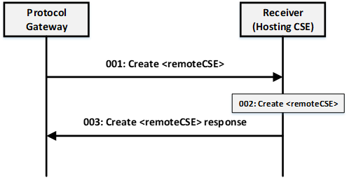
Figure 7 RCSE registration

7.1.2 Subscription to MQTT Broker
At current OGC / SensorThingsAPI 1.1 specification there is no publish / subscribe mechanism on HTTP. The protocol gateway needs to subscribe to the MQTT-Broker where all new <observations> of the OGC / SensorThingsAPI server
are published. According to the ISO 19156 data model an <observation> is published in a <datastream> belonging to a <thing>. The gateway service subscribes to datastreams of things that are of interest for being forwarded to the oneM2M side. The desired things might be configured or discovered beforehand.
For the OGC /STA server the gateway is an application that want to be informed about new observations via MQTT.

7.1.3 Preconfiguration of the OGC / STA Server
A OGC / SensorThingsAPI sensor pushes its sensor data as <Observations> to the server. Before <Observations> can be received and stored according to the ISO 19156 data model a <Thing> and a associated <DataStream> have to be created. The <DataStream> gets an id (e.g. “DataStream”:{“@iot.id:3635353”}) from the OGC / STA server. This id is needed to send the <Observations> to the OGC / STA Server.
For the OGC /STA server the gateway is a sensor that uploads data via MQTT or HTTP.

7.2 Data Mapping
The goal of the interworking is to transmit data, like sensor values from a oneM2M infrastructure to a OGC / SensorThingsAPI infrastructure and vice versa. But the gateway function is not able to transfer the complete feature set of one system to the other.
There are different types of data entities in the ISO 19156 data model. The present document focuses mainly on <Observation> because the goal is to exchange data or measurements of an observed property.
There are three data fields that needs to be mapped:
- Data value
- Time stamp
- Reference to the source system (optional, if additional data are needed later on)
The mapping can be done in different ways:
- The complete STA <Observation> can be copied in the <content> field of a oneM2M <ContentInstance>. On the other direction the complete <content> field of the <ContentInstance> can be copied into the <result> field of an <Observation>.
- Dedicated attributes of a <ContentInstance> are used to create an <Observation> and vice versa.
- oneM2M-to-OGC/STA mapping
In order to build an STA <Observation> that is accepted by a STA server it needs at least, a <result> attribute and a <DataStream> attribute.
The <DataStream> is an id that was assigned during the preconfiguration (see 7.1.3).
The <result> attribute of the <Observation> should be filled with the <content> of an incoming oneM2M <ContentInstance>.
The <creationTime> of the <ContentInstance> may be copied to <resultTime> of the <Observation>.
Sometimes it is necessary to have a reference back to the oneM2M system. So the gateway service may map <resourceID> of the <ContentInstance> to the <Observation>. This is not possible directly, because there is no adequate attribute in the <Observation> entity. But the the ISO 19156 data model allows for an additional entity called <FeatureOfOInterest> that can be related to one or many <observations>. Here the attributes <name> and <description> may be used to put further information about the “oneM2M”-sourced <Observation> like e.g. location information and references.
- OGC/STA-to-oneM2M mapping:
The <result> attribute of the <Observation> should be copied to the <content> of an outgoing oneM2M <ContentInstance>.
When the <resultTime> of the STA <Observation> is not null it may copied to the <creationTime> of the <ContentInstance>.
When the <resultTime> of the STA <Observation> is null the <phenomenonTime> should be copied to the <creationTime> of the <ContentInstance>.
The <@iot.selfLink> of an STA <Observatiom> is a URL of the original data residing on OGC/STA server side. The link is a reference when additional elements of the OGC-data model are need afterwards. In this case the <@iot.selfLink> should be an <contentReference> attribute of the outgoing <ContentInstance>.
Table 1: Attribute Mapping between STA and oneM2M
Attribute Name in  oneM2M | Attribute Name in  SensorThingsAPI | Attribute Format in SensorThingsAPI | Mapping  Direction
creationTime | resultTime | ISO 8601 time string  -could be null- | both
lastModifiedTime | phenomenonTime | ISO 8601 time string | both
content | result | any | both
contentReference | @iot.selfLink | URL | STA to oneM2M
name / description | resourceID / text | Character / String | oneM2M to STA

3. Creaating <FlexContainer> using SDT (tbd)

7.2.1 Interworking Procedures
….protocol flow..(tbd)

7.2.2 Direction oneM2M-to-STA

An data source represented as AE sends a CREATE <CIN> to <RCSE> entity at the Hosting CSE. The <CIN> data are copied to to an <observation>…tbd

7.2.3 Direction STA-to-oneM2M

The following text is to be used when appropriate:

Proforma copyright release text block
This text box shall immediately follow after the heading of an element (i.e. clause or annex) containing a proforma or template which is intended to be copied by the user. Such an element shall always start on a new page.
Notwithstanding the provisions of the copyright clause related to the text of the present document, oneM2M grants that users of the present document may freely reproduce the <proformatype> proforma in this {clause|annex} so that it can be used for its intended purposes and may further publish the completed <proformatype>.
<PAGE BREAK>

Annexes
Each annex shall start on a new page (insert a page break between annexes A and B, annexes B and C, etc.).
Use the Heading 9 style for the title and the Normal style for the text.
Annex <A>:
Title of annex (style H9)
<Text>
<PAGE BREAK>
Annex <B>:
Title of annex (style H9)
<Text>
B.1 First clause of the annex (style H1)
<Text>
B.1.1 First subdivided clause of the annex (style H2)
<Text>
<PAGE BREAK>

Annex <y>:
Bibliography
The annex entitled "Bibliography" is optional.
It shall contain a list of standards, books, articles, or other sources on a particular subject which are not mentioned in the document itself.
It shall not include references mentioned in the document.
Use the Heading 9 style for the title and B1+ or Normal for the text.
<Publication>: "<Title>".
OR
<Publication>: "<Title>".
<PAGE BREAK>

History
This clause shall be the last one in the document and list the main phases (all additional information will be removed at the publication stage).
Publication history
V1.1.1 | <yyyy-mm-dd> | <Milestone>

Draft history (to be removed on publication)
V0.0.1 | 2020-04-17 | Initial draft

