Input Contribution
Meeting ID* | SDS#46
Title:* | SDS-2020-0212-Interworking_SensorThingsAPI_update
Source:* | Ingo Friese, Deutsche Telekom AG, Ingo.Friese@telekom.de
Date:* | 2020-07-15
Input related to* | WI-0100, TR-0065
Intended purpose of  document:* | Decision  Discussion  Information  Other <specify>
Impacted other TS/TR(s) | n/a
Decision requested or recommendation:* | Add this solution to TR-0065
Template Version: January 2020 (do not modify)

oneM2M Notice
The document to which this cover statement is attached is submitted to oneM2M. Participation in, or attendance at, any activity of oneM2M, constitutes acceptance of and agreement to be bound by terms of the Working Procedures and the Partnership Agreement, including the Intellectual Property Rights (IPR) Principles Governing oneM2M Work found in Annex 1 of the Partnership Agreement.

Introduction
This contribution proposes to add a solution to oneM2M to SensorThingsAPI and vice versa

-----------------------Start of change 1-------------------------------------------

6 Architecture Model
The basic interworking enables applications that are connected to an oneM2M-based system to get data from sensors that are connected to a OGC / SensorThingsAPI server. Furthermore an application that is connected to an OGC / SensorThingsAPI server should be able to get data from sensors that are connected to a oneM2M-based system.

6.1 Interworking via Mcc Interface
In this option the interworking is defined as a protocol gateway between SensorThingsAPI and oneM2M. The protocol gatewy resides as a separate service between an OGC / SensorThingsAPI server and a oneM2M CSE. The CSE handles the Gateway as a Remote CSE and the Mcc interface is used for the communication between a CSE and the protocol gateway.
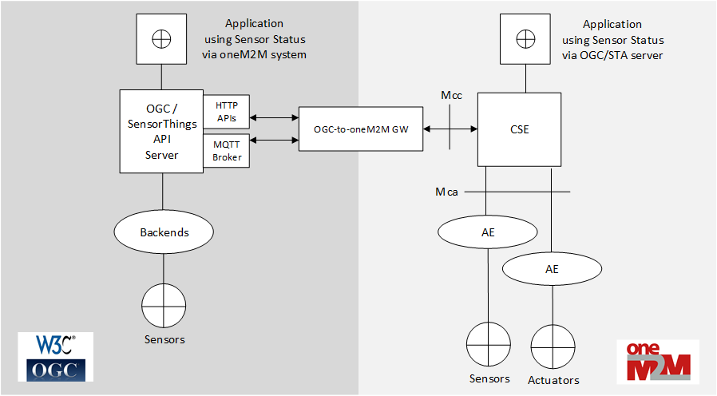
Figure 1: Architecture model - protocol gateway

6.1.1 Composition of the Protocol Gateway
The protocol gateway consists of three modules. Towards the oneM2M-side the gateway implements basic CSE Mcc interface functionalities. So any other CSE can receive data from the gateway and forward data to the gateway using RemoteCSE functionalies.
Towards the OGC/SensorThingsAPI side the gate way implements a sensor interface pushing data via HTTP to the OGC / SensorThingsAPI server.
Since OGC / SensorThingsAPI does not have a publish / subscribe mechanism on HTTP level an MQTT-Borker is used to publish events that are pushed to the OGC / SensorThingsAPI server. The gateway subscribes to the MQTT_broker in order to get data from the OGC / SensorThingsAPI server.
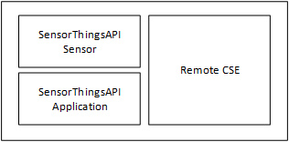
Figure 2: Composition of protocol gateway

7 Architecture Aspects

7.1 Gateway startup
The operation of the protocol gateway requires registration and mapping beforehand at both, CSE and OGC / SensorThingsAPI server:
- Register the gateway as remoteCSE at Hosting CSE
- Subscribe to selected <Thing> at MQTT-broker at OGC / SensorThingsAPI server
- Create <Thing> and <Datastream> at OGC / SensorThingsAPI server

7.1.1 RemoteCSE registration
The RemoteCSE representing the gateway needs to be created at the Hosting CSE. Applications can use this entity to get data from the gateway or to send additional requests. Figure 7 shows the remoteCSE registration call flow.
- The gateway requests to create an <remoteCSE> resource on the Hosting CSE
- The Hosting CSE evaluates the request, performs the appropriate checks, and creates the <remoteCSE> resource. Hosting CSE responds with the successful result of <remoteCSE> resource creation, otherwise it responds with an error.
The <point of access> (poa) of the remoteCSE entity points to the protocol gateway. The remoteCSE should be created along with a login or access token. This ensures that only requests from the entitled Hosting CSE are forwarded through the gateway.
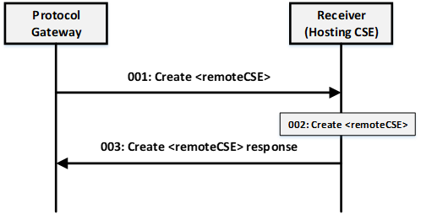
Figure 3 RCSE registration

7.1.2 Subscription to MQTT Broker
At current OGC / SensorThingsAPI 1.1 specification there is no publish / subscribe mechanism on HTTP. The protocol gateway needs to subscribe to the MQTT-Broker where all new <observations> of the OGC / SensorThingsAPI server
are published. According to the ISO 19156 data model an <observation> is published in a <datastream> belonging to a <thing>. The gateway service subscribes to datastreams of things that are of interest for being forwarded to the oneM2M side. The desired things might be configured or discovered beforehand.
For the OGC /STA server the gateway is an application that want to be informed about new observations via MQTT.

7.1.3 Preconfiguration of the OGC / STA Server
A OGC / SensorThingsAPI sensor pushes its sensor data as <Observations> to the server. Before <Observations> can be received and stored according to the ISO 19156 data model a <Thing> and a associated <DataStream> have to be created. The <DataStream> gets an id (e.g. “DataStream”:{“@iot.id:3635353”}) from the OGC / STA server. This id is needed to send the <Observations> to the OGC / STA Server.
For the OGC /STA server the gateway is a sensor that uploads data via MQTT or HTTP.

7.2 Data Mapping
The goal of the interworking is to transmit data, like sensor values from a oneM2M infrastructure to a OGC / SensorThingsAPI infrastructure and vice versa. But the gateway function is not able to transfer the complete feature set of one system to the other.
There are different types of data entities in the ISO 19156 data model. The present document focuses mainly on <Observation> because the goal is to exchange data or measurements of an observed property.
There are three data fields that needs to be mapped:
- Data value
- Time stamp
- Reference to the source system (optional, if additional data are needed later on)
The mapping can be done in different ways:
- The complete STA <Observation> can be copied in the <content> field of a oneM2M <ContentInstance>. On the other direction the complete <content> field of the <ContentInstance> can be copied into the <result> field of an <Observation>.
- Dedicated attributes of a <ContentInstance> are used to create an <Observation> and vice versa.
- oneM2M-to-OGC/STA mapping
In order to build an STA <Observation> that is accepted by a STA server it needs at least, a <result> attribute and a <DataStream> attribute.
The <DataStream> is an id that was assigned during the preconfiguration (see 7.1.3).
The <result> attribute of the <Observation> should be filled with the <content> of an incoming oneM2M <ContentInstance>.
The <creationTime> of the <ContentInstance> may be copied to <resultTime> of the <Observation>.
Sometimes it is necessary to have a reference back to the oneM2M system. So the gateway service may map <resourceID> of the <ContentInstance> to the <Observation>. This is not possible directly, because there is no adequate attribute in the <Observation> entity. But the the ISO 19156 data model allows for an additional entity called <FeatureOfOInterest> that can be related to one or many <observations>. Here the attributes <properties> allows for further user-annotated key-value pairs. Here the attribute key <m2m:ID> should mapped with the <resourceID> of the incoming oneM2M CIN.
- OGC/STA-to-oneM2M mapping:
The <result> attribute of the <Observation> should be copied to the <content> of an outgoing oneM2M <ContentInstance>.
When the <resultTime> of the STA <Observation> is not null it may copied to the <creationTime> of the <ContentInstance>.
When the <resultTime> of the STA <Observation> is null the <phenomenonTime> should be copied to the <creationTime> of the <ContentInstance>.
The <@iot.selfLink> of an STA <Observatiom> is a URL of the original data residing on OGC/STA server side. The link is a reference when additional elements of the OGC-data model are need afterwards. In this case the <@iot.selfLink> should be an <contentReference> attribute of the outgoing <ContentInstance>.
Table 1: Attribute Mapping between STA and oneM2M
Attribute Name in  oneM2M | Attribute Name in  SensorThingsAPI | Attribute Format in SensorThingsAPI | Mapping  Direction
creationTime | resultTime | ISO 8601 time string  -could be null- | both
lastModifiedTime | phenomenonTime | ISO 8601 Time string or Time Interval string | both
content | result | any | both
contentReference | @iot.selfLink | URL | STA to oneM2M
resourceID | properties / m2m:ID | Character / String | oneM2M to STA

-----------------------End of change 1-------------------------------------------

