Input Contribution
Meeting ID* | SDS#47
Title:* | OGC-to-oneM2M Data Mapping Issue
Source:* | Ingo Friese, Deutsche Telekom AG, Ingo.Friese@telekom.de
Date:* | 2020-10-12
Input related to* | SDS-2020-0141
Intended purpose of  document:* | Decision  Discussion  Information  Other <specify>
Impacted other TS/TR(s)
Decision requested or recommendation:* | Add this to the TR0065 V 0.0.1
Template Version: January 2020 (do not modify)

oneM2M Notice
The document to which this cover statement is attached is submitted to oneM2M. Participation in, or attendance at, any activity of oneM2M, constitutes acceptance of and agreement to be bound by terms of the Working Procedures and the Partnership Agreement, including the Intellectual Property Rights (IPR) Principles Governing oneM2M Work found in Annex 1 of the Partnership Agreement.

Introduction
This contribution discusses the OGC-to-oneM2M Data Mapping Issue.

-----------------------Start of change 1-------------------------------------------

6 Architecture Model of OGC/STA to oneM2M interworking
Figure 1 shows an architecture approach for an Interworking Proxy Entity (IPE) to OGC Sensor Things API. The IPE is located between a oneM2M CSE and a OGC SenserThings API-Server.
The basic interworking enables applications that are connected to an oneM2M-based system to get data from sensors that are connected to an OGC / SensorThingsAPI server. Furthermore an application that is connected to an OGC / SensorThingsAPI server is able to get data from sensors that are connected to an oneM2M-based system.
Figure 1: IPE architecture overview

6.1. Composition of the SensorThingsAPI IPE
The IPE consists of three modules. Towards the oneM2M-side the IPE implements an AE with Mca interface functionalities. An application can receive data from the IPE and forward data to the IPE using its interface to the hosting CSE.
Towards the OGC/SensorThingsAPI side the IPE implements a sensor interface pushing data via HTTP to the OGC / SensorThingsAPI server. OGC/STA data entities can be created as well as retrieved via this HTTP-REST-API
Since OGC / SensorThingsAPI does not have a publish / subscribe mechanism on HTTP level an MQTT-Borker is used to publish events that are pushed to the OGC / SensorThingsAPI server. The IPE subscribes to the MQTT-Broker in order to get data from the OGC / SensorThingsAPI server.
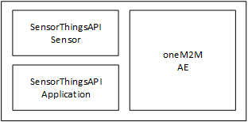
Figure 2: Composition of the IPE

7 Architecture Aspects

7.1 Gateway startup
The operation of the IPE requires registration and mapping beforehand at both, CSE and OGC / SensorThingsAPI server:
- Register the IPE as AE at Hosting CSE
- Subscribe to selected <Thing> at MQTT-broker at OGC / SensorThingsAPI server
- Create <Thing> and <Datastream> at OGC / SensorThingsAPI server

7.1.1 IPE registration
The AE representing the IPE needs to be created at the Hosting CSE. Furthermore a container structure has to be created at the CSE according to the choosen data model.mapping approach. Figure 3 show the IPE registration call flow.
- The IPE requests to create an <AE> resource on the Hosting CSE
- The Hosting CSE evaluates the request, performs the appropriate checks, and creates the <AE> resource.
- Hosting CSE responds with the successful result of <AE> resource creation, otherwise it responds with an error.
The <point of access> (poa) of the <AE> entity points to the IPE. The IPE should be created along with a login or access token.
- The IPE needs to create a <Container> structure inside the <AE> in order to organize the data. The structure of containers depends on application needs and is discussed in the following chapters. It’s recommended to have at least one <Container> for each direction per sensor or group of sensors or backend.
- The Hosting CSE evaluates the requests, performs the appropriate checks, and creates the <Container> resources.
- Hosting CSE responds with the successful result of <Container> resource creation, otherwise it responds with an error.
- All oneM2M applications those are interested in OGC/STA data create a <Subscribtion> to the regarded container where observation data are stored by the IPE.
- The hosting CSE evaluates every subscription by testing the notification endpoint
- The Hosting CSE evaluates the requests, performs the appropriate checks, and creates the <Subscription> resources.
- Hosting CSE responds with the successful result of <Subscription> resource creation, otherwise it responds with an error.
- The IPE also creates a <Subscription> to those containers that are used for the-oneM2M-to-OCG/STA direction. This way incoming data from a oneM2M-based sensor or application are forwarded to the IPE.
- The hosting CSE evaluates the subscription by testing the existence of the notification endpoint at IPE
- The Hosting CSE evaluates the requests, performs the appropriate checks, and creates the <Subscription> resources.
- Hosting CSE responds with the successful result of <Subscription> resource creation, otherwise it responds with an error.
Figure 3: IPE Registartion call flow

7.1.2 Subscription to MQTT Broker
This step is necessary for the OGC/STA-to oneM2M dataflow direction
At current OGC / SensorThingsAPI specification [i..1] there is no publish / subscribe mechanism on HTTP level. The IPE needs to subscribe to the MQTT-Broker where all new events like a <Observation> of the OGC / SensorThingsAPI server are published. The IPE could also subscribe to other events or changes like for example <Location>, <Thing> etc.
According to the ISO 19156 data model an <Observation> is published in a <DataStream> belonging to a <Thing>. The IPE subscribes to datastreams of things that are of interest for being forwarded to the oneM2M side. The desired <Thing> and their regarded <DataStream> might be configured / discovered in an initial startup of the IPE and/or updated on a regular base.
In the introduced architecture model the IPE is for the OGC /STA server an application that wants to be informed about new observations via MQTT.

7.1.3 Preconfiguration of the OGC / STA Server
This step is necessary for the oneM2M-to-OGC/STA data flow direction
A OGC / SensorThingsAPI sensor pushes its sensor data as <Observation> entities to the server. Before an <Observation> can be received and stored according to the ISO 19156 data model a <Thing> and a associated <DataStream> have to be created. The <DataStream> gets an id back (e.g. “DataStream”:{“@iot.id:3635353”}) from the OGC / STA server. This id is needed to send an <Observation> to the OGC / STA Server.
For the OGC /STA server the IPE is a sensor that uploads data via MQTT or HTTP.

7.2 OGC/STA to oneM2M Data Model Mapping
According to TS-0033 a representation of a non-oneM2M Proximal IoT function in a oneM2M-specified resource instance is needed in order to be synchronized with the entity that it actually represents.
This actual means that the OGC/STA data model has to be represented in the hosting CSE. The data in the SensorThings server are organized according to ISO 19156 (see Figure 1: ISO 19156 data model).
The oneM2M struktur for data models is a tree-structure where data is organized in containers or trees of containers. The OGC/STA data model has loops and is not hierarchical. Thus it can not mapped one-to-one to oneM2M.

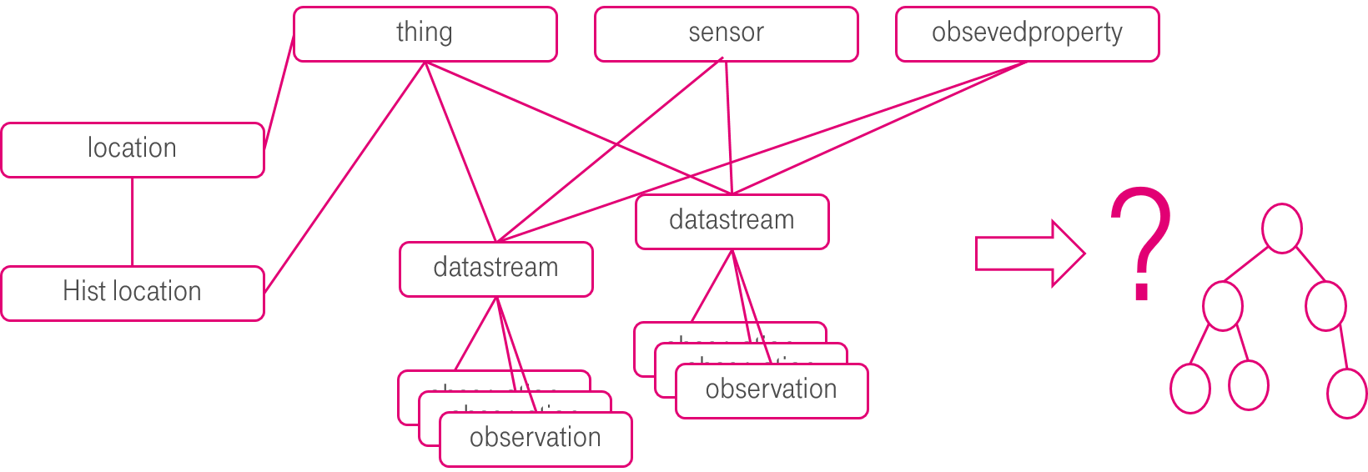
Figure 4: OGC data model can not directly mapped to oneM2M

7.2.1 The flat data model
One possible approach is to form for every single group of entities in OGC data model a seperate oneM2M container entity.
Figure 5 shows a oneM2M data model that could represent a OGC/STA-IPE in a hosting CSE.
The top of a tree is an AE-Entity. Below there are containers representing the dedicated parts of the ISO 19156 data model. They are all at the same level and form a flat data model representation.
There is for example one container where all incoming observations are stored. There is another container where the datastream object(s) for this observation are stored.
There are also container for “Locations”, “Sensors”,”Things” etc.
The OGC/STA-<Observation> itself is represented as an <FlexContainer> under a container called “observations”.
The OGC/STA-<DataStream> itself is also represented as an <FlexContainer> under a container called “datastream”. (grey boxes)
Now we have a oneM2M structure with all kind of entites from ISO 19156 data model.
But we need also to represent the relationshsips between the ISO 19156 entites. This can be done through dedicated attributes defined inside the regarded <FlexContainer>.
Figure 5 shows the <FlexContainer> with the resource name <rn> “ObservationXYZ” that has an attribute “<STAdatastream>” with the value “Datastream123”. This Attribute points to a <FlexContainer> representing the <Datastream> object with the <resourceName>”dataStream123” located in the datastream container. This way the attribute represents the relationship from the OGC/STA world.
We formed two kinds of relationeships. The first kind are the oneM2M specific <AE>-to-<Container>-to-<FlexContainer> relationships. The second kind of relationships are OGC specific and are expressed as attributes inside the <FlexContainer> entities. Here for example a <Observation>-to-<DataStream>-to-<Thing> relationship may be described.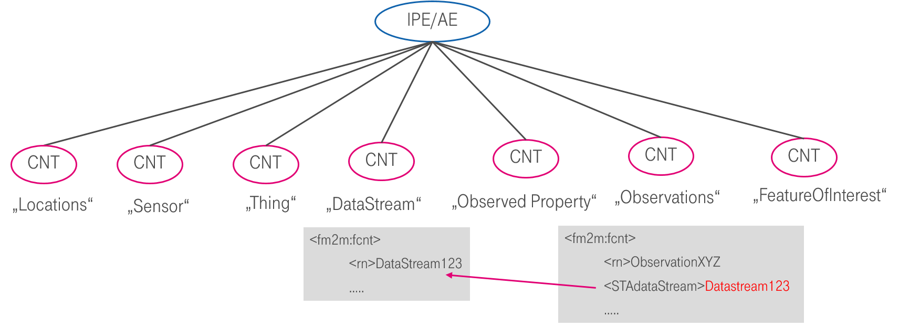
Figure 5: The flat data model with inherent connections

7.2.2 The Issue of missing Relationship Management in a oneM2M-CSE

Allthough the mapping approach described before is sufficient for the operation of the IPE according to TS-0033 it comes with remarkebale unsolved issues.
The inherent relationships (red/magenta line in figure 5) describing the OGC/STA data model can’t be managed by the CSE in todays oneM2M. Only the relationships between AE and container can be managed (grey/dark lines) by the CSE.
When for example a certain <FlexContainer> representing a <DataStream> is deleted all related <FlexContainer> representing an <Observation> have to be deleted too. This is how it’s handled in a OGC/STA Server. But this is not possible inside the hosting CSE.
There are several ways/workarounds to address this issue:
- To not store the data model in the CSE and change data only in the OGC/STA world.
- Design / Implement a relationship management that can be use by the CSE that take also inherent relations into account
- Just to store dedicated parts of the OGC/STA data model. For example it is possible just to store <Observations> of certain <Things> or <Sensors>. Other parts of the data model are not recognized(e.g. changes of the location).

-----------------------End of change 1-------------------------------------------

