Input Contribution
Meeting ID* | SDS#48
Title:* | TR-0057 – Location Policy
Source:* | Laurent Velez, ETSI, laurent.velez@etsi.org
Date:* | 2020-11-27
Input related to* | TR-0057 V0.3.0
Intended purpose of  document:* | Decision  Discussion  Information  Other <specify>
Impacted other TS/TR(s)
Decision requested or recommendation:* | To incorporate into baseline the new proposed text if agreed.
Template Version: January 2017 (Do not modify)

oneM2M Notice
The document to which this cover statement is attached is submitted to oneM2M. Participation in, or attendance at, any activity of oneM2M, constitutes acceptance of and agreement to be bound by terms of the Working Procedures and the Partnership Agreement, including the Intellectual Property Rights (IPR) Principles Governing oneM2M Work found in Annex 1 of the Partnership Agreement.

Introduction
This contribution proposes a overall and basic description of the location policy function.

-----------------------Start of new text 1-------------------------------------------

6.x Location policy

6.x.1 Introduction
Geographical location information of M2M entities is one of most significant exposed service capabilities in oneM2M system for services. It allows applications AE to obtain geographical location information of Nodes (e.g. ASN, MN) for Location-based services. Such information could be more than just longitude and the latitude.

In the CSE, the LOC Common Service Function obtains and manages the geographical location information of oneM2M entities.
On a request of AEs, a dedicated resource <locationPolicy> is created into the CSE. This resource does not contain the location information itself of the target nodes. Based on its specific attributes, the <locationPolicy> contains the configuration on how to obtain the location information of a target M2M node (Update period, target ID, location server, target area, etc…)
When a policy is set, a data container(<container> resource) is created and is linked to the <locationPolicy> by its attribute locationContainerID. Then the CSE stores the location information in the target <container> resource as <contentInstance> resource. The data are updated depending of the policy. Any AE can then get access to the geographical location information.
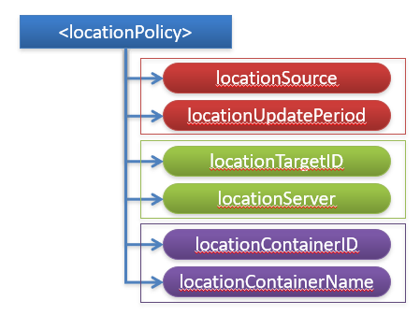
Basic Information
- Source (Network/Device/Sharing)
- Period to obtain location information
For Network-based Location Information
- ID of the Target M2M Node
- ID of the Location Server located in Underlying Network

How to link with a <container> resource
- URI of the created <container>
- Name of the container

Figure 6.x.1-1: <locationPolicy> resource

6.x.2 Obtaining Location Information
The CSE has 3 methods for obtaining location information of an M2M Node . This information is stored in the locationSource attribute of the <locationPolicy> resource.
- Network-based method: where the CSE on behalf of the AE obtains the target M2M Node's location information from an Underlying Network.
- Device-based method: where the ASN is equipped with any location capable modules or technologies (e.g. GPS) and is able to position itself.
- Sharing-based method: where the ADN has no GPS nor an Underlying Network connectivity. Its location information can be retrieved from either the associated ASN or a MN.

Network-based method:

Figure 6.x.2-1: Network-based method

Device-based method

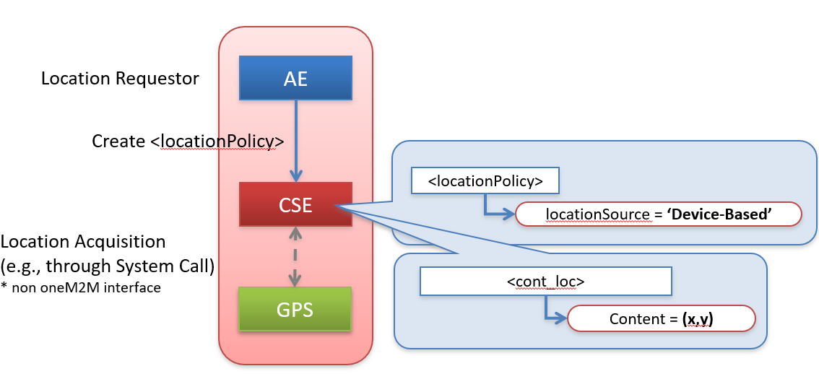

Figure 6.x.2-2: Device-based method

Sharing-based method
Figure 6.x.2-3: Sharing-based method

