CHANGE REQUEST
Meeting ID:* | SDS 48
Source:* | Bob Flynn, Convida Wireless , Bob.Flynn@convidawireless.com  Andreas Kraft, Deutsche Telekom, Andreas.Kraft@t-systems.com  Miguel Angel Reina Ortega, ETSI, MiguelAngel.ReinaOrtega@etsi.org
Date:* | 2020-12-02
Reason for Change/s:* | Announcement Procedure - Update
CR against: Release* | Rel-4
CR against: WI* | Active < WI-0077>  MNT maintenance / < Work Item number(optional)>  Is this a mirror CR? Yes No  mirror CR number: SDS-2020-0327  STE Small Technical Enhancements / < Work Item number (optional)>  Only ONE of the above shall be ticked
CR against: TS/TR* | TS-0004 v4.3.0
Clauses * | 6.3.4.2.1, 6.5.5.3, 7.3.3.10, 7.4.3.1, 7.4.26.1, 8.2.4
Type of change: * | Editorial change  Bug Fix or Correction  Change to existing feature or functionality  New feature or functionality  Only ONE of the above shall be ticked
Other TS/TR(s) impacted | None
Post Freeze checking:* | This CR contains only essential changes and corrections? YES NO  This CR may break backwards compatibility with the last approved version of the TS? YES NO
Template Version: January 2019 (do not modify)
oneM2M Notice
The document to which this cover statement is attached is submitted to oneM2M. Participation in, or attendance at, any activity of oneM2M, constitutes acceptance of and agreement to be bound by terms of the Working Procedures and the Partnership Agreement, including the Intellectual Property Rights (IPR) Principles Governing oneM2M Work found in Annex 1 of the Partnership Agreement.
GUIDELINES for Change Requests:
Provide an informative introduction containing the problem(s) being solved, and a summary list of proposals.
Each CR should contain changes related to only one particular issue/problem.
In case of a correction, and the change apply to previous releases, a separate “mirror CR” should be posted at the same time of this CR
Mirror CR: applies only when the text, including clause numbering are exactly the same.
Companion CR: applies when the change means the same but the baselines differ in some way (e.g. clause number).
Follow the principle of completeness, where all changes related to the issue or problem within a deliverable are simultaneously proposed to be made E.g. A change impacting 5 tables should not only include a proposal to change only 3 tables. Includes any changes to references, definitions, and acronyms in the same deliverable.
Follow the drafting rules.
All pictures must be editable.
Check spelling and grammar to the extent practicable.
Use Change bars for modifications.
The change should include the current and surrounding clauses to clearly show where a change is located and to provide technical context of the proposed change. Additions of complete clauses need not show surrounding clauses as long as the proposed clause number clearly shows where the new clause is proposed to be located.
Multiple changes in a single CR shall be clearly separated by horizontal lines with embedded text such as, start of change 1, end of change 1, start of new clause, end of new clause.
When subsequent changes are made to content of a CR, then the accepted version should not show changes over changes. The accepted version of the CR should only show changes relative to the baseline approved text.

Introduction
While working on announcement development / test cases, there were some issues that we wanted to highlight for discussion and propose a solution for those issues.
Consider the scenario where <aResource> is to be announced to CSE1, CSE2, and CSE5.
R01 – As part of the discussions during the presentation of the contribution , some agreements were made to:
- Remove announceTo and announcedAttributes attributes as CSEBase will not be announceable. CSEBaseAnnc is created when another announcement requires it
- Remove expirationTime attribute from CSEBase as it is desired that CSEBase resource never expires. ExpirationTime attribute value to be provided by the Hosting CSE when creating CSEBaseAnnc
- Make all OA attributes of CSEBaseAnnc NA, as it is desired to announce a minimal set of attributes of CSEBase
- Update procedures to reflect points above

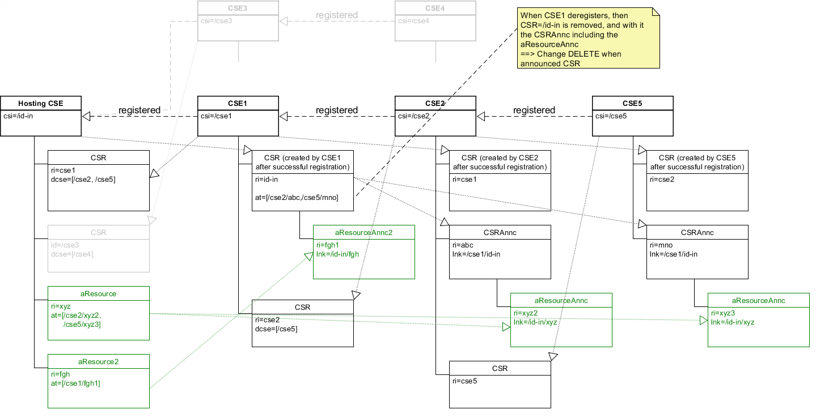
First thing to point out is that the announced resource is in different locations depending on the “registration” status/relationship to Hosting CSE.
The second thing to point out is that when CSE1 deregisters from Hosting CSE then all of the announced resources are DELETED. Whereas if CSE2 de-registers from CSE1, the announced resources remain intact (for example until re-registration). This is a consequence of the first issue above.
The third thing to point out is the specification wording of the announce procedure. Specifically, from 10.2.13.2-1:
The original resource Hosting CSE shall first check if it is a Registree or the Registrar of the announcement target CSE. If that is the case, the announced resource shall be created as a direct child of the Hosting CSE’s <remoteCSE> resource hosted by the announcement target CSE. If that is not the case, the Hosting CSE shall next check if its <remoteCSE> resource has been announced to the announcement target CSE. The Hosting CSE shall perform this check by checking the announceTo attribute of its <remoteCSE> resource hosted on its Registrar CSE if the announcement target CSE is not a descendent CSE, or the corresponding Registree CSE if the announcement target CSE is a descendent CSE. If it is not announced, the Hosting CSE shall request that its Registrar CSE (If the target CSE is not its descendant CSE) or Registree CSE (if the target CSE is its descendant CSE) to create a <remoteCSEAnnc> resource representing the Hosting CSE as a direct child of the <CSEBase> of the announcement target CSE. The announced resource shall then be created by the Hosting CSE as a direct child resource of the <remoteCSEAnnc> resource.

This requires the Hosting CSE to update the ‘announceTo’ attribute of its <remoteCSE> to include the announcement target CSE. At this point, the proper execution become unclear:
It is intended that CSE1 would send a CREATE <remoteCSEAnnc> to the announcement target CSE.
Because the announced resource is a <remoteCSE> CSE1 is NOT supposed to follow the FULL procedure described above, i.e. check if CSE1 is registered to the announcement target CSE. This is not described clearly (perhaps a TS-0004 level of detail).

A proposed solution to simplify the procedure, eliminate the inconsistent parent resource type and address the deleted announced resources during de-registration is:
- to make <cseBase> announceable
- Then, to remove the registration check to determine the target of the announcement as target of the announcement will always be a cseBaseAnnc
- remove the decendent cse check because normal retargeting rules will apply.
- keep original resource tree structure for the announced resources if possible, otherwise announced resources are created under <CSEBaseAnnc>

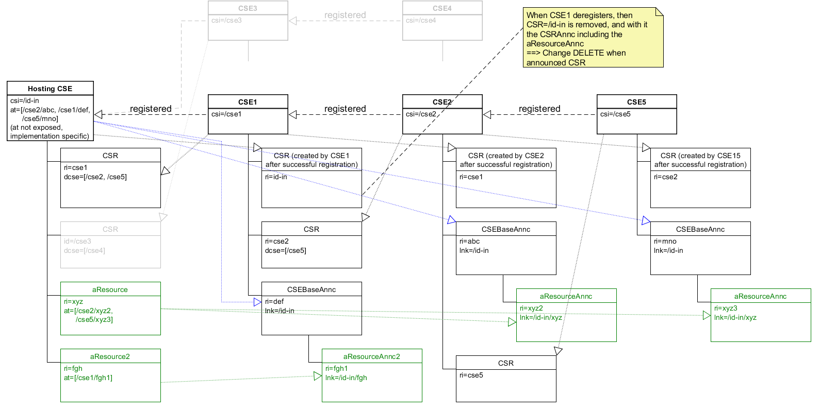

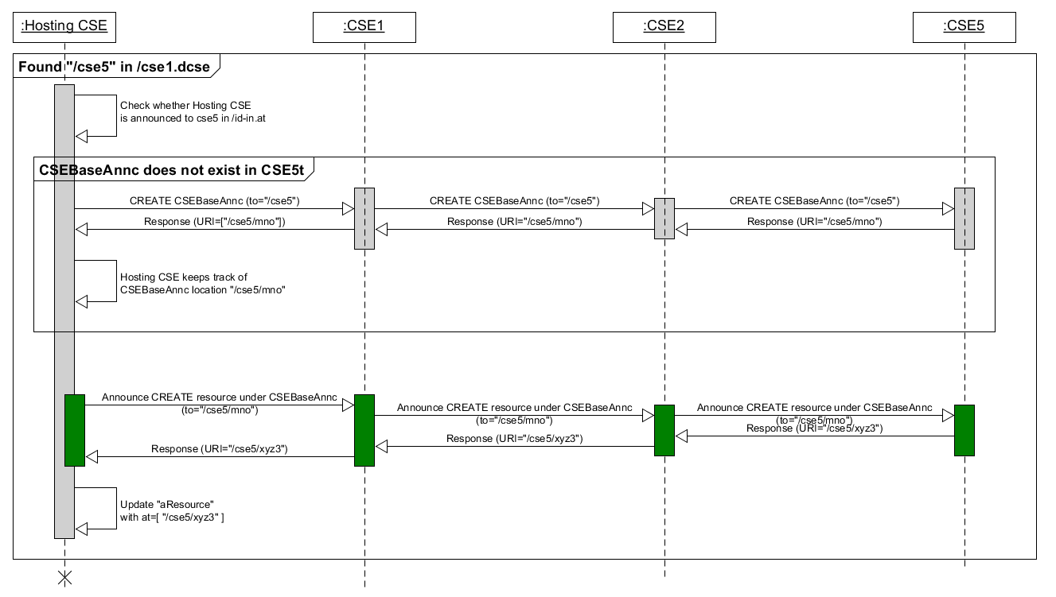

The benefits of these proposed changes are:
There is a consistent location for announced resources (always under <CSEBaseAnnc>)
The newly defined announce procedure applies with no exceptions.
The original resource hosting CSE is able to self manage the target of the announced resources (CSEBaseAnnc)
Separates registration and announcement concerns
Now announced resource will remain after deregistration of a CSE

----------------------- Start of Change 1--------------------------------------------

7.3.3.10 Announce the resource or attribute
If either a CREATE Request that contains an announceTo attribute or an UPDATE Request that adds a URI or CSE-ID in the announceTo attribute that are not already stored into the announceTo attribute of the resource is received:
- Compose the CREATE Request primitive as follows:
The link attribute is set to the URI of the original resource.
If the accessControlPolicyIDs attribute of the original resource is not present, the accessControlPolicyIDs attribute is set to the same value as the parent resource or is set using the local policy of the original resource.
Attributes marked with MA in oneM2M TS-0001 [6]. Such attributes shall be included if present in the original resource and set to same value as in the original resource.
Attributes marked with OA that are included in the announcedAttribute attribute. Such attributes shall be included if present in the original resource and set to same value as in the original resource.
The resourceType attribute is set to the announced variant of the original resource (see Table 6.3.4.2.1-1).
Perform the following steps for each new item (announcement target) in the announceTo attribute list:
  - If the announcement target is a CSE-ID, check if the parent resource of the original resource is announced to the announcement target CSE.
- If yes, announce the original resource by sending the CREATE Request with To parameter set to the location of the announced parent resource.
- If no, then check if the CSE hosting created a <CSEBaseAnnc> resource as a child of the <CSEBase> into the announcement target CSE.
- If yes, announce the original resource by sending the CREATE Request with To parameter set to the <CSEBaseAnnc> resource address.
- If no, then the CSE hosting the original resource shall perform the following steps:
        - Create <CSEBaseAnnc> that represents itself at the announcement target CSE. CSE Hosting shall compose the CREATE <CSEBaseAnnc> Request primitive as described for resource announcement above and provide a value for the expirationTime attribute of the <CSEBaseAnnc> to be created.
        - Once <CSEBaseAnnc> resource is created, send the CREATE Request with To parameter set to the <CSEBaseAnnc> resource address.
  - If the announcement target is not a CSE-ID send the CREATE Request to the provided URI in the announceTo of the request.
  - Wait for the Response to the CREATE that was sent in step a or b.
  - Replace the CSE-ID or URI in the content of the announceTo attribute contained in the original request’s resource representation by the URI of the successfully-announced resource from the received Response.
Include the updated announceTo attribute in the Content parameter of the Response to the received request.

If an UPDATE Request that adds the attribute name into the announcedAttribute attribute is received:
- Compose the UPDATE Request primitive. The UPDATE Request shall provide the attribute name for the attribute to be announced, and the initial value for the attribute in the Content parameter. The initial value shall be the same with the value from the original resource. The attribute that will be announced shall be marked as OA.
- Send UPDATE Requests to all announced resources listed in the announceTo attribute.
- Wait for Response primitive.
- Add the attribute name of the successfully announced attribute to the announcedAttribute attribute.
- Include updated announcedAttribute attribute in the Content parameter in the Response to the received UPDATE Request.
If an attribute(s) specified as MA (see oneM2M TS-0001 [6]) or an attribute(s) included in the announcedAttribute attribute is updated:
- Compose an UPDATE Request primitive by including the updated attribute(s) with its associated updated value.
Send the UPDATE Request to all CSE(s) represented by the URI(s) in the announceTo attribute of the original resource.
Wait for the Response primitive(s).
-------------------------------------------------- End of Change 1---------------------------------------------------

----------------------- Start of Change 2--------------------------------------------

6.3.4.2.1 m2m:resourceType
Table 6.3.4.2.1-1: Interpretation of resourceType
Value | Interpretation | Note
1 | accessControlPolicy
2 | AE
3 | container
4 | contentInstance
5 | CSEBase
6 | delivery
7 | eventConfig
8 | execInstance
9 | group
10 | locationPolicy
11 | m2mServiceSubscriptionProfile
12 | mgmtCmd
13 | mgmtObj
14 | node
15 | pollingChannel
16 | remoteCSE
17 | request
18 | schedule
19 | serviceSubscribedAppRule
20 | serviceSubscribedNode
21 | statsCollect
22 | statsConfig
23 | subscription
24 | semanticDescriptor
25 | notificationTargetMgmtPolicyRef
26 | notificationTargetPolicy
27 | policyDeletionRules
28 | flexContainer
29 | timeSeries
30 | timeSeriesInstance
31 | role
32 | token
33 | void
34 | dynamicAuthorizationConsultation
35 | authorizationDecision
36 | authorizationPolicy
37 | authorizationInformation
38 | ontologyRepository
39 | ontology
40 | semanticMashupJobProfile
41 | semanticMashupInstance
42 | semanticMashupResult
43 | AEContactList
44 | AEContactListPerCSE
45 | localMulticastGroup
46 | multimediaSession
47 | triggerRequest
48 | crossResourceSubscription
49 | backgroundDataTransfer
50 | transactionMgmt
51 | transaction
10001 | accessControlPolicyAnnc
10002 | AEAnnc
10003 | containerAnnc
10004 | contentInstanceAnnc
10005 | CSEBaseAnnc
10009 | groupAnnc
10010 | locationPolicyAnnc
10013 | mgmtObjAnnc
10014 | nodeAnnc
10016 | remoteCSEAnnc
10018 | scheduleAnnc
10024 | semanticDescriptorAnnc
10028 | flexContainerAnnc
10029 | timeSeriesAnnc
10030 | timeSeriesInstanceAnnc
10033 | void
10034 | dynamicAuthorizationConsultationAnnc
10038 | ontologyRepositoryAnnc
10039 | ontologyAnnc
10040 | semanticMashupJobProfileAnnc
10041 | semanticMashupInstanceAnnc
10042 | semanticMashupResultAnnc
10046 | multimediaSessionAnnc
NOTE: See clause 6.4.1 Request primitive parameter data types.

-------------------------------------------------- End of Change 2---------------------------------------

----------------------- Start of Change 3--------------------------------------------

6.5.5.3 Usage
This type is used by the following resource types:
<AEAnnc>, <containerAnnc>, <CSEBaseAnnc>, <groupAnnc>, <locationPolicyAnnc>, <nodeAnnc>, <remoteCSEAnnc>, <semanticDescriptorAnnc>, <[flexContainer]Annc>, <timeSeriesAnnc>, <ontologyRepositoryAnnc>, <ontologyAnnc>, <semanticMashupJobProfileAnnc>, <semanticMashupInstanceAnnc>, <semanticMashupResultAnne>, <multimediaSessionAnnc>,<scheduleAnnc>.
It is also used by the xxxAnnc variants of the <mgmtObj> specializations.
-------------------------------------------------- End of Change 3---------------------------------------

----------------------- Start of Change 4--------------------------------------------
Table 7.4.3.1-4: Child resources of <CSEBase> resource
Child Resource Type | Child Resource Name | Multiplicity | Ref. to Resource Type Definition
<CSEBaseAnnc> | [variable] | 0..n | Clause 7.4.3
<remoteCSE> | [variable] | 0..n | Clause 7.4.4
<remoteCSEAnnc> | [variable] | 0..n | Clause 7.4.4
<node> | [variable] | 0..n | Clause 7.4.18
<AE> | [variable] | 0..n | Clause 7.4.5
<container> | [variable] | 0..n | Clause 7.4.6
<group> | [variable] | 0..n | Clause 7.4.13
<accessControlPolicy> | [variable] | 0..n | Clause 7.4.2
<subscription> | [variable] | 0..n | Clause 7.4.8
<mgmtCmd> | [variable] | 0..n | Clause 7.4.16
<locationPolicy> | [variable] | 0..n | Clause 7.4.10
<statsConfig> | [variable] | 0..n | Clause 7.4.23
<statsCollect> | [variable] | 0..n | Clause 7.4.25
<request> | [variable] | 0..n | Clause 7.4.12
<delivery> | [variable] | 0..n | Clause 7.4.11
<schedule> | [variable] | 0..1 | Clause 7.4.9
<m2mServiceSubscriptionProfile> | [variable] | 0..n | Clause 7.4.19
<serviceSubscribedAppRule> | [variable] | 0..n | Clause 7.4.29
<notificationTargetPolicy> | [variable] | 0..n | Clause 7.4.31
<dynamicAuthorizationConsultation> | [variable] | 0..n | Clause 7.4.36
<flexContainer> | [variable] | 0..n | Clause 7.4.37
<timeSeries> | [variable] | 0..n | Clause 7.4.38
<role> | [variable] | 0..n | Clause 7.4.40
<token> | [variable] | 0..n | Clause 7.4.41
<authorizationDecision> | [variable] | 0..n | Clause 7.4.43
<authorizationPolicy> | [variable] | 0..n | Clause 7.4.44
<authorizationInformation> | [variable] | 0..n | Clause 7.4.45
<ontologyRepository> | [variable] | 0..1 | Clause 7.4.46
<semanticMashupJobProfile> | [variable] | 0..n | Clause 7.4.49
<semanticMashupInstance> | [variable] | 0..n | Clause 7.4.50
<AEContactList> | [variable] | 0..1 | Clause 7.4.53
<localMulticastGroup> | [variable] | 0..n | Clause 7.4.55
<crossResourceSubscription> | [variable] | 0..n | Clause 7.4.58
<backgroundDataTransfer> | [variable] | 0..n | Clause 7.4.59
<transactionMgmt> | [variable] | 0..n | Clause 7.4.60
<transaction> | [variable] | 0..n | Clause 7.4.61

-------------------------------------------------- End of Change 4---------------------------------------

----------------------- Start of Change 5--------------------------------------------

Table 7.4.26.1-1: Data type definition of announced Resource types
Data Type ID | File Name | Note
CSEBaseAnnc | CDT-CSEBase-v3_18_0.xsd
accessControlPolicyAnnc | CDT-accessControlPolicy-v3_18_0.xsd
remoteCSEAnnc | CDT-remoteCSE-v3_18_0.xsd
AEAnnc | CDT-AE-v3_18_0.xsd
containerAnnc | CDT-container-v3_18_0.xsd
[flexContainer]Annc | See Annex J and oneM2M TS-0023 [40] | Announced variants of flexContainer specializations
contentInstanceAnnc | CDT-contentInstance-v3_18_0.xsd
scheduleAnnc | CDT-schedule-v3_18_0.xsd
locationPolicyAnnc | CDT-locationPolicy-v3_18_0.xsd
groupAnnc | CDT-group-v3_18_0.xsd
nodeAnnc | CDT-node-v3_18_0.xsd
semanticDescriptorAnnc | CDT-semanticDescriptor-v3_18_0.xsd
timeSeriesAnnc | CDT-timeSeries-v3_18_0.xsd
timeSeriesInstanceAnnc | CDT-timeSeriesInstance-v3_18_0.xsd
ontologyRepositoryAnnc | CDT-ontologyRepository-v3_18_0.xsd
ontologyAnnc | CDT-ontology-v3_18_0.xsd
semanticMashupJobProfileAnnc | CDT-semanticMashupJobProfile-v3_18_0.xsd
semanticMashupInstanceAnnc | CDT-semanticMashupInstance-v3_18_0.xsd
semanticMashupResultAnnc | CDT-semanticMashupResult-v3_18_0.xsd
genericInterworkingServiceAnnc | CDT-genericInterworkingService-v3_18_0.xsd
genericInterworkingOperationInstanceAnnc | CDT-genericInterworkingOperationInstance-v3_18_0.xsd
svcObjWrapperAnnc | CDT-svcObjWrapper-v3_18_0.xsd
svcFwWrapperAnnc | CDT-svcFwWrapper-v3_18_0.xsd
allJoynAppAnnc | CDT-allJoynApp-v3_18_0.xsd
allJoynSvcObjectAnnc | CDT-allJoynSvcObject-v3_18_0.xsd
allJoynInterfaceAnnc | CDT-allJoynInterface-v3_18_0.xsd
allJoynMethodAnnc | CDT-allJoynMethod-v3_18_0.xsd
allJoynMethodCallAnnc | CDT-allJoynMethodCall-v3_18_0.xsd
allJoynPropertyAnnc | CDT-allJoynProperty-v3_18_0.xsd
multimediaSessionAnnc | CDT-multimediaSession-v3_18_0.xsd

-------------------------------------------------- End of Change 5---------------------------------------

----------------------- Start of Change 6 --------------------------------------------

Table 8.2.4-1: Resource and specialization type short names
Resource Type Name | Short Name
accessControlPolicy | acp
accessControlPolicyAnnc | acpA
AE | ae
AEAnnc | aeA
container | cnt
containerAnnc | cntA
contentInstance | cin
contentInstanceAnnc | cinA
CSEBase | cb
CSEBaseAnnc | cbA
delivery | dlv
eventConfig | evcg
execInstance | exin
group | grp
groupAnnc | grpA
locationPolicy | lcp
locationPolicyAnnc | lcpA
m2mServiceSubscriptionProfile | mssp
mgmtCmd | mgc
node | nod
nodeAnnc | nodA
pollingChannel | pch
remoteCSE | csr
remoteCSEAnnc | csrA
request | req
schedule | sch
scheduleAnnc | schA
serviceSubscribedAppRule | asar
serviceSubscribedNode | svsn
statsCollect | stcl
statsConfig | stcg
subscription | sub
firmware | fwr
firmwareAnnc | fwrA
software | swr
softwareAnnc | swrA
memory | mem
memoryAnnc | memA
areaNwkInfo | ani
areaNwkInfoAnnc | aniA
areaNwkDeviceInfo | andi
areaNwkDeviceInfoAnnc | andiA
battery | bat
batteryAnnc | batA
deviceInfo | dvi
deviceInfoAnnc | dviA
deviceCapability | dvc
deviceCapabilityAnnc | dvcA
reboot | rbo *
rebootAnnc | rboA
eventLog | evl
eventLogAnnc | evlA
cmdhPolicy | cmp
activeCmdhPolicy | acmp
cmdhDefaults | cmdf
cmdhDefEcValue | cmdv
cmdhEcDefParamValues | cmpv
cmdhLimits | cml
cmdhNetworkAccessRules | cmnr
cmdhNwAccessRule | cmwr
cmdhBuffer | cmbf
notificationTargetMgmtPolicyRef | ntpr
notificationTargetPolicy | ntp
policyDeletionRules | pdr
dynamicAuthorizationConsultation | dac
semanticDescriptor | smd
semanticDescriptorAnnc | smdA
timeSeries | ts
timeSeriesAnnc | tsA
timeSeriesInstance | tsi
timeSeriesInstanceAnnc | tsiA
role | rol
token | tk
genericInterworkingService | gis
genericInterworkingServiceAnnc | gisA
genericInterworkingOperationInstance | gio
genericInterworkingOperationInstanceAnnc | gioA
svcObjWrapper | ajsw
svcObjWrapperAnnc | ajswA
svcFwWrapper | ajfw
svcFwWrapperAnnc | ajfwA
allJoynApp | ajap
allJoynAppAnnc | ajapA
allJoynSvcObject | ajso
allJoynSvcObjectAnnc | ajsoA
allJoynInterface | ajif
allJoynInterfaceAnnc | ajifA
allJoynMethod | ajmd
allJoynMethodAnnc | ajmdA
allJoynMethodCall | ajmc
allJoynMethodCallAnnc | ajmcA
allJoynProperty | ajpr
allJoynPropertyAnnc | ajprA
authorizationDecision | auds
authorizationPolicy | aupy
authorizationInformation | auif
ontologyRepository | ontr
ontologyRepositoryAnnc | ontrA
ontology | ont
ontologyAnnc | ontA
semanticMashupJobProfile | smjp
semanticMashupJobProfileAnnc | smjpA
semanticMashupInstance | smi
semanticMashupInstanceAnnc | smiA
semanticMashupResult | smr
semanticMashupResultAnnc | smrA
AEContactList | alst
AEContactListPerCSE | alpc
localMulticastGroup | lmg
multimediaSession | mms
multimediaSessionAnnc | mmsA
triggerRequest | tgr
crossResourceSubscription | crs
backgroundDataTransfer | bdt
transaction | trac
transactionMgmt | tram
NOTE: * marked short names have been already assigned in attribute Tables 8.2.3-1 to 8.2.3-5.

-------------------------------------------------- End of Change 6---------------------------------------

