Input Contribution
Meeting ID* | SDS#47
Title:* | OGC-to-oneM2M Data Mapping Issue
Source:* | Ingo Friese, Deutsche Telekom AG, Ingo.Friese@telekom.de
Date:* | 2020-12-03
Input related to* | SDS-2020-0141
Intended purpose of  document:* | Decision  Discussion  Information  Other <specify>
Impacted other TS/TR(s)
Decision requested or recommendation:* | Add this to the TR0065 V 0.0.1
Template Version: January 2020 (do not modify)

oneM2M Notice
The document to which this cover statement is attached is submitted to oneM2M. Participation in, or attendance at, any activity of oneM2M, constitutes acceptance of and agreement to be bound by terms of the Working Procedures and the Partnership Agreement, including the Intellectual Property Rights (IPR) Principles Governing oneM2M Work found in Annex 1 of the Partnership Agreement.

Introduction
This contribution discusses the OGC-to-oneM2M Data Mapping Issue.

5 Background
The following text explains what is SensorThings API and how does it work. Background section was already agreed but it was copied into the document for providing better context
SensorThings API (STA) is a standard of the Open Geospacial Consortium (OGC). It provides a framework for communication and exchanging data between sensors and applications. The standard is devided in two parts. SensorThings API Part 1 is dedicatd to sensing and was published in 2016. Part 2 deals with tasking and was published in 2019. There is a OGC certified Open-Source SensorThings API Server available (FROST Server). It supports the OGC SensorThings API Part 1: Sensing. It also includes preliminary actuation/tasking support.For the description of entites SensorThings API uses ISO 19156:2011 data model and JSON as data format. The communication is REST-based and uses HTTP and also CoAP, MQTT, 6LowPAN.

5.1 SensorThingsAPI Architecture
A typical STA-based architecture works in Client/Server mode. The sensor device pushes its data to the SensorThings Server via HTTP POST request. The SensorThings Server has also a MQTT broker. An interested application can subscribe to the MQTT-Broker in order to get notified about new sensor events.
The data in the SensorThings server are organized according to ISO 19156 (see Figure 1: ISO 19156 data model).
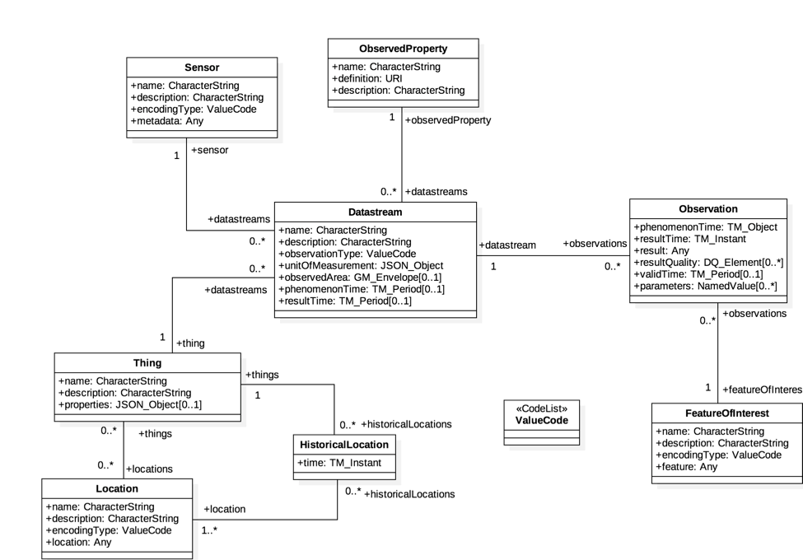
Figure 1: ISO 19156 data model
In the SensorThings data model an events or sensor data is an ‘observations’. Before a sensor is able to push an observation to the server it needs at least a ‘thing’- and a ‘data stream’ entity. This has to be created beforehand. One ‘thing’ might have different ‘sensors’, one ‘location’ or many ‘historical locations’.
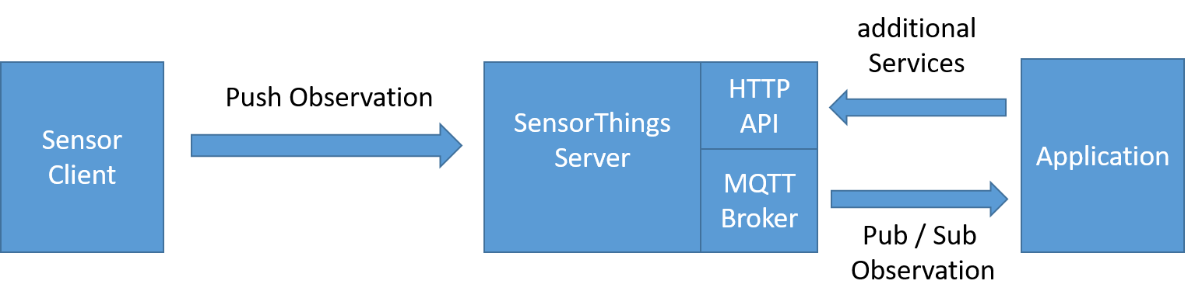
Figure 2: Exemplary STA message flow

5.2 SensorThings API example use-case
The message flow in Figure 2 can be explained by using an example of an application that wants to use data of ev-charging stations in a city.
- In order to get all relevant observations belonging to the cities ev-charging stations the application needs to know all regarded data streams. Therefore the application sends a request with filter parameter to the HTTP-API of the server e.g.:
https://sta-example-server-address.com/v1.0/Things?$filter=substringof(“Charging”,name)&$count=true&$expand=Datastreams
As a response the server provides a list of all data streams belonging to a charging station.
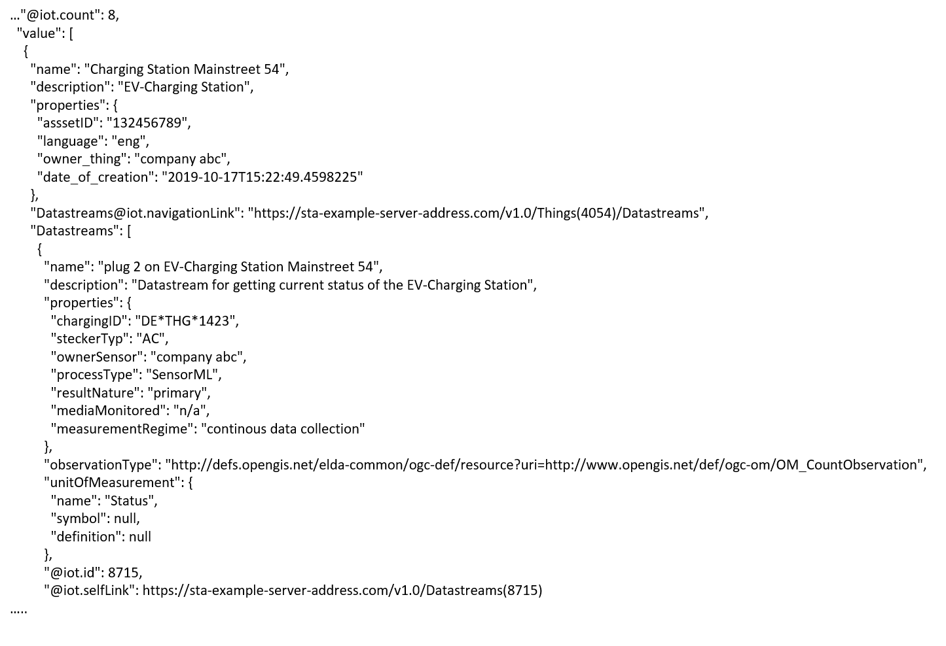
Figure 3: One exemplary entry of the result list of a filter request
- The application can now subscribe to these data streams. Figure 3 shows one entry of the result list. It represents an EV-Charging Station as a thing including the regraded datastream in the last line of the entry.
- As soon as the sensor (ev-charging station) changes its status e.g. from “available” to “charging” it pushes an oberservation to the server.
- The application gets the observation through a notification that is send by the MQTT-Broker. An example of an observation is shown in figure 4. In the result field is shown the current status of the EV-Charging Station “charging”.
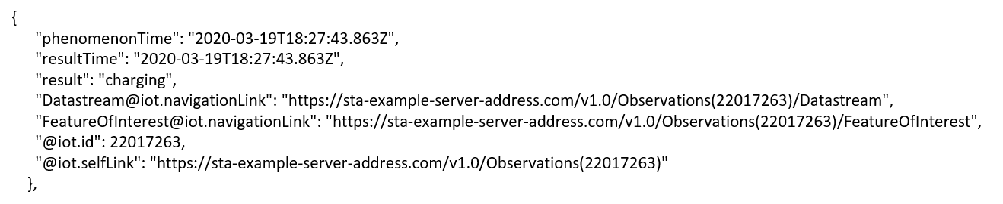
Figure 4: Exemplary STA observation

-----------------------Start of change 1-------------------------------------------

6 Architecture Model of OGC/STA to oneM2M interworking
Figure 1 shows an architecture approach for an Interworking Proxy Entity (IPE) between oneM2M and OGC Sensor Things API. The IPE is located between a oneM2M CSE and a OGC/SensorThingsAPI (STA)-Server.
The basic interworking enables applications that are connected to an oneM2M-based system to get data from sensors that are connected to an OGC/STA server. Furthermore, an application that is connected to an OGC/STA server is able to get data from sensors that are connected to an oneM2M-based system.
Figure 5: IPE architecture overview

6.1 OGC/STA-to-oneM2M Data Model Mapping
According to TS-0033 a representation of a non-oneM2M Proximal IoT function in a oneM2M-specified resource instance is needed to be synchronized with the entity that it represents.
This actual means that the OGC/STA data model has to be represented in the hosting CSE. The data in the OGC/STA server are organized according to ISO 19156 (see Figure 1: ISO 19156 data model).
The oneM2M structure for data models is a tree-structure where data is organized in containers or trees of containers. The OGC/STA data model has loops and is not hierarchical. Thus, it cannot mapped one-to-one to oneM2M or vice-versa.

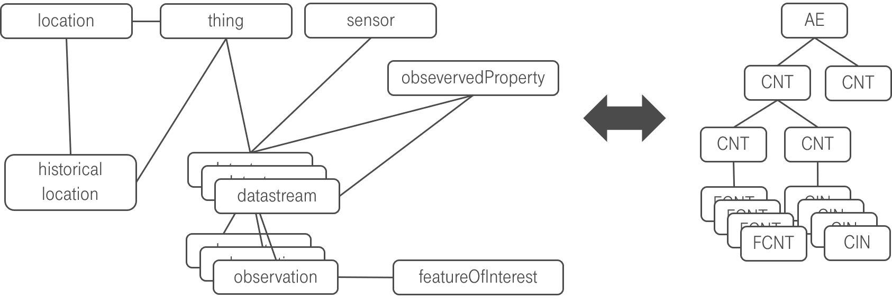
Figure 6: OGC data model cannot directly mapped to oneM2M

6.2. Architecture Approaches
The fact that the data model cannot directly be mapped has consequences for the architecture of an interworking between both standards. In the following sub chapters, we are going to discuss three different approaches and their advantages and disadvantages.

6.2.1 „Flat Data Model“ Approach
One approach is to form for every single group of entities in OGC data model a separate oneM2M container entity. Figure 7 shows a oneM2M data model that could represent an OGC/STA - IPE in a hosting CSE.
The top of a tree is an <ae>. Below there are <containers> representing the dedicated parts of the ISO 19156 data model. They are all at the same level and form a flat data model representation.
There is for example one <container> where all incoming <observations> are stored by the IPE. There is another <container> where the <Datastream> object(s) for this <Observation> are stored.
There are also <containers> for <Locations>, <Sensors>, <Things> etc.
The OGC/STA -<Observation> itself is represented as an <flexContainer> under a <container> called “observations”.
The OGC/STA -<DataStream> itself is also represented as an <flexContainer> under a <container> called <Datastream>. In figure 7 the <flexContainer> are represented as grey boxes.
This way a oneM2M data structure is formed with all kind of entities from ISO 19156 data model.
But we need also to represent the relationships between the ISO 19156 entities. This can be done through dedicated attributes defined inside the regarded <flexContainer>.
Figure 7 shows the <flexContainer> with the resource name <rn> “ObservationXYZ” that has an attribute “<STAdatastream>” with the value “Datastream123”. This Attribute points to a <flexContainer> representing the <Datastream> object with the <resourceName>”dataStream123” located in the DataStream <container>. This way the attribute represents inherent the relationships from the OGC/STA data model.
Actually, two kinds of relationships are described in this approach:
- The first kind are the oneM2M specific <ae>-to-<container>-to-<flexContainer> relationships (grey lines).
- The second kind of relationships are OGC specific and are expressed as attributes inside the <flexContainer> entities. Here for example a <Observation>-to-<DataStream>-to-<Thing> relationship is described (blue line).

- 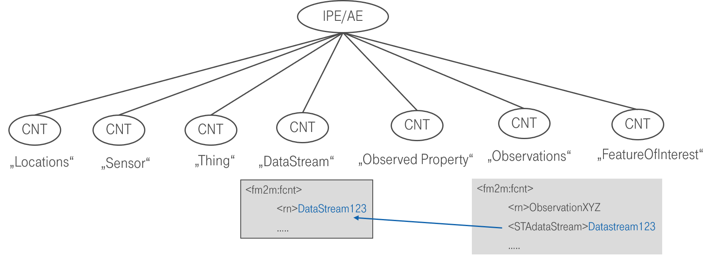
Figure 7: The flat data model with inherent connections

6.2.1.1 Missing Relationship Management
The inherent relationships (blue line in figure 7) describing the OGC/STA data model can’t be managed by the CSE in today’s oneM2M. Only the relationships between <ae> and <container> can be managed (grey lines) by the CSE.
When for example a certain <flexContainer> representing a <DataStream> is deleted all related <flexContainers> representing an <Observation> have to be deleted too. This is how it’s handled in an OGC/STA Server. But this is not possible inside the hosting CSE.

6.2.1.2 Discussion of “Flat Data Model” Approach
This approach has advantages and disadvantages:
- Although the data relationships can be described in the hosting CSE they cannot be managed by the CSE. This might lead to inconsistent data and synchronization issues
- This approach is in line with TS0033 because there is a representation of a non-oneM2M Proximal IoT function
Note: This approach is rather a theoretical one and shows the issue of a missing oneM2M relationship management in the CSE.

6.2.2 „On-the-fly“ Approach
The “On-the-fly” approach forwards every request from the oneM2M side to the IPE. The IPE translates the request “on-the-fly” towards OGC/STA and retrieves the response. The OGC response is translated towards oneM2M and goes through the CSE back to the requesting application. In the hosting CSE a <remoteCSE> entity is used to forward the requests to the gateway.
Figure 8 shows the oneM2M-to- OGC/STA direction. A <contentInstance> is created at the hosting CSE on a <remoteCSE> endpoint. The request is forwarded the remote CSE in this case the IPE. The IPE forms an <Observation> creation request and copies the “content” attribute of the <contentInstance> to the ”result” attribute of the <Observation> and sends it to the OGC/STA server.
Figure 8: Gateway oneM2M-to-OGC/STA direction
Figure 9 shows the OGC/STA-to-oneM2M direction. OGC/STA does not define a publish / subscribe mechanism on HTTP protocol level. The IPE has to subscribe to the MQTT-Broker of the OGC/STA server. The OGC/STA server publishes on its MQTT broker a new <observation>. The IPE forms a <contentInstance> creation request and copies the “result” attribute of the <Observation> to the “content” attribute of the <contentInstance>. Alternatively, also a <flexContainer> might be created. A <container> might be created beforehand at the hosting CSE where the IPE <contentInstances> or <flexContainers> are stored. All interested application might subscribe to this container.
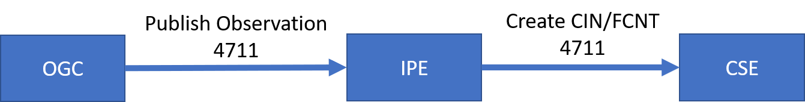
Figure 9: Gateway OGC-to-oneM2M direction
This approach is very simple and sufficient when its only about translating <Observation> to <contenInstances> and vice-versa. In case of other parts of the OGC data model like <Sensor> or <Location> it needs additional requests from an interested application.

6.2.2.1 Optional Additional Data Requests
Every OGC/STA <observation> has an ID. With that ID the OGC/STA server might be asked for further parts of the data model. That is why the ID has to be copied from OGC/STA to oneM2M too. With that ID the oneM2M application might asked the IPE for all other parts of OGC/STA data model.
The kind of additional information might be encoded in the URL. So, the gateway is able to retrieve the requested information. In some case like e.g. for the location the gateway needs to perform several requests before an answer can be delivered to the CSE and a subscribed oneM2M application (see Figure 10).
Figure 10 shows the message flow where an application wants to know the <Location> of an received <Observation> with an ID “4711”. A oneM2M application might request a <contentInstance> on dedicated endpoints e.g. “../observation4711/location”. The request is forwarded via <remoteCSE> mechanism and the IPE performs several requests towards the OGC/STA server in order to get the regarded <Location>. The OGC/STA <Location> might translated to an dedicated attribute of an <flexContainer>.
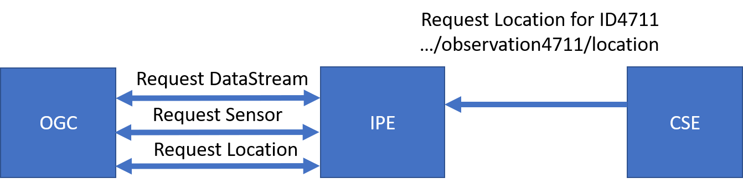
Figure 10: Requesting additional parts of the OGC data model

6.2.2.2 Discussion of “On-the-fly” approach
The “On-the-fly” approach has a number of disadvantages:
- This approach is not acceptable according to TS0033, because there is no representation of a non-oneM2M Proximal IoT function
- The oneM2M client application needs knowledge about the structure of the OGC data model, in case it wants to request additional data to an <observation>
- It needs a dedicated URL scheme for additional data requests. This schema has to be known by the application.
- The observation ID has to be copied from the <Observation> to the oneM2M data structure for example a <flexContainer> in case the oneM2M client application wants to get additional data.
On the other hand, the approach has also advantages:
The IPE does not need a copy of the OGC/STA data model in the hosting CSE. Data are always accurate because they stay in the authoritative source, the OGC/STA server. This approach prevents synchronization effort and possible errors.
Conclusion:
The “On-the-fly” approach is a very flexible solution when only single value data needs be exchanged. When the data get more complex the oneM2M application needs knowledge about the OGC / STA data structure.
This approach is not compliant with TS0033.

6.2.3 “Specific Device” Approach
Another architectural approach is to focus the design of the IPE on a specific device type.
The data model might be described according to TS-0023 Home Appliance Information Model. TS-0023 describes a templating tool for describing heterogenous devices and their functionalities Smart Device Template (SDT). SDT offers a generic and flexible modelling structure for non-oneM2M devices.
The first step in an OGC/STA interworking scenario is to register the IPE to the hosting CSE an <ae> resource. This resource is a parent for a <flexContainer> resource specializations representing a dedicated device connected to the OGC/STA server (for example an EV-Charging station).
OGC/STA devices might be modelled as SDT Devices. Mapping of the SDT Device model to oneM2M resources is performed according to the general mapping procedure described in clause 6.2.2 of TS-0023. A SDT Device component is mapped to a specialization of a <flexContainer> resource with an associated 'DeviceClass ID' (e.g. "org.onem2m.home.device.tv") containerDefinition attribute.
Figure 11 shows an example of a OGC/ STA device:[ [deviceElectricVehicleCharger]], which is modelled as a <flexContainer> resource specialization derived from the corresponding SDT Device component. The model of [[deviceElectricVehicleCharger]] follows the schema described in clause 5.5.18 of TS-0023.
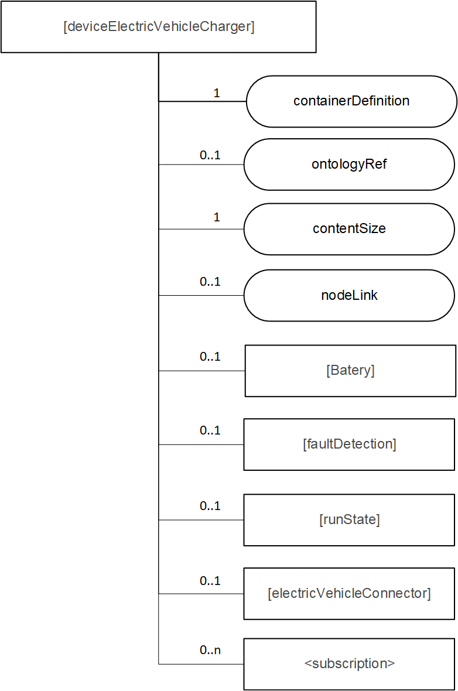
Figure 11: [deviceElectricVehicleCharger] example resource representing a OGC/STA device
<flexContainer> based on SDTs enable to design a desired data model for various device types. The IPE is responsible to translate changes in the OGC data model and update the <flexContainer> accordingly.

6.2.3.1. Communication Schema
In this approach the IPE subscribes to the MQTT message broker of the OGC/STA server to all desired changes in the data model of a certain OGC/STA device. This way apart from <Observations> all changes like e.g. <Location> are published to the IPE (Figure 12). The IPE sorts out what changes affect the <flexContainer> and sends UPDATE messages.
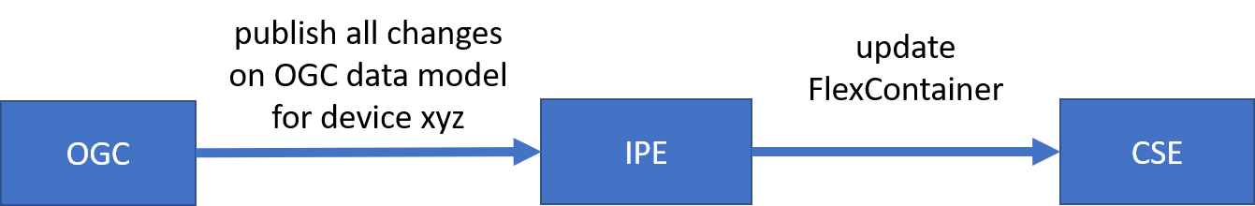
Figure 12: OGC/STA-to-oneM2M direction
The IPE subscribes to the regarded <flexContainer> in the hosting CSE. As soon if there are changes from an application the IPE gets a <notification> message. The IPE assigns the appropriate messages to update the OGC data model (Figure 13.)

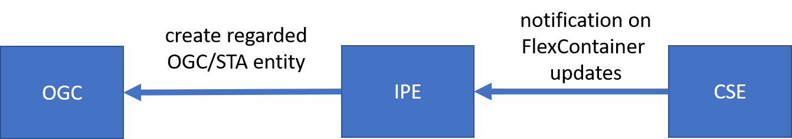
Figure 13: oneM2M-to-OGC/STA direction

6.2.3.2 Discussion of the ““Specific Device” Approach
This disadvantage of this approach is that is not a flexible one-for-all solution. The SDT data model and its mapping to the OGC world has to be designed beforehand specifically to the device. Even if there are tools to create SDT <flexContainer> from a certain device automatically the mapping to or from the OGC/STA data model might be still very individual because e.g. the “properties” field in the OGC/STA data model can be filled with arbitrary data.
As a consequence, this approach enables no OGC/STA IPE for general use. Rather more it enables a OGC / STA IPE for e.g. “EV-Charging Stations” of “Company XYZ” in “Version 1.23”.
But this architecture approach comes also with a great advantage. Unlike in the approaches discussed before here the client application does not any knowledge about the OGC data model. A client application might only rely on oneM2M specifications and is still able to read data coming from a sensor that is connected via OGC / STA.
This approach is fully compliant with TS0033.

7 Architecture Aspects

7.1. Composition of the SensorThingsAPI IPE
The IPE consists of three modules. Towards the oneM2M-side the IPE implements an AE with Mca interface functionalities. An exception is the “On-the-fly” approach, here the IPE would implement a Mcc interface.
An application can receive data from the IPE and forward data to the IPE using its interface to the hosting CSE.
Towards the OGC/SensorThingsAPI side the IPE implements a sensor interface pushing data via HTTP to the OGC/STA server. OGC/STA data entities can be created as well as retrieved via this HTTP-REST-API.
Since OGC/STA does not have a publish / subscribe mechanism on HTTP level an MQTT-broker is used to publish events that are pushed to the OGC/STA server. The IPE subscribes to the MQTT-Broker in order to get data from the OGC/STA server.
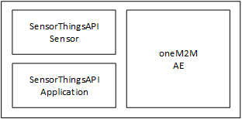
Figure 14: Composition of the IPE

7.2 IPE Startup
The operation of the IPE requires registration and mapping beforehand at both, CSE and OGC/STA server:
- Register the IPE as <AE> at hosting CSE and create initial <container> and / or <flexContainer>
- Subscribe to selected <Thing> (and regraded entities) at MQTT-broker at OGC/STA server
- Create <Thing> and <Datastream> at OGC/STA server in order to push <Observations>.

7.2.1 IPE registration
The AE representing the IPE needs to be created at the hosting CSE. Furthermore a <container> and/or <flexContainer> structure has to be created at the CSE according to the chosen data model.mapping approach. Figure 15 shows a generic IPE registration call flow.
- The IPE requests to create an <AE> resource on the Hosting CSE
- The Hosting CSE evaluates the request, performs the appropriate checks, and creates the <AE> resource.
- Hosting CSE responds with the successful result of <AE> resource creation, otherwise it responds with an error.
The <point of access> (poa) of the <AE> entity points to the IPE. The IPE should be created along with a login or access token.
- The IPE needs to create a <container> and/or <flexContainer> structure inside the <AE> in order to organize the data. The structure of containers depends on application needs and is discussed in the following chapters.
- The Hosting CSE evaluates the requests, performs the appropriate checks, and creates the <Container> resources.
- Hosting CSE responds with the successful result of <Container> resource creation, otherwise it responds with an error.
- All oneM2M applications those are interested in OGC/STA data create a <Subscribtion> to the regarded container where observation data are stored by the IPE.
- The hosting CSE evaluates every subscription by testing the notification endpoint
- The Hosting CSE evaluates the requests, performs the appropriate checks, and creates the <Subscription> resources.
- Hosting CSE responds with the successful result of <Subscription> resource creation, otherwise it responds with an error.
- The IPE also creates a <Subscription> to those containers that are used for the-oneM2M-to-OCG/STA direction. This way incoming data from a oneM2M-based sensor or application are forwarded to the IPE.
- The hosting CSE evaluates the subscription by testing the existence of the notification endpoint at IPE
- The Hosting CSE evaluates the requests, performs the appropriate checks, and creates the <Subscription> resources.
- Hosting CSE responds with the successful result of <Subscription> resource creation, otherwise it responds with an error.
Figure 15: IPE Registartion call flow

7.2.2 Subscription to MQTT Broker
This step is necessary for the OGC/STA-to oneM2M dataflow direction.
At current OGC/STA specification there is no publish / subscribe mechanism on HTTP level. The IPE needs to subscribe to the MQTT-Broker where events like new <Observations> of the OGC/STA sensors are published. The IPE could also subscribe to other events or changes like for example <Location>, <Thing> etc.
According to the ISO 19156 data model an <Observation> is published in a <Datastream> belonging to a <Thing>. The IPE subscribes to a <Datastream> of <things> that are of interest for being forwarded to the oneM2M side. The desired <Thing> and their regarded <DataStream> might be configured / discovered in an initial “Startup”-step of the IPE and/or updated on a regular base.
In the introduced architecture model the IPE is for the OGC /STA server an application that wants to be informed about new observations via MQTT.

7.2.3 Preconfiguration of the OGC / STA Server
This step is necessary for the oneM2M-to-OGC/STA data flow direction.
A OGC / SensorThingsAPI sensor pushes its sensor data as <Observation> entities to the server. Before an <Observation> can be received and stored according to the ISO 19156 data model a <Thing> and an associated <Datastream> have to be created. The <Datastream> gets an ID back (e.g. “Datastream”:{“@iot.id:3635353”}) from the OGC / STA server. This ID is needed to send an <Observation> to the OGC / STA Server and has to be stored in the IPE.
For the OGC /STA server the IPE is a sensor that uploads data via MQTT or HTTP.

-----------------------End of change 1-------------------------------------------

