Input Contribution
Meeting ID* | SDS#48
Title:* | TR-0057 – 3GPP Interworking
Source:* | Laurent Velez, ETSI, laurent.velez@etsi.org  Bob Flynn, Exacta, bob.flynn@exactagss.com
Date:* | 2020-12-08
Input related to* | TR-0057 V0.3.0
Intended purpose of  document:* | Decision  Discussion  Information  Other <specify>
Impacted other TS/TR(s)
Decision requested or recommendation:* | To incorporate into baseline the new proposed text if agreed.
Template Version: January 2017 (Do not modify)

oneM2M Notice
The document to which this cover statement is attached is submitted to oneM2M. Participation in, or attendance at, any activity of oneM2M, constitutes acceptance of and agreement to be bound by terms of the Working Procedures and the Partnership Agreement, including the Intellectual Property Rights (IPR) Principles Governing oneM2M Work found in Annex 1 of the Partnership Agreement.

Introduction
This contribution proposes a overall and basic description of the 3GPP Interworking features.

-----------------------Start of new text 1-------------------------------------------

7 Main feature descriptions

7.2 3GPP Interworking

7.2.1 Introduction
The oneM2M Service Layer can operate over a variety of underlying network connections, including LPWAN Cellular IoT. The northbound API for applications to interface to a oneM2M Service Layer facilitates horizontal sharing of data across different domains. The services exposed by the oneM2M Service Layer allow working with many types of devices and treating different devices as if they are all the same.

Figure 7.2.1-1: Typical Cellular IoT Deployment

- Use of 3GPP IoT features requires low-level knowledge of 3GPP and a business relationship with operator (E.g. Configuration of IoT device sleep times requires intimate knowledge of 3GPP Power Savings Mode (PSM) or extended Idle Mode DRX (eDRX)
➔ This presents a high barrier of use and adoption by typical IoT device manufacturers and app developers
- If devices and apps do not properly use these features, cellular IoT deployments are destined to fail
- Inefficient use of network resources → higher costs and less scalability for operators
- Shortened battery life of devices → inability to deploy cellular IoT devices in many IoT use cases
- Security threats to the network → network, devices and application security will be compromised

3GPP has been adding several IoT centric features to their standard starting in Release 10. For instance, the IoT features are:
- Features to avoid network congestion resulting from massive numbers of IoT devices such that operators can continue to provide a high quality of service to all their subscribers
- Features to enable more efficient use of network resources by IoT devices such that an operator can minimize network deployment and management costs
- Features to help keep an operator’s network secure from the increased threats of IoT devices
- Features that allow IoT devices to sleep for long periods of time such that they can maximize their battery lives

Since Release 3, oneM2M includes additional support for interworking to underlying 3GPP network services , allowing IoT devices to operate in constraint environement where low power and long battery life is necessary.
oneM2M can be deployed internal (or external) to an operator’s network and enable an operator to move up the value-chain to offer not just connectivity but also additional value-add IoT services.
oneM2M interacts with a 3GPP operator’s network to mitigate congestion, enable efficient use of network resources, and help keep network secure. The 3GPP features are exposed to oneM2M service layer for the benefit of IoT applications, and vice-versa.
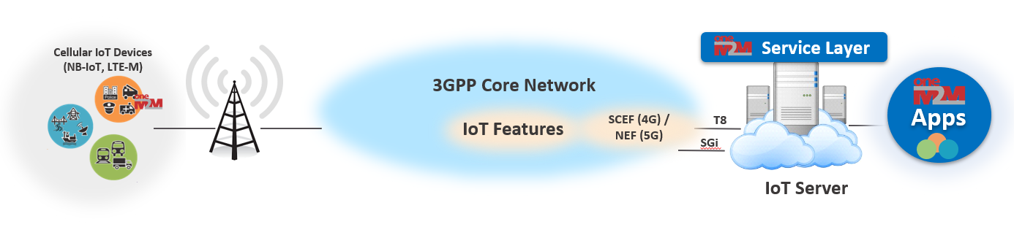
Figure 7.2.1-2: oneM2M - 3GPP Interworking using SCEF / NEF

oneM2M supports interworking to underlying 3GPP network services:
- Sending/Receiving request to/from UE over 3GPP control plane (Non-IP Data Delivery NIDD) rather than data plane
- Configuration of UE’s Power Savings Mode or extended Idle Mode DRX (PSM/eDRX) parameters based on App requirements
- Scheduling and buffering of messages based on UE’s reachability and/or App’s backgroung data policies
- Triggering of UE to establish a network connection and/or register or enrol based on App requirements
- Configuration of network QoS parameters based on App requirements
- Querying of UE location and making it available to Apps
- Receiving notifications when the network is congested and scheduling messages to UE accordingly
- Receiving notifications when UE has been tampered with and disabling communication with UE

7.2.2 IoT Device Enrollment
One of the main challenges when deploying an IoT network is to get unmanned IoT devices to enroll to an IoT Service Provider, provision the devices with essential security IDs, Credentials and contact information required to allow the devices to connect, authenticate and securely register to an IoT Gateway or Server such that they can use services offered by the Service Provider.
Once enrolled and registered, and in order to save battery life, a 3GPP IoT devices does not maintain long-lived network connections. Before a request can be sent to a 3GPP IoT device, it first re-connects to the 3GPP network.
With the standardized interworking with 3GPP network, oneM2M Service Layer initiates the triggering of cellular IoT devices to connect to an operator’s network, be bootstrapped with proper security credentials and authenticate and securely register.

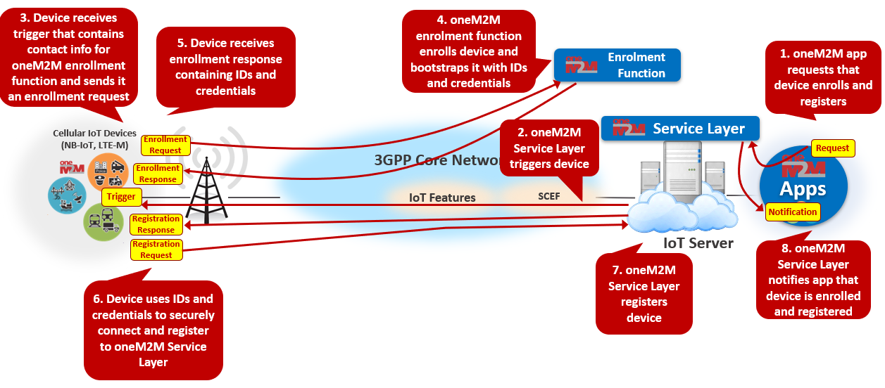
Figure 7.2.2-1: IoT device Enrollement
3GPP T8 supports the capability to allow Service Capability Server to initiate sending a trigger message to a specified UE to perform application specific actions. The underlying 3GPP network routes the trigger request message to the appropriate UE and UE routes the message to the appropriate application
oneM2M defines a trigger payload structure that supports triggering a UE to perform the following actions:
- Contact a oneM2M enrollment server MEF to be provisioned with the necessary IDs and credentials needed for authentication and use of services in a oneM2M Service Provider’s domain.
- Register to a specified oneM2M server (i.e. IN-CSE)
- Establish an IP connection to the oneM2M server that the UE is registered to and update the UE’s point-of-contact information (e.g. IP address and port)
- Perform an specified operation on a specified resource hosted by a specified oneM2M server (e.g. create a new child <contentInstance> resource in a specified parent <container> resource).
oneM2M exposes a trigger API to oneM2M applications that allows them to initiate triggering a UE to perform any of the above actions
- This API is supported via the oneM2M defined <triggerRequest> resource
- This API is layered on top of the SCEF T8 device triggering

7.2.3 IoT Device Sleep Schedule Management
Battery life is crucial for IoT devices. NB-IoT and CAT-M1 devices can supposedly run on 2 double AA batteries for 10 years. 3GPP has defined “deep state” mode (Power Savings Mode or extended Idle Mode DRX) in order to save IoT device battery. But in deep sleep, data can not be sent to the device, thus the device can not be reached. Devices need to sleep for hours if they want to achieve a battery life of multiple years. An IoT Server that collects data from cellular devices needs to understand that the device will be unreachable for long stretches of time.
oneM2M Service Layer optimizes the sleep schedule of cellular IoT devices such that battery life can be maximized. This can be done based on the schedule requirements of IoT devices and the apps that interact with the devices and the requirements of the cellular network operator.
oneM2M supports managing UE schedules based on application requirements:
- oneM2M server (IN-CSE) aggregates schedule requirements for a given UE
  - oneM2M allows each application (AE or CSE) hosted on a UE to specify its schedule of when requests need to be sent or received
  - oneM2M also allows applications that communicate with a UE to specify schedule of when they need to communicate with the UE
- oneM2M server keeps the underlying 3GPP network informed (via T8) of UE schedule requirements

oneM2M exposes a device communication schedule API to oneM2M applications that allows them to configure schedule requirements, retrieve schedule information and receive notifications of schedule changes.
- This API is supported via the oneM2M defined <schedule> resource
- This API is simpler and more user friendly than 3GPP API. It hides complexity of 3GPP T8 API
  - E.g. UE needs to be reachable from 1:00 – 1:30pm every Tuesday
- This API is layered on top of the SCEF T8 Network Parameter Configuration, Reachability Monitoring, and Communication Pattern Configuration APIs

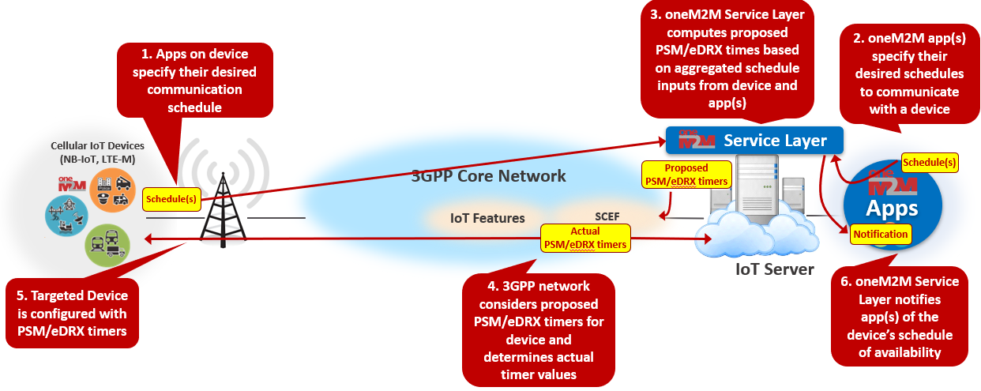

Figure 7.2.3-1: IoT Device Sleep Schedule Management

7.2.4 IoT Device Location Tracking
Certain IoT use cases require awareness of an IoT device location, however many IoT devices lack location reporting capability.
oneM2M Service Layer supports the capability to interwork to the 3GPP T8 for the following Device Location operations :
- A oneM2M server supports the capability to interwork to the 3GPP T8 location monitoring API to retrieve the current location of a UE and to subscribe to receive notifications if a UE’s location changes.
- A oneM2M server supports storing location history of a UE.
- A oneM2M server supports geo-fencing capabilities used to generate events if/when a UE’s location enters or leaves a specified boundary.
- A oneM2M server supports location-based authorization used to grant/deny access to resources based on the location of the originator of a request.
- oneM2M exposes a location API to oneM2M applications :
- Application can retrieve the current location of a UE, instruct the oneM2M server to track the location of a UE or can define a geo-fence boundary.
- This API is supported via the oneM2M defined <locationPolicy> resource
- This API is layered on top of the SCEF T8 location monitoring API

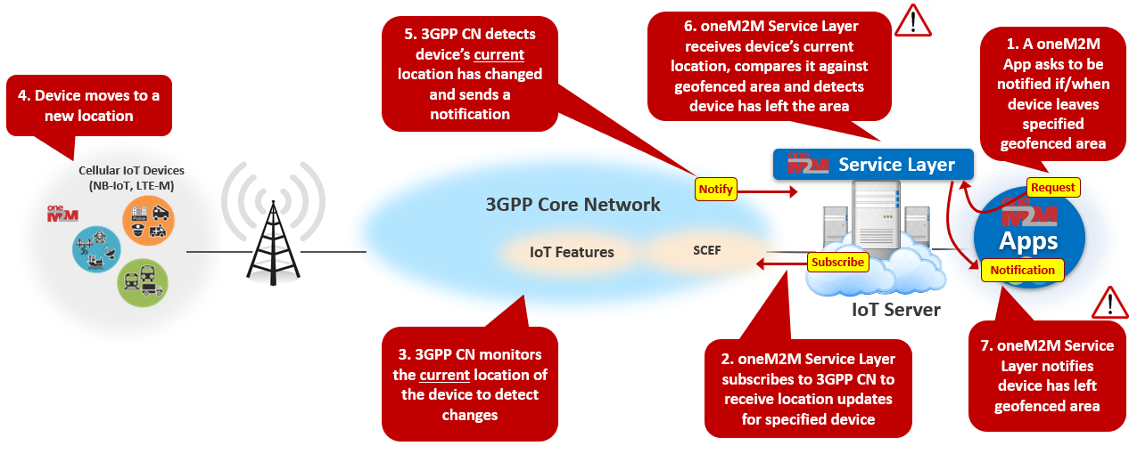
Figure 7.2.4-1: IoT Device Location Tracking

7.2.5 IoT Device Message Delivery Handling

7.2.6 Network Congestion Control

7.2.7 Non-IP Data Delivery (NIDD)

7.2.8 IoT Device Tampering Detection

7.2.9 Management of Groups of IoT Devices

7.2.10 IoT Roaming Device Services

-----------------------End of new text 1-------------------------------------------

