CHANGE REQUEST
Meeting ID:* | SDS 49
Source:* | Rahul, C-DOT, krahul@cdot.in  Anupama, C-DOT, anupama@cdot.in  Poornima, C-DOT, poornima@cdot.in
Date:* | 2020-12-10
Reason for Change/s:* | See the introduction
CR against: Release* | V4.1.1
CR against: WI* | Active <Work Item number>  MNT maintenance / < Work Item number(optional)>  Is this a mirror CR? Yes No  mirror CR number: (Note to Rapporteur - use latest agreed revision)  STE Small Technical Enhancements / < Work Item number (optional)>  Only ONE of the above shall be ticked
CR against: TS/TR* | TS-0022 V4.1.1
Clauses * | 7.1.2, 7.2.2
Type of change: * | Editorial change  Bug Fix or Correction  Change to existing feature or functionality  New feature or functionality  Only ONE of the above shall be ticked
Other TS/TR(s) impacted | <TS/TR number>, <Version Number>, and <Description on which aspect should be reflected in this TS/TR>
Post Freeze checking:* | This CR contains only essential changes and corrections? YES NO  This CR may break backwards compatibility with the last approved version of the TS? YES NO
Template Version: January 2020 (do not modify)

oneM2M Notice
The document to which this cover statement is attached is submitted to oneM2M. Participation in, or attendance at, any activity of oneM2M, constitutes acceptance of and agreement to be bound by terms of the Working Procedures and the Partnership Agreement, including the Intellectual Property Rights (IPR) Principles Governing oneM2M Work found in Annex 1 of the Partnership Agreement.
GUIDELINES for Change Requests:
Provide an informative introduction containing the problem(s) being solved, and a summary list of proposals.
Each CR should contain changes related to only one particular issue/problem.
If this is a correction, and the change applies to previous releases, a separate “mirror CR” should be posted at the same time as this CR
Mirror CR: applies only when the text, including clause numbering are exactly the same.
Companion CR: applies when the change means the same but the baselines differ in some way (e.g. clause number).
Follow the principle of completeness, where all changes related to the issue or problem within a deliverable are simultaneously proposed to be made e.g. a change impacting 5 tables should not only include a proposal to change only 3 tables. Include any changes to references, definitions, and abbreviations in the same deliverable.
Follow the drafting rules.
All pictures must be editable.
Check spelling and grammar.
Use change bars for modifications.
The change should include the current and surrounding clauses to clearly show where a change is located and to provide technical context of the proposed change. Additions of complete clauses need not show surrounding clauses as long as the proposed clause number clearly shows where the proposed new clause is located.
Multiple changes in a single CR shall be clearly separated by horizontal lines with embedded text such as, start of change 1, end of change 1, start of new clause, end of new clause.
When subsequent changes are made to the content of a CR, then the accepted version should not show changes over changes. The accepted version of the CR should only show changes relative to the baseline approved text.

Introduction
Currently in specs, Service subscription information is required at AE registration and it is assumed that the Receiver shall have the subcriber’s profile information stored locally or retrieved from the IN-CSE.
But at the time of AE registration, it is not clear that how to derive the SSP ID corresponding to AE.
This CR proposes to add optional attribute M2M-Sub-ID to [registration] resource in order to provide the ID of the Service Subscription profile to which this <registration> belongs to. This will enable a CSE to map an AE registration info with its service subscription ID.
When MN/ASN is registrar CSE then <registration> resource for an AE can be announced to MN/ASN to update them with its registree information.
R02
In this revision use case diagram is added to describe the purpose.
Minor format edits

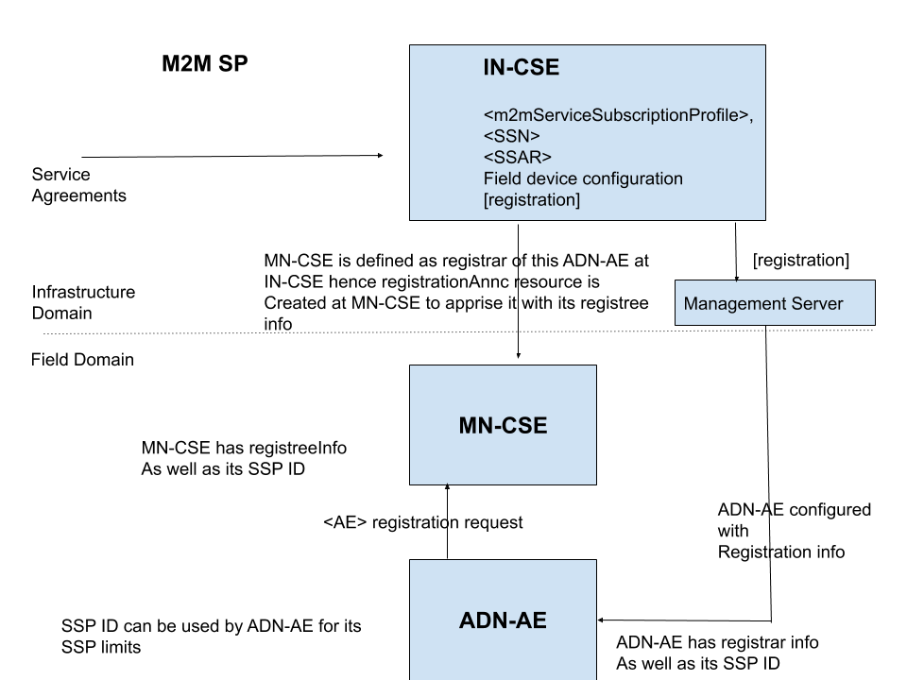

-----------------------Start of change 1-------------------------------------------

7.1.2 Resource [registration]
This specialization of <mgmtObj> is used to convey the service layer configuration information needed to register an AE or CSE with a Registrar CSE.

Figure 7.1.2-1: Structure of [registration] resource
The [registration] resource shall contain the child resource specified in table 7.1.2-1.
Table 7.1.2-1: Child resources of [registration] resource
Child Resources of [registration] | Child Resource Type | Multiplicity | Description
[variable] | <subscription> | 0..n | See clause 9.6.8 of oneM2M TS-0001 [Error: Reference source not found]

The [registration] resource shall contain the attributes specified in table 7.1.2-2.
Table 7.1.2-2: Attributes of [registration] resource
Attributes of  [reboot] | Multiplicity | RW/  RO/  WO | Description
resourceType | 1 | RO | See clause 9.6.1.3 of oneM2M TS-0001 [Error: Reference source not found].
resourceID | 1 | RO | See clause 9.6.1.3 of oneM2M TS-0001 [Error: Reference source not found].
resourceName | 1 | WO | See clause 9.6.1.3 of oneM2M TS-0001 [Error: Reference source not found].
parentID | 1 | RO | See clause 9.6.1.3 of oneM2M TS-0001 [Error: Reference source not found].
expirationTime | 1 | RW | See clause 9.6.1.3 of oneM2M TS-0001 [Error: Reference source not found].
accessControlPolicyIDs | 0..1 (L) | RW | See clause 9.6.1.3 of oneM2M TS-0001 [Error: Reference source not found].
creationTime | 1 | RO | See clause 9.6.1.3 of oneM2M TS-0001 [Error: Reference source not found].
lastModifiedTime | 1 | RO | See clause 9.6.1.3 of oneM2M TS-0001 [Error: Reference source not found].
labels | 0..1(L) | RW | See clause 9.6.1.3 of oneM2M TS-0001 [Error: Reference source not found].
mgmtDefinition | 1 | WO | See clause 9.6.15 of oneM2M TS-0001 [Error: Reference source not found]. This attribute shall have the fixed value 1020 ("registration").
objectIDs | 0..1 (L) | WO | See clause 9.6.15 of oneM2M TS-0001 [Error: Reference source not found].
objectPaths | 0..1 (L) | WO | See clause 9.6.15 of oneM2M TS-0001 [Error: Reference source not found].
description | 0..1 | RW | See clause 9.6.15 of oneM2M TS-0001 [Error: Reference source not found].
originatorID | 0..1 | RW | CSE-ID of the CSE hosted on the ASN/MN or the AE-ID of an AE hosted on an ASN/MN or ADN node.  If the setting is for a CSE, then this attribute shall be present.
pointOfAccess | 0..1(L) | RW | The point of access URI of the Registrar CSE. It represents the list of physical address used by AE/CSEs to connect to registrar CSE.  Example:  http://172.25.0.10:8080/xyz  coap://m2m.sp.com:5683  mqtt://172.25.0.10:1883  ws://10.222.254.26:80  See note.
CSEBase | 0..1 | RW | The resource identifier of the <CSEBase> resource representing Registrar CSE.
CSE-ID | 0..1 | RW | The CSE identifier of Registrar CSEin SP-relative CSE-ID format
appID | 0..1 | RW | The App-ID of an AE. This attribute shall only be present when this resource is used for the registration of an AE.
externalID | 0..1 | RW | The M2M-Ext-ID of the ASN/MN CSE. This attribute can be present when the originatorID is a CSE-ID and the CSE uses the dynamic registration defined in clause 7.1.10 Trigger Recipient Identifier of oneM2M TS-0001 [Error: Reference source not found].
triggerRecipientID | 0..1 | RW | The Trigger-Recipient-ID of the ASN/MN CSE. This attribute can be present when the originatorID is a CSE-ID and the CSE uses the dynamic registration defined in clause 7.1.10 Trigger Recipient Identifier of oneM2M TS-0001 [Error: Reference source not found].
mgmtLink | 0..1 | RW | A link to a <mgmtObj> resource instance containing the information for establishing a security association with the Registrar CSE.
M2M-Sub-ID | 0..1 | RW | The identifier assigned by the M2M Service Provder for the M2M Service Subscription of the registree.
NOTE: Protocol binding is determined from the protocol schema in this URI.

-----------------------End of change 1---------------------------------------------

-----------------------Start of change 2-------------------------------------------

7.2.2 Resource [registration]

7.2.2.1 Introduction
This specialization of <mgmtObj> is used to convey the service layer configuration information needed to register an AE or CSE with a Registrar CSE.
Table 7.2.2.1-1: Data Type Definition of [registration]
Data Type ID | File Name | Note
registration | DCFG-registration-v4_0_0.xsd

Table 7.2.2.1-2: Resource specific attributes of [registration]
Attribute Name | Request Optionality |  | Data Type | Default Value and Constraints
Attribute Name | Create | Update | Data Type | Default Value and Constraints
mgmtDefinition | M | NP | See clause 7.4.15of oneM2M TS-0004 [Error: Reference source not found]. | "registration"
objectIDs | O | NP | See clause 7.4.15 of oneM2M TS-0004 [Error: Reference source not found].
objectPaths | O | NP | See clause 7.4.15 of oneM2M TS-0004 [Error: Reference source not found].
description | O | O | See clause 7.4.15 of oneM2M TS-0004 [Error: Reference source not found].
originatorID | O | O | m2m:ID | CSE-ID of the CSE hosted on the ASN/MN or the AE-ID of an AE hosted on an ASN/MN or ADN node.  If the setting is for a CSE, then this attribute shall be present.
pointOfAccess | O | O | m2m:poaList | The point of access URI of the Registrar CSE.  Note; protocol binding is determined from the protocol schema in this URI.
CSEBase | O | O | xs:anyURI | No Defaults
CSE-ID | O | O | m2m:ID | No Defaults
appID | O | O | m2m:ID | The APP_ID of an AE. This attribute shall only be present when this resource is used for the registration of an AE.
externalID | O | O | m2m:externalID | The M2M-Ext-ID of the ASN/MN CSE. This attribute can be present when the originatorID is a CSE-ID and the CSE uses the dynamic registration defined in clause 7.1.10 Trigger Recipient Identifier of oneM2M TS-0001 [Error: Reference source not found].
triggerRecipientID | O | O | m2m:triggerRecipientID | The Trigger-Recipient-ID of the ASN/MN CSE. This attribute can be present when the originatorID is a CSE-ID and the CSE uses the dynamic registration defined in clause 7.1.10 Trigger Recipient Identifier of oneM2M TS-0001 [Error: Reference source not found].
mgmtLink | O | O | m2m:mgmtLinkRef | 1 link to a [authenticationProfile] resource instance. See note.
M2M-Sub-ID | O | O | m2m:ID
NOTE: The SUID in the linked [authenticationProfile] instance constrains the security framework to be used with the Authentication Profile. The security frameworks used with the [registration] resource are Security Association Establishment Frameworks (SAEF). The entity composing a [registration] instance is expected to confirm that the linked Authentication Profile contains a SUID corresponding to an SAEF. The SAEF SUIDs are the values 12, 22, 32 or 42 as defined in oneM2M TS-0004 [Error: Reference source not found].

7.2.2.2 Resource specific procedure on CRUD operations
When management is performed using technology specific protocols, the procedures defined in clause 7.4.15.2 of oneM2M TS-0004, '<mgmtObj> specific procedures' shall be used. There is no change from the generic procedures in clause 7.2.2 of oneM2M TS-0004 [Error: Reference source not found] for operations on this resource.

-----------------------End of change 2-------------------------------------------

CHECK LIST
- Does this Change Request include an informative introduction containing the problem(s) being solved, and a summary list of proposals.?
- Does this CR contain changes related to only one particular issue/problem?
- Have any mirror CRs been posted?
- Does this Change Request make all the changes necessary to address the issue or problem? E.g. A change impacting 5 tables should not include a proposal to change only 3 tables?Does this Change Request follow the drafting rules?
- Are all pictures editable?
- Have you checked the spelling and grammar?
- Have you used change bars for all modifications?
- Does the change include the current and surrounding clauses to clearly show where a change is located and to provide technical context of the proposed change? (Additions of complete clauses need not show surrounding clauses as long as the proposed clause number clearly shows where the new clause is proposed to be located.)
- Are multiple changes in this CR clearly separated by horizontal lines with embedded text such as, start of change 1, end of change 1, start of new clause, end of new clause.?

