Input Contribution
Meeting ID* | SDS#49
Title:* | TR-0057 – 3GPP Interworking
Source:* | Laurent Velez, ETSI, laurent.velez@etsi.org  Bob Flynn, Exacta, bob.flynn@exactagss.com
Date:* | 2021-01-27
Input related to* | TR-0057 V0.4.0
Intended purpose of  document:* | Decision  Discussion  Information  Other <specify>
Impacted other TS/TR(s)
Decision requested or recommendation:* | To incorporate into baseline the new proposed text if agreed.
Template Version: January 2017 (Do not modify)

oneM2M Notice
The document to which this cover statement is attached is submitted to oneM2M. Participation in, or attendance at, any activity of oneM2M, constitutes acceptance of and agreement to be bound by terms of the Working Procedures and the Partnership Agreement, including the Intellectual Property Rights (IPR) Principles Governing oneM2M Work found in Annex 1 of the Partnership Agreement.

Introduction
This contribution proposes a overall and basic description of the 3GPP Interworking features.

-----------------------Start of new text 1-------------------------------------------

7 Main feature descriptions

7.2 3GPP Interworking

7.2.5 IoT Device Message Delivery Handling
In certain use cases, a user application may need communicate with a device that has a certain availability schedule and hence require input into the device’s communication and sleep schedule.
For deployments consisting of large numbers of IoT devices, managing the communication schedules across these devices such that they connect and communicate to IoT Servers and Gateways in a coordinated and balanced fashion is not trivial. Lack of coordination can lead to contention for core network resources as well as IoT Server and Gateway resources. As IoT devices are added and removed from the system or individual device scheduling requirements change, this problem becomes more dynamic and difficult to manage.
3GPP SCEF supports the capability for a oneM2M IN-CSE (SCS/AS) :
- to inform the 3GPP network how long a UE can stay in long power savings sleep cycle. The network can use this information to configure the UE’s DRX cycles, Power Saving Mode, and Tracking Area Update timer.
- to inform the 3GPP network of when a device is expected to communicate. The core network can then use this information to create assistance information for the RAN like to minimize UE state transitions.

➔ oneM2M supports buffering of requests targeting UEs while they are sleeping
- oneM2M supports priority based buffering of requests when the UE is not awake.
- oneM2M server subscribes via SCEF to receive notifications from the 3GPP core network when an UE goes into a power saving mode sleep cycle and is unavailable to receive requests. oneM2M server can buffer requests targeting a UE while it is sleeping
- When an oneM2M server receives a notification that UE is available, it forwards any buffered requests to the UE.

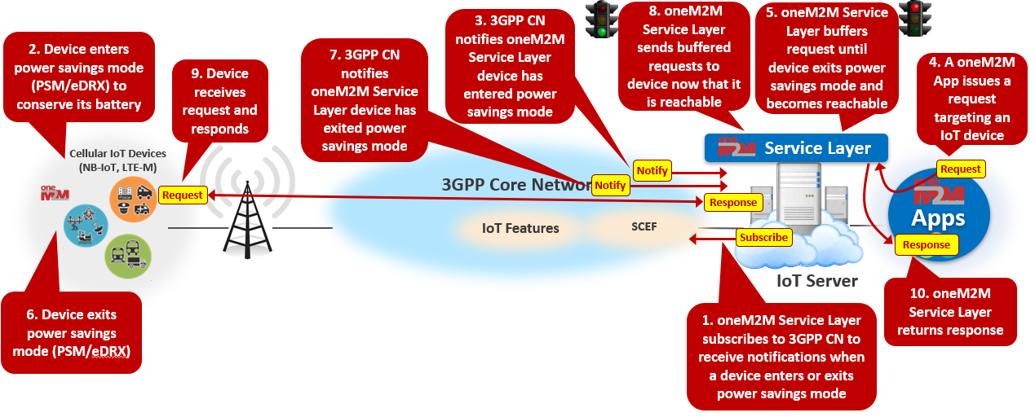
Figure 7.2.5-1: IoT Device Message Delivery Handling

7.2.6 Network Congestion Control
A particular region of an operator’s network may become congested.
When a oneM2M Service Layer receives 3GPP notifications from the SCEF indicating that the core network is congested it can reduce the communication rate or buffer requests targeting IoT devices in that region based on priority until congestion resides.

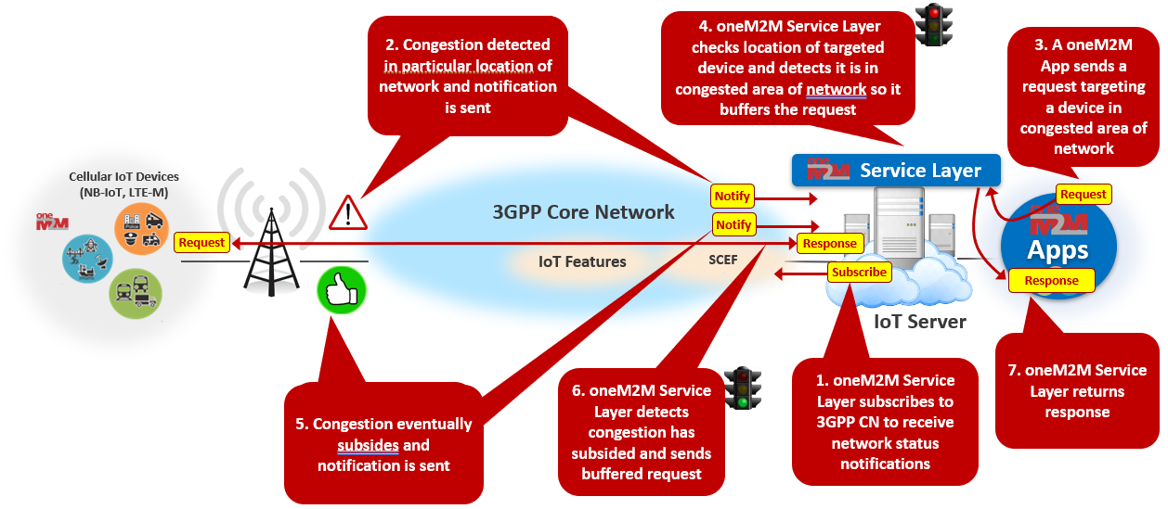
Figure 7.2.6-1: Network Congestion Control

7.2.7 Non-IP Data Delivery (NIDD)
UEs may support different application data delivery method(s) such as delivery of application data to/from a UE over SGi, NIDD or SMS.
Determining which data delivery method(s) a UE supports and under what conditions a method is preferred could depend on various conditions:
- E.g. context of the request targeting the UE (e.g. size, type, originator)
- E.g. state of the targeted UE (location, battery level, etc)
- E.g. congestion level of network where UE resides
An oneM2M Service Layer helps to determine which data delivery method(s) should be used for a given UE and under what conditions.
3GPP supports the capability for a oneM2M server:
- to deliver application data to a UE over SGi (i.e. IP data plane)
- to deliver application data to a UE over the Control Plane

➔ oneM2M Data Delivery Methods:
- A oneM2M server supports delivery of oneM2M requests and responses to/from a UE over NIDD and SGi. (oneM2M currently does not support SMS-based delivery of requests and responses).
- For a given UE, oneM2M relies on a configurable parameter that is exposed via the oneM2M API to determine whether to use SGi or NIDD. This API is supported via the niddRequired attribute of the oneM2M defined <serviceSubcribedNode> resource. Can be set to true or false (default)
- Applications communicating with UEs via the oneM2M server do not need to be concerned about whether a UE uses NIDD or SGi, the oneM2M server will manage and hide this detail.

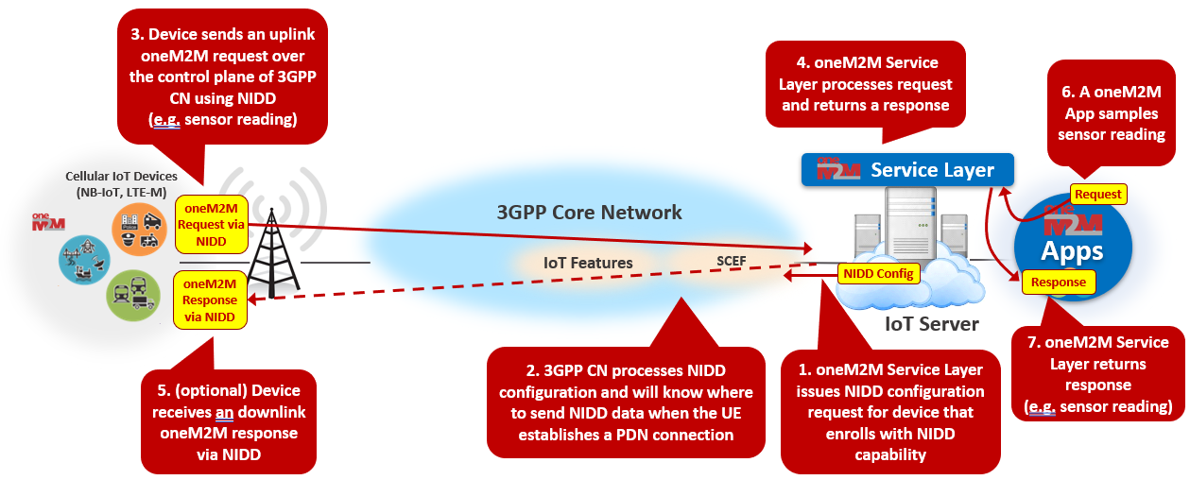
Figure 7.2.7-1: Non-IP Data Delivery (NIDD)

7.2.8 IoT Device Tampering Detection
Unmanned IoT devices can be more easily tampered with and may go can unnoticed for longer periods of time which can amplify the security threat. For instance, SIM card of one device is removed and used in another device.
The oneM2M Service Layer helps mitigate the security threats of a tampered IoT device and assists with remediation of the threat.
3GPP T8 supports the capability for an oneM2M CSE to subscribe and receive notifications from the 3GPP core network if it detects that the IMSI/IMEI of a UE has been tampered with, for example when the SIM card is removed and placed into a another UE.
If a change IMSI/IMEI notification is received, the oneM2M server stops servicing requests to/from the UE and tears down any active security associations (e.g. D/TLS sessions) to the UE. The oneM2M server also denies any new security association establishment requests from the UE. The oneM2M server blocks IoT applications from sending/receiving new requests from the device or accessing stored data from the device which may have been compromised.

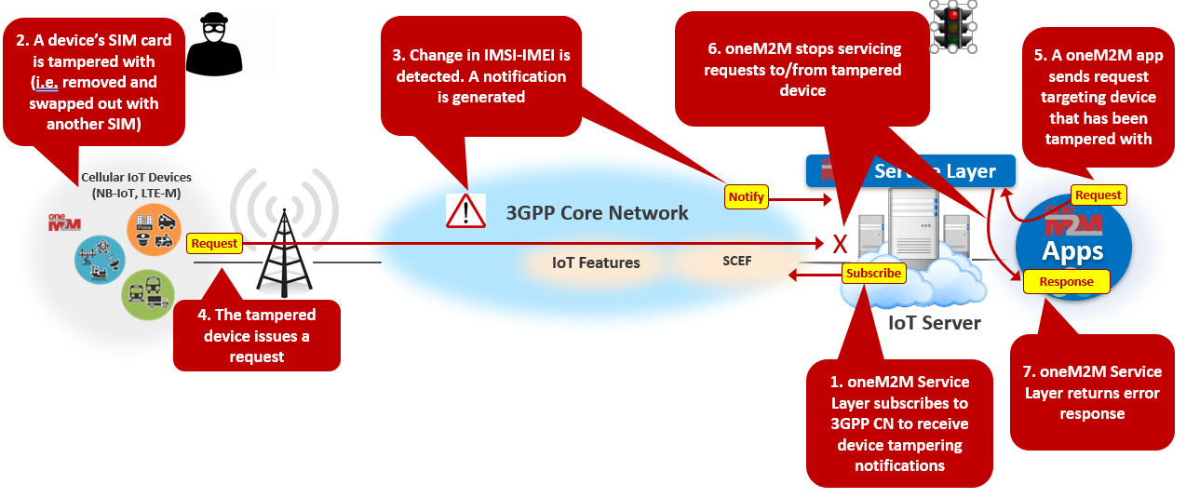
Figure 7.2.8-1: IoT Device Tampering Detection

7.2.9 Management of Groups of IoT Devices
Many IoT use cases call for communicating with a group of devices. For instance, large numbers of IoT devices that need firmware updates can take a lot of time and resources to send data to each UE one at a time.
The oneM2M Service Layer coordinates group message delivery by establishing and tearing down groups of devices and fanning out requests to the group using 3GPP multicast/broadcast feature.
Multimedia Broadcast / Multicast Service (MBMS) is a point-to-multipoint service in which data is transmitted from a single source entity to multiple recipients. Transmitting the same data to multiple recipients allows network resources to be shared. Group message delivery using MBMS is intended to efficiently distribute the same content to the members of a group that are located in a particular geographical area on request of the oneM2M IN-CSE (SCS/AS) via SCEF.
The oneM2M server establishes a MBMS group using the 3GPP SCEF API.
When a device is added to a <group> resource, the oneM2M server checks if the UE supports MBMS.
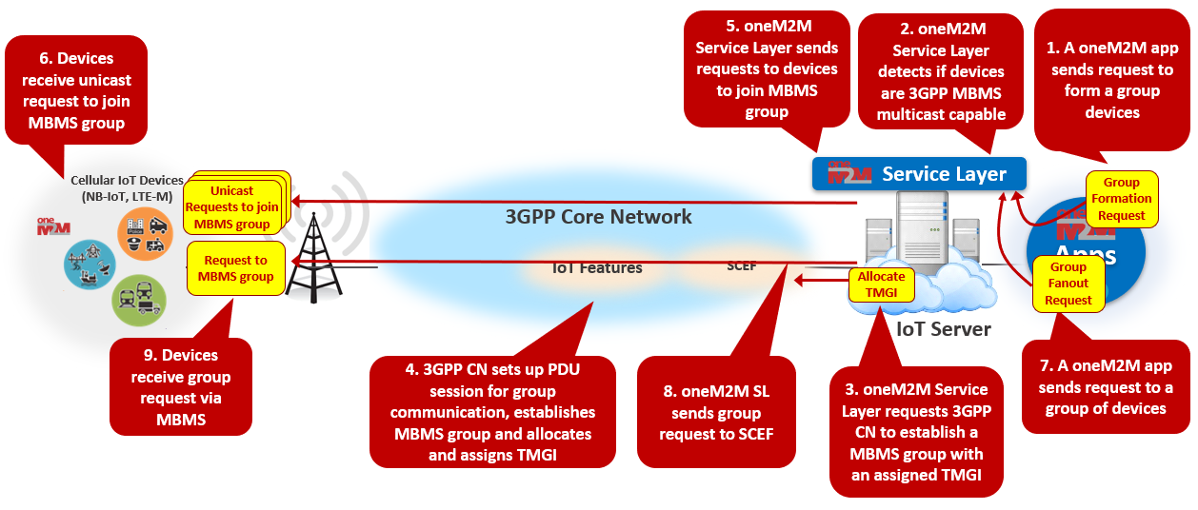
Figure 7.2.9-1: Management of Groups of IoT Devices

7.2.10 IoT Roaming Device Services
IoT applications can make requests that target a roaming cellular IoT device.
When an UE is connected to another network operator’s network (i.e. UE is roaming) communicating with the UE can be more costly. In many deployment use cases, requests made to UEs may be low priority in nature and possibly buffered until the UE re-attaches to its home operator’s network.
The 3GPP SCEF API supports the capability for a oneM2M IN-CSE to subscribe to receive notifications from the 3GPP core network when a UE’s roaming status changes.
When the oneM2M Service Layer receives 3GPP notifications that a cellulsar IoT device is roaming it buffers requests targeting the roaming device until the device is no longer roaming. This can be a valuable service for certain IoT use cases.
oneM2M supports device roaming capabilities:
- oneM2M server subscribes via T8 to receive notifications from 3GPP SCEF of a UE’s roaming status
- oneM2M servers can buffer requests targeting a UE that is roaming

oneM2M exposes a device roaming API that is layered over top of SCEF Roaming Status API
- This API is supported via the roamingStatus attribute of the oneM2M <node> resource
- An application can query the roamingStatus attribute to check current state of the UE
- An application can subscribe to roamingStatus to receive notifications from the oneM2M server when the roaming status changes
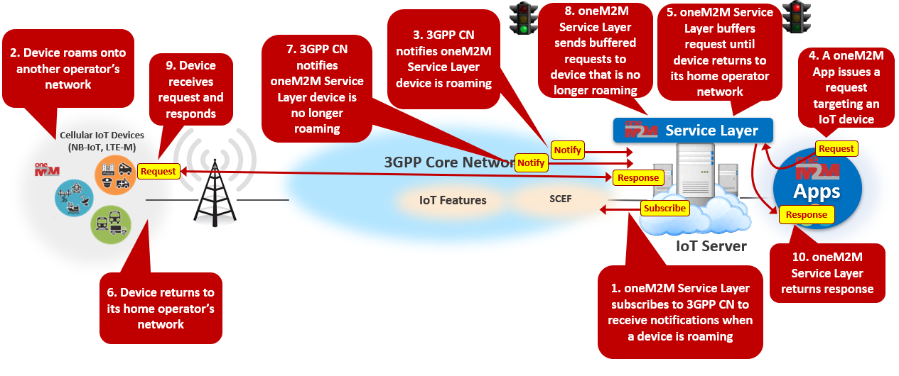
Figure 7.2.10-1: IoT Roaming Device Services

-----------------------End of new text 1-------------------------------------------

