Input Contribution
Meeting ID* | TP50.4
OGC-to-oneM2M Data Mapping | OGC-to-oneM2M Data Mapping
Source:* | Ingo Friese, Deutsche Telekom AG, Ingo.Friese@telekom.de  Andreas Neubacher, Deutsche Telekom AG, andreas.neubacher@magenta.at  Andreas Kraft, , Deutsche Telekom AG, a.kraft@telekom.de
Date:* | 2021-05-14
Input related to* | WI 100, TR-0065 V0.0.1 “oneM2M-SensorThings API interworking”
Intended purpose of  document:* | Decision  Discussion  Information  Other <specify>
Impacted other TS/TR(s) | TR-0065, V0.0.1 “oneM2M-SensorThings API interworking”  The challenge and the different characterisics of Data being in scope of the OGC data model should captured in the TR
Decision requested or recommendation:* | It’s proposed to discuss the results of the assessment in the Documents and add the content of this document to TR0065 V 0.0.1
Template Version: January 2020 (do not modify)

oneM2M Notice
The document to which this cover statement is attached is submitted to oneM2M. Participation in, or attendance at, any activity of oneM2M, constitutes acceptance of and agreement to be bound by terms of the Working Procedures and the Partnership Agreement, including the Intellectual Property Rights (IPR) Principles Governing oneM2M Work found in Annex 1 of the Partnership Agreement.

Introduction
This contribution discusses the OGC-to-oneM2M Data Mapping Issue.

The following text explains what the OGC SensorThings API is and how it is working. The background section was already agreed in SDS-2020-0141R01, but it was copied into this document for providing better context. However, some editorial issues have been corrected in the subsequent text too. The changes are marked by revision marks.

-----------------------Start of corrections 1-------------------------------------------

2.2 Informative references
Clause 2.2 shall only contain informative references which are cited in the document itself.
The following referenced documents are not necessary for the application of the present document but they assist the user with regard to a particular subject area.
[i.1] oneM2M Drafting Rules (http://member.onem2m.org/Static_pages/Others/Rules_Pages/oneM2M-Drafting-Rules-V1_0.doc)
[i.2] SensorThings API website, https://www.ogc.org/standards/sensorthings
[i.3] ISO 19156 website, https://www.iso.org/standard/32574.html
[i.4] oneM2M TS-0033 3.0.0 "Interworking Framework“
[i.5] oneM2M TS-0023 4.7.1 “SDT based Information Model and Mapping for Vertical Industries”
[i.6] FROST®-Server - Open-Source-Implementierung der OGC SensorThings API - Fraunhofer IOSB
[i.7] OGC and ISO 19156:2001, OGC 10-004r3 and ISO 19156:2011(E), OGC Abstract Specification: Geographic
information — Observations and Measurements. Available Online:
http://portal.opengeospatial.org/files

-----------------------End of corrections 1-------------------------------------------

-----------------------Start of corrections 2-------------------------------------------

5 Background
The following text explains what is SensorThings API and how does it work

5.0 Introduction
The SensorThings API (STA) is a standard of the Open Geospacial Consortium (OGC). It provides a framework for communication and exchanging data between sensors and applications. The standard is devided in two parts. SensorThings API Part 1 is dedicatd to sensing and was published in 2016 [i.3]. Part 2 deals with tasking and was published in 2019 [i.3]. There is a OGC certified Open-Source SensorThings API Server available (FROST Server) [i.6]. It supports the OGC SensorThings API Part 1: Sensing. It also includes preliminary actuation/tasking support.
For the description of entites SensorThings API uses the OGC and ISO 19156:2001 data model and JSON as data format. The communication is REST-based and uses HTTP and also CoAP, MQTT, 6LowPAN.

5.1 SensorThings API Architecture
A typical STA-based architecture works in client/server mode. A sensor device pushes data to the SensorThings Server via HTTP POST request. A SensorThings Server may also support MQTT protocol to support publish and subscribe capabilities. In this case an interested application can subscribe to the MQTT-Broker in order to get notified about new sensor events.
The data in the SensorThings server are organized according to the OGC and ISO 19156:2001 [i.7] (see Figure 5.1-1: OGC and ISO 19156:2001 data model).
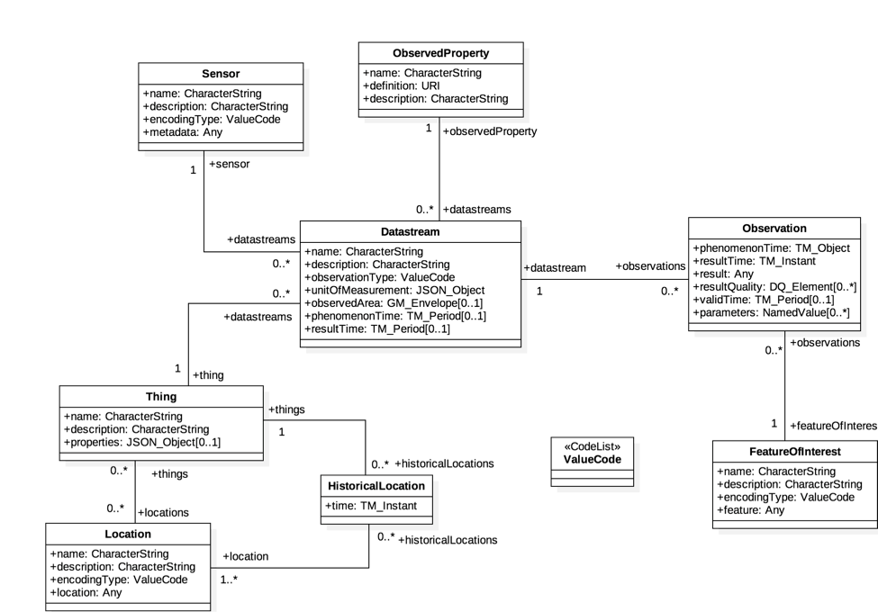
Figure 5.1-1: OGC and ISO 19156:2001 data model
In the SensorThings data model events or sensor data are called ‘observations’. Before a sensor is able to push an observation to the server it needs at least a ‘thing’- and a ‘datastream’ entity. This is created beforehand. One ‘thing’ might have different ‘sensors’, one ‘location’ or many ‘historical locations’.

Taking a closer look at the SensorThings data model and the purpose of data within the data model discloses mainly two data characteristics, associated with a thing.
- Data respectively observations originated by sensors or commands send to interact with actuators may be seen as IoT data from oneM2M point of view.
while
- Data embedded in the SensorThings data model, like “historic locations” may be seen as data for documentation purposes e.g. for the city administration

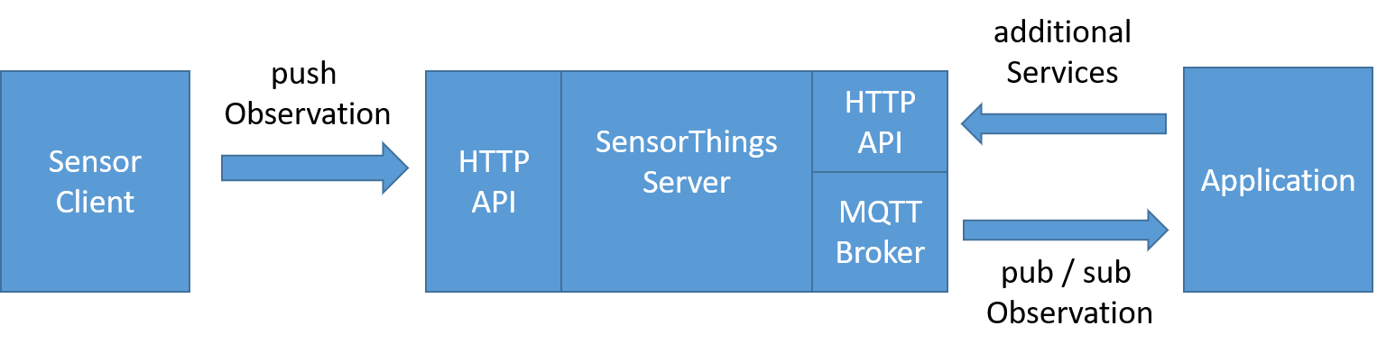

Figure 5.1-2: Exemplary STA message flow

5.2 SensorThings API example use-case
The message flow in Figure 5.1-2 can be explained by using an example of an application that wants to use data of EV-Charging Stations in a city.
- In order to get all relevant observations belonging to the cities EV-Charging Stations the application needs to know all regarded “datastreams”. Therefore the application needs to send a request with filter parameter to the HTTP-API of the server e.g.:
https://sta-example-server-address.com/v1.0/Things?$filter=substringof(“Charging”,name)&$count=true&$expand=Datastreams
As a response the server provides a list of all data streams belonging to a Charging Station.
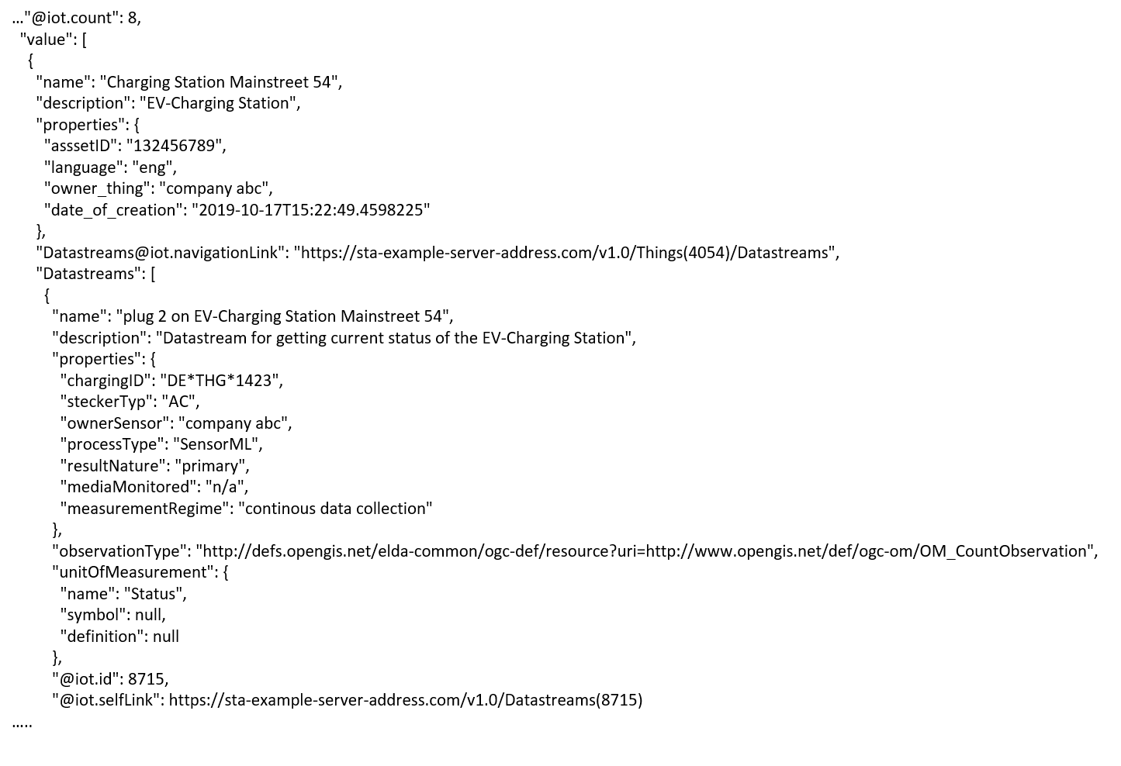
Figure 5.2-1: Exemplary entry of the result list of an filter request
- The application can now subscribe to the these “Datastreams”. Figure 5.2-1 shows one entry of the result list. It represents an EV-Charging Station as a thing including the regraded datastream in the last line of the entry.
- As soon as the sensor (EV-Charging Station) changes its status e.g. from “available” to “charging” it pushes an oberservation to the server.
- The application gets the observation through a notification that is send by the MQTT-Broker. An example of an observation is shown in figure 5.2-2. In the result field the current status of the EV-Charging Station “charging” is shown.
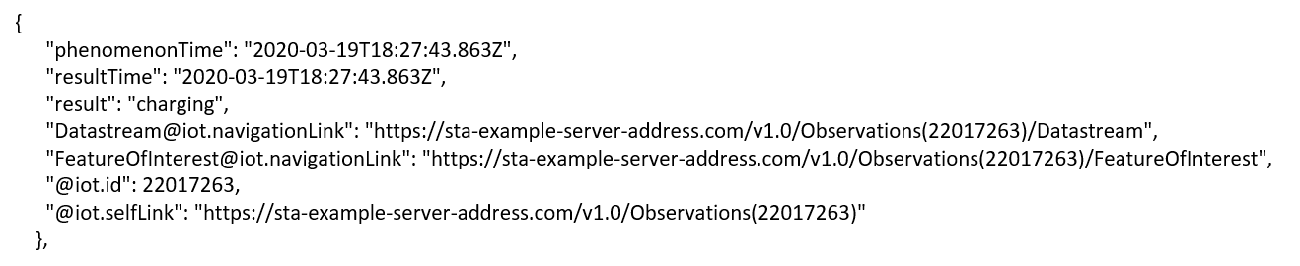
Figure 5.2-2: Exemplary STA observation

-----------------------End of corrections 2-------------------------------------------

-----------------------Start of new Content 1-------------------------------------------

6 Architecture Model of OGC/STA to oneM2M interworking

6.0 Introduction
Figure 6.0-1 shows an architecture approach for an Interworking Proxy Entity (IPE) between oneM2M and the OGC SensorThings API. The IPE is located between a oneM2M CSE and an OGC/SensorThings API (STA)-Server.
The basic interworking enables applications that are connected to an oneM2M-based system to get data from sensors that are connected to an OGC/STA server. Furthermore, an application that is connected to an OGC/STA server is able to get data from sensors that are connected to an oneM2M-based system.
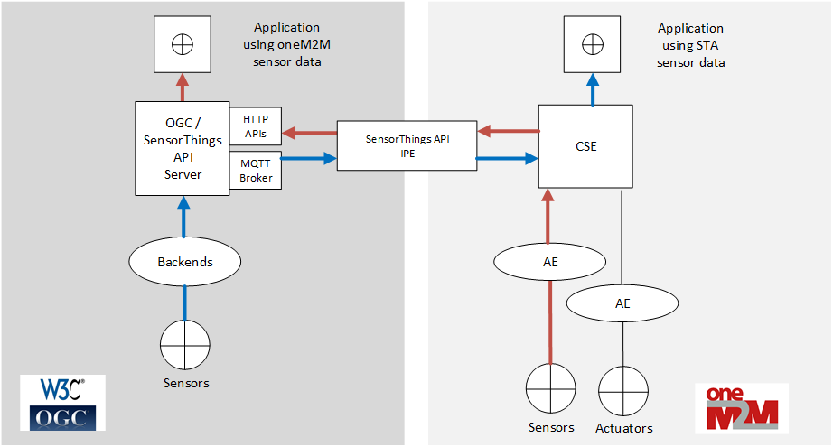
Figure 6.0-1: IPE architecture overview with data flow

6.1 OGC/STA-to-oneM2M Data Model Mapping
According to TS-0033 [i.4] a representation of a non-oneM2M Proximal IoT function/device in a oneM2M-specified resource instance is to be synchronized with the entity that it represents.
This actual means that the OGC/STA data model is represented in the hosting CSE. The data in the OGC/STA server are organized according to ISO 19156 (see Figure 5.1-1: OGC and ISO 19156:2001 data model).
The oneM2M structure for data models is a tree-structure where data are organized in containers or trees of containers.
The OGC/STA data model is a relational one, like used in databases and not hierarchical. Thus, it creates a challenge for a full interworking, on all data being captured in the OGC/STA data model.

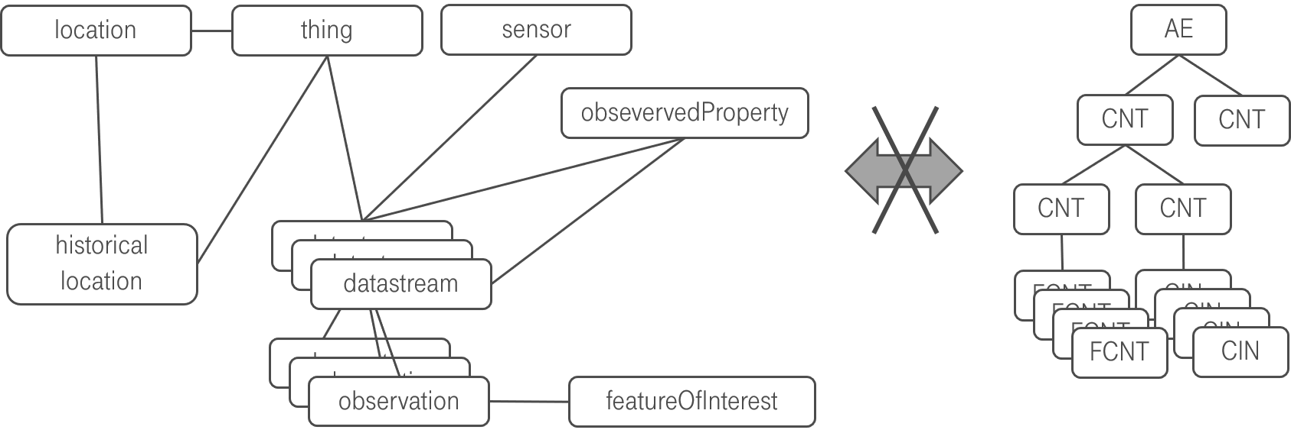
Figure 6.1-1: OGC data model cannot directly be mapped to oneM2M

One reason for this challenge is, as already outlined in section 5.1. The SensorThings data model is comprehensive and may be regarded as a n:m relational database structure, holding both:
- sensor (IoT-data) and
- administrative data (like historic locations or historic products IDs)
with n:m relational database.
Aiming at a full interworking on all data being available in the OGC/STA data model, would require either:
- Additional functionality (possibly a new Common Service Function CSF) within the oneM2M CSE being able to build up, tear down and maintain such relationships between content instances and flex containers based on Mca commands,
or
- The IPE, internally keeps track about relations, and inserts “helper” references in “flexContainers”, pointing to related data (e.g. historical locations) in other flex containers. However, this would allow an interworking from OGC side towards oneM2M, but an AE on oneM2M side, would not be able to retrieve those related data since the relation is only known to the IPE.
In the following section the different approaches are visited in more detail.

6.2. Architecture Approaches

6.2.0 Introduction
In the following section possible options and shortfalls in the context of a full data interworking and the consequences for the architecture of an interworking between both standards are being discussed. In the following sub-clauses, three different approaches and their advantages and disadvantages are discussed.

6.2.1 “Flat Data Model” Approach

6.2.1.0 Overview
One approach is to create for every single group of entities in the OGC data model a separate oneM2M container entity. Figure 6.2.1.0-1shows a oneM2M data model that could represent the OGC/STA - data in a hosting CSE.
The top of a tree may be an <AE> resource. Below in Figure 6.2.1.0-1, there are <container> resources representing the dedicated objects of the OGC and ISO 19156 data model. They may be all at the same level and represent a flat data model representation.
There may be, for example, one <container> resource where all incoming “Observation” objects from SensorThings API are stored by the IPE. There may be another <container> where the “Datastream” object for this “Observation” is stored. There may be also <container> resources for “Location”-, “Sensor”-, “Thing” or other objects.
The OGC/STA – “Observation” object itself may be represented as an <flexContainer>, under a <container> with a resource name “observations”.
The OGC/STA –“Datastream” object itself may also represented as an <flexContainer> under a <container>with a resource name “Datastreams”.
In figure 6.2.1.0-1 these <flexContainer> resources are represented as grey boxes.This way a oneM2M data structure represents all of the entities from the OGC and ISO 19156 data model.
The relationships between the ISO 19156 entities can be represented using dedicated custom attributes defined inside a <flexContainer> specialization.
Figure 6.2.1.0-1 shows the <flexContainer> with the resource name “ObservationXYZ” that has an attribute “STAdatastream” with the value “Datastream123”. This Attribute points to a <flexContainer> representing the “Datastream” object with the resource name ”Datastream123” located in the “Datastreams” <container>. This way the attribute represents inherent the relationships from the OGC/STA data model.
Actually, two kinds of relationships are described in this approach:
- The first kind are the oneM2M specific <AE>-to- <container>-to-<flexContainer> relationships (grey / continuous lines).
- The second kind of relationships are OGC specific and are expressed as attributes inside the <flexContainer> entities. Here for example a “Observation”-to-“Datastream” relationship is described (blue / dashed line).

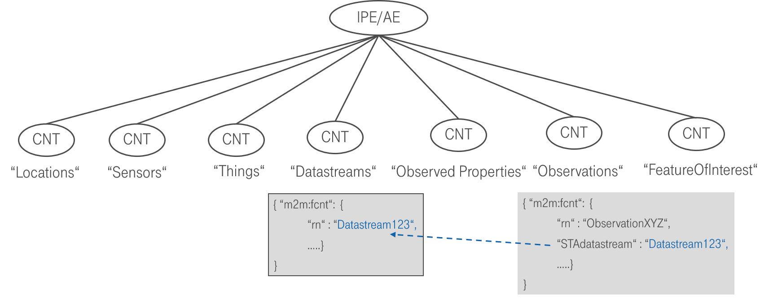
Figure 6.2.1.0-1: The flat data model with inherent relationship

6.2.1.1 Missing Relationship Management
As already briefly addressed in 6.1, the inherent relationships (dashed blue line in figure 6.2.1.0-1) describing the OGC/STA data model is not in scope to be managed by the CSE today. Only the relationships between <AE> and <container> can be managed (grey lines) by the CSE.
For example, in case that a certain <flexContainer>, representing a “Datastream”, is deleted, all related <flexContainer> resources representing an “Observation” need to be deleted too. This is how it is handled in an OGC/STA Server, but this would not be possible by current oneM2M CSE functionality.
Note: This approach is rather a theoretical one and shows the issue of a missing oneM2M relationship management in the CSE.

6.2.2 “On-the-fly” Approach

6.2.2.0 Overview
The “On-the-fly” approach forwards every request from the oneM2M domain to the IPE. The IPE translates the request “on-the-fly” towards OGC/STA domain and retrieves the response. The OGC response is translated towards oneM2M domain and may be retrieved by an application (AE) from the oneM2M CSE.. The IPE sets a <subscription> to the <container> resource with the desired data and gets <notification> messages containing the <contentInstance> resource.
Figure 6.2.2.0-1 shows the oneM2M-to-OGC/STA direction. Based upon the creation of the <contentInstance> in the hosting CSE. The IPE gets a <notification> message including the <contentInstance>. The IPE constructs an “Observation” creation request and copies the ‘content’ attribute of the <contentInstance> to the ‘result’ attribute of the “Observation” shown in Figure 6.2.2.0-2 and sends it to the OGC/STA server.
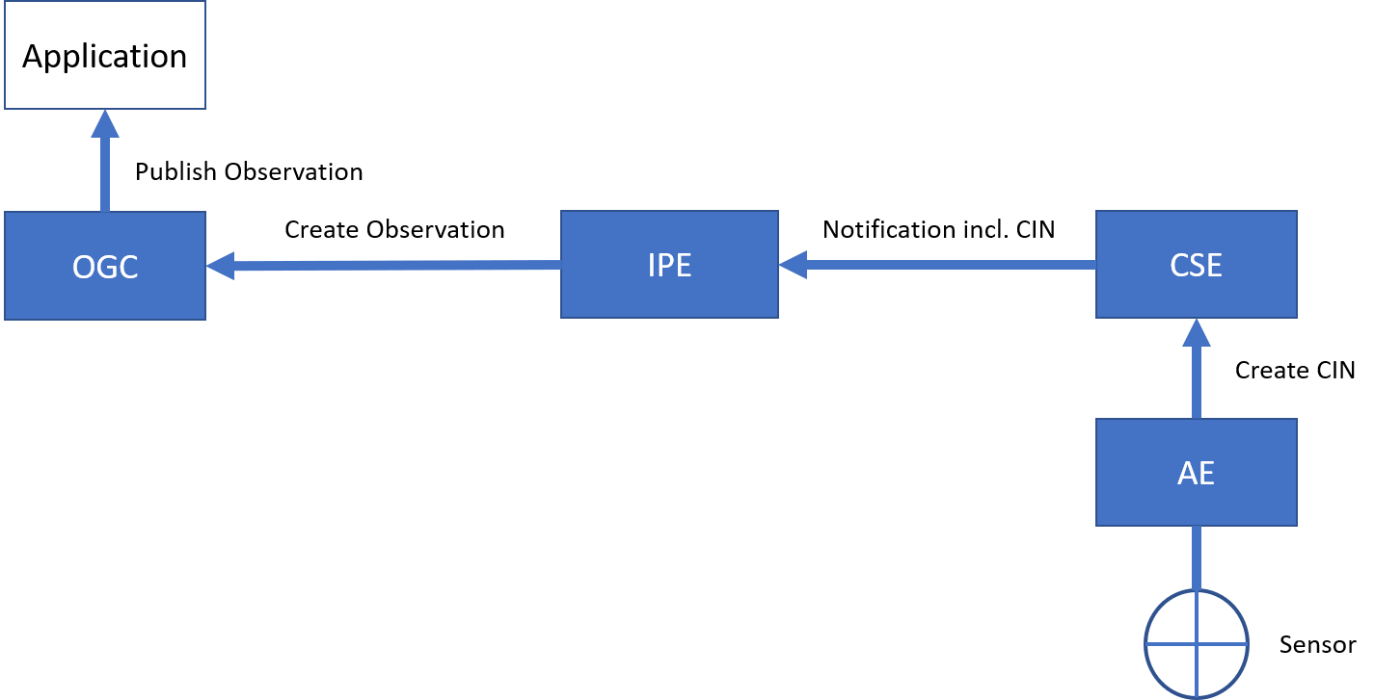
Figure 6.2.2.0-1: Gateway oneM2M-to-OGC/STA direction
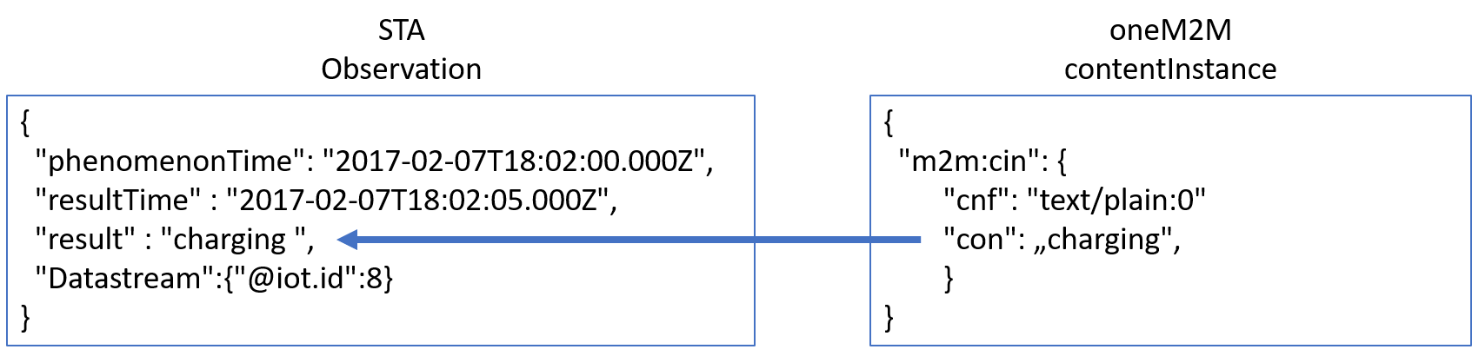
Figure 6.2.2.0-2: Content copying from CIN-to-Observation
Figure 6.2.2.0-3 shows the OGC/STA-to-oneM2M direction. OGC/STA does not provide a publish / subscribe mechanism on HTTP protocol level. OGC allows an optional MQTT extension for STA services [i.2]. The IPE subscribes to the MQTT-Broker of the OGC/STA server. The OGC/STA server publishes its new “Observation” via the MQTT broker. The IPE creates a <contentInstance> using a HTTP request and copies the ‘result’ attribute of the “Observation” to the ‘content’ attribute of the <contentInstance>. Alternatively, a <flexContainer> may be created or updated. The <container> may be created beforehand at the hosting CSE where the IPE <contentInstance> or <flexContainer> resources are stored. All interested applications may subscribe to this <container> resource.
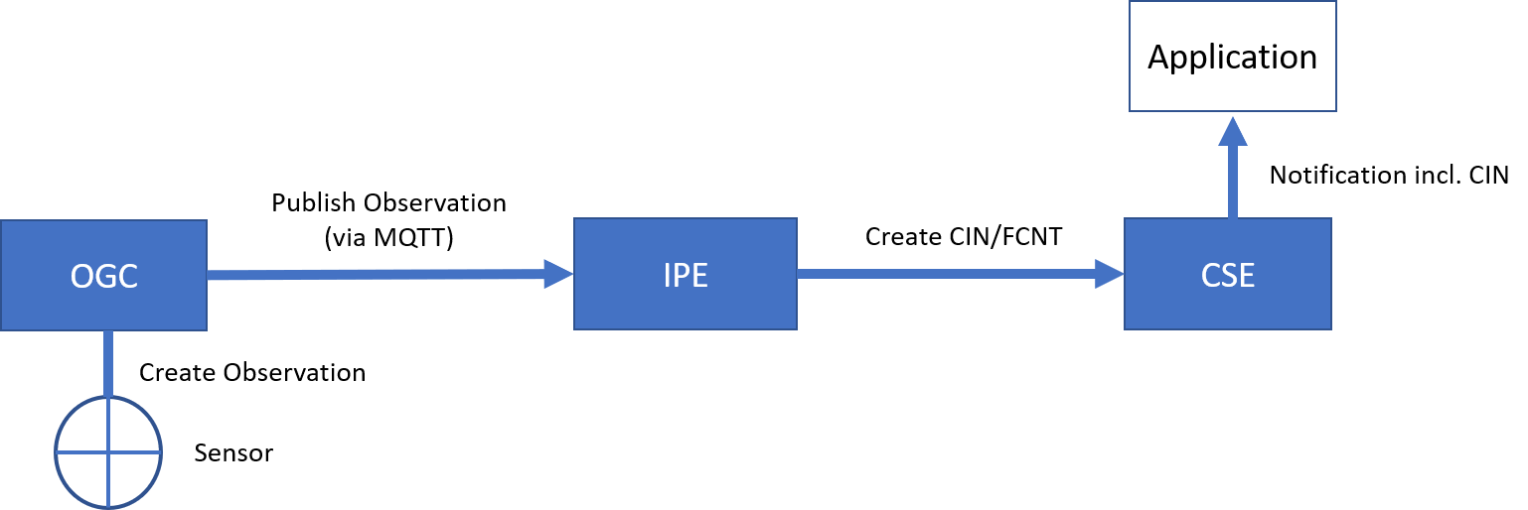
Figure 6.2.2.0-3: Gateway OGC-to-oneM2M direction
This approach is simple and sufficient in case its only about translating “Observation” to <contenInstances> and vice-versa.

6.2.2.2 Discussion of “On-the-fly” approach
The “On-the-fly” approach has disadvantages:
- Data are stored in the hosting CSE, but this is just a subset of the non-oneM2M proximal IoT function.
These are only data, being actually exchanged.
- The oneM2M client application is not able to gain additional information that are linked to an incoming “Observation” like “Location” or “Sensor”. This kind of information would need to be exchanged upfront in the configuration phase described in chapter 6.3.
On the other hand, the approach has also advantages:
- The IPE would not be required to copy the full OGC/STA data model into the hosting CSE. The data would always accurate, because they remain hosted at the authoritative source, the OGC/STA server. This approach avoids synchronization effort and possible errors.
Conclusion:
The “On-the-fly” approach would be a very flexible solution, in case only single value data need be exchanged.

6.2.3 “Specific Device” Approach

6.2.3.0. Overview
Another architectural approach would be to focus the design of the IPE on a specific device type.
The data model may be described according to TS-0023 , [i.5]. TS-0023 [i.5] describes a templating tool for describing heterogenous devices and their functionalities using a Smart Device Template (SDT). SDT offers a generic and flexible modeling structure for non-oneM2M devices.
The first step in an OGC/STA interworking scenario may be to register the IPE to the hosting CSE as an <AE> resource. This <AE> resource is a parent for dedicated <flexContainer> resource specializations that represent each device connected to the OGC/STA server (for example an EV-Charging station).
OGC/STA devices may be modelled as SDT Devices. Mapping of the SDT Device model to oneM2M resources is performed according to the general mapping procedure described in clause 6.2.2 of TS-0023 [i.5]. A SDT Device component is mapped to a specialization of a <flexContainer> resource with an associated 'DeviceClass ID' (e.g. "org.onem2m.home.device.tv") containerDefinition attribute.
Figure 6.2.3.0-1 shows an example of an OGC/ STA device:[deviceElectricVehicleCharger], which is modelled as a <flexContainer> resource specialization derived from the corresponding SDT Device component. The model of [deviceElectricVehicleCharger] follows the schema described in clause 5.5.18 of TS-0023 [i.5].
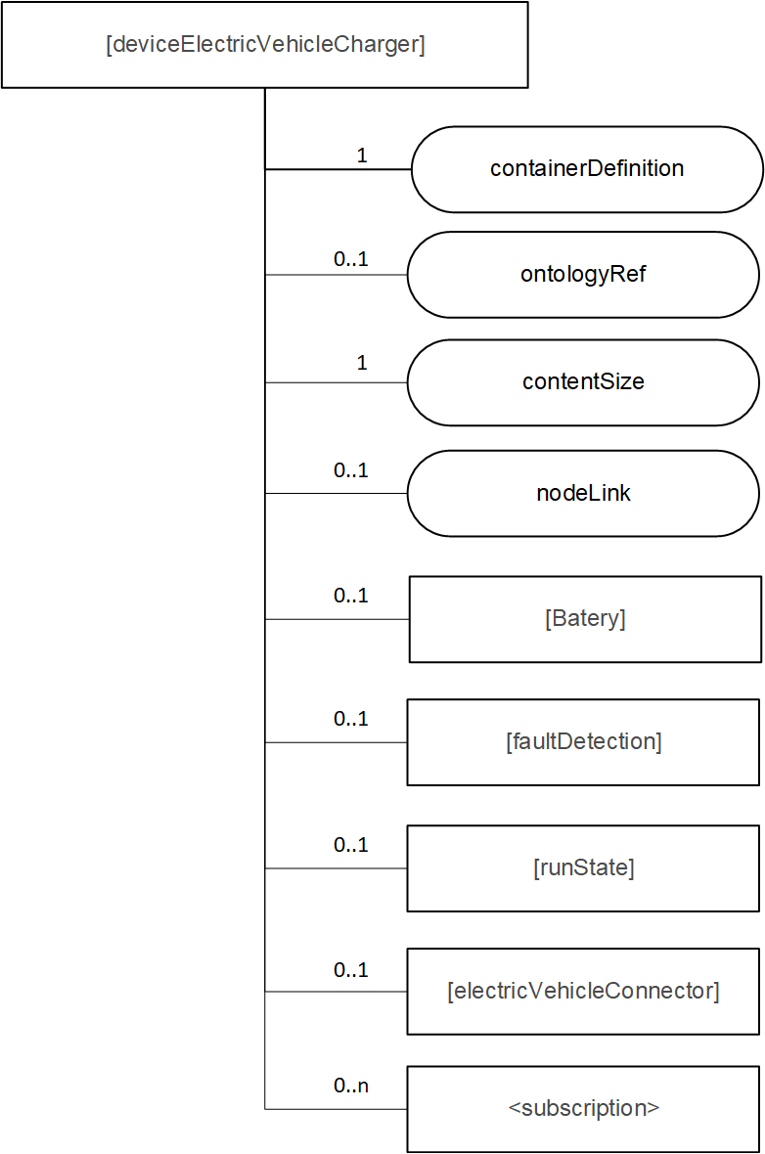
Figure 6.2.3.0-1: [deviceElectricVehicleCharger] example resource representing a OGC/STA device
The <flexContainer> representation based on SDTs allow the design of a desired data model for supported device types. The IPE is responsible for ensuring changes in the OGC data model are mapped to an update of the appropriate <flexContainer>.

6.2.3.1. Communication Schema
In this approach for the OGC-to-oneM2M direction the IPE subscribes to the MQTT message broker of the OGC/STA server, to receive all desired changes in the data model of an OGC/STA device. In this case, apart from “Observations” all changes, such as “Location”, are published to the IPE (Figure 6.2.3.1-1). The IPE may subscribe or filter out only changes affecting the “flexContainer” and sends respective UPDATE messages to the CSE.
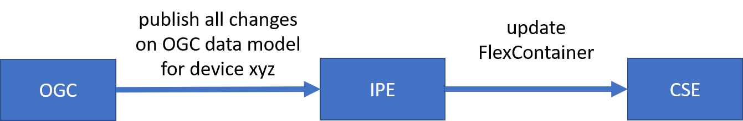
Figure 6.2.3.1-1: OGC/STA-to-oneM2M direction
For the oneM2M-to-OGC direction the IPE subscribes to the <flexContainer> resources in the hosting CSE. If there are changes to the <flexContainer> from an application the CSE will send a <notification> message to the IPE. The IPE assigns the appropriate messages to update the OGC data model (Figure 6.2.3.1-2.)

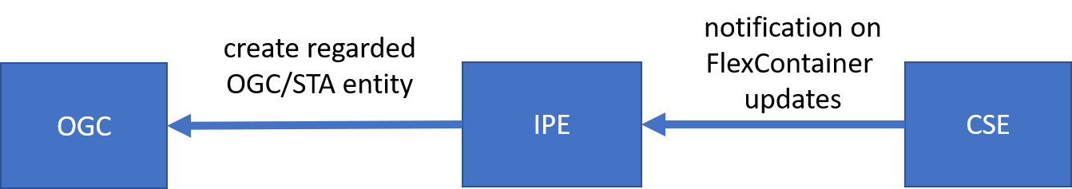
Figure 6.2.3.1-2: oneM2M-to-OGC/STA direction

6.2.3.2 Discussion of the “Specific Device” Approach
The disadvantage of this approach would be a loss of flexibility and an of course it would involve a certain maintenance effort to keep SDT and OGC model in sync and up to date in case there are changes either on SDT or OGC side. Even if there are tools to create SDT <flexContainer> from a certain device automatically, the mapping to or from the OGC/STA data model may still be highly individual because the “properties” field in the OGC/STA data model can be filled with optional data in JSON-Format.
In this case it would be beneficial to have somethings similar for SDTs, a data structure for additional attributes. It is very likely that SDT not always describe all features, information and attributes of a complex device. To have something like ‘property-extensions’ in SDT could ease the process of translating foreign data model into oneM2M. In our OGC / STA example use case “ev-charging” there is a foreign index like “chargingID” (see Figure 5.2-1) that could be defined as an attribute in a “property” structure. In SDT 3.0 “Properties” were already discussed as an addition to “Action”, “Datapoint” and “Event”. They could be used for non-functional data as well. An alternative approach for attributes that are not defined by a SDT is the “Label” attribute.
As a consequence, this approach enables no OGC/STA IPE for general use currently. It rather more enables an OGC / STA IPEs for specific devices e.g. “EV-Charging Stations” of “Company XYZ” in “Version 1.23”.
However, this approach is also beneficial. Compared to the approaches discussed before, in this case the client application does not need to have any knowledge about the OGC data model. A client application may only rely on oneM2M specifications and is still able to read data coming from a sensor that is connected via OGC / STA.

6.2.4 Conlusion
This chapter showed three architecture approaches in the context of full data interworking.
The “Flat data model” is a theoretical approach showing that it creates issues to map the meshed OGC/STA data model to a hierarchical oneM2M data model. In the process of mapping essential relationships get lost.
In today’s oneM2M specifications the maintenance of foreign data model relationships is out of scope for the CSE. This causes potential data inconsistencies. Adding a relationship management to oneM2M would be a beneficial extension.
The “On-the-fly” approach focuses mainly on dynamic parts of the OGC data model. Here only “Observations” are translated to oneM2M <contentInstance> or <flexContainer> . Other parts of the OGC data model are seen as administrative data and are not translated because their change rate is rather low in most use-cases.
A pre-condition for this kind of interworking is the exchange of administrative knowledge during the initial setup phase upfront. The IPE needs to know to which OGC “Datastream” or “Sensor” a certain “Observation” belongs to. Ones the ”Observation” is translated to oneM2M this administrative information is lost.
The advantage of the approach is that the IPE would not be required to copy the full OGC/STA data model into the hosting CSE. The OGC/STA data model would always be accurate, because data remains hosted at the authoritative source, the OGC/STA server. This approach avoids synchronization effort and possible errors.
The “Specific Device” approach uses TS-0023 Smart Device Templates (SDTs) to describe the OGC/STA data model in the hosting CSE. But SDTs look different for various devices. As a consequence, the IPE has to be specific for a certain type of devices.
The disadvantage of this approach would be a loss of flexibility because it enables no OGC/STA IPE for general use currently.
The advantage of this approach is that an oneM2M client application does not need to have any knowledge about the OGC data model. A client application may only rely on oneM2M specifications and is still able to read data coming from a sensor that is connected via OGC / STA.
The “On-the-fly” approach was chosen to be investigated and described in more detail in the next chapters. Such an IPE is an “hands-on” solution and a good trade-of between ease of implementation and full data interworking. It is usable in many application fields like “Smart Home” or “Smart City”.

-----------------------End of new Content 1-------------------------------------------

