|  |
| --- |
|  |

|  |  |
| --- | --- |
| CHANGE REQUEST | |
| Meeting ID:* | SDS 49.3 |
| Source:* | Bob Flynn, Exacta GSS, [bob.flynn@exactagss.com](mailto:bob.flynn@exactagss.com)  Andreas Neubacher, Deutsche Telekom, [andreas.neubacher@magenta.at](mailto:andreas.neubacher@magenta.at)  Marianne Mohali, Orange, [marianne.mohali@orange.com](mailto:marianne.mohali@orange.com) |
| Date:* | 2021-03-24 |
| Reason for Change/s:* |  |
| CR against: Release* | Rel-5 |
| CR against: WI* | Active <WI-0096>  MNT maintenance / < Work Item number(optional)>  Is this a mirror CR? Yes  No  mirror CR number: (Note to Rapporteur - use latest agreed revision)  STE Small Technical Enhancements / < Work Item number (optional)>  Only ONE of the above shall be ticked |
| CR against: TS/TR* | TR-0063 v0.0.1 |
| Clauses * | multiple |
| Type of change: * | Editorial change  Bug Fix or Correction  Change to existing feature or functionality  New feature or functionality  Only ONE of the above shall be ticked |
| Other TS/TR(s) impacted | None |
| Post Freeze checking:* | This CR contains only essential changes and corrections? YES  NO  This CR may break backwards compatibility with the last approved version of the TS? YES  NO |
| Template Version: January 2019 (do not modify) | |

**oneM2M Notice**

The document to which this cover statement is attached is submitted to oneM2M. Participation in, or attendance at, any activity of oneM2M, constitutes acceptance of and agreement to be bound by terms of the Working Procedures and the Partnership Agreement, including the Intellectual Property Rights (IPR) Principles Governing oneM2M Work found in Annex 1 of the Partnership Agreement.

GUIDELINES for Change Requests:

Provide an informative introduction containing the problem(s) being solved, and a summary list of proposals.

Each CR should contain changes related to only one particular issue/problem.

In case of a correction, and the change apply to previous releases, a separate “mirror CR” should be posted at the same time of this CR

Mirror CR: applies only when the text, including clause numbering are exactly the same.

Companion CR: applies when the change means the same but the baselines differ in some way (e.g. clause number).

Follow the principle of completeness, where all changes related to the issue or problem within a deliverable are simultaneously proposed to be made E.g. A change impacting 5 tables should not only include a proposal to change only 3 tables. Includes any changes to references, definitions, and acronyms in the same deliverable.

Follow the drafting rules.

All pictures must be editable.

Check spelling and grammar to the extent practicable.

Use Change bars for modifications.

The change should include the current and surrounding clauses to clearly show where a change is located and to provide technical context of the proposed change. Additions of complete clauses need not show surrounding clauses as long as the proposed clause number clearly shows where the new clause is proposed to be located.

Multiple changes in a single CR shall be clearly separated by horizontal lines with embedded text such as, start of change 1, end of change 1, start of new clause, end of new clause.

When subsequent changes are made to content of a CR, then the accepted version should not show changes over changes. The accepted version of the CR should only show changes relative to the baseline approved text.

## Introduction

-------------------------------------------------- Start of Change 1---------------------------------------------------

# 1 Scope

Mass deployment of IoT devices, is causing an increased risk of signalling floods e.g. by concurrently transmitting IoT devices and hence causing a risk for the stability- and the efficient use of their mobile networks.

One of the reasons is that IoT customers or integrators, often do not considering the specifics of mobile networks in their IoT device application design, subsequently causing inefficient communication or even loss of reachability.

Operators are increasingly reporting problems from their live networks, like masses of concurrently resetting and reattaching devices within a small geographical region. Such events may cause their networks to collapse. GSMA has already flagged such events and has started to address the subject of badly behaving IoT devices / Applications.

To avoid such scenarios upfront, GSMA released TS.34, "IoT Device Connection Efficiency Guideline" [i.1].

GSMA TS. 34 [i.1] gives guidance, which IoT device applications need to consider, to safely- and efficiently cooperate with cellular networks.

However, the drawback of guidelines is the fact that the target audience:

a.) needs to be aware of the existence of such guidelines and  
b.) needs to read, understand and follow such guidelines.

This work aims to check and enhance oneM2M as an Embedded Service Layer in a way that the requirements formulated in GSMA TS.34 [i.1] are taken into account and Applications developed not considering requirements in GSMA TS.34 [i.1], do not create adverse effects in the network, because the oneM2M as Embedded Service Layer is shielding the network from badly behaving applications.

GSMA TS. 34 [i.1] is already referring towards an evolution of an IoT Service Architecture, where the IoT Device Applications are becoming disaggregated from an Embedded Service Layer. Such an Embedded Service Layer is providing several generic IoT functionalities (e.g. device management, security, location, application framework…). The common service layer specified by oneM2M complies to this IoT Service Architecture.



Figure 1-1: Generalised “Layered” IoT Service Architecture, as depicted GSMA TS 34 Figure 3

Applications being deployed on top of a common service layer are less critical to the network, because the common service layer takes over a protection role for the network. Inefficient or even harmful activities of applications would be prevented upfront and can’t hit the network. On the other hand, oneM2M provides functionality for the applications, e.g. scheduling transmissions according to the service needs.

The recommended evolved architecture in GSMA TS.34 [i.1] (refer Figure 1X) aligns well with the oneM2M architecture shown in Fig 1-1.

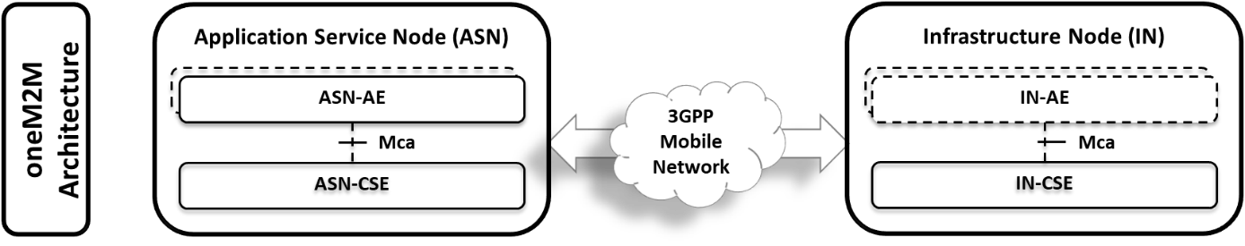

Figure 1‑2: oneM2M architecture for CIoT devices

OneM2M with the CSE functionality in between the IoT Application and the network connectivity, is well suited to enforce the requirements being addressed in GSMA TS.34 [i.1], and hence protect the network from unwanted signalling floods and enforces an efficient communication, even if the Application (AE) has been created without GSMA TS.34 [i.1] knowledge or compliance.

This TR is analysing which functionalities recommended by GSMA TS.34 [i.1] being in scope of an Embedded Service Layer are already covered by oneM2M functionality (e.g. like in CDMH), and which GSMA TS.34 [i.1] functionality is missing from oneM2M, to identify it and enhance oneM2M accordingly to meet the GSMA TS.34 [i.1] recommendations.

-------------------------------------------------- End of Change 1---------------------------------------------------

-------------------------------------------------- Start of Change 2--------------------------------------------------

## 3.1 Terms

**IoT Device** : The combination of both the IoT Device Application and the Communications Module.

**Well-known location**: a target URI in the oneM2M CSE resource tree that is a place where you should store information that is expected to be at the same location on every oneM2M CSE.

-------------------------------------------------- End of Change 2---------------------------------------------------

-------------------------------------------------- Start of Change 3--------------------------------------------------

## 2.2 Informative references

Clause 2.2 shall only contain informative references which are cited in the document itself.

The following referenced documents are not necessary for the application of the present document but they assist the user with regard to a particular subject area.

[i.1] GSM Association Official Document TS.34 "IoT Device Connection Efficiency Guidelines" (<http://member.onem2m.org/Static_pages/Others/Rules_Pages/oneM2M-Drafting-Rules-V1_0.doc>)

[i.2] oneM2M Drafting Rules (<http://member.onem2m.org/Static_pages/Others/Rules_Pages/oneM2M-Drafting-Rules-V1_0.doc>)

[i.3] oneM2M TS-0001: "Functional Architecture".

[i.4] oneM2M TS-0018: "Test Suite Structure & Test Purposes".

[i.5] oneM2M TS-0025: "Definition of Product Profiles".

[i.6] oneM2M TS-0026: "3GPP Interworking".

-------------------------------------------------- End of Change 3---------------------------------------------------

-------------------------------------------------- Start of Change 4--------------------------------------------------

# 5 Efficient Communications over 3GPP networks

## 5.1 Introduction

GSMA TS.34 [i.1] represents a guideline and giving requirements for whole IoT Device, as defined in Figure X to ensure an efficient connection.

**IoT Device Host**

**IoT Device**

**IoT Device Application**

**Communication  
 Module**

**Communication Module  
Firmware**

**Radio Baseband  
Chipset**

**UICC**

Figure 5.1-1: Generalised IoT Device Architecture according to GSMA TS.34 [i.1]

Requirements with regards to an efficient communication are grouped and categorized in TS.34 [i.1]. E.g. requirements are formulated for the following areas:

* IoT Device Application Requirements
* Communication Module Requirements
* IoT Service Provider Requirements
* Policy-based Connection Efficiency Requirements
* Radio Policy Manager Requirements
* 3GPP Connection Efficiency Features

oneM2M is most beneficially able to support an efficient communication in the area of the IoT Device Application, while other areas, like required support of "3GPP Connection Efficiency Features" can be considered out of scope of oneM2M, and hence out of scope of this WI.

With regards to "IoT Device Application Requirements", GSMA TS.34 [i.1] differentiates further between:

1. Monolithic IoT Device Application Requirements:

* *Those requirements are applicable for devices without an embedded Service layer and hence are out of scope oneM2M anyway.*

1. Tiered IoT Device Applications Requirements:

* *Those requirements are applicable for applications providing the required functionality according to GSMA TS.34 [i.1], cooperatively together with the embedded Service layer.*

1. IoT Embedded Service Layer Requirements:

* *Those requirements are applicable for the embedded Service layer, providing the required functionality according to GSMA TS.34 [i.1]*

While the main focus of this work is primarily on b.) and c,) further requirements in GSMA TS.34 [i.1] have been screened, analysed and used to inspire functionality to be taken for oneM2M to ensure an efficient IoT communication.  
  
The considered Requirements out of GSMA TS.34 [i.1] in the context of oneM2M are listed in the subsequent sections, with the respective numbering schema kept as used in TS.34 [i.1], for your reference.

## 5.2 IoT Device Requirements

Table 5.2-1: GSMA defined requirements from GSMA TS 34 [i.1]

|  |  |  |
| --- | --- | --- |
| **Requirement ID** | **Description from GSMA TS 34** [i.1] | **Reference clause** |
| TS.34_3.0_REQ_001 | The IoT Device SHOULD conform to all IoT Device Application requirements defined in TS.34, section 4. | 5.4 |
| TS.34_3.0_REQ_002 | The IoT Device SHALL conform to all Communication Module requirements defined in TS.34, section 5. | Not within the scope of oneM2M |
| TS.34_3.0_REQ_003 | The IoT Device SHOULD conform to GSMA TS.24 "Operator Minimum Acceptance Values for Device Antenna Performance" [x]. | Not within the scope of oneM2M. |
| TS.34_3.0_REQ_004 | When required by the Mobile Network Operator, the IoT Device SHALL be certified by the GCF and/or the PTCRB. | Recommended by oneM2M. Conformance test cases are defined in TS-0018 [i.4]. Profiles are defined in TS-0025 [i.5]. |

## 5.3 IOT Device Application Requirements

This clause is derived from GSMA TS.34 [i.1], clause 4. Two architectures are described in GSMA TS.34 [i.1], where the IoT Device application can be a monolithic application that meets all the requirements in clause 4.0 or an evolved architecture that separates the device application requirements into clause 4.1 and the IoT embedded service layer requirements into clause 4.2. This technical report addresses the evolved architecture.

The remainder of this section is organized by the components shown in figure 5.3-1.

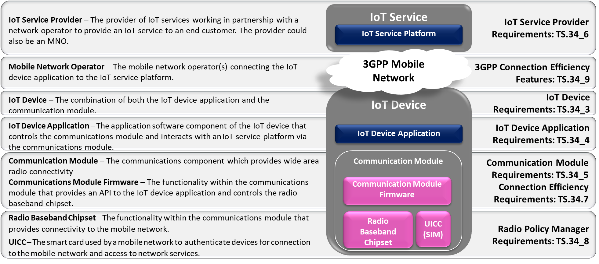

Figure 5.3-1: Requirements for CIoT solutions

### 5.4 **Tiered IoT Device Application Requirements**

In the GSMA evolved architecture the Tiered IoT Device Application performs the business logic of the IoT solution. The GSMA requirements for such an application are captured in table 5.4-1.

Table 5.4‑1: Tiered IoT Device Requirements

|  |  |  |
| --- | --- | --- |
| TS.34_4.1_REQ_001 | If data speed and latency is critical to the IoT Service the IoT Device Application should be able to retrieve mobile network speed and connection quality information from the IoT Embedded Service Layer in order to request the appropriate quality of content from the IoT Service Platform. | See clause 6.1 |
| TS.34_4.1_REQ_002 | The IoT Device Application should always be prepared to handle situations when communication requests fail, when such failure is reported by the IoT Embedded Service Layer. | See clause 6.2 |
| TS.34_4.1_REQ_003 | Each time there is a need to send data over the mobile network the IoT Device Application should classify the priority of each communication. For example, the IoT Device Application should distinguish between data that requires instantaneous transmission and delay tolerant data that could be aggregated and/or sent during non-peak hours. Such information about the priority of the communication should be communicated to the IoT Embedded Service Layer. | See below [UPDATE THIS] |
| TS.34_4.1_REQ_004 | When an IoT Device Application does not need to perform regular data transmissions and it can tolerate some latency for its IoT Service, it should communicate this information to the IoT Embedded Service Layer so that it can use this information in its interactions with the network. | See below [UPDATE THIS] |

-------------------------------------------------- End of Change 4---------------------------------------------------