CHANGE REQUEST
Meeting ID:* | SDS 51.2
Source:* | Andreas Neubacher, Deutsche Telekom, andreas.neubacher@magenta.at  Ingo Friese, Deutsche Telekom, Ingo.Friese@telekom.de  Andreas Kraft, , Deutsche Telekom, a.kraft@telekom.de
Date:* | 2021-10-05
Reason for Change/s:* | Additional input, elaborating the challenge and the different characterisics of Data in scope of the OGC data model. Editorial changes and addition of references.
CR against: Release* | Rel.5
CR against: WI* | Active <Work Item number>  MNT maintenance / < Work Item number(optional)>  Is this a mirror CR? Yes No  mirror CR number: (Note to Rapporteur - use latest agreed revision)  STE Small Technical Enhancements / < Work Item number (optional)>  Only ONE of the above shall be ticked
CR against: TS/TR* | TR-0065 V0.0.1
Clauses * | 2.2, 5.0, 5.1, 5.2, new content in 6.x
Type of change: * | Editorial change  Bug Fix or Correction  Change to existing feature or functionality  New feature or functionality  Only ONE of the above shall be ticked
Other TS/TR(s) impacted | none
Post Freeze checking:* | This CR contains only essential changes and corrections? YES NO  This CR may break backwards compatibility with the last approved version of the TS? YES NO
Template Version: January 2020 (do not modify)

oneM2M Notice
The document to which this cover statement is attached is submitted to oneM2M. Participation in, or attendance at, any activity of oneM2M, constitutes acceptance of and agreement to be bound by terms of the Working Procedures and the Partnership Agreement, including the Intellectual Property Rights (IPR) Principles Governing oneM2M Work found in Annex 1 of the Partnership Agreement.
GUIDELINES for Change Requests:
Provide an informative introduction containing the problem(s) being solved, and a summary list of proposals.
Each CR should contain changes related to only one particular issue/problem.
If this is a correction, and the change applies to previous releases, a separate “mirror CR” should be posted at the same time as this CR
Mirror CR: applies only when the text, including clause numbering are exactly the same.
Companion CR: applies when the change means the same but the baselines differ in some way (e.g. clause number).
Follow the principle of completeness, where all changes related to the issue or problem within a deliverable are simultaneously proposed to be made e.g. a change impacting 5 tables should not only include a proposal to change only 3 tables. Include any changes to references, definitions, and abbreviations in the same deliverable.
Follow the drafting rules.
All pictures must be editable.
Check spelling and grammar.
Use change bars for modifications.
The change should include the current and surrounding clauses to clearly show where a change is located and to provide technical context of the proposed change. Additions of complete clauses need not show surrounding clauses as long as the proposed clause number clearly shows where the proposed new clause is located.
Multiple changes in a single CR shall be clearly separated by horizontal lines with embedded text such as, start of change 1, end of change 1, start of new clause, end of new clause.
When subsequent changes are made to the content of a CR, then the accepted version should not show changes over changes. The accepted version of the CR should only show changes relative to the baseline approved text.

Introduction
Additional input, elaborating the challenge and the different characterisics of Data in scope of the OGC data model. Furthermore editorial changes and addition of references are provided in this CR. The content of this CR has been already presented in SDS 51.1 in document in SDS-2020-0295R05-OGC-to-oneM2M_Data_Mapping

-----------------------Start of Changes to References Clause -------------

2.2 Informative references
Clause 2.2 shall only contain informative references which are cited in the document itself.
The following referenced documents are not necessary for the application of the present document but they assist the user with regard to a particular subject area.
[i.1] oneM2M Drafting Rules (http://member.onem2m.org/Static_pages/Others/Rules_Pages/oneM2M-Drafting-Rules-V1_0.doc)
[i.2] SensorThings API website, https://www.ogc.org/standards/sensorthings
[i.3] ISO 19156 website, https://www.iso.org/standard/32574.html
[i.4] oneM2M TS-0033 3.0.0 "Interworking Framework“
[i.5] oneM2M TS-0023 4.7.1 “SDT based Information Model and Mapping for Vertical Industries”
[i.6] FROST®-Server - Open-Source-Implementierung der OGC SensorThings API - Fraunhofer IOSB
[i.7] OGC and ISO 19156:2001, OGC 10-004r3 and ISO 19156:2011(E), OGC Abstract Specification: Geographic
information — Observations and Measurements. Available Online:
https://www.ogc.org/standards/om
-----------------------End of Changes to References -------------

-----------------------Start of change 1-------------------------------------------

5 Background
The following text explains what is SensorThings API and how does it work

5.0 Introduction
The SensorThings API (STA) is a standard of the Open Geospatial Consortium (OGC). It provides a framework for communication and exchanging data between sensors and applications. The standard is devided in two parts. SensorThings API Part 1 is dedicated to sensing and was published in 2016 [i.2]. Part 2 deals with tasking and was published in 2019 [i.2]. There is an OGC certified Open-Source SensorThings API Server available (FROST Server) [i.6]. It supports the OGC SensorThings API Part 1: Sensing. It also includes preliminary actuation/tasking support.
For the description of entites SensorThings API uses ISO 19156:2001 data model [i.3] and JSON as data format. The communication is REST-based and uses HTTP and also CoAP, MQTT, 6LowPAN.

5.1 SensorThings API Architecture
A typical STA-based architecture works in client/server mode. A sensor device pushes data to the SensorThings Server via HTTP POST request. A SensorThings Server may also support MQTT protocol to support publish and subscribe capabilities. An interested application can subscribe to the MQTT-Broker in order to get notified about new sensor events.
The data in the SensorThings server are organized according to ISO 19156:2001 [i.7] (see Figure 5.1-1: ISO 19156:2001 data model).
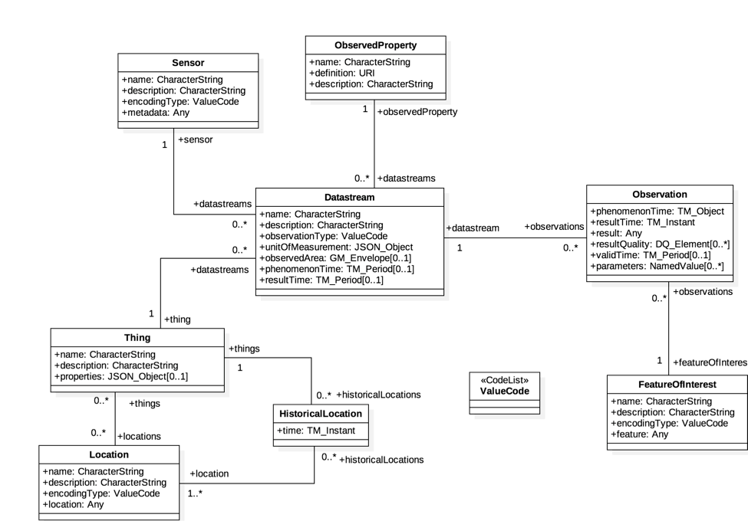
Figure 5.1-1: OGC and ISO 19156:2001 data model
In the SensorThings data model events or sensor data are called ‘observations’. Before a sensor is able to push an observation to the server it needs at least a ‘thing’- and a ‘data stream’ entity. This is created beforehand. One ‘thing’ might have different ‘sensors’, one ‘location’ or many ‘historical locations’.

Taking a closer look at the SensorThings data model and the purpose of data within the data model discloses mainly two data characteristics, associated with a ‘thing’.
- Data observations originated by sensors or commands sent to interact with actuators may be seen as IoT data from oneM2M point of view.
while
- Data embedded in the SensorThings data model, like “historic locations” may be seen as data for documentation purposes e.g. for the city administration

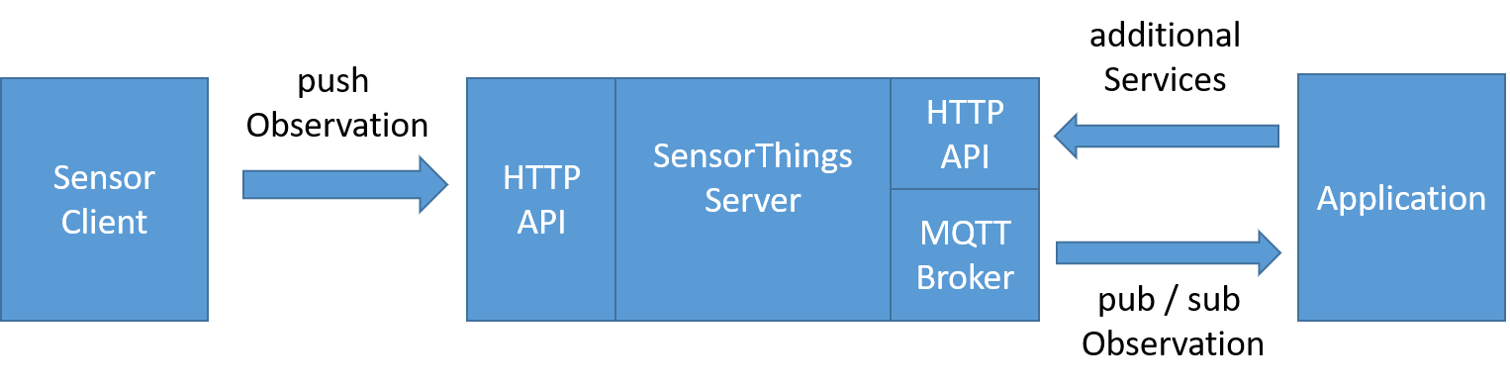

Figure 5.1-2: Example STA message flow

5.2 SensorThings API example use-case
The message flow in Figure 5.1-2 can be explained by using an example of an application that wants to use data of EV-Charging Stations in a city.

1.) In order to get observations belonging to the cities EV-Charging Stations the application needs to know the relevant “datastreams”. Therefore the application needs to send a request with filter parameter to the HTTP-API of the server e.g.:

https://sta-example-server-address.com/v1.0/Things?$filter=substringof(“Charging”,name)&$count=true&$expand=Datastreams

As a response the server provides a list of all datastreams belonging to a Charging Station.

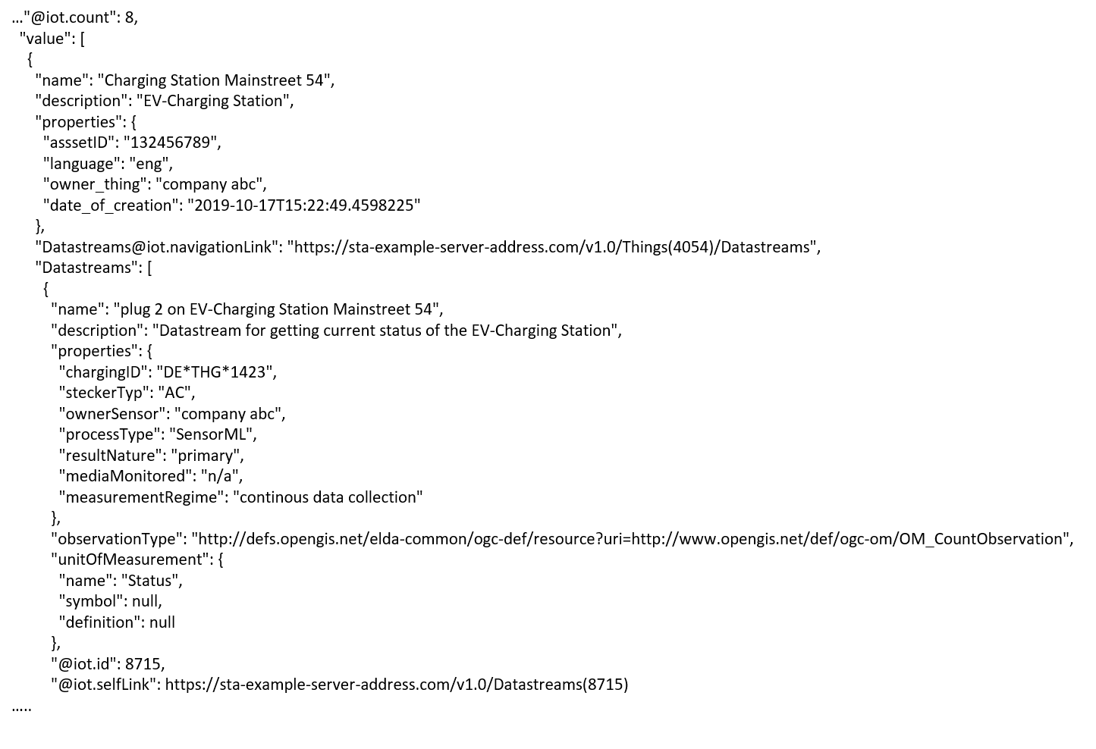
Figure 5.2-1: Example entry from the result list returned by a filter request

2.) The application can now subscribe to these “Datastreams”. Figure 5.2-1 shows one entry of the result list. It represents an EV-Charging Station as a ‘thing’ and includes details of “Datastreams”
3.) As soon as the sensor (EV-Charging Station) changes its status e.g. from “available” to “charging” it pushes an oberservation to the server.

4.) The application gets the observation through a notification that is sent by the MQTT Broker. An example of an observation is shown in Figure5.2-2. In the result field the current status of the EV-Charging Station is shown as “charging”.
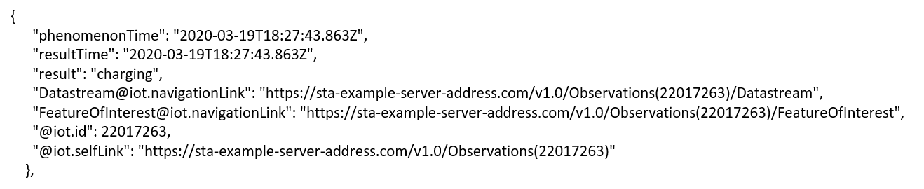
Figure 5.2-2: Example STA observation

-----------------------End of change 1---------------------------------------------

-----------------------Start of new Content 1-------------------------------------------

6 Architecture Model of OGC/STA to oneM2M interworking

6.0 Introduction
Figure 6.0-1 shows an architecture approach for an Interworking Proxy Entity (IPE) between oneM2M and the OGC SensorThings API. The IPE is located between a oneM2M CSE and an OGC/SensorThings API (STA)-Server.
The basic interworking enables applications that are connected to an oneM2M-based system to get data from sensors that are connected to an OGC/STA server. Furthermore, an application that is connected to an OGC/STA server is able to get data from sensors that are connected to an oneM2M-based system.
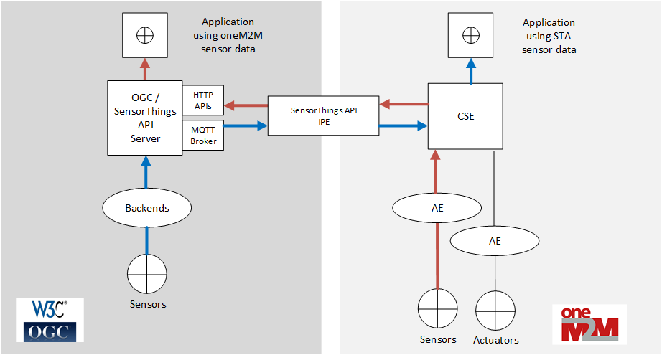
Figure 6.0-1: IPE architecture overview with data flow

6.1 OGC/STA-to-oneM2M Data Model Mapping
According to TS-0033 [i.4] a representation of a non-oneM2M Proximal IoT function/device in a oneM2M-specified resource instance is to be synchronized with the entity that it represents.
This means that the OGC/STA data model is represented in the hosting CSE. The data in the OGC/STA server are organized according to ISO 19156 [i.3] (see Figure 5.1-1: OGC and ISO 19156:2001 data model).
The oneM2M structure for data models is a tree-structure where data are organized in containers or trees of containers.
The OGC/STA data model is a relational one, as used in databases, and not hierarchical. Thus it creates a challenge for full interworking of all data captured in the OGC/STA data model.

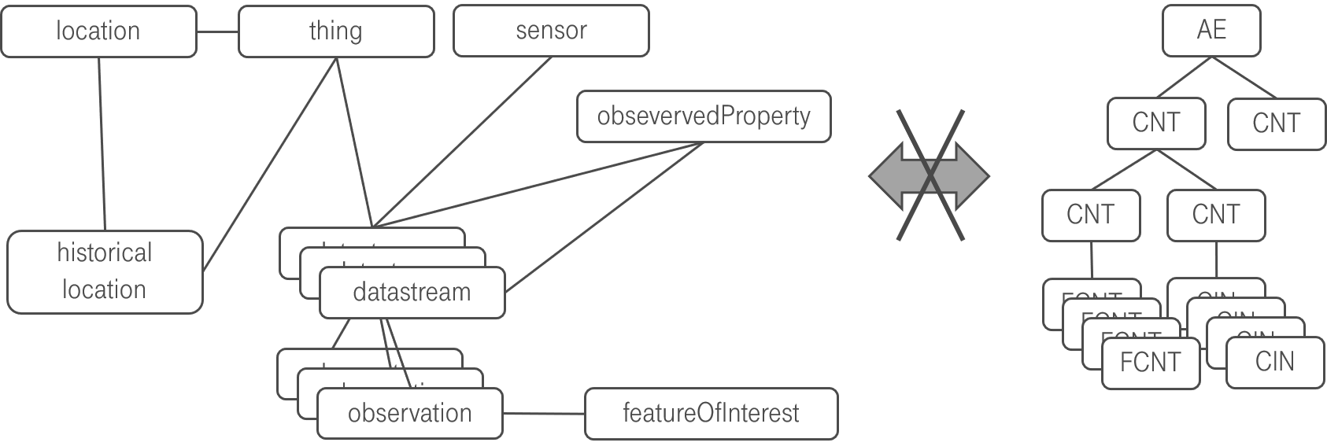
Figure 6.1-1: OGC data model cannot directly be mapped to oneM2M

One reason for this challenge is, as already outlined in section 5.1. The SensorThings data model is comprehensive and may be regarded as a n:m relational database structure, holding both:
- sensor (IoT-data) and
- administrative data (like historic locations or historic products IDs)
with an n:m relational database.
Aiming at a full interworking on all data being available in the OGC/STA data model, would require either:
- Additional functionality (possibly a new Common Service Function CSF) within the oneM2M CSE being able to build up, tear down and maintain such relationships between content instances and flex containers based on Mca commands,
or
- The IPE internally keeps track about relations and inserts “helper” references in “flexContainers”, pointing to related data (e.g. historical locations) in other flex containers. However, this would allow an interworking from OGC side towards oneM2M, but an AE on oneM2M side would not be able to retrieve those related data since the relation is only known to the IPE.
In the following section the different approaches are visited in more detail.

6.2. Architecture Approaches

6.2.0 Introduction
In the following section possible options and shortfalls in the context of a full data interworking and the consequences for the architecture of an interworking between both standards are being discussed. In the following sub-clauses, three different approaches and their advantages and disadvantages are discussed.

6.2.1 “Flat Data Model” Approach

6.2.1.0 Overview
One approach is to create a separate oneM2M container entity for every single group of entities in the OGC data model. Figure 6.2.1.0-1 shows a oneM2M data model that could represent the OGC/STA - data in a hosting CSE.
The top of a tree may be an <AE> resource. Below in Figure 6.2.1.0-1, there are <container> resources representing the dedicated objects of the OGC and ISO 19156 data model. They are all at the same level and represent a flat data model representation.
There may be, for example, one <container> resource where all incoming “Observation” objects from SensorThings API are stored by the IPE. There may be another <container> where the “Datastream” object for this “Observation” is stored. There may be also <container> resources for “Location”-, “Sensor”-, “Thing” or other objects.
The OGC/STA – “Observation” object itself may be represented as an <flexContainer>, under a <container> with a resource name “observations”.
The OGC/STA –“Datastream” object itself may also represented as an <flexContainer> under a <container>with a resource name “Datastreams”.
In figure 6.2.1.0-1 these <flexContainer> resources are represented as grey boxes. This way a oneM2M data structure represents all of the entities from the OGC and ISO 19156 data model.
The relationships between the ISO 19156 entities can be represented using dedicated custom attributes defined inside a <flexContainer> specialization.
Figure 6.2.1.0-1 shows the <flexContainer> with the resource name “ObservationXYZ” that has an attribute “STAdatastream” with the value “Datastream123”. This Attribute points to a <flexContainer> representing the “Datastream” object with the resource name ”Datastream123” located in the “Datastreams” <container>. This way the attribute represents inherent the relationships from the OGC/STA data model.
Actually, two kinds of relationships are described in this approach:
- The first kind are the oneM2M specific <AE>-to- <container>-to-<flexContainer> relationships (grey / continuous lines).
- The second kind of relationships are OGC specific and are expressed as attributes inside the <flexContainer> entities. Here for example a “Observation”-to-“Datastream” relationship is described (blue / dashed line).

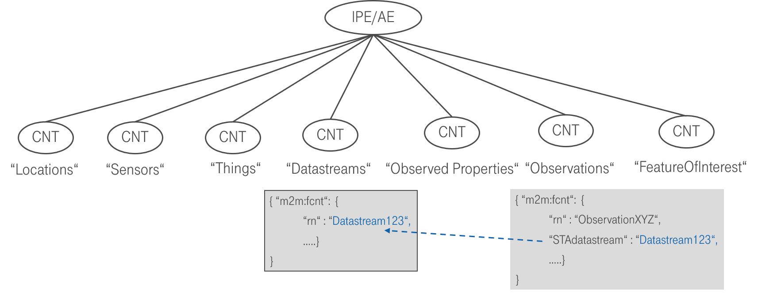
Figure 6.2.1.0-1: The flat data model with inherent relationship

6.2.1.1 Missing Relationship Management
As already briefly addressed in 6.1, the inherent relationships (dashed blue line in figure 6.2.1.0-1) describing the OGC/STA data model are not in scope to be managed by the CSE today. Only the relationships between <AE> and <container> can be managed (grey lines) by the CSE.
For example, in case that a certain <flexContainer>, representing a “Datastream”, is deleted, all related <flexContainer> resources representing an “Observation” need to be deleted too. This is how it is handled in an OGC/STA Server, but this would not be possible by current oneM2M CSE functionality.
Note: This approach is rather a theoretical one and shows the issue of a missing oneM2M relationship management in the CSE.

6.2.2 “Generic” Approach

6.2.2.0 Overview
In the "generic" approach subscriptions are used to replicate observation data between oneM2M <container>s and OGC Datastreams
In order to transfer data from a oneM2M sensor to OGC/STA the IPE creates a <subscription> to the <container> resource with the desired data and when a new <contentInstance> is added it gets a <notification> message containing the <contentInstance> resource.
Figure 6.2.2.0-1 shows the oneM2M-to-OGC/STA direction. Based upon the creation of the <contentInstance> in the hosting CSE, the IPE gets a <notification> message including the <contentInstance>. The IPE constructs an “Observation” creation request and copies the ‘content’ attribute of the <contentInstance> to the ‘result’ attribute of the “Observation” shown in Figure 6.2.2.0-2 and sends it to the OGC/STA server.
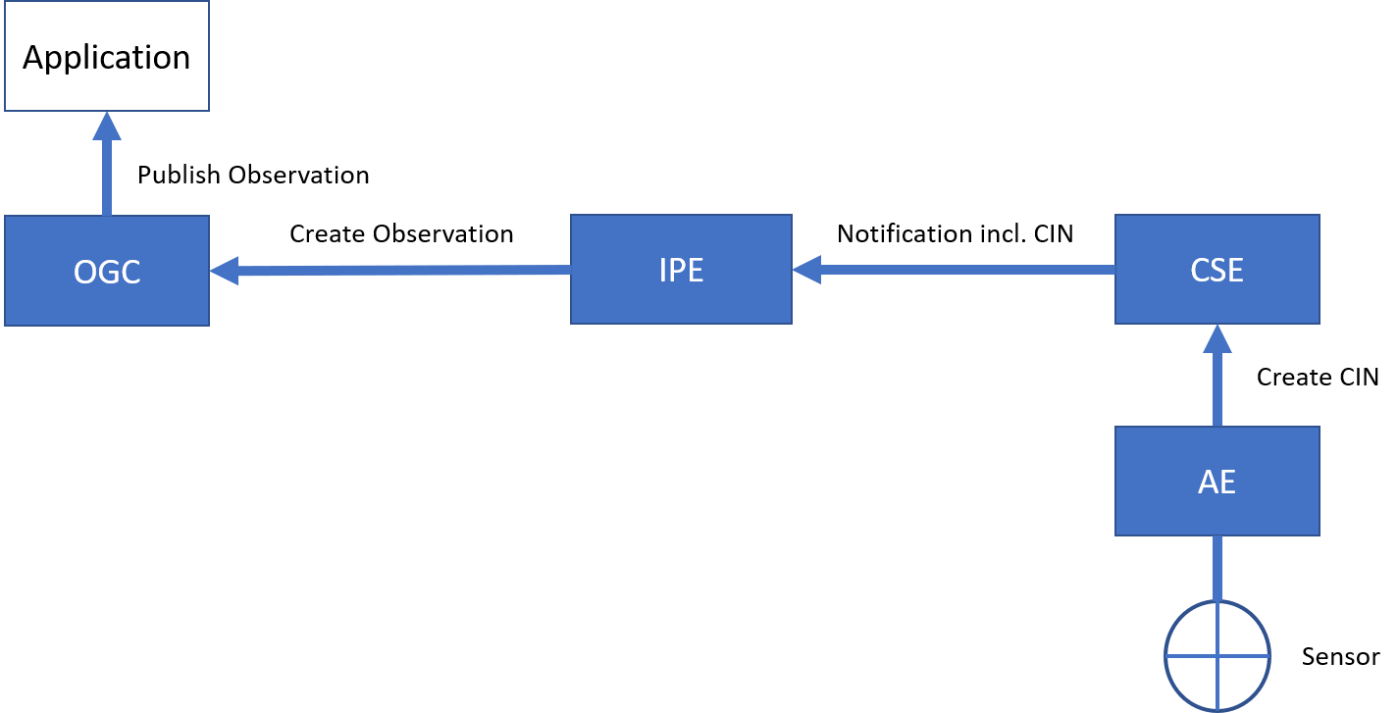
Figure 6.2.2.0-1: Gateway oneM2M-to-OGC/STA direction
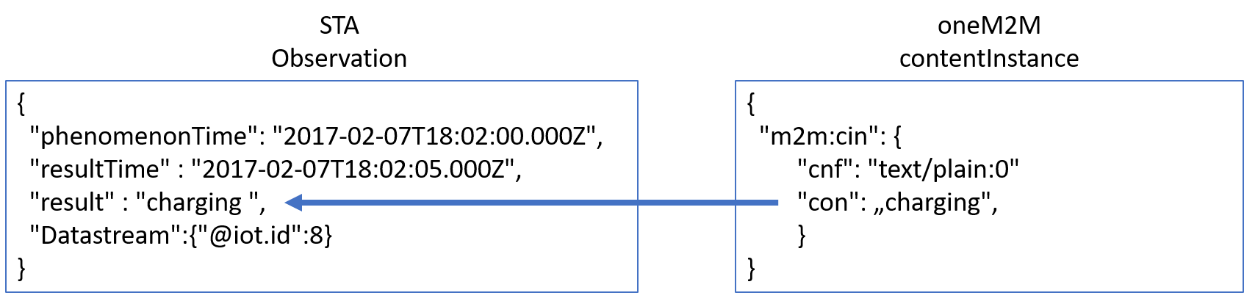
Figure 6.2.2.0-2: Content copying from CIN-to-Observation
Figure 6.2.2.0-3 shows the OGC/STA-to-oneM2M direction. OGC/STA does not provide a publish / subscribe mechanism on HTTP protocol level but OGC allows an optional MQTT extension for STA services [i.2]. The IPE subscribes to the MQTT-Broker of the OGC/STA server. The OGC/STA server publishes its new “Observation” via the MQTT broker. The IPE creates a <contentInstance> using a HTTP request and copies the ‘result’ attribute of the “Observation” to the ‘content’ attribute of the <contentInstance>. The <container> may be created beforehand at the hosting CSE where the IPE <contentInstance> resources are stored. All interested applications may subscribe to this <container> resource.
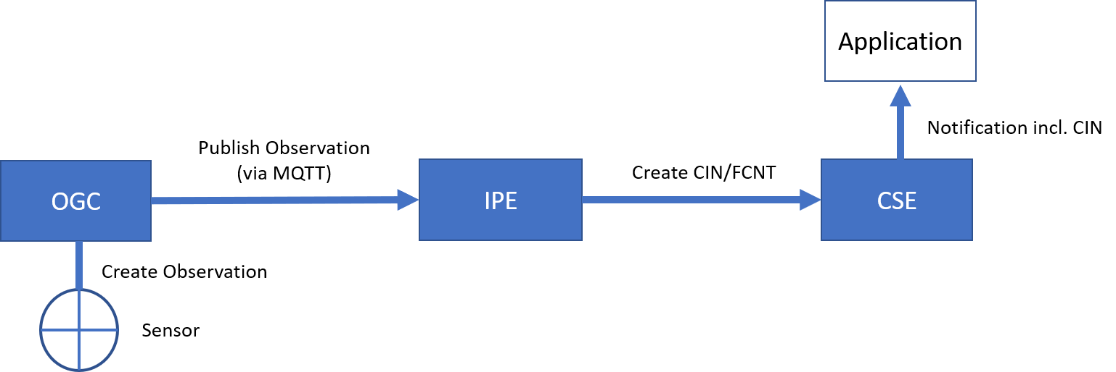
Figure 6.2.2.0-3: Gateway OGC-to-oneM2M direction
This approach is simple and sufficient in cases that only require translating “Observation” to <contentInstances> and vice-versa.

6.2.2.2 Discussion of “Generic” approach
The “generic” approach has disadvantages:
- Data are stored in the hosting CSE, but this is just a subset of the non-oneM2M proximal IoT function.
These are only data that are being actually exchanged.
- The oneM2M client application is not able to gain additional information that are linked to an incoming “Observation” like “Location” or “Sensor”. This kind of information would need to be exchanged upfront in the configuration phase described in chapter 6.3.
On the other hand, the approach has also advantages:
- The IPE would not be required to copy the full OGC/STA data model into the hosting CSE.

Conclusion:
The “generic” approach would be a very flexible solution, in case only simple measurements need to be exchanged.

6.2.3 “Specific Device” Approach

6.2.3.0. Overview
Another architectural approach would be to focus the design of the IPE on a specific device type.
The data model may be described according to TS-0023, [i.5]. TS-0023 [i.5] describes a templating tool for describing heterogenous devices and their functionalities using a Smart Device Template (SDT). SDT offers a generic and flexible modeling structure for non-oneM2M devices.
The first step in an OGC/STA interworking scenario may be to register the IPE to the hosting CSE as an <AE> resource. This <AE> resource is a parent for dedicated <flexContainer> resource specializations that represent each ‘Thing’ connected to the OGC/STA server (for example an EV-Charging station).
A OGC/STA ‘Thing’ may be modelled as a SDT Device. Mapping of the SDT Device model to oneM2M resources is performed according to the general mapping procedure described in clause 6.2.2 of TS-0023 [i.5]. A SDT Device component is mapped to a specialization of a <flexContainer> resource with an associated 'DeviceClass ID' (e.g. "org.onem2m.home.device.tv") containerDefinition attribute.
Figure 6.2.3.0-1 shows an example of an OGC/ STA Thing:[deviceElectricVehicleCharger], which is modelled as a <flexContainer> resource specialization derived from the corresponding SDT Device component. The model of [deviceElectricVehicleCharger] follows the schema described in clause 5.5.18 of TS-0023 [i.5].
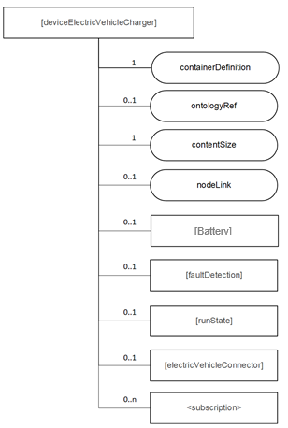
Figure 6.2.3.0-1: [deviceElectricVehicleCharger] example resource representing a OGC/STA device
The <flexContainer> representation based on SDTs allow the design of a desired data model for supported device types. The IPE is responsible for ensuring changes in the OGC data model are mapped to an update of the appropriate <flexContainer>.

6.2.3.1. Communication Schema
In this approach for the OGC-to-oneM2M direction the IPE subscribes to the MQTT message broker of the OGC/STA server, to receive all desired changes in the data model of an OGC/STA device. In addition to “Observations” all changes, such as “Location”, are published to the IPE (Figure 6.2.3.1-1). The IPE may subscribe or filter out only changes affecting the <flexContainer> and sends respective UPDATE messages to the CSE.
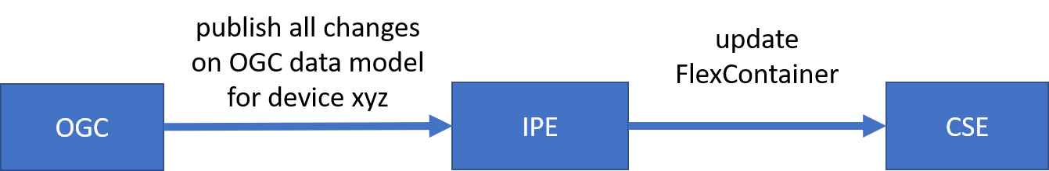
Figure 6.2.3.1-1: OGC/STA-to-oneM2M direction
For the oneM2M-to-OGC direction the IPE subscribes to the <flexContainer> resources in the hosting CSE. If there are changes to the <flexContainer> from an application the CSE will send a <notification> message to the IPE. The IPE assigns the appropriate messages to update the OGC data model (Figure 6.2.3.1-2.)

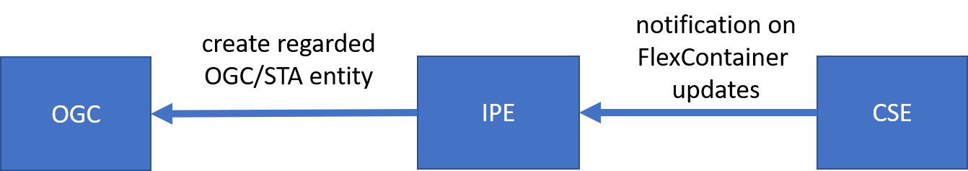
Figure 6.2.3.1-2: oneM2M-to-OGC/STA direction

6.2.3.2 Discussion of the “Specific Device” Approach
The disadvantage of this approach would be a loss of flexibility and an of course it would involve a certain maintenance effort to keep SDT and OGC model in sync and up to date in case there are changes either on SDT or OGC side. Even if there are tools to create SDT <flexContainer> from a certain device automatically, the mapping to or from the OGC/STA data model may still be highly individual because the “properties” field in the OGC/STA data model can be filled with optional data in JSON-Format.
In this case it would be beneficial to have somethings similar for SDTs, a data structure for additional attributes. It is very likely that the SDT would not always describe all features, information and attributes of a complex device. To have something like ‘property-extensions’ in SDT could ease the process of translating foreign data model into oneM2M. In our OGC / STA example use case “ev-charging” there is a foreign index like “chargingID” (see Figure 5.2-1) that could be defined as an attribute in a “property” structure. In SDT 3.0 “Properties” were already discussed as an addition to “Action”, “Datapoint” and “Event”. They could be used for non-functional data as well. An alternative approach for attributes that are not defined by a SDT is the “Label” attribute.
As a consequence, this approach enables no OGC/STA IPE for general use currently. It rather more enables an OGC / STA IPEs for specific devices e.g. “EV-Charging Stations” of “Company XYZ” in “Version 1.23”.
However, this approach is also beneficial. Compared to the approaches discussed before, in this case the client application does not need to have any knowledge about the OGC data model. A client application may only rely on oneM2M specifications and is still able to read data coming from a sensor that is connected via OGC / STA.

6.2.4 Conclusion
This chapter showed three architecture approaches in the context of full data interworking.
The “Flat data model” is a theoretical approach showing that it creates issues to map the meshed OGC/STA data model to a hierarchical oneM2M data model. In the process of mapping some essential relationships get lost.
In today’s oneM2M specifications the maintenance of foreign data model relationships is out of scope for the CSE. This causes potential data inconsistencies. Adding a relationship management to oneM2M would be a beneficial extension.
The “generic” approach focuses mainly on dynamic parts of the OGC data model. Here only “Observations” are translated to oneM2M <contentInstance> or <flexContainer> . Other parts of the OGC data model are seen as administrative data and are not translated because their change rate is rather low in most use-cases.
A pre-condition for this kind of interworking is the exchange of administrative knowledge during the initial setup phase upfront. The IPE needs to know to which OGC “Datastream” or “Sensor” a certain “Observation” belongs to. Once the ”Observation” is translated to oneM2M this administrative information is lost.
The advantage of the approach is that the IPE would not be required to copy the full OGC/STA data model into the hosting CSE. The OGC/STA data model would always be accurate, because data remains hosted at the authoritative source, the OGC/STA server. This approach reduces synchronization effort and possible errors.
The “Specific Device” approach uses TS-0023 Smart Device Templates (SDTs) to describe the OGC/STA data model in the hosting CSE. But SDTs look different for various devices. As a consequence, the IPE has to be specific for a certain type of devices.
The disadvantage of this approach would be a loss of flexibility because it enables no OGC/STA IPE for general use currently.
The advantage of this approach is that an oneM2M client application does not need to have any knowledge about the OGC data model. A client application may only rely on oneM2M specifications and is still able to read data coming from a sensor that is connected via OGC / STA.
The “generic” approach was chosen to be investigated and described in more detail in the next chapters. Such an IPE is a “hands-on” solution and a good trade-of between ease of implementation and full data interworking. It is usable in many application fields like “Smart Home” or “Smart City”.

-----------------------End of new Content 1-------------------------------------------

CHECK LIST
- Does this Change Request include an informative introduction containing the problem(s) being solved, and a summary list of proposals.?
- Does this CR contain changes related to only one particular issue/problem?
- Have any mirror CRs been posted?
- Does this Change Request make all the changes necessary to address the issue or problem? E.g. A change impacting 5 tables should not include a proposal to change only 3 tables?Does this Change Request follow the drafting rules?
- Are all pictures editable?
- Have you checked the spelling and grammar?
- Have you used change bars for all modifications?
- Does the change include the current and surrounding clauses to clearly show where a change is located and to provide technical context of the proposed change? (Additions of complete clauses need not show surrounding clauses as long as the proposed clause number clearly shows where the new clause is proposed to be located.)
- Are multiple changes in this CR clearly separated by horizontal lines with embedded text such as, start of change 1, end of change 1, start of new clause, end of new clause.?

