CHANGE REQUEST
Meeting ID:* | SDS#51
Source:* | Xiaotao Li, CMCC, lixiaotao@chinamobile.com  Yawen Niu, CMCC, niuyawen@chinamobile.com  Shujuan You, CMCC, youshujuan@ chinamobile.com
Date:* | 2021-11-26
Reason for Change/s:* | To introduce a solution of semantic mapping between IoT ontology and object identifiers to meet the requirement ONT-21.
CR against: Release* | Release 4
CR against: WI* | Active <WI-0053>  MNT maintenance / < Work Item number(optional)>  Is this a mirror CR? Yes No  mirror CR number: (Note to Rapporteur - use latest agreed revision)  STE Small Technical Enhancements / < Work Item number (optional)>  Only ONE of the above shall be ticked
CR against: TS/TR* | TR-0033 V4.5.0
Clauses * | 8.x.x
Type of change: * | Editorial change  Bug Fix or Correction  Change to existing feature or functionality  New feature or functionality  Only ONE of the above shall be ticked
Impacted other TS/TR(s) | N/A
Post Freeze checking:* | This CR contains only essential changes and corrections? YES NO  This CR may break backwards compatibility with the last approved version of the TS? YES NO
Template Version: January 2017 (Do not modify)

oneM2M Notice
The document to which this cover statement is attached is submitted to oneM2M. Participation in, or attendance at, any activity of oneM2M, constitutes acceptance of and agreement to be bound by terms of the Working Procedures and the Partnership Agreement, including the Intellectual Property Rights (IPR) Principles Governing oneM2M Work found in Annex 1 of the Partnership Agreement.
GUIDELINES for Change Requests:
Provide an informative introduction containing the problem(s) being solved, and a summary list of proposals.
Each CR should contain changes related to only one particular issue/problem.
In case of a correction, and the change apply to previous releases, a separate “mirror CR” should be posted at the same time of this CR
Mirror CR: applies only when the text, including clause numbering are exactly the same.
Companion CR: applies when the change means the same but the baselines differ in some way (e.g. clause number).
Follow the principle of completeness, where all changes related to the issue or problem within a deliverable are simultaneously proposed to be made E.g. A change impacting 5 tables should not only include a proposal to change only 3 tables. Includes any changes to references, definitions, and acronyms in the same deliverable.
Follow the drafting rules.
All pictures must be editable.
Check spelling and grammar to the extent practicable.
Use Change bars for modifications.
The change should include the current and surrounding clauses to clearly show where a change is located and to provide technical context of the proposed change. Additions of complete clauses need not show surrounding clauses as long as the proposed clause number clearly shows where the new clause is proposed to be located.
Multiple changes in a single CR shall be clearly separated by horizontal lines with embedded text such as, start of change 1, end of change 1, start of new clause, end of new clause.
When subsequent changes are made to content of a CR, then the accepted version should not show changes over changes. The accepted version of the CR should only show changes relative to the baseline approved text.

Introduction
This CR provides a solution of semantic mapping between IoT ontology and object identifiers according to requirement ONT-021 in TS-0002. The supporting use cases can be found in TR-0001 clause 12.34.
Requirement ID | Description | Release
ONT-021  See RDM-2019-0093 | The oneM2M System shall be able to provide machine understandable semantic information for object identifiers to map the identified objects to corresponding classes in the IoT ontology and enable objects to identify what the interactive object is independently. | 5

With the development of communications and artificial intelligence technologies, the value of Internet of Things (IoT) is no longer limited to ubiquitous communication networks but providing intelligent services to human beings. These intelligent services appear in many representative scenarios without the aid of human intervention, such as smart home, self-service store, etc. To achieve these scenarios, objects with heterogeneous identifiers (e.g. EPC, Handle, OID, ucode, mCode, Ecode, etc.) need to cooperate with each other without the human intervention. However, all the existing identifiers appear as a sequence of characters and generally lack semantic information. IoT objects cannot identify what the interactive or cooperative object is through the identifier alone. Therefore, oneM2M system needs to enable semantic mapping between IoT ontology and identifiers to facilitate the IoT intelligence. Besides, the operations including create, retrieve, update, and delete (CRUD) of instances frequently occur in some smart scenarios. For example, in a self-service store, when a customer enters a store, a new instance belonging to the class “Person” should be added to the IoT ontology automatically. If a commodity has been bought by a customer, this “commodity” instance should be deleted from the ontology. It is impractical to achieve these instance operations manually. It requires a semantic mapping between the ontology and the identifiers of objects, which will help the IoT system to manage the instances in an unattended manner.

-----------------------Start of change 1-------------------------------------------

8.x.x Semantic mapping between IoT ontology and object identifiers

8.x.x.1 Introduction
In Internet of Things (IoT), a unique identifier is required for each object to serve as a digital identity and helps applications to obtain detailed information about this object. To support things with heterogeneous identifiers to cooperate with each other in unmanned IoT scenarios, we propose a semantic-based identifier framework named semantic code to provide a semantic prefix for each legacy IoT identifier and map the identified objects to the IoT ontology. In this way, the object can use the common knowledge provided by the IoT ontology to perform intelligent interoperations. Based on the semantic code, in this clause, a potential solution is specified for the process of creating semantic mapping between IoT ontology and object identifiers.
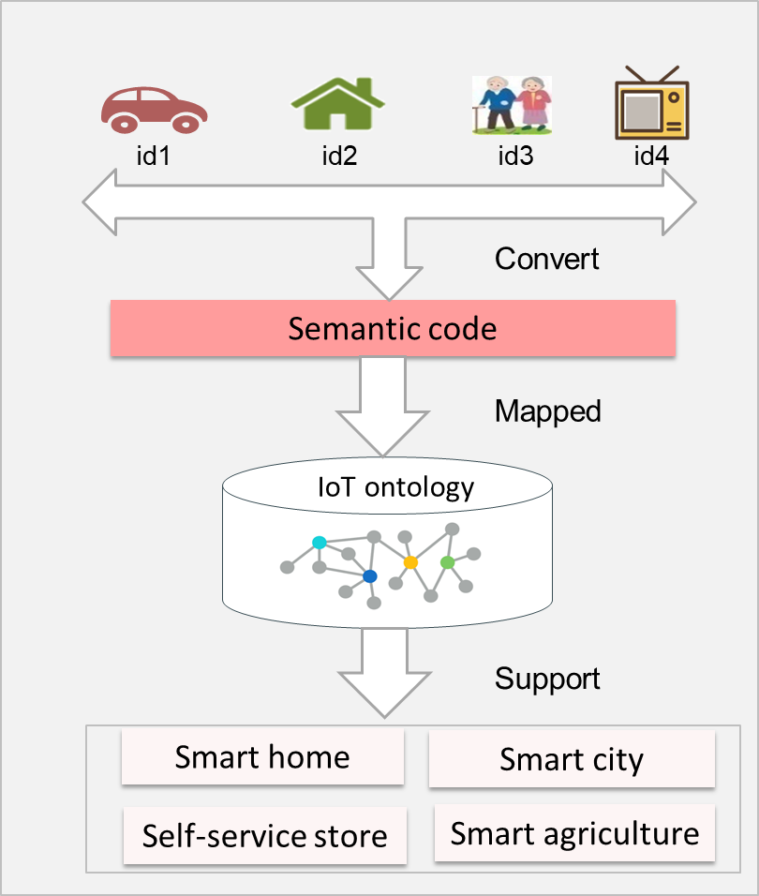
Figure 8.X.X.1-1: Implementing unmanned IoT scenarios based on the semantic mapping between IoT ontology and object identifiers

8.x.x.2 Semantic code
The format of the semantic code has a two-part structure including ontology prefix and legacy identifier. These two segments are connected by the character “/”, i.e. < Semantic code >:= < ontology prefix > “/” < legacy identifier >.
The ontology prefix is composed of a group of integers separated by “.” indicating a path from the root node to a class node in the IoT ontology. In this prefix, the parent node represents the parent class, and each integer segment represents a subclass index number of the parent class from left to right. For example, as shown in Figure 8.X.X.2-1, the prefix “1.4” indicates the class is “Commodity”, and the prefix “1.4.4” indicates the class is “Drink” which is the 4-th subclass of the class “Commodity”. Through the ontology prefix, the specific class which an object belongs to can be obtained, which makes it possible for an object to know what it is and what other objects are. Moreover, each object is mapped to an instance of a specific class in the ontology by the ontology prefix, and the relationships among the object and other objects are established as well.

Take a coffee with an EAN-13 identifier (8938515483013) for example. The oneM2M platform can add semantic information (“1.4.4.2”) to the legacy identifier and convert it to a semantic code “1.4.4.2/8938515483013”. From the ontology prefix (“1.4.4.2”), this object can be mapped to the class “Coffee”, and other objects can know this identified object is a Coffee instance.

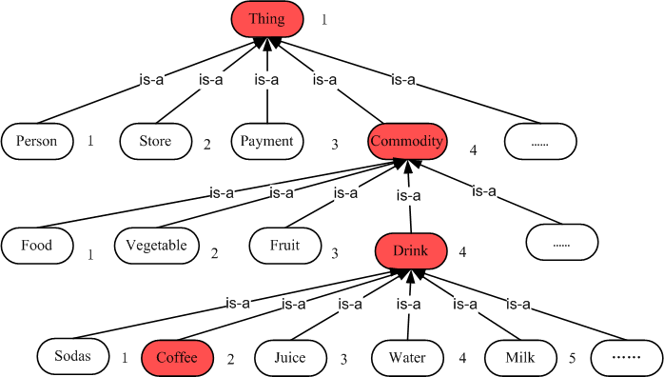
Figure 8.X.X.2-1: Ontology prefix

8.x.x.3 Procedure for initiating a function of semantic mapping between IoT ontology and object identifiers
Solution-1: In this alternative solution, the semantic code is used as the intermediation to create semantic mapping between object identifiers and IoT ontology. Machine understandable semantic information can be provided for object identifiers by the newly added ontology prefixes. Through the semantic codes, the identified objects can be mapped to the corresponding classes in the IoT ontology automatically. The following steps are performed for semantic mapping between IoT ontology and object identifiers.
Figure 8.X.X.3-1: Procedure of converting an object identifier to a semantic code
Step 1: The hosting CSE receives a request to convert an object identifier to a semantic code with the class of the object.
Step 2: The hosting CSE gets the <ontology> resource (IoT Ontology) from the <Ontology> hosting CSE.
Step 3: The hosting CSE obtains the ontology prefix based on the class name of the object and the IoT ontology.
Step 4: The hosting CSE combine the ontology prefix and the legacy object identifier to form a semantic code of the object.
Step 5: The hosting CSE returns the semantic code to the Originator.

Figure 8.X.X.3-2: The uniform mapping of a set of semantic code identifiers to the IoT ontology procedure
Step 1: The hosting CSE receives a request to map an object with a semantic code to the IoT ontology and perform create, retrieve, update, or delete (CRDU) operation to the IoT ontology.
Step 2: The hosting CSE gets the <ontology> resource (IoT Ontology) from the <Ontology> hosting CSE.
Step 3: The hosting CSE extracts ontology prefixes from the semantic code of the object.
Step 4: The hosting CSE maps the identified object to the IoT ontology according to its ontology prefix.
Step 5: The hosting CSE updates the IoT ontology via CRDU operations.
Step 6: The hosting CSE returns the updated IoT ontology to the <Ontology> Hosting CSE.
Step 7: The hosting CSE receives the response from the <Ontology> Hosting CSE.
Step 8: The hosting CSE returns the response to the Originator.

8.x.x.4 Application example
Taking the self-service store as an example, as shown in Figure 8.X.X.4-1, there are four objects identified by different kinds of identifiers respectively, including a person with a passport identifier, a store with a GLN identifier, a payment account with a credit card number, and a coffee with an EAN-13 identifier. These identifiers can be converted to semantic code identifiers uniformly by adding a semantic prefix respectively. Through the semantic code, each object becomes an instance of the ontology. For example, the person with a passport number “E501129487” turns into an instance of the class Person, and the instance name is “1.1/E501129487”. We can define a set of properties such as Buy, hasCommodity, and hasPayment. Through the property hasCommodity, the store can be aware of what commodities it has. With the help of the property Buy, the information that a person has bought which commodity is available. And by the property hasPayment, a payment can be made through the payment account related to the identified person. By combining these classes, instances and properties, each commodity can be paid for by the related payment account automatically.
Figure 8.X.X.4-1: semantic code example
-----------------------End of change1-------------------------------------------

CHECK LIST
- Does this Change Request include an informative introduction containing the problem(s) being solved, and a summary list of proposals.?
- Does this CR contain changes related to only one particular issue/problem?
- Have any mirror CRs been posted?
- Does this Change Request make all the changes necessary to address the issue or problem? E.g. A change impacting 5 tables should not include a proposal to change only 3 tables?Does this Change Request follow the drafting rules?
- Are all pictures editable?
- Have you checked the spelling and grammar?
- Have you used change bars for all modifications?
- Does the change include the current and surrounding clauses to clearly show where a change is located and to provide technical context of the proposed change? (Additions of complete clauses need not show surrounding clauses as long as the proposed clause number clearly shows where the new clause is proposed to be located.)
- Are multiple changes in this CR clearly separated by horizontal lines with embedded text such as, start of change 1, end of change 1, start of new clause, end of new clause.?

