CHANGE REQUEST
Meeting ID:* | SDS#52
Source:* | SeungMyeong JEONG, KETI, sm.jeong@keti.re.kr  NakMyung Sungm, KETI, nmsung@keti.re.kr  Sungchan Choi, KETI, csc@keti.re.kr  Jong-Hong Park, KETI, jonghong@keti.re.kr
Date:* | 2021-11-12
Reason for Change/s:* | To clarify representation of the query-string value in HTTP URL
CR against: Release* | 4
CR against: WI* | Active:  MNT maintenance / < Work Item number(optional)>  Is this a mirror CR? Yes No  mirror CR number:  STE Small Technical Enhancements / < Work Item number (optional)>  Only ONE of the above shall be ticked
CR against: TS/TR* | TS-0009
Clauses * | 6.2.2.2
Type of change: * | Editorial change  Bug Fix or Correction  Change to existing feature or functionality  New feature or functionality  Only ONE of the above shall be ticked
Impacted other TS/TR(s) | n/a
Post Freeze checking:* | This CR contains only essential changes and corrections? YES NO  This CR may break backwards compatibility with the last approved version of the TS? YES NO
Template Version: January 2017 (Do not modify)

oneM2M Notice
The document to which this cover statement is attached is submitted to oneM2M. Participation in, or attendance at, any activity of oneM2M, constitutes acceptance of and agreement to be bound by terms of the Working Procedures and the Partnership Agreement, including the Intellectual Property Rights (IPR) Principles Governing oneM2M Work found in Annex 1 of the Partnership Agreement.
GUIDELINES for Change Requests:
Provide an informative introduction containing the problem(s) being solved, and a summary list of proposals.
Each CR should contain changes related to only one particular issue/problem.
In case of a correction, and the change apply to previous releases, a separate “mirror CR” should be posted at the same time of this CR
Mirror CR: applies only when the text, including clause numbering are exactly the same.
Companion CR: applies when the change means the same but the baselines differ in some way (e.g. clause number).
Follow the principle of completeness, where all changes related to the issue or problem within a deliverable are simultaneously proposed to be made E.g. A change impacting 5 tables should not only include a proposal to change only 3 tables. Includes any changes to references, definitions, and acronyms in the same deliverable.
Follow the drafting rules.
All pictures must be editable.
Check spelling and grammar to the extent practicable.
Use Change bars for modifications.
The change should include the current and surrounding clauses to clearly show where a change is located and to provide technical context of the proposed change. Additions of complete clauses need not show surrounding clauses as long as the proposed clause number clearly shows where the new clause is proposed to be located.
Multiple changes in a single CR shall be clearly separated by horizontal lines with embedded text such as, start of change 1, end of change 1, start of new clause, end of new clause.
When subsequent changes are made to content of a CR, then the accepted version should not show changes over changes. The accepted version of the CR should only show changes relative to the baseline approved text.

Introduction
This CR proposes string value for boolean type request parameters that are mapped to Request-Line (URL) in HTTP binding.
Table 6.4.1-1 (Data Types for Request primitive parameters) in the TS-0004, defines data types for request primitives, which some of them get delivered over HTTP URL (Request-Line).
From the table, the following parameters are using the boolean data type:
- Delivery Aggragation
- Token Request Indicator
- Authorization Signature Indicator
- Authorization Relationship Indicator
- Semantic Query Indicator
Since the query-string in the URL is basically the string, the spec. needs to define the string token for the boolean value “true” or “TRUE”, etc. This is missing in TS-0009, so this CR proposes “true” and “false” for allowed token string for HTTP query-string mapping.
The example semantic query with the Semantic Query Indicator (sqi) parameter would then looks like this:
- csebase? fu=1&sqi=true&smf=urlEncodedSPARQLQuery

Table 6.4.1-1 Data Types for Request primitive parameters (partial) (TS-0004)
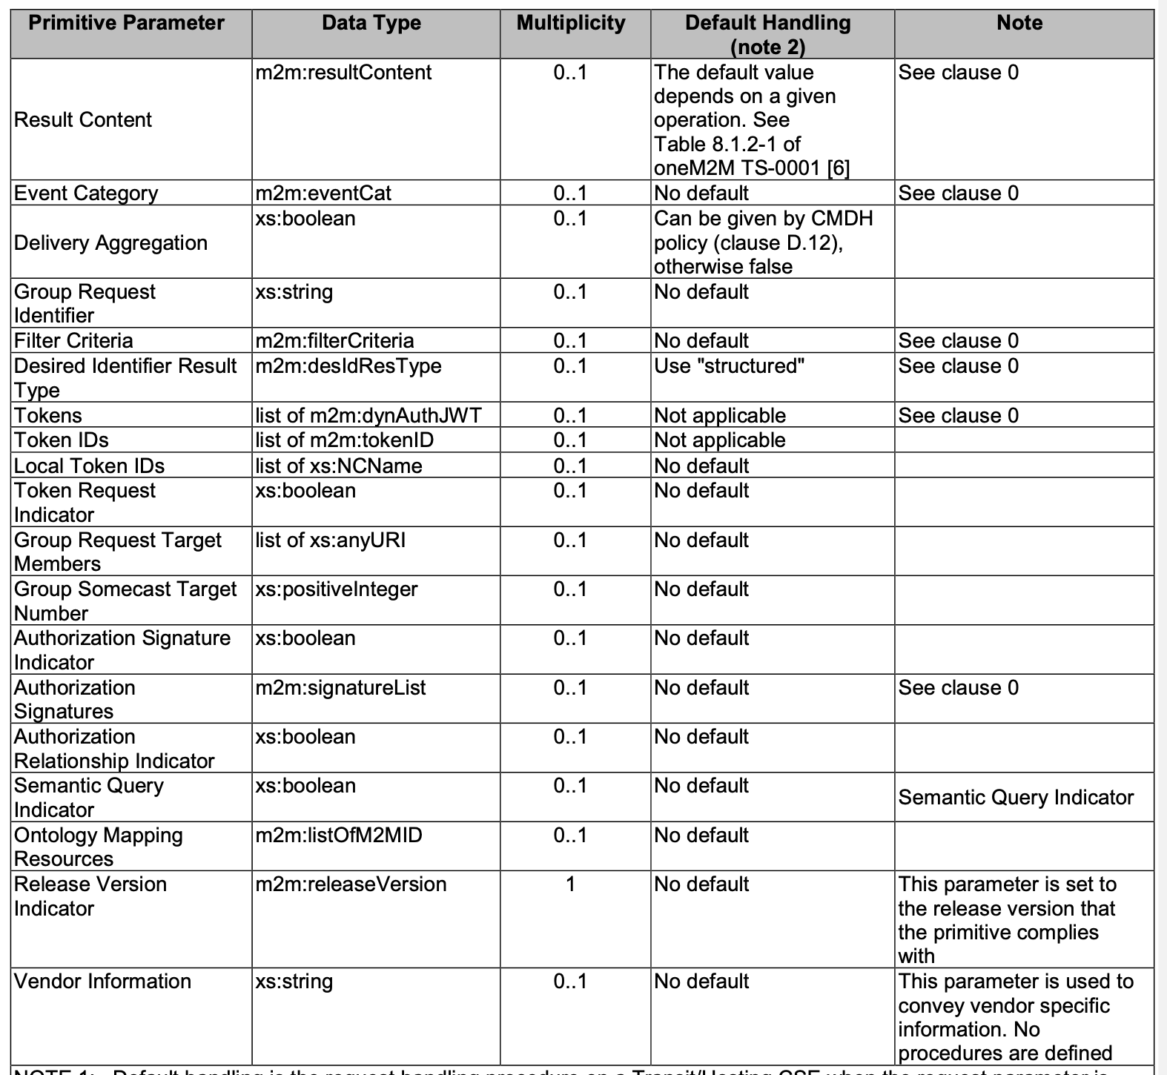

********** Start of change 1 **********

6.2.2 Request-Target

6.2.2.1 Path component
Table 6.2.2.2-1: oneM2M request parameters mapped as query-string field
Request Primitive Parameter | Query Field Name | Multiplicity | Note
Response Type | rt | 0..1 | responseType element of data type responseTypeInfo (cf. clause 6.3.4.29 of TS-0004 [Error: Reference source not found])
Result Persistence | rp | 0..1
Result Content | rcn | 0..1
Delivery Aggregation | da | 0..1 | Allowed values are “true” and “false” for this boolean-typed parameter.
createdBefore | crb | 0..1 | filterCriteria condition
createdAfter | cra | 0..1 | filterCriteria condition
modifiedSince | ms | 0..1 | filterCriteria condition
unmodifiedSince | us | 0..1 | filterCriteria condition
stateTagSmaller | sts | 0..1 | filterCriteria condition
stateTagBigger | stb | 0..1 | filterCriteria condition
expireBefore | exb | 0..1 | filterCriteria condition
expireAfter | exa | 0..1 | filterCriteria condition
labels | lbl | 0..n | filterCriteria condition
resourceType | ty | 0..n | filterCriteria condition
sizeAbove | sza | 0..1 | filterCriteria condition
sizeBelow | szb | 0..1 | filterCriteria condition
contentType | cty | 0..n | filterCriteria condition
limit | lim | 0..1 | filterCriteria condition
attribute | atr | 0..n | filterCriteria condition
filterUsage | fu | 0..1 | filterCriteria condition
semanticsFilter | smf | 0..n | filterCriteria condition, shall use “percent-encoding” [Error: Reference source not found] where required, see example 3)
filterOperation | fo | 0..1 | filterCriteria condition
contentFilterSyntax | cfs | 0..1 | filterCriteria condition
contentFilterQuery | cfq | 0..1 | filterCriteria condition
level | lvl | 0..1 | filterCriteria condition
offset | ofst | 0..1 | filterCriteria condition
geometryType | gmty | 0..1 | filterCriteria condition
geometry | geom | 0..1 | filterCriteria condition
geoSpatialFunction | gsf | 0..1 | filterCriteria condition
Discovery Result Type | drt | 0..1
Role IDs | rids | 0..n
Token IDs | tids | 0..n
LocalTokenIDs | ltids | 0..n
Token Request Indicator | tqi | 0..n | Allowed values are “true” and “false” for this boolean-typed parameter.
Authorization Signature Indicator | asi | 0..1 | Allowed values are “true” and “false” for this boolean-typed parameter.
Authorization Relationship Indicator | auri | 0..1 | Allowed values are “true” and “false” for this boolean-typed parameter.
Semantic Query Indicator | sqi | 0..1 | Allowed values are “true” and “false” for this boolean-typed parameter.

********** End of change 1 **********

CHECK LIST
- Does this Change Request include an informative introduction containing the problem(s) being solved, and a summary list of proposals.?
- Does this CR contain changes related to only one particular issue/problem?
- Have any mirror CRs been posted?
- Does this Change Request make all the changes necessary to address the issue or problem? E.g. A change impacting 5 tables should not include a proposal to change only 3 tables?Does this Change Request follow the drafting rules?
- Are all pictures editable?
- Have you checked the spelling and grammar?
- Have you used change bars for all modifications?
- Does the change include the current and surrounding clauses to clearly show where a change is located and to provide technical context of the proposed change? (Additions of complete clauses need not show surrounding clauses as long as the proposed clause number clearly shows where the new clause is proposed to be located.)
- Are multiple changes in this CR clearly separated by horizontal lines with embedded text such as, start of change 1, end of change 1, start of new clause, end of new clause.?

