CHANGE REQUEST
Meeting ID:* | SDS 532
Source:* | Bob Flynn, Exacta GSS, bob.flynn@exactagss.com
Date:* | 2021-11-29
Reason for Change/s:*
CR against: Release* | Rel-5
CR against: WI* | Active <WI-0096>  MNT maintenance / < Work Item number(optional)>  Is this a mirror CR? Yes No  mirror CR number: (Note to Rapporteur - use latest agreed revision)  STE Small Technical Enhancements / < Work Item number (optional)>  Only ONE of the above shall be ticked
CR against: TS/TR* | TR-0063 v0.0.1
Clauses * | multiple
Type of change: * | Editorial change  Bug Fix or Correction  Change to existing feature or functionality  New feature or functionality  Only ONE of the above shall be ticked
Other TS/TR(s) impacted | None
Post Freeze checking:* | This CR contains only essential changes and corrections? YES NO  This CR may break backwards compatibility with the last approved version of the TS? YES NO
Template Version: January 2019 (do not modify)
oneM2M Notice
The document to which this cover statement is attached is submitted to oneM2M. Participation in, or attendance at, any activity of oneM2M, constitutes acceptance of and agreement to be bound by terms of the Working Procedures and the Partnership Agreement, including the Intellectual Property Rights (IPR) Principles Governing oneM2M Work found in Annex 1 of the Partnership Agreement.
GUIDELINES for Change Requests:
Provide an informative introduction containing the problem(s) being solved, and a summary list of proposals.
Each CR should contain changes related to only one particular issue/problem.
In case of a correction, and the change apply to previous releases, a separate “mirror CR” should be posted at the same time of this CR
Mirror CR: applies only when the text, including clause numbering are exactly the same.
Companion CR: applies when the change means the same but the baselines differ in some way (e.g. clause number).
Follow the principle of completeness, where all changes related to the issue or problem within a deliverable are simultaneously proposed to be made E.g. A change impacting 5 tables should not only include a proposal to change only 3 tables. Includes any changes to references, definitions, and acronyms in the same deliverable.
Follow the drafting rules.
All pictures must be editable.
Check spelling and grammar to the extent practicable.
Use Change bars for modifications.
The change should include the current and surrounding clauses to clearly show where a change is located and to provide technical context of the proposed change. Additions of complete clauses need not show surrounding clauses as long as the proposed clause number clearly shows where the new clause is proposed to be located.
Multiple changes in a single CR shall be clearly separated by horizontal lines with embedded text such as, start of change 1, end of change 1, start of new clause, end of new clause.
When subsequent changes are made to content of a CR, then the accepted version should not show changes over changes. The accepted version of the CR should only show changes relative to the baseline approved text.

Introduction
TS.34_4.1_REQ_001 | If data speed and latency is critical to the IoT Service the IoT Device Application should be able to retrieve mobile network speed and connection quality information from the IoT Embedded Service Layer in order to request the appropriate quality of content from the IoT Service Platform. | See clause 6.1
TS.34_4.1_REQ_002 | The IoT Device Application should always be prepared to handle situations when communication requests fail, when such failure is reported by the IoT Embedded Service Layer. | See clause 6.2

-------------------------------------------------- Start of Change 1---------------------------------------------------

6.1 TS.34_4.1_REQ_001
This requirement indicates the need to expose an API that the IoT device application can use to retrieve current network speed and connection quality. In TS-0026 [i.6] oneM2M describes that this information is available through the SCEF interface.
The UE based application, AE1, should be able to retrieve current network speed and connection quality information from the UE based CSE1. CSE1 stores the information in a "well-known" resource that AE1 has permission to read. The resource in CSE1 is populated by CSE2 when the SCEF notifies CSE2 of network conditions.
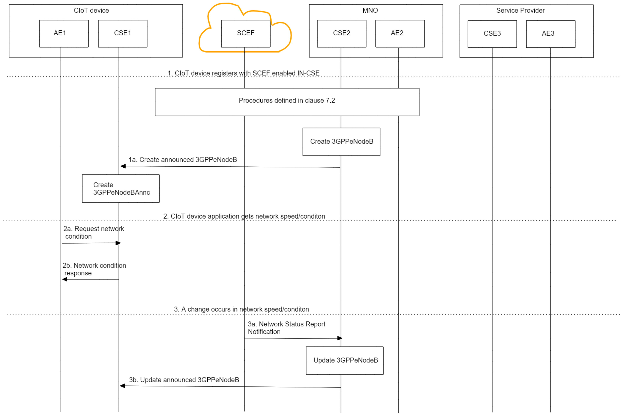
Figure 6.1-1 Network Condition Monitoring

AE1 – IoT Device Application
CSE1 – (PTN) ASN-CSE
CSE2 – IN-CSE managed by MNO
AE2 – MNO Service AE
CSE3 – MN-CSE managed by IoT Service Provider
AE3 – IoT Services and applications managed by IoT SP
SCEF – MNO managed interface to 3GPP IoT services

- CSE1 registers to CSE2, where the 3GPP M2M-Ext-ID is required. This step includes the creation of any other resources needed for the management of the PTN ASN-CSE and the PTN ASN-AE's hosted on the same device. Specifically, the resources needed to store the network conditions are made available during this step.
The quality of a network connection is stored in [3GPPeNodeB] specialization of a <flexContainer> resource defined in clause 8.2 of this document. This network quality information is provided to the IN-CSE from the SCEF using procedures defined in TS-0026 clause 7.8.1. There are two ways that this resource can be made available to the ASN-CSE, announcement by the IN-CSE to the ASN-CSE or subscription by the ASN-CSE. This solution uses announcement because it is less complexity and logic for the ASN-CSE. The registration procedure is described in clause 7.2
  - Create 3GPPeNodeBAnnc

- An AE hosted on the CIoT device needs to retrieve the network condition/speed.
  - AE1 requests network condition/speed. The resource to be received SHALL be at a well-known location so that AE1 does not need to use discovery mechanisms. Therefore, this should be at <CSE1> or <CSE1>/<well-known-location>

Retrieve <CSE1>/<3GPPeNodeBAnnc>.

  - CSE1 responds to request with the <3GPPeNodeBAnnc> resource representation. The <3GPPeNodeBAnnc> resource type is described in clause 7.2.

- A change occurs in network speed/conditions.
  - SCEF notifies CSE2 of network speed/condition changes in an eNodeB (affecting all CIoT devices in that area). This notification comes via the SCEF Network Status Report notification described in TS-0026 [i.6] clause 7.8.1.
This NetworkStatusReportingNotification contains a subscription URI that indicates the targetNetwork that this message applies to.

When a NetworkStatusReportingNotification is received from the SCEF, the Hosting CSE updates the networkCondition attribute of the <3GPPeNodeB> resource that matches the targetNetwork identified by the subscription URI.

  - CSE2 updates each CIoT device (CSE1, etc) within the eNodeB-ID area sending UPDATE <3GPPeNodeBAnnc> primitives to the announceTo entities.

This requirement is met with the procedures described.

6.2 GSMA TS.34_4.1_REQ_002
This requirement is the responsibility of an application hosted on a CIoT device connected to a PTN CSE, however oneM2M should identify the types of errors that can occur and define when the CSE should report the errors such that the application can implement appropriate error handling procedures. Also, since these devices may be in remote locations, there shall be a mechanism to report these errors to the MNO and/or SP such that the need for remote management or maintenance of the device can be indicated. There are three types of errors to discuss.
Application logic errors: these types of errors occur because of operations initiated by the application, such as sending messages that exceed policy limits. NOTE: all normal payload validation errors also apply, but this solution will address errors related to communication on the 3GPP Core Network.
ASN-CSE logic errors occur when the ASN-CSE performs operations that fall within the parameters of specified policies, but have a failure result, e.g. based on a CMDH policy to buffer messages until a specified buffer size occurs, when the ASN-CSE sends the payload a transmission failure occurs. This is an example of an error not caused by the application, rather something in the communication channel (ASN-CSE-comm module-core network-IN-CSE…).
Remote CSE errors occur when the ASN-CSE can successfully send a primitive to an oneM2M entity, yet the response to that message is a failure response (or timeout).

Reporting of application logic errors is fully defined by the procedures defined in TS-0004.
Reporting of ASN-CSE errors needs to be defined in TS-0001. The nature of these errors indicates that they will occur asynchronously, as the CSE has already sent a response to the originator. To meet this requirement, the ASN-CSE should report this type of error to the application(s) on the device. This implies a notification that can be sent to the originator (an AE can only receive a notify request).
The solution proposes to create a container where error messages can be sent. Then a subscription/notification can be created by the AE.
<errorLog> container
<errorInstance> contentInstances where content is the oneM2M error response.
Privacy and security must be maintained, so an AE should only have access to error information related to it own requests. This can be the entire request or key information such as “request ids”.
The requirement states that an application must be prepared to handle this case. In this use case, cancelling a message and then retrying with a different policy may be sufficient.
As these devices may be in remote locations, there should also be a mechanism to report these errors to the MNO and/or SP such that the need for remote management or maintenance of the device can be indicated.
Notification sent to IN-CSE/MN-CSE with indication message using a low bandwidth/high priority communication method. To ensure error reporting does not create a large signalling /communication load on the CN, error reporting should be managed by a CMDH policy and adhere to applicable message transmission policies.
These are CMDH errors and will be further defined in CMDH procedures.
This requirement is not met yet for ASN-CSE logic errors.

Reporting of remote CSE errors will occur when the ASN-CSE sends messages to the destination CSE and an error is reported, such as RESOURCE_NOT_FOUND. These errors need to be delivered to the originator asynchronously. Similar message delivery is needed for successful responses to these asynchronous requests. These are CMDH errors and will be further defined in CMDH procedures.
This requirement is not met yet for remote CSE logic errors.

-------------------------------------------------- End of Change 1---------------------------------------------------
-------------------------------------------------- Start of Change 2--------------------------------------------------

7.2 3GPP ASN-CSE registration to 3GPP IN-CSE
The process for registering an ASN-CSE to an IN-CSE that meets the requirements of GSMA TS 34 [i.1] requires additional procedures beyond the CSE Registration procedures defined in clause 10.2.2.6 [TS-0001] [i.3]. Those additional procedure are described here.
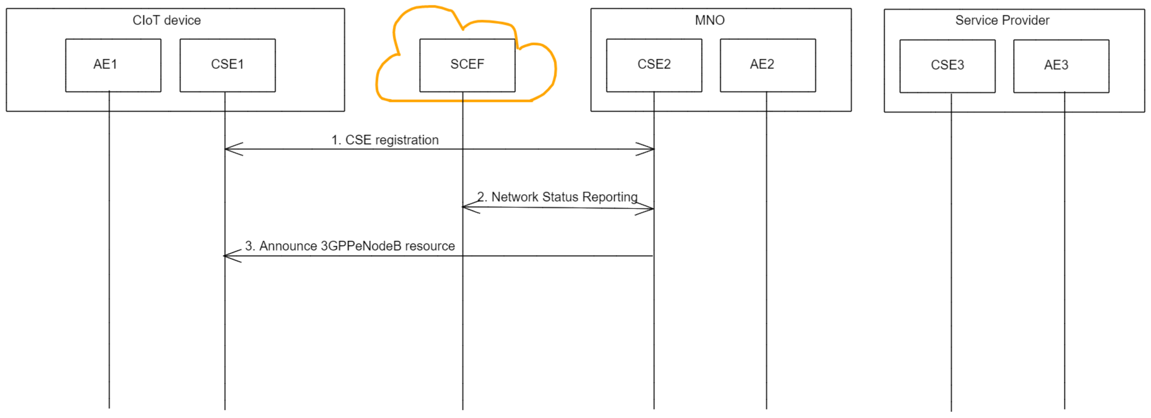
Figure 7.2-1- CIoT device registration (CSE1 registers to CSE2)
- CSE1 registers to CSE2, where CSE2 is an IN-CSE that has access to a 3GPP SCEF interface. CSE Registration procedures are described in TS-0026 clause 6 and TS-0001 clause 10.2.2.6.

- CSE 2 issues a network status report request to the 3GPP SCEF interface, as described in TS-0026 clause 7.8.1. The nsiValue returned in a returned in a Network Status Report from the SCEF shall be stored in an 3GPPeNodeB resource with a matching networkID, in the networkCondition attribute, see clause 8.2. If this 3GPPeNodeB resource with a matching networkID does not exist, the IN-CSE will create one at CSEBase. If the network status report subscription already exists for this networkID then this step is skipped.
NOTE: The location of the 3GPPeNodeB is subject to change
- CSE 2 announces the 3GPPeNodeB resource to CSE1. The announcement procedures are described in TS-0001 clause 10.2.13. The target of the announced 3GPPeNodeB resource is /CSE2/CSEBase, with resourceName set to “3GPPPeNodeBAnnc”.

-------------------------------------------------- End of Change 2---------------------------------------------------

-------------------------------------------------- Start of Change 3--------------------------------------------------

8.2 <flexContainer> specialization describing 3GPP network
This specialization of <flexContainer> is used to represent a single instance of a 3GPP eNodeB area network. Other types of networks may also be represented using this representation, if appropriate. This definition is intended for contribution to TS-0026 [i.6].
NOTE: Only resource specific attributes are shown.
Table 8.2-1: Resource Specific Attributes of [3GPPeNodeB] resource
areaNwkType | 1 | RW | The areaNwkType is a Network specific string that indicates the type of M2M Area Network. For 3GPP Rel15 this could be SCEF, see TS-0026 [i.6]. | NA
networkID | 1 | WO | Configured with the identity of the underlying network which the M2M Node is currently attached to. | OA
networkCondition | 1 | RW | Contains a qualitative description of the network condition. Range of values are from 0-10 with 10 being the best network condition. For 3GPP Rel 15 the values 0-31 should be mapped to this attribute, see TS-0026 [i.6]. | MA (needed at remote CSE) | GSMA TS.34 [i.1] 4.1_REQ_001

Table 8.2-2: Resource Specific Attributes of [3GPPeNodeB] resource

Attribute Name | Request Optionality |  | Data Type | Default Value and Constraints
 | Create | Update
containerDefinition | M | NP | xs:anyURI | No default
areaNwkType | O | O | xs:string | No default
networkID | M | O | tbd (xs:string) | No default
networkCondition | O | O | tbd (restricted values 0-10) | No default

Table 8.2-3: Child Resources of [3GPPeNodeB] resource

Child Resource Type | Child Resource Name | Multiplicity
<subscription> | [variable] | 0..n
<semanticDescriptor> | [variable] | 0..n

-------------------------------------------------- End of Change 3---------------------------------------------------

-------------------------------------------------- Start of Change 4--------------------------------------------------

8.3 Network status report procedures
Clause 7.2 described storing the result of a network status report notification in a 3GPPeNodeB resource. This will be a CR to TS-0026.

7.8.1 Throttling of requests based on Network Status Reports
The 3GPP SCEF Network Status Monitoring functionality described in 3GPP TS 29.122 [4] supports an API to allow an IN-CSE to be informed when there are network congestion issues in a geographical area in the underlying 3GPP network.
An IN-CSE may request to receive notifications from an underlying 3GPP network when the network congestion level in a specified geographical area crosses defined threshold value(s). Based on these reports, the IN-CSE can start/stop throttling of requests initiated by or targeted towards its registree AEs and CSEs that are hosted on Ues residing in this geographical area to help manage the congestion levels in the underlying 3GPP network.
Figure 7.8.1-1: Request for Network Status Reports
Pre-conditions:
There is a relationship in place between the IN-CSE and MNO allowing the IN-CSE to request Network Status Reports from the underlying 3GPP network. The method for establishing this relationship is outside the scope of the present document.
The IN-CSE is configured with system defaults for the following. The method for configuring these system defaults is outside the scope of the present document.

• The network congestion levels to receive reports
• The severity of each specified congestion level
• The specified actions to take based on the severity of each congestion level.
An ASN/MN-CSE or ADN-AE registers with the IN-CSE and configures the M2M-Ext-ID attribute of its <remoteCSE> or <AE> resource. The IN-CSE examines the M2M-Ext-ID and recognizes that it is associated with an MNO that it has a relationship with.
The IN-CSE is able to detect the location of its registree ASN/MN-CSEs and/or ADN-AEs. For example, a <locationPolicy> resource may be used by an IN-CSE to detect the location of each ASN/MN-CSE or ADN-AE.
The ADN-AE’s <node> resource hosted on the IN-CSE has a child <schedule> resource and the IN-CSE has permissions to update it. The ADN-AE has a <subscription> to its <schedule> resource and when it receives a notification from the IN-CSE it updates its communication schedule accordingly.
The ASN/MN-CSE’s <node> resource hosted on the IN-CSE has a child <schedule> resource and the IN-CSE has permissions to update it. The ASN/MN-CSE has a <subscription> to its <schedule> resource and when it receives a notification from the IN-CSE it updates its communication schedule accordingly.
The IN-CSE shall create a 3GPPeNodeB resource.
Step 1: IN-CSE issues a Network Status Request
The IN-CSE issues a Network Status Report request to the SCEF via one or more of the following approaches.
- The IN-CSE may periodically check the location of its registree ASN/MN-CSEs and ADN-AEs. When the IN-CSE detects that a certain number of ASN/MN-CSEs and/or ADN-AEs are in the same geographical area, it may further check if the ASN/MN-CSEs and ADN-AEs are connected to the same network. The IN-CSE can detect if the ASN/MN-CSEs and ADN-AEs are connected to the same network by examining their M2M-Ext-ID attributes. For example, a 3GPP external identifier is composed of a local identifier and a domain identifier. If the ASN/MN-CSEs and ADN-AEs have the same domain identifier, they may be connected to the same network. When the IN-CSE detects that a number of ASN/MN-CSEs and/or ADN-AEs are in the same geographical area and attached to the same network, it may decide to request a Network Status Report in that geographical area.
- The IN-CSE may use [cmdhNwAccessRule] resources for corresponding registree CSEs that support CMDH functionality. The IN-CSE may check the targetNetwork attribute and use this attribute to identify a SCEF and issue a Network Status Request to this SCEF. When issuing the request for a Network Status Report, the IN-CSE shall provide a geographic area for which the report will apply. The IN-CSE may detect the geographic area for which the policy applies by checking the location that is associated with each CSE. For example, <locationPolicy> resources may be associated with a registree CSE for which the CMDH policies apply and used by an IN-CSE to detect locations for the CSEs.
How the IN-CSE determines which of the above approach(es) to use is implementation specific and outside the scope of the present document.
Step 2: Network Status Report Request
The IN-CSE requests network status reports for a geographical area. The Network Status Reporting Subscription request from the IN-CSE to the SCEF shall comply with 3GPP TS 29.122 [4] as follows:
- An HTTP POST method shall be used
- URI shall be set to {apiRoot}/3gpp-net-stat-report/v1/{scsAsId}/subscriptions/. The {apiRoot} and {scsAsId} segments are configured based on Service Provider and MNO policies.
- The request payload shall include a NetworkStatusReportingSubscription data structure as specified in 3GPP TS 29.122 [4] with the following attributes:
  - notificationDestination shall be set to a URI that the SCEF can target Network Status Report notifications towards. The value of this URI shall be based on internal IN-CSE policies.
  - thresholdValues shall be a list of integer values in the range of 0 to 31 and specify what congestion threshold(s) the IN-CSE wants to receive a report for. Whenever the congestion in the geographical area goes above or below an indicated threshold, a report will be sent. The threshold(s) that are indicated by the IN-CSE are determined based on local IN-CSE policies. The definition of these policies is outside the scope of the present document.
  - thresholdTypes shall be a list of enumerated types with values HIGH, MEDIUM and LOW that specify the type of congestion status the IN-CSE would like to receive a report for. The threshold type(s) that are indicated by the IN-CSE are determined based on local IN-CSE policies. The definition of these policies is outside the scope of the present document. The IN-CSE shall not include thresholdValue and thresholdType in the same request. They shall be used mutually exclusive of one another.
  - timeDuration shall indicate the date and time that the SCEF will stop sending reports to the IN-CSE. The data and time value is determined based on local IN-CSE policies. The definition of these policies is outside the scope of the present document.
NOTE: If no duration is provided, then only one Network Status Report will be provided to the IN-CSE
  - locationArea shall be configured with location information specified by the IN-CSE. The IN-CSE may use location information that it collects from its registree’s <locationPolicy> resources and/or M2M-Ext-IDs to configure this attribute. Shall be expressed as a list cell IDs, tracking areas, civic addresses or geopgraphic area.
  - supportedFeatures shall be set to a string value of “0” indicating no support for notifications via Websockets or notification test events.
  - requestTestNotification and websockNotifConfig are not supported by the present document and shall not be included.
General Exceptions:
The SCEF is not reachable when Hosting CSE (i.e. IN-CSE) tries to send Network Status Reporting Subscription request. In this case the IN-CSE will not be able to get receive network status reports from the underlying 3GPP network. Hence the IN-CSE will not be able to provide value-add services to the underlying 3GPP network such as throttling of requests targeted towards AEs and CSEs hosted on Ues residing in congested areas of the network.
Step 3: SCEF Processes Network Status Report Request
The SCEF and the underlying 3GPP network process the Network Status Report Request.
Step 4: Network Status Report Response
The SCEF sends a Network Status Report Response to the IN-CSE to acknowledge the request has been accepted. This response is defined in 3GPP TS 29.122 [4] and includes the following information.
- A response code of 201 CREATED
- The URI of the Group Message Delivery resource created by the SCEF. The URI is returned in the HTTP Location header with a format of {apiRoot}/3gpp-net-stat-report/v1/{scsAsId}/subscriptions/{subscriptionId}. The {apiRoot} and {scsAsId} segments are configured based on Service Provider and MNO policies. The {subscriptionId} segment is configured by the SCEF.
- The response payload will include an updated NetworkStatusReportingSubscription data structure as specified in 3GPP TS 29.122 [4] that includes the attributes present in the request along with the following additional attributes:
  - self is configured with a link to the {apiRoot}/3gpp-net-stat-report/v1/{scsAsId}/subscriptions/{subscriptionId} resource created by the SCEF for the request
See clause 8.3 for a list of possible error scenarios and error handling options for the IN-CSE.
Step 5: Detect Congestion
After receiving the initial Network Status Request or when the congestion level passes one of the indicated threshold(s), the SCEF will create a Network Status Report.
Step 6: Network Status Report
The SCEF sends a Network Status Report to the corresponding notificationDestination of the IN-CSE that was configured in Step 2. The report contains information as specified in 3GPP TS 29.122 [4]. Such information includes:

- An HTTP POST method is used
- URI is set to {notification_uri}. The {notification_uri} is configured by the IN-CSE in the Network Status Reporting Subscription Request.
- The request payload will include a NetworkStatusReportingNotification data structure as specified in 3GPP TS 29.122 [4] with the following attributes:
  - subscription configured with a URI to the subscription resource for which this notification corresponds to
  - nsiValue configured with the network status indicator that is an integer in the range of 0 to 31 that indicates a congestion level as defined in 3GPP TS 29.122 [4]
  - nsiType configured with the network status indicator that is an enumerated value of HIGH, MEDIUM or LOW as defined in 3GPP TS 29.122 [4]
NOTE – A response will not contain both nsiType and nsiValue. They are mutually exclusive.
Step 7: Network Status Report Acknowledgement
After receiving a Network Status Report Notification, the IN-CSE returns a response having a response code of 204 NO CONTENT.
Step 8: Process Network Status Report
In response to the Network Status Report, the IN-CSE may decide to throttle up/down traffic in the congested area of the network via one or more of the following approaches.
- An IN-CSE may reject requests that target nodes in congested areas of the network. If an IN-CSE rejects a request due to network congestion it shall return a EXTERNAL_OBJECT_NOT_REACHABLE response code. The IN-CSE may also inform the Originator to retry the request after some specified backoff delay. The method to inform the Originator is currently not specified in the present document however a message included in the payload of the response could be used.
- An IN-CSE may delay the processing (i.e. buffer) of requests that target nodes in congested areas of the network.
  - If the request is a blocking request, the IN-CSE should not delay the processing of the request and should instead reject this request with a corresponding response code informing the cause of rejection is due to network congestion.
  - If the request includes an Event Category that is set to immediate the IN-CSE should not delay the processing of the request and should instead reject the request with a EXTERNAL_OBJECT_NOT_REACHABLE response code. In this case, the IN-AE may decide to resubmit the request with the Event Category set to “bestEffort” or “latest” to indicate the IN-CSE may buffer the request.
- An IN-CSE may modify the <schedule> resource of its registree AEs or CSEs that are located in a congested area of the network such that they modify the times they send or receive requests.
  - A registree AE or CSE may retrieve or subscribe to its <schedule> resource such that it detects if the IN-CSE updates the scheduleElement attribute. Upon detecting an updated scheduleElement an AE or CSE shall modify the times which it sends requests and makes itself available to receive requests.
- An IN-CSE may modify the [cmdhNwAccessRule] resources for corresponding registree CSEs that support CMDH functionality.
- An IN-CSE shall update the 3GPPeNodeB resource with the networkID that matches the network ID indicated in the Network Status Report Message. The nsiValue from the Network Status Report Message shall be stored in the networkCondition value.
How the IN-CSE determines which of the above approach(es) to use is outside the scope of the current document and may be based on agreements with the MNO.
Step 9 (Optional): Network Status Request Cancellation
Before the Duration expires, the IN-CSE may request that the SCEF stop sending status reports. The IN-CSE may make this decision, for example, when it detects that a number of devices are no longer in the geographical area applicable to the Network Status Request.
The IN-CSE shall send a Network Status Cancellation Request as follows:

- An HTTP DELETE method shall be used
- URI shall be set to {apiRoot}/3gpp-net-stat-report/v1/{scsAsId}/subscriptions/{subscriptionId}. The {apiRoot} and {scsAsId} segments are configured based on Service Provider and MNO policies. The {subscriptionId} corresponds to the one configured by the SCEF and returned to the IN-CSE when the Network Status Reporting Subscription was created.
- The request shall not contain a payload
Step 10 (Optional): Process Network Status Cancellation Request
The SCEF processes the cancelation request.
Step 11 (Optional): Acknowledge Network Status Cancellation Request
The SCEF acknowledges the request to cancel Network Status Reports for the geographical area with a response code of 204 NO CONTENT.
See clause 8.3 for a list of possible error scenarios and error handling options for the IN-CSE.

-------------------------------------------------- End of Change 4---------------------------------------------------
-------------------------------------------------- Start of Change 5--------------------------------------------------

9 TS-0018 contributions
This clause is intended to be contain all the test purposes written in support of this WI. There will be test purposes for an IN-CSE, PTN ASN-CSE, and PTN ADN-AE.
TP/oneM2M/AE/3GPP/PTN/001
TP Id |  | TP/oneM2M/CSE/3GPP/PTN/001
Test objective |  | Check that when a PTN ASN-CSE registers a 3GPPeNodeB resource is announced to the PTN-CSE.
Reference |  | TS-0001 [1], clause 10.2.2.6, and TS-0026 [7], clauses 7.8.1
Config Id |  | CFG0X
Parent Release |  | Release 5
PICS Selection |  | PICS_???
Initial conditions | with {  the IUT being in the "initial state"  }
Expected behaviour | Test events |  | Direction
 | when {  the IUT receives a valid CSE Registration Request containing  From set to PTN_CSE and  Content containing a remoteCSE resource representation containing  a M2M-EXT-ID  } |  | CSE IUT
 | then {  the IUT sends a valid CREATE Request containing  To set to PTN_CSE_BASE_ADDRESS and  Content containing a valid 3GPPeNodeBAnnc resource  } |  | IUT CSE

-------------------------------------------------- End of Change 5---------------------------------------------------

