CHANGE REQUEST
Meeting ID:* | SDS 51.1
Source:* | Bob Flynn, Exacta GSS, bob.flynn@exactagss.com,  Joachim Koss, JK Consulting & Projects, joachim.koss@jk-conpro.de,  SeungMyeong Jeong, KETI, sm.jeong@keti.re.kr
Date:* | 2021-09-29
Reason for Change/s:* | Functional description of Advanced Semantic Discovery (ASD) derived from the ASD concept already identified and agreed in TR001 “Use Cases Collection” and TS-0002 “Requirements”.
CR against: Release* | Release 5
CR against: WI* | Active WI-0101 “Advanced Semantic Discovery”  MNT maintenance / < Work Item number(optional)>  Is this a mirror CR? Yes No  mirror CR number: (Note to Rapporteur - use latest agreed revision)  STE Small Technical Enhancements / < Work Item number (optional)>  Only ONE of the above shall be ticked
CR against: TS/TR* | TS-0034 “Semantics_Support” V4_2_0
Clauses * | New clauses 7.13.n
Type of change: * | Editorial change  Bug Fix or Correction  Change to existing feature or functionality  New feature or functionality  Only ONE of the above shall be ticked
Other TS/TR(s) impacted | This new functionality will impact TS-0004 “Service Layer Core Protocol” and TS-0001 “Functional Architecture” within the Release 5 timeframe
Post Freeze checking:* | This CR contains only essential changes and corrections? YES NO  This CR may break backwards compatibility with the last approved version of the TS? YES NO
Template Version: January 2020 (do not modify)

oneM2M Notice
The document to which this cover statement is attached is submitted to oneM2M. Participation in, or attendance at, any activity of oneM2M, constitutes acceptance of and agreement to be bound by terms of the Working Procedures and the Partnership Agreement, including the Intellectual Property Rights (IPR) Principles Governing oneM2M Work found in Annex 1 of the Partnership Agreement.
GUIDELINES for Change Requests:
Provide an informative introduction containing the problem(s) being solved, and a summary list of proposals.
Each CR should contain changes related to only one particular issue/problem.
If this is a correction, and the change applies to previous releases, a separate “mirror CR” should be posted at the same time as this CR
Mirror CR: applies only when the text, including clause numbering are exactly the same.
Companion CR: applies when the change means the same but the baselines differ in some way (e.g. clause number).
Follow the principle of completeness, where all changes related to the issue or problem within a deliverable are simultaneously proposed to be made e.g. a change impacting 5 tables should not only include a proposal to change only 3 tables. Include any changes to references, definitions, and abbreviations in the same deliverable.
Follow the drafting rules.
All pictures must be editable.
Check spelling and grammar.
Use change bars for modifications.
The change should include the current and surrounding clauses to clearly show where a change is located and to provide technical context of the proposed change. Additions of complete clauses need not show surrounding clauses as long as the proposed clause number clearly shows where the proposed new clause is located.
Multiple changes in a single CR shall be clearly separated by horizontal lines with embedded text such as, start of change 1, end of change 1, start of new clause, end of new clause.
When subsequent changes are made to the content of a CR, then the accepted version should not show changes over changes. The accepted version of the CR should only show changes relative to the baseline approved text.

Introduction
This CR proposes the functional description of the new semantic feature “Advanced Semantic Discovery (ASD)”. The ASD concept has been identified and agreed already in TR001 “Use Cases Collection” and TS-0002 “Requirements”.
This proposal has been derived from ETSI TR 103 717, which supports Advanced Semantic Discovery introduction in oneM2M.
The document attached in the Zip file (ASD concept description.docx) has been copied from ETSI TR 103 717 V1.1.1 clause 6. It describes the proposed ASD concept in detail including examples and shall serve as a background information for better understanding of the present Change Request.
Please note, that this description considers the <semanticRoutingTable> resource as a virtual resource. After presenting the ASD concept in SDS #50, there is the common view to treat the <semanticRoutingTable> resource as the child resource of a <CSEBase> resource (see SDS-2021-0181R3-Introduction_of_new_resource_types_for_Advanced_Semantic_Discovery).
R01
- Editorial changes
- reworked clause 7.13.1 including description of figure 7.13.1-1
- reworked some text in clause 7.13.2.1
R02 (new changes are highlighted in green color):
The revision R01 of the present contribution has been accepted by SDS on 19 October 2021.
SDS-2021-0186R06 has been accepted by SDS on 02 December 2021.
In order to correct discrepancies between both accepted contributions, the changes proposed in this R02 shall ensure consistancy between both contributions.
- In Change 1
- Table 7.13.2.1-4: reference in description of attribute semanticRoutingRecords corrected
- Associated Reference Point Mcc and Mcc' have been added to tables 7.13.2.3-1, 7.13.2.4-1 and 7.13.2.5-1

-----------------------Start of change 1-------------------------------------------

Advanced Semantic Discovery

Introduction
This clause describes the Advanced Semantic Discovery (ASD) which enhances existing semantic discovery and query features (Clause 7.4) to work across a federated CSE deployment. In the semantic discovery and query decribed in Clause 7.4 the Originator needs to know the target CSE and/or target resource identifier. ASD supports when the Originator wants to discover or query resources on unknown target CSEs or multiple targets CSEs.
ASD retargets a semantic request to remote CSEs which the hosting CSE determines to be candidate targets based on the content of the <semanticResourceTable> resources provided by the target CSEs. The Originator sends a semantic query to the <advancedSemanticDiscovery> virtual resource on the Hosting CSE. The Hosting CSE identifies the target CSE(s), which will execute the semantic query, by referring to the information in the Semantic Routing Table. The Hosting CSE then fans-out the ASD request to the targeted remote CSEs, and then the remote CSEs execute the query. The Hosting CSE aggregates responses from the remote CSEs and sends the response to the Originator.
A Hosting CSE creates a <semanticResourceTable> resource, which is a summary of <semanticDescriptor> resources on the Hosting CSE. To share semantic routing information for ASD handling CSE selection, the Hosting CSE creates and updates the <semanticResourceTable> resource on remote CSEs according to policies given by AEs that create <semanticDescriptor> resources.
Figure 7.13.1-1 depicts how ASD mechanism works with examples. Before handling the ASD requests, CSEs share semantic routing information in the form of <semanticRoutingTable> resources. On the CSE1, there are three semantic routing table resource instances. “base/srt”, “base/cse2Annc/srt”, “base/cse3/srt” resources represent Semantic Routing Table of CSE1, CSE2, CSE3, respectively. These three different possibilities show the parent resource type of the <semanticRoutingTable> resource.
CSE1 creates and updates its own routing information in the “base/srt” resource. CSE2 creates the table under “base/cse2Annc” resource, which is the <CSEBaseAnnc> resource. Finally CSE3 creates the table under “base/cse3” resource, which is the <remoteCSE> resource that has been created from registration with CSE1.
When AE1 as the originator of ASD request sends the request to the CSE1, in this case ASD handling CSE, CSE1 tries to select the target CSEs to execute the query in the ASD. To select, CSE1 finds the matched CSEs in the collection of local Semantic Routing Tables with the SPARQL query in the ASD request. In the matching procedure, Resource Summary and CSE Context Information are used. When one or more CSEs are selected, the CSE1 fans-out the ASD request to the targets, so the targets execute the SPARQL query.

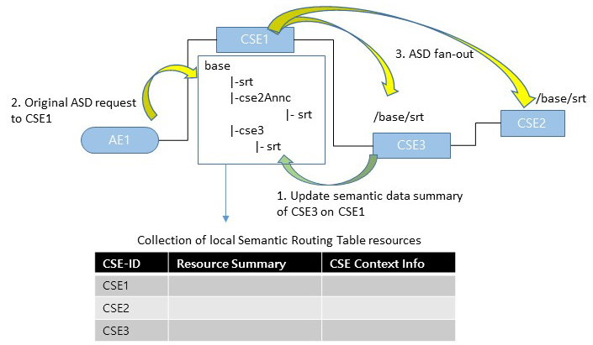
Figure 7.13.1-2: ASD overall illustration

Semantic Routing Table

Introduction
To support an ASD on distributed CSEs, which are not known by the Originator, the Semantic Routing Table (SRT) is hosted and used by ASD handling CSEs. When a CSE receives an ASD request, the CSE queries the collection of <semanticResourceTable> resources to identify remote CSEs that contain resources that match the query from the Originator. The ASD query shall be fanned out to the identified remote CSEs.
Table 7.13.2.1-1 defines the information elements of a <semanticRoutingTable> resource.
Table 7.13.2.1-1: Information on Semantic Routing Table record
Element | Description
CSE-ID | Identifier of the CSE which holds RDF triples that are corresponding to the Resource Summary. This value shall match the CSE-ID of the parent resource.
Resource Summary | List of URIs, representing types of semantic data instances (i.e. RDF Class or RDF Property [i.6]). Optionally this contains the number of instances per RDF type URI.  E.g. "http://www.abc.org/ontology/city-v1#SmartDevice"
CSE Context Information | Optional. A set of context information on the CSE, other than Resource Summary.  See table 7.13.2.1-2.

The CSE Context Information can be used to select the set of remote CSEs that receive the fanout ASD request. For instance there could be an ASD request for maximum 10 hops resource identifiers in the response.
Table 7.13.2.1-2: Types of CSE context information regarding ASD
Element | Description
Number of Hops | The number of hops between the SRT hosting CSE and the semantic data hosting CSE.
Semantic Discovery Agreement | Two CSEs agree on a relationship type which is used during the semantic routing. There is a priority among the types so the ASD handling CSE prefers a specific type over others. Types are defined by each M2M Service Provider.  E.g. Customer-Provider, Peer-Peer.  Editor’s note: definition of these agreements is for further study

The <semanticRoutingTable> resource is the child resource of a <CSEBase> resource and <CSEBaseAnnc>.
It shall contain the child resources specified in table 7.13.2.1-3.
Table 7.13.2.1-3: Child resources of <semanticRoutingTable> resource
Child Resources of <semanticRoutingTable> | Child Resource Type | Multiplicity | Description | <semanticRoutingTableAnnc> Child Resource Types
[variable] | <subscription> | 0..n | See clause 9.6.8 [1] | <subscription>
[variable] | <transaction> | 0..n | See clause 9.6.48 [1] | <transaction>

Table 7.13.2.1-4: Attributes of <semanticRoutingTable> resource
Attributes of  <semanticRoutingTable> | Multiplicity | RW/  RO/  WO | Description | <semanticRoutingTableAnnc> Attributes
resourceType | 1 | RO | See clause 9.6.1.3. [1] | NA
resourceID | 1 | RO | See clause 9.6.1.3. [1] | NA
resourceName | 1 | WO | See clause 9.6.1.3. [1] | NA
parentID | 1 | RO | See clause 9.6.1.3. [1] | NA
accessControlPolicyIDs | 0..1 (L) | RW | See clause 9.6.1.3. [1] | MA
creationTime | 1 | RO | See clause 9.6.1.3. [1] | NA
expirationTime | 1 | RW | See clause 9.6.1.3. [1] | MA
lastModifiedTime | 1 | RO | See clause 9.6.1.3. [1] | NA
labels | 0..1 (L) | RO | See clause 9.6.1.3. [1] | MA
announceTo | 0..1 (L) | RW | See clause 9.6.1.3. [1] | NA
announcedAttribute | 0..1 (L) | RW | See clause 9.6.1.3. [1] | NA
announceSyncType | 0..1 | RW | See clause 9.6.1.3. [1] | MA
dynamicAuthorizationConsultationIDs | 0..1 (L) | RW | See clause 9.6.1.3. [1] | OA
creator | 0..1 | RO | See clause 9.6.1.3. [1] | NA
holder | 0..1 | RW | See clause 9.6.1.3. [1] | NA
semanticRoutingRecords | 1 | RW | This attribute defines the semantic routing table records. The semantic routing table record is defined in Table 7.13.2.2-1. 7.13.2.1-1 | OA

Create
This procedure shall be used for creating a <semanticRoutingTable> resource.
Table 7.13.2.2-1: <semanticRoutingTable> CREATE
<semanticRoutingTable> CREATE
Associated Reference Point | Mcc and Mcc'
Information in Request message | All parameters defined in table 8.1.2-3 of [1] apply with the specific details for:  Content: The resource content shall provide the information as defined in clause 9.6.78 of [1]
Processing at Originator before sending Request | According to clause 10.1.2 [1]
Processing at Receiver | According to clause 10.1.2 [1]
Information in Response message | According to clause 10.1.2 [1]
Processing at Originator after receiving Response | According to clause 10.1.2 [1]

Retrieve
This procedure shall be used for retrieving a < semanticRoutingTable> resource.
Table 7.13.2.3-1: <semanticRoutingTable> RETRIEVE
<semanticRoutingTable> RETRIEVE
Associated Reference Point | Mcc and Mcc'
Information in Request message | All parameters defined in table 8.1.2-2 of [1] apply with the specific details for:  Content: void
Processing at Originator before sending Request | According to clause 10.1.3. [1]
Processing at Receiver | According to clause 10.1.3. [1]
Information in Response message | All parameters defined in table 8.1.3-1 of [1] apply with the specific details for:  Content: attributes of the <semanticRoutingTable> resource as defined in clause 9.6.78 of [1].
Processing at Originator after receiving Response | According to clause 10.1.3. [1]
Exceptions | According to clause 10.1.3.[1]

Update
This procedure shall be used for updating a <semanticRoutingTable> resource.
Table 7.13.2.4-1: <semanticRoutingTable> UPDATE
<semanticRoutingTable> UPDATE
Associated Reference Point | Mcc and Mcc'
Information in Request message | Content: a Semantic Routing Table record of the target CSEBaseAnnc
Processing at Originator before sending Request | According to clause 10.1.4. [1]
Processing at Receiver | According to clause 10.1.4. [1]
Information in Response message | According to clause 10.1.4. [1]
Processing at Originator after receiving Response | According to clause 10.1.4. [1]
Exceptions | According to clause 10.1.4. [1]

Delete
This procedure shall be used for deleting a <semanticRoutingTable> resource.
Table 7.13.2.5-1: <semanticRoutingTable> DELETE
<semanticRoutingTable> DELETE
Associated Reference Point | Mcc and Mcc'
Information in Request message | All parameters defined in table 8.1.2-2 [1] apply.
Processing at Originator before sending Request | According to clause 10.1.5. [1]
Processing at Receiver | According to clause 10.1.5. [1]
Information in Response message | According to clause 10.1.5. [1]
Processing at Originator after receiving Response | According to clause 10.1.5. [1]
Exceptions | According to clause 10.1.5. [1]

ASD handling procedure

ASD request from Originator
The Originator sends an ASD request with the following parameters:
- To: The <advancedSemanticDiscovery> resource identifier on a CSE. (i.e. "{CSE-ID}/{CSEBase-name}/asd")
Note that "asd" is the short name of <advancedSemanticDiscovery> virtual resource (see oneM2M TS-0001 [1] clause 9.6).
Editorial note: see CR SDS-2021-0181.
- Filter Criteria: The semanticsFilter condition contains a SPARQL query and the limit condition to indicate the max number of resource IDs in the response.
- Semantic Query Indicator: "TRUE" for SPARQL query results, or "FALSE" for corresponding oneM2M resource identifiers in the response.
- ASD Handling Indicator: The Handling Indicator indicates the type of matching used for selection of CSEs for the ASD Request. Valid values are "ontology URI", "type URI" and "semantic inferencing". These matching types are described in clause 7.13.3.3.
- ASD Target Limit: Limits to the number of CSEs or the number of hops from the Hosting CSEs that executes the query in the ASD.
- ASD Subsequent Fan-out Allowed: "TRUE" if the Originator allows the ASD fan-out on CSEs after the initial fan-out on the Hosting CSE.
- ASD Multicast Allowed: "TRUE" if the Hosting CSE is allowed to fan-out the ASD to the CSEs in the Hosting CSE's SRT when there is no match in the SRT.
- Other timestamp parameters (i.e. Request Expiration Timestamp, Result Expiration Timestamp) and request handling related request parameters (i.e. Response Type, Event Category) can optionally be included added.

SPARQL Query Fragmentation
Before selecting target CSEs to handle the ASD, the SPARQL query fragmentation can be performed by the Hosting CSE in order to reduce unnecessary query fan-out to multiple CSEs. The Hosting CSE fragments the original query in the ASD request into more than one independent subsequent queries which are then sent to different target CSEs based on the respective lookup result of each query.
One of the considered approaches for SPARQL query fragmentation is by UNION logical operator defined in the query. UNION operator is used as a fragmentation point of the query, whereas the other statements defined in conjunction using the AND logical operator remain together in the subsequent query.
Certain essential statements in the query such as SELECT statement, PREFIX statement which form the main building block of SPARQL query are duplicated for each subsequent query. However, it is ensured that the response type and format remain the same throughout the subsequent queries of the particular ASD. Figure 7.13.3.2-1 shows the general structure of query fragmentation using UNION operator as fragmentation point.
After performing the fragmentation, the process of SRT lookup defined in clause 7.13.3.3 is then executed for each subsequent SPARQL query independently.
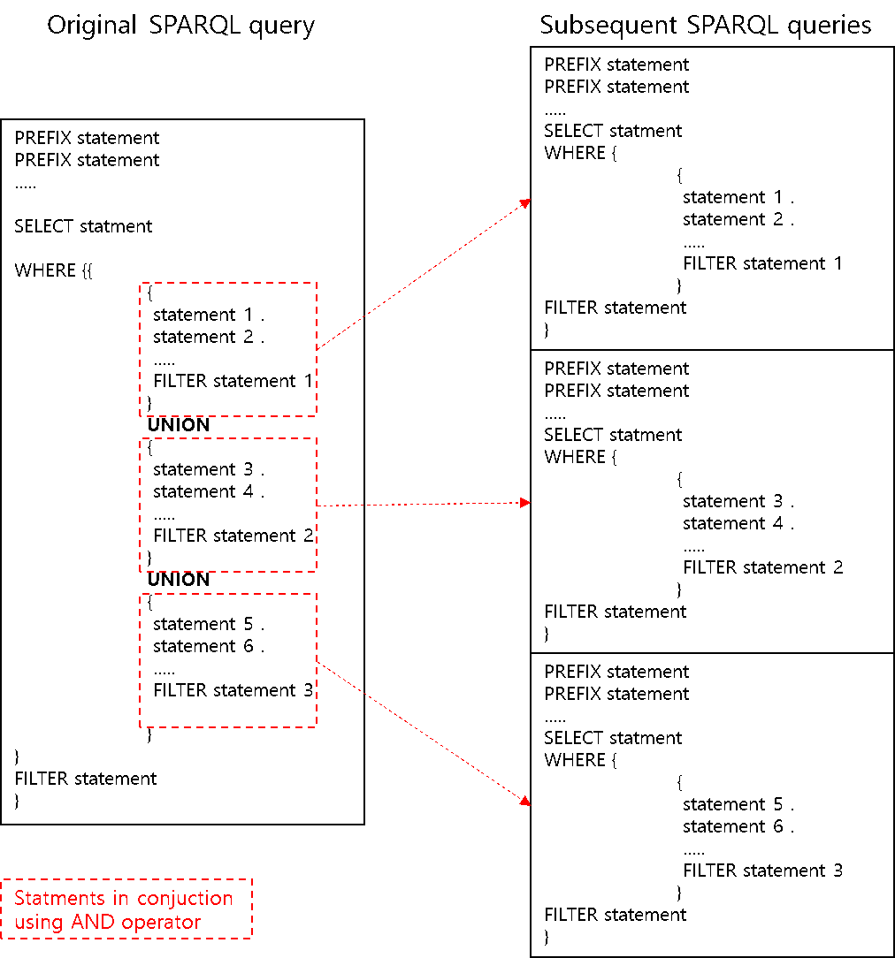
Figure 7.13.3.2-1: SPARQL Query fragmentation using UNION Operator

ASD target selection based on matching criteria
After the query fragmentation of the ASD, the Hosting CSE shall select CSEs from the available <semanticRoutingTable> resources present on the Host CSE at the time of the ASD request.
From ASD query, the Hosting CSE shall check the ASD Handling Indicator parameter, which specifies the matching criteria to be considered while selecting the target CSEs. The matching criteria specifies the information to be considered in the summary of the triple data, for selecting the target CSEs. Depending on the ASD Handling Indicator parameter value, following different target selection scheme shall be performed:
Case 1: The ASD Handling Indicator parameter specifies "ontology URI" to be considered for selecting the target CSE in the SRT. In this case, the Hosting CSE shall extract the ontology URIs, included in the SPARQL query, and performs the lookup of the summary in the SRT for these ontologies. The ontology URI are extracted from either the prefixes specified in the SPARQL query or from the entity URIs specified in the query conditions in any part of SPARQL query. Upon finding the matched ontology URIs, the corresponding CSEs are selected as target for the ASD to be fanned-out.
Case 2: The ASD Handling Indicator parameter specifies "type URI" in the summary to be considered for selecting the target CSE in the SRT. In this case, the Hosting CSE shall extract the relevant attributes from the SPARQL query given in the ASD request, such as ontology URI, RDF Class URI, RDF Property URI, etc., and then performs the loop of the summary in the SRT for these matching attributes. The RDF Class or Property URIs are extracted from the entity URIs specified in the query conditions in any part of SPARQL query.
Case 3: In addition to the detailed summary, the ASD Handling Indicator parameter specifies "semantic inferencing" to be applied in order to select the additional target CSEs in the SRT, which are filtered out in the above-mentioned selection criteria. In this case, the Hosting CSE shall perform the tasks defined in case 2, that is, extracting the attributes to be matched with the summary in the SRT, such as ontology URI, RDF Class URI, RDF Property URI, etc. In addition, those entries in the SRT are listed, whose ontology URIs are matched, but no RDF Class URI or RDF Property URI is matched. Then, the Hosting CSE shall access (e.g. get the ontology from the web) those matched ontology to perform inferencing, from which additional information (e.g. assertions such as rdfs:subClassOf, rdfs:subPropertyOf, etc.) is extracted, to identify whether the listed CSEs are valid targets for the given SPARQL query. From the list, the filtered CSEs are then added to the complete list of target CSEs.
For each case (i.e. cases 2 and 3) a threshold can be defined to have the least number of possible matches at the basic level of ASD target selection process, which is subject to implementation methodologies.

ASD fan-out
When there are multiple target CSE(s) from the query matching in clause 7.13.3.3, to further process the ASD, the Hosting CSE shall fan-out the received or fragmented ASD to those CSE. The request parameters shall be set as follows:
- To: the <advancedSemanticDiscovery> resource identifier on the target CSE. (i.e. "{Target-CSE-ID}/{CSEBase-name}/asd").
- From: CSE-ID of the Hosting CSE that is handling the ASD.
- Filter Criteria: the semanticsFilter condition contains a SPARQL query, this may be the fragmented query (see clause 7.13.3.2). the limit condition can be updated from the original ASD request.
- Semantic Query Indicator: the same value as the original ASD.
- ASD Handling Indicator: the same value as the original ASD.
- ASD Target Limit: updated value of the number of CSEs or hops.
- ASD Subsequent Fan-out Allowed: when there is enough time to further fan-out the ASD this can be set as "TRUE".
- ASD Multicast Allowed: the same value as the original ASD.
- Other timestamp parameters (i.e. Request Expiration Timestamp, Result Expiration Timestamp) are updated and request handling related request parameters (i.e. Response Type, Event Category).
When the Hosting CSE receives the response(s) for the ASD, the Hosting CSE shall aggregate results and send the response back to the Originator who requested the original ASD. When the ASD requests SPARQL query results, not the oneM2M resource identifiers, in the response using Semantic Query Indicator parameter, it could not always possible to aggregate results.
Editorial note: This is for further study.

-----------------------End of change 1---------------------------------------------

-----------------------Start of Changes to References Clause -------------

2.2 Informative references
References are either specific (identified by date of publication and/or edition number or version number) or non-specific. For specific references, only the cited version applies. For non-specific references, the latest version of the referenced document (including any amendments) applies.
The following referenced documents are not necessary for the application of the present document but they assist the user with regard to a particular subject area.
[i.1] W3C Editor's Draft: "Semantic Sensor Network Ontology".
NOTE: Available at http://w3c.github.io/sdw/ssn/.
[i.2] ETSI TS 103 264 (V1.1.1): "SmartM2M; Smart Appliances; Reference Ontology and oneM2M Mapping".
[i.3] oneM2M TR-0033: "Study on Enhanced Semantic Enablement".
[i.4] oneM2M Drafting Rules.
NOTE: Available at http://www.onem2m.org/images/files/oneM2M-Drafting-Rules.pdf.
[i.5] ETSI TR 103 717: "SmartM2M; Study for oneM2M Discovery and Query specification development".
[i.6] W3C®: "RDF Schema 1.1".
NOTE: Available at https://www.w3.org/TR/rdf-schema/#ch_class
[i.7] oneM2M TR-0007: "Study of Abstraction and Semantics Enablement".

-----------------------End of Changes to References -------------

-----------------------Start of Abbriviations Clause -------------

3.3 Abbreviations
For the purposes of the present document, the following abbreviations apply:
ACP Access Control Policy
ACR Access Control Rule
AE Application Entity
ASD Advanced Semantic Discovery
CRUD Create, Retrieve, Update, Delete
CSE Common Service Entity
CSF Common Service Function
IoT Internet of Things
IRI Internationalized Resource Identifier
JSON JavaScript Object Notation
MR Mashup Requestor
RDF Resource Description Framework
RH Resource Host
SAREF Smart Appliances REFerence ontology
SD Semantic Descriptor
SEM Semantics
SGS Semantic Graph Store
SMF Semantic Mashup Function
SMI Semantic Mashup Instance
SMJP Semantic Mashup Job Profile
SPARQL SPARQL Protocol and RDF Query Language
SRT Semantic Routing Table
SSN Semantic Sensor Network
URI Uniform Resource Identifier
URL Uniform Resource Locator
XML Extensible Markup Language

-----------------------End of Abbriviations Clause -------------

CHECK LIST
- Does this Change Request include an informative introduction containing the problem(s) being solved, and a summary list of proposals.?
- Does this CR contain changes related to only one particular issue/problem?
- Have any mirror CRs been posted?
- Does this Change Request make all the changes necessary to address the issue or problem? E.g. A change impacting 5 tables should not include a proposal to change only 3 tables?Does this Change Request follow the drafting rules?
- Are all pictures editable?
- Have you checked the spelling and grammar?
- Have you used change bars for all modifications?
- Does the change include the current and surrounding clauses to clearly show where a change is located and to provide technical context of the proposed change? (Additions of complete clauses need not show surrounding clauses as long as the proposed clause number clearly shows where the new clause is proposed to be located.)
- Are multiple changes in this CR clearly separated by horizontal lines with embedded text such as, start of change 1, end of change 1, start of new clause, end of new clause.?

