CHANGE REQUEST
Meeting ID:* | SDS 52
Source:* | Rahul Kumar, C-DOT, krahul@cdot.in  Poornima Shandilya, C-DOT, poornima@cdot.in  Anupama Chopra, C-DOT, anupama@cdot.in
Date:* | 2020-11-10
Reason for Change/s:* | See the introduction
CR against: Release* | V4_12_0
CR against: WI* | Active A-SDS-50.1-01  MNT maintenance / < Work Item number(optional)>  Is this a mirror CR? Yes No  mirror CR number: (Note to Rapporteur - use latest agreed revision)  STE Small Technical Enhancements / < Work Item number (optional)>  Only ONE of the above shall be ticked
CR against: TS/TR* | TS-0001 V4_12_0
Clauses * | 10.2.12.6, 10.2.12.9
Type of change: * | Editorial change  Bug Fix or Correction  Change to existing feature or functionality  New feature or functionality  Only ONE of the above shall be ticked
Other TS/TR(s) impacted | <TS/TR number>, <Version Number>, and <Description on which aspect should be reflected in this TS/TR>
Post Freeze checking:* | This CR contains only essential changes and corrections? YES NO  This CR may break backwards compatibility with the last approved version of the TS? YES NO
Template Version: January 2020 (do not modify)

oneM2M Notice
The document to which this cover statement is attached is submitted to oneM2M. Participation in, or attendance at, any activity of oneM2M, constitutes acceptance of and agreement to be bound by terms of the Working Procedures and the Partnership Agreement, including the Intellectual Property Rights (IPR) Principles Governing oneM2M Work found in Annex 1 of the Partnership Agreement.
GUIDELINES for Change Requests:
Provide an informative introduction containing the problem(s) being solved, and a summary list of proposals.
Each CR should contain changes related to only one particular issue/problem.
If this is a correction, and the change applies to previous releases, a separate “mirror CR” should be posted at the same time as this CR
Mirror CR: applies only when the text, including clause numbering are exactly the same.
Companion CR: applies when the change means the same but the baselines differ in some way (e.g. clause number).
Follow the principle of completeness, where all changes related to the issue or problem within a deliverable are simultaneously proposed to be made e.g. a change impacting 5 tables should not only include a proposal to change only 3 tables. Include any changes to references, definitions, and abbreviations in the same deliverable.
Follow the drafting rules.
All pictures must be editable.
Check spelling and grammar.
Use change bars for modifications.
The change should include the current and surrounding clauses to clearly show where a change is located and to provide technical context of the proposed change. Additions of complete clauses need not show surrounding clauses as long as the proposed clause number clearly shows where the proposed new clause is located.
Multiple changes in a single CR shall be clearly separated by horizontal lines with embedded text such as, start of change 1, end of change 1, start of new clause, end of new clause.
When subsequent changes are made to the content of a CR, then the accepted version should not show changes over changes. The accepted version of the CR should only show changes relative to the baseline approved text.

Introduction
This CR propses to open action item on “Action to define how to determine relevant service subscription”( refer TS-0004 section 7.3.2.1 and the table below).
A-SDS-50.1-01 | In TS-0004 clause 7.3.2.1 we need to agree how a Registrar or Hosting CSE determines the relevant service subscription resources and accesses these resources and what privileges are required if they are not provisioned and stored locally. | Convida & CDOT

This CR tries to associate link between AE-ID and SSP resourceId.
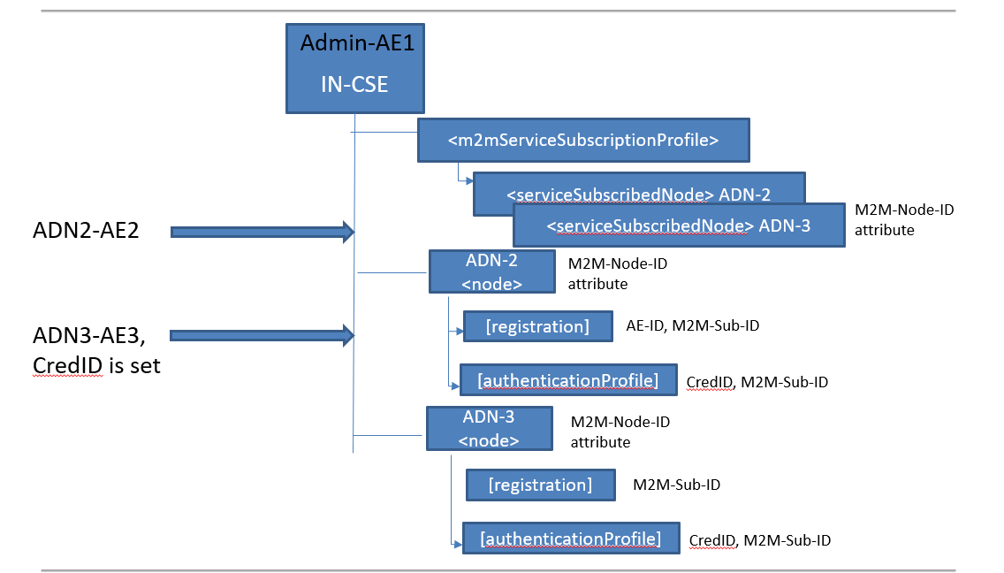

In order to avail M2M services, an M2M application provider has to come in service agreement with M2M Service Provider. In oneM2M, technical part of this agreement is represented through <m2mServiceSubscriptionProfile> resource and details of onem2m nodes is represented through <serviceSubscribedNode> resource.
For configuration of oneM2M nodes in field, oneM2M has defined field device configuration resources in TS-0022. [registration] and [authenticationProfile] management objects provides registrar details and credentials details to field nodes. It also enables CSE to become aware of the details of field nodes.
Preconfiguration in the case of non secure association from an AE:

In order to establish a link between AE-Id and ssp resourceId below changes in CREATE procedure of <serviceSubscribeNode> are required:
- Along with SSN creation i.e. <serviceSubscribedNode> for a particular nodeID , <node> shall also be created.
- And within <node>, Registration resource [registration] shall be created with originatorID set to AE-ID and m2mSubID set to <m2mServiceSubscriptionProfile> resourceId.
Preconfiguration in the case of secure association from an AE:
In order to establish a link between AE-Id and ssp resourceId below changes in CREATE procedure of <serviceSubscribeNode> are required:
- Along with SSN creation i.e. <serviceSubscribedNode> for a particular nodeID , <node> shall also be created.
- And within <node>, Registration resource [registration] shall be created with originatorID set to AE-ID and m2mSubID set to <m2mServiceSubscriptionProfile> resourceId.
- [authenticationProfile] shall also be created with m2mSubID set to <m2mServiceSubscriptionProfile> resourceId.
- On successful deletion of <serviceSubscribedNode> resource, the Hosting CSE shall also delete <node> resource having nodeId attribute value same as that of deleted <serviceSubscribedNode> resource.

-----------------------Start of change 1-------------------------------------------

10.2.12.6 Create <serviceSubscribedNode>
This procedure shall be used for creating a <serviceSubscribedNode> resource which is sub-resource of <m2mServiceSubscriptionProfile> resource.
Table 10.2.12.6-1: <serviceSubscribedNode> CREATE
<serviceSubscribedNode> CREATE
Information in Request message | All parameters defined in table 8.1.2-3 apply with the specific details for:  To: The Receiver or Hosting CSE shall be an IN-CSE  Content: The resource content shall provide the information as defined in clause 9.6.20
Processing at Originator before sending Request | According to clause 10.1.2
Processing at Receiver | According to clause 10.1.2
Information in Response message | All parameters defined in table 8.1.3-1 apply with the specific details for:  Content: Address of the created <serviceSubscribedNode> resource, according to clause 10.1.2
Processing at Originator after receiving Response | According to clause 10.1.2  - The Originator shall request to Create a <node> resource by using the CREATE operation. The request shall address a <CSEBase> of a Hosting CSE. The originator shall set nodeID attribute of <node> resource to a value equal to nodeID attribute of this <serviceSubscribedNode> resource.  - The Originator shall request to Create a [registration] resource by using CREATE operation. The request shall address the above <node> resource. The originator shall set M2M-Sub-ID attribute of [registration] resource to a value equal to parentID attribute of this <serviceSubscribedNode> resource.  - In case the node which is represented by this <node> resource intends to use Security Association then the Originator shall request to Create an [authenticationProfile] resource by using the CREATE operation. The request shall address the above <node> resource. The originator shall set M2M-Sub-ID attribute of [authenticationProfile] resource to a value equal to parentID attribute of this <serviceSubscribedNode> resource.
Exceptions | According to clause 10.1.2

-----------------------End of change 1---------------------------------------------

-----------------------Start of change 2-------------------------------------------

10.2.12.9 Delete <serviceSubscribedNode>
This procedure shall be used for deleting a <serviceSubscribedNode> resource residing under a <m2mServiceSubscriptionProfile> resource.
Table 10.2.12.9-1: <serviceSubscribedNode> DELETE
<serviceSubscribedNode> DELETE
Information in Request message | All parameters defined in table 8.1.2-3 apply with the specific details for:  To: The Receiver or Hosting CSE shall be an IN-CSE
Processing at Originator before sending Request | According to clause 10.1.5
Processing at Receiver | According to clause 10.1.5
Information in Response message | According to clause 10.1.5
Processing at Originator after receiving Response | According to clause 10.1.5  - The originator shall send discovery request to find resourceID of <node> resource having nodeID attribute same as that of of deleted <serviceSubscribedNode> resource.  - The Originator shall request to Delete a <node> resource by using the DELETE operation. The request shall address the <node> resource of a Hosting CSE.
Exceptions | According to clause 10.1.5

-----------------------End of change 2---------------------------------------------

CHECK LIST
- Does this Change Request include an informative introduction containing the problem(s) being solved, and a summary list of proposals.?
- Does this CR contain changes related to only one particular issue/problem?
- Have any mirror CRs been posted?
- Does this Change Request make all the changes necessary to address the issue or problem? E.g. A change impacting 5 tables should not include a proposal to change only 3 tables?Does this Change Request follow the drafting rules?
- Are all pictures editable?
- Have you checked the spelling and grammar?
- Have you used change bars for all modifications?
- Does the change include the current and surrounding clauses to clearly show where a change is located and to provide technical context of the proposed change? (Additions of complete clauses need not show surrounding clauses as long as the proposed clause number clearly shows where the new clause is proposed to be located.)
- Are multiple changes in this CR clearly separated by horizontal lines with embedded text such as, start of change 1, end of change 1, start of new clause, end of new clause.?

