CHANGE REQUEST
Meeting ID:* | SDS #54
Source:* | Cyrille Bareau, Orange, cyrille.bareau@orange.com  Bob Flynn, Exacta, bob.flynn@exactagss.com  Andreas Kraft, Deutsche Telekom, a.kraft@telekom.de  Marianne Mohali, Orange, marianne.mohali@orange.com
Date:* | 2022-05-06
Reason for Change/s:* | See the introduction.
CR against: Release* | Release 5
CR against: WI* | Active WI-0109  MNT maintenance / < Work Item number(optional)>  Is this a mirror CR? Yes No  mirror CR number: (Note to Rapporteur - use latest agreed revision)  STE Small Technical Enhancements / < Work Item number (optional)>  Only ONE of the above shall be ticked
CR against: TS/TR* | TS-0001 v5.0.0
Clauses * | 6.2.4.1.0, 9.6.1.1, 9.6.18, 10.2.8.1, 10.2.8.2, 2.1  New clause 6.2.4.1.2
Type of change: * | Editorial change  Bug Fix or Correction  Change to existing feature or functionality  New feature or functionality  Only ONE of the above shall be ticked
Other TS/TR(s) impacted | N/A
Post Freeze checking:* | This CR contains only essential changes and corrections? YES NO  This CR may break backwards compatibility with the last approved version of the TS? YES NO
Template Version: January 2020 (do not modify)

oneM2M Notice
The document to which this cover statement is attached is submitted to oneM2M. Participation in, or attendance at, any activity of oneM2M, constitutes acceptance of and agreement to be bound by terms of the Working Procedures and the Partnership Agreement, including the Intellectual Property Rights (IPR) Principles Governing oneM2M Work found in Annex 1 of the Partnership Agreement.
GUIDELINES for Change Requests:
Provide an informative introduction containing the problem(s) being solved, and a summary list of proposals.
Each CR should contain changes related to only one particular issue/problem.
If this is a correction, and the change applies to previous releases, a separate “mirror CR” should be posted at the same time as this CR
Mirror CR: applies only when the text, including clause numbering are exactly the same.
Companion CR: applies when the change means the same but the baselines differ in some way (e.g. clause number).
Follow the principle of completeness, where all changes related to the issue or problem within a deliverable are simultaneously proposed to be made e.g. a change impacting 5 tables should not only include a proposal to change only 3 tables. Include any changes to references, definitions, and abbreviations in the same deliverable.
Follow the drafting rules.
All pictures must be editable.
Check spelling and grammar.
Use change bars for modifications.
The change should include the current and surrounding clauses to clearly show where a change is located and to provide technical context of the proposed change. Additions of complete clauses need not show surrounding clauses as long as the proposed clause number clearly shows where the proposed new clause is located.
Multiple changes in a single CR shall be clearly separated by horizontal lines with embedded text such as, start of change 1, end of change 1, start of new clause, end of new clause.
When subsequent changes are made to the content of a CR, then the accepted version should not show changes over changes. The accepted version of the CR should only show changes relative to the baseline approved text.

Introduction
This draft is part of a series of CRs related to the Work Item WI-0109: IPE-based Device Management with FlexContainers. For a full introduction, see clause 2 “Justification” in WI-0109-IPE-based_Device_Management_with_FlexContainers-V0_0_1.DOCX.
In this specific draft, the proposed changes are as follows:
- Clarify the different approaches for DM: CSE-based, native oneM2M, and the new IPE-based.
- Precise the architecture for the new IPE-based DM approach.
- Add <flexContainer> as possible child of <node> (need for <node> / [flexNode] relation).
- Precise the different DM approaches depending on the [flexNode] presence under <node>.
- Precise the articulation between CSE-based approach, described here, and the IPE-based in TS60033.
- Add needed documents in the references list.

----------------------- Start of change 1 -------------------------------------------

6.2.4.1.0 Overview
The Device Management (DMG) CSF provides management of device capabilities on MNs (e.g. M2M Gateways), ASNs and ADNs (e.g. M2M Devices), as well as devices that reside within an M2M Area Network. Application Entities (AE) can manage the device capabilities on those Nodes by using the services provided by the DMG CSF alleviating the need for the AE to have knowledge of the technology specific protocols or data models. While the AE does not require an understanding of the technology specific protocols or data models, this information is provided to the AE so that an AE can utilize this information for administrative purposes (e.g. diagnostics, troubleshooting).
In order to manage the CSE and device capabilities of the MNs, ASNs and ADNs, the DMG can utilize existing technology specific protocols (e.g. BBF TR-069 [i.2], OMA-DM [i.3], and LWM2M [i.4]) in addition to resource operations across the Mcc and Mca reference points.
When non-oneM2M protocols are used to manage oneM2M Nodes the DMG of an IN or MN translates or adapts the management related oneM2M requests to/from the corresponding technology via a Management Adapter. The existing technology then supports operations between Management Servers and Management Clients. Architectural details regarding the use of non-oneM2M technology protocols is provided in clause 6.2.4.1.1.
The architectural model for the native Device Management uses the generic oneM2M architecture and reference points.
The DMG CSF can also be implemented through the use of an Interworking Proxy Application Entity (IPE) to interact with an M2M Area Network. The IPE then supports operations between its registrar CSE and the devices of the M2M Area Network. Architectural details regarding the use of IPEs is provided in clause 6.2.4.1.2.
All Device Management options (IPE-based, native oneM2M or CSE-based using non-oneM2M technology protocols) use resources maintaining information and relationships that are specific to Device Management (i.e. Device Management Resources), as well as general purpose resources.
When using CSE-based Device Management, Device Management Resources maintain information and relationships used to:
- Manage technology specific data model objects via a Management Server which requires the information necessary to identify and access the Management Server.
- Invoke the security mechanism of the Management Server in order to authorize access to the technology specific data model objects.
When using an IPE to perform Device Management, the interactions with the data model objects of the managed entities are handled by the IPE itself, not by the CSE. The mechanism used to attain this goal is implementation dependent. Generic guidelines for an IPE to interact with an IoT network are defined in oneM2M TS-0033 [20].
Procedures for managing Device Management Resources are further detailed in clause 10.2.8. For CSE-based Device Management options. For Device Management using external technologies, at most one Management Server is able to Create, Delete or Update addressable elements of a Management Resource.

----------------------- End of change 1 -------------------------------------------

----------------------- Start of change 2 -------------------------------------------

6.2.4.1.2 Device Management using an IPE
AE
CSE
Mca
Mca
Device in M2M
Area Network
Out of scope
IPE
DMG
Figure 6.2.4.1.2-1: IPE-based Device Management Architecture
The generic architecture for interworking oneM2M platforms with non-oneM2M solutions is described in Annex F. The oneM2M TS-0033 [20] specification describes an Interworking Framework, i.e. interworking methodologies that are defined by oneM2M for the purpose of representing interactions with devices or functions in Proximal IoT networks that are not aware of oneM2M. Clause 8 of TS-0033 [20] describes how an IPE can perform Device Management operations, with <flexContainer> Device Management Resources based on the Smart Device Template data model specified in TS-0023 [8].

----------------------- End of change 2 -------------------------------------------

----------------------- Start of change 3 -------------------------------------------

9.6.1.1 Resource Type Summary
Table 9.6.1.1-1 introduces the normal and virtual resource types and their related child or parent resource types. Details of each resource type follow in the remainder of this clause.
Table 9.6.1.1-1 lists each specified ordinary – i.e. not announced – resource type. An addition of suffix "Annc" to the respective resource type identifier indicates the associated announced resource type. Resource types that can occur as child resources of announced resources are summarized in table 9.6.26.1-1.
Among the resource types listed in table 9.6.1.1-1, the following are termed "Content Sharing Resources" in oneM2M Specifications for the purpose of referring to any of those resource types:
- container;
- contentInstance;
- flexContainer;
- flexContainerInstance;
- timeSeries;
- timeSeriesInstance.

Table 9.6.1.1-1: Resource Types
Resource Type | Short Description | Child Resource Types | Parent Resource Types | Clause
...
flexContainer | A template which allows to define specialized (customizable) versions of containers with a flexible and lightweight structure | container,  flexContainer, flexContainerInstance, latest, oldest, subscription, semanticDescriptor, timeSeries, transaction, action | AE, AEAnnc, container, containerAnnc,  flexContainer, flexContainerAnnc, node, remoteCSE, remoteCSEAnnc,  CSEBase, CSEBaseAnnc | 9.6.35
…
node | Represents specific Node information | flexContainer, mgmtObj,  subscription, semanticDescriptor, schedule, transaction, action | CSEBase | 9.6.18
…

----------------------- End of change 3 -------------------------------------------

----------------------- Start of change 4 -------------------------------------------

9.6.18 Resource Type node
The <node> resource represents specific information that provides properties of an M2M Node that can be utilized by other oneM2M operations. It can contain child resources that represent the Node's context information (e.g. memory and battery), network topology, device information, device capability etc. For NoDNs, these resources can be handled by different techniques:
- One technique uses external management technologies, based on standard Device Management protocols such as OMA DM or LwM2M [i.3] (mapping defined in TS-0005 [21]) or BBF TR-069 [i.2] (mapping defined in TS-0006 [22]). This approach is described in clause 6.2.4.1.1. The <node> resource has specialization of the <mgmtObj>, defined in Annex D, as its child resources. These specialized <mgmtObj> resources are used to perform management of the Node. Operations on these resources are described in clause 10.2.8 and TS-0004 [3] clause 7.4.15.
- Another technique relies on an IPE (Interworking Proxy Application Entity) that is used as an intermediary between a CSE and the managed nodes. This approach is described in clause 6.2.4.1.2. In this case, the <node> resource has the [flexNode] specialization of a <flexContainer> as its child resource, and this [flexNode] has <flexContainer> specializations as its child resources, where these <flexContainer> resources are used to perform management of the Node. These <flexContainer> specializations are defined in oneM2M TS-0023 [8], clause 5.8, and operations on these resources are described in oneM2M TS-0033 [20] clause 8.

For native oneM2M nodes, it is possible to use, as Device Management Resources, either <mgmtObj> or [flexNode] and other DM <flexContainer> specializations.
For the case when the <node> resource belongs to an ADN, please see figure 9.6.18-1 in conjunction with the description of nodeLink attribute in the <AE> resource (clause 9.6.5).
For the case when the <node> resource belongs to an NoDN and the applications that correspond to interworked devices are represented by <flexContainer>s please see figure 9.6.18-2.

Figure 9.6.18-1: Relationship between IN/MN and ADN
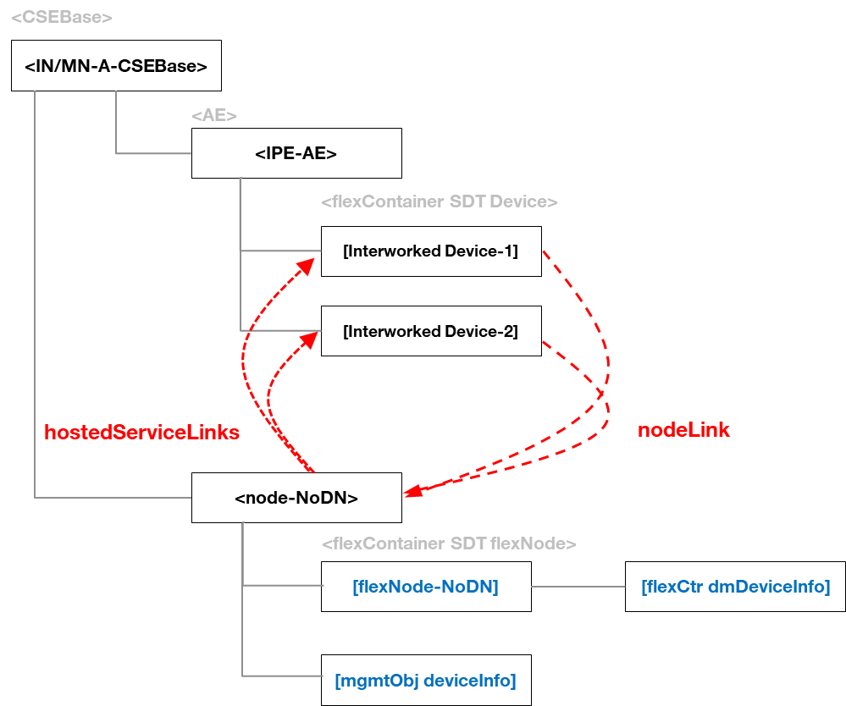
Figure 9.6.18-2: Relationship between IPE, interworked Services and NoDN
The <node> resource shall contain the child resources specified in table 9.6.18-1.
Table 9.6.18-1: Child resources of <node> resource
Child Resources of <node> | Child Resource Type | Multiplicity | Description | <nodeAnnc> Child Resource Type
[variable] | <semanticDescriptor> | 0..n | See clause 9.6.30 | <semanticDescriptor>, <semanticDescriptorAnnc>
[variable] | <flexContainer> as defined in the specialization [flexNode] | 0..1 | This resource provides the root for SDT-based <flexContainers> that correspond to Device Management related ModuleClasses (see clause 5.8 in TS-0023 [8]). | <flexContainerAnnc>
[variable] | <mgmtObj> as defined in the specialization [memory] | 0..1 | This resource provides the memory (typically RAM) information of the node. (E.g. the amount of total volatile memory), See clause D.4. | <mgmtObjAnnc>
[variable] | <mgmtObj> as defined in the specialization [battery] | 0..n | The resource provides the power information of the node. (E.g. remaining battery charge). See clause D.7. | <mgmtObjAnnc>
[variable] | <mgmtObj> as defined in the specialization [areaNwkInfo] | 0..n | This resource describes the list of Nodes attached behind the MN/ASN node and its physical or underlying relation among the nodes in the M2M Area Network. This attribute is defined in case the Node is MN/ASN. See clause D.5. | <mgmtObjAnnc>
[variable] | <mgmtObj> as defined in the specialization [areaNwkDeviceInfo] | 0..n | This resource describes the information about the Node in the M2M Area Network. See clause D.6. | <mgmtObjAnnc>
[variable] | <mgmtObj> as defined in the specialization [firmware] | 0..n | This resource describes the information about the firmware of the Node include name, version etc. See clause D.2. | <mgmtObjAnnc>
[variable] | <mgmtObj> as defined in the specialization [software] | 0..n | This resource describes the information about the software of the Node. See clause D.3. | <mgmtObjAnnc>
[variable] | <mgmtObj> as defined in the specialization [deviceInfo] | 0..n | The resource contains information about the identity, manufacturer and model number of the device. See clause D.8. | <mgmtObjAnnc>
[variable] | <mgmtObj> as defined in the specialization [deviceCapability] | 0..n | The resource contains information about the capability supported by the Node. See clause D.9. | <mgmtObjAnnc>
[variable] | <mgmtObj> as defined in the specialization [reboot] | 0..1 | The resource is the place to reboot or reset the Node. See clause D.10. | <mgmtObjAnnc>
[variable] | <mgmtObj> as defined in the specialization [eventLog] | 0..1 | The resource contains the information about the log of events of the Node. See clause D.11. | <mgmtObjAnnc>
[variable] | <mgmtObj> as defined in the specialization [cmdhPolicy] | 0..n | The resource(s) contain(s) information about CMDH policies that are applicable to the CMDH processing on the CSE hosted on the node represented by this <node> resource and identified by the hostedCSELink attribute of this <node> resource. See clause D.12. | NA
[variable] | <mgmtObj> as defined in the specialization [activeCmdhPolicy] | 0..1 | This resource defines which of the present [cmdhPolicy] resource(s) shall be active for the CMDH processing on the CSE hosted on the node represented by this <node> resource and identified by the hostedCSELink attribute of this <node> resource. See clause D.12. | NA
[variable] | <subscription> | 0..n | See clause 9.6.8. | <subscription>
[variable] | <schedule> | 0..n | See clause 9.6.9. | <scheduleAnnc>
[variable] | <transaction> | 0..n | See clause 9.6.48 | <transaction>
[variable] | <action> | 0..n | See clause 9.6.61 | None

The <node> resource shall contain the attributes specified in table 9.6.18-2.
Table 9.6.18-2: Attributes of <node> resource

Attributes of  <node> | Multiplicity | RW/  RO/  WO | Description | <nodeAnnc> attributes
resourceType | 1 | RO | See clause 9.6.1.3. | NA
resourceID | 1 | RO | See clause 9.6.1.3. | NA
resourceName | 1 | WO | See clause 9.6.1.3. | NA
parentID | 1 | RO | See clause 9.6.1.3. | NA
expirationTime | 1 | RW | See clause 9.6.1.3. | MA
accessControlPolicyIDs | 0..1 (L) | RW | See clause 9.6.1.3. | MA
creationTime | 1 | RO | See clause 9.6.1.3. | NA
lastModifiedTime | 1 | RO | See clause 9.6.1.3. | NA
labels | 0..1 (L) | RW | See clause 9.6.1.3. | MA
announceTo | 0..1 (L) | RW | See clause 9.6.1.3. | NA
announcedAttribute | 0..1 (L) | RW | See clause 9.6.1.3. | NA
announceSyncType | 0..1 | RW | See clause 9.6.1.3. | MA
dynamicAuthorizationConsultationIDs | 0..1 (L) | RW | See clause 9.6.1.3. | OA
owner | 0..1 | RW | See clause 9.6.1.3 | NA
nodeID | 1 | RW | The M2M-Node-ID of the node which is represented by this <node> resource. | MA
nodeType | 0..1 | RW | Indicates the type of node.  It shall have one of the following values:  - IN  - MN  - ASN  - ADN  - NoDN | OA
hostedCSELink | 0..1 | RW | This attribute allows to find the <CSEBase> or <remoteCSE> resource representing the CSE that is residing on the node that is represented by this <node> resource. The attribute contains the resource ID of a resource where all of the following applies:  - The resource is a <CSEBase> resource or a <remoteCSE> resource.  - The resource represents the CSE which resides on the specific node that is represented by the current <node> resource.  In case the node that is represented by this <node> resource does not contain a CSE, this attribute shall not be present. | OA
hostedAELinks | 0..1(L) | RW | This attribute allows to find the AEs hosted by the node that is represented by this <node> resource. The attribute shall contain a list of resource identifiers of <AE> resources representing the ADN-AEs residing on the node that is represented by the current <node> resource.  In case the node that is represented by this <node> resource does not contain an AE, this attribute shall not be present. | OA
hostedServiceLinks | 0..1(L) | RW | This attribute allows to find <flexContainer> resources that have been created by an IPE to represent services hosted on a NoDN, the NoDN being represented by this <node> resource.  If the NoDN hosts a set of services represented by <flexContainer>s, then the attribute shall contain the list of resource identifiers of these <flexContainer> resources.  In case the node that is represented by this <node> resource does not contain an  service that is represented by a <flexContainer>, this attribute shall not be present. | OA
mgmtClientAddress | 0..1 | RW | Represents the physical address of management client of the node which is represented by this <node> resource.  This attribute is absent if management server is able to acquire the physical address of the management client. | OA
roamingStatus | 0..1 | RO | Indicates if the M2M Node is currently roaming from the perspective of the underlying network.  The allowed values are “Yes” or “No”. | OA
networkID | 0..1 | RO | Configured with the identity of the underlying network which the M2M Node is currently attached to. | OA

----------------------- End of change 4 -------------------------------------------

----------------------- Start of change 5 -------------------------------------------

10.2.8.1 Introduction
This clause describes the procedures for managing device capabilities on MNs (e.g. M2M Gateways), ASNs and ADNs (e.g. M2M Devices), as well as devices that reside within an M2M Area Network.
Resources maintaining information and relationships that are specific to Device Management are termed Device Management Resources. This clause details the creation, retrieval, update and deletion of the information associated with the following Device Management Resources: <node>, <mgmtObj>, <mgmtCmd> and its child resource <execInstance>.
These operations are used in two of the three Device Management options available in oneM2M: one utilizing existing technology protocols (e.g. BBF TR-069 [i.2], OMA-DM [i.3], and LWM2M [i.4]) and another utilizing the native oneM2M protocols. Clause 6.2.4 details the Device Management (DMG) CSF supporting this functionality.
For the third option, IPE-based Device Management as described in clause 6.2.4.1.2, the Device Management Resources are <node>, [flexNode] and the other <flexContainer> specializations defined in TS-0023 [8] clause 5.8. The operations on the <node> resource are described in this clause, but the operations on [flexNode] and other <flexContainer> specializations are described in TS-0033 [20] clause 8.

10.2.8.2 Node management
This clause describes node management procedures over Mca and Mcc reference points, using the <node> resource which represents information about M2M Nodes that can be utilized in Device Management and other operations.
M2M Nodes represented by the <node> resource are: MN-CSE, ASN-CSE, ADN and NoDN. Zero, one or more <node> resources may be used to represent each M2M Node, as follows.
- A <node> resource representing a MN-CSE or a ASN-CSE is hosted by the represented CSE or the registrar CSE. The hostedCSELink attribute of the resource allows to find the <CSEBase> or <remoteCSE> resource representing the MN-CSE or ASN-CSE represented by the <node> resource. All <node> resources hosted on M2M Node's CSE may be announced to associated IN-CSEs.
- A <node> resource representing an ADN is hosted by the registrar CSE. The hostedAELink attribute of the resource allows to find the <AE> resources representing the AEs residing on the node ADN.
- A <node> resource representing a NoDN is
  - Either hosted by a CSE with DMG capabilities used to perform Device Management operations on the NoDN.
  - Or hosted by the registrar CSE of an IPE with capabilities used to perform Device Management operations on the NoDN.
  - If the NoDN is an interworked device, the hostedServiceLink attribute of the resource allows to find the <flexContainer> resources representing the services hosted on the NoDN.
An entity co-located with a CSE on an ASN or MN which is managed using oneM2M Device Management shall be represented by the same <node> resource
Device Management resources associated with a M2M Node that is represented by a <node> resource shall be created:
- either as <flexContainer> specializations, children of a [flexNode] child of the <node>: see clause 8 in TS-0033 [20];
- or as <mgmtObj> direct children of the <node>: see clauses 10.2.8.3 to 10.2.8.12;
- or as <mgmtCmd> and <execInstance> resources: the <execInstance> are created as children of the <node> resource(s) referenced in the <mgmtCmd>’s execTarget attribute: see clauses 10.2.8.13 to 10.2.8.21.

----------------------- End of change 5 -------------------------------------------

----------------------- Start of change 6 -------------------------------------------

2.1 Normative references
References are either specific (identified by date of publication and/or edition number or version number) or non-specific. For specific references, only the cited version applies. For non-specific references, the latest version of the referenced document (including any amendments) applies.
The following referenced documents are necessary for the application of the present document.
[1] oneM2M TS-0011: "Common Terminology".
[2] oneM2M TS-0003: " Security Solutions".
[3] oneM2M TS-0004: "Service Layer Core Protocol".
[4] W3C Recommendation: "RDF 1.1 Concepts and Abstract Syntax".
[5] W3C Recommendation: "SPARQL 1.1 Query Language".
[6] oneM2M TS-0012: "oneM2M Base Ontology".
[7] oneM2M TS-0021: "oneM2M and AllJoyn Interworking".
[8] oneM2M TS-0023: "Home Appliances Information Model and Mapping".
[9] oneM2M TS-0016: "Secure Environment Abstraction"
[10] oneM2M TS-0022: "Field Device Configuration".
[11] IETF RFC 5771: "IANA Guidelines for IPv4 Multicast Address Assignments".
[12] IETF RFC 2357: "IPv6 Multicast Address Assignments".
[13] oneM2M TS-0032: "MAF and MEF Interface Specification".
[14] oneM2M TS-0034: "Semantics Support".
[15] oneM2M TS-0026: "3GPP Interworking".
[16] IETF RFC 7946: "The GeoJSON Format".
NOTE: Available at https://tools.ietf.org/html/rfc7946
[17] IETF RFC 4566: "SDP: Session Description Protocol".
[18] IETF RFC 3986: "Uniform Resource Identifier (URI): Generic Syntax".
[19] IETF RFC 8141: "Uniform Resource Names (URNs)".
[20] oneM2M TS-0033: "Interworking Framework".
[21] oneM2M TS-0005: "Management Enablement (OMA)".
[22] oneM2M TS-0006: "Management Enablement (BBF)".

----------------------- End of change 6 -------------------------------------------

