|  |
| --- |
|  |

|  |  |
| --- | --- |
| CHANGE REQUEST | |
| Meeting ID:* | SDS #59 |
| Source:* | Andreas Kraft, DT, [Andreas.Kraft@t-systems.com](mailto:Andreas.Kraft@t-systems.com)  Andreas Neubacher, DT, [Andreas.Neubacher@magenta.at](mailto:Andreas.Neubacher@magenta.at)  Bob Flynn, Exacta GSS, [bob.flynn@exactagss.com](mailto:bob.flynn@exactagss.com) |
| Date:* | 2023-05-17 |
| Reason for Change/s:* | New event evaluation mode for crossResourceSubscription – TS-0001 |
| CR against: Release* | Release 5 |
| CR against: WI* | Active WI-xxxx  MNT maintenance / < Work Item number(optional)>  Is this a mirror CR? Yes  No  mirror CR number: (Note to Rapporteur - use latest agreed revision)  STE Small Technical Enhancements / < Work Item number (optional)>  Only ONE of the above shall be ticked |
| CR against: TS/TR* | TS-0001 v.5.2.0 |
| Clauses * | 9.6.58 |
| Type of change: * | Editorial change  Bug Fix or Correction  Change to existing feature or functionality  New feature or functionality  Only ONE of the above shall be ticked |
| Impacted other TS/TR(s) |  |
| Post Freeze checking:* | This CR contains only essential changes and corrections? YES  NO  This CR may break backwards compatibility with the last approved version of the TS? YES  NO |
| Template Version: January 2017 (Do not modify) | |

**oneM2M Notice**

The document to which this cover statement is attached is submitted to oneM2M. Participation in, or attendance at, any activity of oneM2M, constitutes acceptance of and agreement to be bound by terms of the Working Procedures and the Partnership Agreement, including the Intellectual Property Rights (IPR) Principles Governing oneM2M Work found in Annex 1 of the Partnership Agreement.

GUIDELINES for Change Requests:

Provide an informative introduction containing the problem(s) being solved, and a summary list of proposals.

Each CR should contain changes related to only one particular issue/problem.

In case of a correction, and the change apply to previous releases, a separate “mirror CR” should be posted at the same time of this CR

Mirror CR: applies only when the text, including clause numbering are exactly the same.

Companion CR: applies when the change means the same but the baselines differ in some way (e.g. clause number).

Follow the principle of completeness, where all changes related to the issue or problem within a deliverable are simultaneously proposed to be made E.g. A change impacting 5 tables should not only include a proposal to change only 3 tables. Includes any changes to references, definitions, and acronyms in the same deliverable.

Follow the drafting rules.

All pictures must be editable.

Check spelling and grammar to the extent practicable.

Use Change bars for modifications.

The change should include the current and surrounding clauses to clearly show where a change is located and to provide technical context of the proposed change. Additions of complete clauses need not show surrounding clauses as long as the proposed clause number clearly shows where the new clause is proposed to be located.

Multiple changes in a single CR shall be clearly separated by horizontal lines with embedded text such as, start of change 1, end of change 1, start of new clause, end of new clause.

When subsequent changes are made to content of a CR, then the accepted version should not show changes over changes. The accepted version of the CR should only show changes relative to the baseline approved text.

Introduction

The <crossResourceSubscription> is used to listen to events from one or more <subscription> resources in a specified time window (sliding or fixed). If all the specified <subscription> resources emit events within such a time window, the <crossResourceSubscription> resource itself sends a notification to one or more receivers. This can be used to send a notification only if certain events happen in a given time window.

What is currently missing is the opposite: React and send a notification in case all or some expected events from the monitored <subscription> resource have NOT been received within a time window. Use case for this could be a dead-man-switch or the monitoring of device health / heartbeat.

For this the following three use cases are used.

Send a notification when ALL notifications have been received within a time window. This is the current behaviour.

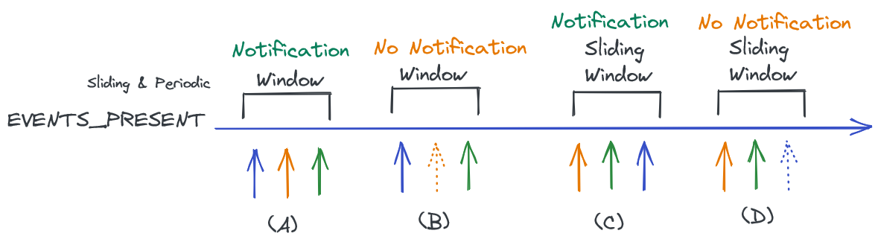

Send a notification when NO notification has been received in a time window. This can only be valid for a periodic window because the correct start of a sliding window cannot be determined, or it is not even started. This is a new proposed behaviour.

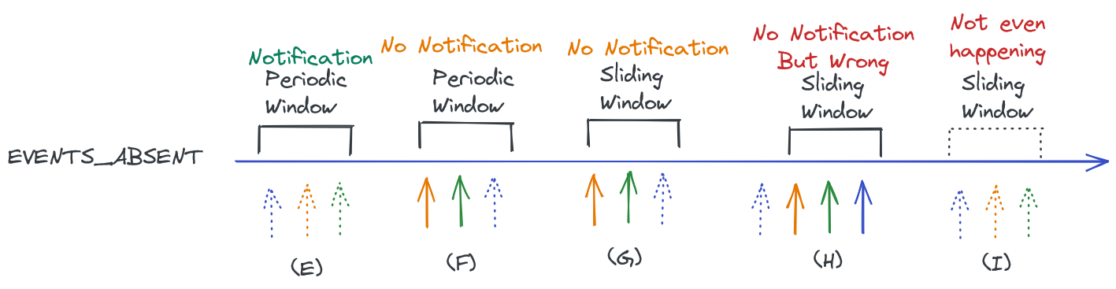

Send a notification when ONLY SOME notifications have been received in a time window. This also can only be valid for a periodic window because a sliding window is only started when a notification is received. This is a new proposed behaviour.

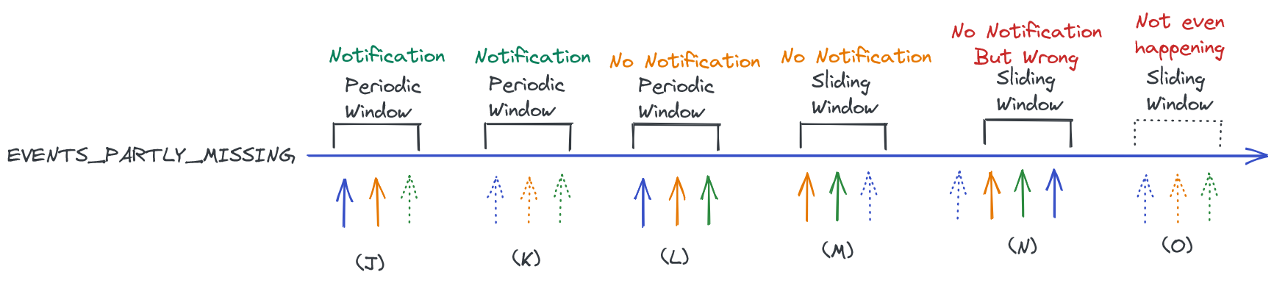

The following table shows the proposed set of options for handling the different event sets.

|  |  |  |
| --- | --- | --- |
|  | Number of events received in a periodic time window | TS-0001 and TS-0004 impacts |
| ALL_EVENTS_PRESENT | N events received | Slide, periodic |
| ALL_OR_SOME_EVENTS_PRESENT | 1..N events received | Slide, periodic |
| ALL_OR_SOME_EVENTS_MISSING | 0..N-1 events received | Periodic |
| ALL_EVENTS_MISSING | 0 events received | Periodic |
| SOME_EVENTS_MISSING | 1..N-1 events received | Slide, periodic |

This CR proposes the introduction of a new optional attribute that enables the functionality in the <crossResourceSubscription> resource type. Another CR SDS-2023-0087 proposes the necessary updates of the procedures in TS-0004.

Change 1: Added the new optional attribute *timeWindowInterpretation* to the <crossResourceSubscription> resource type.

### ********************** Start of Change 1 *****************************

### 9.6.58 Resource Type *crossResourceSubscription*

The <*crossResourceSubscription*> resource represents a cross-resource subscription over a set of target resources which could be existing *<subscription>* and/or other subscribable oneM2M resources. The Hosting CSE shall generate a cross-resource notifications only when expected changes occur on a designated number of target resources concurrently within a time window. The <*crossResourceSubscription*> resource shall specify the involved target resources in order to generate cross-resource notification.

The <*crossResourceSubscription*> resource shall contain the child resources specified in table 9.6.58-1.

Table 9.6.58-1: Child resources of <*crossResourceSubscription*> resource

| Child Resources of <*crossResourceSubscription*> | Child Resource Type | Multiplicity | Description |
| --- | --- | --- | --- |
| *notificationSchedule* | *<schedule>* | 0..1 | See clause 9.6.9. |
| *[variable]* | *<notificationTargetMgmtPolicyRef>* | 0..n | See clause 9.6.31. |
| *nstr* | *<notificationTargetSelfReference>* | 1 | See clause 9.6.34. |
| *[variable]* | *<transaction>* | 0..n | See clause 9.6.48 |

The <*crossResourceSubscription*> resource shall contain the attributes specified in table 9.6.58-2.

Table 9.6.58-2: Attributes of <*crossResourceSubscription*> resource

| Attributes of  <*crossResourceSubscription*> | Multiplicity | RW/  RO/  WO | Description |
| --- | --- | --- | --- |
| *resourceType* | 1 | RO | See clause 9.6.1.3. |
| *resourceID* | 1 | RO | See clause 9.6.1.3. |
| *resourceName* | 1 | WO | See clause 9.6.1.3. |
| *parentID* | 1 | RO | See clause 9.6.1.3. |
| *expirationTime* | 1 | RW | See clause 9.6.1.3. |
| *accessControlPolicyIDs* | 0..1 (L) | RW | See clause 9.6.1.3. |
| *labels* | 0..1 (L) | RW | See clause 9.6.1.3. |
| *creationTime* | 1 | RO | See clause 9.6.1.3. |
| *lastModifiedTime* | 1 | RO | See clause 9.6.1.3. |
| *dynamicAuthorizationConsultationIDs* | 0..1 (L) | RW | See clause 9.6.1.3. |
| *creator* | 1 | RO | See clause 9.6.1.3. |
| *custodian* | 0..1 | RW | See clause 9.6.1.3. |
| *expirationCounter* | 0..1 | RW | See clause 9.6.8. |
| *notificationURI* | 1 (L) | RW | See clause 9.6.8. |
| *notificationEventCat* | 0..1 | RW | See clause 9.6.8. |
| *subscriberURI* | 0..1 | WO | See clause 9.6.8. |
| *regularResourcesAsTarget* | 0..1 | RW | This attribute indicates a list of regular resources (i.e. normal resources rather than *<subscription>* resources), which shall be used as the target resource for this cross-resource subscription. Here, the regular resource is referred to as any subscribable oneM2M resources. |
| *subscriptionResourcesAsTarget* | 0..1 | RW | This attribute indicates a list of existing *<subscription>* resources, which shall be used as the target resource for this cross-resource subscription. |
| *regularResourcesAsTargetSubscriptions* | 0..1 | RO | This attribute indicates a list of subscription resources which correspond to the created <subscription> resources created for each entry in *regularResourcesAsTarget* attribute. It is mandatory if *regularResourcesAsTarget* is present. |
| *timeWindowType* | 1 | RW | This attribute indicates the type of time window mechanisms (*timeWindowType* can stand for periodic time window without any overlapping or for sliding time window where the current time window will be slid to become the next time window when a cross-resource notification is generated) which will be used to determine the generation of a cross-resource notification. |
| *timeWindowSize* | 1 | RW | This attribute indicates the size or time duration of the time window, based on which cross-resource notifications shall be generated. Note that the maximum window size (e.g. 60 seconds) may be enforced by the Hosting CSE for a subscriber; if the *timeWindowSize* indicated or requested by a subscriber is larger than the maximum window size, the Hosting CSE may reject the subscriber's request for cross-resource subscription. |
| *eventEvaluationMode* | 0..1 | RW | This attribute specifies how the occurrence of events from the monitored subscription(s) received during a time window is to be interpreted.  When set to “ALL_EVENTS_PRESENT” (the default) then the <crossResourceSubscription>’s notification is sent to the notification target(s) when all expected notifications have been received within a time window.  When set to “ALL_OR_SOME_EVENTS_PRESENT” then the <crossResourceSubscription>’s notification is sent to the notification target(s) when at least one expected notification has been received within a time window.  When set to “ALL_OR_SOME_EVENTS_MISSING” then the <crossResourceSubscription>’s notification is sent to the notification target(s) when none or some, but not all, of the expected events have been received within a time window.  When set to “ALL_EVENTS_MISSING” then the <crossResourceSubscription>’s notification is sent to the notification target(s) when none of the expected notifications have not been received within a time window.  When set to “SOME_EVENTS_MISSING” then the <crossResourceSubscription>’s notification is sent to the notification target(s) when some, but not all, of the expected notifications have been received within a time window.  This attribute shall only be present and set to either “ALL_OR_SOME_EVENTS_MISSING” or “ALL_EVENTS_MISSING” if the *timeWindowType* attribute is set to periodic window. |
| *eventNotificationCriteriaSet* | 0..1(L) | RW | This attribute lists *eventNotificationCriteria* for each regular target resource as indicated in *regularResourcesAsTarget* attribute and involved in a cross-resource subscription. If there is only one *eventNotificationCriteria* contained in this attribute, it shall be applied to all target resources as indicated by *regularResourcesAsTarget* attribute. If only *subscriptionResourcesAsTarget* attribute appears (i.e. no *regularResourcesAsTarget* attribute), *eventNotificationCriteriaSet* shall not be needed.  See clause 9.6.8 for the description of *eventNotificationCriteria*. |
| *notificationStatsEnable* | 1 | RW | When set to "TRUE", the Hosting CSE shall clear any statistics that were previously stored in the *notificationStatsInfo* attribute and start recording notification statistics for each notification generated for this resource.  When set to "FALSE", the Hosting CSE shall stop recording notification statistics for this resource and maintain the current value of the *notificationStatsInfo* attribute.  Default is "FALSE". |
| *notificationStatsInfo* | 0..1(L) | RO | A list containing notification statistics recorded by the Hosting CSE for each notification target specified by the *notificationURI* attribute of this resource. The Hosting CSE shall maintain a separate set of notification statistics that include:   * Total number of notification requests sent to a notification target * Total number of notification responses received from a notification target   Refer to oneM2M TS‑0004 [3] for further details regarding the format of this attribute. |

### ********************* End of Change 1 *********************************