|  |
| --- |
|  |

|  |  |
| --- | --- |
| CHANGE REQUEST | |
| Meeting ID:* | SDS 60 |
| Source:* | Bob Flynn, Convida Wireless , [Bob.Flynn@convidawireless.com](mailto:Bob.Flynn@convidawireless.com)  Andreas Kraft, Deutsche Telekom, [Andreas.Kraft@t-systems.com](mailto:Andreas.Kraft@t-systems.com)  Miguel Angel Reina Ortega, ETSI, [MiguelAngel.ReinaOrtega@etsi.org](mailto:MiguelAngel.ReinaOrtega@etsi.org) |
| Date:* | 2023-06-19 |
| Reason for Change/s:* | Announcement Procedure clarifications |
| CR against: Release* | Rel-4 |
| CR against: WI* | Active < WI-0077>  MNT maintenance / < Work Item number(optional)>  Is this a mirror CR? Yes  No  mirror CR number:  STE Small Technical Enhancements / < Work Item number (optional)>  Only ONE of the above shall be ticked |
| CR against: TS/TR* | TS-0004 v4.13.0 |
| Clauses * | 7.4.26.2.2, 7.3.3.10 |
| Type of change: * | Editorial change  Bug Fix or Correction  Change to existing feature or functionality  New feature or functionality  Only ONE of the above shall be ticked |
| Other TS/TR(s) impacted | None |
| Post Freeze checking:* | This CR contains only essential changes and corrections? YES  NO  This CR may break backwards compatibility with the last approved version of the TS? YES  NO |
| Template Version: January 2019 (do not modify) | |

**oneM2M Notice**

The document to which this cover statement is attached is submitted to oneM2M. Participation in, or attendance at, any activity of oneM2M, constitutes acceptance of and agreement to be bound by terms of the Working Procedures and the Partnership Agreement, including the Intellectual Property Rights (IPR) Principles Governing oneM2M Work found in Annex 1 of the Partnership Agreement.

GUIDELINES for Change Requests:

Provide an informative introduction containing the problem(s) being solved, and a summary list of proposals.

Each CR should contain changes related to only one particular issue/problem.

In case of a correction, and the change apply to previous releases, a separate “mirror CR” should be posted at the same time of this CR

Mirror CR: applies only when the text, including clause numbering are exactly the same.

Companion CR: applies when the change means the same but the baselines differ in some way (e.g. clause number).

Follow the principle of completeness, where all changes related to the issue or problem within a deliverable are simultaneously proposed to be made E.g. A change impacting 5 tables should not only include a proposal to change only 3 tables. Includes any changes to references, definitions, and acronyms in the same deliverable.

Follow the drafting rules.

All pictures must be editable.

Check spelling and grammar to the extent practicable.

Use Change bars for modifications.

The change should include the current and surrounding clauses to clearly show where a change is located and to provide technical context of the proposed change. Additions of complete clauses need not show surrounding clauses as long as the proposed clause number clearly shows where the new clause is proposed to be located.

Multiple changes in a single CR shall be clearly separated by horizontal lines with embedded text such as, start of change 1, end of change 1, start of new clause, end of new clause.

When subsequent changes are made to content of a CR, then the accepted version should not show changes over changes. The accepted version of the CR should only show changes relative to the baseline approved text.

## Introduction

While working on announcement development / test cases and after the announcement procedures updates from contribution SDS-2020-0343R3_TS-0004_AnnouncementUpdate_R4, there were still some details that we want to clarify.

Consider the scenario where <aResource> is to be announced to CSE1, CSE2, and CSE5.

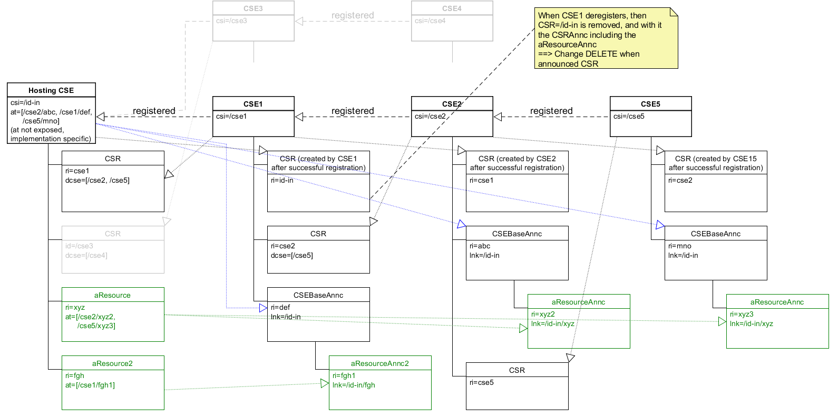

The details to clarify are:

1) What’s the value of the To parameter when Hosting CSE is creating the CSEBaseAnnc?

The only information the Hosting CSE has is the CSE-ID from the announceTo attribute of the original request, but the CREATE Request cannot be sent to “/CSE-ID” as this is not a valid value when targeting a CSEBase (CSEBaseAnnc is created under CSEBase of the announcement target). So, there are only 3 options:

a. Unstructured-SP-Relative-Resource-Identifier: “/CSE-ID/<CSEBase resource” identifier>

b. Structured-SP-Relative-Resource-Identifier: “/CSE-ID/<CSEBase resource name>”

c. Structured-SP-Relative-Resource-Identifier: “/CSE-ID/-“

Proposal) To add some text in the Announced resource Create procedure for the Origiantor to indicate how to set the To parameter.

2) If a Hosting CSE tries to create a CSEBaseAnnc a second time, nothing prevents to create it. This should be considered and the announcement target CSE should not create it once again if already exists.

Proposal) To add some text in the Announced resource Create procedure for the Receiver to reject the Create Request if the CSEBaseAnnc representing a given Hosting CSE already exists.

## ----------------------- Start of Change 1--------------------------------------------

7.3.3.10 Announce the resource or attribute

If a CREATE Request that contains an *announceTo* attribute is received, or if an UPDATE Request is received that adds a URI or CSE-ID to the *announceTo* attribute that is not already stored in the *announceTo* attribute of the resource:

1. Compose a CREATE Request primitive as follows:

* The *link* attribute is set to the URI of the original resource.
* If the *accessControlPolicyIDs* attribute of the original resource is not present, the *accessControlPolicyIDs* attribute is set to the same value as the parent resource or is set using the local policy of the original resource.
* Attributes marked with MA in oneM2M TS-0001 [6]. Such attributes shall be included if present in the original resource and set to same value as in the original resource.
* Attributes marked with OA that are included in the *announcedAttribute* attribute. Such attributes shall be included if present in the original resource and set to same value as in the original resource.
* The *resourceType* attribute is set to the announced variant of the original resource (see Table 6.3.4.2.1‑1).
* The Hosting CSE shall not include a ***Primitive Profile Identifier*** parameter in the CREATE request primitive even if one is included in the received CREATE request.
* If an attribute that is to be announced has an identifier type that supports multiple formats (CSE-relative, SP-relative, absolute), the Hosting CSE shall send this attribute in each request in step 1a or 1b in a format that is permitted by the rules given in oneM2M TS-0001 [6] clause 7.2 for that request's target. If the attribute is a resource identifier the Hosting CSE shall not convert it from a structured to an unstructured format or vice versa.

1. Perform the following steps for each new item (announcement target) in the *announceTo* attribute list:
   1. If the announcement target is a CSE-ID, check if the parent resource of the original resource has been announced to the announcement target CSE by checking the *announceTo* attribute of the parent resource:

- If yes, announce the original resource by sending the CREATE Request with its ***To*** parameter set to the location of the announced parent resource.

- If no, if the resource to be announced is either a <contentInstance>, a <timeSeriesInstance> or a <flexContainerInstance> the Hosting CSE shall consider the announcement unsuccessful and continue with step 3. Otherwise check if the Hosting CSE has created a <CSEBaseAnnc> resource as a child of the <CSEBase> of the announcement target CSE.

- If yes, announce the original resource by sending the CREATE Request to the announcement target CSE with its ***To*** parameter set to the <CSEBaseAnnc> resource address.

- If no, then the CSE hosting the original resource shall perform the following steps:

* + - 1. Create a <CSEBaseAnnc> that represents itself as a child of the <CSEBase> resource of the announcement target CSE. The Hosting CSE shall compose the CREATE <CSEBaseAnnc> request primitive as described for resource announcement above and shall provide a value for the *expirationTime* attribute of the <CSEBaseAnnc> to be created. Then, it shall use the generic procedure for announced resource in clause 7.4.26.2.2.
      2. Once the <CSEBaseAnnc> resource has been created, send the CREATE Request prepared earlier with its ***To*** parameter set to the <CSEBaseAnnc> resource address.
  1. If the announcement target is not a CSE-ID send the CREATE Request to the URI provided in the *announceTo* of the request.

1. Wait for the Response to the CREATE that was sent in step 1a or 1b.
2. Replace the CSE-ID or URI in the content of the *announceTo* attribute contained in the original request’s resource representation with the URI of the successfully-announced resource from the Response received in step 2.
3. Include the updated *announceTo* attribute in the ***Content*** parameter of the Response to the received request.

If an UPDATE Request is received that adds an attribute name into the *announcedAttribute* attribute and that attribute is specified as OA in oneM2M TS-0001 [6]) :

1. Compose an UPDATE Request primitive. The UPDATE Request shall provide the attribute name for the attribute to be announced, and the initial value for this attribute in the ***Content*** parameter. The initial value shall be the same as the value from the original resource. If this attribute has an identifier type that supports multiple formats (CSE-relative, SP-relative, absolute), the Hosting CSE shall send this attribute in each request in step 2 in a format that is permitted by the rules given in oneM2M TS-0001 [6] clause 7.2 for that request's target. If the attribute is a resource identifier the Hosting CSE shall not convert it from a structured to an unstructured format or vice versa. The Hosting CSE shall not include a ***Primitive Profile Identifier*** parameter in the UPDATE request primitive even if one is included in the received UPDATE request.
2. Send UPDATE Requests to all announced resources listed in the *announceTo* attribute.
3. Wait for the Response primitive(s).
4. Add the attribute name of the successfully announced attribute to the *announcedAttribute* attribute.
5. Include updated *announcedAttribute* attribute in the ***Content*** parameter in the Response to the received UPDATE Request.

If an UPDATE Request is received that updates attribute(s) specified as MA (see oneM2M TS-0001 [6]) or updates attribute(s) included in the *announcedAttribute* attribute:

1. Compose an UPDATE Request primitive by including the updated attribute(s) with their associated updated value(s). If an attribute has an identifier type that supports multiple formats (CSE-relative, SP-relative, absolute), the Hosting CSE shall send this attribute in each request in step 2 in a format that is permitted by the rules given in oneM2M TS-0001 [6] clause 7.2 for that request's target. If the attribute is a resource identifier the Hosting CSE shall not convert it from a structured to an unstructured format or vice versa. The Hosting CSE shall not include a ***Primitive Profile Identifier*** parameter in the UPDATE request primitive even if one is included in the received UPDATE request.
2. Send the UPDATE Request to all CSE(s) represented by the URI(s) in the *announceTo* attribute of the original resource.
3. Wait for the Response primitive(s).

-------------------------------------------------- End of Change 1---------------------------------------------------

## ----------------------- Start of Change 2--------------------------------------------

##### 7.4.26.2.2 Create

***Originator:***

No change from the generic procedures in clause 7.2.2.1. with the following exception:

If the announced resource to be created is a <CSEBaseAnnc> and if a CSE-ID was provided in the announceTo attribute of the original request, the Originator shall set the To parameter of the CREATE Request to the CSE-ID of the announcement target appended with a slash and either of the following:

* The CSEBase resource identifier of the announcement target if known (for instance, the announcement target CSE is a registree of the Originator)
* The CSEBase resource name of the announcement target if known (for instance, the announcement target CSE is a registree of the Originator)
* The shortcut for the CSEBase resource name of the announcement target (see TS-0001 clause 7.2 Structured-CSE-Relative-Resource-Identifier)

***Receiver:***

No change from the generic procedures in clause 7.2.2.2. with the following exception:

If the announced resource to be created is a <CSEBaseAnnc>, the Receiver shall check that the provided *link* attribute value is not present in any other existing <CSEBaseAnnc> resource. Otherwise, the Receiver shall reject the request with a ***Response Status Code*** indicating "CONFLICT" error.

-------------------------------------------------- End of Change 2---------------------------------------