Agenda
Meeting: | SDS 60.1
Chair: | Chair: Peter Niblett, IBM  Vice-chair: SeungMyeong Jeong, KETI  Vice-chair: Wei Zhou, CICT  Vice-chair: Poornima Shandilya, C-DOT
Secretary: | oneM2M Secretariat
Meeting Date: | 2023-07-28
Meeting Details: | SDS 60.1 Issues call
Intended purpose of  document: | Decision  Discussion  Information  Other <specify>
Template Version:23 February 2015 (Do not modify)

Participation in, or attendance at, any activity of oneM2M, constitutes acceptance of and agreement to be bound by all provisions of IPR policy of the admitting Partner Type 1 and permission that all communications and statements, oral or written, or other information disclosed or presented, and any translation or derivative thereof, may without compensation, and to the extent such participant or attendee may legally and freely grant such copyright rights, be distributed, published, and posted on oneM2M’s web site, in whole or in part, on a non-exclusive basis by oneM2M or oneM2M Partners Type 1 or their licensees or assignees, or as oneM2M SC directs.
oneM2M Procedure Notice:
oneM2M activities must adhere to the oneM2M Partnership Agreement and Working Procedures, which are based on principles such as fairness, due process, openness and transparency.
IPR Notices:
Each oneM2M Partner Type 2 and oneM2M Member contributing to the technical work of oneM2M must grant a perpetual, worldwide, royalty-free, nonexclusive license: to incorporate material from contributions into oneM2M Technical Specifications and Technical Reports; and for the oneM2M Partners Type 1 to publish the contributed material in Technical Specifications and Technical Reports. Care should be taken when making contributions containing third party material to ensure that the contributor has the right to grant the appropriate license for this material.
Each oneM2M Member who engages in oneM2M activities through its membership in a Partner shall be required to comply with that Partner Type 1’s IPR policies, procedures and guidelines with respect to the availability of licenses for IPR(s) that are or may be essential to implement Technical Specifications and/or Technical Reports developed in oneM2M.
oneM2M cannot ensure the accuracy or completeness of any disclosure, investigate the validity or existence of a patent, or determine whether a patent is essential to the use of a oneM2M Technical Specification or Technical Report.
Antitrust Risk Notice:
oneM2M participants should be sensitive to, and avoid discussions within oneM2M on, sensitive topics such as licensing terms, price, territories, specific contractual terms, etc.
1 Opening of the meeting
1.1 Welcome
- Delegates are advised to read the legal notices on the cover page of this agenda
1.2 Objectives
- Progress the outstanding issue backlog
2 Review & Approval of Agenda
SDS-2023-0120 | Agenda SDS 60 | SDS Chair – Peter Niblett
3 Review of Open Issues
The issue tracker can be found at https://git.onem2m.org/issues/issues/issues
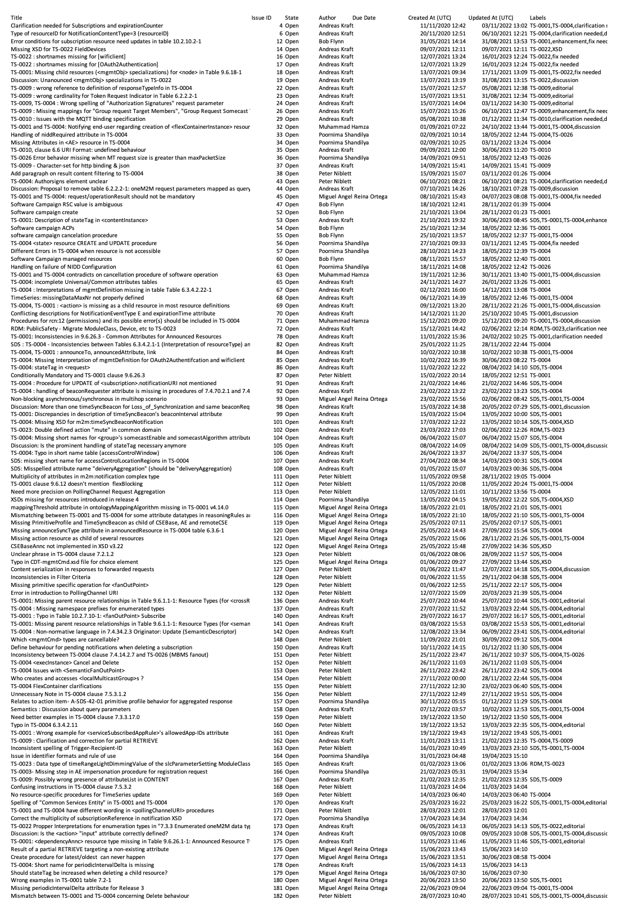

5 Planning for next Meetings
5.1 Next Conference Calls

Meeting | Date | Time (UTC)
SDS 60.2 | Tue 1 Aug 2023 | 12:00-13:30
SDS 60.3 | Tue 8 Aug 2023 | 12:00-13:30

5.2 Next TP Meetings
TP 61 Penn State University 2023 Aug 14th to Aug 18th

6 Any other business
7 Closure of meeting

