CHANGE REQUEST
Meeting ID:* | SDS 61
Source:* | Andreas Neubacher, Deutsche Telekom, andreas.neubacher@magenta.at  Ingo Friese, Deutsche Telekom, Ingo.Friese@telekom.de
Date:* | 2023-08-08
Reason for Change/s:* | Additional input for security considerations (intro)
CR against: Release* | Rel.5
CR against: WI* | Active WI-0100  MNT maintenance / < Work Item number(optional)>  Is this a mirror CR? Yes No  mirror CR number: (Note to Rapporteur - use latest agreed revision)  STE Small Technical Enhancements / < Work Item number (optional)>  Only ONE of the above shall be ticked
CR against: TS/TR* | TR-0065 V0.3.0
Clauses * | New content in clause 6.5 and 6.5.0
Type of change: * | Editorial change  Bug Fix or Correction  Change to existing feature or functionality  New feature or functionality  Only ONE of the above shall be ticked
Other TS/TR(s) impacted | non
Post Freeze checking:* | This CR contains only essential changes and corrections? YES NO  This CR may break backwards compatibility with the last approved version of the TS? YES NO
Template Version: January 2020 (do not modify)

oneM2M Notice
The document to which this cover statement is attached is submitted to oneM2M. Participation in, or attendance at, any activity of oneM2M, constitutes acceptance of and agreement to be bound by terms of the Working Procedures and the Partnership Agreement, including the Intellectual Property Rights (IPR) Principles Governing oneM2M Work found in Annex 1 of the Partnership Agreement.
GUIDELINES for Change Requests:
Provide an informative introduction containing the problem(s) being solved, and a summary list of proposals.
Each CR should contain changes related to only one particular issue/problem.
If this is a correction, and the change applies to previous releases, a separate “mirror CR” should be posted at the same time as this CR
Mirror CR: applies only when the text, including clause numbering are exactly the same.
Companion CR: applies when the change means the same but the baselines differ in some way (e.g. clause number).
Follow the principle of completeness, where all changes related to the issue or problem within a deliverable are simultaneously proposed to be made e.g. a change impacting 5 tables should not only include a proposal to change only 3 tables. Include any changes to references, definitions, and abbreviations in the same deliverable.
Follow the drafting rules.
All pictures must be editable.
Check spelling and grammar.
Use change bars for modifications.
The change should include the current and surrounding clauses to clearly show where a change is located and to provide technical context of the proposed change. Additions of complete clauses need not show surrounding clauses as long as the proposed clause number clearly shows where the proposed new clause is located.
Multiple changes in a single CR shall be clearly separated by horizontal lines with embedded text such as, start of change 1, end of change 1, start of new clause, end of new clause.
When subsequent changes are made to the content of a CR, then the accepted version should not show changes over changes. The accepted version of the CR should only show changes relative to the baseline approved text.

Introduction
Adding an introduction of security consideration for the IPE operation

-----------------------Start of change 1-------------------------------------------

6.5 Security Considerations
6.5.0 Introduction
Every API in the open internet is prone to security attacks. Like most Web APIs the SensorThings API IPE might be designed, implemented and operated respecting API Security Best Practice for example described in OWASP Secure Coding Practices Quick Reference Guide [i.12]. The intention of this chapter is not a comprehensive security analysis. Rather more it aims to lay out the IPE setup and to show regarded security aspects.
From an architectural point of view the IPE is located between an OGC STA Server and a oneM2M CSE (see Figure 6.5-1).

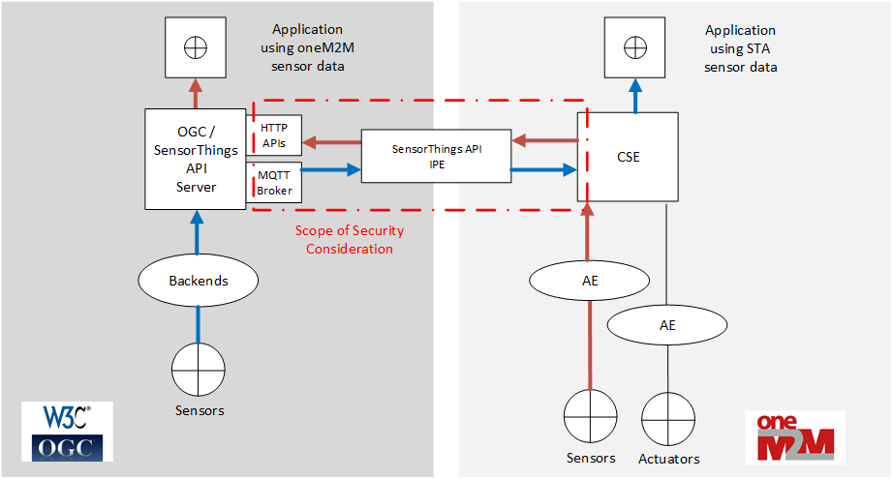
Figure 6.5-1 Scope of the Security Considerations
There might be situations where OGC / STA Server and CSE belong to different security domains (e.g. different company networks). The IPE could be either located in one of the networks or it could be a separate service between two networks operated by a third-party service provider.
The IPE has three different protocol APIs:
- IPE and CSE using oneM2M over HTTP for both communication directions. Other protocol bindings than HTTP are specified in oneM2M but are not discussed in this chapter.
- Communication between IPE and OGC / STA Server is based on two different APIs.
  - Sensor Things API over HTTP is used to push data to the OGC / STA Server described in 6.3.2.2.
  - The IPE subscribes to changes in the data model of the OGC / STA Server via MQTT as described in 6.3.2.1.
Communication relationships between OGC / STA Server, IPE and CSE are static. Each instance knows exactly its communication partner(s) beforehand. There is no dynamic change of communication endpoints.
The level of security measurements depends on the concrete operational situation. The following measurements are recommended:
- Mutual authentication of endpoints makes sure that only legitimate resources communicate with each other.
- Encryption ensures confidentiality of communication between endpoints.
- Authorization ensures that OGC / STA Server, IPE and CSE have the appropriate permissions to access a particular resource and not any other even if one of the three entities is under control of an attacker.
- Throttling limits the number of API requests in a certain period. This protects an API from “denial of service attacks” where an API is overwhelmed with requests.
- Input validation is preventing malformed requests or data from persisting in the database and triggering malfunction in one of the entities.
While most of the recommendations require additional services or tools there are protocol inherent functions for authentication and authorization available.

-----------------------End of change 1---------------------------------------------

-----------------------Start of Changes to References Clause -------------

2.2 Informative references
[i.12] OWASP Secure Coding Practices Quick Reference Guide https://owasp.org/www-pdf-archive/OWASP_SCP_Quick_Reference_Guide_v2.pdf

-----------------------End of Changes to References -------------

CHECK LIST
- Does this Change Request include an informative introduction containing the problem(s) being solved, and a summary list of proposals.?
- Does this CR contain changes related to only one particular issue/problem?
- Have any mirror CRs been posted?
- Does this Change Request make all the changes necessary to address the issue or problem? E.g. A change impacting 5 tables should not include a proposal to change only 3 tables?Does this Change Request follow the drafting rules?
- Are all pictures editable?
- Have you checked the spelling and grammar?
- Have you used change bars for all modifications?
- Does the change include the current and surrounding clauses to clearly show where a change is located and to provide technical context of the proposed change? (Additions of complete clauses need not show surrounding clauses as long as the proposed clause number clearly shows where the new clause is proposed to be located.)
- Are multiple changes in this CR clearly separated by horizontal lines with embedded text such as, start of change 1, end of change 1, start of new clause, end of new clause.?

