|  |  |
| --- | --- |
| CHANGE REQUEST | |
| Meeting ID:* |  |
| Source:* |  |
| Date:* |  |
| Reason for Change/s:* |  |
| CR against: Release* |  |
| CR against: WI* | Active <WI-0100>  MNT maintenance / < Work Item number(optional)>  Is this a mirror CR? Yes  No  mirror CR number:  STE Small Technical Enhancements / < Work Item number (optional)>  Only ONE of the above shall be ticked |
| CR against: TS/TR* |  |
| Clauses * |  |
| Type of change: * | Editorial change  Bug Fix or Correction  Change to existing feature or functionality  New feature or functionality  Only ONE of the above shall be ticked |
| Other TS/TR(s) impacted | None |
| Post Freeze checking:* | This CR contains only essential changes and corrections? YES  NO  This CR may break backwards compatibility with the last approved version of the TS? YES  NO |
| Template Version: January 2019 (do not modify) | |

**oneM2M Notice**

The document to which this cover statement is attached is submitted to oneM2M. Participation in, or attendance at, any activity of oneM2M, constitutes acceptance of and agreement to be bound by terms of the Working Procedures and the Partnership Agreement, including the Intellectual Property Rights (IPR) Principles Governing oneM2M Work found in Annex 1 of the Partnership Agreement.

GUIDELINES for Change Requests:

Provide an informative introduction containing the problem(s) being solved, and a summary list of proposals.

Each CR should contain changes related to only one particular issue/problem.

In case of a correction, and the change apply to previous releases, a separate “mirror CR” should be posted at the same time of this CR

Mirror CR: applies only when the text, including clause numbering are exactly the same.

Companion CR: applies when the change means the same but the baselines differ in some way (e.g. clause number).

Follow the principle of completeness, where all changes related to the issue or problem within a deliverable are simultaneously proposed to be made E.g. A change impacting 5 tables should not only include a proposal to change only 3 tables. Includes any changes to references, definitions, and acronyms in the same deliverable.

Follow the drafting rules.

All pictures must be editable.

Check spelling and grammar to the extent practicable.

Use Change bars for modifications.

The change should include the current and surrounding clauses to clearly show where a change is located and to provide technical context of the proposed change. Additions of complete clauses need not show surrounding clauses as long as the proposed clause number clearly shows where the new clause is proposed to be located.

Multiple changes in a single CR shall be clearly separated by horizontal lines with embedded text such as, start of change 1, end of change 1, start of new clause, end of new clause.

When subsequent changes are made to content of a CR, then the accepted version should not show changes over changes. The accepted version of the CR should only show changes relative to the baseline approved text.

## Introduction

rewordings & more precise descriptions

<https://git.onem2m.org/specifications/ts/ts-0041/-/merge_requests/10>

<https://git.onem2m.org/specifications/ts/ts-0041/-/merge_requests/10/diffs?commit_id=9aa60b75b83ea38bc30023e4a59f25b0a7125933>

========= Comment provided by Ingo Friese at 2025-02-14T07:08:58.132Z: =========

1) "message" instaed of "messages"

2) "may be" instead of "may"

3) after <> has tob the word resource

========= Comment provided by Ingo Friese at 2025-02-13T07:49:42.285Z: =========

1) replace 'regarded' with 'corresponding'

2) refer to "container that is collecting the observations"

3) make clear that there is a 1-to-1 relation between <container> and "Datastream" but a IPE can implement multiple relations

----------------------- Start of change 1 -----------------------

---a/TS-0041-oneM2M-SensorThings_interworking.md  
+++b/TS-0041-oneM2M-SensorThings_interworking.md

@@ -185,7 +185,46 @@ The IPE shall map the 'result' attribute of an OGC/STA 'Observation' to the 'con

**Figure 6.1-1: OGC / STA-to-oneM2M data model mapping**

<mark>The following text is to be used when appropriate:</mark>

## 6.3 Configuration Aspects

### 6.3.0 Introduction

To enable interworking, preparation is required for both the oneM2M-CSE and the OGC/STA server (see Figure 6.3.0-1). As described in Section 6.0, the IPE maps data from an OGC/STA "Observation" to a oneM2M `<contentInstance>` and vice versa. This specification defines a 1-to-1 relationship in each direction between the "Datastream" associated with the "Observation" and the `<container>` associated with the `<contentInstance>`. An IPE may implement multiple 1-to-1 relationships.

![Figure 6.3.0-1: Both sides of the IPE configuration](media/config.png)

**Figure 6.3.0-1: Both sides of the IPE configuration**

### 6.3.1 Configuration of OGC/STA Server Side

#### 6.3.1.0 Overview

Both directions of the data flow between the OGC/STA server and the IPE require their own configuration steps.

#### 6.3.1.1 Communication direction OGC/STA Server towards IPE

In Figure 6.3.1.1-1, an OGC/STA client is connected to an OGC/STA server, and its data is forwarded to the IPE. The OGC/STA client publishes data to the OGC/STA server via an HTTP-POST message.

An "Observation" according to STA Sensing Entities Data Model <a href="#_ref_i.1">[i.1]</a> belongs to a "Datastream" (see Figure 5-2). The IPE shall subscribe to the "Datastream" containing the observations to be forwarded to the oneM2M side at the MQTT broker of the OGC/STA server using its specific URL or topic, e.g., {sta-example-server-address.com/v1.0/Datastreams(8715)}. Upon successful subscription, the IPE will receive every "Observation" pushed to that "Datastream".

![Figure 6.3.1.1-1: Message flow from OGC/STA Client to OGC/STA Server to IPE](media/config_ogc.png)

**Figure 6.3.1.1-1: Message flow from OGC/STA Client to OGC/STA Server to IPE**

#### 6.3.1.2 Communication direction IPE towards OGC/STA Server

The IPE requires a destination-"Datastream" to send an "Observation" containing data from the oneM2M side. If no associated "Datastream" exists on the OGC/STA server, it shall be created. This can be done beforehand or at the IPE's start-up, depending on the implementation.

When a "Datastream" is created on the OGC/STA server, a reference ID (e.g. {"@iot.id:3635353"}) is returned. This reference is required by the IPE to associate an "Observation" with a "Datastream" and shall be available during IPE operation. In addition to the "Datastream" other entities of the STA Sensing Entities Data Model <a href="#_ref_i.1">[i.1]</a>, such as "Location" or "Sensor," may be created.

The creation of entities like "Datastream" and "Thing" requires several mandatory properties that shall be known at configuration time (e.g., 'name' and 'description'). These property fields may be automatically derived, for example, from the "Label" or "ResourceName" attributes of the corresponding oneM2M `<container>` resource or if existing, from the corresponding `<AE>` resource during IPE configuration. The OGC/STA procedures for creating OGC entities are described in SensorThing API documentation <a href="#_ref_i.1">[i.1]</a>.

Once the destination-"Datastream" is created, the IPE can send an "Observation" to the OGC/STA server as HTTP POST message. An interested OGC/STA client can subscribe to the destination-"Datastream" at the MQTT Broker of the OGC/STA server to receive each "Observation" forwarded by the IPE (see Figure 6.3.1.2-1). Alternatively, the OGC/STA client may use an HTTP-GET request to retrieve the data as needed.

![Figure 6.3.1.2-1: Message flow from IPE to OGC/STA Server to OGC/STA Client](media/config_ogc2.png)

**Figure 6.3.1.2-1: Message flow from IPE to OGC/STA Server to OGC/STA Client**

# Proforma copyright release text block

----------------------- End of change 1 -----------------------

----------------------- Start of change 2 -----------------------

---/dev/null  
+++b/media/config.png

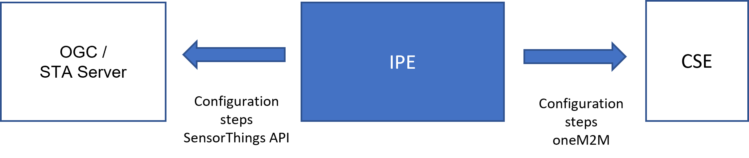

----------------------- End of change 2 -----------------------

----------------------- Start of change 3 -----------------------

---/dev/null  
+++b/media/config_ogc.png

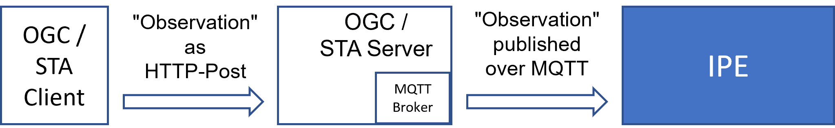

----------------------- End of change 3 -----------------------

----------------------- Start of change 4 -----------------------

---/dev/null  
+++b/media/config_ogc2.png

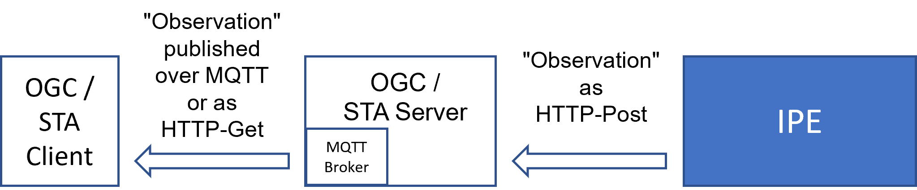

----------------------- End of change 4 -----------------------