CHANGE REQUEST
Meeting ID:* | TDE 54.1
Source:* | Bob Flynn (Exacta GSS); bob.flynn@exactagss.com
Date:* | 30 May 2022
Reason for Change/s:* | Add material for time series capabilities
CR against: Release* | Rel-5
CR against: WI* | Active <WI-0107>  MNT maintenance / < Work Item number(optional)>  Is this a mirror CR? Yes No  mirror CR number: (Note to Rapporteur - use latest agreed revision)  STE Small Technical Enhancements / < Work Item number (optional)>  Only ONE of the above shall be ticked
CR against: TS/TR* | TR-0057v0.6.0
Clauses * | 7.5.1
Type of change: * | Editorial change  Bug Fix or Correction  Change to existing feature or functionality  New feature or functionality  Only ONE of the above shall be ticked
Other TS/TR(s) impacted | None
Post Freeze checking:* | This CR contains only essential changes and corrections? YES NO  This CR may break backwards compatibility with the last approved version of the TS? YES NO
Template Version: January 2019 (do not modify)

oneM2M Notice
The document to which this cover statement is attached is submitted to oneM2M. Participation in, or attendance at, any activity of oneM2M, constitutes acceptance of and agreement to be bound by terms of the Working Procedures and the Partnership Agreement, including the Intellectual Property Rights (IPR) Principles Governing oneM2M Work found in Annex 1 of the Partnership Agreement.

Introduction
While working on “Developer Guide: Time Series” it became clear that some updates to this TR are justified.

-----------------------Start of change 1---------------------------------------------

7.5.1 Time Series
The <timeSeries> and <timeSeriesInstance> resources offer functionality that is useful for data sources that have time as a significant aspect of the data model. Devices generally have no way to know how long it will take the messages that report data to get to the host CSE. The green line in Figure 7.5.1-1 represents the actual time that a sensor measurement occurs, while the blue line represents the time associated with the data when it arrives at the oneM2M CSE and the resource is given a creationTime. In the case where a device communicates through a gateway that stores data so that it can transmit messages in bulk, which is a good practice for cellular or low power devices, there can be significant delays. This can lead to delays that go beyond variations due to latency and create significant offsets in the entire data set as shown in Figure 7.5.1-1. The red line represents the dataset when the sensor measurements are stored in a buffer for some time before transmitting the message to a oneM2M CSE and plotting that data according to the time that it arrive in the CSE. In oneM2M this would create a further delay in the creationTime attribute of the <contentInstance> resource with respect to the actual time of the sensor measurement.
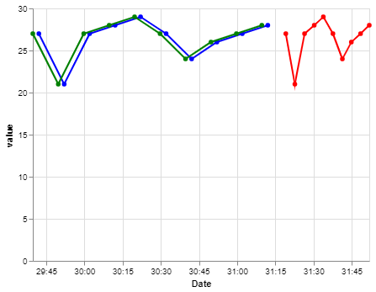
Figure 7.5.1-1

Combined with the configuration of a <subscription> resource an application is able to accurately display time series data, based on the time the measurement is captured by a device, identify and receive notification when time series data that is intended to be periodic is missing. These features enable capabilities that are normally implemented in application specific processing to be provided through simple configuration of a <timeSeries> resource.
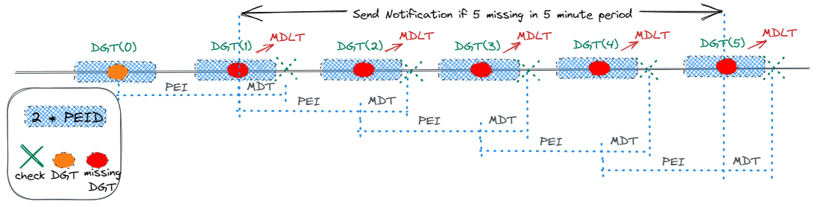

-----------------------End of change 1---------------------------------------------

-----------------------Start of change n---------------------------------------------

-----------------------End of change n---------------------------------------------

