MINUTES
Meeting title: | TDE #65.1
Chair: | Bob Flynn, Exacta GSS, bob.flynn@exactagss.com
Vice-Chairs: | Sherzod Elamanov, SyncTechno Inc., elamanov@synctechno.com
Secretary: | Michael KIM, TTA, yjkim@tta.or.kr
Meeting Date: | 18 July 2024 – Virtual
Intended purpose of  document: | Decision  Discussion  Information  Other <specify>

oneM2M Notice
The document to which this cover statement is attached is submitted to oneM2M. Participation in, or attendance at, any activity of oneM2M, constitutes acceptance of and agreement to be bound by terms of the Working Procedures and the Partnership Agreement, including the Intellectual Property Rights (IPR) Principles Governing oneM2M Work found in Annex 1 of the Partnership Agreement.

1 Opening of the meeting
1.1 Welcome
Bob Flynn, Chair, opened the TDE 65.1 meeting on 18 July 2024. Participants were reminded to familiarize themselves with the participation notices.
1.2 Objectives
The objectives, as listed on the agenda, were reviewed.
1.3 Attendees
N/A
2 Review & Approval of Agenda
TDE-2024-0042 | TDE_65_1_Agenda | TDE Chair
TDE-2024-0042R01 | TDE_65_1_Agenda | TDE Chair
TDE-2024-0042 was NOTED
TDE-2024-0042R1 was AGREED
3 Review & Approval of Previous Minutes
There were no previous minutes to approve.
4 Review of Open Action Item Status
None
5 Contributions

Discussion of Hackathon
Seung Myung shared 2024 Hackathon schedule. Univ in France, Germany and USA expressed their interest, but the schedule may conflict due to their beginning day of the class. It is proposed to postpone the date of Kick-off meeting to Oct 7. Seung Myung also will invite Universities and SME of Asian countries through ASTAP meeting. It also needs to ask Ken to put some LinkedIn post for SME. The following capture is discussion results.
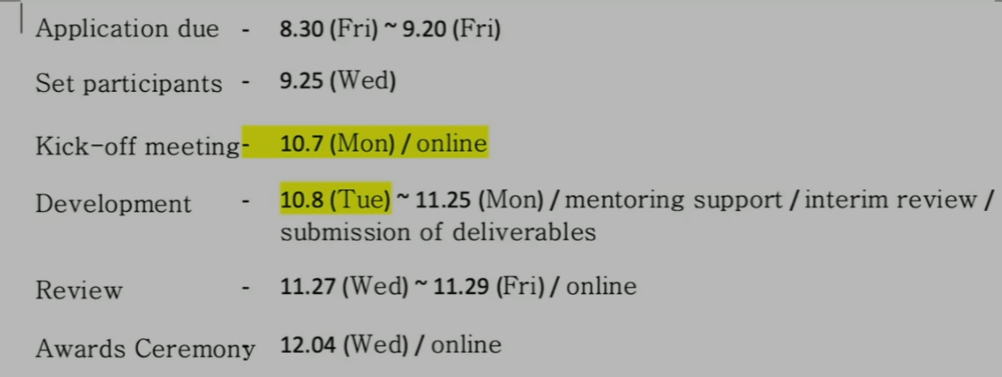

Discussion of creating a new ETSI SDG (Software Development Group)
Andreas and Miguel proposed creating a new ETSI SDG to maintain and develop oneM2M open source. Seung Myung expressed interests to join this group.

Discussion of Capstone Project of Penn State Univ.

Bob shared Fall ’23 Capstone Project of Penn State Univ. There are some discussions on SDT device management and provisioning using oneM2M and manufacturer’s modem library including Verizon etc.

6 Planning for next Meetings
6.1 Face-to-Face Meetings
- TP#66, 9-13 Sept 2024, ETSI

6.2 Next Conference Calls
- TDE65.2: 29 Aug 2024 (THU) 9:00 – 10:30 UTC
7 Any other business

Digital Twins STF - Profiles
Discussion about converting documents to markdown
- Progress
- Issues

Other TDE responsibilities that we need to progress:
- Creating ETSI SDG
- Next Hackathon
- Next Interop session
- oneM2M ICON set usage
- Other activities: support of ACR, other?
- GCF Liaison statement
- oneM2M Recipes
- oneM2M online Specification portal

8 Closure of meeting
The Chair thanked the participants and closed the meeting.

