Input Contribution
Meeting ID* | AI 24.4
Title:* | Recommendation from SC App-ID AHG to the 8 April SC meeting
Source:* | oneM2M SC App-ID AHG
Uploaded Date:* | 2015-04-06
Document(s)  Impacted* | App-ID
Intended purpose of  document:* | Decision  Discussion  Information  Other <specify>
Decision requested or recommendation:* | Contains the SC App-ID AHG recommendation to the 8 April oneM2M SC meeting for the solicitation of a Partner Type 1(s) to act as a legal entity on behalf of oneM2M to enter into a contract with an organization(s) to serve as oneM2M App-ID Registration Authority.
Template Version:23 February 2015 (Dot not modify)

oneM2M Notice
The document to which this cover statement is attached is submitted to oneM2M. Participation in, or attendance at, any activity of oneM2M, constitutes acceptance of and agreement to be bound by terms of the Working Procedures and the Partnership Agreement, including the Intellectual Property Rights (IPR) Principles Governing oneM2M Work found in Annex 1 of the Partnership Agreement.

Introduction
During the 25 February 2015 oneM2M SC meeting, the SC considered the solicitation of a Partner Type 1(s) to act as the legal entity on behalf of oneM2M to enter into a contract with an organization(s) to serve as the oneM2M App-ID Registration Authority. This resulted in the establishment of the SC App-ID AHG, which was tasked with identifying a Partner to take on the responsibility (see Terms of Reference in AI-2015-0001R01).
The SC App-ID AHG met on 12, 19, and 31 March to develop a recommendation on the Partner Type 1(s) and identify the various characters involved in the App-ID Registry (the Registry is defined in TS-0001 and TS-0004). This document provides a recommendation and outlines the various roles.
It was agreed that time to market of the App-ID Registry was critical, and as such, that from the onset, a simple structure was required in order to quickly launch the Registry and demonstrate it prior to the June 2015 oneM2M Showcase. An illustration of the recommended structure is provided below:

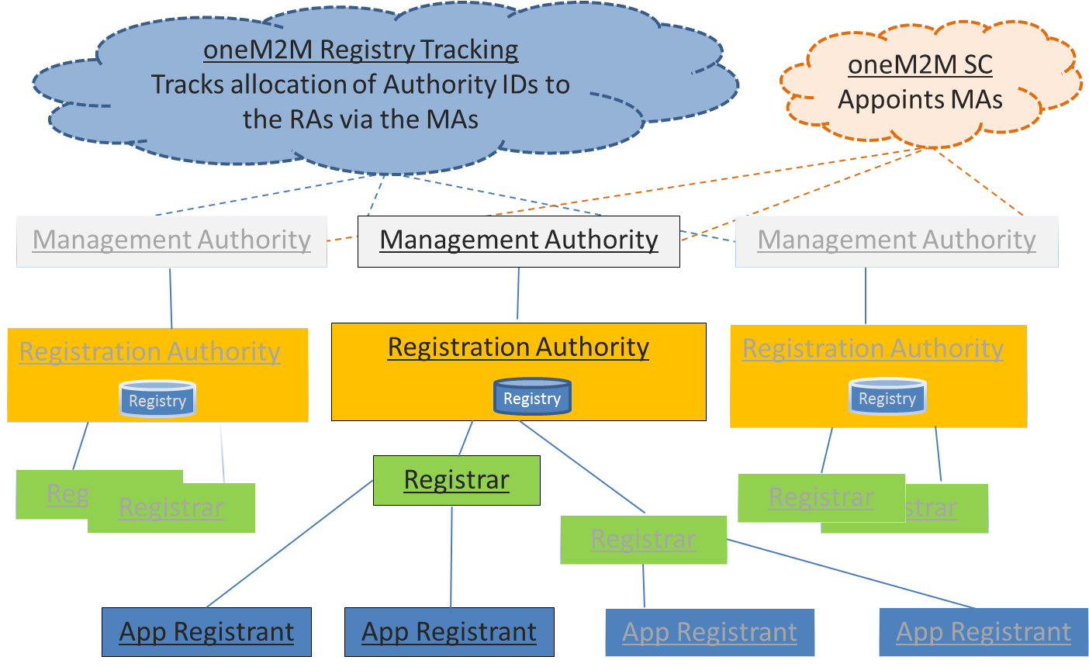

Assumptions
- SC App-ID AHG should provide guidance and input on the organizational, operational and process/legal issues surrounding the implementation of an App-ID Registry.
- Per the approved Terms of Reference, the SC App-ID AHG should recommend a Partner Type 1(s) to act as the legal entity on behalf of oneM2M to enter into a contract with an organization(s) to serve as oneM2M Registration Authority.
- While pricing strategy is out of scope of the SC App-ID AHG; the legal structure and processes should be designed to help to minimize App-ID Registry operating costs.
- Technical work is outside the scope of the SC App-ID AHG, and any such work should be addressed by the Technical Plenary and/or its designated group(s).
- The Release 1 Specifications foresee the existence of Registered App-IDs and Unregistered App-IDs. Registered App-IDs are defined as being composed of two parts: a prefix (Authority-ID) designating the Authority, and a core part. The Release 1 Specifications hence prescribe the existence of an official App-ID Registry.
- Elements of the App-ID Registry will have to be actively managed to ensure validity of the information.
- Sustained growth of registered oneM2M App-IDs is a goal. Therefore, timely (this year) implementation of the official oneM2M Registry is important.
- The App-ID Registry must provide the timely availability of and access to the assignment of App-IDs in all jurisdictions. The Registry is not intended to be a real-time database, but rather a highly available database of existing App-IDs and consistently available for the establishment of new App-IDs.
- Entities that are assigned an App-ID, regardless of whether or not they are a oneM2M Participant, should bear the fair and reasonable costs associated with the issuance/maintenance of App-IDs.
- The format of the App-ID shall conform to TS-0001.

Considerations
- The number of applications and developers could reach very large numbers, potentially in the billions of records.
- Significant cost is anticipated in the establishment, development and maintenance of the Registry, and the Management Authority/Registration Authority will at least need to recover said costs. Efforts must be taken to ensure the availability of App-IDs while minimizing the cost of establishing App-IDs.
- In establishing the initial App-ID Registry, the opportunity must be allowed for multiple Management Authorities and Registration Authorities. As a result, it is recommended that oneM2M (e.g., Secretariat member, Legal Subcommittee) tracks from the very beginning a list of Management Authorities together with their related Registration Authorities and allocated Authority IDs. An example of such a list can be as follows:
Management  Authority (MA) | Registration Authority (RA) | RA-ID | RA Point of contact | RA Internet Point of entry
ARIB | RA1 | A01 | TBD | TBD
ATIS | RA2 | B01 | TBD | TBD
CCSA | RA3 | C01 | TBD | TBD
ETSI | RA4 | D01 | TBD | TBD
TIA | RA5 | B02 | TBD | TBD
TSDSI | RA6 | E01 | TBD | TBD
TTA | RA7 | F01 | TBD | TBD
TTC | RA8 | A02 | TBD | TBD

- In the future, the functions of the Registration Authority could be merged with the Registrars. This would require coordination between the Registration Authorities, for which requirements would have to be developed.
- The concept of making oneM2M a legal entity was raised; however, it was noted that consideration for this concept was evaluated at oneM2M’s onset without substantial support.

App-ID Registry Stakeholders
The stakeholders involved in the App-ID Registry include:
- oneM2M Steering Committee, which will appoint Management Authorities.
- oneM2M Registry Tracking function, which is an entity or role under oneM2M SC (e.g., Secretariat member) that manages the list of Authority-IDs allocated to Management Authorities and their related Registration Authorities.
- Management Authority (MA), which is the legal entity that will supervise the issuance of unique global identifiers under given Authority-IDs, and potentially contract with an organization that will issue such unique global identifiers.
- Registration Authority (RA), which is the legal entity that manages/administers the App-ID database used to issue unique global identifiers consistent with oneM2M specifications.
- Registrars, which are legal entities that will directly interface with App Developers seeking App-IDs and can assign unique IDs.
- Application (App) Registrants (AR), which are entities seeking to obtain a registered App-ID.
This contribution focuses primarily on the MA and RA.

Roles of the Various App-ID Registry Bodies
oneM2M Registry Tracking Function
This function keeps track of the Management Authorities (MA) and their related Registration Authorities (RA) appointed by them, together with the associated Authority-IDs and contact information.
- No additional tasks are expected from this function.

Management Authorities (MAs)
oneM2M is not a legal entity; therefore, when there is a need to contract third parties to act as Registration Authorities, any oneM2M Partner Type 1 (“Management Authority” (MA)) can enter into such a contract. The MAs oversee Registration Authorities on behalf of oneM2M. The MAs must be granted authority to use their best judgment in creating operational Registries, and shall:
- Select and mandate (through a commercial contract) RAs to create/implement Registries that can issue unique global IDs;
  - The selection will be reported to the SC and Registry Tracking Function.
- Establish procedures for fair and non-discriminatory access to these IDs, reclamation and reassignment of IDs, etc.;
  - These procedures will be made available to the SC.
  - Interface with the oneM2M Technical Plenary or its designee may be required to ensure alignment.
- Ensure the RAs issues IDs in a timely manner and in accordance with the established procedures;
- Coordinate with the oneM2M Technical Plenary and the RAs regarding App-ID format/structure and attributes in a timely manner; and
- Provide information and reports to the SC, as appropriate; e.g.,:
  - Updates on the progress of the Registries.
  - Updates on operational and legal issues or risks as they are exposed.
  - Updates on industry adoption of the Registries.

Registration Authorities (RAs)
The RAs shall oversee the issuance of unique IDs by Registrars under their allocated Authority-IDs, and:
- Shall be a legal entity that maintains an App-ID database/Registry;
- Should be familiar with the relevant oneM2M Specifications addressing the App-ID Registry;
- Shall design policies and procedures for the operation of the Registrars;
- Should have a history of providing and managing an industry database in coordination with a recognized standards body and in compliance with relevant industry standards;
- Shall maintain an online “Internet point-of-entry”, i.e., a web page where information on the RA and registered oneM2M App-IDs is accessible;
- Shall maintain a Service Level of 99.9% uptime of its Internet point-of-access and the database/Registry;
- Shall maintain RA equipment/services in a secure environment with sufficient redundancy to protect against failures/outages;
- Shall take all reasonable steps to protect Registrar, App Developer and database information from unauthorized access;
- Shall maintain activity log files that can be provided to the MA upon request;
- Shall maintain all internal database information in English;
- Shall include the oneM2M logo on its website and in interfaces with Registrars;
- Shall comply with the organizational, legal and technical requirements defined by the MA;
- Shall support introduction of multiple Registrars;
- May charge reasonable and non-discriminatory fees for access to App-ID database;
- Develop and maintain the Registry data in a way that will allow transfer to another entity in case the RA ceases to provide the service; and
- Shall not be required to interact with any other RA. Each RA will have their assigned Authority-ID(s) and are free to allocate oneM2M App-IDs within that range without consideration of other RA actions.

Registrars
It is anticipated that there will be multiple Registrars, which may be regional in nature, which:
- Shall comply with the organizational, legal and technical requirements defined by the RA;
- Shall interface with the RA database in order to assign globally unique registered App-IDs to Application Registrants;
- Shall collect/retain the required attributes in support of App-ID generation;
- May elect to localize the user interface for different regions; and
- Develop and maintain the Registry data in a way that will allow transfer to another entity in case the Registrar ceases to provide the service.

Application Registrants (ARs)
- Entities seeking to obtain a registered App-ID.

Recommendation for Partner Type 1
In an effort to expeditiously establish a legal entity with the capability to oversee the launch of an official oneM2M App-ID Registry, it is recommended that a Partner Type 1 be identified to establish the Registry and contract with an appropriate Registration Authority. During the 25 February 2015 oneM2M SC meetings and subsequent SC App-ID AHG meetings, ATIS volunteered to take on the responsibility for establishing the Registry and contracting with an appropriate Registration Authority. ATIS committed to execute a contract with a Registration Authority in the April/May 2015 timeframe in order to allow for the demonstration of a Registry prototype at the June 2015 oneM2M Showcase (with a public launch by December 2015). ATIS also committed to developing procedures for fair and non-discriminatory access to App-IDs by end of August 2015 for limited availability (e.g., to oneM2M Members).
This recommendation does not preclude the ability for additional Partner Type 1(s) and/or RA(s) to volunteer as MAs/RAs. ATIS will serve as the only initial MA for a minimum period of 18 months from the public launch of the oneM2M Registry. However, the SC retains the right to authorize one or more additional MAs prior to the 18 month deadline if ATIS or ATIS’ selected RA fail to perform their duties in a diligent and professional manner, or there are performance related issues (significant Registry downtime, delays or failures in the assignment of App-IDs on a reasonable and non-discriminatory basis, etc.) related to the operation of the oneM2M Registry.

