Input Contribution
Meeting ID* | AI – 24.4
Title:* | Comments on the Draft Recommendation from SC App-ID AHG to the 8 April SC meeting
Source:* | TIA
Uploaded Date:* | 2015-04-05
Document(s)  Impacted* | APP-ID recommendation to SC
Intended purpose of  document:* | Decision  Discussion  Information  Other <specify>
Decision requested or recommendation:* | Contains the proposed SC App-ID AHG recommendation to the 8 April oneM2M SC meeting for the solicitation of a Partner Type 1(s) to act as a legal entity on behalf of oneM2M to enter into a contract with an organization(s) to serve as oneM2M App-ID Registration Authority.
Template Version:23 February 2015 (Dot not modify)

oneM2M Notice
The document to which this cover statement is attached is submitted to oneM2M. Participation in, or attendance at, any activity of oneM2M, constitutes acceptance of and agreement to be bound by terms of the Working Procedures and the Partnership Agreement, including the Intellectual Property Rights (IPR) Principles Governing oneM2M Work found in Annex 1 of the Partnership Agreement.

Introduction
- Steering Committee February 25 meeting minutes (document: SC-2015-0008R01-25Feb15_SC24_Summary) states:
  - Decision SC24-06
“ATIS will convene a small group (1-2 participants/Partner) to meet and discuss the remaining App-ID issues. A recommendation, by the group, will be presented during the SC25 meeting in April”
- The technical plenary chair presentation to steering committee SC24 meeting states, based on document (SC-2015-0009-TP_report_to_SC24) :
  - The TP created an App-ID ad hoc following a request from the SC to provide more information on registration aspects for the App-ID.
  - The current discussion within the TP App-ID ad hoc reflects/confirms that the remaining issues to be resolved are legal and organizational in nature.
  - The technical aspects (stage 2) describing the App-ID are specified in TS0001 section 7.1.3 and 7.2. According to these sections a registered App-ID is structured as follows: “R[authority-ID]/[registered-App-ID]”. The process of administering the “authority-ID” and assigning a “registered-App-ID” are the aspects that need legal and organizational considerations.
  - SC is the right place to progress App-ID related organizational and legal aspects, while the TP can provide support as needed.
  - The SC is invited to provide further input on the App-ID issue
- The Terms of Reference document of the SC App-Id Adhoc (document: AI-2015-0001R01-Draft_ToR.doc), in the objectives states :
  - During the last SC meeting, the SC discussed the possible solicitation of a Partner Type 1(s) to act as the legal entity on behalf of oneM2M to enter into a contract with an organization or organizations to serve as the oneM2M registration authorities.
  - The AHG will examine the organizational functions and processes and legal implementation issues associated with the contracting authority and the selection of the registration authority(ies). Recommendations from the AHG will be presented to the SC at its April 8, 2015, virtual meeting.

TIA Comments
- ATIS has been tasked to produce a recommendation to SC on issues that are “legal and organizational in nature”.
- There was no requirement from the SC to have this done by June 2015 time frame.
- The ToR (Terms on reference) discussed on the App-Id Ad-Hoc have not been approved , per se. It was a starting document.

AI-2015-0018-Consolidated_Recommendation.doc notes
- In the “Introduction” paragraph,
  - Line 12: PT1 was tasked to “discuss the remaining issues” , there was not a decision on having a single PT1 to serve as App-ID RA.
  - Line 19: the time to market is not critical and this was not suggested by the SC in the meeting notes.
- Diagram: Add:.”Based on the last discussion, it has been surfaced that multiple MAs are the preferred choice. Once there is consensus on the diagram, it should be described as "Recommended", not "Potential", and it should be included as a recommendation to the SC”
  - Diagram should reflect the OneM2M Steering Committee supervisory role. Please change it as follows:

OneM2M Steering Committee

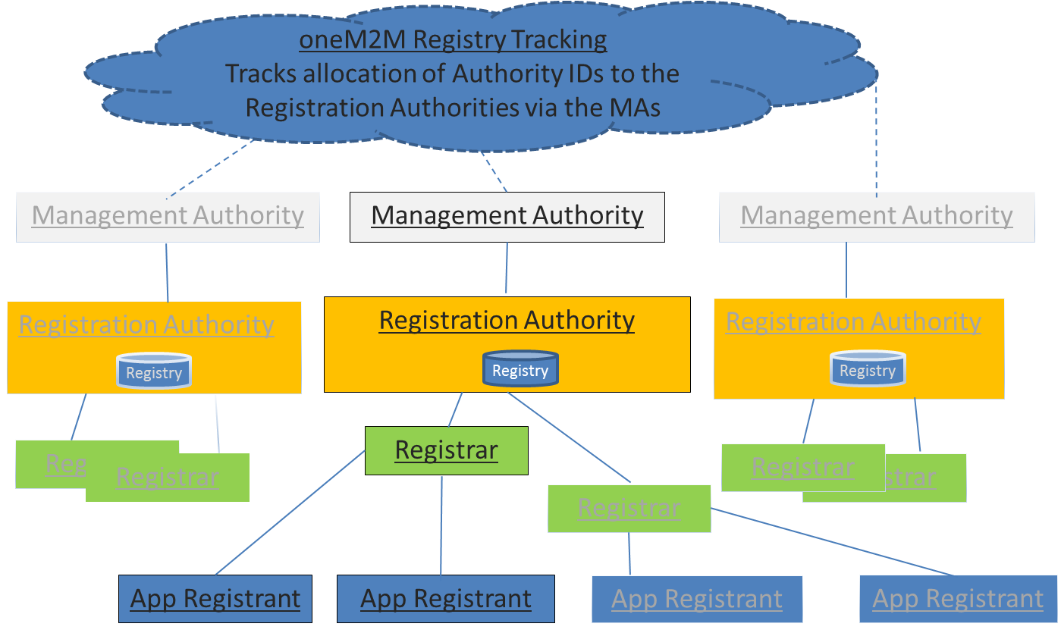
  - Since the “OneM2M Registry Tracking” has a pure administrative function, I would suggest to rename it “OneM2M Registry Tracking” Group.

- In the “Assumptions”.
  - Line 30: there are no ToR that have been approved, just an agreement in principal. There are no meeting minutes where the ToR document has been approved.
  - Line 49: Any references to prices is outside the scope of this document and should be removed.
- In the “Considerations”:
  - Line 62: Comment/Clarification Needed: “This would require coordination between the Registration Authorities”. The relation is Management Authority supervises the Registation Authorities that in turn will supervise the Registars. If there is a merge between the RA and R(s) this will fit into the MA attributions to allow it or not.
- In the “App-ID” Registry Statehoders:
  - Line 67: Add as stakeholders the “OneM2M Steering Committee” as the top level entity that will allow/approve/remove an MA to be added to the list managed by the “oneM2M Registry Tracking” group. It will have the final decision related to the functions of the MAs / RAs and the “oneM2M Registry Tracking” group. OneM2M Steering Committee decisions are final.
- In the “Roles of the Various App-Id Registry Bodies”
  - Line 84: Add: Must implement OneM2M Steering Committee decisions related to MAs and RAs
  - Line 88: Change to: “Any oneM2M Partner Type 1 (“Management Authority” (MA)) can enter into such a contract”.
  - Line 91: Add: The registered MAs must obey any regulations in place or possible in future for the function of the RAs.
  - Line 93: Change to: “Selection will be registered with “OneM2M Registry Tracking” group and submitted to the OneM2M Steering Committee for ratification”.
  - Line 134: Add: • Shall comply with the organizational, legal and technical requirements defined by the OneM2M Steering Committee”
  - Line 96: Change to : “Procedures will be registered with “OneM2M Registry Tracking” group and submitted to the OneM2M Steering Committee for ratification”.
  - Line 97: Eliminate it.
  - Line 98: Change to: “Architect, design and document policies and procedures for the legal and operational functions of the RAs”
  - Line 99: Change to: “Every MA shall implement SC decisions related to App-ID assignments and manageement in their procedures that guide the RAs and/or include the changes when negotiating contract renewals.”
  - Line 104: Change to: The MAs should encourage the RAs to make contributions to OneM2M TPs for technical clarifications of the App-ID and related issues.
  - Line 110: Add: “Shall architect and design policies and procedures for the operation of the RAs”
  - Line 134: Add: “Shall comply with the organizational, legal and technical requirements defined by the RA”
- In the “Recommendation for Partner Type 1”
  - Line 143: Comment: This section should be about the recommendations to SC. It is named differently. It should be titled, “Recommendations to the Steering Committee”.
  - Line 143: Add: “This document should be consider as a whole and represents the recommendation of the SC App-ID AHG. The implementation of the recommendation shall be left for each PT1 (MA). If any PT1 organizations would like to be the initial OneM2M MA, then the proposal should be forwarded to the OneM2M Steering Committee for approval based on the approval of the current recommendations”
  - Line 146: Comment: Any references to PT1 that are willing to start the implementation of these recommendations should be noted as examples. Each PT1 (therefore MA) should be responsible for the implementation of the SC recommendations.
  - Line 152: Eliminate: from “ATIS … “ until the end. It should be replaced with the OneM2M Steering Committee decisions. I do not think we can agree on an EXCLUSIVE right for one of the PT1 for any length of time.

