oneM2M
Business Card Policy
Document Number | oneM2M-MARCOM-2013-MD-0004 v1.0.0
Document Name: | Business Card Policy  oneM2M marketing & Communications Sub-Committee
Date: | 2013-10-09

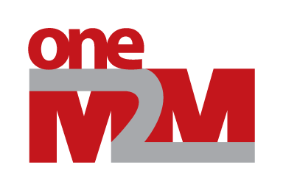

Contents
Contents 2
1 Purpose 3
2 oneM2M Business Card Eligibility 3
3 oneM2M Business Card Format 3
4 Approval Process 4
5 Production and Funding 4
History 5

1 Purpose
The uniform use of business cards by authorized oneM2M participants is an important identification and branding element when dealing with external parties and/or events. This oneM2M Business Card Policy has been established in order to provide consistency in both the look and availability of oneM2M Business Cards. The policies, procedures, and template provided herein shall be utilized whenever oneM2M Business Cards are requested.
As delegated by the oneM2M Steering Committee (SC), the oneM2M Marketing & Communications (MARCOM) Sub-Committee shall oversee the oneM2M Business Card Policy and process.

2 oneM2M Business Card Eligibility
oneM2M Business Cards SHALL be approved by the MARCOM committee upon request for:
- Members of the Steering Committee (SC) Leadership team: Chair(s) and Vice-Chairs
- Members of the Technical Plenary (TP) Leadership team: Chair(s) and Vice-Chairs
- Officers of SC Subcommittees or TP sub-Groups, who have an ongoing need for external organization contact; e.g. SC Subcommittee Chair(s) and TP Working Group Chair(s).
Other requests for oneM2M Business Cards MAY be approved by the MARCOM committee upon request for:
- Speakers at oneM2M supported and/or endorsed events
- Designated oneM2M Secretariat personnel with significant external contact or communication responsibilities.
- Other oneM2M participants formally representing oneM2M externally, as agreed by MARCOM.
oneM2M Visitor Cards (with oneM2M organization contact details and without a printed name) will also be made available for occasional use.

3 oneM2M Business Card Format
The oneM2M Business Card template features the oneM2M logo in the upper left corner, and includes:
- Full Name (Optionally in addition: Name in location-appropriate charter set)
- oneM2M Title or Role
- The oneM2M web address: www.oneM2M.org
- (Optionally) oneM2M Partner or Member Company name
- (Optionally) telephone contact numbers(s)
- Contact eMail Address: e.g. user@affiliation.com, user@domain.com, or address@oneM2M.org

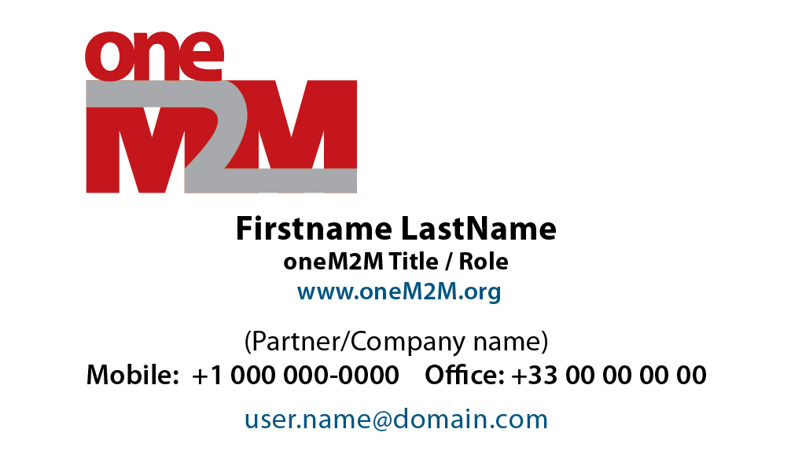
ETSI would like to propose that the company/partner logo appears first on the card, followed by the oneM2M logo and statement that the company is a partner of or member of oneM2M.
Fig. 1 Pro-forma oneM2M Business Card
The default text coding for electronic creation of oneM2M Business Cards shall be UTF-8-encoded Unicode, except for the Optional Name. The default font is Myriad Pro, as specified in the oneM2M Logo and Brand Guidelines, July 2012.

4 Approval Process
The MARCOM Sub-Committee shall review and approve business card requests in the normal course of business. In general, such approval can be obtained via a regular MARCOM meeting or by mailing list approval.
Requests for oneM2M Business Cards should be submitted at least 30-days in advance of their anticipated use. Expedited approval (not less than 36 hours) may be possible, but this does not take into account Business Card production and delivery.
As soon as possible after approval, an electronic copy of the draft business card shall be forwarded to the MARCOM sub-committee for review, and upon completion, a final copy of each oneM2M Business Card shall be provided to MARCOM.
The potential need for oneM2M Business Cards should be evaluated during MARCOM consideration of any external activity, especially those requiring speaking or other formal on-site participation.

5 Appropriate Use of Business Cards
As oneM2M is not a legal entity those eligible to receive business cards under Section 2 shall understand, that by virtue of their position, that statements may be perceived by the public as official and on behalf of oneM2M.

Cardholders shall exercise caution if asked to provide official statements on behalf of oneM2M and may not represent themselves out as having authority to enter into legal contracts or otherwise legally bind oneM2M or its Participants.

6 Production and Funding
In general, Business Cards can be ordered electronically through various on-line sources, or printed locally at a specialty printer. The current vector art Business Card template will be available from oneM2M MARCOM for approved use.
The use of laser-printed Business Cards is discouraged, in order to promote a professional image.
The approved production of Business Cards will be funded by Partners and Member Companies in accordance with the budget procedures created by the SC Finance Committee (FC). In general, a 2014 budgetary estimate for 250 business cards delivered within the US would be USD 40.00, and within Europe, EUR 40.00

History

Document History
V.0.1.0 | 01 Oct 2013 | 1st Draft - oneM2M MARCOM
V.0.1.1 | 01 Oct 2013 | Per MARCOM meeting discussion - 01 Oct 2013
V1.0.0 | 09 Oct 2013 | for SC#13
V1.0.1 | 06 Jan 2014 | Modification proposal of art5 by ETSI

