SMART CITIES DONE SMARTER

1. Executive summary

City planners weighing up their IoT platform options could be forgiven for feeling slightly overwhelmed. According to the research firm IoT Analytics, there are more than 360 different IoT platforms available worldwide. Of that number, more than 60 are targeted specifically at the smart city.
Concern will increase further if procurement departments think they have to pick technology winners from the plethora of standards and open source solutions on offer. They will be fearful too of getting locked into proprietary ecosystems.
The reason that many city authorities are reviewing their IoT platform strategies is because the traditional way of doing things – where each city department fired off their own RFP – is widely acknowledged as inefficient. Cities are starting to appoint people with cross-department responsibilities in order to reduce duplication of hardware and IT software. With city budgets invariably cut after the financial crisis of 2008, the need to drive greater cross-department synergies is all the greater.
oneM2M is a response to the growing demand for a smarter approach to smart cities. Based on open standards, developed in partnership with its some 200 members worldwide, which include various regional standards bodies, oneM2M marks a seismic change in the IoT landscape. It combats market fragmentation.
Instead of the vertical approach, where cities might have several dedicated IoT platforms, one for smart metering, another for waste management and so on, oneM2M enables different IoT use cases to be supported by the same platform. The horizontal approach.
Interoperability of this sort, where different apps can use the same device management and security software, or where sensor-generated data is put to multiple uses (cross-vertical data sharing is a key part of oneM2M) can reap huge cost savings for city authorities.
According to a recent study from Machina Research, an M2M and IoT research firm, cities worldwide could waste as much as $341bn by 2025 if they adopt a fragmented approach towards IoT as opposed to a standardised one. This sum, calculates Machina, comes from the extra cost of vendor lock-in, lack of interoperability and higher system-integration fees.
Machina further points out that fragmentation of different IoT platforms will dampen the rollout of connected devices and could even curtail adoption of smart city apps. Hardly an appealing prospect for authorities wishing to see their cities sit higher in peer rankings and ‘quality of life’ indices. In an era of globalisation, businesses pay close attention to these listings before deciding where to invest.
By adopting oneM2M, however, cities have a route to much more cost-efficient IoT deployment, especially as apps and devices proliferate. There is also peace of mind. Legacy implementations, through the development of adapters, can be brought onto the oneM2M horizontal platform without disruption.
Another standout oneM2M feature is that it can encourage smart city innovation. By exposing open data subsets and IT-friendly APIs to app developers, which do not require them to know details of the underlying network, they can focus entirely on app logic. Simplicity of this sort means that oneM2M will appeal to a much wider app developer community than proprietary IoT systems.

2. Different smart city approaches…
Each city will have its own ‘smart’ priorities and vision. There is no one-size-fits-all. Deployment strategies will also differ. A recent report from Machina Research, which examined smart initiatives in 22 cities worldwide, identified three possible routes towards a mature smart city:
- The ‘anchor’ route: Cities typically aim to deploy one or more standalone applications, identified as key, and ensure they are working properly. They then think about how they might be extended and/or integrated with each other. Other applications are added as priorities evolve.
- The ‘platform’ route: The initial focus is on deploying a common platform to which a number of applications can be delivered over time.
- The ‘beta city’ route: The city continues to experiment with multiple applications without a finalised plan on how pilots might be brought to full operational deployment. Beta cities tend to view the current crop of available technologies and business models as only provisional.
2.1 …common key requirements
oneM2M does not recommend one route over another. Each has its own merits and city managers will have good reasons for choosing their own particular path.
They will however, share the common goal of trying to identify as many cost savings as possible on their smart city journey. Nor will they want to be locked into proprietary solutions, which increases cost and limits technology choice. Data too, must be handled securely.
After taking on board the views of city managers worldwide, oneM2M identified key requirements of a smart city IoT platform. They include:
- Horizontal platform for new deployments. Rather than rolling out a dedicated platform for each IoT use case, new deployments wherever possible, should leverage an open IoT platform and existing networks. Devices with multiple uses and the sharing of software across different applications, such as device management and security, would also be enabled by a horizontal platform.
- Open standards to avoid vendor lock-in. City managers, by being able to mix and match vendors according to their needs, have greater control on TCO. In order to guarantee this, city solutions should be based on globally accepted standards.
- ‘Vertical’ deployments are not disrupted. An ‘integration path’, enabling the onboarding of most legacy rollouts onto the horizontal platform, should be available through the use of adapters.
- Data assets are fully exploited. According to the Machina report, the “most impressive visions for smart cities include synergies and integration between applications and data sets”. To help achieve such an outcome, app developers – subject to privacy legislation, citizen consent and feasibility – should have access to ‘open’ data in standard formats. Access to ‘semantically-enriched’ data, which enables multipurpose use of information in a cost-efficient way, is another key requirement.

The oneM2M value proposition for smart cities is a comprehensive response to these requirements.

3. Smarter cities are built on horizontal foundations

The oneM2M framework, based on open standards and open API interfaces, enables city planners to sidestep ‘vertical’ rollouts that simply do not scale. Having a dedicated wireless mesh network to support a smart street lighting system, for example, can be highly inefficient.
True, there might be some time-to-market advantage by opting for a ‘siloed’ approach. Through painful experience, however, authorities realise that vertical deployments are not sustainable if smart cities are to support multiple IoT use cases and enable data re-use. It would be much more cost-efficient if a single platform could support not only street lighting, but also related services such as street parking, waste management and traffic management.
Dedicated devices, tied to a particular app and network, is another inefficiency. It would be much more cost-effective if sensors could multitask and generate data for different use cases. Much better, for example, if a temperature sensor positioned close to the street could be used not only as a tool for checking road conditions, but also a weather status/forecast tool. Single sensors reduce deployment costs and cut expenditure on communications.

Smart city architects are already thinking along ‘horizontal’ lines. Cities might still see a need to deploy a number of different networks – usually with different throughput and latency characteristics to suit the specific needs of different applications – but capital outlay would clearly be reduced if the number and diversity of those networks were limited to a manageable selection.

This favourable outcome is more likely if the smaller number of networks deployed are used more efficiently. Accommodating different apps, for example, or meeting the needs of several city departments rather than just one stand-alone solution. A horizontal architecture makes all of this possible.

3.1 Middleware muscle

To meet these numerous requirements, oneM2M has developed a horizontal platform architecture (see Figure 1). oneM2M software is found in the M2M Common Services Layer (CSL), which sits below the M2M application layer and above the transport layer. The CSL middleware breaks down silos by enabling apps to share a common services platform.

The middleware also automatically allocates apps to the underlying network elements that are best suited to supporting specific performance criteria, whether it be best served by fibre, satellite, cellular or other types of data transport. In this way, cities can better manage device and app proliferation, as well as make more efficient use of existing networks.

Furthermore, because oneM2M is based on open standards, cities can avoid vendor lock-in and reap the benefits of a much larger and more price-competitive ecosystem, comprising commercial off-the-shelf (COTs) hardware with readily available oneM2M functions. Equipment can be mixed and matched to a city’s own requirements. Several multi-vendor oneM2M rollouts have already been achieved in various cities, including Busan (see sidebar: Busan takes open source route to oneM2M), Bordeaux and Turin.

If cities turned to system integrators to manage their multi-vendor environments, they would no doubt find themselves trapped in another form of supplier lock-in. OpEx, too, is likely to be much higher by going down the system integrator route.

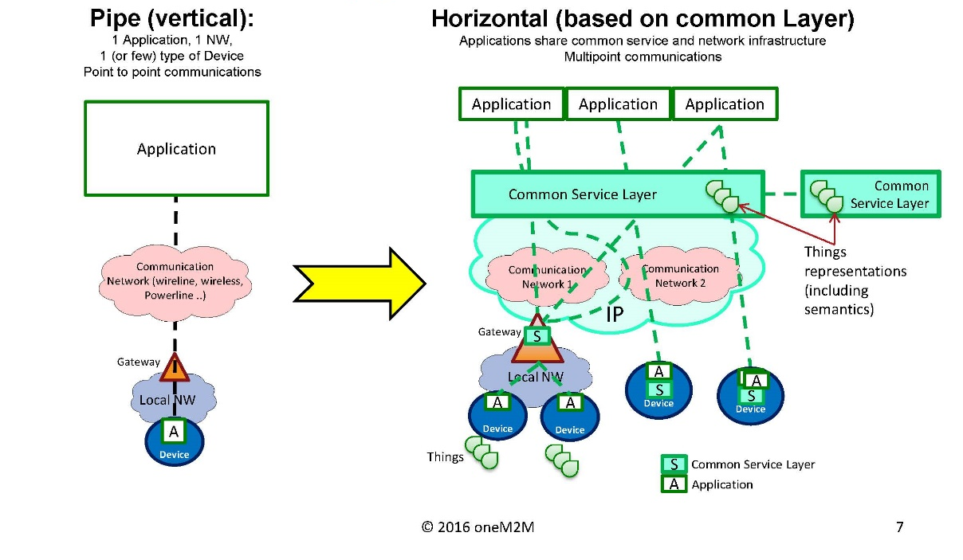
Figure 1: The oneM2M architecture for smart cities

--
[SIDEBAR] Busan takes open source route to oneM2M
Busan, the second-largest city in South Korea with a population of 3.6 million, delivers more than 25 smart city services across a oneM2M platform. The IoT use cases are diverse, spanning community safety, traffic improvement, urban living and energy conservation. From school-zone smart traffic to location-based marketing services (using proximity beacons), Busan is a hot bed of IoT innovation.
The South Korean government selected oneM2M after rejecting proprietary IoT platform solutions and other standards-based approaches that did not enjoy the same level of international backing. Previously, the government had relied on several IoT platforms, in each of the country’s main cities, to support different IoT use cases. This approach was eventually discarded as being too inefficient.
Another oneM2M advantage is that all data, generated from sensors installed in the city, can be collected and shared. Citizens, service providers and innovative local start-ups can all exchange ideas and help develop a ‘smart’ Busan.
Commercial implementation of oneM2M was swift, helped by an ‘open source’ approach. In January 2015, the South Korean government and the Korea Electronics Technology Institute (KETI) established OCEAN (open alliance for IoT standards). The aim of OCEAN is to share open source code based on IoT standards, and to encourage co-working between its members. As of June 2015, when the oneM2M-based implementation was commercially launched in Busan - barely six months after oneM2M Release 1 specifications were published - OCEAN had nearly 160 members worldwide.
[END SIDEBAR]
--

3.2 A reuse culture

When oneM2M published its Release 1 set of specifications in February 2015, it paved the way for devices to connect securely to apps residing in either the cloud or the gateway across a horizontal architecture.
Connectivity is enabled by a library of Common Service Functions (CSF), which forms part of the CSL. Functions include discovery and registration, as well as location and communication management. These functions can all be shared by multiple IoT applications, which is another cost-saving efficiency of the oneM2M horizontal architecture. There is no need for app-specific software, other than the application logic itself.
The device management (DM) function is provided by the well-established DM standard from the Open Mobile Alliance (OMA), which serves as an important reminder that oneM2M is not built from scratch. As our smart city blueprint illustrates, oneM2M can leverage both the standards work and open source initiatives from other industry groups (see Figure 2). In this way, city planners can exploit the best solutions available for their particular requirements.
In the case of network-independent OMA DM, it has the necessary commands, messages and mechanisms to download firmware updates, over-the-air, to devices already deployed in the field. It is an important feature if smart meter devices and other low-power smart city sensors are to realise their lengthy (and budget-friendly) lifespans which, in some cases, reach up to 20 or 30 years.
Security also plays an important part in oneM2M. Through the Release 1 specifications, security keys and algorithms can be upgraded to protect critical smart city infrastructure.
There is, however, no universal approach when it comes to security. In some cases, manual configuration of security credentials on devices can be overly burdensome and costly, particularly in consumer-oriented IoT scenarios. This can prevent timely and cost-effective deployment.
In order to address the complexity of security frameworks, one of the specifications in oneM2M’s Release 2, published in September 2016, introduced ‘dynamic access control’. This function allows devices to be given temporary authorisation, which provides cities greater flexibility on how they allocate security policies.
4. Squeeze the most out of data

The efficient collection and exchange of data is central to any successful smart city. Ideally, data should be provided either via open data portals or through paid-for data marketplaces. In both cases the expectation is that third parties may further exploit the data beyond what is useful for the city itself.

A mature smart city would enable individual citizens, businesses, NGOs and the municipality itself to both contribute and extract data, and to create and make use of applications based on that data (see Figure 2). It is especially important to integrate data contributed from inhabitants living and working in the city. This increases citizen engagement and makes it more likely that city services are adopted. oneM2M provides such a platform.

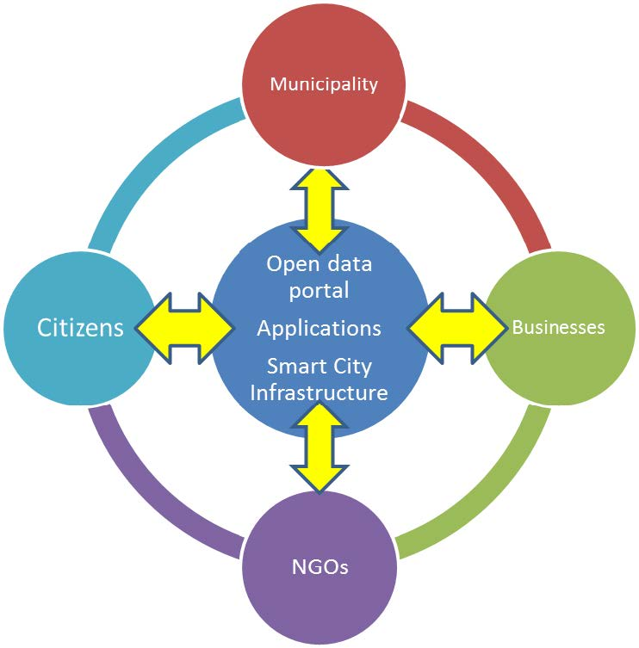
Figure 2

4.1 Life made easier for app developers

By providing app developers with a so-called ‘abstract layer’, which masks the underlying complexity of the network, developers can focus on application logic rather than on communication and device management. They do not need to be communications experts.

This means two things. First, IoT apps are ‘thinner’ and can be developed quicker. Second, by ‘hiding’ WAN technical specifications, the oneM2M platform is accessible to a wider pool of app developer talent. This may well encourage local app developers, who better understand the needs of their fellow citizens, to participate.

Freely exposing subsets of city data to app developers, such as weather, maps and transport information, is another important platform feature. In the hands of innovative app developers, combining different datasets of this sort, or data mashups, can lead to new apps and create extra value.

For example, static historical data about car accident history (where and when incidents occurred) may not be all that interesting in itself. Meld that information with weather and traffic management data, however, and it is possible to create another app, one that reroutes car journeys if traffic and weather conditions suggest a likelihood of delays on the original route.

City authorities also have the option of securely controlling access to certain types of data, perhaps restricted to approved organisations. They must ensure that any data exposure has citizen consent and does not violate privacy legislation.

4.2 Semantic interoperability

Another cornerstone of oneM2M innovation is semantic interoperability. Unveiled as part of Release 2, semantic interoperability uses meta data and ontologies to allow different apps to share ‘meaningful’ data with one another.
Thinking back to our roadside sensor, it generates various numbers. Unless we know that these numbers represent temperature values in Celsius, the information has little meaning (except if known beforehand by a consuming app). Meta-tagged data, however, which shows what the information is about and what it can be used for, can be shared with other apps. The roadside sensor can not only feed information into an app measuring road conditions, but, through semantic interoperability, be exploited by other apps, such as ones monitoring and forecasting weather.
Another example, on a bigger scale, is the sharing of traffic information across different city departments. Police and other emergency services will obviously find traffic conditions relevant, particularly in the case of a disaster (an earthquake, perhaps) when it becomes vital to know which roads are open or blocked. Taxi and other drivers would also find this sort of information useful. Collating traffic patterns over days, weeks and months may also be relevant for city planners. Traffic information could come from multiple sources, including video cameras, or sensors installed on buses and taxis driving around the city.
In the oneM2M context, this would mean posting the meta-tagged data to a oneM2M resource on a gateway, which either notifies interested entities or can be found by ‘semantic discovery’.
In a small IoT setting, attaching ‘meaning’ to what the data represents might not be necessary. The meaning is often implicit for apps developed for a particular purpose. City planners seeking to fully exploit data assets, however, will be greatly restricted without semantic interoperability. As the number of apps producing and consuming information increases, so too will data integration costs if information repeatedly needs to be configured in a particular way. Information available for multiple uses is also likely to be limited in such a scenario, which is sub-optimal. The true value of an IoT system is often only realised by having access to all information.

There will be some initial costs in bringing apps up to speed with semantic interoperability but, as apps and devices proliferate, the alternative method of achieving similar levels of interaction – traditional data integration processes – will see costs shoot up exponentially.

5. oneM2M interworking

Most city planners contemplating a move from a ‘stove pipe’ to horizontal architecture will not want to disrupt legacy IoT implementations. Instead, they will want an integration path to bring existing rollouts on to the new platform. Reassuring for city planners, then, that oneM2M, through the use of adaptors, can potentially interwork with any IoT wireless protocol in the field area network. These include LoRa® , SIGFOX™, WirelessHART™, ZigBee® and Z-Wave®, as well as cellular-based LPWA systems such as NB-IoT, EC-GSM and LTE-M.
They can also be secure in the knowledge that oneM2M’s network-agnostic platform can work with a wide range of IoT industry initiatives. oneM2M’s generic interworking specification, for example, published in Release 2, considerably expands device interoperability.
Through the new specification, oneM2M can interwork with two popular open source IoT device systems: AllJoyn and OCF. Both focus on proximal deployments. such as the consumer’s home or building complexes.
Backed by the AllSeen Alliance, comprising 180 technology partners across a wide range of industries, the AllJoyn certified programme lays claim to millions of devices being able to communicate with one another regardless of manufacturer, operating system, chipset or physical transport. OCF is a similar industry push on IoT device interoperability.
The generic interworking specification also makes interworking with OMA’s Lightweight M2M (LWM2M) system possible. The drivers for LWM2M devices are ones that smart city designers will no doubt be familiar with, particularly when it comes to smart metering over a mobile or wireless network.
For sensors that need to conserve battery power, LWM2M conveniently caters for long-running and ‘sleeping devices.’ The LWM2M system can also onboard devices onto a communications network, as well as manage and troubleshoot the communication layer for characteristics and problems which are unique to mobile networks. Furthermore, all this can be done even in ‘constrained environments’ such as limited CPU resources or harsh operating conditions.
By being able to leverage the useful work of other industry groups with minimal effort, city authorities can avoid onerous system integration costs and ramp up oneM2M’s economy-of-scale benefits even further.
One of the reasons that the oneM2M platform is so flexible is because it can accommodate a wide range of IoT communication protocols. Rather than attempt to pick technology winners, oneM2M supports a wide range of established IP-based protocols for use on its reference points (interfaces between the CSL, network and application layers). These include CoAP, MQTT, Websockets and HTTP.
Flexibility of this sort should give peace of mind to city planners. Not only on ease of interworking with today’s wide array of third-party initiatives (should they wish to), but also reassurance they will not be prevented from interworking with other popular IP-based IoT systems that might emerge in the future. oneM2M offers a future-proof solution.
6. Smart city blueprint
Each city has its own IoT requirements and priorities, so oneM2M does not prescribe a particular interpretation of the horizontal architecture. However, the blueprint of a smart city data centre in Figure 3 – which can be hosted in a public or private cloud – provides a framework that city planners might find helpful.
What may be apparent from the outset is the numerous open source and standards initiatives that complement oneM2M. As can be seen from the blueprint, oneM2M CSL sits in the front-end of the data centre facing devices, gateways and the underlying network. It is designed to handle a massive number of connections to devices and apps, and handle device management, data collection, interworking and protocol adaption.
Devices and the gateways deployed in the field domain generally use protocols developed by the ICT industry, e.g. LWM2M, or by the vertical industries. There are a large number of those protocols such as TALQ for streetlight management, WITS for water management or DLMS/Cosem for smart metering. The front-end role is to decorrelate the actual protocol being used for data exchange (which is irrelevant for the back-end functions) from the actual processing of the data.
The back-end of the data centre, however, will not scale the same way. It focuses on various data functions, including replication, anonymization, VM management and availability. Open source initiatives such as FIWARE™, Eclipse Mosquitto™ and RabbitMQ®, can play an important broker role, integrating different software building blocks within the smart city data centre.
In the case of FIWARE™, it is building up something of a reputation as a provider of ‘smart city middleware,’ not least because it received significant funding from the European Commission. oneM2M, however, is not in competition with FIWARE™, both are complementary, residing as they do in different parts of the data centre.
An additional requirement of the broker is to integrate with other data sources from non-IoT entities. Maps, for example, or banking. If smart parking or other smart city apps require payment, relevant bank details will be needed to make secure transactions.
The exposure of open city data, an important requirement for city app developers, can be performed using an open source implementation, such as CKAN (ckan.org) targeted at data publishers (typically the cities) wanting to make their data open and available. Typically the data stored under the open data repository is about long term historical data often anonymised for the purpose of enforcing privacy. On the other hand, a latest value of say a temperature sensor would be consumed by applications using the API offered by the front-end (left hand side of the blue print).
In this blueprint, protocol adapters can be built (towards the frontend or toward the broker) to collect relevant data on the northbound of legacy vertical deployments. As such it becomes possible to preserve existing deployments while allowing an efficient use of IoT data sets for smart city based data economy.

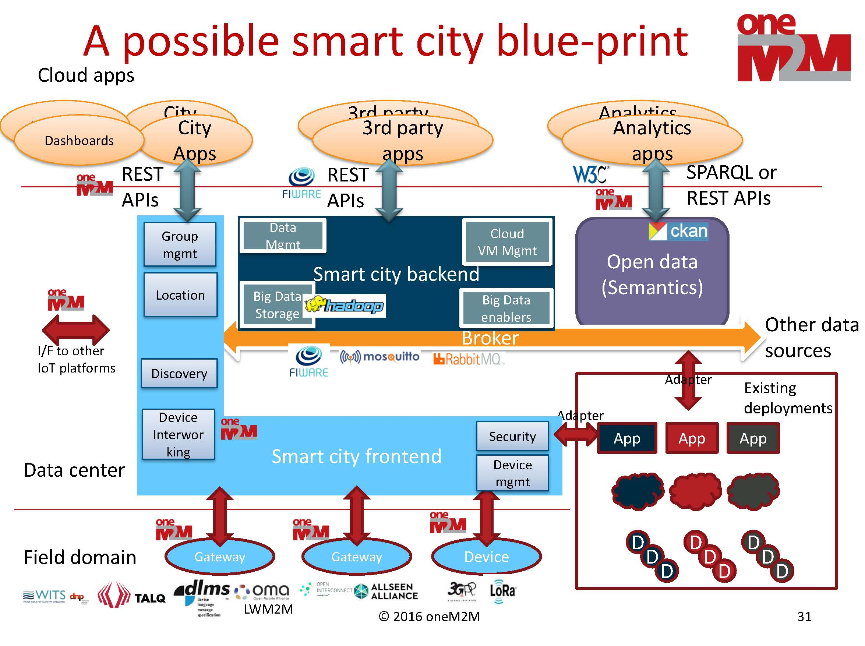
Fig 3: A possible smart city blueprint

7. Conclusion
Cities that are serious about getting smart know that they cannot rely on traditional ways of doing things. Vertical rollouts, where each IoT use case is propped up by a dedicated network, use case-specific data exchange mechanisms, and single-use devices, do not scale.
As city planners strive for greater cross-departmental synergies, it is essential that both networks and devices, as well as data, can be used for more than one purpose. Even better if various functions, such as device management, security and communication management, can be shared by multiple IoT applications. oneM2M, through development of open standards and open APIs, makes this much more cost-efficient horizontal approach possible.
There is also peace of mind. By using oneM2M, cities will not be locked into proprietary ecosystems that limit technology choice and increase costs over time. They will be able to mix and match solutions from multiple vendors according to their specific needs as they arise.
oneM2M. Smart cities done smarter.

Glossary of terms
API Application Programming Interface
CoAP Constrained Application Protocol
CPU Central Processing Unit
HTTP Hypertext Transfer Protocol
IoT Internet of Things
LPWA Low Power Wide Area
LTE-M LTE-Machine
M2M Machine-to-machine
MQTT MQ Telemetry Transport
NB-IoT Narrowband Internet of Things
NGO Non-Governmental Organization
OCF Open Connectivity Foundation
RFP Request for Proposal
TCO Total Cost of Ownership
WAN Wide Area Network

Possible extras:
- Contact details of regional oneM2M offices/contacts for follow-up
- oneM2M overview

About oneM2M
oneM2M is the global standards initiative that covers requirements, architecture, API specifications, security solutions and interoperability for Machine-to-Machine and IoT technologies. oneM2M was formed in 2012 and consists of eight of the world's preeminent ICT standards development organizations: ARIB (Japan), ATIS (North America), CCSA (China), ETSI (Europe), TIA (North America), TSDSI (India), TTA (Korea), and TTC (Japan), together with seven industry fora, consortia or standards bodies (Broadband Forum, CEN, CENELEC, GlobalPlatform, HGI, Next Generation M2M Consortium, OMA) and over 200 member organizations. oneM2M specifications provide a framework to support applications and services such as the smart grid, connected car, home automation, public safety, and health. oneM2M actively encourages industry associations and forums with specific application requirements to participate in oneM2M, to ensure that the solutions developed support their specific needs. For more information, including how to join and participate in oneM2M, see: www.onem2m.org.

Current state of the 360+ IoT Platforms, IoT Analytics (June 2016)
Open standards in IoT deployments would accelerate growth by 27% and reduce deployment costs by 30%, Machina Research (May 2016). Gartner acquired Machina Research in November 2016.
The smart city playbook, Machina Research (November 2016)
In October 2016, the AllSeen Alliance and OCF signed a binding agreement to unify under the OCF name. The merger is intended to advance interoperability between connected devices from both groups.

