

OneM2M
Technical Specification
Document Number | oneM2M-TS-0001 oneM2M Functional Architecture-V-0.0.4
Document Name: | oneM2M Functional Architecture
Date: | 2013-JUNE-28
Abstract: | This document illustrates end-to-end M2M Services Architecture and specifes the functional architecture of the oneM2M Services Platform.

oneM2M IPR and copyright statements
Text required

Contents
Contents 2
1 Scope 4
2 References 4
2.1 Normative references 4
2.2 Informative references 4
3 Definitions, symbols and abbreviations 4
3.1 Definitions 4
3.2 Symbols 5
3.3 Abbreviations 5
4 Conventions 5
5 Architecture Model 5
5.1 General Concepts 5
5.2 Architecture Reference Model 6
5.2.1 High Level Functional View 6
5.2.2 Reference Points 6
5.2.2.1 X Reference Point 6
5.2.2.2 Y Reference Point 7
5.2.2.3 Z Reference Point 7
6. Functional Architecture 7
6.1 Deployment Scenarios 9
6.1.1 Single Intermediate Node case 9
6.1.2 Multiple Intermediate Nodes 9
6.1.3 Application located outside of Device Node 9
6.1.x2 TBD 9
6.2 Functional Entities 9
6.2.1 Functional Entities comprising the set of CSFs 9
6.2.1.1 Communication Management and Delivery Handling 10
6.3 Security Aspects 10
6.4 Other Aspects 10
7. M2M Identification and addressing 11
7.1 Introduction 11
7.2 M2M Identifiers 11
7.2.1 M2M Service Provider Identifier (M2M-SP-ID) 11
7.2.2 Application Instance Identifier (App-Inst-ID) 11
7.2.3 Application Identifier (App-ID) 11
7.2.4 CSE Identifier (CSE-ID) 11
7.2.5 M2M Node Identifier/Device Identifier (M2M-Node-ID) 11
7.2.6 M2M Service Subscription Identifier (M2M-Sub-ID) 11
7.3 M2M Identifiers lifecycle and characteristics 12
8. Functional Description 12
8.1 General Concepts 12
8.7.1 Communication Management and Delivery Handling 12
8.7.2 Other CSFs? 13
9. X and Y Reference Points 13
9.1 Introduction 13
9.2 General communication Flow scheme 13
9.2.1 Description 13
9.2.2 Send 14
9.2.3 Successful Response 15
9.2.4 Unsuccessful Response 15
9.3 Resource Structure 15
9.3.1 Introduction 15
9.4 Procedure Description 16
10. Information Flows 16
10.1 General Concepts 16
Proforma copyright release text block 16
Annex <y>: Bibliography 19
History 20

1 Scope
This specification describes the end-to-end oneM2M functional architecture, including the description of the functional entities and associated reference points.
oneM2M functional architecture has focus on the Service Layer aspects and takes Underlying Network-independent view of the end-to-end services. The Underlying Network is used for the transport of data and potentially for other services.

2 References
References are either specific (identified by date of publication and/or edition number or version number) or non-specific. For specific references,only the cited version applies. For non-specific references, the latest version of the referenced document (including any amendments) applies.

2.1 Normative references
The following referenced documents are necessary for the application of the present document.
[1] ETSI TR 102 473: "<Title>".

2.2 Informative references
The following referenced documents are not necessary for the application of the present document but they assist the user with regard to a particular subject area.
[i.1] oneM2M Drafting Rules (http://member.onem2m.org/Static_pages/Others/Rules_Pages/oneM2M-Drafting-Rules-V1_0.doc)

3 Definitions, symbols and abbreviations

3.1 Definitions
For the purposes of the present document, the following terms and definitions apply:
Application Layer: This layer comprises oneM2M Applications and related business and operational logic.
Common Services Layer: This layer consists of oneM2M service functions that enable oneM2M Applications (via management, discovery and policy enforcement to name a few).
Common Services Entity: The Common Services Entity is an instantiation of Common Services Functions (CSFs). Common Services Entity provides a subset of CSFs that could be used and shared by M2M Applications. Common Services Entity can utilize Underlying Network capabilities and can interact with each other to fulfil the service.
Editor’s Note: This is a provisional definition.
Network Services Layer: Provides transport, connectivity and service functions.
Node: A physical entity containing one of the following:
• one or more applications,
• one CSE and zero or more applications.

3.2 Symbols
<symbol> <Explanation>
<2nd symbol> <2nd Explanation>
<3rd symbol> <3rd Explanation>

3.3 Abbreviations
<ABREVIATION1> <Explanation>
<ABREVIATION2> <Explanation>
<ABREVIATION3> <Explanation>

4 Conventions
The key words “Shall”, ”Shall not”, “May”, ”Need not”, “Should”, ”Should not” in this document are to be interpreted as described in the oneM2M Drafting Rules [i.1]

5 Architecture Model
Editor's Note: Definitions are FFS. As definitions get refined and agreed to, the following text to be adjusted to eflect the agreements

5.1 General Concepts
Figure 5.1-1 depicts the oneM2M Layered Model for supporting end-to-end (E2E) M2M Services. This layered model comprises three layers: Application Layer, Common Services Layer and the Underlying Network Services Layer.

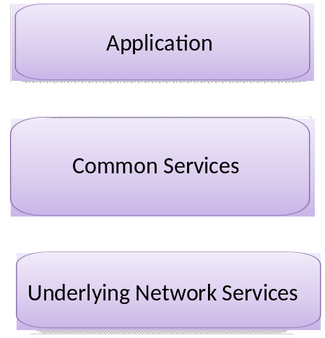
Figure 5.1-1: oneM2M Layered Model

5.2 Architecture Reference Model

5.2.1 High Level Functional View
Figure 5.2.1-1illustrates high level functional view of the oneM2M architecture.

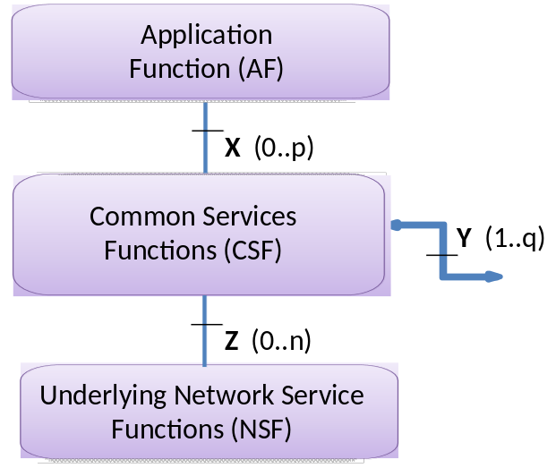
Figure 5.2.1-1: High Level Functional View

Editor's Note: Applicability of this functional view to network infrastructure and /or to M2M devices is FFS.
The high level functional view in Figure 5.2.1-1 comprises of the following functions:
1. Application Function (AF): Application Function provides Application logic for the end-to-end M2M solutions. Examples of the Application Functions can be fleet tracking application, remote blood sugar monitoring application, or remote power metering and controlling application.
2. Common Services Function (CSF):The Common Services Function comprises the set of "service functions" that are common to the M2M environments and specified by oneM2M. Such service functions are exposed to other functions through Reference Points X and Y. Reference point Z is used for accessing Underlying Network Service Functions.
Examples of service functions offered by CSF are: Data Management, Device Management, M2M Subscription Management etc. When the CSF in a oneM2M Node is instantiated as a Common Services Entity (CSE), some of the above stated service functions can be mandatory and others can be optional.
3. Underlying Network Services Function (NSF): Underlying Network Services Function provides services to the CSEs. Examples of such services include device management, location services and device triggering.
Note: Underlying Networks provide data transport services between entities in the oneM2M system. Such data transport services are not included in the NSF.

5.2.2 Reference Points
The following reference points are supported by the CSE.

5.2.2.1 X Reference Point
This is the reference point between an M2M Application and a CSE. The X reference point allows an M2M Application to use the services provided by the CSE, and for the CSE to communicate with the M2M Application.
The services offered via the X reference point are thus dependent on the functionality supported by the CSE. The M2M Application and the CSE it invokes may or may not be co-located within the same physical entity.

5.2.2.2 Y Reference Point
This is the reference point between two CSEs. The Y reference point allows a CSE to use the services of another CSE in order to fulfill needed functionality. Accordingly, the Y reference point between two CSEs shall be supported over different M2M physical entities. The services offered via the Y reference point are dependent on the functionality supported by the CSEs

5.2.2.3 Z Reference Point
This is the reference point between a CSE and the Underlying Network. The Z reference point allows a CSE to use the services (other than transport and connectivity services) provided by the Underlying Network in order to fulfill the needed functionality
The instantiation of the Z reference point is dependent on the services provided by the Underlying Network.
Note: Information exchange between two physical M2M nodes assumes the usage of the transport and connectivity services of the Underlying Network, which are considered to be the basic services.
Editor's Note: While allowing for different instantiations of the CS Function into different functional Entities, this specification follows the following guidelines/principles while specifying the interfaces on X, Y and Z reference points:
• Specification of the interfaces on reference points X and Y are independent of the functionality provided by the CSE.
• Specification of the interfaces on reference point Z may take into account the functionality provided by the CSE.

6. Functional Architecture
Figure 6-1 illustrates the Functional Architecture for providing oneM2M services.

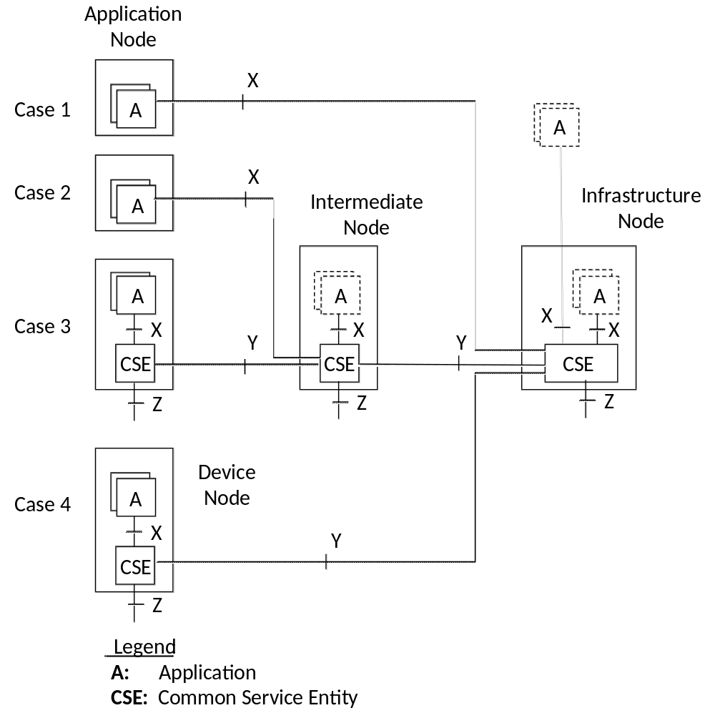
Figure 6-1: Functional Architecture

NOTES:
1. CSE resident in different nodes is not identical and is dependent on the services supported by the CSE in that node.

Editor's Notes:
• The illustration above does not provide an exhaustive list of possible configurations and is subject to qualification. Other possible functions/configurations are FFS.
• Illustration of Multiple domain cases are FFS.
Editor's Note:
- In Figure 6-1, should we explain how Application Function (AF) and Application (A) relate?
- should Case 1 and 2 Application Nodes have Z interfaces else should it be explained why not?
- Should the placement of the text "Application node" and "Device Node" in Figure 6-1 be placed to indicate which applies to cases 2 and 3 ?

6.1 Deployment Scenarios
In this clause various deployment scenarios are introduced based on the functional architecture in Figure 6-1.

6.1.1 Single Intermediate Node case
A single Intermediate Node is placed between a Device Node and an Infrastructure Node.

6.1.2 Multiple Intermediate Nodes
An Intermediate Node can be connected to one or more other Intermediate Nodes. In this deployment scenario, the CSE in an Intermediate Node can communicate with the CSE in another Intermediate Node over the Y reference point.

6.1.3 Application located outside of Device Node
For a node such as that illustrated in Case 3, Applications can be located outside of the Device Node.

6.1.x2 TBD
<Text>

6.2 Functional Entities

6.2.1 Functional Entities comprising the set of CSFs
This clause defines the functional entities that are part of the oneM2M-specified CSFs. A specific instantiation of a set of functions picked from these CSFs, i.e. a specific CSE may not contain all of the listed functions.
The functions in the Common Servics Layer provide common services functions to the Applications via the X reference point and to other CSEs via the Y reference point, and interaction with the Underlying Network Service Functions via the Z reference point. In order to communicate with the Applications, the CSEs and Underlying Networks, the CSFs issues requests to the Communication Management and Delivery Handling function as defined below.

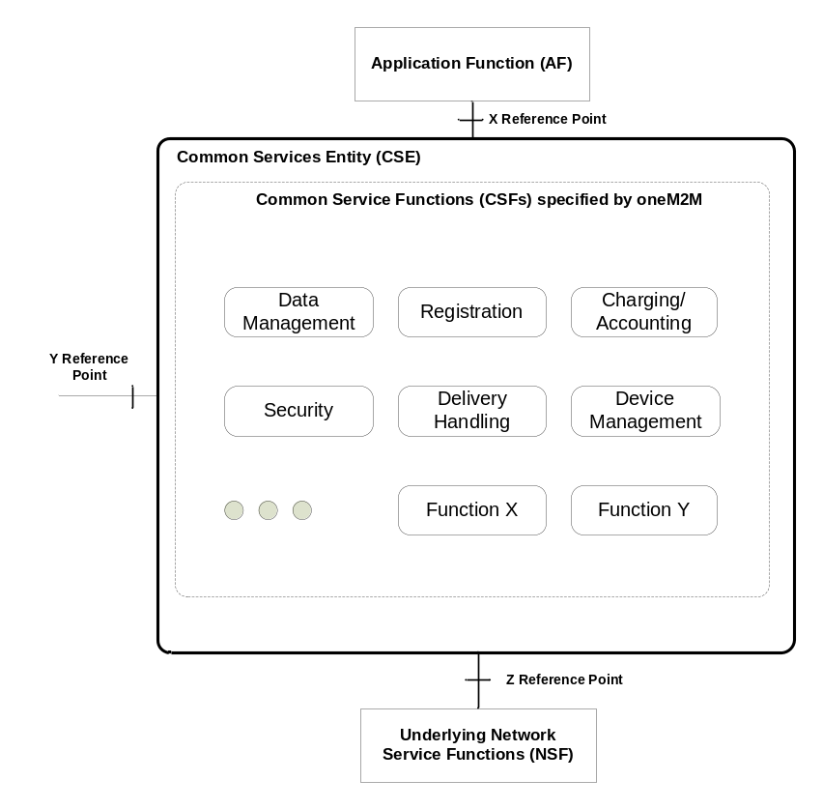
Figure 6.2.1-1 Common Services Functions

Editor's Note: The illustration above will be replaced based on the agreements in contribution # ARC-0293.

6.2.1.1 Communication Management and Delivery Handling
The Communication Management and Delivery Handling CSF is responsible for providing communications with other CSEs, AFs and NSFs .
The Communication Management and Delivery Handling function is responsible to decide at what time which communication connection to use for delivering communication (e.g. CSE-to-CSE) and, when needed and allowed, store communication requests so that they can be forwarded at a later time. This processing in the Communication Management and Delivery Handling function has to be carried out in line with the provisioned policies and delivery handling parameters that can be specific to each request for communication.
For communication using the Underlying Network data transport services, the deployed Underlying Network can support the equivalent delivery handling functionality. In such case the Communication Management and Delivery Handling function shall be able to use the Underlying Network, and it may act as a simple front end to access the Underlying Network equivalent functionality.

6.3 Security Aspects
<Text>

6.4 Other Aspects
<Text>

7. M2M Identification and addressing

7.1 Introduction
This clause provides a list of identifiers required for the purpose of interworking within the oneM2M architectural model.

7.2 M2M Identifiers

7.2.1 M2M Service Provider Identifier (M2M-SP-ID)
An M2M Service Provider shall be uniquely identified by the M2M Service Provider Identifier (M2M-SP-ID). This is a static value assigned to the Service Provider.

7.2.2 Application Instance Identifier (App-Inst-ID)
An Application Instance Identifier (App-Inst-ID) uniquely identifies an M2M Application instance resident on an M2M node, or an M2M Application instance that requests to interact with an M2M node. An App-Inst-ID shall identify an Application for the purpose of all interactions from/to the Application within the M2M framework.
It is the responsibility of the M2M Service Provider to ensure that the App-Inst-ID is globally unique. The App-Inst-ID shall include the Application ID (see clause 7.2.3.)

7.2.3 Application Identifier (App-ID)
This is equivalent to the application name and is not guaranteed to be globally unique on its own.
Editor's Note: Who assigns the App-ID is FFS.

7.2.4 CSE Identifier (CSE-ID)
A CSE shall be identified by a globally unique identifier, the CSE-ID, when instantiated within an M2M node in the M2M architecture.
The CSE-ID shall identify the CSE for the purpose of all interactions from/to the CSE within the M2M framework.

7.2.5 M2M Node Identifier/Device Identifier (M2M-Node-ID)
An M2M node, hosting a CSE and/or Application(s) shall be identified by a globally unique identifier, the M2M-Node-ID.
The M2M system shall allow the M2M Service Provider to set the CSE-ID and the M2M-Node-ID to the same value.
The M2M-Node-ID enables the M2M Service Provider to bind a CSE-ID to a specific M2M node.
Editor's Note: Several terms used in this clause: "M2M framework", "M2M architecture", "M2M system". Need to agree on a single terminology.

7.2.6 M2M Service Subscription Identifier (M2M-Sub-ID)
The M2M-Sub-ID enables the M2M Service Provider to bind application(s), M2M nodes, CSEs to a particular M2M service subscription.
The M2M Service Subscription Identifier has the following characteristics:
• belongs to the M2M Service Provider,
• identifies the subscription to an M2M Service Provider,
• enables communication with the M2M Service Provider,
• can differ from the M2M Underlying Network Subscription Identifier,
• changes with the change of the M2M Service Provider.
There can be multiple M2M Service Subscription Identifiers per M2M Underlying Network subscription.

7.3 M2M Identifiers lifecycle and characteristics
FFS.

8. Functional Description
<Text>

8.1 General Concepts

8.7.1 Communication Management and Delivery Handling
The basic services that other CSFs, AFs or NSFs can request from the Communication Management and Delivery Handling CSF is to transport some given data to a specific target (CSE, AF or NSF), according to specific delivery instructions while staying within the constraints of provisioned Communication Management and Delivery Handling Policies.
The content of the data provided by the requestor is opaque to the delivery handling and does not influence the behaviour of the Communication Management and Delivery Handling CSF. In particular, the Communication Management and Delivery Handling CSF is not aware of the specific destination function (CSF) within the target entity including the parameters of such a function. For instance if the destination of the data to be delivered is a data management CSF within a target entity (CSE, NSF, AF), the Communication Management and Delivery Handling CSF shall not be aware of the data management CSF including the specific storage location or other parameters pertaining to that data management CSF. That means all attributes that are intended to be shared with the destination function (e.g., which CSF is the destination on the target entity, what that CSF should do with the data etc.) should be hidden from the Communication Management and Delivery Handling CSF.
The target entity may be reached either directly or via the CSE of an Intermediate Node.
Editor’s Note: For Rel-1 it would probably make sense to limit to one Intermediate Node along the path since we need to define how to handle routing which could become more complex and should be able to be added at a later stage without or with little impact on the message exchanges.
The delivery instructions that are given to the Communication Management and Delivery Handling function set the limits in the delivery process that the requestor is willing to accept. For instance those instructions can contain acceptable delay tolerance etc.
In line with provisioned policies and delivery instructions that can be specific to each communication request the Communication Management and Delivery Handling CSF shall decide at what time which communication path to use for delivering the communication (e.g. CSE-to-CSE) and, when needed and allowed, store communication requests so that they can be forwarded at a later time.
As a consequence the Communication Management and Delivery Handling CSF will have to be aware of the already established connections to other nodes via the Underlying Networks, request establishment of new connections and tear down existing ones.
In order to accomplish this function, the Communication Management and Delivery Handling CSF will need to have access to provisioned delivery handling policies and needs to parse them so that a proper use of buffers for Store-and-Forward processing can be managed.
Editor’s Note: Clarification of complexity impacts due to use of multiple Underlying Networks are FFS.

8.7.2 Other CSFs?
<Text>

9. X and Y Reference Points

9.1 Introduction
Procedures involving a CSE and Applications are executed by data exchange according to message flow described in clause 9.4.
The data exchange consists of information transferred across the reference points and stored in a standardized resource structure as described in clause 9.3.
The use of the addressable resources is also enabling the “store-and-share” paradigm of application information and big data. Access and manipulation of the resources is subject to their correlated permissions.
Some of the procedures on the X andY reference points may adopt a different approach with respect to the ones described in this clause. Such procedures are described in <reference to be included when available>.
Editors Note: Which of the procedures do not adopt the approach described in this clause and how they are performed is FFS.

9.2 General communication Flow scheme

9.2.1 Description
Figure 9.2.1-1 shows the general flow that governs the information exchange within a procedure, which is based on the use of Send and Response scheme. The scheme applies to communications such as:
- between an Application and a CSE (X reference point), and
- among CSEs (Y reference point).
The communications can be initiated either by the Applications or by the CSEs.
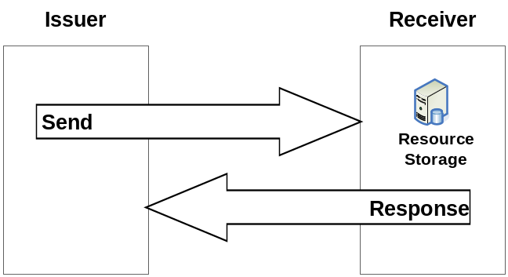
Figure 9.2.1-1: Resource Manipulation by an Application within an Entity

9.2.2 Send
Send request from an Issuer to a Receiver includes the following information:
op: operation to be executed: Create (C), Retrieve (R), Update (U), Delete (D),
to: address of target resource, e.g. /m2m.provider1.com/netBase/temp1,
fr: address of the resource representing the Issuer. Used for access control, e.g., /m2m.provider2.com/remBase/app1,
hd: headers containing meta-information about the Send request,
cn: resource content to be transferred.
Note: The to target resource needs to be known by the Issuer. It can be known either by pre-provisioning or by discovery.
Editor’s Note: How pre-provisioning and discovery are performed is FFS.
The op information shall indicate the operation to be executed in the Receiver:
Create (C): a new resource addressable with to parameter is created,
Retrieve (R): an existing to addressable resource is read and provided back to the Issuer,
Update (U): the content of an existing to addressable resource is replaced with cn new content,
Delete (D): an existing to addressable resource and all its sub-resources are deleted from the Resource Storage.
Editor’s Note: This is an initial list of the verbs. The need for more verbs is anticipated to cover all use cases, configuration and functions.
The to information shall address the target resource in the Receiver.
The fr information shall be used by the Receiver to check the Issuer identity for access permission verification.
The cn information shall be present in Send request for the following operations:
Create: cn is the content of the new resource,
Update: cn is the content to be replaced in an existing resource,
Retrieve: cn is the filter to be applied for discovery purposes.
Once the Send request is delivered, the Receiver shall analyze the Send to determine the target resource.
If the target resource is addressing another M2M node, the Receiver shall route the request appropriately.
If the target resource is addressing the Receiver, it shall:
• Check the existence of to addressed resource,
• Identifying the resource type,
• Check the permission for fr Issuer to perform the requested operation,
• Perform the requested operation (using cn content when provided),
• Respond to the Receiver for successful or unsuccessful operation results. In some specific cases (e.g. limitation in the binding protocol or based on application indications), the Response could be avoided.
The message flow procedure started with an Issuer request shall be considered closed when a Response is delivered to the Issuer.

9.2.3 Successful Response
Response from a Receiver to an Issuer includes the following information:
op: operation being executed: Create (C), Retrieve (R), Update (U), Delete (D) (optional),
hd: headers containing meta-information about the request,
rs: operation result: e.g. Okay, Okay and Done; Okay and Scheduled; Okay and In Progress, etc.,
cs: optional additional result information, e.g. status codes,
to: address of target resource, e.g. /m2m.provider1/netBase/temp1,
cn: resource content to be transferred (optional).
The cn information may be present in a Response in the following cases:
Update: cn is the content replaced in an existing resource,
Delete: cn is the content actually deleted.
The cn information shall be present in a Response in the following cases:
Retrieve: cn is the retrieved resource content or aggregated contents of discovered resources.

9.2.4 Unsuccessful Response
Response from a Receiver to an Issuer includes the following information:
op: operation being executed: Create (C), Retrieve (R), Update (U), Delete (D) (optional),
hd: headers containing meta-information about the request,
rs: operation result: e.g. Not okay.
cs: optional additional result information, e.g. status codes.

9.3 Resource Structure

9.3.1 Introduction
This clause introduces the types of resources used in a CSE. A resource scheme is used for modelling the resource structure and associated relationships.
Table X.1: Resource types and tagging
Resource type | Tag value | Description
Base | b
CSE | e
Application | a
Access Right | r
<tbd>

Editor's Note: The contents of this table is only an initial draft proposal.

9.4 Procedure Description
Editor's Note: This sclause describes the procedures and associated Stage 2 information flows.

10. Information Flows
<Text>

10.1 General Concepts
<Text>

Proforma copyright release text block
This text box shall immediately follow after the heading of an element (i.e. clause or annex) containing a proforma or template which is intended to be copied by the user. Such an element shall always start on a new page.
Notwithstanding the provisions of the copyright clause related to the text of the present document, OneM2M grants that users of the present document may freely reproduce the <proformatype> proforma in this {clause|annex} so that it can be used for its intended purposes and may further publish the completed <proformatype>.

Annex <A> (Informative): Deployment Scenarios
<Text>

Annex <B>(Informative/Normative): Remove Informative or Normative as appropriateTitle of annex (style H9)
<Text>
B.1 First clause of the annex (style H1)
<Text>
B.1.1 First subdivided clause of the annex (style H2)
<Text>

Annex <y>:
Bibliography
The annex entitled "Bibliography" is optional.
It shall contain a list of standards, books, articles, or other sources on a particular subject which are not mentioned in the document itself
It shall not include references mentioned in the document.
Use the Heading 9 style for the title and B1+ or Normal for the text.
- <Publication>: "<Title>".
OR
<Publication>: "<Title>".

History
Publication history
V1.1.1 | <dd-Mmm-yyyy> | <Milestone>

Draft history (to be removed on publication)
V0.0.1 | 27-FEB-2013 | Rapporteur Input - Draft Skeleton
V0.0.2 | 20-APR-2013 | Rapporteur Input –Draft; Including the following contributions:  1. oneM2M-ARC-2013-0255R03-Arcitecture_Description  2. oneM2M-ARC-2013-0256R01-Definitions_for_Arc_TS  3. oneM2M-ARC-2013-0253R03-Definition_to_SCX_and_SFM
V0.0.3 | 08-JUNE-2013 | 1. oneM2M-ARC-2013-0262R02-Update_to_Figure_5-1
V0.0.4 | 28-JUNE-2013 | Includes the following contributions at TP#05:  1. oneM2M-ARC-2013-0275R03-Revised_functional_architecture  2. oneM2M-ARC-2013-0280R03-Definitions_of_Reference_Points  3. oneM2M-ARC-2013-0281R02-M2M_Identifiers  4. oneM2M-ARC-2013-0285R05-Delivery_Handling_in_CSE  5. oneM2M-ARC-2013-0287R04-High_level_Application_Programming_  Interface

