

OneM2M
Technical Specification
Document Number | oneM2M-TS-0001 oneM2M Functional Architecture-V-0.0.7
Document Name: | oneM2M Functional Architecture
Date: | 2013-AUGUST-26
Abstract: | This document illustrates end-to-end M2M Services Architecture and specifies the functional architecture of the oneM2M Services Platform.

oneM2M IPR and copyright statements
Text required

Contents
Contents 2
1 Scope 4
2 References 4
2.1 Normative references 4
2.2 Informative references 4
3 Definitions, symbols and abbreviations 4
3.1 Definitions 4
3.2 Symbols 5
3.3 Abbreviations 5
4 Conventions 6
5 Architecture Model 6
5.1 General Concepts 6
5.2 Architecture Reference Model 6
5.2.1 High Level Functional View 6
5.2.2 Reference Points 7
5.2.2.1 X Reference Point 7
5.2.2.2 Y Reference Point 8
5.2.2.3 Z Reference Point 8
6. Functional Architecture 8
6.1 Deployment Scenarios 11
6.1.1 Single Middle Node case 11
6.1.2 Multiple Middle Nodes 11
6.1.3 Applications located outside of Application Service Node 11
6.2 Common Service Functions 11
6.2.1 Addressing and Identification 12
6.2.1.1 General Concepts 12
6.2.1.2 Detailed Descriptions 12
6.2.2 Communication Management and Delivery Handling 12
6.2.2.1 General Concepts 12
6.2.2.2 Detailed Descriptions 12
6.2.3 Data Management and Repository 13
6.2.3.1 General Concepts 13
6.2.3.2 Detailed Descriptions 13
6.2.4 Device Management 14
6.2.4.1 General Concepts 14
6.2.4.2 Detailed Descriptions 14
6.2.5 Discovery 14
6.2.5.1 General Concepts 14
6.2.5.2 Detailed Descriptions 14
6.2.6 Group Management 15
6.2.6.1 General Concepts 15
6.2.6.2 Detailed Descriptions 15
6.2.7 Location 16
6.2.7.1 General Concepts 16
6.2.7.2 Detailed Descriptions 16
6.2.8 Network Service Exposure, Service Execution and Triggering 16
6.2.8.1 General Concepts 16
6.2.8.2 Detailed Descriptions 16
6.2.9 Registration 17
6.2.9.1 General Concepts 17
6.2.9.2 Detailed Descriptions 17
6.2.10 Security 17
6.2.10.1 General Concepts 17
6.2.10.2 Detailed Descriptions 18
6.2.11 Service Charging and Accounting 19
6.2.11.1 General Concepts 19
6.2.11.2 Detailed Descriptions 19
6.2.12 Session Management 20
6.2.12.1 General Concepts 20
6.2.12.2 Detailed Descriptions 20
6.2.13 Subscription and Notification 21
6.2.13.1 General Concepts 21
6.2.13.2 Detailed Descriptions 22
6.3 Functional Entities Comprising Enablers 22
6.3 Security Aspects 23
6.4 Other Aspects 24
7. M2M Identification and Addressing 24
7.1 M2M Identifiers 24
7.1.1 M2M Service Provider Identifier (M2M-SP-ID) 24
7.1.2 Application Instance Identifier (App-Inst-ID) 24
7.1.3 Application Identifier (App-ID) 24
7.1.4 CSE Identifier (CSE-ID) 24
7.1.5 M2M Node Identifier/Device Identifier (M2M-Node-ID) 24
7.1.6 M2M Service Subscription Identifier (M2M-Sub-ID) 24
7.1.7 Request Identifier (M2M-Request-ID) 25
7.2 M2M Identifiers lifecycle and characteristics 25
8. X and Y Reference Points 25
8.1 General Communication Flow Scheme 26
8.1.1 Description 26
8.1.2 Request 26
8.1.3 Successful Operation 28
8.1.4 Unsuccessful Operation 28
8.2 Procedures for Accessing Resources 28
8.2.1 Generating Responses 29
8.2.2 Accessing Resources in CSEs 29
9 Resource Management 34
9.1 General Principles 34
9.2 Resource Types 34
9.2.1 Types of Virtual Resources 36
9.3 Resource Addressing 36
9.4 Resource Structure 36
9.5 Resource Operations 37
9.5 TBD 37
10. Information Flows 37
10.1 General Concepts 37
Proforma copyright release text block 37
Annex <y>: Bibliography 40
History 41

1 Scope
This specification describes the end-to-end oneM2M functional architecture, including the description of the functional entities and associated reference points.
oneM2M functional architecture has focus on the Service Layer aspects and takes Underlying Network-independent view of the end-to-end services. The Underlying Network is used for the transport of data and potentially for other services.

2 References
References are either specific (identified by date of publication and/or edition number or version number) or non-specific. For specific references,only the cited version applies. For non-specific references, the latest version of the referenced document (including any amendments) applies.

2.1 Normative references
The following referenced documents are necessary for the application of the present document.
[1] ETSI TR 102 473: "<Title>".

2.2 Informative references
The following referenced documents are not necessary for the application of the present document but they assist the user with regard to a particular subject area.
[i.1] oneM2M Drafting Rules (http://member.onem2m.org/Static_pages/Others/Rules_Pages/oneM2M-Drafting-Rules-V1_0.doc)

3 Definitions, symbols and abbreviations

3.1 Definitions
For the purposes of the present document, the following terms and definitions apply:
Application Layer: This layer comprises oneM2M Applications and related business and operational logic.
Common Services Layer: This layer consists of oneM2M service functions that enable oneM2M Applications (via management, discovery and policy enforcement to name a few).
Common Services Entity: The Common Services Entity is an instantiation of Common Services Functions (CSFs). Common Services Entity provides a subset of CSFs that could be used and shared by M2M Applications. Common Services Entity can utilize Underlying Network capabilities and can interact with each other to fulfil the service.
Editor’s Note: This is a provisional definition.
Common Services Function: A Common Services Function (CSF) is a set of service functions that are common to the M2M environment and specified by oneM2M. A CSE contains one or more CSFs.
Editor's Note: This definition needs some more work so that it is more clear (about the M2M environment and the relationship between CSE/CSF and level of service functions.
Hosting CSE: The CSE where the addressed master/original resource resides.
Local CSE: The CSE where an Application or a CSE has registered. It is the first CSE that receives Request from an Originator. For example:
- If an Application on an Infrastructure Node is the Originator, the Local CSE is the CSE on the Infrastructure Node;
- If an Application on a Middle Node is the Originator, the Local CSE is the CSE on the Middle Node;
- If an Application on an End Node is the Originator, the Local CSE is the CSE on the End Node.
Editor's Note: Need to provide definition of an End Note. This is FFS.
Editor's Note: The concept of a CSE registering at a Local CSE needs to be understood. This is FFS.
Editor's Note: Review/clarify "or a CSE" in the definition of Local CSE. Should "or a CSE" be replaced with "or a Node"? This is FFS.
Editor's Note: Need definition for "Application Entity". Need to define relationship between an Application Entity and an Application.
M2M Service Provider Domain: It is the part of the M2M System that is associated with a given M2M Service Provider.
Network Services Layer: Provides transport, connectivity and service functions.
Node: A functional entity containing one of the following:
- one or more M2M Applications,
- one CSE and zero or more M2M Applications.
Originator: The actor that initiates a Request. An Originator can either be an Application or a CSE.
Receiver: The actor that receives the Request. A Receiver can be a CSE or an Application.
Resource: A uniquely addressable entity in oneM2M System such as by the use of a Universal Resource Identifier (URI). A resource can be accessed and manipulated by using the specified procedures.
Editor’s Note: The above stated definition of Resource needs to be revisited. This is FFS.
Editor’s Note: It is expected that more definitions are needed. This is FFS.

3.2 Symbols
<symbol> <Explanation>
<2nd symbol> <2nd Explanation>
<3rd symbol> <3rd Explanation>

3.3 Abbreviations

ADN Application Dedicated Node
AE Application Entity
ASN Application Service Node
CSE Common Service Entity
CSF Common Service Function
EF Enabler Function
IN Infrastructure Node
MN Middle Node
NSE Network Service Entity

The following Common Service Functions (CSFs) have been defined:
AID CSF Addressing and Identification CSF
CMDH CSF Communication Management and Delivery Handling CSF
DMR CSF Data Management and Repository CSF
DMG CSF Device Management CSF
DIS CSG Discovery CSF
GMG CSF Group Management CSF
LOC CSF Location CSF
NSE CSF Network Service Exposure, Service Execution and Triggering CSF
REG CSF Registration CSF
SEC CSF Security CSF
SCA CSF Service Charging and Accounting CSF
SMG CSF Session Management CSF
SUB CSF Subscription and Notification CSF

4 Conventions
The key words “Shall”, ”Shall not”, “May”, ”Need not”, “Should”, ”Should not” in this document are to be interpreted as described in the oneM2M Drafting Rules [i.1]

5 Architecture Model
Editor's Note: Definitions are FFS. As definitions get refined and agreed to, the following text to be adjusted to eflect the agreements

5.1 General Concepts
Figure 5.1-1 depicts the oneM2M Layered Model for supporting end-to-end (E2E) M2M Services. This layered model comprises three layers: Application Layer, Common Services Layer and the Underlying Network Services Layer.

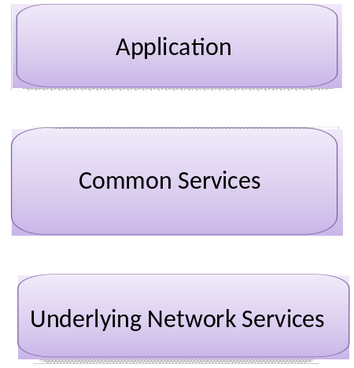
Figure 5.1-1: oneM2M Layered Model

5.2 Architecture Reference Model

5.2.1 High Level Functional View
Figure 5.2.1-1illustrates high level functional view of the oneM2M architecture.
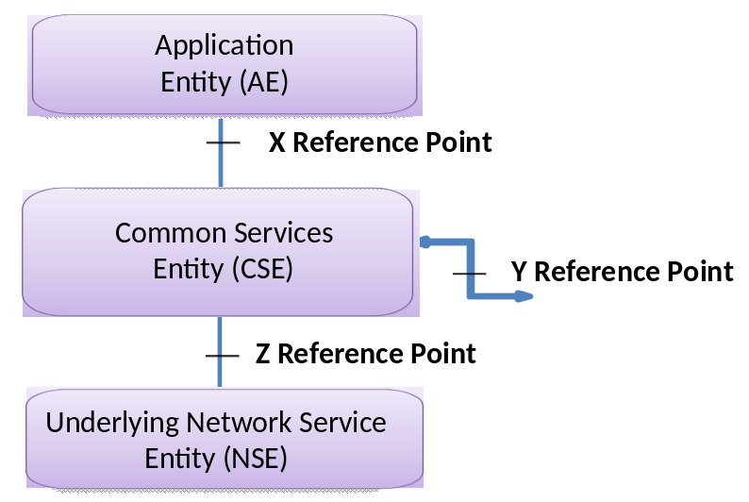
Figure 5.2.1-1: High Level Functional View

Editor's Note: Applicability of this functional view to network infrastructure and /or to M2M devices is FFS.
The high level functional view in Figure 5.2.1-1 comprises of the following functions:
1. Application Entity (AE): Application Entity provides Application logic for the end-to-end M2M solutions. Examples of the Application Entities can be fleet tracking application, remote blood sugar monitoring application, or remote power metering and controlling application.
2. Common Services Entity (CSE): A Common Services Entity comprises the set of "service functions" that are common to the M2M environments and specified by oneM2M. Such service functions are exposed to other entities through Reference Points X and Y. Reference point Z is used for accessing Underlying Network Service Entities.
Examples of service functions offered by CSE are: Data Management, Device Management, M2M Subscription Management, Location Services etc. Such "subfunctions" offered by a CSE may be logically apprehended as Common Services Functions (CSFs). Inside a Common Services Entity (CSE), some of the CSFs can be mandatory and others can be optional. Also, inside a CSF, some subfunctions can be mandatory or optional (e.g., inside a "Device Management" CSF, some of the subfunctions like "Application Software Installation", "Firmware Updates", "Logging", "Monitoring", etc. can be mandatory or optional).
3. Underlying Network Services Entity (NSE): An Underlying Network Services Entity provides services to the CSEs. Examples of such services include device management, location services and device triggering. No particular organization of the NSEs is assumed.
Note: Underlying Networks provide data transport services between entities in the oneM2M system. Such data transport services are not included in the NSE.

5.2.2 Reference Points
The following reference points are supported by the CSE.

5.2.2.1 X Reference Point
This is the reference point between an Application Entity and a CSE. The X reference point shall allow an Application Entity to use the services provided by the CSE, and for the CSE to communicate with the Application Entity.
The services offered via the X reference point are thus dependent on the functionality supported by the CSE. The Application Entity and the CSE it invokes may or may not be co-located within the same physical entity.

5.2.2.2 Y Reference Point
This is the reference point between two CSEs. The Y reference point shall allow a CSE to use the services of another CSE in order to fulfill needed functionality. Accordingly, the Y reference point between two CSEs shall be supported over different M2M physical entities. The services offered via the Y reference point are dependent on the functionality supported by the CSEs

5.2.2.3 Z Reference Point
This is the reference point between a CSE and the Underlying Network Services Entity. The Z reference point shall allow a CSE to use the services (other than transport and connectivity services) provided by the Underlying Network Services Entity in order to fulfill the needed functionality.
The instantiation of the Z reference point is dependent on the services provided by the Underlying Network Services Entity.
Note: Information exchange between two M2M nodes assumes the usage of the transport and connectivity services of the Underlying Network Services Entity, which are considered to be the basic services.
Editor's Note: While allowing for different instantiations of the CS Function into different functional Entities, this specification follows the following guidelines/principles while specifying the interfaces on X, Y and Z reference points:
• Specification of the interfaces on reference points X and Y are independent of the functionality provided by the CSE.
• Specification of the interfaces on reference point Z may take into account the functionality provided by the CSE.

6. Functional Architecture
Figure 6-1 illustrates the Functional Architecture for providing oneM2M services, illustrating the relations amongst the functional entities in relation to the reference points identified in Figure 5.2.1-1 (High Level Functional View).

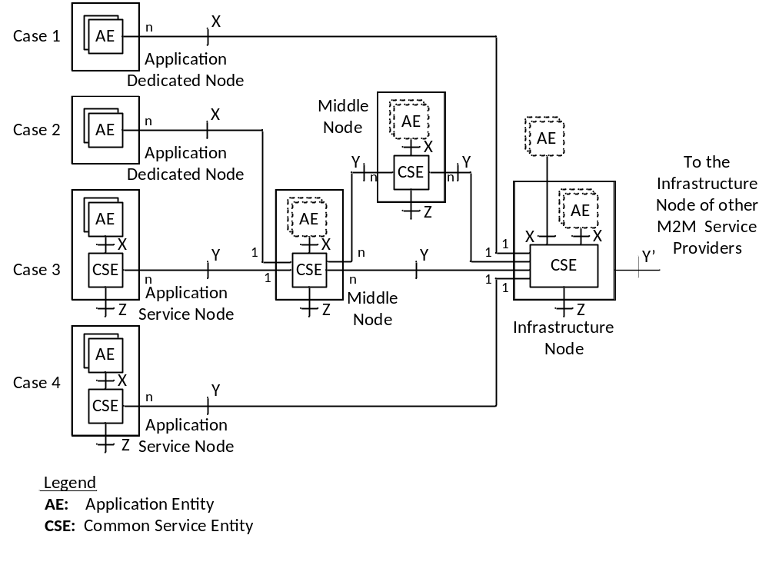Figure 6-1: Functional Architecture

Node: A oneM2M Node is a functional entity that shall contain at least one oneM2M Common Services Entity or one oneM2M Application Entity. A oneM2M Node may be contained in a physical object e.g., M2M device, gateway or server/service infrastructure.
NOTES:
1. CSEs resident in different nodes are not identical and are dependent on the services supported by the CSE in that node.
2. Y' reference point aims to be as similar as possible to the Y reference point. But due to the nature of inter-M2M Service Provider communications, some differences are anticipated.
Editor's Notes:
• The illustration above does not provide an exhaustive list of possible configurations and is subject to qualification. Other possible functions/configurations are FFS.
• Y' reference point aims to be as similar as possible to the Y reference point. But due to the nature of inter-M2M Service Provider communications, some differences are anticipated.
Editor's Note:
- In Figure 6-1, should we explain how Application Function (AF) and Application (A) relate?
- should Case 1 and 2 Application Nodes have Z interfaces else should it be explained why not?
- Should the placement of the text "Application node" and "Device Node" in Figure 6-1 be placed to indicate which applies to cases 2 and 3 ?
Description of Nodes:
oneM2M architecture foresees the following Nodes. It is important that as functional objects, such Nodes are not necessarily mapped to actual physical objects, although they may be mapped to actual physical objects.
Application Service Node (ASN):
An Application Service Node is a Node that contains one Common Services Entity and contains at least one Application Entity.
An Application Service Node may communicate over a Y reference point with either:
- exactly one Middle Node;
- or exactly one Infrastructure Node.
Example of physical mapping: an Application Service Node could reside in an M2M Device.
Application Dedicated Node (ADN):
An Application Dedicated Node is a Node that contains at least one Application Entity and does not contain a Common Services Entity.
An Application Dedicated Node communicates with a Middle Node or an Infrastructure Node over an X reference point.
Example of physical mapping: an Application Dedicated Node could reside in a constrained M2M Device.
Middle Node (MN):
A Middle Node is a Node that contains one Common Services Entity and may contain Application Entities.
A Middle Node communicates over a Y references point with at least two other Nodes among either (not exclusively):
- one or more Application Services Nodes;
- one or more Middle Nodes;
- one Infrastructure Node.
A Middle Node may communicate with Application Dedicated Nodes over an X reference point.
Example of physical mapping: a Middle Node could reside in an M2M Gateway.
Infrastructure Node (IN):
An Infrastructure Node is a Node that contains one Common Services Entity and may contain Application Entities.
An Infrastructure Node communicates over a Y reference point with either:
- one or more Middle Node(s);
- and/or one or more Application Service Node(s).
An Infrastructure Node may communicate with one or more Application Dedicated Nodes over one or more respective X reference points.
Example of physical mapping: an Infrastructure Node could reside in an M2M Server Infrastructure.
Editor’s Note: as of now, It is not clear what actually differentiates the Infrastructure Node from the Application Service Node or the Middle Node. It could be a minimum feature scope of its CSE that would be bigger, or a particular requirement on its Z reference point. It could also be the cardinality of this Node in a deployment. ( there would typically be just one).

6.1 Deployment Scenarios
In this clause various deployment scenarios are introduced based on the functional architecture in Figure 6-1.

6.1.1 Single Middle Node case
A single Middle Node is placed between an Application Dedicated Node and/or Application Service Node and an Infrastructure Node.

6.1.2 Multiple Middle Nodes
A Middle Node can be connected to one or more other Middle Nodes. In this deployment scenario, the CSE in a Middle Node can communicate with the CSE in another Middle Node over the Y reference point.

6.1.3 Applications located outside of Application Service Node
For a node such as that illustrated in Case 3 and Case 4, Applications can be located outside of the Application Service Node.

6.2 Common Service Functions
This clause describes the "service functions" provided by the Common Services Layer that are common to the oneM2M environment. Such service functions are referred to as Common Service Functions (CSFs). The CSFs provide services to the Applications via the X reference point and to other CSEs via the Y reference point. Interaction with the Underlying Network Service Functions is via the Z reference point. An instantiation of a CSE in a Node comprises a subset of the CSFs from the CSFs described herein.
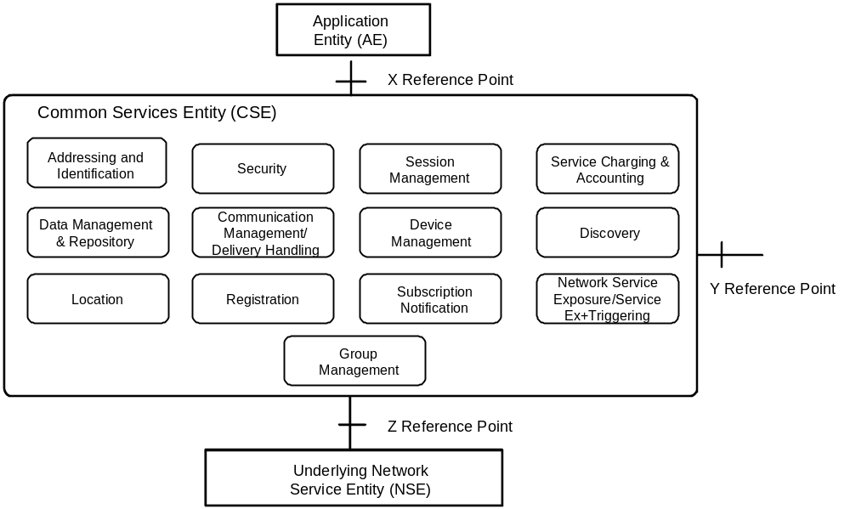
Figure 6.2-1 Common Services Functions

6.2.1 Addressing and Identification

6.2.1.1 General Concepts
Addressing and Identification (AID) CSF provides information needed for identifying and manipulating physical and logical resources in M2M environment. The logical resources are entities related to software such as Applications, CSEs and Data. The physical resources are hardware related entities such as the entities in the Underlying Network and M2M Devices etc.
The AID CSF provides for the provisioning of different types of M2M Identifiers and the association of such Identifiers with M2M Applications, CSEs, M2M Devices etc.

6.2.1.2 Detailed Descriptions
AID CSF shall provide the functionality for creating and managing the Identifiers for Applications, CSEs, M2M Nodes, etc. It is assumed that the "Application Identifier" and the "CSE Identifier" have been assigned initially and are known before M2M System boot up.
The AID CSF shall provide the capability to support other CSFs e.g., Registration CSF and Security CSF.
The AID CSF shall provide the capability to associate identifiers with the information required for M2M services. This capability may be used during the M2M System boot up or CSE initialization, including the association of the Underlying Network Identifiers or External Identifiers with CSE Identifiers and/or with Application Identifiers.

6.2.2 Communication Management and Delivery Handling

6.2.2.1 General Concepts
The Communication Management and Delivery Handling (CMDH) CSF is responsible for providing communications with other CSEs, AEs and NSEs .
The CMDH CSF is responsible to decide at what time which communication connection to use for delivering communication (e.g. CSE-to-CSE communication) and, when needed and allowed, store communication requests so that they can be forwarded at a later time. This processing in the CMDH CSF has to be carried out in line with the provisioned policies and delivery handling parameters that can be specific to each request for communication.
For communication using the Underlying Network data transport services, the Underlying Network can support the equivalent delivery handling functionality. In such case the CMDH CSF is able to use the Underlying Network, and it may act as a front end to access the Underlying Network equivalent delivery handling functionality.

6.2.2.2 Detailed Descriptions
The services that other CSFs, AFs or NSFs can request from the CMDH CSF is to transport some given data to a specific target (CSE, AF or NSF), according to specific delivery instructions while staying within the constraints of provisioned communication management and delivery handling Policies.
The content of the data provided by the requestor shall be opaque to the delivery handling function and shall not influence the behaviour of the CMDH. In particular, the CMDH CSF shall not be aware of the specific destination function (CSF) within the target entity including the parameters of such a function. For instance if the destination of the data to be delivered is a DMR CSF within a target entity (CSE, NSF, AF), the CMDH CSF shall not be aware of the DMR CSF including the specific storage location or other parameters pertaining to that DMR CSF. That means all attributes that are intended to be shared with the destination function (e.g., which CSF is the destination on the target entity, what that CSF should do with the data etc.) should be hidden from the CMDH CSF.
The target entity may be reached either directly or via the CSE of a Middle Node.
Editor’s Note: For Rel-1 it would probably make sense to limit to one Middle Node along the path since we need to define how to handle routing which could become more complex and should be able to be added at a later stage without or with little impact on the message exchanges.
The delivery instructions that are given to the CMDH CSF shall set the limits in the delivery process that the requestor is capable of accepting. For instance those instructions can contain acceptable delay tolerance etc.
In line with provisioned policies and delivery instructions that can be specific to each communication request, the CMDH CSF shall decide at what time which communication path to use for delivering the communication (e.g. CSE-to-CSE communication) and, when needed and allowed, store communication requests so that they can be forwarded at a later time.
As a consequence the CMDH CSF shall need to be aware of the already established connections to other Nodes via the Underlying Networks, request establishment of new connections and tear down existing ones.
In order to accomplish this function, the CMDH CSF shall need to have access to provisioned delivery handling policies and shall need to parse them so that a proper use of buffers for store-and-forward processing can be managed.
Editor’s Note: Clarification of complexity impacts due to use of multiple Underlying Networks are FFS.

6.2.3 Data Management and Repository

6.2.3.1 General Concepts
One of the goals of oneM2M CSEs is to enable M2M Applications to exchange data with each other.
Data Management and Repository (DMR) CSF is responsible for providing data storage and mediation functions. It includes the capability of collecting and aggregating large amounts of data, converting this data into a specified format, and storing it for analytics and semantic processing. The "data" can be either raw data transparently retrieved from an M2M Device, or processed data which is calculated and/or aggregated by M2M entities. This collection of large amounts of data constitutes what is known as the Big Data Repository functionality.

6.2.3.2 Detailed Descriptions
DMR CSF shall provide the capability to store data such as Application data, subscriber information, location information, device information, semantic information, communication status, access permission, etc. The "data" stored by the DMR CSF enables management of the data and provides the foundation of Big Data. Further, the DMR CSF shall be able to support the physical replacement of M2M Devices and/or Gateways in terms of the stored data.
The DMR CSF shall support transfer of data to/from the AEs, other CSFs and remote CSEs. The DMR CSF shall support transfer of data regardless of the peer entity being on-line or not. The DMR CSF shall support operations such as Create, Read, Update and Delete. The DMR CSF may associate event categorization (e.g., normal, urgent) with the data for supporting differentiated services. External entities such as AFs, other CSFs or remote CSEs shall be able to be granted access to the data in the DMR CSF based on defined policies.
Editor's Note: Needs to clarify what is meant by "peer entity" being on-line or not. Is the reference to peer-CSE or something more than that.
The organization of the data helps describe how they relate with each other and how they are addressed. DMR CSF shall allow removal, addition, search of the data. The DMR CSF shall support structured data. Some structures may be specified by oneM2M, others may not. Elements of data stored in the DMR CSF shall be uniquely addressable.
The DMR CSF shall support aggregating the data from the same device or from different devices.
The DMR CSF shall enable the sharing of the data amongst local CSFs, remote CSEs and AFs.
Contextual information such as data types, semantic information, time stamps, location etc. shall complement the data stored by the DMR CSF. This will allow the DMR CSF to access and search the data based on a rich set of parameters. The DMR CSF shall be able to trigger data processing based on access to its data.
Semantic information needs to be available on the data that are transferred within the oneM2M system. The DMR CSF shall provide functions annotating such semantic information to M2M data and exposing M2M resources using the semantic information so that the M2M resources can be discovered by applications that do not have prior knowledge of them. The DMR CSF shall be responsible for enabling applications to discover, interpret and use M2M data from different sources.
Editor's Note: Semantics related capabilities are FFS subject to discussions in MAS (WG5) WG.

6.2.4 Device Management

6.2.4.1 General Concepts
Device Management (DMG) CSF enables the management of device capabilities including one or more of the following:
- Application Software installation and settings;
- Configuration settings and Provisioning;
- Firmware Updates;
- Logging, Monitoring, Diagnostics;
- Topology Management of Area Networks;
- Devices within an Area Network Management.
Note: Such device management capabilities are assigned to one or more Execution Environments within the Device, and access to such Execution Environments is controlled through delegation via Role based permissions.

6.2.4.2 Detailed Descriptions
The DMG CSF shall provide capabilities for the purpose of managing M2M Devices/Gateways as well as devices in M2M Area Networks. Such capabilities shall include:
- Application Software installation and settings;
- Configuration settings and Provisioning;
- Firmware Updates;
- Logging, Monitoring, Diagnostics;
- Topology Management of Area Networks;
- Devices within an Area Network Management.
Note: Such device management capabilities are assigned to one or more Execution Environments and access to such Execution Environments is controlled through Role based permissions.
The DMG CSF shall be able to interact with a Device Management Server for managing M2M Devices/Gateways as well as with devices in the M2M Area Networks that are provisioned with Management Clients.
Editor's Note: Need to provide definition of Execution Environment, Device Management Server, Management Clients, Role based permissions.

6.2.5 Discovery

6.2.5.1 General Concepts
Discovery (DIS) CSF is responsible for searching information/resources according to a "request" from an Originator within a given scope and subject to permissions, including those allowed by M2M service subscription. An Originator could be an Application or another CSE. The scope of the search could be in one CSE, or in more than one CSE. The discovery results are returned back to the Originator.

6.2.5.2 Detailed Descriptions
DIS CSF shall provide discovery of information/resources residing in its own CSE subject to permissions including the M2M service subscription. The DIS CSF shall be able to support various discovery methods through the use of "filter criteria" that can limit the scope of information/resources that are returned based on various filters (e.g. keyword, identifiers, location, semantic information) or a combination of such filters.
The DIS CSF shall be triggered by sending a "request" to the address (e.g., URI) of the discovery resource. Upon receiving such request, the DIS CSF shall identify and return the matching information/resources. A successful response may include the actual discovered information or address(es) (e.g., URI(s)) pertaining to the discovered resources. In addition, based on the policies or Originator request, the CSE which received the Discovery request may forward the request to other CSEs on its registered Middle/Infrastructure Node.

6.2.6 Group Management

6.2.6.1 General Concepts
Group Management (GMG) CSF is responsible for handling Group related requests. The request is sent for the management of a Group and its membership as well as for the bulk operations supported by the Group. When adding or removing members to/from a Group, it is necessary to validate if the member complies with the purpose of the Group. Bulk operations includes read, write, subscribe, notify, device management, etc. Whenever a request or a subscription is made via the Group, the Group is responsible for aggregating its responses and notifications. The members of a Group can have the same role with regards to access rights control towards a resource. In this case, access control is facilitated by grouping. When the Underlying Network provides broadcasting and multicasting capability, the GMG CSF is able to utilize such capability.

6.2.6.2 Detailed Descriptions
GMG CSF shall be responsible for the management of a Group and its membership. The GMG CSF shall support bulk operations to multiple resources of interest and aggregate the results. The GMG CSF shall be able to facilitate access control based on grouping. When needed and available, the GMG CSF may leverage the existing capabilities of the Underlying Network including broadcasting/multicasting.
The GMG CSF handles requests from Applications and/or from other CSEs.
Grouping enables the oneM2M system to perform bulk operations to multiple devices, applications, or resources. The GMG CSF shall manage the resources and operations associated with grouping.
The GMG CSF shall handle the requests to create, query, update, and delete a Group. An Application or a CSE may request the creation/retrieve/update/deletion of a Group as well as the addition and deletion of members of the Group. The GMG CSF shall be able to create one or more Groups in CSEs in any of the Nodes in oneM2M System for a particular purpose (i.e. facilitation of access control, device management, fan-out common operations to a group of devices, etc.). The GMG CSF shall handle the requests to retrieve the information (e.g. URI, metadata, etc.) of a Group and its associated members.
The GMG CSF shall manage Group membership. The GMG CSF shall handle requests to add or remove members to and from a Group’s member list. A member may belong to one or more Groups. A Group may be a member of another Group. When new members are added to a Group, the GMG CSF should validate if the member complies with the purpose of the Group.
In order to fulfil the functionalities of the GMG CSF, functionalities from other CSFs may be needed. Examples include Network Service Exposure CSF for leveraging broadcasting/multicasting capability from the Underlying Network, Security CSF for authentication and authorization etc.
Editor’s Note: How the Underlying Network supports broadcasting/multicasting is FFS.
When facilitating access control using a Group, only members with the same access rights towards a resource shall be included in the same Group. Also, only M2M Applications or CSEs which have a common role with regards to access rights shall be included in the same Group. This shall be used as a representation of the "role" when facilitating role based access control.
Editor's Note: Suggest adding description on what is meant by Group member, what entities can be members of a Group? Can a Group consist of heterogeneous members?
The GMG CSF shall forward requests to all members in the Group. In case the Group contains another Group as a member, the forwarding process shall be done recursively, i.e. the nested Group shall forward the request to its members. After forwarding the request to all members in the Group, the GMG CSF shall generate an aggregated response by aggregating the corresponding responses from the Group members.
Editor’s Note: The structure of the resource in oneM2M System is FFS.
The GMG CSF shall support subscriptions to individual Groups. Subscriptions to a Group shall be made only if the subscriber is interested in all members of the Group. If subscription to a Group is made, the GMG CSF shall aggregate the notifications from the Group members, and it shall notify the subscriber with the aggregated notification. Responses and event notifications relevant to a subscription may be selectively filtered by filtering criteria. The filtering criteria shall be managed by the GMG CSF. In order to subscribe to or query a Group, methods for group discovery shall be provided.
Editor's Note: Methods used for subscribing to and for querying a Group are FFS.

6.2.7 Location

6.2.7.1 General Concepts
The Location (LOC) CSF allows M2M Applications to obtain geographical location information of M2M entities (e.g., M2M Devices and Gateways) for location-based services. Such location information requests may be from M2M Applications residing on either the same or on different M2M Nodes.
Note: Geographical location information can be more than simply the longitude and the latitude information.

6.2.7.2 Detailed Descriptions
LOC CSF shall obtain and manage geographical location information based on the requests from M2M Applications residing on either the same or on different M2M Nodes. The LOC CSF shall interact with either the location server in the Underlying Network, or with a GPS module in the M2M device to obtain the geographical location information.
Note: The location technology (e.g., Cell-ID, Assistant-GPS, and Fingerprint) used by the Underlying Network depends on the capabilities of the Underlying Network.
The LOC CSF shall be able to request M2M Devices and M2M Gateways to share and report their own or other M2M device's geographical location information with the requesting M2M Applications.
Editor's Note: Define what is meant by M2M Devices and Gateways. Provide association between M2M Devices and Gateways and the various types of Nodes defined in the functional architecture.
The LOC CSF shall provide means for protecting the privacy and confidentiality of geographical location information.
Editor’s Note: Details of the protection of privacy (e.g. obtaining the consent) is FFS.

6.2.8 Network Service Exposure, Service Execution and Triggering

6.2.8.1 General Concepts
Network Service Exposure, Service Execution and Triggering (NSE) CSF manages communications with the Underlying Networks for accessing network service functions over the Z reference point. The NSE CSF uses the available/supported methods for service "requests" on behalf of M2M Applications. The NSE CSF shields other CSFs and AFs from the specific technologies and mechanisms supported by the Underlying Networks.
Note: The NSE CSF provides adaptation for different set of network service functions supported by various Underlying Networks.
The network service functions provided by the Underlying Network include service functions such as, but not limited to, device triggering, small data transmission, location notification, policy rules setting, location queries, IMS services, device management. Such services do not include the general transport services.

6.2.8.2 Detailed Descriptions
NSE CSF shall manage communication with the Underlying Networks for obtaining network service functions on behalf of other CSFs, remote CSEs or M2M Applications. The NSE CSF shall use the Z reference point for communicating with the Underlying Networks.
Note: The network services provided by the Underlying Networks include services such as, but not limited to, device triggering, small data transmission, location notification, policy rules setting, location queries, IMS services, device management. Such services do not include general transport services.
The M2M system shall allow the Underlying Networks to control network service procedures and information exchange over the Underlying Networks while providing such network services. For example, for the 3GPP networks, the Underlying Network may chose to provide the network services based on control plane signalling mechanisms.
Other CSFs in a CSE that need to use the services offered by the Underlying Network shall use the NSE CSF.
The NSE CSF shall shield other CSFs and AFs from the specific technology and mechanisms supported by the Underlying Networks.
Note: The NSE CSF provides adaptation for different set of network service functions supported by various Underlying Networks.
The NSE CSF shall maintain over the Z reference point, the necessary connections and/or sessions between the CSE and the Underlying Network when local CSFs are in need of a network service.
The NSE CSF shall provide to the CMDH CSF information related to the Underlying Network so the CMDH CSF can include them to determine proper communication handling.

6.2.9 Registration

6.2.9.1 General Concepts
Registration (REG) CSF is responsible for handling an Application or another CSE to register with a CSE in order to allow the registered entities to use the services offered by the registered-with CSE. The REG CSF handles registration of a Device also, so as to allow registration of Device's properties/attributes with the CSE.

6.2.9.2 Detailed Descriptions
The CSE on a Device or on a Middle Node shall perform registration with the CSE in the Infrastructure Node in order to be able to use M2M services offered by the CSE in the Infrastructure Node. An Application on a Device or on a Middle Node shall perform registration locally with the corresponding CSE in order to use M2M services offered by that CSE. The same holds for the registration of an Application on the Infrastructure Node. An Application on an Infrastructure Node shall perform registration locally with the associated CSE on Infrastructure Node. A registered Application shall be able to have interactions with its local CSE without the need to have the local CSE registered with other CSEs. Such registrations are applicable to a single M2M Service Provider Domain.
A CSE on a Device or on a Middle Node shall perform registration with the CSE on an Infrastructure Node and vice versa. As a result of successful CSE registration, the CSEs on Device/Middle Node and Infrastructure Node establish a peering relationship and shall be able to exchange context information.
A (physical) Device shall be able to register with its local CSE for registering its properties/attributes. Such registration enables correlation of Devices Identities such as M2M-Node-ID with the CSE-ID.
Editor’s Note: The need for Device Registration and the relationship with CSE Registration are FFS.
Editor’s Note: The use of External ID in Registration is FFS.

6.2.10 Security

6.2.10.1 General Concepts
Security (SEC) CSF comprises the following functionalities:
- Sensitive Data Handling functionality;
- Security Administration functionality;
- Security Association Establishment functionality;
- Authorization and Access Control functionality;
- Identity Protection Functionality.
Sensitive Data Handling functionality in the SEC CSF protects the local credentials on which security relies during storage and manipulation. Sensitive Data Handling functionality performs other sensitive functions as well such as security algorithms. This functionality is able to support several cryptographically separated security environments.
Security Administration functionality enables services such as the following:
- Creation and administration of dedicated security environment supported by Sensitive Data Handling functionality;
- Post-provisioning of a root credential protected by the security environment;
- Provisioning and administration of subscriptions related to M2M services and M2M application services.
Security Association Establishment functionality is responsible for establishing security association between corresponding M2M nodes, in order to provide services such as confidentiality, integrity, authentication, authorization, etc.
Authorization and Access Control functionality is responsible for authorizing services and data access to authenticated entities, according to provisioned security policies and assigned roles.
While unique identifier of an entity are used for authentication, the Identity Protection functionality provides pseudonyms which serve as temporary identifiers which cannot be linked to the true identity of either the associated entity or its user.

6.2.10.2 Detailed Descriptions
SEC CSF shall comprise the following functionalities:
- Sensitive Data Handling functionality;
- Security Administration functionality;
- Security Association Establishment functionality;
- Authorization and Access Control functionality;
- Identity Protection Functionality.
Sensitive Data Handling Functionality in the SEC CSF shall have the capability to protect the local credentials on which security relies during storage and manipulation. The SEC CSF shall be able to extend sensitive data handling functionality to other sensitive data used in the M2M systems such as subscription related information, security policies and personal data pertaining to individuals. The Sensitive Data Handling functionality shall perform other sensitive functions as well, such as security algorithms. The Sensitive Data Handling functionality shall be able to support several cryptographically separated security environments.
Security Administration functionality in the SEC CSF shall enable the following services:
- Creation and administration of a dedicated security environment supported by Sensitive Data Handling functionality;
- Post-provisioning of a root credential protected by the security environment;
Note: The security environment can also be pre-provisioned with a root credential prior to deployment; therefore this capability is not always required. Post-provisioning is required when the security bootstrapping needs to be performed or re-initiated after deployment.
- Provisioning and administration of subscriptions related to M2M services and M2M application services. Besides the root secret, a subscription includes other information classified as sensitive data such as associated authorization and security policies.
Security Association Establishment functionality in the SEC CSF shall be able to establish security associations between corresponding M2M nodes, in order to provide specific security services (e.g. confidentiality, integrity, authentication, authorisation, or support for application level signature generation and verification) involving specified security algorithms and sensitive data. This involves key derivation based on provisioned root secrets. This functionality of the SEC CSF is mandatory when security is supported.
Editor's Node: The definition of Security Association will be provided by WG4. A definition may be: "Security associations (SAs) are logical relationships between 2 entities that may be associated with a communications link, but SAs are not communications links. Security associations may take a number of forms but in each case they identify the nature of the security service (confidentiality, integrity, authentication or authorisation), the required algorithm and key. Security associations may be established for single transactions (and thus their establishment may form part of the transaction itself) or for session based associations (in such instances the association is generally established independently of the individual transactions that are to be secured)".
The Authorization and Access Control functionality in the SEC CSF shall be able to authorize services and data access to authenticated entities, according to provisioned security policies and assigned roles. This functionality is mandatory when any services relying on authorization and access control are present. Among other usages, the services of this functionality may be applied to personal information as a means to preserve privacy.
Although an M2M system User is generally considered to be an application or functional agent that represents a human, there are links between a device and its User that can be either directly derived or indirectly deduced. Consequently, identifiers used for communication in the M2M system shall not be directly related to the real identity of either the device or its User, except where this is a requirement for operation of a specific M2M application.
While the unique identifier of an entity shall be used for authentication, the identity protection functionality provides pseudonyms which serve as temporary identifiers which shall not be able to be linked to the true identity of either the associated entity or its user.

6.2.11 Service Charging and Accounting

6.2.11.1 General Concepts
Service Charging and Accounting (SCA) CSF provides charging functions for the Service Layer. It supports different charging models which include online charging and offline charging. The SCA CSF is responsible for capturing chargeable events, recording of information, generating charging records and charging information. The SCA CSF can interact with the charging system in the Underlying Network also. But the SCA CSF is responsible for generating and recording of the final service level charging information. It is the responsibility of the SCA CSF in the Infrastructure Node or the Service Layer Charging Server to handle the charging information for the purpose of charging.
Editor's Node: To provide more information Service Layer Charging Server. What is this entity?

6.2.11.2 Detailed Descriptions
SCA CSF shall perform information recording corresponding to a chargeable event. The SCA CSF shall be able to handle the charging information for the purpose of charging. The SCA CSF shall be able to send the charging information transformed from the specific recorded information to the charging server by the use of a standard or proprietary interface for charging purposes.
The SCA CSF shall support "independent service layer charging" and "correlated charging with the Underlying Network" charging system. For independent service layer charging, only charging functions in the Service Layer shall be involved. For correlated charging, charging functions in both the Service Layer and the Underlying Network shall be involved.
The SCA CSF shall support one or multiple charging models, such as the follows:
- Subscription Based Charging: A service subscriber is charged based on Service Layer subscriptions.
- Event Based Charging: Charging is based on Service Layer chargeable events. A chargeable event refers to the discrete transactions. For example, an operation on data (Create, Update, Retrieve) can be an "event". Chargeable events shall be configurable.
- Session Based Charging: Charging is based on an M2M service session, such as based on secure service connections.
- Service Based Charging: Service Layer can support charging based on the services it provides. A service may require multiple transactions and the requestor is charged based on the services it received.
Two types of service layer charging shall be able to be supported: Online and Offline charging. Offline charging does not affect services provided in real time. Charging triggering information is generated at the CSFs where the chargeable transaction happens. The charging report is passed via different nodes to the network to generate CDRs. Online charging affects the services granted in real time. A service request is first generated and the requestor’s credit is checked before the service is granted.
Editor's Note: Online charging items is FFS.
The Service Layer charging system shall consist of the following logical functions:
- Charging Triggering Function: This function shall reside in the Service Layer and shall be able to capture the chargeable event and generate recorded information for charging. Recorded information may contain mandatory and optional elements.
Editor's Note: The system may record information for other purposes also such as for Event Logging. Some of such information may be applicable for charging purposes.
- Offline Charging Function: This function shall handle offline charging related operations. It shall generate charging information, such as Service Layer Charging Data Record (CDR)s. CDRs are formatted collection of information about a chargeable event (e.g. amount of data transferred) for use in billing and accounting.
- Online Charging Function: This function shall handle online charging related operations.
- Charging Management Function: This function shall handle charging related policies, configurations, inter-node charging function communications, and interacting with the charging system in the Underlying Network.

6.2.12 Session Management

6.2.12.1 General Concepts
An M2M service session is an end-to-end Service Layer connection managed by the Session Management (SMG) CSF. The SMG CSF manages M2M service sessions between M2M Applications, between an M2M Application and a CSE, or between CSEs.
Editor's Note: Provide information as to when an M2M service session is needed.
The management of a M2M service session includes capabilities such as the management of session state, session authentication and establishment, management of Underlying Network connections and services related to the session, coordination of sessions spanning multiple hops of CSEs, exchange of information between session endpoints, and session termination.
The SMG CSF uses the CMDH CSF within its local CSE for sending/receiving messages to/from the next-hop CSE or to/from an Application for a given M2M service session. The SMG CSF also uses the SEC CSF for the management of session related security credentials and authentication of session participants. The SMG CSF generates session specific charging events also that it communicates to the SCA CSF within its local CSE.

6.2.12.2 Detailed Descriptions
An M2M service session is an end-to-end Service Layer connection managed by the SMG CSF. The SMG CSF shall support the management of the following M2M service session related information.
- Session ID: Used by the SMG CSF and session endpoints to uniquely identify M2M service layer session.
- Session Credentials: Security credentials associated with M2M service session. For example, E2E security certificates, public keys, etc. An M2M service session can support an independent set of credentials or it can optionally leverage security credentials from Underlying Network sessions or network connections.
- Session Descriptor: Information describing the M2M service session that can be used by the existing session endpoints or prospective session participants in order to discover an existing session. For example, a description for each session participant (e.g. device identifiers, type of participant, services that participant supports, interface requirements of participant, type of compression used, etc.).
- Session Routing Information: Information describing how to route M2M service session messages. For example, list of CSEs in the routing path, or next-hop CSE in the routing path.
- Session Context/History: Information related to M2M service session activity such as session related events that have occurred or transactions that have been processed. For example, keeping track of the type, number, rate, size, etc. of the resources targeted by the session endpoints. Or keeping track of different service sessions that a specific application establishes (e.g. rate, type, etc).
- Session Policies: Policies that define rules for how SMG CSF manages sessions. For example, session routing policies, session store-and-forward policies, session access control policies, session data management policies, etc. The SMG CSF can use these policies by itself or provide such policies to other CSFs (e.g. CMDH CSF, DMR CSF, SEC CSF, etc).
Some M2M sessions may require security. In order to secure an M2M session, proper security credentials shall be used by session endpoints (e.g., M2M Applications and/or CSEs). If M2M session credentials are not pre-provisioned, the SMG CSF shall support securely bootstrapping of the session credentials to the session endpoints. The SMG CSF shall use the SEC CSF for supporting such bootstrapping. The SMG CSF may also leverage security credentials and trust relationships from Underlying Networks.
The SMG CSF shall support requests to establish an M2M service session between M2M Applications, between an M2M Application and a CSE, or between CSEs. Before a request to establish an M2M service session is granted, the SMG CSF shall first authenticate the requester using session credentials. The SMG CSF shall use the SEC CSF to support session authentication. Once authenticated, the SMG CSF shall establish the M2M session between the requesting and targeted session endpoints. This shall involve the SMG CSF coordinating with the targeted session endpoint on an agreed upon session ID that can be used to identify the session messages. The SMG CSF shall return this session ID to the requester. The SMG CSF shall also maintain additional session information for the management of the session such as session policies, session routing information, session descriptor, etc.
The SMG CSF shall support layering of a M2M service session over the top of Underlying Network connections. The SMG CSF shall support persistency of the M2M sessions with respect to the Underlying Network connections. The SMG CSF shall maintain an active M2M session independent of the state of the Underlying Network connections and shall be robust to network connections that are dynamically torn-down and re-established. The SMG CSF shall support initiating or providing input to other CSFs and/or the Underlying Network on whether the network connections should be torn-down/re-established based on M2M session activity or state.
The SMG CSF shall support requests to terminate an M2M service session between M2M Applications, between an M2M application and a CSE, or between CSEs. Before a request to terminate an M2M service session is granted, the SMG CSF shall first authenticate the requester using session credentials. The SMG CSF shall use the SEC CSF to support session authentication. Once authenticated, the SMG CSF shall terminate the M2M session between the requesting and targeted session endpoints. This shall involve removal of session information on the session endpoints as well as the SMG CSF.
The SMG CSF shall support M2M sessions that span multiple intermediate CSE hops. The SMG CSF shall leverage the SEC CSF on its local CSE as well the SMG CSF and the SEC CSF on intermediate CSEs to support multi-hop M2M sessions. In doing so, SMG CSFs on different CSEs shall support coordinated M2M session management. This includes bootstrapping of session credentials, session authentication and establishment, management of underlying network connections and services related to the session, management of session routing information, and session termination across multiple SMG CSFs.
Editor' Note: Security related descriptions for this CSF need to be updated.
Editor' Note: The session involves Z reference point or does it involve X and Y reference points as well. This is FFS.

6.2.13 Subscription and Notification

6.2.13.1 General Concepts
The Subscription and Notification (SUB) CSF is responsible for providing notifications pertaining to a subscription that tracks changes on a resource (e.g., delete a resource). A subscription to a resource is initiated by an M2M Application or a CSE, and is granted by the hosting CSE subject to access rights. During an active subscription, the hosting CSE sends a notification to the owner of the subscription to notify of a change on the subscribed-to resource.
Editor’s Note: Determining subscribe-able resources is FFS.

6.2.13.2 Detailed Descriptions
SUB CSF shall manage subscriptions to resources, subject to access rights, and send corresponding notifications to the owner of the subscriptions. An M2M Application or a CSE shall be the owner of a subscription. An M2M Application shall be able to subscribe to a resource on a local CSE or on a remote CSEs. A CSE shall be able to subscribe to resources on multiple CSEs. A subscription hosting CSE shall send a notification to the owner of the subscription per modification on a resource.
A subscription request shall include subscription owner ID, the hosting CSE ID and subscribed-to resource address (e.g., URI). It may also include a criteria e.g., to specify the interested modifications and the address (e.g., the URI) where to send the notifications.
A single subscription can subscribe a single resource. Multiple resources shall be able to be subscribed via a single subscription when they are grouped and represented as a single group resource. However, there may be resources that cannot be subscribed to.
A subscription is represented as "subscription resource" in CSE resource structure.
Editor’s Note: The resource structure is yet to be agreed to. How Subscription resource is represented is FFS.

6.3 Functional Entities Comprising Enablers
Figure 6.3-1 illustrates the architecture of the Common Services Entity (CSE). The CSE comprises of a set of Common Service Functions (CSFs) and a set of Enabler Functions (EFs).

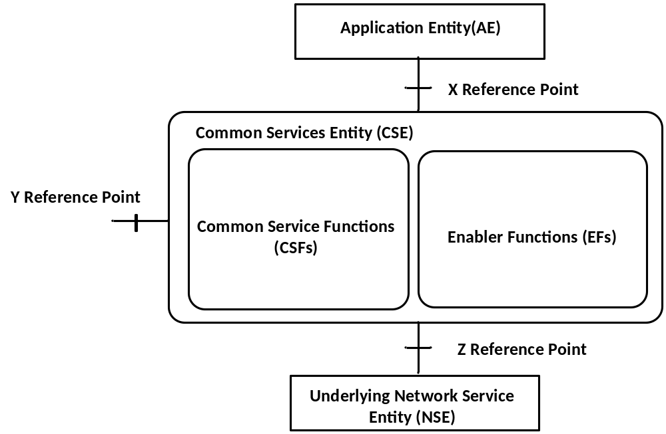
Figure 6.3-1 Common Service Entity Architecture

Figure 6.3-2 illustrates an example of CSFs and EFs within the Common Services Entity (CSE), showing newly added CSFs and associated CSF capabilities.

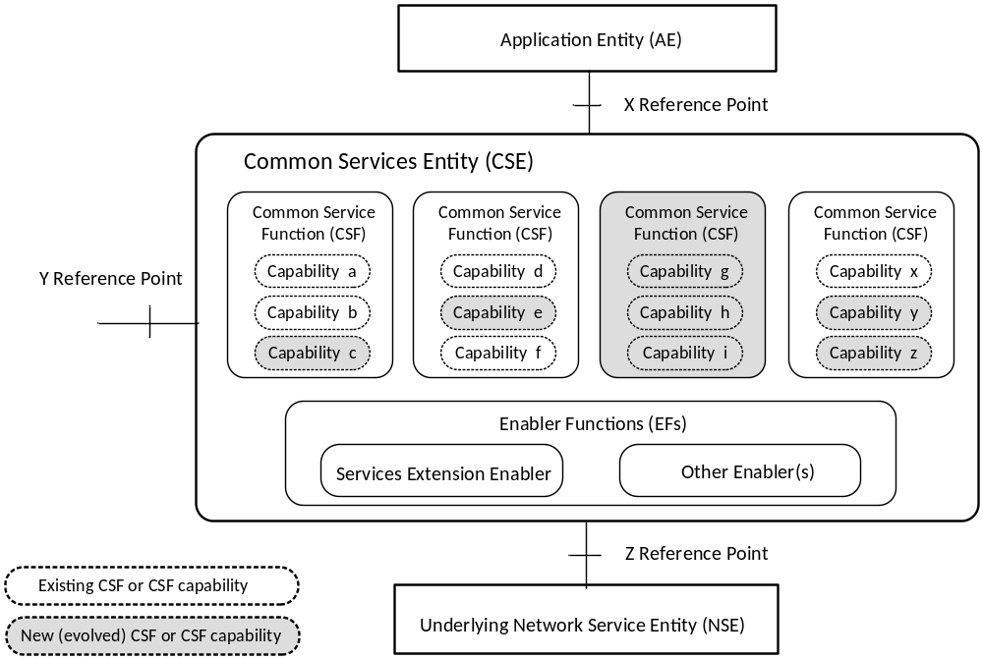
Figure 6.3-2 Example of CSFs and EFs within Common Services Entity Architecture

The Services Extension Enabler enables the CSE to offer M2M Services over the X and Y reference points. The Services Extension Enabler provides the following functions:
- Check module authentication
- Check node resources
- Check interoperability with existing modules
- Check policy and rights to determine how to handle conflicts e.g. Do not register new module or deregister existing module, etc.
- Register new module
- Add new service(s) due to new module to list of services
- Modify API support to reflect new service capabilities
- Modify inter-module communications to incorporate new module
Editor’s Note: The above list is preliminary and is for FFS.
Editor’s Note: How the Service Extension Enabler is associated with the APIs is FFS.

6.3 Security Aspects
<Text>

6.4 Other Aspects
<Text>

7. M2M Identification and Addressing
This clause provides a list of identifiers required for the purpose of interworking within the oneM2M architectural model.

7.1 M2M Identifiers

7.1.1 M2M Service Provider Identifier (M2M-SP-ID)
An M2M Service Provider shall be uniquely identified by the M2M Service Provider Identifier (M2M-SP-ID). This is a static value assigned to the Service Provider.

7.1.2 Application Instance Identifier (App-Inst-ID)
An Application Instance Identifier (App-Inst-ID) uniquely identifies an M2M Application instance resident on an M2M node, or an M2M Application instance that requests to interact with an M2M node. An App-Inst-ID shall identify an Application for the purpose of all interactions from/to the Application within the M2M framework.
It is the responsibility of the M2M Service Provider to ensure that the App-Inst-ID is globally unique. The App-Inst-ID shall include the Application ID (see clause 7.2.3.)

7.1.3 Application Identifier (App-ID)
This is equivalent to the application name and is not guaranteed to be globally unique on its own.
Editor's Note: Who assigns the App-ID is FFS.

7.1.4 CSE Identifier (CSE-ID)
A CSE shall be identified by a globally unique identifier, the CSE-ID, when instantiated within an M2M node in the M2M architecture.
The CSE-ID shall identify the CSE for the purpose of all interactions from/to the CSE within the M2M framework.

7.1.5 M2M Node Identifier/Device Identifier (M2M-Node-ID)
An M2M node, hosting a CSE and/or Application(s) shall be identified by a globally unique identifier, the M2M-Node-ID.
The M2M system shall allow the M2M Service Provider to set the CSE-ID and the M2M-Node-ID to the same value.
The M2M-Node-ID enables the M2M Service Provider to bind a CSE-ID to a specific M2M node.
Editor's Note: Several terms used in this clause: "M2M framework", "M2M architecture", "M2M system". Need to agree on a single terminology.

7.1.6 M2M Service Subscription Identifier (M2M-Sub-ID)
The M2M-Sub-ID enables the M2M Service Provider to bind application(s), M2M nodes, CSEs to a particular M2M service subscription.
The M2M Service Subscription Identifier has the following characteristics:
• belongs to the M2M Service Provider,
• identifies the subscription to an M2M Service Provider,
• enables communication with the M2M Service Provider,
• can differ from the M2M Underlying Network Subscription Identifier,
• changes with the change of the M2M Service Provider.
There can be multiple M2M Service Subscription Identifiers per M2M Underlying Network subscription.

7.1.7 Request Identifier (M2M-Request-ID)
This is an identifier that tracks a Request initiated by a CSE end to end. It is also included in the Response to the Request. The M2M-Request-ID is allocated by the CSE initiating the Request. The Request initiated by the CSE could be the result of an Application Request, or a Request initiated autonomously by the CSE to fulfil a service.
Hence, a CSE receiving a Request from a peer CSE shall include the Received M2M-Request-ID in all additional Requests it has to generate (including propagation of the incoming Request) and that are associated with the incoming Request, where applicable.
The CSE shall include the same M2M-Request-ID in its interactions with the Underlying Network, where applicable
An M2M-Request-ID allocated to a Request by a CSE shall be globally unique.
Editor’s Note: The need for an M2M-Request-ID on the X reference point for Applications that generate multiple simultaneous Requests is FFS.
Editor’s Note. The applicable reference points for various sections will be added.
Editor’s Note: Bring in a contribution to indicate where this information will be carried.
Editor’s Note: The case for multiple Request Identifiers is FFS.

7.2 M2M Identifiers lifecycle and characteristics
<Text>

8. X and Y Reference Points
Procedures involving a CSE and Applications are executed the exchange of data according to message flow described in clause 8.1.
The exchange of data consists of the information transferred across the reference points, and stored in a standardized resource structure as described in clause 9.
The use of the addressable resources also enables the “store-and-share” paradigm of application information and Big Data. Access and manipulation of the resources is subject to their associated permissions.
Some of the procedures on the X and Y reference points may adopt a different approach than the ones described in this clause. Such procedures are described in <reference to be included when available>.
Editors Note: Which of the procedures do not adopt the approach described in this clause and how they are performed is FFS.

8.1 General Communication Flow Scheme

8.1.1 Description
Figure 8.1.1-1 shows the general flow that governs the information exchange within a procedure, which is based on the use of Request and Response scheme. The scheme applies to communications such as:
- between an Application and a CSE (X reference point), and
- among CSEs (Y reference point).
The communications can be initiated either by the Applications or by the CSEs.

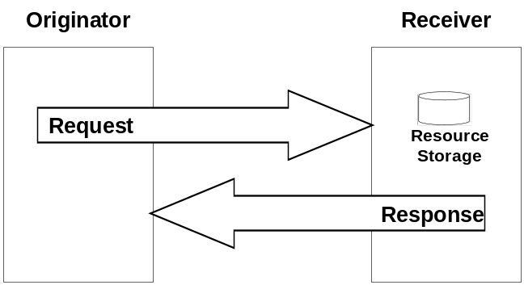

Figure 8.1.1-1: Resource Manipulation by an Application within an Entity

8.1.2 Request
Request from an Originator to a Receiver includes the following information:
op: operation to be executed: Create (C), Retrieve (R), Update (U), Delete (D),
to: address of target resource, e.g. /m2m.provider1.com/netBase/temp1,
fr: address of the resource representing the Originator. Used for access control, e.g., /m2m.provider2.com/remBase/app1,
mi: meta-information about the Request,
Editor's Note: Defaults for meta-information are FFS.
cn: resource content to be transferred.
Note: The to target resource needs to be known by the Originator. It can be known either by pre-provisioning or by discovery.
Editor’s Note: How pre-provisioning and discovery are performed is FFS.
The op information shall indicate the operation to be executed at the Receiver:
Create (C): a new resource addressable with to parameter is created,
Retrieve (R): an existing to addressable resource is read and provided back to the Originator,
Update (U): the content of an existing to addressable resource is replaced with cn new content,
Delete (D): an existing to addressable resource and all its sub-resources are deleted from the Resource Storage.
Editor’s Note: This is an initial list of the verbs. The need for more verbs is anticipated to cover all use cases, configuration and functions.
The to information shall address the target resource in the Receiver.
The fr information shall be used by the Receiver to check the Originator identity for access permission verification.
The cn information shall be present in Request for the following operations:
Create: cn is the content of the new resource,
Update: cn is the content to be replaced in an existing resource,
Retrieve: cn is the filter to be applied for discovery purposes.
The mi information shall be as follows:
ot: optional originating timestamp of when the message was built,
Example usage of the originating timestamp includes: to measure and enable operation (e.g. message logging, correlation, message prioritisation/scheduling, accept performance requests, charging, etc.) and to measure performance (distribution and processing latency, closed loop latency, SLAs, analytics, etc.)
et: optional expiration timestamp,
Example usage of the expiration timestamp includes to indicate when messages (including delay-tolerant) should expire due to the freshness of the responses being no longer of value, and to inform message scheduling/prioritisation.
rt: optional response type: indicates whether response should contain content or the address of the content,
Example usage of the response type set to "address of the content" includes when the response content is extremely large, or when multiple response content from a target group are to be aggregated asynchronously over time
rp: optional response persistence: indicates the duration for which the address containing the responses is to persist.
Example usage of response persistence includes requesting sufficient persistence for analytics to process the response content aggregated asynchronously over time. If an expiration timestamp is specified then the response persistence should last beyond the Request expiry time.
Once the Request is delivered, the Receiver shall analyze the Request to determine the target resource.
If the target resource is addressing another M2M node, the Receiver shall route the request appropriately.
If the target resource is addressing the Receiver, it shall:
- Check the existence of to addressed resource,
- Identify the resource type,
- Check the permission for fr Originator to perform the requested operation,
- Perform the requested operation (using cn content when provided),
- Respond to the Originator with indication of successful or unsuccessful operation results. In some specific cases (e.g. limitation in the binding protocol or based on application indications), the Response could be avoided.
The message flow procedure started with an Originator Request shall be considered closed when either:
- A Request is received with an expired et (expiration timestamp),
- A Response is delivered to the Originator,
- The requested operation at the Receiver is successfully completed and no Response is needed.

8.1.3 Successful Operation
The Response from the Receiver of a Request to the Originator of that Request, in the case of a successful completion of the requested operation includes the following information:
op: operation being executed: Create (C), Retrieve (R), Update (U), Delete (D) (optional),
mi: meta-information about the Request,
Editor's Note: Defaults for meta-information are FFS.
rs: operation result: e.g. Okay, Okay and Done; Okay and Scheduled; Okay and In Progress, etc.,
cs: optional additional result information, e.g. status codes,
to: address of target resource, e.g. /m2m.provider1/netBase/temp1,
cn: resource content to be transferred (optional).
The mi information includes:
ot: optional originating timestamp of when the message was built,
et: optional expiration timestamp.
The cs information includes:
ra: optional, address for the temporary storage of end node Responses.
The cn information may be present in a Response in the following cases:
Update: cn is the content replaced in an existing resource,
Delete: cn is the content actually deleted.
The cn information shall be present in a Response in the following cases:
Retrieve: cn is the retrieved resource content or aggregated contents of discovered resources.

8.1.4 Unsuccessful Operation
The Response from the Receiver of a Request to the Originator of the Request, in the case of unsuccessful completion of the requested operation includes the following information:
op: operation being executed: Create (C), Retrieve (R), Update (U), Delete (D) (optional),
mi: meta-information about the Request,
Editor's Note: Default for meta-information are FFS.
rs: operation result: e.g. Not okay.
cs: optional additional result information, e.g. status codes.
The mi information includes:
ot: optional originating timestamp of when the message was built,
et: optional expiration timestamp.

8.2 Procedures for Accessing Resources
This clause describes the procedures for accessing the resources. The procedures include:
- Generating Responses to the Requests for accessing resources,
- Accessing the resources that may be located in different CSEs.
Editor’s Note: Other procedures related to accessing the resources are FFS.
The procedures are applicable to all cases described in the following clauses.

8.2.1 Generating Responses
The following types of Responses are supported for accessing the resources over the X and Y reference points:
- Success: indicates to the Originator that the Request has been executed successfully by the Hosting CSE.
- Failure: indicates to the Originator that the Request has not been executed successfully by the Hosting CSE.
Both, the Success and the Failure Response types may convey other information also to the Originator of the Request.
Detailed Success and Failure codes are provided in the Protocol specifications.
Editor’s Note: References to Protocol specifications will be provided when available.
- In addition to the above mentioned Success and Failure Response types, there is another Response type that indicates an Acknowledgement of the Request. This indicates to the Originator that the Request has been received by the Hosting CSE, but not executed yet. The Success or the Failure of the execution of the Request is to be conveyed later.
Editor's Note: Details of Acknowledgement Response type is FFS.

8.2.2 Accessing Resources in CSEs
For the procedures described herein, the addressed resource can be stored in different CSEs. Table 8.2.2-1 describes the possible scenarios, where the addressed resource may be on the local-CSE or on a CSE located elsewhere in the oneM2M System.
Editor’s Note: How the target of a Request (i.e, an Application or local/hosting CSE) is identified and addressed, is FFS.
Editor’s Note: A message (Request, Response) can be forwarded immediately or forwarded at a later time (e.g in the case of congestion).The procedures related to the forwarding of the Request at a later time are FFS.

Table 8.2.2-1 Accessing Resources in different CSEs
Traversals across X/Y Reference Points | Description | Reference
No Hops | - The Originator of the Request accesses a resource.  - The Originator of the Request can be an Application or a CSE.  - Local CSE and Hosting CSE are the same entity.  - The CSE shall check the Access Rights for accessing the resource.  - The CSE shall respond to the Originator of the Request, either with a Success or Failure Response. | Figure 8.2.2-1
1 Hop | - The Originator of the Request accesses a resource.  - The Originator of the Request may only be an Application.  - Local CSE and Hosting CSEs different entities.  - Local CSE shall forward the Request to the Hosting CSE, after an optional checking of the Access Rights for accessing the resource and the syntax of the Request message.  - Hosting CSE shall check the Access Rights for accessing the resource and respond with a Success or Failure Response. | Figure 8.2.2-2  (Editor's Note-1)
Multi Hops | - The Originator of the Request accesses a resource.  - The Originator of the Request may be an Application or a CSE.  - Local CSE, Intermediate CSE(s) and the Hosting CSE are different entities.  - Local CSE shall forward the Request to an Intermediate CSE (e.g. MN-CSE) that the Local CSE is registered with, if it cannot communicate with the Hosting CSE directly. An optional checking of the Access Rights for accessing the resource and the syntax of the Request message may be performed prior to forwarding the Request.  - Intermediate CSE may forward the Request to another Intermediate CSE (e.g. another MN-CSE) that the Intermediate CSE is registered with, if it cannot communicate with the Hosting CSE directly. An optional checking of the Access Rights for accessing the resource and the syntax of the Request message can be performed prior to forwarding the Request.  - The Intermediate CSE shall forward the request to the Hosting CSE. An optional checking of the Access Rights and the syntax of the Request message can be performed prior to forwarding the Request.  - Hosting CSE shall check the Access Rights for accessing the resource and respond with a Success or Failure Response. | Figure 8.2.2-3  (Editor's Note-2)
Editor's Note-1: One-Hop case could potentially include the CSE-to-CSE communication also. The need for such procedures is FFS.
Editor's Note-2: The multi-hop procedures addresses the scenario when the target is on a specific remote CSE. How a flow will works when the target is distributed on multiple remote CSEs is FFS.

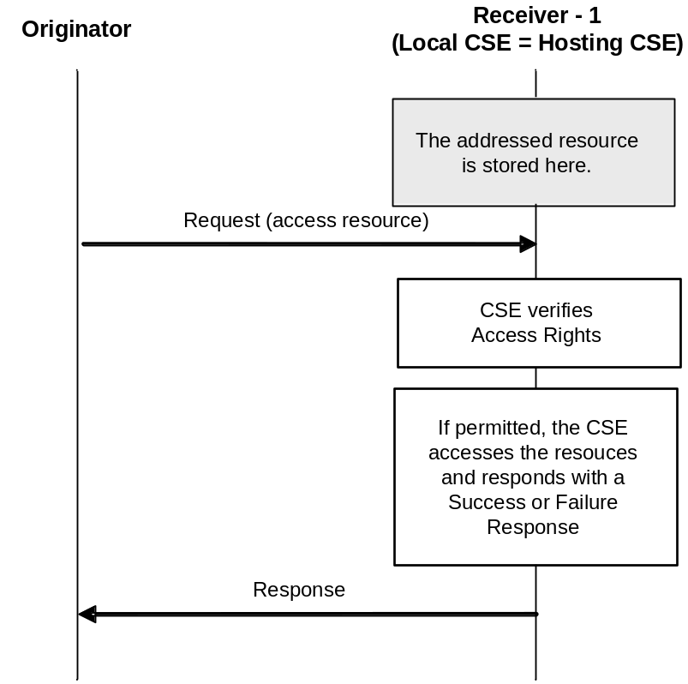
Figure 8.2.2-1: Originator accesses a resource on the Local CSE (No Hops)
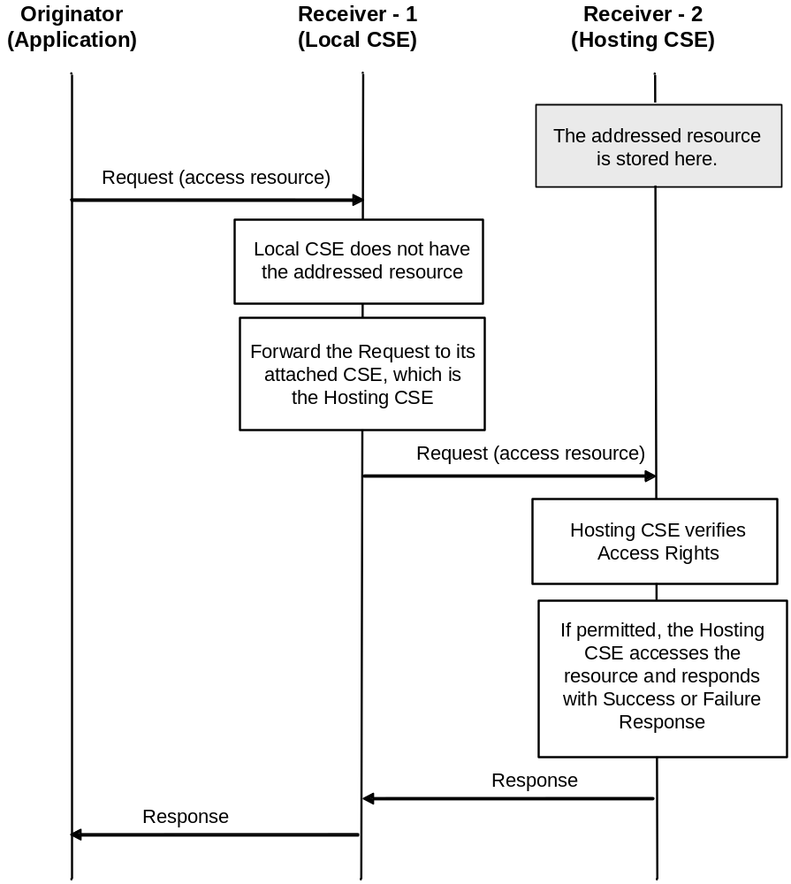
Figure 8.2.2-2: Application accesses a resource at the Hosting CSE (One Hop)

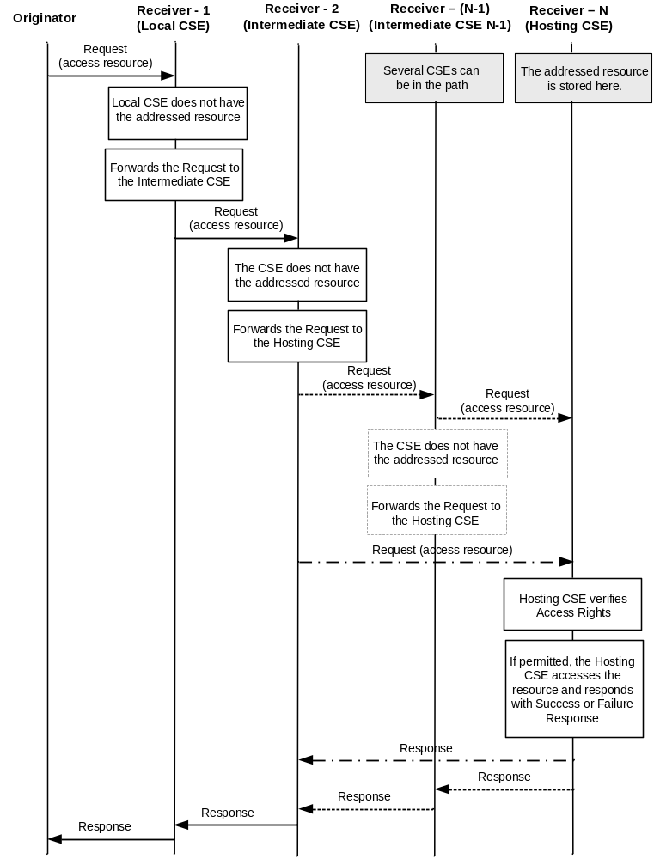
Figure 8.2.2-3: Originator accesses a resource at the Hosting CSE (Multi Hops)

9 Resource Management
All entities in the oneM2M System, such as Applications, CSEs, "data", etc., are represented as "resources". A "resource structure" is specified as a representation of the "resources". Such "resources" are uniquely addressable. Procedures for accessing such resources are also specified.

9.1 General Principles
The following are the general principles for the design of the resource model.
- The "type" of all resource shall be specified. New resource types shall be supported as the need for them is identified;
- The root of the resource structure in a CSE shall be assigned an absolute address, such as <baseURI>;
- The resource structure shall be kept reasonably simple. In particular:
- Application Resources belonging to the local CSE shall be located directly under the baseURI resource,
- Access Right Resources belonging to the local CSE shall be located directly under the baseURI resource,
- Group resources belonging to the local CSE shall be located directly under the baseURI resource,
- CSE resources representing a remote CSE shall be located directly under the baseURI resource,
- Container Resources belonging to the local CSE shall be located under the baseURI resource or under another container resource;
Editor’s Note: These above stated resource types needs to be validated.
- The attributes for all resource type shall be specified;
- Each resource type can have multiple instances;
- All resource and associated attributes shall be uniquely addressable via their associated Universal Resource Identifiers (URI);
- URI shall be used to determine the relationship among the "container" resources. This, however, does not imply any specific storage structure for the container resource. The structure of a container resource is subject to implementations.

9.2 Resource Types
This clause introduces the types of resources used in a CSE. A resource scheme is used for modelling the resource structure and associated relationships.
Table 9.2-1: Resource types and tagging
Resource type  Editor's Note-2.  Editor's Note-3. | Tag value | Description
Base URI Resource: <baseURI> | B | Base URI resource shall be the root of the resource structure. It shall store information about the local CSE. All resources belonging to the local CSE shall be child resources of the Base URI resource.
CSE Resource: <Entity> | E | Entity resource shall store information related to CSEs.  Editor's Note-1.
Application Resource: <Application> | A | Application resource shall store information about the Applications. Application resource is created as a result of successful registration of an Application with the local CSE. Applications shall register with their local CSE only.
Access Right Resource: <AccessRight> | R | AccessRight resource shall store a representation of the permissions. An accessRight resource is associated with resources that shall be accessible to entities external to the hosting CSE. Basically, accessRight resource controls "who" (permissionHolder) is allowed to do "what" (permissionFlag). It can be used for privacy protection as well.
Container Resource: <Container> | C | Container resource is a generic resource that shall be used to exchange "data" between Applications and/or CSEs. "Container" is used as a mediator that takes care of buffering the data. The exchange of data between Applications (e.g. an Application on an end-device and the peer-Application on the network side) is abstracted from the need to set up direct connections and allows for the scenarios where both parties in the exchange are not online at the same time.
Group Resource: <Group> | G | Group resource shall store information about resources of the same type that need to be addressed as a Group. Operations addressed to a Group resource shall be executed in a bulk mode for all members belonging to the Group.
Editor's Note-1": For the <Entity> resource storing information related to CSEs: Is the reference to local CSEs or to both the local and remote CSEs. Need to be clarified.
Editor's Note-2: The type of resources included in this table is not complete yet. This is FFS.

Editor’s Note-3: As the work progresses, the resource types may change. This is FFS.

The resources are indicated in the following notation:
<name>: | Indicates the resource name assigned during the creation of the resource. The name may be provided by the Originator of the Request that created the resource or by the CSE that hosts the resource (if name is not provided by the Originator).
Attributes | FFS
Editor’s Note: Attributes for the Resource Types are FFS.

9.2.1 Types of Virtual Resources
Some resource are defined as “virtual”. Such resources are instantiated when they are only when transferred over some communication interfaces. but tThey are not stored in theto a resource structure.
Some examples of virtual resources are:
Discovery | Virtual resource used to describe the filter criteria for discovery purposes
Notify | Virtual resource used for notification purposes.
Bulk | Virtual resource used for group oriented bulk operations

9.3 Resource Addressing
Resources shall be uniquely addressable via URI. The following are examples of addressable resources.
/baseURI/Entity Instance 1
/baseURI/Entity Instance n
/baseURI/Application Instance 1
/baseURI/Application Instance n
/baseURI/Container1/Container2
Resources may be associated by using a link with reference to another resource.

9.4 Resource Structure

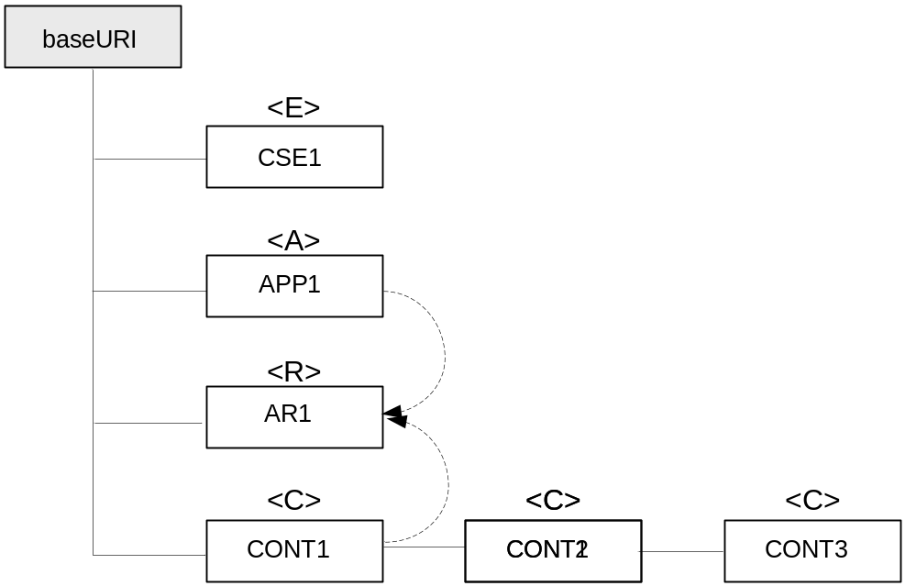
Figure 9.4-1: Topological Resource Structure at a CSE

Editor's Note: The resource structure picture needs to be updated as the resource structure evolves.

9.5 Resource Operations
Resources shall be manipulated using the following operations:
Create: a new resource is created
Retrieve: the content of an existing resource addressed by the Issuer is provided back to it.
Update: the content of an existing addressed resource is replaced with a new content provided by the Issuer.
Delete: an existing addressed resource is deleted by the structure upon request of an Issuer.
Editor's Note: Such information is already included in 8.2.2. Propose to remove this text.

9.5 TBD
<TBD>

10. Information Flows
<Text>

10.1 General Concepts
<Text>

Proforma copyright release text block
This text box shall immediately follow after the heading of an element (i.e. clause or annex) containing a proforma or template which is intended to be copied by the user. Such an element shall always start on a new page.
Notwithstanding the provisions of the copyright clause related to the text of the present document, OneM2M grants that users of the present document may freely reproduce the <proformatype> proforma in this {clause|annex} so that it can be used for its intended purposes and may further publish the completed <proformatype>.

Annex <A> (Informative): Deployment Scenarios
<Text>

Annex <B>(Informative/Normative): Remove Informative or Normative as appropriateTitle of annex (style H9)
<Text>
B.1 First clause of the annex (style H1)
<Text>
B.1.1 First subdivided clause of the annex (style H2)
<Text>

Annex <y>:
Bibliography
The annex entitled "Bibliography" is optional.
It shall contain a list of standards, books, articles, or other sources on a particular subject which are not mentioned in the document itself
It shall not include references mentioned in the document.
Use the Heading 9 style for the title and B1+ or Normal for the text.
- <Publication>: "<Title>".
OR
<Publication>: "<Title>".

History
Publication history
V1.1.1 | <dd-Mmm-yyyy> | <Milestone>

Draft history (to be removed on publication)
V0.0.1 | 27-FEB-2013 | Rapporteur Input - Draft Skeleton
V0.0.2 | 20-APR-2013 | Rapporteur Input –Draft; Including the following contributions:  1. oneM2M-ARC-2013-0255R03-Arcitecture_Description  2. oneM2M-ARC-2013-0256R01-Definitions_for_Arc_TS  3. oneM2M-ARC-2013-0253R03-Definition_to_SCX_and_SFM
V0.0.3 | 08-JUNE-2013 | 1. oneM2M-ARC-2013-0262R02-Update_to_Figure_5-1
V0.0.4 | 28-JUNE-2013 | Includes the following contributions agreed at TP#05:  1. oneM2M-ARC-2013-0275R03-Revised_functional_architecture  2. oneM2M-ARC-2013-0280R03-Definitions_of_Reference_Points  3. oneM2M-ARC-2013-0281R02-M2M_Identifiers  4. oneM2M-ARC-2013-0285R05-Delivery_Handling_in_CSE  5. oneM2M-ARC-2013-0287R04-High_level_Application_Programming_  Interface
V0.0.5 | 26-JULY-2013 | Includes the following contributions agreed during ARC#28 and ARC#29  1. oneM2M-ARC-2013-0307R03-Refinement_proposal_for_reference  _architecture  2. oneM2M-ARC-2013-0311R01-Definition_of_oneM2M_Node  3. oneM2M-ARC-2013-0312R01-Missing_definitions_for_WG1_work_progress
V0.0.6 | 23-AUGUST-2013 | Includes the following contributions agreed during ARC#30 (TP#06 F2F) meeting:  1. oneM2M-ARC-2013-0315R04-Proposal_for_definition_of_specific_Nodes  2. oneM2M-ARC-2013-0316R03-flow_message_extensions  3. oneM2M-ARC-2013-0317R02-Service_Enabler  4. oneM2M-ARC-2013-0340R04-General_mechanism_for_X_and_Y_reference_points  5. oneM2M-ARC-2013-0343R02-Multiple_domains  6. oneM2M-ARC-2013-0348R02-Session-ID  7. oneM2M-ARC-2013-0354R03-Definition_of_Common_Service_Entities_Collection  8. oneM2M-ARC-2013-0357R03-CSF_Descriptions  9. oneM2M-ARC-2013-0359R02-Introducing_Resource_Structure  The following documents are included in  "oneM2M-ARC-2013-0357R03-CSF_Descriptions":  1. oneM2M-ARC-2013-0302R02-Location_CSF  2. oneM2M-ARC-2013-0318R01-oneM2M-ARC-2013-0318-Data_Management_and_Repository_CSF  3. oneM2M-ARC-2013-0319R02-Network_Service_Exposure_Service_execution_and_triggering_CSF  4. oneM2M-ARC-2013-0322R01-Group_Management_CSF  5. oneM2M-ARC-2013-0325R01-A_CSF_description_for_registration  6. oneM2M-ARC-2013-0328R02-A_CSF_description_for_Discovery  7. oneM2M-ARC-2013-0329R02-Normative_Description_for_Subscription_Notification_Support_CSF  8. oneM2M-ARC-2013-0330R02-Device_management_CSF  9. oneM2M-ARC-2013-0331R01-descriptions_of_charging_CSF  10. oneM2M-ARC-2013-0334R02-description_of_session_management_CSF  11. oneM2M-ARC-2013-0335R02-CSF-ID  12. oneM2M-ARC-2013-0339R01-Service_charging_and_accounting_CSF  13. oneM2M-ARC-2013-0345R02-Security_related_CSFs
V0.0.7 | 26-AUGUST-2013 | Includes the following contributions agreed during ARC#31 meeting:  1. 1It was brought to attention that contribution # oneM2M-ARC-2013-0348R02-Session-ID had not been incorporated in v0.0.6 correctly. Corrected in section 7.1.7  2. Review comments provided by Phil Jacobs via his email dated August 21, 2013

