

oneM2M
Technical Specification
Document Number | TS-0007 -V0.6.0
Document Name: | Service Components
Date: | 2014-November-24
Abstract: | This document specifies the M2M Services provided by the M2M Services Platform, the integration and interworking of the M2M Services functional architecture of the oneM2M Services Platform and informatively illustrates the use of the M2M Services within the context of complex business services.

This Specification is provided for future development work within oneM2M only. The Partners accept no liability for any use of this Specification.
The present document has not been subject to any approval process by the oneM2M Partners Type 1. Published oneM2M specifications and reports for implementation should be obtained via the oneM2M Partners' Publications Offices.

About oneM2M
The purpose and goal of oneM2M is to develop technical specifications which address the need for a common M2M Service Layer that can be readily embedded within various hardware and software, and relied upon to connect the myriad of devices in the field with M2M application servers worldwide.
More information about oneM2M may be found at: http//www.oneM2M.org
Copyright Notification
No part of this document may be reproduced, in an electronic retrieval system or otherwise, except as authorized by written permission.
The copyright and the foregoing restriction extend to reproduction in all media.
© 2014, oneM2M Partners Type 1 (ARIB, ATIS, CCSA, ETSI, TIA, TTA, TTC).
All rights reserved.
Notice of Disclaimer & Limitation of Liability
The information provided in this document is directed solely to professionals who have the appropriate degree of experience to understand and interpret its contents in accordance with generally accepted engineering or other professional standards and applicable regulations. No recommendation as to products or vendors is made or should be implied.
NO REPRESENTATION OR WARRANTY IS MADE THAT THE INFORMATION IS TECHNICALLY ACCURATE OR SUFFICIENT OR CONFORMS TO ANY STATUTE, GOVERNMENTAL RULE OR REGULATION, AND FURTHER, NO REPRESENTATION OR WARRANTY IS MADE OF MERCHANTABILITY OR FITNESS FOR ANY PARTICULAR PURPOSE OR AGAINST INFRINGEMENT OF INTELLECTUAL PROPERTY RIGHTS. NO oneM2M PARTNER TYPE 1 SHALL BE LIABLE, BEYOND THE AMOUNT OF ANY SUM RECEIVED IN PAYMENT BY THAT PARTNER FOR THIS DOCUMENT, WITH RESPECT TO ANY CLAIM, AND IN NO EVENT SHALL oneM2M BE LIABLE FOR LOST PROFITS OR OTHER INCIDENTAL OR CONSEQUENTIAL DAMAGES. oneM2M EXPRESSLY ADVISES ANY AND ALL USE OF OR RELIANCE UPON THIS INFORMATION PROVIDED IN THIS DOCUMENT IS AT THE RISK OF THE USER.

Contents
Contents 3
17.. Scope 8
2 References 8
2.1 Normative references 8
2.2 Informative references 8
3 Definitions, symbols, abbreviations and acronyms 8
3.1 Definitions 8
3.2 Symbols 9
3.3 Abbreviations 9
3.4 Acronyms 9
4 Conventions 9
5 M2M Services Architecture 10
5.1 Introduction 10
5.2 Reference Points 11
5.2.1 Mca Reference Point 11
5.2.2 Msc Reference Point 11
5.2.2.1 Message Exchange Patterns 11
5.2.2.2 M2M Identifiers 12
5.2.2.2.1 M2M Service Capability Identifier (M2M-Serv-Cap-ID) 12
5.2.3 Mcc’ Reference Point 13
5.2.4 Mcn Reference Point 13
5.3 Configurations support by M2M Service Architecture 13
6 M2M Services 14
6.1 Introduction 14
6.2 Service Subscription 14
6.2.1 Overview 14
6.2.1.1 M2M Service Subscription Entities 14
6.2.1.2 M2M Service Subscription Broker Entities 15
6.2.1.3 M2M Service Subscription Management Adapter Entities 15
6.2.1.4 M2M Service Subscription Transport Adapter Entities 16
6.2.2 Service Capabilities 17
6.2.2.1 validateServiceSubscription 17
6.2.2.2 getAE 18
6.2.2.3 getBroker 20
6.2.2.4 getManagementAdapter 21
6.2.2.5 getTransportAdapter 22
6.3 Authorization 23
6.3.1 Service Capabilities 23
6.3.1.1 authorizeServiceCapability 23
6.4 Data Exchange 25
6.4.1 Overview 25
6.4.1.1 Subscribe-Publish-Notify Data Exchange 25
6.4.1.2 Request-Response Data Exchange 26
6.4.2 Service Capabilities 26
6.4.2.1 subscribe 26
6.4.2.2 publish 29
6.4.2.3 notify 31
6.4.2.4 sendMessage 32
6.5 Broker 34
6.5.1 Overview 34
6.5.2 Service Capabilities 34
6.5.2.1 subscribe 34
6.5.2.2 publish 35
6.5.2.3 notify 36
6.5.2.4 sendMessage 38
6.6 Device Management 39
6.6.1 Overview 39
6.6.1.1 Device Management 39
6.6.2 Service Capabilities 45
6.6.2.1 downloadFirmware 45
6.6.2.2 installFirmware 48
6.6.2.3 getFirmwareInformation 50
6.6.2.4 getFirmwareExecStatus 52
6.6.2.5 reportFirmwareStatus 53
6.6.2.6 upgradeFirmware 55
6.6.2.7 getDeviceInformation 57
6.6.2.8 getDeviceCapabilities 59
6.6.2.9 enableDeviceCapability 61
6.6.2.10 disableDeviceCapability 63
6.6.2.11 getAreaNetworks 65
6.6.2.12 updateDeviceForAreaNetwork 67
6.6.2.13 rebootDevice 69
6.6.2.14 resetDevice 71
6.6.2.15 uploadDeviceLog 73
6.6.2.16 reportTroubleshootingStatus 75
6.6.2.17 getDeviceLogs 76
6.6.2.18 getDeviceLogInformation 78
6.6.2.19 getSoftwareInformation 80
6.6.2.20 downloadSoftware 82
6.6.2.21 installSoftware 84
6.6.2.22 activateSoftware 86
6.6.2.23 deactivateSoftware 88
6.6.2.24 removeSoftware 90
6.6.2.25 reportSoftwareStatus 92
6.7 Management Adapter 93
6.7.1 Overview 93
6.7.2 Service Capabilities 93
6.7.2.1 downloadFirmware 93
6.7.2.2 installFirmware 94
6.7.2.3 getFirmwareInformation 95
6.7.2.4 getFirmwareExecStatus 96
6.7.2.5 reportFirmwareStatus 97
6.7.2.6 getDeviceInformation 99
6.7.2.7 getDeviceCapabilities 100
6.7.2.8 enableDeviceCapability 101
6.7.2.9 disableDeviceCapability 102
6.7.2.10 getAreaNetworks 103
6.7.2.11 updateDeviceForAreaNetwork 104
6.7.2.12 rebootDevice 104
6.7.2.13 resetDevice 106
6.7.2.14 uploadDeviceLog 107
6.7.2.15 reportTroubleshootingStatus 108
6.7.2.16 getDeviceLogs 110
6.7.2.17 getDeviceLogInformation 111
6.7.2.18 getSoftwareInformation 112
6.7.2.19 downloadSoftware 113
6.7.2.20 installSoftware 114
6.7.2.21 activateSoftware 115
6.7.2.22 deactivateSoftware 116
6.7.2.23 removeSoftware 117
6.7.2.24 reportSoftwareStatus 118
6.8 Service Administration 120
6.8.1 Overview 120
6.8.1.1 M2M Service Entity 120
6.8.2 Service Capabilities 122
6.8.2.1 createM2MService 122
6.8.2.2 deleteM2MService 124
6.8.2.3 updateM2MService 126
6.8.2.4 addRoleToM2MService 128
6.8.2.5 deleteRoleFromM2MService 130
6.8.2.6 getM2MService 132
6.8.2.7 addServiceCapabilityToRole 133
6.8.2.8 deleteServiceCapabilityFromRole 134
6.8.2.9 getServiceCapability 135
6.9 Service Subscription Administration 137
6.9.1 Overview 137
6.9.1.1 Service Subscription Entity 137
6.9.1.2 Device Entity for Service Subscription 138
6.9.1.2.1 Device Filter Criteria 138
6.9.2 Service Capabilities 138
6.9.2.1 createServiceSubscription 138
6.9.2.2 deleteServiceSubscription 141
6.9.2.3 updateServiceSubscription 143
6.9.2.4 addRoleToServiceSubscription 145
6.9.2.5 deleteRoleFromServiceSubscription 147
6.9.2.6 getServiceSubscription 149
6.9.2.7 addDeviceToServiceSubscription 151
6.9.2.8 deleteDeviceFromServiceSubscription 153
6.9.2.9 getDevicesForServiceSubscription 155
6.9.2.10 addApplicationsToServiceSubscription 157
6.9.2.11 deleteApplicationsFromServiceSubscription 159
6.9.2.12 getApplicationsForServiceSubscription 161
6.9.2.13 updateApplicationForDevice 163
6.9.2.14 getApplicationsForDevice 165
6.10 Event Collection 167
6.10.1 Overview 167
6.10.1.1 Event Collection Types 167
6.10.2 Service Capabilities 167
6.10.2.1 setEventCollectionPolicy 167
6.10.2.2 getEventCollectionPolicy 170
6.10.2.3 setEventCollectionTriggers 172
6.10.2.4 getEventCollectionTriggers 174
6.10.2.5 recordEvent 176
6.10.2.6 getEventRecords 178
6.11 Registration 180
6.11.1 Overview 180
6.11.2 Service Capabilities 180
6.11.2.1 registerAE 180
6.11.2.2 refreshAERegistration 182
6.11.2.3 deregisterAE 184
6.12 Registration Administration 186
6.12.1 Overview 186
6.12.2 Service Capabilities 186
6.12.2.1 getRegistrationStatus 187
6.12.2.2 revokeAERegistration 189
6.12.2.3. subscribeInitialAERegistrationEvent 191
6.12.2.4 unsubscribeInitialAERegistrationEvent 193
6.12.2.5 getInitialSubscriptionAERegistrationEvents 195
7 M2M Service Components 197
7.1 Introduction 197
7.1.1 Service Component Interaction Cross Reference 197
7.2 Infrastructure Component (INF) 197
7.2.1 INF to Service Cross Reference 197
7.3 Service Subscription Component (SSUB) 198
7.3.1 SSUB to Service Cross Reference 198
7.4 Transport Adapter (TRA) 198
7.4.1 TRA to Service Cross Reference 198
7.5 Accounting (ACC) 198
7.5.1 Accounting to Service Cross Reference 198
7.6 Service Exposure (SE) 198
7.6.1 Service Exposure to Service Cross Reference 198
7.7 Management Adapter (MA) 199
7.7.1 Management Adapter to Service Cross Reference 199
7.8 Device Management (DM) 199
7.8.1 Device Management to Service Cross Reference 199
Proforma copyright release text block 200
Annex A: Common Request Processing 201
A.1 Overview 201
A.2 Mca Common Request Processing 201
A.2.1 Mca Common Request Data Types (Normative) 201
A.2.2 Authentication and Authorization of Requests 202
A.2.2.1 Pre-conditions 202
A.2.2.2 Common M2M Service Capability Parameters for Request Authentication and Authorization 202
A.2.2.4 Post-Conditions 203
A.2.2.5 Exceptions 203
A.2.2.6 Policies for Use 203
A.3 Msc Common Request Processing 204
A.3.1 Msc Common Request Data Types (Normative) 204
Annex B (Informative): Data Exchange Services 205
B.1 Overview 205
B.2 Supporting Services 205
B.2.1 Subscribe-Publish-Notify Message Exchange 205
B.2.1.1 Service Capabilities 205
B.2.2 Request-Response Message Exchange 214
B.2.2.1 Service Capabilities 214
Annex C (Informative): Service Subscription Administration Services 217
C.1 Overview 217
C.2 Supporting Services 217
C.2.1 Service Capabilities 217
Annex D (Informative): Device Management Services 233
D.1 Overview 233
D.2 Supporting Services 233
D.2.1 Message Exchange 233
D.2.1.1 Service Capabilities 233
Annex E (Informative): Device On-boarding Service 283
E.1 Overview 283
E.2 Supporting Services 283
E.2.1 Remote Administration 283
E.2.1.1 Service Capabilities 283
Annex F (Informative): Registration Services 285
F.1 Overview 285
F.2 Mca Registration Service Processing and Supporting Services 285
F.2.1 Message Exchanges 285
F.2.1.2 Service Capabilities 285
Annex X(Informative): M2M Service Capability Template 291
X.1 <serviceCapabilityName> 291
X.1.1 Signature 291
X.1.2 Pre-conditions 292
X.1.3 Service Interactions 292
X.1.4 Post-Conditions 292
X.1.5 Exceptions 292
X.1.6 Policies for Use 292
X.1.7 oneM2M Resource Interworking 292
Annex Y(Informative): oneM2M Service Requirements 293
History 294

Scope
This specification describes the M2M Services provided by the oneM2M Services Platform, the integration and interworking of the M2M Services functional architecture of the oneM2M Services Platform and informatively illustrates the use of the M2M Services within the context of complex business services.

2 References
References are either specific (identified by date of publication and/or edition number or version number) or non-specific. For specific references, only the cited version applies. For non-specific references, the latest version of the referenced document (including any amendments) applies.

2.1 Normative references
The following referenced documents are necessary, partially or totally, for the application of the present document. Their use in the context of this TS is specified by the normative statements that are referring back to this clause.
[1] oneM2M TS-0002: “oneM2M Requirements; oneM2M-TS-0002-V-0.6.2”
[2] oneM2M TS-0001: “oneM2M Functional Architecture”

2.2 Informative references
The following referenced documents are not necessary for the application of the present document but they assist the user with regard to a particular subject area.
[i.1] oneM2M Drafting Rules (http://member.onem2m.org/Static_pages/Others/Rules_Pages/oneM2M-Drafting-Rules-V1_0.doc)
[i.2] W3C WD-wsdl20-patterns-20040326:”Web Services Description Language (WSDL) Version 2.0 Part 2: Message Exchange Patterns.”
[i.3] OASIS soa-rm: “Reference Model for Service Oriented Architecture 1.0”

3 Definitions, symbols, abbreviations and acronyms
Delete from the above heading the word(s) which is/are not applicable.

3.1 Definitions
For the purposes of the present document, the terms and definitions apply:
M2M Service: A Service that creates added-value to the providing M2M Service Platform and is consumed by one or more Supporting Services. The Data Exchange Service is an example of a M2M Service.
M2M Service Registration: When a Service is deployed into a SOA environment; the SOA environment’s Service Registry is updated so that the Service can be accessed by other Services.
Service[i.3]: A mechanism to enable access to one or more Service Capabilities, where the access is provided using a prescribed interface and is exercised consistent with constraints and policies as specified by the service description.
Service Capability[i.3]: A real-world effect that a service provider is able to provide to a service consumer.
Service Cluster: A collection of distributed and related Services that are gathered to solve a business problem.
Service Component: An entity of the M2M Services Architecture which may contain one or more M2M Services.
Service Execution Environment: An Execution Environment is a logical entity that represents an environment capable of running Services.
Service Exposure Component: A Service Component that provides an enforcement point for specific oneM2M Reference Points (e.g. Mca, Mcn, Mcc’).
Service Registry: A component of an underlying SOA environment that maintains information about Services and provides facilities to publish and discover Services to entities that would utilize the Service.
Supporting Service: A Service that creates added-value to an organization and is relevant to the business process of the organization that consumes Services from the M2M Services Platform. Business Services are typically complex, orchestrated Services which consume M2M Services among other Services. A Device Onboarding Service is an example of a Supporting Service.
Editor’s Note: Need definition of M2M Service Capability; Something like: M2M Service Capability: A Service Capability that is identified within the M2M System Platform.

3.2 Symbols
For the purposes of the present document, the symbols apply:
<symbol> <Explanation>
<2nd symbol> <2nd Explanation>
<3rd symbol> <3rd Explanation>

3.3 Abbreviations
For the purposes of the present document, the following apply:
AE Application Entity
BSS Business Support System
CSE Common Service Entity
ESB Enterprise Service Bus
MEP Message Exchange Pattern
M2M Machine-to-Machine
M2M-Serv-Cap-ID M2M Service Capability Identifier
NMS Network Management System
OSS Operational Support System
SEE Service Execution Environment

3.4 Acronyms
For the purposes of the present document, the following acronyms apply:

4 Conventions
The key words “Shall”, ”Shall not”, “May”, ”Need not”, “Should”, ”Should not” in this document are to be interpreted as described in the oneM2M Drafting Rules [i.1]

5 M2M Services Architecture
This clause describes the architecture the M2M Services within the context of the M2M Services Platform.

5.1 Introduction
The architecture of the M2M Service Platform as defined in the oneM2M Functional Architecture [2] includes an entity described as the Common Service Entity (CSE). The CSE comprises a set of service functions that are common to the M2M environment and are exposed through the Mca and Mcc’ Reference Points. These Reference Points are described in the oneM2M Functional Architecture [2]. The M2M Service Architecture described in this specification is primarily suitable for the Infrastructure Domain where the CSE is viewed as a set of Service Components.
The M2M Service Architecture augments the oneM2M Functional Architecture by specifying M2M Services provided to M2M Application and M2M Service Providers.
These M2M Services are consumed by:
- AEs across the Mca Reference Point via the Service Exposure Component
- Other Infrastructure CSEs across the Mcc’ Reference Point via the Remote Service Exposure Component
- Other Service Components across the Msc Reference Point
These M2M Services utilize services of the:
- Underlying Network across the Mcn Reference Point via the Network Service Utilization Component
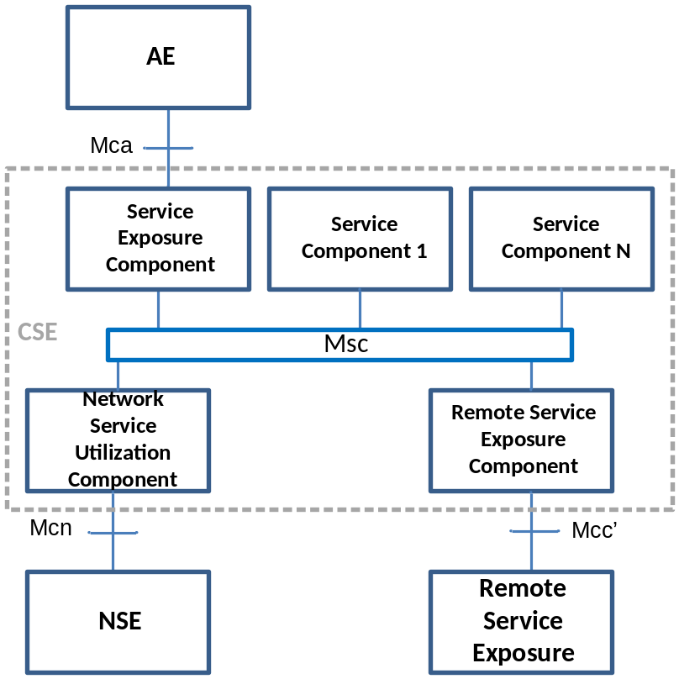
Figure 5.1-2: oneM2M Services Architecture
The oneM2M Services architecture in Figure 5.1-2 comprises of the following entities:
- Application Entity (AE): Defined by the oneM2M Functional Architecture [2], the Application Entity provides Application logic for the end-to-end M2M solutions.
- Common Services Entity (CSE): Defined by the oneM2M Functional Architecture [2], a Common Services Entity comprises the set of “service functions” that are common to the M2M environments and specified by oneM2M. For oneM2M Services, this definition of a CSE is a logical representation where “service functions” that are exposed through the Mca and Mcc’ Reference Points via the corresponding Service Exposure and Remote Service Exposure Components and the Network Service Utilization Component utilizes services of the Underlying Network through the Mcn referent point. In addition Service Components consume and provide M2M Services with other Service Components.
As a logical representation of loosely coupled Service Components, the CSE is entity that in itself is identifiable but not directly addressable. Instead the addressable entities are the corresponding Service Exposure Components of the Reference Points.
Editors note: Need to clarify that the Services are the addressable entities within a components; components are not directly addressable.
  - Service Exposure Component: The Service Exposure Component exposes services to AEs.
  - Network Service Utilization Component: The Network Service Utilization Component consumes services from the NSE.
  - Remote Service Exposure Component: The Remote Service Exposure connects Services from different M2M environments.
The Service Exposure, Network Service Utilization and Remote Service Exposure Components follow the CSE Public Domain Names convention described in section 6.5.1.2 of the Functional Architecture [2] but are extended as a sub-domain of the Infrastructure Node public domain name.

5.2 Reference Points
The M2M Service Architecture exposes M2M Services across the Mca, Mcn, Mcc’ and Msc Reference Points. The enhancement of the Mcc Reference Point to expose M2M Services through the Remote Service Exposure Component is FFS.

5.2.1 Mca Reference Point
The Mca Reference Point is defined within the oneM2M Functional Architecture [2]. Additional protocol support is defined in this specification for other application protocols. In the M2M Service Architecture, when an AE uses a protocol across the Mca Reference Point that is not defined by oneM2M (e.g., XMPP, DDS, MQTT), the CSE passes through the payload and offers additional M2M Services.
Editor’s note: This description needs further clarification; specifically what does it mean to pass through the payload.

5.2.2 Msc Reference Point
The Msc Reference Point specifies set of interactions between the Service Capabilities of different Service Components. The realization of the interaction between the Services Capabilities is implementation specific.
Editor’s Note: There is a need to define a term for an interface which specifies a service definition but does not specify the communication bindings of the stage 3 work.

5.2.2.1 Message Exchange Patterns
Communication between M2M Service Components which pass over the Msc Reference Point utilizes a web services approach, e.g., Web Services Message Exchange Patterns (MEP) defined by WSDL[i.2]:
- In-Only
- Robust In-Only
- In-Out
- In-Optional-Out
- Out-Only
- Robust Out-Only
- Out-In
- Out-Optional-In
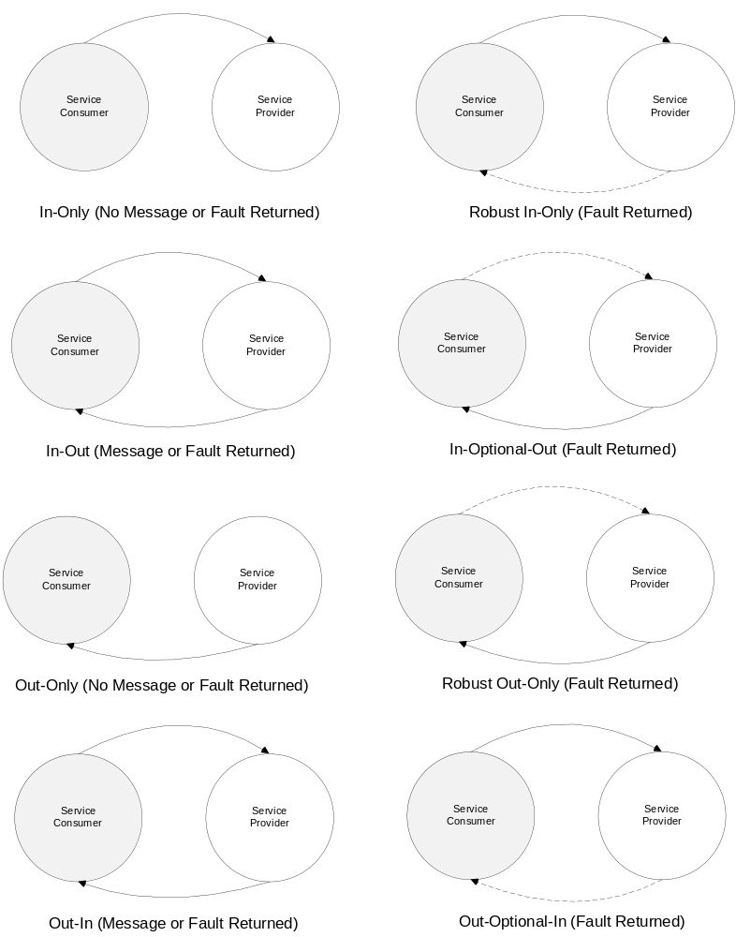
Figure 5.2.2.1-1: Message Exchange Patterns
The MEP(s) utilized by a M2M Service Capability is documented within the Service Capabilities Policy clause.
Note: A subset of the MEPs provided by a M2M Service Capability would be exposed by the Service Exposure Component or the Remote Service Exposure Component.

5.2.2.2 M2M Identifiers

5.2.2.2.1 M2M Service Capability Identifier (M2M-Serv-Cap-ID)
Service Components contain multiple M2M Services (M2M-Serv-ID). Each M2M Service contains multiple M2M Service Capabilities. The M2M Service Capability Identifier is assigned to each M2M Service Capability.
Identifier | Assigned by | Assigned to | Assigned during | Lifetime | Uniqueness | Used during | Remarks
M2M Service Capability Identifier | M2M SP | M2M Service Capability | M2M Service Registration.  This is the identifier from the Services Registry. | Life of the M2M Service Registration. | Global | Message exchange between Service Components across the Msc and Mcc’.  Message exchange across the Mca.
Table 5.2.2.2.1-1 M2M Service Capability Identifier

5.2.3 Mcc’ Reference Point
The Mcc’ Reference Point is defined within the oneM2M Functional Architecture [2]. The oneM2M Service Architecture utilizes communications over the Mcc’ Reference Point to construct a Service Cluster for service sharing and capacity expansion. A messaging exchange protocol (e.g., AMQP, XMPP, JMS) between two service execution environments (SEE) (e.g., ESB, Apache Service Mix) accommodates the SEEs with same and different ownership.
Note: The protocol used for communication between SEEs with different ownership may require additional security capabilities and is FFS.

5.2.4 Mcn Reference Point
The Mcn Reference Point is defined within the oneM2M Functional Architecture [2].

5.3 Configurations support by M2M Service Architecture
M2M Services exposed across the Mca, Mcn, Mcc’ and Msc reference are supported for Infrastructure Nodes as defined in the oneM2M Functional Architecture [2].

6 M2M Services
This clause describes the M2M Services provided by the M2M Services Platform.

6.1 Introduction
The M2M Services defined in this clause are utilized by the Supporting Services described in the Annexes of this specification.
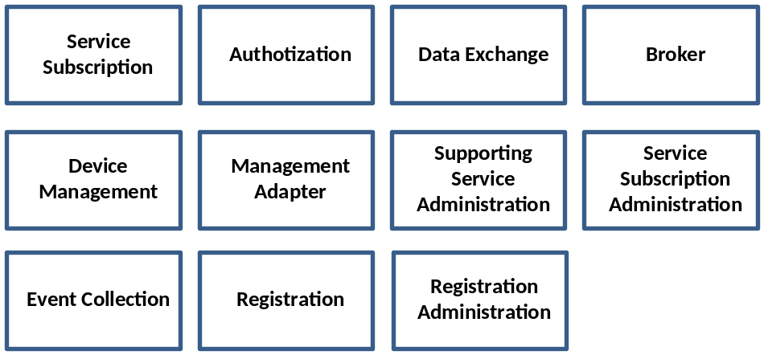
Figure 6.1-1: M2M Services

6.2 Service Subscription

6.2.1 Overview
The Service Subscription service provides the ability to:
- Validate the M2M Service Capabilities (e.g., requests, notifications) that go across the Mca Reference Point by ensuring M2M Service requested by the originator is permitted within the context of the M2M Service Subscription
- Retrieve the Application Entity and associated M2M Service Subscription for the Application Entity
- Assist in returning the Broker and Transport Adapter service instances needed to exchange data for data exchange service capabilities
- Assist in returning the Management Adapter service instance needed to manage the device

6.2.1.1 M2M Service Subscription Entities
The following diagram describes the associations between the AE, Service Roles and the M2M Service Capabilities to obtain an Application Entity and validate the M2M Service Subscription:

The M2M Service Subscription(s) for a specified M2M Service Capability is validated through the associations the Service Role has to the M2M Service Capability and M2M Service Subscription
- The Application Entity and associated M2M Service Subscription is obtained through the Application Entity’s to the M2M Service Subscription that is created during registration of the Application Entity
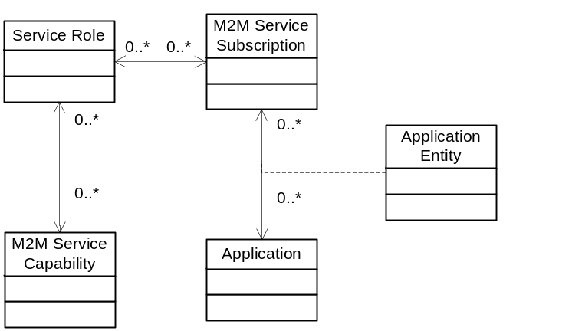
Figure 6.2.1.1-1 Service Subscription Entity Relationships

6.2.1.2 M2M Service Subscription Broker Entities
The following diagram describes the associations between the AE, M2M Service Subscription, M2M Service Capability and the Broker resource in order to obtain the Broker used to exchange the data
- The Broker is obtained through the association of the Broker Resource and the M2M Service Capability.
- The Broker Resource is associated with Applications which are themselves associated with the Application Entity in the context of a M2M Service Subscription
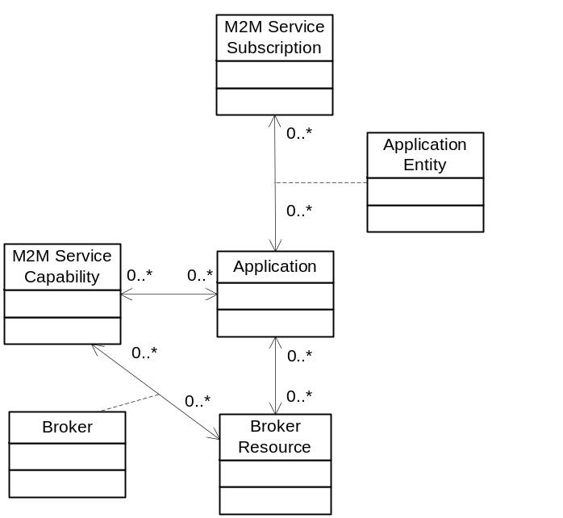
Figure 6.2.1.1-1 M2M Service Subscription for Broker Entity Relationships

6.2.1.3 M2M Service Subscription Management Adapter Entities
The following diagram describes the associations between the M2M Service Subscription, Devices associated with the M2M Service Subscription and M2M Service Capability in order to obtain the Management Adapter.
- The Management Adapter is obtained through the association of the Device and the M2M Service Capability.
- The Device is associated with the M2M Service Subscription
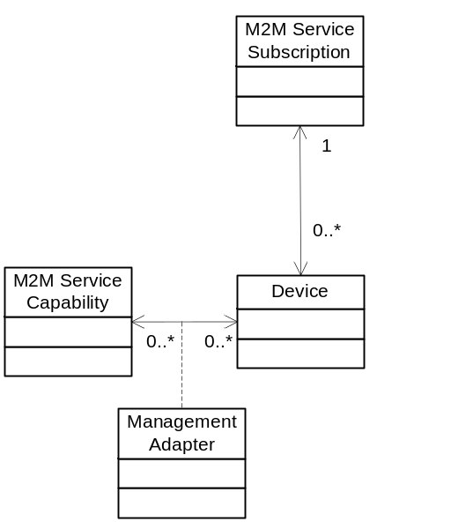
Figure 6.2.1.2-1 M2M Service Subscription For Management Adapter Entity Relationships

6.2.1.4 M2M Service Subscription Transport Adapter Entities
The following diagram describes the associations between the M2M Service Subscription, AE and M2M Service Capability in order to obtain the Transport Adapter.
- The Transport Adapter is obtained through the association of the Application and the M2M Service Capability
- The Application is associated with the M2M Service Subscription
- The AE is associated with an Application and M2M Service Subscription AE registration
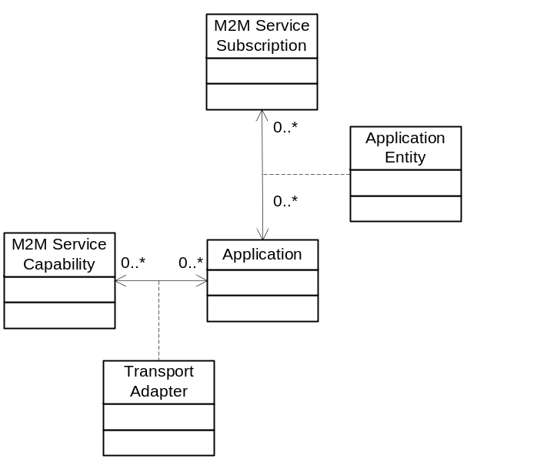
Figure 6.2.1.3-1 M2M Service Subscription For Transport Adapter Entity Relationships

6.2.2 Service Capabilities

6.2.2.1 validateServiceSubscription
This service capability ensures that a valid M2M Service Subscription exists for the requested M2M Service Capability requested that is either received by the M2M Service Platform from an AE or is transmitted to the AE from the M2M Service Platform.

6.2.2.1.1 Pre-conditions
A correlation between the M2M Service Capability, M2M Service Role(s) and the M2M Service Subscription has been defined in order to validate the M2M Service Subscription.

6.2.2.1.2 Signature – validateServiceSubscription
Parameter name | Direction | Optional | Description
serviceSubscriptionId | IN | NO | The M2M Service Subscription Identifier (M2M-Service-Profile-ID)
serviceCapId | IN | NO | The M2M Service Capability Identifier (M2M-Serv-Cap-ID)
responseType | OUT | NO | Response types:  - M2M Service Capability does not exist for requested M2M Service Subscription  - M2M Service Capability does exist for the requested M2M Service Subscription
Table 6.2.2.1.2-1 Service Subscription - validateServiceSubscription capability

6.2.2.1.3 Post-Conditions
Not Applicable

6.2.2.1.4 Exceptions
Not Applicable

6.2.2.1.5 Policies for Use
Message Exchange Patterns: In-Out
Transaction Pattern: Participation allowed

6.2.2.1.6 oneM2M Resource Interworking
This service capability interworks with the following oneM2M Resource operations that are interworked are:

RETRIEVE <m2MServiceSubscriptionProfile> resource retrieves the associated Service Roles. A M2M Service Capability is associated with the M2M Service Roles. The M2M Service Subscription is validated through the Service Roles associated with the M2M Service Capability.

6.2.2.2 getAE
This service capability provides the ability to retrieve the Application Entity information and associated M2M Service Subscription Identifier associated with the Application Entity Identifier.

6.2.2.2.1 Pre-conditions

Not Applicable

6.2.2.2.2 Signature – getAE
Parameter name | Direction | Optional | Description
aeId | IN | NO | The Application Entity Id (AE-ID)
applicationId | OUT | NO | The Application Identifier (App-ID) for the AE
serviceSubscriptionId | OUT | YES | The M2M Service Subscription (M2M-Service-Profile-ID) for the AE
deviceId | OUT | YES | The Device identifier that hosts the AE
responseType | OUT | YES | Unique response types for this service.  - AE does not exist
Table 6.2.2.2.2-1 Service Subscription – getAE capability

6.2.2.2.3 Service Interactions
The interactions of service capabilities required for this service capability:
- Issue the service capability
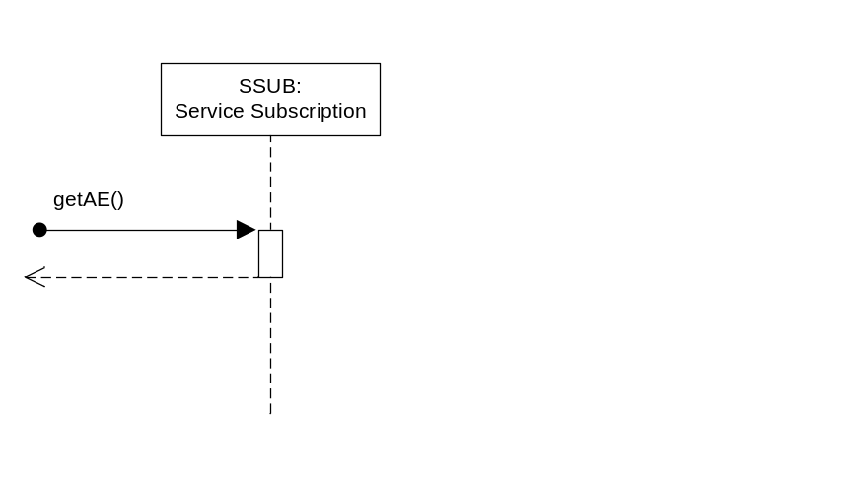
Figure 6.2.2.2.3-1 Service Subscription – getAE Diagram

6.2.2.2.4 Post-Conditions
Not Applicable

6.2.2.2.5 Exceptions
Not Applicable

6.2.2.2.6 Policies for Use
Message Exchange Patterns: In-Out
Transaction Pattern: Participation allowed

6.2.2.2.7 oneM2M Resource Interworking
When an AE is registered using a CREATE operation on the <AE> resource, the AE is associated with the M2M Service Subscription which is returned along with the correlated AE information (e.g.,

Application, Device).

6.2.2.3 getBroker
This service capability obtains the Broker instance that will be used to subscribe and publish requests based on the requested M2M Service Capability (e.g., publishRequest, subscribeRequest), AE, Resource and M2M Service Subscription.
For the publishRequest service capability the AE is the from AE-ID and the resource is the toResource representing a leaf node from the publication resource.
For the subscribeRequest service capability the AE is the from AE-ID and the resource is the publication resource.

6.2.2.3.1 Pre-conditions
A correlation between a M2M Service Subscription, AE, Service Capability, Resource and Broker exist.

6.2.2.3.2 Signature - getBroker
Parameter name | Direction | Optional | Description
serviceSubscriptionId | IN | NO | The M2M Service Subscription Identifier (M2M-Service-Profile-ID).
serviceCapId | IN | NO | The M2M Service Capability Identifier (M2M-Serv-Cap-ID).
aeId | IN | NO | The identifier of the AE
resource | IN | NO | The identifier of the resource that is associated with the AE and M2M Service Subscription
broker | OUT | NO | The returned instance of the Broker service associated with the M2M Service Subscription.
responseType | OUT | NO | Response types:  - Broker does not exist for requested M2M Service Capability, M2M Service Subscription and Resource
Table 6.2.2.3.2-1 Service Subscription - getBroker capability

6.2.2.3.3 Post-Conditions

Not Applicable

6.2.2.3.4 Exceptions
Not Applicable

6.2.2.3.5 Policies for Use
Message Exchange Patterns: In-Out
Transaction Pattern: Participation allowed

6.2.2.3.6 oneM2M Resource Interworking
This service capability interworks with the following oneM2M Resource operations that are interworked are:
Not Applicable

6.2.2.4 getManagementAdapter
This service capability obtains the Management Adapter instance that will be used to manage device based on the requested M2M Service Capability (e.g., downloadFirmware, installFirmware) and device.

6.2.2.4.1 Pre-conditions
A correlation between a Management Adapter, the M2M Service Capability and device exist.

6.2.2.4.2 Signature - getManagementAdapter
Parameter name | Direction | Optional | Description
serviceSubscriptionId | IN | YES | The M2M Service Subscription Identifier (M2M-Service-Profile-ID) , is optional when the deviceId is unique across M2M Service Subscription.
serviceCapId | IN | NO | The M2M Service Capability Identifier (M2M-Serv-Cap-ID).
deviceId | IN | YES | The unique device identifier in the context of the M2M Service Subscription.
managementAdapter | OUT | NO | The returned instance of the Management Adapter service associated with the subscription.
responseType | OUT | NO | Response types:  - Management Adapter does not exist
Table 6.2.4.1.2-1 Service Subscription - getManagementAdapter capability

6.2.2.4.3 Post-Conditions
Not Applicable

6.2.2.4.4 Exceptions
Not Applicable

6.2.2.4.5 Policies for Use
Message Exchange Patterns: In-Out
Transaction Pattern: Participation allowed

6.2.2.4.6 oneM2M Resource Interworking
This service capability interworks with the following oneM2M Resource operations that are interworked are:
Not Applicable

6.2.2.5 getTransportAdapter
This service capability obtains the Transport adapter instance that will be used to send requests based on the requested M2M Service Capability, AE and M2M Service Subscription.

6.2.2.5.1 Pre-conditions
A correlation between a M2M Service Subscription, AE and type of transport adapter (e.g., Broker) service exist.

6.2.2.5.2 Signature - getTransportAdapter
Parameter name | Direction | Optional | Description
serviceSubscriptionId | IN | NO | The M2M Service Subscription Identifier (M2M-Service-Profile-ID)’
serviceCapId | IN | NO | The M2M Service Capability Identifier (M2M-Serv-Cap-ID).
aeId | IN | NO | The identifier of the AE that is to target of the request (“to”) (AE-ID)
transportAdapter | OUT | NO | The returned instance of the service (e.g., Broker) associated with the M2M Service Subscription.
responseType | OUT | NO | Response types:  - Transport Adapter does not exist for requested M2M Service Capability, M2M Service Subscription and target
Table 6.2.2.5.2-1 Service Subscription - getTransportAdapter capability

6.2.2.5.3 Post-Conditions
Not Applicable

6.2.2.5.4 Exceptions
Not Applicable

6.2.2.5.5 Policies for Use
Message Exchange Patterns: In-Out
Transaction Pattern: Participation allowed

6.2.2.5.6 oneM2M Resource Interworking
Not Applicable

Signature – getAE

6.3 Authorization
The Authorization service provides the ability to:
- Authorize the Originator for the service capability

6.3.1 Service Capabilities

6.3.1.1 authorizeServiceCapability
This service capability authenticates an Originator is valid Originator of the request and then authorizes the M2M Service Capability within the context of a M2M Service Subscription between the from AE-ID and to AE-ID.

6.3.1.1.1 Pre-conditions
The M2M Identifiers for the request Originator, M2M Service Subscription from AE-ID and to AE-ID are assigned to the M2M Service Subscription.
A correlation between the M2M Service Capability, M2M Service and the M2M authorization event has been defined in order to authorize the M2M Service Capability.

6.3.1.1.2 Common M2M Service Capability Parameters for Request Authentication and Authorization
Parameter name | Direction | Optional | Description
originator | IN | NO | The identifier of the Originator that is issuing the request.
from | IN | NO | The identifier of the Originator of the request (AE-ID)
to | IN | NO | The identifier of the AE that is to target of the request (AE-ID)
serviceCapId | IN | NO | The identifier of the M2M Service Capability (M2M-Serv-Cap-ID)
serviceRoleIds | IN | NO | List of identifiers of the M2M Service Roles (SRole-ID)
serviceSubscriptionId | IN | NO | The M2M Service Subscription Identifier (M2M-Service-Profile-ID)
responseType | OUT | YES | Response types that are relevant to the Authentication and Authorizations of requests from AEs across the Mca Reference Point.  - Originator is not authenticated  - Originator does not have a M2M Service Subscription  - Originator not authorized for the M2M service capability
Table 6.3.1.1.2-1 Common M2M Service Capability Parameters for Request Authentication and Authorization

6.3.1.1.3 Service Interactions

Not Applicable

6.3.1.1.4 Post-Conditions
Not Applicable

6.3.1.1.5 Exceptions
Not Applicable

6.3.1.1.6 Policies for Use
Message Exchange Patterns: In-Out
Transaction Pattern: Participation allowed

6.3.1.1.7 oneM2M Resource Interworking
This service capability interworks with the following oneM2M Resource operations that are interworked are:
- FFS – The End-to-End Security Framework is expected to develop APIs that can be issued for this purposed.

6.4 Data Exchange

6.4.1 Overview
The Data Exchange service provides the ability to exchange payloads between AEs across the Mca Reference Point using supported data exchange patterns. This service utilizes an underlying transport adapter to provide the transportation functions.
The supported data exchange patterns are:
- Subscribe-Publish-Notify
- Request-Response

6.4.1.1 Subscribe-Publish-Notify Data Exchange
This data exchange pattern permits AEs to subscribe to publication resources. When an AE publishes data to a specific publication resource, the AEs that have subscribe to the publication resource are notified of the publication by receiving the published data.

6.4.1.1.1 Supporting Rules
A publication resource is an entity that represents the mechanism used by underlying publish and subscribe protocols which represent one or more queues in the underlying protocol. A publication resource in the data exchange service provides capabilities to reference one or more queues in the underlying protocol using a tree mechanism where wildcards are placed to represent all elements of the tree branch or leaf.

6.4.1.1.1.1 Publication Resources
When a AE publishes a payload to a publication resource, the publication resource is evaluated to obtain the leaf node of the tree. The AEs that have subscribed to leaf nodes of the tree receive the message via the notify M2M Service Capability.

6.4.1.1.1.2 Delivery Policy
As part of the notify M2M Service Capability the Service Layer attempts to honor the delivery policy of the subscriber and publisher. The delivery policy is the attempt by the Service Layer to provide a reliable delivery of the payload that was published using the mechanisms of the underlying Broker. The reliable delivery of a payload is defined in the deliveryPolicy type.

Attribute | Description
retryLimit | The number of retries by the Broker to connected subscribers before assuming failure of the notification.
Table 6.4.1.1.1..2-1 Type: deliveryPolicy

6.4.1.1.1.3 Message Retainment Policy
When a message is published, the M2M Service Layer, using the resources of the underlying Broker, attempts to retain messages according to a retainment policy. Retainment of messages permits AEs that are subscribed to the publication resource but not connected to the underlying Broker to receive messages, up to the retainLimit once the AE connects to the Broker. The message retainment policy is defined in the retainmentPolicy type.

Attribute | Description
retainLimit | The maximum number of messages retained by the Broker for a subscriber that is not connected to the underlying Broker.
Table 6.4.1.1.1..3-1 Type: retainmentPolicy

6.4.1.1.1.4 Service Subscription Integration
In order for the Data Exchange Service to take advantage of the underlying transport, there shall be an association between the AE Resource and the identifier of the underlying transport within the context of the M2M Service Subscription.

6.4.1.2 Request-Response Data Exchange
This data exchange pattern permits AEs to synchronously send messages to other AEs utilizing the underlying transport.

6.4.1.2.1 Supporting Rules
Messages are sent to from an AE to another AE via the Service Layer. When sending a message the originating AE can provide a delivery policy to be used by the transport adapter when sending the message to the target AE.

6.4.1.1.2.2 Delivery Policy
As part of the message sending capability the Service Layer attempts to honor the delivery policy of the message Originator. The delivery policy is the attempt by the Service Layer to provide a reliable delivery of the payload that was sent using the mechanisms of the transport adapter. The reliable delivery of a payload is defined in the deliveryPolicy type.

Attribute | Description
retryLimit | The number of retries by the transport adapter to target AEs before assuming failure of the notification.
Table 6.4.1.1.2.2-1 Type: deliveryPolicy

6.4.1.1.2.3 Service Subscription Integration
In order for the Data Exchange Service to take advantage of the underlying transport, there shall be an association between the target AE and the identifier of the underlying transport within the context of the M2M Service Subscription.

6.4.2 Service Capabilities

6.4.2.1 subscribe
This service capability provides the ability for AEs to subscribe to receive payloads based on a publication resource.
As part of the subscription, the subscribing AE can provide delivery and retainment policies to enhance the robustness of the notification to AEs that have subscribed to the publication resource identified in the request.

6.4.2.1.1 Pre-conditions
The pre-conditions for Mca Received Requests are met.
A correlation between a M2M Service Subscription, publication resource, subscribing AE and Broker exist.

6.4.2.1.2 Signature - subscribe
Parameter name | Direction | Optional | Description
publicationResource | IN | NO | The publication resource. See 6.4.1.1.1.1
deliveryPolicy | IN | YES | The delivery policy when notifying the subscriber. See 6.4.1.1.1.2
retainmentPolicy | IN | YES | The retainment policy for unconnected subscribers. See 6.4.1.1.1.3
responseType | OUT | YES | Unique response types for this service.  Note: Consumed services also provide response types.  - Exception: Request may not have been completed
Table 6.4.2.1.2-1 Data Exchange Service – subscribe capability

6.4.2.1.3 Service Interactions
The interactions of service capabilities required for this service capability:
- Issue the subscribe request to the Supporting Service to validate the request and obtain the Broker instance for the subscription request.
- Issue the request to the broker to subscribe the AE-ID for the publication resource
- Issue the subscribe complete subscription request to the Supporting Service

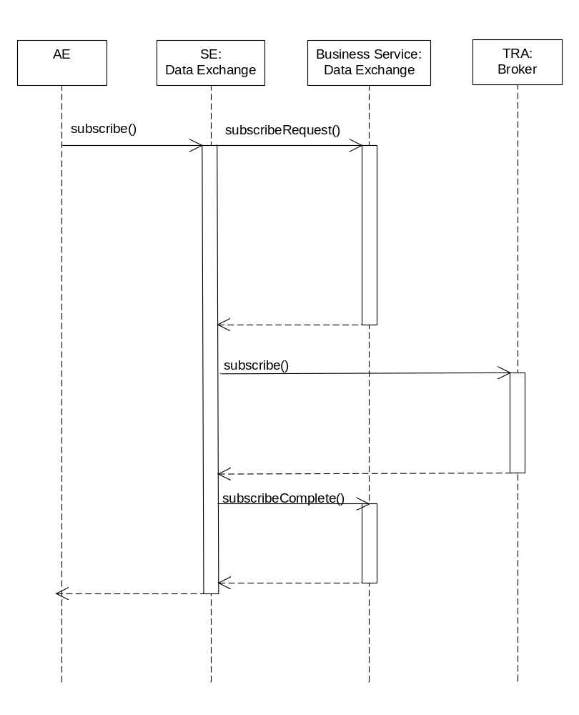
Figure 6.4.2.1.3-1 Data Exchange Service – subscribe capability

6.4.2.1.4 Post-Conditions
Not Applicable

6.4.2.1.5 Exceptions
Not Applicable

6.4.2.1.6 Policies for Use
Message Exchange Patterns: In-Out
Transaction Pattern: Participation allowed

6.4.2.1.7 oneM2M Resource Interworking
This service capability interworks with the following oneM2M Resource operations that are interworked are:
Not Applicable

6.4.2.2 publish
This service capability provides the ability for AEs to publish payloads to a leaf node of a publication resource.
As part of the publication, the publishing AE can provide a delivery policy to enhance the robustness of the publication to AEs that have subscribed to the Resource identified in the request.

6.4.2.2.1 Pre-conditions
The pre-conditions for Mca Received Requests are met.
A correlation between a M2M Service Subscription, resource to publish the payload, publishing AE and Broker exist.

6.4.2.2.2 Signature – publish
Parameter name | Direction | Optional | Description
toResource | IN | NO | The leaf node of a publication resource. See 6.4.1.1.1.1
deliveryPolicy | IN | YES | The delivery policy when notifying the subscriber. See 6.4.1.1.1.2
payload | IN | NO | The payload to published.
responseType | OUT | YES | Unique response types for this service.  Note: Consumed services also provide response types.  - Exception: Request may not have been completed
Table 6.4.2.2.2-1 Data Exchange Service – publish capability

6.4.2.2.3 Service Interactions
The interactions of service capabilities required for this service capability:
- Issue the publish request to the Supporting Service to validate the request
- Issue the request to the broker to publish the payload from the publishing AE to the resource in the request
- Issue the complete publication request to the Supporting Service
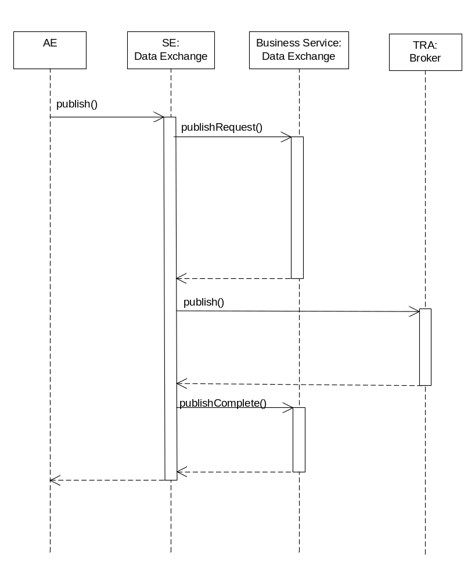
Figure 6.4.2.2.3-1 Data Exchange Service –publish (In-Out) capability

6.4.2.2.4 Post-Conditions
Not Applicable

6.4.2.2.5 Exceptions
Not Applicable

6.4.2.2.6 Policies for Use
Message Exchange Patterns: In-Out, In-Only
The In-Only message exchange pattern would return a transport layer acknowledgement if supported by the underlying transport layer protocol. Response types or Exceptions are not returned in this message exchange pattern.
Transaction Pattern: Participation allowed

6.4.2.2.7 oneM2M Resource Interworking
This service capability interworks with the following oneM2M Resource operations that are interworked are:
Not Applicable

6.4.2.3 notify
This service capability provides the ability to notify AEs that have subscribed to the publication resource identified in a publish request.

6.4.2.3.1 Pre-conditions
A correlation between a M2M Service Subscription, subscribed AE, publication resource and Broker exist.

6.4.2.3.2 Signature – notify
Parameter name | Direction | Optional | Description
fromResource | IN | NO | The leaf node of a publication resource. See 6.4.1.1.1.1
deliveryPolicy | IN | YES | The delivery policy when notifying the subscriber. See 6.4.1.1.1.2
payload | IN | NO | The Payload of the message to notify to the AE
responseType | OUT | YES | Unique response types for this service.  Note: Consumed services also provide response types.  - Exception: Request may not have been completed
Table 6.4.2.3.2-1 Data Exchange Service – notify capability

6.4.2.3.3 Post-Conditions
Not Applicable

6.4.2.3.4 Exceptions
Not Applicable

6.4.2.3.5 Policies for Use
Message Exchange Patterns: In-Out
Transaction Pattern: Participation allowed

6.4.2.3.6 oneM2M Resource Interworking
This service capability interworks with the following oneM2M Resource operations that are interworked are:
Not Applicable

6.4.2.4 sendMessage
This service capability provides the ability for AEs to send messages to a target AE.
As part of the message send request, the originating AE can provide a delivery policy to enhance the robustness of the message to the AE.

6.4.2.4.1 Pre-conditions
The pre-conditions for Mca Received Requests are met.
A correlation between a M2M Service Subscription, Originating AE and Transport Adapter exist.

6.4.2.4.2 Signature – sendMessage
Parameter name | Direction | Optional | Description
deliveryPolicy | IN | YES | The delivery policy when sending to the target AE. See 6.4.1.1.2.2
payload | IN | NO | The payload to be sent.
responseType | OUT | YES | Unique response types for this service.  Note: Consumed services also provide response types.  - Exception: Request may not have been completed
Table 6.4.2.4.2-1 Data Exchange Service – sendMessage capability

6.4.2.4.3 Service Interactions
The interactions of service capabilities required for this service capability:
- Issue the sendMessage request to the Supporting Service to validate the request
- Issue the request to the transport adapter (in this case the Broker service) to send the payload from the Originator to the target AE.
- Issue the complete sendMessage request to the Supporting Service
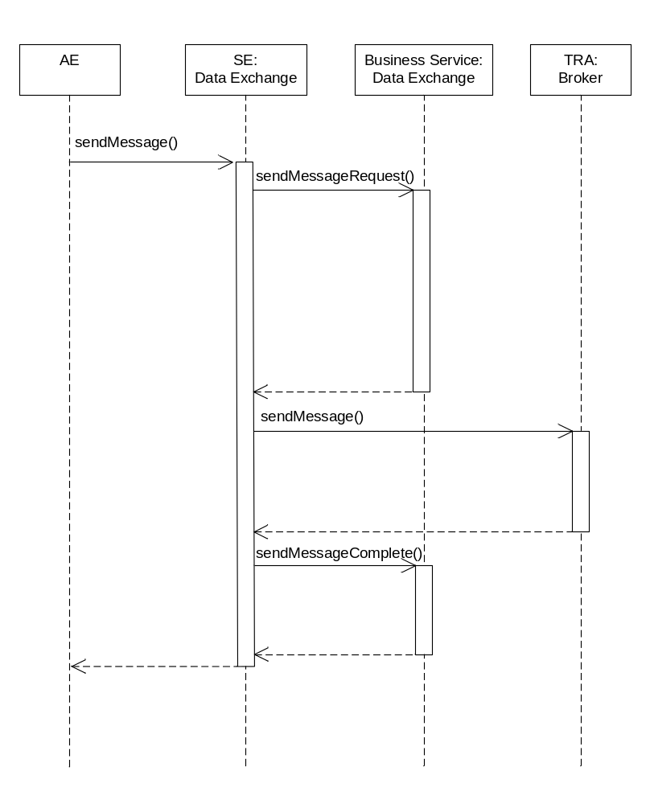
Figure 6.4.2.4.3-1 Data Exchange Service –sendMessage capability

6.4.2.4.4 Post-Conditions
Not Applicable

6.4.2.4.5 Exceptions
Not Applicable

6.4.2.4.6 Policies for Use
Message Exchange Patterns: In-Out
Transaction Pattern: Participation allowed

6.4.2.4.7 oneM2M Resource Interworking
Not Applicable

6.5 Broker

6.5.1 Overview
The Broker service provides the ability to adapt the Publish-Subscribe-Notify and Request Response data exchange patterns to the underlying transport protocol and deployment configuration.
The Broker maintains the subscriptions to the publication resources

6.5.2 Service Capabilities

6.5.2.1 subscribe
This service capability provides the ability for AEs to subscribe to receive payloads based on a publication resource.
As part of the publication, the publishing AE can provide delivery and retainment policies to enhance the robustness of the notification to AEs that have subscribed to the Resource identified in the request.

6.5.2.1.1 Pre-conditions
Not Applicable

6.5.2.1.2 Signature – subscribe
Parameter name | Direction | Optional | Description
publicationResource | IN | NO | The publication resource. See 6.4.1.1.1.1
deliveryPolicy | IN | YES | The delivery policy when notifying the subscriber. See 6.4.1.1.1.2
retainmentPolicy | IN | YES | The retainment policy for unconnected subscribers. See 6.4.1.1.1.3
responseType | OUT | YES | Unique response types for this service.  Note: Consumed services also provide response types.  - Exception: Request may not have been completed

Table 6.5.2.2.2-1 Broker – subscribe capability

6.5.2.1.3 Post-Conditions
Not Applicable

6.5.2.1.4 Exceptions
Not Applicable

6.5.2.1.5 Policies for Use
Message Exchange Patterns: In-Out
The In-Only message exchange pattern would return a transport layer acknowledgement if supported by the underlying Transaction Pattern: Participation allowed

6.5.2.2 publish
This service capability provides the ability for AEs to publish payloads to a leaf node of a publication resource.
As part of the publication, the publishing AE can provide a delivery policy to enhance the robustness of the publication to AEs that have subscribed to the Resource identified in the request.

6.5.2.2.1 Pre-conditions
Not Applicable.

6.5.2.2.2 Signature – publish
Parameter name | Direction | Optional | Description
toResource | IN | NO | The leaf node of a publication resource. See 6.4.1.1.1.1
deliveryPolicy | IN | YES | The delivery policy when notifying the subscriber. See 6.4.1.1.1.2
payload | IN | NO | Payload to be published.
responseType | OUT | YES | Unique response types for this service.  Note: Consumed services also provide response types.  - Exception: Request may not have been completed

Table 6.5.2.2.2-1 Broker – publish capability

6.5.2.3.3 Post-Conditions
Not Applicable

6.5.2.3.4 Exceptions
Not Applicable

6.5.2.3.5 Policies for Use
Message Exchange Patterns: In-Out
The In-Only message exchange pattern would return a transport layer acknowledgement if supported by the underlying Transaction Pattern: Participation allowed

6.5.2.3.6 oneM2M Resource Interworking
This service capability interworks with the following oneM2M Resource operations that are interworked are:
Not Applicable

6.5.2.3 notify
This service capability provides the ability for the Broker to notify AEs that have subscribed to the publication resource identified in the request.

6.5.2.3.1 Pre-conditions
The Broker maintains the AEs (to AE-ID, clientId) that have subscribed to publicationResources.
The Broker maintains the M2M Service Subscription (serviceSubscriptionId) for AE subscriptions to publicationResources.

6.5.2.3.2 Signature – notify
Parameter name | Direction | Optional | Description
payload | IN | NO | See Table A.2.1-1
fromResource | IN | NO | The leaf node of a publication resource. See 6.4.1.1.1.1
deliveryPolicy | IN | YES | The delivery policy when notifying the subscriber. See 6.4.1.1.1.2
responseType | OUT | YES | Unique response types for this service.  Note: Consumed services also provide response types.  - Originator does not have a Broker for the requested resource  - Originator has requested an invalid delivery policy  - Exception: Request may not have been completed
Table 6.5.2.3.2-1 Broker – notify capability

6.5.2.3.3 Service Interactions
For each AE subscribed to the resource perform the interactions of service capabilities required for this service capability:
- Issue the notify request to the Supporting Service to validate the request
- Issue the request to the SE: Data Exchange
- Issue the complete publication request to the Supporting Service
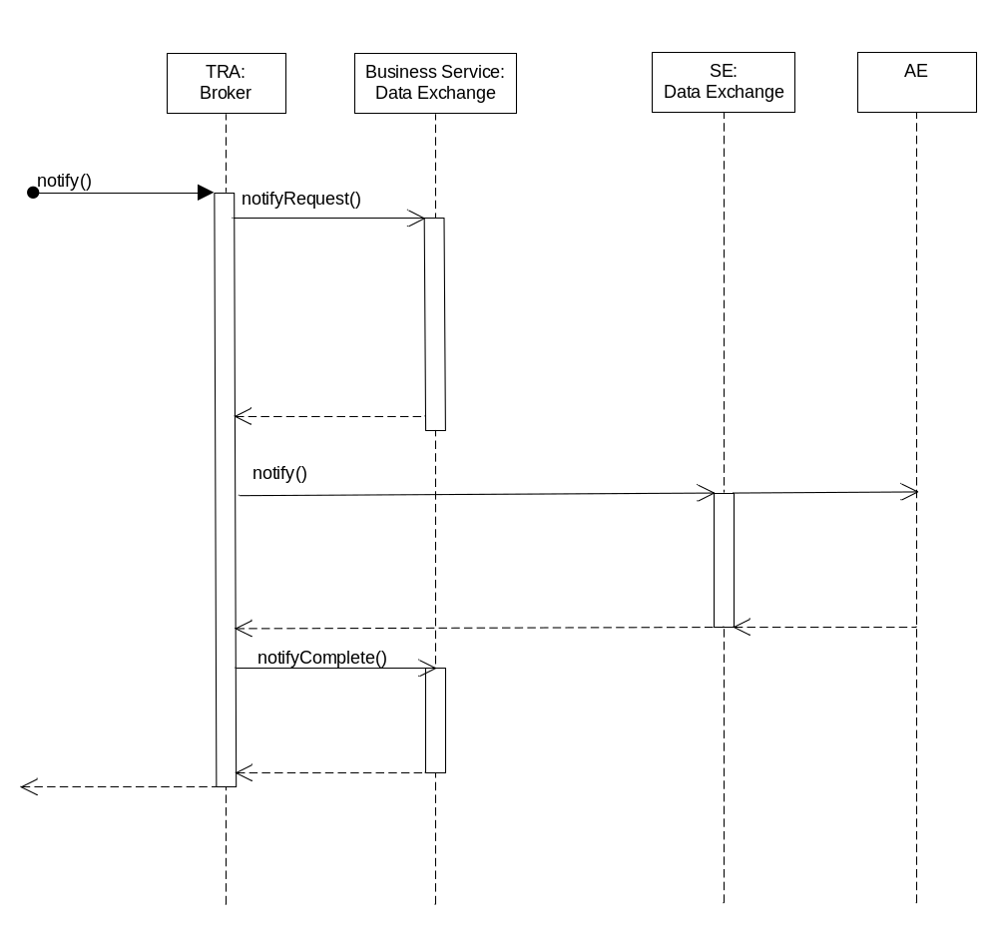
Figure 6.5.2.3.3-1 Broker –notify (In-Out) capability

6.5.2.3.4 Post-Conditions
Not Applicable

6.5.2.3.5 Exceptions
Not Applicable

6.5.2.3.6 Policies for Use
Message Exchange Patterns: In-Out, In-Only
The In-Only message exchange pattern would return a transport layer acknowledgement if supported by the underlying transport layer protocol. Response types or Exceptions are not returned in this message exchange pattern.
Transaction Pattern: Participation allowed

6.5.2.3.7 oneM2M Resource Interworking
This service capability interworks with the following oneM2M Resource operations that are interworked are:
Not Applicable

6.5.2.4 sendMessage
This service capability provides the ability for AEs to send message payloads to a target AE.
As part of the send message, the originating AE can provide delivery to enhance the robustness of the publication to AEs that have subscribed to the Resource identified in the request.

6.5.2.4.1 Pre-conditions
The Broker service has connectivity to the target AE where the target AE has subscribed to the Broker to receive send message requests from the Broker.

6.5.2.4.2 Signature – sendMessage
Parameter name | Direction | Optional | Description
deliveryPolicy | IN | YES | The delivery policy when notifying the subscriber. See 6.4.1.1.2.2
payload | IN | NO | Payload to be published.
responseType | OUT | YES | Unique response types for this service.  - Target AE is not subscribed with the Broker to receive messages  - Originator has requested an invalid delivery policy  Note: Consumed services also provide response types.  - Exception: Request may not have been completed

Table 6.5.2.4.2-1 Broker – sendMessage capability

6.5.2.4.3 Post-Conditions
Not Applicable

6.5.2.4.4 Exceptions
Not Applicable

6.5.2.4.5 Policies for Use
Message Exchange Patterns: In-Out
Transaction Pattern: Participation allowed

6.5.2.4.6 oneM2M Resource Interworking
Not Applicable

6.6 Device Management

6.6.1 Overview
The Device Management service provides for the capability for an AE to manage devices across the Mca Reference Point using supported device management message exchange patterns. This service utilizes management adapters to provide the management functions.
The supported device management message exchanges patterns are:
- Request-Response
- Request- Asynchronous Notification

6.6.1.1 Device Management
The Device Management service permits AEs to request management operations (e.g., device configuration operations, device troubleshooting operations, device firmware management operations, and application software management operations) and provide the result or report/retrieve the status of the operations to the originating AE.
AEs have the option to request to manage a targeted set of devices that include:
- Individual device
- Multiple devices through the use of lists of devices
- A group that designates as list of devices using the groupID.
AEs have option to request management operations to be performed based on a schedule.
AEs have the option to request that responses to requests be delivered synchronous (the request is held until all responses are received) or asynchronously (Reports of the operation are transmitted to the AE when an operation has completed) to the request submission. For asynchronous requests, reports are transmitted based on a report policy configured as part of the original request.
AEs also have the capability to request to manage devices by complex operations (e.g. upgradefirmware), where the M2M service platform can orchestrate management operations (e.g. installfirmware, downloadware) according to the business process.

6.6.1.1.1 Supporting Rules

6.6.1.1.1.1 Report Period Parameter
The reportPolicy parameter is used to determine when a report is sent by the M2M System to the AE. The report period attribute is defined in the reportPolicy parameter.
Parameter | Description
reportPeriod | Describes the period which reports for a operation are sent to the AE.
Table 6.6.1.1.1.1-1 Parameter:reportPolicy

6.6.1.1.1.2 Aggregation Policy Parameter
The aggregationPolicy parameter is used to determine the time period for aggregating the result of the management operation prior to the reports being sent to the AE. The aggregation period attribute is defined in the aggregationPolicy parameter.
Parameter | Description
aggregationPeriod | The time period of aggregating reports prior to transmission to the AE.
Table 6.6.1.1.1.2-1 Parameter: aggregationPolicy

6.6.1.1.1.3 Firmware Report Type
The FirmwareReport is complex type that defines the current state of a firmware management operation for a specific device.
Parameter | Optional | Description
groupId | YES | The group identifier.
deviceId | NO | The unique device identifier in the context of the M2M Service Subscription.
operation | YES | The firmware management operation.(e.g. installFirmware, downloadFirmware)
operationResult | YES | The firmware management operation execution result.
operationStatus | YES | The firmware management operation execution status. It can be Initiated, Started, Finished, Cancelled, or Deleted.
Table 6.6.1.1.1.3-1 Type: FirmwareReport

6.6.1.1.1.4 Orchestration Rule Type
The OrchestrationRule is a complex type that describes the target and associated schedule of the request for the execution of the management operation.
Parameter | Optional | Description
groupId | YES | The group identifier.
deviceId | NO | The unique device identifier in the context of the M2M Service Subscription.
operation | NO | The orchestrated operation. (e.g. installFirmware, downloadFirmware)
schedule | YES | The time when to execute firmware operation. If it is not provided, the operation shall be executed immediately.
Table 6.6.1.1.1.4-1 Type: OrchestrationRule

6.6.1.1.1.5 Firmware Info Type
The FirmwareInfo is a complex type that describes the version, name, URL of the device firmware.
Parameter | Optional | Description
version | YES | The version of the firmware.
name | YES | The name of the firmware to be used on the device.
url | YES | The URL from which the firmware image can be downloaded.
Table 6.6.1.1.1.5-1 Type: FirmwareInfo

6.6.1.1.1.6 Service Subscription Integration
In order for the Device Management Service to take advantage of the Management Adapter, there shall be association between the device associated with a Service Subscription and the service capability to the Management Adapter.

6.6.1.1.1.7 Device Info Type
The DeviceInfo is a complex type that describes the device label, manufacturer, model, device type, firmware version, software version, hardware version.
Parameter | Optional | Description
deviceLabel | YES | Unique device label assigned by the manufacturer. The uniqueness may be global or only valid within a certain domain (e.g. vendor-wise or for a certain deviceType).
manufacturer | YES | The name/identifier of the device manufacturer.
model | YES | The name/identifier of the device mode assigned by the manufacturer.
deviceType | YES | The type (e.g. cell phone, photo frame, smart meter) or product class (e.g. X-series) of the device.
fwVersion | YES | The firmware version of the device.  NOTE: If the device only supports one kind of Software this is identical to softwareVersion.
swVersion | YES | The software version of the device.
hwVersion | YES | The hardware version of the device.
Table 6.6.1.1.1.7-1 Type: DeviceInfo

6.6.1.1.1.8 Memory Type
The Memory is a complex type that describes the current available amount of memory and the total amount of memory.
Parameter | Optional | Description
memAvailable | YES | The current available amount of memory in bytes.
memTotal | YES | The total amount of memory in bytes.
Table 6.6.1.1.1.8-1 Type: Memory

6.6.1.1.1.9 Battery Type
The Battery is a complex type that describes the current battery level and the status of the battery.
Parameter | Optional | Description
level | YES | The current battery level as a percent of the battery capacity
status | YES | Indicates the status of the battery. Enum BatteryStatus, see 6.6.1.1.1.11.
Table 6.6.1.1.1.9-1 Type: Battery

6.6.1.1.1.10 DeviceCapability Type
The DeviceCapability is a complex type that describes the name of the capability, attach label, capability action status.
Parameter | Optional | Description
name | YES | The name of the capability. Enum DeviceCapabilityName, see 6.6.1.1.1.12.
attached | YES | Indicates whether the capability is attached to the device or not.
state | NO | Indicates if the capability is enabled or disabled
Table 6.6.1.1.1.10-1 Type: DeviceCapability

6.6.1.1.1.11 BatteryStatus Enum
Battery Status | Description
Normal | The battery is operating normally and not on power.
Charging | The battery is currently charging.
Charge Complete | The battery is fully charged and still on power.
Damaged | The battery has some problem.
Low Battery | The battery is low on charge.
Not Installed | The battery is not installed.
Unknown | The battery information is not available.
Table 6.6.1.1.1.11-1 Enum: BatteryStatus

6.6.1.1.1.12 DeviceCapabilityName Enum
Device Capability Name | Description
Hardware: ExternalMemory | Used to enable/disable the removable card memory or storage disk.
Hardware: Display | Used to enable/disable the display screen.
Hardware: Camera | Used to enable/disable the camera.
Hardware: Speaker | Used to enable/disable the speaker.
I/O: Tethering | Used to enable/disable the device to be attached to other devices.
I/O: AudioInputEncoder | Used to enable/disable the audio input encoder.
I/O: AttachedDevice | Used to enable/disable the capability to allow other devices to be attached to this device.
I/O: Keyboard | Used to enable/disable the keyboard
I/O: InputPeripheral | Used to enable/disable the input peripheral.
I/O: OutputPeripheral | Used to enable/disable the output peripheral.
I/O: USB | Used to enable/disable the USB port.
I/O: SerialPort | Used to enable/disable the serial port.
I/O: ParallelPort | Used to enable/disable the Parallel port.
I/O: GPS | Used to enable/disable GPS capability
I/O: GNSS | Used to enable/disable GNSS capability
Connectivity: Bluetooth | Used to enable/disable the Bluetooth connectivity.
Connectivity: WLAN | Used to enable/disable the WLAN connectivity.
Connectivity: Infrared | Used to enable/disable the Infrared connectivity.
Connectivity: WCDMA | Used to enable/disable the WCDMA connectivity
Connectivity: GPRS | Used to enable/disable the GPRS connectivity
Connectivity: EDGE | Used to enable/disable the EDGE connectivity
Connectivity: CDMA | Used to enable/disable the CDMA connectivity
Connectivity: WiMAX | Used to enable/disable the WiMAX connectivity
Connectivity: LTE | Used to enable/disable the LTE connectivity
Connectivity: NFC | Used to enable/disable the NFC connectivity
Connectivity: TD-SCDMA | Used to enable/disable the TD-SCDMA connectivity
LAN Interfaces: USB | Used to enable/disable the USB Interface
LAN Interfaces: Wi-Fi | Used to enable/disable the Wi-Fi Radio
LAN Interfaces: HomePlug | Used to enable/disable the HomePlug Interface
LAN Interfaces: MoCA | Used to enable/disable the MoCA Interface
LAN Interfaces: UPA | Used to enable/disable the UPA Interface
Hardware: SmartCardReader | Used to enable/disable the SmartCardReader
Table 6.6.1.1.1.11-1 Enum: DeviceCapabilityName

6.6.1.1.1.13 LockStatus Enum
Lock Status | Description
locked | The device is locked.
unlocked | The device is unlocked.
Table 6.6.1.1.1.11-1 Enum: LockedStatus

6.6.1.1.1.14 Area Network Info Type
The AreaNwkInfo is a complex type that describes the information about a M2M area network. Information includes the area network identifier, area network name, area network type, and the list of devices in the M2M Area Network.
Parameter | Optional | Description
areaNwkId | NO | The unique area network identifier.
areaNwkName | YES | The Area Network name.
areaNwkType | YES | The areaNwkType is an implementation-chosen string that indicates the type of M2M Area Network.
listOfDevices | YES | Indicates the list of devices in the M2M Area Network. Type AreaNwkDevice, see 6.6.1.1.1.15. From listOfDevices, the topology of the area network can be discovered and retrieved.
Table 6.6.1.1.1.14-1 Type: AreaNwkInfo

6.6.1.1.1.15 Area Network Device Type
The AreaNwkDevice is a complex type that describes the device information for a device in the context of a M2M Area Network. Information includes the device identifier, area network identifier and the area network device specific information.
Parameter | Optional | Description
deviceId | NO | The unique device identifier in the context of the M2M Service Subscription.
areaNwkDeviceInfo | YES | The area network device information. Type AreaNwkDeviceInfo, see 6.6.1.1.1.16.
Table 6.6.1.1.1.15-1 Type: AreaNwkDevice

6.6.1.1.1.16 Area Network Device Info Type
The AreaNwkDeviceInfo is a complex type that describes information about the device in the context of the M2M Area Network. Information includes the type of device, the interval of time between two sleep cycles, the time duration of each sleep cycle, the status of the device and any neighbor devices.
Parameter | Optional | Description
deviceType | YES | The type (e.g. cell phone, photo frame, smart meter) or product class (e.g. X-series) of the device.
sleepInterval | YES | The interval between two sleep cycles.
sleepDuration | YES | The time duration of each sleep cycle.
status | YES | The status of the device (sleeping or waked up).
listOfNeighbors | YES | Indicates the neighbour devices of the same area network. When modified, the connection relationship of the devices shall be modified accordingly.
Table 6.6.1.1.1.16-1 Type: AreaNwkDeviceInfo

6.6.1.1.1.17 LogTypeId Enum
LogTypeId | Description
system | System log
security | Security log
event | Event log
trace | Trace log
panic | Panic log
Table 6.6.1.1.1.17-1 Enum: LogTypeId

6.6.1.1.1.18 LogStatus Enum
LogStatus | Description
Started | the logging activity is started
Stopped | the logging activity is stopped
Unknown | the current status of the logging activity is unknown.
NotPresent | the log data is not present and the logData attribute shall be ignored.
Error | error conditions for the logging activities, and the logging is stopped.
Table 6.6.1.1.1.18-1 Enum: LogStatus

6.6.1.1.1.19 LogInfo Type
The LogInfo is a complex type that describes the log type, diagnostic data, log action status.
Parameter | Optional | Description
logTypeId | NO | The type of the log. E.g. security log, system log.  Enum LogTypeId, see 6.6.1.1.1.17.
logData | NO | Diagnostic data logged upon event of interests defined by the diagnostic function.
logActionStatus | NO | Indicates the status of the Action. E.g. Started, Stopped.  Enum LogStatus, see 6.6.1.1.1.18.
Table 6.6.1.1.1.19-1 Type: LogInfo

6.6.1.1.1.20 TroubleshootingReport Type
The TroubleshootingReport is complex type that defines the current state of a troubleshooting operation for a specific device.
Parameter | Optional | Description
groupId | YES | The group identifier.
deviceId | NO | The unique device identifier in the context of the M2M Service Subscription.
operation | YES | The troubleshooting operation.(e.g. rebootDevice, resetDevice, uploadDeviceLog)
operationResult | YES | The troubleshooting operation execution result.
operationStatus | YES | The troubleshooting operation execution status. It can be Initiated, Started, Finished, Cancelling, or Cancelled.
Table 6.6.1.1.1.20-1 Type: TroubleshootingReport

6.6.1.1.1.21 Log Type
The Log is a complex type that describes the log information, log URL.
Parameter | Optional | Description
logInfo | NO | The log information. Type LogInfo, see 6.6.1.1.1.19.
logURL | NO | The URL from which the log can be accessed.
Table 6.6.1.1.1.21-1 Type: Log

6.6.1.1.1.22 Log Filter Criteria
Criterion name | Description
logTypeId | The type of the log. E.g. security log, system log.  Enum LogTypeId, see 6.6.1.1.1.17.
startTime | The start time of log.
endTime | The end time of log.
Table 6.6.1.1.1.22 Log Filter Criteria

6.6.1.1.1.24 Action Enum
InstallStatus | Description
Install | The action that installs the software.
Uninstall | The action that un-installs the software.
Activate | The action that activates software previously installed.
Deactivate | The action that deactivates software.
Table 6.6.1.1.1.24-1 Enum: Action

6.6.1.1.1.25 Status Enum
LogStatus | Description
Successful | The status is successful.
Failure | The status is failure.
In-Process | The status is in process.
Table 6.6.1.1.1.25-1 Enum: Status

6.6.1.1.1.26 ActionStatus Type
The ActionStatus is a complex type that describes the action and related status.
Parameter | Optional | Description
action | NO | The action being performed  Enum Action, see 6.6.1.1.1.24.
status | NO | Indicates the status of the operation is successful, failure or in process. Enum Status, see 6.6.1.1.1.25.
Table 6.6.1.1.1.26-1 Type: ActionStatus

6.6.1.1.1.27 SoftwareReport Type
The SoftwareReport is complex type that defines the current state of an application software management operation for a specific device.
Parameter | Optional | Description
groupId | YES | The group identifier.
deviceId | NO | The unique device identifier in the context of the M2M Service Subscription.
operation | YES | The application software management operation.(e.g. downloadSoftware, installSoftware, activateSoftware, deactivateSoftware, removeSoftware)
operationResult | YES | The application software management operation execution result.
installStatus | YES | Indicates the status of the install.  Enum ActionStatus, see 6.6.1.1.1.26.
activeStatus | YES | The status of active or deactivate action.  Enum ActionStatus, see 6.6.1.1.1.26.
Table 6.6.1.1.1.27-1 Type: SoftwareReport

6.6.2 Service Capabilities

6.6.2.1 downloadFirmware
This service capability provides the ability for AEs to download device firmware.

6.6.2.1.1 Pre-conditions
The pre-conditions for Mca Received Requests are met.
A correlation between a Management Adapter, the service capability and device exist.

6.6.2.1.2 Signature – downloadFirmware
Parameter name | Direction | Optional | Description
firmwareInfo | IN | NO | The device firmware information.  Type FirmwareInfo, see 6.6.1.1.1.5
deviceId | IN | YES | The unique device identifier in the context of the M2M Service Subscription.
reportPolicy | IN | YES | The policy used to report the state of the operation to the originating AE. See clause 6.6.1.1.1.1.
requestId | OUT | NO | The M2M Request Identifier (M2M-Request-ID)
firmwareReport | OUT | YES | The firmware management operation execution result or status. Type FirmwareReport, see 6.6.1.1.1.3.
responseType | OUT | YES | Unique response types for this service.  Note: Consumed services also provide response types.  - Issuer does not have a Management Adapter for the requested operation  - Report policy does not supported by the Management Adapter  - Firmware download failure,e.g. firmware miss dependency, firmware is too large for available program or data memory
Table 6.6.2.1.2-1 Device Management Service –downloadFirmware capability

6.6.2.1.3 Service Interactions
The interactions of service capabilities required for this service capability:
- Issue the request to the Supporting Service to perform the operation

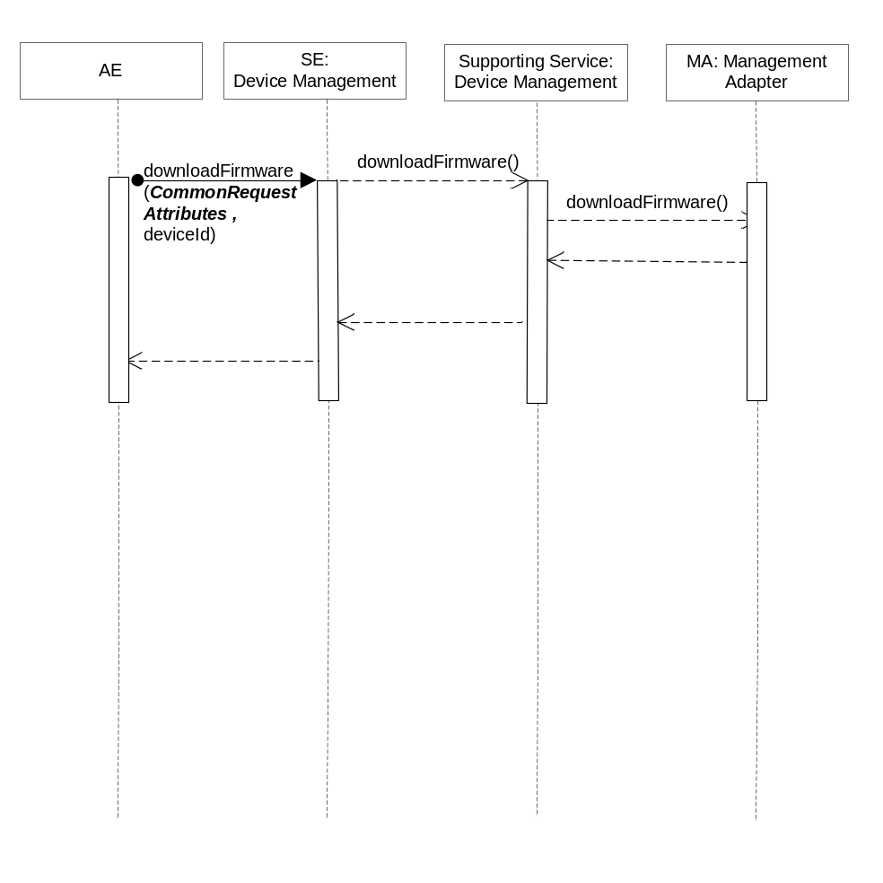
Figure 6.6.2.1.3-1 downloadFirmware Diagram

6.6.2.1.4 Post-Conditions
The Management Adapter has submitted a request to the Management Server to download firmware.

6.6.2.1.5 Exceptions
Not Applicable

- 6.6.2.1.6 Policies for Use
Message Exchange Patterns: In-Out
Transaction Pattern: Participation allowed

6.6.2.1.7 oneM2M Resource Interworking
This service capability is used to download firmware. The service capability aligns with the <firmware> resource and maps to the UPDATE procedure for the attribute update of the resource. The service capability also aligns with the <mgmtCmd> resource and maps to the EXECUTE procedure for the resource.

6.6.2.2 installFirmware
This service capability provides the ability for AEs to install firmware on the device.

6.6.2.2.1 Pre-conditions
The pre-conditions for Mca Received Requests are met.
A correlation between a Management Adapter, the service capability and device exist.

The firmware to be installed exists on the device.

6.6.2.2.2 Signature –installFirmware
Parameter name | Direction | Optional | Description
firmwareInfo | IN | NO | The device firmware information.  Type FirmwareInfo, see 6.6.1.1.1.5
deviceId | IN | YES | The unique device identifier in the context of the M2M Service Subscription.
reportPolicy | IN | YES | The policy used to report the state of the operation to the originating AE.
requestId | OUT | NO | The M2M Request Identifier (M2M-Request-ID)
firmwareReport | OUT | YES | The firmware management operation execution result or status. Type FirmwareReport, see 6.6.1.1.1.3.
responseType | OUT | YES | Unique response types for this service.  Note: Consumed services also provide response types.  - Issuer does not have a Management Adapter for the requested operation  - Report policy does not supported by the Management Adapter  - Firmware install failure, e.g. firmware is missing dependency on the device, firmware is too large for available program or data memory
Table 6.6.2.2.2-1 Device Management Service –installFirmware capability

6.6.2.2.3 Service Interactions
The interactions of service capabilities required for this service capability:
- Issue the request to the Supporting Service to perform the operation
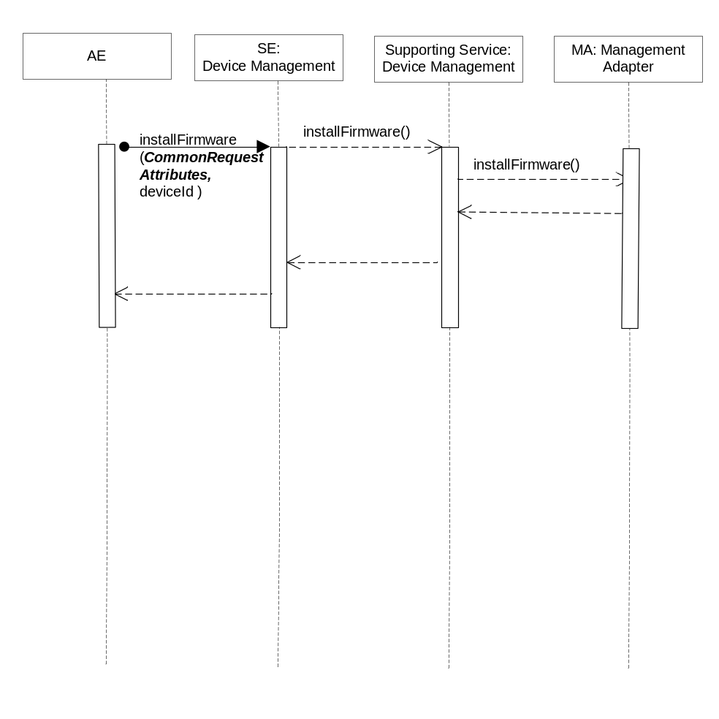
Figure 6.6.2.2.3-1 installFirmware Diagram

6.6.2.2.4 Post-Conditions
The Management Adapter has submitted a request to the Management Server to install firmware.

6.6.2.2.5 Exceptions
- Not Applicable

6.6.2.2.6 Policies for Use
Message Exchange Patterns: In-Out
Transaction Pattern: Participation allowed

6.6.2.2.7 oneM2M Resource Interworking
This service capability is used to install firmware. The service capability aligns with the <firmware> resource and maps to the UPDATE procedure for the attribute update of the resource. The service capability also aligns with the <mgmtCmd> resource and maps to the EXECUTE procedure for the resource.

6.6.2.3 getFirmwareInformation
This service capability provides the ability for AEs to get device firmware information.

6.6.2.3.1 Pre-conditions
The pre-conditions for Mca Received Requests are met.
A correlation between a Management Adapter, the service capability and device exist.

6.6.2.3.2 Signature –getFirmwareInformation
Parameter name | Direction | Optional | Description
deviceId | IN | YES | The unique device identifier in the context of the M2M Service Subscription.
reportPolicy | IN | YES | The policy used to report the state of the operation to the originating AE.
requestId | OUT | NO | The M2M Request Identifier (M2M-Request-ID)
firmwareInfo | OUT | YES | The device firmware information.  Type FirmwareInfo, see 6.6.1.1.1.5
responseType | OUT | YES | Unique response types for this service.  Note: Consumed services also provide response types.  - Issuer does not have a Management Adapter for the requested operation  - Report policy does not supported by the Management Adapter
Table 6.6.2.3.2-1 Device Management Service –getFirmwareInformation capability

6.6.2.3.3 Service Interactions
The interactions of service capabilities required for this service capability:
- Issue the request to the Supporting Service to perform the operation
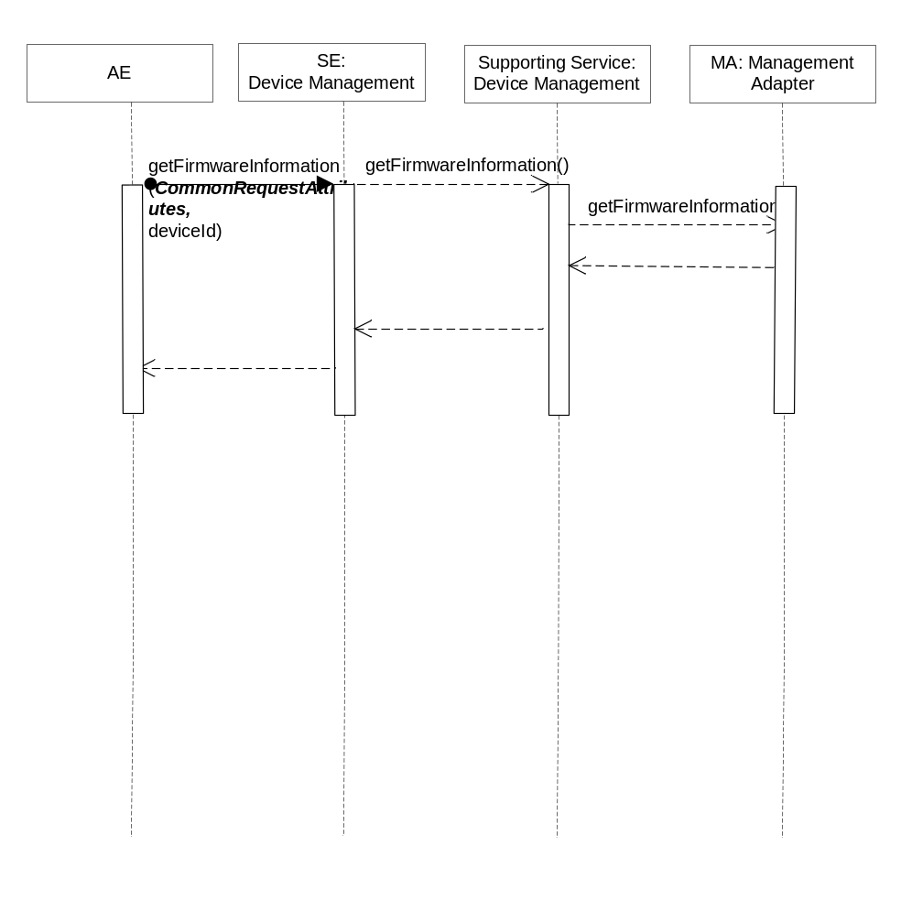
Figure 6.6.2.3.3-1 getFirmwareInformation Diagram

6.6.2.3.4 Post-Conditions
The Management Adapter has submitted a request to the Management Server to get firmware information.

6.6.2.3.5 Exceptions
Not Applicable

6.6.2.3.6 Policies for Use
Message Exchange Patterns: In-Out
Transaction Pattern: Participation allowed

6.6.2.3.7 oneM2M Resource Interworking
This service capability is used to get firmware information. The service capability aligns with the <firmware> resource and maps to the RETRIEVE procedure for the attribute version, name, URL of the resource.

6.6.2.4 getFirmwareExecStatus
This service capability provides the ability for AEs to get state of firmware management operation for a specific device.

6.6.2.4.1 Pre-conditions
The pre-conditions for Mca Received Requests are met.
A correlation between a Management Adapter, the M2M Service Capability and previously submitted firmware request exist.

6.6.2.4.2 Signature –getFirmwareExecInstance
Parameter name | Direction | Optional | Description
operationRequestId | IN | NO | The M2M Request Identifier of previously submitted firmware request (M2M-Request-ID)
deviceId | IN | YES | The unique device identifier in the context of the M2M Service Subscription.
requestId | OUT | NO | The M2M Request Identifier (M2M-Request-ID)
firmwareReport | OUT | YES | The firmware management operation execution result or status. Type FirmwareReport, see 6.6.1.1.1.3.
responseType | OUT | YES | Unique response types for this service.  Note: Consumed services also provide response types.  - Issuer does not have a Management Adapter for the requested operation  - Report policy is not supported by the Management Adapter  - The previously submitted firmware request does not exist
Table 6.6.2.4.2-1 Device Management Service –getFirmwareExecInstance capability

6.6.2.4.3 Service Interactions
The interactions of service capabilities required for this service capability:
- Issue the request to the Supporting Service to perform the operation
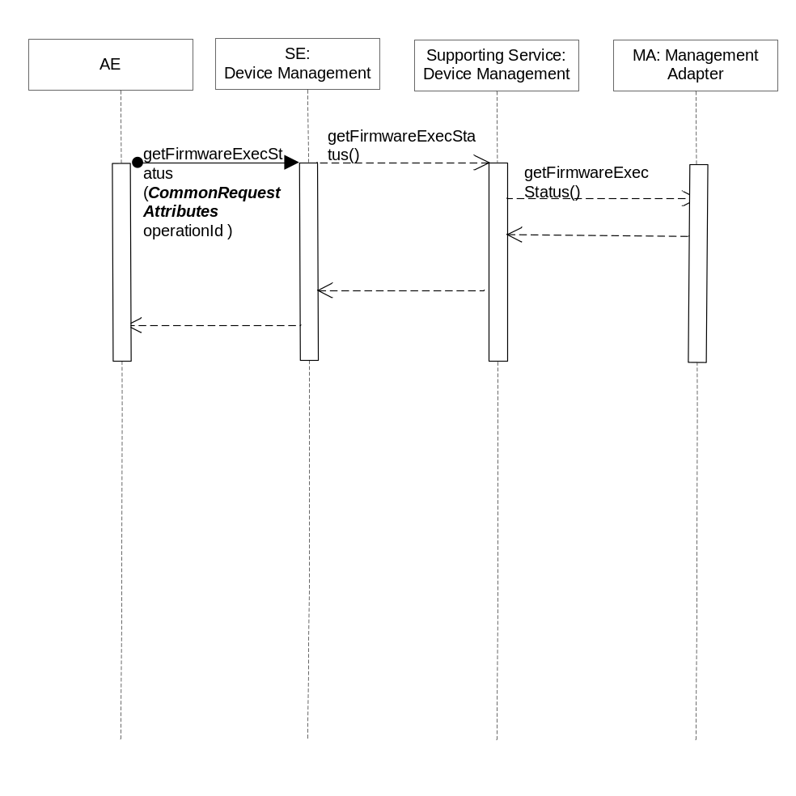
Figure 6.6.2.3.3-1 getFirmwareExecStatus Diagram

6.6.2.4.4 Post-Conditions
The Management Adapter has submitted a request to the Management Server to get firmware state of management operation.

6.6.2.4.5 Exceptions
Not Applicable

6.6.2.4.6 Policies for Use
Message Exchange Patterns: In-Out
Transaction Pattern: Participation allowed

6.6.2.4.7 oneM2M Resource Interworking
This service capability is used to get state of firmware management operation. The service capability aligns with the <firmware> resource and maps to the RETRIEVE procedure for the attribute updateStatus of the resource. The service capability also aligns with the <execInstance> resource and maps to the RETRIEVE procedure for the attribute execStatus, execResult of the resource.

6.6.2.5 reportFirmwareStatus
This service capability provides the ability to report the firmware management operation execution result or status information to the AE.

6.6.2.5.1 Pre-conditions
A correlation between a Management Adapter, the M2M Service Capability and previously submitted firmware request exist.

6.6.2.5.2 Signature –reportFirmwareStatus
Parameter name | Direction | Optional | Description
isLastReport | IN | NO | Boolean, whether it is the last report.
sequenceNumber | IN | NO | The report sequence number.
firmwareReportList | IN | NO | Array of firmwareReport.  Type FirmwareReport, see 6.6.1.1.1.3.
aggregationPolicy | IN | YES | The policy used to aggregate the result of the management operation prior to the reports being sent. See clause 6.6.1.1.1.2.
responseType | OUT | YES | Unique response types for this service.  Note: Consumed services also provide response types.  - The target AE does not exist.  - Aggregation policy does not supported
Table 6.3.2.5.2-1 Device Management Service –reportFirmwareStatus capability

6.6.2.5.3 Post-Conditions
The AE has received a report of firmware operation execution status or result.
Editor’s note; There are post conditions that requires the M2M System to maintain the “state” of the report (i.e., sequence number.

6.6.2.5.4 Exceptions
Not Applicable

6.6.2.5.5 Policies for Use
Message Exchange Patterns: In-Out
Transaction Pattern: Participation allowed

6.6.2.5.6 oneM2M Resource Interworking
Not Applicable

6.6.2.6 upgradeFirmware
This service capability is a complex operation for AEs to upgrade firmware on one or more devices. The service capability utilizes orchestration rules for the related management operations such as downloadFirmware, installFirmware, getFirmwareInformation, getFirmwareExecInstance and reportFirmwareStatus according to the business process.
This service capability permits AEs to upgrade the firmware on individual device, multiple devices or a group of devices. In addition the upgrade of the firmware is permitted based on a schedule for each of the operations.

6.6.2.6.1 Pre-conditions
The pre-conditions for Mca Received Requests are met.
A correlation between Management Adapter, the service capability and devices or device group exist.

6.6.2.6.2 Signature – upgradeFirmware
Parameter name | Direction | Optional | Description
orchestrationRuleList | IN | NO | List of OrchestrationRule. Type OrchestrationRule, see clause 6.6.1.1.1.4.
reportPolicy | IN | YES | The policy used to report the state of the operation to the originating AE. See clause 6.6.1.1.1.1.
aggregationPolicy | IN | YES | The policy used to aggregate the result of the management operation prior to the reports being sent. See clause 6.6.1.1.1.2.
requestId | OUT | NO | The M2M Request Identifier (M2M-Request-ID)
firmwareReportList | OUT | YES | Array of firmwareReport.  Type FirmwareReport, see 6.6.1.1.1.3.
responseType | OUT | YES | Unique response types for this service.  Note: Consumed services also provide response types.  - Report policy is not supported by the Management Adapter  - Aggregation policy is not supported by the Management Adapter  - The Orchestration Rules are not supported by the Management Adapter  - Operation exception: The device’s reachability schedule is inconsistent with the schedule of the Orchestration rule.
Table 6.6.2.6.2-1 Device Management Service –upgradeFirmware capability
Editors Note: Need to clarify the device’s reachability schedule.

6.6.2.6.3 Service Interactions
The interactions of service capabilities required for this service capability:
- Issue the request to the Supporting Service to perform the operation

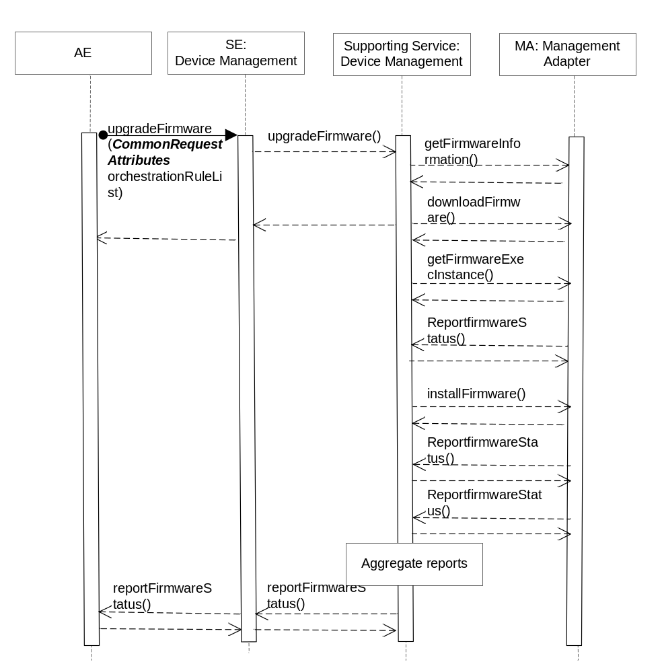

Figure 6.6.2.1.6-1 upgradeFirmware Diagram

6.6.2.6.4 Post-Conditions
The Management Adapter has submitted a set of requests to the Management Server to manage firmware.

6.6.2.6.5 Exceptions
- The device’s reachability schedule is inconsistent with the schedule of the Orchestration rule.

6.6.2.6.6 Policies for Use
Message Exchange Patterns: In-Out
Transaction Pattern: Participation allowed

6.6.2.6.7 oneM2M Resource Interworking
Not Applicable

6.6.2.7 getDeviceInformation
This service capability provides the ability for AEs to get device information.

6.6.2.7.1 Pre-conditions
The pre-conditions for Mca Received Requests are met.
A correlation between a Management Adapter, the M2M Service Capability and device exist.

6.6.2.7.2 Signature – getDeviceInformation
Parameter name | Direction | Optional | Description
deviceId | IN | NO | The unique device identifier in the context of the M2M Service Subscription.
deviceInfo | OUT | NO | The device information. Type DeviceInfo, see 6.6.1.1.1.7.
memory | OUT | YES | The memory information. Type Memory, see 6.6.1.1.1.8.
battery | OUT | YES | The battery information. Type Battery, see 6.6.1.1.1.9.
lockStatus | OUT | YES | The device lock status. Enum LockStatus, see 6.6.1.1.1.13.
responseType | OUT | YES | Unique response types for this service.  Note: Consumed services also provide response types.  - Issuer does not have a Management Adapter for the requested operation
Table 6.6.2.7.2-1 Device Management Service –getDeviceInformation capability

6.6.2.7.3 Service Interactions
The interactions of service capabilities required for this service capability:
- Issue the request to the Supporting Service to perform the operation

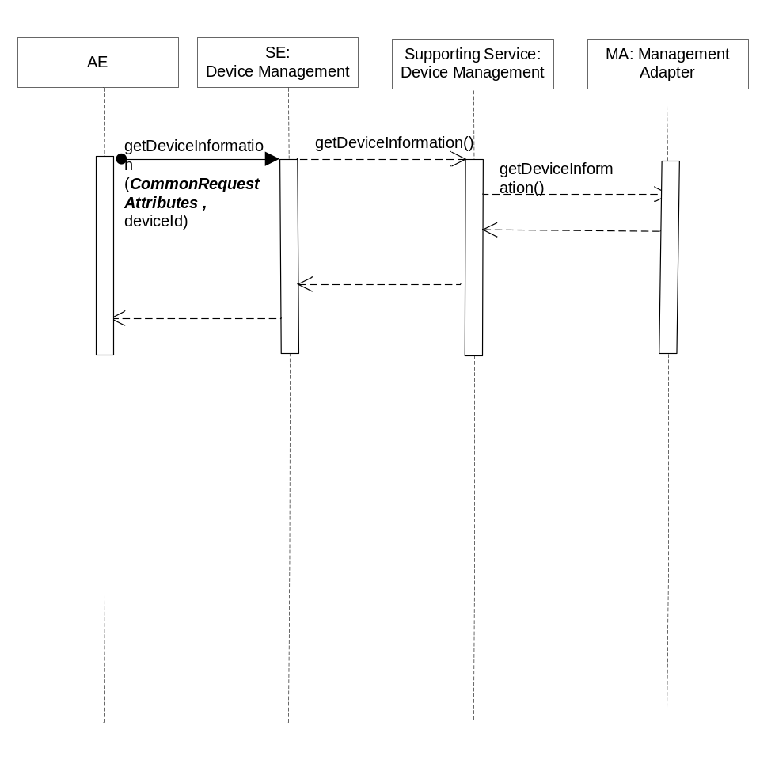
Figure 6.6.2.7.3-1 getDeviceInformation Diagram

6.6.2.7.4 Post-Conditions
The Management Adapter has submitted a request to the Management Server to get device information.
Based on the capabilities supported by the device, the memory, battery and lock status information may or may not be returned.

6.6.2.7.5 Exceptions
Not Applicable

6.6.2.7.6 Policies for Use
Message Exchange Patterns: In-Out
Transaction Pattern: Participation allowed

6.6.2.7.7 oneM2M Resource Interworking
This service capability is used to get device information. The service capability aligns with the <deviceInfo> resource and maps to the Retrieve procedure for the resource. The service capability aligns with the <memory> resource and maps to the Retrieve procedure for the resource. The service capability aligns with the <battery> resource and maps to the Retrieve procedure for the resource.

6.6.2.8 getDeviceCapabilities
This service capability provides the ability for AEs to get the device capabilities.

6.6.2.8.1 Pre-conditions
The pre-conditions for Mca Received Requests are met.
A correlation between a Management Adapter, the M2M Service Capability and device exist.

6.6.2.8.2 Signature –getDeviceCapabilities
Parameter name | Direction | Optional | Description
deviceId | IN | NO | The unique device identifier in the context of the M2M Service Subscription.
deviceCapabilities | OUT | YES | List of deviceCapability. Type DeviceCapability, see 6.6.1.1.1.10.
responseType | OUT | YES | Unique response types for this service.  Note: Consumed services also provide response types.  - Issuer does not have a Management Adapter for the requested operation
Table 6.6.2.8.2-1 Device Management Service –getDeviceCapabilities capability

6.6.2.8.3 Service Interactions
The interactions of service capabilities required for this service capability:
- Issue the request to the Supporting Service to perform the operation
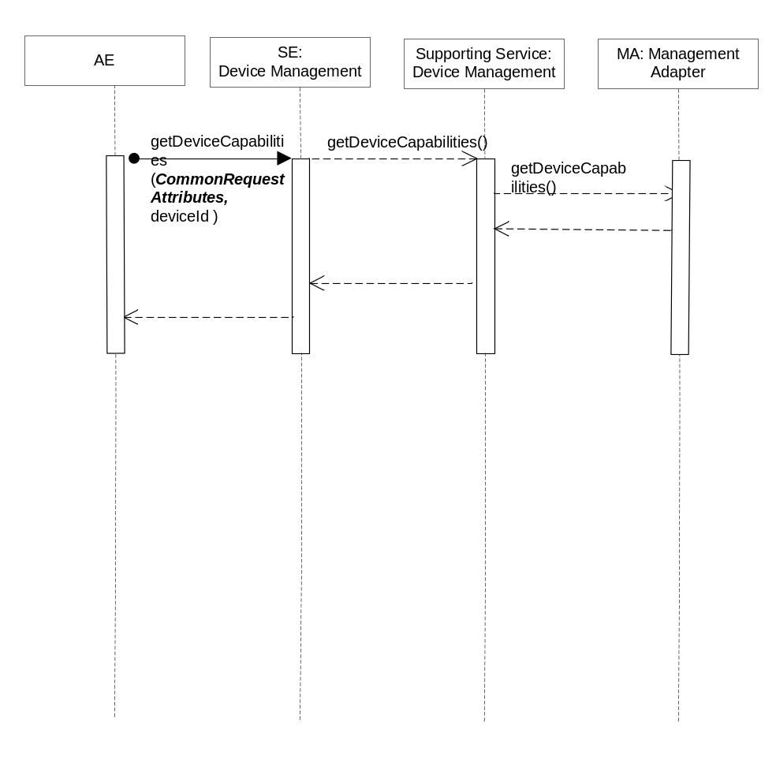
Figure 6.6.2.8.3-1 getDeviceCapabilities Diagram

6.6.2.8.4 Post-Conditions
The Management Adapter has submitted a request to the Management Server to get device capabilities.

6.6.2.8.5 Exceptions
Not Applicable

6.6.2.8.6 Policies for Use
Message Exchange Patterns: In-Out
Transaction Pattern: Participation allowed

6.6.2.8.7 oneM2M Resource Interworking
This service capability is used to get device capabilities. The service capability aligns with the<deviceCapability> resource and maps to the RETRIEVE procedure for the resource.

6.6.2.9 enableDeviceCapability
This service capability provides the ability for AEs to enable device capability.

6.6.2.9.1 Pre-conditions
The pre-conditions for Mca Received Requests are met.
A correlation between a Management Adapter, the M2M Service Capability and device exist.

6.6.2.9.2 Signature –enableDeviceCapability
Parameter name | Direction | Optional | Description
deviceId | IN | NO | The unique device identifier in the context of the M2M Service Subscription.
Name | IN | NO | The name of the capability. Enum DeviceCapabilityName, see 6.6.1.1.1.12.
state | OUT | NO | Indicates if the capability is enabled or disabled.
responseType | OUT | YES | Unique response types for this service.  Note: Consumed services also provide response types.  - Issuer does not have a Management Adapter for the requested operation
Table 6.6.2.9.2-1 Device Management Service –enableDeviceCapability capability

6.6.2.9.3 Service Interactions
The interactions of service capabilities required for this service capability:
- Issue the request to the Supporting Service to perform the operation
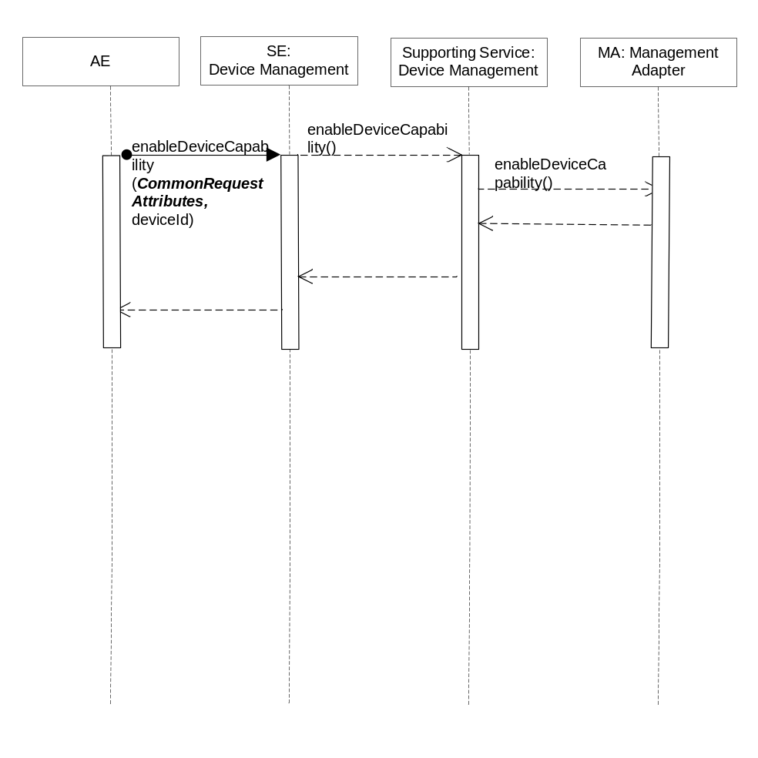
Figure 6.6.2.9.3-1 enableDeviceCapability Diagram

6.6.2.9.4 Post-Conditions
The Management Adapter has submitted a request to the Management Server to enable device capability.

6.6.2.9.5 Exceptions
Not Applicable

6.6.2.9.6 Policies for Use
Message Exchange Patterns: In-Out
Transaction Pattern: Participation allowed

6.6.2.9.7 oneM2M Resource Interworking
This service capability is used to enable device capability. The service capability aligns with the <deviceCapability> resource and maps to the UPDATE procedure for the attribute enable of the resource.

6.6.2.10 disableDeviceCapability
This service capability provides the ability for AEs to disable device capability.

6.6.2.10.1 Pre-conditions
The pre-conditions for Mca Received Requests are met.
A correlation between a Management Adapter, the service capability and device exist.

6.6.2.10.2 Signature –disableDeviceCapability
Parameter name | Direction | Optional | Description
deviceId | IN | NO | The unique device identifier in the context of the M2M Service Subscription.
name | IN | NO | The name of the capability. Enum DeviceCapabilityName, see 6.6.1.1.1.12.
state | OUT | NO | Indicates if the capability is enabled or disabled.
responseType | OUT | YES | Unique response types for this service.  Note: Consumed services also provide response types.  - Issuer does not have a Management Adapter for the requested operation
Table 6.6.2.10.2-1 Device Management Service –disableDeviceCapability capability

6.6.2.10.3 Service Interactions
The interactions of service capabilities required for this service capability:
- Issue the request to the Supporting Service to perform the operation
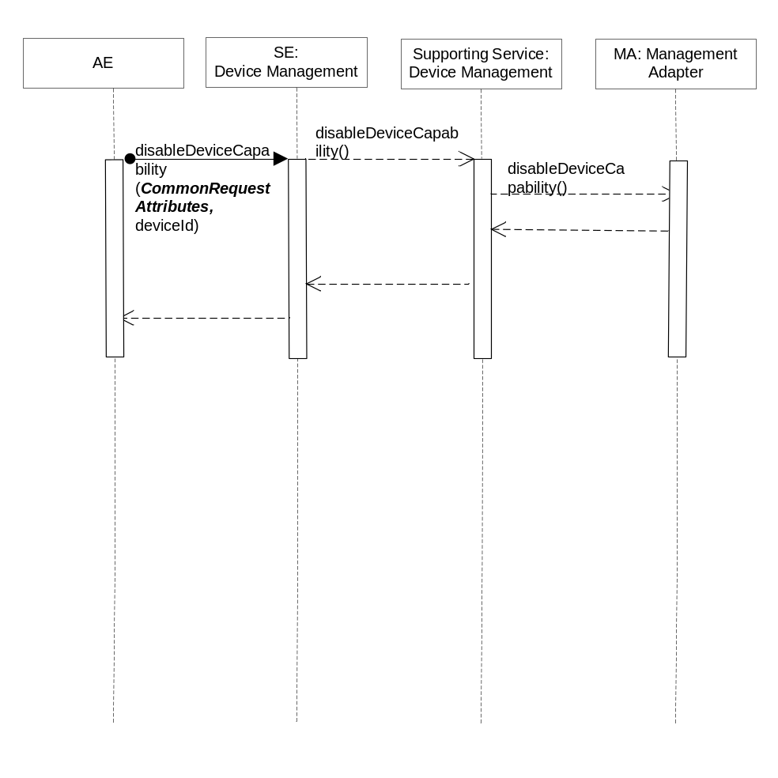
Figure 6.6.2.10.3-1 disableDeviceCapability Diagram

6.6.2.10.4 Post-Conditions
The Management Adapter has submitted a request to the Management Server to disable device capability.

6.6.2.10.5 Exceptions
Not Applicable

6.6.2.10.6 Policies for Use
Message Exchange Patterns: In-Out
Transaction Pattern: Participation allowed

6.6.2.10.7 oneM2M Resource Interworking
This service capability is used to disable device capability. The service capability aligns with the <deviceCapability> resource and maps to the UPDATE procedure for the attribute disable of the resource.

6.6.2.11 getAreaNetworks
This service capability provides the ability for AEs to get area networks information.

6.6.2.11.1 Pre-conditions
The pre-conditions for Mca Received Requests are met.
A correlation between a Management Adapter, the M2M Service Capability and area network exist.

6.6.2.11.2 Signature – getAreaNetworks
Parameter name | Direction | Optional | Description
areaNwks | OUT | YES | Array of area network. Type AreaNwkInfo, see 6.6.1.1.1.14.
responseType | OUT | YES | Unique response types for this service.  Note: Consumed services also provide response types.  - Issuer does not have a Management Adapter for the requested operation
Table 6.6.2.11.2-1 Device Management Service –getAreaNetworks capability

6.6.2.11.3 Service Interactions
The interactions of service capabilities required for this service capability:
- Issue the request to the Supporting Service to perform the operation

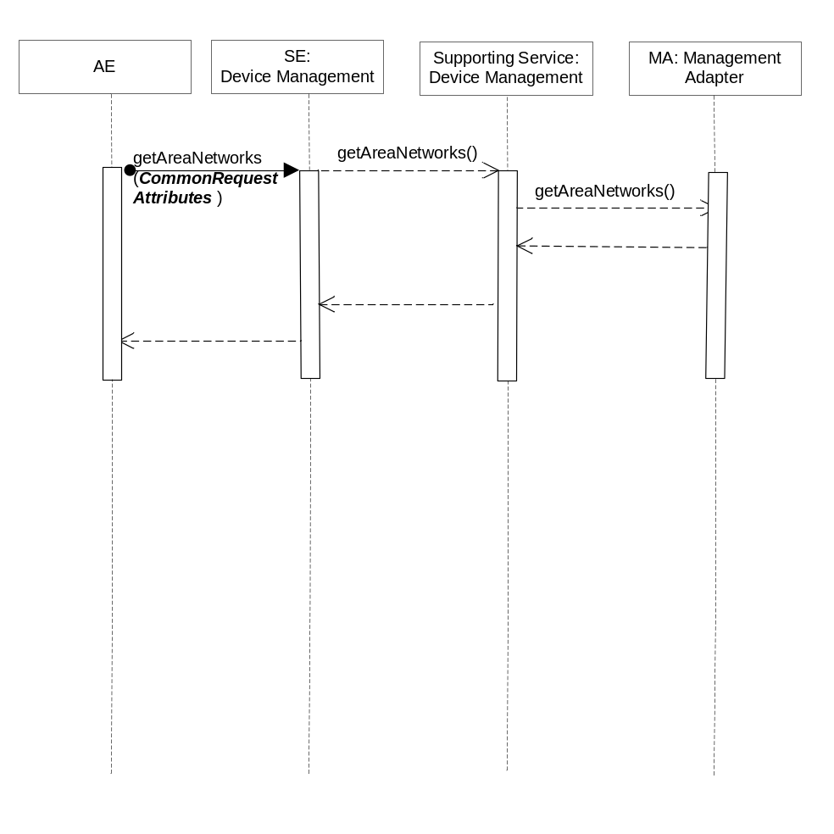
Figure 6.6.2.11.3-1 getAreaNetworks Diagram

6.6.2.11.4 Post-Conditions
The Management Adapter has submitted a request to the Management Server to get area networks information.

6.6.2.11.5 Exceptions
Not Applicable

6.6.2.11.6 Policies for Use
Message Exchange Patterns: In-Out
Transaction Pattern: Participation allowed

6.6.2.11.7 oneM2M Resource Interworking
This service capability is used to get area networks information. The service capability aligns with the <areaNwkInfo> resource and maps to the RETRIEVE procedure for the resource. The service capability aligns with the <areaNwkDeviceInfo> resource and maps to the Retrieve procedure for the resource.

6.6.2.12 updateDeviceForAreaNetwork
This service capability provides the ability for AEs to update device information for area network.

6.6.2.12.1 Pre-conditions
The pre-conditions for Mca Received Requests are met.
A correlation between a Management Adapter, the M2M Service Capability, the device and area network exist.

6.6.2.12.2 Signature –updateDeviceForAreaNetwork
Parameter name | Direction | Optional | Description
areaNwkId | IN | NO | The unique area network identifier.
deviceId | IN | NO | The unique device identifier in the context of the M2M Service Subscription.
areaNwkDeviceInfo | IN | YES | The existing areaNwkDeviceInfo are replaced with the information in this parameter. Type AreaNwkDeviceInfo, see 6.6.1.1.1.16.
lastModifiedTime | OUT | NO | The modified time.
responseType | OUT | YES | Unique response types for this service.  Note: Consumed services also provide response types.  - Issuer does not have a Management Adapter for the requested operation
Table 6.6.2.12.2-1 Device Management Service –updateDeviceForAreaNetwork capability

6.6.2.12.3 Service Interactions
The interactions of service capabilities required for this service capability:
- Issue the request to the Supporting Service to perform the operation
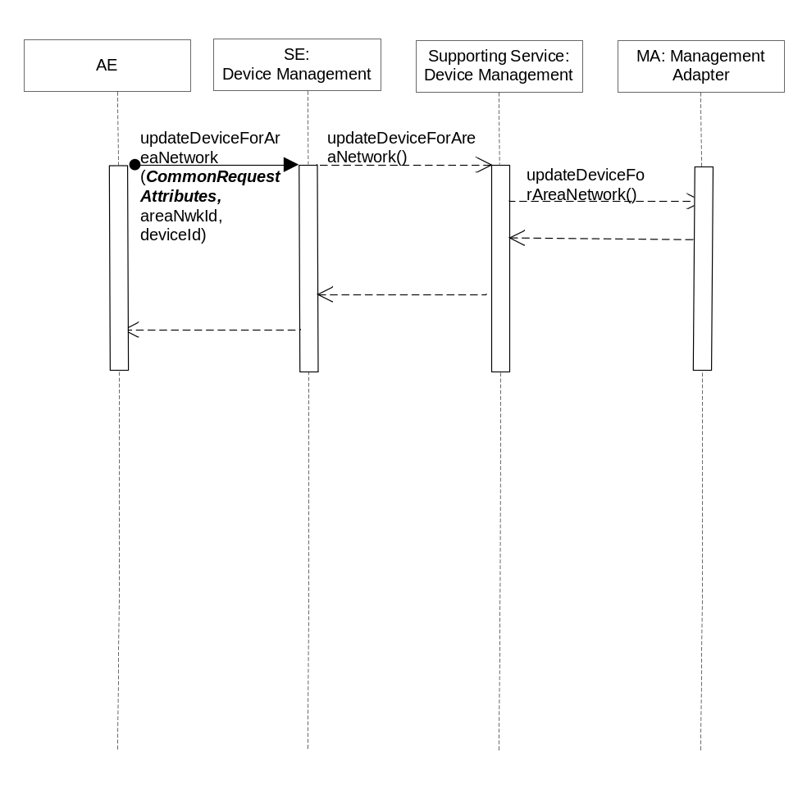
Figure 6.6.2.12.3-1 updateDeviceForAreaNetwork Diagram

6.6.2.12.4 Post-Conditions
The Management Adapter has submitted a request to the Management Server to update device information for area network.

6.6.2.12.5 Exceptions
Not Applicable

6.6.2.12.6 Policies for Use
Message Exchange Patterns: In-Out
Transaction Pattern: Participation allowed

6.6.2.12.7 oneM2M Resource Interworking
The service capability aligns with the <areaNwkDeviceInfo> resource and maps to the Update procedure for attribute devType , sleepInterval , sleepDuration , status , listOfNeighbors of the resource.

6.6.2.13 rebootDevice
This service capability provides the ability for AEs to reboot device.

6.6.2.13.1 Pre-conditions
The pre-conditions for Mca Received Requests are met.
A correlation between a Management Adapter, the M2M Service Capability and device exist.

6.6.2.13.2 Signature – rebootDevice
Parameter name | Direction | Optional | Description
deviceId | IN | NO | The unique device identifier in the context of the M2M Service Subscription.
reportPolicy | IN | YES | The policy used to report the state of the operation to the originating AE. See clause 6.6.1.1.1.1.
troubleshootingReport | OUT | YES | The troubleshooting operation execution result or status. Type TroubleshootingReport, see 6.6.1.1.1.20.
responseType | OUT | YES | Unique response types for this service.  Note: Consumed services also provide response types.  - Issuer does not have a Management Adapter for the requested operation  - report policy does not supported by the Management Adapter
Table 6.6.2.13.2-1 Device Management Service –rebootDevice capability

6.6.2.13.3 Service Interactions
The interactions of service capabilities required for this service capability:
- Issue the request to the Supporting Service to perform the operation

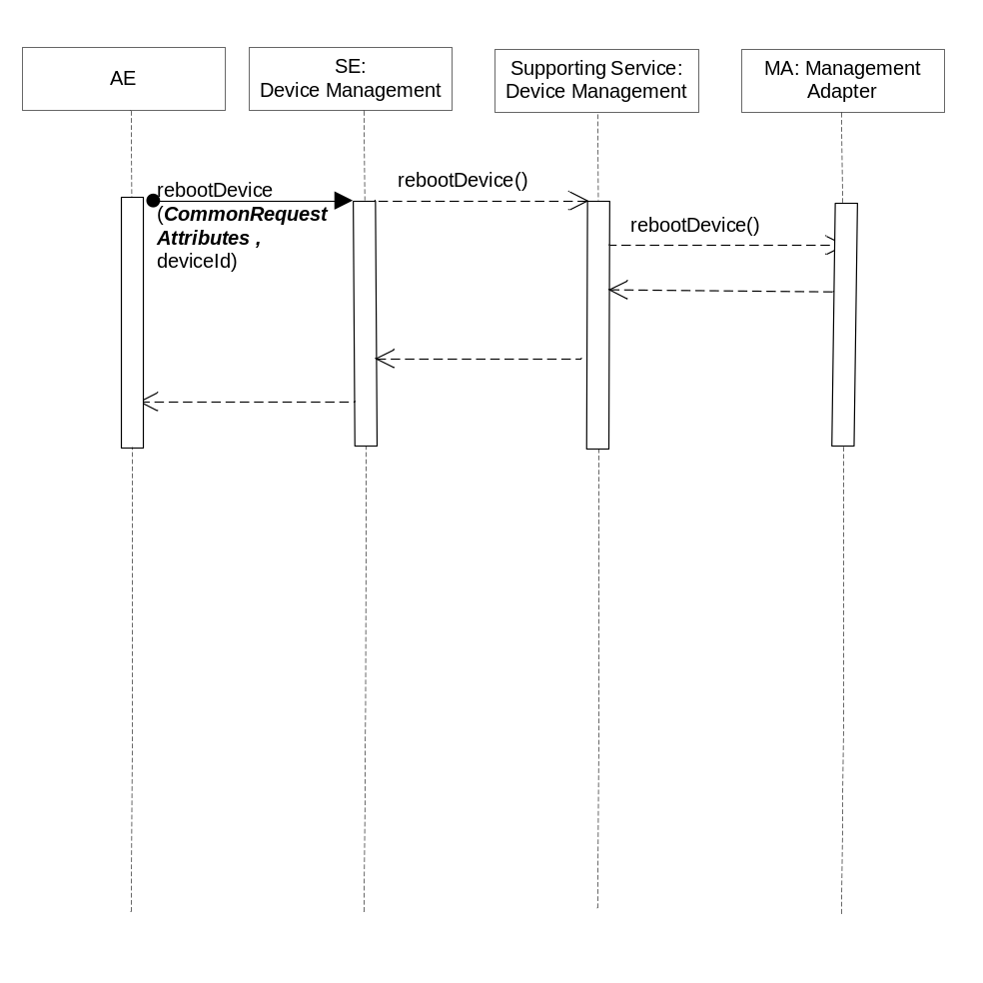
Figure 6.6.2.13.3-1 rebootDevice Diagram

6.6.2.13.4 Post-Conditions
The Management Adapter has submitted a request to the Management Server to reboot device.

6.6.2.13.5 Exceptions
Not Applicable

6.6.2.13.6 Policies for Use
Message Exchange Patterns: In-Out
Transaction Pattern: Participation allowed

6.6.2.13.7 oneM2M Resource Interworking
This service capability is used to reboot device. The service capability aligns with the <reboot> resource and maps to the Execute procedure for the attribute reboot of the resource.

6.6.2.14 resetDevice
This service capability provides the ability for AEs to reset device.

6.6.2.14.1 Pre-conditions
The pre-conditions for Mca Received Requests are met.
A correlation between a Management Adapter, the M2M Service Capability and device exist.

6.6.2.14.2 Signature –resetDevice
Parameter name | Direction | Optional | Description
deviceId | IN | NO | The unique device identifier in the context of the M2M Service Subscription.
reportPolicy | IN | YES | The policy used to report the state of the operation to the originating AE. See clause 6.6.1.1.1.1.
troubleshootingReport | OUT | YES | The troubleshooting operation execution result or status. Type TroubleshootingReport, see 6.6.1.1.1.20.
responseType | OUT | YES | Unique response types for this service.  Note: Consumed services also provide response types.  - Issuer does not have a Management Adapter for the requested operation  - report policy does not supported by the Management Adapter
Table 6.6.2.14.2-1 Device Management Service –resetDevice capability

6.6.2.14.3 Service Interactions
The interactions of service capabilities required for this service capability:
- Issue the request to the Supporting Service to perform the operation
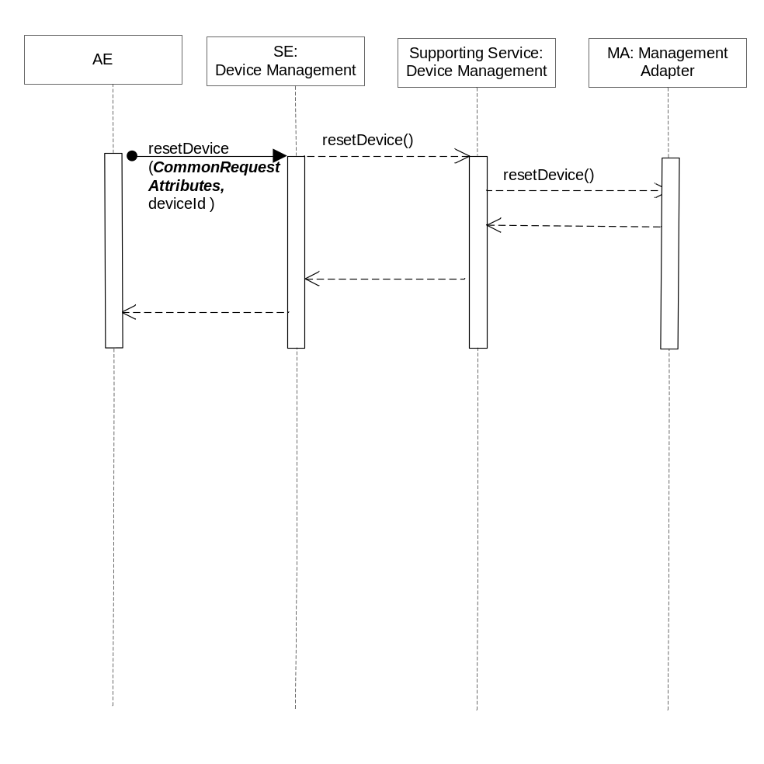
Figure 6.6.2.14.3-1 resetDevice Diagram

6.6.2.14.4 Post-Conditions
The Management Adapter has submitted a request to the Management Server to reset device.

6.6.2.14.5 Exceptions
Not Applicable

6.6.2.14.6 Policies for Use
Message Exchange Patterns: In-Out
Transaction Pattern: Participation allowed

6.6.2.14.7 oneM2M Resource Interworking
This service capability is used to reset device. The service capability aligns with the <reboot> resource and maps to the Execute procedure for the attribute factoryReset of the resource.

6.6.2.15 uploadDeviceLog
This service capability provides the ability for AEs to upload device log.

6.6.2.15.1 Pre-conditions
The pre-conditions for Mca Received Requests are met.
A correlation between a Management Adapter, the M2M Service Capability and device exist.

6.6.2.15.2 Signature –uploadDeviceLog
Parameter name | Direction | Optional | Description
deviceId | IN | NO | The unique device identifier in the context of the M2M Service Subscription.
logInfo | IN | NO | The log information. Type LogInfo, see 6.6.1.1.1.19.
reportPolicy | IN | YES | The policy used to report the state of the operation to the originating AE. See clause 6.6.1.1.1.1.
logURL | OUT | YES | The URL from which the log can be uploaded.
troubleshootingReport | OUT | YES | The troubleshooting operation execution result or status. Type TroubleshootingReport, see 6.6.1.1.1.20.
responseType | OUT | YES | Unique response types for this service.  Note: Consumed services also provide response types.  - Issuer does not have a Management Adapter for the requested operation  - report policy does not supported by the Management Adapter
Table 6.6.2.15.2-1 Device Management Service –uploadDeviceLog capability

6.6.2.15.3 Service Interactions
The interactions of service capabilities required for this service capability:
- Issue the request to the Supporting Service to perform the operation
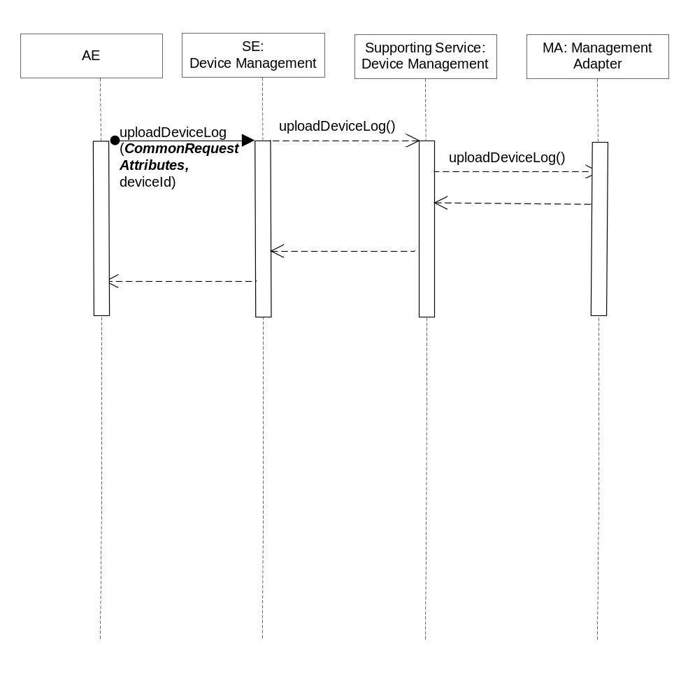
Figure 6.6.2.15.3-1 uploadDeviceLog Diagram

6.6.2.15.4 Post-Conditions
The Management Adapter has submitted a request to the Management Server to upload device log.

6.6.2.15.5 Exceptions
Not Applicable

6.6.2.15.6 Policies for Use
Message Exchange Patterns: In-Out
Transaction Pattern: Participation allowed

6.6.2.15.7 oneM2M Resource Interworking
This service capability is used to upload device log. The service capability aligns with the <eventLog> resource and maps to the Update procedure for the resource.

6.6.2.16 reportTroubleshootingStatus
This service capability provides the ability to report the device troubleshooting operation execution result or status information to the AE.

6.6.2.16.1 Pre-conditions
A correlation between a Management Adapter, the M2M Service Capability and previously submitted troubleshooting request exist.

6.6.2.16.2 Signature –reportTroubleshootingStatus
Parameter name | Direction | Optional | Description
isLastReport | IN | NO | Boolean, whether it is the last report.
sequenceNumber | IN | NO | The report sequence number.
troubleshootingReportList | IN | NO | Array of troubleshootingReport.  Type TroubleshootingReport, see 6.6.1.1.1.20.
aggregationPolicy | IN | YES | The policy used to aggregate the result of the management operation prior to the reports being sent. See clause 6.6.1.1.1.2.
responseType | OUT | YES | Unique response types for this service.  Note: Consumed services also provide response types.  - The target AE does not exist.  - Aggregation policy does not supported
Table 6.6.2.16.2-1 Device Management Service –reportTroubleshootingStatus capability

6.6.2.16.3 Post-Conditions
The AE has received a report of troubleshooting operation execution status or result.

6.6.2.16.4 Exceptions
Not Applicable

6.6.2.16.5 Policies for Use
Message Exchange Patterns: In-Out
Transaction Pattern: Participation allowed

6.6.2.16.6 oneM2M Resource Interworking
Not Applicable

6.6.2.17 getDeviceLogs
This service capability provides the ability for AEs to get all logs of a device.

6.6.2.17.1 Pre-conditions
The pre-conditions for Mca Received Requests are met.
A correlation between a Management Adapter, the M2M Service Capability and device exist.

6.6.2.17.2 Signature – getDeviceLogs
Parameter name | Direction | Optional | Description
deviceId | IN | NO | The unique device identifier in the context of the M2M Service Subscription.
logList | OUT | YES | Array of log. Type Log, see 6.6.1.1.1.21.
responseType | OUT | YES | Unique response types for this service.  Note: Consumed services also provide response types.  - Issuer does not have a Management Adapter for the requested operation
Table 6.6.2.17.2-1 Device Management Service –getDeviceLogs capability

6.6.2.17.3 Service Interactions
The interactions of service capabilities required for this service capability:
- Issue the request to the Supporting Service to perform the operation

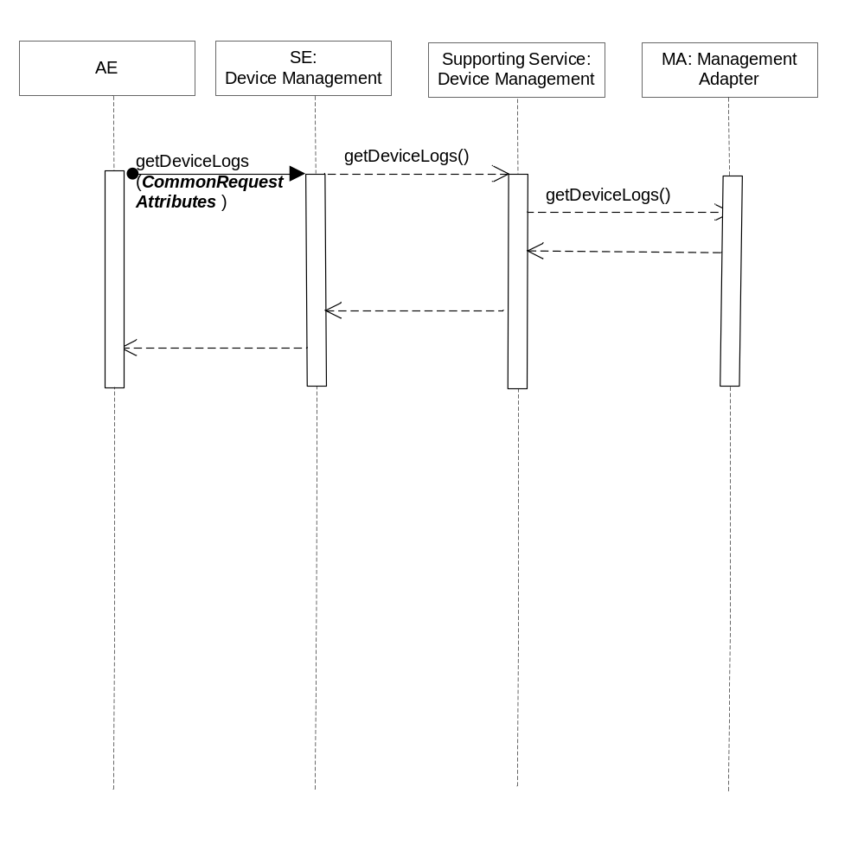
Figure 6.6.2.17.3-1 getDeviceLogs Diagram

6.6.2.17.4 Post-Conditions
The Management Adapter has submitted a request to the Management Server to get all logs of a device.

6.6.2.17.5 Exceptions
Not Applicable

6.6.2.17.6 Policies for Use
Message Exchange Patterns: In-Out
Transaction Pattern: Participation allowed

6.6.2.17.7 oneM2M Resource Interworking
This service capability is used to get all logs of a device. The service capability aligns with the <eventLog> resource and maps to the Retrieve procedure for the resource.

6.6.2.18 getDeviceLogInformation
This service capability provides the ability for AEs to get a device log information.

6.6.2.18.1 Pre-conditions
The pre-conditions for Mca Received Requests are met.
A correlation between a Management Adapter, the M2M Service Capability and device exist.

6.6.2.18.2 Signature – getDeviceLogInformation
Parameter name | Direction | Optional | Description
deviceId | IN | NO | The unique device identifier in the context of the M2M Service Subscription.
filterCriteria | IN | YES | See Table 6.6.1.1.1.22
logURL | IN | YES | The URL from which the log can be accessed.
log | OUT | YES | Type Log, see 6.6.1.1.1.21.
responseType | OUT | YES | Unique response types for this service.  Note: Consumed services also provide response types.  - Issuer does not have a Management Adapter for the requested operation
Table 6.6.2.18.2-1 Device Management Service –getDeviceLogInformation capability

6.6.2.18.3 Service Interactions
The interactions of service capabilities required for this service capability:
- Issue the request to the Supporting Service to perform the operation

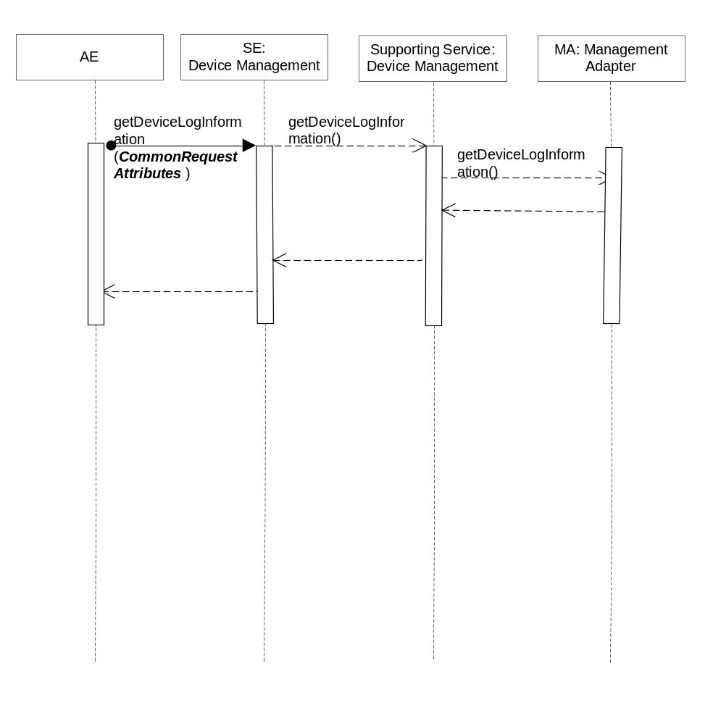
Figure 6.6.2.18.3-1 getDeviceLogInformation Diagram

6.6.2.18.4 Post-Conditions
The Management Adapter has submitted a request to the Management Server to get a device log information.

6.6.2.18.5 Exceptions
Not Applicable

6.6.2.18.6 Policies for Use
Message Exchange Patterns: In-Out
Transaction Pattern: Participation allowed

6.6.2.18.7 oneM2M Resource Interworking
This service capability is used to a device log information. The service capability aligns with the <eventLog> resource and maps to the Retrieve procedure for the resource.

6.6.2.19 getSoftwareInformation
This service capability provides the ability for AEs to get application software information.

6.6.2.19.1 Pre-conditions
The pre-conditions for Mca Received Requests are met.
A correlation between a Management Adapter, the M2M Service Capability and device exist.

6.6.2.19.2 Signature – getSoftwareInformation
Parameter name | Direction | Optional | Description
deviceId | IN | NO | The unique device identifier in the context of the M2M Service Subscription.
version | OUT | YES | The version of the software.
name | OUT | YES | The name of the software.
URL | OUT | YES | The URL from which the software package can be downloaded.
installStatus | OUT | YES | Indicates the status of the install.  Enum ActionStatus, see 6.6.1.1.1.26.
activeStatus | OUT | YES | The status of active or deactivate action.  Enum ActionStatus, see 6.6.1.1.1.26.
responseType | OUT | YES | Unique response types for this service.  Note: Consumed services also provide response types.  - Issuer does not have a Management Adapter for the requested operation
Table 6.6.2.19.2-1 Device Management Service –getSoftwareInformation capability

6.6.2.19.3 Service Interactions
The interactions of service capabilities required for this service capability:
- Issue the request to the Supporting Service to perform the operation

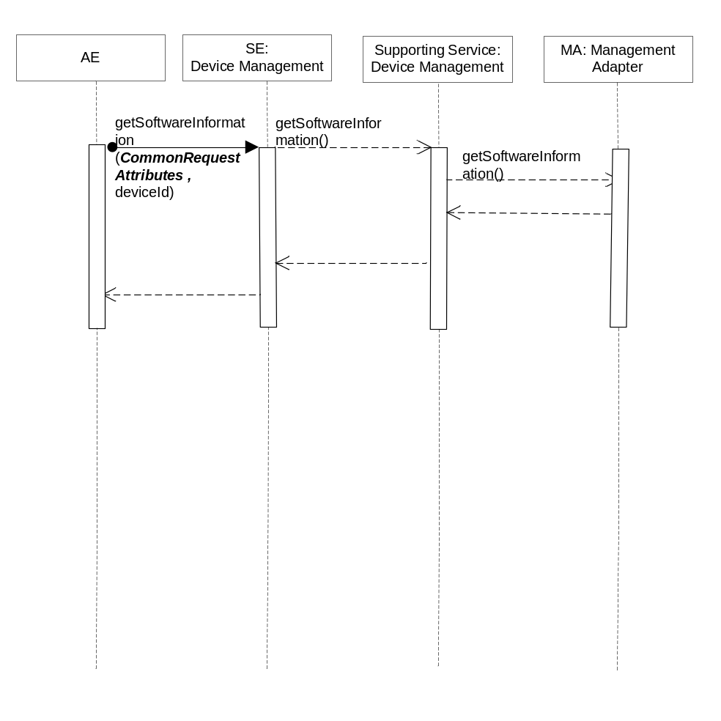
Figure 6.6.2.19.3-1 getSoftwareInformation Diagram

6.6.2.19.4 Post-Conditions
The Management Adapter has submitted a request to the Management Server to get application software information.

6.6.2.19.5 Exceptions
Not Applicable

6.6.2.19.6 Policies for Use
Message Exchange Patterns: In-Out
Transaction Pattern: Participation allowed

6.6.2.19.7 oneM2M Resource Interworking
This service capability is used to get application software information. The service capability aligns with the <software> resource and maps to the Retrieve procedure for the resource.

6.6.2.20 downloadSoftware
This service capability provides the ability for AEs to download application software.

6.6.2.20.1 Pre-conditions
The pre-conditions for Mca Received Requests are met.
A correlation between a Management Adapter, the M2M Service Capability and device exist.

6.6.2.20.2 Signature –downloadSoftware
Parameter name | Direction | Optional | Description
deviceId | IN | NO | The unique device identifier in the context of the M2M Service Subscription.
version | IN | NO | The version of the software.
name | IN | NO | The name of the software.
URL | IN | NO | The URL from which the software package can be downloaded.
reportPolicy | IN | YES | The policy used to report the state of the operation to the originating AE. See clause 6.6.1.1.1.1.
softwareReport | OUT | YES | The software management operation execution result or status. Type SoftwareReport, see 6.6.1.1.1.27.
responseType | OUT | YES | Unique response types for this service.  Note: Consumed services also provide response types.  - Issuer does not have a Management Adapter for the requested operation  - report policy does not supported by the Management Adapter
Table 6.6.2.20.2-1 Device Management Service –downloadSoftware capability

6.6.2.20.3 Service Interactions
The interactions of service capabilities required for this service capability:
- Issue the request to the Supporting Service to perform the operation
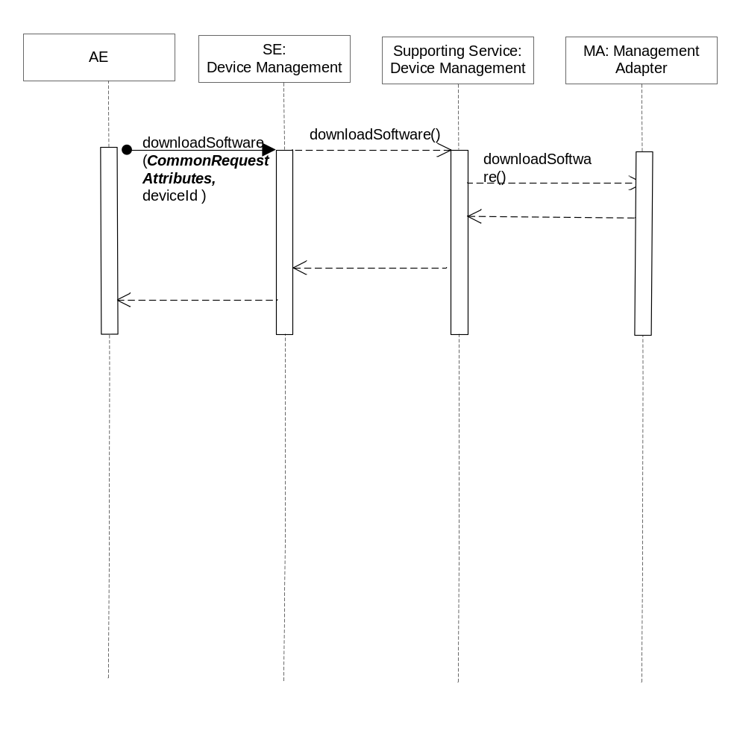
Figure 6.6.2.20.3-1 downloadSoftware Diagram

6.6.2.20.4 Post-Conditions
The Management Adapter has submitted a request to the Management Server to download application software.

6.6.2.20.5 Exceptions
Not Applicable

6.6.2.20.6 Policies for Use
Message Exchange Patterns: In-Out
Transaction Pattern: Participation allowed

6.6.2.20.7 oneM2M Resource Interworking
This service capability is used to download application software. The service capability aligns with the <software> resource and maps to the UPDATE procedure for the attribute install of the resource. The service capability also aligns with the <mgmtCmd> resource and maps to the EXECUTE procedure for the resource.

6.6.2.21 installSoftware
This service capability provides the ability for AEs to install application software.

6.6.2.21.1 Pre-conditions
The pre-conditions for Mca Received Requests are met.
A correlation between a Management Adapter, the M2M Service Capability and device exist.

6.6.2.21.2 Signature –installSoftware
Parameter name | Direction | Optional | Description
deviceId | IN | NO | The unique device identifier in the context of the M2M Service Subscription.
version | IN | NO | The version of the software.
name | IN | NO | The name of the software.
reportPolicy | IN | YES | The policy used to report the state of the operation to the originating AE. See clause 6.6.1.1.1.1.
softwareReport | OUT | YES | The software management operation execution result or status. Type SoftwareReport, see 6.6.1.1.1.27.
responseType | OUT | YES | Unique response types for this service.  Note: Consumed services also provide response types.  - Issuer does not have a Management Adapter for the requested operation  - report policy does not supported by the Management Adapter
Table 6.6.2.21.2-1 Device Management Service –installSoftware capability

6.6.2.21.3 Service Interactions
The interactions of service capabilities required for this service capability:
- Issue the request to the Supporting Service to perform the operation
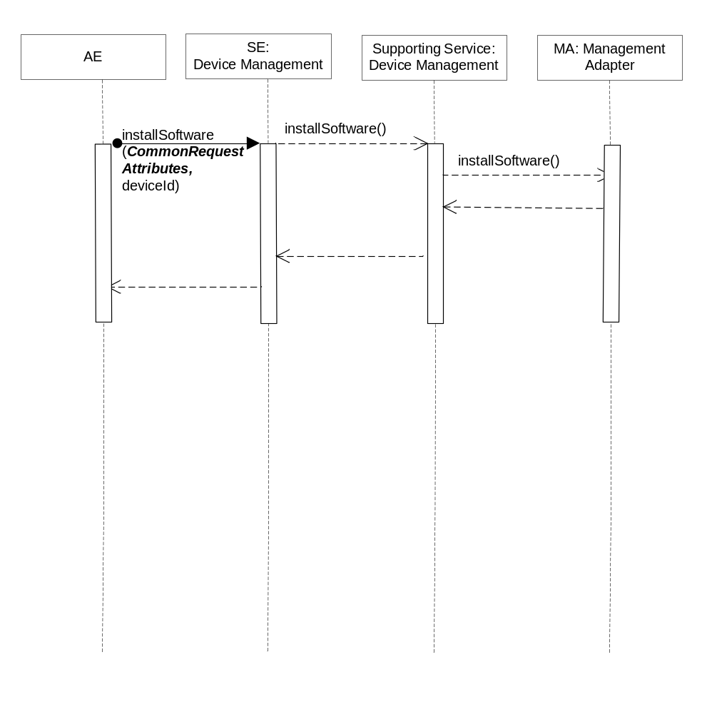
Figure 6.6.2.21.3-1 installSoftware Diagram

6.6.2.21.4 Post-Conditions
The Management Adapter has submitted a request to the Management Server to install application software.

6.6.2.21.5 Exceptions
Not Applicable

6.6.2.21.6 Policies for Use
Message Exchange Patterns: In-Out
Transaction Pattern: Participation allowed

6.6.2.21.7 oneM2M Resource Interworking
This service capability is used to install application software. The service capability aligns with the <software> resource and maps to the UPDATE procedure for the attribute install of the resource. The service capability also aligns with the <mgmtCmd> resource and maps to the EXECUTE procedure for the resource.

6.6.2.22 activateSoftware
This service capability provides the ability for AEs to activate software previously installed.

6.6.2.22.1 Pre-conditions
The pre-conditions for Mca Received Requests are met.
A correlation between a Management Adapter, the M2M Service Capability and device exist.

6.6.2.22.2 Signature –activateSoftware
Parameter name | Direction | Optional | Description
deviceId | IN | NO | The unique device identifier in the context of the M2M Service Subscription.
version | IN | NO | The version of the software.
name | IN | NO | The name of the software.
reportPolicy | IN | YES | The policy used to report the state of the operation to the originating AE. See clause 6.6.1.1.1.1.
softwareReport | OUT | YES | The software management operation execution result or status. Type SoftwareReport, see 6.6.1.1.1.27.
responseType | OUT | YES | Unique response types for this service.  Note: Consumed services also provide response types.  - Issuer does not have a Management Adapter for the requested operation  - report policy does not supported by the Management Adapter
Table 6.6.2.22.2-1 Device Management Service –activateSoftware capability

6.6.2.22.3 Service Interactions
The interactions of service capabilities required for this service capability:
- Issue the request to the Supporting Service to perform the operation
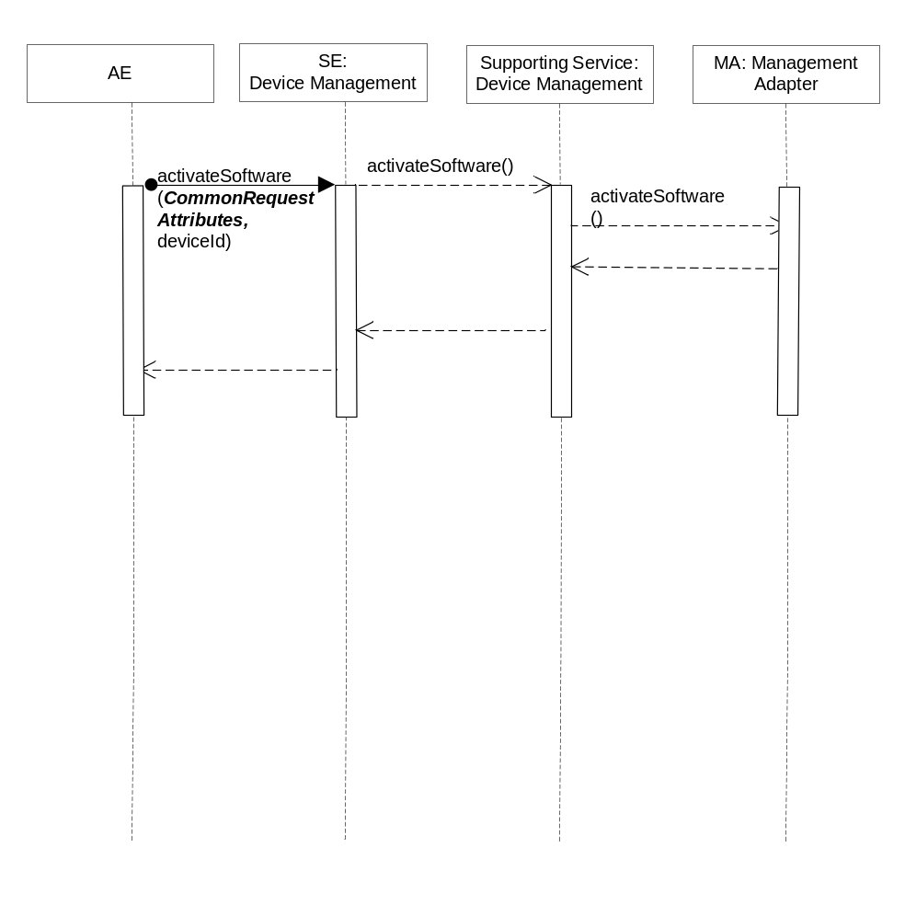
Figure 6.6.2.22.3-1 activateSoftware Diagram

6.6.2.22.4 Post-Conditions
The Management Adapter has submitted a request to the Management Server to activate software previously installed.

6.6.2.22.5 Exceptions
Not Applicable

6.6.2.22.6 Policies for Use
Message Exchange Patterns: In-Out
Transaction Pattern: Participation allowed

6.6.2.22.7 oneM2M Resource Interworking
This service capability is used to activate software previously installed. The service capability aligns with the <software> resource and maps to the UPDATE procedure for the attribute activate of the resource. The service capability also aligns with the <mgmtCmd> resource and maps to the EXECUTE procedure for the resource.

6.6.2.23 deactivateSoftware
This service capability provides the ability for AEs to deactivates software.

6.6.2.23.1 Pre-conditions
The pre-conditions for Mca Received Requests are met.
A correlation between a Management Adapter, the M2M Service Capability and the device exist.

6.6.2.23.2 Signature –deactivateSoftware
Parameter name | Direction | Optional | Description
deviceId | IN | NO | The unique device identifier in the context of the M2M Service Subscription.
version | IN | NO | The version of the software.
name | IN | NO | The name of the software.
reportPolicy | IN | YES | The policy used to report the state of the operation to the originating AE. See clause 6.6.1.1.1.1.
softwareReport | OUT | YES | The software management operation execution result or status. Type SoftwareReport, see 6.6.1.1.1.27.
responseType | OUT | YES | Unique response types for this service.  Note: Consumed services also provide response types.  - Issuer does not have a Management Adapter for the requested operation  - report policy does not supported by the Management Adapter
Table 6.6.2.23.2-1 Device Management Service –deactivateSoftware capability

6.6.2.23.3 Service Interactions
The interactions of service capabilities required for this service capability:
- Issue the request to the Supporting Service to perform the operation
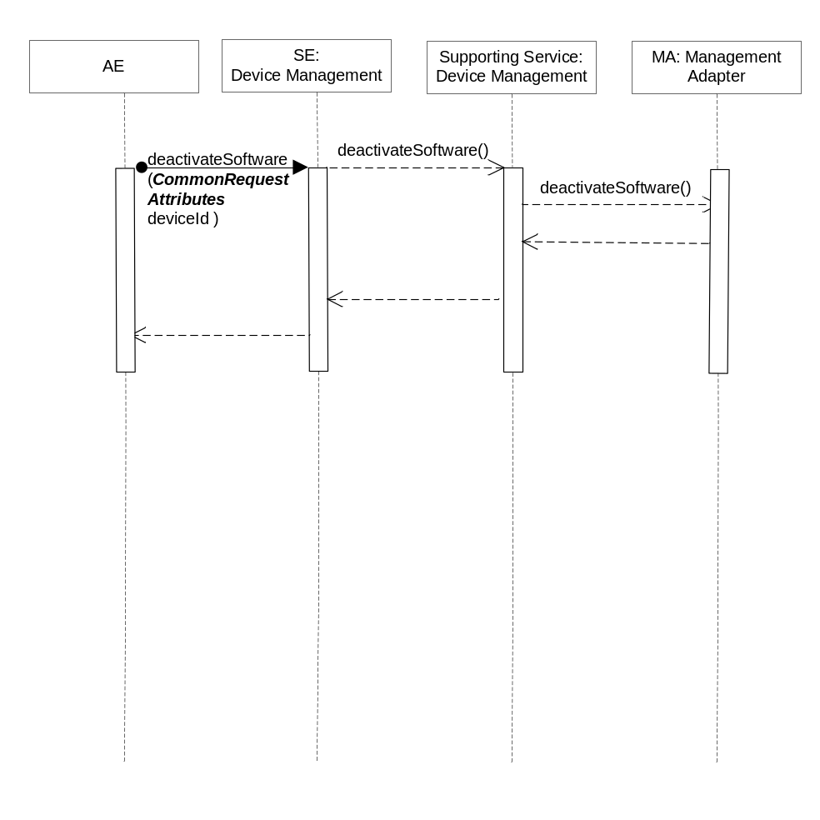
Figure 6.6.2.23.3-1 deactivateSoftware Diagram

6.6.2.23.4 Post-Conditions
The Management Adapter has submitted a request to the Management Server to deactivates software.

6.6.2.23.5 Exceptions
Not Applicable

6.6.2.23.6 Policies for Use
Message Exchange Patterns: In-Out
Transaction Pattern: Participation allowed

6.6.2.23.7 oneM2M Resource Interworking
This service capability is used to deactivates software. The service capability aligns with the <software> resource and maps to the UPDATE procedure for the attribute deactivate of the resource. The service capability also aligns with the <mgmtCmd> resource and maps to the EXECUTE procedure for the resource.

6.6.2.24 removeSoftware
This service capability provides the ability for AEs to uninstall the software.

6.6.2.24.1 Pre-conditions
The pre-conditions for Mca Received Requests are met.
A correlation between a Management Adapter, the M2M Service Capability and the device exist.

6.6.2.24.2 Signature – removeSoftware
Parameter name | Direction | Optional | Description
deviceId | IN | NO | The unique device identifier in the context of the M2M Service Subscription.
version | IN | NO | The version of the software.
name | IN | NO | The name of the software.
reportPolicy | IN | YES | The policy used to report the state of the operation to the originating AE. See clause 6.6.1.1.1.1.
softwareReport | OUT | YES | The software management operation execution result or status. Type SoftwareReport, see 6.6.1.1.1.27.
responseType | OUT | YES | Unique response types for this service.  Note: Consumed services also provide response types.  - Issuer does not have a Management Adapter for the requested operation  - report policy does not supported by the Management Adapter
Table 6.6.2.24.2-1 Device Management Service –removeSoftware capability

6.6.2.24.3 Service Interactions
The interactions of service capabilities required for this service capability:
- Issue the request to the Supporting Service to perform the operation
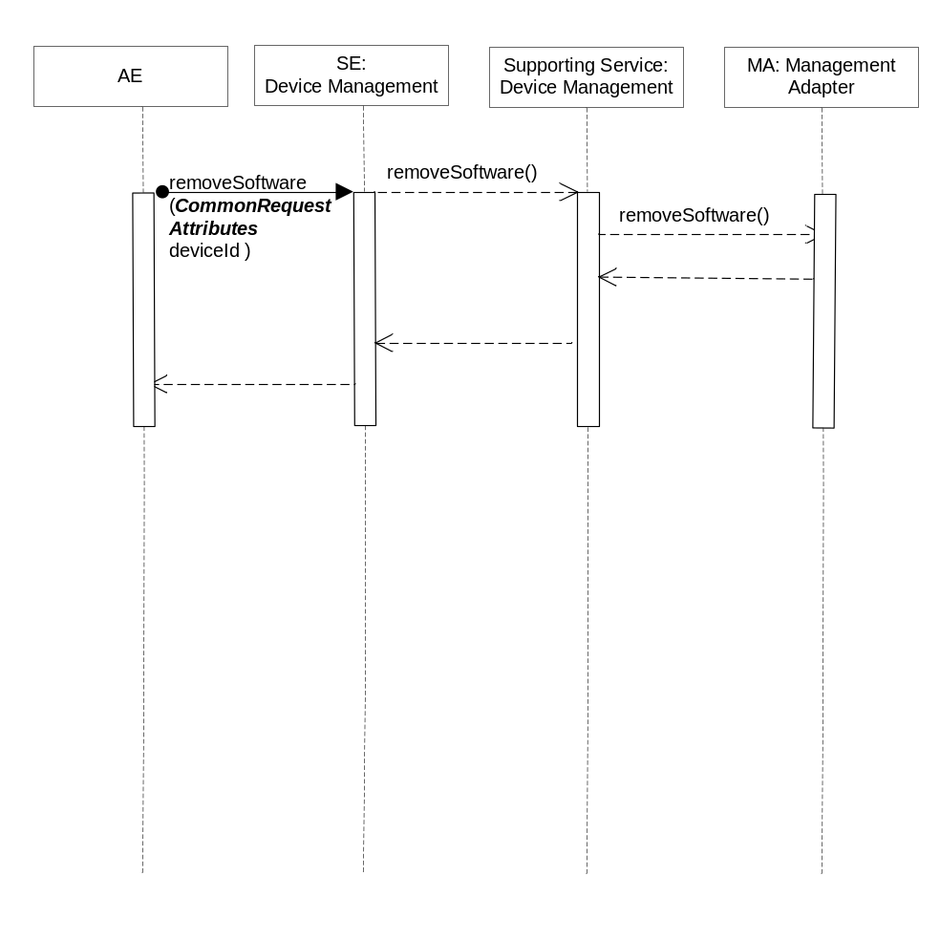
Figure 6.6.2.24.3-1 removeSoftware Diagram

6.6.2.24.4 Post-Conditions
The Management Adapter has submitted a set of requests to the Management Server to uninstall the software.

6.6.2.24.5 Exceptions
Not Applicable

6.6.2.24.6 Policies for Use
Message Exchange Patterns: In-Out
Transaction Pattern: Participation allowed

6.6.2.24.7 oneM2M Resource Interworking
This service capability is used to install application software. The service capability aligns with the <software> resource and maps to the UPDATE procedure for the attribute uninstall of the resource. The service capability also aligns with the <mgmtCmd> resource and maps to the EXECUTE procedure for the resource.

6.6.2.25 reportSoftwareStatus
This service capability provides the ability to report the application software management operation execution result or status information to the AE.

6.6.2.25.1 Pre-conditions
A correlation between a Management Adapter, the M2M Service Capability and previously submitted application software management request exist.

6.6.2.25.2 Signature –reportSoftwareStatus
Parameter name | Direction | Optional | Description
isLastReport | IN | NO | Boolean, whether it is the last report.
sequenceNumber | IN | NO | The report sequence number.
softwareReportList | IN | NO | Array of softwareReport.  Type SoftwareReport, see 6.6.1.1.1.27.
aggregationPolicy | IN | YES | The policy used to aggregate the result of the management operation prior to the reports being sent. See clause 6.6.1.1.1.2.
responseType | OUT | YES | Unique response types for this service.  Note: Consumed services also provide response types.  - The target AE does not exist.  - Aggregation policy does not supported
Table 6.6.2.25.2-1 Device Management Service –reportSoftwareStatus capability

6.6.2.25.3 Post-Conditions
The AE has received a report of application software management operation execution status or result.

6.6.2.25.4 Exceptions
Not Applicable

6.6.2.25.5 Policies for Use
Message Exchange Patterns: In-Out
Transaction Pattern: Participation allowed

6.6.2.25.6 oneM2M Resource Interworking
Not Applicable

6.7 Management Adapter

6.7.1 Overview
The Management Adapter service provides the ability to adapt the M2M Service Layer operations to the technology specific operations of the Management Server.

6.7.2 Service Capabilities

6.7.2.1 downloadFirmware
This service capability provides the ability to download the specific device firmware.

6.7.2.1.1 Pre-conditions
A correlation between a Management Server, the service capability and device exist.

6.7.2.1.2 Signature – downloadFirmware
Parameter name | Direction | Optional | Description
firmwareInfo | IN | NO | The device firmware information.  Type FirmwareInfo, see 6.6.1.1.1.5
deviceId | IN | YES | The unique device identifier in the context of the M2M Service Subscription.
reportPolicy | IN | YES | The policy used to report the state of the operation to the originating AE. See clause 6.6.1.1.1.1.
requestId | IN | NO | The M2M Request Identifier (M2M-Request-ID)
firmwareReport | OUT | YES | The firmware management operation execution result or status. Type FirmwareReport, see 6.6.1.1.1.3.
responseType | OUT | YES | Unique response types for this service.  Note: Consumed services also provide response types.  - Report policy is not supported by the Management Adapter  - Firmware download failure, e.g. firmware is missing dependency on the device, firmware is too large for available program or data memory
Table 6.7.2.1.2-1 Management Adapter –downloadFirmware capability

6.7.2.1.3 Post-Conditions
The Management Adapter has submitted a request to the Management Server to download the firmware.

6.7.2.1.4 Exceptions
Not Applicable

- 6.7.2.1.5 Policies for Use
Message Exchange Patterns: In-Out
Transaction Pattern: Participation allowed

6.7.2.1.6 oneM2M Resource Interworking
This service capability is used to download firmware. The service capability aligns with the <firmware> resource and maps to the UPDATE procedure for the attribute update of the resource. The service capability also aligns with the <mgmtCmd> resource and maps to the EXECUTE procedure for the resource.

6.7.2.2 installFirmware
This service capability provides the ability to install firmware on a device.

6.7.2.2.1 Pre-conditions
A correlation between a Management Server, the M2M Service Capability and device exist.

6.7.2.2.2 Signature –installFirmware
Parameter name | Direction | Optional | Description
firmwareInfo | IN | NO | The device firmware information.  Type FirmwareInfo, see 6.6.1.1.1.5
deviceId | IN | YES | The unique device identifier in the context of the M2M Service Subscription.
reportPolicy | IN | YES | The policy used to report the state of the operation to the originating AE.
requestId | IN | NO | The M2M Request Identifier (M2M-Request-ID)
firmwareReport | OUT | YES | The firmware management operation execution result or status. Type FirmwareReport, see 6.6.1.1.1.3.
responseType | OUT | YES | Unique response types for this service.  Note: Consumed services also provide response types.  - Report policy does not supported by the Management Adapter  - Firmware install failure, e.g. firmware is missing dependency on the device, firmware is too large for available program or data memory
Table 6.7.2.2.2-1 Management Adapter –installFirmware capability

6.7.2.2.3 Post-Conditions
The Management Adapter has submitted a request to the Management Server to install firmware.

6.7.2.2.4 Exceptions
Not Applicable

- 6.7.2.2.5 Policies for Use
Message Exchange Patterns: In-Out
Transaction Pattern: Participation allowed

6.7.2.2.6 oneM2M Resource Interworking
This service capability is used to install firmware. The service capability aligns with the <firmware> resource and maps to the UPDATE procedure for the attribute update of the resource. The service capability also aligns with the <mgmtCmd> resource and maps to the EXECUTE procedure for the resource.

6.7.2.3 getFirmwareInformation
This service capability provides the ability to retrieve the information related to the firmware on a device..

6.7.2.3.1 Pre-conditions
A correlation between a Management Server, the M2M Service Capability and device exist.

6.7.2.3.2 Signature –getFirmwareInformation
Parameter name | Direction | Optional | Description
deviceId | IN | YES | The unique device identifier in the context of the M2M Service Subscription.
reportPolicy | IN | YES | The policy used to report the state of the operation to the originating AE.
requestId | IN | NO | The M2M Request Identifier (M2M-Request-ID)
firmwareInfo | OUT | YES | The device firmware information.  Type FirmwareInfo, see 6.6.1.1.1.5
responseType | OUT | YES | Unique response types for this service.  Note: Consumed services also provide response types.  - Report policy is not supported by the Management Adapter
Table 6.7.2.3.2-1 Management Adapter –getFirmwareInformation capability

6.7.2.3.3 Post-Conditions
The Management Adapter has submitted a request to the Management Server to get the firmware information.

6.7.2.3.4 Exceptions
Not Applicable

6.7.2.3.5 Policies for Use
Message Exchange Patterns: In-Out
Transaction Pattern: Participation allowed

6.7.2.3.6 oneM2M Resource Interworking
This service capability is used to get firmware information. The service capability aligns with the <firmware> resource and maps to the RETRIEVE procedure for the attribute version, name, URL of the resource.

6.7.2.4 getFirmwareExecStatus
This service capability provides the ability to get state of firmware management operation for a specific device.

6.7.2.4.1 Pre-conditions
A correlation between a Management Server, the M2M Service Capability and previously submitted firmware request exist.

6.7.2.4.2 Signature –getFirmwareExecInstance
Parameter name | Direction | Optional | Description
operationRequestId | IN | NO | The M2M Request Identifier of previously submitted firmware request (M2M-Request-ID)
deviceId | IN | YES | The unique device identifier in the context of the M2M Service Subscription. When provided the FirmwareReport type is generated for only the specified device.
firmwareReports | OUT | YES | The list of firmware management operation execution result or status for each device in the operation request. Type FirmwareReport, see 6.6.1.1.1.3.
responseType | OUT | YES | Unique response types for this service.  Note: Consumed services also provide response types.  - The previously submitted firmware request does not exist
Table 6.7.2.4.2-1 Management Adapter –getFirmwareExecStatus capability

6.7.2.4.3 Post-Conditions
The Management Adapter has submitted a request to the Management Server to get the firmware operation execution status or result for each device in the operation request.

6.7.2.4.4 Exceptions
Not Applicable

6.7.2.4.5 Policies for Use
Message Exchange Patterns: In-Out
Transaction Pattern: Participation allowed

6.7.2.4.6 oneM2M Resource Interworking
This service capability is used to get state of firmware management operation. The service capability aligns with the <firmware> resource and maps to the RETRIEVE procedure for the attribute updateStatus of the resource. The service capability also aligns with the <execInstance> resource and maps to the RETRIEVE procedure for the attribute execStatus, execResult of the resource.

6.7.2.5 reportFirmwareStatus
This service capability provides the ability for the Management Adapter to report the firmware management operation execution result or status information. The Management Adapter can send one or multiple firmware reports according to the aggregation policy.

6.7.2.5.1 Pre-conditions
A correlation between a Management Server, the M2M Service Capability and previously submitted firmware requests exist.

6.7.2.5.2 Signature –reportFirmwareStatus
Parameter name | Direction | Optional | Description
to | IN | NO | The identifier of the AE that is to receive the data(M2M-AppInst-ID)
isLastReport | IN | NO | Boolean, whether it is the last report.
sequenceNumber | IN | NO | The report sequence number.
firmwareReportList | IN | NO | Array of firmwareReport.  Type FirmwareReport, see 6.6.1.1.1.3.
aggregationPolicy | IN | YES | The policy used to aggregate the result of the management operation prior to the reports being sent. See clause 6.6.1.1.1.2.
responseType | OUT | YES | Unique response types for this service.  Note: Consumed services also provide response types.  - The target AE does not exist.  - Aggregation policy does not supported
Table 6.7.2.5.2-1 Management Adapter –reportFirmwareStatus capability

6.7.2.5.3 Service Interactions
The interactions of service capabilities required for this service capability:
- Issue the request to the Supporting Service to perform the operation
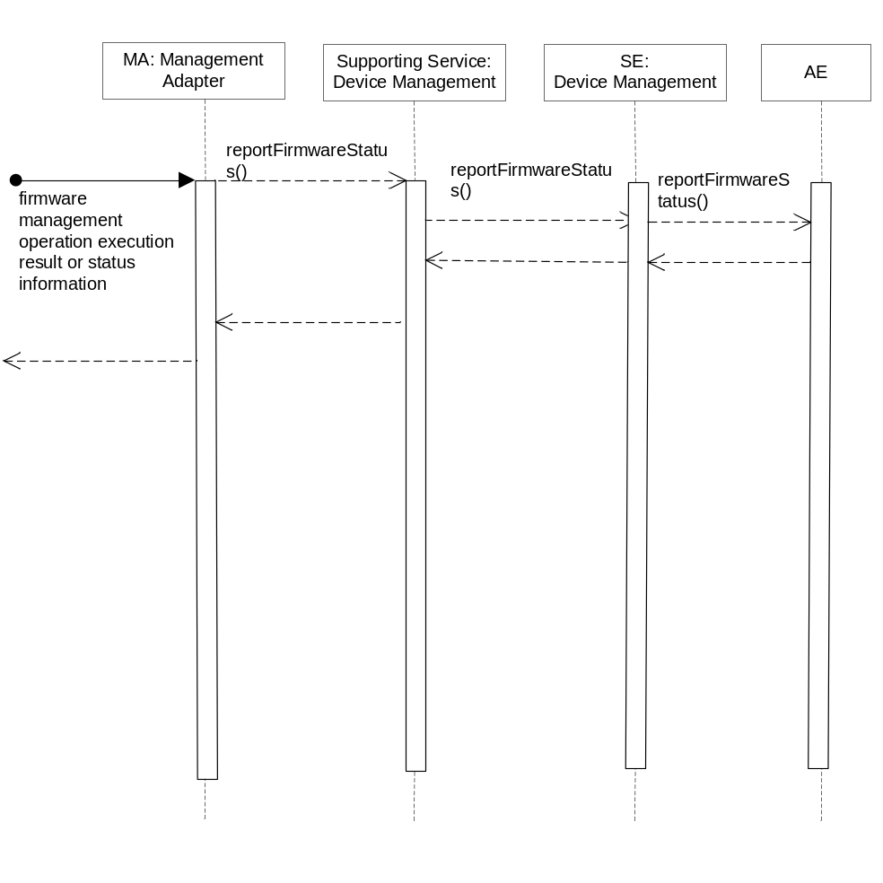
Figure 6.7.2.5.3-1 firmwareReport Diagram

6.7.2.5.4 Post-Conditions
Not Applicable
Editors note: We need to clarify the post conditions around the sequence number of the report.

6.7.2.5.5 Exceptions
Not Applicable

6.7.2.5.6 Policies for Use
Message Exchange Patterns: Not Applicable
Transaction Pattern: Not Applicable

6.7.2.5.7 oneM2M Resource Interworking
Not Applicable

6.7.2.6 getDeviceInformation
This service capability provides the ability to get the specific device information.

6.7.2.6.1 Pre-conditions
A correlation between a Management Server, the M2M Service Capability and device exist.

6.7.2.6.2 Signature –getDeviceInformation
Parameter name | Direction | Optional | Description
deviceId | IN | NO | The unique device identifier in the context of the M2M Service Subscription.
deviceInfo | OUT | YES | The device information. Type DeviceInfo, see 6.6.1.1.1.7.
memory | OUT | YES | The memory information. Type Memory, see 6.6.1.1.1.8.
battery | OUT | YES | The battery information. Type Battery, see 6.6.1.1.1.9.
lockStatus | OUT | YES | The device lock status. Enum LockStatus, see 6.6.1.1.1.13.
responseType | OUT | YES | Unique response types for this service.  Note: Consumed services also provide response types.  - Exception: Request may not have been completed
Table 6.7.2.6.2-1 Management Adapter –getDeviceInformation capability

6.7.2.6.3 Post-Conditions
The Management Adapter has submitted a request to the Management Server to get the device information.

6.7.2.6.4 Exceptions
Not Applicable

6.7.2.6.5 Policies for Use
Message Exchange Patterns: In-Out
Transaction Pattern: Participation allowed

6.7.2.6.6 oneM2M Resource Interworking
This service capability is used to get device information. The service capability aligns with the <deviceInfo> resource and maps to the RETRIEVE procedure for the resource. The service capability aligns with the <memory> resource and maps to the Retrieve procedure for the resource. The service capability aligns with the <battery> resource and maps to the Retrieve procedure for the resource.

6.7.2.7 getDeviceCapabilities
This service capability provides the ability to get device capabilities.

6.7.2.7.1 Pre-conditions
A correlation between a Management Server, the M2M Service Capability and device exist.

6.7.2.7.2 Signature –getDeviceCapabilities
Parameter name | Direction | Optional | Description
deviceId | IN | NO | The unique device identifier in the context of the M2M Service Subscription.
deviceCapabilities | OUT | YES | Array of deviceCapability. Type DeviceCapability, see 6.6.1.1.1.10.
responseType | OUT | YES | Unique response types for this service.  Note: Consumed services also provide response types.  - Exception: Request may not have been completed
Table 6.7.2.7.2-1 Management Adapter –getDeviceCapabilities capability

6.7.2.7.3 Post-Conditions
The Management Adapter has submitted a request to the Management Server to get device capabilities.

6.7.2.7.4 Exceptions
Not Applicable

6.7.2.7.5 Policies for Use
Message Exchange Patterns: In-Out
Transaction Pattern: Participation allowed

6.7.2.7.6 oneM2M Resource Interworking
This service capability is used to get device capabilities. The service capability aligns with the<deviceCapability> resource and maps to the RETRIEVE procedure for the resource.

6.7.2.8 enableDeviceCapability
This service capability provides the ability to enable device capability.

6.7.2.8.1 Pre-conditions
A correlation between a Management Server, the M2M Service Capability and device exist.

6.7.2.8.2 Signature –enableDeviceCapability
Parameter name | Direction | Optional | Description
deviceId | IN | NO | The unique device identifier in the context of the M2M Service Subscription.
name | IN | NO | The name of the capability. Enum DeviceCapabilityName, see 6.6.1.1.1.12.
state | OUT | NO | Indicates if the capability is enabled or disabled.
responseType | OUT | YES | Unique response types for this service.  Note: Consumed services also provide response types.  - Exception: Request may not have been completed
Table 6.7.2.8.2-1 Management Adapter –enableDeviceCapability capability

6.7.2.8.3 Post-Conditions
The Management Adapter has submitted a request to the Management Server to enable device capability.

6.7.2.8.4 Exceptions
Not Applicable

6.7.2.8.5 Policies for Use
Message Exchange Patterns: In-Out
Transaction Pattern: Participation allowed

6.7.2.8.6 oneM2M Resource Interworking
This service capability is used to enable device capability. The service capability aligns with the <deviceCapability> resource and maps to the UPDATE procedure for the attribute enable of the resource.

6.7.2.9 disableDeviceCapability
This service capability provides the ability to disable device capability.

6.7.2.9.1 Pre-conditions
A correlation between a Management Server, the M2M Service Capability and device exist.

6.7.2.9.2 Signature –disableDeviceCapability
Parameter name | Direction | Optional | Description
deviceId | IN | NO | The unique device identifier in the context of the M2M Service Subscription.
name | IN | NO | The name of the capability. Enum DeviceCapabilityName, see 6.6.1.1.1.12.
state | OUT | NO | Indicates if the capability is enabled or disabled.
responseType | OUT | YES | Unique response types for this service.  Note: Consumed services also provide response types.  - Exception: Request may not have been completed
Table 6.7.2.9.2-1 Management Adapter –disableDeviceCapability capability

6.7.2.9.3 Post-Conditions
The Management Adapter has submitted a request to the Management Server to disable device capability.

6.7.2.9.4 Exceptions
Not Applicable

6.7.2.9.5 Policies for Use
Message Exchange Patterns: In-Out
Transaction Pattern: Participation allowed

6.7.2.9.6 oneM2M Resource Interworking
This service capability is used to disable device capability. The service capability aligns with the <deviceCapability> resource and maps to the UPDATE procedure for the attribute disable of the resource.

6.7.2.10 getAreaNetworks
This service capability provides the ability to get area networks information.

6.7.2.10.1 Pre-conditions
A correlation between a Management Server, the M2M Service Capability and area network exist.

6.7.2.10.2 Signature –getAreaNetworks
Parameter name | Direction | Optional | Description
AreaNwks | OUT | YES | Array of area network. Type AreaNwkInfo, see 6.6.1.1.1.13.
responseType | OUT | YES | Unique response types for this service.  Note: Consumed services also provide response types.  - Exception: Request may not have been completed
Table 6.7.2.10.2-1 Management Adapter –getAreaNetworks capability

6.7.2.10.3 Post-Conditions
The Management Adapter has submitted a request to the Management Server to get area networks information.

6.7.2.10.4 Exceptions
Not Applicable

6.7.2.10.5 Policies for Use
Message Exchange Patterns: In-Out
Transaction Pattern: Participation allowed

6.7.2.10.6 oneM2M Resource Interworking
This service capability is used to get area networks information. The service capability aligns with the <areaNwkInfo> resource and maps to the RETRIEVE procedure for the resource. The service capability aligns with the <areaNwkDeviceInfo> resource and maps to the Retrieve procedure for the resource.

6.7.2.11 updateDeviceForAreaNetwork
This service capability provides the ability for the Management Adapter to update device information for area network.

6.7.2.11.1 Pre-conditions
A correlation between a Management Server, the M2M Service Capability, the device and area network exists.

6.7.2.11.2 Signature –updateDeviceForAreaNetwork
Parameter name | Direction | Optional | Description
areaNwkId | IN | NO | The unique area network identifier.
deviceId | IN | NO | The unique device identifier in the context of the M2M Service Subscription.
areaNwkDeviceInfo | IN | YES | The existing areaNwkDeviceInfo are replaced with the information in this parameter. Type AreaNwkDeviceInfo, see 6.6.1.1.1.15.
lastModifiedTime | OUT | NO | The modified time.
responseType | OUT | YES | Unique response types for this service.  Note: Consumed services also provide response types.  - Exception: Request may not have been completed
Table 6.7.2.11.2-1 Management Adapter –updateDeviceForAreaNetwork capability

6.7.2.11.3 Post-Conditions
The Management Adapter has submitted a request to the Management Server to update device information for area network.

6.7.2.11.4 Exceptions
Not Applicable

6.7.2.11.5 Policies for Use
Message Exchange Patterns: Not Applicable
Transaction Pattern: Not Applicable

6.7.2.11.6 oneM2M Resource Interworking
The service capability aligns with the <areaNwkDeviceInfo> resource and maps to the Update procedure for attribute devType , sleepInterval , sleepDuration , status , listOfNeighbors of the resource.

6.7.2.12 rebootDevice
This service capability provides the ability to reboot the specific device.

6.7.2.12.1 Pre-conditions
A correlation between a Management Server, the M2M Service Capability and device exist.

6.7.2.12.2 Signature –rebootDevice
Parameter name | Direction | Optional | Description
deviceId | IN | NO | The unique device identifier in the context of the M2M Service Subscription.
reportPolicy | IN | YES | The policy used to report the state of the operation to the originating AE. See clause 6.6.1.1.1.1.
troubleshootingReport | OUT | YES | The troubleshooting operation execution result or status. Type TroubleshootingReport, see 6.6.1.1.1.20.
responseType | OUT | YES | Unique response types for this service.  Note: Consumed services also provide response types.  - Exception: Request may not have been completed
Table 6.7.2.12.2-1 Management Adapter –rebootDevice capability

6.7.2.12.3 Post-Conditions
The Management Adapter has submitted a request to the Management Server to reboot the device.

6.7.2.12.4 Exceptions
Not Applicable

6.7.2.12.5 Policies for Use
Message Exchange Patterns: In-Out
Transaction Pattern: Participation allowed

6.7.2.12.6 oneM2M Resource Interworking
This service capability is used to reboot device. The service capability aligns with the <reboot> resource and maps to the Execute procedure for the attribute reboot of the resource.

6.7.2.13 resetDevice
This service capability provides the ability to reset device.

6.7.2.13.1 Pre-conditions
A correlation between a Management Server, the M2M Service Capability and device exist.

6.7.2.13.2 Signature –resetDevice
Parameter name | Direction | Optional | Description
deviceId | IN | NO | The unique device identifier in the context of the M2M Service Subscription.
reportPolicy | IN | YES | The policy used to report the state of the operation to the originating AE. See clause 6.6.1.1.1.1.
troubleshootingReport | OUT | YES | The troubleshooting operation execution result or status. Type TroubleshootingReport, see 6.6.1.1.1.20.
responseType | OUT | YES | Unique response types for this service.  Note: Consumed services also provide response types.  - Exception: Request may not have been completed
Table 6.7.2.13.2-1 Management Adapter –resetDevice capability

6.7.2.13.3 Post-Conditions
The Management Adapter has submitted a request to the Management Server to reset device.

6.7.2.13.4 Exceptions
Not Applicable

6.7.2.13.5 Policies for Use
Message Exchange Patterns: In-Out
Transaction Pattern: Participation allowed

6.7.2.13.6 oneM2M Resource Interworking
This service capability is used to reset device. The service capability aligns with the <reboot> resource and maps to the Execute procedure for the attribute factoryReset of the resource.

6.7.2.14 uploadDeviceLog
This service capability provides the ability to upload device log.

6.7.2.14.1 Pre-conditions
A correlation between a Management Server, the M2M Service Capability and device exist.

6.7.2.14.2 Signature –uploadDeviceLog
Parameter name | Direction | Optional | Description
deviceId | IN | NO | The unique device identifier in the context of the M2M Service Subscription.
logInfo | IN | NO | The log information. Type LogInfo, see 6.6.1.1.1.19.
reportPolicy | IN | YES | The policy used to report the state of the operation to the originating AE. See clause 6.6.1.1.1.1.
logURL | OUT | YES | The URL from which the log can be uploaded.
troubleshootingReport | OUT | YES | The troubleshooting operation execution result or status. Type TroubleshootingReport, see 6.6.1.1.1.20.
responseType | OUT | YES | Unique response types for this service.  Note: Consumed services also provide response types.  - Exception: Request may not have been completed
Table 6.7.2.14.2-1 Management Adapter –uploadDeviceLog capability

6.7.2.14.3 Post-Conditions
The Management Adapter has submitted a request to the Management Server to upload device log.

6.7.2.14.4 Exceptions
Not Applicable

6.7.2.14.5 Policies for Use
Message Exchange Patterns: In-Out
Transaction Pattern: Participation allowed

6.7.2.14.6 oneM2M Resource Interworking
This service capability is used to upload device log. The service capability aligns with the <eventLog> resource and maps to the Update procedure for the resource.

6.7.2.15 reportTroubleshootingStatus
This service capability provides the ability for the Management Adapter to report the troubleshooting operation execution result or status information. The Management Adapter can send one or multiple troubleshooting reports according to the aggregation policy.

6.7.2.15.1 Pre-conditions
A correlation between a Management Server, the M2M Service Capability and previously submitted troubleshooting requests exist.

6.7.2.15.2 Signature –reportTroubleshootingStatus
Parameter name | Direction | Optional | Description
to | IN | NO | The identifier of the AE that is to receive the data(M2M-AppInst-ID)
isLastReport | IN | NO | Boolean, whether it is the last report.
sequenceNumber | IN | NO | The report sequence number.
troubleshootingReportList | IN | NO | Array of troubleshootingReport.  Type TroubleshootingReport, see 6.6.1.1.1.20.
aggregationPolicy | IN | YES | The policy used to aggregate the result of the management operation prior to the reports being sent. See clause 6.6.1.1.1.2.
responseType | OUT | YES | Unique response types for this service.  Note: Consumed services also provide response types.  - The target AE does not exist.  - Aggregation policy does not supported
Table 6.7.2.18.2-1 Management Adapter –reportTroubleshootingStatus capability

6.7.2.15.3 Service Interactions
The interactions of service capabilities required for this service capability:
- Issue the request to the Supporting Service to perform the operation
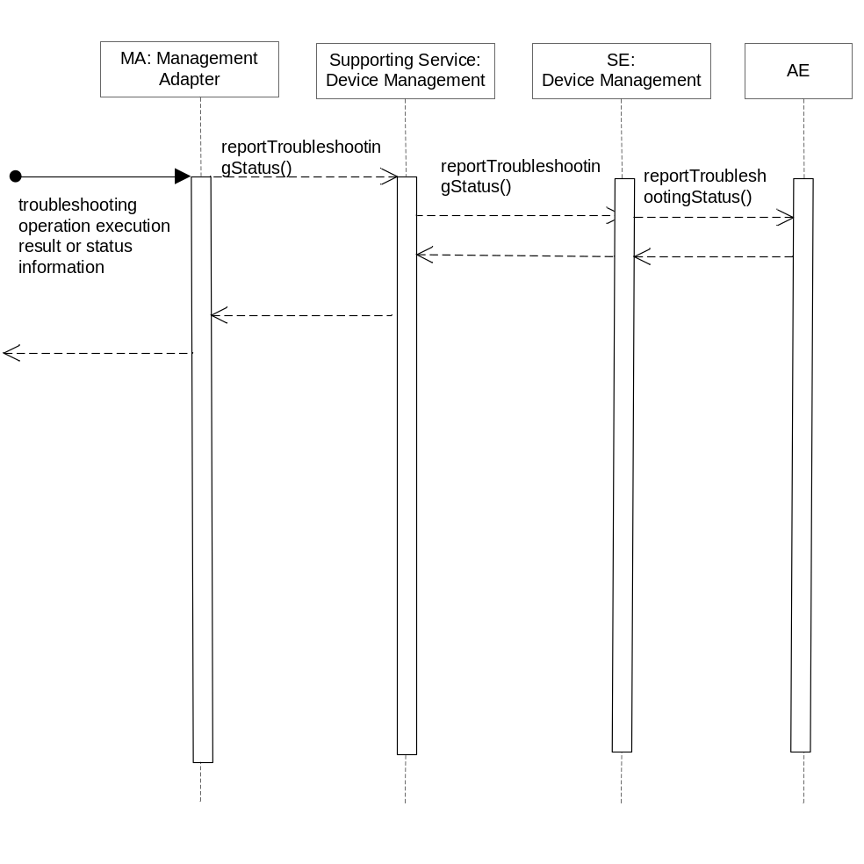
Figure 6.7.2.15.3-1 reportTroubleshootingStatus Diagram

6.7.2.15.4 Post-Conditions
Not Applicable

6.7.2.15.5 Exceptions
Not Applicable

6.7.2.15.6 Policies for Use
Message Exchange Patterns: Not Applicable
Transaction Pattern: Not Applicable

6.7.2.15.7 oneM2M Resource Interworking
Not Applicable

6.7.2.16 getDeviceLogs
This service capability provides the ability to get all logs of a device.

6.7.2.16.1 Pre-conditions
A correlation between a Management Server, the M2M Service Capability and device exist.

6.7.2.16.2 Signature –getDeviceLogs
Parameter name | Direction | Optional | Description
deviceId | IN | NO | The unique device identifier in the context of the M2M Service Subscription.
logList | OUT | YES | Array of log. Type Log, see 6.6.1.1.1.21.
responseType | OUT | YES | Unique response types for this service.  Note: Consumed services also provide response types.  - Exception: Request may not have been completed
Table 6.7.2.16.2-1 Management Adapter –getDeviceLogs capability

6.7.2.16.3 Post-Conditions
The Management Adapter has submitted a request to the Management Server to get all logs of a device.

6.7.2.16.4 Exceptions
Not Applicable

6.7.2.16.5 Policies for Use
Message Exchange Patterns: In-Out
Transaction Pattern: Participation allowed

6.7.2.16.6 oneM2M Resource Interworking
This service capability is used to get all logs of a device. The service capability aligns with the <eventLog> resource and maps to the Retrieve procedure for the resource.

6.7.2.17 getDeviceLogInformation
This service capability provides the ability to get a device log information.

6.7.2.17.1 Pre-conditions
A correlation between a Management Server, the M2M Service Capability and device exist.

6.7.2.17.2 Signature –getDeviceLogInformation
Parameter name | Direction | Optional | Description
deviceId | IN | NO | The unique device identifier in the context of the M2M Service Subscription.
filterCriteria | IN | YES | See Table 6.6.1.1.1.22
logURL | IN | YES | The URL from which the log can be accessed.
log | OUT | YES | Type Log, see 6.6.1.1.1.21.
responseType | OUT | YES | Unique response types for this service.  Note: Consumed services also provide response types.  - Exception: Request may not have been completed
Table 6.7.2.17.2-1 Management Adapter –getDeviceLogInformation capability

6.7.2.17.3 Post-Conditions
The Management Adapter has submitted a request to the Management Server to get a device log information.

6.7.2.17.4 Exceptions
Not Applicable

6.7.2.17.5 Policies for Use
Message Exchange Patterns: In-Out
Transaction Pattern: Participation allowed

6.7.2.17.6 oneM2M Resource Interworking
This service capability is used to get device log information. The service capability aligns with the <eventLog> resource and maps to the Retrieve procedure for the resource.

6.7.2.18 getSoftwareInformation
This service capability provides the ability to get application software information.

6.7.2.18.1 Pre-conditions
A correlation between a Management Server, the M2M Service Capability and device exist.

6.7.2.18.2 Signature –getSoftwareInformation
Parameter name | Direction | Optional | Description
deviceId | IN | NO | The unique device identifier in the context of the M2M Service Subscription.
version | OUT | YES | The version of the software.
name | OUT | YES | The name of the software.
url | OUT | YES | The URL from which the software package can be downloaded.
installStatus | OUT | YES | Indicates the status of the install.  Enum ActionStatus, see 6.6.1.1.1.26.
activeStatus | OUT | YES | The status of active or deactivate action.  Enum ActionStatus, see 6.6.1.1.1.26.
responseType | OUT | YES | Unique response types for this service.  Note: Consumed services also provide response types.  - Exception: Request may not have been completed
Table 6.7.2.18.2-1 Management Adapter –getSoftwareInformation capability

6.7.2.18.3 Post-Conditions
The Management Adapter has submitted a request to the Management Server to get application software information.

6.7.2.18.4 Exceptions
Not Applicable

6.7.2.18.5 Policies for Use
Message Exchange Patterns: In-Out
Transaction Pattern: Participation allowed

6.7.2.18.6 oneM2M Resource Interworking
This service capability is used to get application software information. The service capability aligns with the <software> resource and maps to the Retrieve procedure for the resource.

6.7.2.19 downloadSoftware
This service capability provides the ability to download application software.

6.7.2.19.1 Pre-conditions
A correlation between a Management Server, the M2M Service Capability and device exist.

6.7.2.19.2 Signature –downloadSoftware
Parameter name | Direction | Optional | Description
deviceId | IN | NO | The unique device identifier in the context of the M2M Service Subscription.
version | IN | NO | The version of the software.
name | IN | NO | The name of the software.
url | IN | NO | The URL from which the software package can be downloaded.
reportPolicy | IN | YES | The policy used to report the state of the operation to the originating AE. See clause 6.6.1.1.1.1.
softwareReport | OUT | YES | The software management operation execution result or status. Type SoftwareReport, see 6.6.1.1.1.27.
responseType | OUT | YES | Unique response types for this service.  Note: Consumed services also provide response types.  - Exception: Request may not have been completed
Table 6.7.2.19.2-1 Management Adapter –downloadSoftware capability

6.7.2.19.3 Post-Conditions
The Management Adapter has submitted a request to the Management Server to download application software.

6.7.2.19.4 Exceptions
Not Applicable

6.7.2.19.5 Policies for Use
Message Exchange Patterns: In-Out
Transaction Pattern: Participation allowed

6.7.2.19.6 oneM2M Resource Interworking
This service capability is used to download application software. The service capability aligns with the <software> resource and maps to the UPDATE procedure for the attribute install of the resource. The service capability also aligns with the <mgmtCmd> resource and maps to the EXECUTE procedure for the resource.

6.7.2.20 installSoftware
This M2M Service Capability provides the ability to install application software.

6.7.2.20.1 Pre-conditions
A correlation between a Management Server, the service capability and device exist.

6.7.2.20.2 Signature –installSoftware
Parameter name | Direction | Optional | Description
deviceId | IN | NO | The unique device identifier in the context of the M2M Service Subscription.
version | IN | NO | The version of the software.
name | IN | NO | The name of the software.
reportPolicy | IN | YES | The policy used to report the state of the operation to the originating AE. See clause 6.6.1.1.1.1.
softwareReport | OUT | YES | The software management operation execution result or status. Type SoftwareReport, see 6.6.1.1.1.27.
responseType | OUT | YES | Unique response types for this service.  Note: Consumed services also provide response types.  - Exception: Request may not have been completed
Table 6.7.2.20.2-1 Management Adapter –installSoftware capability

6.7.2.20.3 Post-Conditions
The Management Adapter has submitted a request to the Management Server to install application software.

6.7.2.20.4 Exceptions
Not Applicable

6.7.2.20.5 Policies for Use
Message Exchange Patterns: In-Out
Transaction Pattern: Participation allowed

6.7.2.20.6 oneM2M Resource Interworking
This service capability is used to install application software. The service capability aligns with the <software> resource and maps to the UPDATE procedure for the attribute install of the resource. The service capability also aligns with the <mgmtCmd> resource and maps to the EXECUTE procedure for the resource.

6.7.2.21 activateSoftware
This service capability provides the ability to activate software previously installed.

6.7.2.21.1 Pre-conditions
A correlation between a Management Server, the M2M Service Capability and device exist.

6.7.2.21.2 Signature –activateSoftware
Parameter name | Direction | Optional | Description
deviceId | IN | NO | The unique device identifier in the context of the M2M Service Subscription.
version | IN | NO | The version of the software.
name | IN | NO | The name of the software.
reportPolicy | IN | YES | The policy used to report the state of the operation to the originating AE. See clause 6.6.1.1.1.1.
softwareReport | OUT | YES | The software management operation execution result or status. Type SoftwareReport, see 6.6.1.1.1.27.
responseType | OUT | YES | Unique response types for this service.  Note: Consumed services also provide response types.  - Exception: Request may not have been completed
Table 6.7.2.21.2-1 Management Adapter –activateSoftware capability

6.7.2.21.3 Post-Conditions
The Management Adapter has submitted a request to the Management Server to activate software previously installed.

6.7.2.21.4 Exceptions
Not Applicable

6.7.2.21.5 Policies for Use
Message Exchange Patterns: In-Out
Transaction Pattern: Participation allowed

6.7.2.21.6 oneM2M Resource Interworking
This service capability is used to activate software previously installed. The service capability aligns with the <software> resource and maps to the UPDATE procedure for the attribute activate of the resource. The service capability also aligns with the <mgmtCmd> resource and maps to the EXECUTE procedure for the resource.

6.7.2.22 deactivateSoftware
This service capability provides the ability for the Management Adapter to deactivates software.

6.7.2.22.1 Pre-conditions
A correlation between a Management Server, the M2M Service Capability and device exist.

6.7.2.22.2 Signature –deactivateSoftware
Parameter name | Direction | Optional | Description
deviceId | IN | NO | The unique device identifier in the context of the M2M Service Subscription.
version | IN | NO | The version of the software.
name | IN | NO | The name of the software.
reportPolicy | IN | YES | The policy used to report the state of the operation to the originating AE. See clause 6.6.1.1.1.1.
softwareReport | OUT | YES | The software management operation execution result or status. Type SoftwareReport, see 6.6.1.1.1.27.
responseType | OUT | YES | Unique response types for this service.  Note: Consumed services also provide response types.  - Exception: Request may not have been completed
Table 6.7.2.16.2-1 Management Adapter –deactivateSoftware capability

6.7.2.22.3 Post-Conditions
The Management Adapter has submitted a request to the Management Server to deactivates software.

6.7.2.22.4 Exceptions
Not Applicable

6.7.2.22.5 Policies for Use
Message Exchange Patterns: In-Out
Transaction Pattern: Participation allowed

6.7.2.22.6 oneM2M Resource Interworking
This service capability is used to deactivates software. The service capability aligns with the <software> resource and maps to the UPDATE procedure for the attribute deactivate of the resource. The service capability also aligns with the <mgmtCmd> resource and maps to the EXECUTE procedure for the resource.

6.7.2.23 removeSoftware
This service capability provides the ability for the Management Adapter to uninstall the software.

6.7.2.23.1 Pre-conditions
A correlation between a Management Server, the M2M Service Capability and device exist.

6.7.2.23.2 Signature –removeSoftware
Parameter name | Direction | Optional | Description
deviceId | IN | NO | The unique device identifier in the context of the M2M Service Subscription.
version | IN | NO | The version of the software.
name | IN | NO | The name of the software.
reportPolicy | IN | YES | The policy used to report the state of the operation to the originating AE. See clause 6.6.1.1.1.1.
softwareReport | OUT | YES | The software management operation execution result or status. Type SoftwareReport, see 6.6.1.1.1.27.
responseType | OUT | YES | Unique response types for this service.  Note: Consumed services also provide response types.  - Exception: Request may not have been completed
Table 6.7.2.23.2-1 Management Adapter –removeSoftware capability

6.7.2.23.3 Post-Conditions
The Management Adapter has submitted a request to the Management Server to uninstall the software.

6.7.2.23.4 Exceptions
Not Applicable

6.7.2.23.5 Policies for Use
Message Exchange Patterns: In-Out
Transaction Pattern: Participation allowed

6.7.2.23.6 oneM2M Resource Interworking
This service capability is used to install application software. The service capability aligns with the <software> resource and maps to the UPDATE procedure for the attribute uninstall of the resource. The service capability also aligns with the <mgmtCmd> resource and maps to the EXECUTE procedure for the resource.

6.7.2.24 reportSoftwareStatus
This service capability provides the ability for the Management Adapter to report the application software management operation execution result or status information. The Management Adapter can send one or multiple software reports according to the aggregation policy.

6.7.2.24.1 Pre-conditions
A correlation between a Management Server, the M2M Service Capability and previously submitted application software management requests exist.

6.7.2.24.2 Signature –reportSoftwareStatus
Parameter name | Direction | Optional | Description
to | IN | NO | The identifier of the AE that is to receive the data(M2M-AppInst-ID)
isLastReport | IN | NO | Boolean, whether it is the last report.
sequenceNumber | IN | NO | The report sequence number.
softwareReportList | IN | NO | Array of softwareReport.  Type SoftwareReport, see 6.6.1.1.1.27.
aggregationPolicy | IN | YES | The policy used to aggregate the result of the management operation prior to the reports being sent. See clause 6.6.1.1.1.2.
responseType | OUT | YES | Unique response types for this service.  Note: Consumed services also provide response types.  - The target AE does not exist.  - Aggregation policy does not supported
Table 6.7.2.24.2-1 Management Adapter –reportSoftwareStatus capability

6.7.2.24.3 Service Interactions
The interactions of service capabilities required for this service capability:
- Issue the request to the Supporting Service to perform the operation
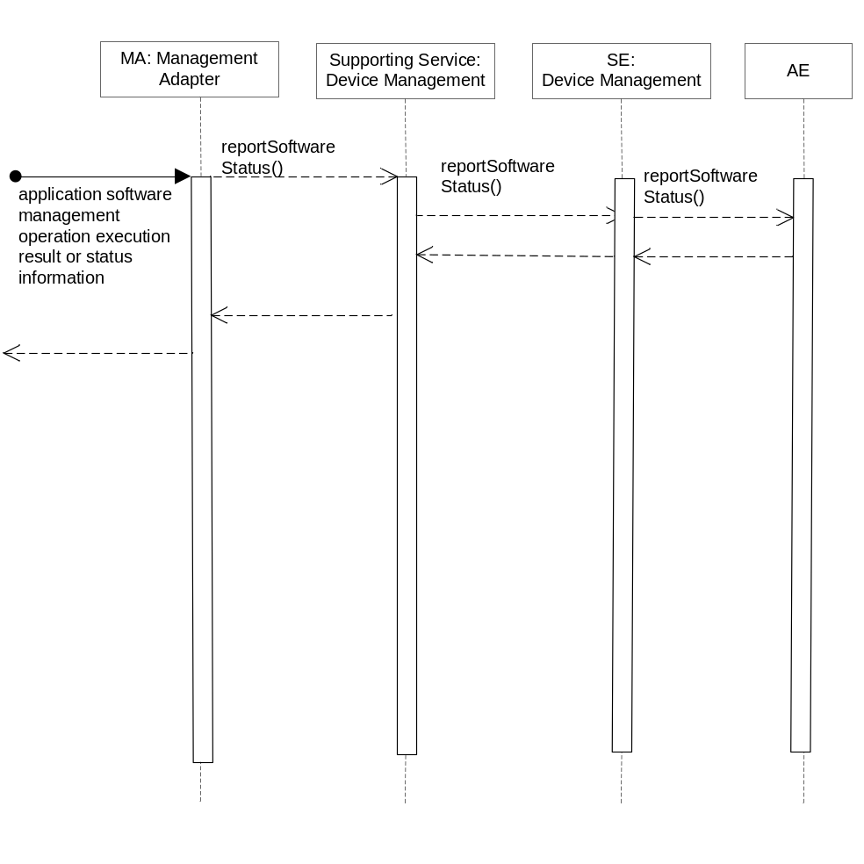
Figure 6.7.2.24.3-1 reportSoftwareStatus Diagram

6.7.2.24.4 Post-Conditions
Not Applicable

6.7.2.24.5 Exceptions
Not Applicable

6.7.2.24.6 Policies for Use
Message Exchange Patterns: Not Applicable
Transaction Pattern: Not Applicable

6.7.2.24.7 oneM2M Resource Interworking
Not Applicable

6.8 Service Administration

6.8.1 Overview
The Service Administration service provides the capability to administer the following across the Msc Reference Points:

- Administration of M2M Service attributes
- Association of M2M Services to corresponding Service Roles
- Association of Service Roles to M2M Service Capabilities

The information elements that relate M2M Services to Service Roles and Service Roles to M2M Service Capabilities is depicted below:
- Each instance of an M2M Service contains zero or instances of a Service Role
- The M2M Service can be obtained from the Service Role. The Service Roles from the M2M Service can be obtained from the M2M Service
- Each instance of a Service Role is associated with zero or more instances of a M2M Service Capability
- The M2M Service can be obtained from the Service Role. The Service Roles associated with the M2M Service can be obtained from the M2M Service
- Each instance of a M2M Service Capability is associated with zero or more instances of a Service Role
- The M2M Service Capabilities that are associated with a Service Role can be obtained from the Service Role. Likewise the Service Roles associated with the M2M Service Capability can be obtained from the M2M Service Capability
- Each operation that is defined within the Service Exposure Component is assigned to exactly one M2M Service Capability
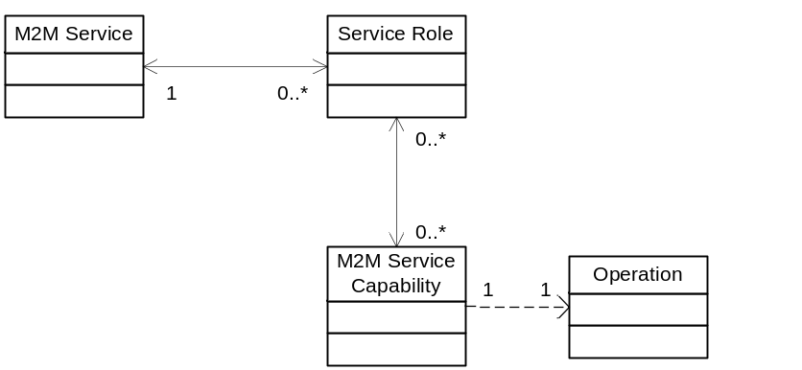
Figure 6.8.1-1 M2M Service Entity Relationships

6.8.1.1 M2M Service Entity
The Service is a primary entity that provides the attributes to identify the M2M Service and associated Service Roles within the oneM2M System. These M2M Services and associated Service Roles shall be maintained by the M2M Service Provider.
Attribute name | Description
serviceId | The M2M Service Identifier (M2M-Serv-ID).
serviceRoleIds | List of Service Role Identifiers (SRole-ID) associated with the Service.
lastModifiedTime | See Table A.2.1-1
creationTime | See Table A.2.1-1
Table 6.8.1.1-1 M2M Service Entity

6.8.1.1.1 M2M Service Filter Criteria
Criterion name | Description
serviceId | The Service Identifier (M2M-Serv-ID).
serviceRoleIds | One or more Service Role Identifiers (SRole-ID) associated with the M2M Service entity.
lastModifiedTime | See Table A.2.1-1
creationTime | See Table A.2.1-1
Table 6.8.1.1.1-1 M2M Service Filter Criteria
Editors Note: last modified time and creation time are common elements of entities – need a section that describes that any information entities has lastModifiedTime and creationTime attributes.

6.8.2 Service Capabilities

6.8.2.1 createM2MService
This service capability provides the ability to create a M2M Service.

6.8.2.1.1 Pre-conditions
Not Applicable

6.8.2.1.2 Signature – createM2MService
Parameter name | Direction | Optional | Description
name | IN | NO | The unique name of the M2M Service.
description | IN | YES | The description of the M2M Service.
serviceId | OUT | NO | The identifier of the created M2M Service (M2M-Serv-ID)
responseType | OUT | YES | Unique response types for this service.  - M2M Service exists for the name parameter  - M2M Service Role exists for M2M Service
Table 6.8.2.1.2-1 M2M Service Administration – createM2M Service capability

6.8.2.1.3 Service Interactions
The interactions of service capabilities required for this service capability:
- Issue this capability
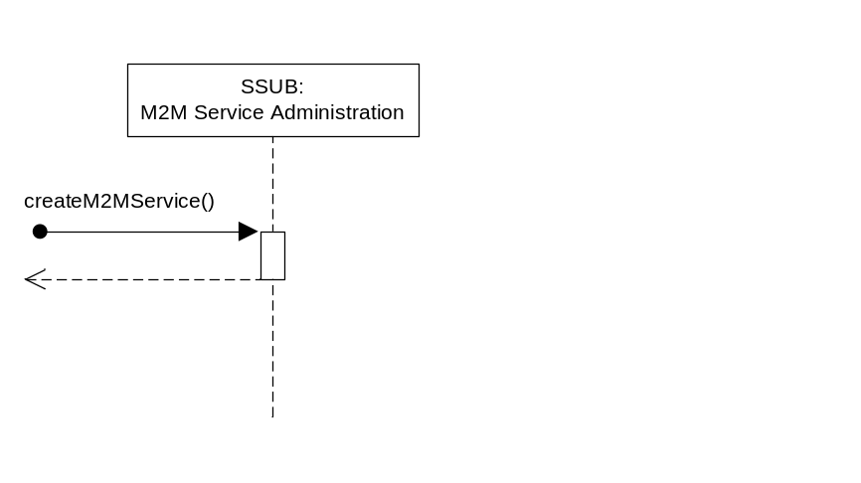
Figure 6.8.2.1.3-1 M2M Service Administration – createM2MService Diagram

6.8.2.1.4 Post-Conditions
Not Applicable

6.8.2.1.5 Exceptions
Not Applicable

6.8.2.1.6 Policies for Use
Message Exchange Patterns: In-Out
Transaction Pattern: Participation allowed

6.8.2.1.7 oneM2M Resource Interworking
This service capability creates the M2M Service. The M2M Service entity is described in the Annex G of the oneM2M Functional Architecture [2]. The M2M-Serv-ID created using this capability shall map to the M2M-Serv-ID of the oneM2M Functional Architecture [2].

6.8.2.2 deleteM2MService
This service capability provides the ability to delete a M2M Service. This service capability shall be restricted to the Msc Reference Point.

6.8.2.2.1 Pre-conditions

The M2M Service’s Service Roles are not associated with any M2M Service Subscriptions.

6.8.2.2.2 Signature – deleteM2MService
Parameter name | Direction | Optional | Description
serviceId | IN | NO | The M2M Service Identifier (M2M-Serv-ID).
responseType | OUT | YES | Unique response types for this service.  - M2M Service does not exist  - M2M Service has Service Roles associated with M2M Service Subscriptions
Table 6.8.2.2.2-1 M2M Service Administration – deleteM2MService capability

6.8.2.2.3 Service Interactions
The interactions of service capabilities required for this service capability:

- Issue this capability
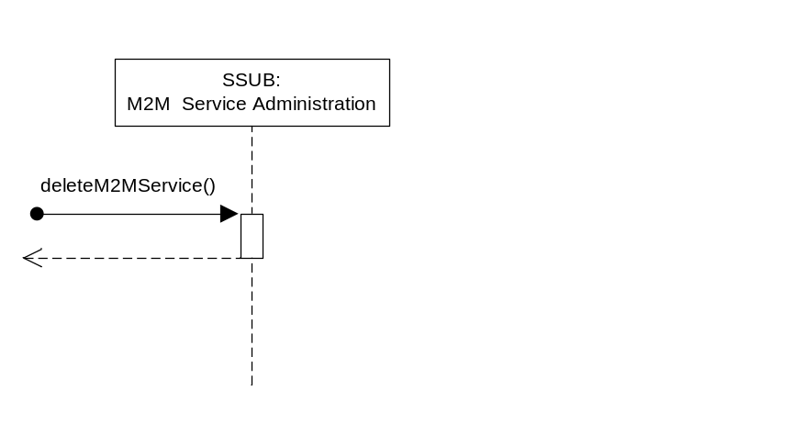
Figure 6.8.2.2.3-1 M2M Service Administration – deleteM2MService Diagram

6.8.2.2.4 Post-Conditions
The M2M Service is deleted along with any associations has to the Service Roles. The Node information associated with the M2M Service is also deleted.

6.8.2.2.5 Exceptions
Not Applicable

6.8.2.2.6 Policies for Use

Message Exchange Patterns: In-Out
Transaction Pattern: Participation allowed

6.8.2.2.7 oneM2M Resource Interworking
This service capability deletes the M2M Service. The M2M Service entity is described in the Annex G of the oneM2M Functional Architecture [2].

6.8.2.3 updateM2MService
This service capability provides the ability to update a M2M Service. This service capability shall be restricted to the Msc Reference Point.

6.8.4.1.1 Pre-conditions
Not Applicable

6.8.2.3.2 Signature – updateSupportingService
Parameter name | Direction | Optional | Description
serviceId | IN | NO | The M2M Service Identifier (M2M-Serv-ID).
lastModifiedTime | OUT | NO | Data and time that the entity was modified.
responseType | OUT | YES | Unique response types for this service.  - M2M Service does not exist
Table 6.8.2.3.2-1 M2M Service Administration – updateM2MService capability

6.8.2.3.3 Service Interactions
The interactions of service capabilities required for this service capability:
- Issue this capability
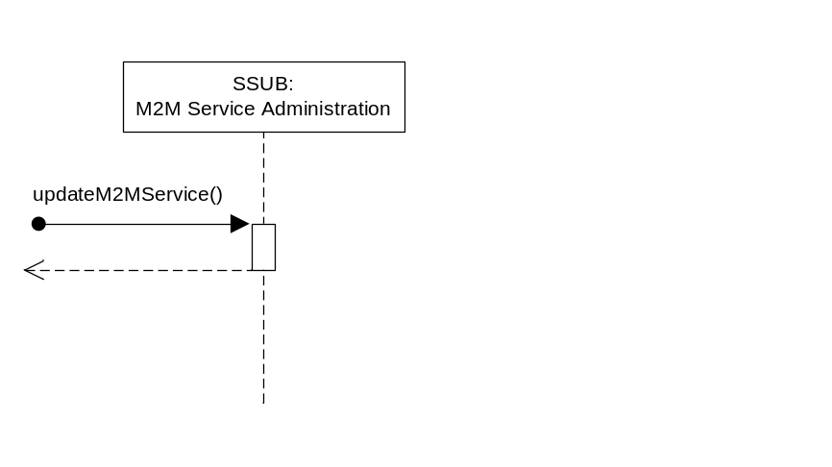
Figure 6.8.2.3.3-1 M2M Service Administration – updateM2MService Diagram

6.8.2.3.4 Post-Conditions
Not Applicable

6.8.2.3.5 Exceptions
Not Applicable

6.8.2.3.6 Policies for Use
Message Exchange Patterns: In-Out
Transaction Pattern: Participation allowed

6.8.2.3.7 oneM2M Resource Interworking
This service capability updates the M2M Service. The M2M Service entity is described in the Annex G of the oneM2M Functional Architecture [2].

6.8.2.4 addRoleToM2MService
This service capability provides the ability to add new Service Roles to a M2M Service. This service capability shall be restricted to the Msc Reference Point.

6.8.2.4.1 Pre-conditions
M2M Service exists.

6.8.2.4.2 Signature – addRoleToM2MService
Parameter name | Direction | Optional | Description
serviceId | IN | NO | The M2M Service Identifier (M2M-Serv-ID).
serviceRoleIds | IN | NO | List of Service Role Identifiers (SRole-ID) to be associated with the M2M Service. If a SRole-ID in the parameter is already associated with the M2M Service, nothing is done for the SRole-ID as it already is associated.
creationTime | OUT | NO | The date and time the Service role(s) were added to the M2M Service.
lastModifiedTime | OUT | NO | The data and time the M2M Service was modified.
responseType | OUT | YES | Unique response types for this service.  - M2M Service does not exist
Table 6.8.2.4.2-1 M2M Service Administration – addRoleToM2MService capability

6.8.2.4.3 Service Interactions
The interactions of service capabilities required for this service capability:
- Issue this capability
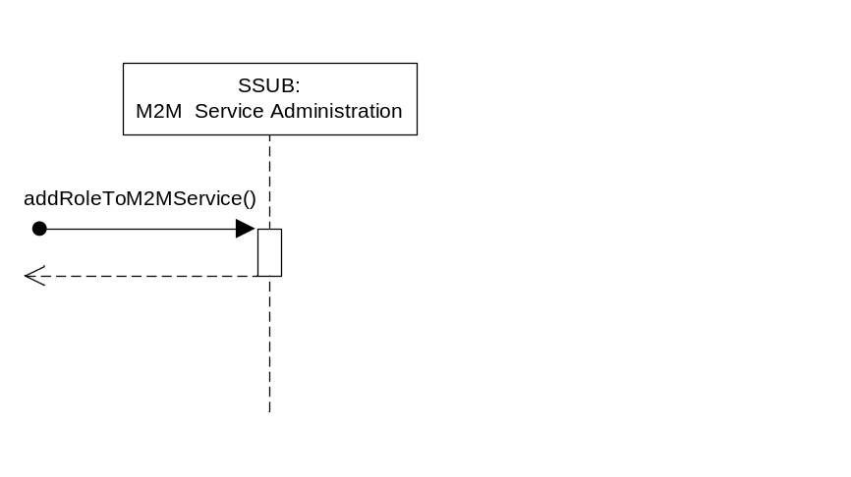
Figure 6.8.2.4.3-1 M2M Service Administration – addRoleToM2MService Diagram

6.8.2.4.4 Post-Conditions
The associations that M2M Service has to the Service Role(s) are updated.

6.8.2.4.5 Exceptions
Not Applicable

6.8.2.4.6 Policies for Use
Message Exchange Patterns: In-Out
Transaction Pattern: Participation allowed

6.8.2.4.7 oneM2M Resource Interworking
This service capability updates the M2M Service with the respective M2M Service Roles. The M2M Service entity is described in the Annex G of the oneM2M Functional Architecture [2].

6.8.2.5 deleteRoleFromM2MService
This service capability provides the ability to delete existing Service Roles from a M2M Service. This service capability shall be restricted to the Msc Reference Point.

6.8.2.5.1 Pre-conditions
The Service Role is not associated with any M2M Service Subscriptions.

6.8.2.5.2 Signature – deleteRoleFromM2MService
Parameter name | Direction | Optional | Description
serviceId | IN | NO | The M2M Service Identifier (M2M-Serv-ID).
serviceRoleIds | IN | NO | List of Service Role Identifiers (SRole-ID) to be deleted from the association with the M2M Service.
lastModifiedTime | OUT | NO | The date and time the M2M Service was modified.
responseType | OUT | YES | Unique response types for this service.  - M2M Service does not exist  - Service Role does not exist  - Service Role is associated with a M2M Service Subscription
Table 6.8.2.5.2-1 M2M Service Administration – deleteRoleFromM2MService capability

6.8.2.5.3 Service Interactions
The interactions of service capabilities required for this service capability:
- Issue this capability
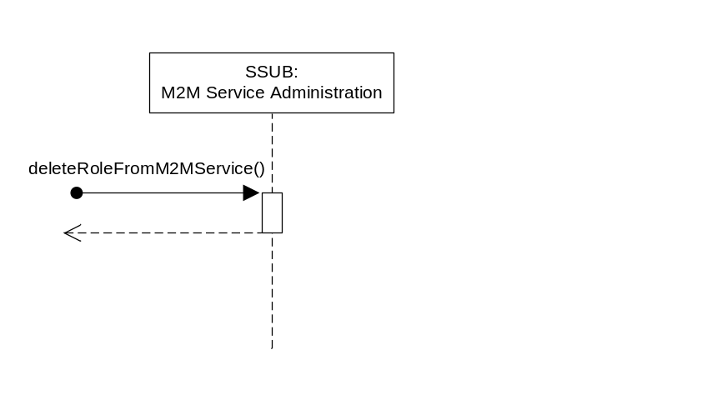
Figure 6.8.2.5.3-1 M2MService Administration – deleteRoleFromM2MService Diagram

6.8.2.5.4 Post-Conditions
The M2M Service is updated with associations of the identified Service Roles deleted.

6.8.2.5.5 Exceptions
Not Applicable

6.8.2.5.6 Policies for Use
Message Exchange Patterns: In-Out
Transaction Pattern: Participation allowed

6.8.2.5.7 oneM2M Resource Interworking
This service capability updates the M2M Service with the respective Service Roles removed. The M2M Service entity is described in the Annex G of the oneM2M Functional Architecture [2].

6.8.2.6 getM2MService
This service capability provides the ability to retrieve the existing M2M Service. This service capability shall be restricted to the Msc Reference Points.

6.8.2.6.1 Pre-conditions
Not Applicable

6.8.2.6.2 Signature – getM2MService
Parameter name | Direction | Optional | Description
filterCriteria | IN | NO | See Table 6.8.1.1.1-1
services | OUT | NO | The resulting M2M Service entities in Table 6.8.1.1-1.
responseType | OUT | YES | Unique response types for this service.  - None
Table 6.8.2.6.2-1 M2M Service Administration – getM2MService capability

6.8.2.6.3 Service Interactions
The interactions of service capabilities required for this service capability:
- Issue this capability
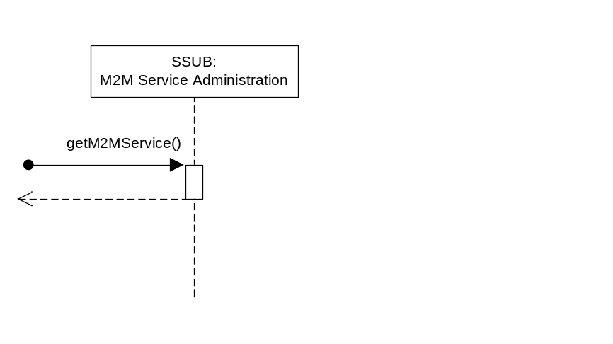
Figure 6.8.2.6.3-1 M2M Service Administration – getM2MService Diagram

6.8.2.6.4 Post-Conditions
Not Applicable

6.8.2.6.5 Exceptions
Not Applicable

6.8.2.6.6 Policies for Use
Message Exchange Patterns: In-Out
Transaction Pattern: Participation allowed

6.8.2.6.7 oneM2M Resource Interworking
This service capability retrieves the M2M Service. The M2M Service entity is described in the Annex G of the oneM2M Functional Architecture [2].

6.8.2.7 addServiceCapabilityToRole
This service capability adds a M2M Service Capability to one or more Service Roles.

6.8.2.7.1 Pre-conditions
Service Roles exist.

6.8.2.7.2 Signature - addServiceCapabilityToRole
Parameter name | Direction | Optional | Description
serviceCapId | IN | NO | The M2M Service Capability Identifier (M2M-Serv-Cap-ID).
serviceRoleIds | IN | NO | List of Service Role Identifiers (SRole-ID) to be associated with the M2M Service Capability.
creationTime | OUT | NO | The date and time the association was created.
responseType | OUT | YES | Response types:  - Service Role does not exist
Table 6.8.2.7.2-1 M2M Service Administration – addServiceCapabilityToRole capability

6.8.2.7.3 Service Interactions
The interactions of service capabilities required for this service capability:
- Issue this capability
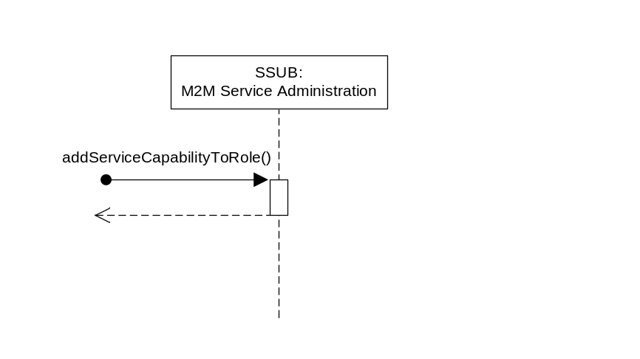
Figure 6.8.2.7.3-1M2M Service Administration – addServiceCapabilityToRole Diagram

6.8.2.7.4 Post-Conditions
Not Applicable

6.8.2.7.5 Exceptions
Not Applicable

6.8.2.7.6 Policies for Use
Message Exchange Patterns: In-Out
Transaction Pattern: Participation allowed

6.8.2.7.7 oneM2M Resource Interworking
Not Applicable

6.8.2.8 deleteServiceCapabilityFromRole
This service capabilitydelete a M2M Service Capability from one or more Service Roles.

6.8.2.8.1 Pre-conditions
The association between the M2M Service Capability and Service Role exists.

6.8.2.8.2 Signature - deleteServiceCapabilityFromRole
Parameter name | Direction | Optional | Description
serviceCapId | IN | NO | The M2M Service Capability Identifier (M2M-Serv-Cap-ID).
serviceRoleIds | IN | NO | List of Service Role Identifiers (SRole-ID) to be associated with the M2M Service Capability to be removed
responseType | OUT | YES | Response types:  - Service Role does not exist  - Service Role is not associated with a M2M Service Capability
Table 6.8.2.8.2-1 M2M Service Administration – deleteServiceCapabilityFromRole capability

6.8.2.8.3 Service Interactions
The interactions of service capabilities required for this service capability:
- Issue this capability
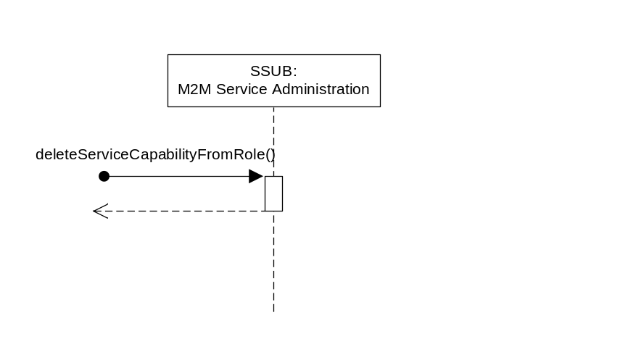
Figure 6.8.2.8.3-1M2M Service Administration – deleteServiceCapabilityFromRole Diagram

6.8.2.8.4 Post-Conditions
The association of the M2M Service Capability and Service Role is deleted.

6.8.2.8.5 Exceptions
Not Applicable

6.8.2.8.6 Policies for Use
Message Exchange Patterns: In-Out
Transaction Pattern: Participation allowed

6.8.2.8.7 oneM2M Resource Interworking
Not Applicable

6.8.2.9 getServiceCapability
This service capability retrieves the M2M Service Capability and associated Service Roles for a specified requested operation.

6.8.2.9.1 Pre-conditions
There is a correlation to the service capabilities’ operation (signature) and the M2M Service Capability. In many deployments the service capabilities’ signature serves as the M2M Service Capability.

6.8.2.9.2 Signature – getServiceCapability
Parameter name | Direction | Optional | Description
operation | IN | NO | Request operation – Common to all requests
serviceCapId | OUT | NO | The M2M Service Capability Identifier (M2M-Serv-Cap-ID).
serviceRoleIds | OUT | NO | List of the M2M Service Roles Identifiers (SRole-ID) associated with the M2M Service Capabilities.
responseType | OUT | YES | Response types:  - Unable to determine M2M Service Capability from the operation
Table 6.8.2.9.2-1 M2M Service Administration – getServiceCapability capability

6.8.2.9.3 Service Interactions
The interactions of service capabilities required for this service capability:
- Issue this capability
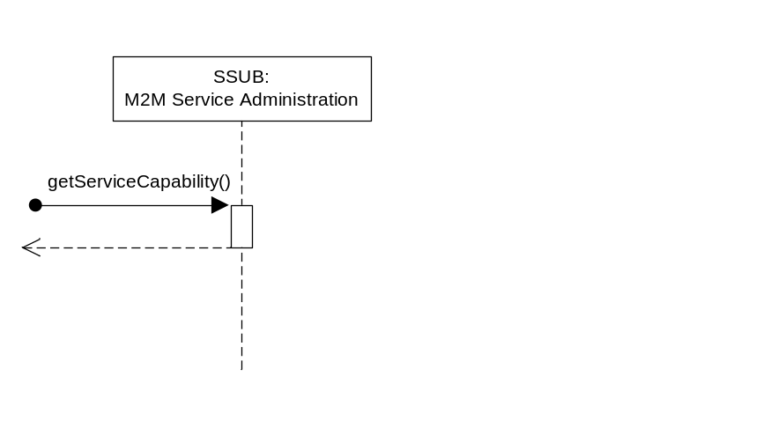
Figure 6.8.2.9.3-1 M2M Service Administration – getServiceCapability Diagram

6.8.2.9.4 Post-Conditions
Not Applicable

6.8.2.9.5 Exceptions
Not Applicable

6.8.2.9.6 Policies for Use

Message Exchange Patterns: In-Out
Transaction Pattern: Participation allowed

6.8.2.9.7 oneM2M Resource Interworking
Not Applicable

6.9 Service Subscription Administration
Editors Note: Need to develop a Section that delineates the request attributes needed by the Mca vs. the Msc.
Editors Note: Need to determine how the entity instance based access management is configured in order to ensure no cross ASP access to other ASPs data.
Editors Note: Need a clause on the language that is permitted for evaluation of Filter Criteria
Editors Note: Need to consider which service capabilities are exposed across the Mcc’ Reference Point and what the request looks like.

6.9.1 Overview
The Service Subscription Administration service provides the capability to administrate the following across the Mca and Msc Reference Points:
- Maintenance of Services Subscriptions
- Association of information for devices and Applications to the M2M Service Subscription
The M2M Service Subscription defines the technical part of the contract between a M2M Subscriber (typically an M2M Application Service Provider) and a M2M Service Provider. Each M2M Service Subscription has a unique identifier (M2M-Service-Profile-ID).
A M2M Service Subscription establishes an association between one or more M2M Applications and one or more devices (M2M Nodes). In addition, the M2M Service Subscription is associated with one or more Service Roles.
A M2M Service Subscription shall be used for the following purposes:
- Serve as a basis for authorization for service capabilities
- Serve as the basis for charging
- Identify which devices and M2M Applications are part of this M2M Service Subscription

6.9.1.1 Service Subscription Entity
Attribute name | Description
serviceSubscriptionId | The M2M Service Subscription Identifier (M2M-Service-Profile-ID).
labelsl | List of labels used as filter criteria for the M2M Service Subscription
serviceRoleIds | List of Service Role Identifiers (SRole-ID) associated with the M2M Service Subscription.

lastModifiedTime | See Table A.2.1-1
creationTime | See Table A.2.1-1
Table 6.9.1.1-1 Service Subscription Entity

6.9.1.1.1 Service Subscription Filter Criteria
Criterion name | Description
serviceSubscriptionId | The M2M Service Subscription Identifier (M2M-Service-Profile-ID).
labels | List of labels assigned to the M2M Service Subscription entity.
serviceRoleIds | List of Service Role Identifiers (SRole-ID) associated with the M2M Service Subscription entity.
lastModifiedTime | See Table A.2.1-1
creationTime | See Table A.2.1-1
Table 6.9.1.1.1-1 Service Subscription Filter Criteria

6.9.1.2 Device Entity for Service Subscription
Attribute name | Description
serviceSubscriptionId | The M2M Service Subscription Identifier (M2M-Service-Profile-ID) for the Device.
deviceId | The unique device identifier in the context of the M2M Service Subscription.
externalIds | List of URNs that represent the external identifiers associated with this device.
applicationIds | List of M2M Application Identifiers (App-ID) associated with the device.
Table 6.9.1.2-1 Device Entity for Service Subscription

6.9.1.2.1 Device Filter Criteria
Criterion name | Description
serviceSubscriptionId | The M2M Service Subscription Identifier (M2M-Service-Profile-ID) for the Device.
deviceId | The unique device identifier in the context of the M2M Service Subscription.
externalIds | List of URNs that represent the external identifiers associated with this device.
applicationIds | List of M2M Application Identifiers (App-ID) associated with the device.
Table 6.9.1.2.1-1 Device Filter Criteria

6.9.2 Service Capabilities

6.9.2.1 createServiceSubscription
This service capability provides the ability to create a M2M Service Subscription. This service capability shall be restricted to the Msc Reference Point.

6.9.2.1.1 Pre-conditions
Not Applicable

6.9.2.1.2 Signature – createServiceSubscription
Parameter name | Direction | Optional | Description
serviceSubscriptionId | IN-OUT | YES | The M2M Service Subscription Identifier (M2M-Service-Profile-ID). If the attribute is not provided on input, the oneM2M System shall assign the M2M-Service-Profile-ID.  The M2M-Service-Profile-ID is unique for the oneM2M System.
labels | IN | YES | See Table A.2.1-1
serviceRoleIds | IN | NO | List of Service Role Identifiers (SRole-ID) to be associated with the M2M Service Subscription.
creationTime | OUT | NO | See Table A.2.1-1
responseType | OUT | YES | Unique response types for this service.  - M2M Service Subscription exists  - Service Role does not exist
Table 6.9.2.1.2-1 Service Subscription Administration – createServiceSubscription capability

6.9.2.1.3 Service Interactions
The interactions of service capabilities required for this service capability:
- Issue the createServiceSubscription capability
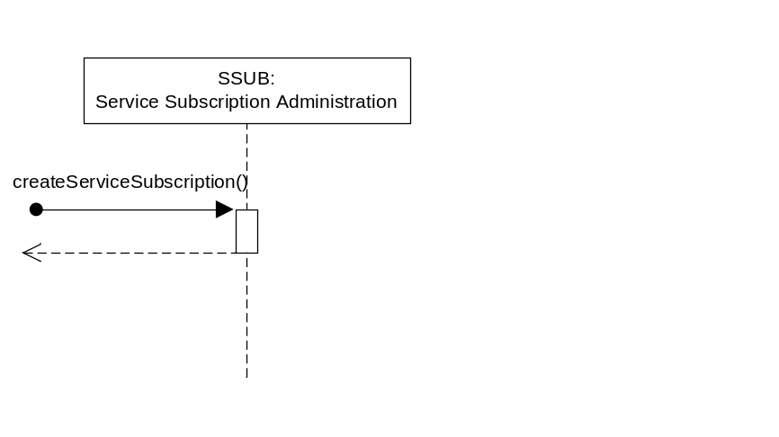
Figure 6.9.2.1.3-1 Service Subscription Administration – createServiceSubscription Diagram

6.9.2.1.4 Post-Conditions
The M2M Service Subscription is created and any Service Roles are associated with the M2M Service Subscription.

6.9.2.1.5 Exceptions
Not Applicable

6.9.2.1.6 Policies for Use
Message Exchange Patterns: In-Out
Transaction Pattern: Participation allowed

6.9.2.1.7 oneM2M Resource Interworking
This service capability creates the M2M Service Subscription with the identifier (M2M-Service-Profile-ID) and maps to the CREATE procedure for the <m2mServiceSubscription> resource.
When the M2M Service Subscription is created the creationTime, M2M-Service-Profile-ID and subsServ&RoleList attributes are present.
This service capability utilizes the access management services with the privileges associated with the associated Service Role. As such the accessControlPolicyIDs and subsGroup attributes of the <m2mServiceSubscription> resource is not used within this service capability.

6.9.2.2 deleteServiceSubscription
This service capability provides the ability to delete a M2M Service Subscription. This service capability shall be restricted to the Msc Reference Point.

6.9.2.2.1 Pre-conditions
Not Applicable

6.9.2.2.2 Signature – deleteServiceSubscription
Parameter name | Direction | Optional | Description
serviceSubscriptionId | IN | NO | The M2M Service Subscription Identifier (M2M-Service-Profile-ID).
responseType | OUT | YES | Unique response types for this service.  - M2M Service Subscription does not exist
Table 6.9.2.2.2-1 Service Subscription Administration – deleteServiceSubscription capability

6.9.2.2.3 Service Interactions
- The interactions of service capabilities required for this service capability:
- Issue the deleteServiceSubscription capability
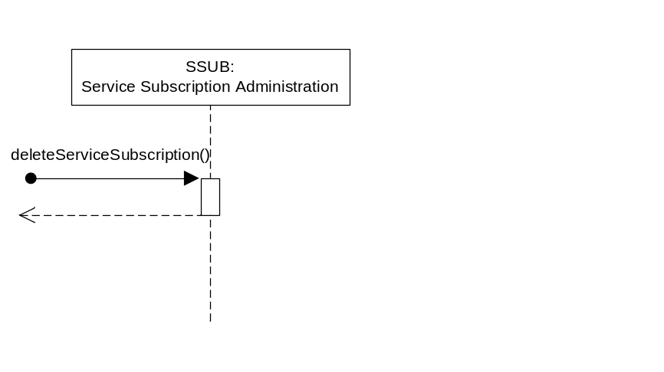
Figure 6.9.2.2.3-1 Service Subscription Administration – deleteServiceSubscription Diagram

6.9.2.2.4 Post-Conditions
The M2M Service Subscription is deleted along with any associations of the M2M Service Subscription has to the Service Roles. The Node information (e.g., devices, M2M Applications) associated with the M2M Service Subscription is also deleted.

6.9.2.2.5 Exceptions
Not Applicable

6.9.2.2.6 Policies for Use
Message Exchange Patterns: In-Out
Transaction Pattern: Participation allowed

6.9.2.2.7 oneM2M Resource Interworking
This service capability deletes the M2M Service Subscription with the identifier (M2M-Service-Profile-ID) and maps to the DELETE procedure for the <m2mServiceSubscription> resource.

6.9.2.3 updateServiceSubscription
This service capability provides the ability to update a M2M Service Subscription. This service capability shall be restricted to the Msc Reference Point.

6.9.2.3.1 Pre-conditions
Not Applicable

6.9.2.3.2 Signature – updateServiceSubscription
Parameter name | Direction | Optional | Description
serviceSubscriptionId | IN | NO | The M2M Service Subscription Identifier (M2M-Service-Profile-ID).
labels | IN | YES | See Table A.2.1-1  The existing labels are replaced with the labels in this parameter.
serviceRoleIds | IN | YES | List of Service Role Identifiers (SRole-ID) to be associated with the M2M Service Subscription. If supplied, SRole-IDs in the list that are not already associated with the M2M Service Subscription are added. SRole-IDs that are associated with the M2M Service Subscription but not in the list are deleted.
lastModifiedTime | OUT | NO | See Table A.2.1-1
roleIdResult | OUT | YES | If the parameter serviceRoleIds is present, this parameter provides the results (added, deleted) for each affected Service Roles.
responseType | OUT | YES | Unique response types for this service.  - M2M Service Subscription does not exist  - Service Role does not exist for a Supporting Service
Table 6.9.2.3.2-1 Service Subscription Administration – updateServiceSubscription capability

6.9.2.3.3 Service Interactions
- The interactions of service capabilities required for this service capability:
- Issue the updateServiceSubscription capability
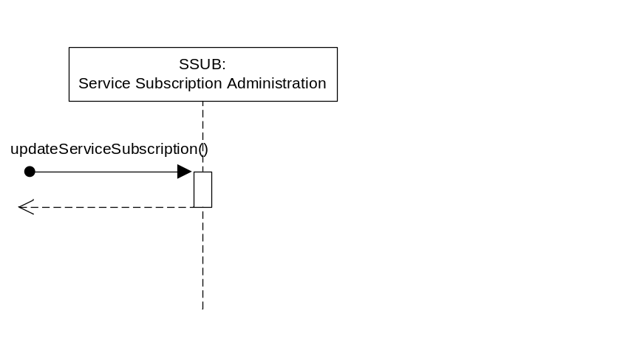
Figure 6.9.2.3.3-1 Service Subscription Administration – updateServiceSubscription Diagram

6.9.2.3.4 Post-Conditions
The M2M Service Subscription is updated along with any associations of the M2M Service Subscription has to the Service Roles.

6.9.2.3.5 Exceptions
Not Applicable

6.9.2.3.6 Policies for Use
Message Exchange Patterns: In-Out
Transaction Pattern: Participation allowed

6.9.2.3.7 oneM2M Resource Interworking
This service capability updates the M2M Service Subscription with the identifier (M2M-Service-Profile-ID) and maps to the UPDATE procedure for the <m2mServiceSubscription> resource.

6.9.2.4 addRoleToServiceSubscription
This service capability provides the ability to add new Service Roles to a M2M Service Subscription. This service capability shall be restricted to the Msc Reference Point.

6.9.2.4.1 Pre-conditions
Not Applicable

6.9.2.4.2 Signature – addRoleToServiceSubscription
Parameter name | Direction | Optional | Description
serviceSubscriptionId | IN | NO | The M2M Service Subscription Identifier (M2M-Service-Profile-ID).
serviceRoleIds | IN | NO | List of Service Role Identifiers (SRole-ID) to be associated with the M2M Service Subscription. If a SRole-ID in the parameter is already associated with the M2M Service Subscription, nothing is done for the SRole-ID as it already is associated.
lastModifiedTime | OUT | NO | See Table A.2.1-1
responseType | OUT | YES | Unique response types for this service.  - M2M Service Subscription does not exist  - Service Role does not exist for a Supporting Service
Table 6.9.2.4.2-1 Service Subscription Administration – addRoleToServiceSubscription capability

6.9.2.4.3 Service Interactions
- The interactions of service capabilities required for this service capability:
- Issue the addRoleToServiceSubscription capability
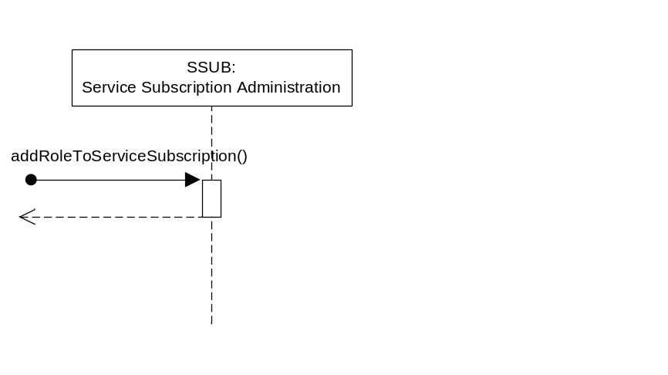
Figure 6.9.2.4.3-1 Service Subscription Administration – addRoleToServiceSubscription Diagram

6.9.2.4.4 Post-Conditions
The M2M Service Subscription is updated with any associations of the M2M Service Subscription has to the Service Roles.

6.9.2.4.5 Exceptions
Not Applicable

6.9.2.4.6 Policies for Use
Message Exchange Patterns: In-Out
Transaction Pattern: Participation allowed

6.9.2.4.7 oneM2M Resource Interworking
Not Applicable

6.9.2.5 deleteRoleFromServiceSubscription
This service capability provides the ability to delete existing Service Roles from a M2M Service Subscription. This service capability shall be restricted to the Msc Reference Point.

6.9.2.5.1 Pre-conditions
Not Applicable

6.9.2.5.2 Signature – deleteRoleFromServiceSubscription
Parameter name | Direction | Optional | Description
serviceSubscriptionId | IN | NO | The M2M Service Subscription Identifier (M2M-Service-Profile-ID).
serviceRoleIds | IN | NO | List of Service Role Identifiers (SRole-ID) to be deleted from the association with the M2M Service Subscription.
lastModifiedTime | OUT | NO | See Table A.2.1-1
responseType | OUT | YES | Unique response types for this service.  - M2M Service Subscription does not exist  - Service Role does not exist for a Supporting Service
Table 6.9.2.5.2-1 Service Subscription Administration – deleteRoleFromServiceSubscription capability

6.9.2.5.3 Service Interactions
The interactions of service capabilities required for this service capability:
- Issue the deleteRoleFromServiceSubscription capability
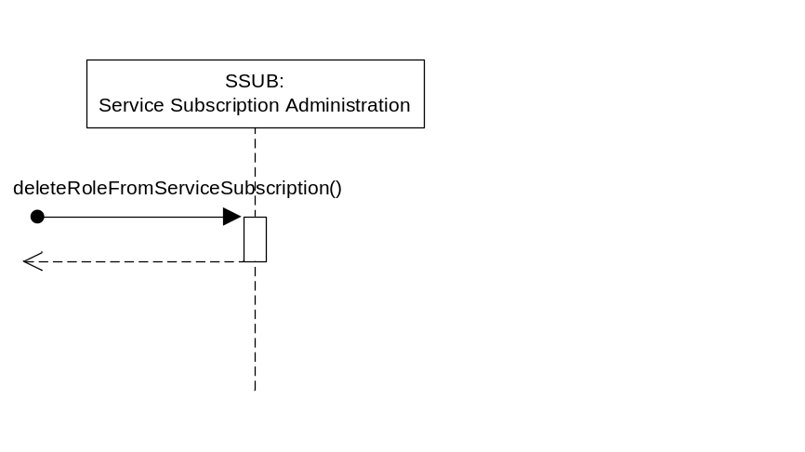
Figure 6.9.2.5.3-1 Service Subscription Administration – deleteRoleFromServiceSubscription Diagram

6.9.2.5.4 Post-Conditions
The M2M Service Subscription is updated with associations of the identified Service Roles deleted.

6.9.2.5.5 Exceptions
Not Applicable

6.9.2.5.6 Policies for Use
Message Exchange Patterns: In-Out
Transaction Pattern: Participation allowed

6.9.2.5.7 oneM2M Resource Interworking
Not Applicable

6.9.2.6 getServiceSubscription
This service capability provides the ability to retrieve the existing M2M Service Subscription. This service capability shall be restricted to the Msc and Mca Reference Points.

6.9.2.6.1 Pre-conditions
Not Applicable

6.9.2.6.2 Signature – getServiceSubscription
Parameter name | Direction | Optional | Description
filterCriteria | IN | NO | See Table 6.9.1.1.1-1
serviceSubscriptions | OUT | NO | The resulting M2M Service Subscription entities in Table 6.9.1.1-1.
responseType | OUT | YES | Unique response types for this service.  - None
Table 6.9.2.6.2-1 Service Subscription Administration – getServiceSubscription capability

6.9.2.6.3 Service Interactions
The interactions of service capabilities required for this service capability:
- Issue the getServiceSubscription capability
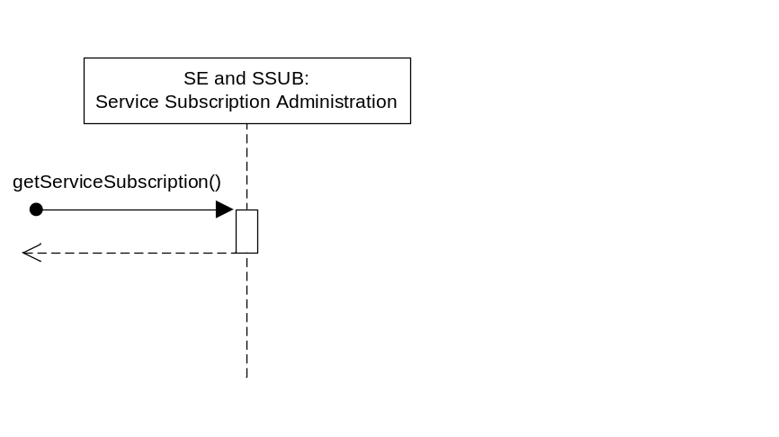
Figure 6.9.2.6.3-1 Service Subscription Administration – getServiceSubscription Diagram

6.9.2.6.4 Post-Conditions
Not Applicable

6.9.2.6.5 Exceptions
Not Applicable

6.9.2.6.6 Policies for Use
Message Exchange Patterns: In-Out
Transaction Pattern: Participation allowed

6.9.2.6.7 oneM2M Resource Interworking
This service capability retrieves the M2M Service Subscription for the specified filter criteria and maps to the RETRIEVE procedure for the <m2mServiceSubscription> resource.

6.9.2.7 addDeviceToServiceSubscription
This service capability provides the ability to add a device to the existing M2M Service Subscription. This service capability shall be restricted to the Msc and Mca Reference Points.

6.9.2.7.1 Pre-conditions
Not Applicable

6.9.2.7.2 Signature – addDeviceToServiceSubscription
Parameter name | Direction | Optional | Description
serviceSubscriptionId | IN | NO | The M2M Service Subscription (M2M-Service-Profile-ID) to add the Device
externalIds | IN | YES | A List of URNs that represent the external identifiers associated with this device.
applicationIds | IN | YES | A list of Application identifiers (App-ID) associated with this device.
deviceId | OUT | NO | The unique device identifier in the context of the M2M Service Subscription.
lastModifiedTime | OUT | NO | See Table A.2.1-1
responseType | OUT | YES | Unique response types for this service.  - Device exists for this M2M Service Subscription

Table 6.9.2.7.2-1 Service Subscription Administration – addDeviceToServiceSubscription capability

6.9.2.7.3 Service Interactions
The interactions of service capabilities required for this service capability:
- Issue the addDeviceToServiceSubscription capability
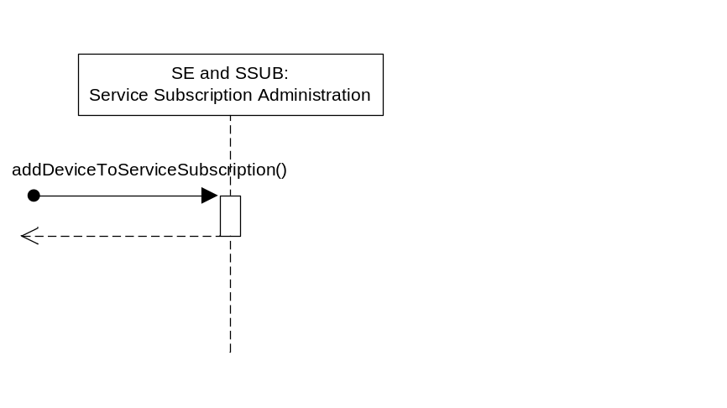
Figure 6.9.2.7.3-1 Service Subscription Administration – addDeviceToServiceSubscription Diagram

6.9.2.7.4 Post-Conditions
Not Applicable

6.9.2.7.5 Exceptions
Not Applicable

6.9.2.7.6 Policies for Use
Message Exchange Patterns: In-Out
Transaction Pattern: Participation allowed

6.9.2.7.7 oneM2M Resource Interworking
This service capability adds the device information for the M2M Service Subscription. This capability maps to the CREATE procedure of the <nodeInfo> resource.

6.9.2.8 deleteDeviceFromServiceSubscription
This service capability provides the ability to delete a device from the existing M2M Service Subscription. This service capability shall be restricted to the Msc and Mca Reference Points.

6.9.2.8.1 Pre-conditions
Not Applicable

6.9.2.8.2 Signature – deleteDeviceFromServiceSubscription
Parameter name | Direction | Optional | Description
serviceSubscriptionId | IN | NO | The M2M Service Subscription (M2M-Service-Profile-ID) for the Devices
deviceId | IN | NO | The unique device identifier in the context of the M2M Service Subscription.
responseType | OUT | YES | Unique response types for this service.  - Device does not exist for this M2M Service Subscription

Table 6.9.2.8.2-1 Service Subscription Administration – deleteDeviceFromServiceSubscription capability

6.9.2.8.3 Service Interactions
The interactions of service capabilities required for this service capability:
- Issue the deleteDeviceFromServiceSubscription capability
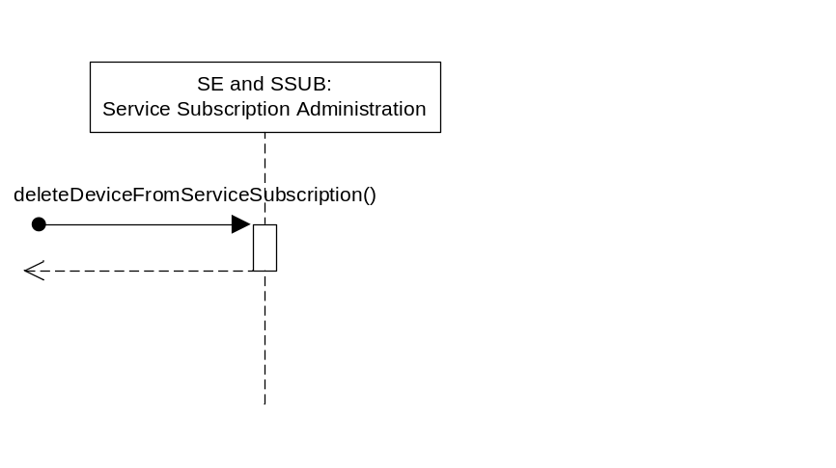
Figure 6.9.2.8.3-1 Service Subscription Administration – deleteDeviceFromServiceSubscription Diagram

6.9.2.8.4 Post-Conditions
Not Applicable

6.9.2.8.5 Exceptions
Not Applicable

6.9.2.8.6 Policies for Use
Message Exchange Patterns: In-Out
Transaction Pattern: Participation allowed

6.9.2.8.7 oneM2M Resource Interworking
This service capability removes the device information for the M2M Service Subscription. This capability maps to the DELETE procedure of the <nodeInfo> resource.

6.9.2.9 getDevicesForServiceSubscription
This service capability provides the ability to retrieve the devices for an existing M2M Service Subscription. This service capability shall be restricted to the Msc and Mca Reference Points.

6.9.2.9.1 Pre-conditions
Not Applicable

6.9.2.9.2 Signature – getDevicesForServiceSubscription
Parameter name | Direction | Optional | Description
filterCriteria | IN | NO | See Table 6.9.1.2.1-1
devices | OUT | NO | The resulting Device entities in Table 6.9.1.2-1.
responseType | OUT | YES | Unique response types for this service.  - None

Table 6.9.2.9.2-1 Service Subscription Administration – getDevicesForServiceSubscription capability

6.9.2.9.3 Service Interactions
The interactions of service capabilities required for this service capability:
- Issue the getDevicesForServiceSubscription capability
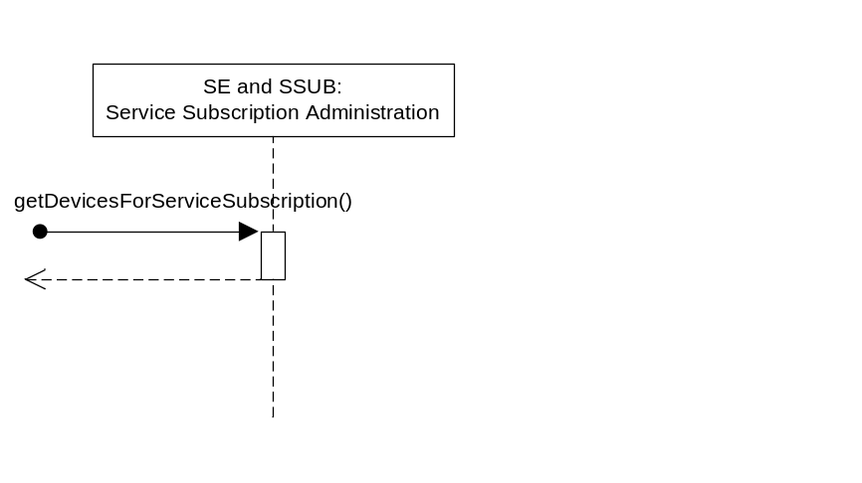
Figure 6.9.2.9.3-1 Service Subscription Administration – getDevicesForServiceSubscription Diagram

6.9.2.9.4 Post-Conditions
Not Applicable

6.9.2.9.5 Exceptions
Not Applicable

6.9.2.9.6 Policies for Use
Message Exchange Patterns: In-Out
Transaction Pattern: Participation allowed

6.9.2.9.7 oneM2M Resource Interworking
This service capability retrieves the devices for a M2M Service Subscription for the specified filter criteria and maps to the RETRIEVE procedure for the <nodeInfo> resource.

6.9.2.10 addApplicationsToServiceSubscription
This service capability provides the ability to add M2M Applications (App-ID) to an existing M2M Service Subscription. This service capability shall be restricted to the Msc and Mca Reference Points.

6.9.2.10.1 Pre-conditions
Not Applicable

6.9.2.10.2 Signature – addApplicationsToServiceSubscription
Parameter name | Direction | Optional | Description
serviceSubscriptionId | IN | NO | The M2M Service Subscription (M2M-Service-Profile-ID) for the M2M Applications.
applicationIds | IN | NO | A list of Application identifiers (App-ID)
lastModifiedTime | OUT | NO | See Table A.2.1-1
responseType | OUT | YES | Unique response types for this service.  - M2M Application exists for this M2M Service Subscription
Table 6.9.2.10.2-1 Service Subscription Administration – addApplicationsToServiceSubscription capability

6.9.2.10.3 Service Interactions
The interactions of service capabilities required for this service capability:
- Issue the addApplicationsToServiceSubscription capability
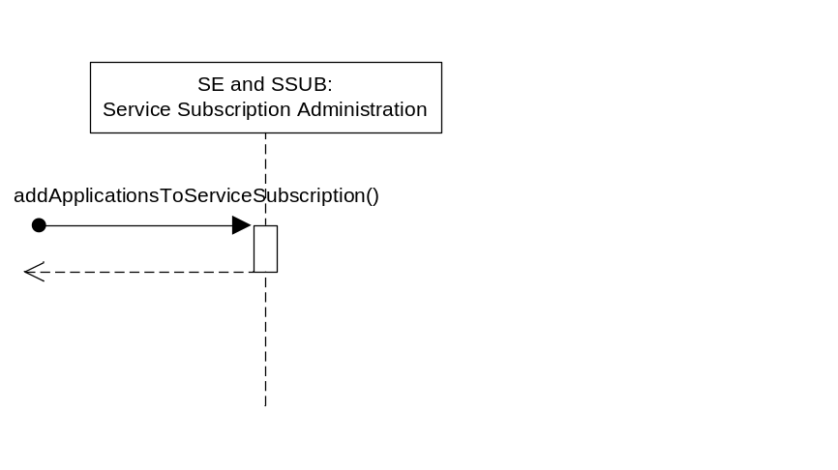
Figure 6.9.2.10.3-1 Service Subscription Administration – addApplicationsToServiceSubscription Diagram

6.9.2.10.4 Post-Conditions
Not Applicable

6.9.2.10.5 Exceptions
Not Applicable

6.9.2.10.6 Policies for Use
Message Exchange Patterns: In-Out
Transaction Pattern: Participation allowed

6.9.2.10.7 oneM2M Resource Interworking
This service capability adds M2M Applications to a M2M Service Subscription. The service capability aligns with the <m2mServiceSubscription> resource. However there isn’t a procedure specified that allows an AE to update just the M2M Applications associated with the <m2mServiceSubscription> resource.

6.9.2.11 deleteApplicationsFromServiceSubscription
This service capability provides the ability to delete M2M Applications (App-ID) from an existing M2M Service Subscription. This service capability shall be restricted to the Msc and Mca Reference Points.

6.9.2.11.1 Pre-conditions
Not Applicable

6.9.2.11.2 Signature – deleteApplicationsFromServiceSubscription
Parameter name | Direction | Optional | Description
serviceSubscriptionId | IN | NO | The M2M Service Subscription (M2M-Service-Profile-ID) for the Applications
applicationIds | IN | NO | A list of M2M Application identifiers (App-ID)
lastModifiedTime | OUT | NO | See Table A.2.1-1
responseType | OUT | YES | Unique response types for this service.  - M2M Application exists for the M2M Service Subscription
Table 6.9.2.11.2-1 Service Subscription Administration – deleteApplicationsFromServiceSubscription capability

6.9.2.11.3 Service Interactions
The interactions of service capabilities required for this service capability:
- Issue the deleteApplicationsFromServiceSubscription capability
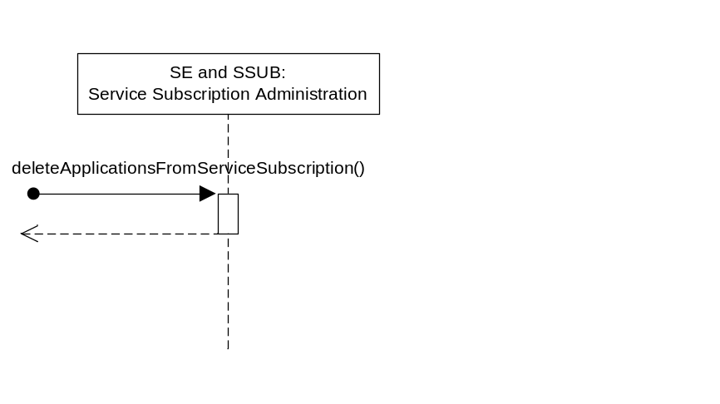
Figure 6.9.2.11.3-1 Service Subscription Administration – deleteApplicationsFromServiceSubscription Diagram

6.9.2.11.4 Post-Conditions
Not Applicable

6.9.2.11.5 Exceptions
Not Applicable

6.9.2.11.6 Policies for Use
Message Exchange Patterns: In-Out
Transaction Pattern: Participation allowed

6.9.2.11.7 oneM2M Resource Interworking
This service capability delete M2M Applications from a M2M Service Subscription. The service capability aligns with the <m2mServiceSubscription> resource. However there isn’t a procedure specified that allows an AE to update just the M2M Applications associated with the <m2mServiceSubscription> resource.

6.9.2.12 getApplicationsForServiceSubscription
This service capability provides the ability to retrieve the M2M Applications for an existing M2M Service Subscription. This service capability shall be restricted to the Msc and Mca Reference Points.

6.9.2.12.1 Pre-conditions
Not Applicable

6.9.2.12.2 Signature – getApplicationsForServiceSubscription
Parameter name | Direction | Optional | Description
serviceSubscriptionId | IN | NO | The M2M Service Subscription (M2M-Service-Profile-ID) for the Applications
applicationIds | OUT | NO | A list of Application identifiers (App-ID)
lastModifiedTime | OUT | NO | See Table A.2.1-1
responseType | OUT | YES | Unique response types for this service.  - None
Table 6.9.2.12.2-1 Service Subscription Administration – getApplicationsForServiceSubscription capability

6.9.2.12.3 Service Interactions
The interactions of service capabilities required for this service capability:
- Issue the getApplicationsForServiceSubscription capability
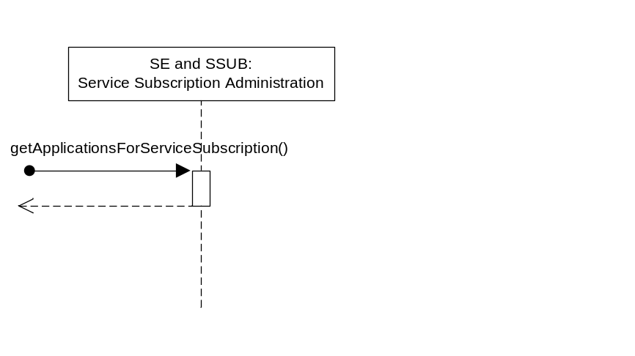
Figure 6.9.2.12.3-1 Service Subscription Administration – getApplicationsForServiceSubscription Diagram

6.9.2.12.4 Post-Conditions
Not Applicable

6.9.2.12.5 Exceptions
Not Applicable

6.9.2.12.6 Policies for Use
Message Exchange Patterns: In-Out
Transaction Pattern: Participation allowed

6.9.2.12.7 oneM2M Resource Interworking
This service capability retrieves M2M Application Identifiers for a M2M Service Subscription. The service capability aligns with the <m2mServiceSubscription> resource and maps to the RETRIEVE procedure for the Resource.

6.9.2.13 updateApplicationForDevice
This service capability provides the ability to update the M2M Applications to be associated to a device within the context of a M2M Service Subscription. This service capability shall be restricted to the Msc and Mca Reference Points.

6.9.2.13.1 Pre-conditions
Not Applicable

6.9.2.13.2 updateApplicationForDevice
Parameter name | Direction | Optional | Description
serviceSubscriptionId | IN | NO | The M2M Service Subscription (M2M-Service-Profile-ID) for the device
deviceId | IN | NO | The unique device identifier in the context of the M2M Service Subscription.
applicationIds | IN | NO | A list of Application identifiers (App-ID)
lastModifiedTime | OUT | NO | See Table A.2.1-1
responseType | OUT | YES | Unique response types for this service.  - M2M Service Subscription does not exist  - Device does not exist for the M2M Service Subscription

Table 6.9.2.13.2-1 Service Subscription Administration – updateApplicationForDevice capability

6.9.2.13.3 Service Interactions
The interactions of service capabilities required for this service capability:
- Issue the updateApplicationForDevice capability
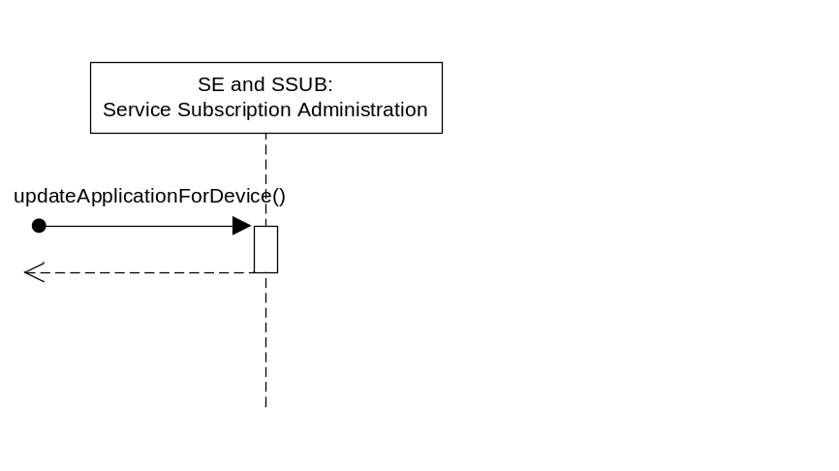
Figure 6.9.2.13.3-1 Service Subscription Administration – updateApplicationForDevice Diagram

6.9.2.13.4 Post-Conditions
The M2M Applications for the device is replaced.

6.9.2.13.5 Exceptions
Not Applicable

6.9.2.13.6 Policies for Use
Message Exchange Patterns: In-Out
Transaction Pattern: Participation allowed

6.9.2.13.7 oneM2M Resource Interworking
This service capability updates the M2M Application list for the device information in M2M Service Subscription. This capability maps to the UPDATE procedure of the <nodeInfo> resource.

6.9.2.14 getApplicationsForDevice
This service capability provides the ability to retrieve the M2M Applications for a Device in the context of a M2M Service Subscription. This service capability shall be restricted to the Msc Reference Point.

6.9.2.14.1 Pre-conditions
Not Applicable

6.9.2.14.2 Signature – getApplicationsForServiceSubscription
Parameter name | Direction | Optional | Description
serviceSubscriptionId | IN | NO | The M2M Service Subscription (M2M-Service-Profile-ID) for the Device
deviceId | IN | NO | A device Identifier that hosts the applications
applicationIds | OUT | NO | A list of Application identifiers (App-ID)
responseType | OUT | YES | Unique response types for this service.  - M2M Service Subscription does not exist  - Device Identifier does not exist for the M2M Service Subscription
Table 6.9.2.14.2-1 Service Subscription Administration – getApplicationsForDevice capability

6.9.2.14.3 Service Interactions
The interactions of service capabilities required for this service capability:
- Issue the getApplicationsForDevice capability
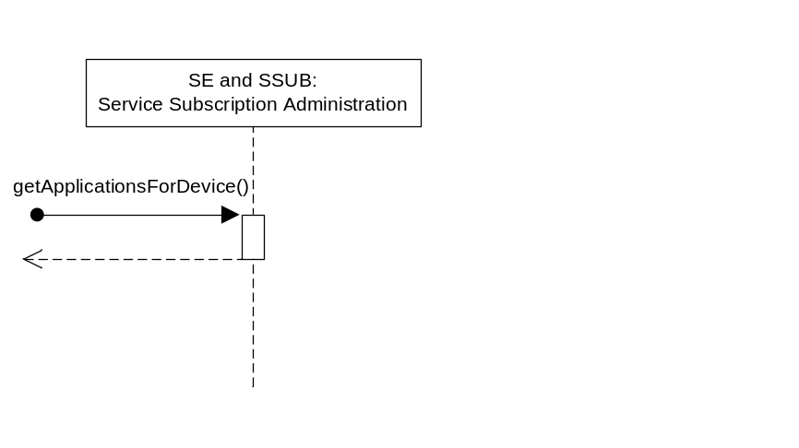
Figure 6.9.2.14.3-1 Service Subscription Administration – getApplicationsForDevice Diagram

6.9.2.14.4 Post-Conditions
Not Applicable

6.9.2.14.5 Exceptions
Not Applicable

6.9.2.14.6 Policies for Use
Message Exchange Patterns: In-Out
Transaction Pattern: Participation allowed

6.9.2.14.7 oneM2M Resource Interworking
This service capability retrieves Service Subscribed Node and maps to the RETRIEVE procedure for the <serviceSubscribedNode> resource. The is not a correlation of which Applications reside on a specific node. This mapping is FFS.

6.10 Event Collection

6.10.1 Overview
The Event Collection service provides the capability to record events for accounting purposes.

6.10.1.1 Event Collection Types

6.10.1.1.1 Event Collection Record
Information Element | Optional | Description
eventRecordID | NO | It is the unique ID that identifies a specific event record.
eventCollectionTriggerID | NO | It is the unique ID that identifies a specific event collection triggering scenario, which triggers information recording for a specific event.
collectingEntityID | NO | This is the unique ID of the entity that collects the statistics. It can be an AE-ID or M2M Service Capability Identifier (M2M-Serv-Cap-ID)
collectedEntityID | NO | This is the unique ID of the entity whose service layer operation statistics are being collected. It can be an AE-ID or M2M Service Capability Identifier (M2M-Serv-Cap-ID).
serviceProfileID | YES | An M2M Service Profile Identifier defines M2M Services and/or M2M Service Roles and AEs applicable to M2M Nodes.
eventDescription | NO | Describes the event triggered at the service. It is a subset of the eventConfig data structure. The specific structure depends on the specific event defined by the Event Collection Trigger.
Vendor Specific Information | YES | Defines Vendor specific information
Table 6.10.1.1-1 Type: Event Record Template

6.10.1.1.2 Event Configuration Type

Parameter name | Optional | Description
eventType | NO | This attribute indicates the type of the event, such as “subscribeComplete”, “downloadFirmware “, “timer based”,, “storage based”, etc. The eventType can be a combination of multiple sub-types, for example, it can be based on both “subscribeComplete” and a timer.
serviceRoleIds | YES | Defines the specific service role.
eventStart | YES | This attribute indicates the start time of the event. It is mandatory if the eventType includes “timer based”.
eventEnd | YES | This attribute indicates the end time of the event. It is mandatory if the eventType includes “timer based”.
dataSize | YES | This attribute defines the data size if an event is triggered when the stored data exceeds a certain size. It is mandatory if the eventType is “storage based”.
Table 6.10.1.1.2-1 Type: Event Collection – eventConfig

6.10.2 Service Capabilities

6.10.2.1 setEventCollectionPolicy
This service capability provides the ability for AEs to configure event collection policies for statistics and charging purposes. This service capability applies to the Mca Reference Point.

6.10.2.1.1 Pre-conditions
The Originator can be an AE, and the Originator wants to configure event collection policies at a receiving service capability. The receiving service capability conducts event collection according to the policies. The receiving service capability may establish its own event collection policies.
The Originator, if different from the receiving service capability, is subscribed and registered to the receiving service capability.

6.10.2.1.2 Signature – setEventCollectionPolicy
Parameter name | Direction | Optional | Description
serviceId | IN | NO | The M2M Service Identifier (M2M-Serv-ID)
eventConfig | IN | NO | The configuration of the event collection policy. Defined in Table 6.10.1.1.2-1.
eventCollectionPolicyID | OUT | NO | The receiving service capability generates a unique policy ID for each policy.
responseType | OUT | YES | Unique response types for this service. Exception:  - Policy already exists

Table 6.10.2.1.2-1 Event Collection – setEventCollectionPolicy capability

6.10.2.1.3 Post-Conditions
Not Applicable

6.10.2.1.4 Exceptions
- The Originator has no access right to create the policy

6.10.2.1.5 Policies for Use
Message Exchange Patterns: In-Out

6.10.2.1.6 Service Interactions
The interactions of service capabilities required for this service capability:
- Issue the request to the Supporting Service to perform the operation

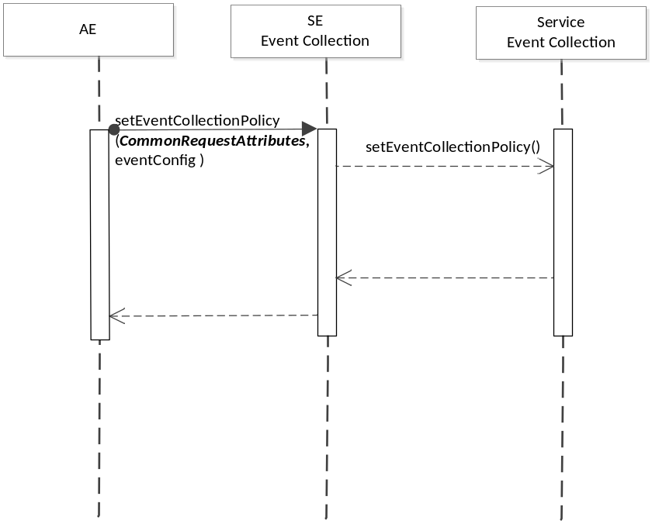
Figure 6.10.2.1.6-1 setEventCollectionPolicy Diagram

6.10.2.1.7 oneM2M Resource Interworking
The service capability aligns with the <eventConfig> resource and maps to the CREATE procedure for the resource.

6.10.2.2 getEventCollectionPolicy
This service capability provides the ability for entities, such as an AE or a service capability, to retrieve the existing policies stored at a service capability. This service capability applies to the Mca and Msc Reference Point.

6.10.2.2.1 Pre-conditions
The Originator can be an AE or a service capability, and the Originator wants to retrieve event collection policies at a receiving service capability.
The Originator, if different from the receiving service capability, is subscribed and registered to the receiving service capability. The Originator is only allowed to retrieve with the proper access right.

6.10.2.2.2 Signature – getEventCollectionPolicy
Parameter name | Direction | Optional | Description
eventCollectionPolicyID | IN | NO | See Table 6.10.2.1.2-2. The eventCollectionPolicyID specifies the specific event collection policy to retrieve, if the Originator has such information. If the Originator does not have the information regarding eventCollectionPolicyID, it indicates eventCollectionPolicyID with a specific value that represents “any IDs”, and uses the filterCriteria to filter selected policies.
filterCriteria | IN | YES | See Table 6.8.1.1.1-1
responseType | OUT | YES | Unique response types for this service. Exception:  - eventCollectionPolicyID does not exist

Table 6.10.2.2.2-1 Event Collection – getEventCollectionPolicy capability
Editors Note: Filter Criteria needs to be defined

6.10.2.2.3 Post-Conditions
Not Applicable

6.10.2.2.4 Exceptions
The Originator has no access right to retrieve the policy

6.10.2.2.5 Policies for Use
Message Exchange Patterns: In-Out

6.10.2.2.6 Service Interactions
The interactions of service capabilities required for this service capability:
- Issue the request to the Supporting Service to perform the operation
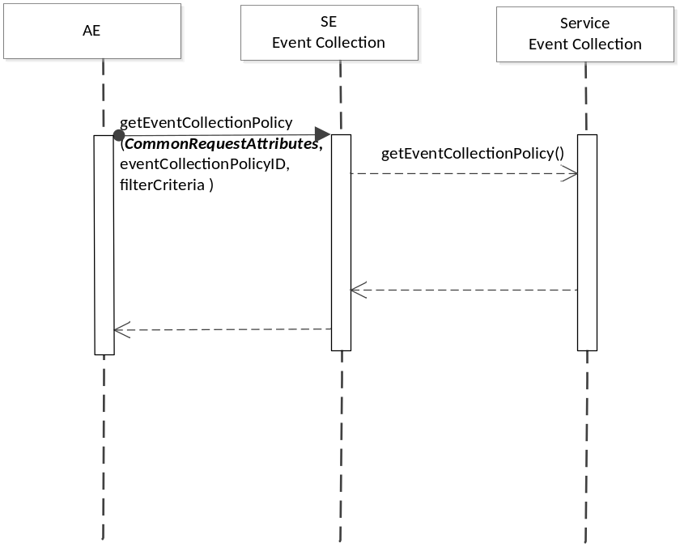
Figure 6.10.2.2.6-1 getEventCollectionPolicy Diagram

6.10.2.2.7 oneM2M Resource Interworking
The service capability aligns with the <eventConfig> resource and maps to the RETRIEVE procedure for the resource.

6.10.2.3 setEventCollectionTriggers
This service capability provides the ability for AEs and service capabilities to configure specific triggers for event collection, based on the Event Collection Policy. This service capability applies to the Mca and Msc Reference Point.

6.10.2.3.1 Pre-conditions
The Originator can be an AE or a service capability, and the Originator wants to configure event collection triggers based on existing event collection policy available at the collecting service capability.

6.10.2.3.2 Signature – setEventCollectionTriggers
Parameter name | Direction | Optional | Description
eventCollectionPolicyID | IN | NO | This attribute specify the policy used to define the specific event collection trigger.
collectingEntityID | IN | NO | This is the ID of the entity where the event is being collected. If not specified, the default collecting entity is the receiving service capability.
collectedEntityID | IN | NO | This is the ID of the entity that triggered the event collection. If not specified, the default is all entities triggered the event at the collecting entity.
eventReceiverID | IN | YES | In cases when there is another entity, other than the collecting entity (such as a service capability), wants to receive the collected event, this attribute provides the unique ID of this entity.
serviceRoleIds | IN | YES | Specifies the service roles that trigger the event collection.
serviceId | IN | YES | Specifies the services that trigger the event collection.
triggerStatus | IN | YES | This attribute indicates if the trigger is activated or not. If not defined, the trigger is activated.
eventCollectionTriggerID | OUT | NO | The receiving service capability generates a unique ID for each event collection trigger.
responseType | OUT | YES | Unique response types for this service. Exception:  - eventCollectionPolicyID is invalid  - collectingEntityID is invalid  - collectedEntityID is invalid  - eventReceiverID is invalid  - triggerStatus is invalid

Table 6.10.2.3.2-1 Event Collection – setEventCollectionTriggers capability

6.10.2.3.3 Post-Conditions
After the successful creation of event collection triggers, when the defined event happens at the collectingEntity, and when the event collection trigger status is ACTIVE, the collectingEntity shall collect the event. The supporting service shall send a recordEvent message to the Event Collection entity.

6.10.2.3.4 Exceptions
The Originator has no access right to create the event collection triggers

6.10.2.3.5 Policies for Use
Message Exchange Patterns: In-Out

6.10.2.3.6 Service Interactions
The interactions of service capabilities required for this service capability:
- Issue the request to the Supporting Service to perform the operation

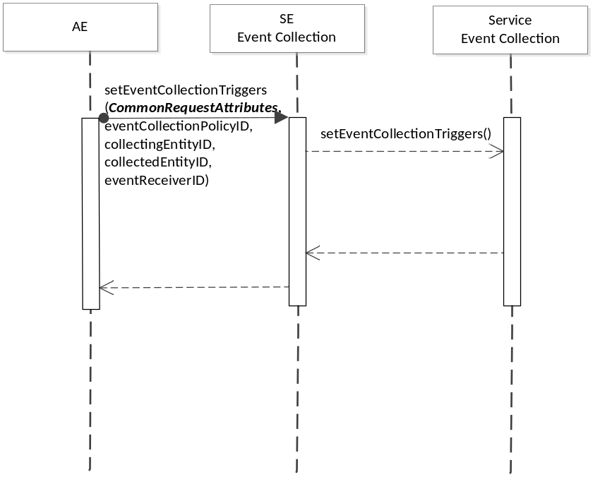
Figure 6.10.2.3.6-1 setEventCollectionTriggers Diagram

6.10.2.3.7 oneM2M Resource Interworking
The service capability aligns with the <statsCollect> resource and maps to the CREATE procedure for the resource.

6.10.2.4 getEventCollectionTriggers
This service capability provides the ability for AEs and service capabilities to retrieve event collection triggers at a receiving service capability. This service capability applies to the Mca and Msc Reference Point.

6.10.2.4.1 Pre-conditions
Originating AEs and service capabilities are subscribed and registered to the receiving service capability. Originator has the access right to retrieve.

6.10.2.4.2 Signature – getEventCollectionTriggers
Parameter name | Direction | Optional | Description
eventCollectionTriggerID | IN | YES | This attribute specifies which event collection triggers to retrieve. If not specified, any event collection trigger matching the filter criteria should be retrieved. If the Originator does not have the information regarding eventCollectionTriggerID, it indicates with a specific value that represents “any IDs”, and uses the filterCriteria to filter selected event triggers.
filterCriteria | IN | YES | See Table 6.8.1.1.1-1
responseType | OUT | YES | Unique response types for this service. Exception:  - eventCollectionTriggerID does not exist

Table 6.10.2.4.2-1 Event Collection – getEventCollectionTriggers capability

6.10.2.4.3 Post-Conditions
Not Applicable

6.10.2.4.4 Exceptions
The Originator has no access right to retrieve the event collection triggers

6.10.2.4.5 Policies for Use
Message Exchange Patterns: In-Out

6.10.2.4.6 Service Interactions
The interactions of service capabilities required for this service capability:
- Issue the request to the Supporting Service to perform the operation
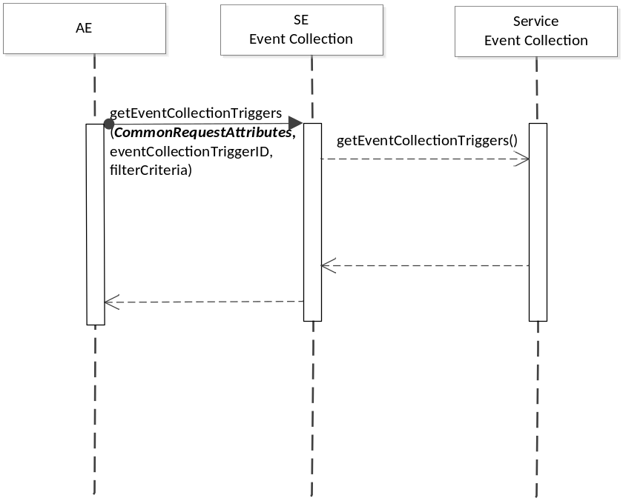
Figure 6.10.2.4.6-1 getEventCollectionTriggers Diagram

6.10.2.4.7 oneM2M Resource Interworking
The service capability aligns with the <statsCollect> resource and maps to the RETRIEVE procedure for the resource.

6.10.2.5 recordEvent
This service capability provides the ability for a service (such as Data Exchange service) to trigger the event collection service to record an event. This service applies to the Msc Reference Point.

6.10.2.5.1 Pre-conditions
Event Collection Triggers have been created by the setEventCollectionTriggers capability.

6.10.2.5.2 Signature – recordEvent
Parameter name | Direction | Optional | Description
eventCollectionPolicyID | IN | YES | This attribute specify the policy used to define the specific event collection trigger.
eventCollectionTriggerID | IN | NO | The service where the trigger happens provides the eventCollectionTriggerID being used.
eventDescription | IN | NO | This attribute describes the event triggered at the service. It is a subset of the eventConfig data structure. It contains one or more parameters defined in the eventConfig data type.
recordID | OUT | NO | The event collection service generates a unique 182apabili.
responseType | OUT | YES | Unique response types for this service. Exception:.  - Event recording cannot be completed

Table 6.10.2.5.2-1 Event Collection – recordEvent capability

6.10.2.5.3 Post-Conditions
Not Applicable

6.10.2.5.4 Exceptions
Not Applicable

6.10.2.5.5 Policies for Use
Message Exchange Patterns: In-Out

6.10.2.5.6 Service Interactions
The request comes from the service where the event was triggered to the Event Collection entity.

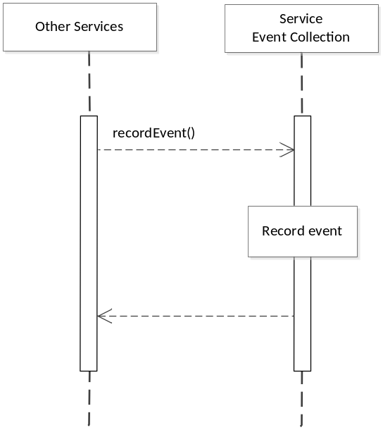
Figure 6.10.2.5.6-1 recordEvent Diagram

6.10.2.5.7 oneM2M Resource Interworking
Not Applicable

6.10.2.6 getEventRecords
This service capability provides the ability for AEs and service capabilities to retrieve the recorded events for statistical or charging purposes. This service capability applies to the Mca and Msc Reference Point.

6.10.2.6.1 Pre-conditions
Originating AEs and service capabilities are subscribed and registered to the receiving service capability.

6.10.2.6.2 Signature – getEventRecords
Parameter name | Direction | Optional | Description
eventRecordID | IN | NO | This attribute specifies which record to retrieve. If not specified, any event records matching the filter criteria should be retrieved. If the Originator does not have the information regarding the eventRecordID, it indicates with a specific value that represents “any IDs”, and use the filterCriteria to filter selected records of events.
filterCriteria | IN | YES | See Table 6.8.1.1.1-1
responseType | OUT | YES | Unique response types for this service. Exception:  - The eventRecordID

Table 6.10.2.6.2-1 Event Collection – getRecords capability

6.10.2.6.3 Post-Conditions
Not Applicable

6.10.2.6.4 Exceptions
Not Applicable

6.10.2.6.5 Policies for Use
Message Exchange Patterns: In-Out

6.10.2.6.6 Service Interactions
The Originator sends the request to the Event Collection entity to obtain the event records that it is
interested in.

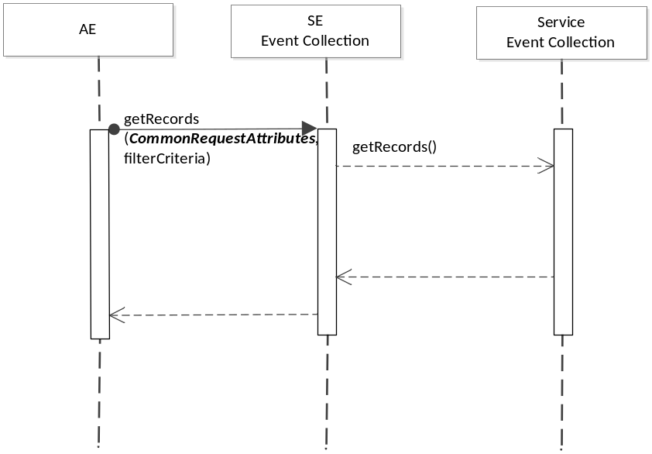
Figure 6.10.2.6.6-1 getEventRecords Diagram

6.10.2.6.7 oneM2M Resource Interworking
Not Applicable

6.11 Registration

6.11.1 Overview
The Registration service provides the ability for:
- Initial Registration of an AE
- Refresh an existing Registration of an AE
- AE initiated termination of an existing Registration

6.11.2 Service Capabilities
Editors Note: The fetching of the service profile is FFS in all operations involving such a step
Editors Note: The validation that the AE-ID is associated with the service profile is FFS in all operations involving such a step

6.11.2.1 registerAE
This service capability enables an AE or a third party provisioned with the proper authorization to register with the M2M System. This service capability shall be restricted across the Mca Reference Point.

6.11.2.1.1 Pre-conditions
The AE has not registered with the M2M System.
The common request attributes for the Mca Reference Point contains the Application Entity (AE-ID) that the Originator has requested to be used for future exchanges between the AE and the M2M System.

6.11.2.1.2 Signature – registerAE
Parameter name | Direction | Optional | Description
pointOf Access | IN | NO | The point of Access of the registered AE.
applicationId | IN | NO | The Application Identifier (App-ID).
expirationTime | IN | NO | The expiration time of the registration as requested by the Originator
aeId | OUT | NO | AE-ID is provided back in the response
responseType | OUT | NO | Unique response types for this service:  - AE successfully registered  - AE not successfully registered
Table 6.11.2.1.2-1 Registration – registerAE capability

6.11.2.1.3 Services Interaction
The interactions of service capabilities required for this service capability:
- Issue the request to Supporting Services to validate the service profile, authorize the request and record the event.
- Send a notification for a first-time application registration on the device in the event there is a subscription

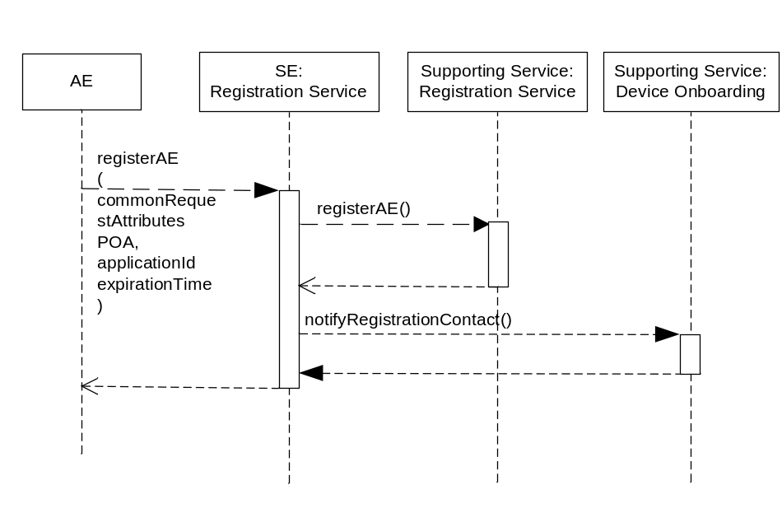
Figure 6.11.2.1.3-1 Registration – registerAE Diagram

6.11.2.1.4 Post-Conditions
AE is registered and can start using service capabilities
The returned AE-ID shall be used in any subsequent operation related to that application

6.11.2.1.5 Exceptions
Not Applicable

6.11.2.1.6 Policies for Use
Message Exchange Patterns: In-Out
Transaction Pattern: Participation allowed

6.11.2.1.7 oneM2M Resource Interworking
This service capability interworks with the following oneM2M Resource operations:
- Create AE

6.11.2.2 refreshAERegistration
This service capability enables an AE or a third party provisioned with the proper authorization to refresh an existing registration with the M2M System. This service capability shall be restricted to the Mca and Msc Reference Points.

6.11.2.2.1 Pre-conditions
The AE has successfully registered with the M2M System.
The common request attributes for the Mca and Msc Reference Points contains the Application Entity (AE-ID) that the Originator has requested to be used for future exchanges between the AE and the M2M System.

6.11.2.2.2 Signature – refreshAERegistration
Parameter name | Direction | Optional | Description
aeId | IN | NO | aeId
pointOfAccess | IN | YES | The point of Access of the registered AE. POA is optional only if identical to the one in the refreshed registration
expirationTime | IN | NO | The expiration time of the registration as requested by the Originator.
responseType | OUT | NO | Unique response types for this service:  - AE successfully refreshed  - Registration Does not exist
Table 6.11.2.2.2-1 Registration – refreshAERegistration capability

6.11.2.2.3 Service Interactions
The interactions of service capabilities required for this service capability:
- Issue the request to Supporting Services to validate the service profile, authorize the service request and record the event.

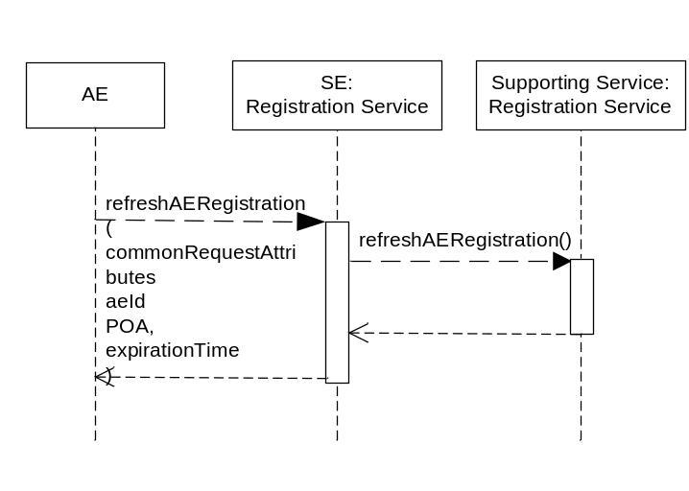
Figure 6.11.2.2.3-1 Registration – refreshAERegistration Diagram

6.11.2.2.4 Post-Conditions
AE is registered and can start using service capabilities

6.11.2.2.5 Exceptions
Not Applicable

6.11.2.2.6 Policies for Use
Message Exchange Patterns: In-Out
Transaction Pattern: Participation allowed

6.11.2.2.7 oneM2M Resource Interworking
This service capability interworks with the following oneM2M Resource operations:
- Update AE

6.11.2.3 deregisterAE
This service capability enables an AE or a third party provisioned with the proper authorization to deregister from the M2M System. This service capability shall be restricted to the Mca Reference Points.

6.11.2.3.1 Pre-conditions
The AE successfully registered with the M2M System.
The common request attributes for the Mca and Msc Reference Points contains the Application Entity (AE-ID) that the Originator has requested to be used for future exchanges between the AE and the M2M System.

6.11.2.3.2 Signature – deregisterAE
Parameter name | Direction | Optional | Description
aeId | IN | NO | aeId
responseType | OUT | NO | Unique response types for this service:  - AE successfully De-registered  - Registration Does not exist
Table 6.11.2.3.2-1 Registration – deregisterAE capability

6.11.2.3.3 Service Interactions
The interactions of service capabilities required for this service capability:
- Issue the request to Supporting Services to validate the service peofile, authorize the request and record the event.

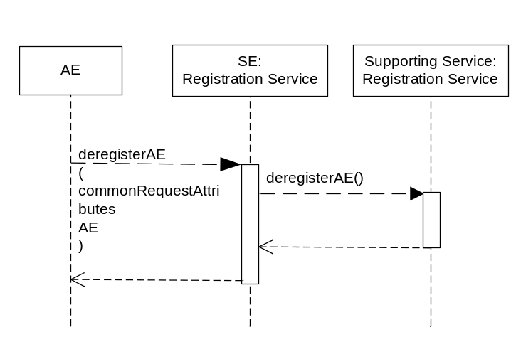
Figure 6.11.2.3.3-1 Registration – deregisterAE Diagram

6.11.2.3.4 Post-Conditions
AE is no longer registered and cannot use any services.

6.11.2.3.5 Exceptions
Not Applicable
Transaction Pattern: Participation allowed

6.11.2.3.6 oneM2M Resource Interworking
This service capability interworks with the following oneM2M Resource operations:
- Delete AE

6.12 Registration Administration

6.12.1 Overview
The Registration administration service provides the ability for:
- Retrieve the AE’s Registration status
- Revoke an AE existing Registration
- Permit subscriptions to AE Registration events

6.12.2 Service Capabilities
Editors Note: The fetching of the service profile is FFS in all operations involving such a step
Editors Note: The validation that the AE-ID is associated with the service profile is FFS in all operations involving such a step
Editors Note: These services need to belong to a component – right now there isn’t a component defined.

6.12.2.1 getRegistrationStatus
This service capability enables a third party authorized for this operation, to retrieve the registration status for an AE. This service capability is limited to the Msc Reference Point

6.12.2.1.1 Pre-conditions
The common request attributes for the Msc Reference Point contains the Application Entity (AE-ID) that the Originator has requested to be used for future exchanges between the AE and the M2M System.

6.12.2.1.2 Signature – getRegistrationStatus
Parameter name | Direction | Optional | Description
aeId | IN | NO | aeId
responseType | OUT | NO | Unique response types for this service:  - AE successfully Retrieved  - Registration does not exist
Table 6.12.2.1.2-1 Registration Administration – getRegistrationStatus capability

6.12.2.1.3 Service Interaction
The interactions of service capabilities required for this service capability:
- Issue a request to Service Subscription Administration to fetch the service profile for the registered AE-ID

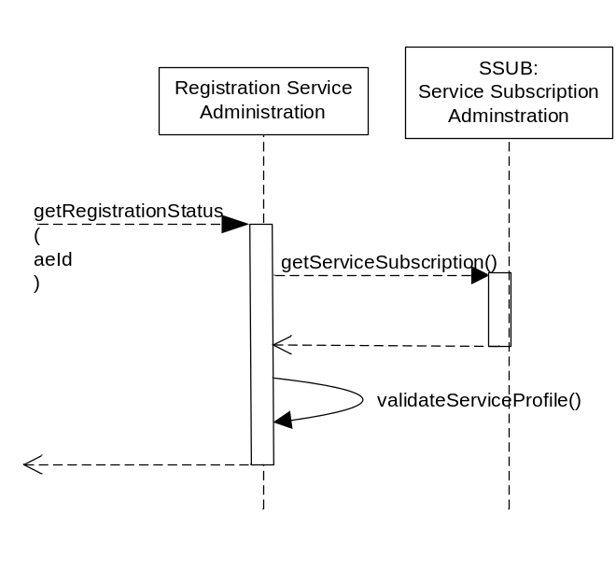
Figure 6.12.2.1.3-1 Registration Administration – getRegistrationStatus Diagram

6.12.2.1.4 Post-Conditions
Not Applicable

6.12.2.1.5 Exceptions
Not Applicable

6.12.2.1.6 Policies for Use
Message Exchange Patterns: In-Out
Transaction Pattern: Participation allowed

6.12.2.1.7 oneM2M Resource Interworking
This service capability interworks with the following oneM2M Resource operations:
- Read AE

6.12.2.2 revokeAERegistration
This service capability enables a third party authorized for this operation to revoke an existing AE registration. This service capability shall be restricted to the Msc Reference Points

6.12.2.2.1 Pre-conditions
The AE successfully registered with the M2M System.
The common request attributes for the Msc Reference Point contains the Application Entity (AE-ID) that the Originator has requested to be used for future exchanges between the AE and the M2M System.

6.12.2.2.2 Signature – revokeAERegistration
Parameter name | Direction | Optional | Description
aeId | IN | NO | aeId
responseType | OUT | NO | Unique response types for this service:  - AE successfully De-registsred  - Registration does not exist
Table 6.12.2.2.2-1 Registration Administration – revokeAERegistration capability

6.12.2.2.3 Service Interaction
The interactions of service capabilities required for this service capability:
- Issue a request to the Service Subscription Administration to fetch the service profile.
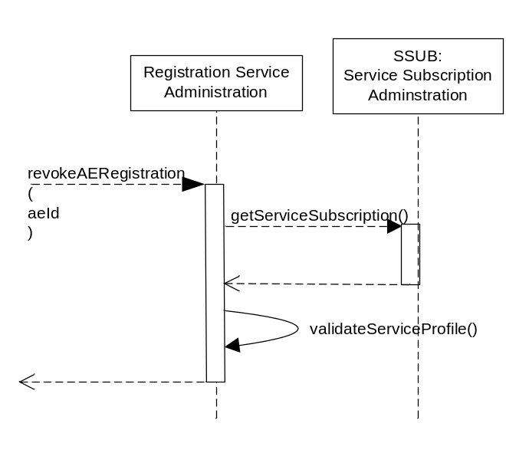

Figure 6.12.2.2.3-1 Registration Administration – revokeAERegistration Diagram

6.12.2.2.4 Post-Conditions
AE is no longer registered and cannot use any services

6.12.2.2.5 Exceptions
Not Applicable

6.12.2.2.6 Policies for Use
Message Exchange Patterns: In-Out
Transaction Pattern: Participation allowed

6.12.2.2.7 oneM2M Resource Interworking
This service capability interworks with the following oneM2M Resource operations:
- Delete AE

6.12.2.3. subscribeInitialAERegistrationEvent
This service capability enables a third party that is authorized to subscribe to the initial (first time ony) registration of an AE on all devices. This capability shall be restricted to the Msc Reference Point

6.12.2.3.1 Pre-conditions
Not Applicable

6.12.2.3.2 Signature – subscriveInitialAERegistrationEvent
Parameter name | Direction |  | Optional | Description
aeId | IN |  | NO | aeId
subscriptionId |  | OUT | YES | Return subscriptionId in case of a success.
responseType |  | OUT | NO | Unique response types for this service:  - successfully subscribed  - not successfully subscribed
6.12.2.3.2-1 Registration Administration – subscribeInitialAERegistrationEvent capability

6.12.2.3.3 Service Interaction
The interactions of service capabilities required for this service capability:
- Issue a request to the Service Subscription Administration to retrieve the service profile.
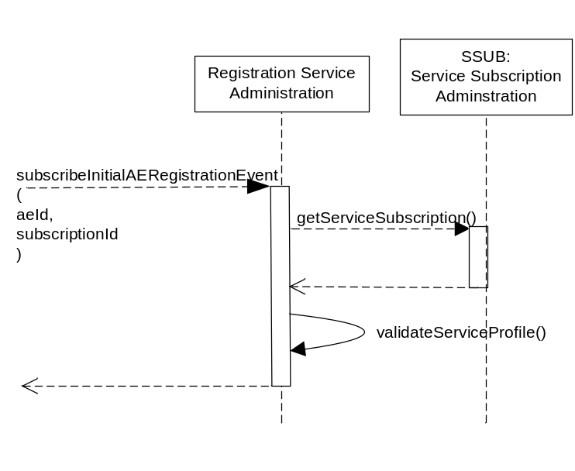

Figure 6.12.2.3.3-1 Registration – subscribeInitialAERegistrationEvent Diagram

6.12.2.3.4 Post-Conditions
An event is created

6.12.2.3.5 Exceptions
Not Applicable

6.12.2.3.6 Policies for Use
Message Exchange Patterns: In-Out
Transaction Pattern: Participation allowed

6.12.2.3.7 oneM2M Resource Interworking
Not Applicable

6.12.2.4 unsubscribeInitialAERegistrationEvent
This service capability enables a third party having the ACP for this operation to remove an existing subscription against an AE initial registration. This capability shall be restricted to the Msc Reference Point.

6.12.2.4.1 Pre-conditions
Not Applicable

6.12.2.4.2 Signature – unsubcribeInitialAERegistrationEvent
Parameter name | Direction | Optional | Description
subscriptionId | IN | NO | The subscriptionId for the AE initial registration event.
responseType | OUT | NO | Unique response types for this service:  - Successfully unsubscribed  - Subscription does not exist
Table 6.12.2.4.2-1 unsubscribeInitialAERegistrationEvent capability

6.12.2.4.3 Service Interaction
The interactions of service capabilities required for this service capability:
- Issue a request to the Service Subscription Administration to fetch the service profile.

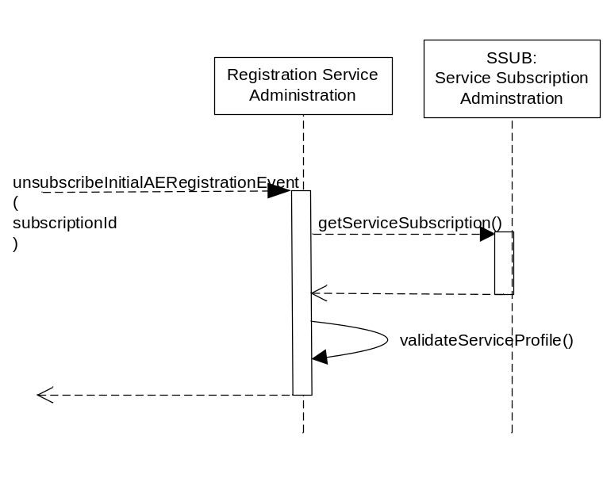
Figure 6.12.2.4.3-1 Registration Administration – unsubscribeInitialAERegistrationEvent Diagram

6.12.2.4.4 Post-Conditions
Subscription to AE no longer exists for the Originator

6.12.2.4.5 Exceptions
Not Applicable

6.12.2.4.6 Policies for Use
Message Exchange Patterns: In-Out
Transaction Pattern: Participation allowed

6.12.2.4.7 oneM2M Resource Interworking
Not Applicable

6.12.2.5 getInitialSubscriptionAERegistrationEvents
This service capability enables a third party authorized for this operation to request a list of subscriptions against an initial registration AE. This capability shall be restricted to the Msc Reference Point.

6.12.2.5.1 Pre-conditions
Not applicable

6.12.2.5.2 Signature – getInitialSubscriptionAERegistrationEvents
Parameter name | Direction | Optional | Description
aeId | IN | NO | aeId
subscriptionIds | OUT | NO | List of subscriptionIds associated with that event
responseType | OUT | NO | Unique response types for this service:  - AE successfully de-registered  - Registration does not exist
Table 6.12.2.5.2-1 Registration Administration – getInitialSubscriptionAERegistrationEvents capability

6.12.2.5.3 Service Interaction
The interactions of service capabilities required for this service capability:
- Issue the request to the Service Subscription Administration to fetch the service profile
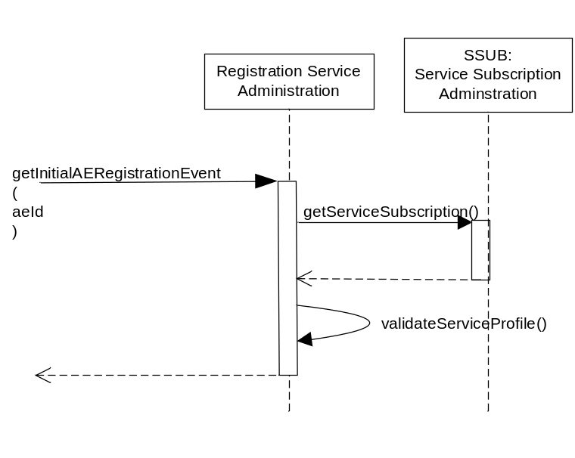
Figure 6.12.2.5.3-1 Registration Administration – getInitialSubscriptionAERegistrationEvents Diagram

6.12.2.5.4 Post-Conditions
Not Applicable

6.12.2.5.5 Exceptions
Not Applicable

6.12.2.5.6 Policies for Use
Message Exchange Patterns: In-Out
Transaction Pattern: Participation allowed

6.12.2.5.7 oneM2M Resource Interworking
Not Applicable

7 M2M Service Components
This clause describes the M2M Service Components provided by the M2M Services Platform.

7.1 Introduction
An M2M Service Component defines the set of M2M Services that are related in the sense that the M2M Services that comprise the M2M Service Component are typically deployed together in order to support one or more Supporting Services.
The M2M Service Architecture augments the oneM2M Functional Architecture by specifying M2M Services provided to M2M Service Providers. These M2M Services are exposed to the AE across the Mca Reference Point as well as other Service Components across the Msc Reference Point.

7.1.1 Service Component Interaction Cross Reference
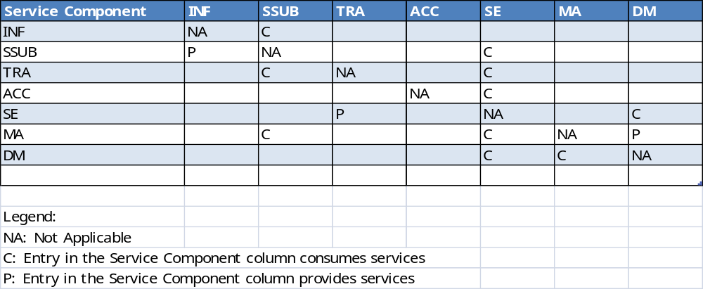
Table 7.1-1 Service Component Cross Reference

7.2 Infrastructure Component (INF)
The INF Component provides services that are exposed to other M2M Service Components across the Msc Reference Point. The Services within the INF Component are common and utility type Services needed to enable other M2M Services.

7.2.1 INF to Service Cross Reference
Authorization: All Service Capabilities

Registration Services: registerAE, refreshAERegistration, deregisterAE

7.3 Service Subscription Component (SSUB)
The SSUB Component provides services that are necessary to maintain the M2M Service, the associations (e.g., Services Roles) to the M2M Service, M2M Service Subscriptions, the associations (e.g., AE, devices) to the M2M Service Subscription and any external identifiers associated with AE and devices. In addition the services used to manage devices and AEs are part of this component.

7.3.1 SSUB to Service Cross Reference
Service Subscription: All Service Capabilities
M2M Service Administration: All Service Capabilities
Service Subscription Administration: All Service Capabilities

7.4 Transport Adapter (TRA)
The TRA component provides services are used to integrate or adapt Data Exchange requests to the underlying Data Exchange transport (e.g., XMPP or MQTT Broker).

7.4.1 TRA to Service Cross Reference
Broker: All Service Capabilities
SE:Data Exchange: notify

7.5 Accounting (ACC)
The ACC Component provides services that are record events necessary to charge for the Services provided to AEs.

7.5.1 Accounting to Service Cross Reference
Event Collection: All Service Capabilities

7.6 Service Exposure (SE)
The SE Component acts as the primary interface for AEs to interact with the M2M Service Layer across the Mca Reference Point.

7.6.1 Service Exposure to Service Cross Reference
SE Data Exchange: All Service Capabilities
Service Subscription: getBroker
Broker: publish, subscribe, sendMessage
Service Subscription Administration: getServiceSubscription, addDeviceToServiceSubscription, deleteDeviceFromServiceSubscription, getDevicesForServiceSubscription, addApplicationsToServiceSubscription, deleteApplicationsFromServiceSubscription, getApplicationsForServiceSubscription
Device Management: All Service Capabilities
Event Collecton: setEventCollectionPolicy, getEventCollectionPolicy, setEventCollectionTriggers, getEventCollectionTriggers, getEventRecords
Registration Services: registerAE, refreshAERegistration, deregisterAE

7.7 Management Adapter (MA)
The Management Adapter component provides services that are used to integrate or adapt Device Management requests to the Management Servers of existing device management technologies(e.g., TR-069, OMA-DM, and LWM2M) .

7.7.1 Management Adapter to Service Cross Reference
Management Adapter: All Service Capabilities
Device Management: reportFirmwareStatus, reportSoftwareStatus, reportTroubleshootingStatus

7.8 Device Management (DM)
The Device Management component provides services to manage devices without consideration of the technology of Underlying Network.

7.8.1 Device Management to Service Cross Reference
Device Management: All Service Capabilities

The following text is to be used when appropriate:

Proforma copyright release text block
This text box shall immediately follow after the heading of an element (i.e. clause or annex) containing a proforma or template which is intended to be copied by the user. Such an element shall always start on a new page.
Notwithstanding the provisions of the copyright clause related to the text of the present document, OneM2M grants that users of the present document may freely reproduce the <proformatype> proforma in this {clause|annex} so that it can be used for its intended purposes and may further publish the completed <proformatype>.

Annex A: Common Request Processing

A.1 Overview
This annex illustrates the usage of the common services described in this technical specification for implementation requests received from AEs across the Mca Reference Point.

A.2 Mca Common Request Processing
AEs communicate with the M2M System over the Mca Reference Point through the SE component. The SE component accepts the request from the AE and provides the request to the Supporting Service in order allow the M2M Service Provider to ensure the request is properly authorized and recorded. In addition, the M2M Service Provider is able to orchestrate other capabilities that have not been specified.

A.2.1 Mca Common Request Data Types (Normative)
Each request that is received by the SE component across the Mca Reference Point shall have a common set of input parameters as described in Table A.2.1-1 Mca: Common Request Input Parameters.
Parameter name | Direction | Optional | Description
from | IN | NO | The identifier of the Originator of the request (AE-ID)
to | IN | NO | The identifier of the AE that is to target of the request (AE-ID)
requestId | IN-OUT | YES | The request identifier. When supplied by the Originator, the same value is returned in the response if the response is applicable for the message exchange pattern. If not supplied by the Originator, the M2M System supplied a globally unique value in the response if the response is applicable for the message exchange pattern.
operation | IN | NO | The signature of the operation that is received or transmitted across the Mca reference point.
Table A.2.1-1 Mca: Common Request Input Parameters
Service capabilities in the SE component whose message exchange patterns require a response shall have a common set of output parameters as described in Table A.2.1-2 Mca: Common Request Output Parameters.
Parameter name | Direction | Optional | Description
responseType | OUT | YES | Response types that are relevant to requests from AEs across the Mca Reference Point.
Table A.2.1-2 Mca: Common Request Output Parameters

A.2.2 Authentication and Authorization of Requests
Upon reception of requests across the Mca reference, the request Originator is authenticated and the requested M2M Service Capability is authorized when the:
- Request Originator has a M2M Service Subscription for the requested operation.
- Request Originator is authorized for the requested operation.

A.2.2.1 Pre-conditions
The external identifiers for the from parameter’s AE-ID are assigned to a M2M Service Subscription (M2M-Service-Profile-ID).
A correlation between the service capability and the M2M authorization event has been defined in order to authorize the service capability.

A.2.2.2 Common M2M Service Capability Parameters for Request Authentication and Authorization
Parameter name | Direction | Optional | Description
Mca common request input parameters | IN | NO | The Mca common request input parameters defined in Table A.2.1-1.
responseType | OUT | YES | Response types that are relevant to the Authentication and Authorizations of requests from AEs across the Mca Reference Point.  - Originator is not authenticated  - Originator does not have a M2M Service Subscription  - Originator not authorized for the M2M Service Capability
Table A.2.2.2-1 Common M2M Service Capability Parameters for Request Authentication and Authorization

A.2.2.3 Service Interactions
The interactions of service capabilities required to authenticate and authorize a request:
- Obtain the M2M Service Capability from the requested operation
- Obtain the Application Entity and associated M2M Service Subscription
- Validate the M2M Service Subscription for the Service Capability.
- Authorize the use of the M2M Service Capability
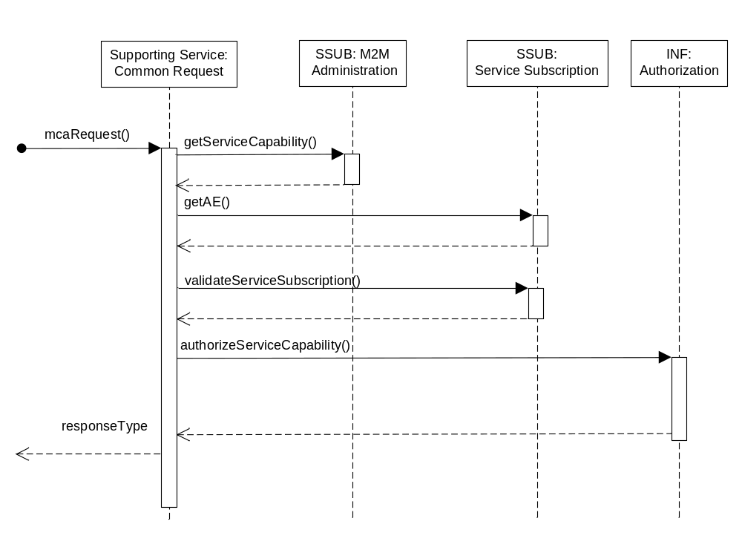
Figure A.2.2.3-1 Mca Common Request Authorization Diagram

A.2.2.4 Post-Conditions
Success case: The request is permitted.
Failure case: The request is not permitted and an optional response type is transmitted back the request Originator.

A.2.2.5 Exceptions
Not Applicable

A.2.2.6 Policies for Use
Message Exchange Patterns: In-Out, In-Only, Robust In-Only, In-Optional-Out
Transaction Pattern: Participation allowed

A.3 Msc Common Request Processing
Service Components communicate with each other across the Msc Reference Point. Additional input or output parameters are not necessary when invoking service capabilities across the Msc Reference Point. As such signature of the service capability is sufficient for implementing the service capability in clause 6 when the capability is invoked across the Msc Reference Point.

A.3.1 Msc Common Request Data Types (Normative)
Each request that is received by the M2M Component across the Msc Reference Point shall have a common set of input parameters as described in Table A.3.1-1 Msc: Common Request Input Parameters.
Parameter name | Direction | Optional | Description
requestId | IN-OUT | NO | The request identifier. When supplied by the Originator, the same value is returned in the response if the response is applicable for the message exchange pattern. If not supplied by the Originator, the M2M System supplied a globally unique value in the response if the response is applicable for the message exchange pattern.
Table A.3.1-1 Msc: Common Request Input Parameters

Annex B (Informative): Data Exchange Services

B.1 Overview
This annex illustrates the usage of the services for requests to exchange data from AEs across the Mca Reference Point.

B.2 Supporting Services

B.2.1 Subscribe-Publish-Notify Message Exchange
This service provides the capability to exchange data using the publish and subscribe message patterns where AEs:
- Request to receive payloads from a publication resource by subscribing to the publication resource.
- Request to publish a payload to a resource.

B.2.1.1 Service Capabilities

B.2.1.1.1 subscribeRequest
This service capability provides the ability to validate a subscription request from an AE.

B.2.1.1.1.1 Pre-conditions
The pre-conditions for Mca Received Requests are met.
A correlation between a M2M Service Subscription, subscribing AE, publication resource and Broker exist.

B.2.1.1.1.2 Signature - subscribeRequest
Parameter name | Direction | Optional | Description
Common request input attributes | - | - | See Table A.2.1-1
publicationResource | IN | NO | The publication resource. See 6.4.1.1.1.1
deliveryPolicy | IN | YES | The delivery policy when notifying the subscriber. See 6.4.1.1.1.2
retainmentPolicy | IN | YES | The retainment policy for unconnected subscribers. See 6.4.1.1.1.3
transportAdapter | OUT | YES | The instance of the transport adapter service (broker)
responseType | OUT | YES | Unique response types for this service.  Note: Consumed services also provide response types.  - Originator does not have a Broker for the requested Resource  - Delivery policy not supported by the transport adapter  - Retainment policy not supported by the transport adapter
Table B.2.1.1.1.2-1 Data Exchange Service – subscribeRequest capability

B.2.1.1.1.3 Service Interactions
The interactions of service capabilities required for this service capability:
- Determine the Broker to be used for the originating AE and publication resource
- Perform the Common Request Services for requests across the Mca Reference Point
- Validate the delivery and retainment policies

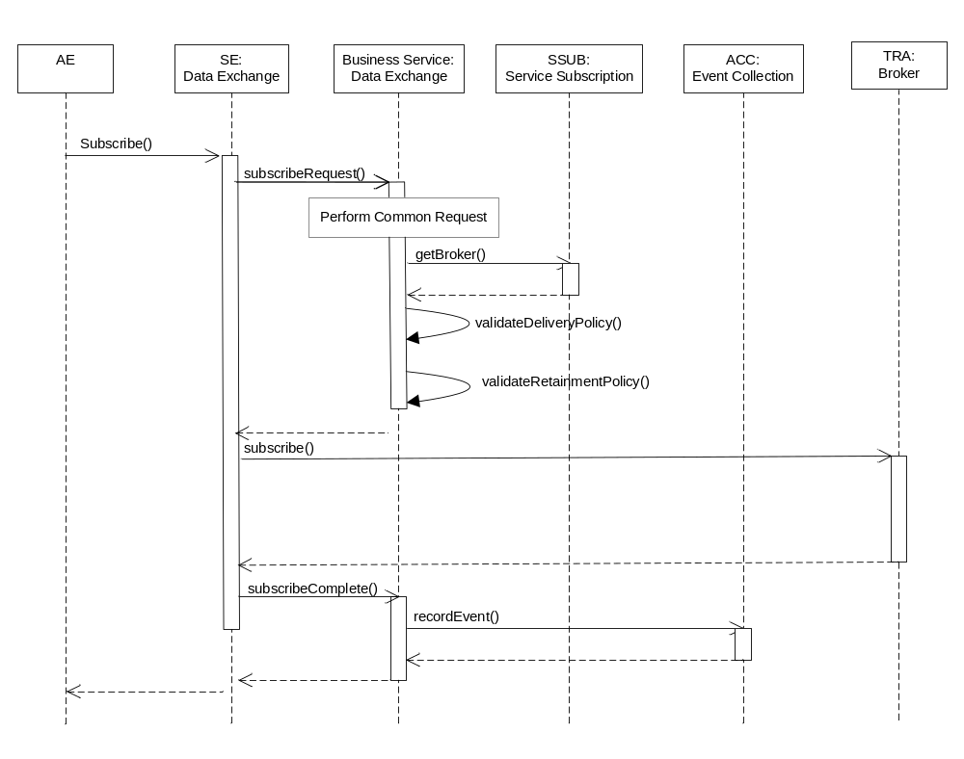
Figure B.2.1.1.1.3-1 subscribeRequest and subscribeComplete Diagram

B.2.1.1.1.4 Post-Conditions
Success case: The request is permitted.
Failure case: The request is not permitted and a response type is transmitted back to the AE.

B.2.1.1.1.5 Exceptions
No unique exceptions for this service capability.
Consumed services may throw exceptions which are forwarded by this service capability.

B.2.1.1.1.6 Policies for Use
Message Exchange Patterns: In-Out
Transaction Pattern: Participation allowed
Maximum Response: 250ms

B.2.1.1.2 subscribeComplete
This service capability provides the ability to complete the actions required once the subscription request has been completed in the Broker.

B.2.1.1.2.1 Pre-conditions
Not Applicable

B.2.1.1.2.2 Signature - subscribeComplete
Parameter name | Direction | Optional | Description
Common request input attributes | - | - | See Table A.2.1-1
publicationResource | IN | NO | The publication resource. See 6.4.1.1.1.1
deliveryPolicy | IN | YES | The delivery policy when notifying the subscriber. See 6.4.1.1.1.2
retainmentPolicy | IN | YES | The retainment policy for unconnected subscribers. See 6.4.1.1.1.3
responseType | OUT | YES | Unique response types for this service.  Note: Consumed services also provide response types.  - Exception: Request may not have been completed
Table B.2.1.1.2.2-1 Data Exchange Service – subscribeComplete capability

B.2.1.1.2.3 Service Interactions
The interactions of service capabilities required for this service capability as shown in Figure B.2.1.1.1.3-1:
- Upon a successful subscribe by the Broker, record the event for accounting purposes

B.2.1.1.2.4 Post-Conditions
Success case: The request is permitted.
Failure case: The request is not permitted and a response type is transmitted back to the AE.

B.2.1.1.2.5 Exceptions
No unique exceptions for this service capability.
Consumed services may throw exceptions which are forwarded by this service capability.

B.2.1.1.2.6 Policies for Use
Message Exchange Patterns: In-Out
Transaction Pattern: Participation allowed
Maximum Response: 50ms

B.2.1.1.3 publishRequest
This service capability provides the ability to validate a publication request from an AE..
As part of the publication, the publishing AE can provide a delivery policy to enhance the robustness of the publication to AEs that have subscribed to the Resource identified in the request.

B.2.1.1.3.1 Pre-conditions
The pre-conditions for Mca Received Requests are met.
A correlation between a M2M Service Subscription, publishing AE, resource to publish the payload and Broker exist.

B.2.1.1.3.2 Signature - publishRequest
Parameter name | Direction | Optional | Description
Common request input attributes | - | - | See Table A.2.1-1
toResource | IN | NO | The leaf node of a publication resource. See 6.4.1.1.1.1
deliveryPolicy | IN | YES | The delivery policy when notifying the subscriber. See 6.4.1.1.1.2
transportAdapter | OUT | YES | The instance of the transport adapter service (broker)
responseType | OUT | YES | Unique response types for this service.  Note: Consumed services also provide response types.  - Originator does not have a Broker for the requested resource  - Originator has requested an invalid deliveryPolicy  - Originator has requested an invalid retainmentPolicy  - Delivery policy not supported by the transport adapter  - Exception: Request may not have been completed

Table B.2.1.1.3.2-1 Data Exchange Service – publishRequest capability

B.2.1.1.3.3 Service Interactions
The interactions of service capabilities required for this service capability:
- Determine the Broker to be used for the originating AE and resource
- Perform the Common Request Services for requests across the Mca Reference Point
- Validate the delivery policy for the Broker
- Upon a successful publication to the Broker, record the event for accounting purposes
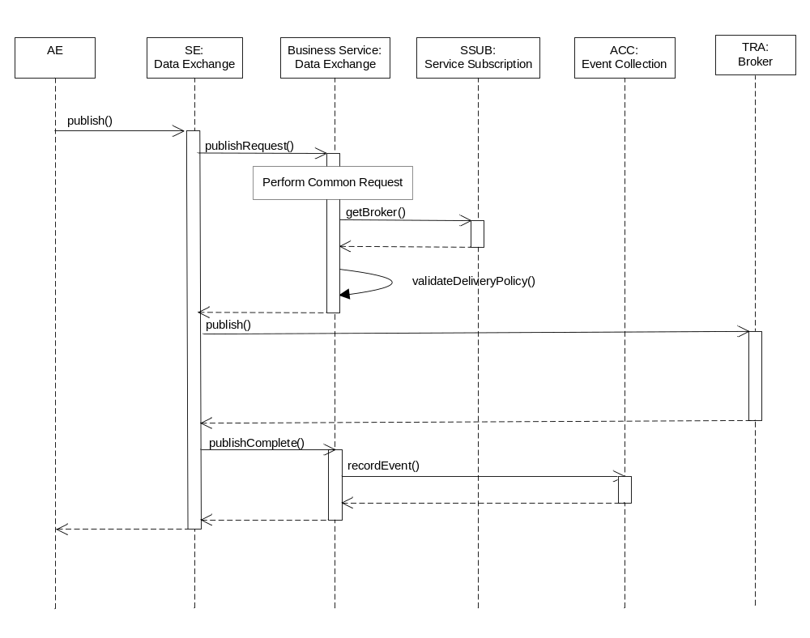
Figure B.2.1.1.3.3-1 publishRequest and publishComplete Diagram

B.2.1.1.3.4 Post-Conditions
Success case: The request is permitted.
Failure case: The request is not permitted and a response type is transmitted back to the AE.

B.2.1.1.3.5 Exceptions
No unique exceptions for this service capability.
Consumed services may throw exceptions which are forwarded by this service capability.

B.2.1.1.3.6 Policies for Use
Message Exchange Patterns: In-Out
Transaction Pattern: Participation allowed
Maximum Response: 300ms

B.2.1.1.4 publishComplete
This service capability provides the ability to complete the actions required once the publication request has been completed in the Broker.

B.2.1.1.4.1 Pre-conditions
Not Applicable

B.2.1.1.4.2 Signature - publishComplete
Parameter name | Direction | Optional | Description
Common request input attributes | - | - | See Table A.2.1-1
toResource | IN | NO | The leaf node of a publication resource. See 6.4.1.1.1.1
deliveryPolicy | IN | YES | The delivery policy when notifying the subscriber. See 6.4.1.1.1.2
retainmentPolicy | IN | YES | The retainment policy for unconnected subscribers. See 6.4.1.1.1.3
responseType | OUT | YES | Unique response types for this service.  Note: Consumed services also provide response types.  - Exception: Request may not have been completed
Table B.2.1.1.4.2-1 Data Exchange Service – pubishComplete capability

B.2.1.1.4.3 Service Interactions
The interactions of service capabilities required for this service capability as shown in Figure B.2.1.1.3.3-1:
- Upon a successful publish by the Broker, record the event for accounting purposes

B.2.1.1.4.4 Post-Conditions
Success case: The request is permitted.
Failure case: The request is not permitted and a response type is transmitted back to the AE.

B.2.1.1.4.5 Exceptions
No unique exceptions for this service capability.
Consumed services may throw exceptions which are forwarded by this service capability.

B.2.1.1.4.6 Policies for Use
Message Exchange Patterns: In-Out
Transaction Pattern: Participation allowed
Maximum Response: 50ms

B.2.1.1.5 notifyRequest
This service capability provides the ability to validate a notification request to an AE.
As part of the notification, delivery policy that is requested to be used is validated and adjusted if necessary.

B.2.1.1.5.1 Pre-conditions
A correlation between a M2M Service Subscription, subscribing AE, subscribed resource and Broker exist.
The pre-conditions for Mca Received Requests are met.

B.2.1.1.5.2 Signature - notifyRequest
Parameter name | Direction | Optional | Description
Common request input attributes | - | - | See Table A.2.1-1
fromResource | IN | NO | The leaf node of a publication resource. See 6.4.1.1.1.1
deliveryPolicy | IN-OUT | YES | The delivery policy when notifying the subscriber. See 6.4.1.1.1.2
responseType | OUT | YES | Unique response types for this service.  Note: Consumed services also provide response types.  - Originator does not have a Broker for the requested resource  - Originator has requested an invalid delivery policy  - Exception: Request may not have been completed

Table B.2.1.1.5.2-1 Data Exchange Service – notifyRequest capability

B.2.1.1.5.3 Service Interactions
The interactions of service capabilities required for this service capability:
- Perform the Common Request Services for requests across the Mca Reference Point
- Validate that the delivery policy requested by the Broker is allowed for the subscribing AE and M2M Service Subscription
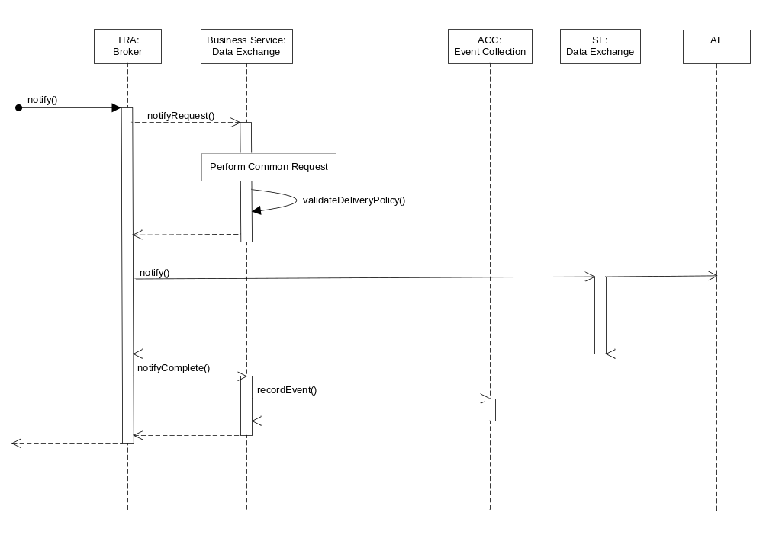
Figure B.2.1.1.5.3-1 notifyRequest and notifyComplete Diagram

B.2.1.1.5.4 Post-Conditions
Success case: The request is permitted.
Failure case: The request is not permitted and a response type is transmitted back to the transport adapter.

B.2.1.1.5.5 Exceptions
No unique exceptions for this service capability.
Consumed services may throw exceptions which are forwarded by this service capability.

B.2.1.1.5.6 Policies for Use
Message Exchange Patterns: In-Out
Transaction Pattern: Participation allowed
Maximum Response: 300ms

B.2.1.1.6 notifyComplete
This service capability provides the ability to complete the actions required once the notification request has been completed in the Data Exchange service.

B.2.1.1.6.1 Pre-conditions
Not Applicable

B.2.1.1.6.2 Signature - notifyComplete
Parameter name | Direction | Optional | Description
Common request input attributes | - | - | See Table A.2.1-1
fromResource | IN | NO | The leaf node of a publication resource. See 6.4.1.1.1.1
deliveryPolicy | IN | YES | The delivery policy when notifying the subscriber. See 6.4.1.1.1.2
responseType | OUT | YES | Unique response types for this service.  Note: Consumed services also provide response types.  - Exception: Request may not have been completed
Table B.2.1.1.6.2-1 Data Exchange Service – notifyComplete capability

B.2.1.1.6.3 Service Interactions
The interactions of service capabilities required for this service capability as shown in Figure B.2.1.1.5.3-1:
- Upon a successful notification by the Data Exchange, record the event for accounting purposes

B.2.1.1.6.4 Post-Conditions
Success case: The request is permitted.
Failure case: The request is not permitted and a response type is transmitted back to the transport adapter.

B.2.1.1.6.5 Exceptions
No unique exceptions for this service capability.
Consumed services may throw exceptions which are forwarded by this service capability.

B.2.1.1.6.6 Policies for Use
Message Exchange Patterns: In-Out
Transaction Pattern: Participation allowed
Maximum Response: 50ms

B.2.2 Request-Response Message Exchange
This service provides the capability to exchange data using the synchronous request-response message pattern where AEs request to send a message to an AE and wait for a response to the message.

B.2.2.1 Service Capabilities

B.2.2.1.1 sendMessageRequest
This service capability provides the ability to validate a send message request from an AE.

B.2.2.1.1.1 Pre-conditions
The pre-conditions for Mca Received Requests are met.
A correlation between a M2M Service Subscription, originating AE and Transport Adapter exist.

B.2.2.1.1.2 Signature - sendMessageRequest
Parameter name | Direction | Optional | Description
Common request input attributes | - | - | See Table A.2.1-1
deliveryPolicy | IN | YES | The delivery policy when sending a request. See 6.4.1.1.1.2
transportAdapter | OUT | YES | The instance of the transport adapter service.
responseType | OUT | YES | Unique response types for this service.  Note: Consumed services also provide response types.  - Originator does not have a transport adaptor for the requested AE.  - Delivery policy not supported by the underlying transport adapter.
Table B.2.2.1.1.2-1 Data Exchange Service – sendMessageRequest capability

B.2.2.1.1.3 Service Interactions
The interactions of service capabilities required for this service capability:
- Determine the transport adapter to be used for the originating AE and target AE. This example shows the use of the Broker service for the transport adapter.
- Perform the Common Request Services for requests across the Mca Reference Point
- Validate the delivery policy
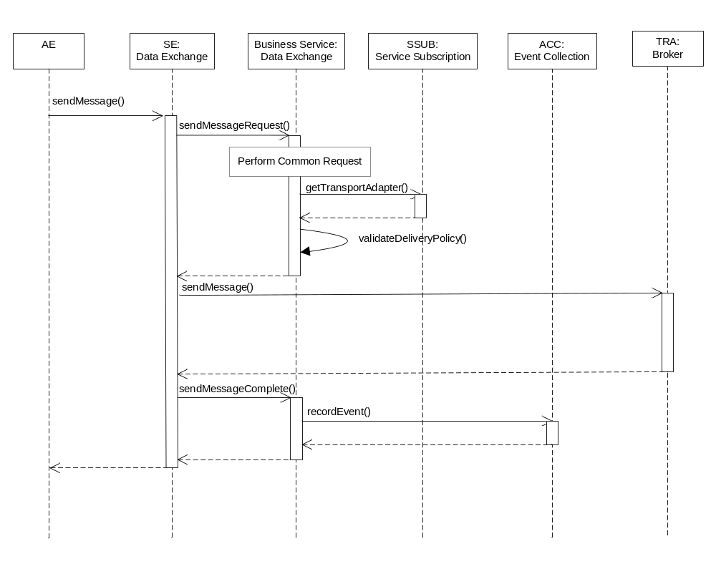
Figure B.2.2.1.1.3-1 sendMessageRequest and sendMessageComplete Diagram

B.2.2.1.1.4 Post-Conditions
Success case: The request is permitted.
Failure case: The request is not permitted and a response type is transmitted back to the AE.

B.2.2.1.1.5 Exceptions
No unique exceptions for this service capability.
Consumed services may throw exceptions which are forwarded by this service capability.

B.2.2.1.1.6 Policies for Use
Message Exchange Patterns: In-Out
Transaction Pattern: Participation allowed
Maximum Response: 250ms

B.2.2.1.2 sendMessageComplete
This service capability provides the ability to complete the actions required once the request has been completed in the Broker.

B.2.2.1.2.1 Pre-conditions
Not Applicable

B.2.2.1.2.2 Signature - sendMessageComplete
Parameter name | Direction | Optional | Description
Common request input attributes | - | - | See Table A.2.1-1
deliveryPolicy | IN | YES | The delivery policy when notifying the subscriber. See 6.4.1.1.1.2
responseType | OUT | YES | Unique response types for this service.  Note: Consumed services also provide response types.  - Exception: Request may not have been completed
Table B.2.2.1.2.2-1 Data Exchange Service – sendMessageComplete capability

B.2.2.1.2.3 Service Interactions
The interactions of service capabilities required for this service capability:
- Upon a successful message send and received from the transport adapter, record the event for accounting purposes

B.2.2.1.2.4 Post-Conditions
Success case: The request is permitted.
Failure case: The request is not permitted and a response type is transmitted back to the AE.

B.2.2.1.2.5 Exceptions
No unique exceptions for this service capability.
Consumed services may throw exceptions which are forwarded by this service capability.

B.2.2.1.2.6 Policies for Use
Message Exchange Patterns: In-Out
Transaction Pattern: Participation allowed
Maximum Response: 50 ms

Annex C (Informative): Service Subscription Administration Services

C.1 Overview
This annex illustrates the usage of the services for requests to administer M2M Service Subscriptions from AEs across the Mca Reference Point.

C.2 Supporting Services
This service provides the capability for AEs to administer the M2M Service Subscriptions that have been previously created by the M2M Service Provider. The following capabilities are provided.
- Retrieval of M2M Service Subscriptions based on a set of filter criteria.
- Administration of the devices associated with a M2M Service Subscriptions as well as the M2M Application associated with the device.
- Administration of the M2M Applications associated with a M2M Service Subscription.
Editor’s note: Need to consider if we should define Service Capabilities to Add/Delete Devices and Applications in Bulk.

C.2.1 Service Capabilities

C.2.1.1 getServiceSubscription
This service capability provides the ability for an AE to retrieve the M2M Service Subscription across the Mca Reference Point.

C.2.1.1.1 Pre-conditions
The pre-conditions for Mca Received Requests are met.

C.2.1.1.2 Signature – getServiceSubscription
Parameter name | Direction | Optional | Description
Mca common request attributes | - | - | See Table A.2.1-1
filterCriteria | IN | NO | See Table 6.9.1.1.1-1
serviceSubscriptions | OUT | NO | The resulting M2M Service Subscription entities in Table 6.9.1.1-1.
responseType | OUT | YES | Unique response types for this service.  - None

Table C.2.2.1.1.2-1 Service Subscription Administration – getServiceSubscription capability

C.2.1.1.3 Service Interactions
The interactions of service capabilities required for this service capability:
- Perform the common request authorization
- Retrieve the M2M Service Subscriptions for the supplied criteria
- Account for the event
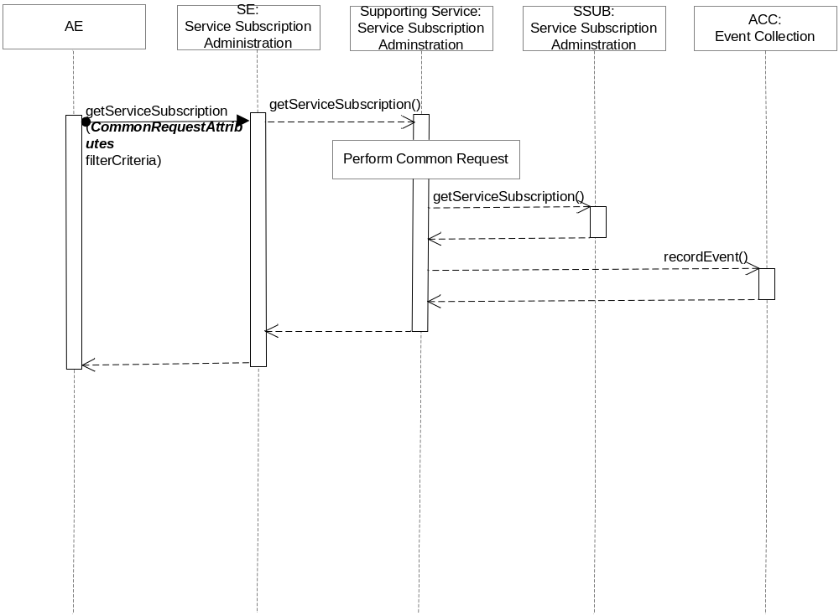
Figure C.2.1.1.3-1 getServiceSubscription Diagram

C.2.1.1.4 Post-Conditions
Not Applicable

C.2.1.1.5 Exceptions
No unique exceptions for this service capability.
Consumed services may throw exceptions which are forwarded by this service capability.

C.2.1.1.6 Policies for Use
Message Exchange Patterns: In-Out
Transaction Pattern: Participation allowed
Maximum Response: 300ms

C.2.1.2 addDeviceToServiceSubscription
This service capability adds a device to a M2M Service Subscription.

C.2.1.2.1 Pre-conditions
The pre-conditions for Mca Received Requests are met.

C.2.1.2.2 Signature – addDeviceToServiceSubscription
Parameter name | Direction | Optional | Description
Mca common request attributes | - | - | See Table A.2.1-1
serviceSubscriptionId | IN | NO | The M2M Service Subscription (M2M-Service-Profile-ID) to add the device
externalIds | IN | YES | A List of URNs that represent the external identifiers associated with this Device.
applicationIds | IN | YES | A list of Application identifiers (App-ID)
deviceId | OUT | NO | The unique device identifier in the context of the M2M Service Subscription.
lastModifiedTime | OUT | NO | See Table A.2.1-1
responseType | OUT | YES | Unique response types for this service.  - Device exists for the M2M Service Subscription

Table C.2.1.2.2-1 Service Subscription Administration – addDeviceToServiceSubscription capability

C.2.1.2.3 Service Interactions
The interactions of service capabilities required for this service capability:
- Perform the common request authorization
- Add the device to the M2M Service Subscription
- Account for the event
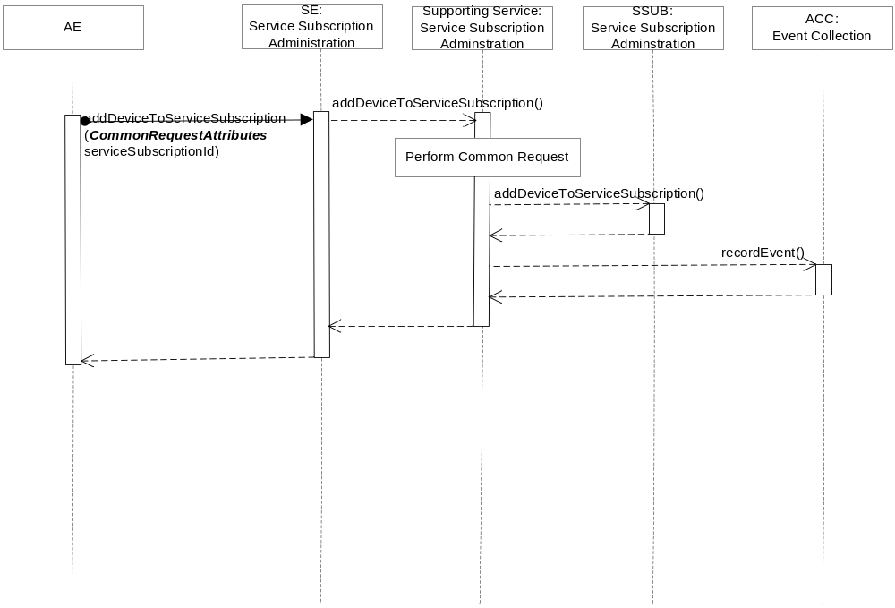
Figure C.2.1.2.3-1 addDeviceToServiceSubscription Diagram

C.2.1.2.4 Post-Conditions
The device is added to the M2M Service Subscription returning the oneM2M System defined deviceId.

C.2.1.2.5 Exceptions
No unique exceptions for this service capability.
Consumed services may throw exceptions which are forwarded by this service capability.

C.2.1.2.6 Policies for Use
Message Exchange Patterns: In-Out
Transaction Pattern: Participation allowed
Maximum Response: 300ms

C.2.1.3 deleteDeviceFromServiceSubscription
This service capability deletes a device from a M2M Service Subscription.

C.2.1.3.1 Pre-conditions
The pre-conditions for Mca Received Requests are met.

C.2.1.3.2 Signature – deleteDeviceFromServiceSubscription
Parameter name | Direction | Optional | Description
Common request input attributes | - | - | See Table A.2.1-1
serviceSubscriptionId | IN | NO | The M2M Service Subscription (M2M-Service-Profile-ID) for the Devices
deviceId | IN | NO | The unique device identifier in the context of the M2M Service Subscription.
responseType | OUT | YES | Unique response types for this service.  - Device does not exist for M2M Service Subscription

Table C.2.1.3.2-1 Service Subscription Administration – deleteDeviceFromServiceSubscription capability

C.2.1.3.3 Service Interactions
The interactions of service capabilities required for this service capability:
- Perform the common request authorization
- Delete the device from the M2M Service Subscription
- Account for the event
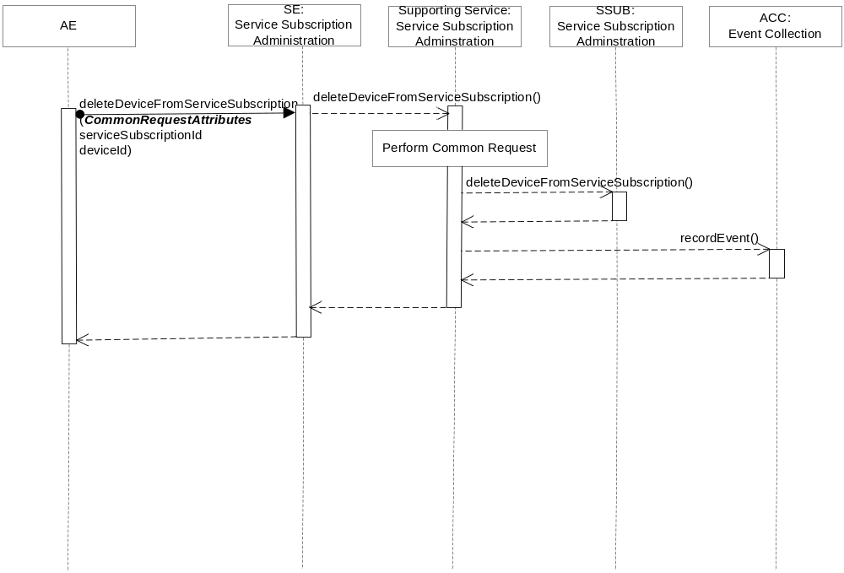
Figure C.2.1.3.3-1 deleteDeviceFromServiceSubscription Diagram

C.2.1.3.4 Post-Conditions
The device is deleted from the M2M Service Subscription.

C.2.1.3.5 Exceptions
No unique exceptions for this service capability.
Consumed services may throw exceptions which are forwarded by this service capability.

C.2.1.3.6 Policies for Use
Message Exchange Patterns: In-Out
Transaction Pattern: Participation allowed
Maximum Response: 300ms

C.2.1.4 getDevicesForServiceSubscription
This service capability retrieves the devices for a M2M Service Subscription.

C.2.1.4.1 Pre-conditions
The pre-conditions for Mca Received Requests are met.

C.2.1.4.2 Signature – getDevicesForServiceSubscription
Parameter name | Direction | Optional | Description
Common request input attributes | - | - | See Table A.2.1-1
filterCriteria | IN | NO | See Table 6.9.1.2.1-1
devices | OUT | NO | The resulting Device entities in Table 6.9.1.2-1.
responseType | OUT | YES | Unique response types for this service.  - M2M Service Subscription does not exist

Table C.2.1.4.2-1 Service Subscription Administration – getDevicesForServiceSubscription capability

C.2.1.4.3 Service Interactions
The interactions of service capabilities required for this service capability:
- Perform the common request authorization
- Retrieve the devices of the M2M Service Subscription with a filter condition
- Account for the event
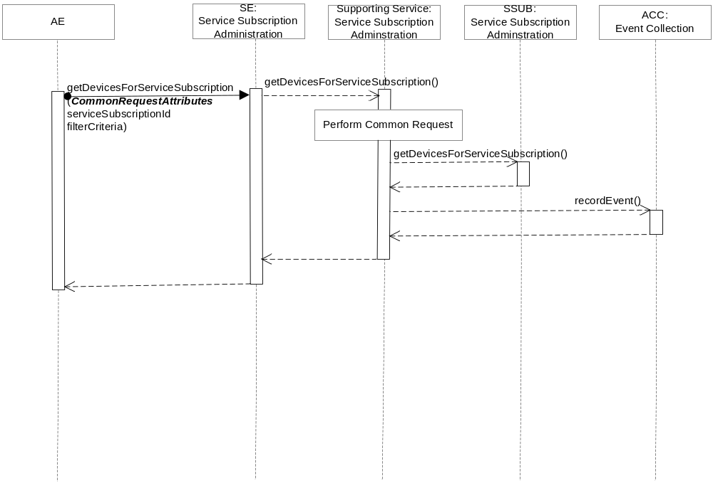
Figure C.2.1.4.3-1 getDevicesForServiceSubscription Diagram

C.2.1.4.4 Post-Conditions
Not Applicable

C.2.1.4.5 Exceptions
No unique exceptions for this service capability.
Consumed services may throw exceptions which are forwarded by this service capability.

C.2.1.4.6 Policies for Use
Message Exchange Patterns: In-Out
Transaction Pattern: Participation allowed
Maximum Response: 300ms

C.2.1.5 addApplicationsToServiceSubscription
This service capability adds M2M Applications to a M2M Service Subscription.

C.2.1.5.1 Pre-conditions
The pre-conditions for Mca Received Requests are met.

C.2.1.5.2 Signature – addApplicationsToServiceSubscription
Parameter name | Direction | Optional | Description
Common request input attributes | - | - | See Table A.2.1-1
serviceSubscriptionId | IN | NO | The M2M Service Subscription (M2M-Service-Profile-ID) for the M2M Applications
applicationIds | IN | NO | List of M2M Application identifiers (App-ID)
lastModifiedTime | OUT | NO | See Table A.2.1-1
responseType | OUT | YES | Unique response types for this service.  - M2M Application exists for the M2M Service Subscription

Table C.2.1.5.2-1 Service Subscription Administration – addApplicationsToServiceSubscription capability

C.2.1.5.3 Service Interactions
The interactions of service capabilities required for this service capability:
- Perform the common request authorization
- Add the M2M Applications to the M2M Service Subscription
- Account for the event
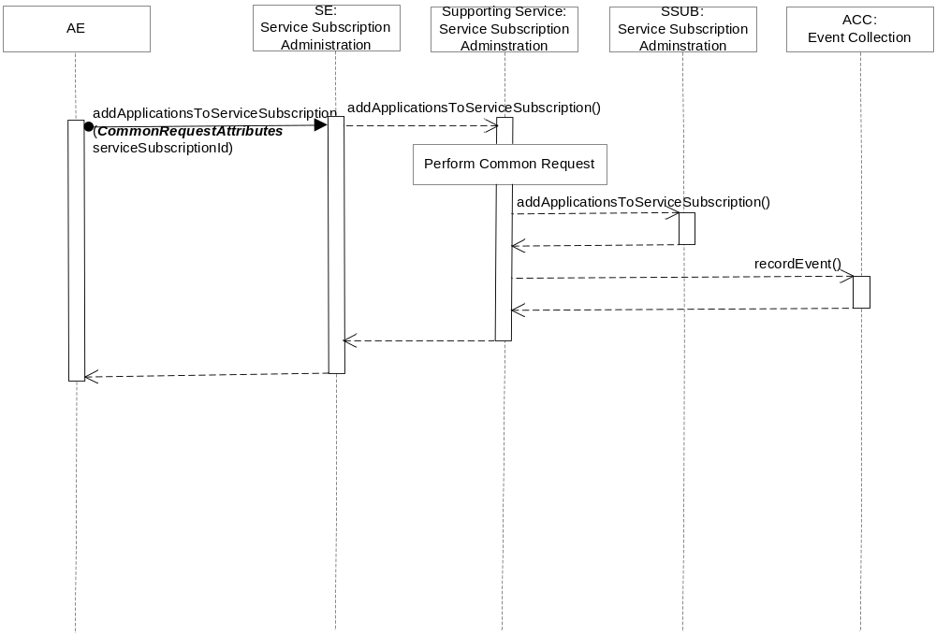
Figure C.2.1.5.3-2 addApplicationsToServiceSubscription Diagram

C.2.1.5.4 Post-Conditions
The M2M Applications are added to the M2M Service Subscription.

C.2.1.5.5 Exceptions
No unique exceptions for this service capability.
Consumed services may throw exceptions which are forwarded by this service capability.

C.2.1.5.6 Policies for Use
Message Exchange Patterns: In-Out
Transaction Pattern: Participation allowed
Maximum Response: 300ms

C.2.1.6 deleteApplicationsFromServiceSubscription
This service capability deletes the M2M Applications from a M2M Service Subscription.

C.2.1.6.1 Pre-conditions
The pre-conditions for Mca Received Requests are met.

C.2.1.6.2 Signature – deleteApplicationsFromServiceSubscription
Parameter name | Direction | Optional | Description
Common request input attributes | - | - | See Table A.2.1-1
serviceSubscriptionId | IN | NO | The M2M Service Subscription (M2M-Service-Profile-ID) for the Applications
applicationIds | IN | NO | A list of Application identifiers (App-ID).
responseType | OUT | YES | Unique response types for this service.  - M2M Application does not exist for the M2M Service Subscription

Table C.2.1.6.2-1 Service Subscription Administration – deleteApplicationsFromServiceSubscription capability

C.2.1.6.3 Service Interactions
The interactions of service capabilities required for this service capability:
- Perform the common request authorization
- Delete the M2M Application from the M2M Service Subscription
- Account for the event
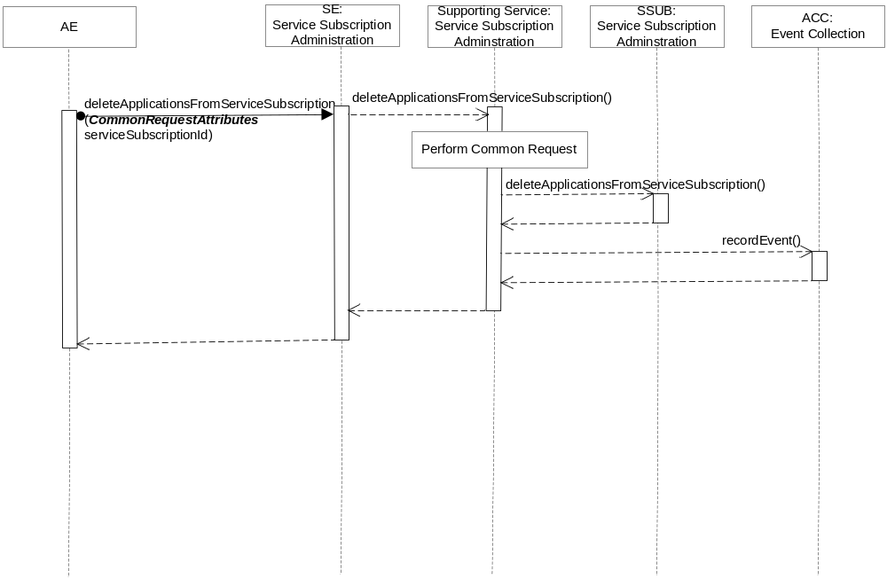
Figure C.2.1.6.3-1 deleteApplicationFromServiceSubscription Diagram

C.2.1.6.4 Post-Conditions
M2M Applications are deleted from the M2M Service Subscription.

C.2.1.6.5 Exceptions
No unique exceptions for this service capability.
Consumed services may throw exceptions which are forwarded by this service capability.

C.2.1.6.6 Policies for Use
Message Exchange Patterns: In-Out
Transaction Pattern: Participation allowed
Maximum Response: 300ms

C.2.1.7 getApplicationsForServiceSubscription
This service capability retrieves the M2M Applications for a M2M Service Subscription.

C.2.1.7.1 Pre-conditions
The pre-conditions for Mca Received Requests are met.

C.2.1.7.2 Signature – getApplicationsForServiceSubscription
Parameter name | Direction | Optional | Description
Common request input attributes | - | - | See Table A.2.1-1
serviceSubscriptionId | IN | NO | The M2M Service Subscription (M2M-Service-Profile-ID) for the M2M Applications
applicationsIds | OUT | NO | The resulting M2M Application Ids (App-ID)
responseType | OUT | YES | Unique response types for this service.  - M2M Service Subscription does not exist.

Table C.2.1.7.2-1 Service Subscription Administration – getApplicationsForServiceSubscription capability

C.2.1.7.3 Service Interactions
The interactions of service capabilities required for this service capability:
- Perform the common request authorization
- Retrieve the M2M Applications of the M2M Service Subscription
- Account for the event
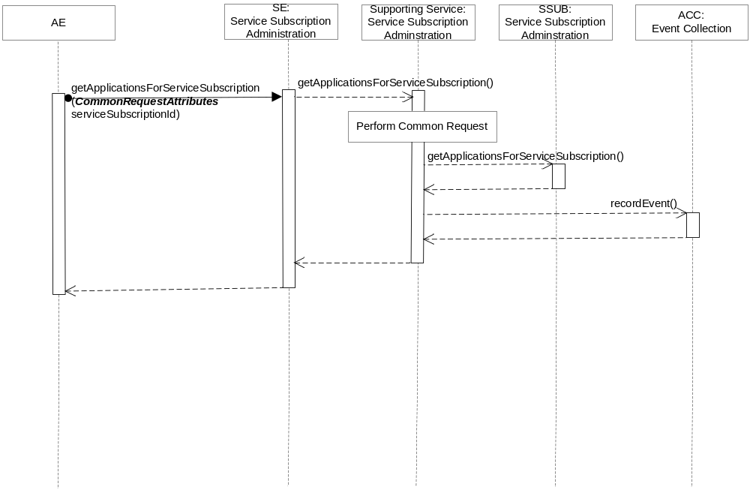
Figure C.2.1.7.3-1 getApplicationsForServiceSubscription Diagram

C.2.1.7.4 Post-Conditions
Not Applicable

C.2.1.7.5 Exceptions
No unique exceptions for this service capability.
Consumed services may throw exceptions which are forwarded by this service capability.

C.2.1.7.6 Policies for Use
Message Exchange Patterns: In-Out
Transaction Pattern: Participation allowed
Maximum Response: 300ms

C.2.1.8 updateApplicationForDevice
This service capability to update the M2M Applications for a device associated with a M2M Service Subscription.

C.2.1.8.1 Pre-conditions
The pre-conditions for Mca Received Requests are met.

C.2.1.8.2 Signature – addDeviceToServiceSubscription
Parameter name | Direction | Optional | Description
Mca common request attributes | - | - | See Table A.2.1-1
serviceSubscriptionId | IN | NO | The M2M Service Subscription (M2M-Service-Profile-ID) for the device
deviceId | IN | NO | The unique device identifier in the context of the M2M Service Subscription.
applicationIds | IN | NO | A list of Application identifiers (App-ID)
lastModifiedTime | OUT | NO | See Table A.2.1-1
responseType | OUT | YES | Unique response types for this service.  - M2M Service Subscription does not exist  - Device does not exist for the M2M Service Subscription

Table C.2.1.8.2-1 Service Subscription Administration – updateApplicationForDevice capability

C.2.1.8.3 Service Interactions
The interactions of service capabilities required for this service capability:
- Perform the common request authorization
- Update the M2M Applications for the device by replacing the existing M2M Application list.
- Account for the event
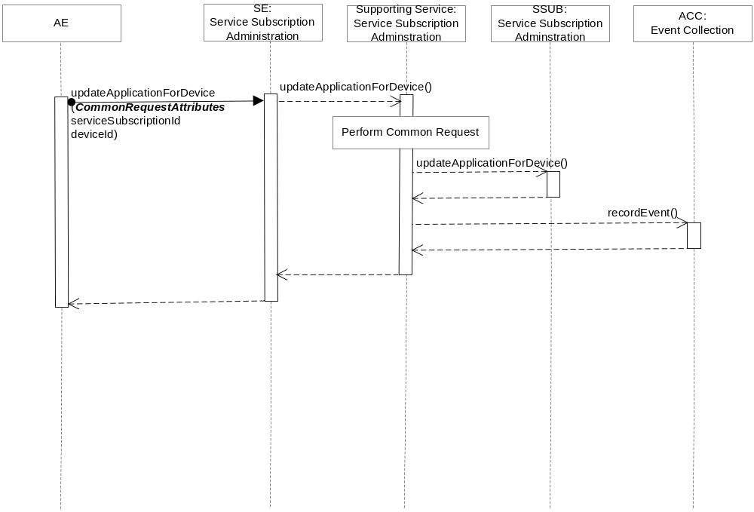
Figure C.2.1.8.3-1 updateApplicationForDevice Diagram

C.2.1.8.4 Post-Conditions
The M2M Applications for the device are replaced with the M2M Applications in the request.

C.2.1.8.5 Exceptions
No unique exceptions for this service capability.
Consumed services may throw exceptions which are forwarded by this service capability.

C.2.1.8.6 Policies for Use
Message Exchange Patterns: In-Out
Transaction Pattern: Participation allowed
Maximum Response: 300ms

Annex D (Informative): Device Management Services

D.1 Overview
This annex illustrates the usage of the services for requests to manage device from AEs across the Mca Reference Point.

D.2 Supporting Services

D.2.1 Message Exchange
This service provides the capability to manage device using the request-response or request-asynchronous notification message patterns where AEs:
- Request to manage device using device specific service capabilities or more complex service capabilities that the Support Service will orchestrate into the individual service capabilities according to their business process.
- Request to obtain management operation execution results or status using the reporting capability. Reports can be generated immediately or periodically based on the report policy. Reports can also be aggregated prior to reporting.

D.2.1.1 Service Capabilities

D.2.2.1.1 downloadFirmware
This service capability provides the ability to execute a downloadFirmware request from an AE.

D.2.2.1.1.1 Pre-conditions
The pre-conditions for Mca Received Requests are met.
A correlation between a Management Adapter, the M2M Service Capability and device exist.

D.2.2.1.1.2 Signature – downloadFirmware
Parameter name | Direction | Optional | Description
Common request input attributes | - | - | See Table A.2.1-1
firmwareInfo | IN | NO | The device firmware information.  Type FirmwareInfo, see 6.6.1.1.1.5
deviceId | IN | YES | The unique device identifier in the context of the M2M M2M Service Subscription.
reportPolicy | IN | YES | The policy used to report the state of the operation to the originating AE. See clause 6.6.1.1.1.1.
firmwareReport | OUT | YES | The firmware management operation execution result or status. Type FirmwareReport, see 6.6.1.1.1.3.
responseType | OUT | YES | Unique response types for this service.  Note: Consumed services also provide response types.
Table D.2.2.1.1.2-1 Device Management Service –downloadFirmware capability

D.2.2.1.1.3 Service Interactions
The interactions of service capabilities required for this service capability:
- Perform the Common Request Services for requests across the Mca Reference Point
- Retrieves the Management Adapter to be used for the device and M2M Service Subscription
- Issues the request to the Management Adapter to download the firmware
- Records the event
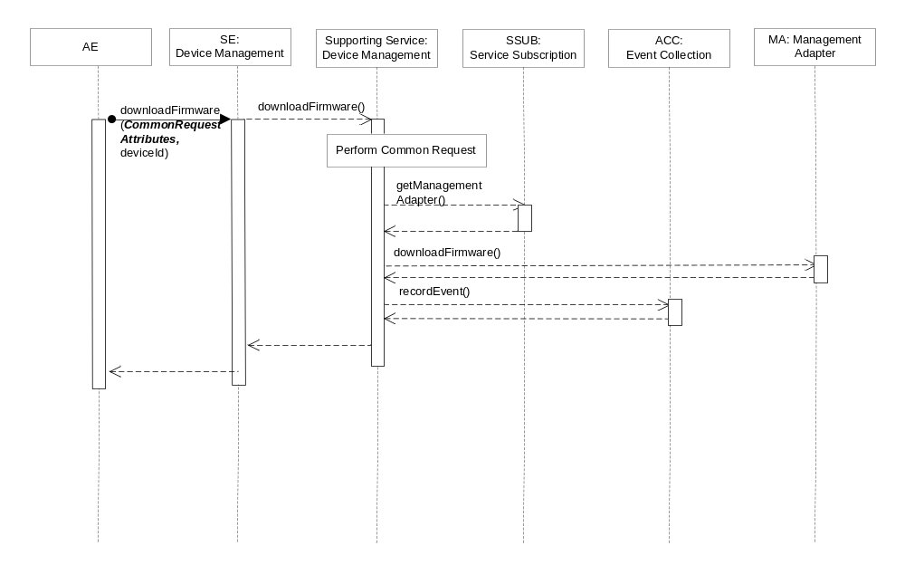
Figure D.2.2.1.1.3-1 downloadFirmware Diagram

D.2.2.1.1.4 Post-Conditions
The Management Adapter has submitted a request to the Management Server to download firmware.

The event has been recorded.

D.2.2.2.1.5 Exceptions

Not Applicable

D.2.2.2.1.6 Policies for Use
Message Exchange Patterns: In-Out
Transaction Pattern: Participation allowed
Maximum Response: 300ms

D.2.2.1.2 installFirmware
This service capability provides the ability to execute a installFirmware request from an AE.

D.2.2.1.2.1 Pre-conditions
The pre-conditions for Mca Received Requests are met.
A correlation between a Management Adapter, the M2M Service Capability and device exist.

D.2.2.1.2.2 Signature – installFirmware
Parameter name | Direction | Optional | Description
Common request input attributes | - | - | See Table A.2.1-1
firmwareInfo | IN | NO | The device firmware information.  Type FirmwareInfo, see 6.6.1.1.1.5
deviceId | IN | YES | The unique device identifier in the context of the M2M M2M Service Subscription.
reportPolicy | IN | YES | The policy used to report the state of the operation to the originating AE.
firmwareReport | OUT | YES | The firmware management operation execution result or status. Type FirmwareReport, see 6.6.1.1.1.3.
responseType | OUT | YES | Unique response types for this service.  Note: Consumed services also provide response types.
Table D.2.2.1.2.2-1 Device Management Service –installFirmware capability

D.2.2.1.2.3 Service Interactions
The interactions of service capabilities required for this service capability:
- Perform the Common Request Services for requests across the Mca Reference Point
- Retrieves the Management Adapter to be used for the device and M2M Service Subscription
- Issues the request to the Management Adapter to install the firmware
- Records the event
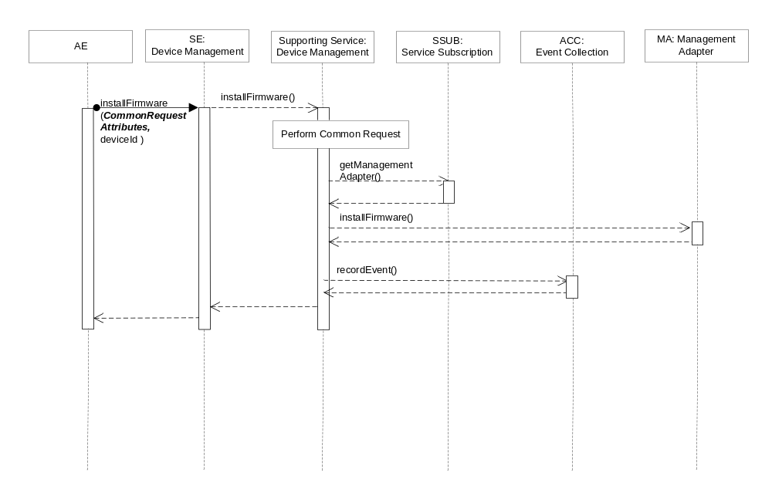
Figure D.2.2.1.2.3-1 installFirmware Diagram

D.2.2.1.2.4 Post-Conditions
The Management Adapter has submitted a request to the Management Server to install firmware.

The event has been recorded.

D.2.2.1.3.5 Exceptions
No unique exceptions for this service capability.
Consumed services may throw exceptions which are forwarded by this service capability.

D.2.2.1.3.6 Policies for Use
Message Exchange Patterns: In-Out
Transaction Pattern: Participation allowed
Maximum Response: 300ms

D.2.2.1.3 getFirmwareInformation
This service capability provides the ability to execute a getFirmwareInformation request from an AE.

D.2.2.1.3.1 Pre-conditions
The pre-conditions for Mca Received Requests are met.
A correlation between a Management Adapter, the M2M Service Capability and device exist.

D.2.2.1.3.2 Signature – getFirmwareInformation
Parameter name | Direction | Optional | Description
Common request input attributes | - | - | See Table A.2.1-1
deviceId | IN | YES | The unique device identifier in the context of the M2M M2M Service Subscription.
reportPolicy | IN | YES | The policy used to report the state of the operation to the originating AE.
firmwareInfo | OUT | YES | The device firmware information.  Type FirmwareInfo, see 6.6.1.1.1.5
responseType | OUT | YES | Unique response types for this service.  Note: Consumed services also provide response types.
Table D.2.2.1.3.2-1 Device Management Service –getFirmwareInformation capability

D.2.2.1.3.3 Service Interactions
The interactions of service capabilities required for this service capability:
- Perform the Common Request Services for requests across the Mca Reference Point
- Retrieves the Management Adapter to be used for the device and M2M Service Subscription
- Issues the request to the Management Adapter to get the firmware information
- Records the event
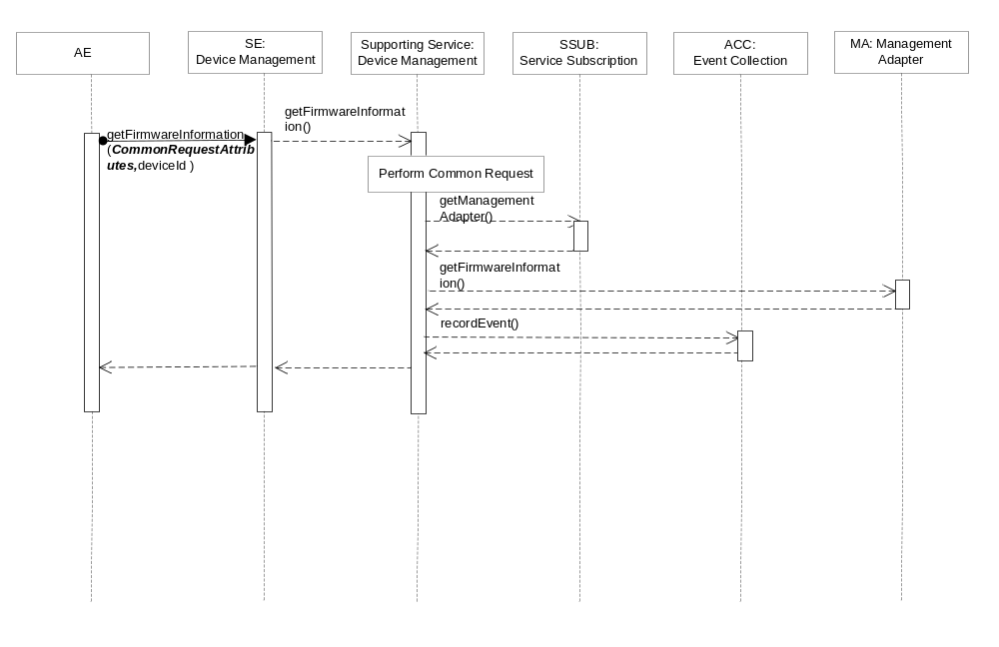

Figure D.2.2.1.3.3-1 getFirmwareInformation Diagram

D.2.2.1.3.4 Post-Conditions
The Management Adapter has submitted a request to the Management Server to get firmware information.

The event is recorded

D.2.2.1.3.5 Exceptions
No unique exceptions for this service capability.
Consumed services may throw exceptions which are forwarded by this service capability.

D.2.2.1.3.6 Policies for Use
Message Exchange Patterns: In-Out
Transaction Pattern: Participation allowed
Maximum Response: 300ms

D.2.2.1.4 getFirmwareExecStatus
This service capability provides the ability to retrieve the execution status or result of a requested firmware operation.

D.2.2.1.4.1 Pre-conditions
The pre-conditions for Mca Received Requests are met.
A correlation between a Management Adapter, the M2M Service Capability and previously submitted firmware request exist.

D.2.2.1.4.2 Signature – getFirmwareExecStatus
Parameter name | Direction | Optional | Description
Common request input attributes | - | - | See Table A.2.1-1
operationRequestId | IN | NO | The M2M Request Identifier of previously submitted firmware request (M2M-Request-ID)
deviceId | IN | YES | The unique device identifier in the context of the M2M M2M Service Subscription.
firmwareReport | OUT | YES | The firmware management operation execution result or status. Type FirmwareReport, see 6.6.1.1.1.3.
responseType | OUT | YES | Unique response types for this service.  Note: Consumed services also provide response types.  - The previously submitted firmware request does not exist
Table D.2.2.1.4.2-1 Device Management Service –getFirmwareExecStatus capability

D.2.2.1.4.3 Service Interactions
The interactions of service capabilities required for this service capability:
- Perform the Common Request Services for requests across the Mca Reference Point
- Retrieves the Management Adapter to be used for the device and M2M Service Subscription
- Issues the request to the Management Adapter to retrieve the firmware operations execution status or result
- Records the event
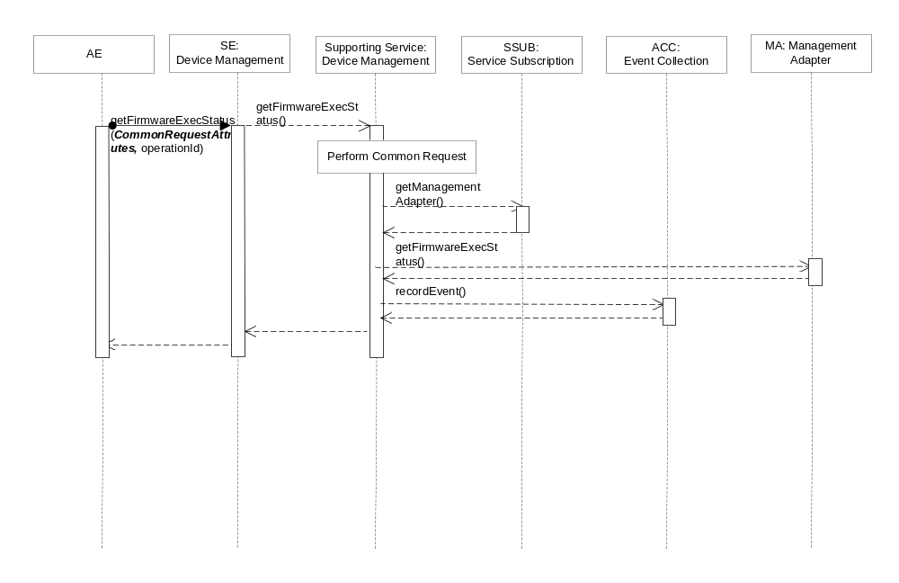
Figure D.2.2.1.4.3-1 getFirmwareExecStatus Diagram

D.2.2.1.4.4 Post-Conditions
The Management Adapter has submitted a request to the Management Server to get firmware operation execution status or result.

Record the event.

D.2.2.1.4.5 Exceptions
No unique exceptions for this service capability.
Consumed services may throw exceptions which are forwarded by this service capability.

D.2.2.1.4.6 Policies for Use
Message Exchange Patterns: In-Out
Transaction Pattern: Participation allowed
Maximum Response: 300ms

D.2.2.1.5 reportFirmwareStatus
This service capability provides the ability to notify an AE about the status or result of a firmware operation for a previously submitted operation request.

D.2.2.1.5.1 Pre-conditions
The pre-conditions for Mca Received Requests are met.
A correlation between a Management Adapter, the M2M Service Capability and previously submitted firmware requests exist.

D.2.2.1.5.2 Signature – reportFirmwareStatus
Parameter name | Direction | Optional | Description
Common request input attributes | - | - | See Table A.2.1-1
isLastReport | IN | NO | Boolean, whether it is the last report.
sequenceNumber | IN | NO | The report sequence number.
firmwareReportList | IN | NO | Array of firmwareReport.  Type FirmwareReport, see 6.6.1.1.1.3.
aggregationPolicy | IN | YES | The policy used to aggregate the result of the management operation prior to the reports being sent. See clause 6.6.1.1.1.2.
responseType | OUT | YES | Unique response types for this service.  Note: Consumed services also provide response types.
Table D.2.2.1.5.2-1 Device Management Service –reportFirmwareStatus capability

D.2.2.1.5.3 Service Interactions
The interactions of service capabilities required for this service capability:
- Perform the Common Request Services for requests across the Mca Reference Point
- Record the event.
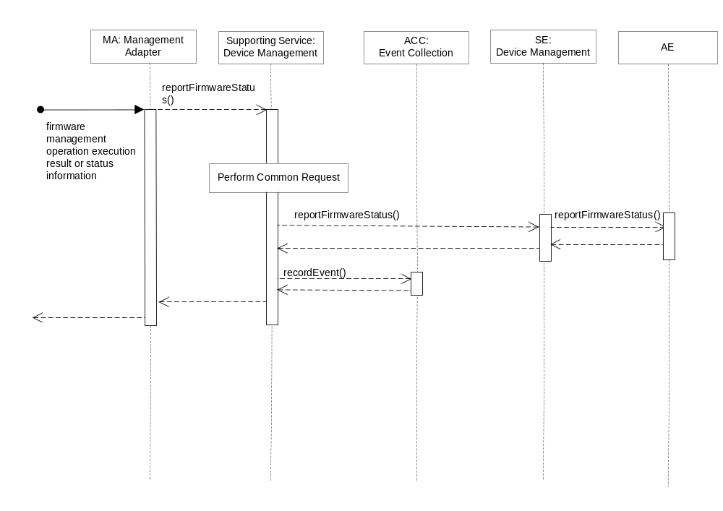Figure D.2.2.1.5.3-3 reportFirmwareStatus Diagram

D.2.2.1.5.4 Post-Conditions
The AE has received a report of firmware operation execution status or result.

The event is recorded.

D.2.2.1.5.5 Exceptions
No unique exceptions for this service capability.
Consumed services may throw exceptions which are forwarded by this service capability.

D.2.2.1.5.6 Policies for Use
Message Exchange Patterns: In-Out
Transaction Pattern: Participation allowed
Maximum Response: 300ms

D.2.2.1.6 upgradeFirmware
This service capability permits AEs to upgrade the firmware on individual device, multiple devices or a group of devices. In addition the upgrade of the firmware is permitted based on a schedule for each of the operations

D.2.2.1.6.1 Pre-conditions
The pre-conditions for Mca Received Requests are met.
A correlation between Management Adapter, the M2M Service Capability and devices or device group exist.

D.2.2.1.6.2 Signature – upgradeFirmware
Parameter name | Direction | Optional | Description
Common request input attributes | - | - | See Table A.2.1-1
orchestrationRuleList | IN | NO | List of OrchestrationRule. Type OrchestrationRule, see clause 6.6.1.1.1.4.
reportPolicy | IN | YES | The policy used to report the state of the operation to the originating AE. See clause 6.6.1.1.1.1.
aggregationPolicy | IN | YES | The policy used to aggregate the result of the management operation prior to the reports being sent. See clause 6.6.1.1.1.2.
firmwareReportList | OUT | YES | List of firmware reports.  Type FirmwareReport, see 6.6.1.1.1.3.
responseType | OUT | YES | Unique response types for this service.  Note: Consumed services also provide response types.
Table D.2.2.1.6.2-1 Device Management Service –upgradeFirmware capability

D.2.2.1.6.3 Service Interactions
The interactions of service capabilities required for this service capability:
- Perform the Common Request Services for requests across the Mca Reference Point
- Retrieves the Management Adapter to be used for the device and M2M Service Subscription
- Issues a series of operations to the Management Adapter to upgrade the firmware on a the devices in the orchestration rule list. Each entry in the orchestration rule list contains the operation, the devices and schedule for the operation.
- Records the event
- Aggregate the report status or results
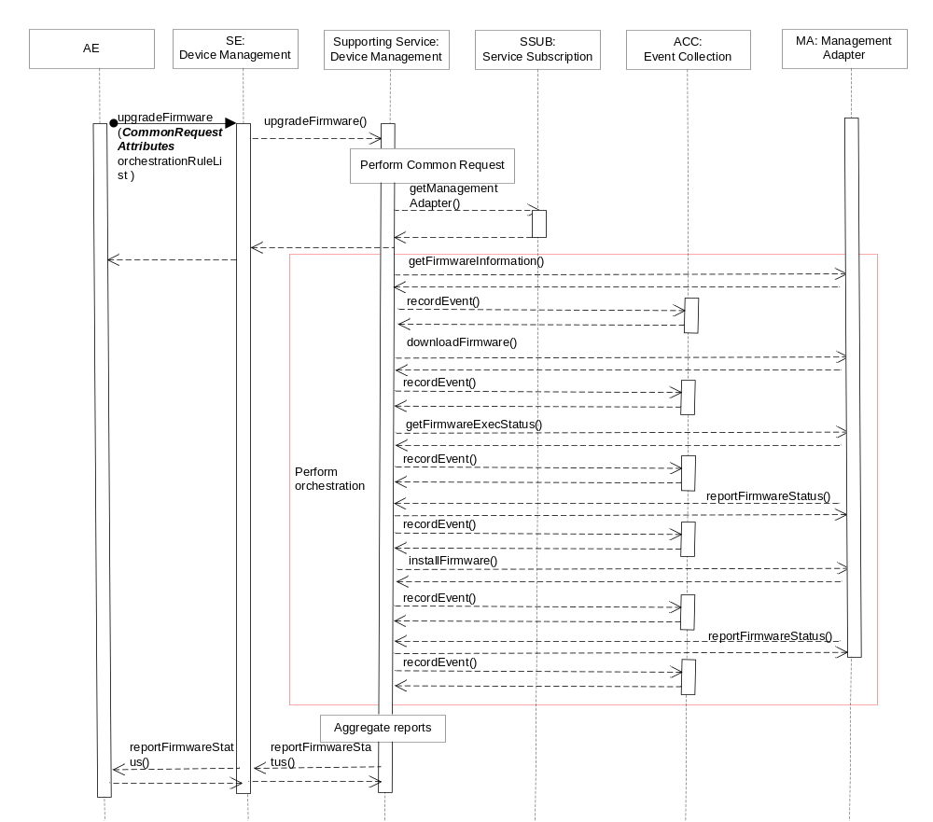

Figure D.2.2.1.6.3-4 upgradeFirmware Diagram
Editors Note: We need a common service capability for Aggregate reports. Flow needs to account for the Report Policy.Aggregate reports need further study.

D.2.2.1.6.4 Post-Conditions
The Management Adapter has submitted a set of requests to the Management Server to upgrade the firmware.

The event is recorded.

D.2.2.2.6.5 Exceptions
The reachability schedule of the device doesn’t not match the schedule of the orchestration rule.

D.2.2.2.6.6 Policies for Use
Message Exchange Patterns: In-Out
Transaction Pattern: Participation allowed
Maximum Response: 300ms

D.2.1.1.7 getDeviceInformation
This service capability provides the ability for an AE to retrieve the information about a device across the Mca Reference Point.

D.2.1.1.7.1 Pre-conditions
The pre-conditions for Mca Received Requests are met.
A correlation between a Management Adapter, the M2M Service Capability and device exist.

D.2.1.1.7.2 Signature – getDeviceInformation
Parameter name | Direction | Optional | Description
Common request input attributes | - | - | See Table A.2.1-1
deviceId | IN | NO | The unique device identifier in the context of the M2M M2M Service Subscription.
deviceInfo | OUT | NO | The device information. Type DeviceInfo, see 6.6.1.1.1.7.
memory | OUT | YES | The memory information. Type Memory, see 6.6.1.1.1.8.
battery | OUT | YES | The battery information. Type Battery, see 6.6.1.1.1.9.
lockStatus | OUT | YES | The device lock status. Enum LockStatus, see 6.6.1.1.1.13.
responseType | OUT | YES | Unique response types for this service.  Note: Consumed services also provide response types.
Table D.2.1.1.7.2-1 Device Management Service –getDeviceInformation capability

D.2.1.1.7.3 Service Interactions
The interactions of service capabilities required for this service capability:
- Perform the Common Request Services for requests across the Mca Reference Point
- Retrieves the Management Adapter to be used for the device and M2M Service Subscription
- Issues the request to the Management Adapter to get device information
- Records the event
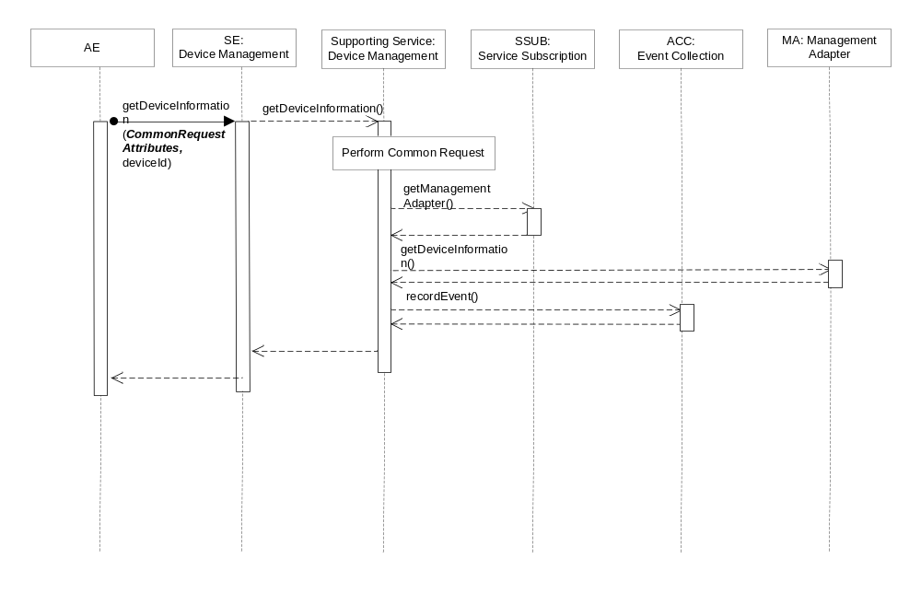Figure D.2.1.1.7.3-1 getDeviceInformation Diagram

D.2.1.1.7.4 Post-Conditions
The Management Adapter has submitted a request to the Management Server to get device information.
Based on the capabilities supported by the device, the memory, battery and lock status information may or may not be returned.
The event has been recorded.

D.2.1.1.7.5 Exceptions
Not Applicable

D.2.1.1.7.6 Policies for Use
Message Exchange Patterns: In-Out
Transaction Pattern: Participation allowed
Maximum Response: 300ms

D.2.1.1.8 getDeviceCapabilities
This service capability provides the ability to execute a getDeviceCapabilities request from an AE.

D.2.1.1.8.1 Pre-conditions
The pre-conditions for Mca Received Requests are met.
A correlation between a Management Adapter, the M2M Service Capability and device exist.

D.2.1.1.8.2 Signature – getDeviceCapabilities
Parameter name | Direction | Optional | Description
Common request input attributes | - | - | See Table A.2.1-1
deviceId | IN | NO | The unique device identifier in the context of the M2M M2M Service Subscription.
deviceCapabilities | OUT | YES | Array of deviceCapability. Type DeviceCapability, see 6.6.1.1.1.10.
responseType | OUT | YES | Unique response types for this service.  Note: Consumed services also provide response types.
Table D.2.1.1.8.2-1 Device Management Service –getDeviceCapabilities capability

D.2.1.1.8.3 Service Interactions
The interactions of service capabilities required for this service capability:
- Perform the Common Request Services for requests across the Mca Reference Point
- Retrieves the Management Adapter to be used for the device and M2M Service Subscription
- Issues the request to the Management Adapter to get device capabilities
- Records the event
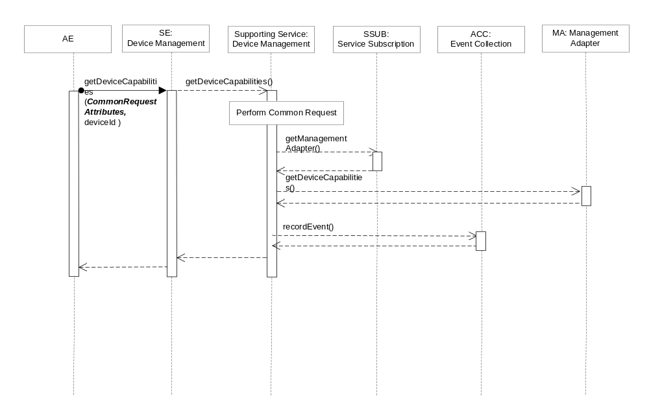Figure D.2.1.1.8.3-1 getDeviceCapabilities Diagram

D.2.1.1.8.4 Post-Conditions
The Management Adapter has submitted a request to the Management Server to get device capabilities.
The event has been recorded.

D.2.1.1.8.5 Exceptions
No unique exceptions for this service capability.
Consumed services may throw exceptions which are forwarded by this service capability.

D.2.1.1.8.6 Policies for Use
Message Exchange Patterns: In-Out
Transaction Pattern: Participation allowed
Maximum Response: 300ms

D.2.1.1.9 enableDeviceCapability
This service capability provides the ability to execute a enableDeviceCapability request from an AE.

D.2.1.1.9.1 Pre-conditions
The pre-conditions for Mca Received Requests are met.
A correlation between a Management Adapter, the M2M Service Capability and device exist.

D.2.1.1.9.2 Signature – enableDeviceCapability
Parameter name | Direction | Optional | Description
Common request input attributes | - | - | See Table A.2.1-1
deviceId | IN | NO | The unique device identifier in the context of the M2M M2M Service Subscription.
name | IN | NO | The name of the capability. Enum DeviceCapabilityName, see 6.6.1.1.1.12.
state | OUT | NO | Indicates if the capability is enabled or disabled.
responseType | OUT | YES | Unique response types for this service.  Note: Consumed services also provide response types.
Table D.2.1.1.9.2-1 Device Management Service –enableDeviceCapability capability

D.2.1.1.9.3 Service Interactions
The interactions of service capabilities required for this service capability:
- Perform the Common Request Services for requests across the Mca Reference Point
- Retrieves the Management Adapter to be used for the device and M2M Service Subscription
- Issues the request to the Management Adapter to enable device capability
- Records the event
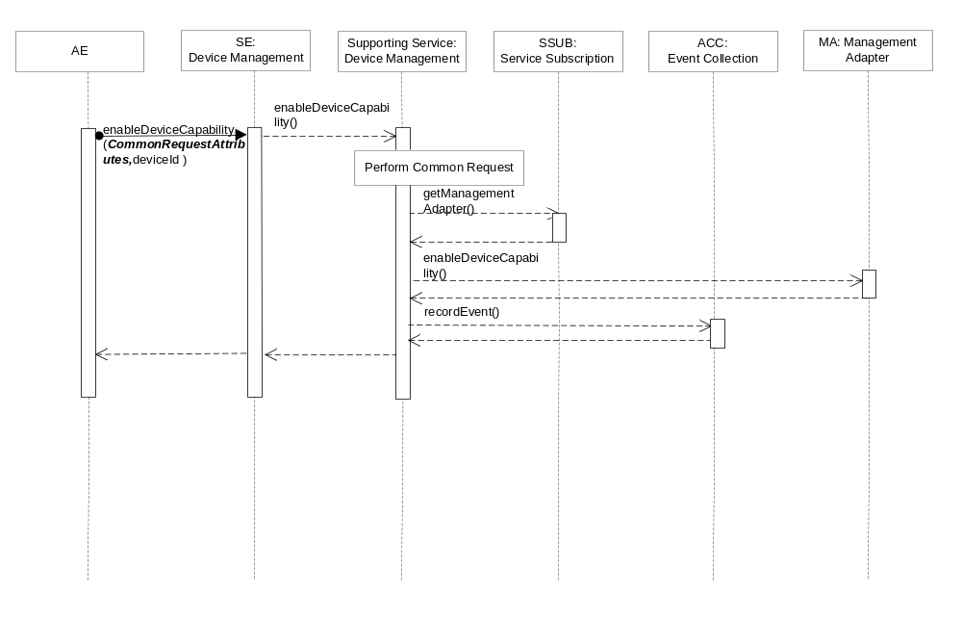Figure D.2.1.1.9.3-1 enableDeviceCapability Diagram

D.2.1.1.9.4 Post-Conditions
The Management Adapter has submitted a request to the Management Server to enable device capability.
The event is recorded

D.2.1.1.9.5 Exceptions
No unique exceptions for this service capability.
Consumed services may throw exceptions which are forwarded by this service capability.

D.2.1.1.9.6 Policies for Use
Message Exchange Patterns: In-Out
Transaction Pattern: Participation allowed
Maximum Response: 300ms

D.2.1.1.10 disableDeviceCapability
This service capability provides the ability to execute a disableDeviceCapability request from an AE.

D.2.1.1.10.1 Pre-conditions
The pre-conditions for Mca Received Requests are met.
A correlation between a Management Adapter, the M2M Service Capability and device exist.

D.2.1.1.10.2 Signature – disableDeviceCapability
Parameter name | Direction | Optional | Description
Common request input attributes | - | - | See Table A.2.1-1
deviceId | IN | NO | The unique device identifier in the context of the M2M M2M Service Subscription.
name | IN | NO | The name of the capability. Enum DeviceCapabilityName, see 6.6.1.1.1.12.
state | OUT | NO | Indicates if the capability is enabled or disabled.
responseType | OUT | YES | Unique response types for this service.  Note: Consumed services also provide response types.
Table D.2.1.1.10.2-1 Device Management Service –disableDeviceCapability capability

D.2.1.1.10.3 Service Interactions
The interactions of service capabilities required for this service capability:
- Perform the Common Request Services for requests across the Mca Reference Point
- Retrieves the Management Adapter to be used for the device and M2M Service Subscription
- Issues the request to the Management Adapter to disable device capability
- Records the event
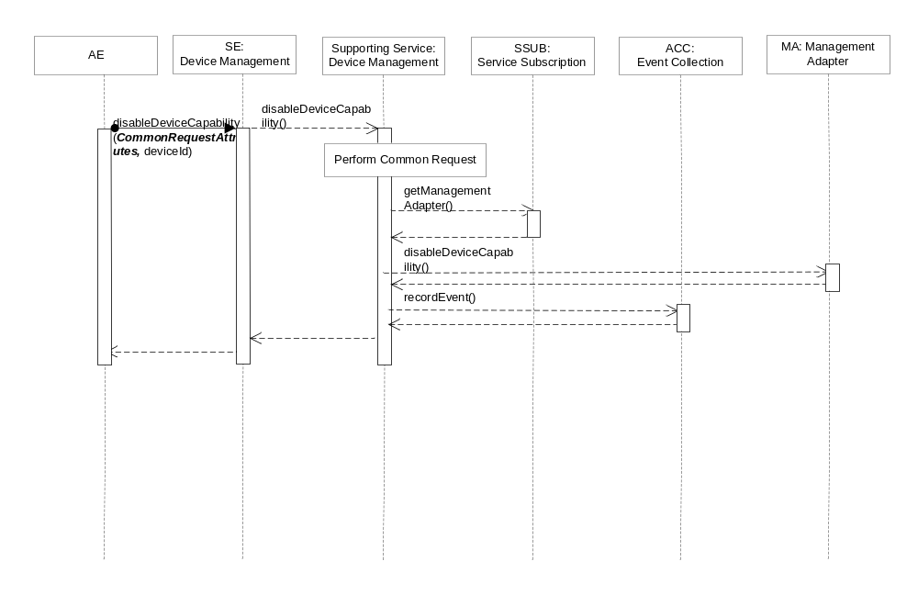Figure D.2.1.1.10.3-1 disableDeviceCapability Diagram

D.2.1.1.10.4 Post-Conditions
The Management Adapter has submitted a request to the Management Server to disable device capability.
Record the event.

D.2.1.1.10.5 Exceptions
No unique exceptions for this service capability.
Consumed services may throw exceptions which are forwarded by this service capability.

D.2.1.1.10.6 Policies for Use
Message Exchange Patterns: In-Out
Transaction Pattern: Participation allowed
Maximum Response: 300ms

D.2.1.1.11 getAreaNetworks
This service capability provides the ability to execute a getAreaNetworks request from an AE.

D.2.1.1.11.1 Pre-conditions
The pre-conditions for Mca Received Requests are met.
A correlation between a Management Adapter, the M2M Service Capability and area network exist.

D.2.1.1.11.2 Signature –getAreaNetworks
Parameter name | Direction | Optional | Description
Common request input attributes | - | - | See Table A.2.1-1
areaNwks | OUT | YES | Array of area network. Type AreaNwkInfo, see 6.6.1.1.1.13.
responseType | OUT | YES | Unique response types for this service.  Note: Consumed services also provide response types.
Table D.2.1.1.11.2-1 Device Management Service –getAreaNetworks capability

D.2.1.1.11.3 Service Interactions
The interactions of service capabilities required for this service capability:
- Perform the Common Request Services for requests across the Mca Reference Point
- Retrieves the Management Adapter to be used for the device and M2M Service Subscription
- Issues the request to the Management Adapter to get area networks information
- Records the event
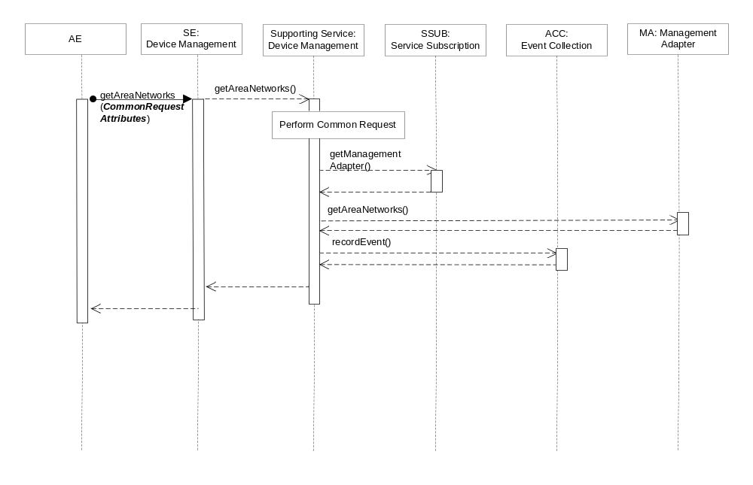Figure D.2.1.1.11.3-1 getAreaNetworks Diagram

D.2.1.1.11.4 Post-Conditions
The Management Adapter has submitted a request to the Management Server to get area networks information.
The event has been recorded.

D.2.1.1.11.5 Exceptions
Not Applicable

D.2.1.1.11.6 Policies for Use
Message Exchange Patterns: In-Out
Transaction Pattern: Participation allowed
Maximum Response: 300ms

D.2.1.1.12 updateDeviceForAreaNetwork
This service capability provides the ability to execute a updateDeviceForAreaNetwork request from an AE.

D.2.1.1.12.1 Pre-conditions
The pre-conditions for Mca Received Requests are met.
A correlation between a Management Adapter, the M2M Service Capability, the device and area network exist.

D.2.1.1.12.2 Signature –updateDeviceForAreaNetwork
Parameter name | Direction | Optional | Description
Common request input attributes | - | - | See Table A.2.1-1
areaNwkId | IN | NO | The unique area network identifier.
deviceId | IN | NO | The unique device identifier in the context of the M2M M2M Service Subscription.
areaNwkDeviceInfo | IN | YES | The existing areaNwkDeviceInfo are replaced with the information in this parameter. Type AreaNwkDeviceInfo, see 6.6.1.1.1.15.
lastModifiedTime | OUT | NO | The modified time.
responseType | OUT | YES | Unique response types for this service.  Note: Consumed services also provide response types.
Table D.2.1.1.12.2-1 Device Management Service –updateDeviceForAreaNetwork capability

D.2.1.1.12.3 Service Interactions
The interactions of service capabilities required for this service capability:
- Perform the Common Request Services for requests across the Mca Reference Point
- Retrieves the Management Adapter to be used for the device and M2M Service Subscription
- Issues the request to the Management Adapter to update device information for area network
- Records the event
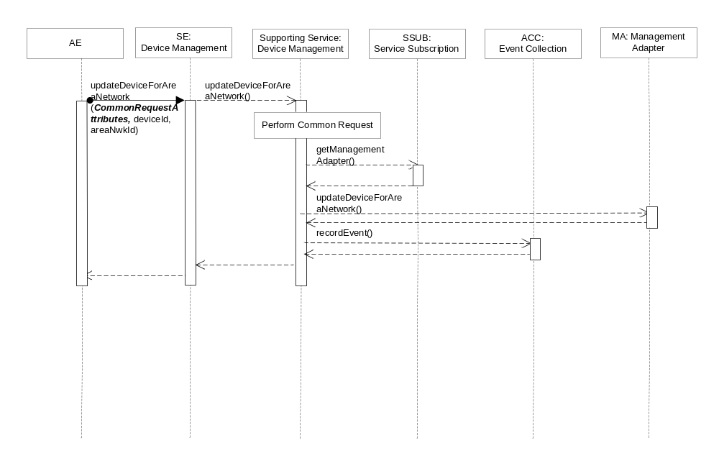Figure D.2.1.1.12.3-5 updateDeviceForAreaNetwork Diagram

D.2.1.1.12.4 Post-Conditions
The Management Adapter has submitted a request to the Management Server to update device information for area network.
The event is recorded.

D.2.1.1.12.5 Exceptions
No unique exceptions for this service capability.
Consumed services may throw exceptions which are forwarded by this service capability.

D.2.1.1.12.6 Policies for Use
Message Exchange Patterns: In-Out
Transaction Pattern: Participation allowed
Maximum Response: 300ms

D.2.1.1.13 rebootDevice
This service capability provides the ability to execute a rebootDevice request from an AE.

D.2.1.1.13.1 Pre-conditions
The pre-conditions for Mca Received Requests are met.
A correlation between a Management Adapter, the M2M Service Capability and device exist.

D.2.1.1.13.2 Signature –rebootDevice
Parameter name | Direction | Optional | Description
Common request input attributes | - | - | See Table A.2.1-1
deviceId | IN | NO | The unique device identifier in the context of the M2M M2M Service Subscription.
reportPolicy | IN | YES | The policy used to report the state of the operation to the originating AE. See clause 6.6.1.1.1.1.
troubleshootingReport | OUT | YES | The troubleshooting operation execution result or status. Type TroubleshootingReport, see 6.6.1.1.1.20.
responseType | OUT | YES | Unique response types for this service.  Note: Consumed services also provide response types.
Table D.2.1.1.13.2-1 Device Management Service –rebootDevice capability

D.2.1.1.13.3 Service Interactions
The interactions of service capabilities required for this service capability:
- Perform the Common Request Services for requests across the Mca Reference Point
- Retrieves the Management Adapter to be used for the device and M2M Service Subscription
- Issues the request to the Management Adapter to reboot device
- Records the event
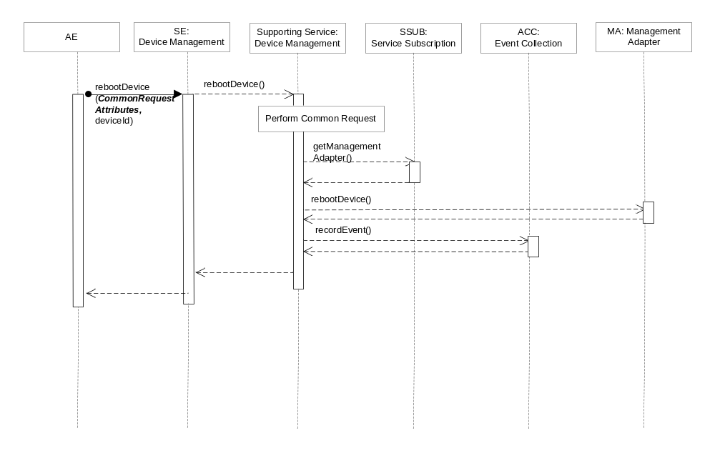Figure D.2.1.1.13.3-1 rebootDevice Interaction Diagram

D.2.1.1.13.4 Post-Conditions
The Management Adapter has submitted a request to the Management Server to reboot device.
The event has been recorded.

D.2.1.1.13.5 Exceptions
Not Applicable

D.2.1.1.13.6 Policies for Use
Message Exchange Patterns: In-Out
Transaction Pattern: Participation allowed
Maximum Response: 300ms

D.2.1.1.14 resetDevice
This service capability provides the ability to execute a resetDevice request from an AE.

D.2.1.1.14.1 Pre-conditions
The pre-conditions for Mca Received Requests are met.
A correlation between a Management Adapter, the M2M Service Capability and device exist.

D.2.1.1.14.2 Signature –resetDevice
Parameter name | Direction | Optional | Description
Common request input attributes | - | - | See Table A.2.1-1
deviceId | IN | NO | The unique device identifier in the context of the M2M M2M Service Subscription.
reportPolicy | IN | YES | The policy used to report the state of the operation to the originating AE. See clause 6.6.1.1.1.1.
troubleshootingReport | OUT | YES | The troubleshooting operation execution result or status. Type TroubleshootingReport, see 6.6.1.1.1.20.
responseType | OUT | YES | Unique response types for this service.  Note: Consumed services also provide response types.
Table D.2.1.1.14.2-1 Device Management Service –resetDevice capability

D.2.1.1.14.3 Service Interactions
The interactions of service capabilities required for this service capability:
- Perform the Common Request Services for requests across the Mca Reference Point
- Retrieves the Management Adapter to be used for the device and M2M Service Subscription
- Issues the request to the Management Adapter to reset device
- Records the event
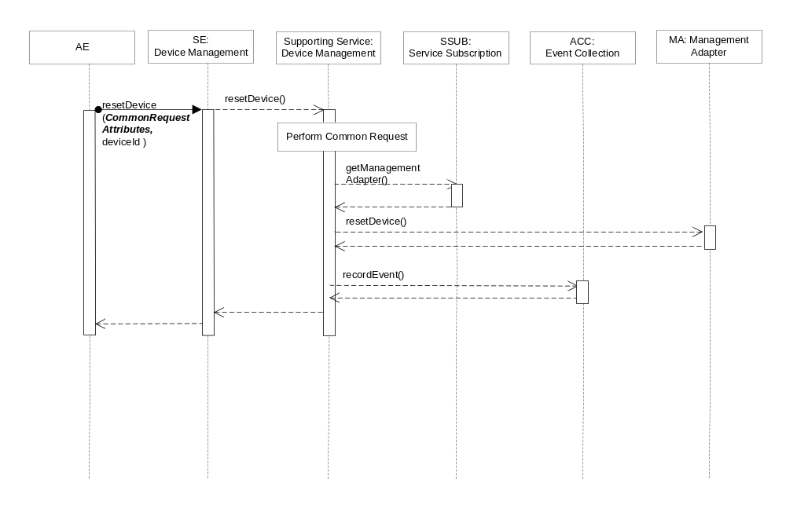Figure D.2.1.1.14.3-1 resetDevice Interaction Diagram

D.2.1.1.14.4 Post-Conditions
The Management Adapter has submitted a request to the Management Server to reset device.
The event has been recorded.

D.2.1.1.14.5 Exceptions
No unique exceptions for this service capability.
Consumed services may throw exceptions which are forwarded by this service capability.

D.2.1.1.14.6 Policies for Use
Message Exchange Patterns: In-Out
Transaction Pattern: Participation allowed
Maximum Response: 300ms

D.2.1.1.15 uploadDeviceLog
This service capability provides the ability to execute a uploadDeviceLog request from an AE.

D.2.1.1.15.1 Pre-conditions
The pre-conditions for Mca Received Requests are met.
A correlation between a Management Adapter, the M2M Service Capability and device exist.

D.2.1.1.15.2 Signature –uploadDeviceLog
Parameter name | Direction | Optional | Description
Common request input attributes | - | - | See Table A.2.1-1
deviceId | IN | NO | The unique device identifier in the context of the M2M M2M Service Subscription.
logInfo | IN | NO | The log information. Type LogInfo, see 6.6.1.1.1.19.
reportPolicy | IN | YES | The policy used to report the state of the operation to the originating AE. See clause 6.6.1.1.1.1.
logURL | OUT | YES | The URL from which the log can be uploaded.
troubleshootingReport | OUT | YES | The troubleshooting operation execution result or status. Type TroubleshootingReport, see 6.6.1.1.1.20.
responseType | OUT | YES | Unique response types for this service.  Note: Consumed services also provide response types.
Table D.2.1.1.15.2-1 Device Management Service –uploadDeviceLog capability

D.2.1.1.15.3 Service Interactions
The interactions of service capabilities required for this service capability:
- Perform the Common Request Services for requests across the Mca Reference Point
- Retrieves the Management Adapter to be used for the device and M2M Service Subscription
- Issues the request to the Management Adapter to upload device log
- Records the event
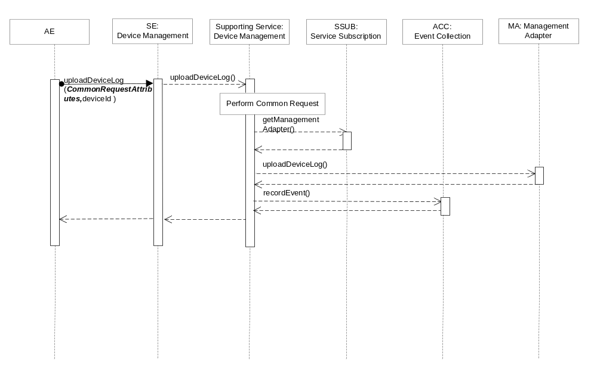Figure D.2.1.1.15.3-1 uploadDeviceLog Interaction Diagram

D.2.1.1.15.4 Post-Conditions
The Management Adapter has submitted a request to the Management Server to upload device log.
The event is recorded

D.2.1.1.15.5 Exceptions
No unique exceptions for this service capability.
Consumed services may throw exceptions which are forwarded by this service capability.

D.2.1.1.15.6 Policies for Use
Message Exchange Patterns: In-Out
Transaction Pattern: Participation allowed
Maximum Response: 300ms

D.2.1.1.16 reportTroubleshootingStatus
This service capability provides the ability to notify an AE about the status or result of a troubleshooting operation for a previously submitted operation request.

D.2.1.1.16.1 Pre-conditions
The pre-conditions for Mca Received Requests are met.
A correlation between a Management Adapter, the M2M Service Capability and previously submitted troubleshooting requests exist.

D.2.1.1.16.2 Signature –reportTroubleshootingStatus
Parameter name | Direction | Optional | Description
Common request input attributes | - | - | See Table A.2.1-1
isLastReport | IN | NO | Boolean, whether it is the last report.
sequenceNumber | IN | NO | The report sequence number.
troubleshootingReportList | IN | NO | Array of troubleshootingReport.  Type TroubleshootingReport, see 6.6.1.1.1.20.
aggregationPolicy | IN | YES | The policy used to aggregate the result of the management operation prior to the reports being sent. See clause 6.6.1.1.1.2.
responseType | OUT | YES | Unique response types for this service.  Note: Consumed services also provide response types.
Table D.2.1.1.16.2-1 Device Management Service –reportTroubleshootingStatus capability

D.2.2.1.16.3 Service Interactions
The interactions of service capabilities required for this service capability:
- Perform the Common Request Services for requests across the Mca Reference Point
- Record the event.
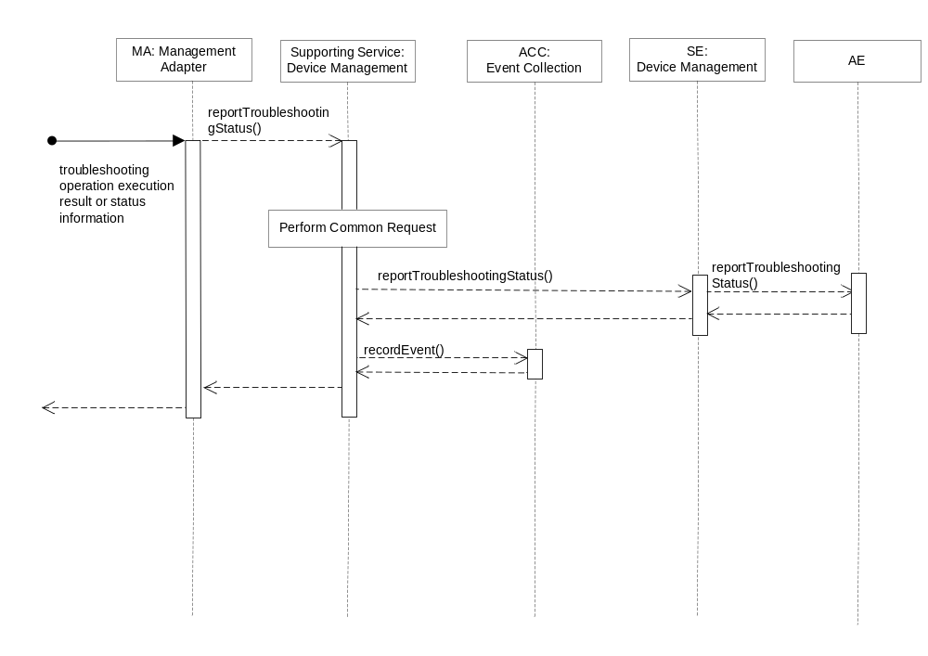Figure D.2.1.1.16.3-1 reportTroubleshootingStatus Interaction Diagram

D.2.1.1.16.4 Post-Conditions
The AE has received a report of troubleshooting operation execution status or result.
The event has been recorded.

D.2.1.1.16.5 Exceptions
No unique exceptions for this service capability.
Consumed services may throw exceptions which are forwarded by this service capability.

D.2.1.1.16.6 Policies for Use
Message Exchange Patterns: In-Out
Transaction Pattern: Participation allowed
Maximum Response: 300ms

D.2.1.1.17 getDeviceLogs
This service capability provides the ability to execute a getDeviceLogs request from an AE.

D.2.1.1.17.1 Pre-conditions
The pre-conditions for Mca Received Requests are met.
A correlation between a Management Adapter, the M2M Service Capability and device exist.

D.2.1.1.17.2 Signature –getDeviceLogs
Parameter name | Direction | Optional | Description
Common request input attributes | - | - | See Table A.2.1-1
deviceId | IN | NO | The unique device identifier in the context of the M2M M2M Service Subscription.
logList | OUT | YES | Array of log. Type Log, see 6.6.1.1.1.21.
responseType | OUT | YES | Unique response types for this service.  Note: Consumed services also provide response types.
Table D.2.1.1.17.2-1 Device Management Service –getDeviceLogs capability

D.2.1.1.17.3 Service Interactions
The interactions of service capabilities required for this service capability:
- Perform the Common Request Services for requests across the Mca Reference Point
- Retrieves the Management Adapter to be used for the device and M2M Service Subscription
- Issues the request to the Management Adapter to get all logs of a device
- Records the event
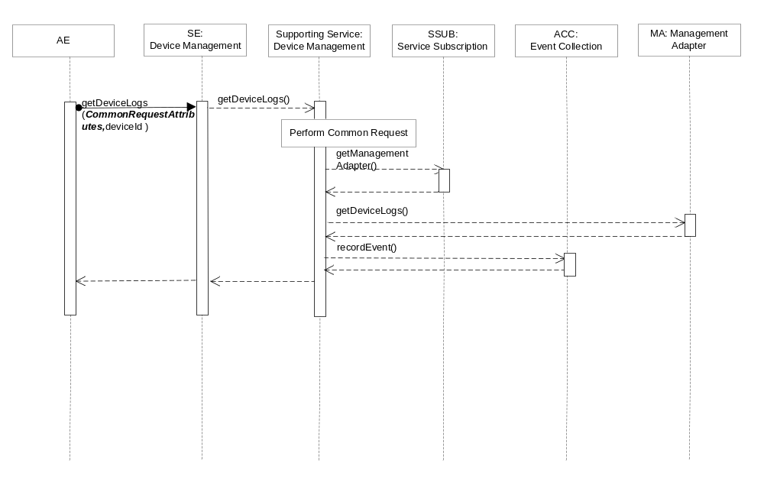Figure D.2.1.1.17.3-1 getDeviceLogs Interaction Diagram

D.2.1.1.17.4 Post-Conditions
The Management Adapter has submitted a request to the Management Server to get all logs of a device.
The event is recorded

D.2.1.1.17.5 Exceptions
No unique exceptions for this service capability.
Consumed services may throw exceptions which are forwarded by this service capability.

D.2.1.1.17.6 Policies for Use
Message Exchange Patterns: In-Out
Transaction Pattern: Participation allowed
Maximum Response: 300ms

D.2.1.1.18 getDeviceLogInformation
This service capability provides the ability to execute a getDeviceLogInformation request from an AE.

D.2.1.1.18.1 Pre-conditions
The pre-conditions for Mca Received Requests are met.
A correlation between a Management Adapter, the M2M Service Capability and device exist.

D.2.1.1.18.2 Signature –getDeviceLogInformation
Parameter name | Direction | Optional | Description
Common request input attributes | - | - | See Table A.2.1-1
deviceId | IN | NO | The unique device identifier in the context of the M2M M2M Service Subscription.
filterCriteria | IN | YES | See Table 6.6.1.1.1.22
logURL | IN | YES | The URL from which the log can be accessed.
log | OUT | YES | Type Log, see 6.6.1.1.1.21.
responseType | OUT | YES | Unique response types for this service.  Note: Consumed services also provide response types.
Table D.2.1.1.18.2-1 Device Management Service –getDeviceLogInformation capability

D.2.1.1.18.3 Service Interactions
The interactions of service capabilities required for this service capability:
- Perform the Common Request Services for requests across the Mca Reference Point
- Retrieves the Management Adapter to be used for the device and M2M Service Subscription
- Issues the request to the Management Adapter to get a device log information
- Records the event
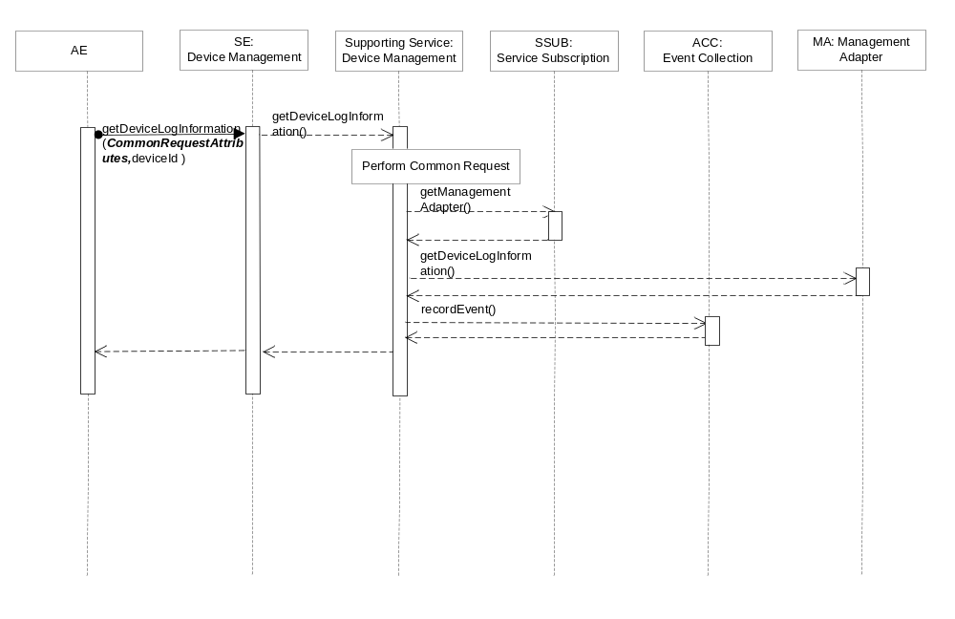Figure D.2.1.1.18.3-1 getDeviceLogInformation Interaction Diagram

D.2.1.1.18.4 Post-Conditions
The Management Adapter has submitted a request to the Management Server to get a device log information.
The event is recorded

D.2.1.1.18.5 Exceptions
No unique exceptions for this service capability.
Consumed services may throw exceptions which are forwarded by this service capability.

D.2.1.1.18.6 Policies for Use
Message Exchange Patterns: In-Out
Transaction Pattern: Participation allowed
Maximum Response: 300ms

D.2.1.1.19 getSoftwareInformation
This service capability provides the ability to execute a getSoftwareInformation request from an AE.

D.2.1.1.19.1 Pre-conditions
The pre-conditions for Mca Received Requests are met.
A correlation between a Management Adapter, the M2M Service Capability and device exist.

D.2.1.1.19.2 Signature –getSoftwareInformation
Parameter name | Direction | Optional | Description
Common request input attributes | - | - | See Table A.2.1-1
deviceId | IN | NO | The unique device identifier in the context of the M2M M2M Service Subscription.
version | OUT | YES | The version of the software.
name | OUT | YES | The name of the software.
URL | OUT | YES | The URL from which the software package can be downloaded.
installStatus | OUT | YES | Indicates the status of the install.  Enum ActionStatus, see 6.6.1.1.1.26.
activeStatus | OUT | YES | The status of active or deactivate action.  Enum ActionStatus, see 6.6.1.1.1.26.
responseType | OUT | YES | Unique response types for this service.  Note: Consumed services also provide response types.
Table D.2.1.1.19.2-1 Device Management Service –getSoftwareInformation capability

D.2.1.1.19.3 Service Interactions
The interactions of service capabilities required for this service capability:
- Perform the Common Request Services for requests across the Mca Reference Point
- Retrieves the Management Adapter to be used for the device and M2M Service Subscription
- Issues the request to the Management Adapter to get application software information
- Records the event
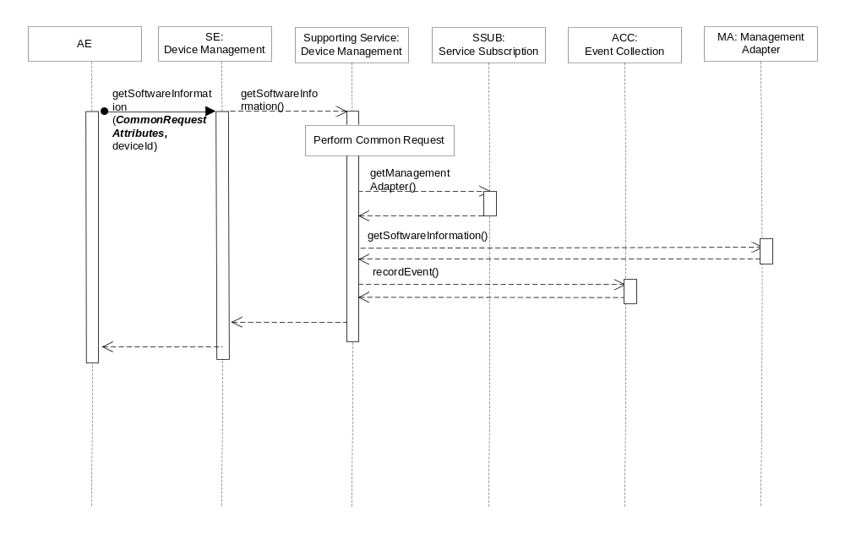Figure D.2.1.1.19.3-1 getSoftwareInformation Interaction Diagram

D.2.1.1.19.4 Post-Conditions
The Management Adapter has submitted a request to the Management Server to get application software information.
The event has been recorded.

D.2.1.1.19.5 Exceptions
Not Applicable

D.2.1.1.19.6 Policies for Use
Message Exchange Patterns: In-Out
Transaction Pattern: Participation allowed
Maximum Response: 300ms

D.2.1.1.20 downloadSoftware
This service capability provides the ability to execute a downloadSoftware request from an AE.

D.2.1.1.20.1 Pre-conditions
The pre-conditions for Mca Received Requests are met.
A correlation between a Management Adapter, the M2M Service Capability and device exist.

D.2.1.1.20.2 Signature –downloadSoftware
Parameter name | Direction | Optional | Description
Common request input attributes | - | - | See Table A.2.1-1
deviceId | IN | NO | The unique device identifier in the context of the M2M M2M Service Subscription.
version | IN | NO | The version of the software.
name | IN | NO | The name of the software.
URL | IN | NO | The URL from which the software package can be downloaded.
reportPolicy | IN | YES | The policy used to report the state of the operation to the originating AE. See clause 6.6.1.1.1.1.
softwareReport | OUT | YES | The software management operation execution result or status. Type SoftwareReport, see 6.6.1.1.1.27.
responseType | OUT | YES | Unique response types for this service.  Note: Consumed services also provide response types.
Table D.2.1.1.20.2-1 Device Management Service –downloadSoftware capability

D.2.1.1.20.3 Service Interactions
The interactions of service capabilities required for this service capability:
- Perform the Common Request Services for requests across the Mca Reference Point
- Retrieves the Management Adapter to be used for the device and M2M Service Subscription
- Issues the request to the Management Adapter to download application software
- Records the event
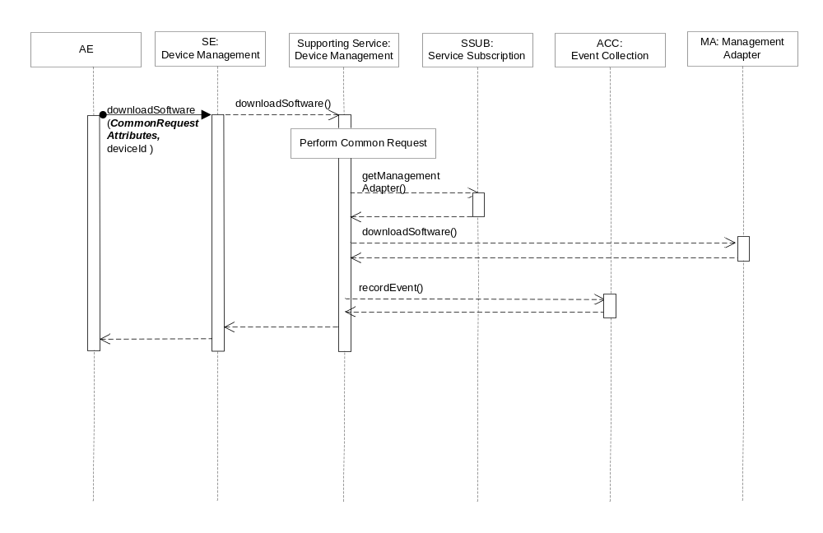Figure D.2.1.1.20.3-1 downloadSoftware Interaction Diagram

D.2.1.1.20.4 Post-Conditions
The Management Adapter has submitted a request to the Management Server to download application software.
The event has been recorded.

D.2.1.1.20.5 Exceptions
No unique exceptions for this service capability.
Consumed services may throw exceptions which are forwarded by this service capability.

D.2.1.1.20.6 Policies for Use
Message Exchange Patterns: In-Out
Transaction Pattern: Participation allowed
Maximum Response: 300ms

D.2.1.1.21 installSoftware
This service capability provides the ability to execute a installSoftware request from an AE.

D.2.1.1.21.1 Pre-conditions
The pre-conditions for Mca Received Requests are met.
A correlation between a Management Adapter, the M2M Service Capability and device exist.

D.2.1.1.21.2 Signature –installSoftware
Parameter name | Direction | Optional | Description
Common request input attributes | - | - | See Table A.2.1-1
deviceId | IN | NO | The unique device identifier in the context of the M2M M2M Service Subscription.
version | IN | NO | The version of the software.
name | IN | NO | The name of the software.
reportPolicy | IN | YES | The policy used to report the state of the operation to the originating AE. See clause 6.6.1.1.1.1.
softwareReport | OUT | YES | The software management operation execution result or status. Type SoftwareReport, see 6.6.1.1.1.27.
responseType | OUT | YES | Unique response types for this service.  Note: Consumed services also provide response types.
Table D.2.1.1.21.2-1 Device Management Service –installSoftware capability

D.2.1.1.21.3 Service Interactions
The interactions of service capabilities required for this service capability:
- Perform the Common Request Services for requests across the Mca Reference Point
- Retrieves the Management Adapter to be used for the device and M2M Service Subscription
- Issues the request to the Management Adapter to install application software
- Records the event
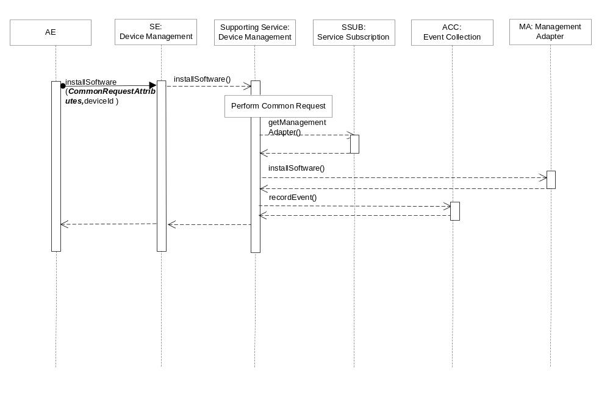Figure D.2.1.1.21.3-1 installSoftware Interaction Diagram

D.2.1.1.21.4 Post-Conditions
The Management Adapter has submitted a request to the Management Server to install application software.
The event is recorded

D.2.1.1.21.5 Exceptions
No unique exceptions for this service capability.
Consumed services may throw exceptions which are forwarded by this service capability.

D.2.1.1.21.6 Policies for Use
Message Exchange Patterns: In-Out
Transaction Pattern: Participation allowed
Maximum Response: 300ms

D.2.1.1.22 activateSoftware
This service capability provides the ability to execute an activateSoftware request from an AE.

D.2.1.1.22.1 Pre-conditions
The pre-conditions for Mca Received Requests are met.
A correlation between a Management Adapter, the M2M Service Capability and device exist.

D.2.1.1.22.2 Signature –activateSoftware
Parameter name | Direction | Optional | Description
Common request input attributes | - | - | See Table A.2.1-1
deviceId | IN | NO | The unique device identifier in the context of the M2M M2M Service Subscription.
version | IN | NO | The version of the software.
name | IN | NO | The name of the software.
reportPolicy | IN | YES | The policy used to report the state of the operation to the originating AE. See clause 6.6.1.1.1.1.
softwareReport | OUT | YES | The software management operation execution result or status. Type SoftwareReport, see 6.6.1.1.1.27.
responseType | OUT | YES | Unique response types for this service.  Note: Consumed services also provide response types.
Table D.2.1.1.22.2-1 Device Management Service –activateSoftware capability

D.2.1.1.22.3 Service Interactions
The interactions of service capabilities required for this service capability:
- Perform the Common Request Services for requests across the Mca Reference Point
- Retrieves the Management Adapter to be used for the device and M2M Service Subscription
- Issues the request to the Management Adapter to activate software previously installed
- Records the event
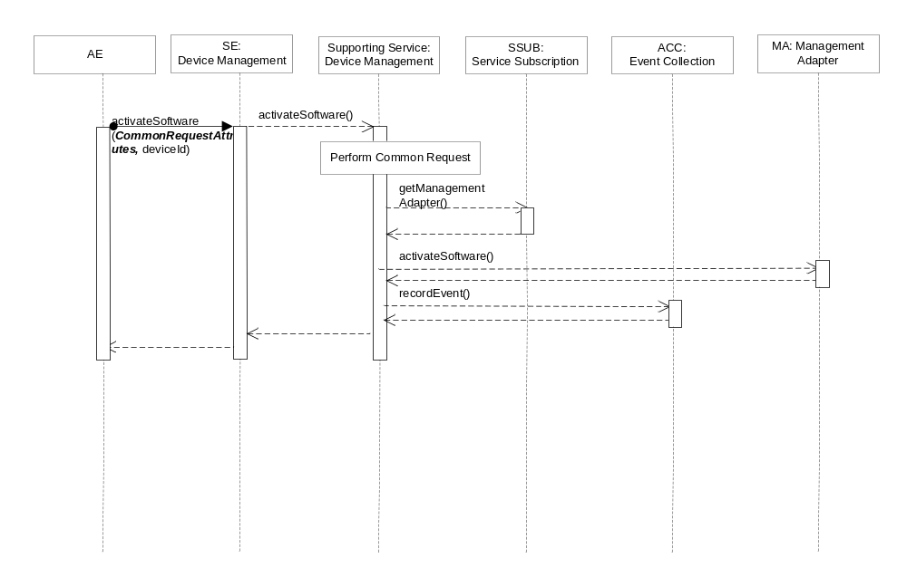Figure D.2.1.1.22.3-1 activateSoftware Interaction Diagram

D.2.1.1.22.4 Post-Conditions
The Management Adapter has submitted a request to the Management Server to activate software previously installed.
Record the event.

D.2.1.1.22.5 Exceptions
No unique exceptions for this service capability.
Consumed services may throw exceptions which are forwarded by this service capability.

D.2.1.1.22.6 Policies for Use
Message Exchange Patterns: In-Out
Transaction Pattern: Participation allowed
Maximum Response: 300ms

D.2.1.1.23 deactivateSoftware
This service capability provides the ability to execute a deactivateSoftware request from an AE.

D.2.1.1.23.1 Pre-conditions
The pre-conditions for Mca Received Requests are met.
A correlation between a Management Adapter, the M2M Service Capability and device exist.

D.2.1.1.23.2 Signature –deactivateSoftware
Parameter name | Direction | Optional | Description
Common request input attributes | - | - | See Table A.2.1-1
deviceId | IN | NO | The unique device identifier in the context of the M2M M2M Service Subscription.
version | IN | NO | The version of the software.
name | IN | NO | The name of the software.
reportPolicy | IN | YES | The policy used to report the state of the operation to the originating AE. See clause 6.6.1.1.1.1.
softwareReport | OUT | YES | The software management operation execution result or status. Type SoftwareReport, see 6.6.1.1.1.27.
responseType | OUT | YES | Unique response types for this service.  Note: Consumed services also provide response types.
Table D.2.1.1.23.2-1 Device Management Service –deactivateSoftware capability

D.2.1.1.23.3 Service Interactions
The interactions of service capabilities required for this service capability:
- Perform the Common Request Services for requests across the Mca Reference Point
- Retrieves the Management Adapter to be used for the device and M2M Service Subscription
- Issues the request to the Management Adapter to deactivates software
- Records the event
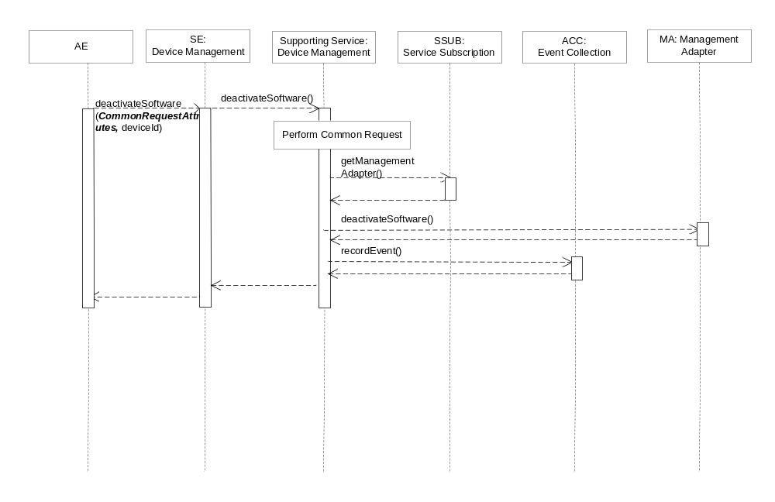
Figure D.2.1.1.23.3-6 deactivateSoftware Interaction Diagram

D.2.1.1.23.4 Post-Conditions
The Management Adapter has submitted a request to the Management Server to deactivates software.
The event is recorded.

D.2.1.1.23.5 Exceptions
No unique exceptions for this service capability.
Consumed services may throw exceptions which are forwarded by this service capability.

D.2.1.1.23.6 Policies for Use
Message Exchange Patterns: In-Out
Transaction Pattern: Participation allowed
Maximum Response: 300ms

D.2.1.1.24 removeSoftware
This service capability provides the ability to execute a removeSoftware request from an AE.

D.2.1.1.24.1 Pre-conditions
The pre-conditions for Mca Received Requests are met.
A correlation between a Management Adapter, the M2M Service Capability and device exist.

D.2.1.1.24.2 Signature –removeSoftware
Parameter name | Direction | Optional | Description
Common request input attributes | - | - | See Table A.2.1-1
deviceId | IN | NO | The unique device identifier in the context of the M2M M2M Service Subscription.
version | IN | NO | The version of the software.
name | IN | NO | The name of the software.
reportPolicy | IN | YES | The policy used to report the state of the operation to the originating AE. See clause 6.6.1.1.1.1.
softwareReport | OUT | YES | The software management operation execution result or status. Type SoftwareReport, see 6.6.1.1.1.27.
responseType | OUT | YES | Unique response types for this service.  Note: Consumed services also provide response types.
Table D.2.1.1.24.2-1 Device Management Service –removeSoftware capability

D.2.1.1.24.3 Service Interactions
The interactions of service capabilities required for this service capability:
- Perform the Common Request Services for requests across the Mca Reference Point
- Retrieves the Management Adapter to be used for the device and M2M Service Subscription
- Issues the request to the Management Adapter to uninstall the software
- Records the event
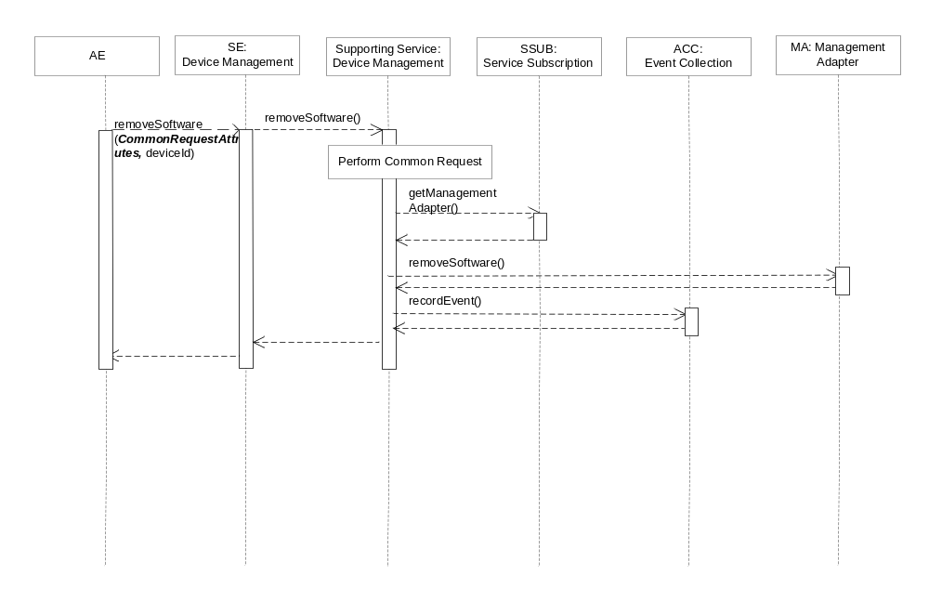Figure D.2.1.1.24.3-7 removeSoftware Interaction Diagram

D.2.1.1.24.4 Post-Conditions
The Management Adapter has submitted a set of requests to the Management Server to uninstall the software.
The event is recorded.

D.2.1.1.24.5 Exceptions
No unique exceptions for this service capability.
Consumed services may throw exceptions which are forwarded by this service capability.

D.2.1.1.24.6 Policies for Use
Message Exchange Patterns: In-Out
Transaction Pattern: Participation allowed
Maximum Response: 300ms

D.2.1.1.25 reportSoftwareStatus
This service capability provides the ability to notify an AE about the status or result of an application software management operation for a previously submitted operation request.

D.2.1.1.25.1 Pre-conditions
The pre-conditions for Mca Received Requests are met.
A correlation between a Management Adapter, the M2M Service Capability and previously submitted application software management requests exist.

D.2.1.1.25.2 Signature –reportSoftwareStatus Status
Parameter name | Direction | Optional | Description
Common request input attributes | - | - | See Table A.2.1-1
isLastReport | IN | NO | Boolean, whether it is the last report.
sequenceNumber | IN | NO | The report sequence number.
softwareReportList | IN | NO | Array of softwareReport.  Type SoftwareReport, see 6.6.1.1.1.27.
aggregationPolicy | IN | YES | The policy used to aggregate the result of the management operation prior to the reports being sent. See clause 6.6.1.1.1.2.
responseType | OUT | YES | Unique response types for this service.  Note: Consumed services also provide response types.
Table D.2.1.1.25.2-1 Device Management Service –reportSoftwareStatus capability

D.2.2.1.29.3 Service Interactions
The interactions of service capabilities required for this service capability:
- Perform the Common Request Services for requests across the Mca Reference Point
- Record the event.
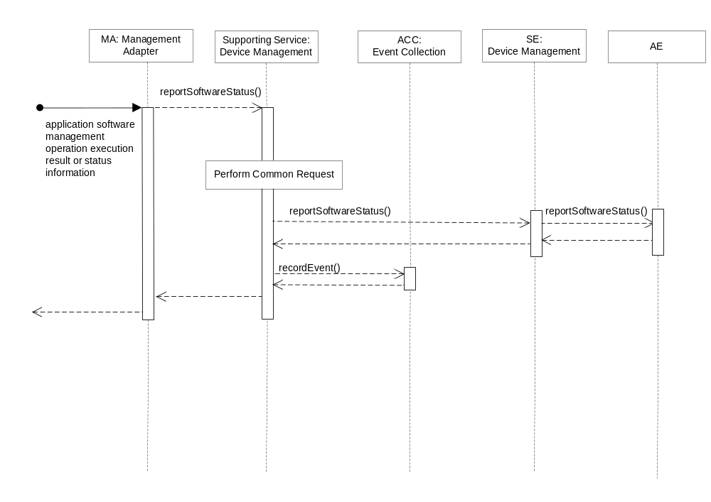Figure D.2.1.1.25.3-1 reportSoftwareStatus Interaction Diagram

D.2.1.1.25.4 Post-Conditions
The AE has received a report of application software management operation execution status or result.
The event has been recorded.

D.2.1.1.25.5 Exceptions
No unique exceptions for this service capability.
Consumed services may throw exceptions which are forwarded by this service capability.

D.2.1.1.25.6 Policies for Use
Message Exchange Patterns: In-Out
Transaction Pattern: Participation allowed
Maximum Response: 300ms

Annex E (Informative): Device On-boarding Service

E.1 Overview
This annex illustrates the usage of services to onboard a device or AE when the Device or AE contacts the M2M System.
The Device On-boarding supporting service is a process by which a Device is provided the artifacts (e.g., configuration information, software and firmware) needed to successfully register an AE with the M2M Service Layer and invoke or receive the authorized service capabilities.

E.2 Supporting Services

E.2.1 Remote Administration
This service provides remote administration of the device and/or AE when an AE registers or registers with the M2M System. The mechanism is implemented using the first contact subscription and notification services provided/used by the Registration Service.

E.2.1.1 Service Capabilities

E.2.1.1.1 notifyRegistrationContact
This service capability provides the capability to invoke a process to update the M2M Service Layer artifacts (e.g., credentials, device firmware, and application software).

E.2.1.1.1.1 Pre-conditions
The pre-conditions for Mca Received Requests are met.
A correlation between a M2M Service Subscription and the contacting entity (Device, AE) exist.
The Supporting Service subscribed to receive registration events using the subscribeInitialAERegistrationEvent service capability.

E.2.1.1.1.2 Signature – notifyRegistrationContact
Parameter name | Direction | Optional | Description
Mca common request input attributes | - | - | See Table A.2.1-1
event | IN | NO | The event that caused the registration contact.  Enumeration of:  - FirstContact
Table E.2.1.1.1.2-1 Device On-boarding Service – notifyRegistrationContact capability

E.2.1.1.1.3 Service Interactions
The interactions of service capabilities required for this service capability:
- Perform the Common Request Services for requests across the Mca Reference Point
- Determine the Application information (Device, Subscription, and Application Id) for the registering AE.
- Determine from the Device information if the device need be updated
- Determine from the Application information if Applications need updated on the Device
- Record the event for accounting purposes.
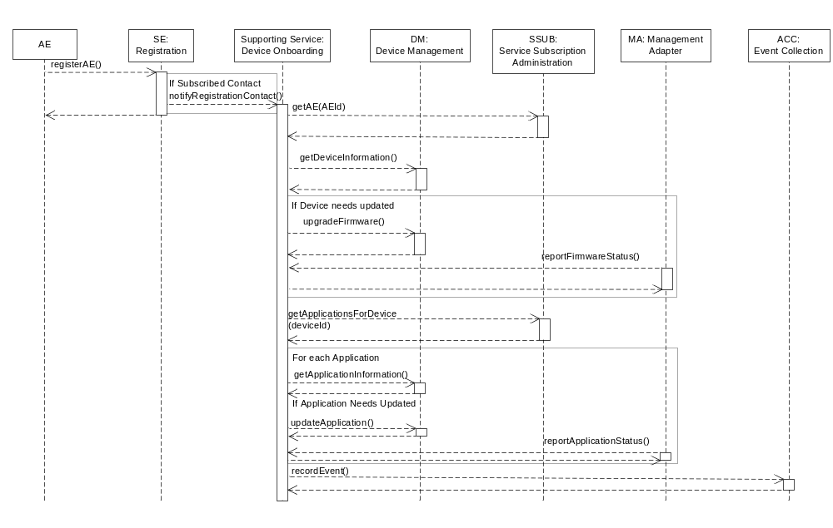
Figure E.2.1.1.1.3-1 notifyRegistrationContact Diagram

E.2.1.1.1.4 Post-Conditions
Success case: The request is permitted and the associated.
Failure case: The request is recorded as a failure.

E.2.1.1.1.5 Exceptions
No unique exceptions for this service capability.
Consumed services may throw exceptions which are recorded by this service capability.

E.2.1.1.1.6 Policies for Use
Message Exchange Patterns: In-Only
Transaction Pattern: Creates Transaction
Maximum Response: Not applicable for the In-Only message exchange pattern

Annex F (Informative): Registration Services

F.1 Overview
This annex illustrates the usage of the services for requests to register AEs across the Mca Reference Point and between M2M Service Components across the Msc Reference Point.

F.2 Mca Registration Service Processing and Supporting Services
AEs communicate with the M2M System over the Mca Reference Point through the SE component. The SE component accepts the request from the AE and provides the request to the Supporting Service in order allow the M2M Service Provider to ensure the request is properly authorized and recorded. In addition, the M2M Service Provider is able to orchestrate other capabilities that have not been specified.

F.2.1 Message Exchanges

F.2.1.2 Service Capabilities

F.2.1.2.1 registerAE
This service capability enables an AE or a third party provisioned with the proper authorization to register with the M2M System. This service capability shall be restricted across the Mca Reference Point

F.2.1.2.1.1 Pre-conditions
The AE has not registered with the M2M System.
The pre-conditions for Mca Received Requests are met.

F.2.1.2.1.2 Signature – registerAE
Parameter name | Direction | Optional | Description
Mca common request input attributes | - | - | See Table A.2.1-1
pointOf Access | IN | NO | The point of Access of the registered AE.
applicationId | IN | NO | The Application Identifer (App-ID).
expirationTime | IN | NO | The expiration time of the registration as requested by the Originator
aeId | OUT | NO | AE-ID is provided back in the response
responseType | OUT | NO | Unique response types for this service:  - AE successfully registered  - AE not successfully registered
Table F.2.1.2.1.2-1 Registration Services – registerAE capability

F.2.1.2.1.3 Service Interactions
The interactions of service capabilities required for this service capability:
- Perform the Common Request Services for requests across the Mca Reference Point
- Record the event
- Notify Device onboarding Support Service for a first registration contact with the M2M system for the AE if a subscription exists.
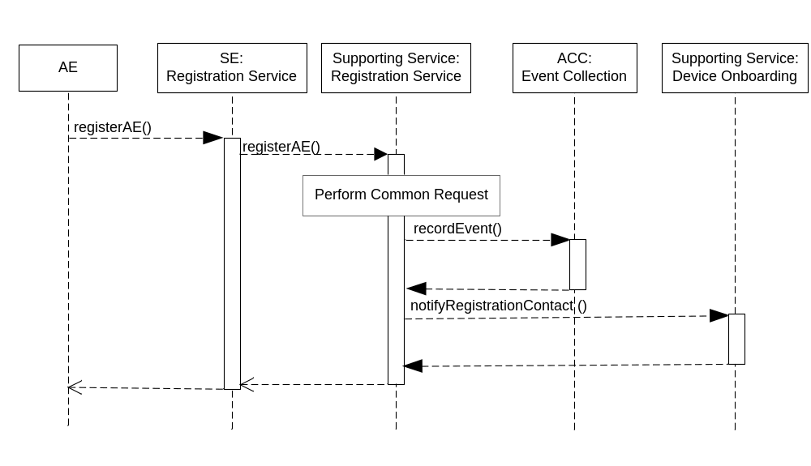
Figure F.2.1.2.1.3-1 Registration Services – registerAE Diagram

F.2.1.2.1.4 Post-Conditions
Success case: The request is permitted.
Failure case: The request is not permitted and a response type is transmitted back to the AE

F.2.1.2.1.5 Exceptions
No unique exceptions for this service capability.
Consumed services may throw exceptions which are forwarded by this service capability.

F.2.1.2.1.6 Policies for Use
Message Exchange Patterns: In-Out
Transaction Pattern: Participation allowed
Maximum Response: 250ms

F.2.1.2.2 refreshAERegistration
This service capability enables an AE or a third party provisioned with the proper authorization to refresh an existing registration with the M2M System

Y2.1.2.2.1 Pre-conditions
The pre-conditions for Mca Received Requests are met.
The AE is registered and allocated an AE-ID by the M2M System.

F.2.1.2.2.2 Signature – refreshAERegsitration
Parameter name | Direction | Optional | Description
Mca common request input attributes | - | - | See Table A.2.1-1
aeId | IN | NO
pointOfAccess | IN | YES | The point of Access of the registered AE. POA is optional only if identical to the one in the refreshed registration
expirationTime | IN | NO | The expiration time of the registration as requested by the Originator.
responseType | OUT | NO | Unique response types for this service:  - AE successfully refreshed  - Registration Does not exist

Table F.2.1.2.2.2-1 Registration Services – refreshAERegistration capability

F.2.1.2.2.3 Service Interactions
The interactions of service capabilities required for this service capability:
- Perform the Common Request Services for requests across the Mca Reference Point
- Record the event
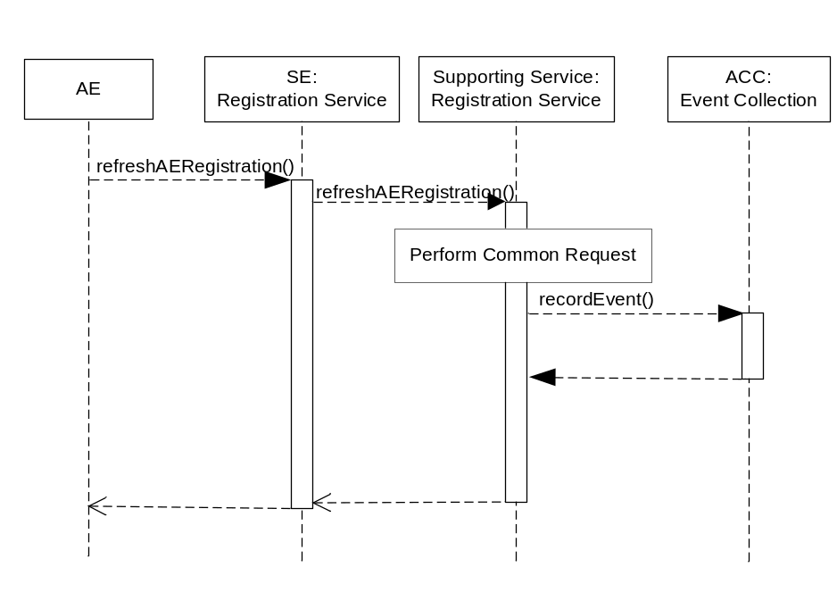
Figure F.2.1.2.2.3-1 Registration Services – refreshAERegistration Diagram

F.2.1.2.2.4 Post-Conditions
Success case: The request is permitted.
Failure case: The request is not permitted and a response type is transmitted to the AE

F.2.1.2.2.5 Exceptions
No unique exceptions for this service capability.
Consumed services may throw exceptions which are forwarded by this service capability.

F.2.1.2.2.6 Policies for Use
Message Exchange Patterns: In-Out
Transaction Pattern: Participation allowed
Maximum Response: 50ms

F.2.1.2.3 deregisterAE
This service capability enables an AE or a third party provisioned with the proper ACP to deregister from the M2M System.

F.2.1.2.3.1 Pre-conditions
The pre-conditions for Mca Received Requests are met.
The AE-ID is registered.

F.2.1.2.3.2 Signature – deregisterAE
Parameter name | Direction | Optional | Description
Mca common request input attributes | - | - | See Table A.2.1-1
aeId | IN | NO
responseType | OUT | NO | Unique response types for this service:  - AE successfully De-registsred  - Registration Does not exist

Table F.2.1.2.3.2-1 RegistrationServcies – deregisterAE capability

F.2.1.2.3.3 Service Interactions
The interactions of service capabilities required for this service capability:
- Perform the Common Request Services for requests across the Mca Reference Point
- Record the event
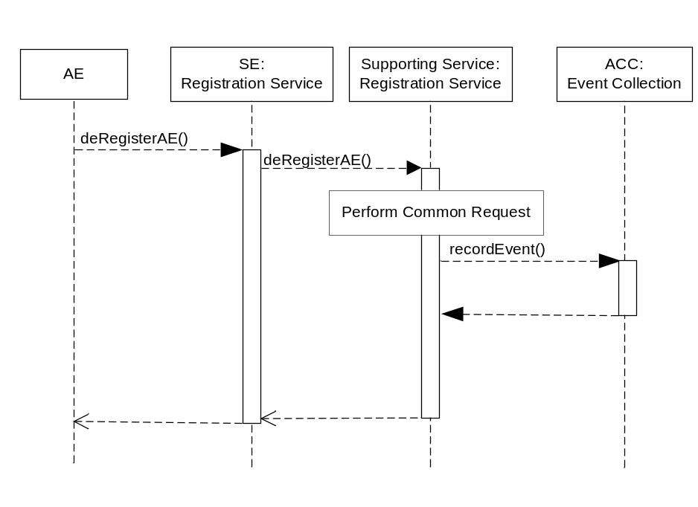
Figure F.2.1.2.3.3-1 Registration Services – deregisterAE Diagram

F.2.1.2.3.4 Post-Conditions
Success case: The request is permitted.
Failure case: The request is not permitted and a response type is transmitted back to the AE

F.2.1.2.3.5 Exceptions
No unique exceptions for this service capability.
Consumed services may throw exceptions which are forwarded by this service capability.

F.2.1.2.3.6 Policies for Use
Message Exchange Patterns: In-Out
Transaction Pattern: Participation allowed
Maximum Response: 300ms

Annex X(Informative): M2M Service Capability Template
The M2M Service Capability template is used as a specification that defines the contract between the consumer of the service capability and the producer of the service capability. The specification contract includes documenting the provided Signature, constraints (pre-conditions, post-conditions, exceptions), policies and runtime expectations.

X.1 <serviceCapabilityName>
<Document introductory description of the service capability>
The <serviceCapabilityName> reflects the operational functionality provided by the M2M Service Capability. M2M Service Capabilities are named using a construct [verb][noun][context] where the:
verb: Used to indicate what will happen to the noun
noun: Is the target of the noun
context: Is optional and further defines the service capability

X.1.1 Signature
Parameter name | Direction | Optional | Description
Name of the parameter. | IN, OUT, IN-OUT | YES, NO | Description of the parameter in the context of the service capability.
Table X.1.1-1 M2M Service Capability Signature

Direction: The direction is relative to the entity that provides (implements) the M2M Service Capability. The value “IN” means that the entity expects to receive a value for the parameter from the consumer (sender) of the M2M Service Capability request. The value “Out” means that the entity will send a value for the parameter to the consumer (sender) of the M2M Service Capability request. A value of “IN-OUT” means that the entity will receive the value for the parameter from the consumer and then send a value (not necessarily the same value) for the parameter back to the consumer.
Optional: Indicates if the parameter is required in requests (Direction: IN, IN-OUT) or responses (Direction: IN-OUT, OUT). A value of YES means that the parameter is optional. A value of NO means that the parameter is mandatory.

X.1.2 Pre-conditions
<Document the pre-conditions that may only be valid to run provided some testable prior business rule check or other value to be changed is actually present and available for the service capability to act upon. Pre-conditions are documented that are in addition to that provided by the internal resource operations and procedures>

X.1.3 Service Interactions
<Document the detail procedure for <serviceCapabilityName>. The detail procedure for the service capability is written as an Diagram in a time order and step-by-step. The Originator and what the Originator carries out (a task, function, accessing to resources or other services) are defined in each step.

X.1.4 Post-Conditions
<Document the post-conditions of the <serviceCapabilityName>. If the service capability has no defined output that can be validated except a notification of success (or failure) to set a value in the target of the service capability, a testable post condition of the service capability is documented. Post-conditions are documented that are in addition to that provided by the internal resource operations and procedures.>

X.1.5 Exceptions
< Document the exception or error conditions that may be returned by the <serviceCapabilityName>. Exceptions are documented that are in addition to that provided by the internal resource operations and procedures.>

X.1.6 Policies for Use
Message Exchange Patterns : See section 5.2.2.1Message Exchange Patterns for allowable patterns
Transaction Pattern:
- Creates Transaction: This service capability starts and completes a transaction
- Participation allowed: This service capability is able to participate in a transaction without violating the ongoing transaction’s properties (i.e. Atomicity, Consistency, Isolation, Durability)
- Participation not allowed: This service capability is unable to participate in a transaction
Maximum Response: The maximum time in milliseconds permitted to complete this service capability.

X.1.7 oneM2M Resource Interworking
<Document the related oneM2M Resources operations to <serviceCapabilityName> here. Interworking rules are defined for each Resource operation. If there is no related internal resource, this resource list can be empty (e.g., the service capability is ‘sendTrigger’).>.

Annex Y(Informative): oneM2M Service Requirements
The primary motivation of this technical specification is to integrate oneM2M Service capabilities with existing M2M deployments without affecting that existing M2M solution’s underlying deployment framework and protocols. For example if an existing M2M solution uses a XMPP based framework to communicate between applications in the network and devices, then M2M Service capabilities are efficiently exposed to the XMPP based framework without requiring modifications to the existing M2M solution’s deployment framework or protocol. A secondary motivation for this technical specification is to offer M2M Service capabilities to M2M service provider’s who utilize service oriented architectural frameworks.
This annex defines requirements that have not been captured in the oneM2M Requirements [1].

Requirement ID | Description
SCA-001 | The M2M System shall be capable of integrating oneM2M service capabilities with existing M2M deployments without affecting the existing M2M solution’s underlying deployment framework and protocols.
SCA-002 | The M2M System shall be capable of offering oneM2M service capabilities to SOA architectural frameworks.

Annex <y>:
Bibliography
The annex entitled “Bibliography” is optional.
It shall contain a list of standards, books, articles, or other sources on a particular subject which are not mentioned in the document itself
It shall not include references mentioned in the document.
Use the Heading 9 style for the title and B1+ or Normal for the text.
- <Publication>: “<Title>”.
OR
<Publication>: “<Title>”.
<PAGE BREAK>

History
This clause shall be the last one in the document and list the main phases (all additional information will be removed at the publication stage).
Publication history
V1.1.1 | <dd-Mmm-yyyy> | <Milestone>

Draft history (to be removed on publication)
V0.0.1 | 19-Feb-2014 | Rapporteur Input – Draft Skeleton
V.0.1.0 | 22-Feb-2014 | Added agreed contributions from TP9  ARC-2014-0081R02
V.0.2.0 | 15-May-2014 | Added agreed contributions from TP10 and interim conference calls  ARC-2014-1259-TS-0007-Reference_Update  ARC-2014-1260R02-TS-0007-Mca-Request_Services  ARC-2014-1324-TS-0007_Attribute_Alignment  ARC-2014-1261R02-TS-0007-Mca-Sub-Pub-Notify
V.0.3.0 | 17-June-2014 | Added agreed contributions from TP11  ARC-2014-1390-TS-0007_IN-OUT_DeSignation  ARC-2014-1391-TS-0007_Alignment_with_TS-0001_terms  ARC-2014-1398-TS-0007_Clause-Role-Interworking-Removal  ARC-2014-1401R02-TS-0007_Response_Code_Cleanup  ARC-2014-1404-TS-0007-Service_Adminstration  ARC-2014-1405-TS-0007-Service_Subscription_Adminstration
V.0.4.0 | 04-August-2014 | Added agreed contributions from TP12  ARC-2014-1411R02-TS-0007-Mca_Device_Firmware_management  ARC-2014-1473R01-TS-0007-Mca_Device_Configuration_service  ARC-2014-1474R01-TS-0007-Mca_Device_Topology_Management_service
V.0.5.0 | 01-October-2014 | Added agreed contributions from TP12 conference calls  ARC-2014-1519R01-TS-0007-Request-Response-Data-Exchange-Pattern  Added agreed contributions from TP13  Updated Normative Reference text  ARC-2014-1534-TS-0007-Annex-A-Rework  ARC-2014-1523R03-TS-0007-Device-Onboarding  ARC-2014-1548R02-TS_0007_Event_Collection_service  ARC-2014-1554-TS-0007-Section_7_DM_update  ARC-2014-1560R01-TS-0007-Mca_Device_Troubleshooting_service  ARC-2014-1555-TS-0007-Mca_Application_Software_Management_Service  ARC-2014-1540R01-TS0007-Registration-Service  ARC-2014-1541R01-TS0007-Supporting-Service-Registration-Services
V.0.5.1 | 17-October-2014 | Added agreed contributions from TP13 conference calls  ARC-2014-1600-TS-0007-_ServiceCapabilities_CommonRequest_Alignment

V.0.6.0 | 24-November-2014 | Added agreed contributions from TP13.4 conference call (email) and TP14  ARC-2014-1615-TS-0007-M2M_Service_Capability_Alignment  ARC-2014-1643-TS-0007-downloadFirmware&installFirmware_update  ARC-2014-1644R01-TS-0007-Section_6_getManagementAdapter_update

