

oneM2M
Technical Specification
Document Number | TS-0026-V3.0.0
Document Name: | 3GPP Interworking
Date: | 2019-05-06
Abstract: | This document specifies interworking between oneM2M service layer and 3GPP features, so that some 3GPP features can be exposed to oneM2M service layer for the benefit of IoT applications, and vice-versa
Template Version: 08 September 2015 (Do not modify)

This Specification is provided for future development work within oneM2M only. The Partners accept no liability for any use of this Specification.
The present document has not been subject to any approval process by the oneM2M Partners Type 1. Published oneM2M specifications and reports for implementation should be obtained via the oneM2M Partners’ Publications Offices.

About oneM2M
The purpose and goal of oneM2M is to develop technical specifications which address the need for a common M2M Service Layer that can be readily embedded within various hardware and software, and relied upon to connect the myriad of devices in the field with M2M application servers worldwide.
More information about oneM2M may be found at: http//www.oneM2M.org
Copyright Notification
© 2019, oneM2M Partners Type 1 (ARIB, ATIS, CCSA, ETSI, TIA, TSTDI, TTA, TTC).
All rights reserved.
The copyright extends to reproduction in all media.

Notice of Disclaimer & Limitation of Liability
The information provided in this document is directed solely to professionals who have the appropriate degree of experience to understand and interpret its contents in accordance with generally accepted engineering or other professional standards and applicable regulations. No recommendation as to products or vendors is made or should be implied.
NO REPRESENTATION OR WARRANTY IS MADE THAT THE INFORMATION IS TECHNICALLY ACCURATE OR SUFFICIENT OR CONFORMS TO ANY STATUTE, GOVERNMENTAL RULE OR REGULATION, AND FURTHER, NO REPRESENTATION OR WARRANTY IS MADE OF MERCHANTABILITY OR FITNESS FOR ANY PARTICULAR PURPOSE OR AGAINST INFRINGEMENT OF INTELLECTUAL PROPERTY RIGHTS. NO oneM2M PARTNER TYPE 1 SHALL BE LIABLE, BEYOND THE AMOUNT OF ANY SUM RECEIVED IN PAYMENT BY THAT PARTNER FOR THIS DOCUMENT, WITH RESPECT TO ANY CLAIM, AND IN NO EVENT SHALL oneM2M BE LIABLE FOR LOST PROFITS OR OTHER INCIDENTAL OR CONSEQUENTIAL DAMAGES. oneM2M EXPRESSLY ADVISES ANY AND ALL USE OF OR RELIANCE UPON THIS INFORMATION PROVIDED IN THIS DOCUMENT IS AT THE RISK OF THE USER.

Contents
Contents 3
1 Scope 5
2 References 5
2.1 Normative references 5
2.2 Informative references 5
3 Definitions, symbols and abbreviations 5
3.1 Definitions 5
3.2 Abbreviations 6
4 Conventions 7
5 oneM2M Architecture for 3GPP cellular IoT interworking with oneM2M 7
6.1 Overview 10
6.2 IP connectivity 11
6.2.1 ASN/MN-CSE Pre-configuration 11
6.2.2 ASN/MN-CSE or ADN-AE Initiated Connectivity Establishment Procedure 12
6.2.3 IN-CSE initiated connectivity establishment procedure 13
6.3 UE Attach with oneM2M Registration Procedure 13
7 Interworking with CioT network features exposed to service layer 15
7.1 Cellular IoT non-IP data delivery(NIDD) 15
7.1.1 SCEF-based NIDD 15
7.1.1.1 SCEF Configuration for NIDD 15
7.1.1.2 SCEF-based Mobile Terminated NIDD 18
7.1.1.3 SCEF-based Mobile Originated NIDD 22
7.2 UE context information storage 26
7.3 High latency communications 26
7.4 Monitoring events 26
7.4.1 UE Reachability monitoring 26
7.4.2 UE Availability after DDN Failure 30
7.4.3 UE Communication Failure 35
7.4.4 UE Loss of Connectivity 39
7.4.5 Detecting Change of IMSI-IMEI(SV) Association 43
7.4.6 Roaming Status 46
7.4.7 Location Reporting 50
7.4.7.1 Introduction 50
7.4.7.2 Location updating triggered by retrieval 51
7.4.7.3 Location updating triggered by location change 56
7.5 3GPP Based Device triggering 59
7.5.1 General Procedure for 3GPP Based Device Triggering 59
7.5.2 3GPP Based Device Trigger Recall/Replace Procedure 63
7.6 Configuration of Traffic Patterns 66
7.7 Group message delivery using MBMS 69
7.7.1 Overview 69
7.7.2 Resource Structure 69
7.7.3 Procedures 69
7.7.3.1 Create MBMS Group 69
7.7.3.2 Group message delivery using MBMS 71
7.8 Informing about Potential Network Issues 75
7.8.1 Throttling of requests based on Network Status Reports 75
7.9 Setting up an AS session with required QoS procedure 80
7.10 Background Data Transfer 80
7.10.1 Overview 80
7.10.2 Resource Structure 81
7.10.3 Procedures 81
7.10.3.1 Requesting and Selecting a Background Data Transfer Policy 81
7.10.3.2 Enabling a Background Data Transfer Policy 85
7.10.3.3 Using Background Data Transfer Policy 86
7.10.3.4 Deleting a Background Data Transfer Policy 87
7.11 Change the chargeable party at session set-up or during the session procedure 88
7.12 Network Parameter Configuration 88
7.13 Node Schedule Management 91
8 3GPP T8 Protocol Binding Details 93
8.1 Transport Protocol Binding 93
8.2 Schemas 94
8.3 Error Handling 94
8.4 Parameter checking for Monitoring Events 95
8.4.1 General Concepts 95
8.4.2 General Parameter checking for Monitoring Events 96
History 97

1 Scope
The present document specifies interworking between the oneM2M service layer and a 3GPP underlying network, so that relevant 3GPP features defined for Cellular IoT can be used by the oneM2M service layer for the benefit of IoT applications.

2 References
References are either specific (identified by date of publication and/or edition number or version number) or non-specific. For specific references, only the cited version applies. For non-specific references, the latest version of the referenced document (including any amendments) applies.

2.1 Normative references
The following referenced documents are necessary for the application of the present document.
[1] oneM2M TS-0001 Functional Architecture
[2] 3GPP TS 23.682 Architecture enhancements to facilitate communications with packet data networks and applications; (Release 15)
[3] oneM2M TS-0004 Service Layer Core Protocol Specification
[4] 3GPP TS 29.122; T8 reference point for Northbound APIs (Release 15)
[5] oneM2M TS-0011 Common Terminology
[6] Open API Initiative, “OpenAPI 3.0.0 Specification”

2.2 Informative references
The following referenced documents are not necessary for the application of the present document but they assist the user with regard to a particular subject area.
[i.1] oneM2M Drafting Rules (http://www.onem2m.org/images/files/oneM2M-Drafting-Rules.pdf)
[i.2] 3GPP TS 29.154; Service capability exposure functionality over Nt reference point (Release 15)
[i.3] 3GPP TS 29.368; Tsp interface protocol between the MTC Interworking Function (MTC-IWF) and Service Capability Server (SCS) (Release 15)
[i.4] IETF RFC 7232: "Hypertext Transfer Protocol (HTTP/1.1) ".

3 Definitions, symbols and abbreviations

3.1 Definitions
For the purposes of the present document, the following terms and definitions given in oneM2M TS-0011 [5] and the following apply:
Mca Reference Point for M2M Communication with AE
Mcc Reference Point for M2M Communication with CSE
Mcc’ Reference Point for M2M Communication with CSE of different M2M Service Provider
Mcn Reference Point for M2M Communication with NSE

3.2 Abbreviations
For the purposes of the present document, the following abbreviations apply:
3GPP 3rd Generation Partnership Project
ADN Application Dedicated Node
ADN-AE AE which resides in the Application Dedicated Node
AE Application Entity
AE/CSE Application Entity/Common Services Entity
AE-ID Application Entity Identifier
API Application Program Interface
AS Application Server
ASN Application Service Node
ASN/MN Application Service Node/Middle Node
ASN-AE Application Entity that is registered with the CSE at Application Service Node
ASN-CSE CSE which resides in the Application Service Node
AVP Attribute Value Pair
BDT Background Data Transfer
CioT Cellular IoT
CMDH Communication Management and Delivery Handling
CP Communication Patterns
CRUD Create Retrieve Update Delete
CSE Common Services Entity
CSE-ID Common Service Entity Identifier
CSE-PoA CSE Point of Access
CSF Common Services Function
DDN Downlink Data Notification
DHCP Dynamic Host Configuration Protocol
DNS Domain Name System
DRX Discontinuous Reception
eDRX Extended Discontinuous Reception
FQDN Fully Qualified Domain Name
GGSN Gateway GPRS Support Node
GMG CSF Group Management CSF
GPRS General Packet Radio Service
HTTP HyperText Transfer Protocol
ID Identifier
IMEI International Mobile Equipment Identity
IMSI International Mobile Subscriber Identity
IN Infrastructure Node
IN-AE Application Entity that is registered with the CSE in the Infrastructure Node
IN-CSE CSE which resides in the Infrastructure Node
IP Internet Protocol
M2M Machine to Machine
MBMS Multimedia Broadcast Multicast Service
MEID Mobile Equipment Identifier
MME Mobility Management Entity
MN Middle Node
MN-AE Application Entity that is registered with the CSE in Middle Node
MN-CSE CSE which resides in the Middle Node
MNO Mobile Network Operator
MO Mobile Originated
MT Mobile Terminated
MTC Machine Type Communications
MTC-IWF Machine Type Communications Interworking Function
N/A Not Applicable
NAT Network Address Translation
NIDD Non-IP Data Delivery
NoDN Non-oneM2M Node
NSE Network Service Entity
NSSE CSF Network Service Exposure, Service Execution and Triggering CSF
NSSE Network Service Exposure, Service Execution and Triggering
PCRF Policy and Charging Rules Function
PDN Packet Data Network
PDP Packet Data Protocol
PGW PDN Gateway
PoA Point of Access
PSM Power Savings Mode
RAU Routing Area Update
RDS Reliable Data Service
SCEF Service Capability Exposure Function
SCS Service Capability Server
SLA Service Layer Agreement
SMS Short Message Service
TAU Tracking Area Update
TMGI Temporary Mobile Group Identity
TP Traffic Patterns
TR Technical Report
TS Technical Specification
UE User Equipment
UL Uplink
URI Uniform Resource Identifier

4 Conventions
The key words “Shall”, ”Shall not”, “May”, ”Need not”, “Should”, ”Should not” in this document are to be interpreted as described in the oneM2M Drafting Rules [i.1]

5 oneM2M Architecture for 3GPP cellular IoT interworking with oneM2M

5.1 Introduction
This document introduces a baseline architecture for supporting 3GPP interworking and 3GPP Cellular Internet of Things (CioT) features such as IP and non-IP data Control Plane Data Delivery. It describes how the oneM2M system may leverage the IoT related features and services that 3GPP added in releases 10 through 15. Features and services may be accessed by an ADN-AE, MN-CSE, or an ASN-CSE that is hosted on a UE and an IN-CSE that is able to access services that are exposed by a mobile network operator.
Figure 5.1-1 shows, at a high level, how 3GPP interfaces with external entities. A more detailed picture can be found in 3GPP TS 23.682 [2].
The 3GPP Trust Domain provides three interfaces to SCS for MTC: i) IP based interface at Sgi reference point, ii) RESTful API interface at T8 reference point, iii) Diameter based interface at Tsp reference point. The Service Capability Server (SCS) is a 3GPP term that refers to an entity which connects to the 3GPP Trust Domain to communicate with Ues used for Machine Type Communication (MTC).
The SCS offers services to MTC Applications that are hosted on the UE or in an Application Server (AS). The SCS connects to the 3GPP network as follows:
- via the Sgi interface for IP based data plane communication between the SCS and 3GPP Trust Domain for MTC.
- via the MTC Interworking Function (MTC-IWF) through the Tsp interface which is based on Diameter protocol as defined in 3GPP TS 29.368[i.3]. In this case, SCS shall support the Diameter protocol.
- via Service Capability Exposure Function (SCEF) through the T8 interface which is based on a RESTful API as defined in 3GPP TS 29.122 [4]. In this case, the SCS shall support the HTTP protocol.
MTC Applications on the UE interact with the 3GPP network via 3 different methods. MTC Applications may use the 3GPP network to send IP packets to and from the SCS and/or other MTC Applications. MT SMS messages (i.e. device triggers) may be received by MTC Applications that are hosted on the UE and MTC Applications may use SMS messages to send data to the SCS and/or other MTC Applications. Also, NAS messaging may be used to send and receive non-IP data, send and receive IP data, configure power savings mode, configure extended idle mode DRX, configure low priority indicators, etc.
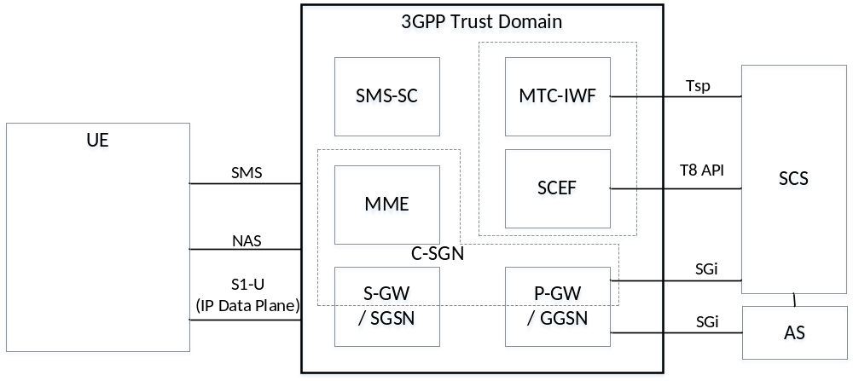
Figure 5.1-1: 3GPP IoT Related Interfaces

5.2 Functional mapping between 3GPP and oneM2M
Figure 5.2-1 shows an architecture and functional mapping for the 3GPP Trust Domain which describes how oneM2M functional entities may access features and services that are exposed by 3GPP.
The “MTC Applications” hosted on the UE may be deployed as follows:
- Application only: UE may be an ADN oneM2M entity
- Application and CSE: UE may be an ASN or MN oneM2M entity
- CSE only: UE may be a MN oneM2M entity
- Neither application nor CSE: UE may be a NoDN.
The SCS may be an IN-CSE, and the “MTC-Applications” or Ass that are hosted in an external network may be IN-Aes.
The “3GPP Trust Domain” in Figures 5.1-1 and Figure 5.2-1 captures the functional entities that shall be part of the 3GPP domain (the network). Although Figure 5.2-1 shows that the IN-CSE and IN-AE are outside of the 3GPP Domain, the IN-CSE may be part of the operator domain.
This figure also shows the oneM2M reference points Mcn and Mca. The Mcc reference point is not shown explicitly as it would have rendered the picture less legible, but as is defined in clause 5 of oneM2M TS-0001 [1] , the Mcc reference point enables communication between CSEs such as the CSE shown on the left-hand side and the IN-CSE shown on the right-hand side of the figure 5.2-1.

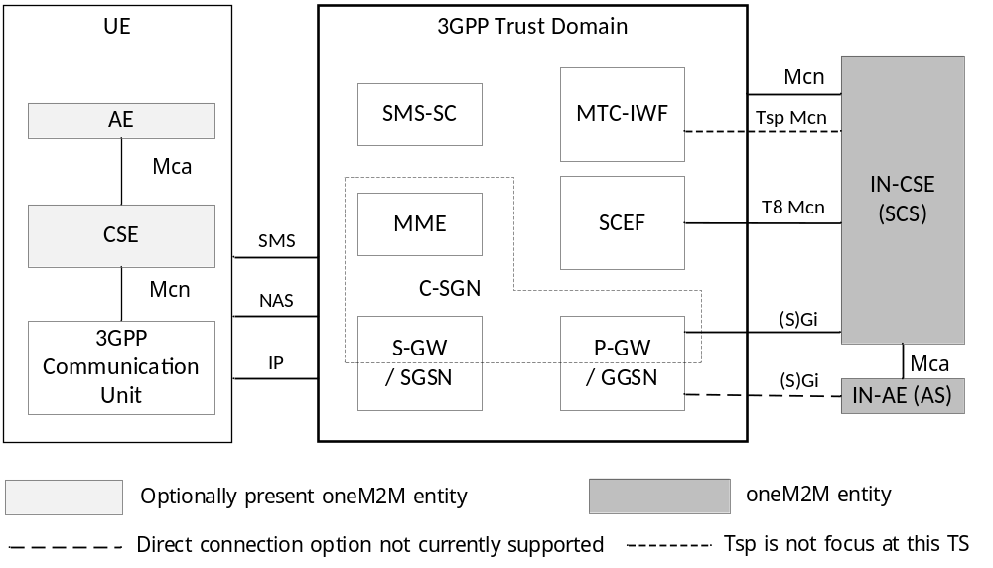
Figure 5.2-1: oneM2M Interfaces to the 3GPP Network
Several implementation options for the placement of the oneM2M IN-CSE relative to the SCEF and the 3GPP network are envisioned. In all implementations, the SCEF always resides within 3GPP domain.
In some options the IN-CSE and the SCEF are deployed by a mobile network provider and are both part of the operator domain. In other options the SCEF is part of the 3GPP domain and the IN-CSE is not part of the operator domain.
In all options, services within the IN-CSE may access the network services that are exposed by the SCEF via the T8 reference point APIs.

5.3 3GPP Cellular IoT Features and Services
The SCEF exposes the following services to the IN-CSE. This document describes how the IN-CSE may access each service.
  - Non-IP Data Delivery, see clause 7.1.
  - UE Context Information Storage, see clause 7.2.
  - High Latency Communication – Extended S-GW and SCEF Buffering, see clause 7.3.
  - Monitoring Events, see clause 7.4.
  - SMS Based Device Triggering, see clause 7.5.
  - Configuring Communication Patterns, see clause 7.6.
  - Group Messaging (via MBMS), see clause 7.7.
  - Mobile Core Network Issue Reports, see clause 7.8.
  - Configuring Session QoS, see clause 7.9.
  - Background Data Transfer, see clause 7.10.
  - Configuring Session Sponsorship, see clause 7.11.
  - Network Parameter Configuration – Configuring PSM and eDRX, see clause 7.12.
A UE hosted ADN-AE, MN-CSE, or ASN-CSE may access the following features that may be exposed by the 3GPP modem. This document describes how the UE hosted ADN-AE, MN-CSE, or ASN-CSE may access each service.
- Non-IP Data Delivery, see clause 7.1.
- High Latency Communication – Configuring PSM and eDRX, see clause 7.3.
- SMS Based Device Triggering, see clause 7.5.
- Group Messaging (via MBMS), see clause 7.7.

5.4 SCEF T8 API
The T8 APIs are a set of APIs defining the related procedures and resources for the interaction between the SCEF and the IN-CSE (SCS). The APIs are RESTful and based on the HTTP protocol. The architectural level description of the T8 APIs is defined in 3GPP TS 23.682 [2]. The protocol level description of the T8 APIs including how the individual T8 requests and responses are mapped to HTTP and encoded in JSON as defined in 3GPP TS 29.122 [4].
This document defines how an IN-CSE interworks with a SCEF via the T8 APIs. For each of the supported SCEF services, this document defines how the individual requests and responses are configured, sent and received by the IN-CSE and SCEF. Details are also provided for how an IN-CSE generates and processes T8 requests and responses using the T8 HTTP protocol binding and JSON message encodings.
The intent of this document is to complement 3GPP TS 23.682 [2] and 3GPP TS 29.122 [4] and care has been taken to minimize duplication of information. It is assumed that the reader of this document is knowledgable of the T8 APIs as defined in 3GPP TS 23.682 [2] and 3GPP TS 29.122 [4].

6 Connectivity Establishment

6.1 Overview
ADN-AE, ASN/MN-CSE and the serving IN-CSE communicate after completion of the Underlying Network bearer establishment and discovery of the serving IN-CSE. Data can then traverse between the oneM2M entities over the IP connection in the Underling Network over the 3GPP Gi/Sgi interface. Figure 6.1-1 depicts the connectivity between the ADN-AE, ASN/MN-CSE and the IN-CSE.

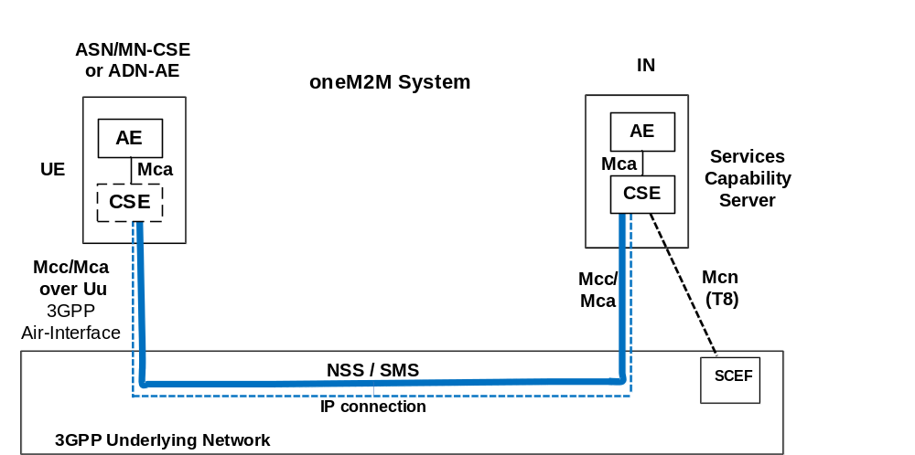
Figure 6.1-1: Connectivity Establishment between ASN/MN-CSE or ADN-AE and IN-CSE

For ADN/ASN/MN initiated connectivity establishment, it is assumed that there is no connectivity previously established, i.e. no association between the ASN/MN-CSE or ADN-AE and the serving IN-CSE exists. When the ASN/MN-CSE or ADN-AE needs to send data to the serving IN-CSE it first discovers the serving IN-CSE, which is located in a packet data network, and establishes a connection. Two methods can be used, as follows:
- Use of DHCP and DNS.
- Pre-configuration.
For serving IN-CSE initiated connectivity establishment, it is assumed that there is no connectivity previously established between the ASN/MN-CSE or ADN-AE and the serving IN-CSE. When the serving IN-CSE needs to contact the ASN/MN-CSE to send data or request data, connectivity between them is established. This connectivity is triggered by the serving IN-CSE.
The ASN/MN-CSE or ADN-AE requests the DNS server address from the DHCP server followed by requesting the serving IN-CSE IP address from the DNS server.

6.2 IP connectivity

6.2.1 ASN/MN-CSE Pre-configuration
The ASN/MN-CSE or ADN-AE is preconfigured with the fully qualified domain name (FQDN) of the serving IN-CSE or the IP address of the serving IN-CSE. If the FQDN is known, DNS resolution is used to obtain the IP address.

6.2.2 ASN/MN-CSE or ADN-AE Initiated Connectivity Establishment Procedure
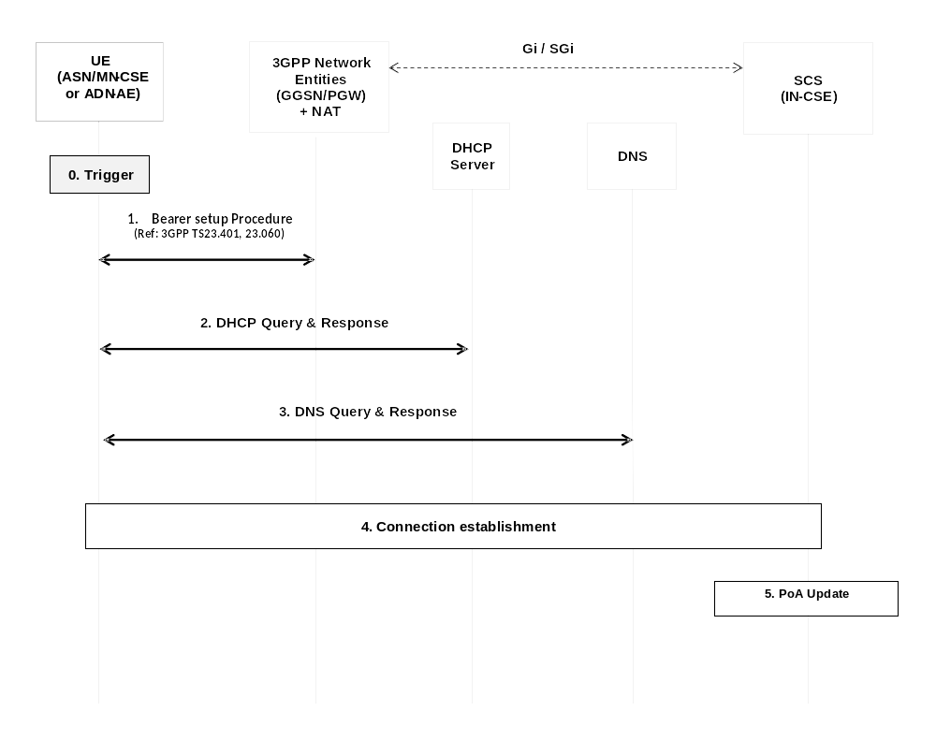
Figure 6.2.2-1: ASN/MN-CSE or ADN-AE initiated connectivity establishment
Step-0: Trigger
Subsequent procedures are triggered either when the ASN/MN-CSE or ADN-AE powers on or resulting from Device Triggering
Step-1: Bearer Setup Procedure
Establish a 3GPP bearer(s) if not already available by using the procedures available in the 3GPP network.
Step-2: DHCP Query & Response
The ASN/MN-CSE or ADN-AE sends a query to a DHCP server to find a particular DNS server IP address. The DHCP server responds with the IP address of a corresponding DNS server. Additionally, it is also possible to include one or a list of domain names, i.e. FQDNs of target IN-CSEs.
Step-3: DNS Query & Response
The ASN/MN-CSE or ADN-AE performs a DNS query to retrieve the IN-CSE(s) IP addresses from which one is selected. If the response does not contain the IP addresses, an additional DNS query is needed to resolve a Fully Qualified Domain Name (FQDN) of the serving IN-CSE to an IP address.
Step-4: Connection Establishment
After reception of domain name and IP address of an IN-CSE, the ASN/MN-CSE or ADN-AE can initiate communication towards the IN-CSE via the IP connection. The IN-CSE at this time shall be informed which Trigger Recipient ID of the ASN/MN-CSE or ADN-AE or the AE-PoA of the ADN-AE to use for establishing communication.
Step-5: CSE-PoA Update
Once the M2M Service Connection (Mcc or Mca) is established to the IN-CSE, the CSE-PoA of the ASN-CSE/MN-CSE or the AE-PoA of the ADN-AE shall be updated with the new established IP address.

6.2.3 IN-CSE initiated connectivity establishment procedure
See clause 7.1 for NIDD based connection establishment and clause 7.5 3GPP Based Device Triggering.

6.3 UE Attach with oneM2M Registration Procedure
After a UE attaches to a 3GPP network and establishes a data (i.e. PDN/PDP) connection, assuming it has not been registered previously with the oneM2M platform, it will initiate a oneM2M registration procedure. The oneM2M part of the procedure corresponds to the generic one described in clause 10.2.2 of oneM2M TS-0001[1], where the Registrar CSE is the IN-CSE.
If the UE hosts one or more ADNs, the registration will result in the IN-CSE hosting one or more corresponding <AE> resources for the UE. If the UE hosts an ASN or a MN, the registration of the ASN/MN-CSE will result in the IN-CSE hosting a corresponding <remoteCSE> resource for the ASN/MN-CSE. The flow is depicted in figure 6.3-1.

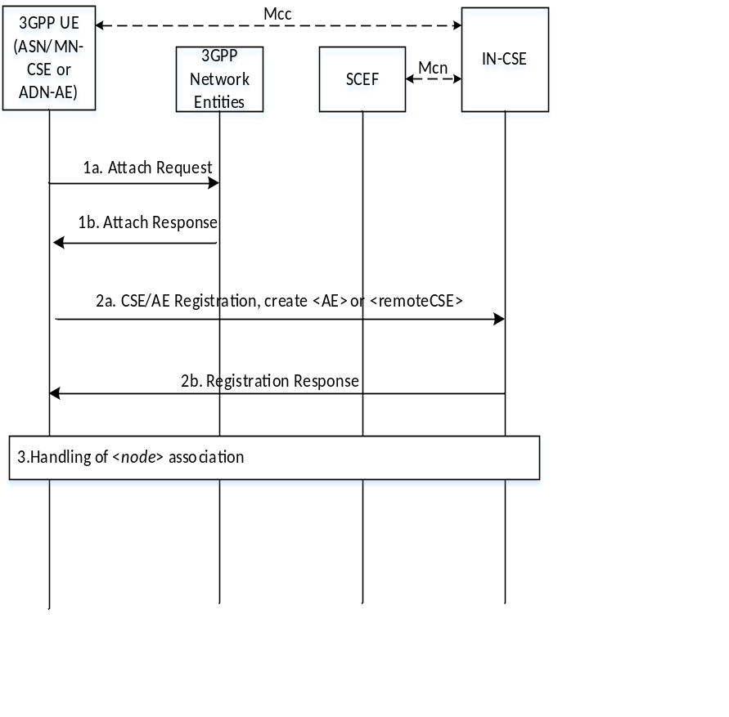
Figure 6.3-1 UE Attach Procedure with oneM2M Registration
Steps 1a and 1b: UE Attach Request and Response
The UE determines that it needs to perform the 3GPP Attach procedure.
The 3GPP Network responds to the UE Attach request.
Steps 2a and 2b: oneM2M Registration Request and Response
The UE Hosting an ADN or an ASN/MN registers to the oneM2M infrastructure, by performing the registration procedure detailed in clause 10.2.2 of oneM2M TS-0001[1].
- If the UE hosts an ADN, the registration procedure of the ADN-AE(s) will include the creation of corresponding <AE> resource(s) being hosted at the IN-CSE.
- If the UE hosts an ASN or MN, the registration procedure of the ASN/MN-CSE will include the establishment of a security association and the creation of a <remoteCSE> resource, corresponding to the registree CSE, to be hosted at the IN-CSE.
The IN-CSE responds to the UE hosted ADN-AE(s) or ASN/MN-CSE request for registration.
These steps allow the UE hosted ADN-AE(s) or ASN/MN-CSE to provide the IN-CSE with information needed for communication and providing services, e.g. pointOfAccess. In return, the IN-CSE provides the UE with oneM2M specific information, e.g. by assigning AE-ID(s) or CSE-ID to the registree(s), respectively
Information provided by the ASN/MN-CSE or ADN-AE(s) to the IN-CSE at this time shall include:
- M2M-Ext-ID, Trigger-Recipient-ID as attributes of <AE> or <remoteCSE>, if available.
- externalGroupID as an attribute of <remoteCSE>, if available.
nodeLink as an attribute of the <AE> or <remoteCSE> resources, providing the resource identifier of a corresponding <node> resource, if pre-provisioned at the UE.
Step 3: Handling of association with a <node> resource
If in Step 2, the IN-CSE receives a valid nodeLink (as an attribute of the <AE> or <remoteCSE> resources) it means that the <node> resource storing the node specific information for this UE exists. For a UE hosted ASN/MN, the IN-CSE shall ensure that the hostedCSELink attribute of the corresponding <node> resource contains the resource identifier of the <remoteCSE > resource. For a UE hosted ADN, the IN-CSE shall ensure that the hostedAELinks attribute of the corresponding <node> resource includes the resource identifier of all the corresponding <AE > resources.
If in Step 2, the IN-CSE does not receive a valid nodeLink (as an attribute of the <AE> or <remoteCSE> resources) or the attribute is not present, the IN-CSE shall create a <node> resource for this UE. The IN-CSE shall populate the nodeLink attribute of the <AE> or <remoteCSE> resources with the resource identifier of the newly created <node> resource. For a UE hosted ASN/MN, the IN-CSE shall also populate the hostedCSELink attribute of the <node> resource with the resource identifier of the <remoteCSE > resource. For a UE hosted ADN, the IN-CSE shall ensure that the hostedAELinks attribute of the <node> resource includes the resource identifiers of all the corresponding <AE> resources.
If the following resources do not exist for this Underlying Network, the IN-CSE may:
- create a <schedule> resource as a child of the <node> representing the UE, which represents the communication schedule for the 3GPP Underlying Network where the Attach procedure was completed. While no specific scheduling information is available, the <schedule> may reflect that communications are available continuously. The IN-CSE may set the networkCoordinated attribute, based on the UE pre-provisioned information or local policies, to indicate if the schedule should be coordinated with the Underlying Network
- create the [activeCmdhPolicy] resource as a child of the <node> resource representing the UE, providing the active communication policies for the 3GPP Underlying Network where the Attach procedure was completed. The IN-CSE shall populate the mgmtLink of the active [cmdhNwAccessRule] with a link to the <schedule> resource created for the communication schedule with this Underlying Network.

7 Interworking with CioT network features exposed to service layer

7.1 Cellular IoT non-IP data delivery(NIDD)

7.1.1 SCEF-based NIDD

7.1.1.1 SCEF Configuration for NIDD
The 3GPP SCEF Non-IP Data Delivery (NIDD) functionality supports an API to allow the exchange of Non-IP data between an IN-CSE and an MN-CSE, ADN-AE, or ASN-CSE hosted on a UE. Via this SCEF NIDD API, an IN-CSE may exchange oneM2M request and response primitives with an MN-CSE, ADN-AE, or ASN-CSE hosted on a UE.
NOTE: The exchange of oneM2M primitives over the Mcn reference point via NIDD is an extension upon the capability defined within oneM2M TS-0001[1] and oneM2M TS-0004 [3] to exchange oneM2M primitives over the Mca and Mcc reference points. The same procedures defined by oneM2M TS-0001[1] and oneM2M TS-0004 [3] for exchanging oneM2M primitives over the Mca and Mcc are also applicable to Mcn via NIDD unless otherwise stated in this document.
The SCEF NIDD API supports an NIDD Configuration procedure that may be used by the IN-CSE to inform the SCEF that it expects Non-IP Data from a UE hosting an MN-CSE, ADN-AE, or ASN-CSE. Figure 7.1.1.1-1 illustrates this procedure. If the NIDD Configuration procedure is performed, the IN-CSE should perform the procedure before a UE attaches and attempts to establish a Non-IP PDN connection to the SCEF.

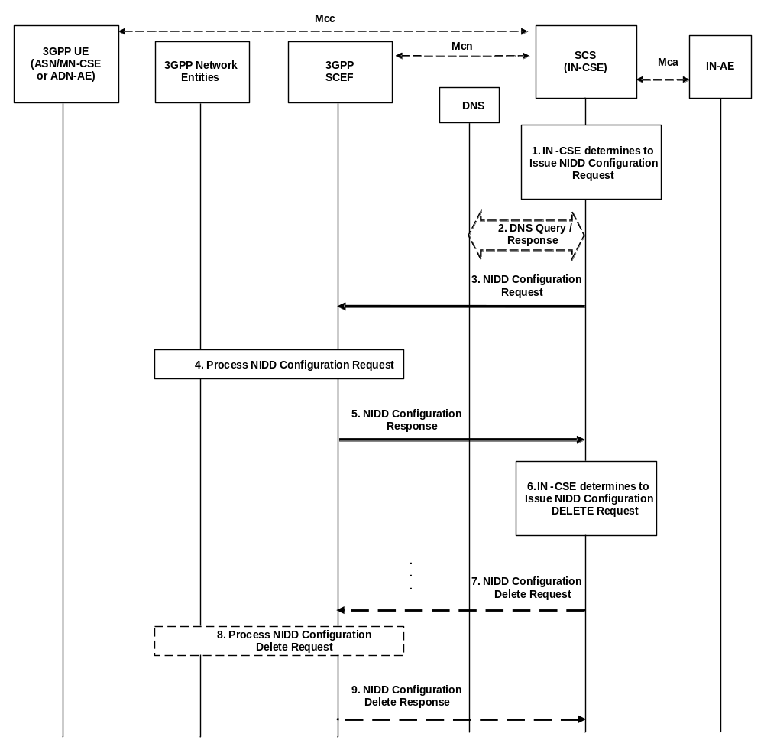
Figure 7.1.1.1-1: NIDD Configuration Request
Pre-conditions:
The IN-CSE is configured with the M2M-Ext-ID of a UE and an indication that the ASN/MN-CSE or ADN-AE hosted on this UE uses NIDD to exchange oneM2M primitives with the IN-CSE. This information is configured in the nodeID and niddRequired attributes, respectively of the <serviceSubscribedNode> resource corresponding to the UE.
There is a relationship in place between the Service Provider and MNO allowing the IN-CSE to perform NIDD Configuration Requests to the underlying 3GPP network. The method for establishing this relationship is outside the scope of the present document.
Step 1: IN-CSE determines to issue NIDD Configuration Request
If the niddRequired attribute of a <serviceSubscribedNode> resource associated with a UE hosting an ASN/MN-CSE or ADN-AE is set to TRUE, then the IN-CSE shall issue a NIDD Configuration Request to the proper SCEF.
Step 2 (Optional): DNS Query/Response
To determine which SCEF to contact, an IN-CSE may determine the IP address(es)/port(s) of the proper SCEF by performing a DNS query using the M2M-Ext-ID of the UE hosting the ASN/MN-CSE or ADN-AE. This M2M-Ext-ID shall be configured in the nodeID attribute of the <serviceSubscribedNode> resource associated with the UE. Alternatively, an IN-CSE may use a pre-configured SCEF identifier. The method for pre-configuring a SCEF identifier into the IN-CSE is outside the scope of the present document.
Step 3: NIDD Configuration Request
The IN-CSE issues a NIDD Configuration Request for a particular ASN/MN-CSE or ADN-AE hosted on a UE. The request is configured as follows.
- An HTTP POST method shall be used
- URI shall be set to {apiRoot}/3gpp-nidd/v1/{scsAsId}/configurations/. The {apiRoot} and {scsAsId} segments are configured based on Service Provider and MNO policies.
- The request payload shall include a NiddConfiguration data structure as specified in 3GPP TS 29.122 [4] with the following attributes:
  - externalId shall be set to the M2M-Ext-ID of the UE hosting the targeted ASN/MN-CSE or ADN-AE.
  - notificationDestination shall be set to a URI of the IN-CSE that the SCEF will deliver MO NIDD data to.
  - duration specifies the lifetime of the NIDD Configuration and shall be set per SLA between the Service Provider and MNO. The SCEF may change the NIDD duration value.
  - pdnEstablishmentOption may be used to indicate the IN-CSE’s default preference for how the SCEF should process a MT NIDD Request from the IN-CSE if the UE has not yet established a Non-IP PDN connection to the SCEF. This value shall be set based on SLA with the MNO.
  - reliableDataService shall be set to TRUE or FALSE to indicate that the Reliable Data Service is enabled or disabled based on IN-CSE preferences.
  - rdsPorts shall be set to the source and destination ports used for MO and MT NIDD between the IN-CSE and the ASN/MN-CSE or ADN-AE hosted on the UE. This field shall be set if reliableDataService is set to TRUE.
  - supportedFeatures shall be set to a string value of “0” indicating no support for group message delivery over NIDD, NIDD notifications over Websocket, testing of NIDD notifications or MT_NIDD_modification_cancellation.
  - msisdn, requestTestNotification, websockNotifConfig and niddDownlinkDataTransfers are not supported by the present document and shall not be included.
Step 4: Process NIDD Configuration Request
The SCEF processes the request.

Step 5: NIDD Configuration Response
If the NIDD Configuration Request is successfully processed, the SCEF responds indicating the request was accepted. The message includes the following information.

- A response code of 201 CREATED
- The URI of the NIDD Configuration resource created by the SCEF. The URI is returned in the HTTP Location header with a format of {apiRoot}/3gpp-nidd/v1/{scsAsId}/configurations/{configurationId}. The {apiRoot} and {scsAsId} segments are configured based on Service Provider and MNO policies. The {configurationId} segment is configured by the SCEF.
- The response payload will include a NiddConfiguration data structure as specified in 3GPP TS 29.122 [4] that includes the attributes present in the request along with the following additional attributes:
  - maximumPacketSize is set to the maximum supported NIDD packet size that can be transferred to the UE by the SCEF. This value is configured by the SCEF per SLA with the MNO.
  - status is set to a value that indicates the NIDD configuration status (e.g. ACTIVE)
  - self is configured with a URI to the resource created by the SCEF for the request
If the response indicates that the request was accepted, the IN-CSE shall use the maximumPacketSize as a limit on the maximum size MT NIDD Request it shall initiate towards the corresponding UE specified in the NIDD Configuration Request.
If the NIDD Configuration Request results in an error, the IN-CSE shall not use NIDD for the corresponding UE until the error is resolved. See clause 8.3 for a list of possible error scenarios.

Step 6 (Optional): NIDD Configuration Delete Request
If the IN-CSE detects that <serviceSubscribedNode> is deleted or the <serviceSubscribedNode> niddRequired attribute is updated to FALSE, then the IN-CSE shall issue a NIDD Configuration Delete Request for the UE. The request is configured as follows.
- An HTTP DELETE method shall be used
- URI shall be set to {apiRoot}/3gpp-nidd/v1/{scsAsId}/configurations/{configurationId}. The {apiRoot} and {scsAsId} segments are configured based on Service Provider and MNO policies. The {configurationId} corresponds to the one configured by the SCEF and returned to the IN-CSE when the NIDD Configuration was created.
- The request shall not contain a payload
Step 7 (Optional): Process NIDD Configuration Delete Request
The SCEF processes the request.

Step 8 (Optional): NIDD Configuration Delete Response
The SCEF responds with a 204 NO CONTENT that indicates the NIDD Configuration was cancelled.

7.1.1.2 SCEF-based Mobile Terminated NIDD
The SCEF API supports a Mobile Terminated (MT) NIDD procedure that may be used by the IN-CSE to send downlink non-IP data to a UE hosting an MN-CSE, ADN-AE, or ASN-CSE. Figure 7.1.1.2-1 illustrates this procedure.

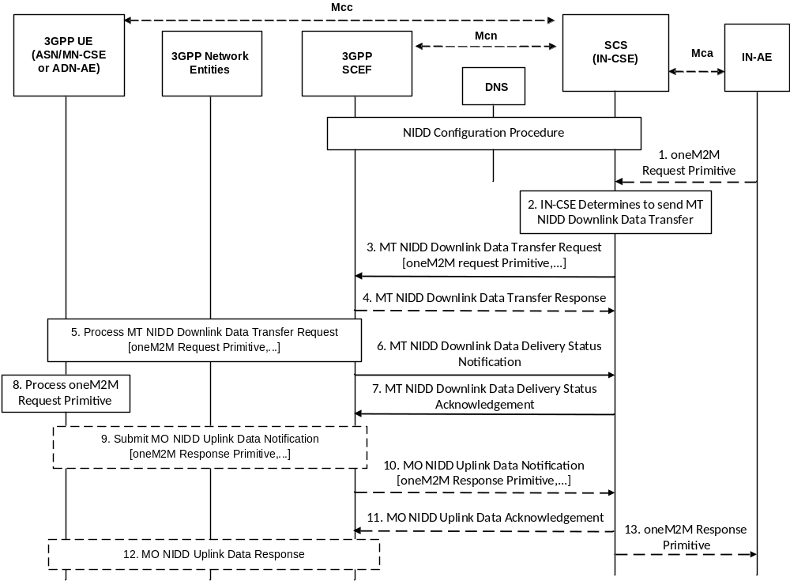
Figure 7.1.1.2-1: SCEF-based Mobile Terminated NIDD
Pre-conditions:
The NIDD Configuration procedure defined in clause 7.1.1.1 completes successfully.
Step 1 (Optional): Application issues oneM2M Request Primitive
An AE (e.g. IN-AE) may issue a oneM2M request targeting a ASN/MN-CSE or ADN-AE.
Step 2: IN-CSE determines to issue a SCEF-based Mobile Terminated NIDD Downlink Data Transfer Request
The IN-CSE shall only issue a SCEF-based Mobile Terminated (MT) NIDD Downlink Data Transfer Request if the NIDD Configuration Request for the targeted ASN/MN-CSE or ADN-AE hosted on a UE was successful and the size of the oneM2M request primitive to be sent in the MT NIDD Request is less than or equal to the maximumPacketSize defined in the NIDD Configuration response.
Step 3: MT NIDD Downlink Data Transfer Request
The IN-CSE issues a MT NIDD Downlink Data Transfer Request for a particular ASN/MN-CSE or ADN-AE hosted on a UE. The request is configured as follows.
- An HTTP POST method shall be used
- URI shall be set to {apiRoot}/3gpp-nidd/v1/{scsAsId}/configurations/{configurationId}/downlink-data-deliveries. The {apiRoot} and {scsAsId} segments are configured based on Service Provider and MNO policies. The {configurationId} segment shall be configured with the {configurationId} returned by the SCEF when the NIDD Configuration was performed by the IN-CSE for this ASN/MN-CSE or ADN-AE.
- The request payload shall include a NiddDownlinkDataTransfer data structure as specified in 3GPP TS 29.122 [4] with the following attributes:

  - externalId shall be set to the M2M-Ext-ID of the UE hosting the targeted ASN/MN-CSE or ADN-AE.
  - maximumLatency may be set to indicate the maximum delay acceptable for MT data and used to configure the buffer duration in the underlying 3GPP network; a maximum latency of 0 indicates that buffering is not allowed. If maximum latency is not provided, the SCEF determines the acceptable delay based on local policies.
  - priority may be set to indicate the priority of the non-IP data packet relative to other non-IP data packets. If a priority is not provided, the SCEF determines the acceptable delay based on local policies.
  - pdnEstablishmentOption may be used to indicate the IN-CSE’s default preference for how the SCEF should process a MT NIDD request from the IN-CSE if the UE has not yet established a Non-IP PDN connection to the SCEF. If a PDN Connection Establishment Option is not provided with the non-IP packet, the SCEF uses the PDN Connection Establishment Option that was provided during NIDD Configuration to decide how to handle the absence of a PDN connection.
  - reliableDataService (optional) shall be set to TRUE or FALSE to indicate that Reliable Data Service acknowledgement is required or not.
  - rdsPort shall be set to the source and destination ports used for MO and MT NIDD between the IN-CSE and the ASN/MN-CSE or ADN-AE hosted on the UE.
  - data shall be configured with a oneM2M primitive to send to the UE hosting the targeted ASN/MN-CSE or ADN-AE.
NOTE: The use of a PUT request to replace an existing MT NIDD Downlink Data Transfer request and a GET request to read the parameters associated with an existing MT NIDD Downlink Data Transfer request by the IN-CSE are not used by the present document.
Step 4: MT NIDD Downlink Data Transfer Response
If the targeted UE does not have an active NIDD PDN connection to the SCEF, the SCEF may buffer the request until the UE establishes the connection. The SCEF may also trigger the UE to establish a NIDD PDN connection to the SCEF. Alternatively, the SCEF may generate an error.

The SCEF may return a MT NIDD Downlink Data Transfer Response to the IN-CSE to indicate if the request is buffered, a trigger has been generated, or an error has occurred. The fields of the response are populated as follows.

- A response code of 200 OK or 201 CREATED
  - 200 OK is returned if the delivery of the NIDD Downlink Data Transfer Request was successful
  - 201 CREATEDis returned if the SCEF accepted and buffered the NIDD Downlink Data Transfer Request to be performed later
- The URI of the NIDD Downlink Data Transfer resource created by the SCEF, for the case when response code is 201 CREATED. The URI is returned in the HTTP Location header with a format of {apiRoot}/3gpp-nidd/v1/{scsAsId}/configurations/{configurationId}/downlink-data-deliveries/{downlinkDataDeliveryId}. The {apiRoot}, {scsAsId} and {configurationId} segments match those in the request. The {downlinkDataDeliveryId} segment is configured by the SCEF.
- The response payload will include a NiddDownlinkDataTransfer data structure as specified in 3GPP TS 29.122 [4] that includes the attributes present in the request along with the following additional attributes:
  - deliveryStatus is used to indicate a success or an appropriate error cause value as defined in 3GPP TS 29.122 [4].
  - self is configured with a URI to the resource created by the SCEF for the request.
  - requestedRetransmissionTime is configured with the absolute time at which the SCEF expects the IN-CSE to retransmit the MT NIDD Downlink Data Transfer Request.
If an error occurs while processing the NIDD Downlink Data Transfer Request, the SCEF will respond with an error code as defined in 3GPP TS 29.122 [4]. See clause 8.3 for further details on the actions an IN-CSE shall take when receiving an error from the SCEF.
If the MT NIDD Downlink Data Transfer Request results in an error, the IN-CSE shall forward a corresponding oneM2M error to the Originator of the request. See clause 8.3 for a list of possible error scenarios.

Step 5: Process MT NIDD Downlink Data Transfer Request
If the UE targeted by the MT NIDD Downlink Data Transfer Request has an active NIDD PDN connection to the SCEF, the SCEF interacts with the 3GPP Core Network to process the request and deliver it to the targeted UE.

NOTE: If a MT NIDD Downlink Data Transfer Request is received with non-IP data for a request that is already buffered, then the buffered data is replaced by the SCEF. If a MT NIDD Downlink Data Transfer Request is received with no non-IP data for a request that is already buffered, then the buffered data is purged by the SCEF.

Step 6 (Optional): MT NIDD Downlink Data Delivery Status Notification
If the SCEF returned a 202 ACCEPTED response in Step 4 indicating that it buffered the NIDD Downlink Data Request to be performed later, then after completing the processing of the MT NIDD Downlink Data Transfer Request, the SCEF returns a MT NIDD Downlink Data Delivery Status Notification configured as follows.

- An HTTP POST method is used
- URI is set to {notification_uri}. The {notification_uri} is configured by the IN-CSE in the NIDD Configuration Request.
- The request payload includes a NiddDownlinkDataDeliveryStatusNotification data structure as specified in 3GPP TS 29.122 [4] with the following attributes:
  - niddDownlinkDataTransfer is configured with the URI of the corresponding MT NIDD Downlink Data Transfer resource.
  - deliveryStatus is set by the SCEF to indicate the delivery status NIDD Downlink Data Transfer request.
  - requestedRetransmissionTime is configured with the absolute time at which the SCEF expects the IN-CSE to retransmit the MT NIDD Downlink Data Transfer Request.
Step 7: MT NIDD Downlink Data Delivery Status Acknowledgement
After receiving a MT NIDD Downlink Data Delivery Status Notification, the IN-CSE responds with a 204 NO CONTENT acknowledging the notification.
Step 8: Process oneM2M Request Primitive
The ASN/MN-CSE or ADN-AE hosted on the UE targeted by the MT NIDD Downlink Data Transfer Request processes the oneM2M request primitive delivered within the MT NIDD Downlink Data Transfer Request. If the oneM2M request primitive requires a response, the ASN/MN-CSE or ADN-AE hosted on the UE prepares the oneM2M response primitive. Otherwise a response is not returned.

Step 9 (Optional): MO NIDD Uplink Data Notification
The UE acknowledges the RDS packet and the ASN/MN-CSE or ADN-AE generates a oneM2M response primitive and issues a MO NIDD Uplink Data Notification to deliver the response primitive back to the Originator. The MO NIDD Uplink Data Notification to deliver the oneM2M response primitive shall be addressed to the same port numbers that were received in step 5 and the request shall indicate that an RDS acknowledgement is desired.

Step 10 (Optional): MO NIDD Uplink Data Notification
When the SCEF receives the MO NIDD Uplink Data Notification, it finds the corresponding T8 Destination Address (URI) of the IN-CSE based on the NIDD Configuration that has been successfully performed. The SCEF then forwards the oneM2M primitive carried in the MO NIDD Uplink Data Notification to the IN-CSE configured as follows.

- An HTTP POST method is used
- URI is set to {notification_uri}. The {notification_uri} is configured by the IN-CSE in the NIDD Configuration Request.
- The request payload includes a NiddUplinkDataNotification data structure as specified in 3GPP TS 29.122 [4] with the following attributes:
  - niddConfiguration is configured with the URI of the NIDD Configuration resource to which this notification is related to.
  - externalId is set to the M2M-Ext-ID of the UE hosting the targeted ASN/MN-CSE or ADN-AE that originated the MO NIDD Uplink Data Notification.
  - reliableDataService shall be set to TRUE or FALSE to indicate whether the Reliable Data Service acknowledgement is enabled or not
  - rdsPort indicates the source and destination ports that were provided in the MO NIDD Uplink Data Notification
  - data is configured with a oneM2M response primitive sent by the UE hosting the Originator ASN/MN-CSE or ADN-AE.
Step 11 (Optional): MO NIDD Uplink Data Acknowledgement
After receiving a MT NIDD Uplink Data Delivery Notification, the IN-CSE responds with a 204 NO CONTENT acknowledging the notification.

Step 12 (Optional): MO NIDD Uplink Data Response
The SCEF sends an NIDD Uplink Data Response to the UE and processes the MO NIDD Uplink Data Acknowledgement from the IN-CSE.

Step 13 (Optional): Return oneM2M Response Primitive to Application
If an AE (e.g. IN-AE) was the Originator of the corresponding oneM2M request primitive, the IN-CSE shall return the oneM2M response primitive to the AE.
If an NIDD request results in an error, the IN-CSE shall forward a corresponding oneM2M error to the Originator of the oneM2M request primitive. See clause 8.3 for a list of possible error scenarios.

7.1.1.3 SCEF-based Mobile Originated NIDD
The SCEF API supports a Mobile Originated (MO) NIDD procedure that may be used by a UE hosting an ASN/MN-CSE or ADN-AE to send uplink non-IP data to an IN-CSE. Figure 7.1.1.3-1 illustrates this procedure.
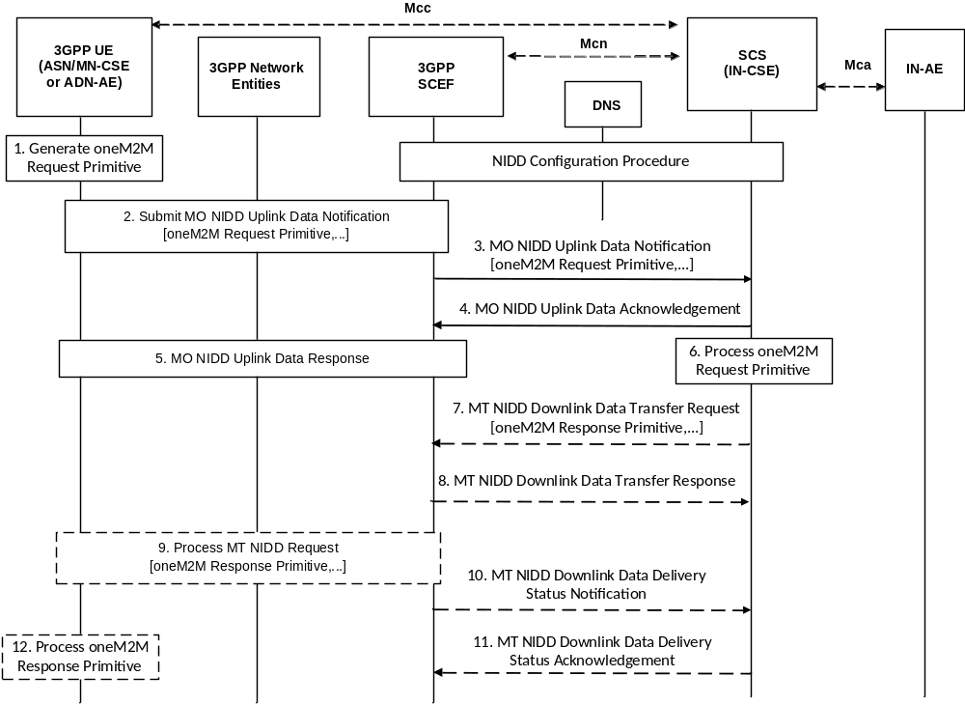
Figure 7.1.1.3-1: SCEF-based Mobile Originated NIDD
Pre-conditions:
The NIDD Configuration procedure defined in clause 7.1.1.1 completes successfully.
Step 1: oneM2M Request Primitive Generation
The ASN/MN-CSE or ADN-AE hosted on a UE generates a oneM2M request primitive targeting the IN-CSE.

Step 2: MO NIDD Uplink Data Notification
The ASN/MN-CSE or ADN-AE issues a MO NIDD Uplink Data Notification to deliver the primitive to the IN-CSE. When the request is sent, the UE shall indicate that an RDS acknowledgment is requested. The RDS source and destination port numbers shall be set to the same values that were provided to the SCEF by the IN-CSE during NIDD Configuration. The port numbers are pre-provisioned in the ASN/MN-CSE or ADN-AE.

Step 3: MO NIDD Uplink Data Notification
When the SCEF receives the MO NIDD Uplink Data Notification, it finds the corresponding T8 Destination Address of the IN-CSE based on the NIDD Configuration that has been successfully performed. The SCEF then forwards the oneM2M request primitive carried in the MO NIDD Uplink Data Notification to the IN-CSE configured as follows.

- An HTTP POST method is used
- URI is set to {notification_uri}. The {notification_uri} is configured by the IN-CSE in the NIDD Configuration Request.
- The request payload includes a NiddUplinkDataNotification data structure as specified in 3GPP TS 29.122 [4] with the following attributes:
  - niddConfiguration is configured with the URI of the NIDD Configuration resource to which this notification is related to.
  - externalId is set to the M2M-Ext-ID of the UE hosting the targeted ASN/MN-CSE or ADN-AE that originated the MO NIDD Uplink Data Notification.
  - reliableDataService is set to TRUE or FALSE by the SCEF to indicate that Reliable Data Service is enabled or not
  - rdsPort indicates the source and destination ports that were provided in the MO NIDD Uplink Data Notification
  - data is configured with a oneM2M request primitive sent by the UE hosting the Originator ASN/MN-CSE or ADN-AE.
Step 4: MO NIDD Uplink Data Acknowledgement
After receiving a MT NIDD Uplink Data Delivery Notification, the IN-CSE responds with a 204 NO CONTENT acknowledging the notification.
Step 5: MO NIDD Uplink Data Response
The SCEF sends an RDS acknowledgment to the UE and the SCEF processes the MO NIDD Uplink Data Acknowledgement from the IN-CSE.

Step 6: Process oneM2M Request Primitive
The IN-CSE processes the oneM2M request primitive that was delivered in the MO NIDD Uplink Data Notification. If the oneM2M request primitive requires a response, the IN-CSE shall prepare the oneM2M response primitive.
Step 7 (Optional): Return oneM2M Response Primitive
The IN-CSE may generate a oneM2M response primitive if a response is required. If a response is required, the IN-CSE shall issue a MT NIDD Downlink Data Transfer Request to deliver it to the ASN/MN-CSE or ADN-AE hosted on the UE that originated the corresponding oneM2M request primitive. The IN-CSE shall only issue a SCEF-based Mobile Terminated (MT) NIDD Downlink Data Transfer Request if the size of the oneM2M response primitive to be sent in the request is less than or equal to the NIDD Max Packet Size established during the corresponding the NIDD Configuration procedure for the UE.
The message is configured as follows.
- An HTTP POST method shall be used
- URI shall be set to {apiRoot}/3gpp-nidd/v1/{scsAsId}/configurations/{configurationId}/downlink-data-deliveries. The {apiRoot} and {scsAsId} segments are configured based on Service Provider and MNO policies. The {configurationId} segment shall be configured with the {configurationId} returned by the SCEF when the NIDD Configuration was performed by the IN-CSE for this ASN/MN-CSE or ADN-AE.
- The request payload shall include a NiddDownlinkDataTransfer data structure as specified in 3GPP TS 29.122 [4] with the following attributes:
  - externalId shall be set to the M2M-Ext-ID of the UE hosting the targeted ASN/MN-CSE or ADN-AE.
  - maximumLatency may be set to indicate the maximum delay acceptable for MT data and used to configure the buffer duration in the underlying 3GPP network; a maximum latency of 0 indicates that buffering is not allowed. If maximum latency is not provided, the SCEF determines the acceptable delay based on local policies.
  - priority may be set to indicate the priority of the non-IP data packet relative to other non-IP data packets. If a priority is not provided, the SCEF determines the acceptable delay based on local policies.
  - pdnEstablishmentOption may be used to indicate the IN-CSE’s default preference for how the SCEF should process a MT NIDD request from the IN-CSE if the UE has not yet established a Non-IP PDN connection to the SCEF. If a PDN Connection Establishment Option is not provided with the non-IP packet, the SCEF uses the PDN Connection Establishment Option that was provided during NIDD Configuration to decide how to handle the absence of a PDN connection.
  - reliableDataService (optional) shall be set to TRUE or FALSE to indicate that Reliable Data Service acknowledgement is required or not.
  - rdsPort shall be set to the source and destination ports used for MO and MT NIDD between the IN-CSE and the ASN/MN-CSE or ADN-AE hosted on the UE.
  - data shall be configured with a oneM2M response primitive to send to the UE hosting the targeted ASN/MN-CSE or ADN-AE.
Step 8 (Optional): MT NIDD Downlink Data Transfer Response
If the targeted UE does not have an active NIDD PDN connection to the SCEF, the SCEF may buffer the request until the UE establishes the connection. The SCEF may also trigger the UE to establish a NIDD PDN connection to the SCEF. Alternatively, the SCEF may generate an error.

The SCEF may return a MT NIDD Downlink Data Transfer Response to the IN-CSE to indicate if the request is buffered, a trigger has been generated, or an error has occurred. The fields of the response are populated as follows.

- A response code of 200 OK or 201 CREATED
  - 200 OK is returned if the delivery of the NIDD Downlink Data Transfer was successful
  - 201 CREATEDis returned if the SCEF accepted and buffered the NIDD Downlink Data Request to be performed later
- The URI of the NIDD Downlink Data Transfer resource created by the SCEF for the case when response code is 201 CREATED. The URI is returned in the HTTP Location header with a format of {apiRoot}/3gpp-nidd/v1/{scsAsId}/configurations/{configurationId}/downlink-data-deliveries/{downlinkDataDeliveryId}. The {apiRoot}, {scsAsId} and {configurationId} segments match those in the request. The {downlinkDataDeliveryId} segment is configured by the SCEF.
- The response payload will include a NiddDownlinkDataTransfer data structure as specified in 3GPP TS 29.122 [4] that includes the attributes present in the request along with the following additional attributes:
  - deliveryStatus is used to indicate a success or an appropriate error cause value as defined in 3GPP TS 29.122 [4].
  - self is configured with a URI to the resource created by the SCEF for the request.
  - requestedRetransmissionTime is configured with the absolute time at which the SCEF expects the IN-CSE to retransmit the MT NIDD Downlink Data Transfer Request.
If the MT NIDD Downlink Data Transfer Request results in an error such that the IN-CSE is not able to return a oneM2M response primitive to the Originator of the request, the IN-CSE shall drop the response. See clause 8.3 for a list of possible error scenarios.

Step 9 (Optional): Process MT NIDD Downlink Data Transfer Request
If the UE targeted by the MT NIDD Downlink Data Transfer Request has an active NIDD PDN connection to the SCEF, the SCEF interacts with the 3GPP Core Network to process the request and deliver it to the targeted UE. The UE responds with an RDS acknowledgment.

NOTE: If an MT NIDD Downlink Data Transfer Request is received with non-IP data that is equal to a request that is already buffered, then the buffered data is replaced by the SCEF. If an MT NIDD Downlink Data Transfer Request is received with no non-IP data that is equal to a request that is already buffered, then the buffered data is purged by the SCEF.

Step 10 (Optional): MT NIDD Downlink Data Delivery Status Notification
After completing the processing of the MT NIDD Downlink Data Transfer Request, the SCEF returns a MT NIDD Downlink Data Delivery Status Notification configured as follows:

- An HTTP POST method is used
- URI is set to {notification_uri}. The {notification_uri} is configured by the IN-CSE in the NIDD Configuration Request.
- The request payload includes a NiddDownlinkDataDeliveryStatusNotification data structure as specified in 3GPP TS 29.122 [4] with the following attributes:
  - niddDownlinkDataTransfer is configured with the URI of the corresponding MT NIDD Downlink Data Transfer resource.
  - deliveryStatus is set by the SCEF to one of the status codes defined in 3GPP TS 29.122 [4] to indicate if the request was delivered successfully or not.
  - requestedRetransmissionTime is configured with the absolute time at which the UE will be reachable in the event that the UE is not reachable.
Step 11 (Optional): MT NIDD Downlink Data Delivery Status Acknowledgement
After receiving a MT NIDD Downlink Data Delivery Status Notification, the IN-CSE responds with a 204 NO CONTENT acknowledging the notification.
Step 12 (Optional): Process oneM2M Request Primitive
The ASN/MN-CSE or ADN-AE hosted on the UE targeted by the MT NIDD Request processes the oneM2M response primitive delivered within the MT NIDD Request.

7.2 UE context information storage
Not supported in this release of the document.

7.3 High latency communications
Not supported in this release of the document.

7.4 Monitoring events

7.4.1 UE Reachability monitoring
The 3GPP SCEF functionality described in 3GPP TS 29.122 [4] supports APIs for monitoring specific events such as UE Reachability status. This allows an SCS to request to receive reports when a device becomes reachable for receiving either SMS or downlink data. In the 3GPP interworking architecture of oneM2M, the UE hosts an ADN with one or more Aes or an ASN/MN-CSE. The UE Monitoring flow in Figure 7.4.1-1 takes place after the UE has attached to the 3GPP Network and the ADN-AE(s) or ASN/MN-CSE register with the IN-CSE.
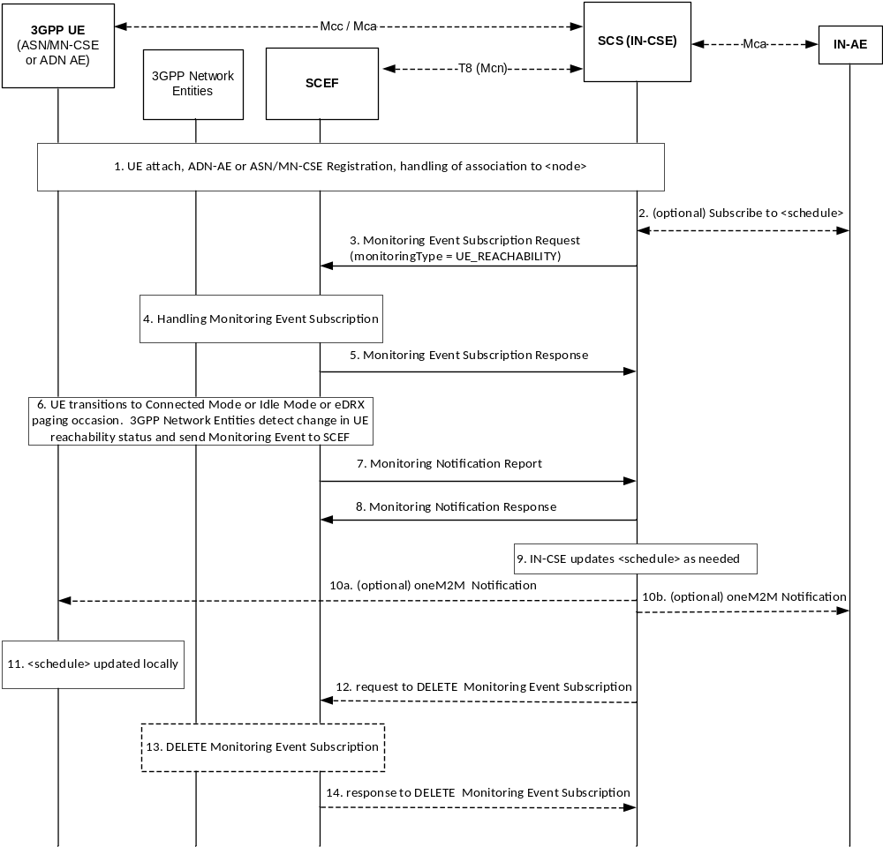
Figure 7.4.1 -1: Procedure for UE Reachability monitoring
Step 1: UE attaches to 3GPP network and registers to IN-CSE
The UE attaches to the 3GPP network and the ADN-AE(s) or ASN/MN-CSE hosted on the UE perform the oneM2M registration procedure, as detailed in clause 6.3. The IN-CSE hosts the corresponding <AE> or <remoteCSE> resources for the registree and an associated <node> resource.
Step 2 (Optional): Subscribe to <schedule>
As described in clause 6.3, if at the time of ADN-AE(s) or ASN/MN-CSE registration to the IN-CSE a child <schedule> resource of the <node> resource representing the UE does not exist, the IN-CSE shall create it. If an IN-AE, ADN-AE(s) or ASN/MN-CSE is interested in receiving notifications when this <schedule> resource is updated by the IN-CSE, based on UE reachability notifications from the underlying 3GPP network, it may subscribe to this <schedule> resource.
Step 3: Request for Monitoring Event Subscription to monitor the UE reachability
The IN-CSE sends a Monitoring Event Subscription request to the SCEF to monitor the reachability of a UE. The creation of one or more subscriptions to the node <schedule> in step 2 may be used to trigger the monitoring request if the networkCoordinated attribute of the <schedule> resource is set to TRUE.
The Monitoring Event Subscription request from the IN-CSE to the SCEF shall comply with Error: Reference source not found3GPP TS 29.122 [4]. The Monitoring Event Subscription request is configured as follows:
- An HTTP POST method shall be used
- URI shall be set to {apiRoot}/3gpp-monitoring-event/v1/{scsAsId}/subscriptions/. The {apiRoot} and {scsAsId} segments are configured based on Service Provider and MNO policies.
- The request payload shall include a MonitoringEventSubscription (API for Monitoring Event Subscription) data structure as specified in 3GPP TS 29.122 [4] with the following attributes:
  - externalId shall be set to the M2M-Ext-ID of the UE.
  - notificationDestination shall be set to a URI that the SCEF can target UE Reachability notifications towards. The value of this URI shall be based on internal IN-CSE policies.
  - monitoringType shall be set to UE_REACHABILITY
  - reachabilityType shall be set to DATA
  - idleStatusIndication shall be set to TRUE or FALSE. A setting of TRUE will result in the SCEF sending notifications to the IN-CSE when the UE transitions into PSM idle mode. These notifications will be in addition to any notifications sent to the IN-CSE when the UE transitions into connected mode or receives an eDRX paging occasion. A setting of FALSE (default) will result in the SCEF not sending notifications when the UE transitions into PSM idle mode. A setting of TRUE is only applicable for Ues supporting PSM. How the IN-CSE determines whether a UE supports PSM, eDRX or both is out of scope of the present document and may be configured based on Service Provider and MNO policies.
  - supportedFeatures shall be set to a string value of “2” indicating support for UE-Reachability notifications.
  - maximumNumberOfReports is optional and may be set to a maximum number of event reports to be generated by 3GPP network entities e.g. HSS or MME/SSGN. If used, the IN-CSE shall configure this time based on Service Provider and MNO policies.
  - monitorExpireTime is optional and may be set to an absolute time at which the UE reachability monitoring event request is considered to expire. If used, the IN-CSE shall configure this time based on Service Provider and MNO policies.
  - msisdn, ipv4Addr, ipv6Addr, externalGroupId, requestTestNotification, websockNotifConfig, groupReportGuardTime, maximumLatency, maximumResponseTime and suggestedNumberOfDlPackets are not supported by the present document and shall not be included.
Step 4: Handling in the 3GPP Network Entities
The SCEF processes the Monitoring Event Subscription request together with the 3GPP network entities, as described in 3GPP TS 29.122 [4].
Step 5: response to Monitoring Event Subscription
If the Monitoring Event Subscription Request is successfully processed, the SCEF responds indicating the request was accepted. The message includes the following information.

- A response code of 201 CREATED
- The URI of the Monitoring Event Subscription resource created by the SCEF. The URI is returned in the HTTP Location header with a format of {apiRoot}/3gpp-monitoring-event/v1/{scsAsId}/subscriptions/{subscriptionId}. The {apiRoot} and {scsAsId} segments are configured based on Service Provider and MNO policies. The {subscriptionId} segment is configured by the SCEF.
- The response payload will include a MonitoringEventSubscription data structure as specified in 3GPP TS 29.122 [4] that includes the attributes present in the request along with the following additional attributes:
  - self is configured with a URI to the resource created by the SCEF for the request
  - monitoringEventReport may be included if a monitoring event report is available.
See clause 8.3 for a list of possible error scenarios and error handling options for the IN-CSE.

Step 6: Detection of UE changing reachability mode and reporting to SCEF
Later, when the UE transitions to connected mode (for a UE using Power Saving Mode or extended idle mode DRX) or the UE becomes reachable for paging (for a UE using extended idle mode DRX) or the UE transitions to idle mode (for a UE using Power Saving Mode), the 3GPP network entities (e.g. HSS) detect the condition and send a Monitoring Event Report for UE reachability with Idle Status Information including Idle Status Timestamp, Periodic RAU/TAU timer, Active Time, eDRX Cycle Length) to the SCEF.
Step 7: SCEF sends Monitoring Notification to IN-CSE
When the SCEF receives information of status change in step 6, the SCEF creates and sends a Monitoring Notification message for UE reachability to the IN-CSE as specified in 3GPP TS 29.122 [4].
Otherwise, the Monitoring Notification message is sent with appropriate information in accordance with the monitoringType.
The Monitoring Notification report for UE_REACHABILITY is configured as follows:
- An HTTP POST method is used
- URI is set to {notification_uri}. The {notification_uri} is configured by the IN-CSE in the Monitoring Event Subscription Request.
- The request payload will include a MonitoringNotification (API for Monitoring Notification) data structure as specified in 3GPP TS 29.122 [4] with the following attributes:
  - subscription configured with a URI to the subscription resource for which this notification corresponds to
  - configResults is used for group-based monitoring and shall be ignored by the IN-CSE if present since group-based monitoring is not supported by the present document.
  - cancelInd shall be ignored by the IN-CSE if present since it is not supported by the present document.
  - monitoringEventReports configured with one or more UE Reachability monitoring reports wherein each report includes the following fields as defined in 3GPP TS 29.122 [4]:
    - externalIDs configured with the one or more externalId that shall be included the same value of M2M-Ext-ID of the UE at step 3.
    - monitoringType configured with UE_REACHABILITY
    - idleStatusInfo configured with information such as activeTime, edrxCycleLength, suggestedNumberOfDlPackets, idleStatusTimestamp, periodicAUTimer as defined in 3GPP TS 29.122 [4]
    - reachabilityType configured with a type of reachability as defined in 3GPP TS 29.122 [4]
Step 8: UE Reachability Monitoring Notification Response
After receiving a UE Reachability Monitoring Notification, the IN-CSE responds with a 204 NO CONTENT acknowledging the notification.

Step 9: UE Reachability Monitoring Notification Handling at the IN-CSE
The IN-CSE uses the information provided in the UE Reachability Monitoring Event Report as follows:
- If idleStatusInfo information is provided in the report, the IN-CSE shall change the scheduleElement of the UE’s node <schedule> resource such that the duration of the scheduleElement is set to the value of the activeTime parameter configured in the idleStatusInfo.
- If maxUEAvailabilityTime is provided in the report, the IN-CSE shall change the scheduleElement of the UE’s node <schedule> resource such that the duration of the scheduleElement is set to the value of maxUEAvailabilityTime.
Step 10a and 10b: (Optional) Notifications are sent to the entities which subscribed to changes in the <schedule> resources. This may include notifications sent to the ADN-AE(s) or ASN/MN-CSE hosted on the UE, if they have subscriptions to their respective <schedule> resources.
Step 11: Notification of schedule update
Upon receiving notification of <schedule> resource updates, the ADN-AE(s) or ASN/MN-CSE hosted on the UE process the notification and should update their local <schedule> resources (if applicable) with the same values.
Step 12 (Optional): request to delete Monitoring Event Subscription
The IN-CSE sends a DELETE request targeting the URI of the subscription resource corresponding to this Monitoring Event Subscription. This step may be triggered by the IN-CSE when the <node> or <schedule> resources associated with a UE are deleted or when the networkCoordinated attribute of the <schedule> resource affiliated with a UE is set to FALSE.
The request is configured as follows.
- An HTTP DELETE method shall be used
- URI shall be set to {apiRoot}/3gpp-monitoring-event/v1/{scsAsId}/subscriptions/{subscriptionId} which is identical to step 3. The {apiRoot} and {scsAsId} segments are configured based on Service Provider and MNO policies. The {subscriptionId} corresponds to the one configured by the SCEF and returned to the IN-CSE when the MonitoringEventSubscription was created.
- The request shall not contain a payload
Step 13 and 14 (Optional): Handling in 3GPP Network Entities and response to delete Monitoring Event Subscription
The SCEF processes the request to delete the Monitoring Event Subscription together with the 3GPP Network Entities.
The SCEF responds to the IN-CSE with a response either a code of 200 OK or 204 NO CONTENT indicating that it has successfully deleted the Monitoring Event Subscription.

7.4.2 UE Availability after DDN Failure
The 3GPP SCEF functionality described in 3GPP TS29.122 [4] supports APIs for monitoring of events such as UE Availability after a Downlink Data Notification (DDN) Failure. When communicating with Ues which sleep for a long time, if downlink packets are not delivered, the Underlying Network recognizes that the UE is not available by a lack of a response within a reasonable time.
Per this feature, the IN-CSE can subscribe and be notified every time the UE becomes reachable after the network fails to deliver a downlink packet. For example, when this option is set and the IN-CSE receives no response to downlink traffic towards a UE, the IN-CSE can assume that the network failed to deliver the packet because the UE was sleeping and not because of Network Issues. The network later sends a notification to the IN-CSE when the UE becomes reachable.
In the 3GPP Underlying Network, this feature involves an entry in the UE subscription, so it is an ongoing event that needs explicit deletion to cancel further reports and it is different than the UE Reachability Monitoring Request. The feature is particularly suitable when there is just one IN-CSE.
The IN-CSE may also request Idle Status Indication. If Idle Status Indication is supported by the Underlying Network, when the UE transitions into Idle mode, the report includes the time at which the UE transitioned into Idle mode, the active time and the periodic TAU/RAU time granted to the UE.
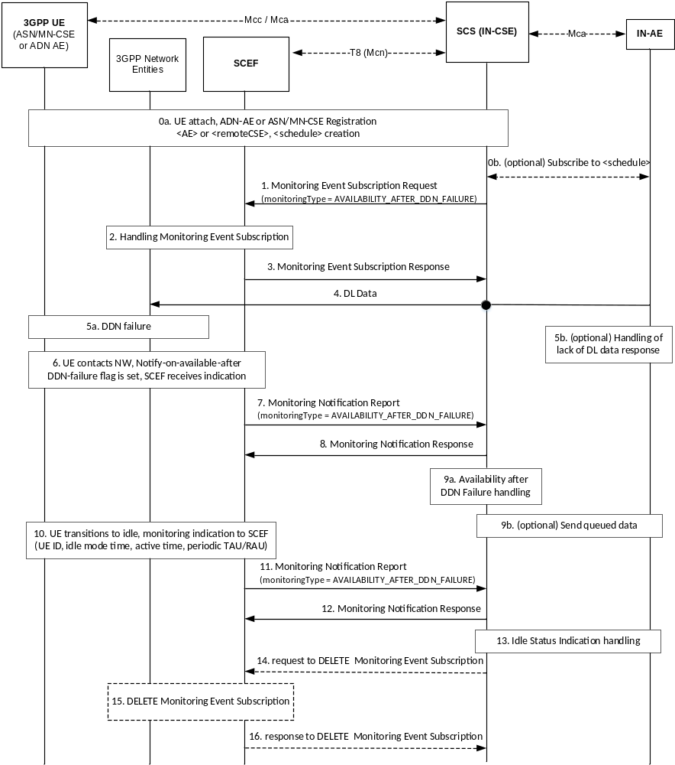
Figure 7.4.2-1: Availability after DDN Failure monitoring

Step 0: UE Attach and oneM2M Registration Procedures
The UE attaches to the 3GPP network and the ADN-AE(s) or ASN/MN-CSE hosted on the UE perform the oneM2M registration procedure, as detailed in clause 6.3. The IN-CSE hosts the corresponding <AE> or <remoteCSE> resources and an associated <node> resource for the registrees. During this procedure, a <schedule> resource is created as a child of the <node> resource. The UE hosted ADN-AE(s) or ASN/MN may subscribe to the node <schedule> resource.
If an IN-AE is interested in the reachability status of the UE, it may subscribe to the <schedule> resource if the networkCoordinated attribute of <schedule> resource is set to TRUE (step 0b, optional).
Step 1: IN-CSE sends a Monitoring Event Subscription Request to SCEF to monitor the UE Availability after a DDN Failure
This step may be triggered by the IN-CSE based on implementation options, for example after a certain number of downlink data delivery failures have occurred. The creation of a <schedule> child resource of a <node> resource may also be used to trigger the monitoring request if the networkCoordinated attribute of the <schedule> resource is set to TRUE.
The Monitoring Event Subscription request from the IN-CSE to SCEF contains information as specified in 3GPP TS 29.122 [4]Error: Reference source not found. Such information includes:
- An HTTP POST method shall be used
- URI shall be set to {apiRoot}/3gpp-monitoring-event/v1/{scsAsId}/subscriptions/. The {apiRoot} and {scsAsId} segments are configured based on Service Provider and MNO policies.
- The request payload shall include a MonitoringEventSubscription data structure as specified in 3GPP TS 29.122 [4] with the following attributes:
  - externalId shall be set to the M2M-Ext-ID of the UE.
  - notificationDestination shall be set to a URI that the SCEF can target DDN Failure notifications towards. The value of this URI shall be based on internal IN-CSE policies.
  - monitoringType shall be set to AVAILABILITY_AFTER_DDN_FAILURE
  - idleStatusIndication shall be set to TRUE or FALSE. A setting of TRUE will result in the SCEF sending notifications to the IN-CSE when the UE transitions into PSM idle mode. These notifications will be in addition to any notifications sent to the IN-CSE when the UE transitions into connected mode or receives an eDRX paging occasion. A setting of FALSE (default) will result in the SCEF not sending notifications when the UE transitions into PSM idle mode. A setting of TRUE is only applicable for Ues supporting PSM. How the IN-CSE determines whether a UE supports PSM, eDRX or both is out of scope for the present document and may be configured based on Service Provider and MNO policies.
  - supportedFeatures shall be set to a string value of “7” indicating support for availability after DDN Failure notifications.
  - maximumNumberOfReports is optional and may be set to a maximum number of event reports to be generated by 3GPP network entities e.g. HSS or MME/SSGN. If used, the IN-CSE shall configure this time based on Service Provider and MNO policies.
  - monitorExpireTime is optional and may be set to an absolute time at which the monitoring event request is considered to expire. If used, the IN-CSE shall configure this time based on Service Provider and MNO policies.
  - msisdn, ipv4Addr, ipv6Addr, externalGroupId, requestTestNotification, websockNotifConfig, groupReportGuardTime, maximumLatency and maximumResponseTime are not supported by the present document and shall not be included.
NOTE: It is recommended that Idle Status monitoring is enabled in conjunction with the Availability after DDN Failure monitoring. This enables the IN-CSE to update the <schedule> resource with updated timing information, once the UE transitions to idle again.
Step 2 and 3: Monitoring Event Subscription Request Handling in the Underlying Network
The SCEF handles the Monitoring Event Subscription Request together with the Mobile Core Network, as described in 3GPP TS23.682[2]. The SCEF sends a Monitoring Event Subscription Response message to the IN-CSE to acknowledge acceptance of the Monitoring Event Subscription Request.
The message includes the following information.

- A response code of 201 CREATED
- The URI of the Monitoring Event Subscription resource created by the SCEF. The URI is returned in the HTTP Location header with a format of {apiRoot}/3gpp-monitoring-event/v1/{scsAsId}/subscriptions/{subscriptionId}. The {apiRoot} and {scsAsId} segments are configured based on Service Provider and MNO policies. The {subscriptionId} segment is configured by the SCEF.
- The response payload will include a MonitoringEventSubscription data structure as specified in 3GPP TS 29.122 [4] that includes the attributes present in the request along with the following additional attributes:
  - self is configured with a URI to the resource created by the SCEF for the request
  - monitoringEventReport may be included if a monitoring event report is available.
See clause 8.3 for a list of possible error scenarios and error handling options for the IN-CSE.

Step 4: DL Data is sent to the UE
Downlink data is sent to the UE which, in the Underlying Network, involves sending a Downlink Data Notification (DDN) message to the MME, and MME initiates paging of UE.
Step 5a: DDN Failure
The Underlying Network diagnoses a DDN Failure when, after DDN, no response to the UE paging is received and if the UE is in PSM mode (not every DDN failure triggers this event), the UE subscription is updated to reflect that a notification of availability should be sent after this DDN failure.
Step 5b: Request failure handling
The IN-CSE may also diagnose the failure when no response to the DL data has been received. It is up to implementation if the IN-CSE changes the node <schedule> resource at this point to indicate that communications are not available (e.g. by using a keyword such as “NULL”), or just records it as a one-time response failure. Other alternatives for implementation are, for example, for the IN-CSE to change the node <schedule> resource to indicate that communications are not available only after a pre-provisioned number of requests fail. The IN-CSE may also buffer future requests or enlarge its buffer size.
Step 6: Available after DDN Failure
At a later time, the UE contacts the network, e.g., to perform a TAU, or as it executes a service request. The Underlying Network notes that the UE is available and that an availability notification is requested in the subscription. A Monitoring Indication that the UE is available is sent to the SCEF.
Step 7: SCEF sends a DDN Failure Monitoring Notification Request to IN-CSE
When the SCEF receives information of status change to available communication, the SCEF creates and sends a Monitoring Notification message for AVAILABILITY_AFTER_DDN_FAILURE to the IN-CSE as specified in 3GPP TS 29.122 [4].
Otherwise, the Monitoring Notification message is sent with appropriate information in accordance with the monitoringType.
The SCEF sends a DDN Failure Monitoring Notification Report to the IN-CSE as specified in 3GPP TS 29.122 [4], indicating that the UE is available, including:
- An HTTP POST method is used
- URI is set to {notification_uri}. The {notification_uri} is configured by the IN-CSE in the Monitoring Event Subscription Request.
- The request payload will include a MonitoringNotification data structure as specified in 3GPP TS 29.122 [4] with the following attributes:
  - subscription configured with a URI to the subscription resource for which this notification corresponds to
  - configResults is used for group-based monitoring and shall be ignored by the IN-CSE if present since group-based monitoring is not supported by the present document.
  - cancelind shall be ignored by the IN-CSE if present since it is not supported by the present document.
  - monitoringEventReports configured with one or more DDN Failure monitoring reports wherein each report includes the following fields as defined in 3GPP TS 29.122 [4]:
    - externalIDs configured with one or more externalID that will be configured with the same values of M2M-Ext-ID of the UE in step 1.
    - monitoringType configured with AVAILABILITY_AFTER_DDN_FAILURE
    - idleStatusInfo configured with information such as activeTime, edrxCycleLength, suggestedNumberOfDlPackets, idleStatusTimestamp, periodicAUTimer as defined in 3GPP TS 29.122 [4]
Step 8: DDN Failure Monitoring Notification Response
After receiving a DDN Failure Monitoring Notification, the IN-CSE returns a response having a response code of 204 NO CONTENT.

Step 9a and 9b: Availability after DDN Failure Handling at the IN-CSE
The IN-CSE uses the information provided in the Monitoring Notification Report to update the node <schedule> to indicate that the UE is available.
A new scheduleElement shall be created that indicates that the node is available for communication starting immediately and will remain available for at least the duration specified by the Maximum Response Time parameter.
Later (step 9b, optional) IN-AE(s) or the IN-CSE may decide to resend data queued for the UE.
Step 10: UE transitions to Idle
UE transitions to idle mode. If Idle Status Indication was requested during Monitoring Event configuration, and the MCN supports Idle Status Indication, then the SCEF is provided with an indication which includes the time at which the UE transitioned into idle mode, the active time and the periodic TAU/RAU timer values.
Step 11: SCEF sends a UE Reachability Monitoring Event Notification Request to IN-CSE
The SCEF provides a Monitoring Event Notification Request to the IN-CSE as specified in 3GPP TS 29.122 [4], including:
- An HTTP POST method is used
- URI is set to {notification_uri}. The {notification_uri} is configured by the IN-CSE in the Monitoring Event Subscription Request.
- The request payload will include a MonitoringNotification (API for Monitoring Notification) data structure as specified in 3GPP TS 29.122 [4] with the following attributes:
  - subscription configured with a URI to the subscription resource for which this notification corresponds to
  - configResults is used for group-based monitoring and shall be ignored by the IN-CSE if present since group-based monitoring is not supported by the present document.
  - cancelind shall be ignored by the IN-CSE if present since it is not supported by the present document.
  - monitoringEventReports configured with one or more UE Reachability monitoring reports wherein each report includes the following fields as defined in 3GPP TS 29.122 [4]:
    - externalIDs configured with one or more externalIDs that will be configured with the same values of M2M-Ext-ID of the UE as step 1.
    - monitoringType configured with UE_REACHABILITY
    - idleStatusInfo configured with information such as activeTime, edrxCycleLength, suggestedNumberOfDlPackets, idleStatusTimestamp, periodicAUTimer as defined in 3GPP TS 29.122 [4]
Step 12: Monitoring Event Notification Response
After receiving a Monitoring Event Notification, the IN-CSE returns a response having a response code of 204 NO CONTENT.

Step 13: UE Idle mode indication Handling at the IN-CSE
The IN-CSE uses the UE Idle status information to update the <schedule> child resource of the <node > resource.
The IN-CSE changes the <schedule> resource such that:
- the start of the scheduleElement is based on the Idle Timestamp, with a periodicity equal to the TAU/RAU Timer.
- the duration of the scheduleElement indicates the Active Time value.
When any traffic is received from the node or an Availability Notification is received for the node, any scheduleElement(s) that were created based on prior Idle Status Indications shall be deleted for the node. A new scheduleElement shall be created that indicates that the node is available for downlink communication starting immediately and will remain available for at least the duration specified by the Maximum Response Time parameter.
Step 14 (Optional): IN-CSE sends request to SCEF to delete Monitoring Event Subscription
The IN-CSE sends a DELETE request targeting the URI of the subscription resource corresponding to this Monitoring Event Subscription. This step may be triggered by IN-CSE when the <node> or <schedule> resources associated with a UE are deleted or when the networkCoordinated attribute of the <schedule> resource affiliated with a UE is set to FALSE .
The request is configured as follows.
- An HTTP DELETE method shall be used
- URI shall be set to {apiRoot}/3gpp-monitoring-event/v1/{scsAsId}/subscriptions/{subscriptionId} which is identical to step 1. The {apiRoot} and {scsAsId} segments are configured based on Service Provider and MNO policies. The {subscriptionId} corresponds to the one configured by the SCEF and returned to the IN-CSE when the MonitoringEventSubscription was created.
- The request shall not contain a payload
Step 15 and 16 (Optional): Monitoring Event Subscription Delete Request Handling in the Underlying Network
The SCEF handles the request to delete Monitoring Event Subscription together with the 3GPP network entities. The SCEF returns a response to the IN-CSE with a response code of 204 NO CONTENT to acknowledge the Monitoring Event Subscription has been deleted.

7.4.3 UE Communication Failure
The 3GPP SCEF Event Monitoring functionality described in 3GPP TS 29.122 [4] supports an API to allow an IN-CSE to be informed when the UE communication failure occurs. Informing the IN-CSE that Ues have suffered communication failures in the Underlying Network helps optimize communications. For example, the IN-CSE may stop attempting to communicate with the UE if it is aware of repeated communication failures.
The UE Communication Failure Monitoring flow is assumed to take place after the UE has attached to the 3GPP Network and registered with the IN-CSE.

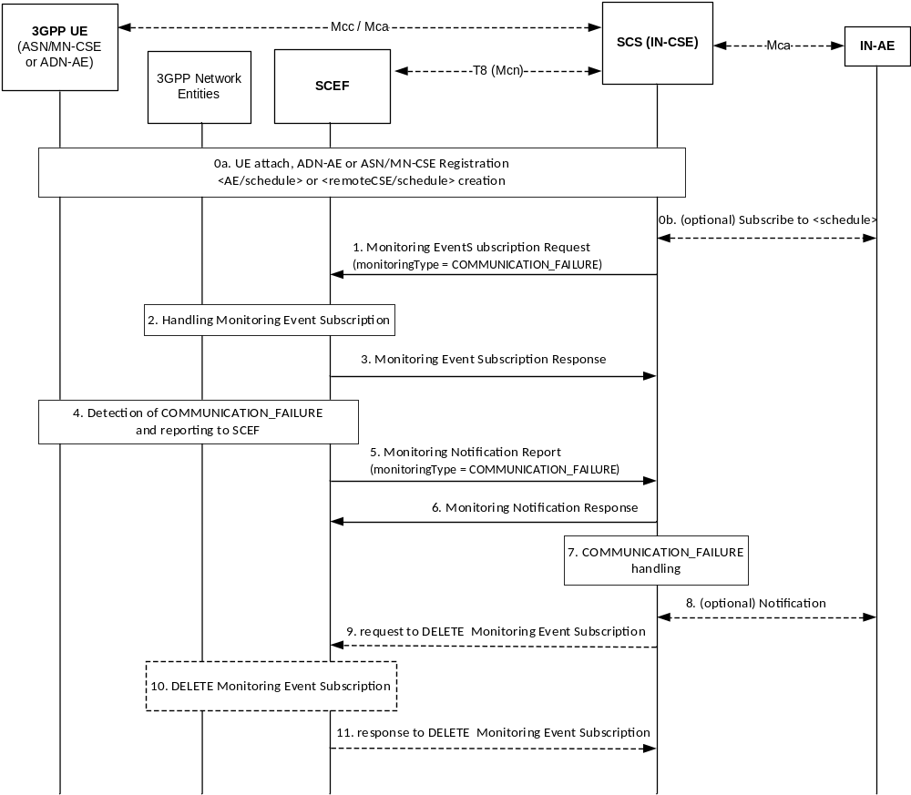
Figure 7.4.3 -1: Communication Failure monitoring

Step 0: UE Attach and oneM2M Registration Procedures
The UE attaches to the 3GPP network and the ADN-AE(s) or ASN/MN-CSE hosted on the UE perform the oneM2M registration procedure, as detailed in clause 6.3. The IN-CSE hosts the corresponding <AE> or <remoteCSE> resources and an associated <node> resource for the registree. During this procedure, a <schedule> resource is created as a child of the <node> resource. The UE hosted ADN-AE(s) or ASN/MN may subscribe to the node <schedule> resource.
If an IN-AE is interested in the communication failure status of the UE, it may subscribe to the node <schedule> resource (step 0b, optional).
Step 1: IN-CSE sends a Monitoring Event Subscription Request to SCEF to monitor the UE Communication Failure
This step may be triggered by an IN-CSE based on implementation options, for example when a type of communication requiring high reliability is scheduled to occur. The creation of a <schedule> child resource of a <node> resource may also be used to trigger the monitoring request if the networkCoordinated attribute of <schedule> resource is set to TRUE.
The Monitoring Event Subscription request from the IN-CSE to SCEF contains information as specified in 3GPP TS 29.122 [4]. Such information includes:
- An HTTP POST method shall be used
- URI shall be set to {apiRoot}/3gpp-monitoring-event/v1/{scsAsId}/subscriptions/. The {apiRoot} and {scsAsId} segments are configured based on Service Provider and MNO policies.
- The request payload shall include a MonitoringEventSubscription (API for Monitoring Event Subscription) data structure as specified in 3GPP TS 29.122 [4] with the following attributes:
  - externalId shall be set to the M2M-Ext-ID of the UE.
  - notificationDestination shall be set to a URI that the SCEF can target Communication Failure notifications towards. The value of this URI shall be based on internal IN-CSE policies.
  - monitoringType shall be set to COMMUNICATION_FAILURE
  - supportedFeatures shall be set to a string value of “6” indicating support for Communication Failure notifications.
  - maximumNumberOfReports is optional and may be set to a maximum number of event reports to be generated by 3GPP network entities e.g. HSS or MME/SSGN. If used, the IN-CSE shall configure this time based on Service Provider and MNO policies.
  - monitorExpireTime is optional and may be set to an absolute time at which the monitoring event request is considered to expire. If used, the IN-CSE shall configure this time based on Service Provider and MNO policies.
  - msisdn, ipv4Addr, ipv6Addr, externalGroupId, requestTestNotification, websockNotifConfig, groupReportGuardTime, maximumLatency and maximumResponseTime are not supported by the present document and shall not be included.
NOTE: It is recommended that Idle Status monitoring is enabled in conjunction with the Availability after DDN Failure monitoring. This enables the IN-CSE to update the <schedule> resource with updated timing information, once the UE transitions to idle again.
Step 2: -Step 3: Monitoring Event Subscription Request Handling in the Underlying Network
The SCEF handles the Monitoring Event Subscription Request together with the 3GPP network entities, as described in 3GPP TS29.122 [4]. The SCEF sends a Monitoring Event Subscription Response message to the IN-CSE to acknowledge acceptance of the Monitoring Event Subscription Request.
The message includes the following information.

- A response code of 201 CREATED
- The URI of the Monitoring Event Subscription resource created by the SCEF. The URI is returned in the HTTP Location header with a format of {apiRoot}/3gpp-monitoring-event/v1/{scsAsId}/subscriptions/{subscriptionId}. The {apiRoot} and {scsAsId} segments are configured based on Service Provider and MNO policies. The {subscriptionId} segment is configured by the SCEF.
- The response payload will include a MonitoringEventSubscription data structure as specified in 3GPP TS 29.122 [4] that includes the attributes present in the request along with the following additional attributes:
  - self is configured with a URI to the resource created by the SCEF for the request
  - monitoringEventReport may be included if a monitoring event report is available.
See clause 8.3 for a list of possible error scenarios and error handling options for the IN-CSE.

Step 4: Detection of Communication Failure and reporting to SCEF
Later, when the UE communication failure occurs the condition is detected in the Underlying Network and the SCEF receives a Monitoring Event Report.
Step 5: SCEF sends UE Communication Failure Monitoring Event Notification Request to IN-CSE
When the SCEF receives information of status change of the UE, the SCEF sends a Monitoring Notification Report to the IN-CSE for UE communication failure information as specified in 3GPP TS 29.122 [4]Error: Reference source not found.
Otherwise, the Monitoring Notification message is sent with appropriate information in accordance with the monitoringType.
The Monitoring Notification report for COMMUNICATION_FAILURE includes:
- An HTTP POST method is used
- URI is set to {notification_uri}. The {notification_uri} is configured by the IN-CSE in the Monitoring Event Subscription Request.
- The request payload will include a MonitoringNotification (API for Monitoring Notification) data structure as specified in 3GPP TS 29.122 [4] with the following attributes:
  - subscription configured with a URI to the subscription resource for which this notification corresponds to.
  - configResults is used for group-based monitoring and shall be ignored by the IN-CSE if present since group-based monitoring is not supported by the present document.
  - cancelind shall be ignored by the IN-CSE if present since it is not supported by the present document.
  - monitoringEventReports configured with one or more Communication Failure monitoring reports wherein each report includes the following fields as defined in 3GPP TS 29.122 [4]:
    - externalID configured with one or more externalID that will be configured with the same value of M2M-Ext-ID of the UE as step 1.
    - monitoringType configured with COMMUNICATION_FAILURE
    - failureCause configured with a reason of communication failure such as bssgpCause, causeType, gmmCause, ranapCause, ranNasCause, s1ApCause and smCause.
Step 6: UE Communication Failure Monitoring Event Notification Response
After receiving a UE Communication Failure Monitoring Notification for communication failure, the IN-CSE returns a response having a response code of 204 NO CONTENT.

Step 7: Communication Failure Handling at the IN-CSE
The IN-CSE uses the information provided in the Monitoring Notification Report to update the scheduleElement of the <schedule> resource to indicate that no communications are currently available (e.g. by using a keyword such as “NULL”). Local IN-CSE policies may specify events/ thresholds further defining when the IN-CSE may provide the <schedule> resource update. For example, the update may be provided only after repeated communication failures are received within a timespan, or only if high reliability communications are expected. It is recommended that UE Reachability monitoring is also enabled in conjunction with the Communication Failure monitoring. This enables the IN-CSE to provide updated timing information in the <schedule> resource, once the UE becomes reachable again.
Step 8: (Optional) Notifying subscribers
Optionally, notifications may sent to the subscribers of the <schedule> resource.
Step 9 (Optional): IN-CSE sends request to SCEF to delete Monitoring Event Subscription
The IN-CSE sends a DELETE request targeting the URI of the subscription resource corresponding to this Monitoring Event Subscription. This step may be triggered by IN-CSE when a ADN-AE(s) or ASN/MN-CSE hosted on the UE de-registers from the IN-CSE or when the networkCoordinated attribute of the <schedule> resource affiliated with an ADN-AE or ASN/MN-CSE hosted on a UE is set to FALSE.
The request is configured as follows.
- An HTTP DELETE method shall be used
- URI shall be set to {apiRoot}/3gpp-monitoring-event/v1/{scsAsId}/subscriptions/{subscriptionId} which is identical to step 1. The {apiRoot} and {scsAsId} segments are configured based on Service Provider and MNO policies. The {subscriptionId} corresponds to the one configured by the SCEF and returned to the IN-CSE when the MonitoringEventSubscription was created.
- The request shall not contain a payload
Step 10 and 11 (Optional): Monitoring Event Subscription Delete Request Handling in the Underlying Network
The SCEF handles request to delete the Monitoring Event Subscription together with the 3GPP network entities. The SCEF responds to the IN-CSE with a response code of 204 NO CONTENT to acknowledge the Monitoring Event Subscription has been deleted.

7.4.4 UE Loss of Connectivity
An IN-CSE can communicate with large numbers of devices, many of which are reachable for short periods of time. An IN-CSE may want to be informed when devices are not reachable to the Underlying Network, to better manage its communications. For example, IN-Aes which normally communicate with the device might not attempt communications if neither signalling or user plane communication are available.
The 3GPP SCEF functionality described in 3GPP TS 29.122 [4] supports APIs for monitoring specific events such as UE Loss of Connectivity Monitoring. The Loss of Connectivity Monitoring Event subscription allows the IN-CSE to provide to the network a Maximum Detection Time, which indicates the maximum period of time without any communication between the UE and Network after which the IN-CSE is to be informed that the device is considered to be unreachable.
The Maximum Detection Time of loss of connectivity is on the order of 1 minute to multiple hours. A timer with the order of magnitude of a few minutes can only apply to a limited number of devices due to the network signalling cost.
NOTE: In the 3GPP Network, the Maximum Detection Time of loss of connectivity can be used to determine the order of magnitude of the Periodic Update timer.

The UE Loss of Connectivity Monitoring flow is assumed to take place after the UE has attached to the 3GPP Network and registered with the IN-CSE.
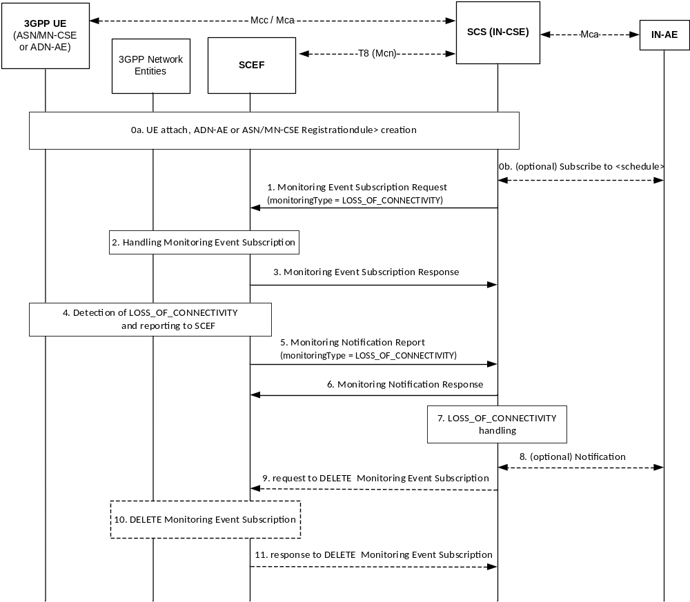
Figure 7.4.4-1: Loss of Connectivity monitoring

Step 0: UE Attach and oneM2M Registration Procedures
The UE attaches to the 3GPP network and the ADN-AE(s) or ASN/MN-CSE hosted on the UE perform the oneM2M registration procedures, as detailed in clause 6.3. The IN-CSE hosts the corresponding <AE> or <remoteCSE> resources for the registree, and an associated <node> resource. During this procedure, a <schedule> resource is created as a child of the <node> resource and the networkCoordinated attribute of the <schedule> resource is set to TRUE.
If an IN-AE is interested in the reachability status of the UE, it may subscribe to the <schedule> resource (step 0b, optional).
Step 1: IN-CSE sends a Monitoring Request to SCEF to monitor the UE Loss of Connectivity
This step may be triggered by the IN-CSE on creation of a <schedule> child resource of a <node> resource if the networkCoordinated attribute of the <schedule> resource is set to TRUE.
The Monitoring Event Subscription request from the IN-CSE to SCEF contains information as specified in 3GPP TS 29.122 [4]. Such information includes:
- An HTTP POST method shall be used
- URI shall be set to {apiRoot}/3gpp-monitoring-event/v1/{scsAsId}/subscriptions/. The {apiRoot} and {scsAsId} segments are configured based on Service Provider and MNO policies.
- The request payload shall include a MonitoringEventSubscription data structure as specified in 3GPP TS 29.122 [4] with the following attributes:
  - externalId shall be set to the M2M-Ext-ID of the UE.
  - notificationDestination shall be set to a URI that the SCEF can target Loss of Connectivity notifications towards. The value of this URI shall be based on internal IN-CSE policies.
  - monitoringType shall be set to LOSS_OF_CONNECTIVITY
  - supportedFeatures shall be set to a string value of “1” indicating support for Loss of Connectivity notifications.
  - maximumNumberOfReports is optional and may be set to a maximum number of event reports to be generated by 3GPP network entities e.g. HSS or MME/SSGN. If used, the IN-CSE shall configure this time based on Service Provider and MNO policies.
  - monitorExpireTime is optional and may be set to an absolute time at which the monitoring event request is considered to expire. If used, the IN-CSE shall configure this time based on Service Provider and MNO policies.
  - msisdn, ipv4Addr, ipv6Addr, externalGroupId, requestTestNotification, websockNotifConfig, groupReportGuardTime, maximumLatency, maximumResponseTime and suggestedNumberOfDlPackets are not supported by the present document and shall not be included.
  - maximumDetectionTime shall be set per IN-CSE pre-provisioning. This value should be set to a value that is longer than the length of time of inactive communications as configured in the <schedule> resource
  - msisdn, ipv4Addr, ipv6Addr, externalGroupId, requestTestNotification, websockNotifConfig, groupReportGuardTime, maximumLatency and maximumResponseTime are not supported by the present document and shall not be included.
Step 2 and Step 3: Monitoring Request Handling in the Underlying Network
The SCEF handles the Monitoring Event Subscription Request together with the 3GPP network entities, as described in 3GPP TS29.122 [4]. The SCEF sends a Monitoring Event Subscription Response message to the IN-CSE to acknowledge acceptance of the Monitoring Event Subscription Request.
The message includes the following information.

- A response code of 201 CREATED
- The URI of the Monitoring Event Subscription resource created by the SCEF. The URI is returned in the HTTP Location header with a format of {apiRoot}/3gpp-monitoring-event/v1/{scsAsId}/subscriptions/{subscriptionId}. The {apiRoot} and {scsAsId} segments are configured based on Service Provider and MNO policies. The {subscriptionId} segment is configured by the SCEF.
- The response payload will include a MonitoringEventSubscription data structure as specified in 3GPP TS 29.122 [4] that includes the attributes present in the request along with the following additional attributes:
  - self is configured with a URI to the resource created by the SCEF for the request
  - monitoringEventReport may be included if a monitoring event report is available.

See clause 8.3 for a list of possible error scenarios and error handling options for the IN-CSE.

Step 4: Detection of Loss of Connectivity and reporting to SCEF
Later, when the UE loses connectivity, the 3GPP network entities (e.g. MME) detect the condition and sends a Monitoring Event Report to SCEF
Step 5: SCEF sends UE Loss of Connectivity Monitoring Notification Request to IN-CSE
The SCEF sends a Monitoring Event Notification Request to the IN-CSE when receiving the Monitoring Report that contains information as specified in 3GPP TS 29.122 [4]Error: Reference source not found. Such information includes:
- An HTTP POST method is used
- URI is set to {notification_uri}. The {notification_uri} is configured by the IN-CSE in the Monitoring Event Subscription Request.
- The request payload will include a MonitoringNotification data structure as specified in 3GPP TS 29.122 [4] with the following attributes:
  - subscription configured with a URI to the subscription resource for which this notification corresponds to
  - configResults is used for group-based monitoring and shall be ignored by the IN-CSE if present since group-based monitoring is not supported by the present document.
  - cancelind shall be ignored by the IN-CSE if present since it is not supported by the present document
  - monitoringEventReports configured with one or more Loss of Connectivity monitoring reports wherein each report includes the following fields as defined in 3GPP TS 29.122 [4]:
    - externalIDs configured with one or more externalID that will be configured with the same value of M2M-Ext-ID of the UE as step 1.
    - monitoringType configured with LOSS_OF_CONNECTIVITY
    - lossOfConnectReason configured with the reason for loss of connectivity as defined in 3GPP TS 29.122 [4]
Step 6: UE Loss of Connectivity Monitoring Event Notification Response
After receiving a UE Loss of Connectivity Monitoring Notification, the IN-CSE returns a response having a response code of 204 NO CONTENT.
Step 7: Loss of Connectivity Handling at the IN-CSE
The IN-CSE uses the information provided in the Monitoring Notification Report to update the <schedule> child resource of the <node> resource to indicate that no communications are currently available (e.g. by using a keyword such as “NULL”). Updates to the <schedule> resource will be performed only if its networkCoordinated attribute is set to TRUE.
NOTE: It is recommended that UE Reachability monitoring is also enabled in conjunction with the Loss of Connectivity monitoring. This enables the IN-CSE to provide updated timing information in the <schedule> resource, once the UE becomes reachable again.
Step 8: (Optional) Notifying subscribers
Optionally, if IN-Aes have subscribed to changes in the <schedule> resources a notification will be sent to the subscribers.
Step 9 (Optional): IN-CSE sends request to SCEF to delete Monitoring Event Subscription
The IN-CSE sends a DELETE request targeting the URI of the subscription resource corresponding to this Monitoring Event Subscription. This step may be triggered by IN-CSE when a ADN-AE(s) or ASN/MN-CSE hosted on the UE de-registers from the IN-CSE or when the networkCoordinated attribute of the <schedule> resource affiliated with an ADN-AE or ASN/MN-CSE hosted on a UE is set to FALSE.
The request is configured as follows.
- An HTTP DELETE method shall be used
- URI shall be set to {apiRoot}/3gpp-monitoring-event/v1/{scsAsId}/subscriptions/{subscriptionId} which is identical to step 1. The {apiRoot} and {scsAsId} segments are configured based on Service Provider and MNO policies. The {subscriptionId} corresponds to the one configured by the SCEF and returned to the IN-CSE when the MonitoringEventSubscription was created.
- The request shall not contain a payload
Step 10 and 11 (Optional): Monitoring Event Subscription Delete Request Handling in the Underlying Network
The SCEF handles the request to delete Monitoring Event Subscription together with the 3GPP network entities. The SCEF responds to the IN-CSE with a response code of 204 NO CONTENT to acknowledge the Monitoring Event Subscription has been deleted.

7.4.5 Detecting Change of IMSI-IMEI(SV) Association
The 3GPP SCEF Event Monitoring functionality described in 3GPP TS 29.122 [4] supports an API that allows the IN-CSE to be informed when the SIM card of one physical device is placed in another physical device. This condition is detected by the underlying 3GPP network when the association between the International Mobile Subscriber Identity (IMSI) and International Mobile Equipment Identity (IMEI/IMEISV) changes.
An IN-CSE may request to receive notifications from an underlying 3GPP network when the association between the IMSI and IMEI(SV) changes for a given UE that hosts one or more ASN/MN-CSEs or ADN-Aes registered to the IN-CSE. Based on this notification, the IN-CSE may then ignore incoming requests from these ASN/MN-CSEs or ADN-Aes.
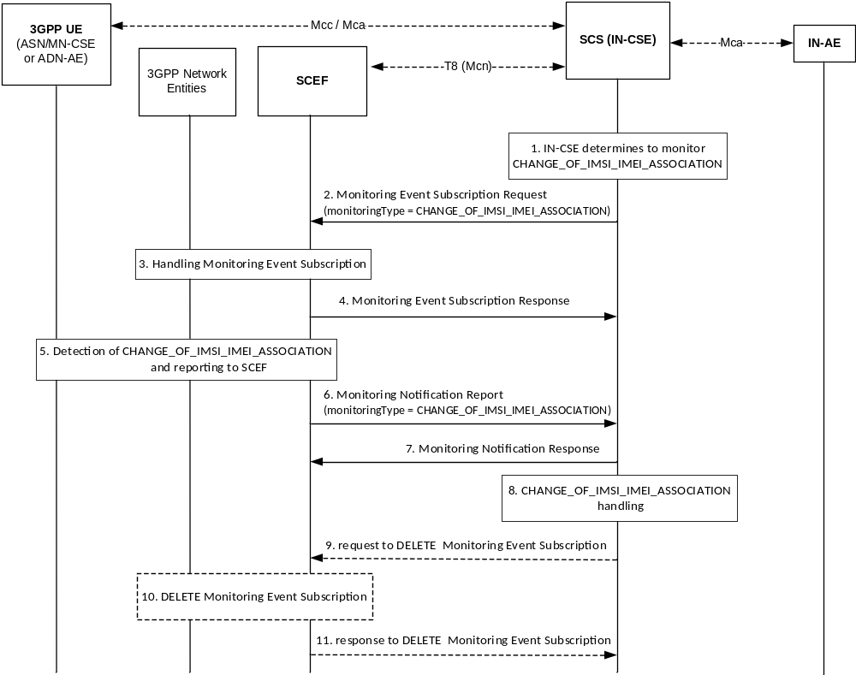
Figure 7.4.5-1: Change of IMSI-IMEI(SV) Association Monitoring Request and Notification
Pre-conditions:
There is a relationship in place between the IN-CSE and MNO allowing the IN-CSE to request notifications for IMSI-IMEI(SV) association changes.
An ASN/MN-CSE or ADN-AE registers with the IN-CSE and configures the M2M-Ext-ID attribute of its <remoteCSE> or <AE> resource. The IN-CSE examines the M2M-Ext-ID and recognizes that it is associated with an MNO that it has a relationship with. The relationship allows the IN-CSE to request notifications when the device’s IMSI-IMEI(SV) association changes.
Step 1: IN-CSE requests notification for changes in IMSI-IMEI(SV) association
The IN-CSE determines whether it wants a notification if the IMSI-IMEI(SV) association of a particular UE hosting one or more ASN/MN-CSEs or ADN-Aes changes. This determination may be based on whether the IN-CSE has an established relationship with the underlying 3GPP network operator that supports this capability and provisioned policies.
Step 2: Monitoring Event Subscription Request
The IN-CSE sends a request to be notified when the device’s IMSI-IMEI(SV) association changes. The Monitoring Event Subscription Request contains information as specified in 3GPP TS 29.122 [4]Error: Reference source not found which includes the following:
- An HTTP POST method shall be used
- URI shall be set to {apiRoot}/3gpp-monitoring-event/v1/{scsAsId}/subscriptions/. The {apiRoot} and {scsAsId} segments are configured based on Service Provider and MNO policies.
- The request payload shall include a MonitoringEventSubscription data structure as specified in 3GPP TS 29.122 [4] with the following attributes:
  - externalId shall be set to the M2M-Ext-ID of the UE.
  - notificationDestination shall be set to a URI that the SCEF can target Change of IMSI/IMEI Association notifications towards. The value of this URI shall be based on internal IN-CSE policies.
  - monitoringType shall be set to CHANGE_OF_IMSI_IMEI_ASSOCIATION
  - supportedFeatures shall be set to a string value of “4” indicating support for Change of IMSI/IMEI Association notifications.
  - maximumNumberOfReports is optional and may be set to a maximum number of event reports to be generated by 3GPP network entities e.g. HSS or MME/SSGN. If used, the IN-CSE shall configure this time based on Service Provider and MNO policies.
  - monitorExpireTime is optional and may be set to an absolute time at which the monitoring event request is considered to expire. If used, the IN-CSE shall configure this time based on Service Provider and MNO policies.
  - maximumDetectionTime shall be set per IN-CSE pre-provisioning. This value should be set to a value that is longer than the length of time of inactive communications as configured in the <schedule> resource
  - associationType shall be set to IMEI or IMEISV. The type that is used is based on IN-CSE policies which may be based on the relationship between the Service Provider and MNO
  - msisdn, ipv4Addr, ipv6Addr, externalGroupId, requestTestNotification, websockNotifConfig, groupReportGuardTime, maximumLatency and maximumResponseTime are not supported by the present document and shall not be included.
Step 3: Process Monitoring Event Subscription Request
The SCEF processes the Monitoring Event Subscription request together with 3GPP network entities.

Step 4: Monitoring Event Subscription Response
The SCEF sends a Monitoring Event Subscription Response message to the IN-CSE to acknowledge acceptance of the Monitoring Event Subscription Request.
The message includes the following information.

- A response code of 201 CREATED
- The URI of the Monitoring Event Subscription resource created by the SCEF. The URI is returned in the HTTP Location header with a format of {apiRoot}/3gpp-monitoring-event/v1/{scsAsId}/subscriptions/{subscriptionId}. The {apiRoot} and {scsAsId} segments are configured based on Service Provider and MNO policies. The {subscriptionId} segment is configured by the SCEF.
- The response payload will include a MonitoringEventSubscription data structure as specified in 3GPP TS 29.122 [4] that includes the attributes present in the request along with the following additional attributes:
  - self is configured with a URI to the resource created by the SCEF for the request
  - monitoringEventReport may be included if a monitoring event report is available.
See clause 8.3 for a list of possible error scenarios and error handling options for the IN-CSE.
Step 5: Detect change in IMSI-IMEI(SV) association
The underlying 3GPP network entities monitor and detect a IMSI-IMEI(SV) association change and reports Monitoring Event Report to SCEF .
Step 6: Monitoring Notification report
When the SCEF receives information of status change on IMSI-IMEI(SV) association, the SCEF sends a Monitoring Notification to the corresponding notificationDestination of the IN-CSE that was configured in the Monitoring Event Subcription Request and that contains information as specified in 3GPP TS 29.122 [4]Error: Reference source not found.
Otherwise, the MonitoringNotification message is sent with appropriate information in accordance with the monitoringType.
The Montoring Notification report for CHANGE_OF_IMSI_IMEI_ASSOCIATION includes:
- An HTTP POST method is used
- URI is set to {notification_uri}. The {notification_uri} is configured by the IN-CSE in the Monitoring Event Subscription Request at step 2.
- The request payload will include a MonitoringNotification data structure as specified in 3GPP TS 29.122 [4] with the following attributes:
  - subscription configured with a URI to the subscription resource for which this notification corresponds to
  - configResults is used for group-based monitoring and shall be ignored by the IN-CSE if present since group-based monitoring is not supported by the present document.
  - cancelind shall be ignored by the IN-CSE if present since it is not supported by the present document
  - monitoringEventReports configured with one or more Loss of Connectivity monitoring reports wherein each report includes the following fields as defined in 3GPP TS 29.122 [4]:
    - externalIDs configured with one or more externalID that will be configured with the same value of M2M-Ext-ID of the UE as step 2.
    - monitoringType configured with CHANGE_OF_IMSI_IMEI_ASSOCIATION
    - associationType configured with IMSI-IMEI or IMSI-IMEISV
Step 7: Monitoring Notofication Response
After receiving a Change of IMSI-IMEI Association Monitoring Event Notification, the IN-CSE returns a response having a response code of 204 NO CONTENT.
Step 8: Process Notification
The IN-CSE shall stop servicing requests from any ASN/MN-CSEs or ADN-Aes having an M2M-Ext-ID matching the one indicated in the report. To block these requests, the IN-CSE may tear down any active security associations (e.g. D/TLS sessions) between the IN-CSE and these ADN-Aes or ASN/MN-CSEs. In addition, the IN-CSE may also deny new security association establishment requests from any ADN-Aes or ASN/MN-CSEs that have an M2M-Ext-ID matching the one indicated in the report until the restriction is removed via administrative means which are outside the scope of the present document.
Step 9 (Optional): IN-CSE sends request to SCEF to delete Monitoring Event Subscription
The IN-CSE sends a DELETE request targeting the URI of the subscription resource corresponding to this Monitoring Event Subscription. This step may be triggered by IN-CSE when a ADN-AE(s) or ASN/MN-CSE hosted on the UE de-registers from the IN-CSE.
The request is configured as follows.
- An HTTP DELETE method shall be used
- URI shall be set to {apiRoot}/3gpp-monitoring-event/v1/{scsAsId}/subscriptions/{subscriptionId} which is identical to step 2. The {apiRoot} and {scsAsId} segments are configured based on Service Provider and MNO policies. The {subscriptionId} corresponds to the one configured by the SCEF and returned to the IN-CSE when the MonitoringEventSubscription was created.
- The request shall not contain a payload
Step 10 and 11 (Optional): Monitoring Event Subscription Delete Request Handling in the Underlying Network.
The SCEF handles the request to delete Monitoring Event Subscription together with the 3GPP network entities. The SCEF responds to the IN-CSE with a response code of 204 NO CONTENT to acknowledge the Monitoring Event Subscription has been deleted.

7.4.6 Roaming Status
The 3GPP SCEF Monitoring functionality described in 3GPP TS 29.122 [4] supports an API to allow an IN-CSE to be informed when the roaming status of a UE in the underlying 3GPP network changes.
An IN-CSE may request to receive indications from an underlying 3GPP network when the roaming status of a 3GPP UE hosting an ASN/MN-CSE or ADN-AE changes. Based on these indications, the IN-CSE may buffer requests for ASN/MN-CSEs or ADN-Aes that are hosted on roaming Ues and send these requests when they are no longer roaming. The determination of whether to buffer requests may be based on system policies that are outside the scope of the current document. An IN-CSE may also make the roaming status of ASN/MN-CSEs or ADN-Aes available to IN-Aes such that they can use this status to determine whether to avoid and or delay communications until they are no longer roaming.
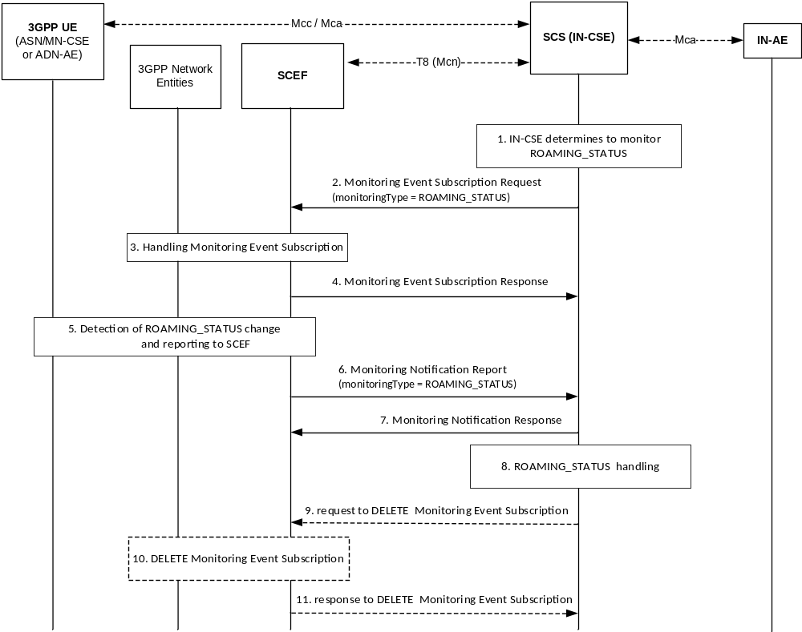
Figure 7.4.6-1: Request for Roaming Status Indications
Pre-conditions:
There is a relationship in place between the IN-CSE and MNO allowing the IN-CSE to request Roaming Status Reports from the underlying 3GPP network. The method for establishing this relationship is outside the scope of the present document.
An ASN/MN-CSE or ADN-AE registers with the IN-CSE and configures the M2M-Ext-ID attribute of its <remoteCSE> or <AE> resource. The IN-CSE examines the M2M-Ext-ID and recognizes that it is associated with an MNO that it has a relationship with.
The ASN/MN-CSE or ADN-AE or IN-CSE creates a <node> resource. This <node> resource has roamingStatus and networkID attributes.
An IN-AE may subscribe to the IN-CSE to receive notifications when the roaming status of a ASN/MN-CSE or ADN-AE changes. This subscription is made to the roamingStatus and/or networkID attributes of the <node> resource.
The IN-CSE may be configured with policies to control whether to buffer requests targeting ASN/MN-CSEs or ADN-Aes hosted on 3GPP Ues that are roaming. The method for configuring these policies is outside the scope of the present document.

Step 1: IN-CSE determines to monitor Roaming Status Request
If the IN-CSE can resolve the M2M-Ext-ID to a SCEF and IN-CSE policies allow for it, the IN-CSE issues a Roaming Status Request.
NOTE: These IN-CSE policies are outside the scope of the present document.
Step 2: Request Monitoring Event Subscription to monitor Roaming Status
The IN-CSE requests to monitor roaming status reports using Monitoring Event Subscription which has specified in 3GPP TS 29.122 [4] for a particular ASN/MN-CSE or ADN-AE hosted on a UE. The fields of the MonitoringEventSubscription API are populated as follows.
- An HTTP POST method shall be used
- URI shall be set to {apiRoot}/3gpp-monitoring-event/v1/{scsAsId}/subscriptions/. The {apiRoot} and {scsAsId} segments are configured based on Service Provider and MNO policies.
- The request payload shall include a MonitoringEventSubscription data structure as specified in 3GPP TS 29.122 [4] with the following attributes:
  - externalId shall be set to the M2M-Ext-ID of the UE.
  - notificationDestination shall be set to a URI that the SCEF can target Roaming Status notifications towards. The value of this URI shall be based on internal IN-CSE policies.
  - monitoringType shall be set to ROAMING_STATUS
  - supportedFeatures shall be set to a string value of “5” indicating support for Roaming Status notifications.
  - maximumNumberOfReports is optional and may be set to a maximum number of event reports to be generated by 3GPP network entities e.g. HSS or MME/SSGN. If used, the IN-CSE shall configure this time based on Service Provider and MNO policies.
  - monitorExpireTime is optional and may be set to an absolute time at which the monitoring event request is considered to expire. If used, the IN-CSE shall configure this time based on Service Provider and MNO policies.
  - maximumDetectionTime shall be set per IN-CSE pre-provisioning. This value should be set to a value that is longer than the length of time of inactive communications as configured in the <schedule> resource
  - pLMNIndication shall be set to TRUE or FALSE to indicate whether the IN-CSE wants to know the identity of the PLMN that the UE is attached to.
  - msisdn, ipv4Addr, ipv6Addr, externalGroupId, requestTestNotification, websockNotifConfig, groupReportGuardTime, maximumLatency and maximumResponseTime are not supported by the present document and shall not be included.
Step 3: Process Monitoring Event Subscription to monitor Roaming Status
The SCEF processes the Monitoring Event Subscription request together with 3GPP network entities as described in 3GPP TS 29.122 [4].

Step 4: Response for Monitorinf Event Subscription to monitor Roaming Status
The SCEF sends a Monitoring Event Subscription Response message to the IN-CSE to acknowledge acceptance of the Monitoring Event Subscription Request.
The message includes the following information.

- A response code of 201 CREATED
- The URI of the Monitoring Event Subscription resource created by the SCEF. The URI is returned in the HTTP Location header with a format of {apiRoot}/3gpp-monitoring-event/v1/{scsAsId}/subscriptions/{subscriptionId}. The {apiRoot} and {scsAsId} segments are configured based on Service Provider and MNO policies. The {subscriptionId} segment is configured by the SCEF.
- The response payload will include a MonitoringEventSubscription data structure as specified in 3GPP TS 29.122 [4] that includes the attributes present in the request along with the following additional attributes:
  - self is configured with a URI to the resource created by the SCEF for the request
  - monitoringEventReport may be included if a monitoring event report is available.
See clause 8.3 for a list of possible error scenarios and error handling options for the IN-CSE.
Step 5: Detect Roaming Status Change in 3GPP network entities
When the 3GPP network entities detect the change of UE roaming status, the 3GPP network entities report Monitoring Event Report to the SCEF.
Step 6: Monitoring Notification for Roaming Status from SCEF to IN-CSE
When the SCEF receives information of roaming status, the SCEF sends a Monitoring Notification to the corresponding notificationDestination of the IN-CSE that was configured in the Monitoring Event Subscription Request and that contains information as specified in 3GPP TS 29.122 [4]Error: Reference source not found.
Otherwise, the MonitoringNotification message is sent with appropriate information in accordance with the monitoringType
The Monitoring Notification report for roaming status includes:

- An HTTP POST method is used
- URI is set to {notification_uri}. The {notification_uri} is configured by the IN-CSE in the Monitoring Event Subscription Request.
- The request payload will include a MonitoringNotification data structure as specified in 3GPP TS 29.122 [4] with the following attributes:
  - subscription configured with a URI to the subscription resource for which this notification corresponds to
  - configResults is used for group-based monitoring and shall be ignored by the IN-CSE if present since group-based monitoring is not supported by the present document.
  - cancelind shall be ignored by the IN-CSE if present since it is not supported by the present document
  - monitoringEventReports configured with one or more change of Roaming Status monitoring reports wherein each report includes the following fields as defined in 3GPP TS 29.122 [4]:
    - externalIDs configured with one or more externalID that will be configured with the same values of the M2M-Ext-ID of the UE as step 2.
    - monitoringType configured with ROAMING_STATUS
    - plmnId if pLMNIIndication in the Monitoring Event Subscription was set to TRUE, this parameter is included and indicate the UE’s serving PLMN
    - roamingStatus is configured with ROAMING or NOT_ROAMING
Step 7: Response for Monitoring Notification from IN-CSE to SCEF
After receiving a Monitoring Notification on roaming status, the IN-CSE returns a response having a response code of 204 NO CONTENT.
Step 8: Process Monitoring Notification at IN-CSE
The IN-CSE shall update the roamingStatus and networkID attributes of the <node> resource that is linked to <AE> or <remoteCSE> resources having a M2M-Ext-ID attribute that matches the M2M-Ext-ID configured in the Roaming Status Request.
In addition, the IN-CSE may determine to delay or reject the processing of requests targeting ASN/MN-CSEs or ADN-Aes hosted on roaming Ues via one or more of the following approaches. How the IN-CSE makes this determination is outside the scope of the current document and may be based on policies and agreements with the mobile network operator.
- An IN-CSE may reject requests that target ASN/MN-CSEs or ADN-Aes hosted on roaming Ues. If an IN-CSE rejects a request due to a roaming UE, it shall return a corresponding response code informing the cause of rejection is due to lack of accessibility to a roaming network node.
- An IN-CSE may delay the processing of requests (i.e. buffer) that target ASN/MN-CSEs or ADN-Aes hosted on roaming Ues.
  - If the request is a blocking request, the IN-CSE should not delay the processing of the request and should instead reject the request with a corresponding response code informing the cause of rejection is due to the destination node is roaming.
  - If the request includes an Event Category that is set to immediate the IN-CSE should not delay the processing of the request and should instead reject the request with a corresponding response code informing the cause of rejection is due to the destination node is roaming. In this case, the IN-AE may decide to resubmit the request with the Event Category set to “bestEffort” or “latest” to indicate the IN-CSE may buffer the request.
Step 9 (Optional): Request to delete Monitoring Event Subscription on Roaming Status
The IN-CSE sends a DELETE request targeting the URI of the subscription resource corresponding to this Monitoring Event Subscription. This step may be triggered by IN-CSE when a ADN-AE(s) or ASN/MN-CSE hosted on the UE de-registers from the IN-CSE.
The request is configured as follows.
- An HTTP DELETE method shall be used
- URI shall be set to {apiRoot}/3gpp-monitoring-event/v1/{scsAsId}/subscriptions/{subscriptionId}. The {apiRoot} and {scsAsId} segments are configured based on Service Provider and MNO policies. The {subscriptionId} corresponds to the one configured by the SCEF and returned to the IN-CSE when the MonitoringEventSubscription was created.
- The request shall not contain a payload
Steps 10 and 11 (Optional): Process Roaming Status Cancellation Request
The SCEF handles the request to delete Monitoring Event Subscription together with the 3GPP network entities. The SCEF responds to the IN-CSE with a response code of 204 NO CONTENT to acknowledge the Monitoring Event Subscription has been deleted

7.4.7 Location Reporting

7.4.7.1 Introduction
The 3GPP SCEF Event Monitoring functionality described in 3GPP TS 29.122 [4] supports an API to allow an IN-CSE to be informed when the 3GPP network entities detect the current location of a UE as well as the last known location of UE. This clause provides details on how the IN-CSE’s oneM2M <locationPolicy>, <container> and <contentInstance> resources are used to interwork with the T8 API and provide location monitoring capability for an ASN/MN-CSE or ADN-AE hosted on a 3GPP UE. To interwork the 3GPP location reporting functionality with oneM2M, the <locationPolicy>, <container> and <contentInstance> resources and corresponding procedures are used.

7.4.7.2 Location updating triggered by retrieval
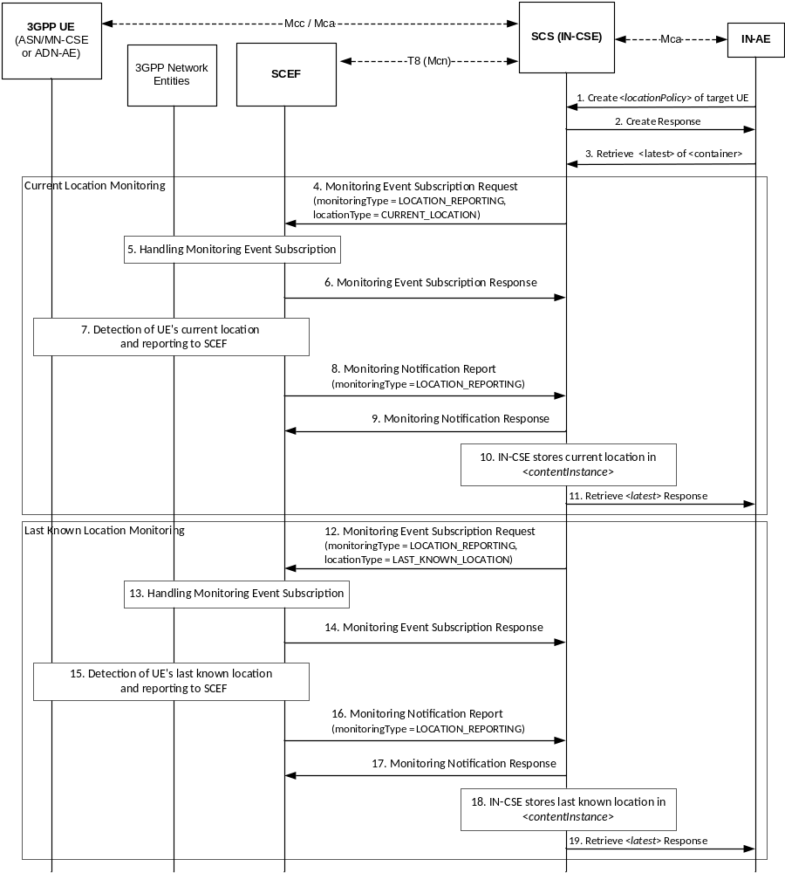
Figure 7.4.7.2-1: Location updating triggered by retrieving
Step 1: Request for creation of <locationPolicy>
The IN-AE sends a < locationPolicy> create request which shall include following parameters as specified in clause 9.6.10 of oneM2M TS-0001[1]:
  - locationSource shall be set to Network Based.
  - locationUpdatePeriod shall not be present or set to 0.
  - locationTargetID shall be set to the M2M-Ext-ID of the targeted UE hosting an ASN/MN-CSE or ADN-AE.
  - locationServer shall not be present.
  - locationContainerID shall not be present.
  - locationInformationType shall be set to position fix.
  - retrieveLastKnownLocation shall be configured with either TRUE or FALSE based on the requirements of the IN-AE.
  - locationUpdateEventCriteria shall not be present.
Step 2: Responds to creation <locationPolicy>
IN-CSE shall create the <locationPolicy> resource and corresponding <container> resource for storing location information based on the procedure specified in clause 10.2.9 of oneM2M TS-0001[1].
Step 3: Retrieve Request for <latest>
The IN-AE sends a RETRIEVE request to the <latest> child resource of the <container> resource linked to the to <locationPolicy> created in Step 2.
Step 4: Request Monitoring Event Subscription to get Current Location
The IN-CSE checks the locationSource attribute of the <locationPolicy> resource that is linked to the <container> targeted by the RETRIEVE request in Step 3. If the locationSource attribute is set to Network Based and the locationUpdatePeriod attribute is set to zero or NULL, then the IN-CSE shall request a Monitoring Event Subscription to get current location to the SCEF. The Monitoring Event Subscription request shall contain the following information as specified in 3GPP TS 29.122 [4].
- An HTTP POST method shall be used
- URI shall be set to {apiRoot}/3gpp-monitoring-event/v1/{scsAsId}/subscriptions/. The {apiRoot} and {scsAsId} segments are configured based on Service Provider and MNO policies.
- The request payload shall include a MonitoringEventSubscription data structure as specified in 3GPP TS 29.122 [4] with the following attributes:
  - externalId shall be set to the locationTargetID.
  - notificationDestination shall be set to a URI that the SCEF can target Location Reporting notifications towards. The value of this URI shall be based on internal IN-CSE policies.
  - monitoringType shall be set to LOCATION_REPORTING
  - supportedFeatures shall be set to a string value of “3” indicating support for Location Reporting notifications.
  - maximumNumberOfReports is optional and may be set to a maximum number of event reports to be generated by 3GPP network entities e.g. HSS or MME/SSGN. If used, the IN-CSE shall configure this time based on Service Provider and MNO policies.
  - monitorExpireTime is optional and may be set to an absolute time at which the monitoring event request is considered to expire. If used, the IN-CSE shall configure this time based on Service Provider and MNO policies.
  - locationType shall be set to CURRENT_LOCATION
  - accuracy shall be set set by the IN-CSE (e.g. CGI_ECGI, ENODEB, TA_RA, PLMN or TWAN_ID)
  - maximumDetectionTime shall be set per IN-CSE pre-provisioning. This value should be set to a value that is longer than the length of time of inactive communications as configured in the <schedule> resource
  - msisdn, ipv4Addr, ipv6Addr, externalGroupId, requestTestNotification, websockNotifConfig, groupReportGuardTime, maximumLatency, maximumResponseTime are not supported by the present document and shall not be included.

Steps 5: Process Monitoring Event Subscription to get Current Location
The SCEF handles request for Monitoring Event Subscription togather with 3GPP network entities based on the procedure defined in 3GPP TS 29.122 [4].
Step 6: Response to Monitoring Event Subscription for Current Location
The SCEF sends a Monitoring Event Subscription Response message to the IN-CSE to acknowledge acceptance of the Monitoring Event Subscription Request.
The message includes the following information.

- A response code of 201 CREATED
- The URI of the Monitoring Event Subscription resource created by the SCEF. The URI is returned in the HTTP Location header with a format of {apiRoot}/3gpp-monitoring-event/v1/{scsAsId}/subscriptions/{subscriptionId} which is identical to step 4. The {apiRoot} and {scsAsId} segments are configured based on Service Provider and MNO policies. The {subscriptionId} segment is configured by the SCEF.
- The response payload will include a MonitoringEventSubscription data structure as specified in 3GPP TS 29.122 [4] that includes the attributes present in the request along with the following additional attributes:
  - self is configured with a URI to the resource created by the SCEF for the request
  - monitoringEventReport may be included if a monitoring event report is available.

See clause 8.3 for a list of possible error scenarios and error handling options for the IN-CSE.

Step 7: Detect Current Location of UE
The 3GPP network entities detect the current location of UE and the SCEF receives a Monitoring Event Report for the location of UE.
Step 8: SCEF sends Monitoring Notification Report to IN-CSE
When the SCEF receives a current location information from the 3GPP network entities, the SCEF sends Monitoring Notification Report to the IN-CSE that contains information as specified in 3GPP TS 29.122 [4]Error: Reference source not found. Otherwise, the MonitoringNotification message is sent with appropriate information in accordance with the monitoringType.
The Monitoring Notification report for LOCATION_REPORTING for current location shall include:
- An HTTP POST method is used
- URI is set to {notification_uri}. The {notification_uri} is configured by the IN-CSE in the Monitoring Event Subscription Request.
- The request payload will include a MonitoringNotification data structure as specified in 3GPP TS 29.122 [4] with the following attributes:
  - subscription configured with a URI to the subscription resource for which this notification corresponds to
  - configResults is used for group-based monitoring and shall be ignored by the IN-CSE if present since group-based monitoring is not supported by the present document.
  - cancelind shall be ignored by the IN-CSE if present since it is not supported by the present document
  - monitoringEventReports configured Location Reporting monitoring report(s) wherein a report includes the following fields as defined in 3GPP TS 29.122 [4]:
    - externalID configured with the same value of M2M-Ext-ID of the UE as step 4.
    - monitoringType configured with LOCATION_REPORTING
    - locationInfo configured with the UE’s current location information (e.g. ageOfLocationInfo, cellId, enodeBId, routingAreaId, trackingAreaId, plmmId and twanId)
Step 9: Response to Monitoring Notification for Current Location
After receiving a Monitoring Notification for current location, the IN-CSE returns a response having a response code of 204 NO CONTENT.
Steps 10 and 11: Current Location Event Notification Handling at the IN-CSE
The IN-CSE shall create a new <contentInstance> child resource of the <container> targeted by the RETRIEVE request in Step 3. The IN-CSE shall store the UE’s current location in this <contentInstance> and send the retrieve response for <latest> which is contains the current location to the IN-AE. The response shall include the newly created <contentInstance>.
Step 12: Request for 2nd attempt Monitoring Event Subscription to get Last Known Location
If the Monitor Indication in Step 6 indicates a failure, then the IN-CSE shall send a Monitoring Event Subscription to the SCEF to get the last known location if the retrieveLastKnownLocation attribute of the <locationPolicy> is set to TRUE. The Monitoring Event Subscription request shall contain the following information as specified in 3GPP TS 29.122 [4].
- An HTTP POST method shall be used
- URI shall be set to {apiRoot}/3gpp-monitoring-event/v1/{scsAsId}/subscriptions/ which is identical to step 4. The {apiRoot} and {scsAsId} segments are configured based on Service Provider and MNO policies.
- The request payload shall include a MonitoringEventSubscription data structure as specified in 3GPP TS 29.122 [4] with the following attributes:
  - externalId shall be set to the locationTargetID which shall be identical to step 4.
  - notificationDestination shall be set to a URI that the SCEF can target Location Reporting notifications towards. The value of this URI shall be based on internal IN-CSE policies.
  - monitoringType shall be set to LOCATION_REPORTING
  - supportedFeatures shall be set to a string value of “3” indicating support for Location Reporting notifications.
  - maximumNumberOfReports is optional and may be set to a maximum number of event reports to be generated by 3GPP network entities e.g. HSS or MME/SSGN. If used, the IN-CSE shall configure this time based on Service Provider and MNO policies.
  - monitorExpireTime is optional and may be set to an absolute time at which the monitoring event request is considered to expire. If used, the IN-CSE shall configure this time based on Service Provider and MNO policies.
  - locationType shall be set to LAST_KNOWN_LOCATION
  - accuracy shall be set set by the IN-CSE (e.g. CGI_ECGI, ENODEB, TA_RA, PLMN or TWAN_ID)
  - maximumDetectionTime shall be set per IN-CSE pre-provisioning. This value should be set to a value that is longer than the length of time of inactive communications as configured in the <schedule> resource
  - msisdn, ipv4Addr, ipv6Addr, externalGroupId, requestTestNotification, websockNotifConfig, groupReportGuardTime, maximumLatency, maximumResponseTime are not supported by the present document and shall not be included.

Step 13: Process Monitoring Event Subscription to get Last Known Location
The SCEF handles Monitoring Event Subsciption Request togather with 3GPP network entities based on the procedure defined in 3GPP TS 29.122 [4].
Step 14: Response to Monitoring Event Subscription for Last Known Location
The SCEF responds a Monitoring Event Subscription to get Last Known Location information to the IN-CSE to acknowledge acceptance of the Monitoring Event Subscription Request.
The message includes the following information.

- A response code of 201 CREATED
- The URI of the Monitoring Event Subscription resource created by the SCEF. The URI is returned in the HTTP Location header with a format of {apiRoot}/3gpp-monitoring-event/v1/{scsAsId}/subscriptions/{subscriptionId}. The {apiRoot} and {scsAsId} segments are configured based on Service Provider and MNO policies. The {subscriptionId} segment is configured by the SCEF.
- The response payload will include a MonitoringEventSubscription data structure as specified in 3GPP TS 29.122 [4] that includes the attributes present in the request along with the following additional attributes:
  - self is configured with a URI to the resource created by the SCEF for the request
  - monitoringEventReport may be included if a monitoring event report is available.
See clause 8.3 for a list of possible error scenarios and error handling options for the IN-CSE.
Step 15: Detect Last Known Location of UE
The 3GPP network entities detect the last known location of UE and SCEF receives Monitoring Event Report for the last known location of UE
Step 16: SCEF sends Monitoring Notification for Last Known Location to IN-CSE
When the SCEF receives a last known location information from the 3GPP network entities, the SCEF sends Monitoring Notification Report to the IN-CSE that contains information as specified in 3GPP TS 29.122 [4]Error: Reference source not found. Otherwise, the Monitoring Notification message is sent with appropriate information in accordance with the monitoringType.
The Monitoring Notification report for LOCATION_REPORTING for last known location shall include:
- An HTTP POST method is used
- URI is set to {notification_uri}. The {notification_uri} is configured by the IN-CSE in the Monitoring Event Subscription Request.
- The request payload will include a MonitoringNotification data structure as specified in 3GPP TS 29.122 [4] with the following attributes:
  - subscription configured with a URI to the subscription resource for which this notification corresponds to
  - configResults is used for group-based monitoring and shall be ignored by the IN-CSE if present since group-based monitoring is not supported by the present document.
  - cancelind shall be ignored by the IN-CSE if present since it is not supported by the present document
  - monitoringEventReports configured Location Reporting monitoring report(s) wherein a report includes the following fields as defined in 3GPP TS 29.122 [4]:
    - externalID configured with the same value of M2M-Ext-ID of the UE as step 12.
    - monitoringType configured with LOCATION_REPORTING
    - locationInfo configured with the UE’s last known location information (e.g. ageOfLocationInfo, cellId, enodeBId, routingAreaId, trackingAreaId, plmmId and twanId)
Step 17: Response to Monitoring Notification
After receiving a Monitoring Notification for last known location, the IN-CSE returns a response having a response code of 204 NO CONTENT.

Steps 18 and 19: Current Location Reporting Event Handling at the IN-CSE
The IN-CSE shall create a new <contentInstance> child resource of the <container> initiated by the RETRIEVE request in Step 3. The IN-CSE shall store the UE’s last known location in this <contentInstance> and send the retrieve response to IN-AE for <latest> which is contains the last known location. The response shall include the newly created <contentInstance>.

7.4.7.3 Location updating triggered by location change
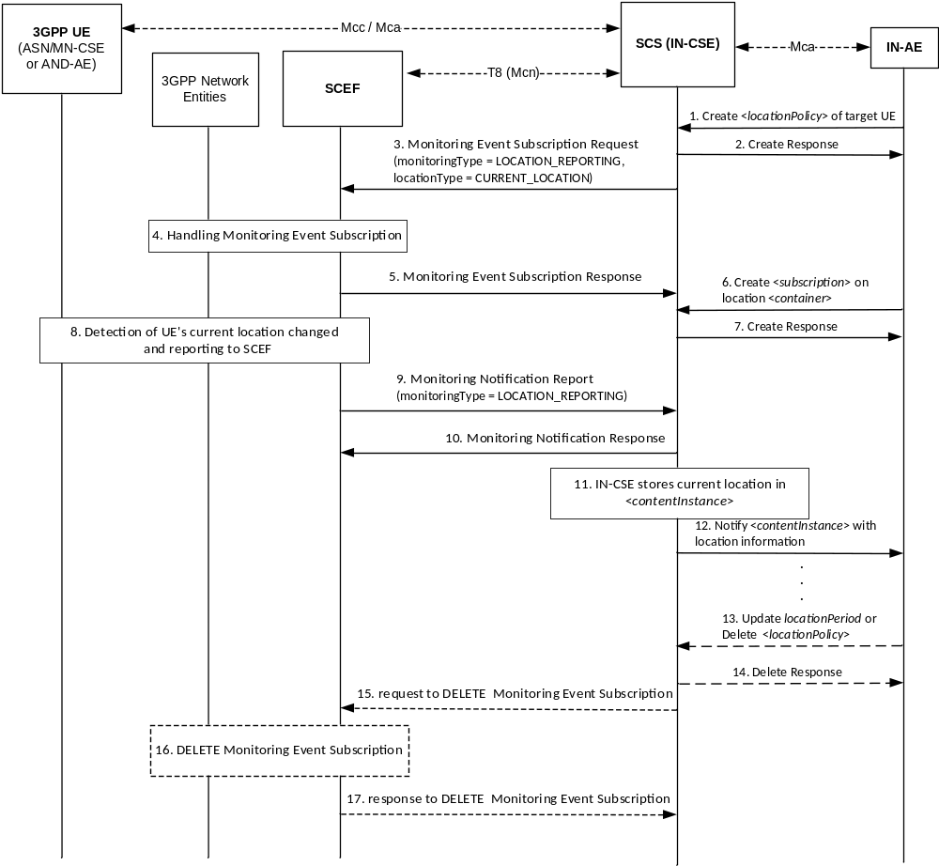
Figure 7.4.7.3-1: Location updating triggered by location change
Step 1: Request for creation of <locationPolicy>
The IN-AE sends <locationPolicy> CREATE request which shall be included following parameters as specified in clause 9.6.10 of oneM2M TS-0001[1]:
  - locationSource shall be set to Network Based.
  - locationUpdatePeriod shall not be present or set to 0.
  - locationTargetID shall be set to the M2M-Ext-ID of the targeted UE hosting an ASN/MN-CSE or ADN-AE.
  - locationServer shall not be present.
  - locationContainerID shall not be present.
  - locationInformationType shall be set to position fix.
  - retrieveLastKnownLocation shall not be configured.
  - locationUpdateEventCriteria shall be set to LocationChange
Step 2: Responds to creation <locationPolicy>
IN-CSE shall create the <locationPolicy> resource and corresponding <container> resource for storing location information and return a response based on the procedure specified in clause 10.2.9 of oneM2M TS-0001[1].
Step 3: Request Monitoring Event Subscription to get Current Location
The IN-CSE sends Monitoring Event Subscription to SCEF. The request contains information as specified in 3GPP TS 29.122 [4]. Such information includes :
- An HTTP POST method shall be used
- URI shall be set to {apiRoot}/3gpp-monitoring-event/v1/{scsAsId}/subscriptions/. The {apiRoot} and {scsAsId} segments are configured based on Service Provider and MNO policies.
- The request payload shall include a MonitoringEventSubscription data structure as specified in 3GPP TS 29.122 [4] with the following attributes:
  - externalId shall be set to the locationTargetID.
  - notificationDestination shall be set to a URI that the SCEF can target Location Reporting notifications towards. The value of this URI shall be based on internal IN-CSE policies.
  - monitoringType shall be set to LOCATION_REPORTING
  - supportedFeatures shall be set to a string value of “5” indicating support for Location Reporting notifications.
  - maximumNumberOfReports is optional and may be set to a maximum number of event reports to be generated by 3GPP network entities e.g. HSS or MME/SSGN. If used, the IN-CSE shall configure this time based on Service Provider and MNO policies.
  - monitorExpireTime is optional and may be set to an absolute time at which the monitoring event request is considered to expire. If used, the IN-CSE shall configure this time based on Service Provider and MNO policies.
  - locationType shall be set to CURRENT_LOCATION
  - accuracy shall be set set by the IN-CSE (e.g. CGI_ECGI, ENODEB, TA_RA, PLMN or TWAN_ID)
  - maximumDetectionTime shall be set per IN-CSE pre-provisioning. This value should be set to a value that is longer than the length of time of inactive communications as configured in the <schedule> resource
  - msisdn, ipv4Addr, ipv6Addr, externalGroupId, requestTestNotification, websockNotifConfig, groupReportGuardTime, maximumLatency, maximumResponseTime are not supported by the present document and shall not be included.

Step 4: Process Monitoring Event Subscription to get Current Location
The SCEF handles request for Monitoring Event Subscription together with 3GPP network entities based on the procedure defined in 3GPP TS 29.122 [4].
Step 5: Response to Monitoring Event Subscription for Current Location
The SCEF sends a Monitoring Event Subscription Response message to the IN-CSE to acknowledge acceptance of the Monitoring Event Subscription Request.
The message includes the following information.

- A response code of 201 CREATED
- The URI of the Monitoring Event Subscription resource created by the SCEF. The URI is returned in the HTTP Location header with a format of {apiRoot}/3gpp-monitoring-event/v1/{scsAsId}/subscriptions/{subscriptionId}. The {apiRoot} and {scsAsId} segments are configured based on Service Provider and MNO policies. The {subscriptionId} segment is configured by the SCEF.
- The response payload will include a MonitoringEventSubscription data structure as specified in 3GPP TS 29.122 [4] that includes the attributes present in the request along with the following additional attributes:
  - self is configured with a URI to the resource created by the SCEF for the request
  - monitoringEventReport may be included if a monitoring event report is available.
See clause 8.3 for a list of possible error scenarios and error handling options for the IN-CSE.
Step 6: Request for Creation of <subscription>
The IN-AE sends the <subscription> CREATE request of <container> which stores location information to the IN-CSE.
Step 7: Response for Creation of <Subscription>
The IN-CSE sends the response to the IN-AE.
Step 8: Detect Current Location change of UE
The 3GPP network entities send a Monitoring Event Report for the current Indication to SCEF when detecting a change in location of the UE hosting an ASN/MN-CSE or ADN-AE.
Step 9: Report Monitoring Notification for Current Location from SCEF to IN-CSE
The SCEF sends a Monitoring Notification Report to the IN-CSE that contains information as specified in 3GPP TS 29.122 [4]Error: Reference source not found.
Otherwise, the Monitoring Notification message is sent with appropriate information in accordance with the monitoringType.
The Monitoring Notification report for LOCATION_REPORTING for current location shall include:
- An HTTP POST method is used
- URI is set to {notification_uri}. The {notification_uri} is configured by the IN-CSE in the Monitoring Event Subscription Request.
- The request payload will include a MonitoringNotification data structure as specified in 3GPP TS 29.122 [4] with the following attributes:
  - subscription configured with a URI to the subscription resource for which this notification corresponds to
  - configResults is used for group-based monitoring and shall be ignored by the IN-CSE if present since group-based monitoring is not supported by the present document.
  - cancelind shall be ignored by the IN-CSE if present since it is not supported by the present document
  - monitoringEventReports configured Location Reporting monitoring report(s) wherein a report includes the following fields as defined in 3GPP TS 29.122 [4]:
    - externalID configured with the same value of M2M-Ext-ID of the UE as step 3.
    - monitoringType configured with LOCATION_REPORTING
    - locationInfo configured with the UE’s current location information (e.g. ageOfLocationInfo, cellId, enodeBId, routingAreaId, trackingAreaId, plmmId and twanId)
Step 10: Response to Monitring Notification for Current Location
After receiving a Location Reporting Monitoring Notification, the IN-CSE returns a response having a response code of 204 NO CONTENT.
Step 11: Handling Monitoring Notification for Current Location at the IN-CSE
The IN-CSE shall create a new <contentInstance> child resource of the <container> resource created in Step 2. The IN-CSE shall store the UE’s current location in this <contentInstance> resource.
Step 12: Notify <contentInstance>
IN-CSE sends a NOTIFY request to the IN-AE. The NOTIFY includes the <contentInstance> with the UE’s current location.
Step 13 (Optional): The IN-AE sends a request to update the locationUpdatePeriod to 0 or <locationPolicy> is deleted.
Step 14 (Optional): The IN-CSE sends a response to the IN-AE.
Step 15 (Optional): IN-CSE requests to SCEF to delete Monitoring Event Subscription
The IN-CSE sends a DELETE request targeting the URI of the subscription resource corresponding to this Monitoring Event Subscription. This step may be triggered by IN-CSE when a ADN-AE(s) or ASN/MN-CSE hosted on the UE de-registers from the IN-CSE.
The request is configured as follows.
- An HTTP DELETE method shall be used
- URI shall be set to {apiRoot}/3gpp-monitoring-event/v1/{scsAsId}/subscriptions/{subscriptionId} which is identical to step 3. The {apiRoot} and {scsAsId} segments are configured based on Service Provider and MNO policies. The {subscriptionId} corresponds to the one configured by the SCEF and returned to the IN-CSE when the MonitoringEventSubscription was created.
- The request shall not contain a payload
Step 16 and 17 (Optional): Monitoring Event Subscription Delete Request Handling in the Underlying Network.
The SCEF handles request to delete the Monitoring Event Subscription together with the 3GPP network entities. The SCEF responds to the IN-CSE with a response code of 204 NO CONTENT to acknowledge the Monitoring Event Subscription has been deleted.

7.5 3GPP Based Device triggering

7.5.1 General Procedure for 3GPP Based Device Triggering
An IN-CSE may initiate a device trigger to an ASN/MN-CSE or ADN-AE hosted on a 3GPP UE to cause it to establish a connection to the IN-CSE, enrolto a MEF, register to the IN-CSE, update its PoA, or perform a CRUD operation on a specified resource. The IN-CSE may initiate the device trigger itself (implicit) or it may be initiated by a request that the IN-CSE receives from an AE (explicit).
Whenever the IN-CSE sends a device trigger to an ASN/MN-CSE or ADN-AE hosted on a 3GPP UE, the device triggering procedure as described in 3GPP TS 29.122 [4] shall be used as the basis for the procedures defined below.
This procedure supports an ASN/MN-CSE or ADN-AE that is hosted on a 3GPP UE that is directly connected to a 3GPP access network.

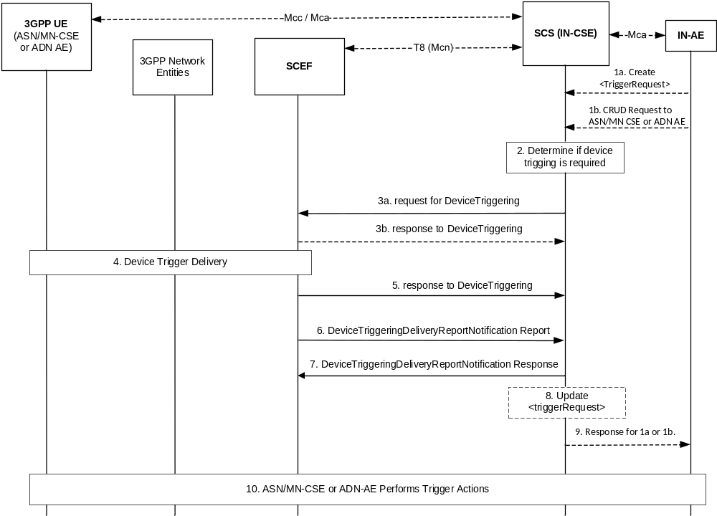
Figure 7.5.1-1: General Procedure for Device Triggering
Pre-conditions
The UE that hosts the ASN/MN-CSE or ADN-AE is available to receive the Device Trigger Request using one of the connectivity establishment methods described in clause 6.
Step 1 (Optional): Request targeted to ASN/MN-CSE or ADN-AE
An AE may initiate a device trigger to an ASN/MN-CSE or ADN-AE explicitly by creating or updating a <triggerRequest> resource as specified in clause 9.6.49 of oneM2M TS-0001[1]. Alternatively, an AE may initiate a device trigger to an ASN/MN-CSE or ADN-AE implicitly by issuing a request to an IN-CSE that requires device triggering. For example, if an IN-CSE receives a request to perform a CRUD operation targeting an ASN/MN-CSE or ADN-AE hosted on a 3GPP UE that is not reachable by the IN-CSE, the IN-CSE may generate a trigger request.
Step-2: Determine if Device Triggering is required
The IN-CSE determines whether to send a device trigger to the targeted ASN/MN-CSE or ADN-AE. Further details are provided in clause 8.3.3.2.1 of oneM2M TS-0001 [1].
If device trigger was initiated by an AE, initiating AE determines device trigger.
Step 3a: Request for Device Triggering
The IN-CSE or AE sends the Device Triggering request that contains information as specified in 3GPP TS 29.122 [4]. Such information includes:

- An HTTP POST method shall be used
- URI shall be set to {apiRoot}/3gpp-device-triggering/v1/{scsAsId}/transactions. The {apiRoot} and {scsAsId} segments are configured based on Service Provider and MNO policies.
- The request payload shall include a DeviceTriggering data structure as specified in 3GPP TS 29.122 [4] with the following attributes:
  - supportedFeatures shall be set to a string value of “0” indicating that trigger notifications over Websockets or trigger notification test events are not supported.
  - validityPeriod shall be set to either the triggerValidityTime attribute of the <triggerRequest> resource if the trigger request is initiated by an AE.
  - triggerPayload shall be configured as described in clause 8.3.3.2.1 of oneM2M TS 0001 [1] and clause 9.2.1 of oneM2M TS-0004 [3]. An empty payload indicates that the targeted ASN/MN-CSE or ADN-AE shall re-establish connectivity with the IN-CSE.
  - externalId shall be set to the M2M-Ext-ID of the targeted UE hosting an ASN/MN-CSE or ADN-AE.
  - applicationPortID shall be set to Trigger-Recipient-ID attribute of the <triggerRequest> resource, if specified.
  - notificationDestination shall be configured with a URI that the SCEF can target Device Trigger notifications towards. The value of this URI shall be based on internal IN-CSE policies or IN-CSE identifier.
  - priority may be set to either PRIORITY or NO_PRIORITY per internal IN-CSE policies and/or agreements between the Service Provider and MNO or the triggerPriority attribute of the <triggerRequest> resource.
  - msisdn, requestTestNotification and websockNotifConfig are not supported by the present document and shall not be included.
General Exceptions:
- The SCEF is not reachable when IN-CSE tries to send DeviceTriggering message. In this case the IN-CSE shall update the triggerStatus attribute of the <triggerRequest> to ERROR_NSE_NOT_FOUND after a prior timeout period (IN-CSE local policy)
Step 3b (Optional): Response to Device Triggering request
The SCEF may send a Device Triggering response to the IN-CSE to acknowledge the successful reception of the Device Trigger request before the request is delivered to the targeted UE as specified in 3GPP TS 29.122 [4]. Otherwise an HTTP error status code as defined in clause 8.3 may be returned. The response includes the following information.
- A response code of 201 CREATED
- The URI of the device triggering resource created by the SCEF. The URI is returned in the HTTP Location header with a format of {apiRoot}/3gpp-device-triggering/v1/{scsAsId}/transactions {transactionId}. The {apiRoot} and {scsAsId} segments are configured based on Service Provider and MNO policies. The {transactionId} segment is configured by the SCEF.
- The response payload will include a DeviceTriggering data structure as specified in 3GPP TS 29.122 [4] that includes the attributes present in the request along with the following additional attributes:
  - self is configured with a URI to the resource created by the SCEF for the request
  - deliveryResult configured with one of the following status for confirmation:
    - TRIGGERED: that the request for device triggering has been received and is accepted by the SCEF but has not yet been delivered. In this case the IN-CSE shall update the triggerStatus attribute of the <triggerRequest> to TRIGGER_TRIGGERED
General Exceptions:
If the SCEF responds with one of the error response codes defined in clause 8.3, the IN-CSE shall update the triggerStatus attribute of the <triggerRequest> to TRIGGER_FAILED.
Step 4: Device Trigger Delivery procedure
The device trigger message shall be delivered to the UE hosting the ASN/MN-CSE or ADN-AE.
Step 5: Response to DeviceTriggering
The SCEF may send a Device Trigger response to the IN-CSE to acknowledge the successful delivery of the Device Trigger request to the targeted UE as specified in 3GPP TS 29.122 [4]. Otherwise an HTTP error status code defined in clause 8.3 may be returned. The response includes the following parameters:

- A response code of 201 CREATED
- The URI of the device triggering resource created by the SCEF. The URI is returned in the HTTP Location header with a format of {apiRoot}/3gpp-device-triggering/v1/{scsAsId}/transactions {transactionId}. The {apiRoot} and {scsAsId} segments are configured based on Service Provider and MNO policies. The {transactionId} segment is configured by the SCEF.
- The response payload will include a DeviceTriggering data structure as specified in 3GPP TS 29.122 [4] that includes the attributes present in the request along with the following additional attributes:
  - self parameter configured with a URI to the resource created by the SCEF for the Device Trigger request.
  - deliveryResult is included in the HTTP response to indicate one of the following status for delivery of the device trigger:
    - SUCCESS: that the device triggering delivery is successfully completed. In this case the IN-CSE shall update the triggerStatus attribute of the <triggerRequest> to TRIGGER_DELIVERED.
    - UNKNOWN: that indicates any unspecified errors.
    - FAILURE: that this trigger encountered an error during delivery or processing and is deemed permanently undeliverable. In this case the IN-CSE shall update the triggerStatus attribute of the <triggerRequest> to TRIGGER_FAILED
    - EXPIRED: that the validity period expired when processing the device triggering request. In this case the IN-CSE shall update the triggerStatus attribute of the <triggerRequest> to TRIGGER_EXPIRED.
    - TERMINATE: that the delivery of the device triggering request is terminated by the IN-CSE. In this case the IN-CSE shall update the triggerStatus attribute of the <triggerRequest> to TRIGGER_TERMINATED.
General Exceptions:
If the SCEF responds with one of the error response codes defined in clause 8.3, and the device trigger was initiated by an AE via a <triggerRequest> resource, the IN-CSE shall update the triggerStatus attribute of the <triggerRequest> to TRIGGER_FAILED.
Step 6: Device Triggering Delivery Report Notification request
The SCEF sends a Device Triggering Delivery Report Notification message to the {notification_uri} of the IN-CSE with the results of the trigger delivery outcome. This message is defined in 3GPP TS 29.122 [4] and shall include the following:

- An HTTP POST method is used
- URI is set to {notification_uri}. The {notification_uri} is configured by the IN-CSE in the Device Triggering Request.
- transaction is configured with a link to the related device triggering transaction resource to which this notification is related to.
- The request payload will include a deliveryResult data structure as specified in 3GPP TS 29.122 [4]. The IN-CSE shall process the deliveryResult and update the the triggerStatus attribute of the <triggerRequest> as defined in Step 5.
Step 7: Device Triggering Delivery Report Notification response
After receiving a Device Triggering Delivery Report Notification request, the IN-CSE or AE returns a HTTP response having a response code of 204 NO CONTENT and no payload.

Steps 8 (optional) and 9: IN-CSE Updates <triggerRequest> and Response to 1a or 1b
If the device trigger was initiated by an AE via a <triggerRequest> resource, then the IN-CSE shall update triggerStatus attribute of <triggerRequest> resource.
Step 10: ASN/MN-CSE or ADN-AE performs trigger actions
If the trigger has no payload, the ASN/MN-CSE or ADN-AE shall re-establish connectivity with the IN-CSE. Otherwise, based on the type of trigger request received, the ASN/MN-CSE or ADN-AE performs the corresponding trigger actions such as establish connectivity with the IN-CSE, enrol with the MEF, register to the IN-CSE, update its PoA, or execute a CRUD request on a specified resource.
Further details are described in clause 8.3.3.2.1 of oneM2M TS-0001 [1] and clause 9.2.1 of oneM2M TS-0004 [3]

7.5.2 3GPP Based Device Trigger Recall/Replace Procedure
Figure 7.5.2-1 shows a procedure for a 3GPP based Device Trigger Recall (i.e. cancel a trigger request) and Replace (i.e. update a trigger request) between oneM2M and an Underlying 3GPP Network.
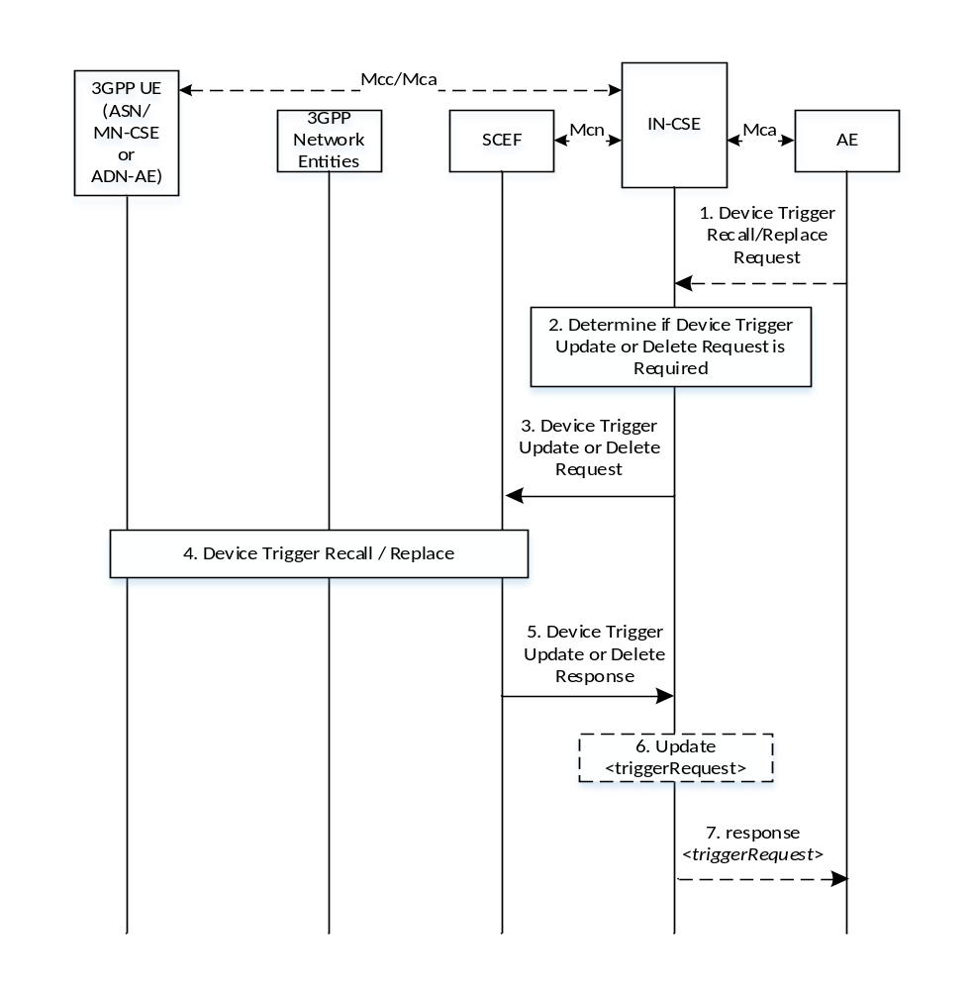
Figure 7.5.2-1: 3GPP Based Device Triggering Recall/Replace Procedure
Pre-condition
The IN-CSE has already sent a device trigger request to the Underlying 3GPP Network. The IN-CSE has stored the previous device trigger information, e.g. trigger reference number, etc.
Step 1 (Optional) IN-AE Trigger Recall/Replace Request
An AE issues a request to the IN-CSE to recall/replace a trigger (via a DELETE or UPDATE of a <triggerRequest> resource) that results in the IN-CSE generating a trigger recall/replace request to the Underlying 3GPP Network.
Step 2: Determine if Device Triggering is required
The IN-CSE determines whether to send a Device Trigger Recall/Replace Request to the targeted ASN/MN-CSE or ADN-AE. Further details are provided in clause 8.3.3.2.1 of oneM2M TS-0001 [1].
Step 3: Device Trigger Recall or Replace Request
After identifying the proper SCEF, the IN-CSE sends a Trigger UPDATE (Replace) or DELETE (Recall) Request to the SCEF targeting the transactionID of the Device Trigger.
For an UPDATE (Replace) request, the request shall contain one or more of the following fields:

- An HTTP PUT method shall be used
- URI shall be set to {apiRoot}/3gpp-device-triggering/v1/{scsAsId}/transactions/{transactionId}. The {apiRoot} and {scsAsId} segments are configured based on Service Provider and MNO policies. The {transactionId} segment is the resource indentifier of the trigger being replaced.
- The request payload shall include a DeviceTriggering data structure as specified in 3GPP TS 29.122 [4] with the following attributes:
  - supportedFeatures shall be set to a string value of “0” indicating that trigger notifications over Websockets or trigger notification test events are not supported.
  - validityPeriod shall be set to either the triggerValidityTime attribute of the <triggerRequest> resource if the trigger request is initiated by an AE.
  - triggerPayload shall be configured as described in clause 8.3.3.2.1 of oneM2M TS 0001 [1] and clause 9.2.1 of oneM2M TS-0004 [3]. An empty payload indicates that the targeted ASN/MN-CSE or ADN-AE shall re-establish connectivity with the IN-CSE.
  - externalId shall be set to the M2M-Ext-ID of the targeted UE hosting an ASN/MN-CSE or ADN-AE.
  - applicationPortID shall be set to Trigger-Recipient-ID attribute of the <triggerRequest> resource, if specified.
  - notificationDestination shall be configured with a URI that the SCEF can target Device Trigger notifications towards. The value of this URI shall be based on internal IN-CSE policies or IN-CSE identifier.
  - priority may be set to either PRIORITY or NO_PRIORITY per internal IN-CSE policies and/or agreements between the Service Provider and MNO or the triggerPriority attribute of the <triggerRequest> resource.
  - msisdn, requestTestNotification and websockNotifConfig are not supported by the present document and shall not be included.
For an DELETE (Recall) request, the request shall contain one or more of the following fields:

- An HTTP DELETE method shall be used
- URI shall be set to {apiRoot}/3gpp-device-triggering/v1/{scsAsId}/transactions/{transactionId}. The {apiRoot} and {scsAsId} segments are configured based on Service Provider and MNO policies. The {transactionId} segment is the resource indentifier of the trigger being recalled.
- The request shall not contain a payload
General Exceptions:
If the SCEF is not reachable when IN-CSE tries to send Device Triggering request, then the IN-CSE shall update the triggerStatus attribute of the <triggerRequest> to ERROR_NSE_NOT_FOUND after a prior timeout period (defined by IN-CSE local policy)
Step 4: Device Trigger Recall/Replace Handling
The SCEF recalls or replaces the trigger as described in 3GPP TS 23.682 [2].
Step 5: Device Trigger Recall/Replace Response
The SCEF sends a Device Trigger Response to the IN-CSE.
If the request was to replace the Device Trigger, then the response is returned by the SCEF with a 200 OK response code and a payload that includes an updated DeviceTriggering data structure as specified in 3GPP TS 29.122 [4]. The DeviceTriggering data structure also includes the deliveryResult configured with REPLACED to indicate that the request to replace the device triggering request has been accepted by the SCEF.
If the request was to recall the Device Trigger, then the response is returned by the SCEF with a 204 NO CONTENT response code and no payload is included.
See clause 8.3 for a list of possible error scenarios and error handling options for the IN-CSE.
Steps 6 and 7 (Optional): Process Device Trigger Recall/Replace Response
The IN-CSE processes the Device Trigger Recall/Replace Response. If the recall/replace request was initiated by an AE, the IN-CSE updates the corresponding <triggerRequest> resource as described in clause 8.3.3.2.1 of oneM2M TS-0001[1].
For a device trigger replace, the IN-CSE shall update the triggerStatus attribute of the <triggerRequest> to TRIGGER_REPLACED if the device trigger was initiated by an AE via a <triggerRequest> resource.
For a device trigger recall, the IN-CSE shall delete the <triggerRequest> resource if the device trigger recall was initiated by an AE via a delete request targeting the <triggerRequest> resource.
If the SCEF responds with one of the error response codes defined in clause 8.3, and the device trigger was initiated by an AE via a <triggerRequest> resource, the IN-CSE shall update the triggerStatus attribute of the <triggerRequest> to TRIGGER_FAILED.

7.6 Configuration of Traffic Patterns
oneM2M uses the 3GPP MTC feature for Configuration of Device Communication Patterns to configure Node Traffic Patterns in the Underlying Network (see clause 8.3.5 Configuration of Node Traffic Patterns of oneM2M TS-0001).
To that purpose the IN-CSE translates the oneM2M Node Traffic Pattern (TP) into a 3GPP Device Communication Pattern. The generic oneM2M procedure for configuration of Node Traffic Patterns is shown in Figure 7.6-1.
The 3GPP Underling Network signalling sequence for provisioning of CP parameters is described in 3GPP TS 23.682 [2].
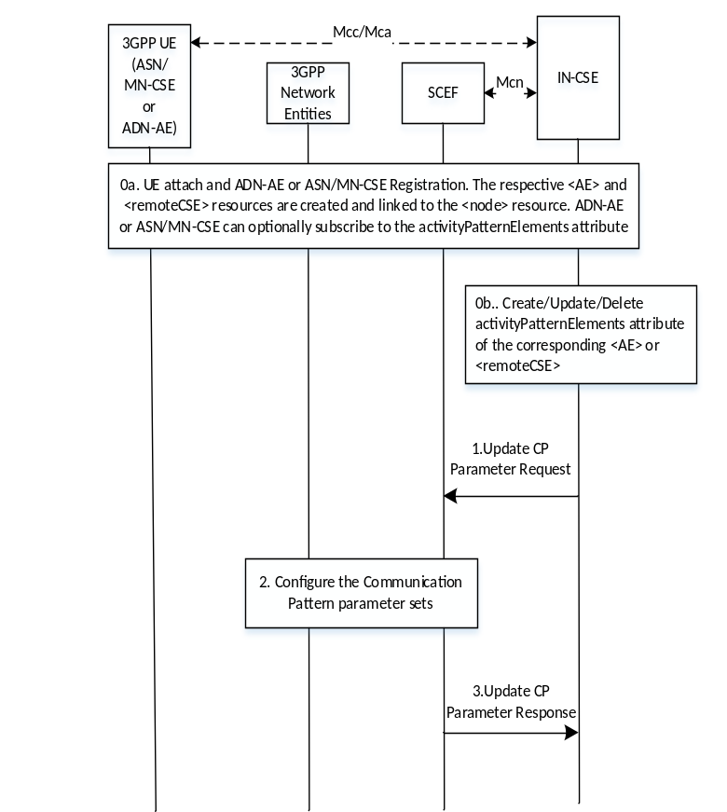
Figure 7.6-1: General procedure for oneM2M configuration of Traffic Patterns
Pre-conditions:
There is a relationship in place between the IN-CSE and MNO allowing the IN-CSE to request Configuration of Device Communication Patterns. The method for establishing this relationship is outside the scope of the present document.
Step 0: UE Attach and oneM2M Registration Procedures
The UE attaches to the 3GPP network and the ADN-AE(s) or ASN/MN-CSE hosted on the UE perform the oneM2M registration procedure, as detailed in clause 6.3. The IN-CSE hosts the corresponding <AE> or <remoteCSE> resources and an associated <node> resource for the registree. During this procedure, the ADN-AE or ASN/MN-CSE can create an activityPatternElements attribute indicating the anticipated communication patterns.
The anticipated communication behavior of the ADN-AE or ASN/MN-CSE may also be changed by updating the activityPatternElements attribute of either the <AE> or <remoteCSE> resource, respectively.
Step 1: IN-CSE sends to the SCEF a Communication Patterns Configuration request
This step is triggered by the create/update/delete of activityPatternElements attribute of either the <AE> or <remoteCSE> resource. The IN-CSE derives the communication patterns from the activityPatternElements.
The IN-CSE selects the SCEF based on the M2M-Ext-ID’s of the registree ASN/MN-CSE or ADN-Aes (e.g. either a DNS lookup on the M2M-Ext-ID or the based on the domain portion of the M2M-Ext-ID’s.).
When the first activityPatternElements for a given a UE is initially configured, the IN-CSE shall generate a Communication Patterns Configuration creation request that contains the following information as specified in 3GPP TS 29.122 [4].

- An HTTP POST method shall be used
- URI shall be set to {apiRoot}/3gpp-cp-parameter-provisioning/v1/{scsAsId}/subscriptions/. The {apiRoot} and {scsAsId} segments are configured based on Service Provider and MNO policies.
- The request payload shall include a CpInfo data structure as specified in 3GPP TS 29.122 [4] with the following attributes:
    - externalId shall be set to M2M-Ext-ID
    - supportedFeatures shall be set to a string value of “0” indicating no support for the expected UE geographical movement feature in the current release of this specification.
    - cpParameterSet – This is a set of communication/traffic pattern parameters indicating an anticipated communication schedule of all the ADN-Aes or ASN/MN-CSE hosted on the UE. The IN-CSE configures this parameter with the aggregated communication/traffic patterns of all ADN-Aes or ASN/MN-CSE hosted on the UE. The IN-CSE derives the aggregated communication/traffic patterns using the activityPatternElements attributes of the corresponding <AE> and <remoteCSE> resources. For a UE hosting one or more Aes, the IN-CSE uses the values provided in all the activityPatternElements attributes for the <AE>s hosted on this UE. For a UE hosting an ASN/MN-CSE, the IN-CSE uses the values provided by the activityPatternElements attribute of the <remoteCSE> resource. The IN-CSE shall configure the cpParameterSet as follows:
      - setId shall be assigned based on internal IN-CSE policies. This parameter will serve as a suggested name for the {aprRoot}/3gpp-cp-parameter-provisioning/v1/{scsAsId}/subscriptions/{subscriptionId}/cpSets/{setId} resource created by the SCEF. The SCEF may override this suggested name in which case, the SCEF will provide an updated value back in the response.
      - validityTime may be configured by the IN-CSE with an expiration time of the communication/traffic pattern of the UE. For example, the IN-CSE may configure this attribute with a value that is aligned with the expirationTime(s) of the corresponding <AE> or <remoteCSE> resource(s) associated with the ADN-AE(s) or ASN/MN-CSE hosted on the UE.
      - periodicCommunicationIndicator shall be set by the IN-CSE. If the activityPatternElements are configured with a repeating periodic communication pattern (e.g. detectable via the use of wildcards and/or step values in the activityPatternElements), then a PERIODICALLY enumerated value shall be used. Otherwise an ON_DEMAND enumerated value shall be used.
      - communicationDurationTime shall only be set by the IN-CSE if the periodicCommunicationIndicator is configured with a value PERIODICALLY. The IN-CSE shall configure this parameter with the time interval when the UE is actively communicating as specified within the activityPatternElements of the ADN-AE(s) or ASN/MN-CSE hosted on the UE. The value shall be expressed as a time duration in seconds.
      - periodicTime shall only be set by the IN-CSE if the periodicCommunicationIndicator is configured with a value PERIODICALLY. The IN-CSE shall configure this parameter with the duration of time separating active communication periods as specified within the activityPatternElements of the ADN-AE(s) or ASN/MN-CSE hosted on the UE. The value shall be expressed as a time duration in seconds.
      - scheduledCommunicationTime shall be set by the IN-CSE if the activityPatternElements of the ADN-AE(s) or ASN/MN-CSE specify certains days of the week and/or specific start and end times in the day that the UE actively communicates.
      - stationaryIndication and expectedUmts are not supported by the present document and shall not be included in the cpParameterSet

  - msisdn and externalGroupId are not supported by the present document and shall not be included.
Once a Communication Patterns Configuration has been created for a given UE, an IN-CSE shall keep it updated if/when any activityPatternElements for the ADN-AE(s) or ASN/MN-CSE hosted on a given UE are modified or deleted. To perform the update, the IN-CSE shall generate a Communication Patterns Configuration update request that contains the following information as specified in 3GPP TS 29.122 [4].
- An HTTP PUT method shall be used
- URI shall be set to {aprRoot}/3gpp-cp-parameter-provisioning/v1/{scsAsId}/subscriptions/{subscriptionId}/cpSets/{setId}. The {apiRoot} and {scsAsId} segments are configured based on Service Provider and MNO policies. The {subscriptionId} and {setId} segment are configured by the SCEF and returned to the IN-CSE in the Communication Patterns Configuration creation response.
- The request payload shall include an updated CpInfo data structure as specified in 3GPP TS 29.122 [4]. The IN-CSE shall configure the CpInfo data structure based on the aggregated values of all the activityPatternElements of the ADN-AE(s) or ASN/MN-CSE that are hosted on the corresponding UE. The configuration of the individual CpInfo attributes shall follow the same rules as specified in the Communication Patterns Configuration create request above.
If/when all the activityPatternElements for the ADN-AE(s) or ASN/MN-CSE hosted on a given UE are deleted or contain communication schedules that have elapsed, the IN-CSE may generate a Communication Patterns Configuration delete request that contains the following information as specified in 3GPP TS 29.122 [4].
- An HTTP DELETE method shall be used
- URI shall be set to {aprRoot}/3gpp-cp-parameter-provisioning/v1/{scsAsId}/subscriptions/{subscriptionId}. The {apiRoot} and {scsAsId} segments are configured based on Service Provider and MNO policies. The {subscriptionId} segment is configured by the SCEF and returned to the IN-CSE in the Communication Patterns Configuration creation response.
Once a Communication Patterns Configuration for a given UE has been deleted, the IN-CSE can create a new Communication Patterns Configuration, using the same procedure described above, if/when an activityPatternElements for an ADN-AE or ASN/MN-CSE hosted on the UE is configured.
General Exceptions:
- The SCEF is not reachable when IN-CSE tries to send Communication Patterns Configuration request. In this case the IN-CSE will not be able to configure the communication patterns of the UE in the underlying 3GPP network. Whether the IN-CSE continues to service requests for ADN-AE(s) or ASN/MN-CSE hosted on Ues that the IN-CSE is is outside the scope of the present document.
Step 2: Communication Patterns Configuration Handling in the Underlying Network
The underlying network elements store the new/updated CP parameter set along with the associated SCEF id and validity time.
Step 3: SCEF sends Communication Patterns Configuration Response to IN-CSE
The SCEF authorizes the request and responds to acknowledge it accepted and processed the request.
A response to a Communication Patterns Configuration create request includes the following information:

- A response code of 201 CREATED
- The URI of the Communication Patterns Configuration subscription resource created by the SCEF. The URI is returned in the HTTP Location header with a format of {apiRoot}/3gpp-cp-parameter-provisioning/v1/{scsAsId}/subscriptions/{subscriptionId}. The {apiRoot} and {scsAsId} segments are configured based on Service Provider and MNO policies. The {subscriptionId} segment is configured by the SCEF.
- The response payload will include a CpInfo data structure as specified in 3GPP TS 29.122 [4] that includes the attributes present in the request along with the following additional attributes:
  - self – a link to the Communication Patterns Configuration resource {apiRoot}/3gpp-cp-parameter-provisioning/v1/{scsAsId}/subscriptions/{subscriptionId}/cpSets/{setId}
A response to a Communication Patterns Configuration update request includes the following information:

- A response code of 200 OK
- The response payload will include an updated CpInfo data structure as specified in 3GPP TS 29.122 [4]
A response to a Communication Patterns Configuration delete request includes the following information:

- A response code of 204 NO CONTENT
- The response will not contain a payload
See clause 8.3 for a list of possible error scenarios and error handling options for the IN-CSE.

7.7 Group message delivery using MBMS

7.7.1 Overview
The Group Management (GMG) CSF is responsible for handling group related requests. The requests are sent to manage a group and its membership as well as to perform fanout operations to group member resources. When the same content is sent to the members of a group that are located in a particular geographical area, 3GPP provides MBMS capabilities that may be used to efficiently distribute the message to the group members using multicasting.

7.7.2 Resource Structure
Refer to the clause 9.6.44 Resource Type <localMulticastGroup> of oneM2M TS-0001[1].

7.7.3 Procedures

7.7.3.1 Create MBMS Group

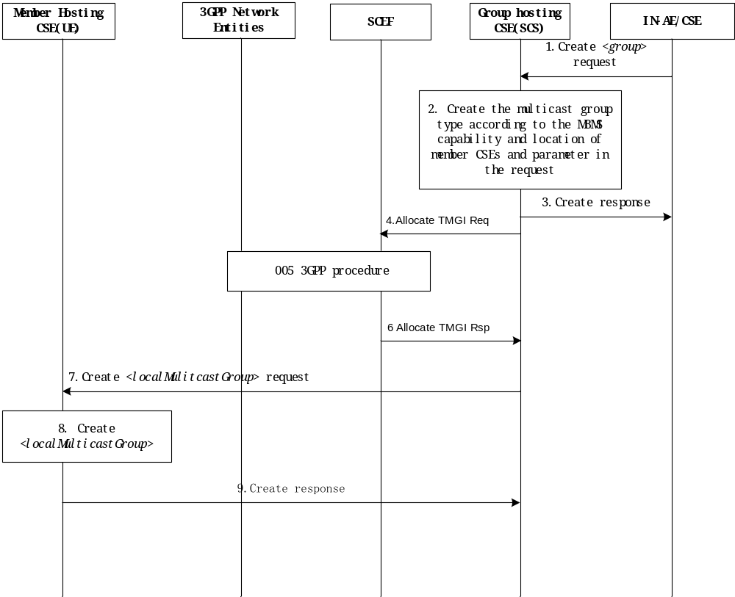
Figure 7.7.3.1-1: Service Flow of MBMS Group Creating
Pre-conditions:
1) The MBMS service area information provided by the operator is configured in the oneM2M System;
2) External Group Identifiers for the devices have been pre-provisioned in the oneM2M System.
Step 1: The IN-AE sends a <group> create request to the Group Hosting CSE.
Step 2: The Group Hosting CSE checks if the multicastCapability attribute of the <remoteCSE> resource for more than two member Hosting CSEs are configured with a value of MBMS and have the same externalGroupID. If so, the Group Hosting CSE then creates the <group> as specified in clause 10.2.7.2 of oneM2M TS-0001[1] and the multicastType attribute of the Multicast Group Information is set to 3GPP_MBMS_group as specified in clause 10.2.7.13 of oneM2M TS-0001[1].
Step 3: The Group Hosting CSE sends the response to the IN-AE/CSE.
Step 4: The Group Hosting CSE sends the Allocate TMGI Request to the SCEF. The request shall contain the following information as specified in 3GPP TS 29.122 [4].
- An HTTP POST method shall be used
- URI shall be set to {apiRoot}/3gpp-group-message-delivery-mb2 /v1/{scsAsId}/tmgi-allocation. The {apiRoot} and {scsAsId} segments are configured based on Service Provider and MNO policies.
- The request payload shall include a TMGIAllocation data structure as specified in 3GPP TS 29.122 [4] with the following attributes:
  - externalGroupId shall be set to the externalGroupID of Member Hosting CSEs.
  - mbmsLocArea may be set to location information of Member Hosting CSEs per the accuracy policy.
  - supportedFeatures shall be set to a string value of “0” indicating no support for notifications over Websockets or notification test events.
General Exceptions:
The SCEF is not reachable when Hosting CSE (i.e. IN-CSE) tries to send Allocate TMGI Request request. In this case the IN-CSE will not be able to get an allocated TMGI from the underlying 3GPP network. Hence the IN-CSE will not be able to use multicast functionality for this group. The IN-CSE may service requests for the group using unicast functionality if applicable.
Step 5: The Allocate TMGI Request is processed by the Underlying 3GPP Network based on the procedure defined in 3GPP TS 23.682 [2].
Step 6: The SCEF sends the Allocate TMGI Response to the Group Hosting CSE. The response will contain the following information as specified in 3GPP TS 29.122 [4].
- A response code of 201 CREATED
- The URI of the Communication Patterns Configuration subscription resource created by the SCEF. The URI is returned in the HTTP Location header with a format of {apiRoot}/3gpp-group-message-delivery-mb2 /v1/{scsAsId}/tmgi-allocation/{tmgi}. The {apiRoot} and {scsAsId} segments are configured based on Service Provider and MNO policies. The {tmgi} segment is configured by the SCEF.
- The response payload will include a TMGIAllocation data structure as specified in 3GPP TS 29.122 [4] that includes the attributes present in the request along with the following additional attributes:
  - self is configured with a link to the {apiRoot}/3gpp-group-message-delivery-mb2 /v1/{scsAsId}/tmgi-allocation/{tmgi} resource created by the SCEF for the request
  - tmgi is configured with the identity of a particular MBMS bearer service
  - tmgiExpiration is configured with absolute time at which the TMGI is considered to expire.
See clause 8.3 for a list of possible error scenarios and error handling options for the IN-CSE.

Step 7: The Group Hosting CSE stores the tmgi and tmgiExpiration in the local Multicast Group Information and sends <localMulticastGroup> creation requests to the Member Hosting CSEs via unicast which contain mandatory attributes specified in clause 9.6.44 of oneM2M TS-0001[1]. If the multicastType is 3GPP_MBMS_group, the request contains the tmgi and responseTimeWindow.
Step 8 and 9: These steps are specified in clause 10.2.7.14 of oneM2M TS-0001[1].

7.7.3.2 Group message delivery using MBMS

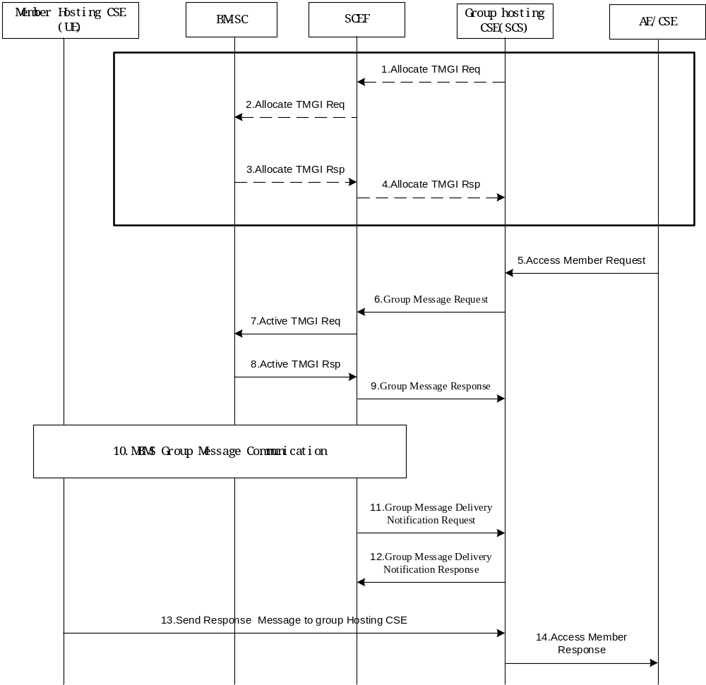
Figure 7.7.3.2-1: Service Flow of MBMS Group Message Delivery
Step 1: Before the tmgiExpiration of the multicast group, the Group Hosting CSE may send an Allocate TMGI Request to renew the expiration time for already allocated TMGIs. The request shall contain the following information as specified in 3GPP TS 29.122 [4].
- An HTTP PUT method shall be used
- URI shall be set to {apiRoot}/3gpp-group-message-delivery-mb2 /v1/{scsAsId}/tmgi-allocation/{tmgi}. The {apiRoot} and {scsAsId} segments are configured based on Service Provider and MNO policies. The {tmgi} segment is configured by the SCEF in the response to the initial TMGI Allocation request.
- The request payload shall include a TMGIAllocation data structure as specified in 3GPP TS 29.122 [4] with the following attributes:
  - externalGroupId shall be set to the externalGroupID of Member Hosting CSEs.
  - mbmsLocArea may be set to location information of Member Hosting CSEs per the accuracy policy.
  - supportedFeatures shall be set to a string value of “0” indicating no support for notifications over Websockets or notification test events.
General Exceptions:
The SCEF is not reachable when Hosting CSE (i.e. IN-CSE) tries to send Allocate TMGI Request. In this case the IN-CSE will not be able to renew the TMGI with the underlying 3GPP network. Hence the IN-CSE will not be able to use multicast functionality for this group. The IN-CSE may service requests for the group using unicast functionality if applicable.
Step 2 and 3: The Allocate TMGI is processed by the Underlying 3GPP Network based on the procedure defined in 3GPP TS 23.682 [2].
Step 4: The SCEF sends the Allocate TMGI Response to the Group Hosting CSE. The response will contain the following information as specified in 3GPP TS 29.122 [4].
- A response code of 200 OK
- The response payload will include an updated TMGIAllocation data structure as specified in 3GPP TS 29.122 [4] that includes the attributes present in the request along with the following additional attributes:
  - self is configured with a link to the {apiRoot}/3gpp-group-message-delivery-mb2 /v1/{scsAsId}/tmgi-allocation/{tmgi} resource created by the SCEF for the request
  - tmgi is configured with the identity of a particular MBMS bearer service
  - tmgiExpiration is configured with absolute time at which the TMGI is considered to expire.
The Group Hosting CSE shall replace the new tmgiExpiration in the Multicast Group Information locally.
Note, Step1- Step4 are optional (e.g. if the tmgiExpiration is not going to expire any time soon).
See clause 8.3 for a list of possible error scenarios and error handling options for the IN-CSE.

Step 5: The IN-AE/CSE sends a request carrying the group resource identifier for accessing member resources to the Group Hosting CSE.
Step 6: If the multicastType is 3GPP_MBMS_group, the Group Hosting CSE checks the existing <schedule> child resources for all the Member Hosting CSE <node> resources. If there is no time intersection of the existing <schedule>s, then the Group Hosting CSE returns an error response to the IN-AE/CSE after which the procedure is terminated. If there is a time intersection, the Group Hosting CSE shall check if the Operation Execution Time and Request Expiration Timestamp are in the scope of the intersection when Operation Execution Time or Request Expiration Timestamp is included in the request. If not, the Group Hosting CSE shall return an error to the IN-AE/CSE after which the procedure is terminated.
NOTE: 3GPP supports the SCS/AS to set the Message Delivery Start Time for the Ues of a group which can impact the power saving mode of the UE, but oneM2M does not support it in release 3.
Then the group Hosting CSE shall send the Group Message Delivery Request to the SCEF to activate the MBMS bearer to provide MBMS communication network resources for MBMS members from the next start time of the time intersection. The request shall contain the following information as specified in 3GPP TS 29.122 [4].
- An HTTP POST method shall be used
- URI shall be set to {apiRoot}/3gpp-group-message-delivery-mb2 /v1/{scsAsId}/tmgi-allocation{tmgi}/delivery-via-mbms. The {apiRoot} and {scsAsId} segments are configured based on Service Provider and MNO policies. The {tmgi} segment is configured by the SCEF in the response to the initial TMGI Allocation request.
- The request payload shall include a GMDViaMBMSByMb2 data structure as specified in 3GPP TS 29.122 [4] with the following attributes:
  - externalGroupId shall be set to the same value as the externalGroupID of Member Hosting CSEs.
  - groupMessagePayload shall be set to the value specified in the request of access member resources from the IN-AE/CSE.
  - mbmsLocArea shall be set to location information of Member Hosting CSEs per the accuracy policy.
  - messageDeliveryStartTime shall be set to the next start time of the time intersection.
  - notificationDestination shall be configured with a URI that the SCEF can target Group Message Delivery notifications towards. The value of this URI shall be based on internal IN-CSE policies.
  - requestTestNotification and websockNotifConfig are not supported by the present document and shall not be included.
General Exceptions:
The SCEF is not reachable when Hosting CSE (i.e. IN-CSE) tries to send Group Message Delivery Request. In this case the IN-CSE will not be able to use multicast functionality to send the request to the group members. The IN-CSE may send the request to the group members using unicast functionality if applicable.
Step 7 and 8: The Activate MBMS Bearer Procedure is processed by the Underlying 3GPP Network based on the procedure defined in 3GPP TS 23.682 [2].
Step 9: The SCEF sends the Group Message Response to the Group Hosting CSE. The response shall contain the following information as specified in 3GPP TS 29.122 [4].
- A response code of 201 CREATED
- The URI of the Group Message Delivery resource created by the SCEF. The URI is returned in the HTTP Location header with a format of {apiRoot}/3gpp-group-message-delivery-mb2 /v1/{scsAsId}/tmgi-allocation{tmgi}/delivery-via-mbms/{transactionId}. The {apiRoot} and {scsAsId} segments are configured based on Service Provider and MNO policies. The {tmgi} and {transactionId} segments are configured by the SCEF.
- The response payload will include an updated GMDViaMBMSByMb2 data structure as specified in 3GPP TS 29.122 [4] that includes the attributes present in the request along with the following additional attributes:
  - self is configured with a link to the {apiRoot}/3gpp-group-message-delivery-mb2 /v1/{scsAsId}/tmgi-allocation{tmgi}/delivery-via-mbms/{transactionId} resource created by the SCEF for the request
  - acceptanceStatus indicating whether the activation of MBMS bearer corresponding to the TMGI was accepted or rejected
  - scefMessageDeliveryIPv4 indicates the Ipv4 address where the SCEF supports receiving group message payloads separate from the Group Message Delivery Request. In the present document, the IN-CSE includes the group message payload in the Group Message Delivery Request and hence the IN-CSE ignores this information in the response.
  - scefMessageDeliveryIPv6 indicates the Ipv6 address where the SCEF supports receiving group message payloads separate from the Group Message Delivery Request. In the present document, the IN-CSE includes the group message payload in the Group Message Delivery Request and hence the IN-CSE ignores this information in the response.
  - scefMessageDeliveryPort indicates the port number where the SCEF supports receiving group message payloads separate from the Group Message Delivery Request. In the present document, the IN-CSE includes the group message payload in the Group Message Delivery Request and hence the IN-CSE ignores this information in the response.
See clause 8.3 for a list of possible error scenarios and error handling options for the IN-CSE.

Step 10: The Group Message Delivery by MBMS Procedure is processed by the Underlying 3GPP Network based on the procedure defined in 3GPP TS 23.682 [2].
Step 11: The SCEF sends a Group Message Delivery Notification to the Group Hosting CSE.
The notification message contains the following information as specified in 3GPP TS 29.122 [4].
- An HTTP POST method is used
- URI is set to {notification_uri}. The {notification_uri} is configured by the IN-CSE in the Group Message Delivery Request.
- The request payload will include a GMDByMb2Notification data structure as specified in 3GPP TS 29.122 [4] with the following attributes:
  - transaction configured with a URI to the transaction resource for which this notification corresponds to
  - tmgi identifies the TMGI that this notification is applicable to
  - deliveryTriggerStatus indicates whether the delivery of the group message payload was successful or not and will have the value of TRUE or FALSE.
Step 12: After receiving a Group Message Delivery Notification, the Group Hosting CSE (i.e. IN-CSE) returns a response having a response code of 204 NO CONTENT.
Step 13: The Member Hosting CSE shall send the response message within the scope of responseTimeWindow. Details are specified in clause 10.2.7.13.2 of oneM2M TS-0001[1].
Step 14: The Group Hosting CSE shall receive the response messages from Member Hosting CSEs until responseTimeWindow expires and return the aggregated group member responses to the IN-AE/CSE.
General Exceptions:
If the SCEF sends a Group Message Delivery Notification to the Group Hosting CSE with a deliveryTriggStatus set to FALSE indicating that the delivery of the group message payload was not successful, then the Group Hosting CSE may choose to return a GROUP_MEMBERS_NOT_RESPONDED error response to the IN-AE/CSE before the responseTimeWindow expires.

7.8 Informing about Potential Network Issues

7.8.1 Throttling of requests based on Network Status Reports
The 3GPP SCEF Network Status Monitoring functionality described in 3GPP TS 29.122 [4] supports an API to allow an IN-CSE to be informed when there are network congestion issues in a geographical area in the underlying 3GPP network.
An IN-CSE may request to receive notifications from an underlying 3GPP network when the network congestion level in a specified geographical area crosses defined threshold value(s). Based on these reports, the IN-CSE can start/stop throttling of requests initiated by or targeted towards its registree Aes and CSEs that are hosted on Ues residing in this geographical area to help manage the congestion levels in the underlying 3GPP network.
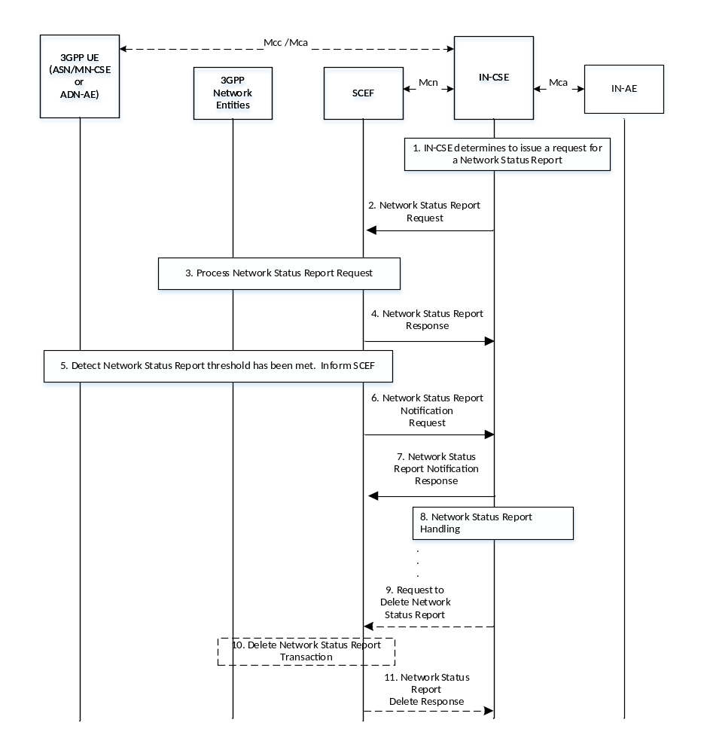
Figure 7.8.1-1: Request for Network Status Reports
Pre-conditions:
There is a relationship in place between the IN-CSE and MNO allowing the IN-CSE to request Network Status Reports from the underlying 3GPP network. The method for establishing this relationship is outside the scope of the present document.
The IN-CSE is configured with system defaults for the following. The method for configuring these system defaults is outside the scope of the present document.

• The network congestion levels to receive reports
• The severity of each specified congestion level
• The specified actions to take based on the severity of each congestion level.
An ASN/MN-CSE or ADN-AE registers with the IN-CSE and configures the M2M-Ext-ID attribute of its <remoteCSE> or <AE> resource. The IN-CSE examines the M2M-Ext-ID and recognizes that it is associated with an MNO that it has a relationship with.
The IN-CSE is able to detect the location of its registree ASN/MN-CSEs and/or ADN-Aes. For example, a <locationPolicy> resource may be used by an IN-CSE to detect the location of each ASN/MN-CSE or ADN-AE.
The ADN-AE’s <node> resource hosted on the IN-CSE has a child <schedule> resource and the IN-CSE has permissions to update it. The ADN-AE has a <subscription> to its <schedule> resource and when it receives a notification from the IN-CSE it updates its communication schedule accordingly.
The ASN/MN-CSE’s <node> resource hosted on the IN-CSE has a child <schedule> resource and the IN-CSE has permissions to update it. The ASN/MN-CSE has a <subscription> to its <schedule> resource and when it receives a notification from the IN-CSE it updates its communication schedule accordingly.
Step 1: IN-CSE issues a Network Status Request
The IN-CSE issues a Network Status Report request to the SCEF via one or more of the following approaches.
- The IN-CSE may periodically check the location of its registree ASN/MN-CSEs and ADN-Aes. When the IN-CSE detects that a certain number of ASN/MN-CSEs and/or ADN-Aes are in the same geographical area, it may further check if the ASN/MN-CSEs and ADN-Aes are connected to the same network. The IN-CSE can detect if the ASN/MN-CSEs and ADN-Aes are connected to the same network by examining their M2M-Ext-ID attributes. For example, a 3GPP external identifier is composed of a local identifier and a domain identifier. If the ASN/MN-CSEs and ADN-Aes have the same domain identifier, they may be connected to the same network. When the IN-CSE detects that a number of ASN/MN-CSEs and/or ADN-Aes are in the same geographical area and attached to the same network, it may decide to request a Network Status Report in that geographical area.
- The IN-CSE may use [cmdhNwAccessRule] resources for corresponding registree CSEs that support CMDH functionality. The IN-CSE may check the targetNetwork attribute and use this attribute to identify a SCEF and issue a Network Status Request to this SCEF. When issuing the request for a Network Status Report, the IN-CSE shall provide a geographic area for which the report will apply. The IN-CSE may detect the geographic area for which the policy applies by checking the location that is associated with each CSE. For example, <locationPolicy> resources may be associated with a registree CSE for which the CMDH policies apply and used by an IN-CSE to detect locations for the CSEs.
How the IN-CSE determines which of the above approach(es) to use is implementation specific and outside the scope of the present document.
Step 2: Network Status Report Request
The IN-CSE requests network status reports for a geographical area. The Network Status Reporting Subscription request from the IN-CSE to the SCEF shall comply with Error: Reference source not found3GPP TS 29.122 [4] as follows:
- An HTTP POST method shall be used
- URI shall be set to {apiRoot}/3gpp-net-stat-report/v1/{scsAsId}/subscriptions/. The {apiRoot} and {scsAsId} segments are configured based on Service Provider and MNO policies.
- The request payload shall include a NetworkStatusReportingSubscription data structure as specified in 3GPP TS 29.122 [4] with the following attributes:
  - notificationDestination shall be set to a URI that the SCEF can target Network Status Report notifications towards. The value of this URI shall be based on internal IN-CSE policies.
  - thresholdValues shall be a list of integer values in the range of 0 to 31 and specify what congestion threshold(s) the IN-CSE wants to receive a report for. Whenever the congestion in the geographical area goes above or below an indicated threshold, a report will be sent. The threshold(s) that are indicated by the IN-CSE are determined based on local IN-CSE policies. The definition of these policies is outside the scope of the present document.
  - thresholdTypes shall be a list of enumerated types with values HIGH, MEDIUM and LOW that specify the type of congestion status the IN-CSE would like to receive a report for. The threshold type(s) that are indicated by the IN-CSE are determined based on local IN-CSE policies. The definition of these policies is outside the scope of the present document. The IN-CSE shall not include thresholdValue and thresholdType in the same request. They shall be used mutually exclusive of one another.
  - timeDuration shall indicate the date and time that the SCEF will stop sending reports to the IN-CSE. The data and time value is determined based on local IN-CSE policies. The definition of these policies is outside the scope of the present document.
NOTE: If no duration is provided, then only one Network Status Report will be provided to the IN-CSE
  - locationArea shall be configured with location information specified by the IN-CSE. The IN-CSE may use location information that it collects from its registree’s <locationPolicy> resources and/or M2M-Ext-IDs to configure this attribute. Shall be expressed as a list cell IDs, tracking areas, civic addresses or geopgraphic area.
  - supportedFeatures shall be set to a string value of “0” indicating no support for notifications via Websockets or notification test events.
  - requestTestNotification and websockNotifConfig are not supported by the present document and shall not be included.
General Exceptions:
The SCEF is not reachable when Hosting CSE (i.e. IN-CSE) tries to send Network Status Reporting Subscription request. In this case the IN-CSE will not be able to get receive network status reports from the underlying 3GPP network. Hence the IN-CSE will not be able to provide value-add services to the underlying 3GPP network such as throttling of requests targeted towards Aes and CSEs hosted on Ues residing in congested areas of the network.
Step 3: SCEF Processes Network Status Report Request
The SCEF and underlying 3GPP network process the Network Status Report Request.
Step 4: Network Status Report Response
The SCEF sends a Network Status Report Response to the IN-CSE to acknowledge the request has been accepted. This response is defined in 3GPP TS 29.122 [4] and includes the following information.
- A response code of 201 CREATED
- The URI of the Group Message Delivery resource created by the SCEF. The URI is returned in the HTTP Location header with a format of {apiRoot}/3gpp-net-stat-report/v1/{scsAsId}/subscriptions/{subscriptionId}. The {apiRoot} and {scsAsId} segments are configured based on Service Provider and MNO policies. The {subscriptionId} segment is configured by the SCEF.
- The response payload will include an updated NetworkStatusReportingSubscription data structure as specified in 3GPP TS 29.122 [4] that includes the attributes present in the request along with the following additional attributes:
  - self is configured with a link to the {apiRoot}/3gpp-net-stat-report/v1/{scsAsId}/subscriptions/{subscriptionId} resource created by the SCEF for the request
See clause 8.3 for a list of possible error scenarios and error handling options for the IN-CSE.
Step 5: Detect Congestion
After receiving the initial Network Status Request or when the congestion level passes one of the indicated threshold(s), the SCEF will create a Network Status Report.
Step 6: Network Status Report
The SCEF sends a Network Status Report to the corresponding notificationDestination of the IN-CSE that was configured in Step 2. The report contains information as specified in 3GPP TS 29.122 [4]Error: Reference source not found. Such information includes:

- An HTTP POST method is used
- URI is set to {notification_uri}. The {notification_uri} is configured by the IN-CSE in the Network Status Reporting Subscription Request.
- The request payload will include a NetworkStatusReportingNotification data structure as specified in 3GPP TS 29.122 [4] with the following attributes:
  - subscription configured with a URI to the subscription resource for which this notification corresponds to
  - nsiValue configured with the network status indicator that is an integer in the range of 0 to 31 that indicates a congestion level as defined in 3GPP TS 29.122 [4]
  - nsiType configured with the network status indicator that is an enumerated value of HIGH, MEDIUM or LOW as defined in 3GPP TS 29.122 [4]
NOTE – A response will not contain both nsiType and nsiValue. They are mutually exclusive.
Step 7: Network Status Report Acknowledgement
After receiving a Network Status Report Notification, the IN-CSE returns a response having a response code of 204 NO CONTENT.
Step 8: Process Network Status Report
In response to the Network Status Report, the IN-CSE may decide to throttle up/down traffic in the congested area of the network via one or more of the following approaches.
- An IN-CSE may reject requests that target nodes in congested areas of the network. If an IN-CSE rejects a request due to network congestion it shall return a EXTERNAL_OBJECT_NOT_REACHABLE response code. The IN-CSE may also inform the Originator to retry the request after some specified backoff delay. The method to inform the Originator is currently not specified in the present document however a message included in the payload of the response could be used.
- An IN-CSE may delay the processing (i.e. buffer) of requests that target nodes in congested areas of the network.
  - If the request is a blocking request, the IN-CSE should not delay the processing of the request and should instead reject this request with a corresponding response code informing the cause of rejection is due to network congestion.
  - If the request includes an Event Category that is set to immediate the IN-CSE should not delay the processing of the request and should instead reject the request with a EXTERNAL_OBJECT_NOT_REACHABLE response code. In this case, the IN-AE may decide to resubmit the request with the Event Category set to “bestEffort” or “latest” to indicate the IN-CSE may buffer the request.
- An IN-CSE may modify the <schedule> resource of its registree Aes or CSEs that are located in a congested area of the network such that they modify the times they send or receive requests.
  - A registree AE or CSE may retrieve or subscribe to its <schedule> resource such that it detects if the IN-CSE updates the scheduleElement attribute. Upon detecting an updated scheduleElement an AE or CSE shall modify the times which it sends requests and makes itself available to receive requests.
- An IN-CSE may modify the [cmdhNwAccessRule] resources for corresponding registree CSEs that support CMDH functionality.
How the IN-CSE determines which of the above approach(es) to use is outside the scope of the current document and may be based on agreements with the network operator.
Step 9 (Optional): Network Status Request Cancellation
Before the Duration expires, the IN-CSE may request that the SCEF stop sending status reports. The IN-CSE may make this decision, for example, when it detects that a number of devices are no longer in the geographical area applicable to the Network Status Request.
The IN-CSE shall send a Network Status Cancellation Request as follows:

- An HTTP DELETE method shall be used
- URI shall be set to {apiRoot}/3gpp-net-stat-report/v1/{scsAsId}/subscriptions/{subscriptionId}. The {apiRoot} and {scsAsId} segments are configured based on Service Provider and MNO policies. The {subscriptionId} corresponds to the one configured by the SCEF and returned to the IN-CSE when the Network Status Reporting Subscription was created.
- The request shall not contain a payload
Step 10 (Optional): Process Network Status Cancellation Request
The SCEF processes the cancelation request.
Step 11 (Optional): Acknowledge Network Status Cancellation Request
The SCEF acknowledges the request to cancel Network Status Reports for the geographical area with a response code of 204 NO CONTENT.
See clause 8.3 for a list of possible error scenarios and error handling options for the IN-CSE.

7.9 Setting up an AS session with required QoS procedure
Not supported in this release of the document.

7.10 Background Data Transfer

7.10.1 Overview
For the oneM2M system, Background Data Transfer (BDT) allows the IN-AE/CSE to have some control over its transmissions to field domain nodes that use an underlying network that provides transfer of data in the background. Namely, the IN-AE/CSE is provided with a list of potential transfer policies (time windows, with associated maximum bit rate) and charging condition so that the IN-AE/CSE may use a time window that is more favorable in terms of tariff/cost and/or overall throughput.
For the cellular network, management of the background data traffic for Ues (such as M2M devices) may result in significant gains for the network. For example, it is expected that for some use cases, 3rd party entities will select the more underutilized time windows to take advantage of the more favorable tariff and/or cost for the charging conditions. This effectively allows the cellular operator to spread the network utilization over time.
The purpose of this feature is to provide a means for the oneM2M System to inform the underlying network of parameters that can be used for optimizing the background data traffic over the underlying network for a set of Field Domain Nodes (Ues). Such parameters may include the expected number of Ues in the set and amount of data to be transferred a desired/preferred time window for the data transfer to these Ues, and network area information. In response, the underlying network may inform the oneM2M system about policies that may be used to meet the given background data transfer request.
Background Data Transfer takes place in 3 steps.
- Policy Request and Selection:
  - An initiating entity (AE or CSE) will provide information on the requested BDT (e.g. expected data volume per UE) for a set of Field Domain Nodes (ADN/ASN /MN) to the IN-CSE. The information will include a group or list of Field Domain Nodes that will use the policy, as well as some guidance to the IN-CSE so that it can better select from a set of potential transfer policies offered by the underlying network.
  - The IN-CSE will use the Mcn interface to provide the SCEF of the selected underlying network with the BDT information and to ask for the Policy.
  - The SCEF may provide the IN-CSE with a set of possible transfer policies for BDT and collect for charging. Using the guidance provided by the initiating Application Entity (AE) or Common Service Entity (CSE), the IN-CSE selects the transfer policy based on its own local policies, and notifies the initiating entity about the selected transfer policy.
  - The IN-CSE indicates to the SCEF which policy was selected and the SCEF records the selection for charging.
- Policy Enablement:
  - The IN-CSE contacts the PCRF via SCEF and enables the policy for each UE.
- Background Data Transfer:
  - During the policy time window, the IN-CSE transfers the data to the UE through the cellular network, and based on the chosen policy.

7.10.2 Resource Structure
The <backgroundDataTransfer> resource is a child of <CSEBase>, <AE>, or <remoteCSE> and is used to request that the IN-CSE negotiates a background data transfer for a set of field nodes, with the Underlying Network. The resource attributes provide the characteristics of the background data transfer (volume per node, number of nodes), optionally a preferred time window for the transfer and geographic information, as well as the nodes that will be involved with the data transfer. Additionally, the resource also includes guidance to the IN-CSE so that it may select a transfer policy, if the underlying network provides multiple potential transfer policies (transferSelectionGuidance).
The groupLink(s) or memberIDs attributes are used to identify the target nodes for the background data transfer request. It is assumed that the memberIDs list only includes field nodes that are UE’s. If the IN-AE wishes to send the same message to a group of field domain nodes, it is assumed that the IN-AE has already created a <group> resource in the IN-CSE, with a memberIDs list that includes all field domain nodes that need to be reached through the background data transfer.
NOTE: The memberIDs are known when the <backgroundDataTransfer> resource is created so that the IN-CSE can determine the proper underlying network to contact.

7.10.3 Procedures

7.10.3.1 Requesting and Selecting a Background Data Transfer Policy
Figure 7.10.3.1-1 depicts a general procedure for the request and configuration of traffic policies for BDT initiated by a request from an IN-AE. The procedure may also be initiated by a request from an MN/ASN-CSE or from the IN-CSE itself.

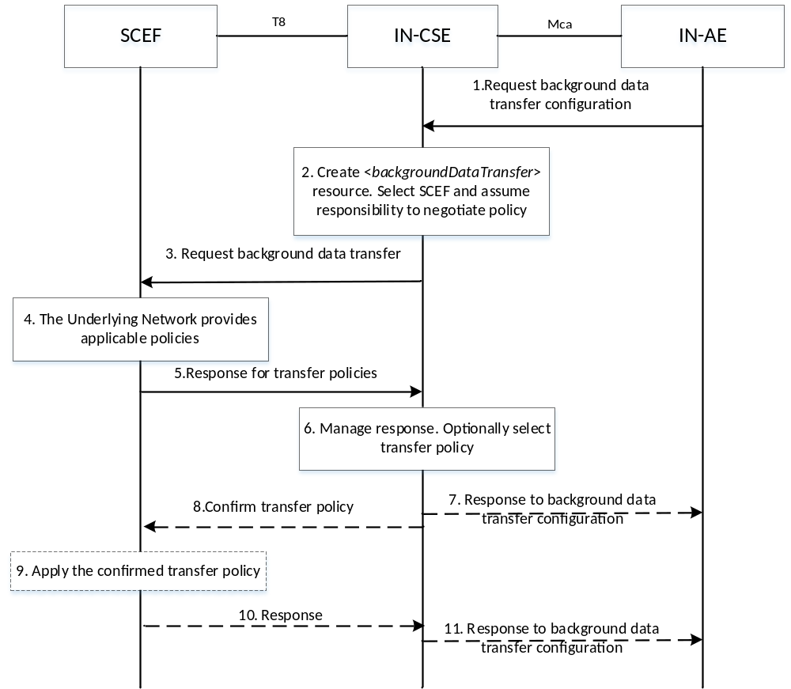
Figure 7.10.3.1-1: General Procedure for configuration of Background Data Transfer
Step 1: Request background data transfer configuration
An IN-AE requests IN-CSE to negotiate with SCEF in the underlying network, to configure background data transfer, by creating a <backgroundDataTransfer> resource.
The request includes:
- the originator AE-ID of the requesting AE,
- a target identifier: i.e. the <backgroundDataTransfer> child resource of <AE>, <CSEBase> or <remoteCSE> resource.
- a set of Background Data Transfer Parameters as indicated in clause 9.6.60 of oneM2M TS-0001[1]..
If the IN-CSE has received a request from an IN-AE or another Originator to create <backgroundDataTransfer> resource, it checks if the request is valid.
Step 2: IN-CSE prepares for background data transfer negotiation
IN-CSE selects the SCEF and assumes the responsibility of negotiating with the underlying network for the background data transfer. The IN-CSE selects the SCEF based on the candidate nodes that were identified in the groupLink(s) or memberIDs list of the background data transfer request. The exact selection methods are outside the scope of this specification; however, it is expected that the external identifiers of the group members can be resolved to a SCEF.

Step 3: Request background data transfer
The IN-CSE selects the SCEF and issues a BDT request, providing Background Data Transfer parameters, to the selected SCEF for negotiating background data transfer. The fields of the API are populated as follows:
- An HTTP POST method shall be used
- URI shall be set to {apiRoot}/3gpp-bdt/v1/{scsAsId}/subscriptions/. The {apiRoot} and {scsAsId} segments are configured based on Service Provider and MNO policies.
- The request payload shall include a Bdt data structure as specified in 3GPP TS 29.122 [4] with the following attributes:
  - supportedFeatures shall be set to a string value of “0”
  - volumePerUE shall be set to the volume of data expected to be transferred per node, based on <backgroundDataTransfer> information.
  - numberOfUEs shall be set to the expected number of nodes, based on <backgroundDataTransfer> information.
  - desiredTimeWindow shall be set to the desired time window
  - locationArea shall be set to the optional geographic information.
  - referenceId, selectedPolicy and transferPolicies shall be absent in a BDT Request POST message.
Based on this request, if the IN-CSE is authorized, the SCEF shall negotiate the transfer policy with PCRF using the Background-Data-Transfer-Request (BTR) command over the Nt reference point as defined in 3GPP TS 29.154 [i.2].
Step 4: The Underlying Network provides applicable policies for Background Data Transfer
The Underlying Network determines one or more applicable transfer policies based on the requesting Background Data Transfer parameters.The SCEF receives the Background-Data-Transfer-Answer (BTA) on the Nt reference point as defined in 3GPP TS 29.154 [i.2]).
Step 5: Response for transfer policies
The SCEF responds to the IN-CSE indicating the request was accepted and sends The response message as follows:
- A response code of 201 CREATED
- The URI of the Background Data resource created by the SCEF. The URI is returned in the HTTP Location header with a format of {apiRoot}/3gpp-bdt/v1/{scsAsId}/subscriptions/{subscriptionId}. The {apiRoot} and {scsAsId} segments are configured based on Service Provider and MNO policies. The {subscriptionId} segment is configured by the SCEF.
- The response payload will include a Bdt data structure as specified in 3GPP TS 29.122 [4] that includes the attributes present in the request along with the following additional attributes:
  - self is configured with a URI to the Background Data resource created by the SCEF for the request
- transferPolicies containing a list of offered transfer policies, each policy including the mandatory attributes bdtPolicyId, ratingGroup and timeWindow, and the optional attributes maxUplinkBandwidth and maxDownlinkBandwidth
- referenceId may be present in the response
The IN-CSE stores locally the response referenceID and policy information received in the SCEF response, namely the transferPolicies list. See clause 8.3 for a list of possible error scenarios and error handling options for the IN-CSE.
Step 6: Process response with transfer policies provided by the underlying network
The IN-CSE manages the SCEF response. If only one transfer policy was received from the underlying network, the IN-CSE updates the desiredTimeWindow attribute of the <backgroundDataTransfer> resource, with the start and end time of the timeWindow attribute of the received policy. The IN-CSE also stores locally the response referenceID.
If more than one transfer policy was received from the underlying network, the IN-CSE uses the transferSelectionGuidance and its own selection policies to select one of them. If transferSelectionGuidance is not provided, then the IN-CSE uses internal policies to select a policy. The definition of these internal policies is outside the scope of the present document.
Step 7: (Optional) Issue response to Entity initiating the background data transfer
If only one transfer policy has been received, IN-CSE responds to the original background data transfer request from the initiating entity.
Step 8: Confirm the transfer policy
If more than one transfer policy was offered in step-4, for the transfer policy selected in Step 6, the IN-CSE informs the SCEF of the selected transfer policy identifier. For this purpose, the IN-CSE shall use the PATCH request to modify the existing resource at the SCEF.
The message includes the following information.
- An HTTP PATCH method shall be used
- URI shall be set to {apiRoot}/3gpp-bdt/v1/{scsAsId}/subscriptions/{subscriptionId}. The {apiRoot} and {scsAsId} segments are configured based on Service Provider and MNO policies. The {subscriptionId} segment is configured by the SCEF.
- The request payload shall include a BdtPatch data structure as specified in 3GPP TS 29.122 [4] with the following attributes:
  - selectedPolicy shall be set to the bdtPolicyId of the selected background data transfer policy among those contained in transferPolicies list.
Step 9: Apply the confirmed transfer policy
The transfer policy confirmed by the IN-CSE is used by SCEF to apply the configuration by notifying the underlying network of the selected transfer policy. The SCEF includes the referenceID and bdtPolicyId of the selected policy in the Background-Data-Transfer-Request (BTR) command to PCRF over the Nt reference point as defined in 3GPP TS 29.154 [i.2].
As response, the SCEF receives the Background-Data-Transfer-Answer (BTA) on the Nt reference point as defined in 3GPP TS 29.154 [i.2]).
Step 10: Response to IN-CSE
Once the underlying network has recorded/ applied the confirmed transfer policy, the SCEF returns a response to the IN-CSE.
The message includes the following information.

- A response code of 200 OK
- The response payload will include the updated Bdt data structure as specified in 3GPP TS 29.122 [4] which includes updated selectedPolicy.
Upon receipt, the IN-CSE updates the desiredTimeWindow attribute of the <backgroundDataTransfer> resource, with the start and end time of the timeWindow attributes of the negotiated policy.
Step 11: (Optional) Issue response to Entity initiating the background data transfer
If more than one transfer policy has been received in step 5, and step 7 has not been performed, the IN-CSE responds to the original background data transfer request from the initiating entity
See clause 8.3 for a list of possible error scenarios and error handling options for the IN-CSE.

7.10.3.2 Enabling a Background Data Transfer Policy
Figure 7.10.3.2-1 depicts a general procedure for configuring the negotiated policy in the underlying network for the specific field domain nodes (Ues) for which the data transfer will be initiated. This is necessary as the underlying network needs to configure its internal nodes so that these may monitor the traffic for these Ues against the negotiated policy. The procedure starts after the procedure of Section 7.10.3.1. This procedure may occur immediately after the procedure of Section 7.10.3.1 or during the time window of the selected policy.

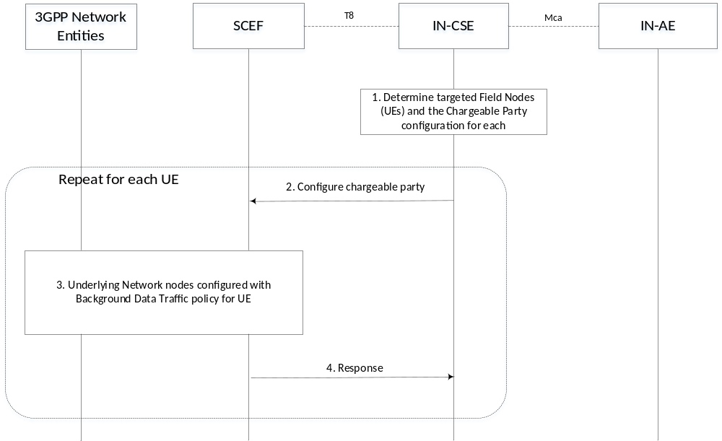

Figure 7.10.3.2-1: General Procedure for Policy Enablement
Step 1: IN-CSE determines the impacted Ues
It is assumed that prior to this procedure the IN-AE a Background Data Transfer has been requested and selected.
The <backgroundDataTransfer> resource either with a list of memberIDs, or with a link to the <group> resource that includes a list of memberIDs has been created. During the negotiation, the member list has been used by the IN-CSE to select the SCEF and a single background data transfer policy has been negotiated, for which the IN-CSE received relevant policy information e.g. the start and end time of the policy time window, the maximum aggregated authorized bandwidth for downlink transmission (in bps), and the maximum aggregated authorized bandwidth for uplink transmission (in bps).
Based on this information the IN-CSE or the initiating IN-AE may update the member list with the specific Ues for which the traffic policy enablement is to be performed (e.g. if the negotiated policy time window is different than the one requested, only a subset of the initial member list is used for performing the data transfer).
The IN-CSE uses the pointOfAccess for the entities on the member list, to obtain the IP address of the field domain nodes.
Step 2: For each UE, IN-CSE activates the selected transfer policy via the SCEF
For each UE involved in the Background Data Transfer, the IN-CSE triggers the “Change the chargeable party during the session” procedure via SCEF.. The IN-CSE identifies each target UE by the IP address of the UE and provides the referenceID for the selected policy transfer to the SCEF. The request is configured as follows.
The body of the HTTP POST message shall include SCS/AS Identifier, UE IP address, Flow description, Sponsor ID, ASP ID, Sponsoring Status, time period and/or traffic volume used for sponsoring. The SCS/AS may also request to activate a previously selected policy of background data transfer by including Reference ID in the body of the HTTP POST message.
- An HTTP POST method shall be used
- URI shall be set to {apiRoot}/3gpp chargeable-party /v1/{scsAsId}/transactions/. The {apiRoot} and {scsAsId} segments are configured based on Service Provider and MNO policies.
- The request payload shall include a ChargeableParty data structure as specified in 3GPP TS 29.122 [4] with the following attributes:
  - supportedFeatures shall be set to a string value of “0” indicating no support for notifications via Websockets or notification test events.
  - referenceId shall be set to referenceID of the applicable background data transfer to be applied.
  - flowInfo shall be set to provide description of the application flows. Each flow shall include a direction (uplink or downlink), source and destination IP address, protocol, and source and destination ports. Depending on the direction of the flow, the IN-CSE shall configure a source/destination with the IP address and port and of the IN-AE initiating the background data transfer. The IN-CSE shall configure the other destination/source with the IP address and port numbers and of the UE hosted ADN-AE or ASN/MN-CSE. The IN-CSE shall configure the protocol based on the corresponding protocol binding used between the IN-AE and ADN-AE or ASN/MN-CSE.
  - NOTE 1: To meet 3GPP requirements, the IP Address of the ADN-AE or ASN/MN-CSE is a non NAT’d IP Address and Port Number.
  - sponsorInformation, sponsoringEnabled shall be configured by IN-CSE as prearranged between the Service Provider and MNO.
  - notificationDestination, requestTestNotification, websockNotifConfig, ipv4Addr, ipv6Addr are not supported by the present document.

NOTE: How to address the case in which referenceID is not provided in the response to the background data transfer request, is outside the scope of the current document and left to implementation.
Step 3: The network is configured by SCEF for the background data transfer
For each UE involved in the Background Data Transfer, the SCEF executes the Change the chargeable party Procedure as described in 3GPP TS 29.154 [i.2].
Via this procedure, the underlying network is configured with the traffic policy information and the SCEF is informed for each UE that it has been enabled for background data transfer.
NOTE: The MNO will not enforce the maximum aggregated bitrate of a selected transfer policy. However, the operator can apply offline CDRs processing to determine whether the maximum aggregated bitrate was reached.
Step 4: SCEF acknowledges policy enablement for each UE
The SCEF informs the IN-CSE that the UE has been enabled for background data transfer. If there is more than one Ues listed in memberIDs, the IN-CSE then moves onto the next UE to enable, and repeats steps 2-4.

7.10.3.3 Using Background Data Transfer Policy
Once the transfer policy has been enabled and the time window has arrived, the initiating entity may:
- Use the fanout and group communication procedure to send the same request to each of the field domain nodes configured for background data transfer, or
- Send individual (and potentially different) requests to each of the field domain nodes configured for background data transfer.
NOTE: The data transfers corresponding to this step uses the Sgi interface.

7.10.3.4 Deleting a Background Data Transfer Policy
Figure 7.10.3.4.1-1 depicts a general procedure for deletion of a Background Data Transfer initiated by a request from an IN-AE. The procedure may also be initiated by a request from an MN/ASN-CSE or from the IN-CSE itself.
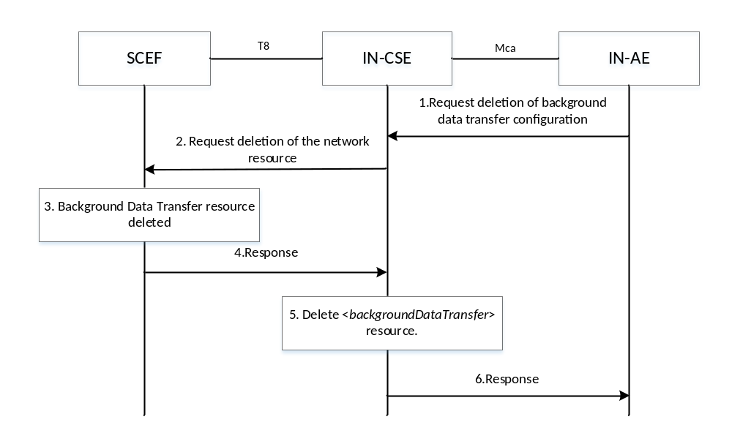
Figure 7.10.3.4-1: General Procedure for deletion of Background Data Transfer
Step 1: Request background data transfer configuration
An IN-AE requests IN-CSE to delete a <backgroundDataTransfer> resource.
The request includes:
- the originator AE-ID of the requesting AE,
- a target identifier: i.e. the <backgroundDataTransfer> child resource of <AE>, <CSEBase> or <remoteCSE> resource.
Step 2: Request deletion of the Background Data Transfer resource
The IN-CSE selects the SCEF and issues request to delete a Background Data Transfer resource at the SCEF as follows:

- An HTTP DELETE method shall be used
- URI shall be set to {apiRoot}/3gpp-bdt/v1/{scsAsId}/subscriptions/{subscriptionId}. The {apiRoot} and {scsAsId} segments are configured based on Service Provider and MNO policies. The {subscriptionId} corresponds to the one configured by the SCEF and returned to the IN-CSE when the Bdt resource was created at the SCEF.
- The request shall not contain a payload
Step 3: The SCEF deletes the Background Data Transfer resource
The Underlying Network removes the applicable Background Data Transfer configuration.
Step 4: SCEF Background Data Transfer deletion
The SCEF responds with a 204 NO CONTENT indicating the request was accepted.
Step 5: The IN-CSE deletes the <backgroundDataTransfer> resource
The IN-CSE deletes the <backgroundDataTransfer> resource based on the procedure specified in clause 10.2.20.5 of oneM2M TS-0001[1].
Step 6: The IN-CSE responds to Originator
If an AE (e.g. IN-AE) was the Originator of the delete request, the IN-CSE shall return the oneM2M response primitive to the AE.

7.11 Change the chargeable party at session set-up or during the session procedure
Not supported in this release of the document.

7.12 Network Parameter Configuration
The 3GPP SCEF functionality described in 3GPP TS 29.122 [4]. supports an API for Network Parameter Configuration which may be used by the IN-CSE to suggest to the 3GPP Mobile Network specific configuration parameters. The procedure may be used by the IN-CSE to influence certain aspects of UE/network behaviour such as the UE’s PSM and extended idle mode DRX. For this purpose, parameter values may be suggested for Maximum Latency and Maximum Response Time for a UE. The Mobile Core Network may choose to accept, reject or modify (via the SCEF) the suggested configuration parameter value.
NOTE: Once the network provides the SCEF with the configured values, the MME could later change the values. For example, the UE can be roaming and the visited network might not allow certain values. In this scenario, the SCEF can request a reachability notification with the Idle Status Indication set to indicate that it wants to be notified of the UE’s active timer and periodic TAU/RAU timer when the UE enters the idle state.
In the 3GPP interworking architecture of oneM2M, the UE can host an ADN-AE or an ASN/MN-CSE. The UE Monitoring flow in Figure 7.12-1 takes place after the UE has attached to the 3GPP Network and the ADN-AE or ASN/MN-CSE is registered with the IN-CSE.

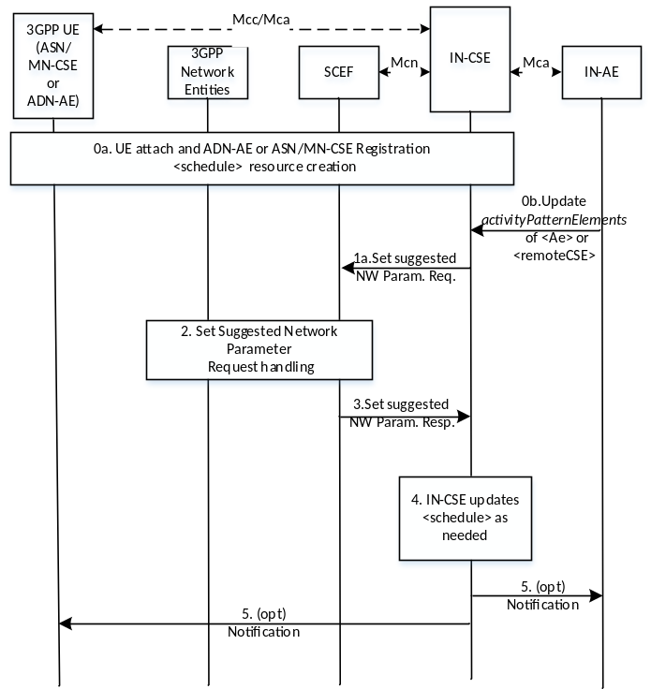
Figure 7.12 -1: Network Parameter Configuration flow

Step 0: UE Attach and oneM2M Registration Procedures
The UE attaches to the 3GPP network and the ADN-AE(s) or ASN/MN-CSE hosted on the UE perform the oneM2M registration procedure, as detailed in clause 6.3. The IN-CSE hosts the corresponding <AE> or <remoteCSE> resources and an associated <node> resource for the registree. During this procedure, a <schedule> resource is created as child of the <node> resource. The UE hosted ADN-AE(s) or ASN/MN may subscribe to the node <schedule> resource. If an IN-AE is interested in the reachability status of the UE, it may also subscribe to the <schedule> resources
Step 1: IN-CSE sends to the SCEF a Network Parameter Configuration request
This step is triggered by the creation of one or more <AE> or <remoteCSE> resources with the activityPatternElements attribute set (step 0a) or the modification of one or more of the activityPatternElements attributes during an update of the <AE> or <remoteCSE> resources (step 0b).
The IN-CSE determines the SCEF based on the M2M-Ext-ID’s of the registree ASN/MN-CSE or ADN-Aes (e.g. either a DNS lookup on the M2M-Ext-ID or the based on the domain portion of the M2M-Ext-ID’s.). The IN-CSE provides the network pattern to the SCEF, the fields of the API are populated as follows.
  - An HTTP POST method shall be used
  - URI shall be set to {apiRoot}/3gpp-network-parameter-configuration/v1/{scsAsId}/configurations/. The {apiRoot} and {scsAsId} segments are configured based on Service Provider and MNO policies.
  - The request payload shall include a NpConfiguration data structure as specified in 3GPP TS 29.122 [4] with the following attributes:
    - externalId shall be set to M2M-Ext-ID
    - supportedFeatures – shall be set to a string value of “0” indicating no support for notifications over Websockets or notification test events.
    - maximumLatency – This value tells the network how long the UE is allowed to sleep. Setting it to 0 will disable PSM, extended idle mode DRX, and S-GW buffering. The IN-CSE shall extract the the active periodicity defined in the scheduleElement(s) of all the applicable activityPatternElements attributes of the <AE> resource(s) of the ADN-AE(s) and <remoteCSE> resource of the ASN/MN-CSE hosted by the UE, if configured. The IN-CSE shall set Maximum Latency to be approximately the periodicity of the active periods defined in the scheduleElement(s) of all the applicable activityPatternElements attributes of the <AE> resource(s) of the ADN-AE(s) and <remoteCSE> resource of the ASN/MN-CSE hosted by the UE, if configured. If there is no periodicity it is recommended not to utilize this parameter.
    - maximumResponseTime – When the UE uses PSM, Maximum Response Time tells the network how long the UE should stay reachable after a TAU. When the UE uses eDRX, Maximum Response Time is used by the network to determine when to send a reachability notification before a UE’s paging occasion. The IN-CSE extracts a duration of activity from the scheduleElement of all the applicable activityPatternElements attributes of the <AE> resource(s) of the ADN-AE(s) and <remoteCSE> resource of the ASN/MN-CSE hosted by the UE, if configured.. The IN-CSE shall set Maximum Response Time to reflect this duration of activity, indicating how long the UE should stay reachable for downlink communications.
    - notificationDestination shall be set to a URI that the SCEF can target Network Parameter notifications towards. The value of this URI shall be based on internal IN-CSE policies.
    - msisdn, externalGroupId, requestTestNotification, groupReportingGuardTime, websockNotifConfig and suggestedNumberOfDlPackets are not supported by the present document and shall not be included.

General exceptions and error handling:
- If the SCEF is not reachable when the IN-CSE tries to send Network Parameter Configuration request then the IN-CSE may attempt to retry Network Parameter Configuration requests some time in the future in case the the SCEF does become reachable. The conditions for when the IN-CSE should retry a Network Parameter Configuration request are not defined in the present document.
Step 2 and 3: Network Parameter Configuration Handling in the Underlying Network
The SCEF processes the request and sends a response to the IN-CSE to acknowledge the request has been accepted. This message is defined in 3GPP TS 29.122 [4] and includes the following information.
- A response code of 201 CREATED
- The URI of the Network Parameter Configuration resource created by the SCEF. The URI is returned in the HTTP Location header with a format of {apiRoot}/3gpp-network-parameter-configuration/v1/{scsAsId}/configurations/{configurationId}. The {apiRoot} and {scsAsId} segments are configured based on Service Provider and MNO policies. The {configurationId} segment is configured by the SCEF.
- The response payload will include a NpConfiguration data structure as specified in 3GPP TS 29.122 [4] that includes the attributes present in the request along with the following additional attributes. The response may include updated values of maximumLatency and maximumResponseTime if the network chose to use values that were different than the values that were suggested by the IN-CSE:
  - self is configured with a URI to the Network Parameter Configuration resource created by the SCEF for the request
See clause 8.3 for a list of possible error scenarios and error handling options for the IN-CSE.
Step 4: Network Parameter Configuration Handling at the IN-CSE
The IN-CSE processes information received in the response which may include updated values of maximumLatency and maximumResponseTime if the network chose to use values that were different than the values that were suggested by the IN-CSE.
Note that IN-CSE shall not update the activityPatternElements attribute based on the response received from SCEF. Any further updates to the UE reachability shall be reflected in the <schedule> resource.
Step 5: (Optional) If IN-Aes have subscribed to changes in the <schedule> resources, a notification will be sent to the subscribers when UE changes it reachability status such as transitioning to connected mode or idle mode. Notifications will also be sent to the UE hosted ADN-AE or ASN-CSE/MN-CSE, if subscriptions to their respective <schedule> resources have been created.

7.13 Node Schedule Management
The <schedule> resource in oneM2M contains scheduling information. The usage of the <schedule> resource is different depending on the associated resource type, as follows:
- A child <schedule> resource of the <node> resource shall indicate the time periods when the node can communicate via the Underlying Network. If multiple Underlying Networks are supported, for each there can be a maximum of one <schedule> resource. One <schedule> resource may be used for multiple Underlying Networks.
The mgmtLink attribute of the <cmdhNwAccessRule> child resource of a <node> resource shall link to a <schedule> resource that is also a child of the same <node> resource.
In the context of 3GPP connectivity technologies, per 3GPP TS 23.682 [2Error: Reference source not found], the network reachability and UE reachability are both indications that the UE becomes reachable for receiving either an SMS or downlink data. The SCEF supports the capability to notify the IN-CSE of the network reachable status or the UE reachable status. The IN-CSE shall maintain a <schedule> resource of a UE and if the networkCoordinated attribute of the <schedule> is set to TRUE, then the IN-CSE shall coordinate the schedule based on the UE’s reachability. For example, the IN-CSE shall support synchronizing the start time of the scheduleElement attribute to be the same as the start time of the targeted UE idle status which the IN-CSE receives from the Underlying 3GPP Network.
Refer to the clause 9.6.9 Resource Type <schedule> of oneM2M TS-0001[1]

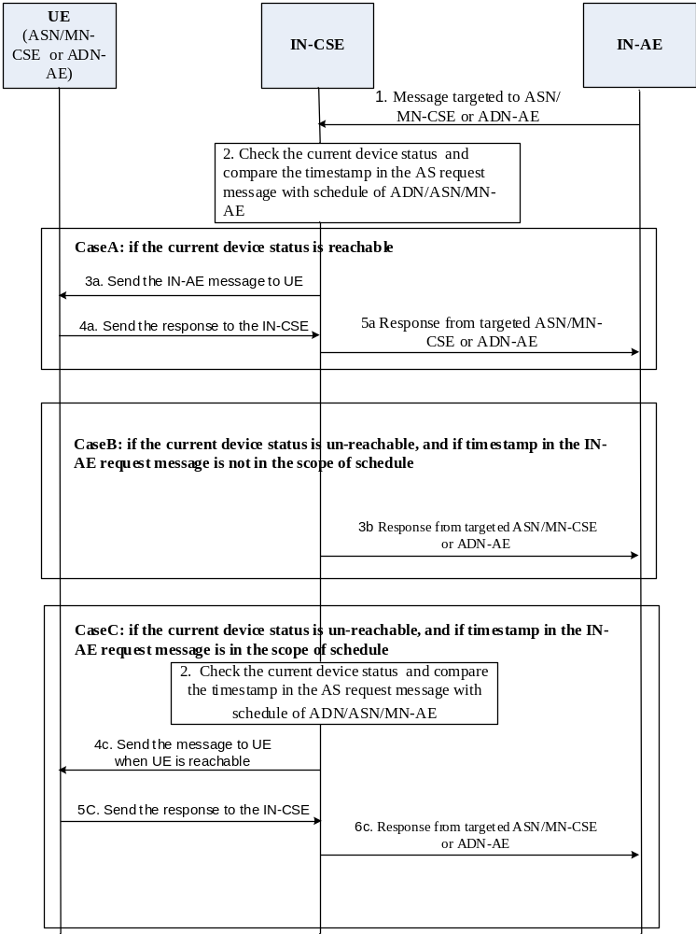
Figure 7.13-1: Targeting UE based on the <schedule> of <node> resource
Pre-requisites:
- The M2M-Ext-ID attribute of <remoteCSE> or <AE> resource of the targeted UE is pre-configured.
- For the targeted UE, the <schedule> resource is a child resource of a <node> resource, and the networkCoordinated attribute of <schedule> is ‘True’.

Step 1: The IN-AE sends message to the IN-CSE that targets an ASN/MN-CSE or ADN-AE hosted on a UE. When the message is a request, it shall include the targeted resource identity.
Step 2: IN-CSE checks the local <schedule> of the targeted ASN/MN-CSE or ADN-AE node which indicates the pre-defined reachability schedule information of the targeted node according to the target resource indentity. The IN-CSE also checks if the networkCoordinated attribute of the <schedule> resource is TRUE, to determine whether the schedule is coordinated with the UE’s underlying network schedule. Based on this information, the IN-CSE determines whether the UE is available to receive a request or response message at the current time.
Case A: if the current time is within the period of <schedule>, then this indicates the target ASN/MN-CSE’s or ADN-AE’s current status is reachable and the following steps are applicable:
- Step 3a: IN-CSE sends the message to ASN/MN-CSE or ADN-AE directly after CMDH message processing is successful as specified in Annex H in oneM2M TS-0004 [3]; and then continues with the step 4a). Otherwise continues with the step 5a) as specified as in Annex H in oneM2M TS-0004 [3].
- Step 4a: The ASN/MN-CSE or ADN-AE sends the response message to the IN-CSE if the message in Step 1 is a request;
- Step 5a: IN-CSE sends response message to the IN-AE if the message in Step 1 is a request;
Case B: if the current time is not in the period of <schedule>, then this indicates the target ASN/MN-CSE’s or ADN-AE’s current status is unreachable. The IN-CSE calculates the next reachable start time based on the <schedule>, and checks if the Operation Execution Time or the Request Expiration Timestamp in the IN-AE request message is earlier than the next reachable start time, or if the Operation Execution Time or Request Expiration Timestamp is not configured in the request. If this is the case, then go to Step 3b,
- Step 3b: IN-CSE sends error response message to the IN-AE which indicates that the request cannot be delivered to the target ASN/MN-CSE or ADN-AE:
If the Operation Execution Time and Request Expiration Timestamp are not configured, the Response Status Code shall be 6003 in the Table 6.6.3.7-1 of oneM2M TS-0004 [3].
If the Request Expiration Timestamp is configured, and Request Expiration Timestamp is earlier than the next reachable start time, the Response Status Code shall be 6030 in the Table 6.6.3.7-1 of oneM2M TS-0004 [3].
If the Operation Execution Time are configured, the Operation Execution Time is earlier than the next reachable start time, the error information should be the request cannot be delivered to the target resource before Operation Execution Time expires.
Case C: if the current time is not in the period of <schedule>, then this indicates the target ASN/MN-CSE’s or ADN-AE’s current status is unreachable . The IN-CSE calculates the next reachable start time based on the <schedule>, and checks if the Operation Execution Time and Request Expiration Timestamp in the IN-AE message are both in the period of <schedule>. For example, later than the next reachable start time and earlier than the next end time. If this is the case, then go to Step 3c:
- Step 3c: IN-CSE buffers the message until the ASN/MN-CSE or ADN-AE is reachable again.
- Step 4c: IN-CSE forwards the message to the target ASN/MN-CSE or ADN-AE before the Operation Execution Time and Request Expiration Timestamp expire during the next reachable time after CMDH message processing is successful as specified in Annex H in oneM2M TS-0004 [3]; and then continues with the step 5c). Otherwise continues with the step 6c) as specified as in Annex H in oneM2M TS-0004 [3].
- Step 5c: the ASN/MN-CSE or ADN-AE sends the response message to the IN-CSE if the message in Step 1 is a request;
Step 6c: IN-CSE sends the response message to the IN-AE if the message in Step 1 is a request.

8 3GPP T8 Protocol Binding Details

8.1 Transport Protocol Binding
An IN-CSE that interworks to a 3GPP SCEF via the T8 reference point shall support sending and receiving of requests and responses that are compliant with the HTPP-based T8 protocol specified by 3GPP 29.122 [4]. Where needed, the present document specifies the binding of the informational elements defined by the T8 protocol and the oneM2M protocol. The present document also specifies the additional actions (i.e. procedures) that the IN-CSE performs with respect to each of the T8 supported features. These actions further complement and provide additional value-added services over top of the 3GPP T8 capabilities.

8.2 Schemas
3GPP 29.122 [4] defines JSON-based schemas based on the OpenAPI 3.0.0. specification [6] for each type of request and response that flows over the T8 reference point. An IN-CSE that complies with the present document and interworks to the 3GPP SCEF T8 reference point shall support encoding and decoding of T8 messages per the 3GPP 29.122 [4] defined JSON schemas.
For the cases where a oneM2M defined primitives is encapsulated within a T8 request or response, the encapsulated oneM2M primitive shall comply with the corresponding oneM2M defined schema. For example, a oneM2M request or response primitive that is encapsulated within the data attribute of a NiddDownlinkDataTransfer or NiddUplinkDataNotification request element.

8.3 Error Handling
An IN-CSE that interworks to a 3GPP SCEF via the T8 reference point shall support handling the following types of error conditions:
        - Unavailable SCEF – If the IN-CSE sends a request to the SCEF, but the SCEF does not respond back, the IN-CSE shall be robust to this scenario. At a minimum, the IN-CSE shall support timing out the request. The IN-CSE may support retrying requests but these details are out of scope of the present document.
        - Errors returned by the SCEF to the IN-CSE within T8 responses - Table 8.3-1 provides a list of the supported T8 error response codes defined by 3GPP 29.122 [4]. 40x response codes indicate a problem due to malformed requests from the IN-CSE that need to be addressed. 50x response codes typically indicate a problem with the SCEF that needs to be addressed.
Table 8.3-1: T8 Error response codes
Response  Codes | Remarks
400 Bad Request | Incorrect parameters were passed in the request issued by the IN-CSE.
401 Unauthorized | The IN-CSE is not authorized to issue request to SCEF.
403 Forbidden | This represents the case when the SCEF is able to understand the request but unable to fulfil the request due to errors (e.g. the requested parameters are out of range).  More information may be provided in the “detail” attribute and/or the “invalidParams” attribute of the “ProblemDetails” structure.
404 Not Found | The resource URI was incorrect, for instance because of a wrong “scsAsId” field.  More information may be provided in the “detail” attribute of the “ProblemDetails” structure.
409 Conflict | The operation is not allowed given the current status of the resource.  This response shall be used when the creation of a resource with an “scsAsId” is requested and a resource with the same such identifiers already exists and has not been deleted; or the change cannot be made due to conflict with current state of the resource.  More information may be provided in the “detail” attribute of the “ProblemDetails” structure.
412 Precondition Failed | Can be used according to IETF RFC 7232 [18].  Also used for the supported feature mechanism as described in subclause 5.2.7.  More information may be provided in the “detail” attribute of the “ProblemDetails” structure.
500 Internal Server Error | The server encountered an unexpected condition that prevented it from fulfilling the request.  More information may be provided in the “detail” attribute of the “ProblemDetails” structure.
503 Service Unavailable | The server is unable to handle the request.  More information may be provided in the “detail” attribute of the “ProblemDetails” structure.

NOTE: Depending on the specific procedure, the IN-CSE performs different error handling actions. These procedure specific error-handling actions are defined in the respective sub-clauses of this specification.

8.4 Parameter checking for Monitoring Events

8.4.1 General Concepts
A monitoring events provides functions that monitors for the following notifcations:
- LOSS_OF_CONNECTIVITY
- UE_REACHABILITY
- LOCATION_REPORTING
- CHANGE_OF_IMSI_IMEI_ASSOCIATION
- ROAMING_STATUS
- COMMUNICATION_FAILURE
- AVAILABILITY_AFTER_DDN_FAILURE
The procedures for each monitoring event are similar to use API which is MonitoringEventSubscription and MonitoringNotification. The basic procedures are:
- An IN-CSE, as a 3GPP SCS, sends a MonitoringEventSubscription requests to a SCEF.
- The SCEF responds to the MonitoringEventSubscription request .
- The 3GPP core network detects monitoring events and reports the detected information to the SCEF.
- The SCEF sends MonitoringNotification reports to IN-CSE.
The received MonitoringNotification depends on monitoringType.

8.4.2 General Parameter checking for Monitoring Events
When IN-CSE receives a MonitoringNotification report, the IN-CSE shall verify the request using the following procedures.
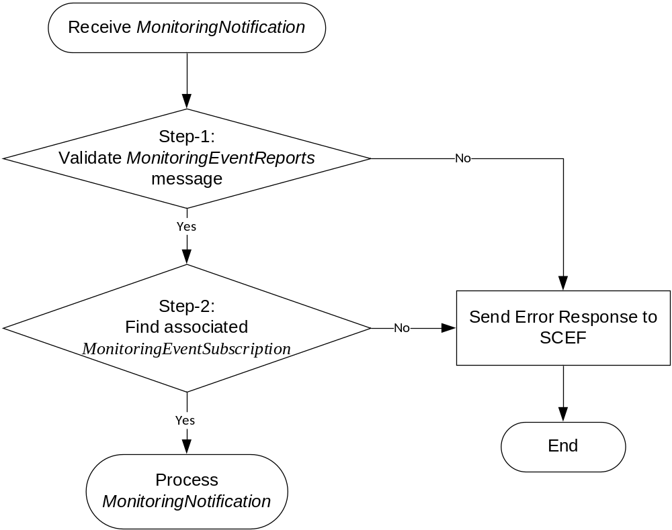
Figure 8.4.2-1: General procedure for parameter checking on monitoring event
When IN-CSE receives a MonitoringNotification from SCEF, the IN-CSE may check the parameters for validation.
Step-1: The IN-CSE validates received attributes of MonitoringEventReports based on MonitoringType. If the received message is not valid then the IN-CSE responds with the 400 Bad Request.
The mandatory attributes for Monitoring Type are:
- lossOfConnectReason for LOSS_OF_CONNECTIVITY
- idleStatusInfo, maxUEAvailabilityTime, eachabilityType for UE_REACHABILITY
- locationInfo for LOCATION_REPORTING
- associationType for CHANGE_OF_IMSI_IMEI_ASSOCIATION
- plmnId, roamingStatus for ROAMING_STATUS
- failureCause for COMMUNICATION_FAILURE
- idleStatusInfo for AVAILABILITY_AFTER_DDN_FAILURE
Step-2: Find the MonitoringEventSubscription that the received MonitoringNotification refers to based on the subscription, monitoringType and the externalIDs attributes. If a matching MonitoringEventSubscription is not found, then the IN-CSE responds with the 400 Bad Request.

History

Publication history
V3.0.0 | May 2019 | Release 3 - Publication

