

oneM2M
Technical Report
Document Number | oneM2M-TR-0044-V-1.0.0
Document Name: | Heterogeneous identification service
Date: | 2017-July-10
Abstract: | This technical report investigates the various IoT ID standards and application requirements, discussion on how to be compatible with the IoT ID standards, and providing the heterogeneous identification service.
Template Version:23 February 2015 (Dot not modify)

This Specification is provided for future development work within oneM2M only. The Partners accept no liability for any use of this Specification.
The present document has not been subject to any approval process by the oneM2M Partners Type 1. Published oneM2M specifications and reports for implementation should be obtained via the oneM2M Partners' Publications Offices.

About oneM2M
The purpose and goal of oneM2M is to develop technical specifications which address the need for a common M2M Service Layer that can be readily embedded within various hardware and software, and relied upon to connect the myriad of devices in the field with M2M application servers worldwide.
More information about oneM2M may be found at: http//www.oneM2M.org
Copyright Notification
© 2016, oneM2M Partners Type 1 (ARIB, ATIS, CCSA, ETSI, TIA, TSDSI, TTA, TTC).
All rights reserved.
The copyright and the foregoing restriction extend to reproduction in all media.

Notice of Disclaimer & Limitation of Liability
The information provided in this document is directed solely to professionals who have the appropriate degree of experience to understand and interpret its contents in accordance with generally accepted engineering or other professional standards and applicable regulations. No recommendation as to products or vendors is made or should be implied.
NO REPRESENTATION OR WARRANTY IS MADE THAT THE INFORMATION IS TECHNICALLY ACCURATE OR SUFFICIENT OR CONFORMS TO ANY STATUTE, GOVERNMENTAL RULE OR REGULATION, AND FURTHER, NO REPRESENTATION OR WARRANTY IS MADE OF MERCHANTABILITY OR FITNESS FOR ANY PARTICULAR PURPOSE OR AGAINST INFRINGEMENT OF INTELLECTUAL PROPERTY RIGHTS. NO oneM2M PARTNER TYPE 1 SHALL BE LIABLE, BEYOND THE AMOUNT OF ANY SUM RECEIVED IN PAYMENT BY THAT PARTNER FOR THIS DOCUMENT, WITH RESPECT TO ANY CLAIM, AND IN NO EVENT SHALL oneM2M BE LIABLE FOR LOST PROFITS OR OTHER INCIDENTAL OR CONSEQUENTIAL DAMAGES. oneM2M EXPRESSLY ADVISES ANY AND ALL USE OF OR RELIANCE UPON THIS INFORMATION PROVIDED IN THIS DOCUMENT IS AT THE RISK OF THE USER.

Contents
Contents 3
1 Scope 5
2 References 5
2.1 Normative references 5
2.2 Informative references 5
3 Definitions, symbols and abbreviations 5
3.1 Definitions 5
3.2 Symbols 6
3.3 Abbreviations 6
4 Conventions, 6
5 Introduction to Heterogeneous Identification Service 6
5.1 Concept of IoT identifier 6
5.2 Concept of identification service 7
5.3 Requirements of Heterogeneous Identification Service 7
6 Introduction on Existing Technologies 8
6.1 Overview 8
7 Use cases analysis 12
7.1 Overview 12
7.2 Use case on heterogeneous identification service 13
8 Potential enhancements to oneM2M 16
8.1 Scenarios analysis based on oneM2M architecture 16
8.2 Potential solutions 19
Proforma copyright release text block 23
Annexes 23
Annex <y>: Bibliography 24
History 24

1 Scope
The present document studies IoT identifier, identification service, and analyses use cases and requirements of heterogeneous identification service. The document also studies and analyzes potential ways to support the heterogeneous identification service in oneM2M systems.

2 References
The following text block applies.
References are either specific (identified by date of publication and/or edition number or version number) or non-specific. For specific references, only the cited version applies. For non-specific references, the latest version of the referenced document (including any amendments) applies.

2.1 Normative references
As a Technical Report (TR) is entirely informative it shall not list normative references.
The following referenced documents are necessary for the application of the present document.
Not applicable.

2.2 Informative references
Clause 2.2 shall only contain informative references which are cited in the document itself.
The following referenced documents are not necessary for the application of the present document but they assist the user with regard to a particular subject area.
[i.1] oneM2M Drafting Rules (http://www.onem2m.org/images/files/oneM2M-Drafting-Rules.pdf)

3 Definitions, symbols and abbreviations
Delete from the above heading the word(s) which is/are not applicable.

3.1 Definitions
Clause numbering depends on applicability.
- A definition shall not take the form of, or contain, a requirement.
- The form of a definition shall be such that it can replace the term in context. Additional information shall be given only in the form of examples or notes (see below).
- The terms and definitions shall be presented in alphabetical order.
For the purposes of the present document, the [following] terms and definitions [given in ... and the following] apply:
Definition format
<defined term>: <definition>
If a definition is taken from an external source, use the format below where [N] identifies the external document which must be listed in Section 2 References.
<defined term>[N]: <definition>
example 1: text used to clarify abstract rules by applying them literally
NOTE: This may contain additional information.

3.2 Symbols
Clause numbering depends on applicability.
For the purposes of the present document, the [following] symbols [given in ... and the following] apply:
Symbol format
<symbol> <Explanation>
<2nd symbol> <2nd Explanation>
<3rd symbol> <3rd Explanation>

3.3 Abbreviations
Abbreviations should be ordered alphabetically.
Clause numbering depends on applicability.
For the purposes of the present document, the [following] abbreviations [given in ... and the following] apply:
Abbreviation format
<ABBREVIATION1> <Explanation>
<ABBREVIATION2> <Explanation>
<ABBREVIATION3> <Explanation>

4 Conventions,
The key words “Shall”, ”Shall not”, “May”, ”Need not”, “Should”, ”Should not” in this document are to be interpreted as described in the oneM2M Drafting Rules [i.1]

5 Introduction to Heterogeneous Identification Service

5.1 Concept of IoT identifier

5.1.1 Overview
IoT identifier is used for uniquely identifying a physical entity or logical entity in a given context. The underlying networks or applications can control and manage an entity, as well as retrieve, transmit and exchange the relevant information by the identifier.
According to the different identified objects, scenarios, and technology characteristics, the identifier can be classified into three categories: tangible identifier, communication identifier, and application identifier.

5.1.2 Tangible identifier
Tangible identifier is used for uniquely identifying the physical entity (e.g. cup, human being, device, room and so on). The tangible identifier is generally bearing in a carrier, and the carrier is attached to the physical entity, so as that the tangible identifier can be captured by other entities. The carrier types include barcodes (e.g. 1D barcode, 2D barcode), RFID and others (e.g. Network card, cellphone).
The common scenario of the usage of the tangible identifier is to retrieve the physical entity related information, and the tangible identifier is not used for communicating or addressing.

5.1.3 Communication identifier
Communication identifier is used for uniquely identifying the network nodes with the communication capability (terminal, RFID reader, sensor, network device). The forms include E.164 number, IP address and so on. The communication identifier can be a relative or absolute address that it is used for communicating or addressing, so as to establish the connections to the identified object.

5.1.4 Application identifier
Application identifier is used for identifying the services in the application layer or service layer, logical entities and objects, for examples, service access code, domain name, and the forms can be URI, URL and so on.

5.2 Concept of identification service

5.2.1 Introduction
IoT identification service mainly implements the management, maintenance, discovery of the mapping between the identifiers, and the retrieval of the identifier related information.

5.2.2 Identification registration service
Identification registration service represents the procedures of establishment of mapping between different identifiers, as well as the identifier and its related information.

5.2.3 Identification resolution service
Identification resolution service represents the procedures of inquiring the associated identifier or information according to the mapping between the different identifiers (e.g. tangible identifier, communication identifier and application identifier), as well as the identifier and its related information, for example, the lookups are implemented by DNS, ONS, handle system and so on.

5.2.4 Identification discovery service
Identification discovery service represents the procedures of discovering all the related identifiers or information in large and complex resources, according to the mapping between the different identifiers, as well as the identifier and its related information. Commonly, more than one result will be retrieved.

5.2.4 Identification maintenance service
Identification maintenance service represents the procedures of deletion and update of mapping between the different identifiers, as well as the identifier and its related information.

5.3 Requirements of Heterogeneous Identification Service
The IoT identifier is not globally unified due to political, commercial and some other reasons, and different kinds of IoT ID standards are derived. Currently, the mainstream IoT identifier standards include “Electronic Product Code (EPC)”, “Object Identifier (OID)”, “Handle Identifier”, “ubiquitous code (ucode)”, “Mobile RFID Code (mCode)” and so on. The application areas probably adopt different IoT standards, and deploy different IoT identification technologies. The main issue under this circumstance is the incompatibility of different IoT identification technologies, and it further exacerbates the information silos for the various IoT applications.
The heterogeneous identification service is in demand to address the aforementioned issue by supporting various identification systems, and allowing them co-existing and interworking in the IoT environment, and then providing the identification service.

6 Introduction on Existing Technologies
Editor’s Note: The clause describes various identifier technologies and identifier resolution technologies.

6.1 Overview
There are many existing mechanisms for identification, naming by assigning unique identifiers to various physical/virtual entities (e.g., devices, users, processes, data, services, applications, etc.). The identification system also includes the resolution mechanisms to resolve its corresponding identification type, and some of resolution mechanisms are not implemented based on DNS infrastructure.

6.1.1 Electronic Product Code (EPC)
EPC has its origins at Auto-ID Center of the Massachusetts Institute of Technology (MIT) since 1998. In 2003, the Auto-ID Center became EPCglobal, and all relevant studies, business, and management about EPC were transferred to GS1 US®. GS1 US® is Founded in 1973, and it is a not-for-profit information standards organization. Currently, GS1 US® has more than 300,000 members, and GS1 Standards are the most widely-used supply chain standards in the world.
A fundamental principle of the EPCglobal Network Architecture is the assignment of a unique identifier for physical objects, loads, locations, assets, and other entities whose use is to be tracked. The EPC has a series of code fields, it uses an 8-bits “Header Value” field to identify specific encoding scheme, such as SSCC, SGTIN, SGLN, GRAI, etc. Taking the “SGTIN” code as an example, the overall structure is shown in Figure 6.1.1-1. A company applies its own “CompanyPrefix” from GS1, and then it assigns the “Item Reference &Indicator Digit” and “Serial Number” fields for each item-level product. In information systems, an EPC is a Uniform Resource Identifier (URI) that is in text format. EPC is not restricted to data carriers.
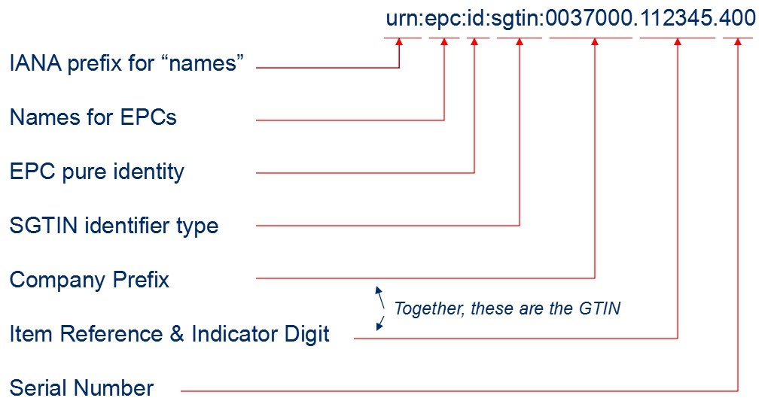
Figure 6.1.1-1 The overall structure of an EPC

EPCglobal network architecture is comprised of ONS (Object Name Service), EPCIS (EPC information service). ONS is designed for resolving information associated with a EPC identifier, which means other identification types can not be recognized and resolved by the system. ONS uses the Domain Name System (DNS) infrastructure and implementation, thus the item’s EPC identifier must be converted into a format that DNS can understand, which is the typical, “dot” delimited, left-to-right form of all domain names, so as to accomplish the identification resolution, and then retrieving the information about the item. The resolution procedure is shown in Figure 6.1.1-2, and the detailed illustrations are as follows:

Figure 6.1.1-2 ONS resolution procedures
- A EPC identifier is read from a barcode or an RFID tag using an appropriate reader.
- The reader sends that sequence of data to an ONS application.
- The ONS application extracts the desired GS1 Identification Key type and the GS1 Identification
Key itself from the data. For example, a contained GTIN is 50614141322607.
- The ONS application sends the GS1 Identification Key type, the GS1 Identification Key itself,
and the optional codes that are the client language code and client country code to the ONS client. For
example, it is configured to operate in English in Canada: en|ca|gtin|50614141322607.
- The ONS client converts the GS1 Identification Key type and the GS1 Identification Key into an
appropriate FQDN as a DNS query, implementing“dot”delimited and left-to-right form, for example: 5.0.6.2.2.3.1.4.1.4.1.6.0.gtin.gs1.id.onsepc.com.
- The DNS infrastructure responds that contains service types and associated data, for example, the URLs point to one or more EPCIS.
- The ONS client extracts the service type and the service data and sends it to the ONS application.
- The application interprets the data and communicates the EPCIS server according to the resolved URL.

6.1.2 Handle Identifier
The Handle System was originally developed at CNRI (The corporation for National Research Initiatives). Each handle identifier is globally unique within the context of the Handle System. It consists of two parts: naming authority (prefix) and local name (suffix), and the structure is as followed:
<Handle> ::= <Handle Naming Authority> "/" <Handle Local Name>
The naming authority and local name are separated by the ASCII character "/". The naming authorities are defined in a hierarchical tree structure, the root and nodes of the tree are separated by the ASCII character ".".
For example, "10.1045/january99-bearman" is a handle identifier for an article. Its naming authority is "10.1045", thereinto “10” is the root naming authority, and “1045” is the subordinate naming authority. Its local name is "january99-bearman".
The Handle System defines a hierarchical service model. The Global Handle Registry (GHR) is at the top level, which can be used to manage any handle namespace, and the Local Handle Services (LHS) is at the lower level, which can be used to manage any handle namespace.
A typical handle resolution procedure is shown in Figure 6.1.2, and the detailed illustrations are as follows:
- The client sends a query to Global Handle Registry to resolve the handle “10.123/456”.
- The Global Handle Registry returns the service information of the Local Handle Service A that is responsible for the handles under the naming authority “10.123”.
- The client sends a query to the Local Handle Service A to resolve the handle “10.123/456”.
- The Local Handle Service A resolves the handle, and then responses the result.
Figure 6.1.2 Handle system resolution procedures

6.1.3 Ubiquitous Code (ucode)
ucode is supported by the uID center, which is a non-profit organisation based in Japan. A ucode is an identifier based on an encoding strategy to uniquely identify individual “objects”, “places” and “concepts” in the real world. "Objects" include tangible objects (e.g. industrial products, agricultural crops) and intangible objects (e.g. Internet content, programs). “Places” include the real world features such as roads and buildings. “Concepts” include the relationships between "objects" and "places" and the information which can be the real world context.
The ucode consists of five fields: Version, Top Level Domain Code, Class Code, Second Level Domain Code, and Identification Code. The basic ucode width is 128 bits, and it can extend the width in 128-bit units. The structure is shown in the Table 6.1.2.
Table 6.1.2: the structure of ucode
 | version | TLD Code | Class Code | SDL Code | Identification Code
ucode-128 | 4bits | 16bits | 4bits | 20-40bits | 24-4bits

The version indicates a ucode version number. The Class Code indicates the boundary between the Second Level Domain Code (SLDc) and the Identification Code (ic). The TLD is a domain allocated to organizations authorized by Ubiquitous ID Center. The SLD is a domain allocated to organizations authorized by the TLD management organizations.
The ucode server architecture is in the multilevel hierarchical structure. In the architecture, the ubiquitous communicator (UC) retrieves the ucode and then gets the information server address by ucodeRP (ucode resolution protocol), and accesses the information associated with the identified “objects/places” .
A typical ucodeRP resolution procedure is shown in Figure 6.1.2, and the detailed illustrations are as follows:
- UC captures a ucode from a tag.
- UC sends a request that containing the ucode to the ucode resolution server, and gets the location information (e.g. 192.168.1.1) of the ucode resolution server for managing a CC field.
- UC sends a request that containing the ucode to the ucode resolution server for managing a CC field and gets the location information (e.g. 192.168.2.1) of the ucode resolution server for managing an SLD.
- UC sends a request that containing the ucode to the ucode resolution server for managing an SLD and gets the location information (e.g. http://www.uidcenter.org/getinfo.cgi) of the information server.
- UC sends the ucode to the information server and gets content.

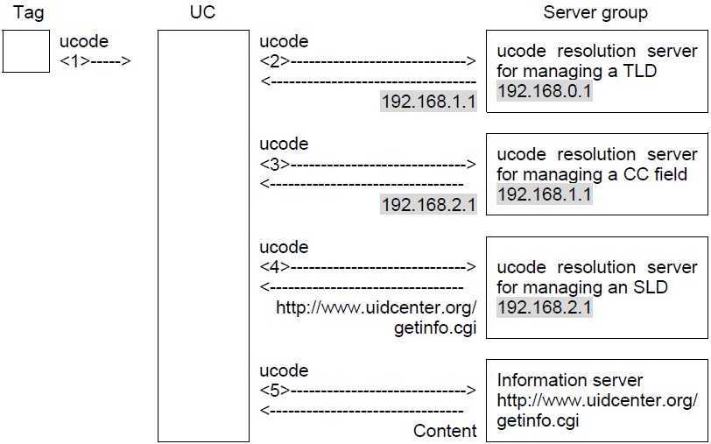
Figure 6.1.3 ucodeRP resolution procedures

6.1.4 Object Identifier (OID)
OID is jointly developed by both ISO/IEC and ITU-T, it is an encoding strategy and used to unambiguous identify an object (physical/virtual objects) uniquely in the global context. It ensures that the object can be addressed and managed absolutely.
OID uses a hierarchical tree structure. An OID consists of several segments called arcs which provide placeholders for identification and description in the hierarchical tree. In the OID tree, the first arc represents the organization code and is used to manage and allocate its corresponding lower arc.The first arc (nodes under the root) can be the value “itu-t (0)”, “iso (1)” and “joint-iso-itu-t (2)”, and the arcs from each node can be infinite. The OID structure is shown in the Figure. OID resolution system (ORS) is a DNS-based protocol.
Figure 6.1.4 the structure of OID

7 Use cases analysis

7.1 Overview
Heterogeneous identification service is a common technology and widely used in the various IoT industries, for example, supply chain management and logistics, product traceability, energy management and so on. The TR-0001 collects the use case “Intelligence agricultural product traceability” in the section 12.20. And another use case “Heterogeneous identification service” has been discussed and approved.
There are three requirements related to the heterogeneous identification service that are not yet implemented by the specification.
Requirement ID | Description | Release
OSR-111  See REQ-2017-0018R01 | The oneM2M system shall be able to support heterogeneous identification services, the recognition of external identification systems and converting an object identifier to a compatible identifier recognized by the oneM2M system.
The oneM2M system shall be able to support the traceability linking service which provides a mapping that relates a product identifier to product related traceability information.
Traceability information consists of:
  - Logs
  - Information on ID service nodes, such as:
    - servers that provide access to traceability information, and
    - devices (sensors and gateways) that gather traceability information
 | The oneM2M system shall be able to enable applications to retrieve the traceability information related to product identifiers.

Use case on heterogeneous identification service

7.2.1 Description
In an industrial internet environment, a physical entity (raw material, component, intermediate product and finished product ...) is given a unique identifier (object identifier) by various labelling technologies (e.g. RFID tag, barcode). The object identifiers can aid the device in identification, monitoring, and management of the physical entities.
In the product life-cycle, there are companies from many different industries. Vendor’s devices create with some information related to the physical entities, such as production date, technology type, and more. Upon implementation of the device into the processing factories, many sensors or devices are used to monitor the conditions within the factory, information such as temperature, humidity, location, duration, running state, maintenance log, etc. are recorded.
All the participant parties (vendors and providers alike) may have permission to acquire the related information. For example, the vendor wants to monitor the processing condition to ensure the processing procedure meets the requirements, as well as to obtain the running state and maintenance log. Therefore, the vendor could detect the problem in a timely manner and provide the best solution based on this information. All the information is mapped to the object identifier, and any participant party may be able to discovery the information of the physical entity by its object identifier.
The object identifier will be applied by the vendor based on various identification standards(e.g. EPC, OID, ucode). To support the applications from different providers or the third party entities, all information related to the physical entity and the M2M service platform should be compatible with the various identification systems. The M2M service platform serves as a public service platform to provide the identification service. When it receives a request with the object identifier, it needs to identify the standards which the object identifier is adopting, and provide the corresponding identification resolver to convert the object identifier to the compatible identifier with the specific format (e.g. URI), and then send it to the corresponding resolution server. Furthermore, the resolution server will resolve the physical addresses (e.g. IP address, FQDN) of devices that record the related information of the physical entity.

Actors
- M2M service platform
-the entity that serves as a public service platform to provide identification service.
- Discovery application
-the discovery request initiator, it can be from a participant party of product life-cycle (e.g. vendor, processor, operator and so on), or the third party.
- Device
- the entity to record the information of the physical entity. It can be a sensor, actuator, RFID reader, and application server.
- Resolution server
The resolution server (e.g. ONS, Handle system) is an entity to resolve the compatible identifier (e.g. URI) to the physical address (e.g. IP address, FQDN). The resolution protocol can be applicable for one specific identification standard or multiple identification standards.
- Physical entity
The physical entity does not have capability to communicate with other entities. It is tagged with object identifier, and the device can identify it and record its information by the object identifier.

Pre-conditions
The application registers in the M2M service platform.

Triggers
The application captures an object identifier, and initiates a request to discovery the related information.

Normal Flow

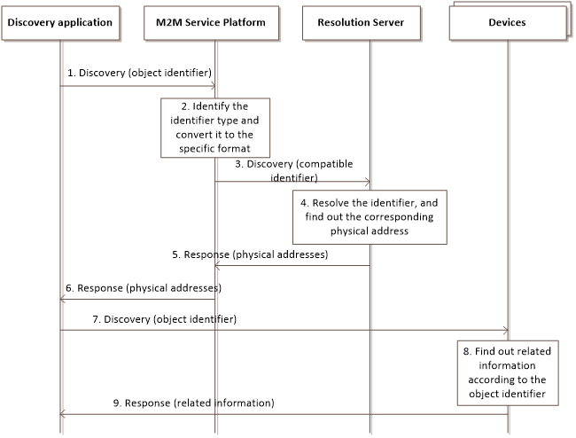
- The discovery application initiates a request to discovery the related information or addresses.
- The M2M service platform receive the request from application/originator, identifies that the standards which the object identifier adopting, converting the object identifier to the compatible identifier with the specific format.
- The M2M service platform sends the compatible identifier to the corresponding resolution server.
- The resolution servers resolve the compatible identifier to the physical addresses.
- The resolution servers respond the physical addresses to the M2M service platform.
- The M2M service platform forwards the physical addresses to the discovery application.
- The discovery application sends the requests with the object identifier to the devices according to the physical addresses.
- The devices find out the related information according to the object identifier.
- The devices respond the information to the discovery application.

Alternative flow
None

Post-conditions
None.

High Level Illustration

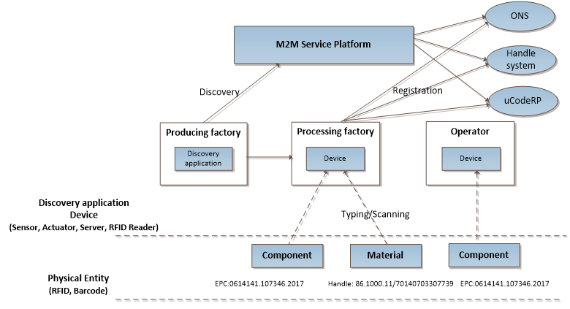

Potential requirements
- The oneM2M system shall be able to support heterogeneous identification services, the recognition of external identification systems and converting an object identifier to a compatible identifier recognized by the oneM2M system.

8 Potential enhancements to oneM2M

8.1 Scenarios analysis based on oneM2M architecture

8.1.1 Creation of mapping information
oneM2M entity captures the tangible identifier from tag attaching on the physical entity and records the related information, with the location information of the entity together constitute the mapping information, which is created and maintained on the corresponding entities. The creation procedures are shown in Figure 8.1.1-1.

Figure 8.1.1-1 Creation procedures
- AEs (AE1, AE2) captures the tangible identifiers attaching on the physical entities.
- AE2 creates the mapping between identifier and the related information on the CSE2.
- CSE2 creates the mapping between the identifiers (e.g. the tangible identifier and the location identifier) on the CSE3.
- CSE3 provides the tangible identifier (or identifier type) and the associated location information to the CSE4. If the CSE4 doesn’t get the information of identifier type (e.g. ‘epc’, ‘handle’, ‘oid’) from the CSE3, it may recognize the identifier type for each tangible identifier and maintain the mapping between the tangible identifier, identifier type and location information.

8.1.2 Discovery of identifiers related information
The application wants to discover the tangible identifier related information from the CSE that provides the heterogeneous service. There are two cases depicted as follows:
Case 1: the CSE4 maintains the tangible identifier related mapping information, the discovery procedures are shown in Figure 8.1.2-1.
Figure 8.1.2-1 discovery procedures for case 1

- The discovery application AE3 initiates a request to discovery the related information, the tangible identifier is contained in the request.
- The CSE4 receives the request, if the identifier type is not included in the request, the CSE4 may recognize the type of tangible identifier, and then searches the corresponding information by the identifier type or tangible identifier. CSE4 sends the discovery request to the CSE3.
- The CSE3 searches the location information of the entities that have the information associated with the tangible identifier, and responds the results to CSE4.
- The CSE4 forwards the results (location information of the CSE1 and CSE2) to the AE3.
- The AE3 sends the discovery request to CSE1 and CSE2 to retrieve the tangible identifier related information.

Case 2: the mapping information is not recorded on the queried CSE3, it will request the external identification resolution systems to implement the identification resolution. The discovery procedures are shown in figure 8.1.2-2.
Figure 8.1.2-2 discovery procedures for case 2

- The discovery application AE3 initiates a request to discovery the related information, the tangible identifier is contained in the request.
- The CSE3 receives the request, if the identifier type is not included in the request, the CSE4 may recognize the type of tangible identifier, and converting the tangible identifier to the compatible identifier with the specific format.
- The CSE3 sends the compatible identifier to the corresponding external resolution system (e.g. Handle system), and gets and resolution results from the resolution system.
- The CSE3 responds the results (location information of CSE1 and CSE2) to the AE3.
- The AE3 sends the discovery request to CSE1 and CSE2 to retrieve the tangible identifier related information.

8.2 Potential solutions
This section includes the changes needed in TS-0001 in existing resources, Figures and Tables to support the above scenarios. Imapcted sections in TS-0001 will be shown using the applicable section number.

9.6.6 Resource Type container
The <container> resource represents a container for data instances. It is used to share information with other entities and potentially to track the data. A <container> resource has no associated content. It has only attributes and child resources.
Figure 9.6.6-1: Structure of <container> resource
The <container> resource shall contain the child resources specified in table 9.6.6-1.
Table 9.6.6-1: Child resources of <container> resource
Child Resources of <container> | Child Resource Type | Multiplicity | Description | <containerAnnc> Child Resource Types
[variable] | <semanticDescriptor> | 0..n | See clause 9.6.30 | <semanticDescriptor>, <semanticDescriptorAnnc>
[variable] | <contentInstance> | 0..n | See clause 9.6.7 | <contentInstance>, <contentInstanceAnnc>
[variable] | <subscription> | 0..n | See clause 9.6.8 | <subscription>
[variable] | <container> | 0..n | See clause 9.6.6 | <container>  <containerAnnc>
[variable] | <flexContainer> | 0..n | See clause 9.6.35 | <flexContainer>  <flexContainerAnnc>
la | <latest> | 1 | See clause 9.6.27 | None
ol | <oldest> | 1 | See clause 9.6.28 | None

The <container> resource shall contain the attributes specified in table 9.6.6-2.
Table 9.6.6-2: Attribute of <container> resource
Attributes of  <container> | Multiplicity | RW/  RO/  WO | Description | <containerAnnc> Attributes
resourceType | 1 | RO | See clause 9.6.1.3. | NA
resourceID | 1 | RO | See clause 9.6.1.3. | NA
resourceName | 1 | WO | See clause 9.6.1.3. | NA
parentID | 1 | RO | See clause 9.6.1.3. | NA
expirationTime | 1 | RW | See clause 9.6.1.3. | MA
accessControlPolicyIDs | 0..1 (L) | RW | See clause 9.6.1.3. If no accessControlPolicyIDs value is configured, the accessControlPolicyIDs of the parent resource shall be applied for privilege checking. | MA
labels | 0..1 (L) | RW | See clause 9.6.1.3. | MA
creationTime | 1 | RO | See clause 9.6.1.3. | NA
lastModifiedTime | 1 | RO | See clause 9.6.1.3. | NA
stateTag | 1 | RO | See clause 9.6.1.3. | OA
announceTo | 0..1 (L) | RW | See clause 9.6.1.3. | NA
announcedAttribute | 0..1 (L) | RW | See clause 9.6.1.3. | NA
dynamicAuthorizationConsultationIDs | 0..1 (L) | RW | See clause 9.6.1.3. | OA
creator | 0..1 | RO | See clause 9.6.1.3. | NA
maxNrOfInstances | 0..1 | RW | Maximum number of direct child <contentInstance> resources in the <container> resource. | OA
maxByteSize | 0..1 | RW | Maximum size in bytes of data (i.e. content attribute of a <contentInstance> resource) that is allocated for the <container> resource for all direct child <contentInstance> resources in the <container> resource. | OA
maxInstanceAge | 0..1 | RW | Maximum age of a direct child <contentInstance> resource in the <container> resource. The value is expressed in seconds. | OA
currentNrOfInstances | 1 | RO | Current number of direct child <contentInstance> resource in the <container> resource. It is limited by the maxNrOfInstances. The currentNrOfInstances attribute of the <container> resource shall be updated on successful creation or deletion of direct child <contentInstance> resource of <container> resource | OA
currentByteSize | 1 | RO | Current size in bytes of data(i.e. content attribute of a <contentInstance> resource) stored in all direct child <contentInstance> resources of a <container> resource. This is the summation of contentSize attribute values of the <contentInstance> resources. It is limited by themaxByteSize. The currentByteSize attribute of the <container> resource shall be updated on successful creation of deletion of direct child <contentInstance> resource of <container> resource | OA
locationID | 0..1 | RW | An ID of the resource where the attributes/policies that define how location information are obtained and managed. This attribute is defined only when the <container> resource is used for containing location information. | OA
ontologyRef | 0..1 | RW | A reference (URI) of the ontology used to represent the information that is stored in the child <contentInstance> resources of the present <container> resource (see note). | OA
disableRetrieval | 0..1 | RW | Boolean value to control RETRIE/UPDATE/DELETE operation on the child <contentInsance> resource.  When the value is set to 'TRUE', RETRIEVE/DELETE/UPDATE operations for child <contentInstance> shall be rejected at all times.  When the value is updated from 'TRUE' to 'FALSE', all existing <contentInstance> are deleted immediately.  When the value is set to 'FALSE', all operations are permitted on the <contentInstance> resource as per existing procedures. | OA
tangibleIDInformation | 0..1(L) | RW | This attribute represents a set of tangible identifiers and its related information. The attribute is comprised of 2-tuples (tangibleID, IDType) with parameters shown in table 9.6.4-3. At least one of them shall be contained in this attribute. | OA
NOTE: The access to this URI is out of scope of oneM2M.

The tangibleIDInformation attribute shall contain the parameters specified in table 9.6.4-3.
Table 9.6.4-3: Parameters in tangibleIDInformation attribute
Parameters in tangibleIDInformation | Multiplicity | Description
tangibleID | 0..1(L) | It represents the set of tangible identifiers  that is associated with the specific physical entities. It is described as a list of tangible identifiers (e.g. 86.1000.11/70140703307739, 1.2.156.20000.2010319).  It shall be present in case IDType parameter is null.
IDType | 0..1 | It shall be present in case tangibleID parameter is null. If the tangibleID parameter is present,  it represents the corresponding type of the tangible identfiers. If the tangibleID parameter is not present,it represents the identifier type that is supported by the creation originator. The identifier type is expressed in string：  - epc;  - handle;  - oid;  - ucode;  - mcode;  - ecode.

Proforma copyright release text block
This text box shall immediately follow after the heading of an element (i.e. clause or annex) containing a proforma or template which is intended to be copied by the user. Such an element shall always start on a new page.
Notwithstanding the provisions of the copyright clause related to the text of the present document, oneM2M grants that users of the present document may freely reproduce the <proformatype> proforma in this {clause|annex} so that it can be used for its intended purposes and may further publish the completed <proformatype>.
<PAGE BREAK>

Annexes
Each annex shall start on a new page (insert a page break between annexes A and B, annexes B and C, etc.).
Use the Heading 9 style for the title and the Normal style for the text.
Annex <A>:
Title of annex (style H9)
<Text>
<PAGE BREAK>
Annex <B>:
Title of annex (style H9)
<Text>
B.1 First clause of the annex (style H1)
<Text>
B.1.1 First subdivided clause of the annex (style H2)
<Text>
<PAGE BREAK>

Annex <y>:
Bibliography
The annex entitled "Bibliography" is optional.
It shall contain a list of standards, books, articles, or other sources on a particular subject which are not mentioned in the document itself.
It shall not include references mentioned in the document.
Use the Heading 9 style for the title and B1+ or Normal for the text.
- <Publication>: "<Title>".
OR
<Publication>: "<Title>".
<PAGE BREAK>

History
This clause shall be the last one in the document and list the main phases (all additional information will be removed at the publication stage).
Publication history
V.1.1.1 | <dd Mmm yyyy> | <Milestone>

Draft history (to be removed on publication)
V.1.0.0 | 10 July 2017 | Incorporated contributions agreed at ARC#27 and ARC#29:  ARC-2017-0043R01-Skeleton_of_heterogeneous_identification_service  ARC-2017-0203R01-TR-0044_Introduction_to_heterogeneous_identification_service  ARC-2017-0204-TR-0044_Existing_technologies  ARC-2017-0205R01-TR-0044_Use_cases_analysis  ARC-2017-0206R01-TR-0044_Potential_enhancements

