

oneM2M
Technical Report
Document Number | TR-0049-V-0.3.0
Document Name: | Industrial Domain Information Model Mapping & Semantics Support
Date: | 2019-05-09
Abstract: | < An abstract of the document and information that may be used in subsequent electronic searches>
'Template Version: January 2019 (do not modify)

The present document is provided for future development work within oneM2M only. The Partners accept no liability for any use of this report.
The present document has not been subject to any approval process by the oneM2M Partners Type 1. Published oneM2M specifications and reports for implementation should be obtained via the oneM2M Partners' Publications Offices.

About oneM2M
The purpose and goal of oneM2M is to develop technical specifications which address the need for a common M2M Service Layer that can be readily embedded within various hardware and software, and relied upon to connect the myriad of devices in the field with M2M application servers worldwide.
More information about oneM2M may be found at: http//www.oneM2M.org
Copyright Notification
© 2019, oneM2M Partners Type 1 (ARIB, ATIS, CCSA, ETSI, TIA, TSDSI, TTA, TTC).
All rights reserved.
The copyright and the foregoing restriction extend to reproduction in all media.

Notice of Disclaimer & Limitation of Liability
The information provided in this document is directed solely to professionals who have the appropriate degree of experience to understand and interpret its contents in accordance with generally accepted engineering or other professional standards and applicable regulations. No recommendation as to products or vendors is made or should be implied.
NO REPRESENTATION OR WARRANTY IS MADE THAT THE INFORMATION IS TECHNICALLY ACCURATE OR SUFFICIENT OR CONFORMS TO ANY STATUTE, GOVERNMENTAL RULE OR REGULATION, AND FURTHER, NO REPRESENTATION OR WARRANTY IS MADE OF MERCHANTABILITY OR FITNESS FOR ANY PARTICULAR PURPOSE OR AGAINST INFRINGEMENT OF INTELLECTUAL PROPERTY RIGHTS. NO oneM2M PARTNER TYPE 1 SHALL BE LIABLE, BEYOND THE AMOUNT OF ANY SUM RECEIVED IN PAYMENT BY THAT PARTNER FOR THIS DOCUMENT, WITH RESPECT TO ANY CLAIM, AND IN NO EVENT SHALL oneM2M BE LIABLE FOR LOST PROFITS OR OTHER INCIDENTAL OR CONSEQUENTIAL DAMAGES. oneM2M EXPRESSLY ADVISES ANY AND ALL USE OF OR RELIANCE UPON THIS INFORMATION PROVIDED IN THIS DOCUMENT IS AT THE RISK OF THE USER.

Contents
Contents 3
1 Scope 4
2 References 4
2.1 Normative references 4
2.2 Informative references 4
3 Definition of terms, symbols and abbreviations 4
3.1 Terms 4
3.2 Symbols 5
3.3 Abbreviations 5
4 Conventions, 5
5 User defined clause(s) from here onwards 5
5.1 User defined subdivisions of clause(s) from here onwards 5
Proforma copyright release text block 5
Annexes 6
Annex <y>: Bibliography 6
History 7

1 Scope
The present document …
EXAMPLE: The present document provides the necessary adaptions to the endorsed document.
The Scope shall not contain requirements.

2 References
The following text block applies.
References are either specific (identified by date of publication and/or edition number or version number) or non-specific. For specific references,only the cited version applies. For non-specific references, the latest version of the referenced document (including any amendments) applies.

2.1 Normative references
As a Technical Report (TR) is entirely informative it shall not list normative references.
The following referenced documents are necessary for the application of the present document.
Not applicable.

2.2 Informative references
Clause 2.2 shall only contain informative references which are cited in the document itself.
The following referenced documents are not necessary for the application of the present document but they assist the user with regard to a particular subject area.
[i.1] oneM2M Drafting Rules (http://member.onem2m.org/Static_pages/Others/Rules_Pages/oneM2M-Drafting-Rules-V1_0.doc)
[i.2] Plattform Industrie 4.0: “Implementation Strategy Industrie 4.0”, January 2016.
NOTE: Available at http://www.zvei.org/Publikationen/Implementation-Strategy-Industrie-40-ENG.pdf
[i.3] Plug & Produce for Field Devices in an Adaptable Factory, June 2017.
NOTE: Available at http://www.plattform-i40.de/I40/Redaktion/EN/Downloads/Publikation/Industrie-40-%20Plug-and-Produce.html
[i.4] TR-0033-Study on Enhanced Semantic Enablement v.0.9.0.
[i.5] TR-0018-Industrial Domain Enablement v.3.0.0.
[i.6] OPC Unified Architecture for ISA-95 Common Object Model Companion Specification, Release 1.00, Oct 30th, 2013.
[i.7] OPC UA Information Model for AutomationML, Release 1.00.00, February 22, 2016.
[i.8] PLCopen and OPC Foundation: OPC UA Information Model for IEC 61131-3, Release 1.00, March 24, 2010
[i.9] OPC and MES Day 2012 presentation “OPC UA Information Modeling”, slide 4.
NOTE: Available at https://www.automaatioseura.fi/site/assets/files/1442/opc_6_hunkar_informationmodel-4.pdf.
[i.10] Industrie 4.0 International Paper. The Structure of the Administration Shell: TRILATERAL PERSPECTIVES from France, Italy and Germany.
[i.11] oneM2M TS-0011: "Common Terminology".
[i.12] oneM2M TS-0023: "SDT based Information Model and Mapping for Vertical Industries".

3 Definitions, symbols and abbreviations
Delete from the above heading the word(s) which is/are not applicable.

3.1 Definitions
Clause numbering depends on applicability.
- A definition shall not take the form of, or contain, a requirement.
- The form of a definition shall be such that it can replace the term in context. Additional information shall be given only in the form of examples or notes (see below).
- The terms and definitions shall be presented in alphabetical order.
For the purposes of the present document, the [following] terms and definitions [given in ... and the following] apply:
Definition format
<defined term>: <definition>
If a definition is taken from an external source, use the format below where [N] identifies the external document which must be listed in Section 2 References.
<defined term>[N]: <definition>
example 1: text used to clarify abstract rules by applying them literally
NOTE: This may contain additional information.

3.2 Symbols
Clause numbering depends on applicability.
For the purposes of the present document, the [following] symbols [given in ... and the following] apply:
Symbol format
<symbol> <Explanation>
<2nd symbol> <2nd Explanation>
<3rd symbol> <3rd Explanation>

3.3 Abbreviations
Abbreviations should be ordered alphabetically.
Clause numbering depends on applicability.
For the purposes of the present document, the following abbreviations given in oneM2M TS-0011 [i.11] and the following apply:
Abbreviation format
AML AutomationML
CAEX Computer Aided Engineering eXchange
IM Information Model
UUID Universally Unique IDentifier

4 Conventions,
The key words “Shall”, ”Shall not”, “May”, ”Need not”, “Should”, ”Should not” in this document are to be interpreted as described in the oneM2M Drafting Rules [i.1]

5 Introduction to Industry 4.0 aspects
Editors’ note: This clause introduces the state of arts of the technical trends, e.g. RAMI4.0 necessarily to understand the following use case defined by I4.0.
In order to achieve a common understanding of what standards, use cases, etc. are necessary for Industrie 4.0, reference architecture model for Industrie 4.0 (RAMI4.0) is developed as a uniform architecture model as a reference, serving as a basis for the discussion of its interrelationships and details.
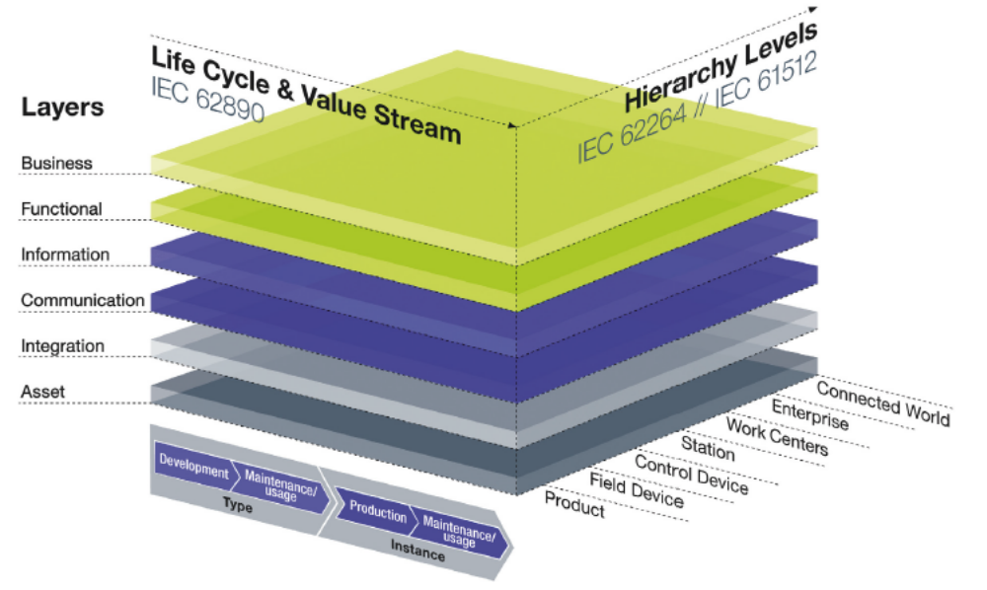
Figure 5-1 Reference Architecture Model for Industrie 4.0 (RAMI4.0) [i.2]
A three-dimensional model is best suited to represent the Industrie 4.0 space. Layers are used in the vertical axis to represent the various perspectives such as data maps, functional descriptions, communications behaviour, hardware/ assets or business processes. This corresponds to IT approaches where complex projects are split up into clusters of manageable parts.
A further important criterion is the product life cycle with the value streams it contains. This is displayed along the horizontal axis. Dependencies, e.g. constant data acquisition throughout the life cycle, can therefore also be well represented in the reference architecture model.
The third important criterion, represented in the third axis, is the location of functionalities and responsibilities within factories/plants. This concerns a functional hierarchy and not the equipment classes or hierarchical levels of the classical automation pyramid.
From a logical point of view, an Industrie 4.0 component comprises one or more objects and an administration shell which contains the data for virtual representation and the functions of the technical functionality. The manifest, as part of the virtual representation, details the necessary administrative details about the Industrie 4.0 component. With the resource manager, IT services have access to the data and functions of the administration shell and make them externally available.
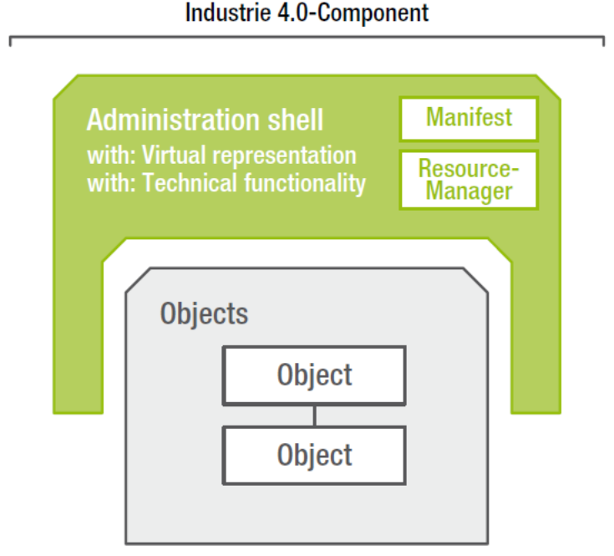
Figure 5-2 Industrie 4.0 component
The administration shell and its contents can be hosted within one of the objects of an embedded system (active, Industrie 4.0 compliant communication ability) or distributed among one or more higher level IT systems (deployment view).

6 Use case
Editors’ note: This clause describes the appliance of semantics technology in industrial scenarios. The preferred approach is to select the relevant use cases defined by existing industry related organizations i.e. I4.0, IIC, etc.
Use case name: Plug & Produce for Field Devices in an Adaptable Factory [i.3]
Description:
The referred use case is defined by I4.0 (which has defined 9 application scenarios; the mentioned one is Adaptable Factory/ AF). Plug & Produce in an AF aims at adaptable manufacturing configurations within a factory for quickly changing production capacities and capabilities (analogous to the “plug-and-play” concept for connecting a new device via USB cable to a computer and utilizing the device almost immediately).
The addressed semantics related requirement in the mentioned use case is about Semantic Understanding: the production modules would contain a machine-readable, semantically unambiguous self-description of their properties and capabilities.
An I4.0 system consists of many interacting I4.0 Components, and each I4.0 Component further consists of many Assets and many Asset Administration Shells (AAS). An AAS is a meta-model describing an asset and it re-uses the concepts from existing standards (mostly IEC 62832 “Digital Factory”, IEC61360 “CDD: Common Data Dictionary”, and IEC 62541 “OPC UA”) as much as possible. In an example realization of the use case, several data models are utilized for describing device information and enabling automatic device integration into the plant.
AutomationML is adopted as Data exchange format, to combine data from different technical discipline for usage in different tools like kinematics, geometry, topology and logic.
eCl@ss is adopted for describing device types bases on their properties (e.g. temperature sensor) , and OPC-UA is adopted for describing device services (e.g. sub/pub data) and storing device runtime data (e.g. process values, history, alarm & events, maintenance data).
Based on the utilization of multiple industrial data models, a physical asset in an I4.0 system could be described in a standardized way, and the integration and configuration of a field device within a production system could be automated.
Below is the figure from [i.3] about AAS. Process Engineering Tool application provides configuration data for a plant, which may include specific configuration parameters for field devices. Device Management Server detects newly connected devices, assesses their capabilities, configures the devices, and sets them into an operational mode, e.g. FDI Server. Intelligent Field Device can be an actuator or sensor. It is equipped with standardized communication capabilities and a self-description. Controller can execute control algorithms based on sensor inputs and passes actions to actuators. It is equipped with standardized communication capabilities and a self-description. Process Control System refers to the Hardware/Software system that visualizes operator screens to supervise an industrial process.
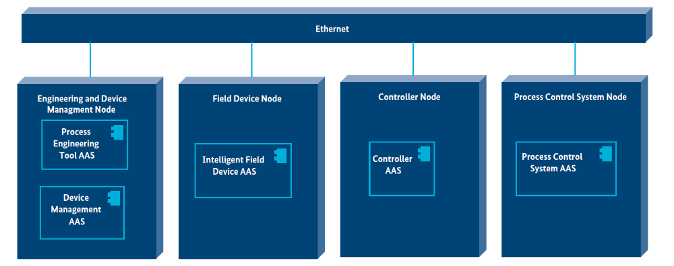
Figure 6-1: Plug & Produce for Field Devices in an Adaptable Factory [i.3]
From the standardization gaps of the referred use case (section 8.3 in [i.3]), it is pointed out that “the possibilities of PnP are rather limited by the availability of rich property catalogs and potentially higher-level services”. On one hand, regarding property catalogs, oneM2M could help potentially with enriched and integrated semantic vocabularies of various industrial value chains, including engineering, manufacturing, logistics, distribution and the respective feedback loops. Therefore the direct exchange of data and control between domains, machines, objects, sensors and processes could be possible to link directly following different technological paradigms.
On the other hand, regarding higher-level services, oneM2M semantic features such as Reasoning Function (clause 8.7 of [i.4]) could be utilized based on semantic annotation. For example, assume the Reasoning Rule derived from domain knowledge that “IF the sensor X in SCADA is an instance of the ontologyA:VideoCamera, THEN X is also an instance of the ontologyB:VideoRecorder”. Then in case a new video monitoring sensor device is “plugged” into the production line without its configuration parameters of ontologyA:VideoCamera at hand, the semantic reasoning engine could generate an inferred fact “the video monitoring sensor is-a ontologyB:VideoRecorder”. So that when the appropriate configuration parameters of ontologyB:VideoRecorder can be found from Device Management Server, the new video monitoring sensor may work instantly before the parameter for ontologyA:VideoCamera is transmitted or even without it temporarily.

7 Analysis of industrial domain information models
Editors’ note: This clause introduces IMs with usage for industry, analyzes each IMs and provides gap analysis. Main contents include, an overall introduction of industrial domain IMs (mapping with architecture of factory and value chain integration), separate introductions and analysis of OPC-UA, ISA-95, AutomationML/ PLCopen and others IMs, and possibly further gap analysis.

7.1 OPC-UA information model
OPC-UA Information Model (IM, a.k.a. data model) is introduced in the clause 10.1.4 of TR-0018 “Industrial Domain Enablement” [i.5]. The following figure provides a summary of main OPC-UA IMs. Based on these IMs, OPC-UA holds companion specifications with ISA-95 [i.6], AutomationML [i.7], and PLCopen [i.8] to map to their IMs. Recently, OPC works with VDMA (Verband Deutscher Maschinen- und Anlagenbau, Mechanical Engineering Industry Association) to develop common IMs for machine vision and robotics.
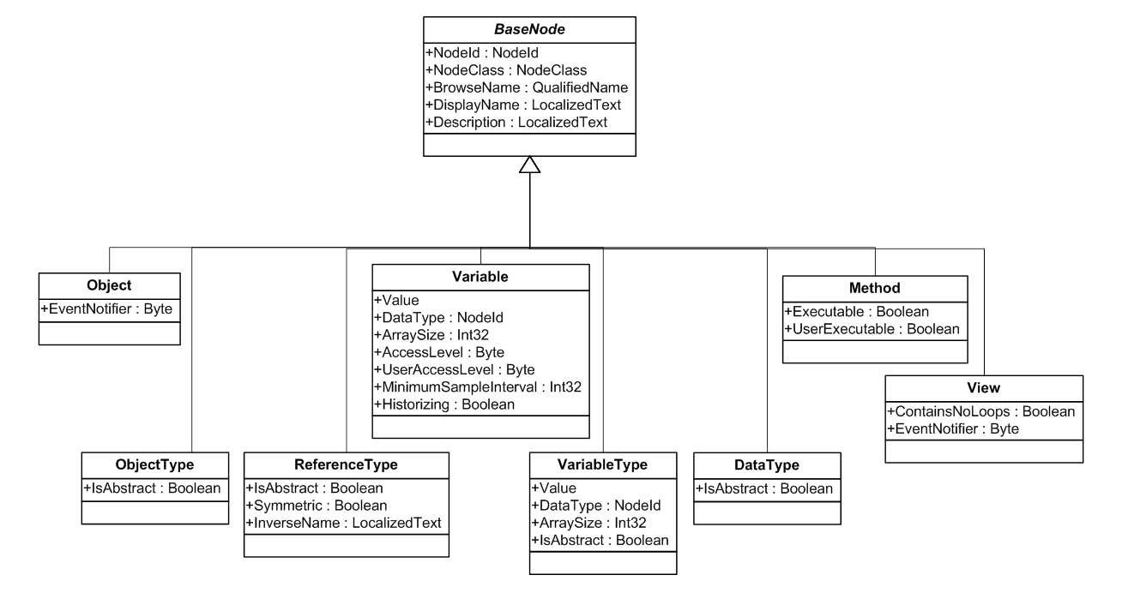
Figure 7.1-1: Summary of OPC-UA IM [i.9]
A comparison between oneM2M and OPC UA with respect to their characters about information model is demonstrated in Table 7.1-1.
Table 7.1-1: Comparison of IMs of oneM2M and OPC UA System
 | oneM2M | OPC UA
Information models | SDT IM is supported in oneM2M. SDT is not restricted to be used specifically in the industrial domain, but also can be utilized in the vehicle domain for logistics, etc., for the potential integration of industrial value chains and the smart city applications.  TR-0018 clause 10.3.3 [i.5] studies the mapping between OPC UA standard objects and oneM2M resources for interworking scenarios, but not other OPC UA IMs. | IM is supported in OPC UA and integrated with ISA-95, AutomationML, PLCopen, etc., in various industry sectors. OPC UA is extended for building automation, but still limited from logistics, and more verticals.
Semantic features | Semantic features (e.g. reasoning, semantic discovery, semantic validation, etc.) are supported in oneM2M using W3C RDF (Resource Description Framework) and OWL (Web Ontology Language). | Data described by OMG (Object Management Group) Unified Modeling Language (UML) in the OPC UA IM can be understood. However rich semantic features, such as reasoning as described in the PnP use case in Chapter 6, are not supported yet.

7.2 AutomationML information model

Editors’ note: The copyright of figures need to be checked with OPC specifications [i.7].

7.2.1 AutomationML Overview
AutomationML (AML) [i.7, i.10] is a scalable, open, neutral, XML based, extendable, and free data exchange format, standardized in IEC 62714. It has been developed in order to support the data exchange in a heterogeneous engineering tools landscape by enabling a discipline and company crossing transfer of engineering data between software tools - in a consistent manner and without data loss. The goal of AutomationML is to interconnect engineering tools in their different disciplines, e.g. plant planning, mechanical engineering, electrical engineering, process engineering, process control engineering, HMI development, PLC programming, robot programming.
With the meta-model, that AML provides, production system structures can be modelled expressed as a hierarchy of AutomationML objects. They can contain geometry and kinematics, logic data (behaviour and sequencing), and relations among AutomationML objects as well as references to information that is stored in external documents. Following this object-oriented paradigm, each AutomationML object can integrate different information with different semantics related to different disciplines and provides an overview of the distributed document architecture of AML.
CAEX (Computer Aided Engineering eXchange), standardized in IEC 62424, is the top level format of AML and is characterized by the four following concepts (see Figure 7.2.1-1), where the AML objects are represented as InternalElements (IE).
- By using RoleClasses (RC), semantics for AML objects can be modeled. RoleClasses describe functions of a physical or logical object independent of a technical implementation. They offer a possibility to specify an object in an abstract way and independent of the manufacturer. They are stored in RoleClass libraries.
- By using InterfaceClasses (IC), the semantics for the interfaces of AML objects can be modeled. InterfaceClasses describe relations of physical or logical objects or references to documents independent of a technical implementation. They are stored in interface class libraries.
- By using SystemUnitClasses (SUC), types or templates of AML objects can be modeled. They are stored in system unit class libraries.
- The InstanceHierachy (IH) stores the actual project.
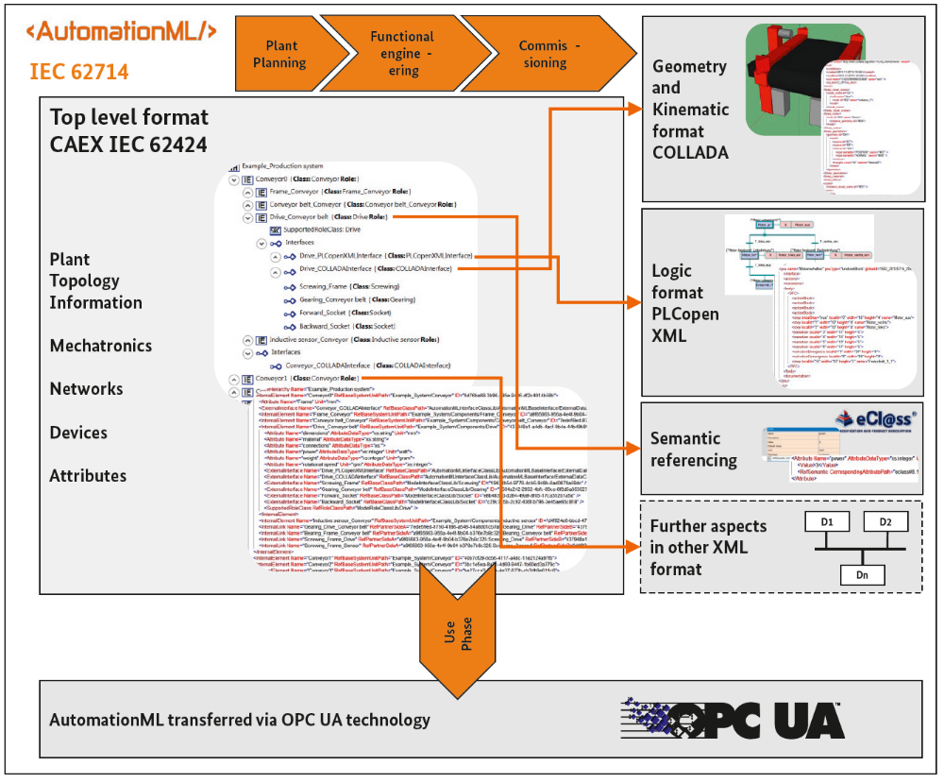
Figure 7.2.1-1: AutomationML base structure [i.7]
For a consistent data exchange, an object identification concept is essential. The concept, AML provides, specifies that every object shall have an UUID (Universally Unique IDentifier), which shall be kept as long as the object exists. With this ID persistence, it is possible to identify a certain AML object throughout its entire life cycle.
AML mechanism to reference external documents enables the integration of further information aspects to AML objects. Therefore, it provides a special set of interface classes and role classes being used to uniquely identify the document type and the semantics of attached information. In case the referenced document has a unique identification concept for its content, also a referencing into the referenced document is possible. Besides AML meta-model, there is the specification for the data exchange format available as well. Since AML is an XML based format, XML specific features are available, like XML encryption, XML signature, or XML serialization.

7.2.2 AutomationML Modeling Concepts
The main AutomationML elements and all possible relations between them are shown in Figure 7.2.2-1. The organization in a hierarchical tree involves that every element type can have child elements of the same type (see ChildElement relations). SystemUnitClasses and RoleClasses are defined in an inheritance structure; the RefBaseClassPath relations define such inheritance relations.
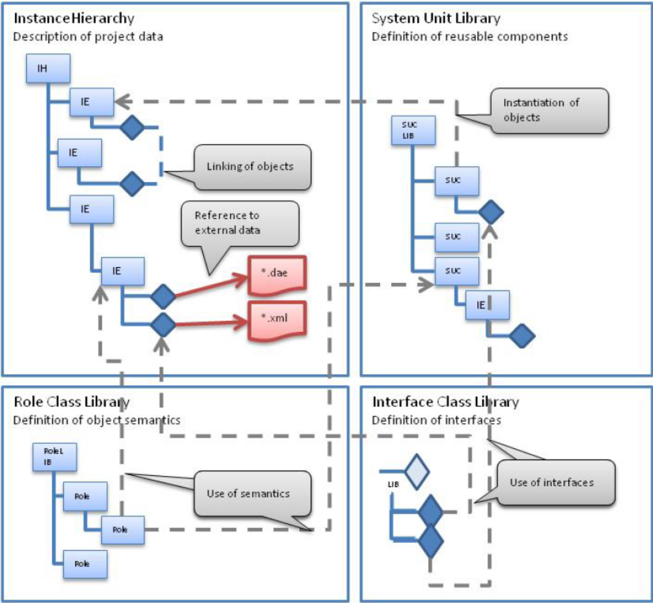
Figure 7.2.2-1: AML topology description architecture [i.7]
An InternalElement shall be inherited from a role class and can inherit from a SystemUnitClass. In the scope of AML, SystemUnitClasses are only templates and can be changed after instantiation. This allows a modification of the AML object regarding instance specific needs, e.g. deleting, editing, or adding attributes and interfaces. However, it is also possible to model AML objects directly into the InstanceHierarchy without having instantiated a SystemUnitClass. The backward relation indicates that a SystemUnitClass can define sub-elements in terms of InternalElements. These sub-elements (InternalElements) should be included on instantiation. RoleClass, SystemUnitClass, or InternalElement can contain arbitrary nested Attributes and Interfaces (see ChildElement relations). The Interfaces are called ExternalInterfaces and shall inherit from an InterfaceClass. They can be connected to other ExternalElements via InternalLinks. The InterfaceClasses are stored hierarchically and shall have independent inheritance relations. InterfaceClasses and certainly ExternalInterfaces may also have arbitrary nested attributes.

7.2.3 OPC UA Connectivity
The existing OPC companion specification OPC UA Information Model for AutomationML as well as the DIN Spec 16592: Combining OPC Unified Architecture and Automation Markup Language further describe a formal mapping between AML and OPC UA elements. In addition, AML enables the modeling of runtime data sources especially within further OPC UA servers or other runtime communication systems. This allows a formal transition between the data model described with AML in Administration Shell of Industrie 4.0 [i.10] and the relevant information model represented by OPC UA.
This allows to communicate and operationalize IMs described with AML by means of OPC UA, which fulfills the requirement on smart manufacturing conformal communication between multiple Administration Shells. Thus, AML can become an important enabler for interoperability in the smart manufacturing domain in the same way as OPC UA for connectivity in that domain.

7.2.4 Conclusion
AutomationML IM can be mapped through OPC UA to oneM2M IM. Moreover, AutomationML semantic reference feature corresponds to oneM2M semantic descriptor. Based on its semantics, potential oneM2M semantic reasoning, mashup, etc., could be possible to be provided in the industrial domain, that would be studied in the next chapter.

8 Design principle of IM mapping and semantics support
Editors’ note: This clause includes 2 phases of work. Phase 1: IM mapping. Phase 2: Study on semantics support.

8.1 Mapping to oneM2M resources
Editors’ note: OPC-UA and ISA-95 are the highlighted models for mapping due to wide adoptions and significance in the concept of value chain integration. There is no intention to devalue other data models.

8.1.1 OPC-UA IM mapping
OPC-UA IM is introduced and studied in the clause 7.1, and TR-0018 “Industrial Domain Enablement” [i.5] clause 10.3.3.
Considering the definition of IMs, e.g. Instances, Types and References, etc., we designed the principle of mapping OPC-UA IM to unified oneM2M IM in vertical domains using SDT 4.0 [i.11] as in Table 8.1.1-1.
Note that both OPC-UA ObjectType and VariableType should be mapped to oneM2M ModuleClass.
Also note that OPC-UA DataType should be mapped to oneM2M DataType, which is a field of Action and DataPoint.
Table 8.1.1-1: OPC-UA and oneM2M IMs Mapping
OPC-UA IM | oneM2M IM
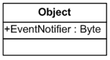 | 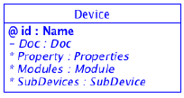
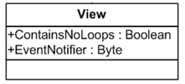 | 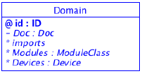
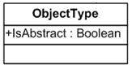  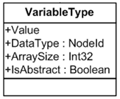 | 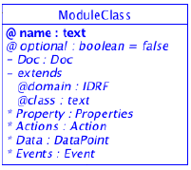
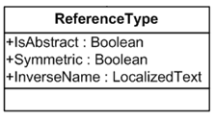 | 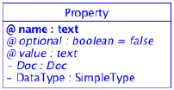
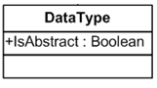 | DataType: DataType
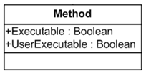 | 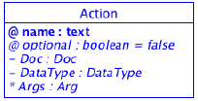
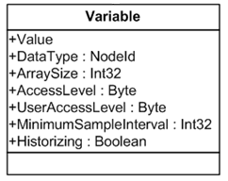 | 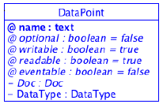

Based on the above OPC-UA and oneM2M IMs mapping design, OPC-UA IM could be further mapped to oneM2M resources following the principles provided in [i.12] clause 6.

8.2 Semantics support by oneM2M
Editors’ note: This sub-clause studies how advanced semantics features in oneM2M e.g. data annotation could enable the industrial domain.

9 Conclusion

Proforma copyright release text block
This text box shall immediately follow after the heading of an element (i.e. clause or annex) containing a proforma or template which is intended to be copied by the user. Such an element shall always start on a new page.
Notwithstanding the provisions of the copyright clause related to the text of the present document, oneM2M grants that users of the present document may freely reproduce the <proformatype> proforma in this {clause|annex} so that it can be used for its intended purposes and may further publish the completed <proformatype>.
<PAGE BREAK>

Annexes
Each annex shall start on a new page (insert a page break between annexes A and B, annexes B and C, etc.).
Use the Heading 9 style for the title and the Normal style for the text.
Annex <A>:
Title of annex (style H9)
<Text>
<PAGE BREAK>
Annex <B>:
Title of annex (style H9)
<Text>
B.1 First clause of the annex (style H1)
<Text>
B.1.1 First subdivided clause of the annex (style H2)
<Text>
<PAGE BREAK>

Annex <y>:
Bibliography
The annex entitled "Bibliography" is optional.
It shall contain a list of standards, books, articles, or other sources on a particular subject which are not mentioned in the document itself.
It shall not include references mentioned in the document.
Use the Heading 9 style for the title and B1+ or Normal for the text.
- <Publication>: "<Title>".
OR
<Publication>: "<Title>".
<PAGE BREAK>

History
This clause shall be the last one in the document and list the main phases (all additional information will be removed at the publication stage).
Publication history

Draft history (to be removed on publication)
V0.0.1 | 2017-11-17 | Skeleton of the TR.
V0.1.0 | 2018-7-16 | Incorporated the contribution agreed at MAS#33 and MAS#35:  - MAS-2018-0002R03-Introduction_to_Industry_4.0_aspects  - MAS-2017-0252R10-Semantics_Use_Case_in_the_Industrial_Domain
V0.2.0 | 2018-12-4 | Incorporated the contribution agreed at MAS#36 and MAS#37.2:  - MAS-2018-0102R02-Analysis of industrial domain information models  - MAS-2018-0134R02-Analysis_of_AutomationML_information_models
V0.3.0 | 2019-5-9 | Incorporated the contribution agreed at RDM#39:  - RDM-2019-0032R01-Industrial_Domain_Information_Model_Mapping

