oneM2M  Technical Specification | oneM2M  Technical Specification
Document Number | TS-0041-V-5.0.0
Document Name: | oneM2M-SensorThings Interworking\
Date: | 2024-03-01
Abstract: | < An abstract of the specification and information that may be used in subsequent electronic searches>
Template Version: | January 2020 (do not modify)
The present document is provided for future development work within oneM2M only. The Partners accept no liability for any use of this specification.
The present document has not been subject to any approval process by the oneM2M Partners Type 1. Published oneM2M specifications and reports for implementation should be obtained via the oneM2M Partners’ Publications Offices.
About oneM2M
The purpose and goal of oneM2M is to develop technical specifications which address the need for a common M2M Service Layer that can be readily embedded within various hardware and software, and relied upon to connect the myriad of devices in the field with M2M application servers worldwide.
More information about oneM2M may be found at: http//www.oneM2M.org
Copyright Notification
- 2024, oneM2M Partners Type 1 (ARIB, ATIS, CCSA, ETSI, TIA, TSDSI, TTA, TTC).
All rights reserved.
The copyright extends to reproduction in all media.
Notice of Disclaimer & Limitation of Liability
The information provided in this document is directed solely to professionals who have the appropriate degree of experience to understand and interpret its contents in accordance with generally accepted engineering or other professional standards and applicable regulations. No recommendation as to products or vendors is made or should be implied.
NO REPRESENTATION OR WARRANTY IS MADE THAT THE INFORMATION IS TECHNICALLY ACCURATE OR SUFFICIENT OR CONFORMS TO ANY STATUTE, GOVERNMENTAL RULE OR REGULATION, AND FURTHER, NO REPRESENTATION OR WARRANTY IS MADE OF MERCHANTABILITY OR FITNESS FOR ANY PARTICULAR PURPOSE OR AGAINST INFRINGEMENT OF INTELLECTUAL PROPERTY RIGHTS. NO oneM2M PARTNER TYPE 1 SHALL BE LIABLE, BEYOND THE AMOUNT OF ANY SUM RECEIVED IN PAYMENT BY THAT PARTNER FOR THIS DOCUMENT, WITH RESPECT TO ANY CLAIM, AND IN NO EVENT SHALL oneM2M BE LIABLE FOR LOST PROFITS OR OTHER INCIDENTAL OR CONSEQUENTIAL DAMAGES. oneM2M EXPRESSLY ADVISES ANY AND ALL USE OF OR RELIANCE UPON THIS INFORMATION PROVIDED IN THIS DOCUMENT IS AT THE RISK OF THE USER.

Contents
1 Scope
2 References
2.1 Normative references
2.2 Informative references
3 Definition of terms, symbols and abbreviations
3.1 Terms
3.2 Symbols
3.3 Abbreviations
4 Conventions
5 Introduction to OGC SensorThings API
5.1 User defined subdivisions of clause(s) from here onwards
Proforma copyright release text block
Annex <y>: Bibliography
History

1 Scope
The present document …
EXAMPLE: The present document provides the necessary adaptions to the endorsed document.
The Scope shall not contain requirements.

2 References
The following text block applies.
References are either specific (identified by date of publication and/or edition number or version number) or nonspecific. For specific references,only the cited version applies. For non-specific references, the latest version of the referenced document (including any amendments) applies.

2.1 Normative references
- [1] OGC SensorThings API “Part 1: Sensing Version 1.1” (http://www.opengis.net/doc/is/sensorthings/1.1)

2.2 Informative references
Clause 2.2 shall only contain informative references which are cited in the document itself.
The following referenced documents are not necessary for the application of the present document but they assist the user with regard to a particular subject area.
- Use the EX style, add the letter “i” (for informative) before the number (which shall be in square brackets) and separate this from the title with a tab (you may use sequence fields for automatically numbering references).
- [i.1] oneM2M Drafting Rules (http://www.onem2m.org/images/files/oneM2M-Drafting-Rules.pdf)

3 Definition of terms, symbols and abbreviations
Delete from the above heading the word(s) which is/are not applicable.

3.1 Terms
Clause numbering depends on applicability.
- A definition shall not take the form of, or contain, a requirement.
- The form of a definition shall be such that it can replace the term in context. Additional information shall be given only in the form of examples or notes (see below).
- The terms and definitions shall be presented in alphabetical order.
For the purposes of the present document, the [following] terms and definitions [given in … and the following] apply:
Definition format
<defined term>: <definition>
If a definition is taken from an external source, use the format below where [N] identifies the external document which must be listed in Section 2 References.
<defined term>[N]: <definition>
example 1: text used to clarify abstract rules by applying them literally
NOTE: This may contain additional information.

3.2 Symbols
Clause numbering depends on applicability.
For the purposes of the present document, the [following] symbols [given in … and the following] apply:
Symbol format
<symbol> <Explanation>
<2nd symbol> <2nd Explanation>
<3rd symbol> <3rd Explanation>

3.3 Abbreviations
Abbreviations should be ordered alphabetically.
Clause numbering depends on applicability.
For the purposes of the present document, the [following] abbreviations [given in … and the following] apply:
Abbreviation format
<ABREVIATION1> <Explanation>
<ABREVIATION2> <Explanation>
<ABREVIATION3> <Explanation>

4 Conventions
The key words “Shall”, “Shall not”, “May”, “Need not”, “Should”, “Should not” in this document are to be interpreted as described in the oneM2M Drafting Rules [i.1]

5 Introduction to OGC SensorThings API
The SensorThings API (STA) is a standard of the Open Geospatial Consortium (OGC). It provides a framework for communication and exchanging data between sensors and applications. The standard is devided in two parts. SensorThings API Part 1 is dedicated to sensing and was published in 2016 and updated in 2021 [1].
A STA-based architecture works in client/server mode. A sensor device pushes data to the SensorThings Server via HTTP. A SensorThings Server may also support MQTT protocol to support publish and subscribe capabilities. An interested application can subscribe to the MQTT-Broker, in order to get notified about new sensor events.
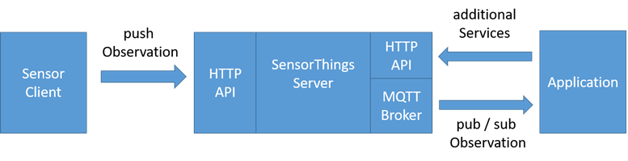
Figure 5-1 STA message flow
The data in the SensorThings server are organized as according to Sensing Entities (see Figure 5.0-1: Sensing Entities data model [1]).
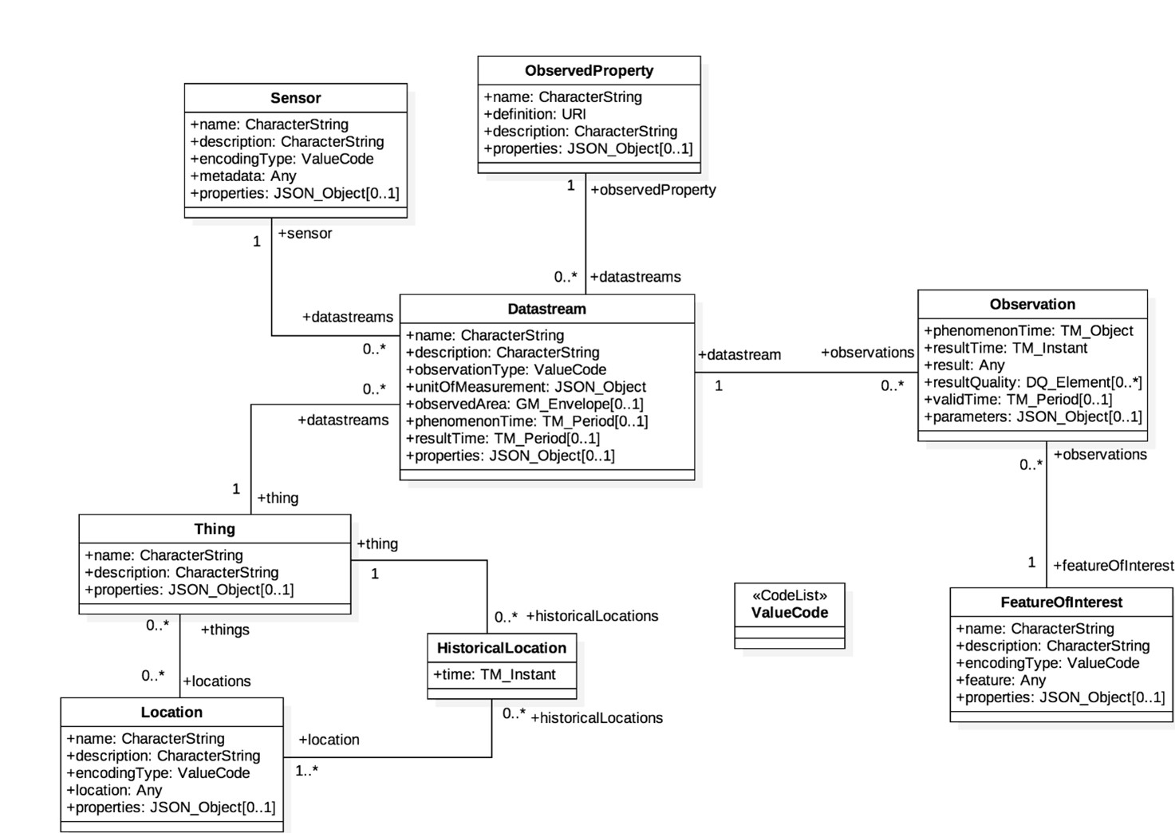
Figure 5-1 STA Sensing Entities Data Model [1]
In the Sensing Entities Data Model events or sensor data are called “observations”. Before a sensor is able to push an observation to the server it needs at least a ‘Thing’ and a ‘Datastream’ entity. This has to be created beforehand. One ‘Thing’ might have different ‘Sensors’, one ‘Location’ or many ‘HistoricalLocations’.
The Sensing Entities data model and the purpose of data within the data model discloses mainly two data characteristics, associated with a ‘thing’:
- Data observations originated by sensors or commands sent to interact with actuators may be seen as IoT data from oneM2M point of view. While:
- Data embedded in the Sensing Entities Data Model, like “historic locations” should be seen as data for documentation purposes.

5.1 User defined subdivisions of clause(s) from here onwards
<Text>
The following text is to be used when appropriate:

Proforma copyright release text block
This text box shall immediately follow after the heading of an element (i.e. clause or annex) containing a proforma or template which is intended to be copied by the user. Such an element shall always start on a new page.
Notwithstanding the provisions of the copyright clause related to the text of the present document, oneM2M grants that users of the present document may freely reproduce the <proformatype> proforma in this {clause|annex} so that it can be used for its intended purposes and may further publish the completed <proformatype>.

<PAGE BREAK>

Annexes
Each annex shall start on a new page (insert a page break between annexes A and B, annexes B and C, etc.).
Use the Heading 9 style for the title and the Normal style for the text.

Annex <A> (Informative/Normative):Remove Informative or Normative as appropriat Title of annex (style H9)
<Text>
<PAGE BREAK>

Annex <B> (Informative/Normative):Remove Informative or Normative as appropriat Title of annex (style H9)
<Text>

B.1 First clause of the annex (style H1)
<Text>

B.1.1 First subdivided clause of the annex (style H2)
<Text>
<PAGE BREAK>
The following text is to be used when appropriate:

Annex <y>:

Bibliography
The annex entitled “Bibliography” is optional.
It shall contain a list of standards, books, articles, or other sources on a particular subject which are not mentioned in the document itself
It shall not include references mentioned in the document.
Use the Heading 9 style for the title and B1+ or Normal for the text.
- <Publication>: “<Title>”.
OR
<Publication>: “<Title>”.
<PAGE BREAK>

History
This clause shall be the last one in the document and list the main phases (all additional information will be removed at the publication stage).
Publication history | Publication history | Publication history
V1.x.x | <yyyy-mm-dd > | <Milestone>

Version (to be removed on publication) | Date (to be removed on publication) | Draft history (to be removed on publication)
V5.0.0 | 2024-03-01 | Includes the following contributions agreed during SDS#58 meeting: SDS-2023-0219R01-initial_OGC_intro

