

101196630 - ESTIMED - STF 685

D6.5
Post-event Hackathon #1 Report

Dissemination Level: PUBLIC

Version 1.0
30 November 2025

Disclaimer:
Funded by the European Union and the EFTA. Views and opinions expressed are, however, those of the author(s) only and do not necessarily reflect those of the European Union or EFTA. Neither the European Union nor the EFTA can be held responsible for them.

COVER PAGE

PROJECT
Project number: | 101196630
Project acronym: | ESTIMED
Project name: | Enabling Standardized IoT deployments in MEC Environments for advanced systems
Project starting date: | 01/12/2024
Project duration: | 36 months

Deliverable No | Deliverable Name | Work Package No | Lead Beneficiary | R | Dissemination Level | Due Date
D6.5 | Post-event Hackathon #1 Report | WP6 | ETSI | R —Document, Report | Public | 30-11-2025
Description
- Post-event report, summarizing notable projects, attendance numbers and types of participants (student, professional, SME, etc)
- Based on T6.3 and T6.4

TABLE OF CONTENTS
Table of Contents
COVER PAGE 2
introduction 4
methodology 4
Overview 5
Evaluation Board and Criteria 9
Promotion and Dissemination 12
Projects Submission and Evaluation 12
awarding ceremony 18
conclusions 19

introduction
The present document provides a comprehensive overview of the organization, execution, and outcomes of the first ESTIMED Hackathon, held remotely from 28 to 30 October 2025. The event was conceived within the framework of Work Package 6 (WP6) of the ESTIMED project (Enabling Standardized IoT deployments in MEC Environments for advanced systems) which focuses on outreach, community engagement, and practical validation of project results through hackathons and collaborative innovation initiatives.
The Hackathon represented a key milestone for the ESTIMED project, offering a dynamic and interactive environment for testing and demonstrating the synergy between the oneM2M and ETSI MEC standards. Its primary objective was to promote innovative use cases and architectures that integrate Internet of Things (IoT) and Multi-access Edge Computing (MEC) technologies to address real-world challenges in domains such as smart cities, industrial automation, maritime logistics, and public safety. By bringing together academic researchers, developers, and industrial practitioners, the event aimed to foster the creation of interoperable, standards-based solutions that can advance the deployment of intelligent IoT and edge ecosystems across multiple sectors.
The event was organized and coordinated by the Specialist Task Force STF685, under the leadership of ETSI, in close collaboration with oneM2M experts and ESTIMED project partners. Its methodology was based on a structured, transparent approach encompassing the definition of clear objectives, the setup of technical resources, and the establishment of evaluation and dissemination procedures. Participants were provided with access to shared technical materials, online repositories, and real-time communication channels to support collaboration and knowledge exchange throughout the event.
The Hackathon attracted five international teams from universities and SMEs across Europe, Asia, and Africa, reflecting the project’s commitment to inclusivity and global participation. Over three days, participants engaged in hands-on development sessions, use-case design, and technical discussions, culminating in the presentation and evaluation of their proposed solutions by an expert Evaluation Board composed of representatives from ETSI, oneM2M, and related research communities.
This report summarizes all aspects of the Hackathon, including its methodology, organizational process, evaluation criteria, project submissions, and final results.

methodology
The STF685 team started planning and organization activities in April 2025. The overall methodology adopted by the team was based on:
- The identification of the title, according to the event’s scope and application domain;
- The definition of the main objectives based on the ESTIMED project use cases and PoCs;
- The identification of the type of participants suitable for the event;
- The definition of the typology of the event itself;
- The identification of the evaluation criteria and the establishment of the evaluation board;
- The arrangement and sharing of all technical material and tools for supporting developers during the event;
- The establishment of a dedicated communication channel providing real-time technical support to the participants;
- Definition of the procedures for submitting the final results/deliveries;
- Drafting and provisioning of the event’s agenda;
- Establishment of appropriate dissemination actions for promoting the event;
- The identification of the prizes and awarding procedures.

Overview
The title of the event was “ESTIMED Hackathon #1 - Enabling Innovative Use Cases with oneM2M and MEC Deployments”.
The event was promoted by actively inviting project partners and associates, universities, and through social media platforms such as LinkedIn.
The event was arranged by relying on the “ETSI Open Session” format and lasted three days, from October 28th to October 30th, 2025. Five distinct teams attended this event as competing participants, according to the table below:
Team Name | Country | Team Members | Organization Type | Project Title
xFlow Research Inc. | Pakistan | 3 | SME | EdgeTwin Logistics Framework
FSCOM | France | 1 | SME | Vulnerable user detection scenario and deployment in smart city based on ETSI C-ITS, ETSI MEC and oneM2M standards and architectures
Green Box | Egypt | 1 | SME | Distributed Edge AI for Predictive Maintenance & Emergency Response (MEC & oneM2M)
Sejong University - SESLab | Republic of Korea | 3 | University | Inclusive Edge Safety Service for Pedestrians with Reduced Mobility
Scuola Superiore Sant'Anna (SSSUP) | Italy | 3 | University | Interoperable oneM2M–MEC architecture enabling automated vessel berthing operations
Table 1: ESTIMED Hackathon #1 – List of Competing Participants.
All the participants were requested to fill a registration form in before participating to the event. The registration form included:
- The type of the organization (e.g., research, university, SME, etc.);
- The teams’ affiliation and country;
- The identification of the team leader and team members;
- The project/proposal title, abstract and application domain;
- The list of the tracks to be addressed during the event;
- The licensing agreement.
Communication, answering questions and coordination during the hackathon happened via a dedicated Discord server.
The agenda that was adopted is reported below:
Day 1
(October 28th, 13:00 – 18:00 CET)
Time Slot |  | Session | Presenter
13:00 – 13:15 |  | Opening and welcome. | JaeSeung Song (oneM2M TP vice chair, Sejong University) and Dario Sabella (ETSI MEC Chair, XFlowResearch)
13:15 – 13:30 |  | ESTIMED STF 685 – Project overview. | Joachim Koss  (JK Consulting)
13:30 – 13:45 |  | Introduction to the Hackathon (objectives and goal). | Alexandr Tardo  (CNIT)
13:45 – 14:30 |  | Introduction to available resources:  - MEC Sandbox and available resources;  - oneM2M open sources (ACME and tinyIoT) and available resources;  - Demo information. | Yann Garcia (FSCOM) / JaeSeung Song (Sejong University)
14:30 – 18:00 |  | Technical and development session (Round 1). | All
Day 2
(October 29th, 09:00 – 18:00 CET)
Time Slot |  | Session | Presenter
09:00 – 18:00 |  | Technical and development session (Round 2). | All
Day 3
(October 30th, 09:00 – 17:00 CET)
 | Time Slot | Session | Presenter
 | 09:00 – 13:00 | Technical and development session (Round 3). | All
13:00 – 14:00 |  | Submission of the results
14:00 – 16:00 |  | Participants’ presentation (20’ each + 5’ for Q&A):  - xFlow (Pakistan)  - Sejong University – SESLab (South Korea)  - FSCOM (France)  - Green Box (Egypt)  - Scuola Superiore Sant’Anna (Italy) | All
 | 16:00 – 16:30 | Evaluation (off-line) | Evaluation Board
 | 16:30 – 17:00 | Award ceremony | ETSI, ESTIMED Project, oneM2M, ISG MEC
Table 2: ESTIMED Hackathon #1 – Agenda.
On Day 1, the focus was that of providing all the participants with an overview about the MEC, oneM2M, ESTIMED project, objectives of the Hackathon and technical (oneM2M/MEC) tools/assets available for the development. A total amount of 19 people attended the session.
During Day 2, no remote sessions were arranged as the participants should have been mostly focused on developing their projects. However, all the participants were informed about the possibility to call-for-a-meeting, if required.
Finally, the Day 3 was focused on submitting and presenting the projects from the participants as well as on evaluation and awarding ceremony. A total amount of 24 people attended the session.
The Hackathon consisted of three different tracks (objectives) that the participants could have addressed during the event. The description of the tracks is reported in the table below:

Track # | Description
1 | Bring innovative use cases that address specific problems and challenges using oneM2M and MEC capabilities (IoT and Edge Computing)  The identification of the use cases shall follow a structured format that makes the problem clear and highlights how and why the interworking between oneM2M and MEC is important. The description shall include:  - Domain and Context: specify the application domain (e.g., smart cities, industrial automation, maritime, healthcare, metaverse, smart home, digital twins, etc.) and explain the current challenges of that domain.  - Problem Statement: identify a specific problem and challenges to be solved and why it is important in terms of safety, efficiency, sustainability, costs reduction, etc.  - Use Case Scenario: to present a narrative describing how the system works from the perspective of the end-users or stakeholders (e.g., a connected ship approaching a port shall avoid collisions in real time, requiring local data processing at the edge).  - Actors and Stakeholders: to identify end-users as well as physical and digital systems involved (e.g., IoT devices, vehicles, robots, sensors, platforms, cloud services, etc.).  - Expected Benefits: to identify concrete/tangible benefits of solving the problem (e.g., improved safety, improved operational efficiency, costs reduction, energy savings, etc.).  - User Requirements: based on the actors and stakeholders, clearly identify the end-users needs by describing what they expect from the proposed solution/system expressed in user language, without technical details.
2 | Provide high level architecture of the proposed solution by explaining how combining oneM2M and MEC is addressing the identified challenges  As soon as the use case is identified, the participants shall propose a high-level system architecture that illustrates how oneM2M and MEC together address the identified challenges. This description should cover the following aspects:  - Overall Architecture: functional diagram showing the main layers and components (e.g., devices, edge nodes, platforms, applications, etc.), indicating where oneM2M and MEC components are deployed.  - System Requirements: based on the user requirements, a comprehensive set of functional/non-functional system requirements shall be derived covering aspects such as performance, scalability, interoperability, security, reliability, latency, etc.  - oneM2M Components: to describe which nodes are used (e.g., IN-CSE in cloud, MN-CSE at edge, ASN/ADN at devices, etc.), how devices and applications register and interact via oneM2M, and which Common Service Functions (CSFs) are used (e.g., data management, device management, security, semantic discovery, etc.).  - MEC Components: to describe which MEC functions and building blocks are leveraged (e.g., MEC platform, MEC applications, MEC orchestrator, etc.), which MEC APIs are used, and how MEC hosts real-time applications (e.g., Federated Learning, AI analytics, Swarm Computing, etc.).  - oneM2M/MEC Interworking: to describe how MEC applications consume or expose oneM2M services, how oneM2M data flows are directed to the MEC applications for low-latency processing, and what deployment options are used (e.g., A, B, C or D).  - Data Management: to describe where time-sensitive data is processed, where a persistent storage and global coordination happens, and how data and service continuity are ensured when devices/users/assets move across zones (e.g., handover).  - Security and Reliability: to describe how security is ensured (e.g., authentication, authorization, secure APIs, etc.), and how the reliability is managed at edge/cloud level.  - Impact: to explain and highlight (from technical point of view) how the proposed architecture solves the identified problem/challenge (e.g., by placing MN-CSE on MEC nodes, collision avoidance algorithms can be executed quickly, ensuring safety during maneuvering operations).
3 | Develop a prototype of a MEC or oneM2M application exploiting existing oneM2M/MEC implementations and considering available oneM2M/MEC configurations (either in a form of a technical documentation or a real prototype)  In order to support the prototype development activities, the ESTIMED project provides the participants with all the required materials and tools (accessible through the project Git repository including:  - Tutorials: MEC Tech Series, ETSI MEC Sandbox, step-by-step guidelines for developing a MEC application (sessions and network scenarios), oneM2M tutorials;  - User Guides: ETSI MEC Sandbox deployment, procedure for developing a MEC application and test it against ETSI MEC Sandbox, practical examples, oneM2M guidelines.  - Proofs of Concept: skeletons and tools for developing single or combined oneM2M and MEC applications.  The participants are requested to submit (public Git repository) all produced material in the same format in order to facilitate its evaluation as follows:  - Project/Results Presentation: MS PowerPoint.  - A hackster.io project that is a clear guide on building a prototype solution. It includes:  - Description of the issue and how the prototype solution addresses it.  - An explanation of the oneM2M and MEC features used in the solution.  - A description of devices, applications used (oneM2M platform, MEC framework, device simulators, etc.)  - A public repository to release the source codes.
Table 3: ESTIMED Hackathon #1 – Tracks & Objectives.
The Track #1 and Track #2 were mandatory, while the Track #3 was optional. In order to provide the participants with all needed technical assets and tools, the following ESTIMED project GitHub repository was setup in advance: https://labs.etsi.org/rep/estimed/wp6/hackathons/hackathon-1.git.

Evaluation Board and Criteria
In order to facilitate the evaluation process, the STF685 team drafted a rubric of evaluation criteria (including scores) that should have been considered by the Hackathon’s participants during developing and delivering phases, as reported in the table below:
Criteria  (Short criteria title) | Evaluation Level
Criteria  (Short criteria title) | Excellent (4-5) (What would make the proposal excellent) | Good (2-3) (What would make the proposal good) | Sufficient (0-1) (What would make the proposal sufficient/acceptable)
Use case innovation and relevance  (applicable to Track #1 and #2) | The proposal clearly addresses a real-world challenge with a strong novelty compared to typical one/M2M-MEC use cases and a compelling justification for using oneM2M-MEC interworking. | The proposal addresses a valid but moderately impactful challenge or problem. It shows some innovative features, but also overlap with existing solutions without much differentiation. A potential impact is plausible but only partially quantified. | The proposal addresses a generic challenge with a low-value in real context and a low level of novelty, as the proposed solution can be implemented without oneM2M/MEC interworking. The application domain is not clearly described or identified.
System requirements and KPIs  (applicable to Track #1 and #2) | The proposal covers functional (e.g., data handling, analytics, device control, etc.) and non-functional (e.g., latency, reliability, security, scalability, etc.) requirements and shows a clear linkage to oneM2M-MEC capabilities. KPIs are realistic, measurable, and directly tied to oneM2M-MEC features, providing also a baseline versus expected improvement. | The proposal includes functional and non-functional requirements, but some are unclear or not appropriate with a partial linkage to oneM2M-MEC. Some critical aspects are not addressed (e.g., interoperability, scalability, etc.). The identified KPIs mix quantitative and qualitative metrics, and no baseline is provided. | The proposal includes only few or high-level requirements with no measurable targets and lacks consideration of oneM2M-MEC capabilities. The KPIs are missing or purely qualitative with no measurable performance targets.
Architecture  (applicable to Track #1 and #2) | The architecture diagram is clear, complete, and technically correct. It proposes an explicit mapping to one deployment options with a strong justification for the choice. The proposed architecture shows component interactions (e.g., MEC platform, MEC applications, oneM2M CSE, IoT devices, APIs, etc.) and clearly highlights performance advantages (e.g., reduced latency, improved resource usage, better interoperability, etc.). | The architecture is mostly clear, but lacks some details on component interactions. The deployment option is mentioned, but the proposed justification is limited. The main benefits are described but not fully quantified. | The proposed architecture is vague or incomplete, with no linkage to deployment options. The oneM2M-MEC integration and interworking is unclear or missing.
Prototype implementation  (applicable to Track #3) | The participant proposed a working prototype or a highly detailed technical blueprint using existing MEC and oneM2M platforms (e.g., MEC Sandbox, ACME, tinyIoT or Mobius). The prototype demonstrates correct use of standard APIs, and it is fully aligned with the chosen deployment option. The prototype is reproducible with provided technical material/documentation. | The participant delivered a partial prototype or mock-up with some functional components. The prototype has limited APIs integration or partial use of oneM2M-MEC features and shows reproducibility gaps. | The participant delivered a minimal or conceptual prototype only, with no real oneM2M-MEC integration and with no sufficient technical material/documentation for its reproducibility.
Quality of the presentation  (applicable to Track #1 and #2) | Complete, well-organized technical material/documentation including use case workflow, architecture diagrams, sequence flows and APIs usage. Explicit mapping to oneM2M-MEC deployment option. The solution is easy to understand and replicate from the technical material/documentation alone. | The technical material/documentation is understandable but lacks some details for replication. The use case or architecture diagrams are partially complete or unclear. | The technical material/documentation is incomplete or poorly structured. The use case or architecture diagrams are missing and no technical explanation is provided.
Table 4: ESTIMED Hackathon #1 – Evaluation Criteria.
In addition to the evaluation criteria, the STF685 team managed to setup the Evaluation Board in such a way that the evaluation process should have been fair with the proper level of expertise in line with the scope of the Hackathon. The list of selected members for the evaluation board is reported in the table below:

Expert | Affiliation | 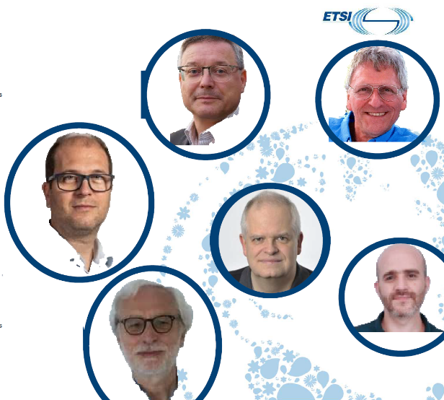
Joachim Koss  (ESTIMED project Leader) | JK Consulting
Andreas Kraft  (Senior Research Expert in IoT and oneM2M) | JK Consulting
Samir Medjiah  (Researcher LAAS-CNRSx) | Samir MEDJIAH EI
Massimo Vanetti  (oneM2M WG RDM Chair) | Digital SME
Roland Hechwartner  (oneM2M TP Chair) | Deutsche Telekom AG
Dario Sabella  (ETSI ISG MEC Chair) | xFlow Research
Table 5: ESTIMED Hackathon #1 – Evaluation Board Members.

Promotion and Dissemination
The promotion and dissemination activities started several months in advance by exploiting existing communication channels. First, the event’s poster was drafted by the STF685 team, as depicted in the figure below:
Figure 1: ESTIMED Hackathon #1 – Poster.
Finally, the following communication channels were exploited in order to promote the event and attract participants such as Research Institutes and Organizations, Universities and SMEs:
- oneM2M LinkedIn channel and X official profile;
- ESTIMED project Website;
- ETSI ISG MEC, oneM2M and ETSI TC DATA mailing lists;
- Personal LinkedIn channels of the ESTIMED members;
- oneM2M/MEC joint sessions;
- ETSI official Website.

Projects Submission and Evaluation
On Day 3, all the participants were requested to submit their projects on the hackster.io platform including the description of the proposed use cases, their architecture and all relevant technical details (e.g., oneM2M/MEC components and interworking, flow and sequence diagrams, etc.). The submitted projects are summarized as follows:

Team | Logo | Project Description | Project Repository
xFlow Research Inc. |  | The Synthetic Edge Twin (SET) Framework is a standards-based architecture that integrates oneM2M for IoT device abstraction with ETSI MEC Sandbox APIs for edge-native network simulation. SET enables the rapid development and validation of digital twins in constrained or pre-deployment environments, offering a unified approach for combining synthetic, hybrid, and real-world data. Its modular design supports scalable, low-latency analytics at the network edge, ensuring safe experimentation and seamless transition from simulated to live operations. Building on this foundation, our Predictive Cold Chain Monitoring use case demonstrates the practical application of SET principles for real-time logistics management. The system employs oneM2M to aggregate telemetry from temperature, humidity, and location sensors, while MEC-hosted services perform edge-level analytics to predict risks such as thermal excursions and route delays. This implementation showcases how edge-twin capabilities enhance reliability, responsiveness, and operational intelligence in cold chain logistics, providing a replicable model for other time-critical and mission-sensitive domains. | Link
FSCOM |  | The use case is about vulnerable users’ detection scenario in an ETSI MEC/5G environment, based on oneM2M release 4, ETSI MEC phase 3 and ETSI C-ITS release 2 standards and architectures. This use case proposes an environment including cars, pedestrians and road side units. The Onboard units are compliant with ETSI C-ITS release 2, the road side units are compliant with ETSI C-ITS release 2, ETSI MEC phase 3 and oneM2M release 4. The 5G sensors are compliant with both ETSI MEC release 3 and oneM2M release 4. | Link
Green Box | N/A | Green Box is a self-sustained edge-AI platform that enables real-time predictive maintenance and emergency detection across industrial, maritime, and aviation environments. Each Green Box functions as a MEC node, analyzing sensor data (temperature, vibration, gas, GPS, etc.) locally using AI-based anomaly detection and sensor fusion. Regional aerial hubs (balloons/aerostats) act as IN-CSE gateways, linking multiple MN-CSEs and ensuring oneM2M CSE-to-CSE communication even without terrestrial networks. Energy Autonomy: Each unit operates independently through solar harvesting, wind turbines and kinetic energy recovery, and ultra-low-power edge computing, ensuring continuous service during disasters or in remote areas without external power or internet. The system integrates a smart assistant that provides field engineers, pilots, and rescue teams with contextual guidance, voice interaction, and automated reporting. An industrial marketplace coordinates spare-part logistics and drone-based delivery. By combining MEC, oneM2M, and federated learning, Green Box forms a resilient, energyefficient, and globally interoperable network that supports continuous operation, predictive diagnostics, and rapid human-machine collaboration in critical missions. | N/A
Sejong University - SESLab |  | The project integrates oneM2M and MEC standards to provide a real-time safety service for mobility-impaired pedestrians. Sensor data from smart devices are analyzed at the edge to reduce latency and alert caregivers and authorities through secure, consent-based data sharing. | Link
Scuola Superiore Sant'Anna (SSSUP) |  | This project proposes a use case for automating docking operations of unmanned vessels in maritime environments using real-time data computation and edge technologies. Currently, docking and related logistics rely heavily on manual coordination between pilots, port operators, and truck drivers, leading to inefficiencies, high costs, safety risks, and environmental impact. The proposed solution integrates oneM2M (for data storage and sharing) with MEC applications that process sensor data (e.g., cameras, LIDAR, and proximity sensors) to detect available berths and coordinate vessel movements autonomously. AI algorithms at the edge identify optimal docking slots and manage real-time communication between ships, OTs, and trucks. Once docking begins, automated notifications and control commands streamline loading and unloading operations. Overall, the use case demonstrates how interoperable, real-time edge computing architectures can transform maritime logistics into a more intelligent, coordinated, and eco-efficient ecosystem. | Link
Table 6: ESTIMED Hackathon #1 – List of Projects submitted per team.

After the submission of the projects, all participants were requested to deliver a 20 minutes-long presentation by describing their project in terms of identified use case and user scenarios, system architecture, oneM2M and MEC components involved and how they interwork, user and system requirements and the main benefits. All the presentations are available on the ESTIMED project SharePoint. The presentations’ session per team are reported in the figures below:

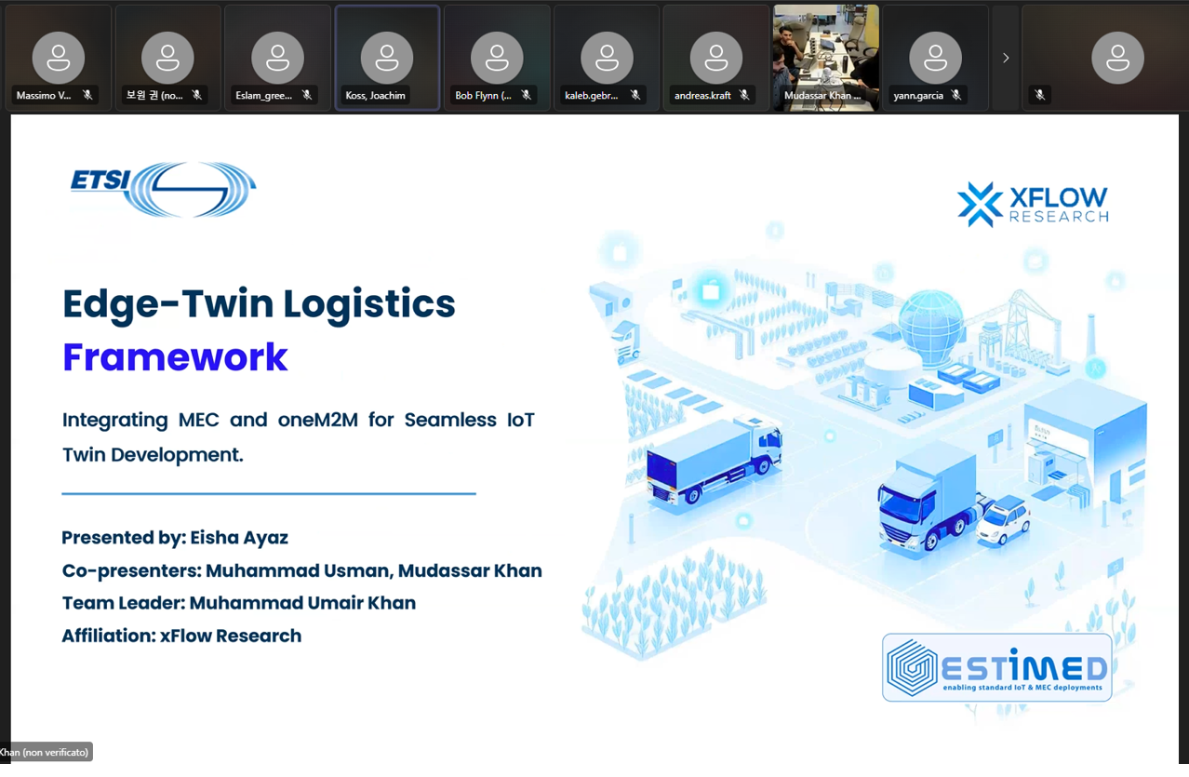
Figure 2: ESTIMED Hackathon #1 - xFlow Research Inc. Team.
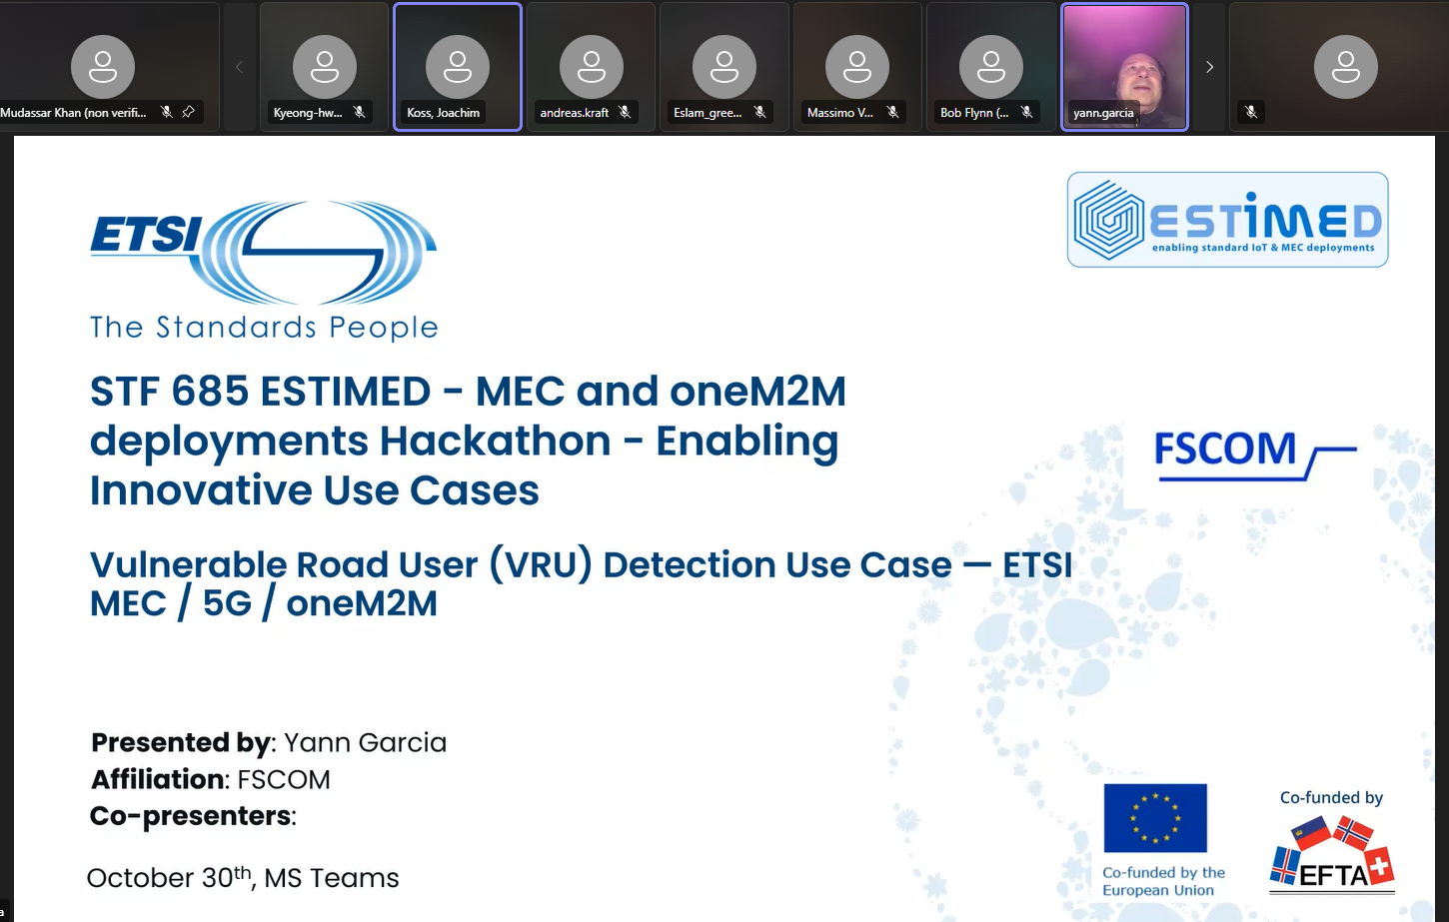
Figure 3: ESTIMED Hackathon #1 - FSCOM Team.

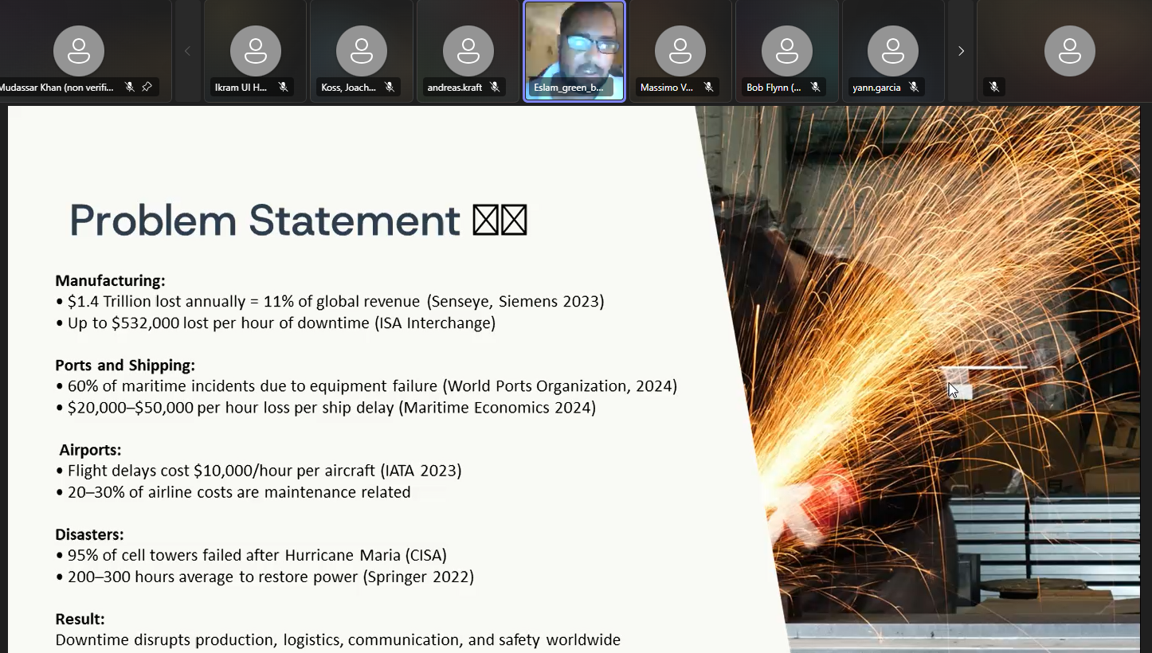
Figure 4: ESTIMED Hackathon #1 - Green Box Team.

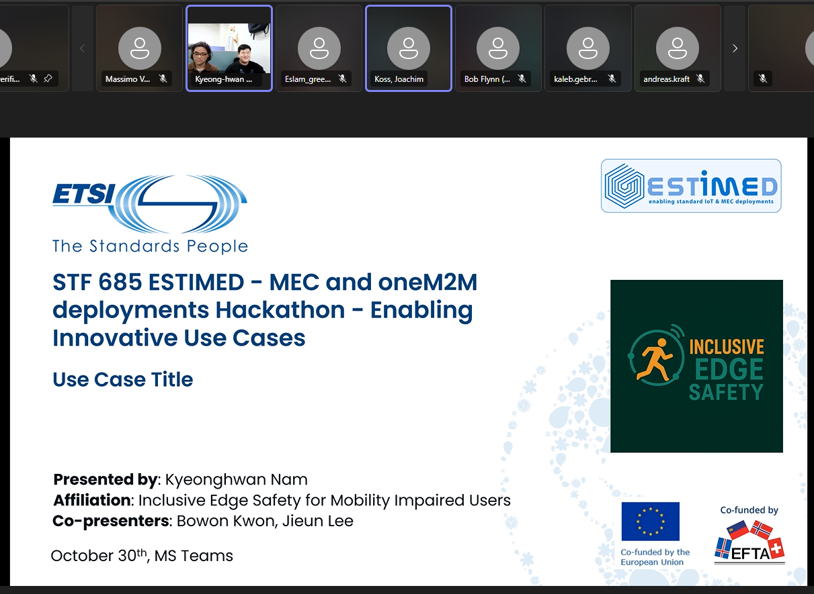
Figure 5: ESTIMED Hackathon #1 - Sejong University/SESLab Team.
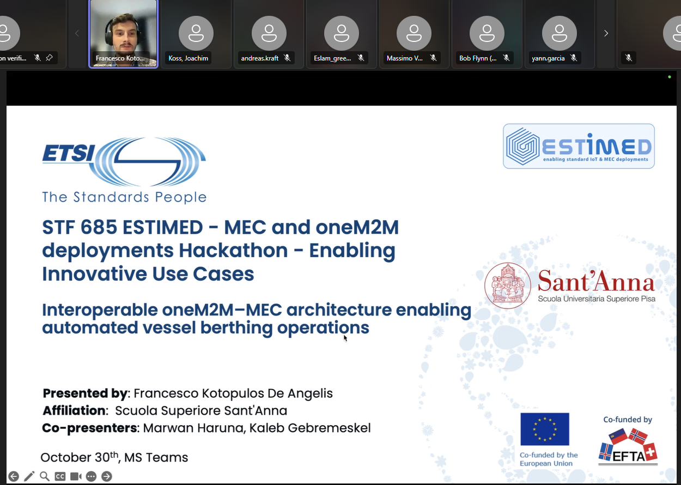
Figure 6: ESTIMED Hackathon #1 - Scuola Superiore Sant'Anna (SSSUP) Team.
As soon as all the participants delivered their projects, a parallel session was started among the members of the Evaluation Board in order to start the evaluation process based on the evaluation criteria. During this session, the evaluators relied on an on-line form (properly formatted) in order to facilitate and optimize the evaluation process. The outcome of such a process is reported in the table below:
Team | Standing
Scuola Superiore Sant'Anna (SSSUP) | 1st
xFlow Research Inc. | 2nd
Sejong University - SESLab | 3rd
FSCOM | 4th
Green Box | 5th
Table 7: ESTIMED Hackathon #1 – Overall Standings.

awarding ceremony
The awarding process took place as follows:
- Participation certificate signed by ETSI sent by email all competing Teams;
- Winner certificate for the 1st, 2nd and 3rd places sent by email;
- Custom trophy for the 1st, 2nd and 3rd places (per team) shipped to the specified destination;
- One-year subscription to the Tech Learning service to each member of the winner team.
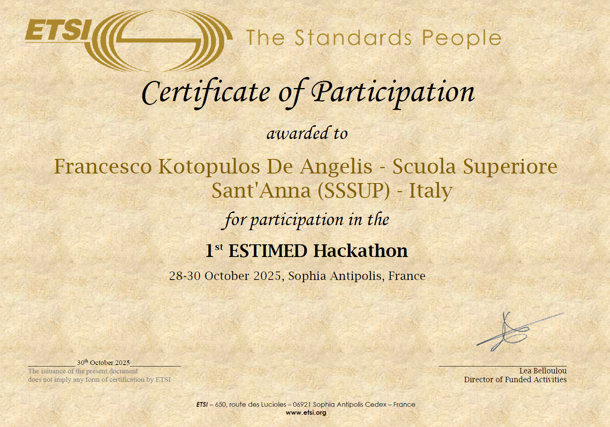
Figure 7: ESTIMED Hackathon #1 – Example of the Certificate of Participation for the team leader of the winner team.

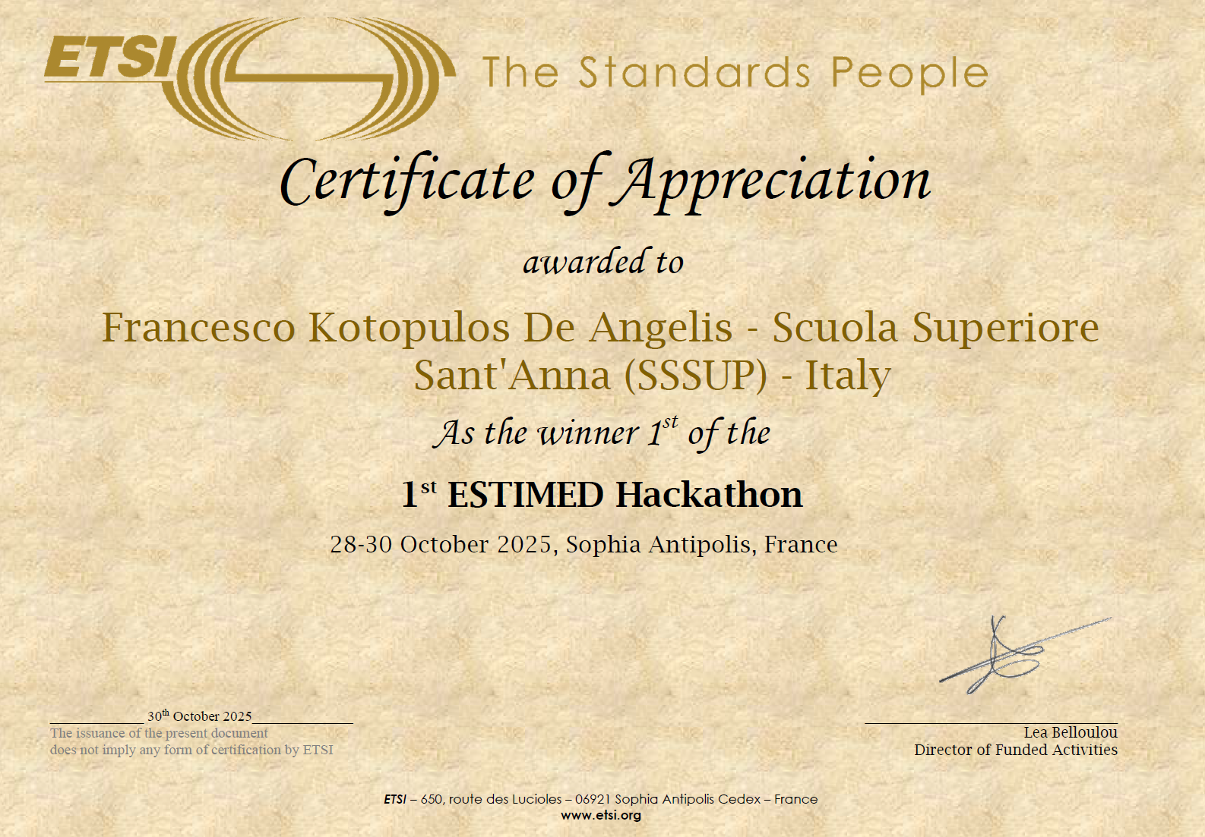
Figure 8: ESTIMED Hackathon #1 – Example of the Certificate of Appreciation for the team leader of the winner team.

conclusions
The ESTIMED Hackathon #1 was the first event of the ESTIMED project’s WP6 (Dissemination and Ecosystem). It was conducted remotely from 28th – 30th October 2025, and aimed to explore innovative use cases demonstrating interworking between oneM2M and MEC standards, advancing IoT-Edge integration. Organized by STF685 under ETSI, the event was public, structured around clear methodology, evaluation procedures, and dissemination strategies, ensuring both technical rigor and community visibility. It successfully combined academic and industrial participation, aligning with ESTIMED’s goal of bridging standards and real-world IoT applications. Participation from Europe, Asia, and Africa (SMEs and universities) provided geographical and organizational diversity, enriching cross-domain innovation.
The event was structured around three complementary tracks: Track #1, dedicated to identifying innovative use cases combining oneM2M and MEC technologies; Track #2, focused on the design of high-level system architectures addressing the defined challenges, and Track #3, an optional track encouraging the implementation of prototypes using existing MEC and oneM2M configurations. Throughout the three days, participants engaged in technical sessions, collaborative development activities, and guided presentations.
All teams effectively explored the interworking between oneM2M and MEC, validating the technical synergy between IoT standardization and edge computing. Even without prototypes, the submitted materials (use cases and system architectures) were technically detailed, demonstrating robust understanding and potential for future PoCs. The evaluation board composition and scoring grid ensured fairness, transparency, and consistency offering a replicable evaluation model for future ESTIMED hackathons (2026/2027).

