Input Contribution
Meeting ID* | RDM#59
Title:* | DNS-SD based oneM2M device discovery and registration
Source:* | JaeSeung Song, Sejong University & KETI, jssong@sejong.ac.kr
Date:* | 2023-04-18
Input related to* | TR-0059 (Rel-5)
Intended purpose of  document:* | Decision  Discussion  Information  Other <specify>
Impacted other TS/TR(s)
Decision requested or recommendation:* | Agree for inclusion in TR-0059 Services and platforms discovery
Template Version: January 2017 (Do not modify)

oneM2M Notice
The document to which this cover statement is attached is submitted to oneM2M. Participation in, or attendance at, any activity of oneM2M, constitutes acceptance of and agreement to be bound by terms of the Working Procedures and the Partnership Agreement, including the Intellectual Property Rights (IPR) Principles Governing oneM2M Work found in Annex 1 of the Partnership Agreement.

Introduction
This contribution introduces a new proposed concept to support DNS-SD based oneM2M device discovery and registration.

-----------------------Start of change 1-------------------------------------------

8.3 DNS-SD based oneM2M Device Discovery and Registration

8.3.1 Overview

Registering and using newly purchased IoT devices in an existing IoT service can be a hassle due to complicated settings and manual work. For instance, the user is required to perform detailed and complex tasks, such as manually setting a network function for each IoT device to be serviced and linking it with a server. To register an IoT device in the existing oneM2M system, the user must individually utilize the IP address and resource information of the oneM2M platform for each device to complete the registration process. This process involves manually including various information, such as the ID, type, and name of each device in the registration information, and transmitting it. Additionally, the existing oneM2M discovery function only allows to find out devices that have already been registered, and there is no search function for a new IoT device to be registered, causing inconvenience. However, in the case of the Zeroconf network protocol, devices and services can be dynamically searched for and registered in a distributed environment. Therefore, if this function can be provided in the oneM2M IoT platform, IoT devices that can be registered automatically are discovered without manual information input by the user. The selected IoT device can be automatically registered and used on the server platform.

8.3.2 Description of DNS-SD based oneM2M Device Discovery

The DNS-SD based oneM2M device discovery function provides an easier way to register oneM2M devices by applying Zeroconf's DNS-SD function, which enables automatic IT service and device discovery, to the oneM2M server platform and devices. As shown in Figure 8.3.2-1, in order to enable these functions, the following parts need to be applied to existing oneM2M entities:
- oneM2M server platform: A function to discover oneM2M type IoT devices using the DNS-SD protocol and a function to use the selected device information to register oneM2M platform.
- oneM2M device: It needs a function that can multicast its own type as a oneM2M device type and the basic information necessary for oneM2M platform registration using the DNS-SD protocol.
- oneM2M device registration application: It includes a function to request a oneM2M type device search from the oneM2M platform and request oneM2M platform registration for a specific selected device.

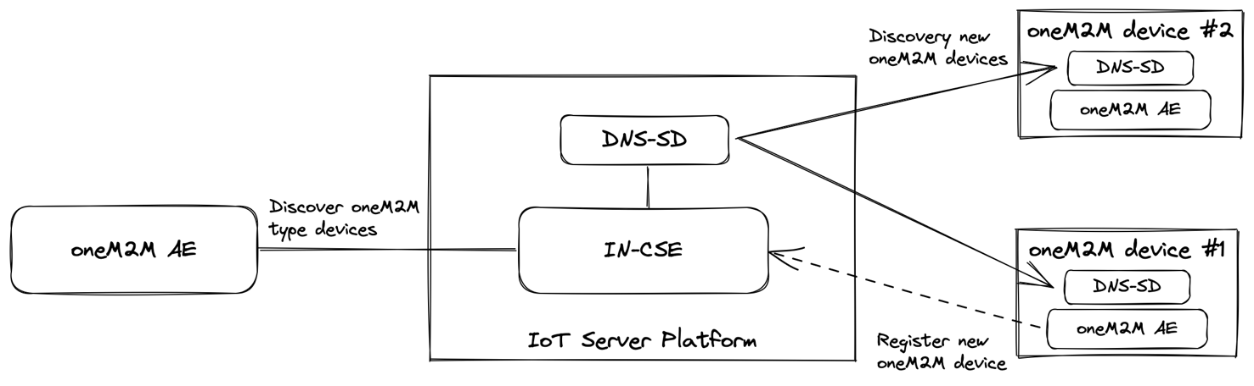
Figure 8.3.2-1 A high-level concept of DNS-SD based oneM2M device discovery and registration
Basically, the user queries the oneM2M platform through the oneM2M application to check if there are any new oneM2M devices that can be registered on the current network. Upon receiving the request, the oneM2M platform sends a DNS-SD multicast message to check if there are any oneM2M type devices and services that can be registered on the network using the DNS-SD function. When oneM2M devices with DNS-SD function receive a message from the IoT platform that they are searching for a oneM2M type device, they respond to it. The oneM2M platform transfers the collected device information that sent the response to the oneM2M application. The user looks at a list of available oneM2M devices, selects a device to be registered, and sends a registration request for the selected device to the oneM2M platform. The oneM2M platform then creates a resource by performing a registration procedure for the selected device and makes it available to the oneM2M application.
The detailed procedure related to introduced DNS-SD based oneM2M type device discovery and registration is described in Figure 8.3.2-2.

Figure 8.3.2-2: DNS-SD based oneM2M Service Discovery
Step 01: Assume there are unregistered oneM2M IoT devices that use the DNS-SD function to advertise their availability on the local network by continuously broadcasting a message indicating that they are oneM2M type devices at regular intervals.
Step 02: A user who wants to register a new oneM2M device sends a request to the oneM2M platform to search for a oneM2M type device using the oneM2M application.
Step 03: The oneM2M platform uses the DNS-SD function to transmit a DNS-SD query to the local network to search for oneM2M type devices based on the received request.
Steps 04 ~ 05: The corresponding oneM2M type devices receiving the query respond to the oneM2M platform by sending a response message that includes their information, including device information necessary for registration.
Step 06: The oneM2M platform collects the received information, i.e., a list of available registrable oneM2M type devices and responds to the oneM2M application.
Step 07: The oneM2M application selects the device to be registered and requests registration of the selected oneM2M type device to the oneM2M platform.
Step 08: The oneM2M platform performs the registration request for the selected device.
Step 09: Assuming the oneM2M type device has an upper interface, the oneM2M platform sends a message to trigger registration to the selected device.
Step 10: The oneM2M type device receiving the registration triggering message performs the oneM2M resource registration procedure using the information (e.g., server platform address, Key, etc.) included in the message.
Steps 11 ~ 13: The oneM2M platform performs the received registration procedure and creates related resources.

-----------------------End of change 1-------------------------------------------

