Input Contribution
Meeting ID* | SDS#44
Title:* | ZigBee introduction and Use Case
Source:* | JaeSeung Song, KETI, jssong@sejong.ac.kr  Sherzod Elamanov, KETI, selamanov@gmail.com
Date:* | 2020-02-21
Input related to* | WI-0090 ZigBee Interworking  TR-0064 V 0.0.1
Intended purpose of  document:* | Decision  Discussion  Information  Other <specify>
Impacted other TS/TR(s)
Decision requested or recommendation:* | Agree for inclusion in TR-0064
Template Version: January 2017 (Do not modify)

oneM2M Notice
The document to which this cover statement is attached is submitted to oneM2M. Participation in, or attendance at, any activity of oneM2M, constitutes acceptance of and agreement to be bound by terms of the Working Procedures and the Partnership Agreement, including the Intellectual Property Rights (IPR) Principles Governing oneM2M Work found in Annex 1 of the Partnership Agreement.

Introduction
This contribution provides input about introduction and use case to TR-0064.

-----------------------Start of change 1-------------------------------------------

1 Scope
The present document studies to enhance the oneM2M system to support interworking with ZigBee devices for horizontally extending the oneM2M ecosystem. The objectives of this TR are as follows:
- Enhancements of oneM2M system to support interworking with ZigBee devices
- Development of mapping information between ZigBee data model and oneM2M defined resources
- Instantiatiation of ZigBee data model by using the oneM2M base ontology and SDT 4.0
- Development of interworking procedures using Generic Interworking

-----------------------Start of change 2-------------------------------------------

5 Introduction

5.1 Motivation and Background
This clause introduces the background of ZigBee,including origin of ZigBee, status quo and so on. In addition, this clause motivates why oneM2M and Zigbee interworking is required.
ZigBee is an IEEE 802.15.4 standard for creating wireless personal area networks (WPANs). The ZigBee specifications are the products from ZigBee alliance. This communication standard defines physical and Media Access Control (MAC) layers to handle many devices at low-data rates. These ZigBee’s WPANs operate at 868 MHz, 902-928MHz and 2.4 GHz frequencies. The data rate of 250 kbps is best suited for periodic as well as intermediate two-way transmission of data between sensors and controllers.
ZigBee is a low-cost and low-powered mesh network widely deployed for controlling and monitoring applications where it covers 10-100 meters within the range. This communication system is less expensive and simpler than the other proprietary short-range wireless sensor network as Bluetooth and Wi-Fi.

ZigBee supports different network configurations for master to master or master to slave communications. In addition, ZigBee devices can be operated in different modes, as a result, the battery power is conserved. ZigBee networks are extendable with the use of routers and allow many nodes to interconnect with each other for building a wider area network.
Since 2003, when ZigBee was standardized, applications gained high attentions in the smart home, commercial buildings, manufacturing and smart cities. There is a report forecasting the ZigBee market is expected to register a Compound Annual Growth Rate of over 9.2% from 2019 to 2024. As ZigBee devices can run for years on inexpensive batteries to monitor and control various applications in different sectors (incl. smart energy, smart grid, smart city, building automation), it is considered as one of core network technologies for enabling IoT.

As oneM2M is an IoT server platform standard that connects heterogeneous IoT devices using different network technologies, ZigBee is a good technology to be interworked with oneM2M.

5.2 Analysis of ZigBee protocol
This clause introduces protocol description as basic information for interworking.
The ZigBee protocol architecture consists of a stack of various layers where IEEE 802.15.4 is defined by physical and MAC layers while this protocol is completed by accumulating ZigBee’s own network and application layers.
Figure 5.2-1 shows the ZigBee protocol stack.

- Physical Layer: This layer does modulation and demodulation operations upon transmitting and receiving signals respectively.
- MAC Layer: This layer is responsible for reliable transmission of data by accessing different networks with the carrier sense multiple access collision avoidances (CSMA). This also transmits the beacon frames for synchronizing communication.
- Network Layer: This layer takes care of all network-related operations such as network setup, end device connection and disconnection to network, routing, device configurations, etc.
- Application Support Sub-Layer: This layer enables the services necessary for ZigBee device object and application objects to interface with the network layers for data managing services. This layer is responsible for matching two devices according to their services and needs.
- Application Framework: It provides two types of data services as a key-value pair and generic message services. The generic message is a developer-defined structure, whereas the key-value pair is used for getting attributes within the application objects. ZDO provides an interface between application objects and the APS layer in ZigBee devices. It is responsible for detecting, initiating and binding other devices to the network.
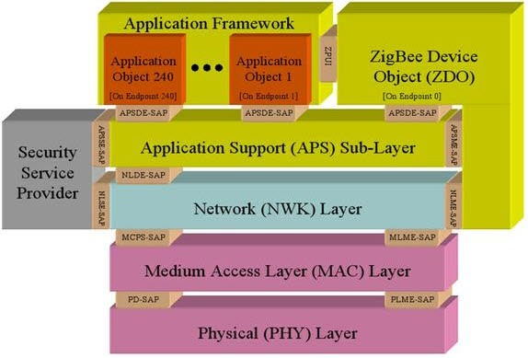
Figure 5.2-1 ZigBee protocol architecture

5.3 ZigBee device types and topologies
This clause introduces device types used in ZigBee networks and topologies they form.
ZigBee devices are categorized as follows:
- ZigBee Coordinator (ZC): This is the most important device as it forms the root of the network tree and helps to bridge to other networks. This means that you will find one ZigBee coordinator in each network as this is the device responsible for the start of the network. This device contains all the information of the network and functions as a Trust Center & repository for the security keys.
- ZigBee Router (ZR): In addition to running an application function, it is used to route the data from other devices and help it reach the destination.
- ZigBee End-Device (ZED): The end device contains just enough functionality to talk to either the co-ordinator or the router. Note that it cannot rely data from other devices. This causes the node to stay asleep for a significant time thereby increasing battery life to a considerable extent. A ZED device requires the least amount of energy as compared to the ZC or ZR.
As shown in Figure 5.3-1, ZigBee supports several network topologies. The most commonly used network topologies are star, mesh and cluster tree topologies. Any topology consists of one or more coordinator. In a star topology, the network consists of one coordinator which is responsible for initiating and managing the devices over the network. All other devices are called end devices that directly communicate with coordinator. This is used in industries where all the end point devices are needed to communicate with the central controller, and this topology is simple and easy to deploy.
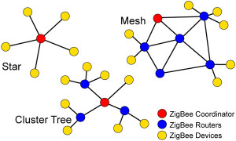
Figure 5.3-1 ZigBee network protocol
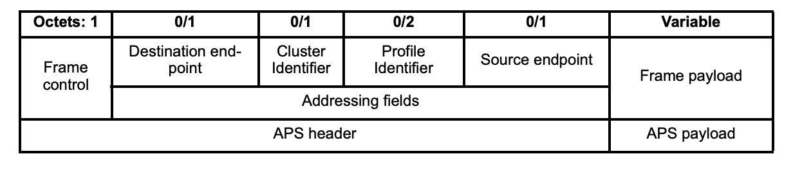
(a) General APS frame format

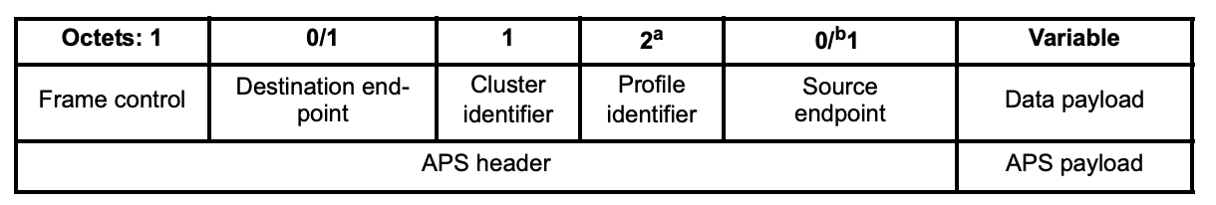
(b) Data frame format

Figure 5.3-2 ZigBee message and data frame format
As ZigBee is an IEEE 802.15.4 standard, it follows an generic 802.15.4 frame message format which consists of the PHY header, MAC header, MAC data payload, and the frame checksum. Generic ZigBee message format and ZigBee data frame are shown in Figure 5.3-2. For an outgoing data frame, the data payload field contains the sequence of octets that the next higher layer has requested the APS data service to transmit. For an incoming data frame, the data payload field contains the sequence of octets that has been received by the APS data service and that is to be reflected to the destination devices or delivered to the next higher layer if the coordinator is one of the destinations.

5.4 Key features of ZigBee
This clause introduces the key features of ZigBee, such as standardization, mesh network, low energy consumption, and high scalability.
As different ZigBee certified devices can be connected, ZigBee is the ideal choice of protocol for various applications, including home automation, industrial aautomation, smart metering, smart grid monitoring and many others. As more ZigBee devices are linked, communication paths between devices multiply, eliminating the risk of single-point signal failure. ZigBee is interoperable and standardizes network and application layers, which means that devices from different vendors can work together seamlessly. The following are key features of ZigBee:

- Standardization: ZigBee is standardized at all layers, this ensures that products from different manufacturers are compatible with each other.
- Mesh network: ZigBee devices form mesh networks, devices tend to connect with every near device, that makes every node of the network reachable from every other node and expanding the network geographically, also providing self-healing, if the preferable path to a node fails there are other paths to reach the node. The more devices you have the more reliable the network is.
- Low energy consumption: Low consumption of energy and working in the network even without the necessity of a battery (Green Power). Energy-harvesting devices lack batteries, getting it by extracting the energy they need from the environment (by tapping into motion, light, piezo/pressure, or the Peltier effect). This is especially effective for devices that are only sometimes on the network (when they have power) and lets these devices securely go on and off the network, so they can be off most of the time and not need any energy.
- High scalability: ZigBee networks can contain up to thousand of devices and they will communicate with each other using the best available path.
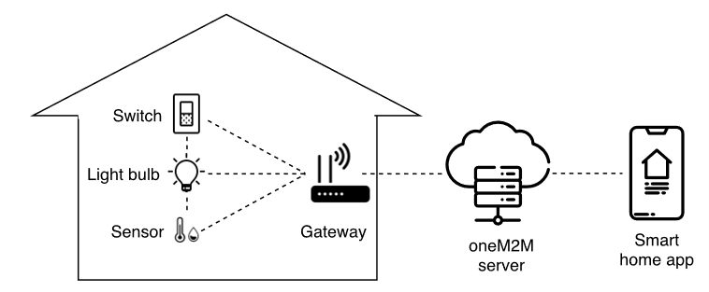
Figure 6.1-1 Use case architecture overview

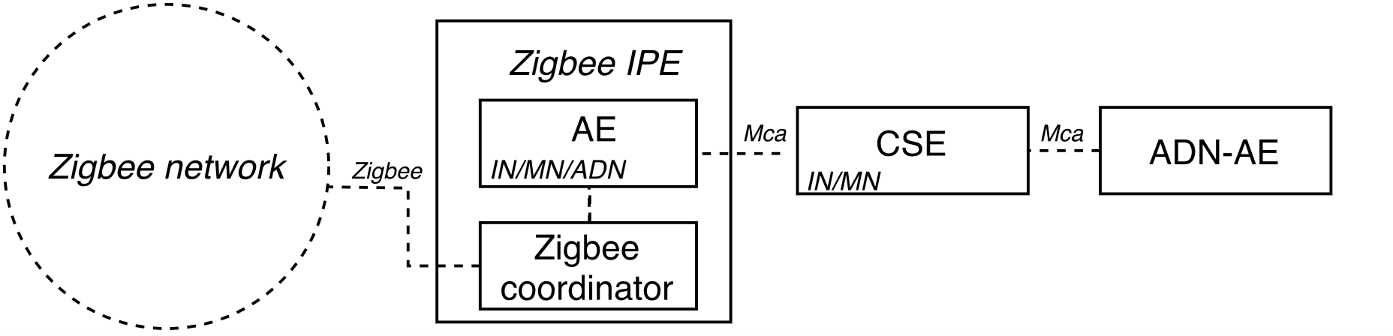
Figure 6.1-2 Use case entity representation

6 Scenarios for oneM2M and ZigBee Interworking
This clause studies the scenarios for oneM2M and ZigBee Interworking, such as ZigBee-based device can connect to IN directly or via MN/ASN, and ZigBee-based devices can connect to each other via IN/MN/ASN.

6.1 Use case
One of the common applications of ZigBee is home automation. Therefore, a use case where a set of ZigBee devices connected to the smart home environment will be described. The figure 6.1-1 below shows a use case of interworking between ZigBee devices and oneM2M services in a smart home application. There are 3 ZigBee devices in the smart home environment: a light bulb, a switch to control the bulb, and a temperature and humidity sensor. The devices form a mesh network and are connected to the local gateway. The gateway provides an access to the devices for a smart home application through a oneM2M cloud server.

Figure 6.1-2 shows how the use case described above can be presented in the form of ZigBee and oneM2M entities. The local gateway runs a ZigBee Interworking Proxy Entity (IPE) which includes a ZigBee coordinator module to access the devices and an AE application which is registered at oneM2M CSE. The smart home application is represented by ADN-AE. It uses the services provided by the CSE to control and monitor the ZigBee devices.

-----------------------End of change 1-------------------------------------------

