CHANGE REQUEST
Meeting ID:* | SDS 61.5
Source:* | Sherzod Elamanov (SyncTechno), TaeHyun Kim (SyncTechno)
Date:* | 2023-10-17
Reason for Change/s:* | To clarify the usage of resource announcement with <mgmtObj>
CR against: Release* | Release 5
CR against: WI* | Active  MNT maintenance / < Work Item number(optional)>  Is this a mirror CR? Yes No  mirror CR number: (Note to Rapporteur - use latest agreed revision)  STE Small Technical Enhancements / < Work Item number (optional)>  Only ONE of the above shall be ticked
CR against: TS/TR* | TS-0022 V4.5.0
Clauses * | 6.1, 8.1.3.3
Type of change: * | Editorial change  Bug Fix or Correction  Change to existing feature or functionality  New feature or functionality  Only ONE of the above shall be ticked
Other TS/TR(s) impacted | <TS/TR number>, <Version Number>, and <Description on which aspect should be reflected in this TS/TR>
Post Freeze checking:* | This CR contains only essential changes and corrections? YES NO  This CR may break backwards compatibility with the last approved version of the TS? YES NO
Template Version: January 2020 (do not modify)

oneM2M Notice
The document to which this cover statement is attached is submitted to oneM2M. Participation in, or attendance at, any activity of oneM2M, constitutes acceptance of and agreement to be bound by terms of the Working Procedures and the Partnership Agreement, including the Intellectual Property Rights (IPR) Principles Governing oneM2M Work found in Annex 1 of the Partnership Agreement.
GUIDELINES for Change Requests:
Provide an informative introduction containing the problem(s) being solved, and a summary list of proposals.
Each CR should contain changes related to only one particular issue/problem.
If this is a correction, and the change applies to previous releases, a separate “mirror CR” should be posted at the same time as this CR
Mirror CR: applies only when the text, including clause numbering are exactly the same.
Companion CR: applies when the change means the same but the baselines differ in some way (e.g. clause number).
Follow the principle of completeness, where all changes related to the issue or problem within a deliverable are simultaneously proposed to be made e.g. a change impacting 5 tables should not only include a proposal to change only 3 tables. Include any changes to references, definitions, and abbreviations in the same deliverable.
Follow the drafting rules.
All pictures must be editable.
Check spelling and grammar.
Use change bars for modifications.
The change should include the current and surrounding clauses to clearly show where a change is located and to provide technical context of the proposed change. Additions of complete clauses need not show surrounding clauses as long as the proposed clause number clearly shows where the proposed new clause is located.
Multiple changes in a single CR shall be clearly separated by horizontal lines with embedded text such as, start of change 1, end of change 1, start of new clause, end of new clause.
When subsequent changes are made to the content of a CR, then the accepted version should not show changes over changes. The accepted version of the CR should only show changes relative to the baseline approved text.

Introduction
Related to issue #193: https://git.onem2m.org/issues/issues/-/issues/193
Change 1:
- In Figure 6.1-1, <mgmtObj> in ASN/MN is replaced by the <mgmtObjAnnc> resource type. Corresponding clarifying text is added.
Change 2:
- Correct the title of clause 8.1.3.3 to add the Mca reference point.
- Move the paragraphs related to resource announcements to the bottom of the clause to make the clause more coherent.
- Text to describe the usage of resource announcement and <mgmtObjAnnc> in particular is added

----------------------Start of change 1-------------------------------------------

6.1 Introduction
The information needed by the remote AE or CSE in the field domain to establish M2M Service Layer operation uses the architectural aspects of oneM2M TS-0001 [2] in order to convey the information elements to the ASN/MN or ADN nodes that host the AE or CSE prior to or during M2M Service Layer operation and to the AE or CSE during M2M Service Layer operation.
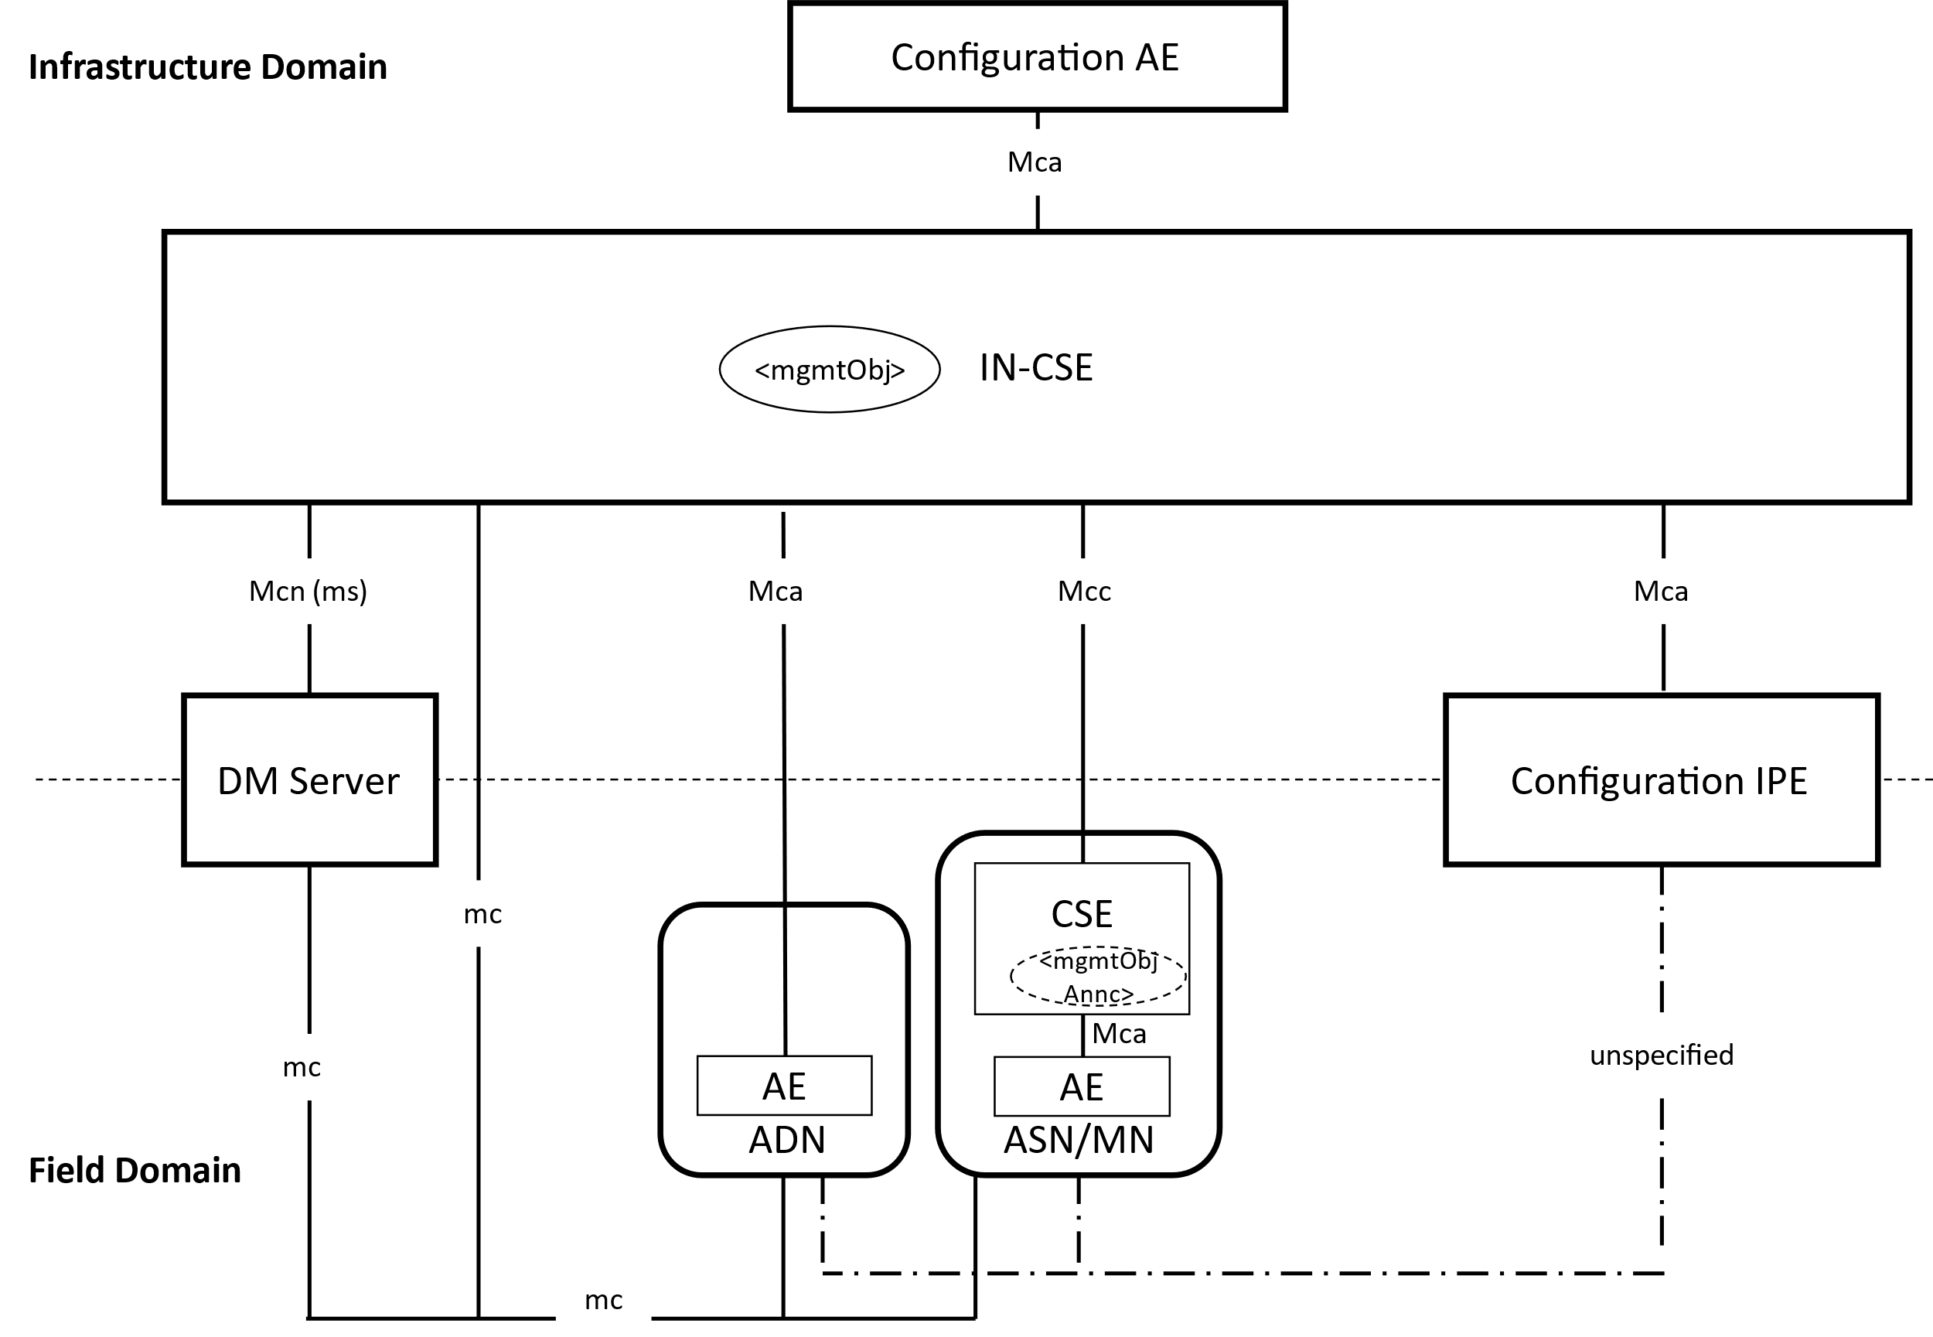
Figure 6.1-1: Architectural Aspects for Configuration of ASN/MN and ADN Nodes
Figure 6.1-1 depicts three (3) methods, in which ADN or ASN/MN nodes are configured using the following:
- Device Management technologies using the mc reference point defined in clause 6 of oneM2M TS-0001 [2]. Using this method, the information that is used to configure the ASN/MN or ADN is described as <mgmtObj> resource types that are hosted in the IN-CSE.
- oneM2M Mcc and Mca reference point when M2M Service Layer operation has been established to the AE or CSE. Establishment of the M2M Service Layer operation includes actions such as setting up security associations and registration of the M2M entities as per oneM2M TS-0003 [3] and oneM2M TS-0001 [2].
- oneM2M IPE technology where the IPE interworks the information exchange between the ADN and ASN/MN and the IN-CSE. This type of IPE is called a Configuration IPE in order to depict the role and capabilities of the IPE related to the present document.
NOTE: The reference point between the Configuration IPE and the ADN and ASN/MN is unspecified in the present document.
In addition, Figure 6.1-1 introduces an AE whose role is to configure the IN-CSE and nodes in the Field Domain with the information needed to establish M2M Service Layer operation. This type of AE is called a Configuration AE in order to depict the role and capabilities of the AE related to the present document.
The information that is used to configure the ASN/MN or ADN is described as <mgmtObj> resource types that are hosted in the IN-CSE. In addition, to deliver the management commands to the ASN/MN nodes that have established M2M Service Layer operation via Mca or Mcc reference points, resource announcement mechanism may be used. In this case, the CSE in the ASN/MN node stores the copy of the <mgmtObj> resource as a <mgmtObjAnnc> resource.

----------------------End of change 1-------------------------------------------

----------------------Start of change 2-------------------------------------------

8.1.3.3 Management using the Mca or Mcc reference point
Once M2M Service Layer operation is established between the AE or CSE and the Registrar/Hosting CSE, <mgmtObj> resources may be managed using the Mca or Mcc reference points by the AE or CSE respectively subscribing to receive changes to the <mgmtObj> resource using the subscription procedures defined in clause 10.2.11 of oneM2M TS-0001 [2]. Establishment of the M2M Service Layer operations includes actions such as establishing the appropriate security associations and registration of the CSEs and AEs.

Figure 8.1.3.3-1: Management using the Mcc reference point
- Once M2M Service Layer operation is established, the AE or CSE on the ASN/MN/ADN node subscribes to the <mgmtObj> resource which is associated with the specific M2M Application functionality creating <subscription> resource.
- When the Configurator AE creates, updates or delete the <mgmtObj> resource, the Configuration AE issues a request on the <mgmtObj> resource.
- The Hosting CSE for the <mgmtObj> resource performs the operation on the resource as Receiver.
- The Hosting CSE notifies the subscribed AE or CSE as the subscribed event message.
- The AE or CSE configures the M2M Application on the ASN/MN or ADN node.
Alternatively, <mgmtObj> specializations hosted by the IN-CSE may be announced to a CSE on a MN or ASN node depending on whether the <mgmtObj> specialization type is announcable. If a <mgmtObj> specialization type is not announcable, the MN or ASN nodes shall be managed using the subscription mechanism as shown in the Figure 8.1.3.3-1.
The following <mgmtObj> specializations specified in the present document are announceable (i.e. announceable variants of this resource type are defined in the XSD of the respective <mgmtObj> specialization):
[registration], [dataCollection]
The following <mgmtObj> specializations specified in the present document are not announceable (i.e. announceable variants of this resource type are not defined in the XSD of the respective <mgmtObj> specialization):
[authenticationProfile], [myCertFileCred], [trustAnchorCred], [MAFClientRegCfg], [MEFClientRegCfg]
When a <mgmtObj> specialization is announced to a CSE on a MN or ASN node, a <mgmtObjAnnc> resource specialization is created in this CSE. The AE residing on the same node as the CSE may subscribe to the <mgmtObjAnnc> specialization for receiving notifications when the original <mgmtObj> is updated by the Configuration AE.

----------------------End of change 2-------------------------------------------

CHECK LIST
- Does this Change Request include an informative introduction containing the problem(s) being solved, and a summary list of proposals.?
- Does this CR contain changes related to only one particular issue/problem?
- Have any mirror CRs been posted?
- Does this Change Request make all the changes necessary to address the issue or problem? E.g. A change impacting 5 tables should not include a proposal to change only 3 tables?Does this Change Request follow the drafting rules?
- Are all pictures editable?
- Have you checked the spelling and grammar?
- Have you used change bars for all modifications?
- Does the change include the current and surrounding clauses to clearly show where a change is located and to provide technical context of the proposed change? (Additions of complete clauses need not show surrounding clauses as long as the proposed clause number clearly shows where the new clause is proposed to be located.)
- Are multiple changes in this CR clearly separated by horizontal lines with embedded text such as, start of change 1, end of change 1, start of new clause, end of new clause.?

