CHANGE REQUEST
Meeting ID:* | SDS69
Source:* | Martin Bauer
Date:* | 2025-04-03
Reason for Change/s:*
CR against: Release* | R5
CR against: WI* | Active <#WI#>  MNT maintenance / < Work Item number(optional)>  Is this a mirror CR? Yes No  mirror CR number:  STE Small Technical Enhancements / < Work Item number (optional)>  Only ONE of the above shall be ticked
CR against: TS/TR* | TR-0076
Clauses * | 2.2, 7.2.3, 7.3.1, 7.3.2.1, 7.3.2.2, 7.3.2.3, 7.3.2.4, 7.3.3, 7.4
Type of change: * | Editorial change  Bug Fix or Correction  Change to existing feature or functionality  New feature or functionality  Only ONE of the above shall be ticked
Other TS/TR(s) impacted | None
Post Freeze checking:* | This CR contains only essential changes and corrections? YES NO  This CR may break backwards compatibility with the last approved version of the TS? YES NO
Template Version: January 2019 (do not modify)
oneM2M Notice
The document to which this cover statement is attached is submitted to oneM2M. Participation in, or attendance at, any activity of oneM2M, constitutes acceptance of and agreement to be bound by terms of the Working Procedures and the Partnership Agreement, including the Intellectual Property Rights (IPR) Principles Governing oneM2M Work found in Annex 1 of the Partnership Agreement.
GUIDELINES for Change Requests:
Provide an informative introduction containing the problem(s) being solved, and a summary list of proposals.
Each CR should contain changes related to only one particular issue/problem.
In case of a correction, and the change apply to previous releases, a separate “mirror CR” should be posted at the same time of this CR
Mirror CR: applies only when the text, including clause numbering are exactly the same.
Companion CR: applies when the change means the same but the baselines differ in some way (e.g. clause number).
Follow the principle of completeness, where all changes related to the issue or problem within a deliverable are simultaneously proposed to be made E.g. A change impacting 5 tables should not only include a proposal to change only 3 tables. Includes any changes to references, definitions, and acronyms in the same deliverable.
Follow the drafting rules.
All pictures must be editable.
Check spelling and grammar to the extent practicable.
Use Change bars for modifications.
The change should include the current and surrounding clauses to clearly show where a change is located and to provide technical context of the proposed change. Additions of complete clauses need not show surrounding clauses as long as the proposed clause number clearly shows where the new clause is proposed to be located.
Multiple changes in a single CR shall be clearly separated by horizontal lines with embedded text such as, start of change 1, end of change 1, start of new clause, end of new clause.
When subsequent changes are made to content of a CR, then the accepted version should not show changes over changes. The accepted version of the CR should only show changes relative to the baseline approved text.

Introduction
#REASON#
https://git.onem2m.org/specifications/tr/tr-0076/-/merge_requests/12
https://git.onem2m.org/specifications/tr/tr-0076/-/merge_requests/12/diffs?commit_id=c9d1e7aa8dd1d1f8b312112a2d2c3215448008a6
----------------------- Start of change 1 -----------------------

---a/TR-0076-Integrating_NGSI-LD_API_in_oneM2M.md
+++b/TR-0076-Integrating_NGSI-LD_API_in_oneM2M.md
@@ -79,6 +79,8 @@ The following referenced documents are not necessary for the application of the
- <a name="_ref_i.3">[i.3]</a> ETSI GS CIM 006: "Context Information Management (CIM); Information Model" [https://www.etsi.org/deliver/etsi_gs/CIM/001_099/006/01.03.01_60/gs_CIM006v010301p.pdf](https://www.etsi.org/deliver/etsi_gs/CIM/001_099/006/01.03.01_60/gs_CIM006v010301p.pdf)
- <a name="_ref_i.4">[i.4]</a> JSON-LD 1.1 - A JSON-based Serialization for Linked Data", W3C Recommendation 16 July 2020, [https://www.w3.org/TR/json-ld11/](https://www.w3.org/TR/json-ld11/)
- <a name="_ref_i.5">[i.5]</a> Smart Data Models [https://smartdatamodels.org/](https://smartdatamodels.org/)
- <a name="_ref_i.6">[i.6]</a> ETSI GR CIM 022: "NGSI-LD/oneM2M interworking proxy proposal" [https://www.etsi.org/deliver/etsi_gr/CIM/001_099/022/01.01.01_60/gr_CIM022v010101p.pdf](https://www.etsi.org/deliver/etsi_gr/CIM/001_099/022/01.01.01_60/gr_CIM022v010101p.pdf)
- <a name="_ref_i.7">[i.7]</a> Fed4IoT project [https://fed4iot.org/](https://fed4iot.org/)

# 3 Definition of terms, symbols and abbreviations
<mark>Delete from the above heading the word(s) which is/are not applicable.</mark>
@@ -870,6 +872,110 @@ The final question is how to anchor the NGSI-LD base resource `ngsi-ld` into the

**Figure 7.2.3-6: NGSI-LD resource as child resource of CSE Base**

## 7.3 Interworking Approaches

### 7.3.1 Motivation

oneM2M typically interfaces with existing systems defining an interworking approach. oneM2M utilizes a specialized Application Entity (AE) called Interworking Proxy Entity (IPE) to handle the interaction between the system to interwork with, using its respective native API or reference point, and the oneM2M system, using the Mca reference point as shown in Figure 7.3.1-1.

![oneM2M Interworking Proxy Entity (IPE)](media/oneM2M_Interworking.png)

**Figure 7.3.1-1: oneM2M Interworking Proxy Entity (IPE)**

In general, there are two types of interworking approaches - a synchronization-based approach, where the IPE is responsible for automatically synchronizing information between the two systems - and a request-based approach, where the IPE only acts when triggered by a request from one system, i.e. the information required for answering the request first needs to be gathered from the other system. Both approaches can be applied unidirectionally or bi-directionally, i.e. in one case the information is only fetched from one system an pushed to the other, but not the other way round, and in the other case this happens in both directions. Synchronization-based approaches duplicate data, but make information access more efficient, whereas request-based approach avoid any duplication of data, but answering requests becomes more expensive, possibly prohibitively expensive.

ETSI ISG CIM has already developed three synchronization-based interworking approaches <a href="#_ref_i.6">[i.6]</a>. Two of these are unidirectional, i.e. the idea is to synchronize certain oneM2M information with an NGSI-LD system, but not the other way round, and one can be used bi-directionally, i.e. information can be fully synchronized between two systems.
These three approaches are summarized in the following. Details can be found in <a href="#_ref_i.6">[i.6]</a>. A request-driven interworking approach is sketched as well.

As oneM2M and NGSI-LD follow different approaches, a mapping is needed. This can be a general approach, which requires a mapping language, or a specific approach which relies on a certain resource structure or a data model. The mapping information can either be stored in one (or both) of the systems or in the IPE.

### 7.3.2 IPE-driven Synchronization Approaches

#### 7.3.2.1 Overview

![General interworking setup between a oneM2M system and an NGSI-LD Context Broker](media/CSE_IPE_NGSI-LD_Broker.png)

**Figure 7.3.2.1-1: General interworking setup between a oneM2M system and an NGSI-LD Context Broker**

Figure 7.3.2.1-1 shows the general interworking setup between a oneM2M system and an NGSI-LD Context Broker with an IPE implementing the interworking.

Depending on the use case, oneM2M data needs synchronizing to NGSI-LD context broker or NGSI-LD data needs synchronizing to oneM2M.
* oneM2M to NGSI-LD: This can be used when services are already implemented and data are already being stored in the oneM2M platform. The goal is for users to get data of oneM2M services using the NGSI-LD API.
* NGSI-LD to oneM2M: This can be used when device management or actuation is required from NGSI-LD enabled system (e.g. city operation centre) as well as when oneM2M applications make use of NGSI-LD data.

Synchronization approaches duplicate data, but enable more efficient information access.

In the following, the aspects of the proposed interworking approaches in CIM 022 <a href="#_ref_i.6">[i.6]</a> that are relevant for the discussion in this document are sketched. For details, please refer to <a href="#_ref_i.6">[i.6]</a>.

#### 7.3.2.2 Label-based, dynamic interworking

The first approach specified in CIM 022 <a href="#_ref_i.6">[i.6]</a> is a label-based, dynamic interworking scheme. The idea is that specific labels are introduced that are used to label resources in the oneM2M system as show in Table 7.3.2.2-1.

**Table 7.3.2.2-1 Interworking mapping using labels**

![Interworking mapping using labels](media/Interworking-Labels-1.png)

The labels identify to which NGSI-LD Entity (_Iwked-Entity-ID_) and Entity Type (_Iwked-Entity-Type_) the information contained the labelled oneM2M resource belongs. If not all information is contained in the same resource, a list of additional oneM2M resource can be provided in _Iwked-Related-Resources_.

The detailed information that is needed for the mapping of the NGSI-LD Attributes is provided as a list of mapping rules in _Iwked-mapping-rule_. The information that is contained in such a mapping rule is shown in Table 7.3.2.2-2.

**Table 7.3.2.2-2 Interworking mapping using labels - mapping rule**

![Interworking mapping using labels - mapping rule](media/Interworking-Labels-2.png)

The IPE discovers the labelled resources, retrieves the information from the labelled and identified additional resources and uses the mapping rule to create the NGSI-LD entity information that is then updated in the NGSI-LD Context Broker. Thus, the approach is unidirectional, making information originally available in the oneM2M system also available in the NGSI-LD Context Broker.

#### 7.3.2.3 Ontology-based, dynamic interworking

The difference to the label-based interworking approach described in Clause 7.3.2.2 is that the mapping information is not contained in labels, but rather in a semantic descriptor child resource. The semantic information that describes the mapping is specified following an ontology that is sketched in Figure 7.3.2.3-1.

![Ontology-based interworking](media/Ontology-based-Interworking.png)

**Figure 7.3.2.3-1: Ontology-based interworking**

The IPE uses semantic discovery to find the relevant resources, retrieves the information from the semantically annotated resource plus any additional resources specified in the semantic descriptions, and, together with the mapping information in the semantic descriptor, created the NGSI-LD entity information that the IPE then uses to update the NGSI-LD Context Broker. Again, the approach is unidirectional, making information originally available in the oneM2M system also available in the NGSI-LD Context Broker.

#### 7.3.2.4 Static, bi-directional resource-to-entity mapping

An approach, originally proposed by the Fed4IoT project <a href="#_ref_i.7">[i.7]</a>, is to map entities to oneM2M resource structures and labels in a bi-directional way. Table 7.3.2.4-1 shows an example for such a mapping between NGSI-LD entities and oneM2M Resources. This is not the only possible mapping, e.g. it would also be possible to define specific flexContainers for the purpose.

**Table 7.3.2.4-1 Static resource to entity mapping example**

![Static resource to entity mapping guidelines](media/Mapping-NGSI-LD-Entities-to-Resources.png)

Using subscriptions to the resources on the oneM2M system side and the NGSI-LD entities on the NGSI-LD Broker side, an IPE can then ensure synchronization in a bi-directional way, as it will be triggered by notifications whenever there is a relevant change.

This approach is suitable for cases, where the same information is to be represented in both the oneM2M system and the NGSI-LD Context Broker, and the resource structure in the oneM2M system can be freely decided. It is not suitable for the case that information is already available in a oneM2M system using a different resource structure. At least in such a case, the information would have to be duplicated and kept synchronized.

Another important aspect of the static resource-to-entity mapping is the resource granularity, which plays an important role regarding the number of requests needed to retrieve or update NGSI-LD entity information. In the approach shown in Table 7.3.2.4-1, the granularity is on the NGSI-LD attribute level, i.e. each attribute is mapped to a oneM2M container resource, and the attribute values are stored as content instances. Alternatively, there could be a container for each NGSI-LD entity where the whole entity information is stored in a content instance, or there could even be a single resource for a whole group of entities.
Which resource structure is most suitable depends on the typical requests, i.e. in the case of synchronization, what types of updates are to be expected. Updates pertaining to (parts of) entities have to deal with a higher overhead the larger the entity information is that needs to be handled, e.g. only a single value is updated, but a new content instance has to be created for the whole entity or group of entities. If there are typically batch updates for all entities of the group, having fewer resources is more suitable as otherwise a large number of requests are needed to update the information on an attribute value level.

### 7.3.3 Request-driven approach

In the request-driven approach, the interworking proxy entity does not permanently keep information synchronized, i.e. is triggered whenever information changes, but only acts on a request basis. Only if information is actually requested, it is retrieved from the other system. If suitable request forwarding mechanisms are available in oneM2M, the request-driven approach could also be used in the opposite direction.

In the following, such an approach is sketched where the IPE acts on an NGSI-LD request and then retrieves information from the oneM2M system. The proposal here is to keep the mapping information in the IPE, i.e. the oneM2M itself does not contain any (mapping) information related to NGSI-LD.

Figure 7.3.3-1 shows an IPE with mapping information, where the information in the pointed bracket is retrieved from known oneM2M resources using regular Mca requests.

![Request-driven interworking approach with mapping information in the IPE](media/Request-Driven-Approach.png)

**Figure 7.3.3-1: Request-driven interworking approach with mapping information in the IPE**

A possible issue with this approach is the number of Mca requests that the IPE needs to execute in order to answer a request. This can range from a few (e.g. retrieval of a single entity with few attributes) to a very large query (e.g. graph query with many entities).

## 7.4 High-level comparison of approaches (preliminary)

In clauses 7.2 a mapping-based approach is described that proposes to integrate the NGSI-LD functionality directly into a oneM2M system, whereas Clause 7.3 describes different interworking-based approaches, where NGSI-LD related functionality is implemented by an Interworking Proxy Entity.

The general aspects that have to be taken into account for the comparison is efficiency and avoidance of information duplication on the one side and the complexity of the implementation on the other side.

The integrated approach described in clause 7.2 generally enables more efficient access as many of the steps are internal and do not have to go via the external binding. Also, internally, more implementation optimizations are possible, e.g. indexing, pre-fetching of information and pre-processing.
Furthermore, there is no need to duplicate information. However, there is a significant complexity of implementation that has to be handled by the implementor of the oneM2M system.

The synchronization-based interworking approaches all duplicate information, so the respective applications can efficiently access the information. The efficiency of the information access by the Interworking Proxy is worse than in the integrated approach as there is the overhead of the binding for each request and there are less optimization possibilities as in the internal case.
The request-based interworking approach avoids the duplication of information, but possibly, at the expense of access efficiency and the resulting delay suffered by the requesting application.

# 8 Mapping between the information stored in oneM2M resources and the NGSI-LD information model

<mark>Study the mapping between the information stored in oneM2M resources and the NGSI-LD information model. This includes, but is not limited to the current oneM2M semantic models (in particular SDT and the oneM2M base ontology, including SAREF integration) to the NGSI-LD information model, with the goal of making it available through an integration of NGSI-LD API and the Mca reference point. This may lead to an evolution of the current NGSI-LD and Mca, and the related information models.</mark>
----------------------- End of change 1 -----------------------

----------------------- Start of change 2 -----------------------

---/dev/null
+++b/media/CSE_IPE_NGSI-LD_Broker.png
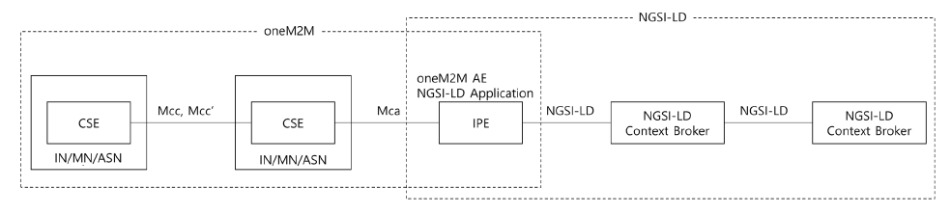
----------------------- End of change 2 -----------------------

----------------------- Start of change 3 -----------------------

---/dev/null
+++b/media/Interworking-Labels-1.png
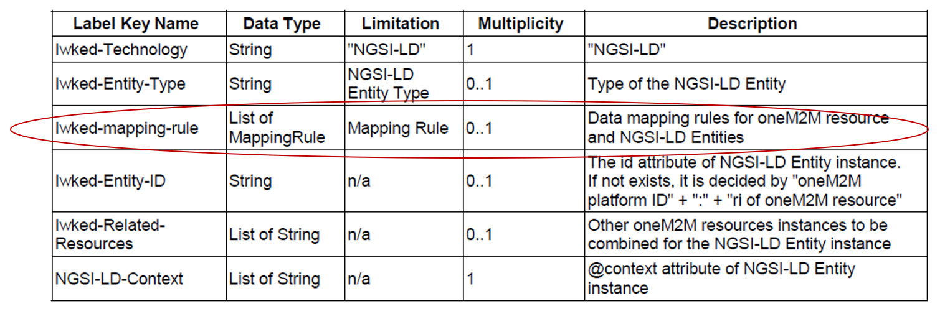
----------------------- End of change 3 -----------------------

----------------------- Start of change 4 -----------------------

---/dev/null
+++b/media/Interworking-Labels-2.png
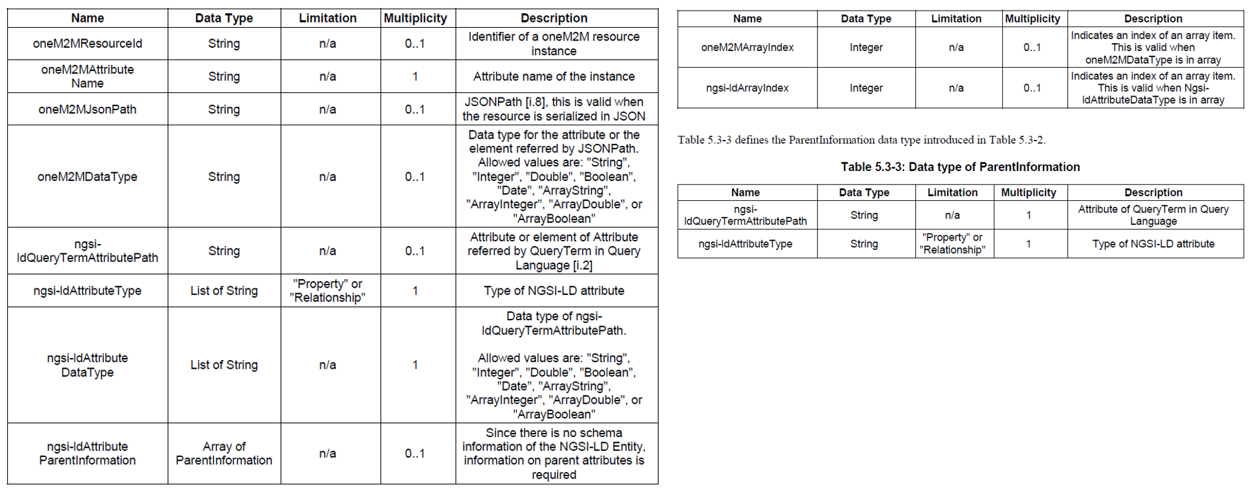
----------------------- End of change 4 -----------------------

----------------------- Start of change 5 -----------------------

---/dev/null
+++b/media/Mapping-NGSI-LD-Entities-to-Resources.png
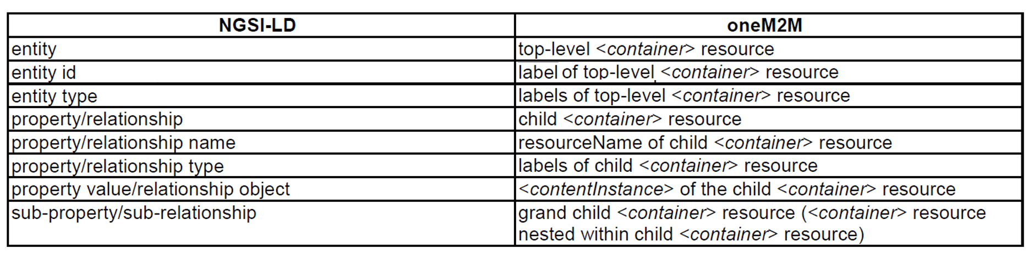
----------------------- End of change 5 -----------------------

----------------------- Start of change 6 -----------------------

---/dev/null
+++b/media/Ontology-based-Interworking.png
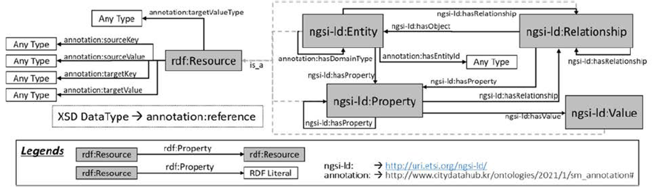
----------------------- End of change 6 -----------------------

----------------------- Start of change 7 -----------------------

---/dev/null
+++b/media/Request-Driven-Approach.png
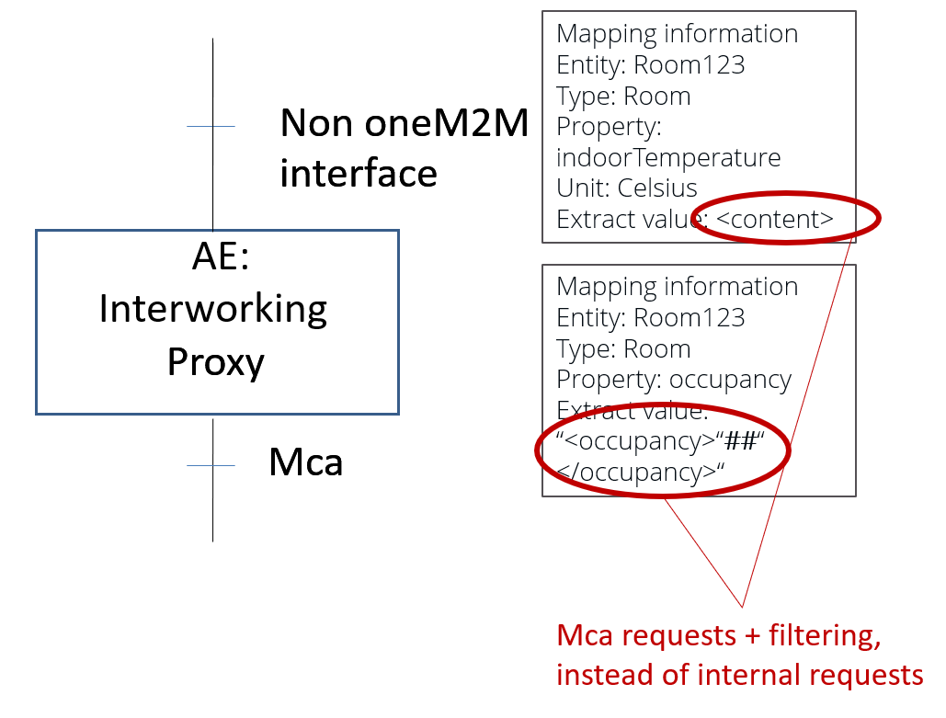
----------------------- End of change 7 -----------------------

----------------------- Start of change 8 -----------------------

---/dev/null
+++b/media/oneM2M_Interworking.png
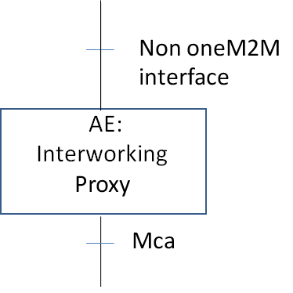
----------------------- End of change 8 -----------------------

