CHANGE REQUEST
Meeting ID:* | SDS-71
Source:* | Ingo Friese
Date:* | 2025-11-12
Reason for Change/s:* | MCP-Introduction
CR against: Release* | R5
CR against: WI* | Active <WI-0122>  MNT maintenance / < Work Item number(optional)>  Is this a mirror CR? Yes No  mirror CR number:  STE Small Technical Enhancements / < Work Item number (optional)>  Only ONE of the above shall be ticked
CR against: TS/TR* | TR-0081
Clauses * | 2.2, 4, 5, 5.1, 5.2, 5.3, 5.4, 5.4.1
Type of change: * | Editorial change  Bug Fix or Correction  Change to existing feature or functionality  New feature or functionality  Only ONE of the above shall be ticked
Other TS/TR(s) impacted | None
Post Freeze checking:* | This CR contains only essential changes and corrections? YES NO  This CR may break backwards compatibility with the last approved version of the TS? YES NO
Template Version: January 2019 (do not modify)
oneM2M Notice
The document to which this cover statement is attached is submitted to oneM2M. Participation in, or attendance at, any activity of oneM2M, constitutes acceptance of and agreement to be bound by terms of the Working Procedures and the Partnership Agreement, including the Intellectual Property Rights (IPR) Principles Governing oneM2M Work found in Annex 1 of the Partnership Agreement.
GUIDELINES for Change Requests:
Provide an informative introduction containing the problem(s) being solved, and a summary list of proposals.
Each CR should contain changes related to only one particular issue/problem.
In case of a correction, and the change apply to previous releases, a separate “mirror CR” should be posted at the same time of this CR
Mirror CR: applies only when the text, including clause numbering are exactly the same.
Companion CR: applies when the change means the same but the baselines differ in some way (e.g. clause number).
Follow the principle of completeness, where all changes related to the issue or problem within a deliverable are simultaneously proposed to be made E.g. A change impacting 5 tables should not only include a proposal to change only 3 tables. Includes any changes to references, definitions, and acronyms in the same deliverable.
Follow the drafting rules.
All pictures must be editable.
Check spelling and grammar to the extent practicable.
Use Change bars for modifications.
The change should include the current and surrounding clauses to clearly show where a change is located and to provide technical context of the proposed change. Additions of complete clauses need not show surrounding clauses as long as the proposed clause number clearly shows where the new clause is proposed to be located.
Multiple changes in a single CR shall be clearly separated by horizontal lines with embedded text such as, start of change 1, end of change 1, start of new clause, end of new clause.
When subsequent changes are made to content of a CR, then the accepted version should not show changes over changes. The accepted version of the CR should only show changes relative to the baseline approved text.

Introduction
Initial Contribution - Intro of MCP
https://git.onem2m.org/specifications/tr/tr-0081/-/merge_requests/2
https://git.onem2m.org/specifications/tr/tr-0081/-/merge_requests/2/diffs?commit_id=826ac4df875d407688af48620155aea344a179d2

--------------------- Start of change 1 ---------------------
TR-0081-AI_Agent_Interworking.md

---a/TR-0081-AI_Agent_Interworking.md
+++b/TR-0081-AI_Agent_Interworking.md
@@ -84,6 +84,17 @@ The following referenced documents are not necessary for the application of the
84 84
85 85 - <a name="_ref_i.1">[i.1]</a> oneM2M Drafting Rules [https://member.onem2m.org/static_Pages/others/Rules_Pages/oneM2M-Drafting-Rules-V1%202%202.doc](https://member.onem2m.org/static_Pages/others/Rules_Pages/oneM2M-Drafting-Rules-V1%202%202.doc)
86 86
87 + - <a name="_ref_i.2">[i.2]</a> ISO/IEC 22989:2022 Information technology — Artificial intelligence — Artificial intelligence concepts and terminology [https://www.iso.org/standard/74296.html](https://www.iso.org/standard/74296.html)
88 +
89 + - <a name="_ref_i.3">[i.3]</a> Introduction page for the Model Context Protocol [https://modelcontextprotocol.io/introduction](https://modelcontextprotocol.io/introduction)
90 +
91 + - <a name="_ref_i.4">[i.4]</a> Startpage HTML living standard [https://html.spec.whatwg.org/multipage/](https://html.spec.whatwg.org/multipage/)
92 +
93 + - <a name="_ref_i.5">[i.5]</a> Introduction Server Side Events [https://html.spec.whatwg.org/multipage/server-sent-events.html](https://html.spec.whatwg.org/multipage/server-sent-events.html)
94 +
95 + - <a name="_ref_i.6">[i.6]</a> JSON RPC Specification [https://www.jsonrpc.org/](https://www.jsonrpc.org/)
96 +
97 +
87 98
88 99 # 3 Definition of terms, symbols and abbreviations
89 100 <mark>Delete from the above heading the word(s) which is/are not applicable.</mark>
@@ -142,15 +153,155 @@ For the purposes of the present document, the [following] abbreviations [given i
142 153 The key words "Shall", "Shall not", "May", "Need not", "Should", "Should not" in this document are to be interpreted as described in the oneM2M Drafting Rules <a href="#_ref_i.1">[i.1]</a>
143 154
144 155
145 - # 5 User defined clause(s) from here onwards
146 - &lt;Text>
156 + # 5 Overview
147 157
158 + ## 5.1 Agentic AI
148 159
149 - ## 5.1 User defined subdivisions of clause(s) from here onwards
150 - &lt;Text>
160 + Agentic AI is an emerging field that is gaining increasing attention across the AI community. According to ISO/IEC 22989:2022 <a href="#_ref_i.2">[i.2]</a>, an AI agent is defined as an automated entity that senses and responds to its environment and takes actions to achieve its goals.
161 +
162 + Agentic AI systems utilize foundation models across various scales, modalities, and adaptations capable of multi-step reasoning through chain-of-thought approaches to decompose complex problems into manageable steps.
163 +
164 + Foundation model-based agents are limited in their knowledge of the environment. They have no direct access to real-time information or data that was not part of their training. AI agents also do not inherently have access to data from the cyber-physical world, such as sensor readings. However, newer generations of foundation models used by AI agents are increasingly capable of tool calling, that is, invoking local software functions, for example to access external data sources.
165 +
166 + The models do not necessarily have to be co-located with the agent and can run in the cloud.
167 +
168 + ## 5.2 Architecture Overview
169 +
170 + The Model Context Protocol (MCP) <a href="#_ref_i.3">[i.3]</a> is an open standard and open-source framework for creating a unified interface through which models with language capabilities can seamlessly interact with external resources, including data sources and computational capabilities.
171 +
172 + MCP enables AI agents to interact with external systems, such as those providing access to search engines, databases, or IoT platforms. MCP enables applications to provide context to various kind of language models in the form of human-readable API or functionality descriptions.
173 +
174 + Figure 5.2-1 shows an architecture overview of the Model Context Protocol. AI agents use MCP to interact with external software services via MCP servers that expose API functionalities.
175 +
176 + The Model Context Protocol follows a client-server architecture, allowing an **MCP Host** application to connect to multiple servers.
177 + The interfaces of the non-AI software are exposed through an **MCP Server**. The AI agent may have one or more **MCP Client(s)**. MCP clients connect to their corresponding servers in a one-to-one relationship.
178 +
179 +
180 + ![Figure 5.2-1: Architecture overview](media/new_overview.png)
181 +
182 + **Figure 5.2-1: Architecture overview**
183 +
184 + ## 5.3 Transport Protocol and Message Format
185 +
186 + The Model Context Protocol supports two primary transport mechanisms: STDIO (Standard Input/Output) and HTTP <a name="_ref_i.4">[i.4]</a> combined with SSE (Server-Sent Events) <a name="_ref_i.5">[i.5]</a>.
187 +
188 + The STDIO mechanism uses standard input and output streams and is typically used for direct inter-process communication on the same machine, delivering optimal performance without network overhead.
189 +
190 + In contrast, the HTTP with SSE mechanism relies on HTTP for communication, with server-sent events for server-to-client messages and POST requests for client-to-server communication, making it suitable for distributed setups.
191 + Both local and distributed communication modes use JSON-RPC 2.0 <a name="_ref_i.6">[i.6]</a> as the message format for data transmission.
192 +
193 + ## 5.4 Lifecycle
194 +
195 + The Model Context Protocol defines a lifecycle for client-server connections, as shown in figure 5.4-1, ensuring clear capability negotiation and consistent state management throughout the session.
196 +
197 + - **Initialization**: Negotiation of supported features and agreement on the protocol version
198 +
199 + - **Operation**: Standard communication according to the agreed protocol
200 +
201 + - **Shutdown**: Clean and orderly termination of the connection
202 +
203 + The MCP protocol enables three different kinds of function calls:
204 +
205 + - **Tools**:
206 + MCP tools are server-side functions provided by MCP servers that allow LLMs to perform actions and operations on external systems which can modify states or trigger processes.
207 +
208 + - **Resources**:
209 + MCP resources provide a structured way for MCP servers to expose read-only data to LLMs. Typical use cases include requests like "Get customer details for account XYZ" or "Fetch the latest webcam image", receiving existing content without performing actions.
210 +
211 + - **Prompts**:
212 + MCP prompts are reusable instruction templates provided by MCP servers that guide LLMs to handle specific tasks with consistent expertise, combining these pre-defined instructions with user input to create complete, contextualized requests.
213 +
214 + All server-side functions share the characteristic that the agent first requests a list of available functions and then selects and invokes the appropriate one.
215 +
216 +
217 + ![Figure 5.4-1: Lifecycle phases](media/protocol_uml_01.svg)
218 +
219 + **Figure 5.4-1: Lifecycle phases**
220 +
221 + ### 5.4.1 Illustrative simple API wrapper scenario
222 +
223 + A very simple scenario for the introduction of MCP is "basic API wrapping". In this case, more complex function calls, authentication and authorization, as well as security measures are not considered. The focus is on the core functionality, specifically the operational aspects of the MCP protocol.
224 +
225 + Figure 5.4.1-1 illustrates a simple MCP call flow. In this case, a local weather station API is connected to an AI Agent using MCP. A user can interact with the AI Agent to discuss the current indoor climate, effectively serving as a local weather chatbot.
226 +
227 + **Note**: For querying passive data such as temperature, MCP's '*resource*' function could be utilized. However, this example uses the '*tools*' function for simplicity and because tools are available on most MCP servers. The flow diagram illustrates only the successful execution path, omitting error or alternative paths.
228 +
229 + **Involved Services and Applications**
230 +
231 + - **AI App** – provides a web interface that allows the user to send prompts to the AI Agent, for example, *"How warm is it right now?"*.
232 + - **AI Agent** – receives user requests and responds using an LLM. In this process, the AI Agent may decide to use tools that connect it to other systems or services.
233 + - **MCP Server** – The MCP server manages the **AI Agent’s** requests, executes functions, and returns results. It implements a set of functions that call the underlying service APIs. These functions are additionally described with *human-readable context* for the LLM.
234 + - **API** – The service API of the local weather station.
235 +
236 + **Call Flow Description**
237 +
238 + - The user asks via the **AI App**: *"How warm is it right now?"* using an HTTP POST request to the "/run" endpoint of the **AI Agent**.
239 +
240 + - The **AI Agent** receives the request and forwards it to its LLM for processing (not shown in diagram). The **AI Agent's** instructions for the LLM specify that it may use available tools and invoke them via MCP.
241 +
242 + - If the LLM decides to use MCP functions, the **AI Agent** requests a list of available tools from the **MCP Server** using an HTTP POST request to the "/message" endpoint along with a "session_id".
243 + **Note**: Session handling between **AI Agent** and **MCP Server** as well as between **MCP Server** and **API** is handled on HTTP-level.
244 +
245 + - The **MCP Server** responds to the request with "HTTP 202 Accepted".
246 +
247 + - The **MCP Server** sends the list of available tools along with a detailed description in human-readable text to the **AI Agent** in a server-sent event. The RPC message is shown in figure 5.4.1-2.
248 +
249 + - The **AI Agent** chooses with the help of its LLM the most appropriate tool from the list in order to fulfill the user request (not shown in diagram).
250 +
251 + - The **AI Agent** calls the selected tool on the **MCP Server** using an HTTP POST request. The RPC message contained within is shown in Figure 5.4.1-3.
252 +
253 + - The **MCP Server** responds to the request with "HTTP 202 Accepted".
254 +
255 + - The **MCP Server** calls the local weather station **API** with an HTTP GET request. The result contains a complete set of different local climate values.
256 +
257 + - The **MCP Server** sends the complete set of data to the **AI Agent** in a server-sent event.
258 +
259 + - The **AI Agent** processes the received data and, with the help of its LLM, formulates a textual response for the user (not shown in diagram).
260 +
261 + - The **AI App** receives the textual response from the **AI Agent** in HTTP 200 OK response.
262 +
263 +
264 + ![Figure 5.4.1-1: Call flow example from AI Application to API](media/call_flow2.svg)
265 +
266 + **Figure 5.4.1-1: Call flow example from AI Application to API**
267 +
268 +
269 + ```json
270 + {
271 + "jsonrpc": "2.0",
272 + "id": 7,
273 + "result": {
274 + "tools": [
275 + {
276 + "name": "get_climate",
277 + "description": "Returns the current climate data from a weather station with different sensors.\n\nSensor Data Structure Overview:\nThe data comes from a multi-zone environmental sensor system and is formatted as a nested dictionary (similar to JSON). Each top-level key represents a physical location or sensor module. The values are sub-dictionaries containing measurements and status information for that location.\n\n1. General Structure\n{\n \"Location/Sensor\": {\n \"Measurement1\": value1,\n \"Measurement2\": value2,\n ...\n },\n ...\n}\n\n2. Locations and Typical Measurements\nIndoor\nTypical keys:\n- Temperature data (Temperature, min_temp, max_temp, temp_trend)\n- Air quality (CO2)\n- Humidity (Humidity)\n- Noise level (Noise)\n- Pressure (Pressure, AbsolutePressure, pressure_trend)\n- Timestamps for temp extremes (date_max_temp, date_min_temp)\n- Wi-Fi status (wifi_status)\n- Timestamp of last update (When)\n\nBedroom\nTypical keys:\n- Temperature data (including trend and min/max)\n- Humidity\n- CO₂ concentration\n- Battery status (battery_vp, battery_percent)\n- Radio frequency connection status (rf_status)\n- Timestamp (When)\n\nBalcony\nTypical keys:\n- Temperature data (with trend and min/max)\n- Humidity\n- Battery and RF status\n- Timestamp\n\nRain\nTypical keys:\n- Rainfall (Rain, sum_rain_1, sum_rain_24)\n- Battery and RF status\n- Timestamp\n\n3. General Characteristics\n- Values are either numeric or categorical (e.g., 'temp_trend': 'up', 'pressure_trend': 'down').\n- Time values are Unix timestamps.\n- Sensors report both environmental data and system status (connectivity, power, etc.).\n- Trend indicators describe simple directional change over time (e.g., 'up', 'down', 'stable').",
278 + "inputSchema": {
279 + "properties": {},
280 + "title": "get_climateArguments",
281 + "type": "object"
282 + }
283 + }
284 + ]
285 + }
286 + }
287 +
288 + ```
289 +
290 + **Figure 5.4.1-2: JSON-RPC message example sent from the MCP Server to the AI Agent listing available tools. In this example there is only one tool available.**
151 291
152 - <mark>The following text is to be used when appropriate:</mark>
292 + ```json
293 + {
294 + "jsonrpc": "2.0",
295 + "id": 8,
296 + "method": "tools/call",
297 + "params": {
298 + "name": "get_climate",
299 + "arguments": {}
300 + }
301 + }
302 + ```
153 303
304 + **Figure 5.4.1-3: JSON-RPC message example sent from the AI Agent to the MCP Server to invoke a tool from the list.**
154 305
155 306 # <mark>Proforma copyright release text block</mark>
156 307 <mark>This text box shall immediately follow after the heading of an element (i.e. clause or annex) containing a proforma or template which is intended to be copied by the user. Such an element shall always start on a new page.</mark>
----------------------- End of change 1 -----------------------

--------------------- Start of change 2 ---------------------
media/call_flow.svg

---/dev/null
+++b/media/call_flow.svg
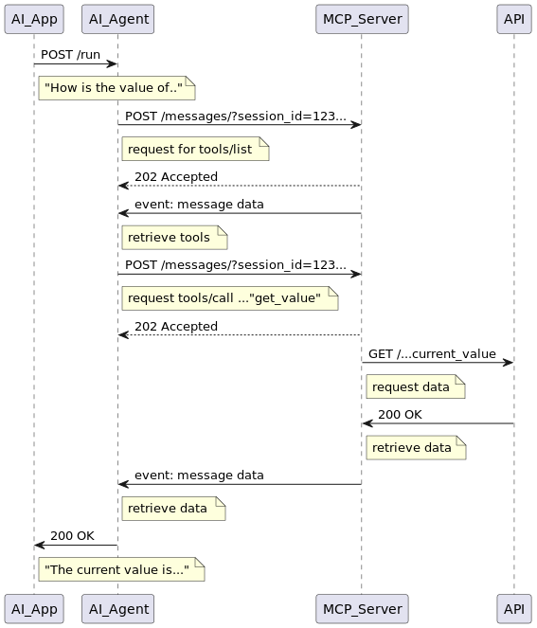
----------------------- End of change 2 -----------------------

--------------------- Start of change 3 ---------------------
media/call_flow2.svg

---/dev/null
+++b/media/call_flow2.svg
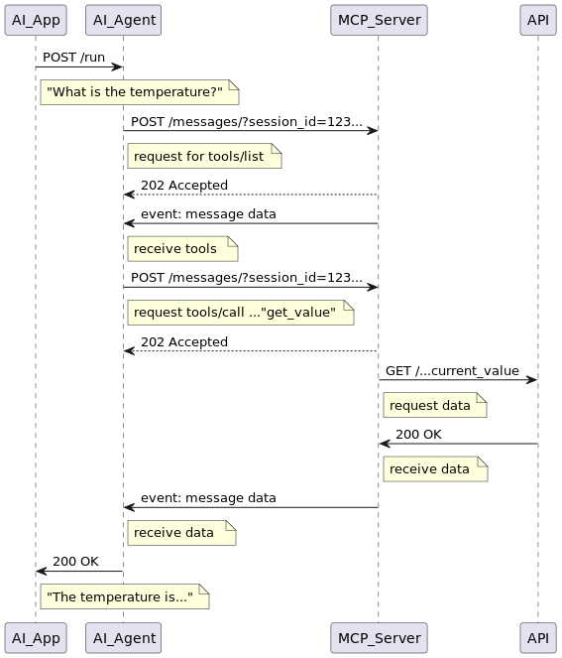
----------------------- End of change 3 -----------------------

--------------------- Start of change 4 ---------------------
media/figure_01_2_TR81.svg

---/dev/null
+++b/media/figure_01_2_TR81.svg
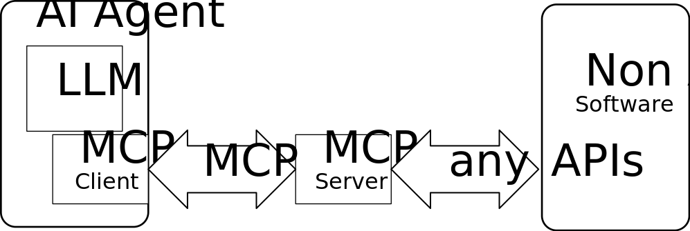
----------------------- End of change 4 -----------------------

--------------------- Start of change 5 ---------------------
media/figure_01_3_TR81.svg

---/dev/null
+++b/media/figure_01_3_TR81.svg
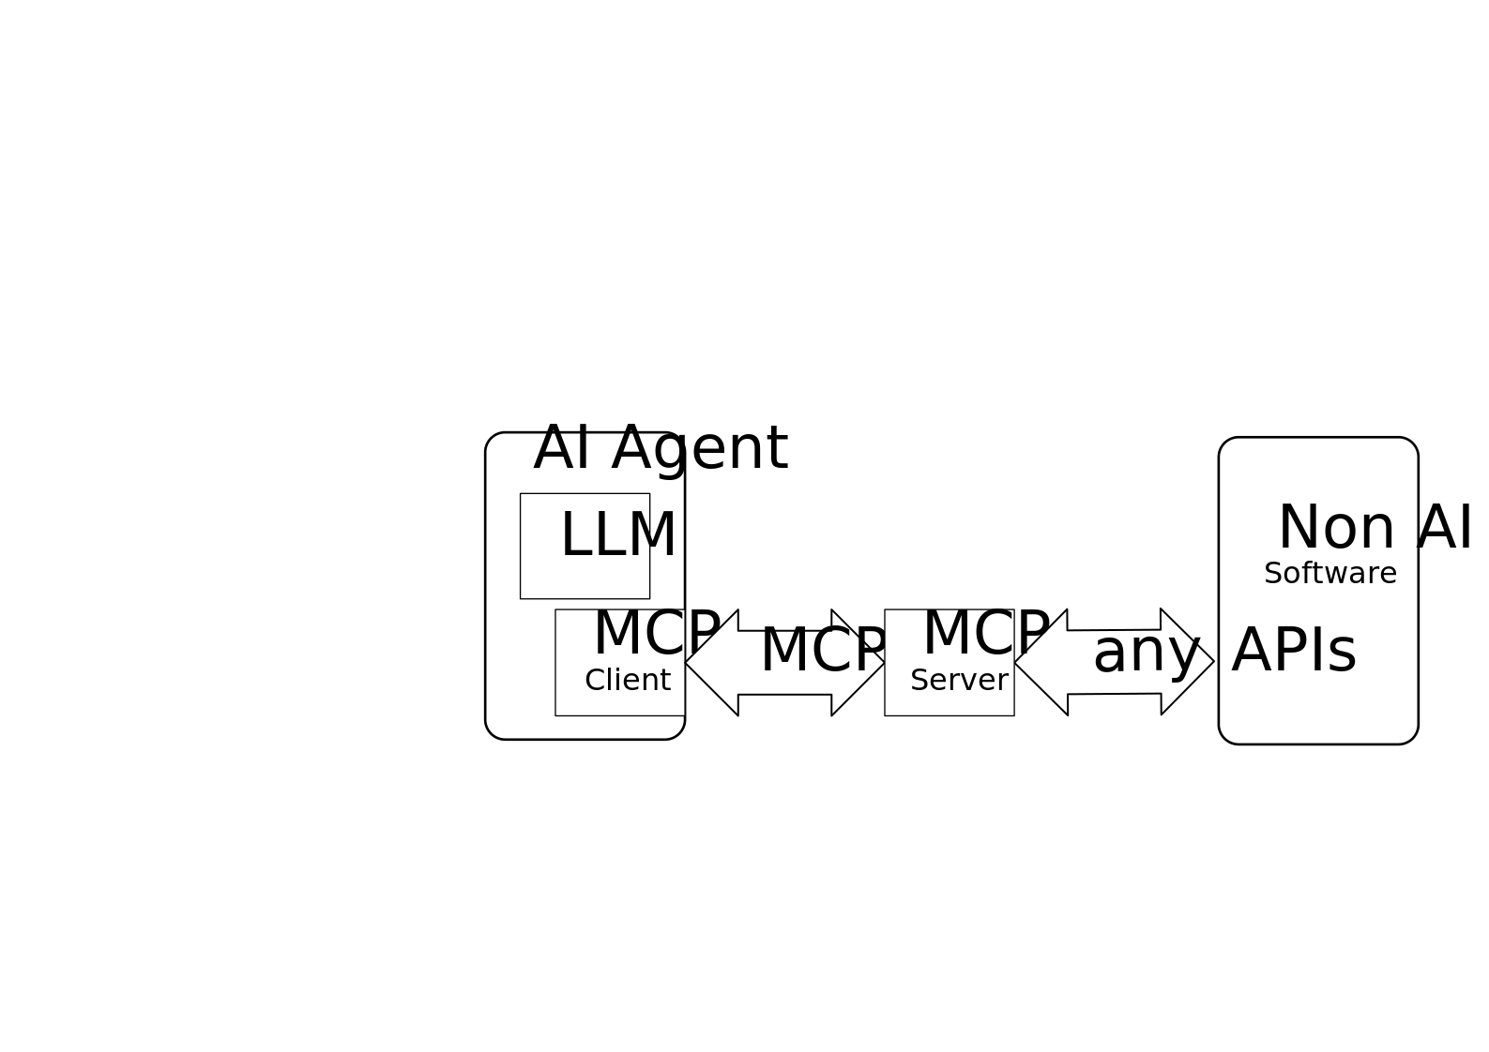
----------------------- End of change 5 -----------------------

--------------------- Start of change 6 ---------------------
media/figure_01_4_TR81.svg

---/dev/null
+++b/media/figure_01_4_TR81.svg
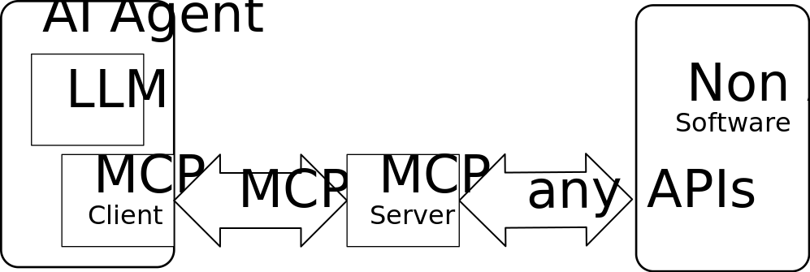
----------------------- End of change 6 -----------------------

--------------------- Start of change 7 ---------------------
media/figure_01_5_TR81.svg

---/dev/null
+++b/media/figure_01_5_TR81.svg
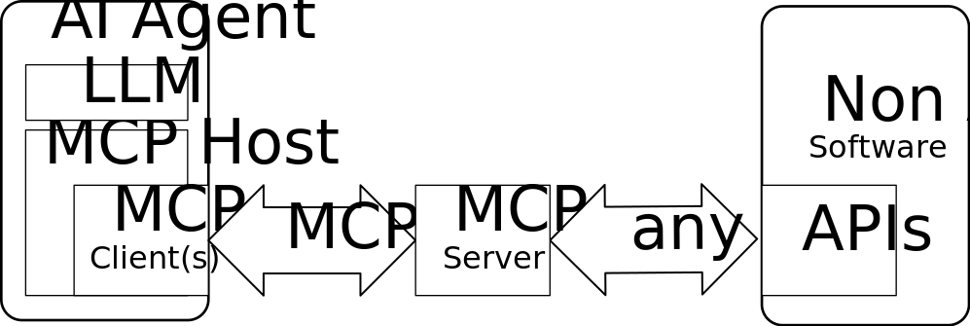
----------------------- End of change 7 -----------------------

--------------------- Start of change 8 ---------------------
media/figure_01b_TR81.svg

---/dev/null
+++b/media/figure_01b_TR81.svg
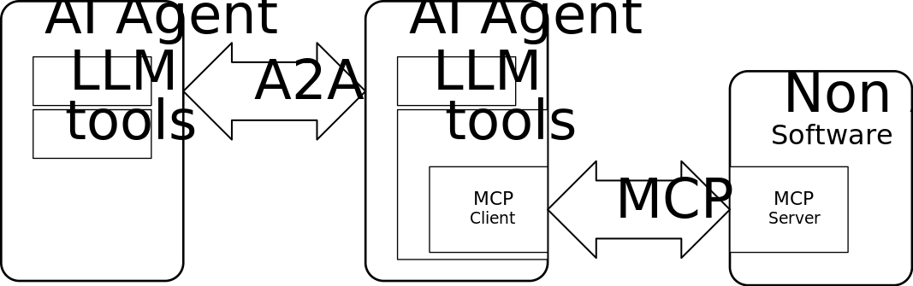
----------------------- End of change 8 -----------------------

--------------------- Start of change 9 ---------------------
media/mcp_overview.drawio.png

---/dev/null
+++b/media/mcp_overview.drawio.png
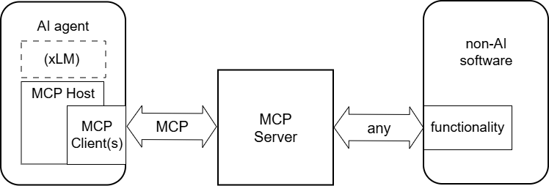
----------------------- End of change 9 -----------------------

--------------------- Start of change 10 ---------------------
media/mcp_overview.png

---/dev/null
+++b/media/mcp_overview.png
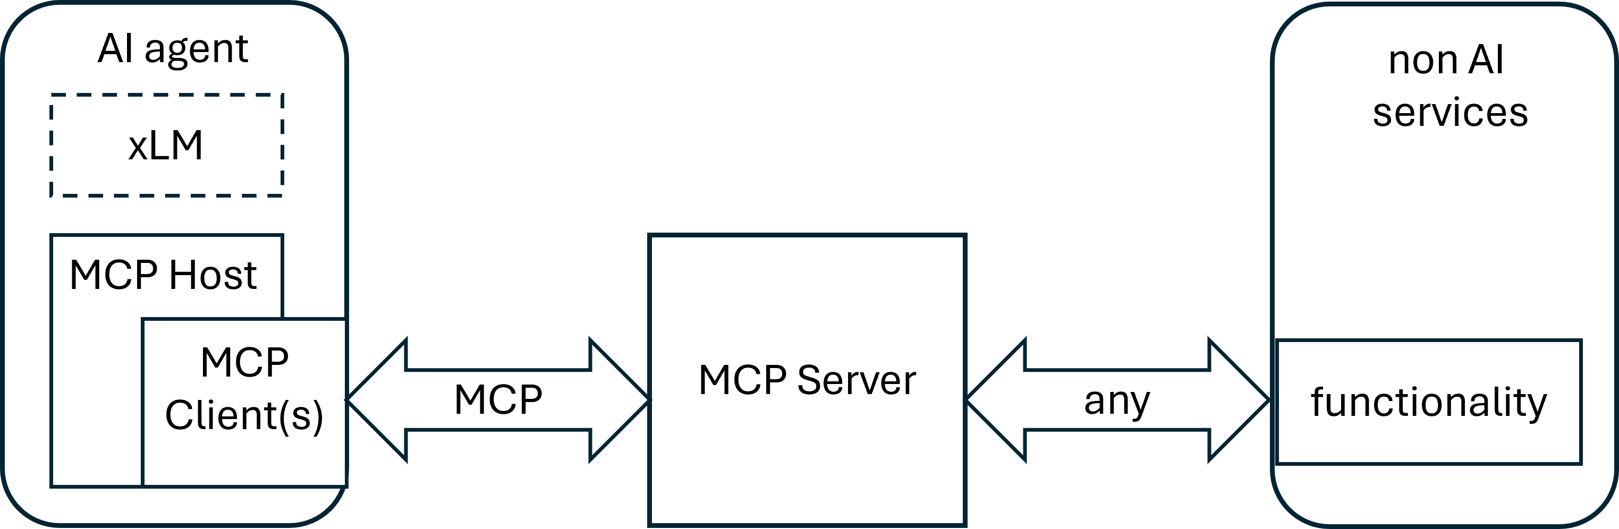
----------------------- End of change 10 -----------------------

--------------------- Start of change 11 ---------------------
media/new_overview.png

---/dev/null
+++b/media/new_overview.png
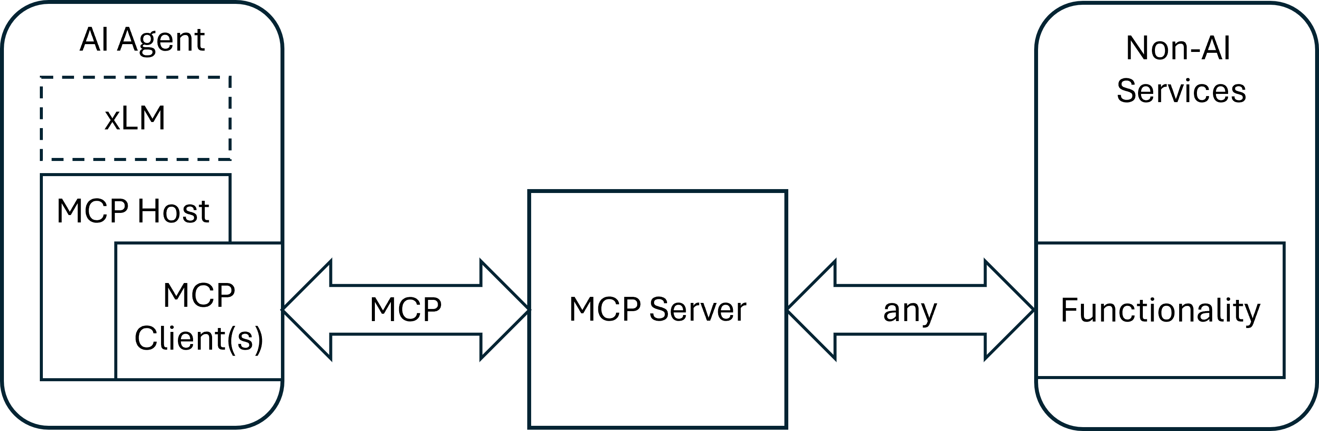
----------------------- End of change 11 -----------------------

--------------------- Start of change 12 ---------------------
media/protocol_uml_01.svg

---/dev/null
+++b/media/protocol_uml_01.svg
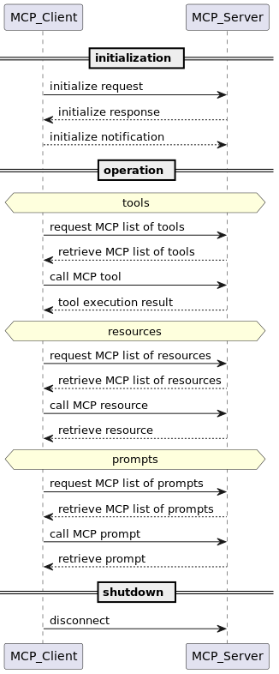
----------------------- End of change 12 -----------------------

