CHANGE REQUEST
Meeting ID:* | SDS 72
Source:* | Jieun Lee
Date:* | 2025-11-13
Reason for Change/s:* | Security procedure for MCP Interworking
CR against: Release* | R5
CR against: WI* | Active <WI-0122>  MNT maintenance / < Work Item number(optional)>  Is this a mirror CR? Yes No  mirror CR number:  STE Small Technical Enhancements / < Work Item number (optional)>  Only ONE of the above shall be ticked
CR against: TS/TR* | TR-0081
Clauses * | 2.2, 6.1, 6.2, 6.3, 6.3.1, 6.3.2, 6.3.3
Type of change: * | Editorial change  Bug Fix or Correction  Change to existing feature or functionality  New feature or functionality  Only ONE of the above shall be ticked
Other TS/TR(s) impacted | None
Post Freeze checking:* | This CR contains only essential changes and corrections? YES NO  This CR may break backwards compatibility with the last approved version of the TS? YES NO
Template Version: January 2019 (do not modify)
oneM2M Notice
The document to which this cover statement is attached is submitted to oneM2M. Participation in, or attendance at, any activity of oneM2M, constitutes acceptance of and agreement to be bound by terms of the Working Procedures and the Partnership Agreement, including the Intellectual Property Rights (IPR) Principles Governing oneM2M Work found in Annex 1 of the Partnership Agreement.
GUIDELINES for Change Requests:
Provide an informative introduction containing the problem(s) being solved, and a summary list of proposals.
Each CR should contain changes related to only one particular issue/problem.
In case of a correction, and the change apply to previous releases, a separate “mirror CR” should be posted at the same time of this CR
Mirror CR: applies only when the text, including clause numbering are exactly the same.
Companion CR: applies when the change means the same but the baselines differ in some way (e.g. clause number).
Follow the principle of completeness, where all changes related to the issue or problem within a deliverable are simultaneously proposed to be made E.g. A change impacting 5 tables should not only include a proposal to change only 3 tables. Includes any changes to references, definitions, and acronyms in the same deliverable.
Follow the drafting rules.
All pictures must be editable.
Check spelling and grammar to the extent practicable.
Use Change bars for modifications.
The change should include the current and surrounding clauses to clearly show where a change is located and to provide technical context of the proposed change. Additions of complete clauses need not show surrounding clauses as long as the proposed clause number clearly shows where the new clause is proposed to be located.
Multiple changes in a single CR shall be clearly separated by horizontal lines with embedded text such as, start of change 1, end of change 1, start of new clause, end of new clause.
When subsequent changes are made to content of a CR, then the accepted version should not show changes over changes. The accepted version of the CR should only show changes relative to the baseline approved text.

Introduction
Change Request
https://git.onem2m.org/specifications/tr/tr-0081/-/merge_requests/4
https://git.onem2m.org/specifications/tr/tr-0081/-/merge_requests/4/diffs?commit_id=e59e640ff10f01d94a57d531294eb21795efba8f

========= REVISION R01 =========
========= Comment provided by Peter Niblett at 2025-11-12T17:25:53.690Z: =========
**R01 remarks**

Thank you for providing such comprehensive detail. Here are my comments - I am sorry that there are so many:

- In 6.1 you say "such as retrieving, updating, or managing data". The use cases we have discussed so far have only involved retrieving data. Do people agree that we need to discuss MCP tools that add or modify oneM2M data? I guess there's no way to stop someone from writing such a tool and therefore it needs to be mentioned in the document. If so, we should make it clear earlier in the document (i.e. before you get to the Security clause) that the MCP-IPE is a bidirectional thing.
- Also, what do you mean by "managing data"? Does it mean anything different from adding, modifying and deleting data?
- Would you see an MCP tool also calling administrative oneM2M APIs, not just performing data-related operations. I would expect the MCP-IPE to be able to register itself as an AE but might it want to do things like registering other AE's, e.g. Sensor devices, or creating subscriptions for other AEs?
- In the last sentence of the first paragraph of 6.1 you say "MCP may lack equivalent built-in controls". I am questioning the use of the word "may". Does the MCP protocol, as currently specified, have these things built in or not?
- In Clause 6.2 you describe an MCP client "The originating entity that generates MCP request messages to perform operations (e.g., create, retrieve, update, or delete) on oneM2M resources. My understanding from is that there is a level of indirection provided by the MCP Server. The MCP client makes requests to perform operations using Tools, Resources and Prompts that are provided by the MCP Server. While I suppose you could have Tools and Resources that surface oneM2M resources directly I thought that idea was that in general the MCP client need not be aware that oneM2M is even present. Can you change this to say "The originating entity that makes requests to the MCP Server. These may result in the MCP server performing operations (e.g., create, retrieve, update, or delete) on oneM2M resources."
- In Figure 6.2.1 you show the MCP-Server and oneM2M AE has two separate boxes inside the MCP-IPE, and in the bullet describing the MCP-IPE you talk about it having an internal MCP-Server and a oneM2M AE. I think the way it is generally implemented is that there is a single block of code that acts as both an MCP-Server (from the MCP client's viewpoint) and a oneM2M AE (from the IN-CSE's viewpoint). If I have understood things right you start with a base MCP-Server and then add your own code to it, which in our case would be the AE functionality).
- Also in the description of MCP-IPE you talk about the AE translating messages into oneM2M format, as if there's a simple 1-1 message conversion. Returning to my earlier point, I don't see it being as simple as that. In some cases the MCP-Server won't contact oneM2M at all; in other cases it might execute a sequence of multiple oneM2M API calls. Someone might want to code a simple pass-through tool, so that you could use natural language interface to talk to oneM2M but I don't think we should assume that's the only use case.
- Following on from that clause 6.3.2 (Operation Procedure) seems to be centered on that particular use case - for example it talks about sending RSC values in the MCP response. It might be better for 6.3.2 to focus on the Security-specific details and leave the application details more generic.
- Figure 6.3.2.1 show a synchronous response (200 OK) to Request tools/list whereas in the Introduction Ingo shows it as asynchronous (a 202 acknowledgement followed by a separate SSE message to send the response).
- General comment 1. My interpretation of the use of AE's is the following (if this is right it might be useful to say something like this in the text):
* The MCP-IPE acts as an AE (the "internal AE") and so it has to be registered with its CSE resulting in the creation of an `<AE>` resource
* Something (I guess it's the MCP-IPE using its internal AE) registers a new (virtual) AE, creating a new `<AE>` resource, for each distinct MCP client
* When it is acting on behalf of an MCP client, the MCP-IPE sets the **_From_** parameter in its requests to the AE-ID of the AE corresponding to the MCP client and authenticates using the credentials of that AE. Note that Clause 7.2 of TS-0003 talks about preventing one AE from impersonating another so you would need to make sure that we don't fall foul of that.
- General comment 2. I don't understand the idea of including an ACP in the PAT token. The normal authorization model in oneM2M uses an ID to represent an authenticated subject (the AE-ID in our case) and then has ACPs on each of the target resources. A resource's ACP identifies which subjects are allowed to access these resources (and what operations they can perform on them). There is an acpi on the `<AE>` resource but that controls access to that specific resource, it doesn't control what the corresponding AE can do. See TS-0003 clause 7.1.1. With this approach you will need to make sure that the ACP's of the resources that need to be accessed are configured to permit the appropriate access for the client's AE-ID. This is all held in the CSE - the only thing you need in the token is the AE-ID. However there is also a Dynamic Authorization service (see TS-0003 clause 7.3) - is this what you are planning to use?
- General comment 3. I know that you are thinking of the HTTP binding, but I think you should use the protocol-neutral parameter names used in TS-0001 and TS-0004. For example **_From_** instead of X-M2M-Origin and **_Request Identifier_** instead of X-M2M-RI. Also we usually say RSC instead of rsc.
========= Comment provided by Jieun Lee at 2025-11-12T03:46:54.090Z: =========
**R01 Remarks from SDS#72:**

1. IN-CSE to CSE:
* The current doc uses *IN-CSE* throughout the procedures, which may unintentionally limit the scope of applicability to the infrastructure CSE only.

2. Security Issues on oneM2M side:
* The current architecture depicts security issues being handled and sent via OAuth and tokens from MCP-IPE before being transferred to oneM2M
* But the actual internal security processing — how the IPE maps token information (PAT claims) to the oneM2M AE/ACP structure — is not clearly specified.
========= Comment provided by Ingo Friese at 2025-11-12T03:47:42.346Z: =========
**R01 remarks:**

\- A very good and exhaustive description of an authorization framework. MCP has an existing authorization framework based on OAuth 2.0/2.1. We should make sure, that we state in text, how our proposal relates to this. Do we describe OAuth with oneM2M specific additions? Is it a new framework? Maybe one or two sentences in the beginning.

\- We write here: "Verifying the client’s authorization against oneM2M ACPs or embedded PAT scopes." I think we should also verify ACP against the actual resource identifier the agent wants to access using Protected Resource Metadata RFC. Because the scope alone usualy does not have all information.

\- Synchronize the figures (dotted line for xLM)

\- provide few references e.g. for OAuth under 2.2

---a/TR-0081-AI_Agent_Interworking.md
+++b/TR-0081-AI_Agent_Interworking.md
@@ -80,6 +80,11 @@
80 80 The following referenced documents are not necessary for the application of the present document but they assist the user with regard to a particular subject area.
81 81
82 82 - <a name="_ref_i.1">[i.1]</a> oneM2M Drafting Rules [https://member.onem2m.org/static_Pages/others/Rules_Pages/oneM2M-Drafting-Rules-V1%202%202.doc](https://member.onem2m.org/static_Pages/others/Rules_Pages/oneM2M-Drafting-Rules-V1%202%202.doc)
83 + - <a name="_ref_i.2">[i.2]</a> IETF RFC 8414: OAuth 2.0 Authorization Server Metadata [https://www.rfc-editor.org/info/rfc8414](https://www.rfc-editor.org/info/rfc8414)
84 + - <a name="_ref_i.3">[i.3]</a> IETF RFC 7517: JSON Web Key (JWK) [https://www.rfc-editor.org/info/rfc7517](https://www.rfc-editor.org/info/rfc7517)
85 + - <a name="_ref_i.4">[i.4]</a> IETF RFC 7636: Proof Key for Code Exchange by OAuth Public Clients [https://www.rfc-editor.org/info/rfc7636](https://www.rfc-editor.org/info/rfc7636)
86 + - <a name="_ref_i.5">[i.5]</a> IETF RFC 8707: Resource Indicators for OAuth 2.0 [https://www.rfc-editor.org/info/rfc8707](https://www.rfc-editor.org/info/rfc8707)
87 + - <a name="_ref_i.6">[i.6]</a> IETF RFC 9728: OAuth 2.0 Protected Resource Metadata [https://www.rfc-editor.org/info/rfc9728](https://www.rfc-editor.org/info/rfc9728)
83 88
84 89
85 90 # 3 Definition of terms, symbols and abbreviations
@@ -151,16 +156,18 @@
151 156
152 157 # 6 Security aspects of MCP interworking
153 158 ## 6.1 Overview
154 - The integration of Model Context Protocol (MCP) with oneM2M in Internet of Things (IoT) systems introduces unique security challenges that necessitate dedicated solutions to ensure secure interworking. MCP, designed for contextual data exchange and model-based interactions, enables advanced querying and resource access in IoT environments. However, when MCP clients seek to interact with oneM2M resources—such as retrieving, updating, or managing data stored in Common Service Entities (CSEs)—potential vulnerabilities arise, including unauthorized access, data leakage, impersonation attacks, and integrity breaches. These risks stem from differences in the protocols’ native security mechanisms: oneM2M relies on Access Control Policies (ACPs) and Application Entity (AE) identifiers for fine-grained authorization, while MCP may lack equivalent built-in controls for cross-protocol operations, leading to exposure if direct access is attempted without mediation.
155 -
156 - A security solution is essential to mitigate these issues by providing robust authentication, authorization, and message translation. Without such measures, MCP clients could bypass oneM2M’s security layers, compromising sensitive IoT data or enabling denial-of-service scenarios. The approach should adopt a token-based authentication framework, such as Personal Access Tokens (PATs), which encapsulate client identifiers, issuance/expiration timestamps, permissible resource scopes, and corresponding AE mappings. This enables stateless verification while aligning with oneM2M’s ACP framework. Conceptually, the solution should employ an intermediary proxy (e.g., MCP Interworking Proxy Entity, MCP-IPE) to handle protocol translation, validate access rights, and enforce policies, ensuring that MCP requests are securely mapped to oneM2M operations without exposing underlying resources directly. This proxy-centric model promotes scalability, reduces attack surfaces, and facilitates compliance with IoT security standards like those from oneM2M and related bodies.
159 + The integration of Model Context Protocol (MCP) with oneM2M in Internet of Things (IoT) systems introduces unique security challenges that necessitate dedicated solutions to ensure secure interworking. MCP, designed for contextual data exchange and model-based interactions, enables advanced querying and resource access in IoT environments. However, when MCP clients seek to interact with oneM2M resources—such as retrieving, updating, or managing data stored in Common Service Entities (CSEs)—potential vulnerabilities arise, including unauthorized access, data leakage, impersonation attacks, and integrity breaches. These risks stem from differences in the protocols' native security mechanisms: oneM2M relies on Access Control Policies (ACPs) and Application Entity (AE) identifiers for fine-grained authorization, while MCP may lack equivalent built-in controls for cross-protocol operations, leading to exposure if direct access is attempted without mediation.
160 +
161 + A security solution is essential to mitigate these issues by providing robust authentication, authorization, and message translation. Without such measures, MCP clients could bypass oneM2M's security layers, compromising sensitive IoT data or enabling denial-of-service scenarios. The approach should adopt a token-based authentication framework, such as Personal Access Tokens (PATs), which encapsulate client identifiers, issuance/expiration timestamps, permissible resource scopes, and corresponding AE mappings. This enables stateless verification while aligning with oneM2M's ACP framework. Conceptually, the solution should employ an intermediary proxy (e.g., MCP Interworking Proxy Entity, MCP-IPE) to handle protocol translation, validate access rights, and enforce policies, ensuring that MCP requests are securely mapped to oneM2M operations without exposing underlying resources directly. This proxy-centric model promotes scalability, reduces attack surfaces, and facilitates compliance with IoT security standards like those from oneM2M and related bodies.
162 +
163 + This proposal does not define a new authorization framework. Instead, it profiles MCP’ existing OAuth 2.0/2.1-based model for secure oneM2M interworking. PATs are standard JWTs issued and validated in conformance with OAuth specifications—utilizing Authorization Server Metadata [i.2], JSON Web Keys [i.3], Proof Key for Code Exchage [i.4], Resource Indicators [i.5], and Protected Resource Metadata [i.6]. The framework therefore remains interoperable with any MCP implementation that already supports OAuth, while introducing oneM2M-specific binding for AE/ACP enforcement and message translation. In practice, the solution described in the present clause is mainly targeted at shared CSE deployments where an HTTP-based MCP-IPE mediates external MCP requests; single-user, local deployments (e.g. using the STDIO transport) can rely on simpler arrangements that are outside its scope.
157 164
158 165 ## 6.2 High-level security architecture
159 166 The high-level security architecture for MCP-oneM2M interworking is designed around a proxy-mediated framework to ensure secure, controlled access between MCP clients and oneM2M resources. Key components include:
160 167
161 - - MCP Client: The originating entity that generates MCP request messages to perform operations (e.g., create, retrieve, update, or delete) on oneM2M resources. It must obtain and include a PAT in requests, where the PAT contains the client's identifier, issuance time, expiration time, authorized resource scopes (including specific resources and permitted operations), and a mapping to a corresponding oneM2M AE identifier.
168 + - MCP Client: The originating entity that generates MCP request messages to perform operations (e.g., create, retrieve, update, or delete) on oneM2M resources. It must obtain and include a PAT in requests, where the PAT contains the client's identifier, issuance time, expiration time, authorized resource permissions (including specific resources and permitted operations), and a mapping to a corresponding oneM2M AE identifier.
162 169 - MCP Interworking Proxy Entity (MCP-IPE): Acts as the central intermediary, incorporating an internal MCP Server and a oneM2M AE. The MCP Server receives and processes messages from MCP Clients. These messages are then forwarded to the internal oneM2M AE, which translates them into oneM2M-compliant formats (e.g., converting MCP operations to oneM2M CRUD operations and mapping parameters to oneM2M primitives). The AE subsequently sends the transformed message to the oneM2M CSE for processing. The MCP-IPE is responsible for:
163 - - Authorization Check: Verifying the client’s authorization against oneM2M ACPs or embedded PAT scopes.
170 + - Authorization Check: Verifying the client's authorization against oneM2M ACPs and embedded PAT permissions.
164 171 - PAT management: Handling PAT validation (checking expiration, signature, and structural integrity) and key management by obtaining Authorization Server metadata and JSON Web Key Set (JWKS) for local verification.
165 172 - Message Translation: Upon successful validation, translating the MCP message into an equivalent oneM2M message (e.g., mapping MCP methods to oneM2M operations like CREATE/RETRIEVE/UPDATE/DELETE) and inserting the AE identifier into the oneM2M header for traceability.
166 173 - Forwarding and Relay: Sending the translated message to the oneM2M CSE and relaying responses back to the MCP Client after reverse translation (converting oneM2M responses to MCP responses).
@@ -175,32 +182,34 @@
175 182
176 183
177 184 ## 6.3 Security procedure for MCP Interworking
178 - This clause defines the end-to-end authorization and protected operation in which access to the IN-CSE is mediated by the MCP-IPE on behalf of the MCP Client, while preserving oneM2M’s resource-centric authorization based on ACP and AE identifier. This procedure uses short-lived Personal Access Tokens (PATs). A PAT is presented to the MCP-IPE only and is not forwarded to the IN-CSE; this enables continued client–proxy communication without repeated credential entry and limits exposure through short lifetimes. PATs are renewed to address expiry, changes in effective permissions, and key rotation. For clarity, this clause assumes the MCP interface is deployed over HTTP using JSON-RPC 2.0; other transports (e.g., stdio) are out of scope here. At the MCP-IPE, MCP requests are processed and translated into corresponding oneM2M operations, which are then invoked over Mca by the MCP-IPE’s internal AE; the IN-CSE processes only oneM2M operations under ACP enforcement. The MCP-IPE is the sole endpoint for MCP requests, maintaining a clear separation between the MCP and oneM2M domains.
185 + This clause defines the end-to-end authorization and protected operation in which access to the CSE is mediated by the MCP-IPE on behalf of the MCP Client, while preserving oneM2M's resource-centric authorization based on ACP and AE identifier. This procedure uses short-lived Personal Access Tokens (PATs). A PAT is presented to the MCP-IPE only and is not forwarded to the CSE; this enables continued client–proxy communication without repeated credential entry and limits exposure through short lifetimes. PATs are renewed to address expiry, changes in effective permissions, and key rotation. For clarity, this clause assumes the MCP interface is deployed over HTTP using JSON-RPC 2.0; other transports (e.g., STDIO) are out of scope here. At the MCP-IPE, MCP requests are processed and translated into corresponding oneM2M operations, which are then invoked over Mca by the MCP-IPE's internal AE; the CSE processes only oneM2M operations under ACP enforcement. The MCP-IPE is the sole endpoint for MCP requests, maintaining a clear separation between the MCP and oneM2M domains.
186 +
187 + The procedure in this clause is therefore intended for shared CSE deployments with an HTTP-based MCP-IPE deployed close to the CSE to terminate external MCP requests and apply additional security controls. In single-user deployments where a CSE instance is used only for personal purposes and the MCP Server runs locally (e.g. via the STDIO transport), this procedure may be applied as a recommended defence-in-depth pattern but is not expected as a baseline practice.
179 188
180 189 The procedure is organized into three stages:
181 190 1. **Authorization (token issuance).** The MCP Client discovers the Authorization Server designated for the MCP-IPE and requests a short-lived PAT that is addressed to the MCP-IPE as the intended recipient. Using a PAT enables continued client–proxy communication without repeated credential entry; the short lifetime limits exposure, and issuance remains outside the oneM2M domain.
182 - 2. **Protected operation.** The MCP Client presents the PAT to the MCP-IPE when sending MCP requests. At the MCP-IPE, the token is validated and authorization is checked against the token’s permissions and the applicable AE/ACP policy; the request is then prepared for the IN-CSE, including required headers (e.g., X-M2M-Origin). When needed, the MCP-IPE’s internal AE ensures that the target AE and its ACP exist at the IN-CSE and then invokes the corresponding oneM2M operation over Mca. The IN-CSE enforces ACP and returns status codes and results; these are relayed to the MCP Client without exposing sensitive data. The PAT is not forwarded to the IN-CSE.
191 + 2. **Protected operation.** The MCP Client presents the PAT to the MCP-IPE when sending MCP requests. At the MCP-IPE, the token is validated and a token-based authorization is checked against the token's permissions and the applicable AE/ACP policy. For each MCP Client, one AE and one ACP at the CSE are configured for authorization, and the permissions claim indicates which oneM2M operations are to be authorized for this AE instead of an OAuth 2.0 scope parameter. The request is then prepared for the CSE, including required headers (e.g., X-M2M-Origin). When needed, the MCP-IPE's internal AE ensures that the target AE and its ACP exist at the CSE and then invokes the corresponding oneM2M operation over Mca. The CSE enforces ACP and returns status codes and results; these are relayed to the MCP Client without exposing sensitive data. The PAT is not forwarded to the CSE.
183 192 3. **PAT renewal.** When the PAT expires or effective permissions need to change, the MCP Client refreshes or re-authorizes with the Authorization Server. The Authorization Server issues a new PAT without contacting the oneM2M domain. Any ACP/AE reconciliation takes place at the next protected operation.
184 193
185 194 ### 6.3.1 Authorization procedure (PAT Issuance)
186 - This procedure describes issuance of a PAT used for authorization at the MCP-IPE. The MCP Client first contacts the MCP-IPE without a PAT to obtain information about the Authorization Server required for issuance. The MCP Client then communicates with the Authorization Server to obtain and store a short-lived PAT designated for use with the MCP-IPE as the intended recipient. Issuance takes place outside the oneM2M domain—the Authorization Server does not interact with the IN-CSE and does not manage AEs or ACPs.
195 + This procedure describes issuance of a PAT used for authorization at the MCP-IPE. The MCP Client first contacts the MCP-IPE without a PAT to obtain information about the Authorization Server required for issuance. The MCP Client then communicates with the Authorization Server to obtain and store a short-lived PAT designated for use with the MCP-IPE as the intended recipient. Issuance takes place outside the oneM2M domain—the Authorization Server does not interact with the CSE and does not manage AEs or ACPs.
187 196
188 197 PAT satisfies the following conditions:
189 - - PAT is a signed JWT; its signature is verified with a key discoverable via the Authorization Server’s metadata (e.g., JWKS).
198 + - PAT is a signed JWT; its signature is verified with a key discoverable via the Authorization Server's metadata (e.g., JWKS).
190 199 - PAT is short-lived to limit exposure and to enable periodic renewal.
191 200 - Target designation: PAT includes an audience claim (aud) that identifies the MCP-IPE (MCP Server) as the intended recipient.
192 201 - PAT includes registered claims sufficient for local verification at the MCP-IPE: issued-at (iat), expiration time (exp), optionally not-before (nbf), issuer (iss), audience (aud), subject (sub), and a JWT ID (jti).
193 - - Boundary and secrecy: PAT is presented to the MCP-IPE only and is not forwarded to the IN-CSE; the token does not include oneM2M secrets.
194 - - Private claims are carried only as untrusted hints and are cross-checked against AE/ACP state at the IN-CSE:
202 + - Boundary and secrecy: PAT is presented to the MCP-IPE only and is not forwarded to the CSE; the token does not include oneM2M secrets.
203 + - Private claims used at the MCP-IPE as token-based authorization parameters and are cross-checked against AE/ACP state at the CSE:
195 204 - onem2m_aeid: an AE identifier (AE-ID) mapped one-to-one to the MCP Client, which can be distinct from sub.
196 - - permissions: a least-privilege set expressed as tuples {operation, target_path, resource_type} used to describe the allowed actions for the AE.
205 + - permissions: a least-privilege set expressed as tuples {operation, target_path, resource_type} used to describe the allowed actions for the AE; because the structured tuples can describe fine-grained oneM2M operations and resource paths more explicitly than generic scope values.
197 206
198 207
199 208 **Pre-conditions**
200 209 - Communications among the involved entities are protected by transport security.
201 210 - The MCP-IPE (MCP Server) exposes OAuth Protected Resource Metadata (PRM) at a well-known location. PRM provides, at minimum, the authorization server locations, the issuer information, and the resource identifier used to derive the audience.
202 - - The Authorization Server shall not contact the MCP-IPE (Application Entity) or the IN-CSE during issuance.
203 - - The Authorization Server publishes Authorization Server Metadata and a JWKS reachable by the MCP-IPE for local verification of the PAT. The MCP-IPE is to maintain availability of the issuer’s metadata and keys (for example, by caching and periodic refresh) so that signature verification, key selection via kid, and key rotation can be handled without on-line introspection.
211 + - The Authorization Server shall not contact the MCP-IPE (Application Entity) or the CSE during issuance.
212 + - The Authorization Server publishes Authorization Server Metadata and a JWKS reachable by the MCP-IPE for local verification of the PAT. The MCP-IPE is to maintain availability of the issuer's metadata and keys (for example, by caching and periodic refresh) so that signature verification, key selection via kid, and key rotation can be handled without on-line introspection.
204 213 - Each MCP Client is provisioned with the MCP-IPE endpoint and discovery parameters in its MCP configuration. Per-agent registration differs by implementation, but the configuration includes sufficient information to reach the MCP-IPE and to follow PRM-based discovery.
205 214
206 215
@@ -212,7 +221,7 @@
212 221
213 222 **Step 001:** Discovery at the MCP-IPE
214 223
215 - The MCP Client contacts the MCP-IPE without a PAT to trigger discovery and obtains a reference to OAuth PRM that identifies the canonical resource identifier and the Authorization Server candidates. Alternatively, the MCP Client retrieves PRM from the MCP-IPE’s well-known endpoint. When discovery is triggered by a HTTP authentication challenge, the reference is carried in the WWW-Authenticate header as a resource_metadata parameter.
224 + The MCP Client contacts the MCP-IPE without a PAT to trigger discovery and obtains a reference to OAuth PRM that identifies the canonical resource identifier and the Authorization Server candidates. Alternatively, the MCP Client retrieves PRM from the MCP-IPE's well-known endpoint. When discovery is triggered by a HTTP authentication challenge, the reference is carried in the WWW-Authenticate header as a resource_metadata parameter.
216 225
217 226 **Step 002a:** Authorization Server metadata retrieval
218 227
@@ -236,23 +245,23 @@
236 245
237 246 Alternative flows.
238 247
239 - A001) If authorization is denied or a device flow expires, the Authorization Server returns an authorization error. No oneM2M interaction occurs between the Authorization Server and the oneM2M domain (the MCP-IPE’s internal AE or the IN-CSE).
248 + A001) If authorization is denied or a device flow expires, the Authorization Server returns an authorization error. No oneM2M interaction occurs between the Authorization Server and the oneM2M domain (the MCP-IPE's internal AE or the CSE).
240 249
241 250
242 251 **Post-conditions.**
243 252 - The MCP Client holds a valid PAT whose aud identifies the MCP-IPE as the intended recipient.
244 - - Issuance does not create, modify, or imply the existence of any AE or ACP at the IN-CSE.
253 + - Issuance does not create, modify, or imply the existence of any AE or ACP at the CSE.
245 254 - Verification material for subsequent PAT validation—Authorization Server Metadata and the JWKS referenced by jwks_uri—is maintained by the MCP-IPE; obtaining or refreshing such material does not involve interaction with the oneM2M domain.
246 255
247 256
248 257 ### 6.3.2 Operation procedure
249 - This procedure describes the protected interaction between the MCP Client and the MCP-IPE. The MCP Client presents a PAT with each protected request; the MCP-IPE verifies the token using the issuer’s metadata and keys and applies freshness, replay, rate, and permission checks with permissions cross-checked against AE/ACP state. The MCP-IPE derives X-M2M-Origin from the resolved AE, prepares required headers, and invokes the corresponding oneM2M operation over Mca. The IN-CSE enforces ACP and returns result status codes (rsc), which are relayed in the MCP response; the PAT is not forwarded to the IN-CSE.
258 + This procedure describes the protected interaction between the MCP Client and the MCP-IPE. The MCP Client presents a PAT with each protected request; the MCP-IPE verifies the token using the issuer's metadata and keys and applies freshness, replay, rate, and permission checks with permissions claim in the PAT cross-checked against AE/ACP state. The MCP-IPE derives X-M2M-Origin from the resolved AE, prepares required headers, and invokes the corresponding oneM2M operation over Mca. The CSE enforces ACP and returns result status codes (rsc), which are relayed in the MCP response; the PAT is not forwarded to the CSE.
250 259
251 260
252 261 **Pre-conditions.**
253 262 - The MCP Client holds a valid PAT whose aud identifies the MCP-IPE as the intended recipient, and the PAT is within its validity period.
254 263 - Authorization Server Metadata and the JWKS identified by jwks_uri are available to the MCP-IPE for local verification; keys are current and selected by kid.
255 - - The MCP-IPE’s internal AE can reach the IN-CSE over the Mca reference point.
264 + - The MCP-IPE's internal AE can reach the CSE over the Mca reference point.
256 265 - The clocks of the MCP Client and the MCP-IPE are within the operator-defined skew window to support freshness evaluation.
257 266 - Each protected request includes a client-created timestamp and a unique request identifier; the MCP-IPE evaluates freshness against the published window and rejects duplicates, and the request identifier is propagated to X-M2M-RI when invoking oneM2M operations.
258 267
@@ -265,7 +274,7 @@
265 274
266 275 **Step 001:** Initialize the protected MCP session
267 276
268 - The MCP Client sends initialize with Authorization: Bearer <PAT> header. The MCP-IPE verifies the PAT signature and claims locally using the issuer’s metadata and the JWKS with key selection by kid. On success, the MCP-IPE returns an InitializeResult that includes a capability summary (e.g., available listing functions, supported operations, size limits, required headers, and stable reason-code categories) and references to operational policies (e.g., freshness and replay requirements) and, when provided, a session identifier. The purpose of initialization is to confirm token validity, publish operational policy references, and provide a concise capability summary for subsequent requests.
277 + The MCP Client sends initialize with Authorization: Bearer <PAT> header. The MCP-IPE verifies the PAT signature and claims locally using the issuer's metadata and the JWKS with key selection by kid. On success, the MCP-IPE returns an InitializeResult that includes a capability summary (e.g., available listing functions, supported operations, size limits, required headers, and stable reason-code categories) and references to operational policies (e.g., freshness and replay requirements) and, when provided, a session identifier. The purpose of initialization is to confirm token validity, publish operational policy references, and provide a concise capability summary for subsequent requests.
269 278
270 279 **Step 002:** Discover available capabilities
271 280
@@ -277,60 +286,60 @@
277 286
278 287 **Step 004:** Policy enforcement at the MCP-IPE
279 288
280 - Before any IN-CSE invocation, the MCP-IPE applies local verification and policy controls. If the kid is unknown or rotated, the MCP-IPE refreshes the JWKS and retries local verification. The following controls are applied:
289 + Before any CSE invocation, the MCP-IPE applies local verification and policy controls. If the kid is unknown or rotated, the MCP-IPE refreshes the JWKS and retries local verification. The following controls are applied:
281 290
282 291 - **Step 004a:** Enforce audience equality and message freshness
283 292
284 - The MCP-IPE verifies that the PAT’s aud identifies the MCP-IPE’s canonical resource identifier, evaluates the request timestamp within the allowed skew and window, and suppresses replay; failures are handled locally without contacting the IN-CSE.
293 + The MCP-IPE verifies that the PAT's aud identifies the MCP-IPE's canonical resource identifier, evaluates the request timestamp within the allowed skew and window, and suppresses replay; failures are handled locally without contacting the CSE.
285 294 - **Step 004b:** Rate limiting per subject and per AE-ID
286 295
287 296 The MCP-IPE applies rate limits per subject and per AE-ID and returns 429 Too Many Requests on excess; a Retry-After header is included when applicable.
288 - - **Step 004c:** Permission evaluation under a deny-by-default policy
297 + - **Step 004c:** Ensure AE and ACP presence at the CSE (ACP → AE)
298 +
299 + When the AE or ACP for the MCP Client is missing or out of date, the MCP-IPE’s internal AE creates or updates an ACP with least-privilege rules for that MCP Client and creates or updates an AE whose acpi attribute references this ACP, so that one AE and one ACP exist at the CSE for the MCP Client. After this step, the MCP-IPE updates its local cache for the MCP Client with the AE-ID and a local copy of the ACP, including its accessControlRule elements. Subsequent token-based checks at the MCP-IPE compare PAT claims such as onem2m_aeid and permissions against this cached AE/ACP information, while ACP-based authorization for oneM2M requests is enforced only at the CSE.
300 +
301 + - **Step 004d:** Permission evaluation under a deny-by-default policy
289 302
290 303 The MCP-IPE evaluates the private claim permissions {operation, target_path, resource_type} against the effective least-privilege policy for the AE. Requests that are not in the allowed set are rejected locally with a 403 error.
291 - - **Step 004d:** Handling Private claims as untrusted hints
292 -
293 - If present, onem2m_aeid is treated as an untrusted hint and is validated against the authoritative mapping and IN-CSE state.
294 -
295 - **Step 005:** Ensure authorization state at the IN-CSE (ACP → AE)
296 -
297 - When required state is missing or out of date, the MCP-IPE’s internal AE ensures policy at the IN-CSE in this order: create or update an ACP to reflect least-privilege rules; create an AE with acpi referencing that ACP, or update the AE’s acpi as needed; cache the returned AE-ID for subsequent use as X-M2M-Origin.
298 -
299 - **Step 006:** Translate and invoke a oneM2M operation over Mca
300 -
301 - The MCP-IPE translates the MCP request into the corresponding oneM2M operation and does not forward the PAT. The internal AE invokes the IN-CSE over Mca with headers X-M2M-Origin = <AE-ID> and X-M2M-RI = <request-identifier> (and other required headers such as X-M2M-RVI as applicable); the body carries the converted content. The IN-CSE enforces ACP and returns a oneM2M response with rsc and payload.
302 -
303 - **Step 007:** Normalize the result and record an audit entry
304 + - **Step 004e:** Handling Private claims as token-based authorization parameters
305 +
306 + If present, onem2m_aeid is treated as token-based authorization parameters and is validated against the authoritative mapping and CSE state.
307 +
308 + **Step 005:** Translate and invoke a oneM2M operation over Mca
309 +
310 + The MCP-IPE translates the MCP request into the corresponding oneM2M operation and does not forward the PAT. The internal AE invokes the CSE over Mca with headers X-M2M-Origin = \<AE-ID\> and X-M2M-RI = \<request-identifier\> (and other required headers such as X-M2M-RVI as applicable); the body carries the converted content. The CSE enforces ACP and returns a oneM2M response with rsc and payload.
311 +
312 + **Step 006:** Normalize the result and record an audit entry
304 313
305 314 The MCP-IPE normalizes the oneM2M response into an MCP response: rsc semantics are preserved; internal identifiers, resource tree paths, ACP details, and transport-specific headers are not exposed; and stable reason codes are provided for diagnostics. The MCP-IPE returns the normalized result to the MCP Client and records an audit entry that includes the request identifier, the effective AE-ID, the reason code, and the outcome; sensitive token material is not logged.
306 315
307 316 Alternative flows.
308 317
309 - A001) If the PAT’s aud does not identify the MCP-IPE’s canonical resource identifier, the MCP-IPE returns 401 Unauthorized and does not contact the IN-CSE.
310 -
311 - A002) If PAT verification, freshness, replay, rate, permission evaluation, or mapping fails, the MCP-IPE rejects locally with an appropriate error and does not contact the IN-CSE.
312 -
313 - A003) If the IN-CSE returns a non-success rsc, the MCP-IPE propagates the status with minimal shaping.
318 + A001) If the PAT's aud does not identify the MCP-IPE's canonical resource identifier, the MCP-IPE returns 401 Unauthorized and does not contact the CSE.
319 +
320 + A002) If PAT verification, freshness, replay, rate, permission evaluation, or mapping fails, the MCP-IPE rejects locally with an appropriate error and does not contact the CSE.
321 +
322 + A003) If the CSE returns a non-success rsc, the MCP-IPE propagates the status with minimal shaping.
314 323
315 324
316 325 **Post-conditions.**
317 - - Authorized requests are executed at the IN-CSE as oneM2M operations under ACP enforcement; required headers (e.g., X-M2M-Origin) are derived by the MCP-IPE from the effective AE.
318 - - Requests that fail local checks—PAT verification, freshness/replay evaluation, rate limiting, or permission evaluation—are handled at the MCP-IPE and do not reach the IN-CSE.
319 - - Replay attempts, audience mismatches against the MCP-IPE’s canonical resource identifier, and permission violations are rejected locally at the MCP-IPE; no call is issued to the IN-CSE.
320 - - The PAT is presented to the MCP-IPE only and is not forwarded to the IN-CSE.
326 + - Authorized requests are executed at the CSE as oneM2M operations under ACP enforcement; required headers (e.g., X-M2M-Origin) are derived by the MCP-IPE from the effective AE.
327 + - Requests that fail local checks—PAT verification, freshness/replay evaluation, rate limiting, or permission evaluation—are handled at the MCP-IPE and do not reach the CSE.
328 + - Replay attempts, audience mismatches against the MCP-IPE's canonical resource identifier, and permission violations are rejected locally at the MCP-IPE; no call is issued to the CSE.
329 + - The PAT is presented to the MCP-IPE only and is not forwarded to the CSE.
321 330 - The response returned to the MCP Client is normalized: oneM2M rsc semantics are preserved, internal identifiers and token material are not exposed, and an audit entry is recorded with the request identifier, the effective AE-ID, a stable reason code, and the outcome.
322 331
323 332
324 333
325 334 ### 6.3.3 PAT Re-issue procedure
326 - This procedure describes renewal of the PAT used for protected MCP requests. The PAT is short-lived and is reused across requests until it expires; a renewal process is therefore required. Renewal is initiated when local verification at the MCP-IPE rejects the token because it is expired or not yet valid, signature or key selection fails (e.g., rotated kid), the audience does not identify the MCP-IPE as the intended recipient, or policy-relevant claims have changed. The MCP Client obtains a new PAT from the Authorization Server using a refresh token when available or by re-authorization; issuance does not involve the oneM2M domain. On the next request, the MCP-IPE verifies the renewed PAT and proceeds with the operation; where claims affecting authorization have changed, policy is re-evaluated and AE/ACP are reconciled at the IN-CSE before invoking the oneM2M operation.
335 + This procedure describes renewal of the PAT used for protected MCP requests. The PAT is short-lived and is reused across requests until it expires; a renewal process is therefore required. Renewal is initiated when local verification at the MCP-IPE rejects the token because it is expired or not yet valid, signature or key selection fails (e.g., rotated kid), the audience does not identify the MCP-IPE as the intended recipient, or policy-relevant claims have changed. The MCP Client obtains a new PAT from the Authorization Server using a refresh token when available or by re-authorization; issuance does not involve the oneM2M domain. On the next request, the MCP-IPE verifies the renewed PAT and proceeds with the operation; where claims affecting authorization have changed, policy is re-evaluated and AE/ACP are reconciled at the CSE before invoking the oneM2M operation.
327 336
328 337
329 338 **Pre-conditions.**
330 339 - The MCP Client has a renewal path: either a refresh token or a re-authorization flow to obtain a new PAT from the Authorization Server; the issuer and endpoints (authorization_endpoint, token_endpoint) are known or discoverable from PRM or Authorization Server Metadata.
331 340 - Authorization Server Metadata and the JWKS referenced by jwks_uri are available to the MCP-IPE for local verification of renewed PATs; keys are current and selected by kid.
332 - - The MCP-IPE’s canonical resource identifier is established so that the renewed PAT’s aud identifies the MCP-IPE as the intended recipient.
333 - - The MCP-IPE’s internal AE can reach the IN-CSE over Mca for subsequent authorization-state reconciliation when claims affecting authorization have changed; issuance does not involve the oneM2M domain.
341 + - The MCP-IPE's canonical resource identifier is established so that the renewed PAT's aud identifies the MCP-IPE as the intended recipient.
342 + - The MCP-IPE's internal AE can reach the CSE over Mca for subsequent authorization-state reconciliation when claims affecting authorization have changed; issuance does not involve the oneM2M domain.
334 343
335 344
336 345 ![Figure 6.3.3-1: PAT Re-issue procedure](media/6.3.3-1.png)
@@ -341,7 +350,7 @@
341 350
342 351 **Step 001:** Rejection of a protected request
343 352
344 - When a protected MCP request arrives with an expired, malformed, or otherwise unacceptable PAT, the MCP-IPE returns 401 Unauthorized with a WWW-Authenticate reference to PRM or Authorization Server Metadata and does not contact the IN-CSE. When the PAT is valid but authorization is insufficient for the requested operation/target/resource type, the MCP-IPE returns 403 Forbidden with a local policy reason and does not contact the IN-CSE.
353 + When a protected MCP request arrives with an expired, malformed, or otherwise unacceptable PAT, the MCP-IPE returns 401 Unauthorized with a WWW-Authenticate reference to PRM or Authorization Server Metadata and does not contact the CSE. When the PAT is valid but authorization is insufficient for the requested operation/target/resource type, the MCP-IPE returns 403 Forbidden with a local policy reason and does not contact the CSE.
345 354
346 355 **Step 002:** Renewal initiation and token issuance
347 356
@@ -355,21 +364,21 @@
355 364
356 365 Upon receipt of a protected request with the renewed PAT, the MCP-IPE validates the token—signature, time validity, audience identifying the MCP-IPE—prior to translating or invoking any oneM2M operation. If the signing key is not available locally (e.g., an unknown or rotated kid), the MCP-IPE retrieves the current JWKS via jwks_uri, selects the key by kid, and completes validation before processing.
357 366
358 - **Step 005:** Authorization-state reconciliation at the IN-CSE
359 -
360 - If claims affecting authorization have changed (e.g., permissions narrowed or AE hints updated), the MCP-IPE’s internal AE ensures that the IN-CSE reflects the effective least-privilege policy: update or create an ACP; update the AE’s acpi to reference that ACP; and, if the AE is absent, create the AE accordingly. Execution proceeds after reconciliation.
367 + **Step 005:** Authorization-state reconciliation at the CSE
368 +
369 + If claims affecting authorization have changed (e.g., permissions narrowed or AE hints updated), the MCP-IPE's internal AE ensures that the CSE reflects the effective least-privilege policy: update or create an ACP; update the AE's acpi to reference that ACP; and, if the AE is absent, create the AE accordingly. Execution proceeds after reconciliation.
361 370
362 371 Alternative flows.
363 372
364 373 A001) If renewal is denied (e.g., invalid grant, consent declined, or policy conflict), the Authorization Server returns an authorization error; no interaction occurs between the Authorization Server and the oneM2M domain in this clause.
365 374
366 - A002) If the renewed PAT’s audience does not identify the MCP-IPE as the intended recipient, the MCP-IPE returns 401 Unauthorized on the next protected request; the IN-CSE is not contacted.
375 + A002) If the renewed PAT's audience does not identify the MCP-IPE as the intended recipient, the MCP-IPE returns 401 Unauthorized on the next protected request; the CSE is not contacted.
367 376
368 377
369 378 **Post-conditions.**
370 379 - The MCP Client holds a valid PAT whose aud identifies the MCP-IPE as the intended recipient and is within its validity period.
371 - - At the IN-CSE, the AE and its ACP reflect the effective least-privilege permissions applicable at the time of operation; no change is implied when authorization has not changed.
372 - - Requests that are unauthorized or invalid are handled at the MCP-IPE and do not reach the IN-CSE.
380 + - At the CSE, the AE and its ACP reflect the effective least-privilege permissions applicable at the time of operation; no change is implied when authorization has not changed.
381 + - Requests that are unauthorized or invalid are handled at the MCP-IPE and do not reach the CSE.
373 382 - The PAT is not forwarded beyond the MCP-IPE.
374 383
375 384

---a/media/6.2-1.png
+++b/media/6.2-1.png
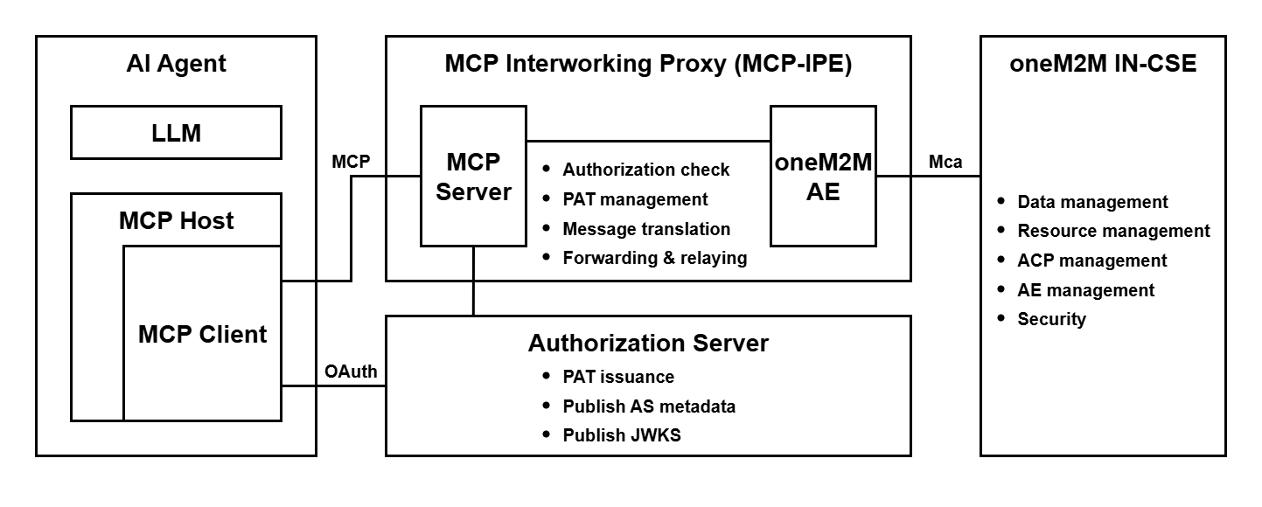
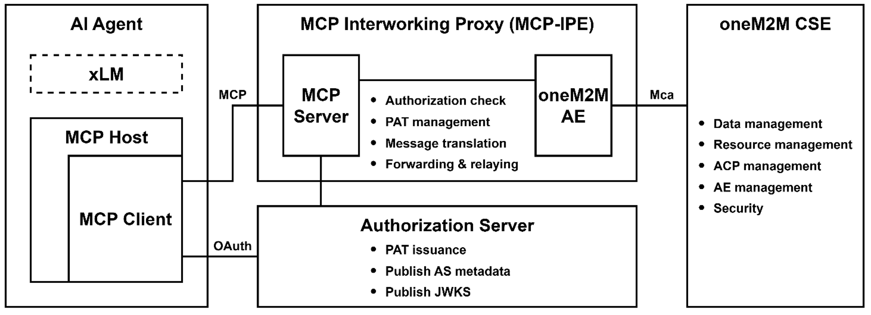
========= END OF REVISIONS =========

--------------------- Start of change 1 ---------------------
TR-0081-AI_Agent_Interworking.md

---a/TR-0081-AI_Agent_Interworking.md
+++b/TR-0081-AI_Agent_Interworking.md
@@ -80,6 +80,11 @@ Not applicable.
80 80 The following referenced documents are not necessary for the application of the present document but they assist the user with regard to a particular subject area.
81 81
82 82 - <a name="_ref_i.1">[i.1]</a> oneM2M Drafting Rules [https://member.onem2m.org/static_Pages/others/Rules_Pages/oneM2M-Drafting-Rules-V1%202%202.doc](https://member.onem2m.org/static_Pages/others/Rules_Pages/oneM2M-Drafting-Rules-V1%202%202.doc)
83 + - <a name="_ref_i.2">[i.2]</a> IETF RFC 8414: OAuth 2.0 Authorization Server Metadata [https://www.rfc-editor.org/info/rfc8414](https://www.rfc-editor.org/info/rfc8414)
84 + - <a name="_ref_i.3">[i.3]</a> IETF RFC 7517: JSON Web Key (JWK) [https://www.rfc-editor.org/info/rfc7517](https://www.rfc-editor.org/info/rfc7517)
85 + - <a name="_ref_i.4">[i.4]</a> IETF RFC 7636: Proof Key for Code Exchange by OAuth Public Clients [https://www.rfc-editor.org/info/rfc7636](https://www.rfc-editor.org/info/rfc7636)
86 + - <a name="_ref_i.5">[i.5]</a> IETF RFC 8707: Resource Indicators for OAuth 2.0 [https://www.rfc-editor.org/info/rfc8707](https://www.rfc-editor.org/info/rfc8707)
87 + - <a name="_ref_i.6">[i.6]</a> IETF RFC 9728: OAuth 2.0 Protected Resource Metadata [https://www.rfc-editor.org/info/rfc9728](https://www.rfc-editor.org/info/rfc9728)
83 88
84 89
85 90 # 3 Definition of terms, symbols and abbreviations
@@ -155,26 +160,226 @@ The integration of Model Context Protocol (MCP) with oneM2M in Internet of Thing
155 160
156 161 A security solution is essential to mitigate these issues by providing robust authentication, authorization, and message translation. Without such measures, MCP clients could bypass oneM2M's security layers, compromising sensitive IoT data or enabling denial-of-service scenarios. The approach should adopt a token-based authentication framework, such as Personal Access Tokens (PATs), which encapsulate client identifiers, issuance/expiration timestamps, permissible resource scopes, and corresponding AE mappings. This enables stateless verification while aligning with oneM2M's ACP framework. Conceptually, the solution should employ an intermediary proxy (e.g., MCP Interworking Proxy Entity, MCP-IPE) to handle protocol translation, validate access rights, and enforce policies, ensuring that MCP requests are securely mapped to oneM2M operations without exposing underlying resources directly. This proxy-centric model promotes scalability, reduces attack surfaces, and facilitates compliance with IoT security standards like those from oneM2M and related bodies.
157 162
163 + This proposal does not define a new authorization framework. Instead, it profiles MCP’ existing OAuth 2.0/2.1-based model for secure oneM2M interworking. PATs are standard JWTs issued and validated in conformance with OAuth specifications—utilizing Authorization Server Metadata [i.2], JSON Web Keys [i.3], Proof Key for Code Exchage [i.4], Resource Indicators [i.5], and Protected Resource Metadata [i.6]. The framework therefore remains interoperable with any MCP implementation that already supports OAuth, while introducing oneM2M-specific binding for AE/ACP enforcement and message translation. In practice, the solution described in the present clause is mainly targeted at shared CSE deployments where an HTTP-based MCP-IPE mediates external MCP requests; single-user, local deployments (e.g. using the STDIO transport) can rely on simpler arrangements that are outside its scope.
164 +
158 165 ## 6.2 High-level security architecture
159 166 The high-level security architecture for MCP-oneM2M interworking is designed around a proxy-mediated framework to ensure secure, controlled access between MCP clients and oneM2M resources. Key components include:
160 167
161 - - MCP Client: The originating entity that generates MCP request messages to perform operations (e.g., retrieve, create, update, or delete) on oneM2M resources. It must obtain and include a PAT in requests, where the PAT contains the client's identifier, issuance time, expiration time, authorized resource scopes (including specific resources and permitted operations), and a mapping to a corresponding oneM2M AE identifier.
168 + - MCP Client: The originating entity that generates MCP request messages to perform operations (e.g., create, retrieve, update, or delete) on oneM2M resources. It must obtain and include a PAT in requests, where the PAT contains the client's identifier, issuance time, expiration time, authorized resource permissions (including specific resources and permitted operations), and a mapping to a corresponding oneM2M AE identifier.
162 169 - MCP Interworking Proxy Entity (MCP-IPE): Acts as the central intermediary, incorporating an internal MCP Server and a oneM2M AE. The MCP Server receives and processes messages from MCP Clients. These messages are then forwarded to the internal oneM2M AE, which translates them into oneM2M-compliant formats (e.g., converting MCP operations to oneM2M CRUD operations and mapping parameters to oneM2M primitives). The AE subsequently sends the transformed message to the oneM2M CSE for processing. The MCP-IPE is responsible for:
163 - - Authorization Check: Verifying the client’s authorization against oneM2M ACPs or embedded PAT scopes.
164 - - PAT management: Handling all PAT-related operations including validation (checking expiration, signature, and structural integrity) and issuance (generating PATs upon client request by registering a corresponding AE with the oneM2M CSE and creating an ACP based on requested permissions).
165 - - Message Translation: Upon successful validation, translating the MCP message into an equivalent oneM2M message (e.g., mapping MCP methods to oneM2M operations like CREATE/UPDATE/RETRIEVE/DELETE) and inserting the AE identifier into the oneM2M header for traceability.
170 + - Authorization Check: Verifying the client's authorization against oneM2M ACPs and embedded PAT permissions.
171 + - PAT management: Handling PAT validation (checking expiration, signature, and structural integrity) and key management by obtaining Authorization Server metadata and JSON Web Key Set (JWKS) for local verification.
172 + - Message Translation: Upon successful validation, translating the MCP message into an equivalent oneM2M message (e.g., mapping MCP methods to oneM2M operations like CREATE/RETRIEVE/UPDATE/DELETE) and inserting the AE identifier into the oneM2M header for traceability.
166 173 - Forwarding and Relay: Sending the translated message to the oneM2M CSE and relaying responses back to the MCP Client after reverse translation (converting oneM2M responses to MCP responses).
174 + - Authorization Server: The external entity (following the OAuth 2.0 authorization-server pattern) that issues short-lived PATs bound to the MCP-IPE and publishes discovery metadata and public keys (JWKS) for verification by the MCP-IPE; it remains outside the oneM2M domain and does not participate in AE or ACP management.
167 175 - oneM2M CSE: The target server hosting IoT resources, enforcing its native security through ACPs linked to registered AEs. It processes only validated oneM2M messages from the MCP-IPE, ensuring no direct exposure to MCP clients.
168 176
169 - ![Figure 6.2-1: AHigh-level architecture for MCP-interworking security](media/6.2.1.png)
177 + ![Figure 6.2-1: AHigh-level architecture for MCP-interworking security](media/6.2-1.png)
170 178 **Figure 6.2-1: High-level architecture for MCP-interworking security**
171 179
172 180
173 - The architecture operates in a layered manner: (1) PAT issuance flow, where the MCP client requests a token from the MCP-IPE, triggering AE registration and ACP creation; (2) Request processing flow, involving PAT validation, authorization checks (cross-referencing ACPs or PAT scopes), message conversion, and forwarding; and (3) Response handling, ensuring secure relay without leakage. This structure minimizes direct protocol exposure, supports granular access control, and can integrate additional safeguards like encryption (e.g., TLS for transport) and auditing logs, aligning with scalable IoT deployments.
181 + The architecture operates in a layered manner: (1) PAT issuance, where the MCP Client requests a short-lived token from the Authorization Server that is addressed to the MCP-IPE as the intended recipient. (2) Request processing, involving PAT validation, authorization checks (cross-referencing ACPs or PAT scopes), AE registration and ACP creation, message conversion, and forwarding; and (3) Response handling, ensuring secure relay without sensitive leakage. This structure minimizes direct protocol exposure, supports granular access control, and can integrate additional safeguards like encryption (e.g., TLS for transport) and auditing logs, aligning with scalable IoT deployments.
174 182
175 183
176 184 ## 6.3 Security procedure for MCP Interworking
177 - <span style="color: red;">Editor's note: Detailed interworking procedure will be added in this clause.</span>
185 + This clause defines the end-to-end authorization and protected operation in which access to the CSE is mediated by the MCP-IPE on behalf of the MCP Client, while preserving oneM2M's resource-centric authorization based on ACP and AE identifier. This procedure uses short-lived Personal Access Tokens (PATs). A PAT is presented to the MCP-IPE only and is not forwarded to the CSE; this enables continued client–proxy communication without repeated credential entry and limits exposure through short lifetimes. PATs are renewed to address expiry, changes in effective permissions, and key rotation. For clarity, this clause assumes the MCP interface is deployed over HTTP using JSON-RPC 2.0; other transports (e.g., STDIO) are out of scope here. At the MCP-IPE, MCP requests are processed and translated into corresponding oneM2M operations, which are then invoked over Mca by the MCP-IPE's internal AE; the CSE processes only oneM2M operations under ACP enforcement. The MCP-IPE is the sole endpoint for MCP requests, maintaining a clear separation between the MCP and oneM2M domains.
186 +
187 + The procedure in this clause is therefore intended for shared CSE deployments with an HTTP-based MCP-IPE deployed close to the CSE to terminate external MCP requests and apply additional security controls. In single-user deployments where a CSE instance is used only for personal purposes and the MCP Server runs locally (e.g. via the STDIO transport), this procedure may be applied as a recommended defence-in-depth pattern but is not expected as a baseline practice.
188 +
189 + The procedure is organized into three stages:
190 + 1. **Authorization (token issuance).** The MCP Client discovers the Authorization Server designated for the MCP-IPE and requests a short-lived PAT that is addressed to the MCP-IPE as the intended recipient. Using a PAT enables continued client–proxy communication without repeated credential entry; the short lifetime limits exposure, and issuance remains outside the oneM2M domain.
191 + 2. **Protected operation.** The MCP Client presents the PAT to the MCP-IPE when sending MCP requests. At the MCP-IPE, the token is validated and a token-based authorization is checked against the token's permissions and the applicable AE/ACP policy. For each MCP Client, one AE and one ACP at the CSE are configured for authorization, and the permissions claim indicates which oneM2M operations are to be authorized for this AE instead of an OAuth 2.0 scope parameter. The request is then prepared for the CSE, including required headers (e.g., X-M2M-Origin). When needed, the MCP-IPE's internal AE ensures that the target AE and its ACP exist at the CSE and then invokes the corresponding oneM2M operation over Mca. The CSE enforces ACP and returns status codes and results; these are relayed to the MCP Client without exposing sensitive data. The PAT is not forwarded to the CSE.
192 + 3. **PAT renewal.** When the PAT expires or effective permissions need to change, the MCP Client refreshes or re-authorizes with the Authorization Server. The Authorization Server issues a new PAT without contacting the oneM2M domain. Any ACP/AE reconciliation takes place at the next protected operation.
193 +
194 + ### 6.3.1 Authorization procedure (PAT Issuance)
195 + This procedure describes issuance of a PAT used for authorization at the MCP-IPE. The MCP Client first contacts the MCP-IPE without a PAT to obtain information about the Authorization Server required for issuance. The MCP Client then communicates with the Authorization Server to obtain and store a short-lived PAT designated for use with the MCP-IPE as the intended recipient. Issuance takes place outside the oneM2M domain—the Authorization Server does not interact with the CSE and does not manage AEs or ACPs.
196 +
197 + PAT satisfies the following conditions:
198 + - PAT is a signed JWT; its signature is verified with a key discoverable via the Authorization Server's metadata (e.g., JWKS).
199 + - PAT is short-lived to limit exposure and to enable periodic renewal.
200 + - Target designation: PAT includes an audience claim (aud) that identifies the MCP-IPE (MCP Server) as the intended recipient.
201 + - PAT includes registered claims sufficient for local verification at the MCP-IPE: issued-at (iat), expiration time (exp), optionally not-before (nbf), issuer (iss), audience (aud), subject (sub), and a JWT ID (jti).
202 + - Boundary and secrecy: PAT is presented to the MCP-IPE only and is not forwarded to the CSE; the token does not include oneM2M secrets.
203 + - Private claims used at the MCP-IPE as token-based authorization parameters and are cross-checked against AE/ACP state at the CSE:
204 + - onem2m_aeid: an AE identifier (AE-ID) mapped one-to-one to the MCP Client, which can be distinct from sub.
205 + - permissions: a least-privilege set expressed as tuples {operation, target_path, resource_type} used to describe the allowed actions for the AE; because the structured tuples can describe fine-grained oneM2M operations and resource paths more explicitly than generic scope values.
206 +
207 +
208 + **Pre-conditions**
209 + - Communications among the involved entities are protected by transport security.
210 + - The MCP-IPE (MCP Server) exposes OAuth Protected Resource Metadata (PRM) at a well-known location. PRM provides, at minimum, the authorization server locations, the issuer information, and the resource identifier used to derive the audience.
211 + - The Authorization Server shall not contact the MCP-IPE (Application Entity) or the CSE during issuance.
212 + - The Authorization Server publishes Authorization Server Metadata and a JWKS reachable by the MCP-IPE for local verification of the PAT. The MCP-IPE is to maintain availability of the issuer's metadata and keys (for example, by caching and periodic refresh) so that signature verification, key selection via kid, and key rotation can be handled without on-line introspection.
213 + - Each MCP Client is provisioned with the MCP-IPE endpoint and discovery parameters in its MCP configuration. Per-agent registration differs by implementation, but the configuration includes sufficient information to reach the MCP-IPE and to follow PRM-based discovery.
214 +
215 +
216 + ![Figure 6.3.1-1: Authorization procedure (PAT Issuance)](media/6.3.1-1.png)
217 + **Figure 6.3.1-1: Authorization procedure (PAT Issuance)**
218 +
219 +
220 + **Procedure.**
221 +
222 + **Step 001:** Discovery at the MCP-IPE
223 +
224 + The MCP Client contacts the MCP-IPE without a PAT to trigger discovery and obtains a reference to OAuth PRM that identifies the canonical resource identifier and the Authorization Server candidates. Alternatively, the MCP Client retrieves PRM from the MCP-IPE's well-known endpoint. When discovery is triggered by a HTTP authentication challenge, the reference is carried in the WWW-Authenticate header as a resource_metadata parameter.
225 +
226 + **Step 002a:** Authorization Server metadata retrieval
227 +
228 + The MCP Client retrieves Authorization Server Metadata (issuer, authorization_endpoint, token_endpoint, jwks_uri, and relevant capabilities) from the selected Authorization Server and caches the issuer and endpoints. When multiple Authorization Servers are advertised, the MCP Client selects one according to local policy and caches the selection. This metadata is used to locate the authorization and token endpoints, and to obtain the JWKS for signature verification.
229 +
230 + **Step 002b** Authorization request with Proof Key for Code Exchange (PKCE)
231 +
232 + The MCP Client initiates an Authorization Code request with PKCE through the User-Agent to the Authorization Server, including a resource indicator that identifies the MCP-IPE as the intended recipient. PKCE is used to prevent authorization-code interception for public clients (e.g., browser) by verifying a code_verifier that corresponds to the previously supplied code_challenge. On success, the Authorization Server returns an authorization code to the MCP Client.
233 +
234 + **Step 002c:** Token request and issuance
235 +
236 + The MCP Client exchanges the authorization code at the token endpoint with the code_verifier and the same target designation. The issued PAT includes an audience (aud) that identifies the MCP-IPE as the intended recipient. The Authorization Server issues a short-lived PAT (and, if applicable, a refresh token) for use withthe MCP-IPE, and returns the token(s) to the MCP Client.
237 +
238 + **Step 003:** Obtain and maintain verification material
239 +
240 + The MCP-IPE resolves Authorization Server metadata and obtains the current JWKS referenced by jwks_uri prior to validating any PAT; keys are cached by kid and refreshed on expiry or on key mismatch.
241 +
242 + **Step 004:** Start of protected operation
243 +
244 + The MCP Client starts the protected MCP interaction by presenting the PAT in the Authorization header to the MCP-IPE. processing follows the Operation procedure in Clause 6.3.2.
245 +
246 + Alternative flows.
247 +
248 + A001) If authorization is denied or a device flow expires, the Authorization Server returns an authorization error. No oneM2M interaction occurs between the Authorization Server and the oneM2M domain (the MCP-IPE's internal AE or the CSE).
249 +
250 +
251 + **Post-conditions.**
252 + - The MCP Client holds a valid PAT whose aud identifies the MCP-IPE as the intended recipient.
253 + - Issuance does not create, modify, or imply the existence of any AE or ACP at the CSE.
254 + - Verification material for subsequent PAT validation—Authorization Server Metadata and the JWKS referenced by jwks_uri—is maintained by the MCP-IPE; obtaining or refreshing such material does not involve interaction with the oneM2M domain.
255 +
256 +
257 + ### 6.3.2 Operation procedure
258 + This procedure describes the protected interaction between the MCP Client and the MCP-IPE. The MCP Client presents a PAT with each protected request; the MCP-IPE verifies the token using the issuer's metadata and keys and applies freshness, replay, rate, and permission checks with permissions claim in the PAT cross-checked against AE/ACP state. The MCP-IPE derives X-M2M-Origin from the resolved AE, prepares required headers, and invokes the corresponding oneM2M operation over Mca. The CSE enforces ACP and returns result status codes (rsc), which are relayed in the MCP response; the PAT is not forwarded to the CSE.
259 +
260 +
261 + **Pre-conditions.**
262 + - The MCP Client holds a valid PAT whose aud identifies the MCP-IPE as the intended recipient, and the PAT is within its validity period.
263 + - Authorization Server Metadata and the JWKS identified by jwks_uri are available to the MCP-IPE for local verification; keys are current and selected by kid.
264 + - The MCP-IPE's internal AE can reach the CSE over the Mca reference point.
265 + - The clocks of the MCP Client and the MCP-IPE are within the operator-defined skew window to support freshness evaluation.
266 + - Each protected request includes a client-created timestamp and a unique request identifier; the MCP-IPE evaluates freshness against the published window and rejects duplicates, and the request identifier is propagated to X-M2M-RI when invoking oneM2M operations.
267 +
268 +
269 + ![Figure 6.3.2-1: Operation procedure](media/6.3.2-1.png)
270 + **Figure 6.3.2-1: Operation procedure**
271 +
272 +
273 + **Procedure.**
274 +
275 + **Step 001:** Initialize the protected MCP session
276 +
277 + The MCP Client sends initialize with Authorization: Bearer <PAT> header. The MCP-IPE verifies the PAT signature and claims locally using the issuer's metadata and the JWKS with key selection by kid. On success, the MCP-IPE returns an InitializeResult that includes a capability summary (e.g., available listing functions, supported operations, size limits, required headers, and stable reason-code categories) and references to operational policies (e.g., freshness and replay requirements) and, when provided, a session identifier. The purpose of initialization is to confirm token validity, publish operational policy references, and provide a concise capability summary for subsequent requests.
278 +
279 + **Step 002:** Discover available capabilities
280 +
281 + The MCP Client retrieves the list of available capabilities (e.g., tools/list, resources/list, prompts/list) and the MCP-IPE returns the applicable entries. This step enumerates the run-time capabilities available to the resolved AE under the current ACP; the result can be narrower than the capability summary returned at initialization. For example, a discovery function may be exposed that enumerates a oneM2M container (CNT) path and resource types available to the mapped AE.
282 +
283 + **Step 003:** Submit a tool invocation with PAT
284 +
285 + MCP requests are JSON-RPC 2.0 messages; the MCP Client sends tools/call (method and params) with Authorization: Bearer <PAT> header.
286 +
287 + **Step 004:** Policy enforcement at the MCP-IPE
288 +
289 + Before any CSE invocation, the MCP-IPE applies local verification and policy controls. If the kid is unknown or rotated, the MCP-IPE refreshes the JWKS and retries local verification. The following controls are applied:
290 +
291 + - **Step 004a:** Enforce audience equality and message freshness
292 +
293 + The MCP-IPE verifies that the PAT's aud identifies the MCP-IPE's canonical resource identifier, evaluates the request timestamp within the allowed skew and window, and suppresses replay; failures are handled locally without contacting the CSE.
294 + - **Step 004b:** Rate limiting per subject and per AE-ID
295 +
296 + The MCP-IPE applies rate limits per subject and per AE-ID and returns 429 Too Many Requests on excess; a Retry-After header is included when applicable.
297 + - **Step 004c:** Ensure AE and ACP presence at the CSE (ACP → AE)
298 +
299 + When the AE or ACP for the MCP Client is missing or out of date, the MCP-IPE’s internal AE creates or updates an ACP with least-privilege rules for that MCP Client and creates or updates an AE whose acpi attribute references this ACP, so that one AE and one ACP exist at the CSE for the MCP Client. After this step, the MCP-IPE updates its local cache for the MCP Client with the AE-ID and a local copy of the ACP, including its accessControlRule elements. Subsequent token-based checks at the MCP-IPE compare PAT claims such as onem2m_aeid and permissions against this cached AE/ACP information, while ACP-based authorization for oneM2M requests is enforced only at the CSE.
300 +
301 + - **Step 004d:** Permission evaluation under a deny-by-default policy
302 +
303 + The MCP-IPE evaluates the private claim permissions {operation, target_path, resource_type} against the effective least-privilege policy for the AE. Requests that are not in the allowed set are rejected locally with a 403 error.
304 + - **Step 004e:** Handling Private claims as token-based authorization parameters
305 +
306 + If present, onem2m_aeid is treated as token-based authorization parameters and is validated against the authoritative mapping and CSE state.
307 +
308 + **Step 005:** Translate and invoke a oneM2M operation over Mca
309 +
310 + The MCP-IPE translates the MCP request into the corresponding oneM2M operation and does not forward the PAT. The internal AE invokes the CSE over Mca with headers X-M2M-Origin = \<AE-ID\> and X-M2M-RI = \<request-identifier\> (and other required headers such as X-M2M-RVI as applicable); the body carries the converted content. The CSE enforces ACP and returns a oneM2M response with rsc and payload.
311 +
312 + **Step 006:** Normalize the result and record an audit entry
313 +
314 + The MCP-IPE normalizes the oneM2M response into an MCP response: rsc semantics are preserved; internal identifiers, resource tree paths, ACP details, and transport-specific headers are not exposed; and stable reason codes are provided for diagnostics. The MCP-IPE returns the normalized result to the MCP Client and records an audit entry that includes the request identifier, the effective AE-ID, the reason code, and the outcome; sensitive token material is not logged.
315 +
316 + Alternative flows.
317 +
318 + A001) If the PAT's aud does not identify the MCP-IPE's canonical resource identifier, the MCP-IPE returns 401 Unauthorized and does not contact the CSE.
319 +
320 + A002) If PAT verification, freshness, replay, rate, permission evaluation, or mapping fails, the MCP-IPE rejects locally with an appropriate error and does not contact the CSE.
321 +
322 + A003) If the CSE returns a non-success rsc, the MCP-IPE propagates the status with minimal shaping.
323 +
324 +
325 + **Post-conditions.**
326 + - Authorized requests are executed at the CSE as oneM2M operations under ACP enforcement; required headers (e.g., X-M2M-Origin) are derived by the MCP-IPE from the effective AE.
327 + - Requests that fail local checks—PAT verification, freshness/replay evaluation, rate limiting, or permission evaluation—are handled at the MCP-IPE and do not reach the CSE.
328 + - Replay attempts, audience mismatches against the MCP-IPE's canonical resource identifier, and permission violations are rejected locally at the MCP-IPE; no call is issued to the CSE.
329 + - The PAT is presented to the MCP-IPE only and is not forwarded to the CSE.
330 + - The response returned to the MCP Client is normalized: oneM2M rsc semantics are preserved, internal identifiers and token material are not exposed, and an audit entry is recorded with the request identifier, the effective AE-ID, a stable reason code, and the outcome.
331 +
332 +
333 +
334 + ### 6.3.3 PAT Re-issue procedure
335 + This procedure describes renewal of the PAT used for protected MCP requests. The PAT is short-lived and is reused across requests until it expires; a renewal process is therefore required. Renewal is initiated when local verification at the MCP-IPE rejects the token because it is expired or not yet valid, signature or key selection fails (e.g., rotated kid), the audience does not identify the MCP-IPE as the intended recipient, or policy-relevant claims have changed. The MCP Client obtains a new PAT from the Authorization Server using a refresh token when available or by re-authorization; issuance does not involve the oneM2M domain. On the next request, the MCP-IPE verifies the renewed PAT and proceeds with the operation; where claims affecting authorization have changed, policy is re-evaluated and AE/ACP are reconciled at the CSE before invoking the oneM2M operation.
336 +
337 +
338 + **Pre-conditions.**
339 + - The MCP Client has a renewal path: either a refresh token or a re-authorization flow to obtain a new PAT from the Authorization Server; the issuer and endpoints (authorization_endpoint, token_endpoint) are known or discoverable from PRM or Authorization Server Metadata.
340 + - Authorization Server Metadata and the JWKS referenced by jwks_uri are available to the MCP-IPE for local verification of renewed PATs; keys are current and selected by kid.
341 + - The MCP-IPE's canonical resource identifier is established so that the renewed PAT's aud identifies the MCP-IPE as the intended recipient.
342 + - The MCP-IPE's internal AE can reach the CSE over Mca for subsequent authorization-state reconciliation when claims affecting authorization have changed; issuance does not involve the oneM2M domain.
343 +
344 +
345 + ![Figure 6.3.3-1: PAT Re-issue procedure](media/6.3.3-1.png)
346 + **Figure 6.3.3-1: PAT Re-issue procedure**
347 +
348 +
349 + **Procedure.**
350 +
351 + **Step 001:** Rejection of a protected request
352 +
353 + When a protected MCP request arrives with an expired, malformed, or otherwise unacceptable PAT, the MCP-IPE returns 401 Unauthorized with a WWW-Authenticate reference to PRM or Authorization Server Metadata and does not contact the CSE. When the PAT is valid but authorization is insufficient for the requested operation/target/resource type, the MCP-IPE returns 403 Forbidden with a local policy reason and does not contact the CSE.
354 +
355 + **Step 002:** Renewal initiation and token issuance
356 +
357 + The MCP Client obtains a new PAT from the Authorization Server using a refresh token when available, or by re-authorization. The renewed PAT identifies the MCP-IPE as the intended recipient via its audience claim. Issuance occurs without interaction with the oneM2M domain.
358 +
359 + **Step 003:** First protected request with the renewed PAT
360 +
361 + The MCP Client sends the next MCP request (e.g., initialize or the previously failed tools/call) with the renewed PAT..
362 +
363 + **Step 004:** Validation of the renewed PAT at the MCP-IPE
364 +
365 + Upon receipt of a protected request with the renewed PAT, the MCP-IPE validates the token—signature, time validity, audience identifying the MCP-IPE—prior to translating or invoking any oneM2M operation. If the signing key is not available locally (e.g., an unknown or rotated kid), the MCP-IPE retrieves the current JWKS via jwks_uri, selects the key by kid, and completes validation before processing.
366 +
367 + **Step 005:** Authorization-state reconciliation at the CSE
368 +
369 + If claims affecting authorization have changed (e.g., permissions narrowed or AE hints updated), the MCP-IPE's internal AE ensures that the CSE reflects the effective least-privilege policy: update or create an ACP; update the AE's acpi to reference that ACP; and, if the AE is absent, create the AE accordingly. Execution proceeds after reconciliation.
370 +
371 + Alternative flows.
372 +
373 + A001) If renewal is denied (e.g., invalid grant, consent declined, or policy conflict), the Authorization Server returns an authorization error; no interaction occurs between the Authorization Server and the oneM2M domain in this clause.
374 +
375 + A002) If the renewed PAT's audience does not identify the MCP-IPE as the intended recipient, the MCP-IPE returns 401 Unauthorized on the next protected request; the CSE is not contacted.
376 +
377 +
378 + **Post-conditions.**
379 + - The MCP Client holds a valid PAT whose aud identifies the MCP-IPE as the intended recipient and is within its validity period.
380 + - At the CSE, the AE and its ACP reflect the effective least-privilege permissions applicable at the time of operation; no change is implied when authorization has not changed.
381 + - Requests that are unauthorized or invalid are handled at the MCP-IPE and do not reach the CSE.
382 + - The PAT is not forwarded beyond the MCP-IPE.
178 383
179 384
180 385
----------------------- End of change 1 -----------------------

--------------------- Start of change 2 ---------------------
media/6.2-1.png

---/dev/null
+++b/media/6.2-1.png
----------------------- End of change 2 -----------------------

--------------------- Start of change 3 ---------------------
media/6.2.1.png

---a/media/6.2.1.png
+++/dev/null
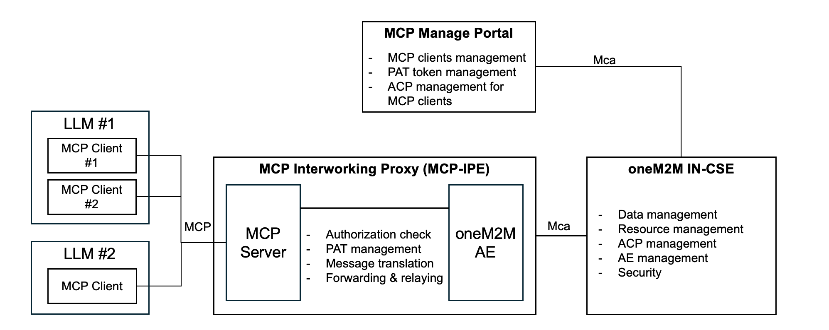
----------------------- End of change 3 -----------------------

--------------------- Start of change 4 ---------------------
media/6.3.1-1.png

---/dev/null
+++b/media/6.3.1-1.png
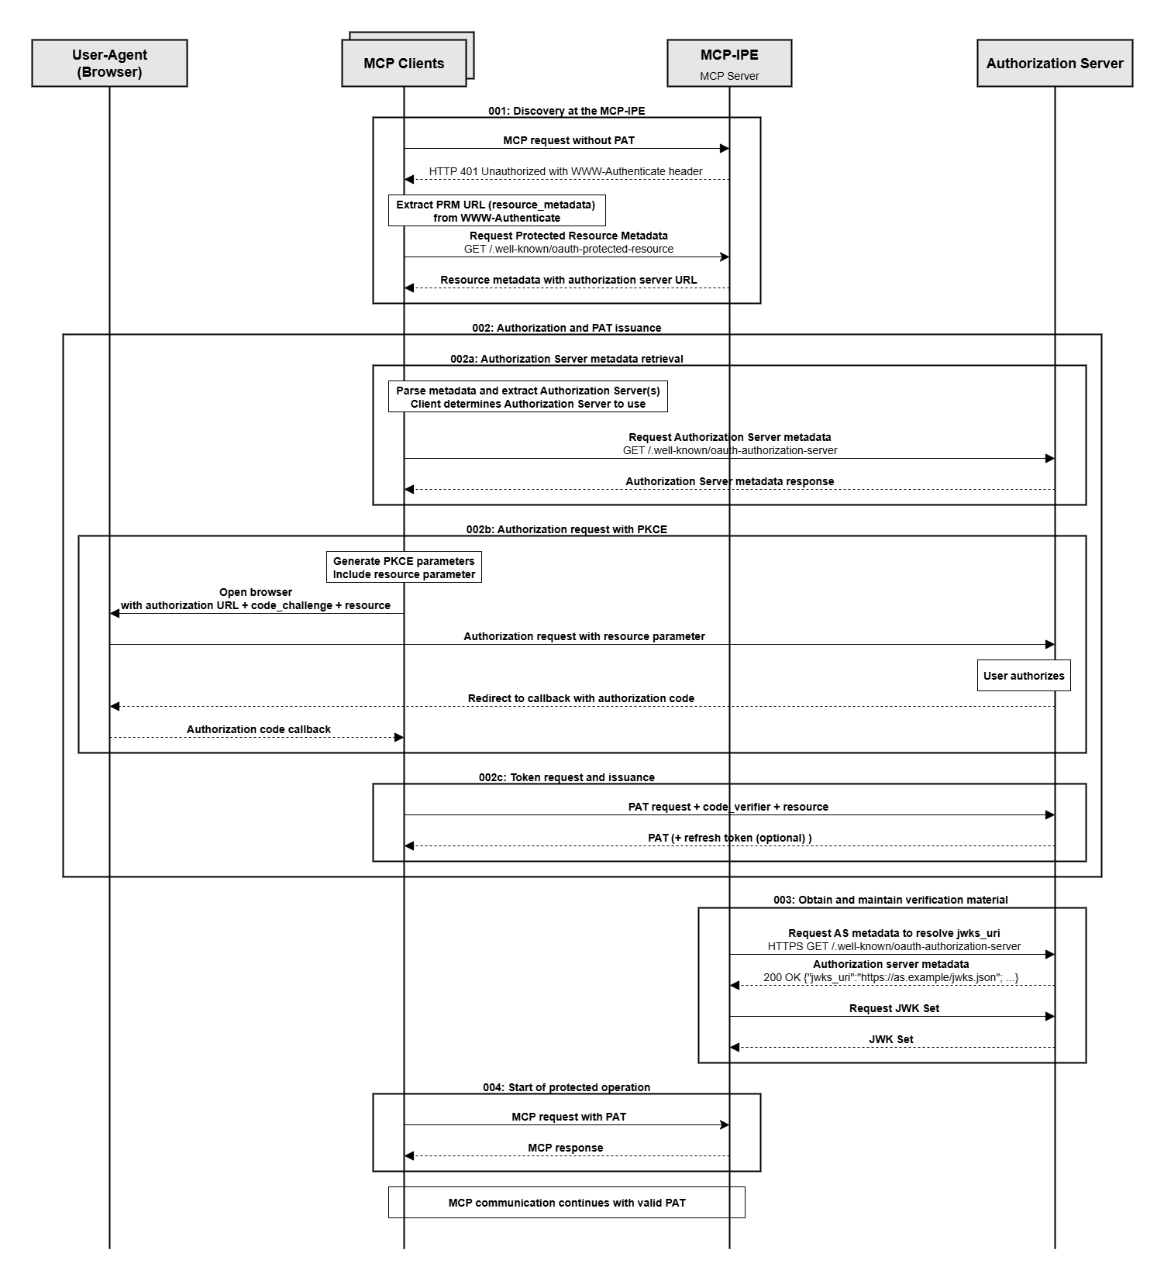
----------------------- End of change 4 -----------------------

--------------------- Start of change 5 ---------------------
media/6.3.2-1.png

---/dev/null
+++b/media/6.3.2-1.png
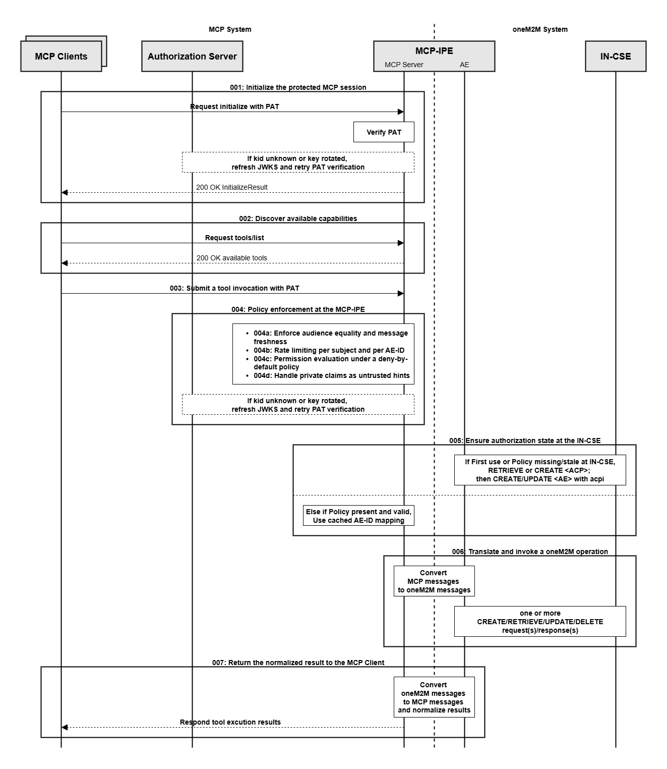
----------------------- End of change 5 -----------------------

--------------------- Start of change 6 ---------------------
media/6.3.3-1.png

---/dev/null
+++b/media/6.3.3-1.png
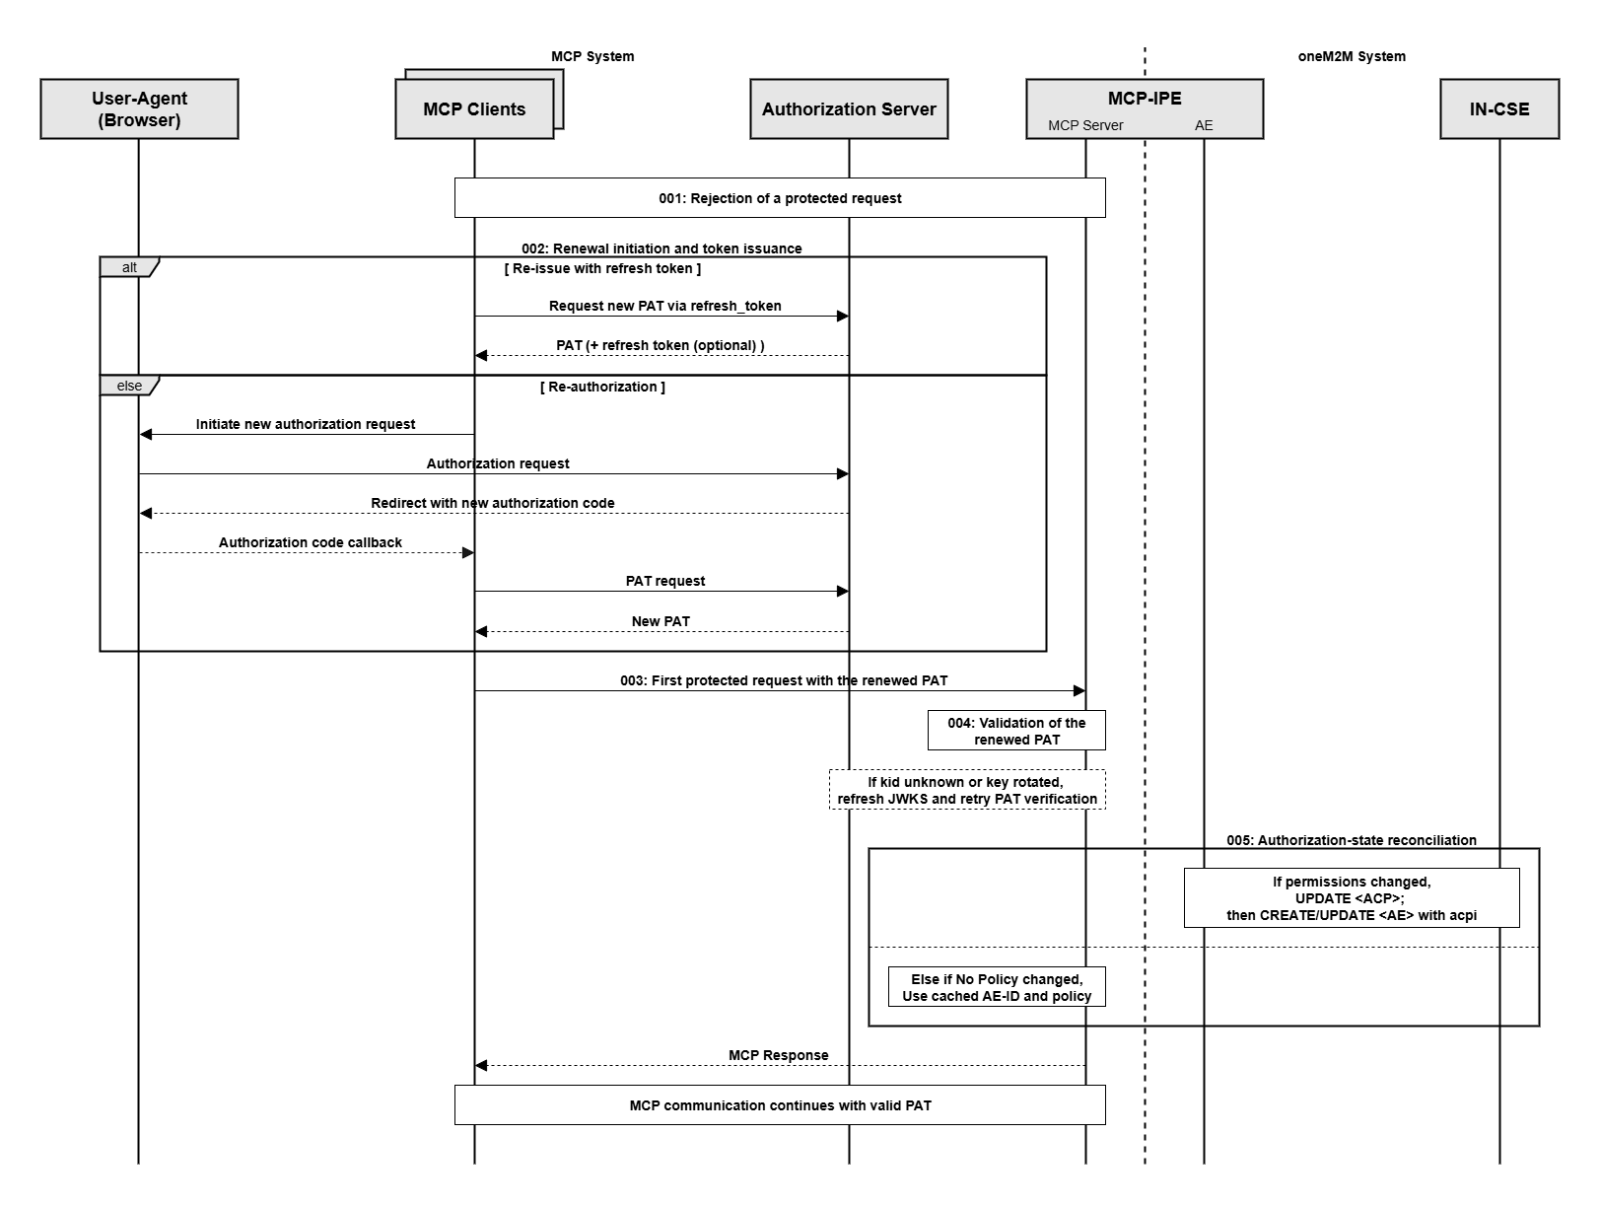
----------------------- End of change 6 -----------------------

