
oneM2M
Technical Specification
Document Number | TR-0081-V-0.0.2
Document Name: | AI Agent Interworking
Date: | 2025-09-23
Abstract: | oneM2M TR-0081 collects studies about solutions that enable oneM2M Interworking  with AI Agents
Template Version: January 2020 (Do not modify)
The present document is provided for future development work within oneM2M only. The Partners accept no liability for any use of this report.
The present document has not been subject to any approval process by the oneM2M Partners Type 1. Published oneM2M specifications and reports for implementation should be obtained via the oneM2M Partners’ Publications Offices.
About oneM2M
The purpose and goal of oneM2M is to develop technical specifications which address the need for a common M2M Service Layer that can be readily embedded within various hardware and software, and relied upon to connect the myriad of devices in the field with M2M application servers worldwide.
More information about oneM2M may be found at: http//www.oneM2M.org
Copyright Notification
- 2025, oneM2M Partners Type 1
All rights reserved.
The copyright and the foregoing restriction extend to reproduction in all media.
Notice of Disclaimer & Limitation of Liability
The information provided in this document is directed solely to professionals who have the appropriate degree of experience to understand and interpret its contents in accordance with generally accepted engineering or other professional standards and applicable regulations. No recommendation as to products or vendors is made or should be implied.
NO REPRESENTATION OR WARRANTY IS MADE THAT THE INFORMATION IS TECHNICALLY ACCURATE OR SUFFICIENT OR CONFORMS TO ANY STATUTE, GOVERNMENTAL RULE OR REGULATION, AND FURTHER, NO REPRESENTATION OR WARRANTY IS MADE OF MERCHANTABILITY OR FITNESS FOR ANY PARTICULAR PURPOSE OR AGAINST INFRINGEMENT OF INTELLECTUAL PROPERTY RIGHTS. NO oneM2M PARTNER TYPE 1 SHALL BE LIABLE, BEYOND THE AMOUNT OF ANY SUM RECEIVED IN PAYMENT BY THAT PARTNER FOR THIS DOCUMENT, WITH RESPECT TO ANY CLAIM, AND IN NO EVENT SHALL oneM2M BE LIABLE FOR LOST PROFITS OR OTHER INCIDENTAL OR CONSEQUENTIAL DAMAGES. oneM2M EXPRESSLY ADVISES ANY AND ALL USE OF OR RELIANCE UPON THIS INFORMATION PROVIDED IN THIS DOCUMENT IS AT THE RISK OF THE USER.

Contents
1 Scope
2 References
2.1 Normative references
2.2 Informative references
3 Definition of terms, symbols and abbreviations
3.1 Terms
3.2 Symbols
3.3 Abbreviations
4 Conventions
5 User defined clause(s) from here onwards
5.1 User defined subdivisions of clause(s) from here onwards
6 Security Aspects of MCP Interworking
6.1 Overview
6.2 High-level security architecture
6.3 Security procedure for MCP Interworking
6.3.1 Authorization procedure (PAT Issuance)
6.3.2 Operation procedure
6.3.3 PAT Re-issue procedure
[Proforma copyright release text block]
[Annexes]
[Annex <A>:Title of annex]
[Annex <B>:Title of annex]
[ First clause of the annex]
B.1.1 First subdivided clause of the annex
[Annex <y>:Bibliography]
History

1 Scope
The present document …
EXAMPLE: The present document provides the necessary adaptions to the endorsed document.
The Scope shall not contain requirements.

2 References
The following text block applies.
References are either specific (identified by date of publication and/or edition number or version number) or nonspecific. For specific references,only the cited version applies. For non-specific references, the latest version of the referenced document (including any amendments) applies.

2.1 Normative references
As a Technical Report (TR) is entirely informative it shall not list normative references.
The following referenced documents are necessary for the application of the present document.
Not applicable.

2.2 Informative references
Clause 2.2 shall only contain informative references which are cited in the document itself.
The following referenced documents are not necessary for the application of the present document but they assist the user with regard to a particular subject area.
- [i.1] oneM2M Drafting Rules https://member.onem2m.org/static_Pages/others/Rules_Pages/oneM2M-Drafting-Rules-V1%202%202.doc
- [i.2] IETF RFC 8414: OAuth 2.0 Authorization Server Metadata https://www.rfc-editor.org/info/rfc8414
- [i.3] IETF RFC 7517: JSON Web Key (JWK) https://www.rfc-editor.org/info/rfc7517
- [i.4] IETF RFC 7636: Proof Key for Code Exchange by OAuth Public Clients https://www.rfc-editor.org/info/rfc7636
- [i.5] IETF RFC 8707: Resource Indicators for OAuth 2.0 https://www.rfc-editor.org/info/rfc8707
- [i.6] IETF RFC 9728: OAuth 2.0 Protected Resource Metadata https://www.rfc-editor.org/info/rfc9728
- [i.7] oneM2M TS-0001: Functional Architecture.
- [i.8] oneM2M TS-0003: Security Solutions.
- [i.9] oneM2M TS-0004: Service Layer Core Protocol.

3 Definition of terms, symbols and abbreviations
Delete from the above heading the word(s) which is/are not applicable.

3.1 Terms
Clause numbering depends on applicability.
- A definition shall not take the form of, or contain, a requirement.
- The form of a definition shall be such that it can replace the term in context. Additional information shall be given only in the form of examples or notes (see below).
- The terms and definitions shall be presented in alphabetical order.
For the purposes of the present document, the [following] terms and definitions [given in … and the following] apply:
Definition format
<defined term>: <definition>
If a definition is taken from an external source, use the format below where [N] identifies the external document which must be listed in Section 2 References.
<defined term>[N]: <definition>
example 1: text used to clarify abstract rules by applying them literally
NOTE: This may contain additional information.

3.2 Symbols
Clause numbering depends on applicability.
For the purposes of the present document, the [following] symbols [given in … and the following] apply:
Symbol format
<symbol> <Explanation>
<2nd symbol> <2nd Explanation>
<3rd symbol> <3rd Explanation>

3.3 Abbreviations
Abbreviations should be ordered alphabetically.
Clause numbering depends on applicability.
For the purposes of the present document, the [following] abbreviations [given in … and the following] apply:
Abbreviation format
<ABBREVIATION1> <Explanation>
<ABBREVIATION2> <Explanation>
<ABBREVIATION3> <Explanation>

4 Conventions
The key words “Shall”, “Shall not”, “May”, “Need not”, “Should”, “Should not” in this document are to be interpreted as described in the oneM2M Drafting Rules [i.1]

5 User defined clause(s) from here onwards
<Text>

5.1 User defined subdivisions of clause(s) from here onwards
<Text>
The following text is to be used when appropriate:

6 MCP interworking

6.1 Security aspects

6.1.1 Overview
The integration of Model Context Protocol (MCP) with oneM2M in Internet of Things (IoT) systems introduces unique security challenges that necessitate dedicated solutions to ensure secure interworking. MCP, designed for contextual data exchange and model-based interactions, enables advanced querying and resource access in IoT environments. However, when MCP clients seek to interact with oneM2M resources—such as creating, retrieving, updating, or deleting data stored in Common Service Entities (CSEs), or invoking administrative procedures such as AE registration and subscription management—potential vulnerabilities arise, including unauthorized access, data leakage, impersonation attacks, and integrity breaches. These risks stem from differences in the protocols’ native security mechanisms: oneM2M relies on Access Control Policies (ACPs) and Application Entity (AE) identifiers for fine-grained authorization, while MCP does not define equivalent built-in controls for cross-protocol operations, leading to exposure if direct access is attempted without mediation.
A security solution is essential to mitigate these issues by providing robust authentication, authorization, and message translation. Without such measures, MCP clients could bypass oneM2M’s security layers, compromising sensitive IoT data or enabling denial-of-service scenarios. The approach should adopt a token-based authentication framework, such as Personal Access Tokens (PATs), which encapsulate client identifiers, issuance/expiration timestamps, permissible resource scopes, and corresponding AE mappings. This enables stateless verification while aligning with oneM2M’s ACP framework. Conceptually, the solution should employ an intermediary proxy (e.g., MCP Interworking Proxy Entity, MCP-IPE) to handle protocol translation, validate access rights, and enforce policies, ensuring that MCP requests are securely mapped to oneM2M operations without exposing underlying resources directly. This proxy-centric model promotes scalability, reduces attack surfaces, and facilitates compliance with IoT security standards like those from oneM2M and related bodies. The MCP-IPE is conceptually bidirectional in the sense that, subject to policy, it may mediate both read-only and state-changing interactions with oneM2M, even though this clause primarily discusses read-oriented use cases.
This proposal does not define a new authorization framework. Instead, it profiles MCP’s existing OAuth 2.0/2.1-based model for secure oneM2M interworking. PATs are standard JWTs issued and validated in conformance with OAuth specifications—utilizing Authorization Server Metadata [i.2], JSON Web Keys [i.3], Proof Key for Code Exchange [i.4], Resource Indicators [i.5], and Protected Resource Metadata [i.6]. The framework therefore remains interoperable with any MCP implementation that already supports OAuth, while introducing oneM2M-specific binding for AE/ACP enforcement and message translation. These tokens can be realized using the Dynamic Authorization framework defined in oneM2M security specifications, but the detailed interaction between the Authorization Server and the CSE remains part of the underlying oneM2M security infrastructure as specified in oneM2M TS-0003. This clause only profiles their use for MCP interworking and does not repeat those procedures. From the perspective of oneM2M security, this interworking pattern corresponds to an indirect dynamic authorization style, in which the MCP-IPE acts as a front-end policy enforcement point that consumes PATs while the CSE and its Dynamic Authorization Service evaluate token state and ACP configuration in accordance with the oneM2M security specifications. Within this report, a PAT is therefore understood as a JWT-based access token that is compatible with the oneM2M token model defined for dynamic authorization, while the exact token serialization and transport remain under the responsibility of the underlying oneM2M security infrastructure. In practice, the solution described in the present clause is mainly targeted at shared CSE deployments where an HTTP-based MCP-IPE mediates external MCP requests; single-user, local deployments (e.g. using the STDIO transport) can rely on simpler arrangements that are outside its scope.

6.1.2 High-level security architecture
The high-level security architecture for MCP-oneM2M interworking is designed around a proxy-mediated framework to ensure secure, controlled access between MCP clients and oneM2M resources. Key components include:
- MCP Client: The originating entity that generates MCP requests to the MCP-IPE (MCP Server). These requests use MCP tools, resources, and prompts, and may result in the MCP-IPE performing operations (e.g., create, retrieve, update, or delete) on oneM2M resources. It obtains and includes a PAT in requests, where the PAT contains the client’s identifier, issuance time, expiration time, authorized resource permissions (including specific resources and permitted operations), and a mapping to a corresponding oneM2M AE identifier.
- MCP Interworking Proxy Entity (MCP-IPE): Acts as the central intermediary, implementing both the MCP Server role (towards the MCP Client) and the oneM2M AE role (towards the CSE), typically within a single software component. The MCP-IPE receives and processes messages from MCP Clients. Depending on the tool implementation, it may not contact the oneM2M CSE at all, may perform a simple pass-through of MCP parameters to oneM2M primitives, or may execute a sequence of multiple oneM2M API calls (e.g., CRUD operations, AE or subscription management) on behalf of the client. The MCP-IPE is responsible for:
  - Authorization Check: Applying token-based at the MCP-IPE using PAT claims and locally cached AE/ACP information, while the final access control decision is enforced by ACPs at the CSE.
  - PAT management: Handling PAT validation (checking expiration, signature, and structural integrity) and key management by obtaining Authorization Server metadata and JSON Web Key Set (JWKS) for local verification.
  - Message Translation: Upon successful validation, translating the MCP message into one or more appropriate oneM2M requests (e.g., mapping MCP methods to oneM2M operations like CREATE/RETRIEVE/UPDATE/DELETE) and inserting the AE identifier into the From parameter for traceability (for the HTTP binding, this corresponds to X-M2M-Origin).
  - Forwarding and Relay: Sending the translated message to the oneM2M CSE and relaying responses back to the MCP Client after reverse translation (converting oneM2M responses to MCP responses).
- Authorization Server: The external entity (following the OAuth 2.0 authorization-server pattern) that issues short-lived PATs bound to the MCP-IPE and publishes discovery metadata and public keys (JWKS) for verification by the MCP-IPE. From the MCP-IPE’s viewpoint, PAT issuance does not require interaction over the Mca reference point; details of any Dynamic Authorization interaction between the Authorization Server and the CSE are defined in oneM2M TS-0003 and are not repeated here.
- oneM2M CSE: The target server hosting IoT resources, enforcing its native security through ACPs linked to registered AEs. It processes only validated oneM2M messages from the MCP-IPE, ensuring no direct exposure to MCP clients.

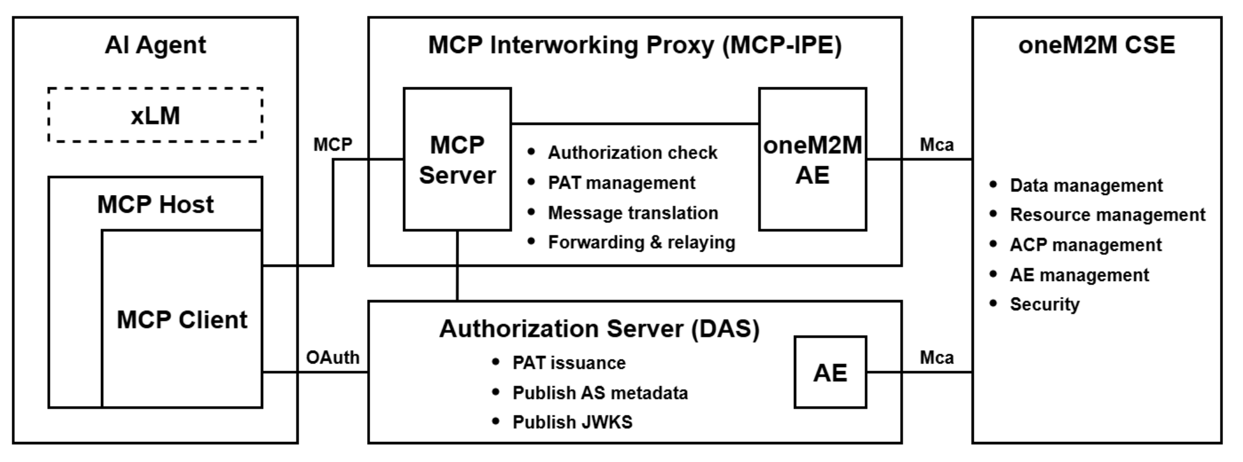
Figure 6.1.2-1: High-level architecture for MCP-interworking security
The architecture operates in a layered manner: (1) PAT issuance, where the MCP Client requests a short-lived token from the Authorization Server that is addressed to the MCP-IPE as the intended recipient. (2) Request processing, involving PAT validation, authorization checks (cross-referencing PAT claims and AE/ACP state), message conversion, and forwarding based on the AE and ACP configuration that is maintained by the operator’s oneM2M security infrastructure; and (3) Response handling, ensuring secure relay without sensitive data leakage. This structure minimizes direct protocol exposure, supports granular access control, and can integrate additional safeguards like encryption (e.g., TLS for transport) and auditing logs, aligning with scalable IoT deployments.
Detailed procedures on the Mca reference point between the MCP-IPE (acting as an IPE and internal AE) and the CSE follow the applicable oneM2M specifications and are out of scope of this clause, which focuses on the security procedure between the MCP Client and the MCP-IPE. The roles of the AE and CSE and the use of the Mca reference point follow oneM2M TS-0001 [i.7] and TS-0004 [i.9].

6.1.3 Security procedure for MCP Interworking
This clause defines the end-to-end authorization and protected operation in which access to the CSE is mediated by the MCP-IPE on behalf of the MCP Client, while preserving oneM2M’s resource-centric authorization based on ACP and AE identifier. This procedure uses short-lived Personal Access Tokens (PATs). A PAT is presented to the MCP-IPE only and is not forwarded to the CSE; this enables continued client–proxy communication without repeated credential entry and limits exposure through short lifetimes. PATs are renewed to address expiry, changes in effective permissions, and key rotation. For clarity, this clause assumes the MCP interface is deployed over HTTP using JSON-RPC 2.0; other transports (e.g., STDIO) are out of scope here. At the MCP-IPE, MCP requests are processed and translated into corresponding oneM2M operations, which are then invoked over Mca by the MCP-IPE’s internal AE; the CSE processes only oneM2M operations under ACP enforcement. The MCP-IPE is the sole endpoint for MCP requests, maintaining a clear separation between the MCP and oneM2M domains.
The procedure in this clause is therefore intended for shared CSE deployments with an HTTP-based MCP-IPE deployed close to the CSE to terminate external MCP requests and apply additional security controls. In single-user deployments where a CSE instance is used only for personal purposes and the MCP Server runs locally (e.g. via the STDIO transport), this procedure may be applied as a recommended defence-in-depth pattern but is not expected as a baseline practice.

The procedure is organized into three stages:
- Authorization (token issuance). The MCP Client discovers the Authorization Server designated for the MCP-IPE and requests a short-lived PAT that is addressed to the MCP-IPE as the intended recipient. Using a PAT enables continued client–proxy communication without repeated credential entry; the short lifetime limits exposure. From the MCP-IPE’s viewpoint, PAT issuance is performed by the Authorization Server and does not involve the MCP-IPE.
- Protected operation. The MCP Client presents the PAT to the MCP-IPE when sending MCP requests. At the MCP-IPE, the token is validated and a token-based authorization is checked against the token’s permissions and the applicable AE/ACP policy. For each MCP Client, one AE and one ACP at the CSE are configured for authorization by the operator’s oneM2M security infrastructure, and the permissions claim indicates which oneM2M operations are to be authorized for this AE instead of an OAuth 2.0 scope parameter. The request is then prepared for the CSE, including required headers (e.g., From parameter). When needed, the MCP-IPE’s internal AE invokes the corresponding oneM2M operation over Mca using the AE-ID derived from the PAT, relying on the AE and ACP state that is maintained by the oneM2M security infrastructure. The CSE enforces ACP and returns status codes and results; these are relayed to the MCP Client without exposing sensitive data. The PAT is not forwarded to the CSE.
- PAT renewal. When the PAT expires or effective permissions need to change, the MCP Client refreshes or re-authorizes with the Authorization Server. The Authorization Server issues a new PAT. Any subsequent policy or authorization-state changes on the oneM2M side are handled by the oneM2M security infrastructure and are reflected when the next protected operation is processed.

6.1.3.1 Authorization procedure (PAT Issuance)
This procedure describes issuance of a PAT used for authorization at the MCP-IPE. The MCP Client first contacts the MCP-IPE without a PAT to obtain information about the Authorization Server required for issuance. The MCP Client then communicates with the Authorization Server to obtain and store a short-lived PAT designated for use with the MCP-IPE as the intended recipient. From the MCP-IPE’s viewpoint, issuance does not require interaction with the CSE. Any interaction between the Authorization Server and the CSE, as defined by the oneM2M Dynamic Authorization framework in TS-0003 Clause 7.1.3, belongs to the underlying oneM2M security infrastructure and is not described in this clause.
PAT satisfies the following conditions:
- PAT is a signed JWT; its signature is verified with a key discoverable via the Authorization Server’s metadata (e.g., JWKS).
- PAT is short-lived to limit exposure and to enable periodic renewal.
- Target designation: PAT includes an audience claim (aud) that identifies the MCP-IPE (MCP Server) as the intended recipient.
- PAT includes registered claims sufficient for local verification at the MCP-IPE: issued-at (iat), expiration time (exp), optionally not-before (nbf), issuer (iss), audience (aud), subject (sub), and a JWT ID (jti). The JWT ID (jti) serves as a stable identifier for the token instance at the MCP-IPE and can be correlated, where configured by the operator’s security infrastructure, with token identifiers such as Token-Id or Local-Token-Id defined in the oneM2M security specifications.
- Boundary and secrecy: PAT is presented to the MCP-IPE only and is not forwarded to the CSE; the token does not include oneM2M secrets.
- Private claims used at the MCP-IPE as token-based authorization parameters and are cross-checked against AE/ACP state at the CSE:
  - onem2m_aeid: an AE identifier (AE-ID) mapped one-to-one to the MCP Client. In this profile, the subject (sub) identifies the principal behind the MCP Client (e.g., a user or agent), and onem2m_aeid identifies the corresponding AE at the CSE. When dynamic authorization is executed at the CSE, the subject (sub), the AE identifier (onem2m_aeid), and the ACPs are evaluated together in line with the oneM2M token model, even though only the AE identifier is carried in oneM2M requests.
  - permissions: a least-privilege set expressed as tuples {operation, target_path, resource_type} used to describe the allowed actions for the AE; because the structured tuples can describe fine-grained oneM2M operations and resource paths more explicitly than generic scope values. These tuples are interpreted as policy input for token-based checks at the MCP-IPE and for AE/ACP provisioning within the oneM2M security infrastructure rather than representing ACPs embedded inside the token.

Pre-conditions.
- Communications among the involved entities are protected by transport security.
- The MCP-IPE (MCP Server) exposes OAuth Protected Resource Metadata (PRM) at a well-known location. PRM provides, at minimum, the authorization server locations, the issuer information, and the resource identifier used to derive the audience.
- PAT issuance is performed between the Authorization Server and the MCP Client and does not require interaction over the Mca reference point .
- The Authorization Server publishes Authorization Server Metadata and a JWKS reachable by the MCP-IPE for local verification of the PAT. The MCP-IPE is to maintain availability of the issuer’s metadata and keys (e.g., by caching and periodic refresh) so that signature verification, key selection via kid, and key rotation can be handled without on-line introspection.
- Each MCP Client is provisioned with the MCP-IPE endpoint and discovery parameters in its MCP configuration. Per-agent registration differs by implementation, but the configuration includes sufficient information to reach the MCP-IPE and to follow PRM-based discovery.

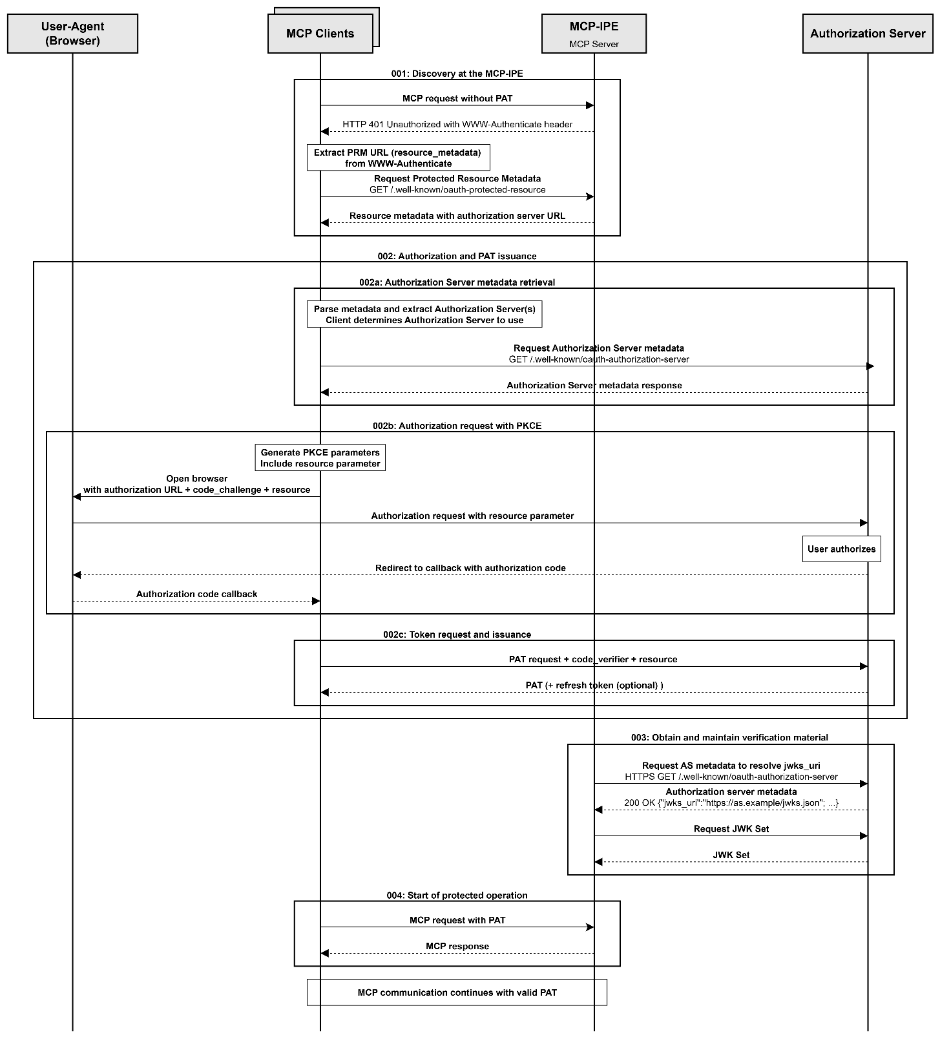Figure 6.1.3.1-1: Authorization procedure (PAT Issuance)

Procedure.
Step 001: Discovery at the MCP-IPE
The MCP Client contacts the MCP-IPE without a PAT to trigger discovery and obtains a reference to OAuth PRM that identifies the canonical resource identifier and the Authorization Server candidates. Alternatively, the MCP Client retrieves PRM from the MCP-IPE’s well-known endpoint. When discovery is triggered by a HTTP authentication challenge, the reference is carried in the WWW-Authenticate header as a resource_metadata parameter.
Step 002a: Authorization Server metadata retrieval
The MCP Client retrieves Authorization Server Metadata (issuer, authorization_endpoint, token_endpoint, jwks_uri, and relevant capabilities) from the selected Authorization Server and caches the issuer and endpoints. When multiple Authorization Servers are advertised, the MCP Client selects one according to local policy and caches the selection. This metadata is used to locate the authorization and token endpoints, and to obtain the JWKS for signature verification.
Step 002b: Authorization request with Proof Key for Code Exchange (PKCE)
The MCP Client initiates an Authorization Code request with PKCE through the User-Agent to the Authorization Server, including a resource indicator that identifies the MCP-IPE as the intended recipient. PKCE is used to prevent authorization-code interception for public clients (e.g., browser) by verifying a code_verifier that corresponds to the previously supplied code_challenge. On success, the Authorization Server returns an authorization code to the MCP Client.
Step 002c: Token request and issuance
The MCP Client exchanges the authorization code at the token endpoint with the code_verifier and the same target designation. The issued PAT includes an audience (aud) that identifies the MCP-IPE as the intended recipient. The Authorization Server issues a short-lived PAT (and, if applicable, a refresh token) for use with the MCP-IPE, and returns the token(s) to the MCP Client.
Step 003: Obtain and maintain verification material
The MCP-IPE resolves Authorization Server metadata and obtains the current JWKS referenced by jwks_uri prior to validating any PAT; keys are cached by kid and refreshed on expiry or on key mismatch.
Step 004: Start of protected operation
The MCP Client starts the protected MCP interaction by presenting the PAT in the Authorization header to the MCP-IPE. Subsequent processing follows the Operation procedure in Clause 6.1.3.2.
Alternative flows.
A001) If authorization is denied or a device flow expires, the Authorization Server returns an authorization error. From the MCP-IPE’s viewpoint, this alternative flow does not involve any interaction over the Mca reference point; any other interaction between the Authorization Server and the oneM2M domain, if present, is handled within the underlying security infrastructure and is not described here.

Post-conditions.
- The MCP Client holds a valid PAT whose aud identifies the MCP-IPE as the intended recipient.
- This procedure does not specify creation or modification of any AE or ACP at the CSE; such provisioning is handled by the oneM2M security infrastructure and management procedures outside the scope of this clause.
- Verification material for subsequent PAT validation—Authorization Server Metadata and the JWKS referenced by jwks_uri—is maintained by the MCP-IPE; obtaining or refreshing such material does not involve interaction with the CSE.

6.1.3.2 Operation procedure
This procedure describes the protected interaction between the MCP Client and the MCP-IPE. The MCP Client presents a PAT with each protected request; the MCP-IPE verifies the token using the issuer’s metadata and keys and applies freshness, replay, rate, and permission checks with permissions claim in the PAT cross-checked against AE/ACP state. The MCP-IPE derives the From parameter from the resolved AE, prepares required headers, and invokes the corresponding oneM2M operation over Mca. The CSE enforces ACP and returns result status codes (RSC), which are relayed in the MCP response; the PAT is not forwarded to the CSE.
This clause focuses on security-relevant behaviour (PAT validation, policy enforcement, and exposure boundaries); the mapping between MCP tools and oneM2M primitives is illustrative and may involve no oneM2M request, a single request, or a multi-step sequence depending on the tool.
Pre-conditions.
- The MCP Client holds a valid PAT whose aud identifies the MCP-IPE as the intended recipient, and the PAT is within its validity period.
- Authorization Server Metadata and the JWKS identified by jwks_uri are available to the MCP-IPE for local verification; keys are current and selected by kid.
- The MCP-IPE’s internal AE can reach the CSE over the Mca reference point.
- The clocks of the MCP Client and the MCP-IPE are within the operator-defined skew window to support freshness evaluation.
- Each protected request includes a client-created timestamp and a unique request identifier.

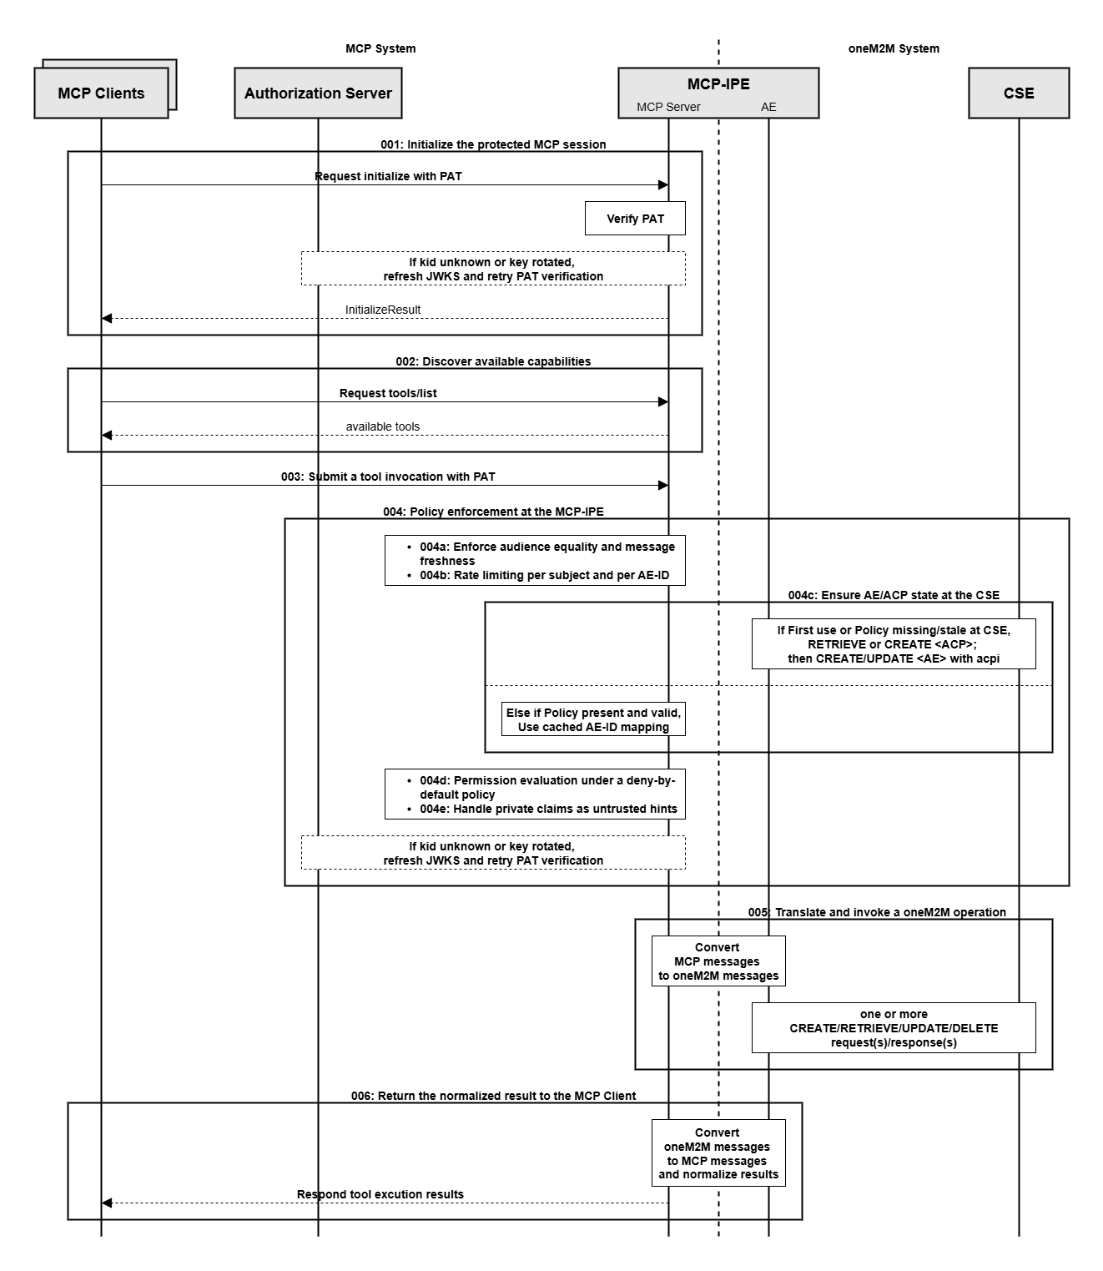
Figure 6.1.3.2-1: Operation procedure

Procedure.
Step 001: Initialize the protected MCP session
The MCP Client sends initialize with Authorization: Bearer <PAT> header. The MCP-IPE verifies the PAT signature and claims locally using the issuer’s metadata and the JWKS with key selection by kid. On success, the MCP-IPE returns an InitializeResult that includes a capability summary (e.g., available listing functions, supported operations, size limits, required headers, and stable reason-code categories) and references to operational policies (e.g., freshness and replay requirements) and, when provided, a session identifier. The purpose of initialization is to confirm token validity, publish operational policy references, and provide a concise capability summary for subsequent requests.
Step 002: Discover available capabilities
The MCP Client retrieves the list of available capabilities (e.g., tools/list, resources/list, prompts/list) and the MCP-IPE returns the applicable entries. This step enumerates the run-time capabilities available to the resolved AE under the current ACP; the result can be narrower than the capability summary returned at initialization. For example, a discovery function may be exposed that enumerates a oneM2M container (CNT) path and resource types available to the mapped AE. The MCP-IPE filters tools/list, resources/list and prompts/list responses according to the effective permissions and AE/ACP state so that capabilities that would be rejected by policy are not advertised.
Step 003: Submit a tool invocation with PAT
MCP requests are JSON-RPC 2.0 messages; the MCP Client sends tools/call (method and params) with Authorization: Bearer <PAT> header.
Step 004: Policy enforcement at the MCP-IPE
Before any CSE invocation, the MCP-IPE applies local verification and policy controls. If the kid is unknown or rotated, the MCP-IPE refreshes the JWKS and retries local verification. Validation results and AE/ACP mappings may be cached per PAT (e.g., per jti) to avoid repeated discovery, provided that each request still passes freshness, replay, and rate-limiting checks. The following controls are applied:
- Step 004a: Enforce audience equality and message freshness
The MCP-IPE verifies that the PAT’s aud identifies the MCP-IPE’s canonical resource identifier, evaluates the request timestamp within the allowed skew and window, and suppresses replay; failures are handled locally without contacting the CSE.
- Step 004b: Rate limiting per subject and per AE-ID
The MCP-IPE applies rate limits per subject and per AE-ID and returns 429 Too Many Requests on excess; a Retry-After header is included when applicable.
- Step 004c: Ensure AE and ACP presence at the CSE (ACP → AE)
When the AE or ACP for the MCP Client is missing or out of date according to operator policy, the MCP-IPE’s internal AE performs existence or consistency checks against the CSE using oneM2M management procedures. Creation and modification of AEs and ACPs are performed by the operator’s oneM2M security infrastructure in accordance with oneM2M security and management specifications and are not specified in this clause.
After this step, the MCP-IPE updates its local cache for the MCP Client with the AE-ID and a local view of the applicable ACP policy. Subsequent token-based checks at the MCP-IPE compare PAT claims such as onem2m_aeid and permissions against this cached information, while ACP-based authorization for oneM2M requests is enforced only at the CSE.
- Step 004d: Permission evaluation under a deny-by-default policy
The MCP-IPE evaluates the private claim permissions {operation, target_path, resource_type} against the effective least-privilege policy for the AE. Requests that are not in the allowed set are rejected locally with a 403 error.
- Step 004e: Handling private claims as token-based authorization parameters
If present, onem2m_aeid is treated as a token-based authorization parameter and is validated against the authoritative mapping and CSE state.

Step 005: Translate and invoke a oneM2M operation over Mca
The MCP-IPE translates the MCP request into the corresponding oneM2M operation and does not forward the PAT. The internal AE invokes the CSE over Mca with the From parameter set to the AE-ID and the Request Identifier set to the request identifier (for the HTTP binding, these correspond to X-M2M-Origin and X-M2M-RI respectively, and other required headers such as X-M2M-RVI as applicable); the body carries the converted content. The CSE enforces ACP and returns a oneM2M response with RSC and payload.
Step 006: Normalize the result and record an audit entry
The MCP-IPE normalizes the oneM2M response into an MCP response: RSC semantics are preserved; internal identifiers, resource tree paths, ACP details, and transport-specific headers are not exposed; and stable reason codes are provided for diagnostics. The MCP-IPE returns the normalized result to the MCP Client and records an audit entry that , at minimum, includes a timestamp, the request identifier, the effective AE-ID, the reason code, and the outcome; sensitive token material is not logged. Implementations may additionally record a pseudonymous token identifier (e.g., jti) for correlation without exposing full token contents.
Alternative flows.
A001) If the PAT’s aud does not identify the MCP-IPE’s canonical resource identifier, the MCP-IPE returns 401 Unauthorized and does not contact the CSE.
A002) If PAT verification, freshness, replay, rate, permission evaluation, or mapping fails, the MCP-IPE rejects locally with an appropriate error and does not contact the CSE.
A003) If the CSE returns a non-success RSC, the MCP-IPE propagates the status with minimal shaping.

Post-conditions.
- Authorized requests are executed at the CSE as oneM2M operations under ACP enforcement; required headers (e.g., From parameter) are derived by the MCP-IPE from the effective AE.
- Requests that fail local checks—PAT verification, freshness/replay evaluation, rate limiting, or permission evaluation—are handled at the MCP-IPE and do not reach the CSE.
- Replay attempts, audience mismatches against the MCP-IPE’s canonical resource identifier, and permission violations are rejected locally at the MCP-IPE; no call is issued to the CSE.
- The PAT is presented to the MCP-IPE only and is not forwarded to the CSE.
- The response returned to the MCP Client is normalized: oneM2M RSC semantics are preserved, internal identifiers and token material are not exposed, and an audit entry is recorded with the request identifier, the effective AE-ID, a stable reason code, and the outcome.
- At the CSE, the AE identifier and token-related identifiers that are derived from the PAT by the underlying security infrastructure are evaluated together with ACPs and other security state, so that dynamic authorization procedures defined in oneM2M TS-0003 can be applied without redefining them in this clause.

6.1.3.3 PAT Re-issue procedure
This procedure describes renewal of the PAT used for protected MCP requests. The PAT is short-lived and is reused across requests until it expires; a renewal process is therefore required. Renewal is initiated when local verification at the MCP-IPE rejects the token because it is expired or not yet valid, signature or key selection fails (e.g., rotated kid), the audience does not identify the MCP-IPE as the intended recipient, or policy-relevant claims have changed. The MCP Client obtains a new PAT from the Authorization Server using a refresh token when available or by re-authorization. From the MCP-IPE’s viewpoint, renewal does not require interaction over the Mca reference point. On the next request, the MCP-IPE verifies the renewed PAT and proceeds with the operation; where claims affecting authorization have changed, policy is re-evaluated at the MCP-IPE, and any resulting changes to AE or ACP state at the CSE are handled by the oneM2M security infrastructure before the next oneM2M operation is invoked.

Pre-conditions.
- The MCP Client has a renewal path: either a refresh token or a re-authorization flow to obtain a new PAT from the Authorization Server; the issuer and endpoints (authorization_endpoint, token_endpoint) are known or discoverable from PRM or Authorization Server Metadata.
- Authorization Server Metadata and the JWKS referenced by jwks_uri are available to the MCP-IPE for local verification of renewed PATs; keys are current and selected by kid.
- The MCP-IPE’s canonical resource identifier is established so that the renewed PAT’s aud identifies the MCP-IPE as the intended recipient.
- The MCP-IPE’s internal AE can reach the CSE over Mca for subsequent oneM2M operations when claims affecting authorization have changed; any authorization-state reconciliation at the CSE is handled by the oneM2M security infrastructure and is not specified in this clause.
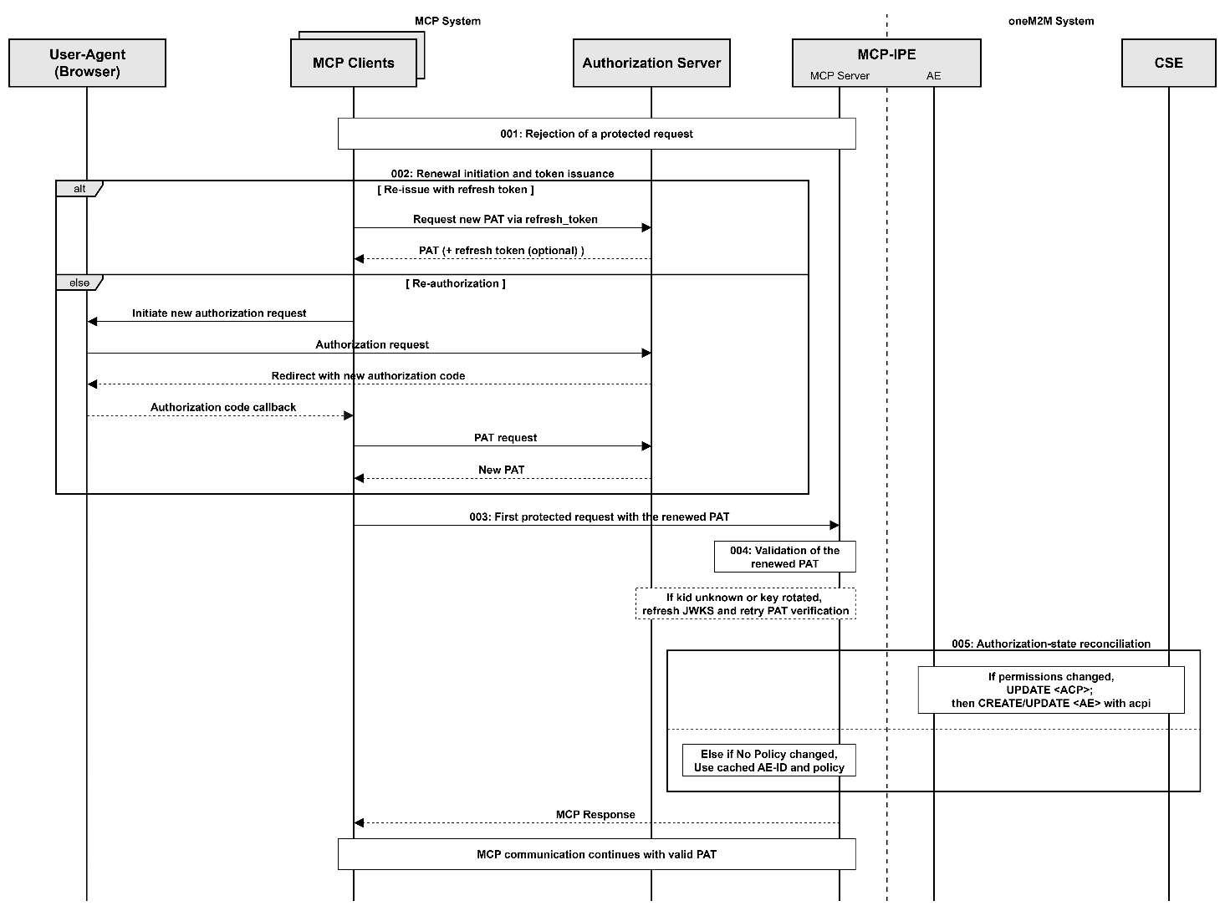
Figure 6.1.3.3-1: PAT Re-issue procedure

Procedure.
Step 001: Rejection of a protected request
When a protected MCP request arrives with an expired, malformed, or otherwise unacceptable PAT, the MCP-IPE returns 401 Unauthorized with a WWW-Authenticate reference to PRM or Authorization Server Metadata and does not contact the CSE. When the PAT is valid but authorization is insufficient for the requested operation/target/resource type, the MCP-IPE returns 403 Forbidden with a local policy reason and does not contact the CSE.
If information from the Authorization Server or from the operator’s oneM2M security infrastructure indicates that a PAT has been revoked, the MCP-IPE treats the token as invalid independently of local cache state and responds as for an expired or otherwise unacceptable PAT; the mechanisms used to convey revocation status are part of the underlying security infrastructure and are not described in this clause.
Step 002: Renewal initiation and token issuance
The MCP Client obtains a new PAT from the Authorization Server using a refresh token when available, or by re-authorization. The renewed PAT identifies the MCP-IPE as the intended recipient via its audience claim. Issuance is handled by the Authorization Server; any related oneM2M security procedures follow TS-0003 and are not described in this clause.
Step 003: First protected request with the renewed PAT
The MCP Client sends the next MCP request (e.g., initialize or the previously failed tools/call) with the renewed PAT..
Step 004: Validation of the renewed PAT at the MCP-IPE
Upon receipt of a protected request with the renewed PAT, the MCP-IPE validates the token—signature, time validity, audience identifying the MCP-IPE—prior to translating or invoking any oneM2M operation. If the signing key is not available locally (e.g., an unknown or rotated kid), the MCP-IPE retrieves the current JWKS via jwks_uri, selects the key by kid, and completes validation before processing.
Step 005: Authorization-state reconciliation at the CSE
If claims affecting authorization have changed (e.g., permissions narrowed or AE hints updated), the MCP-IPE re-evaluates its local policy for the MCP Client (e.g., capability filtering, deny-by-default checks, and rate or replay limits) based on the renewed PAT. Any authorization-state reconciliation at the CSE is performed by the operator’s oneM2M security infrastructure and is not specified in this clause.
Alternative flows.
A001) If renewal is denied (e.g., invalid grant, consent declined, or policy conflict), the Authorization Server returns an authorization error;
A002) If the renewed PAT’s audience does not identify the MCP-IPE as the intended recipient, the MCP-IPE returns 401 Unauthorized on the next protected request; the CSE is not contacted.
Post-conditions.
- The MCP Client holds a valid PAT whose aud identifies the MCP-IPE as the intended recipient and is within its validity period.
- At the CSE, the AE and its ACP reflect the effective least-privilege permissions applicable at the time of operation; no change is implied when authorization has not changed. When authorization becomes more restrictive, this clause assumes that existing AE and ACP resources remain under the control of the oneM2M security infrastructure and are not implicitly deleted by PAT renewal; updated policies are applied when subsequent oneM2M requests are evaluated.
- Requests that are unauthorized or invalid are handled at the MCP-IPE and do not reach the CSE.
- The PAT is not forwarded beyond the MCP-IPE.

Proforma copyright release text block
This text box shall immediately follow after the heading of an element (i.e. clause or annex) containing a proforma or template which is intended to be copied by the user. Such an element shall always start on a new page.
Notwithstanding the provisions of the copyright clause related to the text of the present document, oneM2M grants that users of the present document may freely reproduce the <proformatype> proforma in this {clause|annex} so that it can be used for its intended purposes and may further publish the completed <proformatype>.
<PAGE BREAK>

Annexes
Each annex shall start on a new page (insert a page break between annexes A and B, annexes B and C, etc.).

Annex <A>:
Title of annex
<Text>
<PAGE BREAK>

Annex <B>:
Title of annex
<Text>

First clause of the annex
<Text>

B.1.1 First subdivided clause of the annex
<Text>
<PAGE BREAK>

Annex <y>:
Bibliography The annex entitled “Bibliography” is optional.
It shall contain a list of standards, books, articles, or other sources on a particular subject which are not mentioned in the document itself.
It shall not include references mentioned in the document.
- <Publication>: “<Title>”.
OR
<Publication>: “<Title>”.
<PAGE BREAK>

History
This clause shall be the last one in the document and list the main phases (all additional information will be removed at the publication stage).
Publication history
V1.1.1
Draft history table to be removed on publication
Draft history
V0.0.1 | 2025-XX-YY | initial TR skeleton
V0.0.2 | 2025-09-23 | Includes the following contributions agreed during SDS#71  meeting:SDS-2025-0149R01 Security aspect of MCP interworking

