

oneM2M
Technical Report
Document Number | oneM2M-TR-0006-Study_of_Management_Capability_Enablement-V0_3_0
Document Name: | Study of Management Capability Enablement Technologies for Consideration by oneM2M
Date: | 2013-July-31
Abstract: | Collect and describe the state-of-the-art technologies (e.g. OMA DM and BBF TR069) that are relevant to oneM2M management capabilities. Analyze the collected technologies to match with the oneM2M requirements on management aspects;  Evaluate the possibility of leveraging all or part of those technologies by oneM2M to enable its management capability.

oneM2M IPR and copyright statements
“Participation in, or attendance at, any activity of oneM2M, constitutes acceptance of an agreement to be bound by all provisions of IPR policy of the admitting Partner Type 1 and permission that all communications and statements, oral or written, or other information disclosed or presented, and any translation or derivative thereof, may without compensation, and to the extent such participant or attendee may legally and freely grant such copyright rights, be distributed, published, and posted on oneM2M’s web site, in whole or in part, on a non-exclusive basis by oneM2M or oneM2M Partners Type 1 or their licensees or assignees, or as oneM2M SC directs.

Contents
Contents 2
1 Scope 5
2 References 5
2.1 Normative references 5
2.2 Informative references 5
3 Definitions, symbols, abbreviations and acronyms 6
3.1 Definitions 6
3.2 Symbols 6
3.3 Abbreviations 7
3.4 Acronyms 7
4 Conventions 8
5 Introduction of existing technologies 8
5.1 Introduction to OMA DM 8
5.1.1 Description 8
5.1.2 Architecture 9
5.1.3 Reference points 9
5.1.3.1 Introduction 10
5.1.3.2 DM-1 DM Client-Server Notification 10
5.1.3.3 DM-2 DM Client-Server Protocol 10
5.1.3.4 DM-3 DM Bootstrap Profile via Smart Card 10
5.1.3.5 DM-4 DM Bootstrap Profile OTA 10
5.1.3.6 CP-1 CP Bootstrap Profile 10
5.1.3.7 DM-6 DM Server-Server Interface 10
5.1.3.8 Procedures 10
5.1.4 Protocols 11
5.1.4.1 Protocol Stack 11
5.1.4.2 Application MO 11
5.1.4.3 DM Protocol 11
5.1.4.4 DM Representation 11
5.1.4.5 Binding to transports and Transports 12
5.1.5 Functions 12
5.1.5.1 Introduction 12
5.1.5.2 The MO tree 12
5.1.5.2.1 Standard Objects 13
5.1.5.2.2 Other Management Objects 13
5.2 TR-069 Family of Specifications 14
5.2.1 Description 14
5.2.2 Architecture 14
5.2.2.1 TR-069 Proxy Management 15
5.2.2.1.1 Proxied Device Deployment Archirecture 16
5.2.3 Reference points 16
5.2.4 Protocols 16
5.2.4.1 ACS to CPE Protocol 16
5.2.4.2 CPE to BSS 17
5.2.4.2.1 IPDR Reference Points 18
5.2.4.3 CPE to Device Protocol 19
5.2.4.3.1 UPnP Proxy 19
5.2.4.3.2 ZigBee Proxy 19
5.2.5 Functions 21
5.3 Introduction to OMA LightweightM2M (LWM2M) 21
5.3.1 Description 21
5.3.2 Architecture 22
5.3.3 Reference Points 22
5.3.3.1 Functional Components 22
5.3.3.1.1 LWM2M Server 22
5.3.3.1.2 LWM2M Client 23
5.3.3.2 Interfaces 23
5.3.4 Protocols 23
5.3.4.1 Protocol Stack 23
5.3.4.2 Resource Model 24
5.3.4.3 Interface Descriptions 24
5.3.4.3.1 Device Discovery and Registration 24
5.3.4.3.2 Bootstrap 25
5.3.4.3.3 Device Management and Service Enablement 25
5.3.4.3.4 Information Reporting 26
5.3.5 Functions 26
5.4 Introduction to OMA Device Management 2.0 27
5.4.1 Description 27
5.4.2 Architecture 27
5.4.3 Reference Points 28
5.4.3.1 Functional Components 28
5.4.3.1.1 DM Client 28
5.4.3.1.2 DM Server 28
5.4.3.1.3 Web Server Component 28
5.4.3.1.4 Web Browser Component 28
5.4.3.1.5 Data Repository 28
5.4.3.2 Interfaces 29
5.4.4 Protocol 29
5.4.4.1 DM Packages 29
5.4.4.2 DM Commands 30
5.4.5 Functions 30
5.4.5.1 Introduction 30
5.4.5.2 Management Objects supported by OMA DM 2.0 31
5.4.5.3 Detailed Comparisons with OMA DM 1.x 31
5.4.5.4 Protocol Examples 32
6 Gap analysis of existing relevant technolgoies 33
6.1 Management related requirements gap analysis reference 33
6.2 MGR-001 34
6.2.1 Requirement Description 34
6.2.2 OMA DM 1.3 34
6.2.3 BBF TR069 34
6.2.4 OMA DM LWM2M 35
6.2.5 OMA DM 2.0 35
6.3 MGR-002 35
6.3.1 Requirement Description 35
6.3.2 OMA DM 1.3 and OMA DM 2.0 35
6.3.3 BBF TR069 36
6.3.4 OMA DM LWM2M 36
6.4 MGR-003 37
6.4.1 Requirement Description 37
6.4.2 OMA DM 1.3 and OMA DM 2.0 37
6.4.3 BBF TR069 37
6.4.4 OMA DM LWM2M 37
6.5 MGR-004 37
6.5.1 Requirement Description 37
6.5.2 OMA DM 1.3 and OMA DM 2.0 37
6.5.3 BBF TR069 38
6.5.4 OMA DM LWM2M 38
6.6 MGR-005 38
6.6.1 Requirement Description 38
6.6.2 OMA DM 1.3 and OMA DM 2.0 38
6.6.3 BBF TR069 38
6.6.4 OMA DM LWM2M 38
6.7 MGR-006 39
6.7.1 Requirement Description 39
6.7.2 OMA DM 1.3 and OMA DM 2.0 39
6.7.3 BBF TR069 39
6.7.4 OMA DM LWM2M 39
6.8 MGR-007 39
6.8.1 Requirement Description 39
6.8.2 OMA DM 1.3 and OMA DM 2.0 39
6.8.3 BBF TR069 39
6.8.4 OMA DM LWM2M 40
6.9 MGR-008 40
6.9.1 Requirement Description 40
6.9.2 OMA DM 1.3 and OMA DM 2.0 40
6.9.3 BBF TR069 40
6.9.4 OMA DM LWM2M 40
6.10 MGR-009 41
6.10.1 Requirement Description 41
6.10.2 OMA DM 1.3 and OMA DM 2.0 41
6.10.3 BBF TR069 41
6.10.4 OMA DM LWM2M 41
6.11 MGR-010 41
6.11.1 Requirement Description 41
6.11.2 OMA DM 1.3 and OMA DM 2.0 41
6.11.3 BBF TR069 41
6.11.4 OMA DM LWM2M 42
6.12 MGR-011 42
6.12.1 Requirement Description 42
6.12.2 OMA DM 1.3 and OMA DM 2.0 42
6.12.3 BBF TR069 42
6.12.4 OMA DM LWM2M 42
6.13 MGR-012 42
6.13.1 Requirement Description 42
6.13.2 OMA DM 1.3 and OMA DM 2.0 42
6.13.3 BBF TR069 42
6.13.4 OMA DM LWM2M 43
6.14 MGR-013 43
6.14.1 Requirement Description 43
6.15 MGR-014 43
6.15.1 Requirement Description 43
6.16 MGR-015 43
6.16.1 Requirement Description 43
6.17 MGR-016 43
6.17.1 Requirement Description 43
7 oneM2M Architectural Considerations 44
7.1 Introduction 44
7.2 Current Management Deployment Scenarios 44
7.2.1 Managed Device Using Network Operator Management 44
7.2.2 Managed Device Using Service Provider Management 44
7.3 Possible Future Management Deployment Scenarios 45
7.3.1 Shared Managed Device Using Network Operator Management 45
7.3.2 Shared Managed Device Using Service Provider Management 45
7.3.3 Shared Managed Device Using Separate Management 46
7.3.4 Federated Managed Device Using Separate Management 47
7.3.5 Conclusions To Guide the Device Management Architecture 47
7.4 Management Generalized Architectural Framework 48
Annex <y>: Bibliography 50
History 50

1 Scope
The present document describes and collects the state-of-art of the existing technologies on management capability, evaluates if the technologies can match the requirements defined in oneM2M, analyzes how the technologies can leverage the design of the architecture of oneM2M.
Editor’s note: the title of this TR needs further study to e.g. separate the management of application and device.

2 References
References are either specific (identified by date of publication and/or edition number or version number) or non-specific. For specific references, only the cited version applies. For non-specific references, the latest version of the referenced document (including any amendments) applies.

2.1 Normative references
Not applicable.

2.2 Informative references
The following referenced documents are not necessary for the application of the present document but they assist the user with regard to a particular subject area.
- Use the EX style, add the letter "i" (for informative) before the number (which shall be in square brackets) and separate this from the title with a tab (you may use sequence fields for automatically numbering references, (see example).
[i.1] oneM2M Drafting Rules (http://member.onem2m.org/Static_pages/Others/Rules_Pages/oneM2M-Drafting-Rules-V1_0.doc)
[i.2] OMA-AD-DM-V1_3 “Device Management Architecture”
[i.3] OMA-TS-DM_Protocol-V1_3 “OMA Device Management Protocol”
[i.4] OMA-TS-DM_RepPro-V1_3 “OMA Device Management Representation Protocol”
[i.5] OMA-TS-DM_StdObj-V1_3 “OMA Device Management Standardized Objects”
[i.6] OMA-TS-DCMO-V1-0: “Device Capability Management Object”
[i.7] OMA-TS-LAWMO-V1-0: “Lock and Wipe Management Object”
[i.8] OMA-TS-DM-FUMO-V1-0: “Firmware Update Management Object”,.
[i.9] OMA-TS-DM-SCOMO-V1-0: “Software Component Management Object”, Version 1.0.
[i.10] OMA-TS-GwMO-V1-0: “Gateway Management Object Technical Specification”, Version 1.0.
[i.11] OMA-TS-DiagMonFunctions-1-0: “DiagMon Functions Supplemental Specification”, Version 1.0.
[i.12] OMA-AD-GwMO-V1_1-20130214-D “Gateway Management Object Architecture”
[i.13] BBF TR-069 CPE WAN Management Protocol Issue: 1 Amendment 4, July 2011
[i.14] BBF MR-239 Broadband Forum Value Proposition for Connected Home Issue: 1, April 2011
[i.15] BBF TR-232 Bulk Data Collection Issue: 1, May 2012
[i.16] TMForum IPDR Service Specification Design Guide, Version 3.8, Release 1.0, 2009
[i.17] ZigBee Alliance ZigBee Specification: ZigBee Documents 053474r17, 2008
[i.18] OMA-RD-LightweightM2M-V1_0”OMA Lightweight Machine to Machine Requirement”
[i.19] OMA-AD-LightweightM2M-V1_0 “OMA Lightweight Machine to Machine Architecture”
[i.20] OMA-TS-LightweightM2M-V1_0 “OMA Lightweight Machine to Machine Protocol” (work on progress)
[i.21] Shelby, Z., Hartke, K., Bormann, C., and B. Frank, "Constrained Application Protocol (CoAP)", draft-ietf-core-coap-14 (work in progress), Sept 2012.
[i.22] Rescorla, E. and N. Modadugu, "Datagram Transport Layer Security Version 1.2", RFC 6347, January 2012.
[i.23] oneM2M-TS-0002-Requirements-V0_4_0
[i.24] ETSI M2M TS 103 092 OMA DM compatible Management Objects for ETSI M2M v2.1.1
[i.25] “Device Management Requirements”, Version 2.0, Open Mobile Alliance™, OMA-RD-DM-V2_0, http://www.openmobilealliance.org/
[i.26] “Device Management Architecture”, Version 2.0, Open Mobile Alliance™, OMA-AD-DM-V2_0, http://www.openmobilealliance.org/
[i.27] “OMA Device Management Protocol”, Version 2.0, Open Mobile Alliance™, OMA-TS-DM-V2_0, http://www.openmobilealliance.org/
[i.28] “Enabler Release Definition for Firmware Update Management Object”, Version 1.0, Open Mobile Alliance™, OMA-ERELD-FUMO-V1_0, http://www.openmobilealliance.org/

3 Definitions, symbols, abbreviations and acronyms

3.1 Definitions
For the purposes of the present document, the [following] terms and definitions [given in ... and the following] apply:
<defined term>: <definition>
<defined term>[N]: <definition>
example 1: text used to clarify abstract rules by applying them literally
NOTE: This may contain additional information.

3.2 Symbols
For the purposes of the present document, the [following] symbols [given in ... and the following] apply:
<symbol> <Explanation>
<2nd symbol> <2nd Explanation>
<3rd symbol> <3rd Explanation>

3.3 Abbreviations
For the purposes of the present document, the [following] abbreviations [given in ... and the following] apply:

3.4 Acronyms
For the purposes of the present document, the [following] abbreviations [given in ... and the following] apply:
ACS Auto-Configuration Server
BSS Business Support System
CoAP Constrained Application Protocol
CPE Customer Premises Equipment
CWMP CPE WAN Management Protocol
DM Device Management
DTLS Datagram Transport Layer Security
GW Gateway
HTTP Hypertext Transfer Protocol
IP Internet Protocol
IPDR Internet Protocol Detail Record
IrDA Infrared Data Association
MO Management Object
OBEX OBject EXchange
OMA Open Mobile Alliance
OSS Operation Support System
OTA Over The Air
PAN Personal Area Network
SIP Session Initiation Protocol
SMS Short Message Service
TR Technical Report
UDP User Datagram Protocol
UI User Interaction
WAP Wireless Application Protocol
WSP Wireless Session Protocol
ZC ZigBee Coordinator
ZDO ZigBee Device Object
ZED ZigBee End Device
ZR ZigBee Router

4 Conventions
The key words “Shall”, ”Shall not”, “May”, ”Need not”, “Should”, ”Should not” in this document are to be interpreted as described in the oneM2M Drafting Rules [i.1].

5 Introduction of existing technologies

5.1 Introduction to OMA DM
Editor’s Note: The chapter is to introduce certain kind of device management technology. All the description in the chapter is the introduction to the currently existing technology. The relation between the technology and oneM2M is not covered in this section.

5.1.1 Description
Editor’s Note: The chapter is to give description to the technology
OMA DM is a protocol for device management designed by Open Mobile Alliance. It’s widely used in the remote management of mobile devices. It is composed of a number of specifications including protocol, architecture, underlying network binding etc. In the most common scenario, by implementing OMA DM specifications, the DM Server is able to do remote management on devices with DM Clients which are usually mobile phones. The devices could also include sensors, actuators, and gateways as well. With implementing the Management Object and the DM Client, the DM Server can perform remote management on devices such as provisioning, diagnostics, firmware upgrade, and remove, install, activate software components.
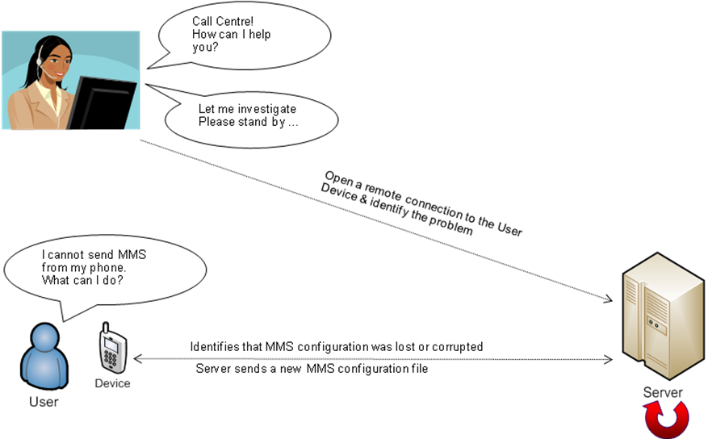
Figure 5.1.1: OMA DM Use Case
As is shown from Figure 5.1.1, the user of a mobile phone doesn’t know what to do when his mobile is unable to send out MMS. After calling to the Call Center, the operator of the Call Center can remotely upgrade the MMS configuration file via OMA DM Server.
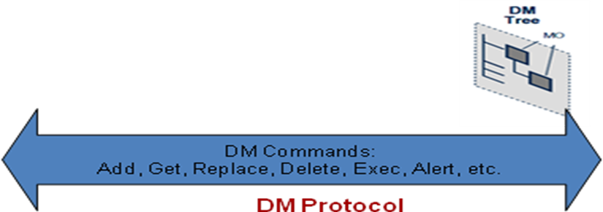
Figure 5.1.2: Device Management Protocol
OMA DM protocol deploys management between a DM Client and a DM Server as Figure 5.1.2. DM Server can send DM commands to DM Client to manage the device. The DM Client can also send command to DM Server to indicate the result corresponding to the commands from DM Server. A group of tree structured Management Objects are used to manage the device.

5.1.2 Architecture
Editor’s Note: The chapter is to give the high level architecture of the technology and the corresponding description.
Figure 5.1.3: Architecture and Reference Points
DM Server2
DM Server1
DM-6

DM Client
DM-1
DM-2
Smart Card
OTA Provisioning Server
CP Enabler
DM-3
DM-4
CP-1
DM Gateway
DM-1
DM Enabler
DM-1
The architecture of OMA Device Management Enabler is shown in Figure 5.1.3 [i.2] . Functional components which are DM Server and DM Client compose the DM Enabler. Components Smart Card, OTA Provisioning Server and CP Enabler are outside of the DM Enabler. They are used to bootstrap the DM Client.
DM Server can also manage a device with DM Client through a DM Gateway. DM Gateway can be deployed in DM-1 interface in Transparent Mode, Proxy Mode or Adaption Mode [i.12].

5.1.3 Reference points
Editor’s Note: The chapter is to introduce the reference point.

5.1.3.1 Introduction
This clause introduces the interfaces carried over the reference points between DM Server, DM Client, Smart Card, OTA Provision Server and CP Enabler. Also the procedures of packages exchanged via these interfaces are also briefly introduced.

5.1.3.2 DM-1 DM Client-Server Notification
The DM-1 interface provides the ability for the DM Servers to send device management notifications to the DM Clients. Because devices with DM Clients may not be able to continuously listen for connection all the time, DM Server may send notifications to DM Client to start a DM session. More details can be referred to [i.2]

5.1.3.3 DM-2 DM Client-Server Protocol
The interface provides the ability for the DM Servers and DM Clients to exchange DM commands and corresponding responses. The interface can be bound to different underlying protocols including HTTP and HTTPS. More details can be referred to [i.2].

5.1.3.4 DM-3 DM Bootstrap Profile via Smart Card
Bootstrap via Smart Card is one way to provision a DM Client. The DM Client gets all the related configuration settings from the Smart Card. More details can be referred to [i.2].

5.1.3.5 DM-4 DM Bootstrap Profile OTA
Bootstrap via push protocol over the air can provision necessary configuration setting file to DM Client. The file contains a series of DM Commands. More details can be referred to [i.2].

5.1.3.6 CP-1 CP Bootstrap Profile
Bootstrap via CP enabler can provision necessary configuration setting file to DM Client. The file contains a series of DM Commands. More details can be referred to [i.2].

5.1.3.7 DM-6 DM Server-Server Interface
DM Server-Server Interface enables one DM Server delegate the management of a device to another DM Server. More details can be referred to [i.2].

5.1.3.8 Procedures
Server
Client
Package 0: alert from the DM Server
Package 1: client initialization with client credentials and device information
Setup phase
Package 2: server initialization with server credentials, initial management operations or user interaction commands from the server
Server
Client
Management phase
Package 3: client response to server management operations
Package 4: more user interaction and management operations if the session is continued.
Figure 5.1.4: DM Phases
The interaction between Client and Server is achieved by Packages. OMA DM Protocol consists of two parts: setup phase (authentication and device information exchange) and management phase. Management phase can be repeated as many times as the DM Server wishes. The setup phase is composed of Pachage#0, Package#1 and Package#2. The management phase is composed of Package#3 and Package#4 as shown in Figure 5.1.4[i.3].

5.1.4 Protocols
Editor’s Note: The chapter is to give the protocol stack used between the reference points.

5.1.4.1 Protocol Stack
Application MO
DM Protocol
DM Representation
Binding to transports
Transports
Figure 5.1.5: Protocol Stack
As shown in Figure 5.1.5, the protocol stack of OMA DM is composed of five layers which are Application MO, DM Protocol, DM Representation, Binding to transports and Transports.

5.1.4.2 Application MO
The Management Object is built on top of the DM Protocol to be transferred to fulfil the management of devices. MO is implemented in the device with DM Client and DM Server to carry on the management. DM Server manages the device by operation to the MO through DM Client. The introduction to the MOs will be shown in chapter 5.1.5.

5.1.4.3 DM Protocol
DM Protocol is the Packages exchanged between the entities of OMA DM. As is described in the reference point part, OMA DM uses these Packages to exchange the MO between DM Client and DM Server.

5.1.4.4 DM Representation
OMA DM uses DM representation syntax and semantics for device management. The DM representation is carried in the XML formatted DM Messages between OMA DM entities. The DM representation protocol also can be identified as a MIME content type.
The DM representation protocol is performed in a request/response way using the concept of DM Package. The concept of DM Package is shown in the Procedure chapter. It’s used to carry the device management operations.
A DM Message is a well-formed XML document and adheres to the DTD.
OMA DM uses SyncML as the container for the DM Message. SyncML was first designed and used by OMA CP, and was reused by OMA DM. SyncML provides a set of tags and syntaxes to mark up the language to be understandable to both DM Clients and DM Servers.
Details can be referred to [i.4].

5.1.4.5 Binding to transports and Transports
TCP/IP
IrDA
WAP

OBEX
SIP
Push OTA
DM Message
Push OTA
HTTP
WSP
Figure 5.1.6: OMA DM Transports
OMA DM provides the following ways for transporting DM Messages which are HTTP, OBEX, WSP, SIP and Push OTA as shown in Figure 5.1.6 OMA DM Transports.

5.1.5 Functions
Editor’s Note: The chapter makes a list of all the functionalities supported by the technology and describes how the function is achieved.

5.1.5.1 Introduction
The device management functionalities are achieved by the Management Objects defined by OMA DM and some other third party organizations.

5.1.5.2 The MO tree
Figure 5.1.7: MO tree
OMA DM uses Management Object to management the device. The MOs forms a tree structure and the tree is stored with the DM Client. Each MO in the tree is a node. If the MO has child Nodes, the MO is an Interior Node. Otherwise, the MO is a Leaf Node. Nodes in the Management Tree can be either permanent or dynamic.
Permanent Nodes are typically built in at device manufacture. Permanent Nodes can also be temporarily added to a device by, for instance, connecting new accessory hardware. A DM Server cannot modify permanent Nodes at run-time.
Dynamic Nodes can be created and deleted at run-time by DM Servers. DM Server use Add and Delete command to create or delete Dynamic Nodes. If the deleted Dynamic Nodes is a Interior Node, all the related Nodes which are the children of the Interior Node shall also be deleted.

5.1.5.2.1 Standard Objects
The MOs that shall be supported by DM Client and DM Server are standard objects. Standard objects expose basic information of the DM Client for the DM Server to perform managements.

Management Object | Reference | Description
DMAcc | [i.5] | Settings for the DM client in a managed device.
DevInfo | [i.5] | Device information for the OMA DM server. Sent from the client to the server. Needed by the DM Server for problem free operation of the DM protocol.
DevDetail | [i.5] | General device information that benefits from standardization. DevDetail contains parameters that are manipulated by the server for the operation purposes.
Inbox | [i.5] | Reserved URI where the device SHOULD use the management object identifier to identify the absolute URI.
Table 5.1.1: Standard Objects

5.1.5.2.2 Other Management Objects
Besides the Standard Objects, there may be other Management Objects to carry on further management functionalities as well. MOs that are considered as relevant to the management of M2M Devices or Gateways are listed in Table 5.1.2.
Management Object | Reference | Description
SCOMO | [i.9] | Device information collection, remote configuration, software management
DIAGMON | [i.11] | Diagnostics and monitoring
GwMO | [i.10] | Managements to devices through gateway.
FUMO | [i.8] | Firmware update
DCMO | [i.6] | Specify the mechanisms required for the remote management of device capabilities.
LAWMO | [i.7] | The MO is designed to protect user and enterprise-related data by means including Lock/Unlock Device, Wipe Device’s Data and Factory Reset
<TBD> | <TBD> | <TBD>
Table 5.1.2: Other MOs
Editor’s note: Table 5.1.2 is to be further populated.

5.2 TR-069 Family of Specifications

5.2.1 Description
The Broadband Forum has developed a series of specifications that have been termed the TR-069 Family of Specifications. These specifications provides the capability to manage CPEs within the connected home. MR-239 Broadband Forum Value Proposition for Connected Home Issue: 1, April 2011 provides an overview of the value proposition for utilizing the TR-069 family of specifications for the connected home.

5.2.2 Architecture
The TR-069 family of specifications is anchored by the TR-069 specification for the base CWMP protocol.
Included in the the capability for the ACS to manage devices that are CWMP capable. In Figure 5.2.1: TR-069 Family of Specifications this capability is defined as TR-069: Proxy Management as defined in BBF MR-239 Broadband Forum Value Proposition for Connected Home Issue: 1, April 2011.
Figure 5.2.1: TR-069 Family of Specifications
In addition Service Providers are increasingly interested in retrieving large quantities of data from their installed CPE base at regular intervals. The amount of data being requested represents a significant portion of the CPE’s data model and is thus a large amount of data. In response to this, the Broadband Forum has documented a data collection solution in TR-232 Bulk Data Collection. This specification is based on the IPDR protocol from the TMForum.
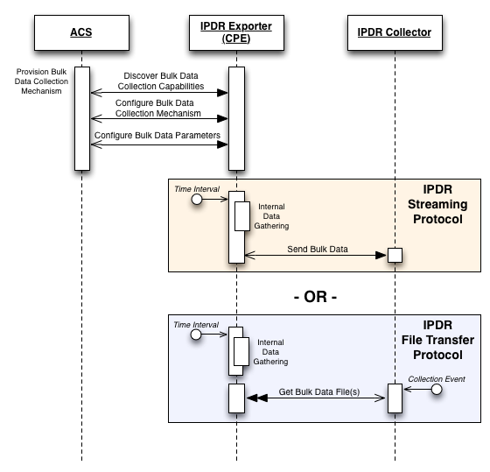
Figure 5.2.2: TR-232 Bulk Data Collection

5.2.2.1 TR-069 Proxy Management
CWMP can be extended to devices that do not have a native CWMP Endpoint of their own, but instead support another management protocol or “Proxy Protocol”. A CPE Proxier is a CPE that supports a CWMP Endpoint(s) and also supports one or more Proxy Protocols (example services include UPnP DM, Z-Wave etc.). A CPE Proxier uses these Proxy Protocols to manage the devices connected to it, i.e. the Proxied Devices. This approach is designed to support Proxy Protocols of all types that can exist in the CPE network now or in the future. Annex J of the BBF TR-069 CPE WAN Management Protocol Issue: 1 Amendment 4, July 2011 provides an overview of CWMP Proxy Management.
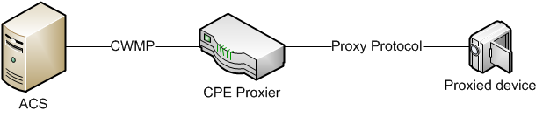
Figure 5.2.3: Proxy management terminology

5.2.2.1.1 Proxied Device Deployment Archirecture
Figure 5.2.4: TR-069 UPnP Proxied Device depicts an example scenario where a proxied device that supports the UPnP protocol is managed using CWMP.
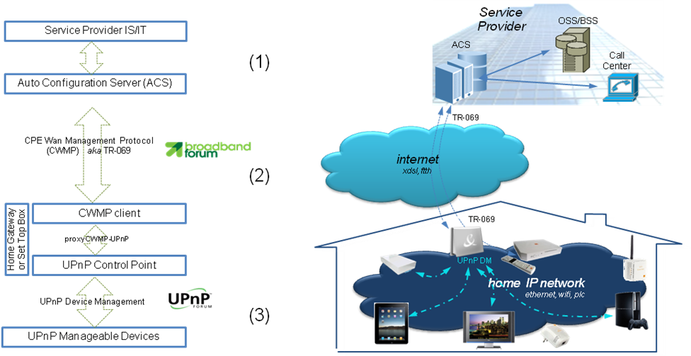
Figure 5.2.4: TR-069 UPnP Proxied Device
The entities include the Service Provider OSS/BSS systems that interface with the ACS (1); the CWMP and IPDR protocols between the ACS and the TR-069 enabled CPE (2) and the Home Area Network protocol UPnP (3).

5.2.3 Reference points
The reference points that have been standardized for the TR-069 family of specifications includes:
- ACS to CPE
- CPE to BSS
- CPE to Device

5.2.4 Protocols

5.2.4.1 ACS to CPE Protocol
The protocol that is supported on the ACS to CPE reference point is the CWMP Protocol.The CPE WAN Management Protocol as defined in BBF TR-069 CPE WAN Management Protocol Issue: 1 Amendment 4, July 2011 takes a layered approach to the protocol based on several standard protocols for transport and exchange of messages. The protocol stack defined by the CPE WAN Management Protocol is shown in Figure 5.2.5. A brief description of each layer is provided in Table 5.2.1.
Figure 5.2.5: Protocol stack
Layer | Description
CPE/ACS Application | The application uses the CPE WAN Management Protocol on the CPE and ACS, respectively. The application is locally defined and not specified as part of the CPE WAN Management Protocol.
RPC Methods | The specific RPC methods that are defined by the CPE WAN Management Protocol. These methods are specified in CPE WAN Management Protocol.
SOAP | A standard XML-based syntax used here to encode remote procedure calls. Specifically SOAP 1.1, as specified in Simple Object Access Protocol (SOAP) 1.1.
HTTP | HTTP 1.1, as specified in RFC 2616, Hypertext Transfer Protocol -- HTTP/1.
TLS | The standard Internet transport layer security protocol. Specifically, TLS 1.2 (Transport Layer Security) as defined in RFC 5246, The Transport Layer Security (TLS) Protocol, Version 1.2 (or a later version). Note that previous versions of this specification referenced SSL 3.0 and TLS 1.0.
TCP/IP | Standard TCP/IP.
Table 5.2.1: Protocol layer summary

5.2.4.2 CPE to BSS
The protocol that is supported on the CPE to BSS reference point is the IPDR protocol. The IPDR reference architecture is presented in Figure 5.2.6 is defined in TMForum IPDR Service Specification Design Guide, Version 3.8, Release 1.0, 2009. The figure depicts a Service Element communicating to an IPDR Recorder that sends messages to the IPDR Transmitter and optionally to an IPDR Store. BBF TR-232 Bulk Data Collection Issue: 1, May 2012 utilizes the A and D interfaces of this specification where the Service Element is a device within the Connected Home.
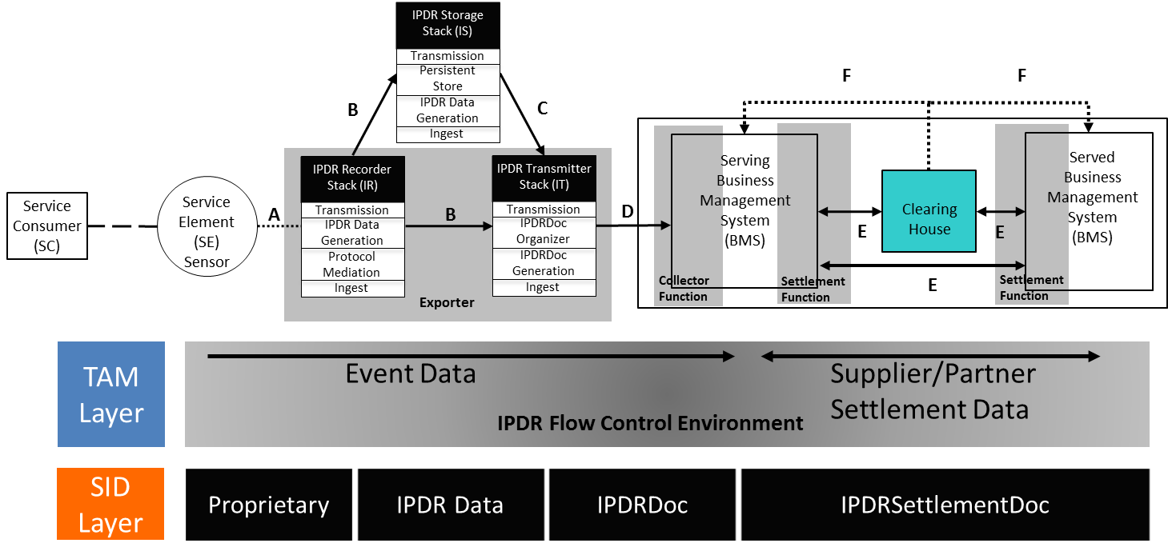
Figure 5.2.6: IPDR Reference Architecture
From the perspective of the Broadband Forum, the CPE or device is the Service Element and IPDR Exporter. The IPDR Data Collector is the BSS. As described in Annex A IPDR Theory of Operaton of BBF TR-232 Bulk Data Collection Issue: 1, May 2012, the IPDR documentation clarifies that the following scenario, where the Service Element directly communicates to the BSS, is valid and simply means that the IPDR Recorder and IPDR Transmitter (collectively the IPDR Exporter in this use case) are all incorporated into the Service Element. The Service Element is permitted to directly interface with the BSS if it supports the “D” interface specifications including backing stores and retransmission of IPDR documents.
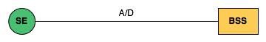
Figure 5.2.7: Simplified IPDR Architecture

5.2.4.2.1 IPDR Reference Points
BBF TR-232 Bulk Data Collection Issue: 1, May 2012 defines 6 interfaces and 4 defintions for the IPDR Reference Model:
Interface | Description
A | Vendor proprietary. High-volume with high granularity void of context. This interface is not part of the IPDR Protocol.
B | IPDR Data Interface. From IPDR Recorders to IPDR Stores or IPDR Transmitters.
C | IPDR Store Export Interface.
D | BSS Interface. XML or XDR data from IPDR Exporter to IPDR Collector
E | Settlement Interface. Connects Service Delivery Business Management Systems.
F | Financial System Interface. This interface is not part of the IPDR Protocol.
Table 5.2.2: IPDR Interfaces
The IPDR File Transfer Protocol uses FTP or HTTP to transfer files that contain IPDR records from the SE to the BSS. The IPDR Streaming Protocol uses SCTP or TCP to transfer IPDR records from the SE to the BSS using highly efficient XDR encoding as described in the IPDR/XDR Encoding Format document or an XML encoding as described in the IPDR/XML File Encoding Format document.

5.2.4.3 CPE to Device Protocol
The TR-069 proxy mechanism is designed to incorporate any protocol for area networks within the customer premises. The following protocols have been standardized or are currently in development:
- UPnP
- ZigBee

5.2.4.3.1 UPnP Proxy
The CPE Proxier consists of three logical modules: CWMP client, TR-069/UPnP DM Proxy Module and UPnP DM Control Point. CWMP requests received by the CWMP client from the ACS are translated by the TR-069/UPnP DM Proxy Module to the UPnP DM actions, and then passed to the UPnP DM Control Point to be sent to the UPnP DM devices. When an UPnP action response or event is received by the UPnP DM Control Point, the action response and event is passed to the TR-069/UPnP DM Proxy Module to be converted to a CWMP response or sent to the ACS using the CWMP event notification mechanism.
Figure 5.2.8: TR-069/UPnP DM Proxy Management Architecture

5.2.4.3.2 ZigBee Proxy
Figure 5.2.9 and Figure 5.2.10 present the principle and an example basic sequence for the management of ZigBee devices by using TR-069 with the ZigBee data model.
The ZigBee devices reside behind a GW and communicate with the ACS via this GW. The GW resides normally in a CPE such as a broadband router (home gateway or business gateway). The GW has a proxy function to change a CWMP message to a ZDO function invocation based on the ZigBee data model object. The proxy function changes messages by referring to a mapping of ZigBee data model objects and CWMP methods to ZDO functions and their parameters. A management example is shown in Figure 5.2.10.
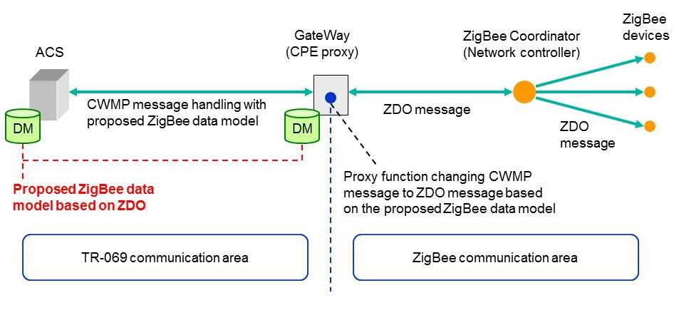
Figure 5.2.9: Usage of the data model to manage ZigBee devices with TR-069
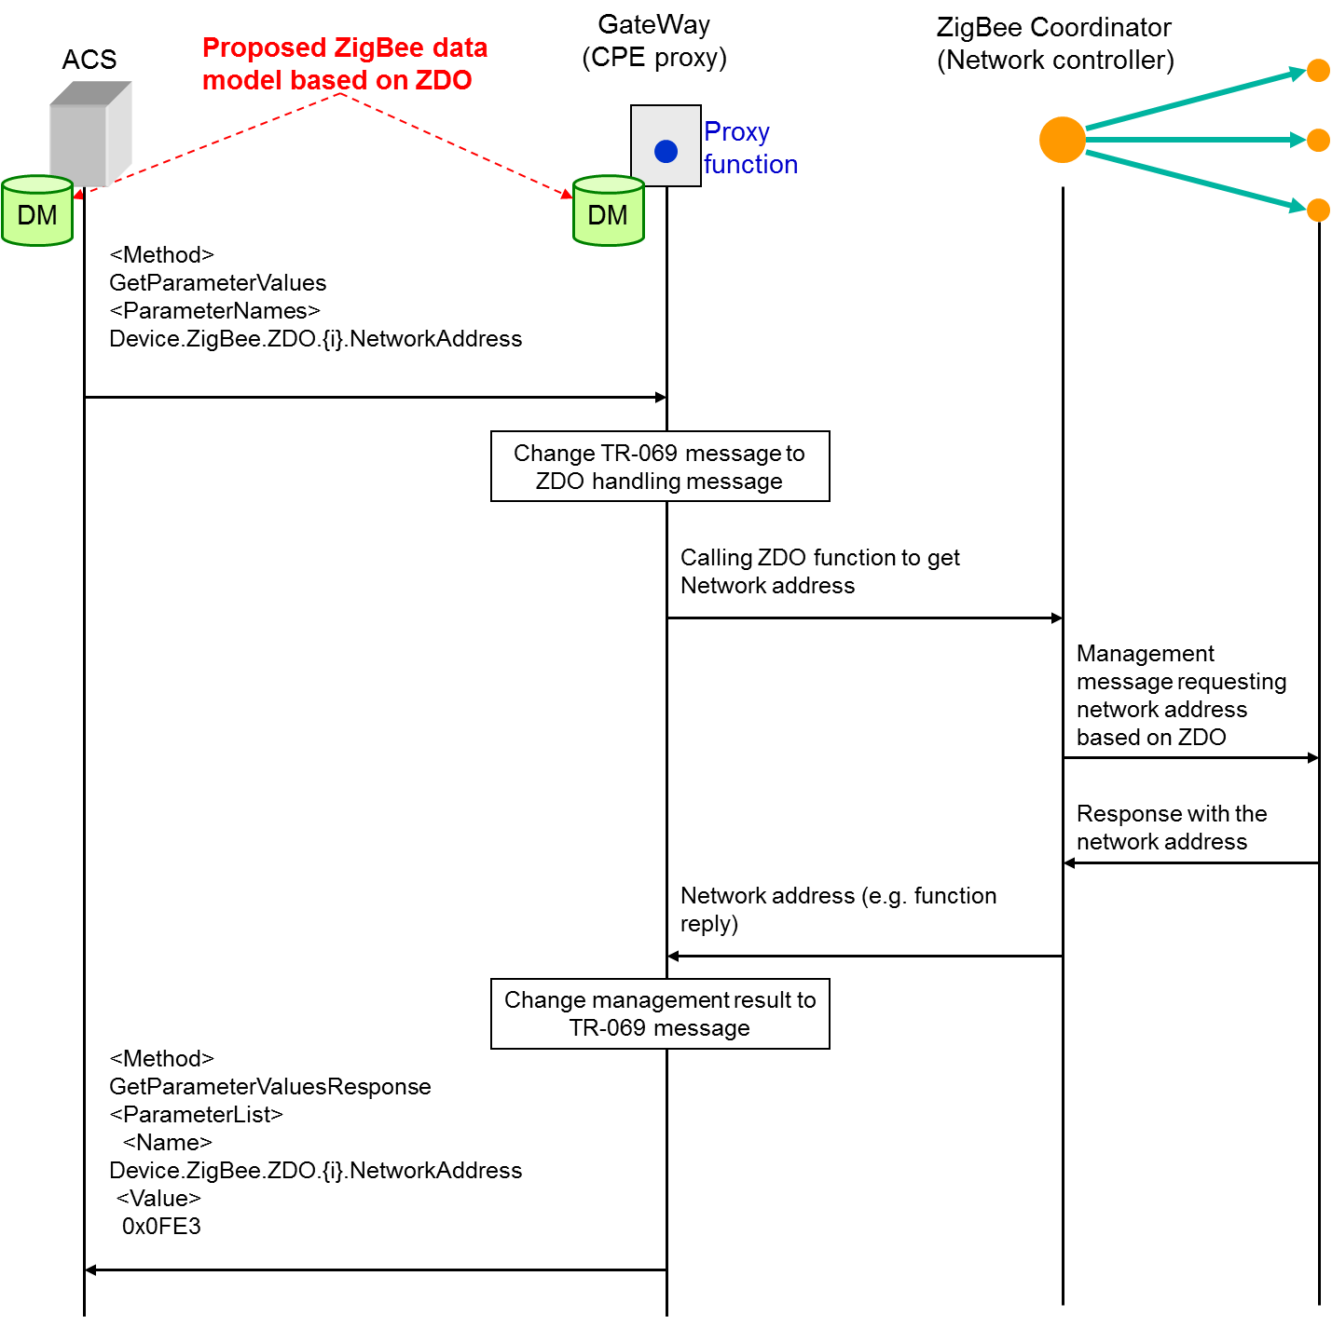
Figure 5.2.10: Example sequence diagram of ZigBee management with TR-069
This example shows how the ACS gets a ZigBee device’s network address by using TR-069 communication based on the ZigBee data model. The ACS sends a CWMP message which includes the “GetParameterValues” as a method and the part of the ZigBee data model “Device.ZigBee.ZDO.{i}.NetworkAddress”, which refers to the network address, as a parameter name. The proxy function in the GW changes the received message to a ZDO handling message to call some ZDO function on the ZC. The ZC manages the ZigBee devices according to the called ZDO function and sends the result (the searched network address, in this case) to the proxy. The proxy function changes the ZDO management result to a CWMP message which is denoted in Figure 5.2.10 as “GetParameterValuesResponse”. The name of the parameter list is “Device.ZigBee.ZDO.{i}.NetworkAddress” and the value of the parameter list is “0x0fE3” (network address instance).

5.2.5 Functions
The TR-069 family of specifications is intended to support a variety of functionalities to manage a collection of devices, including the following primary capabilities:
- Auto-configuration and dynamic service provisioning
- Software/firmware image management
- Software module management
- Status and performance monitoring
- Diagnostics
- Proxy Management
- Bulk data collection

5.3 Introduction to OMA LightweightM2M (LWM2M)

5.3.1 Description
OMA Lightweight M2M is a protocol for device and service management for M2M. The main purpose of this technology is to address service and management needs for constrained M2M devices, over a number of transports and bearers. The crucial aspects in this work are:
- The target, that is a variety of devices “constrained” at very different levels
- Data collection and remote controlling without complex computing and UI operations
- The optimization of network resources, as a very large numbers of devices may be connected to the communication network simultaneously
- The fusion of device functionalities management and service manipulation in a single protocol
From the implementation view, the LWM2M has the following features:
- Suitable for really resource constraint devices
- Compact binary packet
- Support Binary Data Format and JSON format
- Easy to be implemented (reusing implementation of IETF technologies)
One of typical use cases of using LWM2M technology is a firmware upgrade of streetlight [i.18].
- A Streetlights supervisor is responsible to manage streetlights system. (There are thousands of streetlights in the city and low-cost LWM2M Devices embedded in the streetlights.)
- The supervisor needs to remotely upgrade of the firmware of a specific streetlight or a group of streetlights.
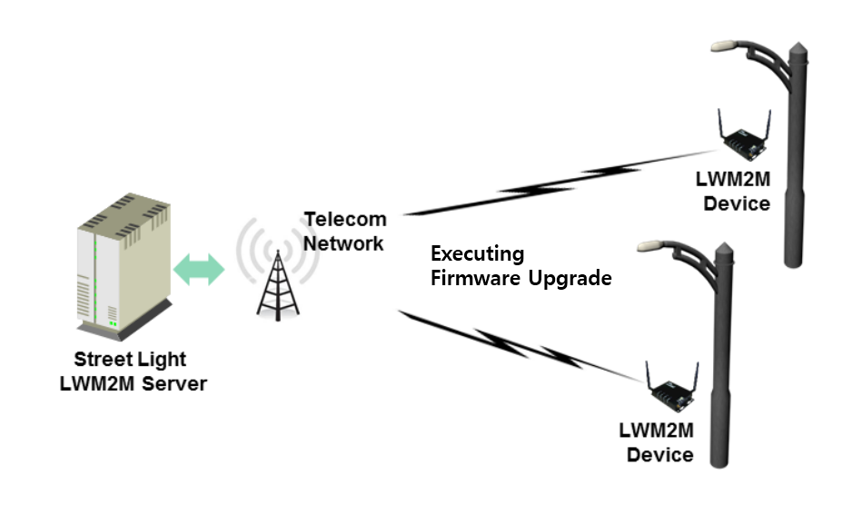
Figure 5.3.1: Firmware Upgrade of Streetlight of Use Case using LWM2M

5.3.2 Architecture

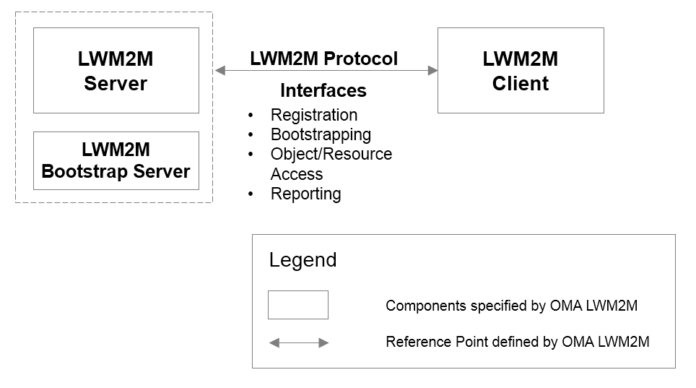
Figure 5.3.2: LWM2M Architecture
As shown in the Figure 5.3.2, the layout is the architecture of LWM2M [i.19]. The Components specified by OMA LWM2M compose the LWM2M enabler which specifies the LWM2M Server / LWM2M Client interface. LWM2M Server and LWM2M Client are typically instantiated in an M2M Server and an M2M Device.
Based on the deployment scenario, the LWM2M Server has the bootstrapping capability itself, or the LWM2M Bootstrap Server exists separately for security reasons.

5.3.3 Reference Points
This section introduces the interfaces carried over the reference point consisting of two main components LWM2M Server and LWM2M Client.

5.3.3.1 Functional Components

5.3.3.1.1 LWM2M Server
The LWM2M Server is a logical component which serves as an endpoint of the LWM2M protocol.

5.3.3.1.2 LWM2M Client
The LWM2M Client is a logical component. This LWM2M Client serves as an endpoint of the LWM2M protocol, and communicates with the LWM2M Server to execute the operations from the LWM2M Server and report results of the operations for the device management and the service enablement.

5.3.3.2 Interfaces
There are four interfaces supported by the reference point between LWM2M server and LWM2M Client. The logical operation of each interface is defined as follow.
- Device Discovery and Registration
This interface allows the LWM2M Client do the Device Registration. This procedure lets the Server know the existence and information (e.g., capability) of the LWM2M Device so that LWM2M Server can perform M2M services and device management on the LWM2M Client.
- Bootstrap
This interface is used to initial parameters and configurations on the LWM2M Client so that the Client can register to the Server after bootstrap procedure has completed.
- Device Management and Service Enablement
This interface allows the LWM2M Server to perform the device management and M2M service enablement. Over this interface, the LWM2M Server can send operations to the Client and gets response of the operations from the Client.
- Information Reporting
This interface allows the LWM2M Client to report resource information to the LWM2M Server. This Information Reporting can be triggered periodically or by events.

5.3.4 Protocols

5.3.4.1 Protocol Stack
The LWM2M has the protocol stack defined as below.
Figure 5.3.3: LWM2M Protocol Stack
- LWM2M Objects: LWM2M Objects are designed for each functionality the LWM2M enabler provides. The LWM2M specification [i.20] provides Standard Objects. Other Objects may be added by OMA, external SDOs or vendors to enable certain M2M Services. (E.g. the IPSO alliance has already started developing LWM2M Objects.)
- LWM2M Protocol: LWM2M protocol defines logical operations and mechanisms per each interface.
- CoAP: The LWM2M utilizes the IETF Constrained Application Protocol [i.21] as an underlying transfer protocol across UDP and SMS bearers. This protocol defines the message header, request/response codes, message options, and retransmission mechanisms. The LWM2M only uses the subset of features defined CoAP.
- DTLS: DTLS [i.22] is used to provide security channel between the LWM2M Server and the LWM2M Client for all the messages interchanged.
- UDP Binding with CoAP (Mandatory): NoSec mode and reliability over the UDP transport is provided by the built-in retransmission mechanism of CoAP.
- SMS Binding with CoAP (Optional): CoAP is used over SMS by placing a CoAP message in the SMS payload using 8-bit encoding.

5.3.4.2 Resource Model
In the LWM2M Enabler technical specification [i.20], a simple resource model is described. Basically, a resource made available by resource model of the LWM2M Client is a Resource, and Resources are logically organized into Objects. Figure 5.3.4 illustrates this structure, and the relationship between Resources, Objects, and the LWM2M Client. The LWM2M Client may have any number of Resources, each of which belongs to an Object.
Figure 5.3.4: LWM2M Resource Model [i.20]
Resources are defined per Object, and each resource is given a unique identifier within that Object. Each Resource is designed to have one or more Operations that it supports. A Resource may contain multiple instances dependent on the Resource definition in Object specification.
An Object defines a grouping of Resources, for example the Firmware Object contains all the Resources used for firmware update purposes. The LWM2M enabler defines standard Objects and Resources and other Objects may be added to enable a certain M2M Services.
Object shall be instantiated either by the LWM2M Server or the LWM2M Client, which is called Object Instance before using the functionality of an Object. After Object Instance is created, the LWM2M Server can access that Object Instance and Resources in the Object Instance.
Editor’s Note: Support of linking a resource to another object is currently under discussion in OMA.

5.3.4.3 Interface Descriptions

5.3.4.3.1 Device Discovery and Registration
The Device Discovery and Registration Interface are used by a LWM2M Client to register with one or more LWM2M Servers, maintain each registration, and de-register from the Server(s). When registering, the LWM2M Client indicates its Endpoint Name, Client registration lifetime, the list of Objects the Client supports and available Object Instances. The registration is soft state, with a lifetime indicated by the registration lifetime. The LWM2M Client periodically performs an update of its registration information to the registered Server(s). If the lifetime of a registration expires without receiving an update from the Client, the Server removes the registration. Finally, when shutting down or discontinuing use of a Server, the Client performs de-registration.
Figure 5.3.5: Example of Registration Procedure

5.3.4.3.2 Bootstrap
Bootstrap process is used to provision essential information into the LWM2M Client to make the LWM2M Client be able to register to a certain LWM2M Server. There are four modes for bootstrapping.
- Manufacturer pre-configuration: the LWM2M Client is already provisioned at manufacturer stage. The pre-configuration data can be stored in a storage of the LWM2M Client.
- SmartCard provisioning: When the Device supports a SmartCard and retrieval of bootstrap message from SmartCard is successful, the LWM2M Client processes the bootstrap message from the SmartCard and apply it to the Device configuration
- Client initiated Bootstrap: the LWM2M Client retrieves the bootstrap message from a LWM2M Bootstrap Server in this case the LWM2M Client needs to be pre-provisioned at the manufacturer stage with a bootstrap Server URI.
- Server initiated Bootstrap: the LWM2M Server provision the bootstrap message to the LWM2M Client after recognizing the existence of the LWM2M Device.
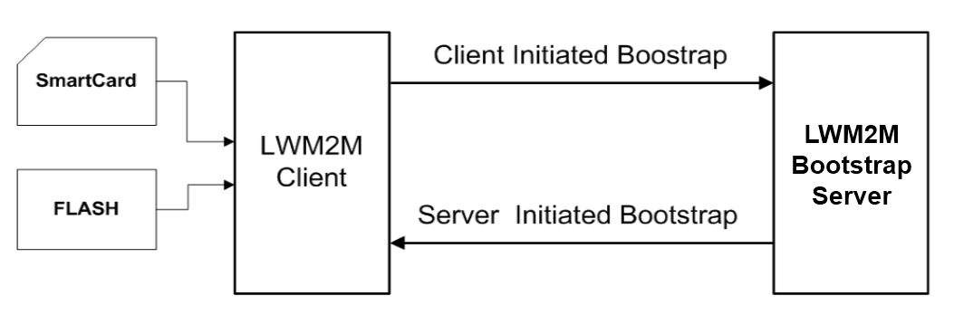
Figure 5.3.6: Four Modes for bootstrapping

5.3.4.3.3 Device Management and Service Enablement
This interface is used by the LWM2M Server to access Resources available from a LWM2M Client using Create, Read, Write, Delete, or Execute operations. The operations that a Resource supports are defined in the definition of its Object.
Figure 5.3.7: Example of Device Management and Service Enablement Interface

5.3.4.3.4 Information Reporting
This interface is used by a LWM2M Server to observe any changes in a Resource on a LWM2M Client, receiving notifications when new values are available. (Note: this procedure is similar to the operation of notification procedure in M2M service) This observation relationship is initiated by sending an Observe operation to the L2M2M Client for an Object Instance or Resource. An observation ends when a Cancel Observation operation is performed.
Figure 5.3.8: Example of Information Reporting Interface

5.3.5 Functions
A first set of standard Objects for the LWM2M 1.0 enabler have been developed. The Standard Objects are intended to support a variety of functionalities to manage LWM2M Devices. OMA might create further objects in future. Furthermore, other organizations and companies may define additional LWM2M Objects for their own M2M services using according to LWM2M Object Template and Guideline Annex in [i.20].
- Server: data, configuration and security data related to a LWM2M server
- Access Control: to check whether the LWM2M server has access right for performing an operation
- Device: provision of a range of device related information, device reboot and factory reset function
- Connectivity: provision of management of parameters related to underlying network connectivity
- Firmware: provision of firmware management, installing and updating new firmware
- Location: provision of location information of the LWM2M devices

5.4 Introduction to OMA Device Management 2.0

5.4.1 Description
OMA Device Management 2.0 is the new evolution of the OMA Device Management 1.x Protocols, and defines the interface between the DM Server and the DM Client to manage devices. Compared to OMA DM 1.x Protocols, the unique features of OMA DM 2.0 are as follows:
- Protocol Simplification and Optimization – Transaction model, DM Packages, addressing schemes and security model are simplified and optimized as well for the fast market penetrations. Simplifications and optimization is the fundamental spirits that goes throughout OMA DM 2.0.
- Extended DM Command Set – OMA DM 2.0 supports 10 DM commands, that is much extended compared to OMA DM 1.x. For example, the HGET/HPUT/HPOST commands are specified to utilize the RESTful interface, and the SHOW command is specified for the web-based user interaction.
- Management Data Delivery using HTTP (RESTful interface) – The DM Client can retrieve or send the management data from or to the Data Repository using the HTTP protocol. This enables the effective management data delivery.
- Web-based User Interaction – The DM Server can utilize web pages to interact with the user. The Web Browser Component and the Web Server Component are newly introduced, and these two components can perform the user interaction session, which is independent with the DM session. This feature brings the rich user interactions to OMA DM 2.0.
- JSON Representation for DM Packages – In OMA DM 2.0, JSON replaces XML. The new JSON format for DM Packages lightens the parsing overheads and shortens the DM Package length keeping the same degree of the extensibility.
- New Addressing Scheme – OMA DM 2.0 introduces the new addressing scheme that uniquely addresses each node based on the Management Object Instance. In OMA DM 2.0, Management Objects do not need to be organized as a tree, and the DM Server does not need to have the knowledge of the DM Tree that can be different for each type of devices.
OMA DM 2.0 is not backward compatible with OMA DM 1.x. This is because OMA DM 2.0 uses the completely different representation based on JSON, and eliminates complex functionalities that are not required by the market. Although OMA DM 2.0 is not backward compatible with OMA DM 1.x, Management Objects (e.g., FUMO, SCOMO, DiagMon, LAWMO) designed for OMA DM 1.x can be still used for OMA DM 2.0. This is possible since OMA DM 2.0 uses the same Management Object definition and provides the necessary functionalities such as Generic Alerts. The complete separation between Management Objects and the OMA DM Protocol is one of the success factors as well.
Note that the OMA DM 2.0 is in the draft version, and the Candidate Approval is expected at the 15th Oct 2013.

5.4.2 Architecture
The following figure shows the OMA DM 2.0 Architecture and the related components and the interfaces:
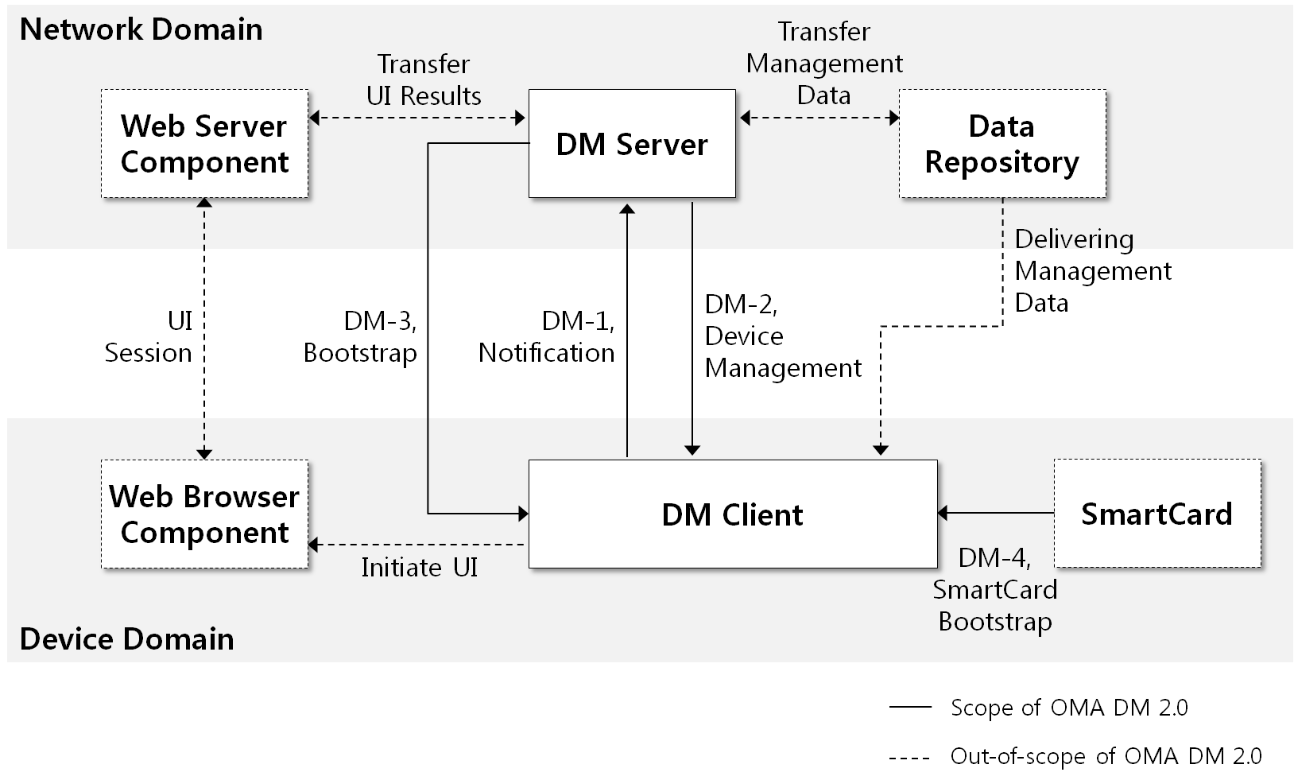
Figure 5.4.1: OMA DM 2.0 Architecture
The Web Server Component and the Web Browser Component can be utilized for the user interactions. For the user interaction, OMA DM 2.0 specifies that the DM Server can send the SHOW command; therefore, the DM Client initiates the Web Browser Component with the specified web page. The actual user interaction can be performed using the HTTP/HTML, which is out-of-scope of the OMA DM 2.0. Please note that how to initiate the Web Browser Component, and how the transfer the user interaction results are out-of-scope of OMA DM 2.0 as well.
Using the Data Repository, the DM Client can retrieve and upload the management data from or to the Data Repository using the HTTP protocol. The DM Server can send the HPUT/HPOST and HGET command for those purposes.

5.4.3 Reference Points

5.4.3.1 Functional Components

5.4.3.1.1 DM Client
The DM Client is the logical software component that conforms to the requirements for DM Clients specified in OMA DM 2.0.

5.4.3.1.2 DM Server
The DM Server is the logical software component that conforms to the requirements for DM Servers specified in OMA DM 2.0. The DM Server is also responsible for providing the Bootstrap Message using the DM-3 Interface.

5.4.3.1.3 Web Server Component
Web Server Component is the logical software component responsible to host web pages for the Web Browser Component in the device. The web pages are used for the user interactions.

5.4.3.1.4 Web Browser Component
Web Browser Component is the logical software component responsible for retrieving web pages from the Web Server Component and presenting them to the user.

5.4.3.1.5 Data Repository
Data Repository is the logical software component that the DM Client can retrieve or send management data to or from this component by using HTTP.

5.4.3.2 Interfaces
The brief explanations for the defined interfaces are as follows:
- DM-1 Notification – the interface over which the DM Server sends DM Notification to the DM Client to initiate the DM session.
- DM-2 Device Management – the interface over which the DM Server sends device management commands to the DM Client and the DM Client returns status code, results and Alerts.
- DM-3/4 Bootstrap – the interface over the Bootstrap Message is delivered. OMA DM 2.0 supports factory bootstrap, client-initiated bootstrap, server-initiated bootstrap and SmartCard bootstrap.

5.4.4 Protocol

5.4.4.1 DM Packages
The below figure describes the DM Package exchanges between the DM Client and the DM Server defined in OMA DM 2.0:
Figure 5.4.2: OMA DM 2.0 Package Flow
- Step 0 (DM Notification): The DM Server requests the DM session by sending the DM notification to the DM Client.
- Step 1 (DM Session Initiation): This DM package initiates the DM session and might contain information for the supported Management Object and Generic Alerts generated by the DM Client.
- Step 2 (Request): The DM Server sends the DM commands to the DM Client.
- Step 3 (Command Processing): The DM Client processes the DM commands received. To process the DM command, the DM Client might interact with components such as the Web Browser Component, the Data Repository.
- Step 4 (Response): Unless the END command is received, the DM Client responses to the DM Server. It contains the results for the DM command and Generic Alerts generated by the DM Client.

5.4.4.2 DM Commands
The below table shows the DM commands specified in the OMA DM 2.0:
Logical Op. | Name | Description | DM 1.x Relation
Read | GET | To retrieve data from the device. The data is included in Package#3. | Get
Read | HPUT | To request the device to send data to the Data Repository using HTTP PUT. | MO individually implements this
Read | HPOST | To request the device to send data to the Data Repository using HTTP POST. | MO individually implements this
Write | DELETE | To delete data in the device. | Delete
Write | HGET | To requests the DM Client to retrieve data from the Data Repository using HTTP GET, and add or replace the received data into the device. | Add, Replace
Exec | EXEC | To execute an executable node. | Exec
Not related to MO | SHOW | To initiate a UI session between the Web Browser Component and the Web Server Component. | Alert for UI. Only 5 UI types exist
Not related to MO | CONT | To continue the DM session with the specified DM Server URI. | <RespURI> element
Not related to MO | END | To terminate the DM session. | <Final> element
Not related to MO | DEFAULT | To use a specific address to capture configuration if that is missing in the device for a specific MOID. | None
Table 5.4.1: OMA DM 2.0 Commands

5.4.5 Functions

5.4.5.1 Introduction
Each device that deploys OMA DM 2.0 supports Management Objects. Management Object is the set of related nodes for a specific function, and OMA DM 2.0 achieves management functions by using the Management Objects. The type of the Management Object is defined by the MOID.
For example, for the firmware management functions, the Firmware Update Management Object as specified in [i.4] can be used as shown below:
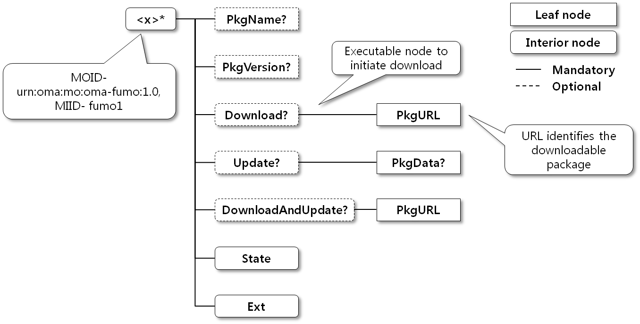
Figure 5.4.3: Firmware Update Management Object
OMA DM 2.0 does not require that Management Objects in the device are organized as a hierarchical tree structure since the nodes are addressed based on the Management Object instance. In the device, Management Object is realized as a Management Object instance. Once the Management Object instance is created in the device, the DM Client assigns the MO Instance Identifier (MIID) to it, and the DM Server can use the ClientURI to uniquely identify each node in the Management Object Instance. Note that ClientURI is built based on the MOID and MIID.
Suppose that the above FUMO is realized as an instance in the device. Then the DM Server can use below Client URIs:
- urn:oma:mo:oma-fumo:1.0/fumo1/PkgName – to identify the <x>/PkgName node
- urn:oma:mo:oma-fumo:1.0/fumo1/DownloadAndUpdate/PkgURL – to identify the <x>/DownloadAndUpdate/PkgURL node
The “fumo1” in the above ClientURI is the MIID assigned to the FUMO instance, and can be omitted if the MOID is enough to uniquely identify a Management Object Instance (i.e., there is only one Management Object Instance for the MOID). Hence, the ClientURI can be simplified further to “urn:oma:mo:oma-fumo:1.0/ /PkgName” if MIID is not needed.

5.4.5.2 Management Objects supported by OMA DM 2.0
OMA DM 2.0 shares the same Management Object definitions, which allows that Management Objects designed for OMA DM 1.x can be reused for OMA DM 2.0. Hence, every MO identified in the section 5.1.5.2.2 that is considered as relevant to the management of M2M Device/Gateway are supported by the OMA DM 2.0 (e.g., FUMO, SCOMO, Gateway MO, etc.). In addition, OMA DM 2.0 supports below standard MOs:
Standard MO | Description
DevInfo MO V1.2 | - This MO provides the basic device information such as the device identifier, manufactures, etc.
DM Account MO V2.0 | - This MO provides the account information for the DM Servers.
Delegation Access Control MO V1.0 | - This MO provides the information for the access control.
Session Info MO V1.0 | - This MO provides the information for the DM session.
Table 5.4.2: Standard Management Object for OMA DM 2.0

5.4.5.3 Detailed Comparisons with OMA DM 1.x
Below table explains the differences between OMA DM 2.0 and OMA DM 1.x from the overall perspective:
Label | DM 2.0 | DM 1.x
Package Representation | - JSON | - XML
DM Command | - 10 DM commands.  - Sequential processing only | - 6 DM commands.  - Random, Sequential, Atomic processing
MO Addressing | - ClientURI | - Absolute, Relative, Virtual
User Interaction | - Web-based User Interaction using SHOW command | - User Interaction Alert supports 5 types (Display, Confirmation, User Input, Single Choice, Multi Choice)
Security | - Authorization – ACL for MO instance granularity (can be extended to node granularity)  - Confidentiality/Authentication – transport layer security only | - Authorization – ACL for node granularity  - Confidentiality/Authentication – DM Protocol security or transport layer security
DM Notification | - TLV (2 Headers, 5 Options)  - Transport: SMS, Google Cloud Messaging | - TLV (6 Headers, 8 Options, Digest) + Binary Format (backward compatible with DM 1.2)  - Transport: SMS, OBEX, SIP, HTTP, Cell Broadcast.
Table 5.4.3: Comparison between OMA DM 2.0 and OMA DM 1.x

5.4.5.4 Protocol Examples
In this section, an example is presented in which the DM Server updates the firmware of the device. The Package#1 (DM session initialization) sent from the DM Client to the DM Server is as follows:
POST /dmclient/dm20 HTTP/1.1
Content-Type: application/vnd.oma.dm.initiation+json
Accept: application/vnd.oma.dm.request+json
OMADM-DevID: IMEI:493005100592800
Host: www.dms.com

{
"MOS": [
{
"DDF": "http://www.vendor.com/DDF/devinfo1.0.ddf",
"MOID": "urn:oma:mo:oma-dm-devinfo:1.0",
"MIID": ["miid1"]
},
{
"DDF": "http://www.vendor.com/DDF/oma-fumo1.0.ddf",
"MOID": "urn:oma:mo:oma-fumo:1.0",
"MIID": ["miid1"]
},
{
"DDF": "http://www.vendor.com/DDF/oma-dm-dmacc2.0.ddf",
"MOID": "urn:oma:mo:oma-dm-dmacc:2.0",
"MIID": ["miid1"]
}
]
}
In the above Package#1, the JSON object “MOS” carries the Management Object information that is supported by the device. According to the “MOS”, the DM Server can know that the DM Client supports DevInfo MO, FUMO, DM Account MO.
After receiving the Package#1, the DM Server sends the Package#2 to update the firmware of the device. The Package#2 is as follows:
HTTP/1.1 200 OK
Content-Type: application/vnd.oma.dm.request+json

{
"CMD": [
["EXEC", "oma:mo:oma-fumo:1.0//Update"]
]
}
After completing the firmware updating, the DM Client sends the Package#3 for the response as follows:
POST /dmserver/dm20 HTTP/1.1
Content-Type: application/vnd.oma.dm.response+json
Accept: application/vnd.oma.dm.request+json
OMADM-DevID: IMEI:493005100592800
Host: www.dms.com

{
"Status": [
{"sc": 200}
]
}
After receiving the Packge#3 from the DM Client, the DM Server terminates the DM session by sending the END command. The Package#2 for this is as follows:
HTTP/1.1 200 OK
Content-Type: application/vnd.oma.dm.request+json

{
"CMD": [
["END"]
]
}
On receiving the Package#2, the DM Client does not send the Package#3. The DM session is terminated.

6 Gap analysis of existing relevant technolgoies
Editor’s Note: The chapter lists all the requirements related to management in oneM2M and analyzes how the technologies can fulfil the requirements and identifies potential gaps. The chapter also gives reference to the specification of the analyzed technologies.

6.1 Management related requirements gap analysis reference
Editor’s Note: The table below gives cross reference to the requirements and the technologies. The matrix represents whether or not the technology can fulfil the requirement. At the same time, in the following chapters, detailed description of the depth of how well the technology can fulfil the requirement should be shown.
Some MGR requirements (e.g., MGR-004) target functionality outside the scope of the existing technology (e.g., TR-069, OMA-DM). In those cases the analysis of the technology against the requirement determines if the the functionality that is outside the scope of the technology is allowed.
The definitions for the values in below table are:
- FULL: the requirement can be fulfilled by the technology alone
- PARTIAL: the requirement can be partially fulfilled by the technology
- ALLOWED: Adopting this technology will allow this requirement to be implemented
- NOT ALLOWED: This technology does not fulfill the requirement AND adopting this technology would not allow the requirement to be implemented
Requirement Support
 | OMA DM 1.3 | BBF TR069 | OMA DM LWM2M | OMA DM 2.0
MGR-001 | Partial | Partial | Full | Partial
MGR-002 | Full | Full | Full | Full
MGR-003 | Full | Full | Full | Full
MGR-004 | Allowed | Allowed | Allowed | Allowed
MGR-005 | Partial | Partial | Partial | Partial
MGR-006 | Full | Full | Full | Full
MGR-007 | Full | Full | Full | Full
MGR-008 | Full | Full | Partial | Full
MGR-009 | Full | Full | Full | Full
MGR-010 | Partial | Partial | Partial | Partial
MGR-011 | Full | Full | Full | Full
MGR-012 | Full | Full | Partial | Full
MGR-013
MGR-014
MGR-015
MGR-016
Table 6.1.1: Requirements fulfilment reference

6.2 MGR-001
Editor’s Note: This chapter gives descriptions in depth how the technologies can fulfil each management related requirements defined in oneM2M as well as the gaps related to the requirements.

6.2.1 Requirement Description
Editor’s note: This section is a copy paste of the requirement text in the requirement TS. Revision number of the requirement TS should be explicitly referenced.
The M2M System shall support management and configuration of M2M Gateways/ Devices including resource constrained M2M Devices.[i.23]

6.2.2 OMA DM 1.3
OMA DM 1.3 can PARTIALLY fulfil the requirement.
The definition of resource constrained devices depends on the progress of the device classification work item.
OMA DM 1.3 requires an OMA DM compliance device shall have at least one of the protocol stacks among TCP/IP, IrDA or WSP. And the devices shall also have a capability to parse the xml file. Because the DM Representation OMA DM uses to deliver the DM Message is in the format of XML. The OMA DM devices shall also be capable of store a certain amount of information which is the MO trees to carry the management functions. For constrained devices that serve very simple functions and have the basic capability of parsing short XML and small amount of storage to store the MO, OMA DM 1.3 can be used for device management. As a result, OMA DM can be applied to some resource constrained devices but not those very limited in resources (no memory, cannot parse the XML, no communication module).

6.2.3 BBF TR069
TR-069 provides PARTIAL support for this requirement.
The TR-069 provides support for resource constrained devices that are CWMP enabled through the use of its standard CWMP protocols. For resource constrained devices that are not CWMP enabled (e.g., ZigBee devices, IP devices without CWMP stack), TR-069 provides mechanisms to access the constrained devices through a CWMP enabled device called a CWMP Proxy. Section 5.2.1.1 TR-069 Proxy Management describes this architecture. A technology constraint exists in that the CWMP Proxy must have connectivity, typically LAN, with the non-CWMP enabled device. As such, the TR-69 Proxy Management functions generally reside on a M2M Gateway within the customer premises.
Resource constrained devices that are CWMP enabled requires, at a minimum, the support for the:
- Protocol stack as defined in Section 5.1.4.1 ACS to CPE Protocol
- Implementation of the TR-181i2 Baseline:3 profile [reference TR-181 Device Data Model for TR-069 Issue: 02 Amendment 6 November 2012]
Resources required to implement a CWMP stack have been advertised as low as 150 Kilobytes storage and 30 Kilobytes DRAM (heap and stack) on an Android operating system.
Many resource constrained devices require monitoring of the device’s environment (e.g., processor, memory, battery, temperature), the TR-181i2 data model provides support for many of these objects (processor, memory, temperature) where these objects may be monitored and alarmed using the FaultMgmt objects of the data model or using the Active/Passive notification mechanism described in Section 3.7.1.5 of TR-069 [i.13]. While TR-181i2 provides support for many objects within a resource constrained device, the current data model does not provide support for a Battery resource. This type of resource may be implemented using Vendor specific extensions or submitted to the Broadband Forum for inclusion in a revision of the TR-181i2 data model.

6.2.4 OMA DM LWM2M
OMA DM LWM2M can FULLY fulfil the requirement.
Since the main focusing M2M device of LWM2M is resource constraint device, LWM2M is specialized in managing and configuring resource constraint devices.
For resource constraint device, LWM2M has the several features which are listed below:
- CoAP with minimum set of required features for header and options
- Either UDP or SMS as transport layer binding
- Binary TLV format (Tag, Length, Value) for conveying values of multiple Resources
- JSON format is optionally supported
Editor’s Note: According to the definition of resource constrained, this analysis can be reformulated.

6.2.5 OMA DM 2.0
OMA DM 2.0 PARTIALLY fulfil the requirement.
The device that conforms to OMA DM 2.0 shall support TCP/IP, HTTP protocol stack, which might be not applicable for severely resource-constrained devices (e.g., 8-bit microcontrollers with small accounts of memory).
OMA DM 2.0 also requires the HTTP client in the device that can be used to retrieve management data from the Data Repository. Note that this is a mandatory feature of OMA DM 2.0. Optionally, OMA DM 2.0 might require the Web Browser Component in the device to support the web-based user interaction.
If the resource constrained device can support TCP/IP and HTTP protocol, OMA DM 2.0 can be used to manage those devices with the the simple DM package representations based on the JSON format.
Compared to OMA DM 1.3, OMA DM 2.0 has different factors to support resource constrained devices as follows:
- Supporting only HTTP transport-binding,
- Providing the simple JSON-based DM package representations,
- Requiring the HTTP Client to interact with the Data Repository,
Optionally requiring the Web Browser Component for the user interaction.

6.3 MGR-002

6.3.1 Requirement Description
The M2M System shall provide the capability to discover the M2M Area Networks including information about devices on those networks and the parameters (e.g. topology, protocol) of those networks.[i.23]

6.3.2 OMA DM 1.3 and OMA DM 2.0
OMA DM 1.3 can FULLY fulfil the requirement.
In the setup phase of the OMA DM protocols. The MO DevInfo is transported from DM Client to DM Server. And the MO DevDetail can be requested by DM Server if necessary. In the MO DevInfo and DevDetail, information about how the device can be reached, the protocol, the address, port number, required security parameters is transferred from device to DM server.
For devices in the local area network that are attached to the DM Gateway, GwMO can be used to get the address information.
Also some work has been done in ETSI M2M to define MANMO and MANDMO [i.24] to enable the DM Server to get the information about the topology and protocol of the local area network.
In this way, the DM Server can get to know the connection related parameters (protocol) from the device.GwMO defines how DM Server can manage device in a local area network through DM Gateway. DM Gateway can work in three modes which are transparent mode, proxy mode and adaptor mode. OMA DM devices and non-OMA DM devices can all be managed using DM Gateway. Combined with other MOs defined by OMA DM, devices in the local area network can be managed by DM Server.

6.3.3 BBF TR069
TR-069 provides FULL support for this requirement.
The TR-069 provides support for discovery of devices in the associated Local Area Networks for CWMP enabled devices.
TR-069 proxy management has mechanisms where a CPE Proxier discovers devices using device discovery mechanisms as described in Appendix I of TR-069 [i.13]. These mechanisms rely on the discovery of the device using the device’s native protocol (e.g., UPnP, ZigBee, Z-wave).
The discovery of the topology of the area network in which the device exists is constrained by the device’s native protocol support for topology discovery. For example – UPnP doesn’t provide any support for discovery of topologies while ZigBee topologies can be inferred by evaluating the routing tables of the ZigBee nodes. The TR-181 data model exposes these elements (e.g., ZigBee routing tables) but rely on the management systems to develop the topologies.
The TR-181i2 data model [reference TR-181 Device Data Model for TR-069 Issue: 02 Amendment 6 November 2012] provides support for the following LAN topologies:
- Ethernet
- WiFi
- USB
- HPNA
- MoCA
- G.hn
- HomePlug
- Universal Powerline Association (UPA)
- UPnP
In addition the ZigBee Pro topology support is expected to be included in the next release of TR-181i2.

6.3.4 OMA DM LWM2M
OMA DM LWM2M can FULLY fulfil the requirement.
Connectivity Monitoring Object contains which networks are available and which network is currently used.
Also, it has parent router IP address of each M2M Device so the M2M System can discover entire topology of M2M Local Area Network.
Protocol (e.g., WLAN, Bluetooth) used by M2M Device is specified in Connectivity Object also.

6.4 MGR-003

6.4.1 Requirement Description
The M2M System shall provide the capability to maintain and describe the management information model of devices and parameters (e.g. topology, protocol) of M2M Area Networks. [i.23]

6.4.2 OMA DM 1.3 and OMA DM 2.0
OMA DM 1.3 can FULLY fulfil the requirement.
For devices in the local area network, some work has been done in ETSI M2M to define MANMO and MANDMO [i.24] to maintain and describe the information model about the topology and protocol of the local area network. The MANMO and MANDMO have been submitted for registration in OMA.

6.4.3 BBF TR069
TR-069 provides FULL support for this requirement.
TR-069 provides capabilities to describe and maintain the management information model of CWMP and non-CWMP enabled devices as through the Supported Data Model and Software/Firmware Management features of the protocol. Within TR-069 all devices and services that are of interest to the problem space are modelled using the TR-069 XML meta-model. These models are a description of the device and services that are under management. These models can be either configured within the device or CWMP Proxy (if the device is not CWMP enabled) or the device can report its Supported Data Model to the ACS.

6.4.4 OMA DM LWM2M
OMA DM LWM2M can FULLY fulfil the requirement.
Connectivity Monitoring Object contains lots of Resources to maintain and describe the information model about the topology and protocol of the local area network.
LWM2M has several features to be able to manage LWM2M Clients in M2M Local Area Network. The main barrier is how to reach LWM2M Clients from LWM2M Server.
- Let a LWM2M Server know when IP Address is changed at LWM2M Client by sending Registration Update logical operation.
- Support Queue mode which makes LWM2M Server queue the request until LWM2M Client is online. If LWM2M Client with Queue mode is within M2M Local Area Network, LWM2M Client sends Update message triggered by time or event. After LWM2M Server receives Update message, the LWM2M Server reaches LWM2M Client so the LWM2M Server sends queued message.

6.5 MGR-004

6.5.1 Requirement Description
The M2M System shall support common means to manage devices enabled by different management technologies (e.g. OMA DM, BBF TR069).[i.23]

6.5.2 OMA DM 1.3 and OMA DM 2.0
OMA DM 1.3 can ALLOW the fulfilment of the requirement.
OMA DM does not provide features that translate between OMA DM and other management protocols (e.g., BBF TR069, oneM2M). As such there is an expectation that the M2M System would translate between management protocols.
The management of devices defined by OMA DM is fulfilled by sending DM Messages from DM Server to DM Client. The management related information is carried by Management Objects. For the oneM2M system to support common means to manage devices through OMA DM, the oneM2M system could include the DM Server, DM Client and DM Gateway in the oneM2M system and could have some abstraction to include the MO trees in the oneM2M system to enable the device management in spite of the detailed technologies.

6.5.3 BBF TR069
TR-069 ALLOWS fulfilment of the requirement by Service Layer mechanisms.
The TR-069 family of specifications do not provide features that translate between TR-069 and other management protocols (e.g., OMA-DM, oneM2M). As such there is an expectation that the M2M System would translate between management protocols.
TR-069 provides access to manage devices through its Auto-configuration Server. The Auto-configuration Server has interfaces with the NMS/OSS and BSS systems of the Service provider. As such the ACS would have expected to interface with the M2M System.

6.5.4 OMA DM LWM2M
OMA DM LWM2M ALLOWS fulfilment of the requirement when common means between the oneM2M Server and LWM2M Server are defined. OMA DM LWM2M only defines the protocol between the LWM2M Server and LWM2M Client.
LWM2M does not provide features that translate between LWM2M and other management protocols (e.g., OMA-DM, oneM2M, TR069).

6.6 MGR-005

6.6.1 Requirement Description
The M2M System shall provide the capability to manage multiple devices in a grouped manner. [i.23]

6.6.2 OMA DM 1.3 and OMA DM 2.0
OMA DM 1.3 can PARTIALLY fulfil the requirement.
The requirement can be fulfilled both in service layer and by OMA DM technology.
For service layer, one DM Server could manage multiple DM Clients. The oneM2M system is able to manage multiple devices in a grouped manner by utilize one DM Server. The M2M System could have multiple devices in a group. When the M2M System needs to send identical DM Message to each device in the group, the M2M System could pass the command to DM Server to send DM Messages one by one or simultaneously.
For manage group of devices in OMA DM. GwMO is defined how to fan out DM Command to a group devices.

6.6.3 BBF TR069
TR-069 provides PARTIAL support for this requirement.
The TR-069 family of specifications defines management actions that are destined for a single CWMP enabled device. The concept of groups within the TR-069 family of specifications does not exist. Grouping, while not specified within the CWMP protocol is implemented within ACS or the NMS/OSS/BSS systems. As such, the M2M System would be required to implement the grouping feature.

6.6.4 OMA DM LWM2M
OMA DM LWM2M can PARTIALY fulfil the requirement.
The requirement can be fulfilled at service layer.
A LWM2M Server could manage multiple LWM2M Clients. The oneM2M system is able to manage multiple devices in a grouped manner by utilizing one LWM2M Server. The M2M System could have multiple devices in a group. When the oneM2M System needs to send identical message to each device in the group, the oneM2M System could pass the command to the LWM2M Server to send the messages one by one.

6.7 MGR-006

6.7.1 Requirement Description
The M2M System shall provide the capability for provisioning and configuration of devices in M2M Area Networks. [i.23]

6.7.2 OMA DM 1.3 and OMA DM 2.0
OMA DM 1.3 can FULLY fulfil the requirement.
For devices in the local area network, GwMO can be used to provision and configure End Devices that are attached to the DM Gateway. Gateway Config MO contains the information related to each attached End Device.\

6.7.3 BBF TR069
TR-069 provides FULL support for this requirement.
TR-069 provides support for provisioning and configuration of devices in the Local Area Networks for CWMP enabled and non-CWMP enabled devices. TR-069 has the capability to manage a device through the device’s life-cycle (bootstrap through decommissioning).
For CWMP enabled devices that reside behind a Gateway with Firewalls and Network Address Translation features enabled, the CWMP protocol provides a mechanism that allows the ACS to communicate those devices. This mechanism is described in as described in Annex G of TR-069 [i.13].

6.7.4 OMA DM LWM2M
OMA DM LWM2M can FULLY fulfil the requirement.
In LWM2M, bootstrap mechanism is used to provision and configure the M2M Device. Four approaches are introduced in TS: Manufacturer Pre-configuration, SmartCard Provisioning, Client Initiated Bootstrap, and Server Initiated Bootstrap. And detail bootstrap steps are described.

6.8 MGR-007

6.8.1 Requirement Description
The M2M System shall provide the capability for monitoring and diagnostics of M2M Gateways/Devices in M2M Area Networks. [i.23]

6.8.2 OMA DM 1.3 and OMA DM 2.0
OMA DM 1.3 can FULLY fulfil the requirement.
The capability of monitoring and diagnostics of OMA DM is mainly achieved by MO DiagMon. DiagMon supports diagnostics policies management, fault reporting, performance monitoring, device interrogation, remote diagnostics procedure invocation and remote device repairing. The monitoring and diagnostics of the devices in the local area network can be fulfilled by DiagMon plus GwMO.

6.8.3 BBF TR069
TR-069 provides FULL support for this requirement.
TR-069 provides support for monitoring and diagnostics of devices in the Local Area Networks for CWMP enabled and non-CWMP enabled devices. Monitoring can include notification support for devices that need immediate attention as well as passive monitoring of device information and statistics that may be collected in a periodic manner. Likewise, TR-069 provides the capability to execute diagnostics in a synchronous or asynchronous fashion; allowing for long lived diagnostics to be executed on a device,
For non-CWMP enabled devices, the device is implemented as a non-CWMP enabled Virtual Device where the procedure is documented in Appendix I of TR-069 [i.13]
CWMP and non-CWMP enabled Virtual and Embedded devices support the following diagnostic operations:
- Reboot
- Factory Reset
In addition CWMP enabled and non-CWMP enabled Virtual Devices also support the following standard diagnostics:
- IP Diagnostics (Ping, Trace Route, HTTP or FTP Download or Upload, UDP Echo)
- DNS – NS Lookup
- HPNA Diagnostics
- UPA Diagnostics
- Device Self Tests
- DSL Line
- ATM Interface
These tests are documented within the TR-181i2 data model [reference TR-181 Device Data Model for TR-069 Issue: 02 Amendment 6 November 2012].

6.8.4 OMA DM LWM2M
OMA DM LWM2M can FULLY fulfil the requirement.
In LWM2M, Connectivity Monitoring Object and Connectivity Statistics Object are used to monitor current connection and collect connection information to configure parameters based on the collected result respectively.
LWM2M enabler also has concept to send diagnostic information such as GPS module failure, IP connectivity failure, and Peripheral malfunction.

6.9 MGR-008

6.9.1 Requirement Description
The M2M System shall provide the capability for software management of devices in M2M Area Networks. [i.23]

6.9.2 OMA DM 1.3 and OMA DM 2.0
OMA DM 1.3 can FULLY fulfil the requirement.
Software management capability is fulfilled by the MO SCOMO (Software Component Management Object). SCOMO can be used to remotely manage a software component within a device. The functionalities provided by SCOMO includes delivery, download, installation, update, removal, activation, and de-activation of software. The software management of devices in local area network can be fulfilled by SCOMO plus GwMO.

6.9.3 BBF TR069
TR-069 provides FULL support for this requirement.
TR-069 provides support for software and firmware management of devices in the Local Area Networks for CWMP enabled and non-CWMP enabled devices. Software and firmware management of non-CWMP enabled devices may be performed using Software modules within the CWMP enabled M2M Gateway or may be downloaded directly to device by implementing the non-CWMP enabled device as a Non-CWMP enabled Virtual Device.

6.9.4 OMA DM LWM2M
OMA DM LWM2M can PARTIALY fulfil the requirement.
Since LWM2M talks about resource constraint M2M devices, LWM2M enabler provides the capability for management of a full package, firmware. So firmware contains all the software which is necessary for all the services provided by M2M Service Platform.

6.10 MGR-009

6.10.1 Requirement Description
The M2M System shall provide the capability for rebooting and/or resetting of M2M Gateways/Devices and other devices in M2M Area Networks. [i.23]

6.10.2 OMA DM 1.3 and OMA DM 2.0
OMA DM 1.3 can FULLY fulfil the requirement.
The functionality for reset the device is provided by the MO LAWMO. LAWMO is for remotely locking and wiping the device. The functionality of rebooting a device is enabled by DiagMon. In this way, OMA DM can reset the device to its original state and reboot the device as well. The reset and reboot of a device in local area network can be enabled by DCMO or DiagMon plus GwMO.

6.10.3 BBF TR069
TR-069 provides FULL support for this requirement.
TR-069 provides support for resetting (boot, factory) of devices in the Local Area Networks for CWMP enabled and non-CWMP enabled devices. For non-CWMP enabled devices, the device is implemented as a Non-CWMP enabled Virtual Device.
In the scenario where the device in the M2M Local Area network is a CWMP enabled device, TR-069 provides a mechanism where the device can communicate through a Gateway (which might be NAT or Firewall enabled) to the ACS. Annex G of TR-069 [i.13] describes this mechanism.

6.10.4 OMA DM LWM2M
OMA DM LWM2M can FULLY fulfil the requirement.
Device Object has a Reset Resource which is used for resetting M2M Devices. LWM2M also provides factory reset function which makes M2M Device initial state of deployment.

6.11 MGR-010

6.11.1 Requirement Description
The M2M System shall provide the capability for authorizing devices to access M2M Area Networks. [i.23]

6.11.2 OMA DM 1.3 and OMA DM 2.0
OMA DM 1.3 can PARTAILLY fulfil the requirement.
Configuration methods of OMA DM can be used to detach certain device from the network. Coordinator and router can also be configured to block the new access request to deny devices to be attached to the local area network. In this way, devices can be authorized to access M2M Local Area Network.

6.11.3 BBF TR069
TR-069 provides PARTIAL support for this requirement.
TR-069 does not provide direct support for authorizing devices for access to Local Area Networks but does allow for configuration of credentials and other properties that these networks utilize. TR-069 does this for CWMP and non-CWMP enabled devices.

6.11.4 OMA DM LWM2M
OMA DM LWM2M can PARTIALLY fulfil the requirement.
If M2M devices have configuration for accessing M2M Local Area Networks prior to deployment, the M2M devices can be authorized based on the configured information.

6.12 MGR-011

6.12.1 Requirement Description
The M2M System shall provide the capability for modifying the topology of devices in M2M Area Networks. [i.23]

6.12.2 OMA DM 1.3 and OMA DM 2.0
OMA DM 1.3 can FULLY fulfil the requirement.
OMA DM can be used to modify the topology of devices in M2M Local Area Network by activate and de-activate devices that serve as coordinator or router in the area network. For example, if a coordinator or router is de-activated, devices attached to the coordinator or router will automatically find other coordinators or routers to access the local area network.
Configuration methods can also be used to configure the router or coordinator to accept or deny access request of new devices. The topology is modified.

6.12.3 BBF TR069
TR-069 provides FULL support for this requirement.
TR-069 does allow for configuration of properties for Local Area Networks that can determine which devices are to be included within a Local Area Network. TR-069 does this for CWMP and non-CWMP enabled devices.

6.12.4 OMA DM LWM2M
OMA DM LWM2M can FULLY fulfil the requirement.
OMA DM LWM2M can be used to modify the topology of devices in M2M Local Area Network by disabling M2M devices which serve as coordinator in the area network. For example, if a coordinator is disabled, devices in M2M Local Area Network attached to the coordinator will automatically find other coordinators to access the local area network.

6.13 MGR-012

6.13.1 Requirement Description
Upon detection of a new device the M2M Gateway shall be able to be provisioned by the M2M Service Infrastructure with an appropriate configuration which is required to handle the detected device. [i.23]

6.13.2 OMA DM 1.3 and OMA DM 2.0
OMA DM 1.3 can FULLY fulfil the requirement.
In a DM Server assisted bootstrap procedure defined in GwMO. Whenever a new device is detected, DM Server will install the End Device credentials to the gateway through Gateway Config MO.

6.13.3 BBF TR069
TR-069 provides FULL support for this requirement.
TR-069 provides support for detection of new devices in the Local Area Networks. TR-069 has the capability to detect new devices via active and passive notification mechanisms described in Section 3.7.1.5 of TR-069 [i.13] as well as using the CWMP protocol’s inform event (e.g., Bootstrap) mechanisms for CWMP enabled devices.
In the most common M2M deployment scenarios, the M2M Gateway would include a CWMP Agent making the M2M Gateway a CWMP-enabled device with a CWMP Proxier as defined in Annex J of TR-069 [i.13].
In this scenario, the M2M Gateway’s CWMP agent could detect and report the new device to the ACS via the M2M Gateway’s CWMP agent. Once a device is reported to the ACS, the ACS can inform the M2M System about the device addition for further configuration and software/firmware management activities. Possible configuration activities could include:
- Software management (Annex H of TR-069[i.13])
- Device configuration via Proxy management (Appendix I of TR-069[i.13])

6.13.4 OMA DM LWM2M
OMA DM LWM2M is PARTIALY for the requirement.
LWM2M doesn’t have gateway concept so to be able to handle the detected devices, the M2M Gateway needs to have LWM2M Server feature which means that device thinks gateway as LWM2M Server. In this case, M2M Gateway can manage the device detected.

6.14 MGR-013

6.14.1 Requirement Description
The M2M System shall be able to identify and manage M2M Service status of M2M Devices. [i.23]

6.15 MGR-014

6.15.1 Requirement Description
The M2M System shall be able to retrieve events and information logged by M2M Gateways/ Devices and other devices in M2M Area Networks. [i.23]

6.16 MGR-015

6.16.1 Requirement Description
The M2M System shall be able to support firmware management (e.g. update) of M2M Gateways/ Devices and other devices in M2M Area Networks.. [i.23]

6.17 MGR-016

6.17.1 Requirement Description
The M2M System shall be able to retrieve information related to the Static and Dynamic Device/Gateway Context for M2M Gateways/Devices as well as Device Context for other devices in M2M Area Networks. [i.23]

7 oneM2M Architectural Considerations

7.1 Introduction
This chapter evaluates whether utilisation of the analysed management technologies, to fulfil the oneM2M management related requirements, results in any architectural recommendations for, or potential constraints to, the oneM2M architectural design. This chapter also highlights any restrictions that the oneM2M arhctecture potentially places on utilisation of the analysed management technologies within oneM2M.

7.2 Current Management Deployment Scenarios
This section describes the common deployment scenarios that exist today for deployments of the Device Management technologies listed in this TR.

7.2.1 Managed Device Using Network Operator Management
When discussing M2M Device Management deployment scenarios we must review the Device Management deployment scenarios that exist today in the underlying network operator’s communication network. In the scenario depicted below the underlying network operator has, other than the end user, exclusive control of the resources within the device. Also in this deployment scenario, the device management technologies described in the TR utilize a management client in the device that connects to the underlying network operator’s management server. Typically there is one instance of the management client within the device that connects to one management server controlled by the underlying network operator. In several of the device management technologies the management client in the device offers a proxier capabability that provides the underlying network operator with the capability to manage devices that do not have their own management client. The underlying network operator’s Operational Support System(s) (OSS) manage devices through their interaction with the underlying network operator’s management server.
The underlying network operator ensures exclusive control of the resources within the device by providing device firmware and software that have been approved for use by the underlying network operator.
Figure 7.2.1: Device Management in the Communication Network

7.2.2 Managed Device Using Service Provider Management
With the introduction of the M2M System a new stakeholder, the M2M Service Provider, also requires control of resources of the device. In this scenario depicted below, the M2M Service Provider controls all or selected resources of the device via its own management server which may be part of the M2M Service Platform. In this scenario the underlying network operator ensures that the M2M Service Provider has control of underlying network operator restricted resources using an out-of-band responsibility delegation mechanism. The delegation mechanism utilized is usually a certification process by the underlying network operator of the firmware and software that is downloaded on the device by the M2M Service Provider. The process of certifying the software and firmware of the device is outside the scope of this TR.
Figure 7.2.2: Service Provider Controlled Devices

7.3 Possible Future Management Deployment Scenarios
This section describes common deployment scenarios that are expected to exist in the future for deployments of the Device Management technologies listed in this TR in addition to the ones described above.

7.3.1 Shared Managed Device Using Network Operator Management
In some scenarios, the underlying network operator and the M2M Service Provider share control of the device by utilizing the underlying network operator’s management server. The underlying network operator restricts which resources the M2M Service Provider can control by exposing the capabilities from the management server to the M2M Service Platform. Typically this is performed by providing the M2M Service Provider an account, with appropriate access control to the resources, within the underlying network operators management server.
Figure 7.3.1: Shared Control via Network Operator Management Server

7.3.2 Shared Managed Device Using Service Provider Management
In some scenarios, the underlying network operator and the M2M Service Provider share control of the device by utilizing the service provider’s management server. The service provider’s management server is the primary DM server, and any requests that the underlying network operator wants to initiate on the M2M device using occurs over the X interface to the service provider’s Common Services Entity, which in turn sends the request to the service provider’s DM server who will execute the DM operation. This scenario is typically interesting when the M2M Service Provider uses different underlying networks that all require some “unified” DM access to the M2M devices (example: the use case “Oil and Gas Pipeline Cellular/Satellite Gateway from TR-0001 Use Cases).
Figure 7.3.2: Shared Control via Network Operator Management Server

7.3.3 Shared Managed Device Using Separate Management
In this scenario the underlying network operator and the M2M Service Provider share control of the device by utilizing separate management servers as depicted by the below figure. It should be noted that some technologies (e.g., TR-069) cannot implement the scenario as a management client can only connect to one management server. In this scenario, the authorization enforcement point can be implemented within the device using the delegation and access control list features of the device management technologies or in the M2M Service Platform. Regardless of the enforcement point, the network operator restricts control to the network operator controlled resources by certifying the firmware and software that is placed on the device.
Figure 7.3.3: Shared Control via Separate Management Servers

7.3.4 Federated Managed Device Using Separate Management
In some M2M Devices, the control of resources in a device is federated within separate operating environments of the device as depicted by the figure below. This scenario is typical of devices with multiple CPU complexes where one complex is dedicated to the access network termination functions (e.g., machine termination) while another CPU complex is dedicated to application functions. One important point of this type of deployment scenario is fact that there are multiple management clients where a management client is assigned to the M2M Service Provider’s management server and another management client is assigned to the underlying network operator’s management server.
Figure 7.3.4: Federated Managed Device

7.3.5 Conclusions To Guide the Device Management Architecture
The deployment scenarios described in the Section 7.2 allows several conclusions can be described to guide the development of the device management architecture in M2M Systems. These conclusions are:
The M2M Service Provider manages resources in a device by:
Utilizing the Network Operator's management server to access resources in the device
Operating a separately owned management server that allows access to resources in the device. In this case, a separate management client might exist in the device to which the M2M Service Provider’s management server connects.
The M2M Service Platform reaches the Network Operator or M2M Service Provider management server through the Z reference point
Resources within a device are owned by either the Network Operator or the M2M Service Provider. Access to the resource is controlled by:
Certifying the firmware or software that is used on the device
Utilizing the access control mechanisms of the device management technologies (e.g., accounts, delegation, access control lists)

7.4 Management Generalized Architectural Framework
Infrastructure Node
CSE
Application
X
Y(mc)
Device in M2M Area Networks
Management Server
Z(ms)
Service Layer
Underlying Network
DMF
Intermediate/End Node
DMF
CSE
Management Client
Proxy
Z(mc)
Proxy Management Client
Management Server
mp
Management Adapter
Management Adapter
Figure 7.4.1: DM Architecture and reference points of oneM2M
Figure 7.4.1 is the generalized architecture framework for device management.
The Device Management Function (DMF) is the Common Service Function (CSF) functional architectural component that is responsible for management of Intermediate and End Nodes. The DMF is responsible for exposing the device management capabilities supported by the CSE to other CSEs or M2M Applications. In addition the DMF is responsible for management of the CSE within for Intermediate and End Nodes. In order to manage the CSE and device capabilities of these nodes, the DMF utilizes existing device management technologies (e.g., TR-069, OMA-DM, and LWM2M). As such, the DMF translates or adapts the management related requests from other CSEs or M2M Applications to device management commands corresponding of the device management technology.
In the oneM2M functional architecture, the DMF in the CSE of the Infrastructure Node is used to manage Intermediate and End Nodes that are representative of M2M Gateways/Devices as well as devices in the M2M Area Network. The DMF of the Infrastructure Node manages the Intermediate and End Nodes using the device management technologies Management Server. These Management Servers could reside within the CSE (embedded Management Server), outside the CSE as part of the Infrastructure Node or as separate entity in the Underlying Network.
The DMF has a functional component termed the Management Adapter that performs the adaptation between:
- Device Management Function and Management Servers
After the DMF receives the requests from M2M Applications via the X reference points, the Management Adapter in the DMF translates the requests from the M2M Applications to requests that can be understood by the Management Server. The Management Server then communicates with the Management Client or Proxy.
- DMF and Management Clients
The Management Adapter in the DMF of Intermediate Node or End Node interacts with the Management Client to exchange information with the Management Client using the interface provided by the Management Client (e.g. DM-7,8,9 in OMA DM). The Management Adapter can then interact with DMF in the Infrastructure Node over the Y reference point using interface defined between CSEs.
While the Management Adapter provides a translation function between the DMF and Management Servers and Clients, the communication between the Management Client and Management Server uses the technology specific protocol (e.g., TR-069, OMA-DM, LWM2M).
The interface between Management Server and Management Client is the mc interface which is subject to the device management technology that is used (e.g. OMA DM, BBF TR069 or OMA LWM2M). The interface between Management Server and Management Adapter is the ms interface which is provided by the Management Server.
In the case of the Intermediate and End Nodes, the DMF in the CSE of the Intermediate Node has the same functionality as the DMF in the CSE of the End Node. In addition, the DMF in the Intermediate Node can be used to manage devices in the M2M Area Network. In this case, the DMF is deployed with Proxy functionality that interacts with the Proxy Management Client using mp interface. Depending on the technology of the Management Client (e.g., TR-069, OMA-DM, LWM2M), the Proxy functionality (mode) can differ (e.g., transparent, adaptation, proxy) as well as the mp interface. For example TR-069 only supports an adaptation mode, OMA-DM supports transparent, adaptation and proxy modes [i.10] and LWM2M does not currently support a Proxy function. Depending on the mode, the Proxy Management Client may be a Technology Specific (OMA-DM) or Native Protocol (ZigBee) Management Client.

Notwithstanding the provisions of the copyright clause related to the text of the present document, oneM2M grants that users of the present document may freely reproduce the <proformatype> proforma in this {clause|annex} so that it can be used for its intended purposes and may further publish the completed <proformatype>.
Annex <A>:
Title of annex
<Text>
Annex <B>:
Title of annex
<Text>
B.1 First clause of the annex
<Text>
B.1.1 First subdivided clause of the annex
<Text>

Annex <y>:
Bibliography
- <Publication>: "<Title>".
OR
<Publication>: "<Title>".

History
Publication history
V.1.1.1 | <dd Mmm yyyy> | <Milestone>

Draft history (to be removed on publication)
V 0.0.1 | 08/04/2013 | Skeleton draft
V 0.1.0 | 26/04/2013 | Incoporate contributions:  oneM2M-MAS-2013-0016R02-Introduction_to_OMA_DM  oneM2M-MAS-2013-0024R05-Introduction_to_OMA_DM_LWM2M  oneM2M-MAS-2013-0014R04-Study_of_TR-069_Management
V 0.1.1 | 08/05/2013 | Editorial changes:  Move the acronyms from clause 3.3 to 3.4  Added IETF document as informative reference in Convention section  The titles of 5.1.3, 5.1.4, 5.2.3, 5.2.4, 5.3.3 and 5.3.4 changed to plural
V 0.1.2 | 14/06/2013 | Incoporate contributions:  oneM2M-MAS-2013-0030R01-requirements_list_for_gap_analysis  oneM2M-MAS-2013-0032-OMA_DM_DM6_interface
V 0.2.0 | 28/06/2013 | Incoporate contributions:  oneM2M-MAS-2013-0031R04-BBF_TR-069_Technology_–_Management_TR_Section_6_Gap_Analysis  oneM2M-MAS-2013-0042R02-OMA_DM_requirements_gap_analysis  oneM2M-MAS-2013-0043R02-Introduction_to_OMA_DM_2_0  oneM2M-MAS-2013-0048R01-LWM2M_Gap_Analysis  oneM2M-MAS-2013-0053R01-OMA_DM_2_0_Gap_Analysis  Template updated according to:  oneM2M-Template-TR-20130606  Add new MGR requirements from:  oneM2M-TS-0002-Requirements-V0_4_0
V 0.3.0 | 31/07/2013 | Incoporate contributions:  oneM2M-MAS-2013-0062R02-Section_7_to_Management_Capability_Enablement_TR-006  oneM2M-MAS-2013-0058-oneM2M_TR006_Section_5_TR-069_Editorials  oneM2M-MAS-2013-0061R04-device_management_architecture

