

oneM2M
Technical Report
Document Number | TR-0013-V-0.2.0
Document Name: | Home Domain Enablement
Date: | 2014-October-xx
Abstract: | This technical report examines how the release 1 oneM2M System can be used in the home vertical domain and includes a study of advanced features which the next oneM2M release(s) could support for this domain.

This Specification is provided for future development work within oneM2M only. The Partners accept no liability for any use of this Specification.
The present document has not been subject to any approval process by the oneM2M Partners Type 1. Published oneM2M specifications and reports for implementation should be obtained via the oneM2M Partners' Publications Offices.

About oneM2M
The purpose and goal of oneM2M is to develop technical specifications which address the need for a common M2M Service Layer that can be readily embedded within various hardware and software, and relied upon to connect the myriad of devices in the field with M2M application servers worldwide.
More information about oneM2M may be found at: http//www.oneM2M.org
Copyright Notification
No part of this document may be reproduced, in an electronic retrieval system or otherwise, except as authorized by written permission.
The copyright and the foregoing restriction extend to reproduction in all media.
© 2014, oneM2M Partners Type 1 (ARIB, ATIS, CCSA, ETSI, TIA, TTA, TTC).
All rights reserved.
Notice of Disclaimer & Limitation of Liability
The information provided in this document is directed solely to professionals who have the appropriate degree of experience to understand and interpret its contents in accordance with generally accepted engineering or other professional standards and applicable regulations. No recommendation as to products or vendors is made or should be implied.
NO REPRESENTATION OR WARRANTY IS MADE THAT THE INFORMATION IS TECHNICALLY ACCURATE OR SUFFICIENT OR CONFORMS TO ANY STATUTE, GOVERNMENTAL RULE OR REGULATION, AND FURTHER, NO REPRESENTATION OR WARRANTY IS MADE OF MERCHANTABILITY OR FITNESS FOR ANY PARTICULAR PURPOSE OR AGAINST INFRINGEMENT OF INTELLECTUAL PROPERTY RIGHTS. NO oneM2M PARTNER TYPE 1 SHALL BE LIABLE, BEYOND THE AMOUNT OF ANY SUM RECEIVED IN PAYMENT BY THAT PARTNER FOR THIS DOCUMENT, WITH RESPECT TO ANY CLAIM, AND IN NO EVENT SHALL oneM2M BE LIABLE FOR LOST PROFITS OR OTHER INCIDENTAL OR CONSEQUENTIAL DAMAGES. oneM2M EXPRESSLY ADVISES ANY AND ALL USE OF OR RELIANCE UPON THIS INFORMATION PROVIDED IN THIS DOCUMENT IS AT THE RISK OF THE USER.

Contents
Contents 3
1 Scope 5
2 References 5
2.1 Normative references 5
2.2 Informative references 5
3 Definitions, symbols, abbreviations and acronyms 5
3.1 Definitions 5
3.2 Symbols 6
3.3 Abbreviations 6
3.4 Acronyms 6
4 Conventions 6
5 Introduction to Home Domain Enablement 6
5.1 Home Domain Overview 6
5.2 Overview of oneM2M Release 1 Enablement 6
6 Home Domain Use Cases 6
6.1 Use case for Device Pairing in Home Domain 6
6.1.1 Overview 6
6.1.1.1 Description 6
6.1.1.2 Source 7
6.1.1.3 Actors 7
6.1.1.4 Pre-condition 7
6.1.1.5 Triggers 7
6.1.1.6 Normal Flow 7
6.1.1.7 Post-conditions 8
6.1.1.8 High Level Illustration 8
6.1.2 High Level Analysis 9
6.1.2.1 Functional Impacts 9
6.1.2.2 High Level Information Flows 10
6.1.3 Potential Requirements 10
6.X Use Case X 10
6.X.1 Overview 11
6.X.1.1 Description 11
6.X.1.2 Source 11
6.X.1.3 Actors 11
6.X.1.4 Pre-condition 11
6.X.1.5 Triggers 11
6.X.1.6 Normal Flow 11
6.X.1.7 Post-conditions 11
6.X.1.8 High Level Illustration 11
6.X.2 High Level Analysis 11
6.X.2.1 Functional Impacts 11
6.X.2.2 High Level Information Flows 11
6.X.3 Potential Requirements 12
7 Overview of Potential Requirements 12
8 Architecture Analysis 12
9 Security Analysis 12
10 Abstraction and Semantics Analysis 12
11 Management Analysis 12
12 Conclusions 12
History 13

1 Scope
This Technical Report examines how the release 1 oneM2M system can be used in the home vertical domain and includes a study of advanced features which the next oneM2M release(s) could support for this domain.
To this end, a collection of new home domain use cases with potential requirements, including those provided by related PT2s, i.e., smart home related groups such as HGI and BBF, will be analysed to investigate if the release 1 oneM2M system needs to be enhanced in the architecture, security, semantics and management areas. The missing requirements and the corresponding enhanced features derived though this process are detailed for the next oneM2M release(s) enablement of the home vertical domain.

2 References
References are either specific (identified by date of publication and/or edition number or version number) or non-specific. For specific references, only the cited version applies. For non-specific references, the latest version of the referenced document (including any amendments) applies.

2.1 Normative references
The following referenced documents are necessary for the application of the present document.
Not applicable.

2.2 Informative references
The following referenced documents are not necessary for the application of the present document but they assist the user with regard to a particular subject area.
[i.1] oneM2M TS0011, “Definitions and Acronyms” (http://member.onem2m.org/Application/documentapp/downloadLatestRevision/?docId=5309)

3 Definitions, symbols, abbreviations and acronyms

3.1 Definitions
For the purposes of the present document, the terms and definitions given in oneM2M TS0011, “Definitions and Acronyms” [i.1] and the following apply. A term defined in the present document takes precedence over the definition of the same term, if any, in [i.1].

3.2 Symbols
For the purposes of the present document, the [following] symbols [given in ... and the following] apply:

3.3 Abbreviations
For the purposes of the present document, the [following] abbreviations [given in ... and the following] apply:

3.4 Acronyms
For the purposes of the present document, the [following] abbreviations [given in ... and the following] apply:

4 Conventions
The key words “Shall”, ”Shall not”, “May”, ”Need not”, “Should”, ”Should not” in this document are to be interpreted as described in the oneM2M Drafting Rules [i.1]

5 Introduction to Home Domain Enablement
Editor’s Note: This section summarizes the specific characteristics and challenges presented by the Home Domain to M2M service platform specifications and implementation. It also provides a description of home domain and its relevance to M2M, i.e., how M2M is being applied in the home domain.

5.1 Home Domain Overview
Editor’s Note: This section provides details on the Home Domain goals and landscape.
<Text>

5.2 Overview of oneM2M Release 1 Enablement
Editor’s Note: This section contains high-level considerations on the way the basic functions may be enabled by release 1 specifications.
<Text>

6 Home Domain Use Cases

6.1 Use case for Device Pairing in Home Domain

6.1.1 Overview

6.1.1.1 Description
In home domain environments, there exist many kinds of home appliances such as air conditioner, refrigerator, smart plug, washing machine, lighting equipment, audio player, television, etc., that may be capable of M2M communication.
In this use case it is proposed that under certain circumstances two physically distinct devices in the home domain are correlated to each other.
A refrigerator is a home appliance which is used for storing vegetable, meat, or perishable food such as milk, egg etc. In this use case the refrigerator can provide M2M services (e.g. indicate a shortness of milk) but does not monitor and report its own energy consumption.
A smart plug is a home appliance used for measuring the consumed energy level of a connected home appliance. That is, if a smart plug is connected to a refrigerator, we can interpret that data generated from a smart plug in relation to the consumed energy level of the refrigerator. Therefore, we can conceptually regard the two physically separate devices as one device.
The physical relationship among the two devices (the smart plug is connected to the refrigerator) can be detected – either manually by the user or automatically by some non-oneM2M technology – through a smart device (e.g. smart phone and tablet device). This relationship is called “pairing” of the two devices.
The smart device sends the information about the pairing relationship configuration to the home server.
In addition, it is supposed that the smart plug connected to the refrigerator is later disconnected from the refrigerator and then is connected to another home appliance such as a washing machine. In this situation, the data from smart plug are no more related to the refrigerator but are related to the washing machine.
The oneM2M System should support this kind of pairing relationship between physically separate home appliances. As the home appliance connected with the smart plug can dynamically be changed the oneM2M System needs to be able to dynamically change the pairing relationship between home appliances.

6.1.1.2 Source
- KETI

6.1.1.3 Actors
- Home appliances
(include air conditioner, refrigerator, washing machine, smart plug, lightening equipment, etc.). Every home appliance needs to register its registration information with a home server.
- Home server
is an oneM2M platform provided by a service provider in the infrastructure domain.
- A smart device
(e.g. smart phone and tablet device) detects and configures the relationship between the smart plug and the refrigerator

6.1.1.4 Pre-condition
- A smart plug and a refrigerator are registered with a home server. In addition, the smart plug is connected to the refrigerator and reports the consumed energy level of the refrigerator to the home server.

6.1.1.5 Triggers
- None

6.1.1.6 Normal Flow
A smart device (e.g. smart phone and tablet device) detects and configures the relationship between the smart plug and the refrigerator. It sends the information about relationship configuration to the home server.
In this scenario, the configuration information includes the pairing information between the smart plug and the refrigerator and it implies that the smart plug is connected to the refrigerator and the data from the smart plug is related to the energy consumption of the refrigerator.
Receiving the configuration information, the home server checks its registered device list and makes a pairing/relationship between devices based on the configuration information.
Later, it is supposed that the refrigerator is pulled out of the smart plug and the smart plug is connected to different home appliance e.g. a washing machine.
The smart device detects the new pairing relationship and sends this information to the home server.
The home server receives the updated relationship information and then changes the pairing relationship among its registered devices.

6.1.1.7 Post-conditions
- In the home server, the information about the pairing relationship between home appliances is reflected.
- A smart home application can discover and use this kind of pairing information between devices.

6.1.1.8 High Level Illustration
The following figure illustrates that at time t1 the smart socket is connected to the refrigerator and then at time t2 the smart socket is disconnected from the refrigerator and connected to the washing machine. Home server manages the pairing information between home appliances.
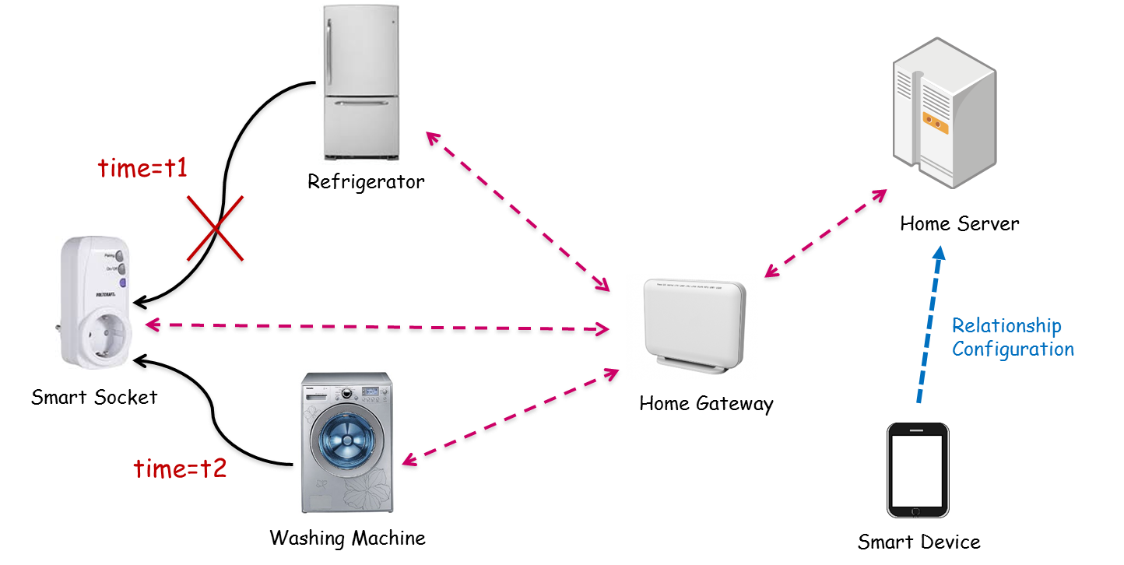

6.1.2 High Level Analysis

6.1.2.1 Functional Impacts
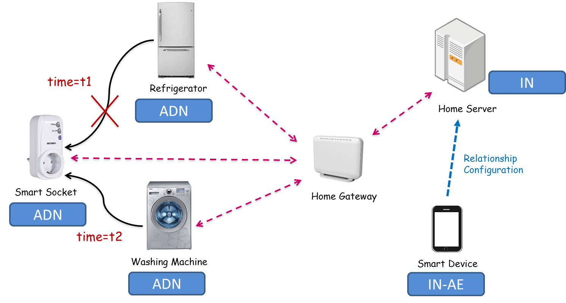
- In oneM2M configurations, the smart socket, the refrigerator, and the washing machine can be interpreted as ADN (Application Dedicated Node). The home server can be interpreted as IN (Infrastructure Node) and Smart device as IN-AE.
- For enabling this kind of service, first of all, each device needs to register its information with the server. (Registration)
- Using smart device, all the registered home appliances can be discovered. (Discovery)
- The smart device can make the pairing information between home appliances (Making Pairing information)
- The home server needs to store the pairing information in its registered device information. (Storing Pairing information)
- The home server needs to update the pairing information in its registered device information (Updating Pairing information)

6.1.2.2 High Level Information Flows
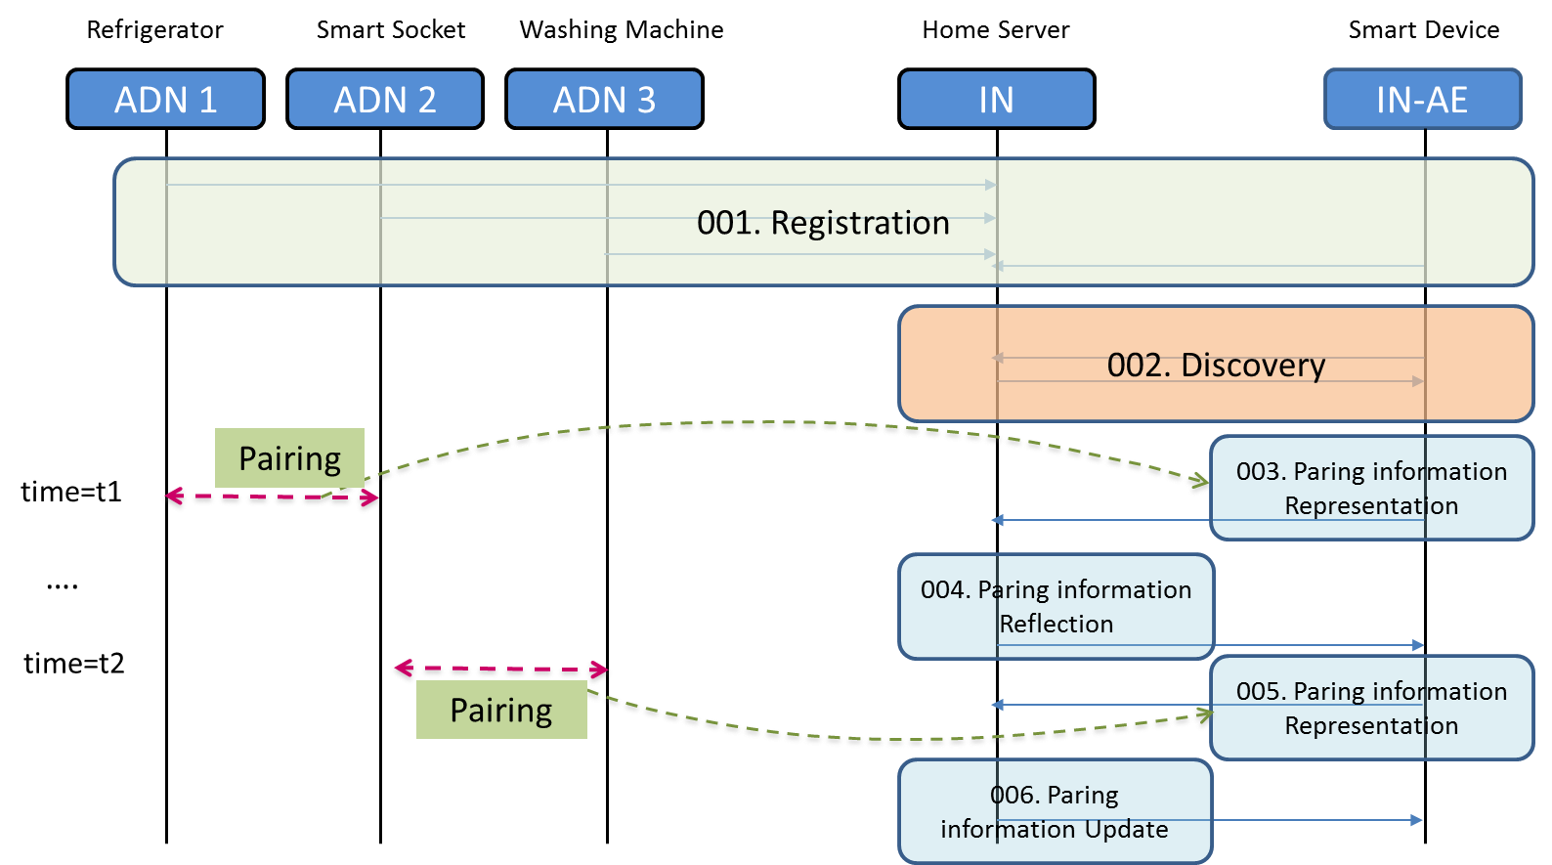
- 001: ADN1,2,3, and IN-AE register its information with IN. ADN 1,2,3 send their generated data to the IN.
- 002: IN-AE discovers the registered device list from the IN.
- 003: The pairing information between ADN 1 and 2 can be represented in the IN-AE and the IN-AE send the pairing information as oneM2M message to the IN.
- 004: IN receives the pairing information message and stores the pairing information in its database i.e. oneM2M resource tree.
- 005: When the connection of the ADN2 is changed from ADN1 to ADN 3, IN-AE sends new pairing information as oneM2M message to the IN.
- 006: IN received new pairing information message and updates the pairing information in its database i.e. oneM2M resource tree.
Note: We assume that IN-AE can acquire the pairing information from ADNs1,2,3 through a mechanism that is out of scope of oneM2M.

6.1.3 Potential Requirements
- The oneM2M System shall support a semantic relation (“Is Paired To”) between two M2M Devices.
- The oneM2M System shall be able to store/update information about pairing between two M2M Devices as a relation (“Is Paired To”) between M2M Devices.
- The oneM2M System shall enable the creation and deletion of a semantic pairing relation (“Is Paired To”) between M2M Devices by M2M applications, subject to access rights.
- The oneM2M System shall be able to make information about pairing between M2M Devices available to M2M Applications.

6.X Use Case X
Editor’s Note: Individual use cases go here. Sections 6.x.1.1 to 6.x.1.8 follow the same format as in the Use case TR. Section 6.x.1 Overview shall be a oneM2M architecture agnostic.

6.X.1 Overview

6.X.1.1 Description
<Text>

6.X.1.2 Source
<Text>

6.X.1.3 Actors
<Text>

6.X.1.4 Pre-condition
<Text>

6.X.1.5 Triggers
<Text>

6.X.1.6 Normal Flow
<Text>

6.X.1.7 Post-conditions
<Text>

6.X.1.8 High Level Illustration
<Text>

6.X.2 High Level Analysis
Editor’s Note: This section provides a high level analysis on how oneM2M can be used to enable the proposed use case. It provides a mapping of oneM2M technology to the particular use case.

6.X.2.1 Functional Impacts
Editor’s Note: The functional impacts provide a first-cut analysis of the functionality affected by (or proposed by) the use case. It should describe the oneM2M entities (AND, ASN, …) and functions (discovery, registration, security …) proposed to implement [parts of] the use case. Where appropriate, functionality that is not available in oneM2M Rel-1 but is proposed to be standardized in a subsequent release should be indicated.
<Text>

6.X.2.2 High Level Information Flows
Editor’s Note: This section should contain flow diagram(s), illustrating the information flow among oneM2M entities to support the use case.
<Text>

6.X.3 Potential Requirements
Editor’s Note: List of potential requirements that are proposed to be supported by the oneM2M System beyond oneM2M Release 1 to support the functional impacts derived in 6.x.2.
<Text>

7 Overview of Potential Requirements
Editor’s Note: This section summarizes all potential requirements on the oneM2M System from sections 6.x.3 with editing and merging as needed. Potential requirements should not contain architectural considerations.
<Text>

8 Architecture Analysis
Editor’s Note: Identify and analyse potential requirements from section 7, relevant to architecture through joint work with WG2. Methodology is TBD.
<Text>

9 Security Analysis
Editor’s Note: Identify and analyse potential requirements from section 7, relevant to security through joint work with WG4. Methodology is TBD.
<Text>

10 Abstraction and Semantics Analysis
Editor’s Note: Identify and analyse potential requirements from section 7, relevant to Abstraction and Semantics through joint work with WG5. Methodology is TBD.
<Text>

11 Management Analysis
Editor’s Note: Identify and analyse potential requirements from section 7, relevant to Management Capability through joint work with WG5. Methodology is TBD.
<Text>

12 Conclusions
Editor’s Note: This section summarizes contents from each section and describes the usefulness and applicability of this Technical Report.
<Text>
Annex <A>:
Title of annex
<Text>
Annex <B>:
Title of annex
<Text>
B.1 First clause of the annex
<Text>
B.1.1 First subdivided clause of the annex
<Text>

History

Publication history
V.1.1.1 | <dd Mmm yyyy> | <Milestone>

Draft history (to be removed on publication)
V.0.1.0 | 15-Sep-2014 | Initial Draft Version
V.0.2.0 | 27-Oct-2014 | Incorporates: REQ-2014-0469R03

