

oneM2M
Technical Specification
Document Number | TS-0014-V0.2.0
Document Name: | LWM2M Interworking
Date: | 2015-March-27
Abstract: | This present document specifies the interworking capabilities of the M2M Service Layer between ASN/IN/MN CSEs and LWM2M Endpoints.

This Specification is provided for future development work within oneM2M only. The Partners accept no liability for any use of this Specification.
The present document has not been subject to any approval process by the oneM2M Partners Type 1. Published oneM2M specifications and reports for implementation should be obtained via the oneM2M Partners' Publications Offices.

About oneM2M
The purpose and goal of oneM2M is to develop technical specifications which address the need for a common M2M Service Layer that can be readily embedded within various hardware and software, and relied upon to connect the myriad of devices in the field with M2M application servers worldwide.
More information about oneM2M may be found at: http//www.oneM2M.org
Copyright Notification
No part of this document may be reproduced, in an electronic retrieval system or otherwise, except as authorized by written permission.
The copyright and the foregoing restriction extend to reproduction in all media.
© 2013, oneM2M Partners Type 1 (ARIB, ATIS, CCSA, ETSI, TIA, TTA, TTC).
All rights reserved.
Notice of Disclaimer & Limitation of Liability
The information provided in this document is directed solely to professionals who have the appropriate degree of experience to understand and interpret its contents in accordance with generally accepted engineering or other professional standards and applicable regulations. No recommendation as to products or vendors is made or should be implied.
NO REPRESENTATION OR WARRANTY IS MADE THAT THE INFORMATION IS TECHNICALLY ACCURATE OR SUFFICIENT OR CONFORMS TO ANY STATUTE, GOVERNMENTAL RULE OR REGULATION, AND FURTHER, NO REPRESENTATION OR WARRANTY IS MADE OF MERCHANTABILITY OR FITNESS FOR ANY PARTICULAR PURPOSE OR AGAINST INFRINGEMENT OF INTELLECTUAL PROPERTY RIGHTS. NO oneM2M PARTNER TYPE 1 SHALL BE LIABLE, BEYOND THE AMOUNT OF ANY SUM RECEIVED IN PAYMENT BY THAT PARTNER FOR THIS DOCUMENT, WITH RESPECT TO ANY CLAIM, AND IN NO EVENT SHALL oneM2M BE LIABLE FOR LOST PROFITS OR OTHER INCIDENTAL OR CONSEQUENTIAL DAMAGES. oneM2M EXPRESSLY ADVISES ANY AND ALL USE OF OR RELIANCE UPON THIS INFORMATION PROVIDED IN THIS DOCUMENT IS AT THE RISK OF THE USER.

Contents
Contents 3
1 Scope 5
2 References 5
2.1 Normative references 5
2.2 Informative references 5
3 Definitions, symbols, abbreviations and acronyms 5
3.1 Definitions 5
3.2 Symbols 6
3.3 Abbreviations 6
3.4 Acronyms 6
4 Conventions 6
5 Architecture Model 7
5.1 Introduction 7
5.2 Reference Model 7
5.3 Types of Interworkings 8
5.4 Composition of the Interworking Proxy Entity 9
6 Architecture Aspects 10
6.1 Introduction 10
6.2 LWM2M Device and Endpoint Lifecycle 10
6.2.1 Introduction 10
6.2.2 LWM2M Device and Endpoint Resource Respresentation 10
6.2.2.1 LWM2M Device and Endpoint Resource Identification 10
6.2.2.2 LWM2M Endpoint Lifecycle 11
6.2.2.3 Configuration of CMDH Policies 12
6.2.2.4 Registering A Registered LWM2M Endpoint 12
6.3 LWM2M Object Discovery 12
6.3.1 Introduction 12
6.3.2 LWM2M Object Identifier Representation 12
6.3.2.1 LWM2M Object Resource Identification 13
6.3.2.2 LWM2M Object Lifecycle 13
7 Transparent Interworking Mode 15
7.1 Introduction 15
7.2 Specific Aspect 15
8 Semantic Interworking Mode 16
8.1 Introduction 16
8.2 Specific Aspect 16
Annex A (Informative): Introduction to OMA LightweightM2M (LWM2M) 17
A.1 Introduction 17
A.2 Architecture 18
A.3 Terminology 18
A.4 Reference Points 18
A.4.1 Functional Components 19
A.4.1.1 LWM2M Server 19
A.4.1.2 LWM2M Client 19
A.4.2 Interfaces 19
A.5 Protocols 19
A.5.1 Protocol Stack 19
A.5.2 Data Model 20
A.5.3 Interface Descriptions 21
A.5.3.1 Bootstrap 21
A.5.3.2 Client Registration 21
A.5.3.3 Device Management and Service Enablement 21
A.5.3.4 Information Reporting 22
A.6 Functions 23
History 24

1 Scope
The present document specifies the interworking capabilities of the M2M Service Layer between ASN/IN/MN CSEs and LWM2M Endpoints using the architecture identified in Annex F of TS-0001 [2] for the following interworking scenarios:
- Interworking using containers for transparent transport of encoded LWM2M Objects and commands in <container> resources between LWM2M Endpoints and M2M Applications.
- Interworking with full mapping of LWM2M Objects in LWM2M Endpoints to semantically enabled <container> resources that are utilized by M2M Applications.

2 References
References are either specific (identified by date of publication and/or edition number or version number) or non-specific. For specific references,only the cited version applies. For non-specific references, the latest version of the referenced document (including any amendments) applies.

2.1 Normative references
[1] oneM2M TS-0011 v1.2.1: "Common Terminology"
[2] oneM2M TS-0001 v1.6.1: " Function Architecture"
[3] OMA OMA-TS-LightweightM2M-V1_0-20141111-D: "Lightweight Machine to Machine Technical Specification"

2.2 Informative references
[i.1] oneM2M Drafting Rules (http://member.onem2m.org/Static_pages/Others/Rules_Pages/oneM2M-Drafting-Rules-V1_0.doc)
[i.2] oneM2M TS-0002 v1.0.1: "Requirements"
[i.3] IETF RFC 7552: "Constrained Application Protocol (CoAP)"
[i.4] IETF RFC 6347: “Datagram Transport Layer Security Version 1.2
[i.5] OMA OMA-RD-LightweightM2M-V1_0: ”OMA Lightweight Machine to Machine Requirement”

3 Definitions, symbols, abbreviations and acronyms

3.1 Definitions
For the purposes of the present document, the terms and definitions given in TS-0011 [1], TS-0002[2] and the following apply. A term defined in the present document takes precedence over the definition of the same term, if any, in TS-0011 [1] and TS-0001[2]:
Definition format
<defined term>: <definition>
If a definition is taken from an external source, use the format below where [N] identifies the external document which must be listed in Section 2 References.
<defined term>[N]: <definition>
example 1: text used to clarify abstract rules by applying them literally
NOTE: This may contain additional information.

3.2 Symbols
Clause numbering depends on applicability.
For the purposes of the present document, the [following] symbols [given in ... and the following] apply:
Symbol format
<symbol> <Explanation>
<2nd symbol> <2nd Explanation>
<3rd symbol> <3rd Explanation>

3.3 Abbreviations
For the purposes of the present document, the followingterms and definitions given in TS-0011 [1] and the following apply:
LWM2M Lightweight M2M
OMA Open Mobile Alliance

3.4 Acronyms
Acronyms should be ordered alphabetically.
Clause numbering depends on applicability.
For the purposes of the present document, the [following] abbreviations [given in ... and the following] apply:
Acronym format
<ACRONYM1> <Explanation>
<ACRONYM2> <Explanation>
<ACRONYM3> <Explanation>

4 Conventions
The key words “Shall”, ”Shall not”, “May”, ”Need not”, “Should”, ”Should not” in this document are to be interpreted as described in the oneM2M Drafting Rules [i.1]

5 Architecture Model

5.1 Introduction
The architecture model followed in the present document is based on the architecture model in Annex F of TS-001 [2] that describes how interworking between CSEs and non-oneM2M solutions and protocol using specialized Interworking Proxy application Entities (IPE). The present document descibes the LWM2M IPE that supports the following scenarios:
Hybrid Application
CSE(s)
LWM2M Interface
Mca
LWM2M
IPE
Mca
(note 1)
LWM2M Application
LWM2M
IPE
Mca
LWM2M Interface
Figure 5.1-1 - LWM2M Interworking Scenarios
In the scenarios depicted in Figure 5.1-, the Hybrid and LWM2M Applications represent applications that implement the LWM2M Client role defined in the LWM2M Protocol [3].

5.2 Reference Model
The LWM2M Interworking reference model utilizes the Functional Architecture’s reference model in TS-0001 [2]; augmenting the TS-0001 reference model with capabilities provided by the LWM2M IPE.

LWM2M Application
CSE
LWM2M Protocol
LWM2M
IPE
Mca
AE
Mca
ASN/MN/IN
CSE
Mcc/Mcc’
MN/IN
Figure 5.2-1 - LWM2M Reference Model
Note: The AE in the reference model could be registered with the same CSE as the LWM2M IPE.

5.3 Types of Interworkings
LWM2M IPEs provide the following types of interworkings:
- Interworking using the <containter> resource for transparent transport of encoded LWM2M Objects that are available to AEs as depicted in Figure 5.3-1.
- Interworking with full mapping of the semantics of LWM2M Objects to semantically enabled resources that are available to AEs as depicted in Figure 5.3.-2.
- While depicted outside the hosting CSE, the <container> resources are hosed a CSE (e.g., CSE1)
Figure 5.3-1 - LWM2M Transparent Transport Interworking

Figure 5.3-2 - LWM2M Objects Semantic Transport Interworking

5.4 Composition of the Interworking Proxy Entity
The LWM2M IPE participation in the LWM2M Protocol as described in clause 5 does so in the role of a LWM2M Server to which LWM2M Applications (LWM2M Clients) interact. For each LWM2M Client (Endpoint) that is maintained by the LWM2M Server in the LWM2M IPE, the LWM2M IPE shall instantiate and maintain an instance of a M2M Application.
Figure 6.1-1 - LWM2M IPE Architecture

6 Architecture Aspects

6.1 Introduction
The LWM2M IPE participation in the LWM2M Protocol as described in clause 5 does so in the role of a LWM2M Server to which LWM2M Applications (LWM2M Clients) interact. As a LWM2M Server, the IPE provides the following Architecture Aspects based on the LWM2M Protocol Aspects described in Annex A.2:
- LWM2M Device and Endpoint Lifecycle (Client Registration)
- LWM2M Object Discovery (Client Registration, Device Management and Service Enablement)
- LWM2M Object Subscription and Notification (Information Reporting)
- LWM2M Object Security (Device Management and Service Enablement)
- LWM2M Object Transport and Interworking (Device Management and Service Enablement)
- LWM2M Client Pre-provisioning (Bootstrap)
- LWM2M Interworking Proxy Entity Administration

6.2 LWM2M Device and Endpoint Lifecycle

6.2.1 Introduction
As the LWM2M IPE discovers LWM2M Endpoints when the LWM2M IPE interacts with the LWM2M Client over the LWM2M protocol’s Bootstrap and Client Registration interfaces, the LWM2M IPE shall maintain the associated resources in the CSE that represents the LWM2M Device and Endpoint.

6.2.2 LWM2M Device and Endpoint Resource Respresentation
As discussed in clause 5.4, each LWM2M Endpoint is maintained by the LWM2M IPE, the LWM2M IPE maintains a M2M Application. As such, the CSE that hosts the M2M Application shall represent the LWM2M Endpoint as a <AE> resource. The LWM2M Device that host the LWM2M Endpoint shall be represented as a <node> resource.
Editor’s Note: The wording in the first sentence of this clause needed to be editted.

6.2.2.1 LWM2M Device and Endpoint Resource Identification
LWM2M Endpoints are identified by their Endpoint Client Name described in section 6.2.1 of the LWM2M Technical Specification [3]. The Endpoint Client Name URN without the “urn:” sequence is used as the AE-ID of the associated <AE> resource that represents the LWM2M Client.
In most deployment scenarios, LWM2M Devices host one (1) LWM2M Endpoint. In this scenario the LWM2M Device’s <node> resource’s M2M-Node-ID should be the same as the LWM2M Endpoint Client Name URN without the “urn:” sequence. When a LWM2M Device host’s more than one (>1) LWM2M Endpoint, the determination of the <node> resource’s M2M-Node-ID is implementation specific. In all deployment scenarios, the <AE> resource is linked with the <node> resource as described in TS-001 [2].
As the LWM2M Endpoint is represented as an <AE> resource and the LWM2M Object is represented as a <container> resource in the M2M Service Layer, a reference shall be made between the <AE> resource that represents the LWM2M Endpoint and the <container> resource.
In addition. the <AE> resource uses the Hierachical and Non-Hierachical mechanisms for Resource Addressing as defined in clause 9.3.1 of TS-001 [2] where the resouceName attribute of the <container> resource shall be a Endpoint Client Name URN without the “urn:” sequence.

6.2.2.2 LWM2M Endpoint Lifecycle
LWM2M Endpoint’s are discovered when the LWM2M Client is successfully registers with the LWM2M Server using the LWM2M Register operation. In addition to the LWM2M Register operation, the LWM2M Client can periodically refresh the LWM2M Client’s registration with the LWM2M IPE using the LWM2M Update operation. Finally a LWM2M Client can deregister when the LWM2M Client issues a De-register operation to the LWM2M IPE or the LWM2M Client’s registration lifetime expires.
The LWM2M Client Registration interface’s operations and the registration lifetime expiration event maps to the following operations on the <AE> and <node> resources:
LWM2M Operation  Client Registration Interface | oneM2M Resource and Operation
Register | create <AE>, create <Node>
Update | update <AE>, update <Node>
De-register | delete <AE>, delete <Node>
Table 6.2.2.2-1 LWM2M Endpoint Lifecycle Translation – Client Registration Interface

LWM2M Server Events | oneM2M Resource and Operation
client lifetime expiration | delete <AE>, delete <Node>, delete <containers> associated with the <AE> resource.
Table 6.2.2.2-2 LWM2M Endpoint Lifecycle Translation – LWM2M Server Events

LWM2M Attributes  Client Registration Interface | oneM2M Resource Attribute
Endpoint Client Name | <AE>: AE-ID, resourceName  <Node>: M2M-Node-ID when the Device only supports one Endpoint; resourceName
Lifetime | <AE>, <Node>: expirationTime
LWM2M Version | <AE>, <Node>: labels. Value is “LWM2M Client: ”appended with the value of the LWM2M Version.
Binding Mode | Not Applicable
SMS Number | Not Applicable
Table 6.2.2.2-3 LWM2M Endpoint Lifecycle Attribute Translation

LWM2M Errors  Client Registration Interface | oneM2M Resource Operation Response
Register  2.01 Created:  4.00 Bad Request  4.03 Forbidden | create <AE>, create <Node>  2001 Created  All other codes  4105 Conflict
Update  2.04 Changed  4.00 Bad Request  4.04 Not Found | update <AE>, update <Node>  2004 Changed  All other codes  4000 Not Found
De-register  2.02 Deleted  4.04 Not Found | delete <AE>, delete <Node>  2002 Deleted  4004 Not Found
Table 6.2.2.2-4 LWM2M Endpoint Lifecycle Response Code Translation

6.2.2.3 Configuration of CMDH Policies
In the present document, the CMDH Policies associated with the <Node> resource for the AE is implementation specification.

6.2.2.4 Registering A Registered LWM2M Endpoint
In the scenario where a LWM2M Client issues a Register operation for an AE that is already created, the LWM2M IPE shall treat the operation as if the LWM2M Client requested a De-Register prior this Register operation. The procedure for the LWM2M Server is defined in section 5.2.1 of the LWM2M Technical Specification [3].
Editors note: This section needs clarity of the procedure with respect to what is done in the oneM2M System.

6.3 LWM2M Object Discovery

6.3.1 Introduction
The LWM2M Client uses the Registration Interface to provide the properties required by the LWM2M Server of the IPE to contact the LWM2M Client (e.g., Endpoint Name) and to maintain the session between these two LWM2M entities (e.g., Lifetime, Queue Mode).In addition, the LWM2M Client also provides the knowledge of the supported Objects and existing Object Instances across the Registration Interface.
The LWM2M IPE uses the information exchange across this interface to synchronize which LWM2M Objects supported by the LWM2M Endpoint and what is defined in the hosting CSE for the M2M Application representing the LWM2M Endpoint. This clause specifies how discovered LWM2M Objects identifiers are translated to discoverable CSE <container> resource’s along with the associated linkages to other resources.

6.3.2 LWM2M Object Identifier Representation
Through the Registration Interface, the LWM2M Client provides the list of supported LWM2M Objects and existing LWM2M Object Instances. Each element of the list is described by its path, which can be the path of an Object or an Object Instance.
For example the LWM2M Client could provide the following list of paths: </1/0>, </1/1>, </2/0>, </2/1>, </3/0>, </4/0>, </5> . This list of paths is a valid list of LWM2M Objects and LWM2M Object Instances in the CoRE Link Format [RFC6690], specifiying that LWM2M Objects with OMNA Identifiers 1, 2, 3,4, and 5 are supported. The respective OMNA references are : urn:oma:lwm2m:oma:1, urn:oma:lwm2m:oma:2, urn:oma:lwm2m:oma:3, urn:oma:lwm2m:oma:4, urn:oma:lwm2m:oma:5.
Additionaly, information is provided that LWM2M Object 1 (Server Object) and LWM2M Object 2 (Access Control Object) have 2 instances (Instance Identifiers 0 and 1); LWM2M Object 3 (Device Object) and LWM2M Object 4 (Connectivity Monitoring Object) have 1 instance each (0); LWM2M Object 5 is supported but no instance has been created yet for that LWM2M Object.
Optionally other information can be carried by that list as the capability for all the Objects in the LWM2M Client to support :
- an alternate root path (default root path is ‘/’),
- a specific Content-Format (e.g. LWM2M JSON Content-Format)

For discovery of LWM2M Objects by M2M Applications, the properties carried by LWM2M Objects list (i.e. Objects and LWM2M Object Instances Identifiers, optional alternate rootpath, supported Content-Format) shall be translated into the labels attribute of the <container> resource as separate entries with the following format:
- LWM2MRT:Resource Type
- LWM2MPTH:Resource Root Path (for LWM2M default rootpath is “/”)
- LWM2MURI:Resource Path Object Identifier and Instance Identifier
- LMM2MCT : Supported Content Format (LWM2M default Supported ContentFormat is LWM2M TLV other can be LWM2M JSON)
For example if the LWM2M Endpoint provided the following LWM2M Objects as part of the Client Registration Interface: </lwm2m>;rt="oma.lwm2m";ct=LWM2M+JSON,</1/0> would translate into a <container> resource with the following entries in the labels attribute: LWM2MRT:urn:oma:lwm2m:oma:1 LWM2MPTH:”/lwm2m” LWM2MURI: ”/1/0” LMM2MCT=LWM2M+JSON
The CoAP Resource Type may also be used as the semantic ontology of the <container> resource by inserting this value in the ontologyRef attribute of the <container> resource.

6.3.2.1 LWM2M Object Resource Identification
LWM2M Object Resources are identified by their URI within the context of the LWM2M Endpoint described in section 6.2.1 of the LWM2M Technical Specification [3].
As the LWM2M Endpoint is represented as an <AE> resource and the LWM2M Object is represented as a <container> resource in the M2M Service Layer, a reference shall be made between the <AE> resource that represents the LWM2M Endpoint and the <container> resource.
In addition <container> resource that represents the LWM2M Object or LWM2M Object Instance uses the Hierachical and Non-Hierachical mechanisms for Resource Addressing as defined in clause 9.3.1 of TS-001 [2] where the resourceName attribute of the <container> resource shall be the value of the the LWM2MURI.
For example if the LWM2MURI is “/1/0 and the LWM2MPTH is “/” then the resourceName attribute of the <container> resource could be “/1/0”.
Editors Note: The syntax of the resourceName should be FFS..

6.3.2.2 LWM2M Object Lifecycle
LWM2M Endpoint’s are discovered when the LWM2M Client is successfully registers with the LWM2M Server using the LWM2M Register operation. In addition to the LWM2M Register operation, the LWM2M Client can periodically refresh the LWM2M Client’s registration with the LWM2M IPE using the LWM2M Update operation. Finally a LWM2M Client can deregister when the LWM2M Client issues a De-register operation to the LWM2M IPE or the LWM2M Client’s registration lifetime expires.
The LWM2M Client Registration interface’s operations and the registration lifetime expiration event maps to the following operations on the <container> resource:
LWM2M Operation  Client Registration Interface | oneM2M Resource and Operation
Register | create <container>
Update | update <container>, delete <container>
De-register | delete <container>
Table 6.3.2.2-1 LWM2M Object Lifecycle Translation – Client Registration Interface

LWM2M Server Events | oneM2M Resource and Operation
client lifetime expiration | delete <container>
Table 6.3.2.2-2 LWM2M Object Lifecycle Translation – LWM2M Server Events

LWM2M Attributes  Client Registration Interface | oneM2M Resource Attribute
Endpoint Client Name | Not Applicable
Resource Links | <container> resourceName
Lifetime | <container> expirationTime
LWM2M Version | Not Appliable
Binding Mode | Not Applicable
SMS Number | Not Applicable
Table 6.3.2.2-3 LWM2M Object Lifecycle Attribute Translation

LWM2M Errors  Client Registration Interface | oneM2M Resource Operation Response
Register  2.01 Created:  4.00 Bad Request  4.03 Forbidden | create <container>  2001 Created  All other codes  4105 Conflict
Update  2.04 Changed  4.00 Bad Request  4.04 Not Found | update <container>  2004 Changed  All other codes  4000 Not Found
De-register  2.02 Deleted  4.04 Not Found | delete <container>  2002 Deleted  4004 Not Found
Table 6.2.2.2-4 LWM2M Object Lifecycle Response Code Translation

7 Transparent Interworking Mode
Editor’s note: consider to add text: a single interworking function (or IPE) can act in transparent mode, semantic mode or both
Editor’s note: consider to use the term interworking function (as opposed to proxy)

7.1 Introduction
<text to introduce the section for aspects specific to the Transparent interworking mode>

7.2 Specific Aspect
<text >

8 Semantic Interworking Mode

8.1 Introduction
<text to introduce the section for aspects specific to the Smeantic interworking mode>

8.2 Specific Aspect
<text >

Annex A (Informative): Introduction to OMA LightweightM2M (LWM2M)

A.1 Introduction
OMA Lightweight M2M is a protocol for device and service management for M2M. The main purpose of this technology is to address service and management needs for constrained M2M devices, over UDP and SMS bearers.
Note: This annex provides an overview of the LWM2M protocol. The authoritative source for the protocol is provided by the LWM2M Technical Specification [3].
The crucial aspects in this work are the:
- Target devices for this protocol are resource constraint devices (e.g., 8-16bit MCU, RAM is in tens of KB and flash is in hundreds of KB)
- Ability to perform Data collection and remote control of devices without the need for complex computing and UI operations
- Optimization of network resources to allow a large numbers of devices may be connected to the communication network simultaneously
- Fusion of device functionalities management and service manipulation into a single protocol
From the implementation view LWM2M has the following features:
- Suitable for resource constraint devices
- Usage of compact binary packets
- Support for multiple data encoding formats that include Binary , JSON, plain text and opaque data formats
- Support for reporting information from the Server to the Client when specified condition are met
- Easy to be implemented though the reuse of existing implementation of IETF technologies : e.g., CoAP
(Constrained Application Protocol) for the Transfert Protocol, and DTLS (Datagram, Transport Layer Security) for securing the Server/Client exchanges
One of typical use cases of using LWM2M technology is the firmware upgrade of streetlights [i.5].
A Streetlights supervisor is responsible for managing the streetlights system. (There are thousands of streetlights in the city and low-cost LWM2M devices embedded in the streetlights.)
The supervisor needs to remotely upgrade of the firmware of a specific streetlight or a group of streetlights.
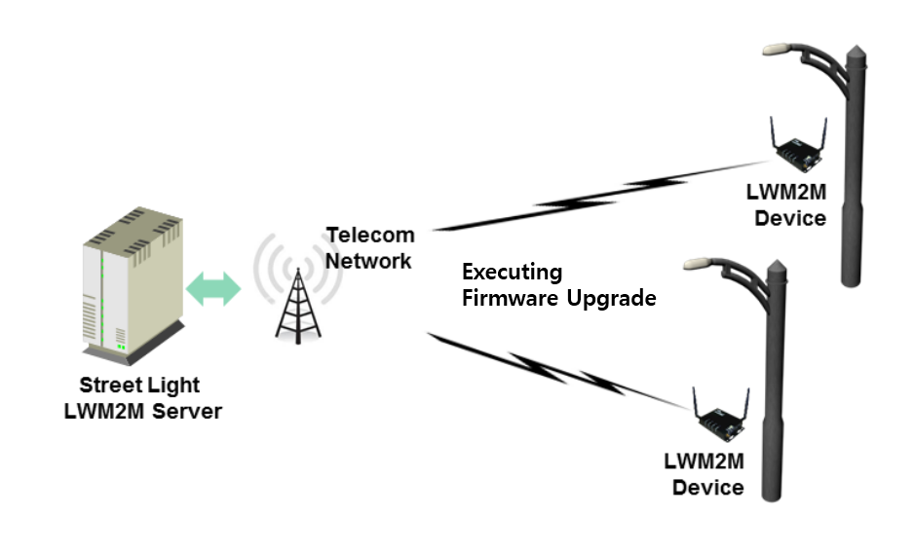
Figure A.1-1: Firmware Upgrade of Streetlight of Use Case using LWM2M

A.2 Architecture

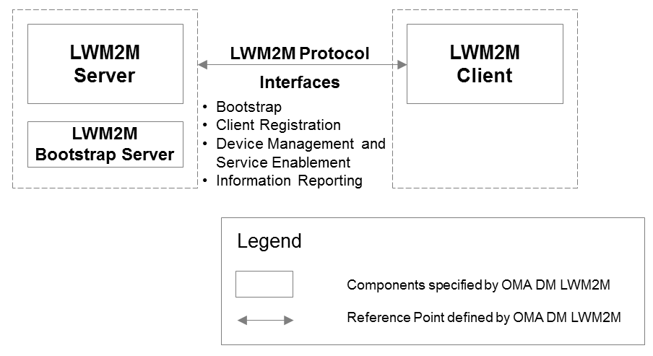
Figure A.2-1: LWM2M Architecture
As shown in the Figure A.2, the layout is the architecture of LWM2M [3]. The Components specified by OMA LWM2M compose the LWM2M enabler which specifies the LWM2M Server / LWM2M Client interface. The LWM2M Server and LWM2M Client are typically instantiated in a M2M Server and a M2M Device.
Based on the deployment scenario, the LWM2M Server has the bootstrapping capability itself, or the LWM2M Bootstrap Server exists separately for security reasons.

A.3 Terminology
Editor’s note: This section should describe the LWM2M terms used in this annex specifically how is compares and constrasts with oneM2M as applicable. (e.g., LWM2M Client = oneM2M AE, Resource = oneM2M Attribute), Object = oneM2M Resource)

A.4 Reference Points
This section introduces the interfaces carried over the reference point consisting of two main components LWM2M Server and the LWM2M Client.

A.4.1 Functional Components

A.4.1.1 LWM2M Server
The LWM2M Server is a logical component which serves as an endpoint of the LWM2M protocol.

A.4.1.2 LWM2M Client
The LWM2M Client is a logical component. This LWM2M Client serves as an endpoint of the LWM2M protocol and communicates with the LWM2M Server to execute the device management and service enablement operations from the LWM2M Server and reporting results of the operations.

A.4.2 Interfaces
There are four interfaces supported by the reference point between LWM2M server and LWM2M Client. The logical operation of each interface is defined as follows:
- Bootstrap
This interface is used to provision essential information into the LWM2M Client so that the LWM2M Client can register to the LWM2M Server(s) after bootstrap procedure has completed.
- Client Registration
This interface allows the LWM2M Client register to the LWM2M Server. This procedure lets the Server know the existence and information (e.g., address, capabilities) of the LWM2M Client so that LWM2M Server can perform M2M services and device management on the LWM2M Client.
- Device Management and Service Enablement
This interface allows the LWM2M Server to perform the device management and M2M service enablement operations. Over this interface, the LWM2M Server can send operations to the LWM2M Client and gets response of the operations from the LWM2M Client.
- Information Reporting
This interface allows the LWM2M Client to report resource information to the LWM2M Server. This Information Reporting can be triggered periodically or by events (e.g., resource information is changed and configured conditions are met).

A.5 Protocols

A.5.1 Protocol Stack
The LWM2M has the protocol stack defined as below:
Figure A.5.1-1: LWM2M Protocol Stack
- LWM2M Objects: LWM2M Objects are designed for the functionality provided by the LWM2M enabler. The LWM2M specification [i.20] defines a set of Standard Objects. Other Objects may also be added by OMA, external SDOs (e.g., the IPSO alliance) or vendors to enable certain M2M Services.
- LWM2M Protocol: LWM2M protocol defines the logical operations and mechanisms per each interface.
- CoAP: The LWM2M utilizes the IETF Constrained Application Protocol [i.3] as an underlying transfer protocol across UDP and SMS bearers. This protocol defines the message header, request/response codes, message options and retransmission mechanisms. The LWM2M only uses the subset of features defined in CoAP.
- DTLS: DTLS [i.22] is used to provide secure UDP / SMS on-device channels between the LWM2M Server and the LWM2M Client for all the messages interchanged.
- UDP Binding with CoAP (Mandatory): Reliability over the UDP transport is provided by the built-in retransmission mechanisms of CoAP.
- SMS Binding with CoAP (Optional): CoAP is used over SMS by placing a CoAP message in the SMS payload using 8-bit encoding.

A.5.2 Data Model
In the LWM2M Enabler technical specification [i.20], a simple data model is described. Basically, a resource made available by data model of the LWM2M Client is a Resource, and Resources are logically organized into Objects. Figure 5.3.4 illustrates this structure, and the relationship between Resources, Objects, and the LWM2M Client. The LWM2M Client may have any number of Resources, each of which belongs to an Object.
Figure A.5.2-1: LWM2M Data Model [3]
Resources are defined per Object, and each resource is given a unique identifier within that Object. Each Resource is designed to have one or more Operations that it supports. A Resource may be a single or multiple (possibility of several instanciations) one, dependent on the Resource definition in Object specification. An Object defines a grouping of Resources, for example the Firmware Object contains all the Resources used for firmware update purposes. The LWM2M enabler defines standard Objects and Resources and other Objects may be added to enable a certain M2M Services.
Object must be instantiated either by the LWM2M Server or the LWM2M Client, which is called Object Instance, before using the functionality of an Object. After Object Instance is created, the LWM2M Server can access that Object Instance and Resources in the Object Instance. Furthermore a Resource can contain a simple value (e.g. sensor measure), or a reference to an Object Instance.

A.5.3 Interface Descriptions

A.5.3.1 Bootstrap
The Bootstrap interface is used to provision essential information into the LWM2M Client in order to allow the LWM2M Client to be able to register to a certain LWM2M Server. There are four modes for bootstrapping:
- Factory Bootstrap: the LWM2M Client is already provisioned at the time of the device manufacture. The pre-configured data is stored in the LWM2M Client.
- Bootstrap from Smartcard: When the Device supports a Smartcard and retrieval of bootstrap message from Smartcard is successful, the LWM2M Client processes the bootstrap message from the Smartcard and applies it to the LWM2M Client.
- Client initiated Bootstrap: the LWM2M Client requests and retrieves the bootstrap message from a LWM2M Bootstrap Server. In this case the LWM2M Client needs to be pre-provisioned with the LWM2M Bootstrap Server Bootstrap Information.
- Server initiated Bootstrap: the LWM2M Bootstrap Server provisions the bootstrap message into the LWM2M Client after recognizing the existence of the LWM2M Device. In this case the LWM2M Client needs to be pre-provisioned with the LWM2M Bootstrap Server Bootstrap Information.
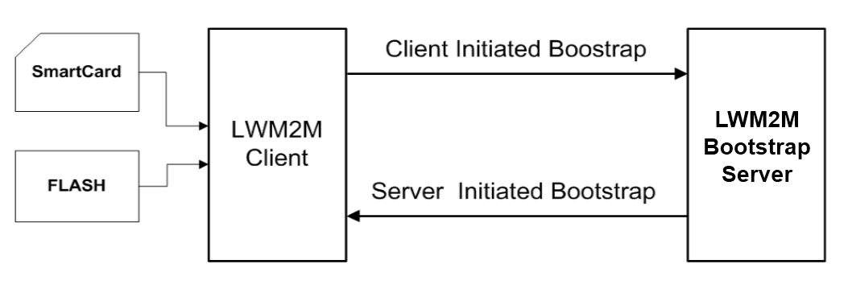
Figure A.5.3.1-1: Bootstrap Modes

A.5.3.2 Client Registration
The Client Registration interface is used by the LWM2M Client to register with one or more LWM2M Servers, maintain each registration, and de-register from the LWM2M Server(s). When registering, the LWM2M Client indicates its Endpoint Name, MSISDN, supporting binding modes, lifetime of registration, the list of Objects the Client supports and available Object Instances. The registration is a soft state, with a lifetime indicated by the registration lifetime. The LWM2M Client periodically performs an update of its registration information to the registered Server(s). If the lifetime of a registration expires without receiving an update from the Client, the Server removes the registration information. Finally, when shutting down or discontinuing use of a Server, the Client performs de-registration.
Error! Objects cannot be created from editing field codes.
Figure A.5.3.2-1: Example of Registration Procedure

A.5.3.3 Device Management and Service Enablement
This interface is used by the LWM2M Server to access Resources available from a LWM2M Client using Create, Read, Write, Delete, or Execute operations. The operations that a Resource supports are defined in the definition of its Object.
Figure A.5.3.3-1: Example of Device Management and Service Enablement Interface

A.5.3.4 Information Reporting
This interface is used by the LWM2M Server to observe any changes in a Resource on the LWM2M Client, receiving notifications when new values are available. The LWM2M Server needs to configure observation related parameters by sending “Write Attribute” operation before observing Resources in the LWM2M Client. This observation relationship is initiated by sending an “Observe” operation to the L2M2M Client for an Object Instance or Resource. An observation ends when a “Cancel Observation” operation is performed
Figure A.5.3.4-1: Example of Information Reporting Interface

A.6 Functions
A first set of standard Objects for the LWM2M 1.0 enabler have been developed:
- Server Security: security data related to the LWM2M server(s) and/or the LWM2M Bootstrap Server
- Server: data, configuration, functions related to the LWM2M Server
- Access Control: to check whether the LWM2M server has access right for performing an operation on Resources in the LWM2M Client
- Device: provision of a range of device related information, device reboot and factory reset function
- Connectivity Monitoring: to monitor parameters related to underlying network connectivity
- Firmware: provision of firmware management, installing and updating new firmware
- Location: provides location information of the LWM2M Devices
- Connectivity Statistics: to statistical information of network connection (e.g., SMS counter, UDP data size)
These Standard Objects are intended to support a variety of functionalities to manage LWM2M Devices. OMA has already specified others LWM2M objects (e.g. as Software Management, Device Capability Management, ..) and may create further objects in future. Furthermore, other organizations and companies may define additional LWM2M Objects for their own M2M services using according to LWM2M Object Template and Guideline Annex in [3]: e.g oneM2M has specified the set of LWM2M Objects around CMDH Policy functionality, IPSO Alliance has developped LWM2M Objects for various sensors.

History
Publication history
V1.1.1 | <dd-Mmm-yyyy> | <Milestone>

Draft history (to be removed on publication)
V0.1.0 | 30 Jan 2015 | Skeleton
V.0.2.0 | 27 Mar 2015 | Agreed contributions from TP16:  ARC-2015-1734R04, ARC-2015-1735R04, ARC-2015-1744R04, ARC-2015-1746R04  Editors cleanup for LWM2M qualifier for LWM2M components (e.g., LWM2M Object instead of Object)

LWM2M+JSON is an entry (numerical ID) in the CoAP Content-Format Registry representing the media-type “application/vnd.oma.lwm2m+json” used in LWM2M TS 1.0 enabler and currently engaged in the IANA registration process.

